Phytochemical evaluation and Allelopathic activity of Asparagus racemosus Willd. plant oleoresin

Abstract
Asparagus racemosus Willd. (family Asparagaceae), widely recognised as Shatavari, is a medicinally significant species with an extensive history of application in Ayurvedic therapeutics. The present investigation seeks to characterise and comparatively assess the chemical constituents and allelopathic potential of oleoresins derived from the roots (ARRO) and leaves (ARLO) of this plant. The oleoresins were obtained by cold percolation using methanol and analyzed by gas chromatography-mass spectrometry (GC-MS). A total of sixty-nine compounds were identified, contributing to 80.42% and 81.22% of the total peak area in ARRO and ARLO, respectively. Phytol (13.33%) and 5-hydroxymethylfurfural (13.16%) were the major constituents. Allelopathic activity was assessed against radish (Raphanus raphanistrum subsp. sativus) seeds at concentrations ranging from 250–1000 µL/mL. Radish was selected as a model plant because it is standard bioindicator species for allelopathic studies due to its rapid germination, uniform growth, and high sensitivity to phytotoxins. Both oleoresins exhibited significant inhibition of seed germination, root length, and shoot length in a dose-dependent manner, with IC₅₀ values determined for each parameter. The findings demonstrate that A. racemosus oleoresins possess promising allelopathic properties, indicating their potential as natural herbicide alternatives for plant protection applications.
Keywords: Asparagus racemosus Willd., Oleoresin, Cold percolation, Phytol, Allelopathic activity.
- INTRODUCTION
Asparagus racemosus Willd. (Asparagaceae), widely known as Shatavari, is a perennial climbing herb native to South Asia, including India, Nepal, and Sri Lanka [1,2]. It has long held a prominent position within traditional Ayurvedic medicine, where it is highly regarded for its diverse pharmacological properties, notably its antioxidant, immunomodulatory, anti-inflammatory, and adaptogenic activities [3,4]. Morphologically, the plant is distinguished by its slender, climbing stems, needle-like cladodes (leaf-like structures), and small, fragrant white flowers borne in racemose inflorescences [5]. Within the Ayurvedic tradition, A. racemosus is classified as a Rasayana, or rejuvenative agent, and is especially esteemed for its beneficial role in supporting female reproductive health, a status that has contributed to its epithet as the ‘Queen of Herbs’ [6,7]. The tuberous roots constitute the primary medicinally utilised part of the plant and are traditionally employed in the management of various conditions, including night blindness, leprosy, epilepsy, inflammatory disorders, and diarrhoeal diseases. In the Unani system of medicine, the roots are similarly valued and are used as laxatives, general tonics, and aphrodisiacs [8,9].
The plant is known to contain a diverse array of bioactive phytochemicals, including steroidal saponins (notably shatavarins), flavonoids such as quercetin and rutin, alkaloids, and volatile essential oils [7,10]. Among these constituents, the saponins are regarded as the principal active compounds, largely attributed with mediating the plant’s broad spectrum of pharmacological activities [11,12]. In recent years, increasing scientific attention has been directed towards validating its traditional medicinal claims, with experimental studies highlighting its significant antioxidant potential, anti-inflammatory effects, and immunomodulatory activity [13].
However, the allelopathic potential of A. racemosus oleoresins has not been previously explored. Therefore, this study aims to evaluate the chemical composition (via GC-MS) and allelopathic activity of leaf and root oleoresins against radish (Raphanus raphanistrum subsp. sativus) seeds.
- MATERIALS AND METHODS
  - Collection of plant material
The plant material was collected from the Horawala, Dehradun (30º42’59.6709” N and 77º88’92.6239’’ E). The altitude is about 648m above sea level in the Garhwal region of Uttarakhand in the month of February 2023.
  - Oleoresin preparation
Fresh leaves and roots of the Asparagus racemosus Willd. plant were collected, dried, and pulverized into a coarse powder. The pulverized powder of leaves and roots was then extracted using the cold percolation method with methanol. The resulting oleoresins was filtered and condensed using a rotary evaporator. The oleoresin was stored at 4°C for further chemical analysis and determination of biological activities.
  - GC-MS analysis
Asparagus racemosus Willd. leaf and root oleoresin were subjected to a gas chromatography-mass spectrometry (GC-MS) examination utilizing GCMS-QP 2010 Plus technique. Oven temperature 50 ⁰C, Carrier gas Helium, Injection volume 1µl, Injection temp. 60 ⁰C, Injection mode Split, Flow control mode Linear velocity, Pressure 69.0 kPa, Total flow 30.8 mL/min, Column flow rate 1.21 mL/min, Linear velocity 39.9 cm/sec, Purge flow 3.0 mL/min, Split ratio 22:1. The injector and ion source temperature were set at 250⁰C and 200⁰C, respectively. The oven temperature program was as follows: initial temperature at 50 ⁰C (held for 2 min), increased to 210⁰C at a rate of 6 ⁰C/min, and held for 11 min. Mass spectra were recorded at 70 eV with a scan range of 40-600 m/z. The identification of the compounds of oleoresin was performed by comparing their mass spectra and kovats indices with those in the NIST and Wiley libraries [14].

  - Allelopathic bioassay
The Allelopathic activity of methanol oleoresin from Asparagus racemosus Willd. at different concentrations (250-1000µL/mL) were assessed against radish (Raphanus raphanistrum sub sp. Sativus) seeds by using the method developed by Sahu and Devkota [15]. Radish was selected as a model plant because it is a standard bioindicator species for allelopathic studies due to its rapid germination, uniform growth, and high sensitivity to phytotoxins (Sahu and Devkota, 2013). For evaluating the seed germination inhibition, different concentrations of methanol oleoresin (250-1000µL/mL) were prepared in 1% Tween-20 aqueous solution. The stock solution (100µL/mL) was serially diluted to obtain final concentrations of 250, 500, 750, and 1000µL/mL. All experiments were performed in triplicate (n=3) with proper controls. The seeds were surface sterilized in a 5% sodium hypochlorite solution for 15 minutes. Three replicates of seven sterilized radish seeds were placed in each petri dish lined with filter paper to maintain adequate moisture for germination. Then 4 mL of each concentration was added, and seeds were allowed to germinate at 25±1ºC for 24 hrs. Distilled water with 1% Tween-20 served as negative control, and Pendimethalin (1000µL/mL ) was used as a positive control (synthetic herbicide) for comparison. Pendimethalin at 1000 µL/mL showed 100% inhibition of seed germination, root length, and shoot length at all tested concentrations because it is a commercial synthetic herbicide with potent phytotoxic activity, used here as a positive control to validate the bioassay system. IC₅₀ values were calculated by non-linear regression analysis. The formulas used was:
% Inhibition =100 × (1- St/Sc)
Where,
St – no. of seeds germinates in treatment
Sc – no. of seeds germinates in control
  - Statistical analysis
All experiments were performed in triplicates, and the results were expressed as mean ± standard deviation (SD). Data were analyzed using one way analysis of variance (ANOVA) followed by Duncan’s multiple range test (DMRT) at p< 0.05 significance level using SPSS software version 20.0 (IBM Corp., USA). IC₅₀ values were calculated using regression analysis in Microsoft Excel 2016.
- RESULTS
  - Chemical composition of oleoresin
The phytoconstituents present in ARRO and ARLO are shown in Table 1. Twenty-eight and forty-five compounds were identified in ARRO and ARLO, contributing to 80.42% and 81.22% of the total peak area, respectively. Minor and trace components (below 1% area) included compounds such as 1,5-hexadien-3-ol (0.73%), 4-fluoroamphetamine (0.55%), 4-fluorobenzyl alcohol (0.51%), acetamide (0.53%), and others listed in Table 1. In ARLO, major constituents were phytol (13.33%), n-hexadecanoic acid (12.04%), and δ-6-octadecenoic acid (8.37%). In ARRO, major constituents were 5-hydroxymethylfurfural (13.16%), 3-furoic acid (11.59%), and benzyl-dimethyl-silyl ester (9.77%). The ion-chromatograms are shown in Fig. 1.
Table 1. Comparative chemical composition of ARRO and ARLO
S.No | Compound name | ARRO | ARLO
 | (E)-4-(3-hydroxyprop-1-en-1-yl)-2-methoxyphenol | _ | 1.45
 | 1-(3'-isopropylphenylthio) prop-1-yne | _ | 0.56
 | 1,5-hexadien-3-ol | _ | 0.73
 | 1,7-acetoxy-3-beta methoxy-4,4- | _ | 2.74
 | 1-H-cyclopropa [3,4] Benz1 | _ | 0.95
 | 1-methyl-5-fluorouracil | 2.45 | 1.44
 | 2-(trimethylsilyl) ethyl | 1.13 | _
 | 2-cyclohexylpiperidine | 0.88 | _
 | 2-dimethyl-4-methoxy-7-  [5 (t-butyldimethylsilyloxy)-4-methyl-2-hexenyl- | 1.17 | _
 | 2-ethanediyl ester | _ | 0.79
 | 2-H-pyran | 0.66 | _
 | 2-phenyl-1,3-dioxan5-yl-ester | _ | 1.57
 | 2-thiophenecarboxamide | _ | 0.62
 | 3-(1,4-dioxa-8-azaspiro [4.5] dec-8-ylmethyl)-5 | _ | 0.49
 | 3,3'-dimentoxy | _ | 1.13
 | 3,6-nonadecadione | _ | 0.53
 | 3,7,11,15-tetramethylhexadec-2-en-1-yl acetate | _ | 1.42
 | 3-furoic acid | 11.59 | _
 | 4,4,5,8-tetramethylchroman-2-ol | _ | 1.77
 | 4,8,12,16-tetramethylheptadecan-4-olide | _ | 1.72
 | 4-ethenyl-2,6-dimethoxy | _ | 2.40
 | 4-fluoroamphetamine | _ | 0.55
 | 4-fluorobenzyl alcohol | _ | 0.51
 | 4H-1-benzopyran-4-one | _ | 3.00
 | 5-ethenyl-2-methoxy | 0.72 | _
 | 5-hydroxymethylfurfural | 13.16 | _
 | 6,8-dimethoxy-3 | _ | 1.37
 | 6-hydroxy-4,4,7-atrimethyl-5,6, | _ | 0.75
 | 8,14-seco-3,19-epoxyandrostane | _ | 0.88
 | Acetamide | _ | 0.53
 | α- Hydroxytestosterone | _ | 0.63
 | Benzenemethanol | _ | 0.54
 | Benzenepropanoic acid | 1.19 | _
 | Benzenepropanoic acid | _ | 1.63
 | Benzofuran | _ | 1.03
 | Benzoic acid | 1.52 | _
 | Benzyldimethylsilyl ester | 9.77 | _
 | Campesterol | _ | 1.26
 | cis-9- hexadecanoic acid | 3.58 | _
 | Dasycarpidan-1-methanol, acetate | _ | 1.16
 | Demeton-S-methyl sulfone | 1.20 | _
 | Disulfide | 0.99 | _
 | Dodecanoic acid | _ | 0.67
 | Elaidic acid | 3.5 | _
 | Ethanol | _ | 2.08
 | Ethyl ester | 1.24 | 1.00
 | Girinimbine | 2.07 | _
 | Glycerol -β-palmitate | 1.73 | _
 | Heptadecanoic acid | 1.65 | _
 | Linoleic acid | 2.67 | _
 | Methyl ester | _ | 1.69
 | Murrayafolin | 1.74 | _
 | n-Hexadecanoic acid | 3.59 | 12.04
 | Palmitic acid | 3.33 | _
 | Phen-1,4-diol | _ | 0.75
 | Phenol | 2.23 | _
 | Phenol | _ | 0.81
 | Phenylacetic acid | _ | 1.35
 | Phthalic acid | _ | 0.61
 | Phytol | _ | 13.33
 | p-xylene | _ | 0.77
 | Pyrimidine | _ | 1.23
 | Ropivacaine | 2.47 | _
 | Ropivacaine | _ | 0.63
 | Stearin | 0.75 | _
 | TMS derivative | _ | 0.58
 | trans-sinapyl alcohol | _ | 1.16
 | γ-pyrone | 0.76 | _
 | δ-6-octadecenoic acid | 2.68 | 8.37
 | Total % | 80.42 | 81.22
ARLO= Asparagus racemosus Willd. Leave oleoresin. ARRO= Asparagus racemosus Willd. Root oleoresin [14].
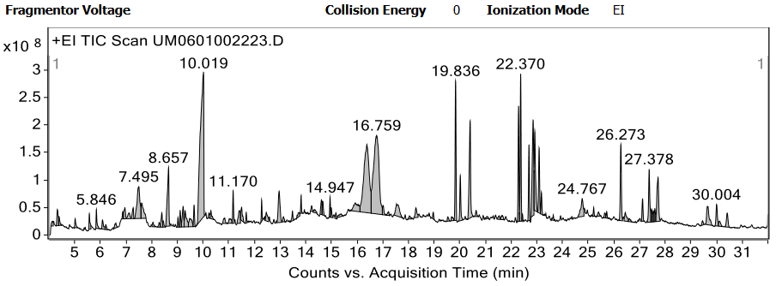
(a)
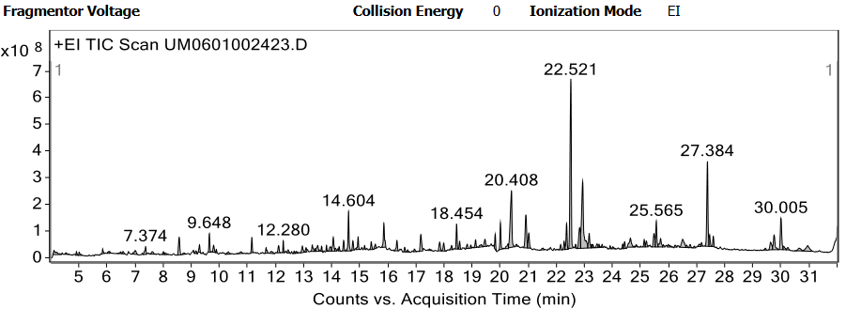
(b)
Fig. (1). (a) Ion-chromatogram of ARRO; (b) Ion-chromatogram of ARLO
  - Allelopathic activity
    - Inhibition of seed germination
The effect of various concentrations of oleoresins on seed germination is shown in Table 5. Seed germination rate decreased with increasing oleoresin concentrations (250–1000 µL/mL). At 1000 µL/mL, ARLO showed 82.00% inhibition and ARRO showed 87.00% inhibition. IC₅₀ values for seed germination were 145.31±40.89 µL/mL (ARLO) and 109.98±22.49 µL/mL (ARRO), indicating ARRO was more potent (Table 2, Fig. 2).
For root length inhibition, ARLO exhibited IC₅₀ = 75.78±13.65 µL/mL and ARRO = 80.86±59.49 µL/mL (Table 3). For shoot length inhibition, IC₅₀ values were 70.87±17.62 µL/mL (ARLO) and 70.91±69.25 µL/mL (ARRO) (Table 4). ARLO showed greater allelopathic activity for root and shoot growth inhibition, while ARRO showed greater seed germination inhibition.
Table 2. IC₅₀ value for seed germination inhibition
S. No. | Sample name | IC₅₀ values (µL/mL) |  |  | Mean IC₅₀ values (µL/mL) ±SD
S. No. | Sample name | I | II | III | Mean IC₅₀ values (µL/mL) ±SD
1 | ARLO | 185.95 | 145.83 | 104.16 | 145.31±40.89
2 | ARRO | 123.96 | 121.95 | 84.03 | 109.98±22.49
Columns I, II, and III represent three independent replicate experiments. ARLO= Asparagus racemosus Willd. Leave oleoresin. ARRO= Asparagus racemosus Willd. Root oleoresin; IC₅₀-half maximal inhibitory concentration
    - Inhibition of root length
The percent root length inhibition for ARLO was recorded as 54.00%, 63.00%, 77.66%, and 93.33% from lowest to highest concentration (250–1000 L/mL), while for ARRO it was 52.00%, 66.33%, 81.33%, and 93.66%, respectively (Table 5). The IC₅₀ for root length inhibition was observed in the following order: ALRO (75.78±13.65 μL/mL) > ARRO (80.86±59.49 μL/mL), indication that ARLO exhibited greater potency for root growth inhibition (Table 3 and Fig.2).
Table 3. IC₅₀ value of root length inhibition
S. No. | Sample name | IC₅₀ values (µL/mL) |  |  | Mean IC₅₀ values (µL/mL) ±SD
S. No. | Sample name | I | II | III | Mean IC₅₀ values (µL/mL) ±SD
1 | ARLO | 89.28 | 76.08 | 61.98 | 75.78±13.65
2 | ARRO | 147.63 | 61.47 | 33.48 | 80.86±59.49
Columns I, II, and III represent three independent replicate experiments. ARLO= Asparagus racemosus Willd. Leave oleoresin; ARRO= Asparagus racemosus Willd. Root oleoresin; IC₅₀-half maximal inhibitory concentration
    - Inhibition of shoot length
The percent shoot length inhibition was calculated when 100% germination was achieved at level of concentrations 250, 500, 750, 1000 μL/mL. In the case of ARLO, the percent inhibition of root length was recorded as 59.00%, 68.00%, 78.66% and 92.00% from lowest to highest concentrations, while in the case of ARRO, the percent inhibition was calculated as 61.00%, 64.66%, 73.00%, and 92.66% respectively, and represented in Table 5. When 100% of the control seeds germinated, the IC₅₀ was computed to assess the relative allelopathic activities of each sample with regard to the inhibition of root growth. The following is the order in which the activity was noticed: ARLO (70.87±17.62 μL/mL) > ARRO (70.91±69.25 μL/mL) (Table 4; Fig.2).
Table 4. IC₅₀ value of shoot length inhibition
S. No. | Sample name | IC₅₀ values (µL/mL) |  |  | Mean IC₅₀ values (µL/mL) ±SD
S. No. | Sample name | I | II | III | Mean IC₅₀ values (µL/mL) ±SD
1 | ARLO | 83.33 | 58.41 | 64.10 | 70.87±17.62
2 | ARRO | 150.46 | 38.26 | 24.03 | 70.91±69.25
Columns I, II, and III represent three independent replicate experiments. ARLO= Asparagus racemosus Willd. Leave oleoresin; ARRO= Asparagus racemosus Willd. Root oleoresin; IC₅₀-half maximal inhibitory concentration.
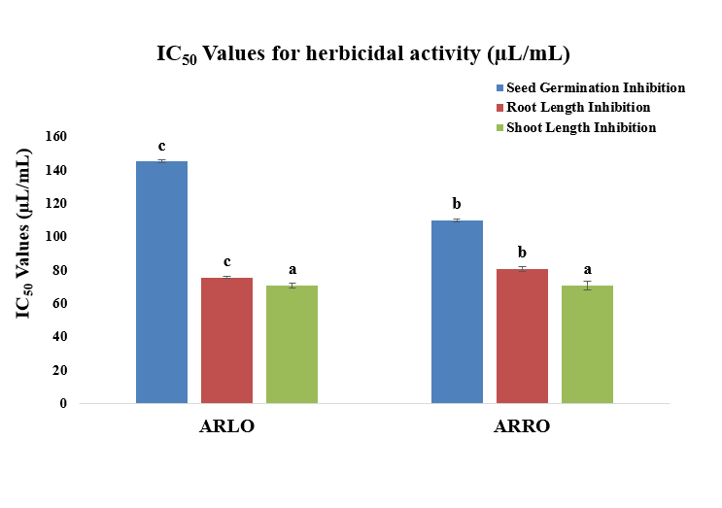
Fig. (2). IC₅₀ values of seed germination, root length and shoot length inhibition of Asparagus racemosus Willd. oleoresin
Table 5. Percent inhibition of seed germination, root length, shoot length of Asparagus racemosus Willd.
S. No. | Sample name | % Inhibition of seed germination |  |  |  | % Inhibition of root length |  |  |  | % Inhibition of shoot length
S. No. | Sample name | 250 µL/mL | 500 µL/mL | 750 µL/mL | 1000 µL/mL | 250 µL/mL | 500 µL/mL | 750 µL/mL | 1000 µL/mL | 250 µL/mL | 500 µL/mL | 750 µL/mL | 1000 µL/mL
1 | ARLO | 58.00±2.00ª | 61.00±1.00^{b} | 65.00±1.00^{c} | 82.00±2.64^{d} | 54.00±2.00 ª | 63.33±1.52^{b} | 77.66±2.51^{c} | 93.33±1.52^{d} | 59.00±1.00 ª | 68.00±1.00^{b} | 78.66±2.51^{c} | 92.00±2.54^{d}
2 | ARRO | 58.33±1.52 ª | 58.66±2.30^{b} | 66.66±2.51^{c} | 87.00±2.64^{d} | 52.00±1.00 ª | 66.33±0.57 ^{b} | 81.33±0.57 ^{c} | 93.66±1.52^{d} | 61.00±2.64 ª | 64.66±2.51^{b} | 73.00±2.00^{c} | 92.66±2.08 ^{d}
3 | Pendimethalin* | 100 ± 0.0 | 100 ± 0.0 | 100 ± 0.0 | 100 ± 0.0 | 100 ± 0.0 | 100 ± 0.0 | 100 ± 0.0 ^{c} | 100 ± 0.0 | 100 ± 0.0 | 100 ± 0.0 | 100 ± 0.0 | 100 ± 0.0
*Positive control (synthetic herbicide); ARLO= Asparagus racemosus Willd. Leave oleoresin ARRO= Asparagus racemosus Willd. Root oleoresin. Values in the same row followed by different superscript letters are significantly different at p<0.05 according of Duncan’s multiple range test.
4. Discussion
The chemical composition of A. racemosus oleoresins revealed distinct organ-specific profiles. Phytol (13.33%) was the predominant compound in leaves, while 5-hydroxymethylfurfural (13.16%) dominated in roots. Phytol is known to possess allelopathic properties, inhibiting seed germination and seedling growth in various plant species [17]. Similarly, 5-hydroxymethylfurfural has been reported to exhibit phytotoxic effects [18]. The presence of these compounds likely contributes to the observed allelopathic activity.
Comparison with previous studies: The IC₅₀ values observed in this study (70–145 µL/mL) are comparable to those reported for other medicinal plant extracts against radish seeds. For example, Mikania micrantha leaf extract showed similar inhibition patterns [15]. The higher potency of ARRO for seed germination inhibition may be attributed to its higher content of 5-hydroxymethylfurfural and furoic acid derivatives.
Radish (Raphanus sativus) is widely used as a model bioindicator in allelopathic studies due to its rapid germination (24–48 hours), uniform growth, and high sensitivity to phytotoxic compounds [15]. While radish is not a typical agricultural weed, its use allows standardized comparison with existing literature.
Limitations: The authors acknowledge that plant material was collected from a single geographical location, limiting generalizability. The study was conducted under controlled laboratory conditions; field trials are needed to validate practical applicability. Additionally, the active compounds have not been individually isolated and tested for synergistic effects.
These findings align with previous reports of allelopathic properties in Asparagaceae species and support further investigation of A. racemosus oleoresins as natural weed management agents.
5. CONCLUSION
A. racemosus oleoresins exhibited significant organ-specific chemical profiles and promising allelopathic activity against radish seeds. ARRO showed greater seed germination inhibition, while ARLO was more effective against root and shoot growth. Phytol and 5-hydroxymethylfurfural were identified as major bioactive constituents. Further studies are needed to isolate individual compounds, evaluate field efficacy against weeds, and elucidate the mode of action before A. racemosus oleoresins can be developed as natural bioherbicides.
LIST OF ABBREVATIONS
ARLO | : Asparagus racemosus leaf oleoresin
ARRO | : Asparagus racemosus root oleoresin
GC-MS | : Gas chromatography-mass spectrometry
IC₅₀ | : Half maximal inhibitory concentration
NIST | : National Institute of Standards and Technology
SD | : Standard deviation
Disclaimer (Artificial intelligence)
Author(s) hereby declare that NO generative AI technologies such as Large Language Models (ChatGPT, COPILOT, etc.) and text-to-image generators have been used during the writing or editing of this manuscript.

REFERENCES
- Angiosperm Phylogeny Group III. An update of the Angiosperm Phylogeny Group classification for the orders and families of flowering plants: APG III”. Bot. J. Linn. Soc., 2009, 161 (2), 105–121. https://doi.org/10.1111/j.1095-8339.2009.00999.x
- Arya S; Kumar R; Prakash O; Kumar S; Mahawer SK; Chamoli S; de Oliveira MS. Chemical composition and biological activities of Hedychium coccineum Buch.-Ham. ex Sm. essential oils from Kumaun hills of Uttarakhand. Molecules, 2022, 27(15), 4833. https://doi.org/10.3390/molecules27154833
- Negi JS; Singh P; Joshi G.P; Rawat M.S; Bisht V.K. Chemical constituents of Asparagus. Pharmacog., 2004, Vol 4, Issue 8. https://doi.org/10.4103%2F0973-7847.70921
- Arya S; Mahawer S.K; Karakoti H; Kumar R; Prakash O; Kumar S; Rawat D.S. Study of the Variability of the Chemical Profile, and Biological Activity Approaches of Hedychium coronarium J. Koenig Essential Oil from Different Habitats of Uttarakhand, India. J. Food Qual., 2023. https://doi.org/10.1155/2023/7335134
- Gogte V.M. Ayurvedic pharmacology and therapeutic uses of medicinal plants. Mumbai: SPARC, 2000.
- Singh J; Tiwari H. Chemical examination of roots of Asparagus racemosus. J Indian Chem Soc. 1991, 68, 427428.
- Clifford H.G. "Asparagus racemosus". Flora of Australia. Canberra: Australian Biological Resources Study, Department of Agriculture. Water and the Environment. 2020. https://doi.org/10.3390/horticulturae8050439
- Hayes PY. Structural clarification with the isolation of Shatavarin V. A new steroidal saponin from the root of A. racemosus. Tetrahedron Lett. 2006; 47(49):8683-8687. https://doi.org/10.1016/j.tetlet.2006.10.030
- Michael F; Fay Mark W; Chase Nina Rønsted; Dion S; Devey Yohan Pillon J; Chris Pires; Gitte Peterson; Ole Seber; Jerrold I. Davis. Phylogenetic of liliales: summarized evidence from combined analysis of five plastid and one mitochondrial loci Alis. 2006, 22, 559-565.
- Kirtikar K.R; Basu B.D. Indian Medicinal Plants. In: Singh B, Singh MP, editors. Dehradun, India: New Connaught Place. 1984, 2499.
- Shashi Alok; Sanjay Kumar Jain; Amita Verma; Mayank Kumar; Alok Mahor; Monika Sabharwal. Plant profile, phytochemistry and pharmacology of Asparagus racemosus (Shatavari) Asian Pacific J. Trop. Dis. 2013, 242-251. https://doi.org/10.1016/S2222-1808(13)60049-3
- Goyal R.K; Singh J; Lal H. Asparagus racemosus- An update. Ind. J. Med. Sci. 2003. 57, 408- 414.
- Hussain A; Ahmad M.P; Wahab S; Sarfaraj Hussain M; Ali M. A Review on Pharmacological and Phytochemical Profile of Asparagus racemosus Wild. 2002.
- Adams R.P. Identification of essential oil components by gas chromatography/mass spectrometry (Vol.456). Carol stream, IL: Allured Publishing Corporation. 2007.
- Sahu and Devkota. Allelopathic effects of Aqueous extract of leaves of mikania micrantha h.b.k on seed germination and seedling growth of Oryza sativa L. and Raphanus sativus L. scientific world, 2013, Vol. 11, No. 11.
- Battu, G. R., & Kumar, B. M. (2010). Phytochemical and antimicrobial activity of leaf extract of Asparagus racemosus Willd. Pharmacognosy Journal, 2(12), 456-463.
- Poonpaiboonpipat, T., et al. (2013). Allelopathic activity of phytol. Weed Biology and Management, 13(2), 67-75.
- Chon, S. U., et al. (2006). Phytotoxic compounds in Artemisia princeps. Journal of Chemical Ecology, 32(4), 877-891.

