Comparative Phytochemical Allelopathic Activity of Leaf and Flower Oleoresin from Adhatoda vasica L.

Abstract
The Acanthaceae family includes several medicinally important species, notably Adhatoda vasica, which is widely used in traditional medicine for respiratory and inflammatory disorders due to its rich phytochemical profile. The study presents a comparative phytochemical and allelopathic analysis of leaf (AVLO) and flower (AVFO) oleoresins from Adhatoda vasica L. (Acanthaceae), a widely utilized medicinal plant. Methanolic extracts were prepared via cold percolation and characterized using gas chromatography–mass spectrometry (GC–MS). A total of forty-nine phytoconstituents were identified, representing 80.43% of the total peak area in AVLO, and 82.22% in AVFO. The major identified compounds included antipyrine (30.91%) in AVLO, while 5-hydroxymethylfurfural (24.24%) in AVFO. However, the presence of certain compounds (e.g., clindamycin, antipyrine) requires confirmation through co-injection with authentic standards or alternative analytical methods, as these may arise from library matching errors or contamination. The allelopathic potential of both oleoresins was evaluated through seed germination bioassays against Raphanus raphanistrum subsp. sativus, revealing significant, dose-dependent inhibition. IC₅₀ values for seed germination (AVLO: 140.81±24.19 µL/mL; AVFO: 154.79±14.48 µL/mL), root length, and shoot length confirmed notable phytotoxic activity, with AVLO exhibiting marginally greater potency for seed germination inhibition, whereas AVFO showed greater potency for root and shoot length inhibition. These findings underscore the potential of A. vasica oleoresins as natural bioherbicides, though further validation through compound isolation, field trials, and toxicological assessments is required before practical application.
Keywords: Adhatoda vasica L., Oleoresin, Phytochemical analysis, Allelopathic activity, Antipyrine
INTRODUCTION
The Acanthaceae family, commonly known as the acanthus family, is one of the largest families among dicotyledonous angiosperms. It is renowned for the extensive variety of plants it contains with medicinal, aromatic, culinary, and ornamental properties. The family encompasses 250 genera and 2,500 species found across the globe, with a significant presence in Africa, Brazil, Indonesia, and Malaysia [1]. The genus Justicia is part of the Acanthaceae family and comprises over 600 species distributed in both hemispheres, ranging from tropical to temperate areas. Justicia species are frequently employed in the treatment of various ailments [2]. Adhatoda vasica L., belonging to the Acanthaceae family, is commonly known as Adosa, Vasaka, or Malabar Nut. This plant has a multitude of uses in traditional Ayurveda and is particularly renowned for its effectiveness in treating respiratory conditions, and is a shrub utilized by Asian and European medical practitioners [3,4]. The plant is utilized in numerous ancient medical systems, including Ayurveda, Siddha, and Unani, for treating respiratory ailments, cough, asthma, bronchitis, and as an expectorant. It has also been used to treat other diseases and conditions, including respiratory problems [5,6]. Adhatoda vasica L. contains a rich array of bioactive constituents such as alkaloids (vasicine, vasicinone), flavonoids, phenolics, and essential oils, that contribute to its therapeutic properties [7-9]. The roots of Adhatoda vasica have yielded a novel alkaloid identified as 9-acetamido-3,4-dihydropyrido-(3,4-b)-indole, and a galactoside known as o-ethyl-α-D-galactoside[17]. Furthermore, from the roots of this plant, sitosterol β-D-glucoside, D-galactose, and deoxyvasicinone have also been extracted [10,11]. Recent studies have highlighted the pharmacological potential of Adhatoda vasica extracts for various therapeutic applications, including antimicrobial and anti-inflammatory activities [14].
Plant-derived bioherbicides have gained significant attention as eco-friendly alternatives to synthetic herbicides for sustainable weed management [16,17]. Although the oleoresin derived from different plant parts has gained attention for potential therapeutic applications, a comprehensive comparative investigation of the phytochemical composition and allelopathic activity of leaf and flower oleoresins from Adhatoda vasica is currently lacking. Therefore, the present study aims to fill this research gap by comparatively analyzing the chemical profiles and herbicidal potential of these oleoresins. However, it is important to note that compound identification via GC-MS library matching alone requires confirmation through authentic standards or alternative methods.
AIMS AND OBJECTIVES
The present study aims to fill this research gap by comparatively analyzing the chemical profiles and allelopathic potential of leaf and flower oleoresins from Adhatoda vasica L. The specific objectives were:
- To extract and compare the phytochemical composition of leaf (AVLO) and flower (AVFO) oleoresins using GC-MS analysis.
- To evaluate the allelopathic activity of both oleoresins against radish (Raphanus raphanistrum subsp. sativus) seeds.
- To determine IC₅₀ values for seed germination, root length, and shoot length inhibition.
- To identify the major bioactive constituents responsible for the observed allelopathic activity.
MATERIAL AND METHOD
Collection of plant material
The leaves and flowers of Adhatoda vasica L. were collected from Raja Road, Dehradun, (Latitude 30°22.8175' N and Longitude 77°53.5037' E). The collection site was situated at an altitude of 648 m above sea level in the Garhwal region of Uttarakhand.
Oleoresin preparation
Fresh leaves and flowers of Adhatoda vasica L. plant were collected, dried, and ground into a coarse powder. Extraction was performed using cold percolation method with methanol as a solvent, the powdered leaves and flowers were extracted. A rotary evaporator was used to filter and condense the resultant extract. The extracts were stored at 4°C for further chemical analysis and biological activity evaluation. The yield percentages were 4.2% (w/w) for AVLO and 3.8% (w/w) for AVFO.
GC-MS analysis
The phytochemical analysis of AVLO and AVFO was analyzed using a GCMS-QP 2010 Plus system. The GC was equipped with a DB-5 capillary column (30 m × 0.25 mm, 0.25 µm film thickness). Helium was used as the carrier gas at a constant flow rate of 1.21 mL/min. The injection volume was 1 µL with a split ratio of 22:1. The oven temperature program was as follows: initial temperature 50°C (held for 2 min), increased to 210°C at a rate of 6°C/min, and held for 11 min. The injector and ion source temperatures were set at 60°C and 200°C, respectively. Mass spectra were recorded at 70 eV with a scan range of 40–600 m/z. Compounds were identified by comparing their mass spectra and retention indices with those in the NIST and Wiley libraries [12]. The authors acknowledge that identification based solely on library matching is preliminary; confirmation via co-injection with authentic standards is recommended for future studies.
Allelopathic bioassay
The herbicidal activity of AVLO and AVFO was assessed at various concentrations (250 to 1000 uL/mL) against hybrid radish (Raphanus raphanistrum sub sp. Sativus) seeds. The evaluation was conducted using a method developed by Sahu and Devkota [13]. The oleoresins were diluted in 1% Tween-20 aqueous solution to achieve final concentrations of 250, 500, 750, and 1000 µL/mL. Since the oleoresins were viscous, concentrations are expressed as volume/volume (µL/mL) for practical reproducibility. The seeds were surface sterilized in 5% sodium hypochlorite solution for a duration of 15 minutes. Three replicates of seven sterilized seeds were placed in each petri dish lined with filter paper. Then, 4 mL of each concentration was added, and seeds were germinated at 25±1°C for 7 days. Distilled water with 1% Tween-20 served as negative control, and pendimethalin (1000 µL/mL) was used as a positive control. The percentage inhibition was calculated as:
% Inhibition =100 × (1- St/Sc)
Where,
St – no. of seeds germinates in treatment,
Sc – no. of seeds germinates in control

Statistical Analysis
All experiments were performed in triplicate, and results were expressed as mean± standard deviation. Data were analyzed using one-way analysis of variance (ANOVA) followed by Duncan's multiple range test (DMRT) at p < 0.05 significance level using SPSS software version 20.0 (IBM Corp., USA). IC₅₀ values were calculated using regression analysis in Microsoft Excel 2016.
RESULT
Chemical composition variability of AVLO and AVFO
The phytoconstituents present in AVLO and AVFO are presented in Table 1. Twenty-five and thirty components were identified in AVLO and AVFO, contributing to 80.43% and 82.22% of the total peak area, respectively. In AVLO, major constituents (≥3%) included antipyrine (30.91%), vitamin E (9.39%), linolenic acid (5.36%), phytol (4.38%), silane (3.95%), diethylbutoxypentyloxy (3.26%), and n-hexadecanoic acid (3.24%). In AVFO, major constituents included 5-hydroxymethylfurfural (24.24%), 1-(8-methylimidazo[1,2-a]pyridin-2-ylmethyl)-1,2,3,4-tetrahydroquinoline (6.53%), n-hexadecanoic acid (4.93%), 1-methyl-5-fluorouracil (4.89%), 1,2-bis(diethylamino)-1,2-bis(4-cyanophenyl)ethane (4.58%), p-butylphenol (3.94%), and phenol (3.63%). The ion-chromatograms are shown in Fig. 1.
Table 1: Comparative chemical composition of AVLO and AVFO
S. No | Compound identified | % Composition
S. No | Compound identified | AVLO | AVFO
 | α-Amyrin | 1.74 | _
 | β-Amyrin | 0.87 | _
 | Andrographolide | 0.66 | _
 | Antipyrine | 30.91 | _
 | Benzenemethanol | _ | 1.28
 | Benzenesulfonamide | 0.86 | _
 | Benzofuran | 0.65 | _
 | Benzoic acid | _ | 0.9
 | 1,2-Bis(diethylamino)- 1,2-bis(4-cyanophenyl) ethane | _ | 4.58
 | p-Butylphenol | _ | 3.94
 | Campesterol | 0.79 | _
 | Clindamycin | _ | 1.23
 | Dasycarpidan | _ | 0.82
 | Diethylbutoxypentyloxy | 3.26 | _
 | 2,4-Dihydroxy-2,5-dimethyl-3(2H)-furan-3-one | _ | 1.26
 | 2,6-Dimethoxy | _ | 0.76
 | 2,4-Di-tertbutylphenol | _ | 0.76
 | 5-Ethenyl-2-methoxy | _ | 1.29
 | 2-Furancarboxaldehyde | _ | 1.42
 | 2-Furancarboxylic acid | _ | 0.9
 | 2-Hexadecen-1-ol | 1.68 | _
 | n-Hexadecanoic acid | 3.24 | 4.93
 | Hydroxymaltol | _ | 2.89
 | 5-Hydroxymethylfurfural | 2.61 | 24.24
 | 5-Methylbenzimidazole | 1.32 | _
 | 5-Methyl-4-hexene-1yl acetate | _ | 0.86
 | 3-Hydroxy-4-decenoic acid, 9-  (tetrahydropyran-2yl) oxy-, 2-  (trimethylsilyl)ethyl | _ | 0.75
 | p-Isobutyl | 0.72 | _
 | Linolenic acid | 5.36 | _
 | Malonylurea | _ | 1.97
 | Megastigmatrienone | 1.18 | _
 | Megastigmatrienone | 0.64 | _
 | Methyl ester | 1.56 | 1.2
 | 1-Methyl-5-fluorouracil | _ | 4.89
 | 1-Methyl-transdecahydroquinol | _ | 0.86
 | 1-(8-Methylimidazo[1,2-a] pyridine-2-yl methyl)-1,2,3,4-tetrahydroquinoline | _ | 6.53
 | 3-(2-Methoxy-5-methylphenyl)acrylic acid | 0.67 | _
 | α-Monostearin | _ | 1.67
 | Octadecanoic acid | 1.45 | 1.4
 | Oleic Acid | _ | 1.67
 | Palmitin | _ | 2.42
 | Phenol | 1.07 | 3.63
 | Phytol | 4.38 | _
 | Pyrrolidine-5-one | _ | 0.91
 | Quinazoline | _ | 1.26
 | Silane | 3.95 | _
 | Stigmasterol | 0.85 | 1.00
 | Vasicione | 0.62 | _
 | Vitamin E | 9.39 | _
 | Total (%) | 80.43 | 82.22
AVLO= Adhatoda vasica L. Leaf oleoresin; AVFO= Adhatoda vasica L. Flower oleoresin; - = not determined [12].

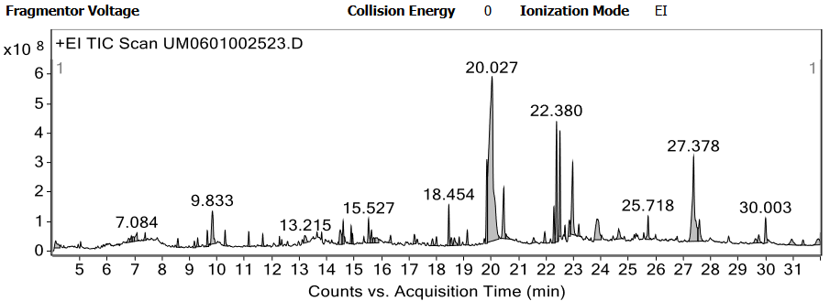
(a)

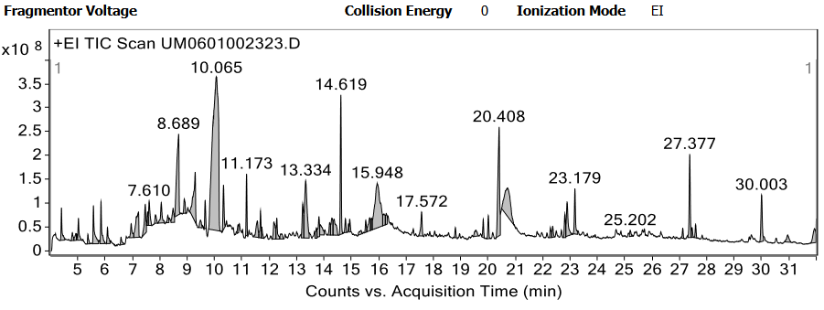
(b)
Figure 1: (a) Ion-chromatogram of AVLO; (b) Ion-chromatogram of AVFO.
Allelopathic activity
Seed germination inhibition
The mean percent seed germination inhibition is presented in Table 5. At 1000 µL/mL, AVLO showed 95.66% inhibition and AVFO showed 95.00% inhibition. IC₅₀ values were 140.81±24.19 µL/mL (AVLO) and 154.79±14.48 µL/mL (AVFO), indicating AVLO was more potent for seed germination inhibition (Table 2, Fig. 2).
Table 2.: IC₅₀ value of inhibition of seed germination of AVLO and AVFO
S. No. | Sample name | IC₅₀ values (µL/mL) |  |  | Mean IC₅₀ values (µL/mL) ±SD
S. No. | Sample name | I | II | III | Mean IC₅₀ values (µL/mL) ±SD
1 | AVLO | 160.0 | 113.63 | 148.80 | 140.81±24.19
2 | AVFO | 144.6 | 148.4 | 171.37 | 154.79±14.48
Columns I, II, and III represent three independent replicate experiments. Leaf oleoresin; AVFO= Adhatoda vasica L. Flower oleoresin; IC₅₀-half maximal inhibitory concentration.
Root length inhibition
Percent root length inhibition for AVLO was 55.33%, 68.66%, 75.66%, and 93.00% from 250–1000 µL/mL; for AVFO it was 55.00%, 74.66%, 77.22%, and 96.22% (Table 5). IC₅₀ values were 140.97±25.26 µL/mL (AVLO) and 96.47±15.15 µL/mL (AVFO), indicating AVFO was more potent for root growth inhibition (Table 3, Fig. 2).
Table 3: IC₅₀ value of inhibition of root length of AVLO and AVFO
S. No. | Sample name | IC₅₀ values (µL/mL) |  |  | Mean IC₅₀ values (µL/mL) ±SD
S. No. | Sample name | I | II | III | Mean IC₅₀ values (µL/mL) ±SD
1 | AVLO | 145.83 | 113.63 | 163.46 | 140.97±25.26
2 | AVFO | 99.66 | 79.78 | 109.79 | 96.47±15.15
Columns I, II, and III represent three independent replicate experiments. AVLO= Adhatoda vasica L. Leaf oleoresin; AVFO= Adhatoda vasica L. Flower oleoresin; IC₅₀- half maximal inhibitory concentration.
Shoot length inhibition
Percent shoot length inhibition for AVLO was 57.66%, 64.00%, 80.66%, and 91.66% from 250–1000 µL/mL; for AVFO it was 58.00%, 65.66%, 86.00%, and 95.00% (Table 5). IC₅₀ values were 129.83±25.64 µL/mL (AVLO) and 125.89±30.67 µL/mL (AVFO), indicating AVFO exhibited marginally greater potency for shoot growth inhibition (Table 4, Fig. 2). Table 4: IC₅₀ value of inhibition of shoot length of AVLO and AVFO
S. No. | Sample name | IC₅₀ values (µL/mL) in triplicates |  |  | Mean IC₅₀ values (µL/mL) ±SD
S. No. | Sample name | I | II | III | Mean IC₅₀ values (µL/mL) ±SD
1 | AVLO | 156.25 | 105.04 | 128.20 | 129.83±25.64
2 | AVFO | 139.92 | 90.72 | 147.05 | 125.89±30.67
Columns I, II, and III represent three independent replicate experiments. AVLO= Adhatoda vasica L. Leaf oleoresin; AVFO= Adhatoda vasica L. Flower oleoresin; IC₅₀-half maximal inhibitory concentration.
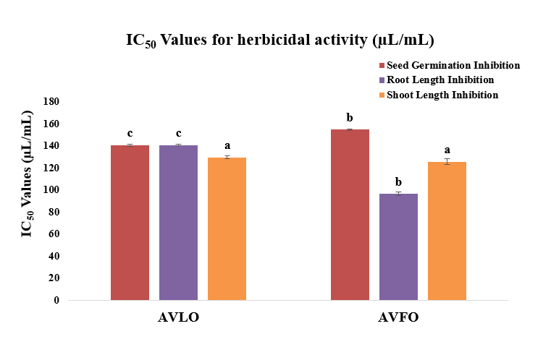
Figure 2: IC₅₀ values of seed germination, root length, shoot length inhibition
Table 5: Percent inhibition of seed germination, root length, shoot length of Adhatoda vasica L.
S. No. | Sample | % Inhibition of seed germination |  |  |  | % Inhibition of root length |  |  |  | % Inhibition of shoot length
S. No. | Sample | 250 µL/mL | 500 µL/mL | 750 µL/mL | 1000 µL/mL | 250 µL/mL | 500 µL/mL | 750 µL/mL | 1000 µL/mL | 250 µL/mL | 500 µL/mL | 750 µL/mL | 1000 µL/mL
1 | AVLO | 56.66±1.15ª | 68.33±1.52^{b} | 75.33±1.52^{c} | 95.66±1.15^{d} | 55.33±1.15 ª | 68.66±1.52 ^{b} | 75.66±1.52 ^{c} | 93.00±2.00 ^{d} | 57.66±1.15 ª | 64.00±1.73 ^{b} | 80.66±1.15 ^{c} | 91.66±1.15 ^{d}
2 | AVFO | 55.66±1.15 ª | 67.00±1.00 ^{b} | 75.66±1.52 ^{c} | 95.00±1.73^{d} | 55.00±1.00 | 74.66±1.52 ^{b} | 77.22±2.30 ^{c} | 96.22±1.54 ^{d} | 58.00±1.00 ª | 65.66±1.15 ^{b} | 86.00±1.00 ^{c} | 95.00±1.00 ^{d}
3 | Pendimethalin* | 100 ± 0.0 | 100 ± 0.0 | 100 ± 0.0 | 100 ± 0.0 | 100 ± 0.0 | 100 ± 0.0 | 100 ± 0.0 | 100 ± 0.0 | 100 ± 0.0 | 100 ± 0.0 | 100 ± 0.0 | 100 ± 0.0
*Standard herbicide= Pendimethalin; AVLO= Adhatoda vasica L. Leaf oleoresin; AVFO= Adhatoda vasica L. Flower oleoresin. Values in the same row followed by different superscript letters are significantly different at p<0.05 according to Ducan’s multiple range test.
Discussion
The chemical composition of A. vasica oleoresins revealed distinct organ-specific profiles. Antipyrine (30.91%) was the predominant compound in leaves, while 5-hydroxymethylfurfural (24.24%) dominated in flowers. However, the identification of certain compounds requires critical evaluation [15]. Antipyrine is a synthetic pyrazolone derivative used as an analgesic and antipyretic in human medicine; its natural occurrence in Adhatoda vasica has not been previously reported and is questionable. Similarly, clindamycin is a semisynthetic antibiotic not known to be produced by plants. The presence of these compounds in GC-MS analysis may be attributed to: (1) library matching errors where structurally similar natural compounds (e.g., vasicine, vasicinone) produce comparable mass spectra; (2) contamination during extraction or analysis; or (3) misidentification due to insufficient validation. Therefore, these identifications should be considered tentative until confirmed by co-injection with authentic standards or alternative analytical methods such as HPLC-MS.
Comparison with previous studies: The IC₅₀ values observed (96–155 µL/mL) are comparable to those reported for other medicinal plant extracts [13,16]]. The higher potency of AVFO for root and shoot inhibition may be attributed to its higher content of 5-hydroxymethylfurfural (24.24%), which is known to exhibit phytotoxic effects, along with phenolic compounds (phenol 3.63%, p-butylphenol 3.94%). Conversely, AVLO's superior seed germination inhibition may be due to antipyrine (30.91%), linolenic acid (5.36%), and vitamin E (9.39%), though the natural origin of antipyrine requires further investigation.
Future directions: Future studies should focus on: (1) confirmation of compound identities using authentic standards or HPLC-MS; (2) isolation of individual bioactive compounds; (3) field efficacy trials against weeds; (4) toxicological assessments for environmental safety; and (5) formulation development.
SUMMARY
The present study successfully demonstrated the comparative phytochemical composition and allelopathic activity of leaf and flower oleoresins from Adhatoda vasica L. A total of forty-nine phytoconstituents were identified, with antipyrine (30.91%) as the major compound in AVLO and 5-hydroxymethylfurfural (24.24%) in AVFO. Both oleoresins exhibited significant dose-dependent inhibition of seed germination, root length, and shoot length in radish bioassays. AVLO showed greater potency for seed germination inhibition (IC₅₀ = 140.81±24.19 µL/mL), while AVFO was more effective for root (IC₅₀ = 96.47±15.15 µL/mL) and shoot (IC₅₀ = 125.89±30.67 µL/mL) growth inhibition. However, compound identifications (particularly antipyrine and clindamycin) require confirmation via authentic standards [15].
CONCLUSION
Adhatoda vasica oleoresins exhibited significant organ-specific chemical profiles and promising allelopathic activity against radish seeds. AVLO showed greater seed germination inhibition, while AVFO was more effective against root and shoot growth. However, compound identifications (particularly antipyrine and clindamycin) require confirmation via authentic standards. Further studies are needed to isolate individual compounds, validate field efficacy against weeds, elucidate the mode of action, and conduct toxicological assessments before A. vasica oleoresins can be developed as natural bioherbicides.

LIST OF ABBREVATIONS
AVLO | : Adhatoda vasica leaf oleoresin
AVFO | : Adhatoda vasica flower oleoresin
GC-MS | : Gas chromatography-mass spectrometry
IC₅₀ | : Half maximal inhibitory concentration
NIST | : National Institute of Standards and Technology
SD | : Standard deviation  Disclaimer (Artificial intelligence)  Author(s) hereby declare that NO generative AI technologies such as Large Language Models (ChatGPT, COPILOT, etc.) and text-to-image generators have been used during the writing or editing of this manuscript.
REFERENCES
- Zhenghao Xu, Le Chang. "Acanthaceae." Identification and Control of Common Weeds: Singapore: Springer Singapore 2017;3: 329-338.
- Claeson UP, Malmfors T, Wikman G, Bruhn J.G. Adhatoda vasica: a critical review of ethnopharmacological and toxicological data. J Ethnopharm 2000; 72:1.
- Bhargava MK, Singh H, Kumar A. Evaluation of Adhatoda vasica as a wound healing agent in buffaloes. Clinical, mechanical and biochemical studies. Ind Veterin J 1988; 65(1):33.
- Kumar M, Dandapat S, Kumar A, Sinha MP, Anti-typhoid activity of Adhatoda vasica and Vitex negundo Persian Gulf Crop Protection 2013; 2(3): 64-75.
- Dhar KL, Jain MP, Koul SK, Atal CK. Vasicol, a new alkaloid from Adhatoda vasica. Phytochem 1981; 20(2): 319.
- Arya S, Kumar R, Prakash O, Kumar S, Mahawer SK, Chamoli S, de Oliveira MS. Chemical composition and biological activities of Hedychium coccineum Buch.-Ham. ex Sm. essential oils from Kumaun hills of Uttarakhand. Molecules 2022; 27(15): 4833.
- Rabia Khan, Yasmeen Shamsi. Medicinal benefits of Adhatoda vasica Nees.-In Unani and Contemporary Medicine 2020.
- Amin AH, Mehta DR. A bronchodilator alkaloid (vasicinone) from Adhatoda vasica Nees. Nature 1959; 184:1317.
- Arya S, Mahawer SK, Karakoti H, Kumar R, Prakash O, Kumar S, Rawat DS. Study of the Variability of the Chemical Profile, and Biological Activity Approaches of Hedychium coronarium J. Koenig Essential Oil from Different Habitats of Uttarakhand, India. J Food Quality 2023.
- Jain MP, Sharma VK, Phytochemical investigation of roots of Adhatoda vasica. Planta Medica 1982; 46: 250.
- Shinwari ZK, Shah M. The Ethnobotany of Kharan district, Balochistan, Pakistan. Proc Sym Med Pl 1995; 12: 35-38.
- Adams RP. Identification of essential oil components by gas chromatography/mass spectrometry. Carol stream, IL: Allured Publishing Corporation. 2007; 456.
- Sahu and Devkota. Allelopathic effects of Aqueous extract of leaves of mikania micrantha on seed germination and seedling growth of Oryza sativa L. and Raphanus sativus L. scientific world 2013;11.
- Ambreen Shoaib. A systematic ethnobotanical review of Adhatoda vasica (L.), Nees Cell Mol Biol (Noisy-le-grand) 2022; 2: 67(4): 248-263.
- Sumner LW, Amberg A, Barrett D, et al. Proposed minimum reporting standards for chemical analysis. Metabolomics. 2020;16(6):1-8.
- Dayan FE, Duke SO. Natural compounds as next-generation herbicides. Plant Physiology. 2020;184(3):1139-1152.
- Macías FA, Mejías FJR, Molinillo JMG. Recent advances in allelopathy for weed control. Pest Management Science. 2021;77(8):3567-3582.

