Original Research Article
Development and Application of an Efficient Bacterial Liquid Inoculum for Composting of Organic Kitchen Waste

Abstract
The growing population along with urbanization have resulted in a rapid rise in the generation of organic waste. Neglecting the proper treatment of this waste would cause pollution and pose health risks. Households, restaurants, canteens and hotel waste constitute kitchen waste. Every day our growing cities generate more and more waste, which is overloading our municipal systems. Kitchen waste contains a high proportion of biodegradable organic material and therefore, microorganisms can play an important role in its degradation. So, a study was conducted to develop an efficient bacterial liquid inoculum for the composting of organic kitchen waste. The Liquid microbial inoculum is capable of coexisting and bringing out effective degradation of organic waste. The biological treatment of kitchen waste appears to be the most cost effective and carrier less negative environmental impact. Composting at home can be used as a sound method of kitchen waste management and the waste can be managed at the source itself and there by recycled. The microbial inoculum showed significant outcome for composting parameters such as Moisture content, Temperature, pH, Organic Carbon, Nitrogen, C:N ratio, Phosphate, Potash, Bulk density, Electric conductivity and Heavy metal analysis. The results show that the created microbial inoculum needs less time to produce compost that contains high nutrients than standard composting methods. The importance of this study exists because it offers a budget-friendly and sustainable method to handle kitchen waste that operates independently from centralized systems. The system decreases municipal waste system demands while it transforms organic waste into useful compost which helps advance sustainable waste management solutions and circular economy practices.
Key Words: Organic Waste management, Kitchen Waste, Microorganism, Liquid inoculum, Composting
1. Introduction
In developing nations, the most critical environmental and health issue facing many urban areas is the subpar management of solid waste. As cities expand and populations grow, the amount of waste generated in urban regions increases. Waste collection systems, which are often inefficient, typically serve only a portion of the urban area, resulting in garbage being discarded on streets and in unregulated dumping grounds. Organic materials constitute up to 70% of Municipal Solid Waste (MSW) in developing countries (Voegeli, Y., & Zurbrugg, C. 2008).
The Supreme Court in India has mandated the composting of biodegradable waste, following the recommendations of the Burman Committee report from 1999 and the subsequent MSW handling rules established in 2000 (CPCB, 2002). The breakdown efficiency of organic materials in a typical solid waste stream is largely influenced by microbial activity. Microorganisms facilitate the decomposition of organic substances by utilizing various substrate-specific hydrolytic enzymes. During the composting process, these enzymes, produced by the microorganisms, decompose numerous complex organic compounds, ultimately resulting in the formation of simple, water-soluble compounds (Benitez et al., 1999). This continuous process reduces organic materials into smaller volumes (Raut et al., 2008) and occurs under natural or controlled conditions, where microbial activity decomposes organic matter into compost (Giglotti et al., 2005).
Composting is an aerobic, biochemical, and microbial activity which is illustrated as the breakdown of organic material to a secure and sterilized residue referred to as humus (Wei et al., 2017). Microbes carry out the decomposition of kitchen waste in the process, taking carbon and nitrogen as energy sources, alongside oxygen and water, leading to the generation of water, carbon dioxide, heat, and nutrient-rich compost. A very high amount of biologically stable humic substances is present in the compost and they are an excellent soil amendment (Bialobrzewski et al., 2015). The rising temperature during composting acts as a natural barrier and thus eradicates the pathogens, thereby making the compost safer for application. It is a good practice to compost at home as it provides easy access to the waste and makes it possible to recycle it instantly thereby managing it at the source.
The purpose of this research was to determine the composition of compost and its quality, using a 1% liquid microbial inoculum in the kitchen waste composting process. The variables that were analyzed included temperature, moisture content, pH level, carbon and nitrogen levels, C:N ratio, and heavy metal content to find out the extent to which microbial inoculation can contribute to the composting process and quality of the final product.
2. Material and Methods
2.1 Sample collection of kitchen waste:
Kitchen waste collection throughout various residential districts of Surat Gujarat India. The collected waste mainly consisted of vegetable peels, fruit residues, cooked food waste, and other biodegradable materials. Non-biodegradable components such as plastics, metals, and glass were manually removed to ensure sample purity.
The collected waste required washing for cleaning but underwent mechanical shredding to produce smaller particles of approximately 2-4 millimeters which would enhance microbial access to the material. The size reduction process makes it easier for microorganisms to reach the material which accelerates decomposition according to the findings of Manu et al. (2019). The processed waste needed to be stored in controlled conditions before the analysis and composting experiments could begin.
2.2 Analysis of kitchen waste:
The first study of kitchen waste showed its potential to be transformed into compost material. The following physicochemical parameters were analyzed using standard methods:
- Moisture Content: Determined by oven-drying the sample at 65°C until constant weight.
- pH and Electrical Conductivity (EC): Measured using a pH meter and conductivity meter with a 1:5 (w/v) waste-to-distilled water extract.
- Bulk Density: Determined through the evaluation of mass waste which occupied specific volume space.
- Total Organic Matter and Carbon: Estimated by loss-on-ignition method at 650–700°C.
- Total Nitrogen: Determined using the Kjeldahl method.
- C:N Ratio: Calculates from total carbon and nitrogen values.
- Phosphate and Potash: Estimated through gravimetric and flame photometric methods.
- Particle Size: Determined through sieve analysis.
The spectrophotometric techniques used to measure E4/E6 ratio humification index at 465 nm and 665 nm according to Duchaufour and Jacquine (1966) procedure.
2.3 Inoculum preparation for the kitchen waste composting:
The liquid microbial inoculum was prepared using a consortium of bacterial isolates that can degrade kitchen waste. The selected bacterial strains were cultured in modified Czapek mineral salt broth under sterile conditions. (Patil et al., 2021).
The inoculated broth at 30–37°C for 24–48 hours while shaking it at 120–150 rpm to promote active growth. A cell density of 1 McFarland standard (approximately 10⁸ CFU/mL) to achieve consistent inoculation. The prepared inoculum (LH1) directly in their composting experiments.

2.4 Composting Process:
The composting experiment used pulverized kitchen waste as its base material for composting. Approximately collected 4 kilograms of processed kitchen waste for their composting experiment. The waste material received liquid bacterial inoculum at 1 percent (v/w) which served as the first treatment. The control group of the experiment received no bacterial inoculum. It is established two identical environmental conditions which they tested three times through a study. The composting material underwent complete mixing and oxygen supply through manual turning which took place every two days to create conditions for aerobic composting. The calcium oxide (CaO) is used in small amounts to control pH levels and start microbial growth while charcoal was used to decrease odor emissions. A digital thermometer is used to monitor the composting temperature on a daily basis. The composting process continued for a period of 7 to 15 days which ended with the stabilization of compost material. The coco peat added to the compost after it finished to enhance the compost's texture and moisture management. The final compost was air drying for two to three days before they stored it in sealed containers which they used for future analysis (Haddad G. et al., 2015).
2.5 Evaluation of Compost:
The compost was analyzed for various parameters, including moisture content, pH, bulk density, conductivity, carbon, nitrogen, organic matter, phosphate, potash, and particle size, in accordance with the government guidelines of FCO (1985). The humic acid to fulvic acid ratio was examined using the method by Duchaufour and Jacquine (1966). Phytotoxicity assessments of the compost were conducted based on studies by Zucconi et al. (1981b), Tam and Tiquia (1994), and Tiquia et al. (1996).
Table 1 Summary of the methods for evaluation the compost
Parameters | Frequency | Methods and References
Temperature | Daily | Thermometer at room temperature & inner temperature of bin (Yee Van Fan et al.,2016)
Particle Size | Initial, Final | Minimum 90% material should pass through 4.0 mm SI sieve (FCO, 1985)
Ph | Initial, Final | Eutech instrument pH meter with extraction ratio of 1:5 (FCO, 1985)
Conductivity | Initial, Final | Equiptronics Model No. EQ664A with extraction ratio of 1:5 (FCO, 1985)
Total Organic Matter | Initial, Final | Sample ignite at 650ºC- 700ºC for 6-8 hrs (FCO, 1985)
Total Carbon | Initial, Final | 10g of sample dried at 105ºC for 6 hrs & ignite at 650ºC- 700ºC for 6-8 hrs (FCO, 1985)
Total Nitrogen | Initial, Final | Kjeldahl method (FCO, 1985)
C: N Ratio | Initial, Final | FCO, 1985
Moisture | Initial, Final | Dry oven method at 65ºC+ 1ºC (FCO, 1985)
Bulk density | Initial, Final | Measurement of compact volume (FCO, 1985)
Total Phosphate | Initial, Final | Gravimetric quimociac reagent method (FCO, 1985)
Total Potash | Initial, Final | Sample dry ashing at 650ºC-700ºC& dissolving in conc. HCl by flame photometer (FCO, 1985)
E4/E6 ratio | Initial, Final | Wavelength measured at 465 and 665 nm by spectrophotometer (Duchaufour & Jacqin,1966)
Heavy Metal Analysis | Final | Cadmium, Copper, Chromium, Lead, Nickel & Zinc – by Atomic Absorption Spectrophotometer, Mercury – by Flameless atomic absorption spectrophotometer, Arsenic- sample digest by aquaregia (HNO₃ + HCl in ratio of 1:3) (FCO, 1985)

2.6 Phytotoxicity Test of Compost:
Compost maturity assessment and compost toxicity assessment were performed through seed germination tests which followed established testing protocols (Zucconi et al., 1981; Tam and Tiquia, 1994; Tiquia et al., 1996). The study used Vigna radiata seeds and Cyamopsis tetragonoloba seeds and Sorghum seeds and Triticum aestivum (wheat) seeds. A prepared compost extracts by combining compost with distilled water at a 1:10 ratio and then they filtered the mixture. The germination index (GI) is used to measure seed germination percentage and root elongation in relation to control (distilled water). The research shows that increased GI values show decreased phytotoxicity and improved compost maturity.

3. Results AND Discussion:
3.1 Collection of kitchen waste:
In Surat, Gujarat, kitchen waste was collected from residential households. The collected waste showed multiple compositions because people's eating habits differed from each other. The observed variability of the data matched the results that Raut et al. (2008) documented, which showed the different types of municipal kitchen waste that existed.
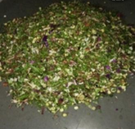
Figure 1 Collected Kitchen Waste

3.2 Kitchen Waste Analysis:
The analysis of kitchen waste showed its main physicochemical characteristics which are documented in Table 2. The initial moisture content was high (80%), which is favorable for microbial activity during composting, as reported by Bhave and Joshi (2017). The pH reading of 7.9 established that the environment had slightly alkaline conditions which enabled microbial development.
The low C:N ratio (4.9) showed that the waste contained high nitrogen content which would speed up decomposition but needed adjustment to achieve maximum composting results. Similar observations were reported by Sarkar et al. (2016). The electrical conductivity measured at 1.19 dS/m and the bulk density measured at 0.52 g/cm³ both fell within composting substrate limits.
The E4/E6 ratio (5.2) showed that the material contained unprocessed organic matter which had a high chance of becoming stable during composting according to Freppaz et al. (2002).
Table 2 Analysed parameter of kitchen waste
Analysed Perameter
Particle Size (mm) | 4 ± 0.2
PH | 7.9 ± 0.1
Conductivity (as dsm-¹) | 1.19 ± 0.05
Total Organic matter % | 8.6 ± 0.3
Total Carbon % | 4.9 ± 0.2
Total Nitrogen % | 1 ± 0.05
C: N Ratio | 4.9 ± 0.3
Moisture % | 80 ± 2.0
Bulk density (g/cm³) | 0.52 ± 0.02
Phosphate (Quimociac reagent) % | 3.4 ± 0.2
Total Potash % | 1.5 ± 0.1
E4/E6 | 5.2 ± 0.3

3.3 Development of Liquid Bacterial Inoculum:
A liquid bacterial inoculum was developed using kitchen waste-degrading bacterial strains cultured in modified mineral salt broth following Patil et al. (2021). The inoculum created for research purposes functions to improve microbial activity while it simultaneously speeds up the process of organic matter decomposition through the cooperative relationships between its different bacterial populations.
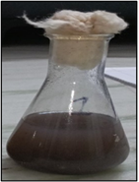
Figure. 2 Bacterial Liquid Inoculum
3.4 Composting of kitchen waste by microbial Inoculum:
The research used pulverized kitchen waste which scientists had treated with 1% liquid inoculum (LH1) to perform composting experiments which they compared with a control group that used no inoculum. The research team tracked the composting process during seven days while maintaining same environmental conditions throughout the study.
The inoculated samples showed quicker decomposition rates than the control samples which proved that microorganisms can speed up composting processes through their application. The research conducted by Dharani et al. (2021) discovered that microbial inoculation leads to similar improvements in composting success rates.
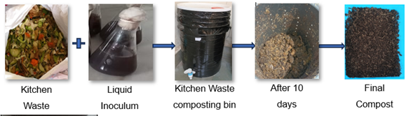
Figure 3 Composting process
3.5 Evaluation of Compost:
Daily observations of temperature changes during the composting process resulted in the presented in Figure 4. The final compost, with and without microbial inoculum (control), was subjected to quantitative analysis of parameters including moisture content, pH, bulk density, conductivity, carbon, nitrogen, organic matter, phosphate, potassium, particle size, E4/E6 ratio, and a phytotoxicity study. The outcomes of the compost heavy metal assessment are delineated in Table 3
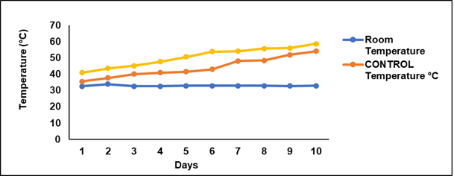
Figure: 4 Temperature profiling of composting process
Composting operations depend on temperature as their main operational measurement. The inoculated sample (LH1) showed a rapid increase in temperature from 40.9°C to above 50°C within 6 days, reaching a peak of ~59°C. The control sample displayed a gradual temperature rise which ended at a maximum temperature of 54°C. The rapid thermophilic phase of the inoculated sample demonstrates increased microbial activity through effective pathogen elimination, which matches the results found by Raut et al. (2008).
The inoculated sample showed a moisture reduction from 80% to 20% which exceeded the control sample's moisture reduction of 23%. The two measurements achieved FCO (1985) standards which require measurements to stay below 25%. The pH of compost maintained its stability between 6.5 and 7.5 which created ideal conditions for microbial growth. The research results obtained by Dharani et al. (2021) and Agapios et al. (2020) demonstrate that neutral pH levels serve as a crucial factor for compost maturity assessment.
The inoculated compost demonstrated carbon content improvement which exceeded 12% when compared to the control sample and it achieved FCO standards. The nitrogen content of LH1 reached 2.4% which exceeded the control's nitrogen content of 1.09%. The compost that received inoculation showed a C:N ratio of 5.58 which proved that it had achieved both stabilization and maturity since its value stayed below the FCO restriction of 20. These findings are consistent with Sarkar et al. (2016) and Manu et al. (2019).
The electrical conductivity of LH1 compost measured 0.94 dS/m which showed lower salinity and better compost quality than the control value of 1.27 dS/m. The inoculated samples showed a significant organic matter content increase to 23.1% while the control samples showed an organic matter content of 19.83%. The enhancement proves better biodegradation efficiency which matches the results that Tiquia et al. (1996) reported.
The phosphate content of LH1 compost reached 5.34% while the potash content climbed to 7.5% both of which exceeded FCO minimum requirements (0.4%). The compost production process creates high-quality compost which agricultural farms can use because of the nutrient enrichment. Khyalia et al. (2022) confirmed this finding.
The inoculated compost showed increased bulk density from 0.52 g/cm³ to 0.95 g/cm³ which demonstrates better structural integrity. The results comply with FCO standards while matching the results obtained by Bhave and Joshi in 2017.
The E4/E6 ratio decreased from 5.2 to 0.31 in LH1 compost because advanced humification process created stable organic matter. This observation aligns with Freppaz et al. (2002) because it shows that high-quality compost has developed.

Figure: 5 Particle size of compost Figure: 6 pH of compost

Figure: 7 Conductivity of compost Figure: 8 Organic matter of compost

Figure: 9 Total Carbon of compost Figure: 10Total Nitrogen of compost

Figure: 11 C:N ratio of compost Figure: 12 Moisture content of compost

Figure: 13 Bulk density of compost Figure: 14 Total potash of compost

Figure: 15 Total Phosphate of compost Figure: 16 E4/E6 ratio of compost

The final compost showed heavy metal concentrations for Cu, Mn, Zn, Hg, and Pb which remained below the acceptable levels established by FCO (1985). The compost demonstrates safe agricultural use because it contains either no toxic metals or only very small amounts of these metals.
Table: 3 Heavy metal analysis of Compost
Heavy metal  content, (as  mg/Kg), maximum | Control | LH1 | Reference value as per FCO
Arsenic | 0 | 0 | 10
Cadmium | 0 | 0 | 5
Manganese | 2.06 ± 0.1 | 2.71 ± 0.1 | 50
Copper | 1.46 ± 0.05 | 0.63 ± 0.03 | 300
Mercury | 0.0051 ± 0.0002 | 0.0048 ± 0.0002 | 0.15
Nickel | 0 | 0 | 50
Lead | 0.45 ± 0.02 | 0.15 ± 0.01 | 100
Zinc | 3.04 ± 0.01 | 2.7 ± 0.01 | 1000

The germination index study showed significant improvement in seed germination for all tested species (Vigna radiata, Cyamopsis tetragonoloba, Sorghum, and wheat) in inoculated compost. The highest germination rate of Vigna radiata shows that the compost has achieved complete maturity because it produces very little toxic effects. These results are consistent with Zucconi et al. (1981) and Tam and Tiquia (1994).

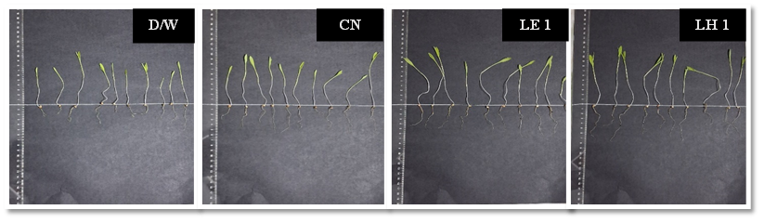

Figure 17 Seed Germination of Triticum aestivum (Wheat)

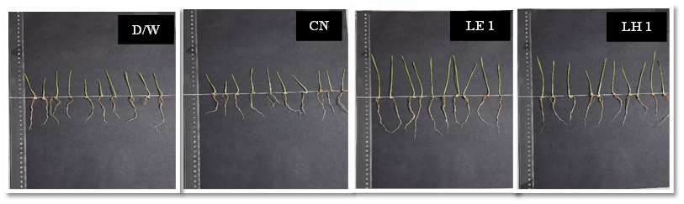

Figure 18 Seed Germination of Sorghum bicolor (Sorghum)

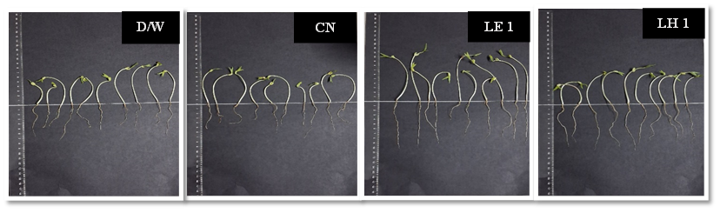

Figure 19 Seed Germination of Vigna radiata (Mungbean)

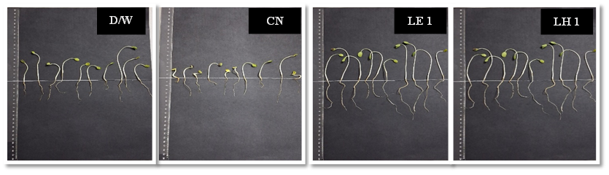

Figure 20 Seed Germination of Cyamopsis tetragonoloba (Guar)

Figure 21 Seed Germination
Figure 21 reveals that the application of treatments LH1 resulted in considerable enhancement of seed germination indices in all species that were tested. Among the different species, Vigna radiata was found to have the maximum germination percentage, while Cyamopsis tetragonoloba, Sorghum, and wheat came next in that order, showing a decreasing trend in their respective values. This suggests that the LH1 treatments not only counteracted but also gave rise to the best germination performance in these plants compared to others due to the lower toxicity of the compost extract in water.
The recent studies which show that microbial inoculation accelerates organic waste decomposition support the enhanced composting results which inoculated sample LH1 achieved. Luo et al. (2024) found that active microbial communities boost the thermophilic stage of composting through their research which demonstrated that Microbial activities accelerate composting process. Microbial formulations which Jiang et al. (2023) studied at their research site showed that they expand microbial diversity while enhancing metabolic functions which resulted in successful kitchen waste degradation.
The study found that nutrient levels increased because of higher carbon and nitrogen and phosphate and potash content while the C:N ratio decreased according to Li et al. (2024) research which showed that microbial inoculum enhances compost quality and nutrient availability. The E4/E6 ratio decrease which shows advanced humification process has been demonstrated by Feng et al. (2024) who found that special microbial consortia help create enduring humic materials.
Microbial inoculation provides two major benefits during composting because it increases composting speed and creates higher quality compost. The developed bacterial inoculum achieves its intended purpose because of the rapid temperature increase and increased nutrient content and decreased moisture level and higher germination index.
The findings provide strong confirmation of previous research conducted by Raut et al. (2008) and Dharani et al. (2021) and Sarkar et al. (2016) and Khyalia et al. (2022) and Jiang et al. (2023) and Luo et al. (2024) and Li et al. (2024) and Feng et al. (2024) which proved that microbial inoculation functions as an essential element in sustainable waste management.
Conclusion:
The current research demonstrates that using microbial inoculation methods can enhance composting efficiency and product quality. The bacterial liquid inoculum (LH1) which scientists created, enabled kitchen waste to decompose faster while producing compost that reached maturity more quickly than the untreated control sample. The inoculated system displayed a rapid temperature increase during composting which reached a higher thermophilic peak of 59.3 °C compared to the control systems 54 °C peak because of increased microbial activity and better organic material decomposition. The compost showed successful stabilization through a major moisture content reduction which dropped from 80% to 20%. The compost showed better physicochemical characteristics which included optimal pH values and increased organic carbon content and higher nitrogen levels and improved C:N ratio and enhanced organic matter and suitable electrical conductivity and bulk density measurements. The final compost achieved compliance with FCO (1985) agricultural standards which established its agricultural application suitability. Heavy metal analysis confirmed that all parameters, including lead (Pb), remained well within permissible limits, highlighting the environmental safety of the compost. The phytotoxicity assessment showed that the inoculum-treated compost improved seed germination which resulted in Vigna radiata achieving the highest germination index. This finding established the composts maturity level and agricultural value. The research demonstrates that microbial inoculation functions as a sustainable and economical method for managing kitchen waste in decentralized systems. The developed inoculum not only decreases municipal waste system requirements but also facilitates the process of turning organic waste into compost that contains essential nutrients which supports circular economy principles. The upcoming research will investigate three main areas compost application at large scales microbial consortium development and assessment of long-term effects on soil health and crop yields through field studies. The research presents an environmentally safe method for recycling organic waste which leads to sustainable waste management practices.
.

Disclaimer (Artificial intelligence)
Author(s) hereby declare that NO generative AI technologies such as Large Language Models (ChatGPT, COPILOT, etc.) and text-to-image generators have been used during the writing or editing of this manuscript.

References:
- Agapios, A., Andreas, V., Marinos, S., Katerina, M., & Antonis, Z. A. (2020). Waste aroma profile in the framework of food waste management through household composting. Journal of Cleaner Production, 257, 120340.
- Benitez, E., Nogales, R., Elvira, C., Masciandaro, G., Ceccanti, B., 1999. Enzyme activities as indicators of the stabilization of sewage sludges composting with Eisenia foetida. Bioresource Technol. 67, 297–303.

- Bhave, P. P., & Joshi, Y. S. (2017). Accelerated in-vessel composting for household waste. Journal of The Institution of Engineers (India): Series A, 98, 367-376.
- Bialobrzewski, I., Miks-Krajnik, M., Dach, J., Markowski, M., Czekała, W., & Głuchowska, K. (2015). Model of the sewage sludge-straw composting process integrating different heat generation capacities of mesophilic and thermophilic microorganisms. Waste Management, 43, 72-83.

- CPCB, 2002. Central Pollution Control Board, Management of Municipal Solid Wastes, New Delhi, India.

- Dharani, S., Saliha, B. B., Suresh, S., & Shenbagavalli, S. (2021). Evaluation and Acceleration of Municipal Biowaste Compost Production and its Effect on Growth and Yield of Amaranthus. International Journal of Plant & Soil Science, 33(21), 195-201.

- Duchaufour, Ph., and F. Jacquin, 1966. Nouvelles recherches sur l’extraction et le fractionnement des composés humiques. Bulletin ENSAN, VIII, 1, 3-24.

- Feng, X., Qiu, M., & Zhang, L. (2024). Construction of lignocellulose-degrading compound microbial inoculum and its effects on green waste composting. Journal of environmental management, 370, 122502.

- Freppaz, M., Lunardi, S., Bonifacio, E., Scalenghe, R., & Zanini, E. (2002). Ski slopes and stability of soil aggregates.
- Gigliotti, G., Valentini, F., Erriquens, F. G., & Said-Pullicino, D. (2005). Evaluating the efficiency of the composting process: a comparison of different parameters. In Geophysical Research Abstracts (Vol. 7, p. 09606). Perugia, Italy: European Geosciences Union.

- Haddad, G., El-Ali, F., & Mouneimne, A. H. (2015). Humic matter of compost: determination of humic spectroscopic ratio (E4/E6). Curr Sci Int, 4, 56-72.

- Jiang, H., Zhang, Y., Cui, R., Ren, L., Zhang, M., & Wang, Y. (2023). Effects of two different proportions of microbial formulations on microbial communities in kitchen waste composting. Microorganisms, 11(10), 2605.

- Khyalia, P., Dangi, J., Barapatre, S., Dhania, G., Laura, J. S., & Nandal, M. (2022). Comparative analysis of compost quality produced from fungal consortia and rice straw by varying C/N ratio and its effect on germination of Vigna radiata. Nature Environment and Pollution Technology, 21(3), 1235-1242.

- Li, H., Yang, Z., Zhang, C., Shang, W., Zhang, T., Chang, X., ... & He, Y. (2024). Effect of microbial inoculum on composting efficiency in the composting process of spent mushroom substrate and chicken manure. Journal of Environmental Management, 353, 120145.

- Luo, Y., Shen, J., Wang, X., Xiao, H., Yaser, A. Z., & Fu, J. (2024). Recent advances in research on microbial community in the composting process. Biomass Conversion and Biorefinery, 14(19), 23319-23333.
- Manu, M. K., Kumar, R., & Garg, A. (2019). Decentralized composting of household wet biodegradable waste in plastic drums: Effect of waste turning, microbial inoculum and bulking agent on product quality. Journal of Cleaner Production, 226, 233-241. https://doi.org/10.1016/j.jclepro.2019.03.350

- National Centre of Organic Farming. (2019). Biofertilizers and Organic Fertilizer- Fertilizer (Control) Order, 1985

- Patil, S. A., Navale, A. M., Deokar, C. D., & Patil, D. A. (2021). Development and assessment of microbial consortium for composting of organic waste. Journal of Pharmacognosy and Phytochemistry, 10(2), 241-245.
- Raut, M. P., William, S. P., Bhattacharyya, J. K., Chakrabarti, T., & Devotta, S. (2008). Microbial dynamics and enzyme activities during rapid composting of municipal solid waste–a compost maturity analysis perspective. Bioresource technology, 99(14), 6512-6519. https://doi.org/10.1016/j.biortech.2007.11.030

- Sarkar, S., Pal, S., & Chanda, S. (2016). Optimization of a vegetable waste composting process with a significant thermophilic phase. Procedia Environmental Sciences, 35, 435-440.

- Tam, N. F. Y., & Tiquia, S. (1994). Assessing toxicity of spent pig litter using a seed germination technique. Resources, Conservation and Recycling, 11(1-4), 261-274.

- Tiquia, S. M., Tam, N. F. Y., & Hodgkiss, I. J. (1996). Effects of composting on phytotoxicity of spent pig-manure sawdust litter. Environmental pollution, 93(3), 249-256.

- Van Fan, Y., Lee, C. T., Klemeš, J. J., Chua, L. S., Sarmidi, M. R., & Leow, C. W. (2018). Evaluation of effective microorganisms on home scale organic waste composting. Journal of Environmental Management, 216, 41 -48.
- Voegeli, Y., & Zurbrugg, C. (2008). Decentralised anaerobic digestion of kitchen and market waste in developing countries-‘state of the art’in south India. Proceedings Venice.

- Wei YunMei, W. Y., Li JingYuan, L. J., Shi DeZhi, S. D., Liu GuoTao, L. G., Zhao YouCai, Z. Y., & Shimaoka, T. (2017). Environmental challenges impeding the composting of biodegradable municipal solid waste: a critical review.

- Zucconi, F.; A. Pera; M. Forte and M. de Bertoldi(1981b). Evaluating toxicity of immure compost. Biocycle, 22 (4): 54-57.

