Structural Analysis of Power Weeder Frame Using Finite Element Method (ANSYS)

Abstract
Weed management in rice (Oryza sativa L.) food crop cultivation is a labour-intensive operation that significantly affects crop productivity and production cost. The use of walk-behind paddy weeders provides an effective mechanized alternative to reduce labour requirement and improve field efficiency. The performance and durability of such machines depend on the strength of the main frame of the machine, which is subjected to different types of loads during its operation. For the present study, the structural integrity of the main frame of a walk-behind dual-action paddy weeder was evaluated through Finite Element Analysis (FEA). For this purpose, a three-dimensional finite element model of the frame was developed in SolidWorks and analyzed through ANSYS Workbench software under static conditions. The frame was designed and developed using mild steel angle sections. The analysis was performed to evaluate the stress distribution, strain characteristics, and deformation of the frame. The analysis showed that the highest equivalent (von Mises) stress developed in the frame (28.514 MPa) was within limits compared to the yield strength of the material (175 MPa). At the same time, the highest deformation of the frame was found to be 0.10136 mm. The strain values developed in different sections of the frame were within limits, which confirmed that there would be no permanent deformation of the frame under such conditions. Overall, the analysis indicates that the frame design is structurally safe and suitable for field operation. The study also demonstrates the usefulness of FEA in evaluating and improving the design of agricultural machinery.
Keywords:
Finite Element Analysis; Paddy weeder; Frame design; Mild steel; Structural safety; ANSYS
1. INTRODUCTION
Rice (Oryza sativa L.) is one of the world's leading food crops supplying food to approximately 60% of the population. In India, rice is an essential crop for both food production and income generation (Hashim et al. 2024; Jabeen et al. 2024). The success and number of acres of rice produced each year continues to grow; however, due to a lack of proper intercultural practices, especially weed control, production can suffer significantly. To control weed competition with rice and increase yield, timely weed control is critical (Rathika and Ramesh 2018; Mohan et al. 2025). Mechanical weeders have, therefore, gained popularity as a means to reduce labour requirements in rice farming while increasing the efficiency of rice producers working in wetland areas.
Structural integrity is an important factor for agricultural machinery and greatly affects durability, safety, and operational reliability (Sebastian & Kalita, 2021). The main frame of a paddy weeder is the primary load bearing structure of the paddy weeder, and it bears the parts most critical to the weeder's operation (engine, transmission system, blade assembly, and drum wheels with their accompanying handle assembly).
During field operation, the frame is subjected to combined static and dynamic loads, including engine weight, traction forces, soil resistance, and operator handling forces. (Veeraprasad et al., 2023). As a result, it is vital that the overall structural design of the frame be correct in order to provide the necessary strength and rigidity, as well as the longest possible usable life (Veeraprasad et al., 2023). In recent years, the finite element method (NEM) has greatly aided in the design and evaluation of mechanical components. Finite Element Analysis (FEA) allows design engineers to determine how much stress, how much strain, and how much deformation a structure will experience under various types of loading conditions before it is ever built (Saygılı & Çakmak, 2025; Bhelave et al., 2023). The method works by dividing the geometry into smaller pieces known as "elements," which are connected at points called "nodes." The FEM solves many complex engineering problems numerically with high accuracy. In addition, many commercial programs have become very popular for conducting structural analyses, including ANSYS Workbench, because they can perform static analysis, dynamic analysis, and thermal analysis simulations with high precision (Silva et al., 2014; Saygılı & Çakmak, 2025).
The use of FEA in agricultural machinery design helps in identifying stress concentration regions, optimizing material usage, reducing development costs, and enhancing structural safety (Yang, 2024). Previous studies have successfully applied finite element techniques for evaluating machine frames and agricultural equipment under working loads (Sebastian et al., 2024). However, limited research has been reported on the structural analysis of walk-behind dual-action paddy weeders, particularly focusing on frame performance under combined loading conditions. (Veeraprasad et al., 2023).
Therefore, the present study aims to perform a static structural analysis of the main frame of a walk-behind dual-action paddy weeder using FEA in ANSYS. The study evaluates stress distribution, strain behavior, and total deformation of the frame to verify whether the selected mild steel material and structural dimensions provide sufficient strength and safety under operating conditions. The findings of this research contribute to improving the structural reliability and performance of mechanized weed management equipment in paddy cultivation.
2. MATERIAL AND METHODS
A 3D CAD model of the weeder’s frame and blade was created in SolidWorks version 2022, and a static structural analysis was carried out using the FEA method in ANSYS Workbench version 25.0. respectively and fabricated at JNKVV, Jabalpur. The flow chart of procedure of ANSYS Analysis on the frame is given in Fig.1. The main frame was constructed using mild steel (MS) angle sections to support various components such as engine, float, blade assembly, drum wheel, handle, and ground wheels. The frame was designed for structural stability, ease of fabrication, and corrosion resistance paint coating. The frame was constructed using two parallel angle mild steel of 30×30×3 mm. The width of the frame is 140 mm. The frame has three parts on which engine, traction wheel, transmission system, blade assembly, drum wheel and sweep tyne was mounted. The first part of the main frame was 604 in length and has four angle in between to provide strength and to hold the float. The second part of the main frame i.e. top of main frame was used to mount engine. The engine was mounted on rectangular sheet of 4 mm thickness of 245 mm in length and 160 mm width using four rectangular angle frames of height 240 at front end and 93 mm at rear end of main frame. The third part of the main frame which is at the rear end of the main frame on which sweep tyne and drum wheel was attached was constructed using two parallel angle ms steel of 30×30×3 and has length of 320 mm. It has two angle in between to provide strength as well to mount the sweep tyne. The schematic diagram of the main frame is shown in Fig.2 and physical properties of MS steel is given in Table 1.
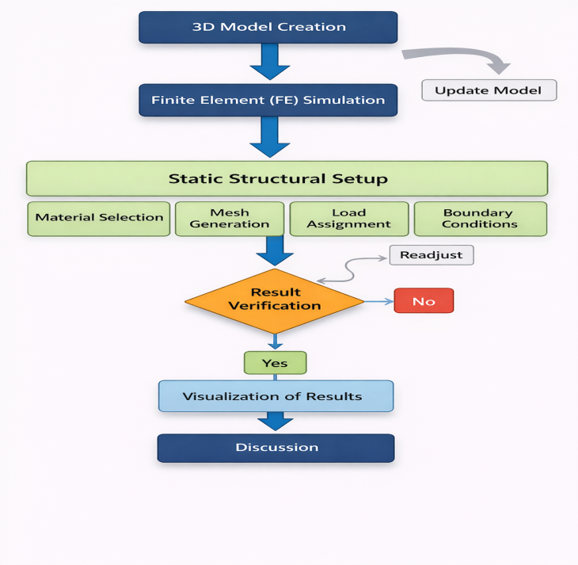
Fig. 1. Flow chart of step for ANSYS analysis
Procedure of ANSYS Analysis on the Frame (Fig. 1)
The ANSYS analysis of the frame (Fig. 1) was carried out following a systematic procedure to evaluate its structural performance under applied loading conditions. Initially, a three-dimensional (3D) CAD model of the frame was developed to serve as the geometric basis for the analysis. This model was then imported into the finite element analysis (FEA) environment of ANSYS for further processing. A static structural analysis setup was defined by assigning appropriate material properties to the model, followed by discretization through mesh generation to divide the geometry into finite elements. Subsequently, relevant boundary conditions and external loads were applied to simulate actual working conditions of the frame. After defining the analysis parameters, the simulation was executed to compute the resulting stress distribution and deformation characteristics. The obtained results were carefully examined to ensure their accuracy and to evaluate the safety and reliability of the design. If required, modifications were made to the model to improve performance and eliminate potential weaknesses. Finally, the validated results were visualized using contour plots and interpreted to assess the structural integrity and suitability of the frame for field operation.
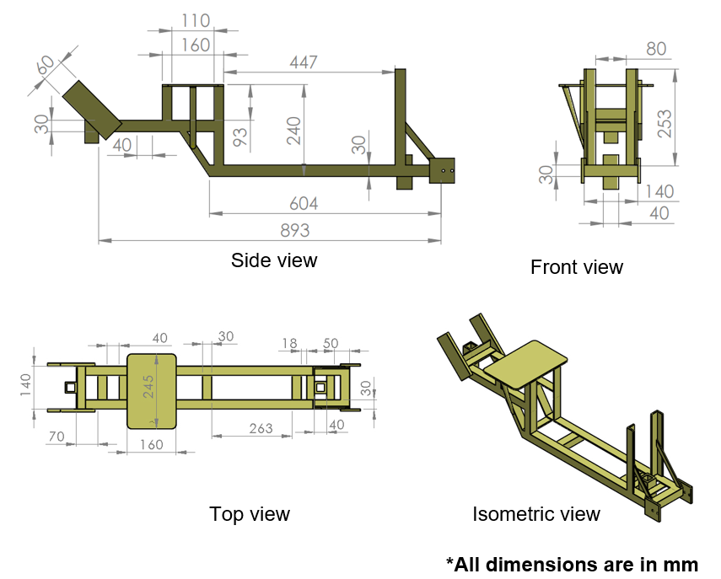
Fig. 2. Schematic diagram of mainframe of weeder
Table 1. Physical Properties of MS Steel
S.No | MS STEEL
S.No | Physical Properties | Details
1 | Modulus of elasticity | 208
2 | Density, kg/m³ | 7800
3 | Tensile strength, MPa | 350
4 | Yield strength, MPa | 175
5 | Poisson’s ratio | 0.29
3. RESULT AND DISCUSSION
3.1 Finite element analysis by using ANSYS software of strain results in main frame
The strain behavior of the main frame of the walk-behind dual-action paddy weeder was evaluated through static structural finite element analysis using ANSYS. Three primary strain parameters—namely equivalent elastic strain, maximum principal elastic strain, and maximum shear elastic strain—were considered to assess the elastic response of the structural steel frame. The computed results are presented in Table 2.
The equivalent elastic strain was found to vary from $1.1797×{10}^{-10}$mm/mm to $1.4266×{10}^{-4}$mm/mm (Fig. 3). Similarly, the maximum principal elastic strain ranged between $-4.9443×{10}^{-7}$mm/mm and $1.1871×{10}^{-4}$mm/mm (Fig. 4). The maximum shear elastic strain values were observed in the range of $1.0263×{10}^{-10}$mm/mm to $1.8637×{10}^{-4}$mm/mm (Fig. 5), while the shear elastic strain varied from $-1.1561×{10}^{-4}$mm/mm to $1.0492×{10}^{-4}$mm/mm (Fig. 6).The strain contour distributions indicate that higher strain concentrations occur predominantly near the mounting locations and bolted joints, where load transfer is most significant. This trend is consistent with findings reported in earlier finite element studies on agricultural machinery components, such as power weeder frames and rotary weeder attachments, where localized deformation and stress intensification were observed at critical connection regions. Despite these localized strain concentrations, all computed strain values remain well within the elastic limit of the selected structural steel material, which possesses a yield strength exceeding 250 MPa. The magnitude of strain is comparable to previously reported values (~${10}^{-3}$ mm/mm) for similar systems, confirming that the induced deformation is entirely elastic in nature. Therefore, the structural integrity of the frame is maintained under the applied loading conditions, and no permanent deformation or failure is expected during normal field operation. (Jog & Agashe, 2025; Veeraprasad et al., 2023; Wang & Wu, 2023; Rajashekar & Mohankumar, 2015).
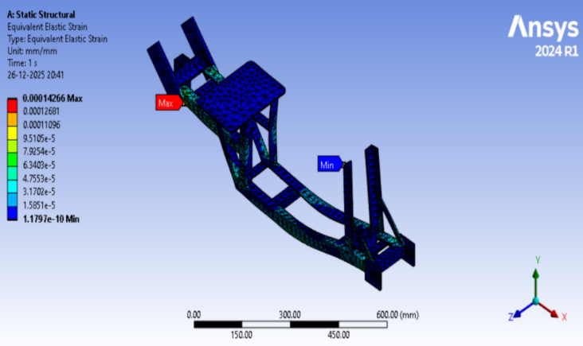
Fig. 3. Results of equivalent elastic strain
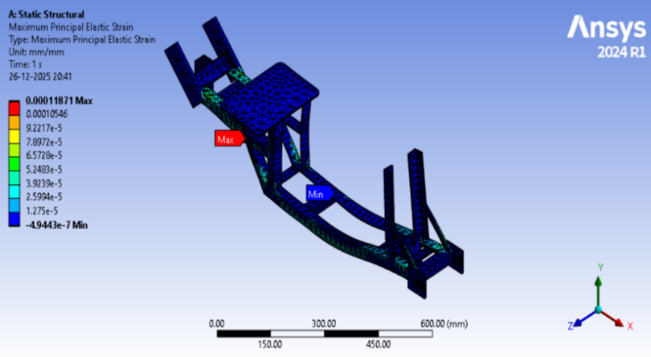
Fig. 4. Results of maximum principal elastic strain
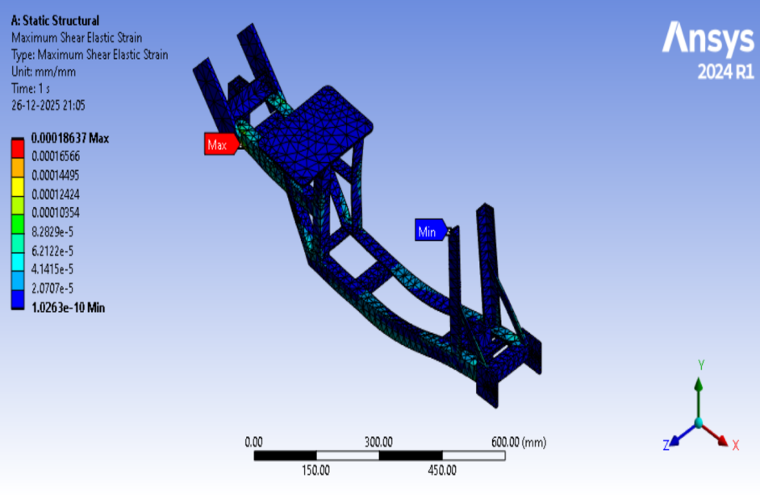
Fig. 5. Results of maximum shear elastic strain
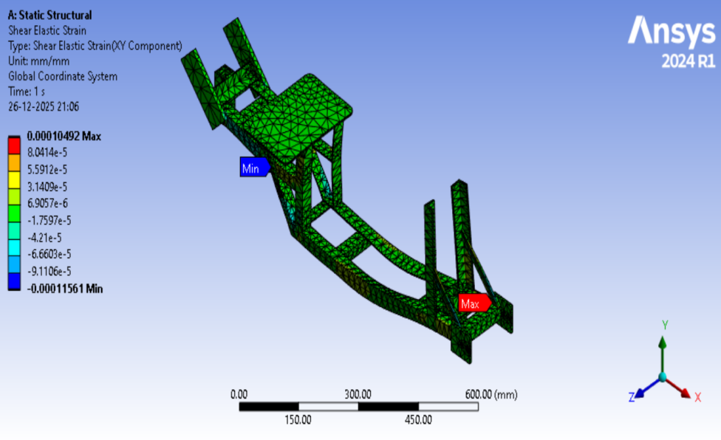
Fig. 6. Results of shear elastic strain
3.2 Finite element analysis by using ANSYS software of stress results in main frame
The numerical results of stress analysis presented in Table 2 show that the equivalent (von Mises) stress ranged from 1.4385 × 10⁻⁵ MPa to 28.514 MPa (Fig. 7). The calculated maximum principal stress values varied between -2.3744 MPa and 25.641 MPa, as shown in Fig. 8 and Table 2, while the maximum shear stress ranged from 7.8948 × 10⁻⁶ MPa to 14.336 MPa, as depicted in Fig. 9 (Prasetiyo & Sekarjati, 2022). The calculated shear stress values ranged from -8.893 MPa to 8.0706 MPa, as shown in Fig. 10. The color-coded stress contours in the figure illustrate the variation of stress levels across the frame, from minimum to maximum values. Higher stresses are primarily observed around welded joints and bolted connections, where load transfer is most critical. While minor stress fluctuations are present in different regions of the structure, the overall stress levels remain well below the yield strength of the selected structural steel, approximately 350 MPa. This confirms that the frame can safely withstand the applied loads without experiencing permanent deformation during operation (Prasetiyo et al., 2022), consistent with FEA validations for weeder attachments showing similar low-stress regimes (max 108 MPa, FoS >1.5) under dynamic conditions. Such margins ensure durability against fatigue and overloads typical in paddy weeding. (Prasetiyo et al., 2022).
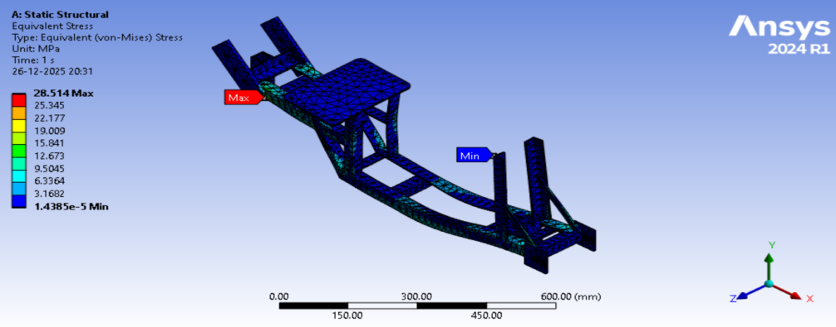
Fig. 7. Results of equivalent (von-Mises) stress
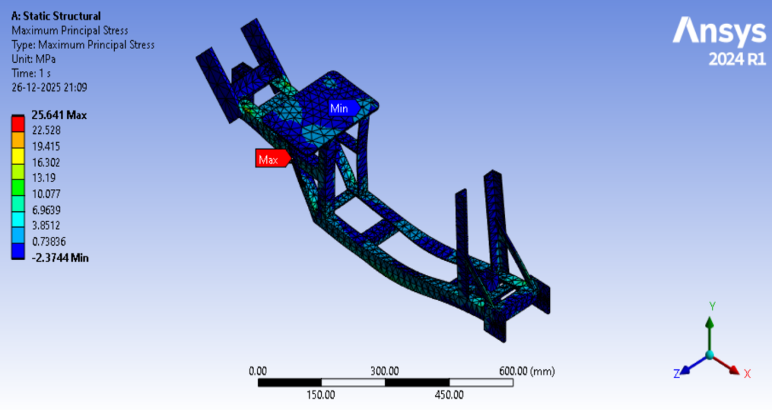
Fig. 8. Results of maximum principal stress
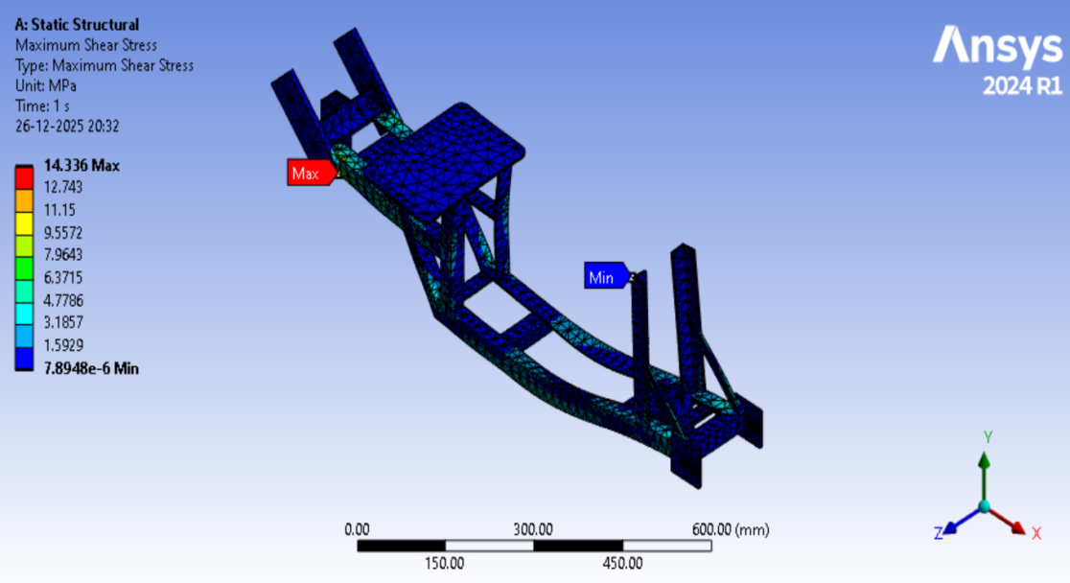
Fig. 9. Results of maximum shear stress
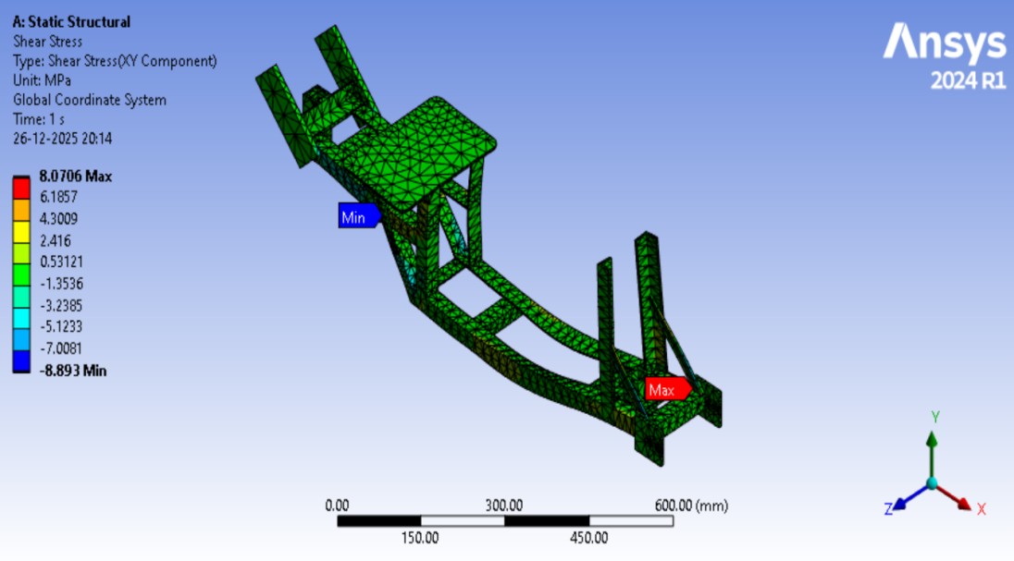
Fig. 10. Results of shear stress
3.3 Finite element analysis using ANSYS: Deformation of the main frame
The total deformation of the main frame under the applied loading conditions was examined using static structural analysis in ANSYS. The results show that deformation ranges from 0 mm to a maximum of 0.10136 mm, as illustrated in the Table 2 and Fig. 11. The color-coded deformation contours reveal how displacement spreads along the frame members. The greatest deformation occurs in areas where external loads enter the structure, consistent with FEA patterns in comparable agricultural frames where displacements under operational loads remain below 1 mm. This localized behavior ensures that global frame alignment and component functionality are preserved during field use. Overall, the amount of deformation is very small compared to the frame's overall size. This shows that the structure keeps enough stiffness under working loads. Since the maximum deformation stays within safe limits—far below thresholds that could impair weeding precision or durability—the analysis confirms that the frame is strong enough to support the mounted components and handle working forces without significant deformation, supporting reliable performance across typical paddy conditions. Comparable studies on weeder chassis report similar low deflections (0.5-5 mm max), validating factor-of-safety margins exceeding 1.5 under dynamic soil interactions. (Shi, 2024)
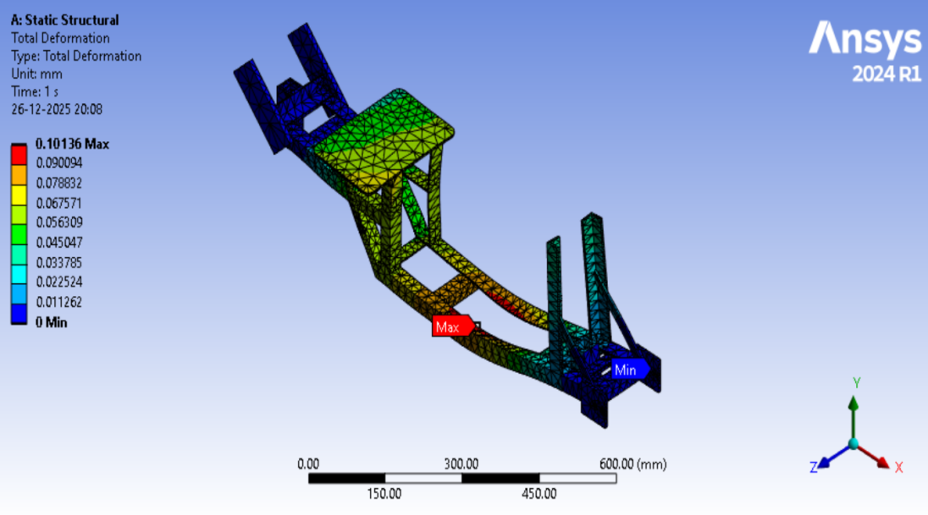
Fig. 11. Total deformation of the main frame under combined load conditions

Table 2. Resultant forces for finite element analysis of mainframe
Parameters | Type | Minimum Value | Maximum Value | Unit
Strain | Equivalent elastic strain | 1.1797e-10 | 0.00014266 | mm/mm
Strain | Maximum principal elastic Strain | -4.9443e-7 | 0.00011871 | mm/mm
Strain | Maximum shear elastic Strain | 1.0263e-10 | 0.00018637 | mm/mm
Strain | Shear elastic strain | -0.00011561 | 0.00010492 | mm/mm
Stress | Equivalent (von-Mises) stress | 1.4385e-5 | 28.514 | MPa
Stress | Maximum principal stress | -2.3744 | 25.641 | MPa
Stress | Maximum shear stress | 7.8948e-6 | 14.336 | MPa
Stress | Shear stress | -8.893 | 8.0706 | MPa
Deformation | Total deformation | 0 | 0.10136 | mm
4. CONCLUSION
The present study evaluated the structural integrity of the main frame of a walk-behind dual-action paddy weeder using Finite Element Analysis (FEA) performed in ANSYS Workbench. The frame, fabricated from mild steel angle sections, was analyzed under static loading conditions to determine stress distribution, strain characteristics, and total deformation. The results indicated that the maximum equivalent (von-Mises) stress developed in the frame was 28.514 MPa, which is significantly lower than the yield strength of mild steel (175 MPa). Similarly, the maximum principal and shear stresses were well within permissible limits. The strain values obtained from the simulation remained within the elastic range, confirming that the deformation experienced by the structure is completely recoverable and does not result in permanent damage. The maximum total deformation observed was 0.10136 mm, which is negligible compared to the overall dimensions of the frame, demonstrating sufficient stiffness and rigidity during operation. Stress and strain concentrations were primarily observed near welded joints and mounting locations where load transfer occurs. However, these localized effects did not exceed the allowable limits of the material. The analysis confirms that the selected material properties, cross-sectional dimensions, and structural configuration provide adequate strength and safety under expected working conditions. Overall, the finite element analysis validates the structural design of the paddy weeder frame, ensuring reliability, durability, and operational safety. The application of FEA in the design stage reduces the need for repeated physical prototyping, minimizes material wastage, and improves design optimization. The findings of this study support the suitability of the developed frame for field applications in paddy cultivation and contribute to the advancement of mechanically efficient weed management systems.
5. LIMITATION OF STUDY
Although the results of the present study confirm the structural safety of the paddy weeder frame under static loading conditions, there are some limitations to be considered. The analysis performed in the present study considered only ideal static conditions, but in practice, there might be effects of vibrations, impact loads, and varying resistance in uneven paddy fields. The material used in the structure, i.e., mild steel, was considered to have homogeneous and isotropic properties, but in practice, there might be effects of varying material properties. The model also simplifies welded and bolted joint conditions and does not take into consideration any residual stresses, possible imperfections, or long-term effects such as corrosion, especially under conditions of operating in a wetland environment. In addition, the fatigue properties under conditions of repeated cycles were not taken into consideration. The interaction between the soil and tool, as well as the forces exerted by the operator, were not taken into consideration in the simulation, which may have a significant effect in practice. The thermal effects and environmental conditions were not taken into consideration in this analysis. Although meshing was done with care, a detailed mesh sensitivity analysis was not extensively done for various mesh densities. Additionally, the results obtained through FEA have not yet been validated through experimental testing, which is also important in confirming the accuracy of the results. The future work should be focused on adding dynamic and nonlinear analysis, considering soil-structure interaction, and validating the model to enhance the reliability of the design

Disclaimer (Artificial intelligence)

Author(s) hereby declare that NO generative AI technologies such as Large Language Models (ChatGPT, COPILOT, etc.) and text-to-image generators have been used during the writing or editing of this manuscript.

REFERENCE
- Hashim, N., Ali, M. M., Mahadi, M. R., Abdullah, A. F., Wayayok, A., Kassim, M. S. M., & Jamaluddin, A. (2024). Smart Farming for Sustainable Rice Production: An Insight into Application, Challenge, and Future Prospect. Rice Science, 31(1), 47-61.
- Jabeen, A., Subrahmanyam, D., & Krishnaveni, D. (2024). The global lifeline: A staple crop sustaining two-thirds of the world's population. International Journal of Agriculture and Environmental Research, 15–18.
- Rathika, S., & Ramesh, T. (2018). Weed management effect in system of rice intensification. Indian Journal of Weed Science, 50(4), 388–390.
- Mohan, J., Negi, N., Kumar, A., Bharti, B., & Arya, R. (2025). Review of a study on rice weed management techniques. International Journal of Advanced Biochemistry Research, 9(4), 28–31.
- Paul, S., Nath, B. C., Huda, M. D., Bhuiyan, M. G. K., & Paul, H. (2025). Assessment of mechanical weeders in paddy fields: A study on operational effectiveness in Bangladesh. Heliyon, 11(4), Article e42639
- Chanakyan, C., & Mohanty, S. K. (2017). Performance evaluation of power operated wetland paddy weeder in Odisha. International Journal of Multidisciplinary Research and Development, 4(10), 140–146
- Sebastian, S., & Kalita, K. (2024). Theoretical analysis and design of inter cum intra-row wetland paddy field weeder. Crop Protection, 181, Article 106696.
- Veeraprasad, G., Srinivas, I., Ramireddy, K. V. S., Hemakumar, H. V., & Srinivasa Rao, V. (2023). Structural analysis of the differential chassis for development of paddy weeder using finite element analysis. International Journal of Plant & Soil Science, 35(22), 549–555.
- Veeraprasad, G., Srinivas, I., Ramireddy, K. V. S., Hemakumar, H. V., & Srinivasa, R. V. (2023). Structural analysis of the weeding attaching frame of robotic paddy weeder using finite element analysis. The Pharma Innovation Journal, 12(11), 2104–2109.
- Saygılı, Y. S., & Çakmak, B. (2025). Use of finite element method in agricultural machinery and application examples. Ege Üniversitesi Ziraat Fakültesi Dergisi, 62(3), 407–419.
- Bhelave, K., Shrivastava, A. K., & Meena, B. S. (2023). A finite-element method for enhancement issues of frame of battery operated ridge planter with drip line installer. International Journal of Environment and Climate Change, 13(9), 1355–1362.
- Silva, E. P. D., Silva, F. M. D., & Magalhães, R. R. (2014). Application of finite elements method for structural analysis in a coffee harvester. Engineering, 6(3), 138–147.
- Yang, J. (2024). Strength calculation method of agricultural machinery structure using finite element analysis. (IJACSA) International Journal of Advanced Computer Science and Applications, 15(10), 699–705
- Jog, M. S., & Agashe, S. D. (2025). Development of a weeding agrobot prototype for inter-row and intra-row weeding. Agricultural Science Digest, 45(6), 1040–1049.
- Wang, R., & Wu, Z. (2023). Recent advancement in finite element analysis of spinal interbody cages: A review. Frontiers in Bioengineering and Biotechnology, 11, Article 1041973.
- Prasetiyo, A. B., & Sekarjati, K. A. (2022). Finite element simulation of power weeder machine frame. Indonesian Journal of Computing, Engineering, and Design, 4(2), 25–34.
- Prasetiyo, A. B., Prastowo, R., Sekarjati, K. A., Susiana, A., Ardiyat, I. N., & P, F. Y. (2022). Finite Element Analysis (FEA) of blade weed design using Ansys workbench. SINERGI, 26(3), 371–378.
- Rajashekar, M., & Mohankumar, S. (2015). Virtual simulation based design of low cost modified three row weeder equipment. International Journal on Emerging Technologies, 6(2), 409–416.
- Shi, X. (2024). Modal characteristics analysis of agricultural vehicle support frame. Vibroengineering Procedia, 69, 15–20.

