Original Research Article

Assessment of the outcomes of a modified version of the Reverse Hockey Stick Incision (mRHSI): A single institutional ambispective longitudinal study

Abstract:
Background: Neck dissection is a cornerstone of head and neck cancer management, requiring an incision design that balances surgical exposure with skin viability and cosmesis. Traditional designs, such as the Y-shaped incision, often suffer from poor blood supply at trifurcation points, leading to vessel exposure and wound breakdown.
Objectives: This study aimed to assess the outcomes of a modified version of the Reverse Hockey Stick Incision (mRHSI). The primary objective was to evaluate its usability and feasibility in a large clinical sample, focusing on intraoperative accessibility and postoperative complications.
Methods: An ambispective longitudinal study was conducted from May 2018 to March 2022, involving 451 patients with oral, oropharyngeal, or parotid malignancies. The mRHSI utilizes a gentle curve 3–4 cm below the angle of the mandible along the skin crease, extending longitudinally toward the mid-clavicle. Parameters assessed included dissection duration, marginal necrosis, wound dehiscence, and long-term cosmesis using the Vancouver Scar Scale (VSS).
Results: The mean dissection time was 22.49 +/- 1.69 minutes, significantly shorter than historical rates for MacFee or Schobinger incisions (p < 0.001). Complication rates remained low, with marginal necrosis at 3.1% and wound dehiscence requiring re-suturing at 2.4%. Scar assessment showed significant longitudinal improvement, with mean VSS scores decreasing from 11.43 at discharge to 2.81 at the three-year follow-up (p < 0.001). Approximately 85.6% of patients reported "good" or "satisfactory" cosmetic feedback.
Conclusion: The mRHSI provides excellent surgical exposure and accessibility while minimizing operative time and flap-related complications. By avoiding acute angles and three-point junctions, the modification ensures superior healing and favorable cosmetic outcomes without compromising oncological radicality.

Keywords: Neck dissection, mRHSI, Oral carcinoma, Vancouver Scar Scale, Surgical incision, Head and neck cancer.

Introduction:
Neck dissection is fundamental to head and neck cancer management. Maintaining sufficient skin viability, covering the carotid artery to reduce the risk of rupture, providing sufficient exposure for the procedure, producing acceptable cosmetic results, and enabling the transfer of suitable flaps to the head and neck region for reconstruction are the primary factors to be taken into account when designing skin flaps for neck dissection. ^{[1, 2]}.
The conventional description of the neck dissection procedure involves a Y-shaped incision, a technique that has been employed for several decades and has undergone various modifications over time [1]. However, the sharp trifurcation of this incision is associated with poor vascularity, which may result in wound breakdown and subsequent exposure of major cervical vessels. Since the 1950s, single transverse incisions were introduced, culminating in the development of the MacFee incision, characterised by two parallel horizontal incisions [1,4].
To avoid three-point suture line junctions—which can compromise healing—and to enhance cosmetic outcomes, particularly in extensively irradiated regions of the neck, a modified MacFee double-incision approach was proposed. This technique utilises separate horizontal incisions on the upper and lower neck [5,6]. Despite these advantages, certain limitations have been reported: the absence of a longitudinal incision restricts surgical exposure, and the procedure can be time-consuming, especially for novice surgeons or patients with short, fatty necks.
The three-point suture line is cosmetically inferior giving a high incidence of postoperative scar contracture along with the possibility of compromise in wound healing. Excessive traction on the skin ﬂaps can also result in bruising and damaging of the skin edges. The traditional hockey stick incision (HSI) was first described by Lahey et al in 1940 for thyroid gland carcinomas. Eventually, it was modified to be of use in Neck dissections for oral carcinomas with more recent modifications from Rush, Ariyan, Bocca, and Omura. ^{[7-10]}
While there has been no universally accepted type of flap design, there have been multiple studies showcasing the strengths and weaknesses of each design that could be used suitably to the surgeon's preference.
The Reverse Hockey stick incision (RHSI) has none of the complications faced by the use of a three-point junction of the flap, has excellent exposure and accessibility needed for neck dissection, an acceptable to good cosmesis. Despite its initial popularity it is not commonly used. ^{[7-10]}
The mRHSI modifies RHSI with a gentle curve while preserving incision extent; we hypothesized that modification would reduce drawbacks We present our experience and perspective on using a modified version of the RHSI in patients with head and neck carcinomas requiring neck dissection.
Material and methods:
We performed an ambispective longitudinal study from May 2018 to March 2022 of all patients undergoing neck dissections with mRHSI in patients diagnosed with oral and oropharyngeal and parotid malignancies.
The NCHRI Institutional Ethics Committee approved this ambispective longitudinal study (May 2018–March 2022). With institutional consent, prospective data collecting started in May 2018; in accordance with the Declaration of Helsinki, retrospective analysis of all follow-up records was carried out in 2026. For this audit, individual research consent was waived; informed consent for surgery included data use for quality improvement.
Aim & Objectives:
The study aimed to assess the outcome of the modification in neck dissection procedures. The primary objective was to assess the usability and feasibility of this modification in a large sample size. The secondary objectives were to assess the outcome based on various intraoperative and postoperative parameters that are further explained in detail in the following paragraphs.
Inclusion criteria:
- Patients undergoing neck dissections using mRHSI
- Diagnosed with oral, oropharyngeal, and parotid malignancies
- Study period: May 2018 to March 2022
Exclusion criteria:
- Laryngeal carcinomas
- Thyroid carcinomas
- 74 patients lost to follow-up (excluded from final analysis)
Surgical technique:
The traditional hockey-stick incision begins at the mastoid tip, extending inferiorly posterior to the anterior border of the trapezius, traversing the acromioclavicular junction, and running medially beneath the clavicle towards the sternum. In contrast, the reverse hockey-stick incision initiates as a longitudinal cut that curves gently approximately 2–3 cm below the mastoid tip, proceeding medially towards the submental region roughly 2 cm below the inferior border of the mandible, following natural skin creases, as reported in the literature [8]. This approach allows for the elevation of a large, single skin flap based medio-inferiorly. The incision can be further extended superiorly to incorporate a lip-split incision, either in alignment with the primary resection plan or contralaterally as required, providing adequate access for surgical procedures.
We have modified the extent of the incision laterally to permit an even better cosmetic result and avoid the possible marginal necrosis at the apex; the gentle curve of the horizontal arm of our incision is placed approx. 3-4 cm below the angle of the mandible along the skin crease, before continuing longitudinally toward the mid-clavicle close to the anterior border of the Sternocleidomastoid muscle. [Fig.1] Patients with bilateral neck dissections or a history of previous surgeries were also operated on using the same incision with slight modifications.
The outcome of mRHSI was assessed intraoperatively with – operative details such as the modification or extension types - angle split, midline lip split and the number of patients that underwent skin excision as a part of their neck dissection procedure; along with the parameters - the exposure, duration of the procedure, accessibility of structures; and immediate post-operatively - neck skin flap marginal necrosis, the wound dehiscence and long term outcome of scar assessment. Since the procedure was carried out by the same surgeon, operator bias was eliminated.
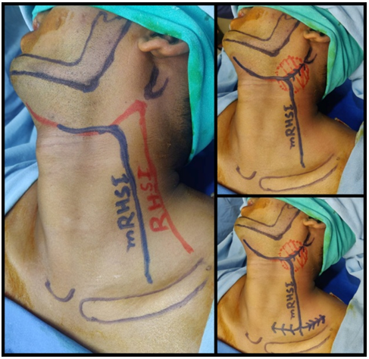
Fig.1. (clockwise) left picture shows the difference in the modification (mRHSI) from the original reverse hockey stick incision (RHSI)
The duration of the procedure was observed from the time of the incision placement to the completion of the neck dissection procedure. The duration in our study does not include the flap closure time since it could not be assessed separately due to the variability in location of the primary tumor.
Wound dehiscence of the neck dissection incision that required re suturing was recorded. Patients with marginal necrosis that were treated conservatively with regular dressing were noted. Surgical site infection if any was recorded in the same.
The scar assessment was recorded during 10th postoperative day (POD) and subsequently over 1 month, 3 months, 6 months up to 3 years follow-up. Scar evaluation was done based on the Vancouver Scar Scale (VSS). ^{[11-13]} Lower the total score, the more the scar represented normal skin [Fig.2]. Since the VSS lacked the patient perspective, we had included an additional record of patient perspective on overall appearance under three categories, unsatisfactory, satisfactory and good.
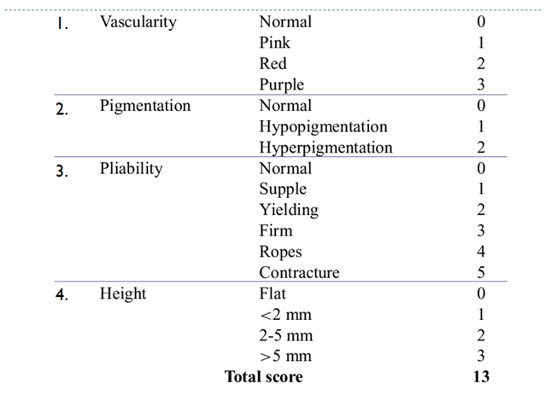
Fig. 2 Vancouver Scar Scale (VSS)
Results:
A total of 537 patients underwent neck dissection for head and neck carcinomas during the above study period. Seventy-four patients were excluded in view of losing to follow-up. Finally, 451 patients were included in the study for analysis. The mean age of the patients was 44.8 years (+/- 12 years SD). The majority of the patients were men (90.9%). Fifty-seven patients had a prior history of chemotherapy and/or radiotherapy. Table.1 shows diagnostic and histopathological data of the participants. Out of 451 patients, 228 (50.5%) patients underwent skin excision as a part of neck dissection. Twenty-seven patients were operated on with a midline lip incision, and 196 patients were operated using the angle split incision.[Table.2]
The mRHSI results in 451 provided excellent exposure without excessive trauma to surrounding tissues, accessibility to the lymphatic and other major structures was optimum with ease in handling of the tissues. Mean dissection time 22.49 ± 1.69 min (95% CI: 22.17-22.81) was significantly shorter than MacFee (42.9 min) and Schobinger (37 min) flap raising times ^{[9]} (p<0.001).
Wound dehiscence that required re-suturing was observed in a total of 11 patients, 2.4% (95% CI: 1.2-4.3%). Marginal necrosis rate 3.1% (95% CI: 1.7-5.1%) was lower than typical 5-15% literature rates.^{[2, 9-14]} The patients were treated with debridement, antibiotics and re-suturing along with proper wound hygiene instructions as indicated [Table 3].
Scar assessment was done using the Vancouver Scar Scale (out of a total of score 13) during the follow up period. A mean of the total score on discharge was 11.43 (+/- 1.37 SD), at 1 month Post op were 10.25 (+/- 1.52 SD), at 3 months post op were 9.56 (+/- 1.44 SD), 6 months post op was 6.32 (+/- 2.17 SD). The 3 year follow-up of 74 patients recorded an average of score of 2.81 out of 13, suggestive of improvement over time (Friedman χ²=452.3, p<0.001). [Table 3].

Table 1: Participant relevant data
Variables |  | N | Percentage
Diagnosis | Oral | 319 | 70.7%
 | Oropharyngeal | 7 | 1.55%
 | Parotid malignancies | 10 | 2.2%
 | Unknown primary | 115 | 25.4%
Type of ND | SND | 5 | 1.1%
 | MRND | 409 | 90.7%
 | RND | 37 | 8.2%
Laterality | Unilateral | 333 | 73.8%
 | Bilateral | 59 | 13.0%
Stage (T) | T1 | 37 | 8.2%
 | T2 | 84 | 18.6%
 | T3 | 73 | 16.2%
 | T4 | 135 | 29.9%
Stage (N) | No | 198 | 43.9%
 | N1 | 74 | 16.4%
 | N2 | 72 | 15.9%
 | N3 | 107 | 23.7%
Histology | SCC | 445 | 98.6%
 | Others | 6 | 1.3%
Grade | 1 | 82 | 18.1%
 | 2 | 311 | 68.9%
 | 3 | 49 | 10.8%
 | unknown | 9 | 1.9%
Table 2: Incision design modifications
Operative details
Technique | Numbers | Percentage
Angle split technique | 196 | 43.4%
Midline lip split technique | 27 | 5.9%
Skin excised modification | 228 | 50.5%

Table 3: Outcome assessment data
Variable |  | Data recorded
Intraoperative outcome | Exposure | -
Intraoperative outcome | Accessibility | -
Intraoperative outcome | Duration | 22.49 ± 1.69 min (95% CI: 22.17-22.81)
Immediate postoperative | Margin flap necrosis | 14 (3.1%, 95% CI: 1.7-5.1%)
Immediate postoperative | Wound dehiscence | 11 (2.4%, 95% CI: 1.2-4.3%)
Immediate postoperative | SSI | 3 (0.7%, 95% CI: 0.1-2.0%)
Follow-up scar assessment  (Vancouver Scar scale- VSS, max=13) | 10th POD (n=451) | 11.43 ± 1.37
 | 1 month (n=451) | 10.25 ± 1.52
 | 3 months (n=451) | 9.56 ± 1.44
 | 6 months (n=377*) | 6.32 ± 2.17
 | 3years (n=74) | 2.81 ± 1.02**
VSS trend over time** Friedman χ² = 432.7, p < 0.001
**Patient satisfaction (6 months)
Good | 279 (61.9%)
Satisfactory | 107 (23.7%)
Unsatisfactory | 68 (15.1%)
*Lost to follow-up progressive: 74 total by 3 years
**Estimated SD based on trend
"Vancouver Scar Scale scores recorded at 6 months showed significant improvement over time (Friedman χ² = 432.7, df = 4, p < 0.001), decreasing from 11.43 at day 10 to 2.81 at 3-year follow-up. Two- hundred and seventy-nine patients (61.86%) gave good feedback [Fig.3], 107 patients (23.72%) with satisfactory feedback and 68 patients with unsatisfactory feedback (15.07%) [Fig. 4].
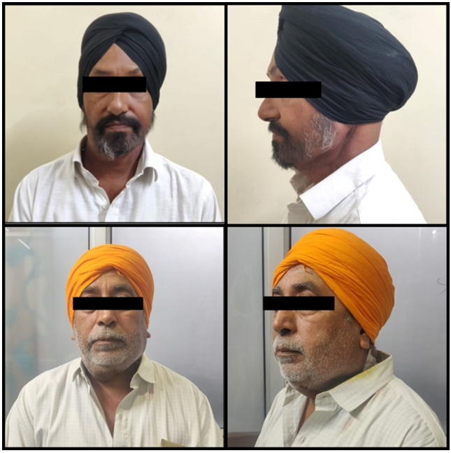
Fig. 3 . Patients who gave positive feedbacks

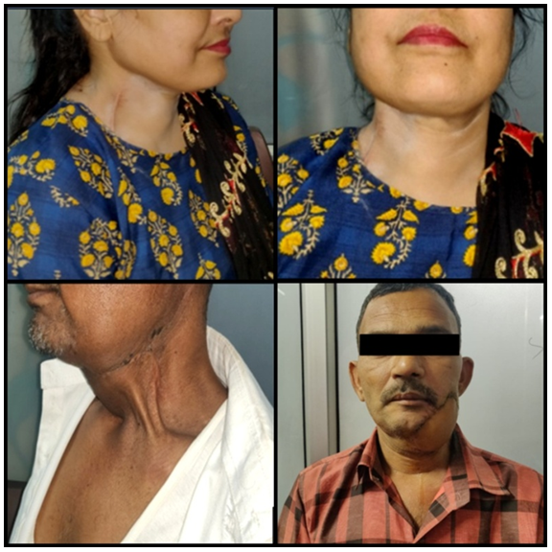
Fig. 4 Pictures represent patient who gave satisfactory feedback (Upper); Pictures represent patients with unsatisfactory feedback (Lower)
Although complications in any procedure are inevitable, related to incision design and cervical flaps remain low. Physical therapy minimized postoperative neck/shoulder morbidity
Discussion:
No incision is universally ideal; however, mRHSI fulfills established incision principles. RHSI although initially popular, is still one of the less commonly used flap designs for neck dissection Optimal exposure is prioritized over cosmesis in oncologic surgery. Although it has been proven in literature, ^{[7-10]} our observation of 451 cases infers that the Modified Reverse Hockey stick Incision (mRHSI) offers to be versatile incision, with excellent exposure of the neck node levels, scar cosmesis, healing, and relatively less duration in raising and closure of the flap.
It is to be noted that there are a few technical advantages of using mRHSI; it allows exploration of the oral cavity without having to retract the cervical skin flap. In most cases, during composite resections involving the submandibular region due to skin involvement, the transverse incision of RHSI can be conveniently modified to adapt to the primary resection. When a level IA or a level II nodal mass along with the platysma needs to be taken as part of the resection mRHSI presents as a viable option, to extend the incision as per convenience.
To ensure the optimum outcome, every surgeon must follow the principles and guidelines of incisions and flaps given by Norman and Bramley ^{[3]} in 1990 such as; incision and flap planning must be based on sound anatomical principles, follow and demarcate the anatomical landmarks, must be designed to give protection to the important structures in the vicinity, provide a relatively bloodless field, provide excellent visibility of the surgical site without tension on the skin flap , easy and efficient execution, easy repair of wound, provide with good cosmesis with fewer functional complications and should be easily reproducible for teaching and learning.

On comparing the results of mRHSI with the available literature on the RHSI, the results showed similar outcomes. The explanation and conclusion given by Goswamy et al ^{[8]} in their study on modified Hockey stick incision in 64 patients, is parallel to the outcome of our study, although our sample is a substantially larger one; that mRHSI is predominantly vertical and aids venous drainage, which is predominantly superior to inferior. As such, predominantly transverse incisions tend to result in signiﬁcantly greater oedema, which is a major cause of ﬂap separation.
Our observation aligns with the results of Omura et al ^{[2]} that the RHSI provides an inconspicuous scar and acceptable cosmesis without interfering with the primary resection. Although the author had mentioned a drawback of skin necrosis at the apex of the flap; we in our study have not observed any skin necrosis. It can be avoided by placing a gentle curve, without an acute angle.
It was observed that the modified reverse hockey-stick incision (mRHSI) yielded satisfactory cosmetic outcomes, as the longitudinal suture line healed without significant contraction or webbing of the neck. Notably, our modification of the RHSI demonstrated comparable aesthetic results, with both longitudinal and transverse incisions effectively concealed by hair or clothing. Although the transverse incision may be partially visible, it remains largely inconspicuous from a frontal perspective, being almost entirely obscured by the lower margin of the mandible.
In a comparative study by Roy et al.^9 evaluating four incision types—the MacFee incision, the modified MacFee incision, the modified Schobinger incision, and the reverse hockey-stick incision—the findings regarding RHSI align closely with our observations. The RHSI was identified as the most versatile of the four, offering an optimal balance between surgical exposure and access to cervical lymph node levels, scar cosmesis, healing efficiency, and relatively shorter procedural duration. While minor variations exist between the RHSI design reported in the literature and our modification, these differences do not affect the overall outcomes and may mitigate certain limitations associated with the conventional RHSI.
The use of this incision came into place after exploring various approaches to the use of a reverse Z-type vertical incision with the horizontal limbs superiorly 3-4cm below the inferior border of the mandible along the skin crease, from the submental region and runs posteriorly to gently curve below the angle of the mandible following the course of the Sternocleidomastoid muscle for the vertical limb to continue 2-3 cm above the sternal head of sternocleidomastoid muscle over the clavicle. This single-surgeon series reflects 4 years of evolving technique refinement at our center, where we adapted RHSI after noticing apex necrosis in initial reverse Z-plasty along with minimizing the duration and to raise a single, large anterior flap and avoid two angle creation. Presently we are preparing a study to compare both these incision designs.
While aligning with surgical and oncological principles, it is also of utmost importance to continuously receive patient feedback or perspective, especially post-operatively, hence we also believe in psychological counselling for patients to understand the nature of the operative procedure along with possible complications they might face. We have observed that this protocol helps the patients and their attendants to understand and accept post-operative morbidity and the limitations they might face. From the patient's perspective, for our study, we have received satisfactory to good feedback on their rate of healing and long-term cosmetic outcome.
This study has some technical and statistical limitations:
- The data on patients lost to follow-up during the 3-year follow-up interval may be notable in terms of scar assessment. Although it did not affect the outcome of our study, the scar assessment is done regardless of the radiation therapy status and effect, and hence a separate statistical analysis on any effect of radiation on the incision could not be obtained.
- Our results may not be entirely applicable to other hands or settings due to the single-surgeon, single-center nature of the study, and the primarily descriptive statistics lacking head-to-head comparisons to other incisions restrict how firmly we can assert superiority; however, the low complication rates and positive patient feedback on cosmesis speak for themselves in routine practice.
- Since there was no control group at the same time, it is difficult to directly compare this with other incision methods; instead, present comparisons are based on established data.

Conclusion:
While complete surgical clearance is of prime importance, a surgeon's experience, training, and preference play a role in planning an approach. Taking into consideration the surgeon’s experience and training, as well as patient-specific factors, we propose that the modified reverse hockey-stick incision (mRHSI) offers optimal surgical exposure, facilitates operative manoeuvrability, and ensures adequate access to cervical structures. Additionally, it is associated with relatively short healing times, favourable cosmetic outcomes, and an acceptable complication profile, without compromising the oncological radicality of the resection when performed in accordance with established anatomical and surgical principles.
.

Consent
As per international standards or university standards, patient(s) written consent has been collected and preserved by the author(s).

Ethical Approval:

As per international standards or university standards written ethical approval has been collected and preserved by the author(s).
COMPETING INTERESTS DISCLAIMER:
Authors have declared that they have no known competing financial interests OR non-financial interests OR personal relationships that could have appeared to influence the work reported in this paper.

Disclaimer (Artificial intelligence)

Author(s) hereby declare that NO generative AI technologies such as Large Language Models (ChatGPT, COPILOT, etc.) and text-to-image generators have been used during the writing or editing of this manuscript.

References:
- Crile G. Excision of cancer of the head and neck. JAMA. 1906;47(18):1780-6.
- Omura S, Bukawa H, Kawabe R, Aoki S, Fugita K. Comparison between hockey-stick and reversed-hockey-stick incision: gently curved single linear neck incisions for oral cancer. Int J Oral Maxillofac Surg 1999;28(3):197-202.
- Patnaik VVG, Singla R, Bala S. Surgical incisions-their anatomical basis Part 1-head and neck. J Anat Soc India. 2000;49(1):69-77.
- MacFee WF. Transverse incisions for neck dissection. Ann Surg. 1960;151(2):279-84.
- White K, Mosdell DM, Morris D (1993) MacFee incision: a safe approach to the neck. South Med J 86:871–874
- Shaw HJ (1988) A modiﬁcation of the MacFee incisions for neck dissection. J Laryngol Otol 102:1124–1126
- Dancey AL, Srivastava S. Experience with the modified hockey stick incision for block dissection of neck. J Plast Reconstr Aesthet Surg. 2006;59(11):1276-9. doi:10.1016/j.bjps.2006.03.054. PMID: 17113503..
- Goswamy, Jay & Murthy, Praduman. (2014). The Modified Hockey-Stick Incision for Neck Dissection. International Journal of Head and Neck Surgery. 5. 22-24. 10.5005/jp-journals-10001-1173.
- Roy S, Shetty V, Sherigar V, Hegde P, Prasad R. Evaluation of Four Incisions Used For Radical Neck Dissection- A Comparative Study. Asian Pac J Cancer Prev. 2019;20(2):575-80. doi:10.31557/APJCP.2019.20.2.575. PMID: 30803224..
- Sabreen N. A comprehensive review of conventional incisions in the neck for neck dissections. International Journal of Research and Review. 2020; 7(10): 306-310
- Vercelli S, Ferriero G, Sartorio F, Stissi V, Franchignoni F. How to assess postsurgical scars: a review of outcome measures. Disabil Rehabil. 2009;31(25):2055-63. doi: 10.3109/09638280902874196. PMID: 19888834.
- Ferriero G, Carlo SD, Ferriero A, Salgovic L, Bravini E, Sartorio F and Vercelli S. Post-surgical scar assessment in rehabilitation: a systematic review. Phys Ther Rehabil. 2015; 2:2. http://dx.doi.org/10.7243/2055-2386-2-2
- Hsu, Ya-Lan RN, BSNª; Hsieh, Chia-En RN, MSNª; Lin, Ping-Yi PhD^{b}; Lin, Shin-Lung MD^{c}; Lin, Kuo-Hua MD^{d}; Weng, Li-Chueh PhDe; Chen, Yao-Li MD^{d,∗}. Postoperative incision scars and cosmetic satisfaction of living liver donors. Medicine: June 11, 2021 - Volume 100 - Issue 23 - p e26187 doi: 10.1097/MD.0000000000026187
- Agrawal SM, Anehosur V. Incidence and Clinical Analysis of Complications of Neck Dissection. Indian J Otolaryngol Head Neck Surg. 2022 Dec;74(Suppl 3):5875-5880. doi: 10.1007/s12070-021-02489-w. Epub 2021 Mar 8. PMID: 36742775; PMCID: PMC9895549.

