Assessment of Irrigation Water Quality in the Experimental Farm of Tiruvannamalai District, Tamil Nadu, India

ABSTRACT
Assessment of irrigation water quality is essential for sustainable agricultural production, particularly in regions where water resources are limited. The present study was carried out to evaluate the irrigation water quality of the experimental farm of Agricultural College and Research Institute, Vazhavachanur, Tiruvannamalai district, Tamil Nadu. Water samples were collected from different blocks and analyzed for physico-chemical parameters such as pH, electrical conductivity (EC), major cations (Ca, Mg, Na, K) and anions (HCO₃⁻, Cl⁻, SO₄²⁻), total dissolved solids (TDS), and total suspended solids (TSS).To assess irrigation water quality, various indices were computed, including Soluble Sodium Percentage (SSP), Potential Salinity (PS), Sodium Adsorption Ratio (SAR), Kelley’s Ratio (KR), Residual Sodium Carbonate (RSC), Permeability Index (PI), and Magnesium Ratio (MR), based on established methods. The results indicated that the pH ranged from 7.01 to 7.75, reflecting neutral to mildly alkaline nature, while EC ranged from 1.40 to 1.60 dS m⁻¹, classifying the water as moderately saline. Computed irrigation water quality indices such as soluble sodium percentage (SSP), sodium adsorption ratio (SAR), sodium ratio, residual sodium carbonate (RSC), permeability index (PI) and magnesium ratio (MR) were also evaluated. The SSP (17.46–32.55%) and SAR (0.99–2.10) values indicated low sodium hazard, while negative RSC values (-16.36 to -7.20 mg L⁻¹) suggested the dominance of calcium and magnesium over carbonate and bicarbonate ions. The sodium ratio values were less than unity, indicating no risk of sodium accumulation. Based on EC, SAR and RSC classification, all water samples were categorized under good quality for irrigation. However, potential salinity values indicated moderate salinity risk, necessitating proper management practices. The irrigation water in the study area is suitable for agricultural use with appropriate soil and water management strategies such as leaching, adequate drainage and cultivation of salt-tolerant crops to ensure long-term soil health and productivity.
Keywords: Irrigation water quality, salinity, SAR, RSC, permeability index, Tiruvannamalai.

1. INTRODUCTION

Water is one of the most vital natural resources, playing a crucial role in sustaining agricultural productivity, environmental balance and human livelihood. Surface water, in particular, is widely utilized for irrigation, drinking and various domestic and industrial purposes (Shukla and Saxena, 2020; Li et al., 2021). In regions where agriculture is predominantly dependent on irrigation, the quality of water becomes a key factor influencing soil health, crop growth and overall farm sustainability. Irrigation refers to the artificial application of water to soil using various methods, including pumps, tubes, and sprays. The need for irrigation typically arises in regions with irregular rainfall, during periods of drought, or in areas prone to frequent soil moisture deficits (Gamal et al., 2023). Irrigation plays a critical role in ensuring food security and supporting economic growth, which underscores the importance of assessing and maintaining the quality of water used for irrigation purposes (Vranešević et al., 2025). Poor quality irrigation water can adversely affect soil structure, permeability and nutrient availability, ultimately leading to reduced crop yields and long-term land degradation.
Assessment of irrigation water quality is therefore essential for the effective management of water resources and for ensuring sustainable agricultural production. Water quality is often considered the most critical aspect of drinking water and is evaluated based on physical, chemical, and bacteriological parameters, as well as overall consumer satisfaction (Giri et al., 2022; Addisie, 2022; Hussein et al., 2024). it is generally evaluated based on its physical and chemical characteristics, including parameters such as pH, electrical conductivity (EC), major cations and anions, and derived indices like sodium adsorption ratio (SAR), residual sodium carbonate (RSC) and soluble sodium percentage (SSP). These parameters provide valuable insights into salinity and sodicity hazards, which are critical in determining the suitability of water for irrigation as per established national and international standards (Khan et al., 2021).
In like Tiruvannamalai district of Tamil Nadu, where water scarcity and groundwater dependency are common, periodic evaluation of irrigation water quality is particularly important. The use of marginal or moderately saline water without proper assessment may lead to gradual deterioration of soil properties and productivity. Hence, systematic monitoring helps in adopting appropriate management practices such as crop selection, leaching and soil amendments (Siddha and Sahu, 2023). The present study was undertaken to assess the irrigation water quality of the experimental farm of Agricultural College and Research Institute, Vazhavachanur, Tiruvannamalai district. The study aims to evaluate the physico-chemical characteristics of irrigation water and to classify its suitability for irrigation based on standard water quality indices.

MATERIALS AND METHODS
The study was conducted at the experimental farm of the Agricultural College and Research Institute, Vazhavachanur, under Tamil Nadu Agricultural University, located in the Tiruvannamalai district. Geographically, the study area lies between 12°4′15″ N and 12°4′45″ N latitude and 77°59′0″ E and 78°59′25″ E longitude (Fig. 1). The region receives an average annual rainfall of 759.4 mm, with mean maximum and minimum temperatures of 38 °C and 21 °C, respectively.
Geologically it is underlain by granites. Bore well is prime source of irrigation and total of 5 bore wells and 1 open well is available.
The water samples were collected in 2-L HDPE bottles during May 2025 for physicochemical analysis according to standard protocols. The water samples were collected at five borewells and one openwell. Ten water quality parameters were analysed using standard protocols.

The groundwater samples were analysed for pH, electrical conductivity (EC), bicarbonate (HCO₃⁻), carbonate (CO₃⁻), chloride (Cl⁻), sulphate (SO₄²⁻), calcium (Ca²⁺), magnesium (Mg²⁺), sodium (Na⁺), potassium (K) and total suspended solids (TSS) by adopting standard procedures.

2.1 Water quality assessment parameters
The water quality parameters were calculated by using the results of chemical analysis of water.
Soluble Sodium Percentage (SSP)
Gupta (1986) proposed this ratio for evaluating water quality. Soluble Sodium Percentage is the proportion of sodium in relation to other cations in water. The formula for calculating SSP is,
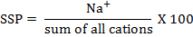
Potential Salinity (PS)
The formula used for calculating Potential Salinity is as follows;
Sodium Adsorption Ratio (SAR) (Richards, 1954)
It is commonly used as an index for evaluating the sodium hazard associated with irrigation water supply. The formula for SAR is
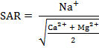
The Sodium ratio
Kelley et al., (1940) proposed this criteria. Sodium measured against Ca²⁺ and Mg²⁺ is used to calculate Kelley’s ratio. The formula used in estimation of Kelley’s ratio is expressed as,
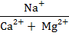
Residual Sodium Carbonate (RSC)
Eaton (1950) proposed this criteria for evaluating water quality.
The Permeability index (PI)

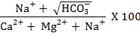
The Magnesium ratio (MR)
Szobolc and Darab, (1964) proposed this criteria. Magnesium ratio is the magnesium content in relation to total divalent cations. The formula for calculating Magnesium ratio is,
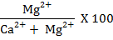

The quality of groundwater samples were also assessed by adopting the following classification (AICRP, 1991).

Table 1. CSSRI criteria for groundwater quality

Class | Quality | EC (dS/m) | RSC (meq/L) | SAR
A | Good | <2.0 | <2.5 | <10
B1 | Marginally Saline | 2-4 | <2.5 | <10
B2 | Saline | >4 | <2.5 | <10
B3 | High SAR Saline | >4 | <2.5 | >10
C1 | Marginally Alkali | <4.0 | 2.5-4.0 | <10
C2 | Alkali | <4.0 | >4.0 | <10
C3 | Highly alkali | Variable | >4.0 | >10

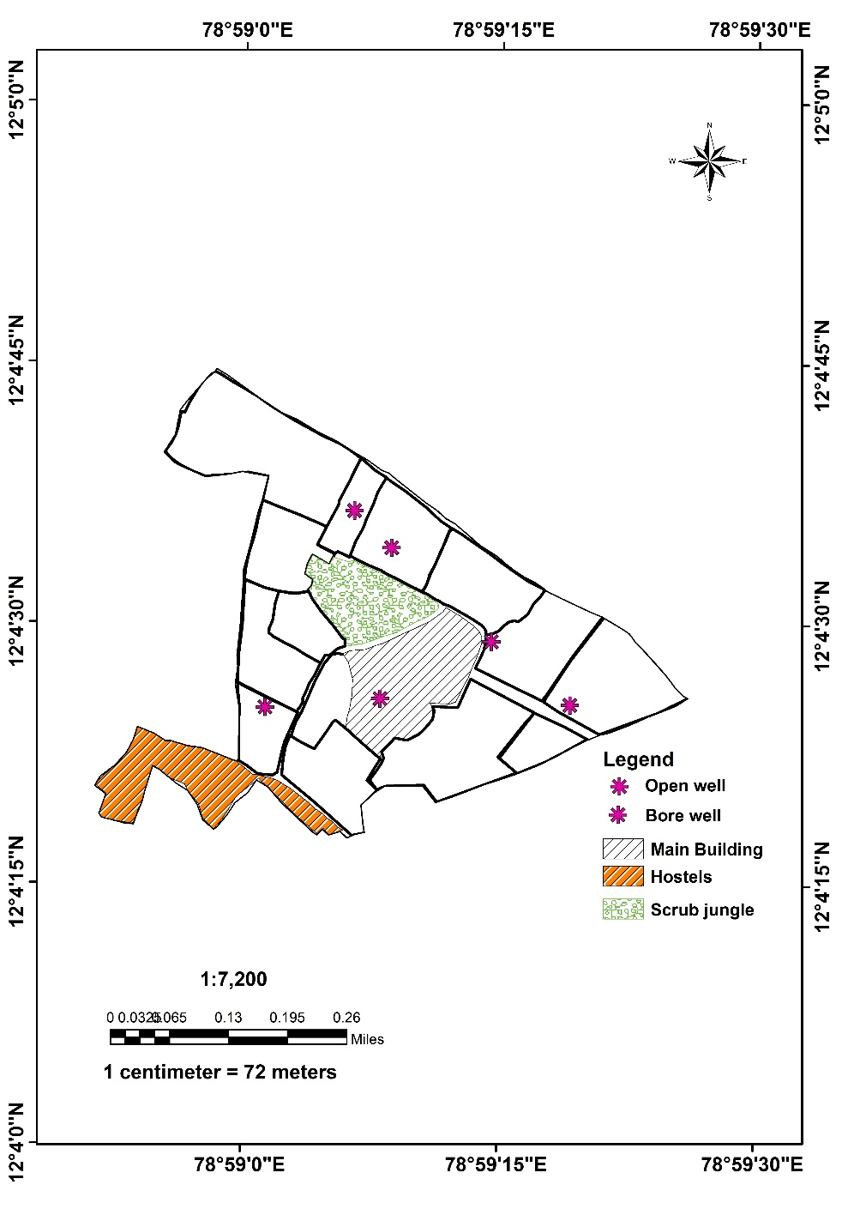
Fig. 1 Map showing well /Borewell locations at AC&RI, Vazhavachanur

3. RESULTS AND DISCUSSION

The irrigation water samples collected from AC & RI, Vazhavachanur exhibited a pH ranging from 7.01 to 7.75 with a mean value of 7.28 (Table 2), indicating neutral to mildly alkaline reaction. Such pH conditions are generally favourable for irrigation as they do not pose any immediate soil acidity or alkalinity hazards (Kumar et al., 2020; Ahmed et al., 2022). The electrical conductivity (EC) varied from 1.40 to 1.60 dS m⁻¹ with a mean of 1.47 dS m⁻¹, classifying the water under moderately saline category. Continuous use of such water may lead to salt accumulation in soil, particularly under poor drainage conditions.

Table 2. Chemical Constituents of Irrigation water of AC & RI, Vazhavachanur

location | pH | EC (dS m⁻¹) | Ca  (mg L⁻¹) | Mg  (mg L⁻¹) | Na  (mg L⁻¹) | K  (mg L⁻¹) | HCO₃  (mg L⁻¹) | Cl  (mg L⁻¹) | SO₄  (mg L⁻¹) | TSS  (mg L⁻¹)
A Block | 7.30 | 1.50 | 3.52 | 10.16 | 2.89 | 1.46 | 4.20 | 6.60 | 142.70 | 960.00
C Block | 7.34 | 1.40 | 1.60 | 10.32 | 3.86 | 1.98 | 4.30 | 5.07 | 130.25 | 896.00
G Block | 7.16 | 1.60 | 11.20 | 9.76 | 4.97 | 5.67 | 4.60 | 7.30 | 124.00 | 1024.00
H Block | 7.10 | 1.40 | 3.20 | 8.80 | 5.79 | 2.48 | 4.80 | 7.50 | 112.81 | 896.00
MBlock | 7.75 | 1.40 | 11.20 | 6.24 | 5.16 | 2.90 | 4.20 | 7.40 | 54.27 | 896.00
P block | 7.01 | 1.50 | 2.56 | 11.92 | 4.42 | 1.98 | 4.40 | 7.10 | 121.97 | 960.00
Minimum | 7.01 | 1.40 | 1.60 | 6.24 | 2.89 | 1.46 | 4.20 | 5.07 | 13.25 | 896.00
Maximum | 7.75 | 1.60 | 11.20 | 11.92 | 5.79 | 5.67 | 4.80 | 7.50 | 142.70 | 1024.00
Mean | 7.28 | 1.47 | 5.55 | 9.53 | 4.52 | 2.75 | 4.40 | 6.83 | 94.83 | 938.67

The concentration of cations revealed that calcium ranged from 1.60 to 11.20 mg L⁻¹ (mean: 5.55 mg L⁻¹, while magnesium varied between 6.24 and 11.92 meq L⁻¹ (mean: 9.53 (mg L⁻¹). Sodium content ranged from 2.89 to 5.79 mg L⁻¹ with a mean of 4.52 mg L⁻¹,and potassium ranged from 1.46 to 5.67 mg L⁻¹ (mean: 2.75 (mg L⁻¹). The relatively higher magnesium concentration compared to calcium in several samples may influence soil structure over prolonged use, though the overall ionic balance appears within permissible limits (Khan et al., 2021).

Among anions, bicarbonate (HCO₃⁻) content ranged from 4.20 to 4.80 mg L⁻¹ with a mean of 4.40 mg L⁻¹, and carbonate was absent in all samples, indicating no risk of carbonate hazard. Chloride concentration ranged from 5.07 to 7.50 mg L⁻¹, (mean: 6.83 mg L⁻¹, falling within safe limits for most crops. Sulphate concentration showed wider variation (13.25 to 142.70 mg L⁻¹; mean: 94.83 (mg L⁻¹)), suggesting differential geochemical influences across sampling locations (Varol et al., 2020; Wang et al., 2020). Total soluble salts (TSS) ranged from 896 to 1024 mg L⁻¹ with a mean of 938.67 mg L⁻¹, supporting the EC-based classification of moderately saline water.

3.1 Computed Quality Parameters of Irrigation Water (Table 3)
The quality parameters of irrigation water viz., soluble sodium percentage (SSP), potential salinity, sodium Absorption Ratio (SAR), sodium ratio, Residual Sodium Carbonate (RSC), permeability index and magnesium ratio in irrigation water of AC &RI, Vazhavachanur.

The soluble sodium percentage (SSP) ranged from 17.46 to 32.55 per cent with a mean value of 23.27 per cent (Table 3). Since all values were below 60 per cent, the irrigation water can be classified as excellent, indicating minimal sodium hazard to soil.

Table 3. Quality parameters of irrigation water in AC & RI, Vazhavachanur

location | SSP | Potential Salinity | SAR | Sodium Ratio | RSC | PI | Magnesium ratio
A Block | 17.46 | 77.95 | 0.99 | 0.21 | -9.48 | 15.26 | 74.27
C Block | 24.46 | 11.70 | 1.48 | 0.32 | -7.72 | 16.85 | 86.58
G Block | 19.18 | 69.30 | 1.24 | 0.24 | -16.36 | 13.24 | 46.56
H Block | 32.55 | 63.91 | 2.10 | 0.48 | -7.20 | 18.11 | 73.33
MBlock | 22.83 | 34.54 | 1.36 | 0.30 | -13.24 | 14.23 | 35.78
P block | 23.37 | 68.09 | 1.51 | 0.30 | -10.08 | 15.52 | 82.32
Mean | 23.27 | 54.24 | 1.44 | 0.30 | -10.68 | 18.64 | 79.77

Potential salinity (PS) varied from 11.70 to 77.95 with a mean of 54.24, suggesting moderate salinity effects depending on soil permeability and leaching conditions (Li et al., 2023). The sodium adsorption ratio (SAR), a key indicator of sodicity hazard, ranged from 0.99 to 2.10 with a mean of 1.44, indicating very low sodium hazard. This suggests that the water is safe for irrigation without risk of soil dispersion or structural degradation.

The sodium ratio ranged from 0.21 to 0.48 (mean: 0.30), and all values were less than 1.0, indicating good quality water with no risk of sodium accumulation (Khan et al., 2021). The residual sodium carbonate (RSC) values ranged from -16.36 to -7.20 (mg L⁻¹) with a mean of -10.68 mg L⁻¹ The negative RSC values indicate an excess of calcium and magnesium over carbonate and bicarbonate, which is beneficial and confirms the suitability of water for irrigation .

The permeability index (PI) ranged from 13.24 to 18.11, indicating that all samples fall well below the critical limit of 65 per cent, thereby suggesting no adverse effect on soil permeability. However, relatively lower PI values indicate the need for proper soil management practices to maintain infiltration characteristics (Siddha and Sahu, 2023). The magnesium ratio ranged from 35.78 to 86.58, and higher values in certain locations may pose a slight risk to soil structure over long-term use.

3.2 Classification of Irrigation Water

Based on EC, SAR and RSC values, all irrigation water samples were classified under ‘Good’ category as per the All India Coordinated Research Project (AICRP) guidelines. The EC values (<2.0 dS m⁻¹), SAR values (<10) and RSC values (<2.5 meq L⁻¹) clearly indicate the suitability of water for irrigation without any significant salinity or sodicity hazard (Kumar et al., 2020; Ahmed et al., 2024).

Further classification based on sodium ratio indicated that all samples fall under class C1 (Na ratio <1.0), suggesting no sodium build-up in soil (Khan et al., 2021). Chloride content placed the samples under excellent to good category, implying no toxicity risk to crops (Varol, 2022). Based on potential salinity, all samples were categorized under class C3 (PS >15), indicating suitability for irrigation particularly in well-drained soils (Li et al., 2023). The permeability index classification grouped all samples under class CII (PI <25), confirming their suitability for irrigation with moderate permeability characteristics (Tiwari et al., 2021).

Table 4. Classification of irrigation water based on Different Parameters
location | EC Class | RSC Class | SAR Class | sodium ratio | Chloride | Potential salinity | permeability Index
A Block | A | A | A | C1 | C2 | C3 | C II
C Block | A | A | A | C1 | C2 | C3 | C II
G Block | A | A | A | C1 | C2 | C3 | C II
H Block | A | A | A | C1 | C2 | C3 | C II
M Block | A | A | A | C1 | C2 | C3 | C II
P block | A | A | A | C1 | C2 | C3 | C II

Overall Interpretation

The overall assessment of irrigation water quality in the study area indicates that the water is suitable for irrigation with low sodicity hazard but moderate salinity risk. Adoption of appropriate management practices such as periodic leaching, selection of salt-tolerant crops, and maintenance of adequate drainage is recommended to prevent long-term soil degradation (Siddha and Sahu, 2023).

4. CONCLUSION
The present investigation on irrigation water quality of the experimental farm at Agricultural College and Research Institute, Vazhavachanur, Tiruvannamalai district revealed that the water is generally suitable for irrigation purposes. The pH of the water samples indicated neutral to mildly alkaline nature, while the electrical conductivity classified the water under moderately saline category. The ionic composition of water showed that the concentrations of major cations and anions were within permissible limits, although relatively higher magnesium and sulphate levels were observed in certain locations.
The computed water quality parameters such as soluble sodium percentage (SSP), sodium adsorption ratio (SAR), sodium ratio and residual sodium carbonate (RSC) indicated low sodicity hazard and confirmed the suitability of water for irrigation. The negative RSC values further suggested the dominance of calcium and magnesium over carbonate and bicarbonate, which is beneficial for maintaining soil structure. The permeability index (PI) and magnesium ratio (MR) also supported the suitability of irrigation water, though continuous monitoring is essential due to moderate salinity levels.
Based on standard classification systems, all water samples were categorized under ‘good’ quality for irrigation with respect to EC, SAR and RSC. However, classification based on potential salinity indicated moderate salinity risk, emphasizing the need for proper soil and water management practices.
Overall, the irrigation water of the study area can be safely used for agricultural purposes with appropriate management strategies such as periodic leaching, maintenance of adequate drainage and selection of salt-tolerant crops to prevent long-term soil degradation and sustain crop productivity.

DISCLAIMER (ARTIFICIAL INTELLIGENCE)
Author(s) hereby declare that NO generative AI technologies such as Large Language Models (ChatGPT, COPILOT, etc) and text-to-image generators have been used during writing or editing of this manuscript.

References
- AICRP (1991). All India Coordinated Research Project on Management of Salt Affected Soils and Use of Saline Water in Agriculture: Annual Report. Indian Council of Agricultural Research (ICAR), New Delhi, India.
- Eaton, F.M. (1950). Significance of carbonates in irrigation waters. Soil Science, 69(2): 123–133.
- Kelley, W.P., Brown, S.M. and Liebig, G.F. (1940). Chemical effects of saline irrigation waters on soils. Soil Science, 49(2): 95–107.
- Khan, S., Shahid, M. and Bibi, S. (2021). Hydrochemical assessment and irrigation suitability of river water using geospatial techniques. Environmental Earth Sciences, 80: 572.
- Kumar, A., Singh, R. and Sharma, P. (2022). GIS-based water quality assessment of river systems using hydrochemical indices. Environmental Monitoring and Assessment, 194: 315.
- Richards, L.A. (Ed.) (1954). Diagnosis and improvement of saline and alkali soils. USDA Agriculture Handbook No. 60, United States Department of Agriculture, Washington, DC, USA.
- Siddha, S. and Sahu, P. (2023). Integrating GIS and irrigation water quality index approaches for identifying groundwater irrigation potential zones in Central Gujarat, India. Environmental Monitoring and Assessment, 195: 1082.
- Szabolcs, I. and Darab, C. (1964). The influence of irrigation water of high sodium carbonate content on soils. In: Proceedings of 8th International Congress of Soil Science, Trans. II, Bucharest, Romania, pp. 803–812.
- Uslu, A., Dugan, S.T. and Muhammetoglu, A. (2024). Comparative evaluation of spatiotemporal variations of surface water quality using water quality indices and GIS. Earth Science Informatics, 17: 4197–4212.
- Varol, M. (2022). Assessment of water quality and pollution status of river systems using water quality indices. Environmental Research, 204: 112345. https://doi.org/10.1016/j.envres.2021.112345
- Varol, M., Gökot, B., Bekleyen, A. and Şen, B. (2020). Spatial and temporal variations in surface water quality of the Tigris River basin using multivariate statistical techniques. Environmental Monitoring and Assessment, 192: 1–14. https://doi.org/10.1007/s10661-020-8104-7
- Yavuz, V.S., Kartal, V. and Sambito, M. (2024). Comparative analysis of water quality in major rivers using hydrochemical and pollution indices. Water, 16(18): 2676. https://doi.org/10.3390/w16182676
- Gamal, Y., Soltan, A., Said, L. A., Madian, A. H., & Radwan, A. G. (2023). Smart irrigation systems: Overview. Ieee Access.
- Vranešević, M., Meseldžija, M., Grabić, J., Zemunac, R., & Boukalova, Z. (2025). Irrigation water quality in a framework of sustainable development goal 6: a review of challenges impacts policy alignments. Frontiers in Agronomy, 7. https://doi.org/10.3389/fagro.2025.1580338
- Addisie, M. B. (2022). Evaluating Drinking Water Quality Using Water Quality Parameters and Esthetic Attributes. Air, Soil and Water Research, 15. https://doi.org/10.1177/11786221221075005
- Hussein, E. E., Derdour, A., Zerouali, B., Almaliki, A., Wong, Y. J., Ballesta-de los Santos, M., Minh Ngoc, P., Hashim, M. A., & Elbeltagi, A. (2024). Groundwater Quality Assessment and Irrigation Water Quality Index Prediction Using Machine Learning Algorithms. Water, 16(2), 264. https://doi.org/10.3390/w16020264
- Giri, A., Bharti, V. K., Kalia, S., Kumar, K., & Khansu, M. (2022). Hydrochemical and quality assessment of irrigation water at the trans-himalayan high-altitude regions of Leh, Ladakh, India. Applied Water Science, 12(8). https://doi.org/10.1007/s13201-022-01716-1

