Emergency Management of Obstructive Uropathy in Resource-Constrained Settings: Current Concepts and Surgical Perspectives

Abstract
Background and aim: Obstructive uropathy is a common urological emergency and an important reversible cause of acute kidney injury. Delayed recognition and inadequate management may lead to irreversible renal damage, sepsis, and increased mortality. Although standardized guidelines exist for the management of urinary obstruction, their implementation remains challenging in many healthcare systems, particularly in resource-constrained settings where access to imaging and specialist care may be limited. A practical, clinically oriented synthesis of current management principles is therefore necessary to guide decision-making in diverse clinical environments.
Methods: A structured narrative review of the literature was conducted using electronic databases including PubMed/MEDLINE, Scopus, and Google Scholar. Relevant articles addressing etiology, pathophysiology, clinical presentation, diagnostic strategies, emergency decompression techniques, complications, and management approaches in resource-limited settings were identified. Priority was given to guideline-based evidence, randomized trials, systematic reviews, and clinically relevant observational studies. Selected findings were synthesized into clinically oriented sections supported by summary tables and a management algorithm.
Results: Obstructive uropathy arises from multiple etiologies, with urolithiasis, malignancy, benign prostatic hyperplasia, and ureteric strictures representing the most common causes in emergency practice. Early recognition of high-risk features—including infection, bilateral obstruction, solitary kidney involvement, and acute kidney injury—is essential in guiding urgent intervention. Both ureteric stenting and percutaneous nephrostomy remain effective methods of decompression, with procedure selection influenced by patient condition, anatomical factors, and resource availability. In resource-constrained environments, ultrasound-based evaluation, early stabilization, and timely referral play a critical role in improving outcomes. Advances in portable imaging, training programs, and referral networks have the potential to further enhance patient care in underserved settings.
Conclusion: Emergency management of obstructive uropathy requires timely diagnosis, prompt decompression, and careful follow-up to prevent irreversible renal injury. Adaptation of established management principles to local resource availability remains essential for improving outcomes. Strengthening diagnostic capacity, procedural training, and referral systems may reduce morbidity and mortality associated with obstructive emergencies, particularly in low-resource healthcare settings.

Keywords: Obstructive uropathy; Urinary obstruction; Emergency decompression; Percutaneous nephrostomy; Ureteric stenting; Hydronephrosis; Resource-constrained settings

2. Introduction
Obstructive uropathy represents a significant and potentially reversible cause of renal dysfunction worldwide. It occurs when urinary flow is impeded at any level of the urinary tract, leading to increased intraluminal pressure, progressive dilation of the collecting system, and ultimately impairment of renal function if left untreated.¹ Although the underlying mechanisms are well described, delays in recognition and intervention continue to contribute to avoidable morbidity and mortality, particularly in emergency settings.
Obstructive nephropathy is an important contributor to acute kidney injury (AKI), accounting for a notable proportion of reversible renal impairment across healthcare systems.² Among the various etiologies, urolithiasis remains the most frequent cause of acute obstruction in adults, with increasing prevalence reported globally over the past decades.³ The rising incidence of stone disease, coupled with aging populations and increasing prevalence of malignancy-related obstruction, has contributed to a growing clinical burden on emergency and urological services.
Early recognition and timely decompression remain the cornerstone of management in obstructive uropathy. International guidelines emphasize that urgent relief of obstruction is essential in patients presenting with infection, renal impairment, or bilateral obstruction, as delays may lead to irreversible renal damage and life-threatening complications.⁴ In addition to surgical decompression, medical optimization—including fluid resuscitation, infection control, and supportive care—plays a central role in improving clinical outcomes.⁵ Despite the availability of standardized recommendations, translating these guidelines into real-world practice often presents challenges, particularly outside tertiary care environments.
A considerable proportion of patients worldwide receive emergency surgical care in resource-limited healthcare systems, where access to advanced imaging, specialist services, and interventional facilities may be restricted.⁶ In such settings, clinical decision-making frequently relies on limited diagnostic resources, delayed referrals, and improvisation of available treatment strategies. These constraints significantly influence patient outcomes and contribute to disparities in survival and long-term renal function.⁷ The management of obstructive uropathy in such environments therefore requires a pragmatic and adaptable approach that integrates available resources with sound clinical judgment.
While several reviews have examined the pathophysiology and management of obstructive uropathy, relatively few have focused specifically on the challenges encountered in resource-constrained settings. Understanding these challenges is particularly relevant in regions where healthcare infrastructure varies widely and timely intervention may not always be feasible. Furthermore, integrating global recommendations with context-specific adaptations may help improve clinical outcomes and reduce preventable complications.
Therefore, the present narrative review aims to summarize current concepts in the emergency management of obstructive uropathy, with particular emphasis on clinical decision-making, decompression strategies, and management pathways applicable to resource-constrained environments. By synthesizing available evidence and highlighting practical considerations, this review seeks to provide a clinically relevant framework that may assist healthcare providers in optimizing patient care across diverse healthcare settings.

3. Methods
Search Strategy and Study Selection
A structured literature search was conducted to identify relevant studies addressing the emergency management of obstructive uropathy. Electronic databases including PubMed/MEDLINE, Scopus, and Google Scholar were searched to retrieve published literature. The search strategy incorporated combinations of keywords such as “obstructive uropathy,” “urinary obstruction,” “hydronephrosis,” “emergency decompression,” “ureteric stent,” “percutaneous nephrostomy,” and “resource-limited settings.” Boolean operators (AND, OR) were used to refine the search and improve retrieval of relevant studies.⁸⁻¹⁰
The search primarily included articles published in English from January 1990 to December 2024, with emphasis placed on clinically relevant studies, guideline recommendations, and high-quality review articles. Reference lists of selected articles were also manually screened to identify additional relevant publications that may not have been captured through database searches. This iterative approach helped ensure broader coverage of the available literature.¹¹
Inclusion and Exclusion Criteria
Studies were considered eligible if they addressed clinical aspects of obstructive uropathy, including etiology, pathophysiology, diagnostic evaluation, emergency management strategies, decompression techniques, and complications. Particular attention was given to studies evaluating ureteric stenting, percutaneous nephrostomy, and management strategies applicable to resource-constrained healthcare settings. Clinical guidelines from recognized international urological associations were also included to support evidence-based recommendations.
Articles that were clearly unrelated to emergency care, focused solely on highly specialized experimental techniques, or lacked clinical applicability were excluded. Where available, priority was given to guideline-based evidence, prospective studies, randomized trials, and systematic reviews to maintain clinical relevance.
Data Synthesis
Given the narrative nature of this review, findings from selected studies were synthesized descriptively rather than through formal meta-analysis. Key themes were identified and organized into clinically relevant sections, including causes of obstruction, diagnostic pathways, emergency indications for decompression, procedural options, complications, and management strategies in resource-limited environments. The aim was to provide a practical and clinically meaningful summary of current concepts rather than an exhaustive statistical comparison of individual studies.
Section 4 — Etiology of Obstructive Uropathy
Obstructive uropathy can arise from a wide range of intrinsic and extrinsic causes affecting different levels of the urinary tract. The underlying etiology often determines the clinical presentation, urgency of intervention, and long-term outcomes. In emergency practice, recognizing the likely cause based on patient demographics and clinical context is essential for timely diagnosis and management. The major etiological categories relevant to emergency settings are summarized in Table 1. The relative contribution of major etiologies of obstructive uropathy is summerized in Figure 3.

4.1 Urolithiasis
Urolithiasis represents the most common cause of acute obstructive uropathy in adults and accounts for a substantial proportion of emergency urological presentations worldwide.¹²,¹³ Ureteric calculi, particularly those lodged in the distal ureter, frequently result in acute obstruction and severe flank pain. Larger calculi or impacted stones may lead to progressive hydronephrosis and deterioration of renal function if not relieved promptly.
Staghorn calculi and recurrent stone disease may present with more chronic obstruction but can still result in acute deterioration, especially in the presence of infection. The coexistence of obstruction and infection represents a particularly dangerous clinical scenario, as it significantly increases the risk of sepsis and renal injury.¹² Early identification and timely decompression are therefore critical in patients with obstructing calculi associated with systemic symptoms.

4.2 Malignancy
Malignant obstruction is another important cause of obstructive uropathy, particularly in older patients. Pelvic malignancies such as prostate, bladder, and cervical cancers frequently lead to ureteric compression or invasion, resulting in progressive hydronephrosis.¹⁴ In many cases, malignant obstruction develops gradually, but acute deterioration may occur due to tumor progression, clot retention, or superimposed infection.
Patients with malignant obstruction often present with nonspecific symptoms, including flank discomfort, hematuria, or declining renal function. Imaging plays a crucial role in identifying the level and cause of obstruction, particularly when malignancy is suspected. In advanced disease, bilateral obstruction may occur, requiring urgent decompression to preserve renal function and facilitate further oncological treatment.

4.3 Benign Prostatic Hyperplasia
Benign prostatic hyperplasia (BPH) remains one of the most common causes of lower urinary tract obstruction in aging male populations.¹⁵ Progressive enlargement of the prostate gland may result in bladder outlet obstruction, urinary retention, and secondary hydronephrosis. Acute urinary retention represents a frequent emergency presentation in elderly men and may be associated with post-renal renal impairment if prolonged.
Although many cases of BPH-related obstruction develop gradually, acute worsening may occur in the presence of infection, medication effects, or dehydration. Early catheterization and subsequent evaluation are essential to prevent complications such as renal dysfunction or recurrent retention episodes.

4.4 Ureteric Strictures
Ureteric strictures represent another significant cause of obstructive uropathy, particularly in patients with a history of previous surgery, inflammation, or chronic infection.¹⁶ Strictures may arise following urological procedures, pelvic surgeries, radiation therapy, or infectious conditions such as genitourinary tuberculosis, which remains relevant in many endemic regions.
Patients with ureteric strictures often present with progressive hydronephrosis and intermittent flank pain. In resource-limited settings, delayed diagnosis may contribute to chronic renal impairment. Early identification through imaging and timely decompression are necessary to prevent long-term damage.

4.5 Pregnancy-Related Causes
Physiological hydronephrosis is a well-recognized finding during pregnancy, particularly during the second and third trimesters.¹⁷ Mechanical compression of the ureters by the gravid uterus, combined with hormonal effects, contributes to dilation of the collecting system. Although typically asymptomatic, symptomatic obstruction may occur in some patients, especially in the presence of concurrent stone disease.
Pregnancy-related obstruction requires careful evaluation, as imaging options may be limited due to concerns regarding fetal radiation exposure. Ultrasound remains the preferred diagnostic modality, and conservative management is often sufficient. However, intervention may be required in cases complicated by infection, persistent pain, or renal dysfunction.

4.6 Other Causes
Less common causes of obstructive uropathy include congenital anomalies, retroperitoneal fibrosis, external compression from lymphadenopathy, and iatrogenic injuries. These conditions may present in both acute and chronic forms, depending on the underlying pathology. In pediatric populations, congenital causes such as pelvi-ureteric junction obstruction and posterior urethral valves are particularly important considerations.
Although individually less frequent, these etiologies should not be overlooked, especially in patients with atypical clinical presentations or recurrent obstruction. A thorough clinical history, combined with appropriate imaging, remains essential for accurate diagnosis.

5. Pathophysiology of Obstructive Uropathy
Obstructive uropathy results from interruption of normal urinary flow, leading to a cascade of physiological and structural changes within the urinary tract and renal parenchyma. The degree of renal injury largely depends on the duration, completeness, and level of obstruction, as well as the presence of infection and underlying renal reserve.¹⁸,¹⁹
Immediately following obstruction, intraluminal pressure rises proximal to the site of blockage, causing dilation of the renal pelvis and calyces. This increase in pressure is transmitted to the renal tubules, resulting in reduced glomerular filtration rate (GFR) and impaired renal perfusion.¹⁹ Initially, compensatory mechanisms attempt to maintain renal blood flow; however, sustained obstruction leads to progressive vasoconstriction and ischemic injury within the renal cortex.²¹
During the early phase of obstruction, renal tubular function becomes impaired due to altered intrarenal hemodynamics and reduced oxygen delivery. These changes lead to decreased sodium reabsorption and impaired concentrating ability, which may manifest clinically as polyuria following relief of obstruction.²⁰ This phenomenon, commonly referred to as post-obstructive diuresis, reflects both osmotic and tubular factors and requires careful monitoring to prevent dehydration and electrolyte imbalance.
If obstruction persists, inflammatory pathways become activated, leading to interstitial fibrosis and tubular atrophy. Chronic obstruction results in irreversible structural damage, characterized by progressive loss of functional nephrons and permanent decline in renal function.¹⁸ Experimental and clinical studies have demonstrated that the duration of obstruction is one of the most critical determinants of long-term renal recovery. Early relief of obstruction significantly improves the likelihood of functional restoration, whereas delayed intervention increases the risk of permanent renal impairment.¹⁹,²¹
In cases of bilateral obstruction or obstruction in a solitary functioning kidney, renal deterioration may occur rapidly. The absence of compensatory function from the contralateral kidney leads to accumulation of metabolic waste products and fluid imbalance, often resulting in acute kidney injury. Clinically, such patients may present with oliguria or anuria and require urgent decompression to prevent life-threatening complications.
The presence of infection further amplifies the severity of renal injury. Obstruction combined with infection creates a closed system that favors bacterial proliferation and increases the risk of urosepsis. Elevated intrapelvic pressure facilitates bacterial translocation into the systemic circulation, contributing to rapid clinical deterioration if not addressed promptly.²⁰ This combination of obstruction and infection represents one of the most dangerous clinical scenarios encountered in emergency urology.
Another important aspect of obstructive pathophysiology is the development of hydronephrosis. Progressive dilation of the collecting system reflects the mechanical consequences of urinary retention upstream from the obstruction. Although hydronephrosis itself is not synonymous with renal failure, persistent dilation is often associated with declining renal function and structural damage over time.
Following relief of obstruction, renal recovery varies depending on the duration and severity of the initial insult. In cases of short-term obstruction, renal function may return to near baseline levels. However, prolonged obstruction frequently results in incomplete recovery, particularly in elderly patients or those with pre-existing renal disease. Careful post-decompression monitoring is therefore essential to detect complications such as post-obstructive diuresis and electrolyte disturbances.
Understanding these pathophysiological processes is important not only for diagnosis but also for guiding the urgency of intervention. Recognition of the time-dependent nature of renal injury reinforces the need for early decompression, particularly in high-risk situations such as bilateral obstruction, solitary kidney involvement, or associated infection. The sequential pathological mechanism underlying obstructive uropathy are illustrated in Figure 4.

6. Clinical Presentation
The clinical presentation of obstructive uropathy varies widely depending on the site, severity, and duration of obstruction, as well as the presence of infection or renal impairment. In many emergency settings, the diagnosis is initially suspected based on history and physical examination before imaging confirmation. Recognizing common patterns of presentation is therefore essential for early intervention and prevention of complications.²²,²³

6.1 Pain
Pain is the most frequent presenting symptom in patients with acute obstruction, particularly in those with ureteric calculi. The classic presentation is acute flank pain, often severe, colicky in nature, and radiating toward the groin. Patients frequently describe difficulty finding a comfortable position and may appear restless during examination. Nausea and vomiting are commonly associated symptoms, particularly in acute ureteric obstruction.
In contrast, pain related to chronic obstruction or malignant causes may be less intense and more persistent. Patients with slowly progressive obstruction may report dull flank discomfort rather than acute colic. In elderly individuals, pain may be less prominent, and diagnosis may be delayed due to atypical presentation.
Pain that fails to respond to standard analgesics should raise suspicion of significant obstruction requiring intervention. Persistent severe pain despite conservative treatment is often considered an indication for decompression, particularly when associated with hydronephrosis or infection.

6.2 Infection and Systemic Features
Infection in the presence of obstruction represents one of the most serious clinical scenarios. Patients may present with fever, chills, tachycardia, and generalized malaise. In more severe cases, systemic inflammatory response or septic shock may develop rapidly.
Obstructive urosepsis is associated with high morbidity and requires urgent intervention. The combination of fever, flank pain, and urinary obstruction should always prompt consideration of infected hydronephrosis or pyonephrosis.²⁴ Early recognition is critical, as delays in decompression significantly increase the risk of mortality.
Elderly patients and those with immunocompromised states may present with less obvious signs of infection. In such cases, subtle symptoms such as confusion, weakness, or unexplained hypotension may be the only early indicators of sepsis.

6.3 Renal Dysfunction
Renal impairment is another important manifestation of obstructive uropathy, particularly in bilateral obstruction or obstruction affecting a solitary kidney. Patients may present with reduced urine output, ranging from oliguria to complete anuria. Fluid overload, electrolyte imbalance, and rising serum creatinine are common findings in such cases.
Acute kidney injury related to obstruction is often reversible if treated promptly. However, prolonged obstruction may result in irreversible renal damage.²⁵ Clinicians should maintain a high index of suspicion in patients presenting with unexplained renal dysfunction, especially when risk factors such as malignancy, stone disease, or prostatic enlargement are present.
Post-obstructive diuresis may occur following relief of obstruction, particularly in patients with bilateral involvement. This phase requires careful monitoring to prevent dehydration and electrolyte disturbances.

6.4 Lower Urinary Tract Symptoms
Lower urinary tract symptoms (LUTS) are commonly seen in patients with bladder outlet obstruction, particularly in older men with benign prostatic hyperplasia. Symptoms may include urinary hesitancy, weak stream, incomplete emptying, frequency, and nocturia.
Acute urinary retention is a frequent emergency presentation in such patients. Individuals may present with severe suprapubic discomfort and inability to void, often requiring immediate catheterization. Although bladder outlet obstruction is often gradual in onset, acute episodes may occur in the presence of infection, medication changes, or dehydration.

6.5 Special Presentations
Certain clinical situations warrant particular attention due to increased risk of complications. Obstruction in pregnancy may present with flank pain and urinary symptoms, but evaluation must be approached cautiously to minimize fetal risk. Similarly, pediatric obstruction may present with recurrent urinary tract infections, failure to thrive, or abdominal mass.
Malignant obstruction may present insidiously, with progressive decline in renal function rather than acute symptoms. Patients with known malignancy should be evaluated carefully when presenting with unexplained renal dysfunction or hydronephrosis.
Another important presentation involves patients with bilateral obstruction or solitary kidney involvement. These cases often progress rapidly and require urgent decompression to prevent permanent renal injury.

7. Diagnostic Evaluation
Accurate and timely diagnosis of obstructive uropathy is essential to guide appropriate management and prevent complications. In most cases, the diagnosis relies on a combination of clinical suspicion, laboratory findings, and imaging studies. The choice of diagnostic modality often depends on patient stability, suspected etiology, and availability of resources. In emergency settings, rapid confirmation of obstruction and identification of complications such as infection or renal impairment are particularly important.²⁶,²⁷ Representative imaging findigs in obstructive uropathy are illustrated in Figure 2

7.1 Laboratory Evaluation
Laboratory investigations provide important information regarding renal function, infection, and metabolic disturbances. Serum creatinine remains one of the most useful indicators of renal impairment and should be measured in all patients with suspected obstruction. A rising creatinine level may suggest bilateral obstruction, solitary kidney involvement, or prolonged obstruction.
Complete blood count and inflammatory markers are useful in detecting infection. Leukocytosis and elevated inflammatory markers often support the diagnosis of infected obstruction, particularly when accompanied by fever or systemic symptoms. Urinalysis may reveal hematuria, pyuria, or bacteriuria, depending on the underlying cause.
Electrolyte disturbances are commonly seen in patients with renal dysfunction, especially in prolonged obstruction. Hyperkalemia represents a particularly dangerous complication and may require urgent management before definitive decompression. Laboratory testing therefore plays a key role in identifying patients at high risk of complications and guiding early intervention.²⁶

7.2 Ultrasound
Ultrasound is widely regarded as the first-line imaging modality in the evaluation of suspected obstructive uropathy, particularly in emergency and resource-limited settings. It is non-invasive, readily available, and free from ionizing radiation. In many district hospitals and smaller centers, ultrasound may be the only imaging modality available.
The most important ultrasound finding in obstruction is hydronephrosis, which appears as dilation of the renal pelvis and calyces. The severity of hydronephrosis may provide indirect information about the duration and degree of obstruction. Ultrasound can also identify bladder distension, post-void residual urine, and certain causes such as stones or prostatic enlargement.
Despite its advantages, ultrasound has limitations. Small ureteric stones, particularly in the mid-ureter, may be difficult to visualize. In obese patients or those with excessive bowel gas, image quality may be compromised. Nevertheless, ultrasound remains extremely valuable as an initial diagnostic tool, especially when rapid decision-making is required.²⁹

7.3 Computed Tomography
Computed tomography (CT), particularly non-contrast CT of the kidneys, ureters, and bladder (CT KUB), is considered the gold standard imaging modality for suspected ureteric obstruction. It provides detailed visualization of stone size, location, and degree of obstruction. CT imaging is particularly useful in patients with atypical symptoms or when ultrasound findings are inconclusive.
Non-contrast CT offers high sensitivity and specificity for detecting urinary calculi and can also identify alternative diagnoses such as appendicitis, diverticulitis, or abdominal masses. In emergency practice, CT imaging has significantly improved diagnostic accuracy and reduced unnecessary surgical interventions.²⁸
In cases of suspected malignant obstruction, contrast-enhanced CT or CT urography may provide additional information regarding tumor location and extent. However, the use of contrast must be carefully considered in patients with impaired renal function.

7.4 Imaging in Resource-Constrained Settings
In many parts of the world, advanced imaging such as CT may not be immediately available. In such environments, clinical assessment combined with ultrasound findings often guides early management decisions. The absence of advanced imaging should not delay urgent intervention when clinical suspicion of obstructed infection or renal compromise is high.
Portable ultrasound devices have become increasingly useful in remote and low-resource settings. With adequate training, bedside ultrasound can assist clinicians in detecting hydronephrosis and guiding referral decisions. In situations where imaging availability is limited, clinical judgment plays a critical role in determining the need for urgent decompression or transfer to higher centers.³⁰,³¹

7.5 Special Diagnostic Considerations
Certain clinical situations require modification of diagnostic strategies. In pregnant patients, ultrasound remains the preferred imaging modality due to concerns regarding fetal radiation exposure. If additional imaging is required, magnetic resonance imaging (MRI) may be considered as an alternative to CT in selected cases.
In pediatric populations, ultrasound is also the primary diagnostic tool due to its safety profile. Early recognition of congenital causes of obstruction is important to prevent long-term renal damage.
In critically ill patients, rapid bedside imaging may be necessary to confirm obstruction and guide urgent intervention. In such cases, the emphasis should be placed on speed and clinical utility rather than diagnostic perfection.

8. Emergency Management
Emergency management of obstructive uropathy focuses on rapid stabilization of the patient, identification of high-risk features, and timely relief of obstruction. The urgency of intervention depends largely on the presence of infection, renal impairment, bilateral involvement, or obstruction affecting a solitary kidney. In many emergency settings, management decisions must be made before complete diagnostic clarity is achieved, making clinical judgment an essential component of care.³²,³³ A stepwise clinical approach to the emergency management of obstructive uropathy is illustrated in Figure 1.

8.1 Initial Stabilization
The first priority in suspected obstructive uropathy is assessment of the patient’s overall clinical condition. Hemodynamic stability should be evaluated immediately, with attention to blood pressure, heart rate, urine output, and mental status. Patients presenting with fever, hypotension, or signs of systemic infection require urgent resuscitation.
Initial stabilization typically includes intravenous fluid administration to restore circulating volume and maintain renal perfusion. In patients with suspected infection, broad-spectrum antibiotics should be initiated as early as possible, ideally after obtaining appropriate cultures. Delay in antibiotic administration has been associated with increased morbidity, particularly in cases of obstructive urosepsis.³²
Pain management is another important aspect of early care. Non-steroidal anti-inflammatory drugs and opioids are commonly used to control severe flank pain. Persistent pain despite adequate analgesia should raise suspicion of significant obstruction requiring intervention.
In cases of bladder outlet obstruction, immediate bladder catheterization is often necessary to relieve retention and reduce patient discomfort. This simple intervention can rapidly improve symptoms and prevent further renal deterioration.

8.2 Indications for Emergency Decompression
Not all patients with obstruction require immediate intervention; however, certain clinical situations mandate urgent decompression. The most critical indication is obstructed infection, where delayed drainage may result in rapid progression to sepsis or septic shock. The key clinical indications requiring urgent urinary decompression are summarized in Table 2.
Other important indications include anuria, bilateral obstruction, obstruction in a solitary functioning kidney, and acute kidney injury associated with obstruction. Progressive hydronephrosis accompanied by worsening renal function should also prompt consideration of urgent drainage.
In patients with persistent severe pain that does not respond to conservative treatment, decompression may be required to provide symptomatic relief. Similarly, malignant obstruction with declining renal function often requires intervention to preserve renal reserve and allow further oncological treatment.³³,³⁴
Recognition of these indications is particularly important in resource-limited environments, where delays in referral or intervention may significantly worsen outcomes. The temporal progression of renal injury following untreated obstruction is depicted in Figure 6.

8.3 Ureteric Stenting
Ureteric stenting is a commonly used method for relieving ureteric obstruction. The procedure involves placement of a double-J stent through cystoscopic access, allowing internal drainage of urine from the kidney to the bladder. A comparison between ureteric stenting and percutaneous nephrostomy, including procedural considerations and clinical indications, is presented in Table 3.
Stenting is generally preferred in stable patients when retrograde access to the ureter is feasible. It provides effective decompression while avoiding the need for an external drainage device, which improves patient comfort and mobility. In many centers, ureteric stenting is performed under general or regional anesthesia and can be completed relatively quickly.
Despite its advantages, ureteric stenting may be technically challenging in cases of severe obstruction, distorted anatomy, or advanced malignancy. Failure to access the ureter may necessitate conversion to percutaneous nephrostomy. Additionally, stent-related symptoms such as urinary frequency, urgency, and discomfort are relatively common and may affect patient quality of life.³⁵,³⁷

8.4 Percutaneous Nephrostomy
Percutaneous nephrostomy (PCN) represents an alternative method of urinary diversion and is often preferred in critically ill or unstable patients. The procedure involves placement of a drainage catheter directly into the renal pelvis through a percutaneous approach, typically under ultrasound or fluoroscopic guidance.
PCN offers several advantages in emergency situations. It can be performed under local anesthesia, making it suitable for patients who are hemodynamically unstable or unfit for general anesthesia. It is also particularly useful in cases where retrograde stenting is not possible due to severe obstruction or anatomical distortion.
However, PCN requires ongoing catheter care and may be associated with complications such as bleeding, infection, or catheter displacement. The presence of an external drainage tube may also reduce patient comfort and mobility. Nevertheless, in patients with obstructive urosepsis, PCN remains one of the most reliable methods for achieving rapid decompression.³⁶,³⁸

8.5 Choosing Between Ureteric Stent and PCN
The decision between ureteric stenting and percutaneous nephrostomy depends on several factors, including patient stability, availability of expertise, anatomical considerations, and local resources. In stable patients with accessible ureters, ureteric stenting is often preferred due to its internal drainage mechanism and better patient comfort.
In contrast, PCN is generally favored in unstable patients, particularly those with septic shock or severe infection, where rapid decompression is essential. It is also the preferred option when retrograde stenting fails or when ureteric obstruction is associated with complex anatomical changes.
Comparative studies have demonstrated that both ureteric stenting and PCN are effective methods of decompression, with similar overall success rates. However, technical success rates may be slightly higher with PCN in complex cases.³⁷,³⁹ The choice of procedure should therefore be individualized based on patient characteristics and institutional capabilities.
In resource-constrained settings, the decision is often influenced by equipment availability and operator expertise. Facilities lacking cystoscopic capabilities may rely more heavily on ultrasound-guided PCN, whereas centers with trained urologists may favor ureteric stenting. A compatative overview of ureteric stenting and percutaneous nephrostomy is presented in Figure 5.

9. Management in Resource-Constrained Settings
Management of obstructive uropathy in resource-constrained settings presents challenges that differ significantly from those encountered in well-equipped tertiary centers. Limited access to advanced imaging, specialist expertise, and interventional facilities often delays diagnosis and definitive treatment. In many district hospitals, clinicians are required to make early management decisions using minimal diagnostic information, making structured clinical judgment particularly important.⁴⁰,⁴¹

9.1 Challenges in Resource-Limited Environments
One of the most common limitations in resource-constrained settings is restricted availability of imaging modalities. While CT imaging remains the gold standard for evaluating urinary obstruction, many centers rely primarily on ultrasound due to cost, infrastructure, and availability constraints. This reliance on ultrasound requires clinicians to develop familiarity with indirect signs of obstruction, such as hydronephrosis and bladder distension.
Another major challenge involves delayed patient presentation. In many settings, patients may seek medical attention only after symptoms become severe, often due to limited transportation, financial barriers, or lack of awareness. As a result, clinicians frequently encounter advanced disease, including infected hydronephrosis, renal failure, or bilateral obstruction.
Human resource limitations also play a significant role. The absence of trained urologists or interventional radiologists may restrict the ability to perform ureteric stenting or percutaneous nephrostomy. In such situations, patients often require referral to higher centers, which may introduce additional delays.⁴²

9.2 Role of Ultrasound in Decision-Making
Ultrasound plays a central role in the evaluation of obstructive uropathy in limited-resource environments. Its portability, relatively low cost, and safety profile make it an invaluable tool for early diagnosis. Even when CT imaging is unavailable, identification of moderate to severe hydronephrosis on ultrasound may be sufficient to justify urgent intervention or referral.
Bedside ultrasound is particularly useful in emergency situations, allowing rapid confirmation of obstruction and facilitating timely decision-making. In many remote settings, portable ultrasound devices have improved access to imaging and enabled earlier detection of complications.
Although ultrasound may not always identify the exact cause of obstruction, its ability to confirm hydronephrosis makes it an effective screening tool. In patients with compatible clinical features, ultrasound findings alone may be sufficient to proceed with decompression or referral when clinical risk is high.⁴³

9.3 Stabilization Prior to Referral
In situations where definitive intervention is not immediately available, stabilization of the patient becomes the primary objective. This includes administration of intravenous fluids, correction of electrolyte abnormalities, and initiation of broad-spectrum antibiotics when infection is suspected.
Early stabilization is particularly important in patients with obstructive urosepsis, where delays in antibiotic therapy significantly increase mortality risk. Adequate resuscitation prior to transfer can improve patient stability and reduce complications during transport.
Bladder catheterization should be performed promptly in patients with suspected bladder outlet obstruction. This simple procedure may relieve symptoms and prevent further renal deterioration while arrangements for referral are made.
Clear communication with referral centers is also important to ensure continuity of care. Providing relevant clinical details, laboratory findings, and imaging results can help reduce delays once the patient reaches the receiving facility.⁴⁴

9.4 Decision-Making with Limited Resources
Clinical decision-making in constrained environments often relies on a combination of patient history, physical findings, and basic imaging results. When advanced diagnostics are unavailable, clinicians must prioritize recognition of high-risk features such as fever, anuria, severe pain, or signs of renal impairment.
Patients presenting with suspected obstructed infection should be considered high priority for urgent referral, even if definitive imaging is not available locally. Delaying referral while awaiting confirmatory tests may lead to clinical deterioration.
Where trained personnel and equipment are available, ultrasound-guided percutaneous nephrostomy may be performed safely even in non-tertiary settings. Expanding training opportunities in basic interventional techniques has the potential to improve outcomes in regions where specialist services are limited. A structured decision-making framework applicable to resource-constrained settings is outlined in Table 4.

9.5 Importance of Training and System Strengthening
Improving outcomes in obstructive uropathy requires not only individual clinical expertise but also strengthening of healthcare systems. Training healthcare providers in early recognition of obstruction, interpretation of ultrasound findings, and emergency stabilization protocols can significantly improve patient outcomes.
Establishing referral networks and improving communication between peripheral centers and tertiary hospitals are equally important. Standardized protocols for managing obstructive emergencies can help reduce delays and improve consistency of care.
Investment in basic infrastructure, including portable ultrasound machines and essential interventional equipment, has the potential to reduce morbidity associated with delayed diagnosis and treatment. Such measures are particularly relevant in regions where the burden of obstructive uropathy is high and healthcare resources remain limited.⁴¹

10. Outcomes After Emergency Decompression
Relief of urinary obstruction is the primary goal of emergency management, and clinical outcomes largely depend on the timing of intervention and the patient’s baseline condition. In many cases, decompression leads to rapid symptomatic improvement; however, recovery of renal function and resolution of infection may vary depending on the duration and severity of obstruction. Understanding expected outcomes helps guide monitoring and long-term management decisions.⁴⁵,⁴⁶

10.1 Renal Recovery
Renal recovery following decompression depends strongly on how long the obstruction has been present and whether the obstruction is unilateral or bilateral. In cases of short-term obstruction, particularly when treated promptly, renal function often improves significantly after drainage. Many patients demonstrate gradual normalization of serum creatinine over several days.
However, prolonged obstruction may result in permanent structural damage and incomplete recovery. Studies have shown that delayed relief of ureteral obstruction is associated with persistent renal impairment, particularly in elderly patients or those with pre-existing renal disease.⁴⁵ Chronic obstruction leads to interstitial fibrosis and loss of functional nephrons, reducing the likelihood of full renal recovery.
Post-obstructive diuresis is a commonly observed phenomenon after relief of bilateral obstruction or long-standing hydronephrosis. Patients may produce large volumes of urine during the initial recovery phase, reflecting impaired tubular concentrating ability and osmotic diuresis. This phase requires close monitoring of fluid balance and electrolytes to prevent dehydration and electrolyte disturbances.⁴⁶

10.2 Resolution of Infection
In patients with infected obstruction, relief of urinary obstruction is considered a critical component of source control. Antibiotic therapy alone is often insufficient if drainage is delayed. Once decompression is achieved, clinical improvement is usually observed within the first 24 to 48 hours, with reduction in fever, improvement in hemodynamic stability, and normalization of inflammatory markers.
Prompt drainage of infected systems has been associated with reduced morbidity and shorter hospital stays. In contrast, delayed intervention may result in persistent infection, septic shock, or multi-organ dysfunction. The combination of antimicrobial therapy and timely decompression therefore remains essential in the management of obstructive urosepsis.⁴⁷

10.3 Mortality and Long-Term Outcomes
Mortality in obstructive uropathy is most commonly associated with delayed treatment, particularly in patients presenting with infection or septic shock. Studies have demonstrated that postponement of decompression in patients with obstructing stones and infection significantly increases mortality risk.⁴⁸ This emphasizes the importance of early recognition and rapid intervention.
Long-term outcomes also depend on the underlying cause of obstruction. Patients with malignant obstruction often require ongoing drainage or repeat procedures, and overall prognosis may be influenced more by the primary malignancy than by the obstruction itself. In contrast, patients with stone-related obstruction generally experience favorable outcomes when intervention is timely.
Follow-up evaluation remains important after emergency decompression. Monitoring renal function, imaging findings, and recurrence risk helps guide further management and prevents progression to chronic kidney disease. In many cases, definitive treatment of the underlying cause is required to prevent recurrence of obstruction.
11. Complications of Emergency Decompression
Although emergency decompression of the urinary system is generally safe and highly effective, complications may occur depending on the procedure performed, patient condition, and duration of device placement. Most complications are minor and manageable; however, serious adverse events can occur, particularly in critically ill patients or those with complex anatomy. Awareness of potential complications allows early recognition and timely intervention, reducing the risk of long-term morbidity.⁴⁹,⁵¹ Common complications associated with emergency urinary decompression procedures are summarized in Table 5.

11.1 Complications Related to Ureteric Stenting
Ureteric stenting is widely used for relief of obstruction, but it is not without associated complications. One of the most common issues encountered is stent-related discomfort, often described as urinary frequency, urgency, flank pain, or suprapubic discomfort. These symptoms are usually mild but may significantly affect patient quality of life, particularly when stents remain in place for extended periods.
Stent migration represents another recognized complication. Improper positioning or patient movement may result in displacement of the stent, leading to inadequate drainage or recurrent obstruction. In such cases, repositioning or replacement of the stent is usually required.
Encrustation and blockage may occur when stents remain in situ for prolonged periods. The risk of encrustation increases significantly with duration of placement, particularly beyond several weeks.⁵⁰ Encrusted stents may become difficult to remove and occasionally require additional procedures.
Infection is another potential complication. Although stents are placed to relieve obstruction, they may serve as a nidus for bacterial colonization, particularly in patients with prolonged indwelling times. Prompt recognition and treatment with appropriate antibiotics are usually sufficient in most cases.⁴⁹

11.2 Complications Related to Percutaneous Nephrostomy
Percutaneous nephrostomy (PCN) is generally considered safe, but it carries its own set of risks, particularly those related to percutaneous access. Bleeding is among the most frequently reported complications and may occur due to injury to renal vessels during needle insertion. Most cases involve minor bleeding, but significant hemorrhage may occasionally require intervention.
Catheter dislodgement is another common issue, particularly in patients who are mobile or require prolonged drainage. Dislodged tubes may result in loss of drainage and recurrence of obstruction, necessitating reinsertion of the catheter.
Local infection at the insertion site may also occur. Patients may develop redness, discharge, or localized pain around the catheter site. Regular catheter care and dressing changes help reduce the risk of infection.
In rare instances, injury to adjacent organs such as the colon or pleura may occur, particularly when anatomical landmarks are difficult to identify. These complications are uncommon but require prompt recognition and appropriate management.⁵¹,⁵²

11.3 General Procedural Complications
Some complications are not specific to either ureteric stenting or PCN but may occur following any decompression procedure. Recurrent obstruction may occur due to device blockage, tumor progression, or stone migration. In such cases, repeat intervention is often necessary.
Persistent infection may occur despite adequate drainage, particularly in patients presenting late or with extensive infection. Continued antibiotic therapy and reassessment of drainage adequacy are required in such situations.
Another important consideration is patient discomfort and reduced mobility, particularly in individuals with external drainage devices. The presence of a nephrostomy tube may limit physical activity and require adjustments in daily routines.
Long-term complications may include chronic dependence on drainage devices, especially in patients with malignant obstruction. These patients often require ongoing monitoring and periodic device replacement.
12. Special Situations
Certain clinical scenarios require modification of standard management strategies due to increased risk of complications or limited physiological reserve. These situations demand earlier intervention and closer monitoring, as delays may lead to rapid deterioration. Among these, pregnancy, bilateral obstruction, and obstruction in a solitary kidney represent particularly important clinical considerations.⁵³⁻⁵⁶

12.1 Obstructive Uropathy in Pregnancy
Obstructive uropathy during pregnancy presents unique diagnostic and therapeutic challenges. Physiological hydronephrosis is commonly observed during pregnancy, particularly on the right side, due to mechanical compression of the ureter by the enlarging uterus and hormonal relaxation of smooth muscle.⁵³ Although this condition is usually asymptomatic, it may complicate the diagnosis of true obstruction.
Symptomatic obstruction during pregnancy is most often related to ureteric calculi. Patients typically present with flank pain, nausea, or urinary symptoms. Evaluation should be approached cautiously, with ultrasound serving as the preferred imaging modality due to its safety and absence of radiation exposure.⁵⁴ When ultrasound findings are inconclusive, magnetic resonance imaging may be considered in selected cases.
Management decisions must balance maternal benefit and fetal safety. Conservative treatment with hydration and analgesia is appropriate in many cases, particularly when symptoms are mild. However, intervention becomes necessary when obstruction is associated with infection, persistent pain, or renal dysfunction.
Ureteric stenting is generally preferred when intervention is required, as it provides effective drainage while minimizing procedural risk. Percutaneous nephrostomy may be used as an alternative when stenting is not feasible. Close follow-up is essential throughout pregnancy, as recurrent obstruction may occur due to anatomical changes.

12.2 Bilateral Obstruction
Bilateral urinary obstruction represents a true medical emergency due to the risk of rapid deterioration in renal function. Unlike unilateral obstruction, where the contralateral kidney may compensate, bilateral obstruction results in progressive accumulation of metabolic waste products and fluid imbalance.
Patients typically present with oliguria or anuria, often accompanied by signs of renal failure such as fluid overload or electrolyte abnormalities. Laboratory findings frequently reveal rising creatinine and potassium levels, which may pose immediate life-threatening risks.
Prompt decompression is essential in bilateral obstruction, even when symptoms appear mild. Delay in intervention significantly increases the likelihood of permanent renal damage.⁵⁵ In many cases, bilateral drainage may be required to restore adequate urine flow and improve renal function.
Post-decompression monitoring is particularly important in these patients, as post-obstructive diuresis is more commonly observed following bilateral obstruction. Careful attention to fluid balance and electrolyte replacement helps prevent dehydration and metabolic disturbances.

12.3 Obstruction in a Solitary Kidney
Obstruction affecting a solitary functioning kidney requires urgent evaluation and intervention due to the absence of compensatory renal function. This situation may occur in patients with congenital absence of one kidney, previous nephrectomy, or severe contralateral renal dysfunction.
Clinical presentation often includes reduced urine output, rising creatinine, and symptoms related to obstruction. Even partial obstruction in a solitary kidney may lead to rapid deterioration in renal function.
Urgent decompression is recommended once obstruction is identified.⁵⁶ The choice between ureteric stenting and percutaneous nephrostomy depends on patient condition and available expertise. In many cases, early intervention results in significant recovery of renal function.
Long-term follow-up is necessary in patients with solitary kidneys, as recurrent obstruction or delayed treatment may result in permanent renal impairment. Preventive strategies, including monitoring for recurrent stone disease or structural abnormalities, play an important role in preserving renal function.

13. Future Directions
The management of obstructive uropathy continues to evolve with improvements in imaging technology, procedural techniques, and healthcare delivery systems. While the fundamental principles of stabilization and timely decompression remain unchanged, recent developments have focused on improving early diagnosis, expanding procedural access, and strengthening healthcare networks, particularly in underserved regions.⁵⁷⁻⁶⁰

13.1 Expanding Role of Portable Imaging
Portable imaging technologies are increasingly influencing the early diagnosis of obstructive uropathy, particularly in remote and resource-limited environments. The growing availability of compact ultrasound devices has made bedside imaging more accessible in emergency settings. These devices allow rapid identification of hydronephrosis and facilitate early referral decisions.
Training non-specialist healthcare providers in focused ultrasound techniques has shown promise in improving diagnostic accuracy in peripheral centers. In settings where CT imaging remains unavailable, enhanced ultrasound capability may significantly reduce delays in recognition of obstruction.⁵⁷ Portable ultrasound systems are also useful in emergency departments and rural clinics, where rapid decision-making is often required with limited resources.
As technology advances, the affordability and portability of ultrasound equipment are expected to improve further. Wider adoption of handheld imaging devices may help bridge diagnostic gaps and improve access to care in areas with limited infrastructure.

13.2 Training and Skill Development
Improving outcomes in obstructive uropathy depends not only on equipment availability but also on the availability of trained personnel. Expanding training opportunities for healthcare providers in emergency urological procedures represents an important step toward improving patient care.
Basic training in ultrasound-guided procedures, including percutaneous nephrostomy placement, has been explored in several healthcare systems. With appropriate supervision and structured protocols, these skills may be safely introduced into district-level hospitals. Such initiatives have the potential to reduce referral delays and improve timely access to decompression procedures.⁵⁹
In addition to procedural training, education in early recognition of obstructive emergencies is equally important. Standardized clinical pathways and simulation-based training may improve clinician confidence and reduce delays in intervention.

13.3 Strengthening Referral and Telemedicine Networks
Another important development involves the expansion of referral networks and telemedicine-based support systems. In many regions, remote consultation with specialists has improved decision-making in peripheral hospitals. Telemedicine platforms allow clinicians to share imaging findings, discuss management plans, and coordinate patient transfers more efficiently.
Improved communication between primary, secondary, and tertiary care centers may help streamline referral pathways and reduce unnecessary delays. In emergency situations, early specialist input may influence decisions regarding stabilization and urgency of transfer.
Telemedicine may also support training and mentorship in smaller hospitals, allowing junior clinicians to gain confidence in managing obstructive emergencies. Although technological and infrastructure challenges remain, continued investment in digital health systems is likely to improve coordination of care in resource-limited settings.⁶⁰

14. Conclusion
Obstructive uropathy remains a common and potentially reversible cause of renal dysfunction that frequently presents in emergency settings. The clinical course is often determined by the speed of recognition and the timing of intervention. Early identification of high-risk features such as infection, bilateral obstruction, or involvement of a solitary kidney is critical in preventing irreversible renal damage and reducing mortality.⁶¹
Timely decompression remains the central principle in the management of obstructive uropathy. Both ureteric stenting and percutaneous nephrostomy are effective methods of relieving obstruction, and the choice of procedure should be guided by patient condition, anatomical considerations, and available expertise. In many cases, appropriate stabilization and rapid decision-making can significantly influence outcomes, even before definitive intervention is performed.⁶²
Management in resource-constrained settings presents additional challenges, including limited access to imaging, specialist care, and interventional facilities. In such environments, reliance on clinical assessment, early stabilization, and timely referral plays a particularly important role. Strengthening basic diagnostic capabilities and improving referral systems may help reduce delays and improve patient outcomes in these settings.
Overall, successful management of obstructive uropathy depends on a structured clinical approach that emphasizes early recognition, appropriate decompression, and careful follow-up. Continued efforts to improve training, expand access to imaging, and strengthen healthcare infrastructure are likely to further enhance outcomes, particularly in regions where resources remain limited.

Availability of Data and Materials
All data supporting the findings of this study are derived from previously published articles and guidelines, which are cited within the manuscript. No new datasets were generated or analyzed during the preparation of this review.

COMPETING INTERESTS DISCLAIMER:
Authors have declared that they have no known competing financial interests OR non-financial interests OR personal relationships that could have appeared to influence the work reported in this paper.
Disclaimer (Artificial intelligence)
Author(s) hereby declare that NO generative AI technologies such as Large Language Models (ChatGPT, COPILOT, etc.) and text-to-image generators have been used during the writing or editing of this manuscript.

References
- Klahr S, Harris K, Purkerson ML. Obstructive nephropathy. N Engl J Med. 1988;318(12):776–783.
- Chávez-Iñiguez JS, Navarro-González JF, Medina-González R, et al. Acute kidney injury caused by obstructive nephropathy. Kidney Int Rep. 2020;5(9):1420–1430.
- Scales CD Jr, Smith AC, Hanley JM, Saigal CS. Prevalence of kidney stones in the United States. Eur Urol. 2012;62(1):160–165.
- Türk C, Neisius A, Petřík A, et al. EAU guidelines on urolithiasis. Eur Urol. 2023.
- Pearle MS, Goldfarb DS, Assimos DG, et al. Medical management of kidney stones: AUA guideline. J Urol. 2014;192(2):316–324.
- Mock CN, Donkor P, Gawande A, et al. Essential surgery: key messages from Disease Control Priorities. Lancet. 2015;385(9983):2209–2219.
- Shrime MG, Dare AJ, Alkire BC, et al. Global burden of surgical disease. Lancet Glob Health. 2015;3(S2):S8–S9.
- Briscoe S. Search methods for evidence synthesis. Res Synth Methods. 2015;6(2):93–105.
- Bramer WM, Rethlefsen ML, Kleijnen J, Franco OH. Optimal database combinations for literature searches. Syst Rev. 2017;6:245.
- Page MJ, McKenzie JE, Bossuyt PM, et al. The PRISMA 2020 statement. BMJ. 2021;372:n71.
- Green BN, Johnson CD, Adams A. Writing narrative literature reviews. J Chiropr Med. 2006;5(3):101–117.
- Türk C, Neisius A, Petřík A, et al. EAU guidelines on urolithiasis. Eur Urol. 2023.
- Romero V, Akpinar H, Assimos DG. Kidney stones: global epidemiology. Rev Urol. 2010;12(2–3):e86–e96.
- Rosevear HM, Lightfoot AJ, Assimos DG. Malignant ureteral obstruction. Eur Urol. 2012;61(3):558–565.
- Gratzke C, Bachmann A, Descazeaud A, et al. EAU guidelines on management of non-neurogenic male LUTS. Eur Urol. 2015;67(6):1099–1109.
- López-Huertas HL, et al. Management of ureteral strictures: current options. World J Urol. 2015;33(1):55–61.
- Puskar D, Balagović I, Filipović A, et al. Symptomatic physiologic hydronephrosis in pregnancy. Eur Urol. 2001;39(3):260–263.
- Klahr S. New insights into obstructive nephropathy. Am J Kidney Dis. 1991;18(6):689–699.
- Chevalier RL, Thornhill BA, Forbes MS, Kiley SC. Mechanisms of renal injury in obstructive uropathy. Kidney Int. 2009;75(11):1145–1152.
- Chávez-Iñiguez JS, et al. Acute kidney injury in obstructive nephropathy. Kidney Int Rep. 2020;5(9):1420–1430.
- Klahr S, Morrissey J. Obstructive nephropathy and renal injury. Kidney Int. 2002;62(2):698–703.
- Türk C, et al. EAU guidelines on urolithiasis. Eur Urol. 2023.
- Assimos D, Krambeck A, Miller NL, et al. Surgical management of stones: AUA guideline. J Urol. 2016;196(4):1153–1160.
- Singer M, Deutschman CS, Seymour CW, et al. The third international consensus definitions for sepsis and septic shock (Sepsis-3). JAMA. 2016;315(8):801–810.
- Kellum JA, Lameire N, Aspelin P, et al. KDIGO clinical practice guideline for acute kidney injury. Kidney Int Suppl. 2012;2(1):1–138.
- Mehta RL, Kellum JA, Shah SV, et al. Acute Kidney Injury Network report. Crit Care. 2007;11(2):R31.
- Bonkat G, Bartoletti R, Bruyère F, et al. EAU guidelines on urological infections. Eur Urol. 2023.
- Smith RC, Rosenfield AT, Choe KA, et al. Diagnosis of acute flank pain: value of unenhanced CT. N Engl J Med. 1995;332(5):300–305.
- Moore CL, Scoutt LM. Sonography in acute flank pain. Radiology. 2012;263(3):675–685.
- Mock CN, et al. Essential surgical systems. Lancet. 2015;385:2209–2219.
- Shrime MG, et al. Global surgical disease burden. Lancet Glob Health. 2015;3:S8–S9.
- Rhodes A, Evans LE, Alhazzani W, et al. Surviving sepsis campaign guidelines. Intensive Care Med. 2017;43(3):304–377.
- Bonkat G, et al. EAU urological infections guidelines. Eur Urol. 2023.
- Türk C, et al. Emergency decompression recommendations. Eur Urol. 2023.
- Assimos D, et al. AUA surgical management guideline. J Urol. 2016;196(4):1153–1160.
- Wah TM, Weston MJ, Irving HC. Percutaneous nephrostomy insertion outcomes. Cardiovasc Intervent Radiol. 2004;27(4):341–345.
- Pearle MS, Pierce HL, Miller GL, et al. Prospective randomized trial comparing ureteral stent vs nephrostomy. J Urol. 1998;160(4):1260–1264.
- Zul Khairul Azwadi MN, et al. PCN vs ureteral stent meta-analysis. Sci Rep. 2021;11:6613.
- Mokhmalji H, Braun PM, Martinez Portillo FJ, et al. Percutaneous nephrostomy vs ureteral stent placement. J Urol. 2001;165(4):1088–1092.
- Mock CN, et al. Essential surgery global perspective. Lancet. 2015;385:2209–2219.
- Meara JG, Leather AJM, Hagander L, et al. Global surgery 2030. Lancet. 2015;386(9993):569–624.
- Chao TE, Sharma K, Mandigo M, et al. Surgical care capacity in low-income countries. World J Surg. 2012;36(6):1207–1216.
- Watterson JD, Soon S, Jana K. Ultrasound-guided percutaneous nephrostomy. J Endourol. 2001;15(5):473–476.
- Radecka E, Magnusson A. Complications associated with percutaneous nephrostomies. Acta Radiol. 2004;45(2):184–188.
- Lucarelli G, et al. Delayed relief of ureteral obstruction outcomes. J Urol. 2013;189(3):960–965.
- Chevalier RL. Pathogenesis of renal injury in obstruction. Kidney Int. 2006;69(1):20–29.
- Wagenlehner FM, et al. Urosepsis epidemiology and management. Eur Urol. 2013;63(5):872–880.
- Blackwell RH, et al. Delayed decompression and mortality. J Urol. 2016;195(3): 1–7.
- Damiano R, et al. Complications of double-J ureteral stent placement. J Urol. 2002;167(2):703–706.
- El-Faqih SR, et al. Ureteral stent morbidity and encrustation. J Urol. 1991;146(6):1487–1491.
- Wah TM, et al. PCN complication rates. Cardiovasc Intervent Radiol. 2004;27:341–345.
- Farrell T, Hicks ME. Percutaneous nephrostomy complications. Radiology. 1997;203(3):593–596.
- Puskar D, et al. Hydronephrosis in pregnancy. Eur Urol. 2001;39(3):260–263.
- White WM, et al. Imaging in pregnancy-related urolithiasis. J Urol. 2007;178(3): 1–7.
- Klahr S, Morrissey J. Bilateral obstruction outcomes. Kidney Int. 2002;62(2):698–703.
- Türk C, et al. Solitary kidney obstruction management. Eur Urol. 2023.
- Kim C, et al. Point-of-care ultrasound in low-resource settings. Lancet Glob Health. 2017;5:e000–e000.
- Shokoohi H, et al. Ultrasound expansion in limited-resource systems. Crit Ultrasound J. 2015;7:21.
- Meara JG, et al. Global surgical training initiatives. Lancet. 2015;386:569–624.
- Scott RE, Mars M. Telehealth in resource settings. J Glob Health. 2015;5(1):010301.
- Klahr S, Morrissey J. Progression of obstructive nephropathy. Kidney Int. 2002;62:698–703.
- Türk C, et al. Emergency decompression recommendations. Eur Urol. 2023.

Table 1 — Causes of Obstructive Uropathy
Etiology of Obstructive Uropathy with Clinical Characteristics and Emergency Risk

Etiological Category | Specific Causes | Common Anatomical Level | Typical Patient Population | Clinical Features | Emergency Risk Level | Preferred Initial Diagnostic Modality | Common Emergency Intervention
Urolithiasis | Ureteric calculi (proximal, mid, distal ureter) | Upper urinary tract | Adults (20–60 yrs), males > females | Acute flank pain, hematuria, nausea, vomiting | High | CT KUB¹ | Ureteric stenting or PCN²
 | Renal calculi causing pelvi-ureteric obstruction | Renal pelvis | Adults | Flank pain, hydronephrosis | Moderate–High | CT KUB¹ | PCN or ureteroscopy²
 | Staghorn calculi | Renal pelvis | Chronic stone formers | Recurrent infection, flank discomfort | High | CT KUB¹ | PCN with staged intervention²
Malignancy | Prostate cancer | Bladder outlet | Elderly males (>60 yrs) | LUTS, urinary retention | Moderate–High | Ultrasound ± CT³ | Catheterization or stenting²
 | Bladder cancer | Distal ureter | Elderly patients | Hematuria, obstruction | Moderate | CT Urography³ | Ureteric stenting²
 | Cervical cancer | Distal ureter | Adult females | Pelvic mass symptoms | Moderate–High | Ultrasound³ | PCN²
 | Retroperitoneal tumors | Ureter | Adults | Flank pain, hydronephrosis | Moderate | CT Scan³ | PCN²
Benign Prostatic Hyperplasia (BPH) | Enlarged prostate causing bladder outlet obstruction | Lower urinary tract | Elderly males (>50 yrs) | LUTS, retention, overflow incontinence | Moderate | Ultrasound⁴ | Catheterization
Ureteric Strictures | Post-surgical strictures | Ureter | Surgical history patients | Progressive obstruction | Moderate | CT or Ultrasound⁴ | Stenting
 | Inflammatory strictures | Ureter | Young–middle aged | Chronic flank pain | Moderate | Ultrasound⁴ | Stenting
 | Tubercular strictures | Ureter | Endemic regions | Chronic symptoms | Moderate–High | Ultrasound⁴ | PCN
Pregnancy-related | Physiological hydronephrosis | Right ureter > left | Pregnant females | Flank discomfort | Low–Moderate | Ultrasound⁵ | Conservative ± stenting
 | Pregnancy-associated calculi | Ureter | Pregnant females | Acute flank pain | Moderate | Ultrasound⁵ | Stenting
Congenital Causes | Pelvi-ureteric junction obstruction | Upper tract | Pediatric population | Recurrent UTI | Moderate | Ultrasound⁶ | PCN
 | Posterior urethral valves | Urethra | Neonates | Poor urinary stream | High | Ultrasound⁶ | Catheterization
External Compression | Retroperitoneal fibrosis | Ureter | Middle-aged adults | Flank pain | Moderate | CT Scan³ | PCN
 | Lymphadenopathy | Ureter | Oncology patients | Gradual obstruction | Moderate | CT Scan³ | PCN
Iatrogenic Causes | Post-surgical injury | Ureter | Surgical patients | Acute obstruction | High | CT Scan³ | PCN
 | Radiation fibrosis | Ureter | Oncology patients | Chronic obstruction | Moderate | CT Scan³ | Stenting

Risk Level | Meaning
High | Requires urgent decompression (hours)
Moderate–High | Likely intervention required
Moderate | Monitor closely
Low–Moderate | Conservative initially

Footnotes
¹ CT KUB (non-contrast computed tomography of kidneys, ureters, and bladder) remains the gold standard for diagnosis of ureteric obstruction.
² Urinary diversion via ureteric stent or percutaneous nephrostomy is recommended in obstructed systems requiring urgent decompression.
³ CT-based imaging is preferred for identifying malignant causes of obstruction.
⁴ Ultrasound remains a useful first-line investigation in lower urinary tract obstruction.
⁵ Ultrasound is the preferred imaging modality during pregnancy due to radiation safety.
⁶ Ultrasound is the primary imaging modality in congenital obstructive conditions.

Table 2 — Indications for Emergency Urinary Decompression
Clinical Indications for Emergency Decompression in Obstructive Uropathy
Clinical Indication | Definition / Diagnostic Criteria | Clinical Features | Emergency Priority Level | Preferred Initial Intervention | Alternative Intervention | Expected Clinical Outcome if Treated Early
Obstructive Urosepsis | Urinary obstruction with infection and systemic inflammatory response | Fever, tachycardia, hypotension, leukocytosis | Immediate (within hours) | Ureteric stent¹ | Percutaneous nephrostomy (PCN)² | Resolution of sepsis, reduced mortality
Septic Shock with Obstruction | Persistent hypotension requiring vasopressors with obstruction | Hypotension, altered sensorium, organ dysfunction | Immediate (life-saving) | PCN² | Ureteric stent¹ | Improved survival and hemodynamic stability
Anuria due to Bilateral Obstruction | Absence of urine output due to bilateral ureteric obstruction | Anuria, renal failure signs | Urgent | PCN² | Bilateral stenting¹ | Recovery of renal function
Obstruction in Solitary Kidney | Obstruction affecting single functioning kidney | Reduced urine output | Urgent | Ureteric stent¹ | PCN² | Prevention of permanent renal damage
Acute Kidney Injury due to Obstruction | Rising creatinine with imaging-confirmed obstruction | Oliguria, fluid overload | Urgent | PCN² | Stenting¹ | Improvement of renal function
Infected Hydronephrosis (Pyonephrosis) | Presence of pus within obstructed collecting system | Fever, flank pain | Immediate | PCN² | Stenting¹ | Resolution of infection
Persistent Severe Pain | Pain refractory to analgesics | Severe flank pain | Semi-urgent | Stenting¹ | PCN² | Symptom relief
Progressive Hydronephrosis | Increasing hydronephrosis on imaging | Worsening renal function | Urgent | PCN² | Stenting¹ | Renal preservation
Malignant Obstruction with Renal Dysfunction | Tumor causing obstruction with renal impairment | Weight loss, hydronephrosis | Urgent | PCN² | Stenting¹ | Renal function stabilization
Post-operative Obstruction | Iatrogenic ureteric injury | Acute obstruction symptoms | Urgent | PCN² | Stenting¹ | Prevent long-term damage
Obstruction during Pregnancy | Symptomatic obstruction confirmed on imaging | Flank pain, infection | Urgent | Stenting¹ | PCN² | Maternal and fetal protection
Obstructive Hematuria with Clot Retention | Obstruction due to clot formation | Hematuria | Urgent | Catheterization³ | Stenting¹ | Relief of obstruction
Failure of Conservative Therapy | Persistent obstruction despite medication | Pain or infection persists | Urgent | Stenting¹ | PCN² | Symptom resolution
High-Risk Patients (Elderly, Immunocompromised) | Obstruction with risk factors | Rapid deterioration risk | Urgent | PCN² | Stenting¹ | Reduced morbidity

Priority Level | Suggested Timeline
Immediate | Within hours
Urgent | Within 6–12 hours
Semi-urgent | Within 24 hours

Footnotes
¹ Ureteric stenting is widely used for rapid decompression of obstructed systems when retrograde access is feasible.
² Percutaneous nephrostomy (PCN) is preferred in cases of severe infection, difficult ureteric access, or unstable patients.
³ Bladder catheterization remains essential in lower urinary tract obstruction.
Reference:

Table 3 — Comparison of Ureteric Stenting vs Percutaneous Nephrostomy
Comparison of Ureteric Stent and Percutaneous Nephrostomy for Emergency Urinary Decompression

Parameter | Ureteric Stenting | Percutaneous Nephrostomy (PCN)
Definition | Placement of internal ureteral stent via cystoscopy | Placement of external drainage tube into renal pelvis
Route of Access | Retrograde (via urethra and bladder) | Percutaneous (through flank into kidney)
Primary Purpose | Internal drainage of obstructed ureter | External drainage of obstructed collecting system
Typical Clinical Setting | Stable patient with accessible ureter | Unstable or septic patient
Anesthesia Requirement | General or regional anesthesia¹ | Local anesthesia ± sedation²
Procedure Location | Operating theatre | Radiology suite / bedside
Technical Difficulty | Moderate | Moderate–High
Time to Perform | 20–40 minutes | 15–30 minutes
Success Rate | 80–95%³ | 90–98%³
Preferred in Septic Shock | Less preferred | Preferred²
Preferred in Severe Infection | Possible | Preferred²
Preferred in Pregnancy | Often preferred | Alternative option
Preferred in Malignancy | Common | Common
Preferred in Bilateral Obstruction | Used when feasible | Often preferred
Use in Solitary Kidney | Yes | Yes
Radiation Exposure | Possible fluoroscopy | Ultrasound-guided possible
Pain Relief Speed | Rapid | Rapid
Drainage Type | Internal | External
Need for External Device | No | Yes
Patient Comfort | Better long-term comfort | Less comfortable due to tube
Mobility After Procedure | Normal | Limited mobility
Hospital Stay Duration | Short | Slightly longer
Risk of Failure | Higher if ureter inaccessible | Lower
Risk of Bleeding | Low | Moderate⁴
Risk of Infection | Moderate | Moderate
Risk of Tube Dislodgement | None | Present
Risk of Encrustation | Possible with prolonged use⁵ | Less common
Ease of Replacement | Requires cystoscopy | Easier external exchange
Monitoring Requirements | Routine follow-up | Tube monitoring required
Cost Consideration | Moderate | Moderate–High
Availability in Resource Settings | Limited in rural centers | Often feasible
Training Requirement | Urologist required | Radiologist/urologist required
Suitability in Difficult Anatomy | Limited | Better
Use in Obstructive Urosepsis | Possible | Preferred²
Long-Term Management Role | Temporary | Temporary or long-term
Typical Complications | Migration, encrustation | Bleeding, dislodgement
Patient Quality of Life | Better | Lower
Follow-Up Needs | Scheduled removal | Regular tube care
Overall Clinical Utility | Highly effective | Highly effective
Footnotes
¹ Ureteric stenting typically requires cystoscopic access under general or regional anesthesia.
Reference:
² Percutaneous nephrostomy is recommended in septic or unstable patients due to rapid drainage capability.
³ Success rates for both ureteric stenting and PCN are high, with slightly higher technical success reported for PCN in complex obstruction.
⁴ Bleeding risk is a known complication of PCN due to vascular injury during access.
⁵ Stent encrustation risk increases with prolonged indwelling time.

Table 4 — Decision-Making in Resource-Constrained Settings
Clinical Decision Framework for Emergency Management of Obstructive Uropathy in Resource-Constrained Settings

Clinical Scenario | Available Resources | Key Clinical Findings | Recommended Initial Action | Alternative Strategy | Referral Requirement | Risk of Delay | Expected Outcome if Managed Promptly
Suspected ureteric obstruction with stable vitals | Ultrasound available | Flank pain, hydronephrosis | Ultrasound confirmation¹ | Clinical monitoring | Referral if worsening | Moderate | Symptom relief, prevention of renal damage
Suspected septic obstruction | Ultrasound available | Fever, tachycardia | Immediate antibiotics² | Urgent PCN | Immediate referral | High | Reduction in mortality risk
Obstruction with AKI | Limited laboratory access | Oliguria | Initiate fluid resuscitation³ | Transfer to higher center | Required | High | Renal recovery
Bilateral obstruction | Basic imaging only | Anuria | Emergency decompression² | Transfer if unavailable | Mandatory | Very High | Renal preservation
Solitary kidney obstruction | Ultrasound available | Reduced urine output | Urgent stenting or PCN² | Transfer | Mandatory | Very High | Prevent permanent renal loss
Malignant obstruction | Ultrasound available | Hydronephrosis | PCN² | Stenting | Referral for oncology care | Moderate | Renal stabilization
Pregnancy-related obstruction | Ultrasound available | Flank pain | Conservative management⁴ | Stenting if required | Conditional | Moderate | Maternal safety
Obstruction with limited imaging | Clinical diagnosis only | Severe flank pain | Clinical stabilization³ | Referral | Recommended | Moderate | Symptom control
Pediatric obstruction | Ultrasound available | UTI symptoms | Ultrasound-based diagnosis¹ | Referral | Required | Moderate | Infection control
Post-surgical obstruction | Ultrasound available | Acute flank pain | Urgent imaging¹ | PCN | Referral | High | Renal preservation
Obstructive uropathy in remote settings | Minimal infrastructure | Delayed presentation | Stabilize and transfer⁵ | Empirical antibiotics | Mandatory | Very High | Survival improvement
Recurrent obstruction | Ultrasound available | Repeat symptoms | Repeat imaging¹ | PCN | Referral | Moderate | Prevent chronic damage
Elderly frail patient | Basic imaging | Urinary retention | Catheterization⁶ | Referral | Conditional | Moderate | Symptom relief
Immunocompromised patient | Ultrasound available | Infection risk | Early antibiotics² | PCN | Referral | High | Reduced mortality
Obstruction with severe pain | Limited imaging | Refractory pain | Analgesia and referral³ | PCN | Recommended | Moderate | Pain control

Footnotes
¹ Ultrasound is recommended as the first-line imaging modality in resource-limited environments due to its availability and safety profile.
² Emergency urinary decompression using ureteric stenting or PCN is recommended in cases of infection, sepsis, or renal impairment.
³ Initial stabilization, including fluid resuscitation and analgesia, remains essential before definitive intervention.
⁴ Conservative management is preferred in pregnancy when feasible, with ultrasound as the preferred imaging modality.
⁵ Timely referral remains critical in resource-constrained settings where definitive intervention is unavailable.
⁶ Bladder catheterization remains first-line treatment for lower urinary tract obstruction.

Table 5 — Complications of Emergency Urinary Decompression
Comparison of Complications Associated with Ureteric Stenting and Percutaneous Nephrostomy

Complication Category | Ureteric Stenting | Percutaneous Nephrostomy (PCN) | Clinical Severity | Typical Management
Infection | Urinary tract infection | Catheter-site infection | Moderate | Antibiotics
Sepsis | Possible if drainage delayed | Possible | High | Urgent antibiotics
Hematuria | Mild hematuria common | More frequent due to tract formation | Mild–Moderate | Observation
Bleeding | Rare | More common | Moderate | Hemostasis
Stent Migration | Common complication | Not applicable | Mild–Moderate | Repositioning
Tube Dislodgement | Not applicable | Common | Moderate | Tube replacement
Stent Encrustation | Risk increases with duration | Rare | Moderate | Stent replacement
Obstruction Recurrence | Possible | Possible | Moderate | Reintervention
Pain/Discomfort | Bladder irritation symptoms | Flank discomfort | Mild–Moderate | Analgesia
Urinary Leakage | Rare | Pericatheter leakage | Mild–Moderate | Dressing care
Device Blockage | Possible | Possible | Moderate | Irrigation
Ureteral Injury | Rare | Not typical | Moderate | Surgical repair
Adjacent Organ Injury | Rare | Possible | Severe | Surgical management
Quality-of-Life Impact | Urinary urgency symptoms | External device burden | Mild–Moderate | Counseling
Long-Term Complications | Encrustation, biofilm formation | Chronic tube dependency | Moderate | Scheduled follow-up
Need for Reintervention | Moderate frequency | Moderate | Moderate | Device replacement
Hospital Readmission | Possible | Possible | Moderate | Medical management
Device Maintenance Burden | Minimal | High | Moderate | Nursing support
Skin Complications | None | Local irritation | Mild | Dressing care
Patient Mobility Restriction | Minimal | Moderate | Mild–Moderate | Support measures

Footnotes
¹ Ureteric stent-related complications include infection, migration, and encrustation.
² Encrustation risk increases significantly with prolonged stent duration.
³ Percutaneous nephrostomy complications include bleeding and catheter dislodgement.
⁴ Catheter-related complications may require reintervention.

Figure 1
Emergency Management Algorithm for Obstructive Uropathy in Resource-Constrained Settings

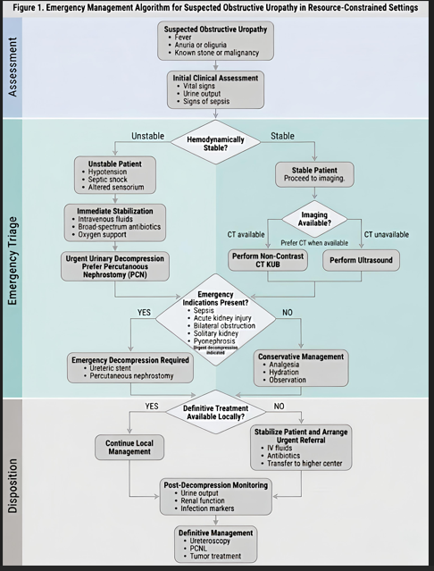
This figure illustrates a structured clinical approach to the emergency management of suspected obstructive uropathy. The algorithm outlines sequential steps beginning with clinical suspicion, initial stabilization, assessment of hemodynamic status, imaging selection, identification of emergency indications, and selection of decompression methods. The model emphasizes decision-making in resource-constrained settings, including stabilization and referral pathways where definitive intervention is unavailable. Post-decompression monitoring and definitive management pathways are also included.

Figure 2
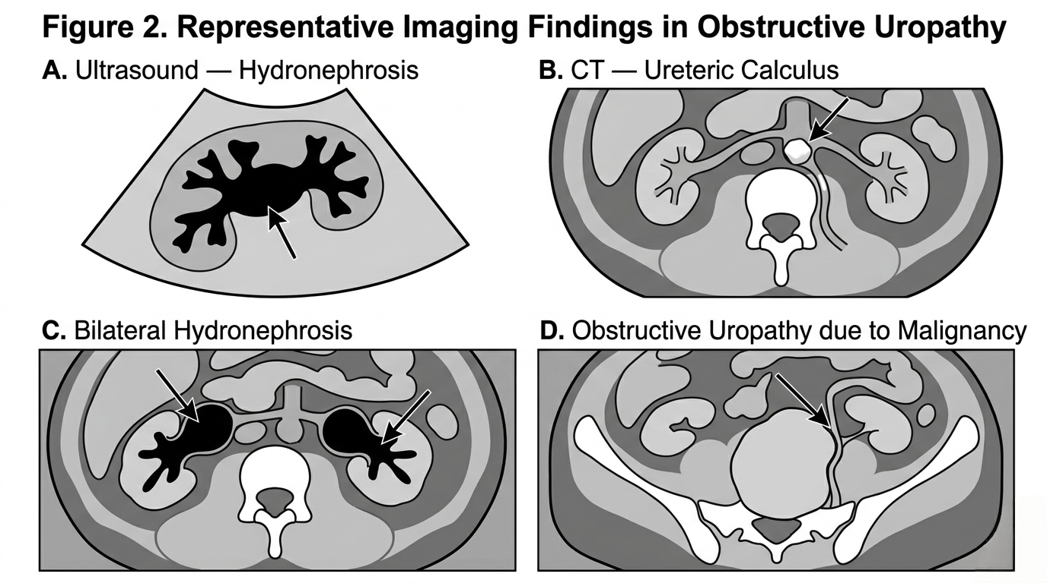
Figure 2. Representative imaging findings in obstructive uropathy.
This figure presents schematic representations of common imaging findings associated with obstructive uropathy.
(A) Ultrasound demonstrating hydronephrosis with dilatation of the renal pelvis and calyces.
(B) Non-contrast CT illustrating ureteric calculus causing proximal obstruction.
(C) CT representation of bilateral hydronephrosis with dilated collecting systems.
(D) CT representation of obstructive uropathy secondary to pelvic malignancy with proximal urinary tract dilatation.

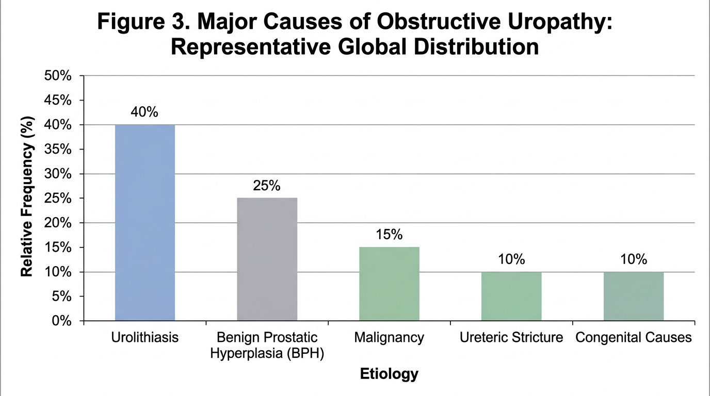
Figure 3
Figure 3. Major causes of obstructive uropathy: representative distribution of common etiologies.
This bar chart illustrates the relative contribution of major etiologies of obstructive uropathy based on representative epidemiological patterns reported in the literature. Urolithiasis remains the most frequent cause, followed by benign prostatic hyperplasia, malignancy, ureteric stricture, and congenital causes.
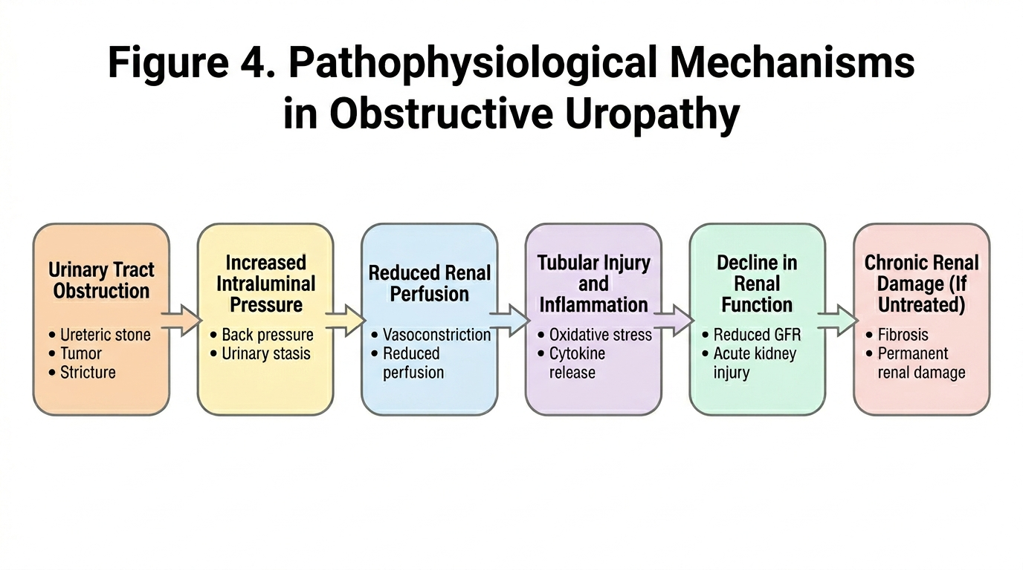
Figure 4
Figure 4. Pathophysiological mechanisms involved in obstructive uropathy.
This schematic diagram demonstrates the sequential pathophysiological events that occur following urinary tract obstruction. Increased intraluminal pressure results in reduced renal perfusion, leading to tubular injury and inflammatory responses. Persistent obstruction ultimately results in decline in renal function and progression to chronic renal damage if untreated.
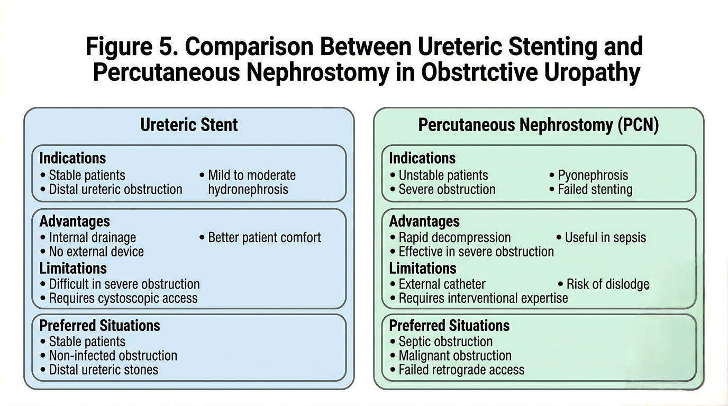
Figure 5
Figure 5. Comparison between ureteric stenting and percutaneous nephrostomy in obstructive uropathy.
This schematic comparison outlines the principal indications, advantages, limitations, and preferred clinical scenarios for ureteric stenting and percutaneous nephrostomy. Both techniques are effective methods of urinary decompression, and selection depends on patient stability, anatomical considerations, and clinical urgency.
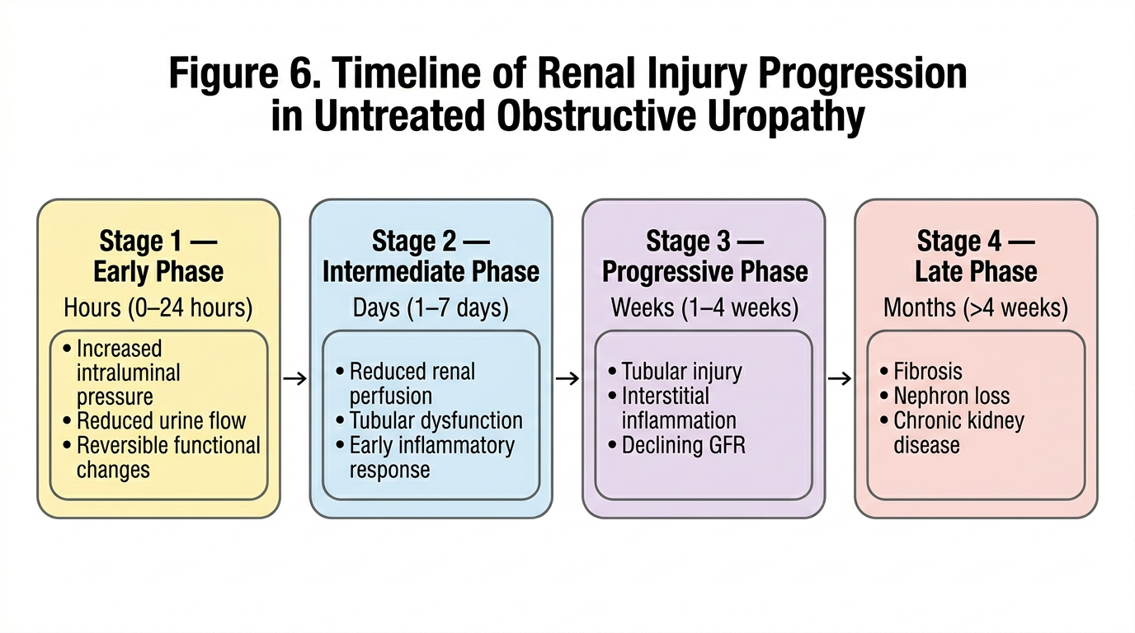
Figure 6
Figure 6. Timeline of renal injury progression in untreated obstructive uropathy.
This schematic timeline illustrates the progressive physiological and structural changes that occur following untreated urinary tract obstruction. Early functional alterations are potentially reversible, whereas prolonged obstruction leads to inflammation, fibrosis, nephron loss, and irreversible chronic kidney damage.

