Case report
Testicular Teratoma with Metastatic Somatic Malignant Transformation: A Rare Case Report

Abstract
Background: Somatic malignant transformation (SMT) in testicular teratomas is a rare phenomenon and is associated with relative resistance to chemotherapy, making therapeutic management particularly challenging.
Case report: A 69-year-old man presented with a large left testicular mass associated with para-aortic lymphadenopathy. Radical orchiectomy revealed a teratoma with somatic malignant transformation, including adenocarcinomatous, sarcomatous, and neuroectodermal components.
Following BEP chemotherapy (bleomycin, etoposide, and cisplatin), the persistence of a residual lymph node mass led to a retroperitoneal lymph node dissection (RPLND). Histopathological examination revealed a pure residual teratoma.
Conclusion: This case highlights the prognostic value of histological analysis of residual masses and emphasizes the central role of surgery in metastatic forms with somatic malignant transformation.

Keywords
Testicular Neoplasms; Teratoma; Somatic Malignant Transformation; Germ Cell Tumor; Retroperitoneal Lymph Node Dissection; Neoplasm Metastasis

Introduction
Testicular germ cell tumors represent the majority of testicular cancers, accounting for approximately 95% of all testicular malignancies [1], among which teratomas constitute nearly 11% [2]. Somatic malignant transformation (SMT) is observed in 3–6% of testicular germ cell tumors (TGCTs) [3].
Among these tumors, teratoma is characterized by its capacity for pluritissue differentiation. Somatic malignant transformation is defined by the development of a non-germ cell malignant component within a teratoma and occurs in a small proportion of cases.
This entity is important to recognize because it significantly influences prognosis, response to systemic therapies, and surgical management. We report a case of metastatic lymph node SMT and discuss the key aspects of its management in light of the current literature.
Case Presentation
A 69-year-old patient presented with a painless left testicular mass that had been evolving for approximately one year. Clinical examination revealed a firm mass measuring about 15 cm.
Tumor markers showed elevated AFP levels (6181 IU/L), moderately increased LDH, and normal β-HCG levels.
Scrotal ultrasound and thoraco-abdominopelvic CT scan demonstrated a heterogeneous testicular mass associated with a 5 cm left para-aortic lymphadenopathy.
In our case, retroperitoneal lymph node dissection (RPLND) was not performed as an initial approach despite the presence of a 5 cm para-aortic lymph node on CT imaging. The patient was initially considered to have metastatic disease, thus justifying the initiation of first-line systemic chemotherapy. This strategy aims to treat potential occult metastatic sites, reduce tumor burden, and improve the conditions for subsequent surgical management [4].
Although teratoma is generally considered chemoresistant, systemic chemotherapy remains indicated in non-seminomatous germ cell tumors due to the presence of chemosensitive components, allowing control of systemic disease. [5].
Furthermore, the patient’s general condition in the immediate postoperative period following orchiectomy did not allow for an extensive surgical procedure such as upfront RPLND.
Histopathological confirmation of teratoma was subsequently obtained from the retroperitoneal lymph node dissection specimen, which was performed at a later stage after clinical improvement, as part of a staged and individualized management strategy. [6].
A left radical inguinal orchiectomy was performed. Histopathological examination revealed a teratoma with somatic malignant transformation, including adenocarcinomatous, sarcomatous, and neuroectodermal components, with epididymal invasion and extension beyond the tunica albuginea (pT2 according to UICC 2017).
Figure 1: Axial and coronal CT images showing the left testicular mass.
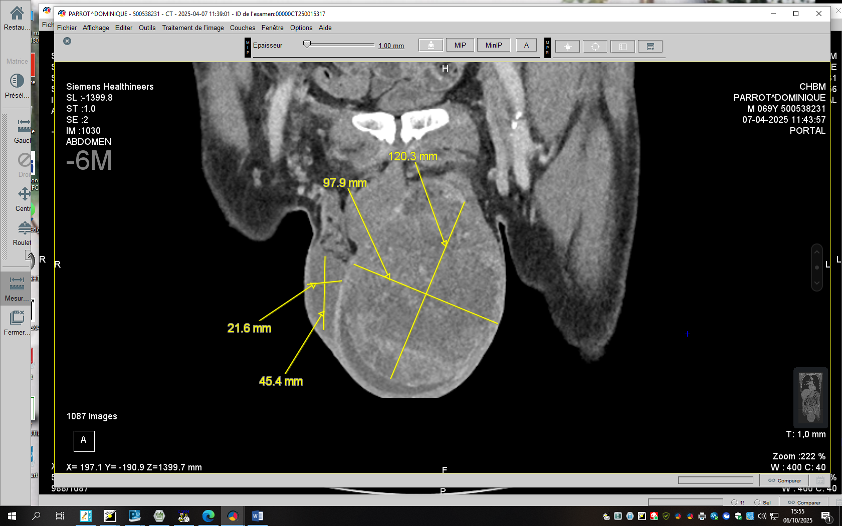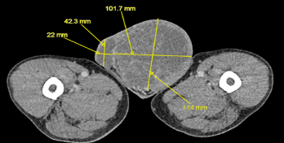
Figure 2: Axial and coronal sections of the latero-aortic metastasis.
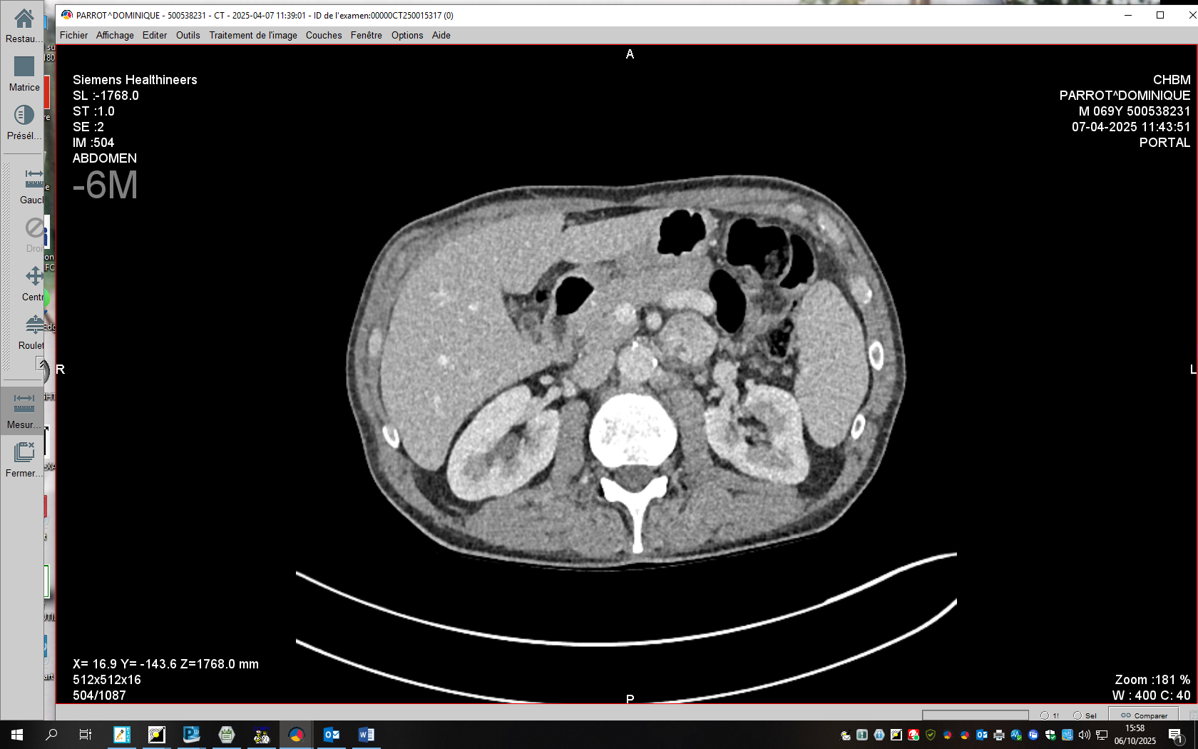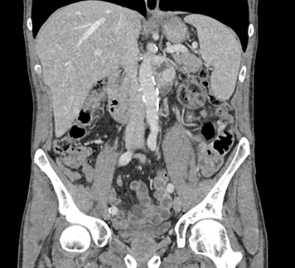
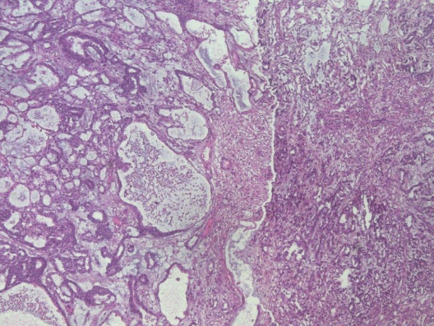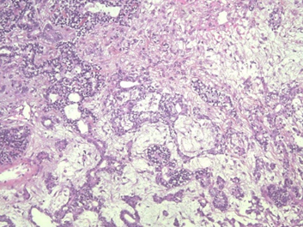
B
A
Figure 3: (A) Complex glandular structures consistent with an infiltrating adenocarcinomatous transformation; (B) Sarcomatous proliferation of atypical spindle cells arranged in fascicles.
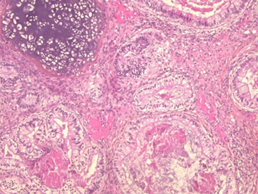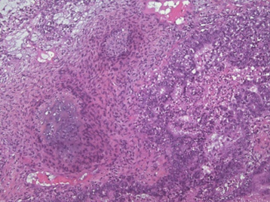
D
C
Figure 4:
(C) Focus of neuroendocrine differentiation composed of small round cells arranged in clusters;
(D) Intermingling of the different components, illustrating the pluripotential nature of teratoma and its potential for transformation into multiple cellular lineages

Postoperative Course: Postoperatively, AFP levels remained elevated (4500 IU/L). A PET-CT scan demonstrated hypermetabolic nodal progression, consistent with an increase in the size of the lymph node mass to 70 × 50 mm with intense radiotracer uptake.
After multidisciplinary discussion, the patient received BEP chemotherapy (four cycles), which resulted in a partial response with near normalization of AFP levels (28 IU/L). However, the findings did not allow exclusion of a germ cell component. The tumor was therefore classified as pT2N3M0S2, corresponding to an intermediate prognosis, stage IIC.
The persistence of a residual mass led to the performance of a retroperitoneal para-aortic lymph node dissection (RPLND). Histological analysis revealed a pure teratoma without viable malignant components.
The clinical course was favorable, with normalization of tumor markers and no evidence of recurrence at the first follow-up evaluation. A standardized clinical, biological, and radiological surveillance program was subsequently initiated.

Results and Discussions
Somatic malignant transformation (SMT) within a testicular teratoma represents a rare but clinically significant entity, observed in approximately 3–6% of testicular germ cell tumors [3].
Recent case reports have further highlighted the diversity of somatic-type malignancies arising in metastatic teratomas. In a recent study, Chu B and Huang described a case of neuroendocrine tumor developing as a somatic-type malignancy within a metastatic teratomatous lesion. This report underscores the broad spectrum of differentiation potential in teratomas and emphasizes that somatic transformation may preferentially occur in metastatic sites rather than in the primary tumor. Moreover, the presence of neuroendocrine differentiation illustrates the diagnostic challenges associated with these rare entities, particularly in distinguishing them from primary neuroendocrine neoplasms. Importantly, the authors highlight that such transformations may exhibit aggressive clinical behavior and limited responsiveness to conventional germ cell tumor chemotherapy, thereby reinforcing the need for a tailored therapeutic approach based on the specific histological subtype of the somatic component [7].
It corresponds to the development of a non-germ cell malignant component arising from the pluripotent differentiation of the teratoma, leading to significant changes in tumor biological behavior and prognosis [8].
From a histopathological perspective, several cellular lineages may be identified, most commonly including sarcomas, adenocarcinomas, and primitive neuroectodermal tumors [9]. This heterogeneity explains the clinical and therapeutic variability reported in the literature. In our case, the coexistence of adenocarcinomatous, sarcomatous, and neuroectodermal components illustrates the pluripotent potential of teratoma and confirms the diagnostic complexity of these mixed forms
The exact pathophysiological mechanism of somatic malignant transformation (SMT) remains debated. Two main hypotheses have been proposed: secondary malignant differentiation of totipotent embryonic cells or acquired neoplastic transformation of mature teratomatous tissues [10]. Some authors have also suggested a potential role of selective pressure induced by chemotherapy, which may promote the emergence of chemo resistant somatic components [11].
From a therapeutic perspective, SMT clearly differs from classical germ cell tumors because of its reduced sensitivity to cisplatin-based chemotherapy regimens [12]. Nevertheless, chemotherapy may still be indicated when an active germ cell component is suspected, particularly in the presence of elevated tumor markers. In our case, the persistent elevation of AFP after orchiectomy justified the administration of BEP chemotherapy, which resulted in a partial response, although a residual lymph node mass remained.
The management of residual masses represents a major clinical challenge. Several studies have shown that these masses contain viable teratoma in approximately 45% of cases and active malignant tissue in about 10% of cases. Because their histological nature cannot be reliably predicted based solely on radiological findings, surgical resection remains the standard strategy [13]. Moreover, complete resection helps prevent the development of growing teratoma syndrome, characterized by tumor enlargement despite normalization of tumor markers, as well as the possibility of secondary malignant transformation [14].
Rare cases of somatic malignant transformation in testicular teratomas with neuroendocrine differentiation have been reported, including the case described by Liu Y et al. Their report highlights the occurrence of metastatic primary testicular neuroendocrine carcinoma arising within a teratoma, illustrating the broad spectrum of possible somatic transformations. This case underscores the diagnostic challenges associated with these rare entities, particularly in distinguishing primary germ cell components from secondary somatic malignancies. Moreover, it emphasizes aggressive clinical behavior that may be observed in such transformations, especially in metastatic settings. Importantly, the authors stress that management should be tailored according to the histological subtype of the somatic component, as these tumors often demonstrate limited responsiveness to conventional germ cell tumor chemotherapy. This observation reinforces the need for a multidisciplinary and individualized therapeutic approach in cases of somatic malignant transformation. [15].
Regarding immunohistochemistry, additional markers such as Glypican-3 and SALL4 were evaluated in our case and did not demonstrate an expression pattern consistent with a yolk sac tumor. These findings further support the absence of histological and immunohistochemical evidence of such a component [16].
Therefore, the final diagnosis was established based on an integrated approach combining morphological, immunohistochemical, and clinical data, in accordance with current recommendations for the pathological evaluation of testicular germ cell tumors
In our case, the persistence of a lymph node mass after chemotherapy led to a retroperitoneal lymph node dissection, and histological analysis revealed a pure teratoma. This finding is consistent with data reported in the literature and highlights the predominantly therapeutic—not merely diagnostic—role of surgery for residual masses [06].
A complementary immunohistochemical study was performed to further characterize the histological nature of the tumor and to investigate the presence of any associated germ cell tumor components.
Immunostaining for alpha-fetoprotein (AFP) did not demonstrate significant cytoplasmic positivity in tumor cells, arguing against the presence of a yolk sac tumor component.
Furthermore, Glypican-3 expression, a marker frequently associated with yolk sac tumors, was negative, as was SALL4, a sensitive marker for germ cell tumors. These immunohistochemical findings support the absence of yolk sac differentiation in our case.
Regarding immunohistochemistry, additional markers such as Glypican-3 and SALL4 were evaluated in our case and did not demonstrate an expression pattern consistent with a yolk sac tumor. These findings further support the absence of histological and immunohistochemical evidence of such a component [16].
Malignant transformation arising within mature teratomas has been well documented in the literature, particularly in ovarian locations. In a seminal study, Kikkawa F et al [17]. reported that somatic malignant transformation may occur not only at initial diagnosis but also during follow-up, highlighting the dynamic and potentially progressive nature of teratomatous lesions.
Histological examination did not reveal immature neuroectodermal tissue arranged in sheets or rosettes, thereby excluding the diagnosis of immature teratoma.
Overall, the integration of morphological and immunohistochemical findings supports the diagnosis of teratoma without immature or yolk sac tumor components.
Prognostic factors in testicular teratoma have been explored in earlier clinical studies, including the work of Alderdice JM and Merrett, who identified several determinants influencing patient survival. Their analysis highlighted the critical role of disease stage at diagnosis, the presence of metastatic involvement, and the completeness of surgical resection in shaping clinical outcomes. In particular, patients with advanced disease or residual tumor burden after treatment exhibited significantly poorer survival rates. These findings underscore the importance of early diagnosis, accurate staging, and aggressive multimodal management, including complete surgical excision of residual disease. In the context of somatic malignant transformation, these prognostic considerations remain highly relevant, as the presence of metastatic lesions and incomplete resection are associated with a less favorable outcome. [18].
The concept of growing teratoma syndrome (GTS), first described by Logothetis CJ et al., represents a distinct clinical entity characterized by an increase in tumor size during or after chemotherapy despite normalization of serum tumor markers. This paradoxical phenomenon is attributed to the persistence and proliferation of mature teratomatous elements, which are inherently resistant to cytotoxic chemotherapy. The recognition of GTS is of major clinical importance, as continued chemotherapy is ineffective and may delay appropriate management. Complete surgical resection remains the treatment of choice, both to achieve disease control and to prevent further complications, including mass effect and potential secondary malignant transformation. These observations reinforce the central role of surgery in the management of residual masses in non-seminomatous germ cell tumors, particularly in the context of teratomatous components. [11].
In our case, although the serum alpha-fetoprotein (AFP) level was elevated, Representative immunohistochemical findings are illustrated in Figure3.4) detailed histopathological examination, complemented by targeted immunohistochemical analysis, did not reveal any evidence of yolk sac tumor differentiation. Notably, AFP expression in immunohistochemistry may be variable and is not consistently detected in all tumor components, particularly in cases with minimal foci or mixed germ cell tumors [09].
Furthermore, it is well established that serum AFP is a sensitive but not entirely specific marker and should always be interpreted in conjunction with morphological findings. Indeed, some germ cell tumors may present with elevated AFP levels in the absence of a histologically identifiable yolk sac component, possibly due to partial differentiation or heterogeneous tumor production [10].
Therefore, the final diagnosis was established based on an integrated approach combining morphological, immunohistochemical, and clinical data, in accordance with current recommendations for the pathological evaluation of testicular germ cell tumors.
Long-term follow-up is based on combined surveillance using thoraco-abdominopelvic imaging and serum tumor markers. It has been demonstrated that biological marker elevation may precede radiological recurrence in a significant proportion of cases, supporting the need for structured and prolonged follow-up [05].
Thus, SMT represents a rare entity requiring a personalized multimodal strategy. Multidisciplinary coordination among urologists, medical oncologists, pathologists, and radiologists is essential to optimize oncological outcomes. The management of testicular germ cell tumors with somatic-type malignancy has been further clarified in recent literature, including the work of Konneh B et al. Their study emphasizes that these tumors require a tailored therapeutic approach distinct from conventional germ cell tumors due to their biological heterogeneity and relative resistance to standard cisplatin-based chemotherapy. The authors highlight that treatment decisions should be guided by the histological subtype of the somatic component, as this directly influences therapeutic sensitivity and prognosis. They stress the central role of complete surgical resection, especially in cases of residual or metastatic disease, as it remains the most effective strategy for achieving long-term disease control. Furthermore, a multidisciplinary approach involving urologists, oncologists, and pathologists is essential to optimize outcomes in these complex and rare cases. [24].
Recent advances in the understanding of somatic-type malignancy in testicular germ cell tumors have been highlighted by Rozsvai T et al., who described the progression from teratomatous elements to adenocarcinoma within metastatic lesions. Their findings support the concept of clonal evolution, whereby teratomatous components may undergo secondary malignant transformation into epithelial malignancies with distinct biological behavior. This transformation is often associated with increased aggressiveness and resistance to conventional cisplatin-based chemotherapy. The authors emphasize the importance of integrating histopathological, immunohistochemical, and molecular analyses to accurately characterize these tumors. These observations further reinforce the critical role of complete surgical resection in the management of somatic-type malignancy, particularly in the setting of metastatic disease, where systemic therapies alone are often insufficient. [19].
The prognostic classification proposed by the International Germ Cell Cancer Collaborative Group represents a cornerstone in the management of metastatic germ cell tumors. This system stratifies patients into good, intermediate, and poor prognosis groups based on primary tumor site, the presence of non-pulmonary visceral metastases, and serum tumor marker levels, including alpha-fetoprotein (AFP), beta-hCG, and LDH. This classification has significant therapeutic implications, guiding the choice and intensity of systemic chemotherapy regimens. In the context of somatic malignant transformation, the IGCCCG classification remains relevant for initial risk assessment and treatment planning, although it may not fully capture the biological heterogeneity and chemoresistance associated with somatic components. Therefore, while IGCCCG criteria are essential for prognostic stratification, individualized management strategies integrating histopathological findings and surgical considerations are crucial in these complex cases. [20].
Recent literature has further emphasized that somatic-type malignancy arising in testicular germ cell tumors is not only rare but also biologically distinct from conventional non-seminomatous germ cell tumor components. Contemporary reviews report that somatic-type malignancy occurs in approximately 2.5% to 8% of testicular germ cell tumors and is identified more frequently in metastatic sites than in primary testicular lesions. In addition, sarcomatous elements appear to predominate in primary tumors, whereas carcinomatous differentiation is more often encountered in metastases, suggesting site-specific biological evolution and supporting the concept of clonal selection during tumor progression. [21].
Somatic malignant transformation arising within testicular teratoma has also been described in individual case reports, such as that reported by Ibrahim DY and Sun. Their study highlights the rarity of this entity and emphasizes the diagnostic complexity associated with the identification of somatic components within germ cell tumors. The authors underline the importance of thorough histopathological evaluation, often supported by immunohistochemistry, to accurately characterize the different tumor components. Furthermore, their findings confirm that somatic malignant transformation is frequently associated with a more aggressive clinical course and reduced sensitivity to conventional cisplatin-based chemotherapy. As a result, complete surgical resection remains a key element of management whenever feasible. This report reinforces the concept that individualized therapeutic strategies are essential in such rare and heterogeneous tumors. [22].
Somatic-type malignancy arising within germ cell tumors has been increasingly reported in recent literature, including the case and review by Cheema A et al. Their study highlights the rarity and heterogeneity of this entity, emphasizing that somatic transformation can give rise to a wide spectrum of malignant histologies, including sarcomatous, carcinomatous, and neuroectodermal components. The authors underline the diagnostic challenges associated with these tumors, particularly in distinguishing somatic malignancy from conventional germ cell tumor elements. Importantly, they report that somatic-type malignancies are often resistant to standard cisplatin-based chemotherapy, which is typically effective for germ cell tumors. Consequently, complete surgical resection remains the cornerstone of treatment whenever feasible, and management should be individualized based on the specific histological subtype and extent of disease. This work reinforces the importance of a multidisciplinary approach in optimizing outcomes for patients with these rare and complex tumors [23].
Recent case reports have further illustrated the complexity of somatic-type malignancy in metastatic testicular germ cell tumors. In a report by Yamashita M et al., a case of retroperitoneal metastasis composed of teratoma with somatic-type malignant transformation was described, highlighting the potential for such transformations to occur in metastatic sites, even after initial treatment. This study underscores the importance of long-term surveillance, as somatic transformation may develop or become apparent during disease evolution. Moreover, the authors emphasize that residual retroperitoneal masses following chemotherapy should not be considered benign, as they may harbor teratomatous or malignant components requiring surgical excision. These findings reinforce the critical role of post-chemotherapy retroperitoneal lymph node dissection in both diagnostic confirmation and therapeutic management, particularly in cases with persistent or progressive masses. [25].
Primitive neuroectodermal tumor (PNET) represents a rare but well-recognized form of somatic-type malignant transformation in testicular teratomas. In a recent case report, Callaghan J et al. described the transformation of a testicular teratoma into a PNET component, highlighting the aggressive biological behavior associated with neuroectodermal differentiation. The authors emphasized the diagnostic challenges posed by these tumors, particularly in distinguishing PNET arising from teratoma from other small round blue cell tumors, necessitating careful histopathological and immunohistochemical evaluation. Importantly, PNET components are typically resistant to conventional cisplatin-based chemotherapy used for germ cell tumors, and their management may require alternative treatment strategies, including aggressive surgical resection and, in some cases, chemotherapy protocols tailored tosarcomatous or neuroectodermal malignancies. This report reinforces the heterogeneity of somatic-type malignancy and the need for individualized, histology-driven therapeutic approaches [26].
Conclusion
Somatic malignant transformation within a testicular teratoma is a rare and complex entity. Its management primarily relies on a surgical approach, as standard germ cell tumor chemotherapy is often ineffective. A multidisciplinary strategy is essential to optimize the diagnosis, treatment, and prognosis of these patients.

Consent
As per international standards or university standards, patient(s) written consent has been collected and preserved by the author(s).
Ethical Approval:

As per international standards or university standards written ethical approval has been collected and preserved by the author(s).

References
1.Albers P, Albrecht W, Algaba F, Bokemeyer C, Cohn-Cedermark G, Fizazi K, et al. EAU guidelines on testicular cancer. Eur Urol. 2015;68(6):1054–1068.
2. Alderdice JM, Merrett JD. Factors influencing the survival of patients with testicular teratoma. J Clin Pathol. 1985;38(7):791–796.
3. Logothetis CJ, Samuels ML, Trindade A, Johnson DE. The growing teratoma syndrome. Cancer. 1982;50(8):1629–1635.
4. Motzer RJ, Jonasch E, Agarwal N, et al. Testicular cancer, version 2.2023, NCCN clinical practice guidelines in oncology. J Natl Compr Canc Netw. 2023;21(2):123–154.
(justifie chimiothérapie en première intention dans maladie métastatique)
5. Albers P, Albrecht W, Algaba F, et al. EAU Guidelines on Testicular Cancer. Eur Urol. 2024;85(3):456–489.
(tératome chimiorésistant mais traitement des composantes sensibles)
6. Stephenson AJ, Sheinfeld J. The role of retroperitoneal lymph node dissection in testicular cancer. Urol Oncol. 2004;22(3):225–233.
(RPLND différée après chimiothérapie / masses résiduelles)
7. Chu B, Huang J. Neuroendocrine tumor as a somatic-type malignancy in metastatic teratoma. Int J Surg Pathol. 2025
8. Carver BS, Shayegan B, Eggener S, et al. Incidence and clinical outcome of patients with teratoma with malignant transformation. J Urol. 2007;178(3):1107–1111.
9. Ulbright TM. Germ cell tumors of the gonads: a selective review emphasizing problems in differential diagnosis. Mod Pathol. 2005;18 Suppl 2:S61–79.
10. Oosterhuis JW, Looijenga LHJ. Testicular germ-cell tumours in a broader perspective. Nat Rev Cancer. 2005;5(3):210–222.
11. Logothetis CJ, Samuels ML, Trindade A, et al. The growing teratoma syndrome. Cancer. 1982;50(8):1629–1635.
12. Donadio AC, Motzer RJ, Bajorin DF, et al. Chemotherapy for teratoma with malignant transformation. J Clin Oncol. 2003;21(23):4285–4291.
13. Sheinfeld J, Motzer RJ, Rabbani F. Management of post-chemotherapy residual mass in testicular cancer. Urol Clin North Am. 2007;34(2):181–190.
14. Andre F, Fizazi K, Culine S, et al. The growing teratoma syndrome: results of therapy and long-term follow-up. J Clin Oncol. 2000;18(20): 3746–3752.
15. Liu Y, Wang H, Li J, Zhang L. Metastatic primary testicular neuroendocrine carcinoma associated with somatic malignant transformation of teratoma: a rare case report. World J Surg Oncol. 2020;18:231.
16. Zynger DL, McKenney JK. Role of immunohistochemistry in the diagnosis of germ cell tumors. Arch Pathol Lab Med. 2010;134(4):531–540.
17. Kikkawa F, Nawa A, Tamakoshi K, Ishikawa H, Suganuma N, Tomoda Y. Malignant transformation of mature cystic teratoma of the ovary including three cases occurring during follow-up. Gynecol Oncol. 1997;67(2):203–207.
18. Alderdice JM, Merrett JD. Factors influencing the survival of patients with testicular teratoma. J Clin Pathol. 1985;38(7):791–796.
19. Rozsvai T, et al. From teratoma to adenocarcinoma: somatic-type malignancy in testicular germ cell tumors. Pathol Oncol Res. 2025.
20. International Germ Cell Cancer Collaborative Group. International germ cell consensus classification: a prognostic factor-based staging system for metastatic germ cell cancers. J Clin Oncol. 1997;15(2):594–603.
21 Siegmund SE, Idrees MT. Somatic-type malignancies of germ cell origin: a comprehensive review. Surg Pathol Clin. 2025;18(1):1–15.
(SMT : fréquence 2.5–8%, biologie, métastases)
22. Ibrahim DY, Sun H. Somatic malignant transformation of a testicular teratoma: a case report. Case Rep Pathol. 2019;2019:Article ID 5273601.
23. Cheema A, Siddiqui F, Kamran A. Germ cell tumor with somatic-type malignancy: a case report and review. Cureus. 2022
24. Konneh B, Leonard AJ, Lafin JT, et al. Management of testicular germ cell tumor with somatic-type malignancy. Oncology (Williston Park). 2022.
25. Yamashita M, et al. Testicular cancer with retroperitoneal metastasis of teratoma with somatic-type malignancy. IJU Case Rep. 2023.
26. Callaghan J, et al. Testicular teratoma with transformation to PNET. Urol Case Rep. 2025.

