Case Report

Double Inferior Vena Cava with Renal Angiomyolipoma in a Living Kidney Donor: A Rare Vascular and Parenchymal Anomaly with Surgical Implications

Abstract
Background: Duplication of the inferior vena cava (IVC) and renal angiomyolipoma (AML) are uncommon findings in living kidney donors and rarely coexist. Both anomalies may influence donor nephrectomy and graft implantation strategy.
Case Presentation: We report a 72-year-old female living kidney donor who underwent ABO-incompatible transplantation for her 32-year-old son with end-stage renal disease (donor: B positive; recipient: A negative). Preoperative contrast-enhanced CT angiography demonstrated a duplicated IVC with a left-sided cava crossing anterior to the aorta and joining the right IVC (pre-aortic confluence), along with an accessory left renal vein. A small lower pole AML measuring 8 × 7.5 × 12 mm was identified in the donor kidney. Bilateral single renal arteries were present. The anticipated technical challenge was reduced left renal vein length due to early drainage into the duplicated cava, potentially complicating venous anastomosis. Following multidisciplinary evaluation and immunological optimization, donor nephrectomy and transplantation were completed successfully without vascular compromise or graft-related complications. Conclusion: This case underscores the importance of meticulous preoperative vascular mapping and individualized operative planning in donors with complex venous anatomy. Small, asymptomatic AMLs should not represent an absolute contraindication to donation when appropriately assessed. Even in the presence of ABO incompatibility and dual anatomical anomalies, successful transplantation is achievable with structured multidisciplinary management.

Keywords: Angiography, Inferior vena cava, Renal angiomyolipoma, Transplantation, Venous anastomosis

INTRODUCTION
Congenital venous anomalies and incidental renal masses are increasingly detected during living donor evaluation due to widespread use of high-resolution cross-sectional imaging. Duplication of the inferior vena cava (IVC), reported in 0.2–3% of the population, results from persistence of the left supracardinal vein during embryogenesis and represents a recognized developmental variant of systemic venous return [1, 2]. Although typically asymptomatic, it carries important surgical implications in retroperitoneal surgery and transplantation, where unrecognized variants may increase the risk of vascular injury, hemorrhage, or technical difficulty during hilar dissection and graft retrieval [2-5].
Renal angiomyolipoma (AML) is a benign mesenchymal tumor often identified incidentally during donor assessment. Previously considered a relative contraindication to donation, accumulating evidence suggests that carefully selected donors with small, asymptomatic AMLs can safely undergo nephrectomy, with or without ex vivo excision, without compromising graft or recipient outcomes [7, 8].
The coexistence of duplicated IVC and renal AML in a living donor is exceptionally rare and necessitates meticulous imaging, multidisciplinary evaluation, and individualized operative planning [2-7].

Case Presentation
A 72-year-old female was evaluated as a prospective living kidney donor for her 32-year-old son with end-stage renal disease. The donor was blood group B positive and the recipient A negative, constituting an ABO-incompatible mother-to-son transplantation. Following comprehensive immunological assessment and institutional desensitization protocol—including pre-transplant plasmapheresis with serial isoagglutinin titer monitoring and induction immunosuppression—adequate antibody reduction was achieved, and both donor and recipient were cleared for surgery. Baseline hematological, biochemical, renal functional, and cardiopulmonary evaluations were within acceptable limits for living donation.
Contrast-enhanced CT renal angiography (15 December 2025) demonstrated a right kidney measuring 101 × 40 mm and a left kidney measuring 100 × 47 mm, both with preserved corticomedullary differentiation and homogeneous enhancement. No calculi or hydronephrosis were identified. A well-defined lower pole hypodense lesion measuring 8 × 7.5 × 12 mm was detected in the left kidney without significant post-contrast enhancement, radiologically consistent with a small angiomyolipoma (AML).
Arterial anatomy was favorable, with single renal arteries bilaterally. The right renal artery measured 5 mm at origin with first segmental branching at approximately 40 mm, while the left measured 5.2 mm with first branching at 29 mm, providing adequate arterial length for procurement and implantation.
Venous mapping revealed duplication of the inferior vena cava (IVC). A left-sided IVC in the left paravertebral region received the left renal vein and crossed anterior to the aorta to join the right-sided IVC (pre-aortic confluence). The right infra-renal IVC continued along its usual course, receiving the right external iliac vein. A small accessory left renal vein arose near the confluence of the main left renal vein and drained into the left-sided IVC approximately 15 mm inferior to the primary junction. The right renal vein measured 10 mm in caliber and the left 9 mm prior to IVC entry. No arterial stenosis, venous thrombosis, or additional vascular anomalies were identified (Figure 1).
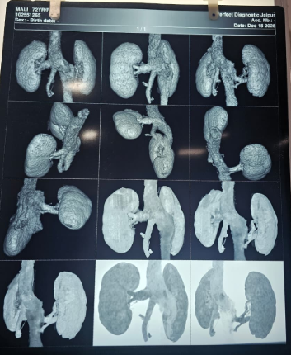
Figure 1: 3D CT angiographic reconstruction demonstrating duplicated inferior vena cava with pre-aortic confluence.

The coexistence of duplicated IVC and lower pole AML introduced combined vascular and parenchymal considerations. Of particular relevance was the potential reduction in effective left renal vein length due to early drainage into the duplicated cava and the accessory venous channel. In living donor transplantation, shortened venous length may complicate end-to-side anastomosis to the recipient’s external iliac vein, risking tension or kinking and occasionally necessitating venous extension.
After multidisciplinary evaluation involving transplant surgery, urology, nephrology, and radiology teams, the AML’s small size and benign radiologic features were considered acceptable under contemporary donor criteria. The duplicated IVC was deemed surgically manageable with meticulous hilar dissection and planned control of accessory veins. Donor nephrectomy and implantation were successfully completed without vascular compromise or graft-related complications, highlighting the importance of comprehensive vascular mapping, immunological optimization, and individualized operative planning in high-complexity living donor transplantation. (Figure 2).
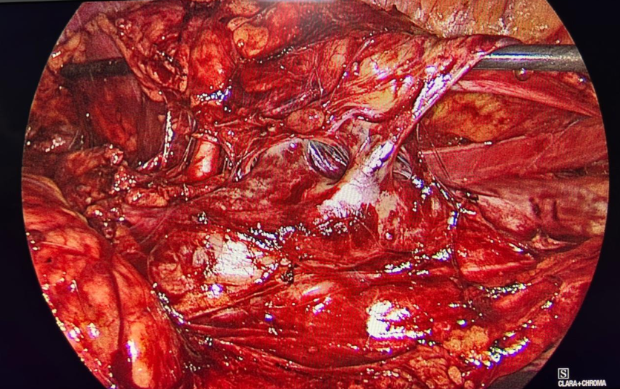

Figure 2: Intraoperative view of the left renal hilum demonstrating venous anatomy in the setting of duplicated IVC, highlighting the main renal vein and accessory venous channel.

Postoperative Course and Follow-up
Donor nephrectomy was completed in 40 minutes with blood loss of 30 mL and a warm ischemia time of 27 minutes. The intraoperative course was uneventful. The donor had an uncomplicated recovery without Clavien–Dindo complications and was discharged on postoperative day 3. Serum creatinine at discharge was 0.8 mg/dL and remained stable at 7 days and 3 months.
The recipient demonstrated immediate graft function with satisfactory intraoperative urine output and no delayed graft function. Serum creatinine was 1.1 mg/dL at discharge, 1.1 mg/dL at 3 months, and 1.12 mg/dL at 6 months. No vascular thrombosis, anastomotic complications, or rejection episodes occurred during follow-up.

Discussion
Duplication of the inferior vena cava (IVC) is an uncommon congenital anomaly, reported in approximately 0.2–3% of the population, resulting from persistence of the left supracardinal vein during embryogenesis [2-7]. Although usually asymptomatic, its surgical relevance becomes significant during living donor nephrectomy, where precise hilar dissection and preservation of adequate venous length are essential. Failure to recognize venous duplication preoperatively may result in unexpected bleeding, misidentification of vascular structures, or technical difficulty during graft retrieval [5]. In the present case, CT angiography clearly demonstrated a left-sided IVC crossing anterior to the aorta and joining the right-sided IVC (pre-aortic confluence), allowing meticulous operative planning.
The principal concern in duplicated IVC is potential shortening of the left renal vein. Early venous convergence and accessory renal veins may limit mobilization and reduce effective venous length for implantation, increasing the risk of tension or kinking during end-to-side anastomosis to the recipient’s external iliac vein. However, when identified preoperatively, these variations are predictable and manageable. In this case, careful hilar dissection enabled safe procurement without need for venous extension, reinforcing that duplicated IVC is not a contraindication to donation when adequately characterized.
The incidental 12 mm lower pole angiomyolipoma (AML) introduced a parenchymal consideration. Historically regarded as a relative contraindication, contemporary evidence supports transplantation of kidneys harboring small (<4 cm), radiologically benign AMLs in carefully selected donors [8]. Lesions demonstrating classical fat attenuation and absence of suspicious features carry minimal risk of progression or hemorrhage. In this case, the lesion was left in situ after multidisciplinary review, without ex vivo excision or histopathological confirmation, and did not affect procurement or graft function. Conservative management was therefore appropriate.
The coexistence of duplicated IVC and renal AML in a living donor is exceedingly rare and represents combined vascular–parenchymal complexity. Importantly, this case illustrates that dual anatomical variations do not inherently increase perioperative risk when managed within a structured multidisciplinary framework [8]. Comprehensive vascular mapping and individualized operative planning remain central to successful outcomes.
In the context of organ scarcity and expanding donor criteria, rigid exclusion based solely on anatomical variation may be unwarranted [8]. Careful evaluation rather than automatic rejection should guide decision-making in such surgically manageable scenarios.
The coexistence of duplicated inferior vena cava and renal angiomyolipoma in a living kidney donor represents a rare but surgically manageable combination of vascular and parenchymal anomalies. Neither duplicated IVC nor a small (<4 cm), radiologically benign AML should be considered an absolute contraindication to donation when identified through comprehensive imaging and multidisciplinary evaluation. Detailed CT angiographic mapping and individualized operative planning enable safe procurement and successful transplantation. Careful assessment rather than exclusion should guide decision-making in such cases [9-13].

Conclusion
The coexistence of duplicated inferior vena cava and renal angiomyolipoma in a living kidney donor represents a rare but surgically manageable combination of vascular and parenchymal anomalies. Neither duplicated IVC nor a small, radiologically benign AML should be considered an absolute contraindication to donation when identified through comprehensive preoperative imaging and multidisciplinary evaluation. Detailed CT angiographic mapping and individualized operative planning are essential to anticipate potential venous shortening and ensure tension-free anastomosis. With meticulous surgical technique and structured transplant planning, favorable donor and graft outcomes can be achieved. Careful assessment rather than automatic exclusion should guide management in such uncommon but manageable scenarios.

Key Learning Points
• Duplicated IVC is not a contraindication when accurately mapped preoperatively.
• Pre-aortic confluence may shorten effective left renal vein length.
• Small (<4 cm), benign AMLs can be safely accepted in selected donors.
• Multidisciplinary planning enables safe ABO-incompatible transplantation.

Ethical Approval and Consent
This case report complied with institutional ethical standards. Ethics committee review determined that formal approval was not required. Written informed consent was obtained from both donor and recipient. All procedures adhered to the Declaration of Helsinki.

COMPETING INTERESTS DISCLAIMER:
Authors have declared that they have no known competing financial interests OR non-financial interests OR personal relationships that could have appeared to influence the work reported in this paper.
Disclaimer (Artificial intelligence)
Author(s) hereby declare that NO generative AI technologies such as Large Language Models (ChatGPT, COPILOT, etc.) and text-to-image generators have been used during the writing or editing of this manuscript.

REFERENCES

- Zahran MH, Kamal AI, Abdelfattah A, Mashaly ME, Fakhreldin I, Osman Y, Ali-El-Dein B. Outcome of live-donor renal transplants with incidentally diagnosed renal angiomyolipoma in the donor. InTransplantation Proceedings 2019 Jul 1 (Vol. 51, No. 6, pp. 1773-1778). Elsevier.
- Balawender K, Pliszka A, Kłos M, Orkisz S, Barszcz K, Dubrowski A, Matuszyk A, Żytkowski A. Duplication of the inferior vena cava-an anatomical case report with comments on embryological background and clinical implications. Translational Research in Anatomy. 2022 Nov 1;29:100221.
- Li WR, Feng H, Jin L, Chen XM, Zhang ZW. Duplication of the inferior vena cava: a case series. Journal of International Medical Research. 2022 May;50(5):03000605221100771.
- Rofaiel G, Pan G, Campsen J, Kim R, Hamilton B. Successful Utilization of a Live Donor Kidney with Angiomyolipoma. Cureus. 2020 Feb 10;12(2).
- Saad KR, Saad PF, Amorim CA, Armstrong D, Soares BL, Neves PC, Razuk Filho A. Duplication of the inferior vena cava: case report and a literature review of anatomical variation. J Morphol Sci. 2012;29(1):60-4.
- Sarvepalli A, Prasad GS. WCN25-4404 SUCCESSFUL TRANSPLANTATION OF LIVE DONOR KIDNEY WITH A LARGE ANGIOMYOLIPOMA: A CASE REPORT. Kidney International Reports. 2025 Feb 1;10(2):S556.
- Natsis K, Apostolidis S, Noussios G, Papathanasiou E, Kyriazidou A, Vyzas V. Duplication of the inferior vena cava: anatomy, embryology and classification proposal. Anatomical science international. 2010 Mar;85(1):56-60.
- Anton DG, Kovvuru K, Kanduri SR, Aeddula NR, Bathini T, Thongprayoon C, Kaewput W, Wijarnpreecha K, Watthanasuntorn K, Salim SA, Matemavi P. Use and outcomes of kidneys from donors with renal angiomyolipoma: A systematic review. Urology annals. 2021 Jan 1;13(1):67-72.
- Kushwaha SS, Aggarwal A, Guleria K, Chaturvedi S, Kumar A, Maheshwari R. Managing Angiomyolipoma with triple vessel in right donor kidney: An innovative approach in robot-assisted kidney transplant. Urology Video Journal. 2025 Mar 1;25:100309.
- Aldughiem A. Imaging diagnosis of major kidney and urinary tract disorders in children. Medicina. 2025 Apr 10;61(4):696.
- Yadav M, Srivastava S, Dighe M, Möller K, Jenssen C, Dietrich CF. Sonographic Anatomy and Normal Measurements of the Human Kidneys: A Comprehensive Review. Diagnostics. 2025 Dec 15;15(24):3208.
- Pimentel LF, Fé TS, Viana PC, Coelho FM, Miranda JA. Kidney involvement in multisystem diseases: a review and key imaging findings. Abdominal Radiology. 2026 Feb;51(2):812-38.
- Santamarina MG, Necochea Raffo JA, Lavagnino Contreras G, Recasens Thomas J, Volpacchio M. Predominantly multiple focal non-cystic renal lesions: an imaging approach. Abdominal Radiology. 2025 Jan;50(1):224-60.

