Case report
Ureteral strictures after intravesical BCG therapy: Should antituberculous treatment always be initiated?

.
ABSTRACT

Objectives:
Intravesical Bacillus Calmette–Guérin (BCG) therapy is the standard adjuvant treatment for intermediate- and high-risk non-muscle-invasive bladder cancer. Although generally well tolerated, severe complications may occur, while involvement of the upper urinary tract remains exceptional. We report a rare case of bilateral ureteral strictures following BCG therapy and discuss the diagnostic challenge between active infection and inflammatory reaction.
Case presentation:
A 74-year-old woman with a history of pT1 low-grade non-muscle-invasive bladder cancer developed acute renal failure during maintenance intravesical BCG therapy. The delay between initiation of BCG therapy and onset of renal failure was approximately 7 months. Pre-treatment imaging showed no dilatation of the pyelocaliceal systems, and ureteral orifices were consistently patent on surveillance cystoscopy. Subsequent imaging revealed bilateral uretero-hydronephrosis due to distal ureteral strictures associated with inflammatory bladder wall thickening. A comprehensive microbiological workup, including urine cultures and GeneXpert testing, as well as thoracic imaging, was negative. Bladder and peri-meatal biopsies demonstrated chronic fibro-inflammatory changes without evidence of mycobacterial infection. BCG therapy was discontinued, and bilateral double-J stenting with periodic replacement allowed stabilization of renal function at 6 months of follow-up.
Discussion:
Bilateral ureteral strictures following BCG therapy are extremely rare. The main diagnostic challenge lies in distinguishing active Mycobacterium bovis infection from an immune-mediated inflammatory reaction. In the absence of microbiological and histological evidence of infection, an inflammatory mechanism is more likely.
Conclusion:
Careful diagnostic evaluation is essential in such cases. When no evidence of active infection is found, conservative management with urinary drainage and discontinuation of BCG therapy may avoid unnecessary antituberculous treatment.

Keywords: Intravesical BCG therapy; Non-muscle-invasive bladder cancer; Ureteral stricture; Hydronephrosis; BCGitis; Mycobacterium bovis

1. INTRODUCTION

Non-muscle-invasive bladder cancer accounts for approximately 70–75% of bladder cancers at the time of diagnosis. Intravesical BCG therapy is the standard adjuvant treatment for intermediate- and high-risk disease, significantly reducing recurrence and progression rates (1) .
BCG is a live attenuated strain of Mycobacterium bovis, initially developed as a vaccine against tuberculosis and later repurposed for intravesical use in bladder cancer due to its potent immunostimulatory properties. It induces a complex local immune response involving both innate and adaptive immunity, leading to activation of cytokine-mediated antitumor mechanisms and recruitment of immune cells to the urothelium (2).
Despite its effectiveness, BCG therapy may lead to adverse effects, most commonly local and mild. Severe complications remain rare (<5%), and involvement of the upper urinary tract is exceptional (3). Bilateral ureteral strictures complicating BCG therapy are very rarely reported in the literature, raising diagnostic and therapeutic challenges, particularly regarding the distinction between active mycobacterial infection and immune-mediated inflammatory reaction.
We report a rare case of bilateral ureteral strictures leading to obstructive renal failure following intravesical BCG therapy.

2. Case Report

A 74-year-old woman had been followed since 2013 for non-muscle-invasive bladder cancer. Her medical history included hypertension, type 2 diabetes mellitus, and dyslipidemia.
The disease initially presented with intermittent episodes of gross hematuria associated with lower urinary tract symptoms, which led to several transurethral resections of bladder tumors. Tumor mapping revealed multiple small papillary lesions measuring approximately 1 cm, located at the trigone, right lateral wall, and bladder dome. Histopathological examination revealed low-grade urothelial carcinoma staged first as pTa and later as pT1, and the presence of uninvolved detrusor muscle. (Figure 1)
Given the pT1 stage, intravesical BCG therapy was initiated according to an induction regimen followed by maintenance therapy. The patient received intravesical BCG at a dose of 80 mg once weekly, with a dwell time of 2 hours, according to standard instillation protocols. A total of seven instillations were administered, including six induction sessions and one maintenance session. During the second maintenance instillation, the patient developed deterioration of general condition associated with acute renal failure. The delay between initiation of BCG therapy and onset of acute renal failure was approximately 7 months.
Renal and bladder ultrasound and abdominopelvic computed tomography revealed bilateral uretero-hydronephrosis upstream of regular bladder wall thickening (Figure 2), whereas imaging studies performed prior to BCG therapy had shown no dilation of the pyelocaliceal systems.
Urinary tract drainage was performed using bilateral double-J ureteral stents. Retrograde ureteropyelography demonstrated bilateral distal ureteral strictures, located approximately 1.5–2 cm from the ureterovesical junction, with lengths estimated at 1.5 cm on the right and 2 cm on the left (Figure 3). Endoscopic exploration revealed diffuse inflammatory lesions without evidence of tumor recurrence. Both ureteral orifices were visualized (Figure 4).
An infectious workup investigating Mycobacterium bovis infection, including direct examination, mycobacterial cultures, and GeneXpert molecular testing performed on urine and sputum samples, as well as thoracic computed tomography, was negative. Bladder and peri-ureteral biopsies showed chronic fibro-inflammatory changes without active tumor lesions, and mycobacterial cultures performed on biopsy specimens were also negative.
After multidisciplinary discussion, BCG therapy was definitively discontinued and close cystoscopic surveillance was adopted. Management of the bilateral ureteral strictures consisted of conservative treatment with periodic replacement of the double-J stents every six months in order to ensure durable drainage and preserve renal function.

At 6 months of follow-up after discontinuation of BCG therapy and bilateral ureteral drainage, the patient demonstrated a favorable clinical evolution, with marked improvement in general condition and stabilization of renal function, with no further deterioration observed.

3. discussion

Intravesical BCG therapy is the standard adjuvant treatment for intermediate- and high-risk non-muscle-invasive bladder cancer, in accordance with international recommendations, including those of the European Association of Urology (EAU), which confirm its efficacy in reducing recurrence and tumor progression (4). Meta-analyses conducted by Sylvester and colleagues have robustly demonstrated the superiority of BCG over intravesical chemotherapy in terms of disease control, particularly for carcinoma in situ and high-risk tumors (5,6). Despite this recognized efficacy, BCG therapy may cause adverse events, most of which are local and transient, while severe complications remain rare, occurring in less than 5% of cases (3). Documented BCG infections occur in approximately 1% of treated patients (7), and upper urinary tract involvement, particularly in the form of bilateral ureteral strictures, remains exceptional.
Our observation fits within this rare context and raises a major diagnostic issue: distinguishing active urogenital tuberculosis caused by Mycobacterium bovis from a local granulomatous inflammatory reaction, commonly referred to as BCGitis. This distinction is crucial because it determines whether antituberculous therapy should be initiated. In the case reported by Tominaga et al., microbiologically confirmed bladder tuberculosis occurring several years after BCG therapy was complicated by bilateral ureteral strictures and progressive hydronephrosis (8). The diagnosis was based on a positive urine culture for the Mycobacterium tuberculosis complex and PCR specifically identifying M. bovis. In this situation, antituberculous therapy combining isoniazid, rifampicin, and ethambutol achieved microbiological sterilization, although functional sequelae were only partially reversible.
In contrast, in our case, several findings argued against active urogenital tuberculosis. The complete microbiological workup, including direct examination, mycobacterial cultures, and molecular investigations, was negative. Bladder and peri-ureteral biopsies showed no caseating granulomas or tumor infiltration, but only chronic fibro-inflammatory changes. Moreover, imaging studies performed prior to initiation of BCG therapy revealed no dilation of the pyelocaliceal systems, and ureteral orifices were consistently visualized and patent during surveillance cystoscopies, strengthening the direct temporal relationship between BCG therapy and the occurrence of strictures. The relatively early onset of the complication, unlike infectious forms sometimes reported several years after instillation (7,8), also supports an immune-mediated inflammatory mechanism.
From a pathophysiological perspective, two mechanisms have been described: True infection with M. bovis secondary to BCG dissemination or local granulomatous hypersensitivity reaction, resulting in mucosal thickening and progressive fibrosis (3,9). Chronic inflammation may involve the ureterovesical junction, leading to bilateral distal obstruction. Muneer et al. reported that ureteral strictures in urogenital tuberculosis result from granulomatous inflammation followed by cicatricial fibrosis that may become irreversible (10). However, in the absence of specific microbiological and histological evidence, the diagnosis of active tuberculosis cannot be established according to classical diagnostic criteria for urogenital tuberculosis (10,11).
The indication for antituberculous therapy therefore becomes a central issue. According to World Health Organization guidelines, confirmed urogenital tuberculosis should be treated with standard multidrug therapy adapted to strain susceptibility, with M. bovis being naturally resistant to pyrazinamide (11). In cases of confirmed post-BCG bladder tuberculosis, treatment with isoniazid, rifampicin, and ethambutol is generally recommended (8). Conversely, when no microbiological evidence of active infection is found, EAU guidelines recommend permanent discontinuation of BCG therapy in the event of severe complications and appropriate symptomatic management, without systematically initiating antituberculous therapy (4). In our case, the absence of evidence of active infection and clinical improvement with drainage alone justified a conservative approach, avoiding unnecessary exposure to the potentially severe adverse effects of antituberculous drugs.
Management of ureteral strictures primarily aims to relieve obstruction and preserve renal function. Drainage with double-J ureteral stents represents the recommended initial approach. In some reported cases, anatomical improvement has been observed after antituberculous therapy (8), whereas others progress to irreversible sequelae requiring reconstructive surgery (10,12).

In deciding on our management approach, both the extent of the strictures and the patient’s overall condition were key considerations. Given the bilateral distal ureteral strictures of significant extent, immediate reconstructive surgery would have entailed increased morbidity and technical complexity. Considering the patient’s advanced age (74 years) and comorbidities, a conservative strategy based on iterative replacement of bilateral double-J stents was preferred in order to relieve obstruction, maintain upper tract drainage, and preserve renal function while minimizing surgical risk. This approach is consistent with contemporary recommendations supporting temporary stenting for extensive benign or inflammatory ureteral strictures, particularly in patients for whom major reconstructive surgery would carry substantial morbidity (13). Periodic stent replacement ensured durable drainage, stabilization of renal function, and avoidance of unnecessary invasive procedures.
In our case, this conservative strategy allowed stabilization of renal function and avoided, at this stage, the need for major reconstructive surgery.
This case therefore highlights the importance of rigorous diagnostic reasoning when bilateral hydronephrosis occurs during BCG therapy. Distinguishing active urogenital tuberculosis from inflammatory BCGitis determines therapeutic strategy and should rely on combined analysis of clinical, microbiological, and histological findings. Our observation also demonstrates that bilateral ureteral strictures may occur in the absence of active mycobacterial infection, likely as a result of severe BCG-induced inflammatory reaction.
4. Conclusion

Bilateral ureteral strictures represent an exceptional but potentially serious complication of intravesical BCG therapy. Their occurrence requires thorough evaluation to exclude active urogenital tuberculosis.
In the absence of microbiological evidence, a conservative strategy combining definitive discontinuation of BCG therapy and endourological drainage may be preferred.
This observation contributes to the literature on rare complications of BCG therapy and emphasizes the need for careful clinical and radiological monitoring, particularly in the presence of renal function deterioration or unexplained uretero-hydronephrosis.

Consent

Written informed consent for publication of the clinical data and images was obtained from the patient.

Ethical approval

This study was conducted in accordance with institutional ethical standards after approval was obtained from the Ethics Committee of the Faculty of Medicine and Pharmacy of Tangier, Abdelmalek Essaâdi University, Morocco.

COMPETING INTERESTS DISCLAIMER:
Authors have declared that they have no known competing financial interests OR non-financial interests OR personal relationships that could have appeared to influence the work reported in this paper.
Disclaimer (Artificial intelligence)
Author(s) hereby declare that NO generative AI technologies such as Large Language Models (ChatGPT, COPILOT, etc.) and text-to-image generators have been used during the writing or editing of this manuscript.

References

1. European Association of Urology. EAU guidelines on non-muscle-invasive bladder cancer (TaT1 and CIS). Arnhem: EAU Guidelines Office; 2024. Available from: https://uroweb.org/guidelines/non-muscle-invasive-bladder-cancer
2. Liatsos GD, Mariolis I, Hadziyannis E, Bamias A, Vassilopoulos D. Review of BCG immunotherapy for bladder cancer. Forrest GN, éditeur. Clin Microbiol Rev. 13 mars 2025;38(1):e00194-23.
3. Green DB, Kawashima A, Menias CO, Tanaka T, Redelman-Sidi G, Bhalla S, et al. Complications of Intravesical BCG Immunotherapy for Bladder Cancer. Radiographics. 2019;39(1):80‑94.
4. Babjuk M, Burger M, Capoun O, Cohen D, Compérat EM, Dominguez Escrig JL, et al. European Association of Urology Guidelines on Non-muscle-invasive Bladder Cancer (Ta, T1, and Carcinoma in Situ). Eur Urol. janv 2022;81(1):75‑94.
5. Sylvester RJ, van der Meijden APM, Witjes JA, Kurth K. Bacillus calmette-guerin versus chemotherapy for the intravesical treatment of patients with carcinoma in situ of the bladder: a meta-analysis of the published results of randomized clinical trials. J Urol. juill 2005;174(1):86‑91; discussion 91-92.
6. Sylvester RJ, van der Meijden APM, Lamm DL. Intravesical bacillus Calmette-Guérin reduces the risk of progression in patients with superficial bladder cancer: a meta-analysis of randomized clinical trials. J Urol. 2002;168(5):1964–70.
7. Larsen ES, Nordholm AC, Lillebaek T, Holden IK, Johansen IS. The epidemiology of bacille Calmette-Guérin infections after bladder instillation from 2002 through 2017: a nationwide retrospective cohort study. BJU Int. déc 2019;124(6):910‑6.
8.Tominaga Y, Fujii M, Sadahira T, Katayama S, Iwata T, Nishimura S, et al. Bladder tuberculosis with ureteral strictures after bacillus Calmette-Guérin therapy for urinary bladder cancer: a case report. Mol Clin Oncol. 2023;18(2):Article 7.
9. Liu Y, Lu J, Huang Y, Ma L. Clinical Spectrum of Complications Induced by Intravesical Immunotherapy of Bacillus Calmette-Guérin for Bladder Cancer. J Oncol. 2019;2019:Article ID 6230409.
10. Muneer A, Macrae B, Krishnamoorthy S, Zumla A. Urogenital tuberculosis - epidemiology, pathogenesis and clinical features. Nat Rev Urol. oct 2019;16(10):573‑98.
11. World Health Organization. Treatment of tuberculosis: guidelines. Geneva: World Health Organization; 2010. Available from: https://iris.who.int/items/d6548430-74c3-4acc-8b44-10cdb3a5c770
12. Kulchavenya E. Urogenital tuberculosis: definition and classification. Ther Adv Infect Dis. oct 2014;2(5‑6):117‑22.
13. Bourillon A, Peyronnet B, McGuire BB, Pinar U, Lee Z, Nair R, et al. Ureteral stricture: current treatment algorithm and key surgical principles in the robotic upper urinary tract reconstruction era. World J Urol. 17 janv 2026;44(1):102.

ABREVIATIONS

BCG: Bacillus Calmette–Guérin
EAU: European Association of Urology
CT: Computed tomography

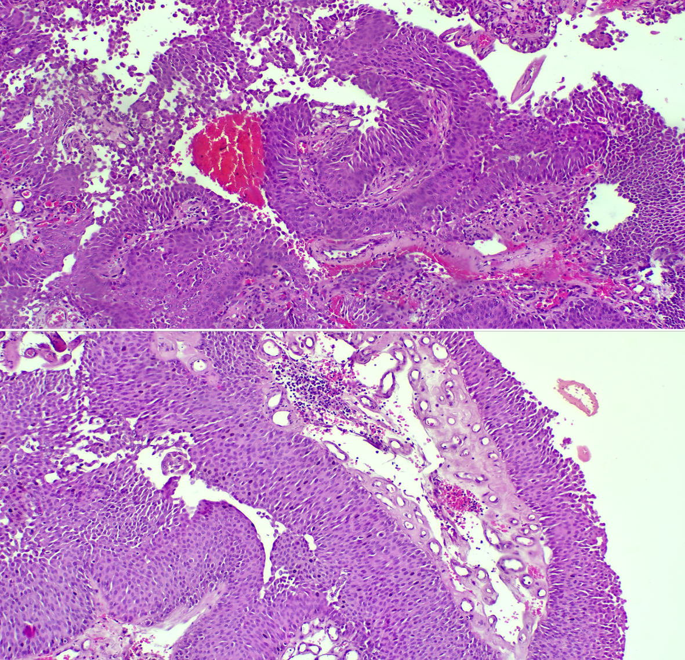

Fig. 1. Histopathological features of bladder tumor (Upper panel ×100; lower panel ×200)

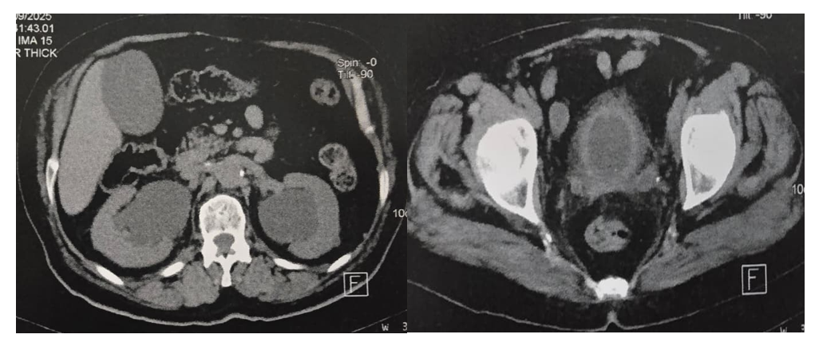

Fig. 2. CT scan images showing bilateral uretero-hydronephrosis upstream of regular bladder wall thickening
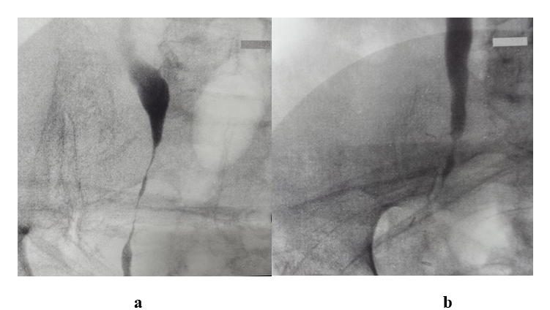

Fig. 3. Retrograde ureteropyelography showing bilateral ureteral dilation upstream of distal pelvic ureteral narrowing; right ureter (a), left ureter (b).

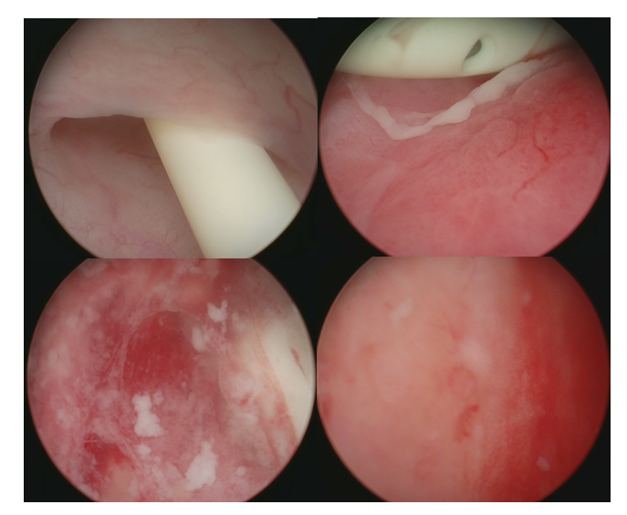

Fig. 4. Cystoscopy showing visualization of both ureteral orifices with diffuse inflammatory lesions, particularly peri-meatal on the left side and retro-trigonal.

