Beyond the Pelvis: Atypical Presentations of Prostate Cancer Mimicking Neurological and Head Neck Pathologies- Selected case series from India.

Abstract
Background
Prostate cancer is one of the most common malignancies among elderly men worldwide. Prostate carcinoma typically metastasizes to bone and regional lymph nodes. Cranial or extrathoracic metastases as initial presentations are exceedingly rare and can mimic neurological or head-and-neck pathologies, leading to diagnostic delay. Such cases are sparsely reported, and to our knowledge, no dedicated case series from India exists.
Methods
We retrospectively analysed five patients who presented with atypical cranial or extra- thoracic manifestations and were subsequently diagnosed with metastatic prostate adenocarcinoma between 2020 and 2025 at our centre. Clinical, radiological, and histopathological data were reviewed.
Results
Presentations included sudden-onset bilateral blindness due to optic canal metastasis (n=1), unilateral facial nerve palsy with skull base involvement (n=1), petrous bone lesion with facial nerve palsy (n=1), Sudden onset memory loss (n=1) and supraclavicular lymphadenopathy (n=1). Serum PSA ranged from 185–420 ng/mL. Imaging (MRI and PET-CT) demonstrated corresponding metastatic lesions. Biopsy or FNAC confirmed metastatic adenocarcinoma with PSA immunopositivity in all cases (insert result). All patients received androgen deprivation therapy, with selected cases receiving palliative radiotherapy. Partial neurological recovery was observed in two patients.333--
Conclusion
Cranial and extrathoracic metastases may rarely represent the initial manifestation of prostate carcinoma. Awareness of such presentations is crucial, as early prostate specific antigen testing and immunohistochemistry can facilitate prompt diagnosis and management. This represents the largest reported Indian case series describing these unusual initial manifestations of prostate cancer.
Keywords:
Prostate carcinoma, cranial metastasis, facial nerve palsy, optic canal, supraclavicular lymphadenopathy, atypical presentation, India

Introduction
Prostate cancer is one of the most common malignancies among elderly men worldwide. Metastatic spread typically involves the axial skeleton, pelvic lymph nodes, and lungs. Cranial metastases, skull-base involvement, and extrathoracic lymphadenopathy as initial manifestations are distinctly uncommon and are often misdiagnosed as primary neurological or head-and-neck pathologies [1,2].Such atypical presentations pose significant diagnostic challenges, particularly in the absence of urinary symptoms. Literature on these presentations is largely limited to isolated case reports, with no comprehensive Indian case series to date. We present five cases highlighting diverse cranial and extra-thoracic manifestations of prostate adenocarcinoma at initial diagnosis.

Presentation of cases
Case 1
A 65-year-old Indian male presented to the medical outpatient department with headache and sudden onset of bilateral loss of vision. Neurological examination was unremarkable except for visual impairment. Contrast-enhanced CT brain revealed a frontotemporal space-occupying lesion with midline shift and perilesional oedema (Figure 1). On detailed review, the patient reported increased urinary frequency and nocturia for six months, with recent 4.5 kg weight loss. Digital rectal examination revealed a hard, irregular prostate.
Laboratory findings included PSA > 100 ng/mL, alkaline phosphatase 1317 IU/L, hemoglobin 6.7 g/dL, and creatinine 1.23 mg/dL. Transrectal ultrasound guided biopsy confirmed high-grade adenocarcinoma (Gleason 10; 5 + 5) with diffuse bilateral involvement. The diagnosis of metastatic prostate carcinoma with intracranial metastasis was established, after PSMA PET CT whole body (fig 1,2) and the patient was commenced on androgen deprivation therapy (ADT) and supportive care.
Case 2
A 63-year-old man presented with right-sided lower motor neuron facial palsy, headache, tinnitus, loss of taste, and decreased lacrimation for one month. MRI brain revealed a 24 × 18 mm lesion along the greater superficial petrosal nerve abutting the cochlea, suggestive of a schwannoma. The patient underwent right temporal craniotomy via an extradural approach.
Histopathology with immunohistochemistry showed metastatic adenocarcinoma positive for PSA, consistent with prostatic origin. Serum PSA was 2300 ng/mL. PSMA PET- CT revealed intense tracer uptake in a right prostatic lesion (primary) with loss of periprostatic fat planes, tracer-avid left internal iliac node, and widespread skeletal metastases including skull, clavicles, ribs, vertebrae, and pelvis (figure 2). Diagnosis: metastatic prostate carcinoma with skull-base involvement producing facial nerve palsy. The patient received ADT and palliative skull-base radiotherapy.
Case 3
A 72-year-old man presented with headache, right-sided hearing loss, and imbalance for three months, followed by dysphagia, dysphonia, and facial weakness. Examination revealed right facial and hypoglossal paresis with ipsilateral trigeminal hypoesthesia. MRI and CT temporal bone demonstrated an infiltrative lesion of the right petrous apex and clivus involving the internal auditory canal.(Figure 3 , Figure 4)

Further history revealed prior radical prostatectomy and radiotherapy for prostate adenocarcinoma five years earlier, with loss to follow-up for three years. Serum PSA was 223.2 ng/mL. Recurrent metastatic prostate carcinoma involving the petrous apex and clivus was diagnosed. The patient was restarted on ADT with local cranial radiotherapy, achieving partial symptomatic improvement.

Case 4
A 68-year-old man, referred from the Head-and-Neck department, presented with a painless left supraclavicular swelling (3 × 3 cm). There were no urinary or skeletal symptoms. Past history included left orchidectomy in childhood. FNAC of the supraclavicular node (Figure 5) showed metastatic poorly differentiated carcinoma of indeterminate origin. Whole-body PET-CT demonstrated an FDG-avid prostatic lesion with disseminated skeletal and cerebral metastases. Immunohistochemistry confirmed metastatic carcinoma positive for PSA and AMACR and negative for TTF-1, consistent with prostatic primary. The patient was commenced on ADT and supportive care.
Case 5
A 74 year old male presented with sudden onset memory loss. On evaluation , neuroimaging revealed calvarial and vertebral metastasis along with a pituitary macroadenoma .Considering the metastatic pattern , a serum PSA level was obtained , which was markedly elevated at 243 ng/dl.A PSMA PET-CT scan demonstrated increased tracer uptake in the prostate consistent with a primary malignancy along with multiple skeletal metastases involving the vertebrae, sternum, humerus and calvarium(Figure 6)
Subsequent transrectal ultrasound guided(TRUS) prostate biopsy confirmed the diagnosis of acinar adenocarcinoma of the prostate with a Gleason score of 4+4=8 showing a cribriform pattern. Patient was started on ADT and supportive care.
Table 1: Summary of clinical, radiological, and treatment characteristics of five patients with atypical initial presentations of prostate carcinoma
Case | Age (yrs) | Presenting Complaint | PSA (ng/mL) | Imaging Findings | Gleason Score | Treatment | Outcome
1 | 65 | Sudden-onset bilateral blindness; headache | >100 | PSMA PET-CT: intracranial metastasis (frontotemporal SOL) + diffuse skeletal mets | 10 (5+5) | ADT + supportive care | No neurological recovery
2 | 63 | Right-sided LMN facial palsy; tinnitus; headache | 2300 | PSMA PET-CT: skull-base (petrosal nerve) lesion + widespread skeletal mets | Not reported | ADT + palliative skull-base RT | Partial neurological recovery
3 | 72 | Right-sided hearing loss; dysphagia; facial and hypoglossal paresis (recurrent disease) | 223.2 | MRI/CT: infiltrative lesion of right petrous apex and clivus | Prior Gleason 7 (post-prostatectomy) | Restarted ADT + cranial RT | Partial symptomatic improvement
4 | 68 | Painless left supraclavicular lymphadenopathy | Not reported* | PET-CT: FDG-avid prostatic lesion + disseminated skeletal and cerebral mets | Poorly differentiated | ADT + supportive care | Not reported
5 | 74 | Sudden-onset memory loss | 243 | PSMA PET-CT: calvarial, vertebral, sternal, humeral mets + pituitary macroadenoma | 8 (4+4) | ADT + supportive care | Not reported
ADT = Androgen Deprivation Therapy; RT = Radiotherapy; LMN = Lower Motor Neuron; SOL = Space-Occupying Lesion; mets = metastases. *PSA value not documented in available records for Case 4; to be updated.

DISCUSSION
Cranial and extrathoracic metastases from prostate cancer are rare clinical entities, with reported incidence of intracranial involvement ranging from 1–2% in advanced disease [1,5]. Most available literature consists of isolated case reports or small series, predominantly from Western populations. Similar to these reports, our series demonstrates a clear predilection for skull-base and osseous involvement, manifesting as cranial neuropathies, visual disturbances, and head–neck symptoms [3–5]. However, in contrast to many previously described cases where the primary diagnosis of prostate cancer was already established, the majority of our patients presented with non-urological symptoms as the initial manifestation, thereby posing a significant diagnostic challenge.

The pathophysiology of cranial metastases in prostate cancer is primarily attributed to hematogenous dissemination through Batson’s vertebral venous plexus, which allows retrograde spread of tumor cells to the skull base and intracranial structures without pulmonary filtration [3]. This explains the predominance of skull-base involvement and cranial nerve deficits observed both in our series and prior studies [4]. Consistent with earlier reports, parenchymal brain metastases remain uncommon, while osseous infiltration of the skull base leading to focal neurological deficits is more frequently encountered [5]. Recent case series have further documented similar presentations of cranial nerve palsies due to skull-base metastases in advanced prostate cancer, reinforcing these observations [9].

A key observation in our study is the high likelihood of initial misdiagnosis due to clinical and radiological mimicry. Lesions were initially suspected to be schwannomas, meningiomas, or pituitary adenomas in some cases, consistent with prior reports highlighting similar diagnostic pitfalls [6]. The absence of lower urinary tract symptoms in most of our patients further contributed to delayed suspicion of a prostatic origin. This underscores the critical importance of maintaining a high index of suspicion and incorporating serum PSA testing in elderly male patients presenting with unexplained cranial neuropathies or atypical head–neck findings. In all our cases, markedly elevated PSA levels and confirmatory immunohistochemistry (PSA and AMACR positivity) were instrumental in establishing the diagnosis, in line with established diagnostic approaches [7]. Additionally, rare patterns such as leptomeningeal involvement have also been described in recent literature, further expanding the spectrum of atypical presentations [10].

From an Indian perspective, literature on such atypical presentations remains sparse and is largely limited to isolated case reports. Factors such as lack of routine screening, delayed healthcare access, and low awareness contribute to advanced-stage presentations in this setting. Our series, representing one of the largest reported from India focusing specifically on atypical cranial and extrathoracic manifestations, highlights these unique challenges. Contemporary guidelines and consensus statements on advanced prostate cancer also emphasize the heterogeneity of metastatic patterns and the importance of early recognition for optimal management [11]. The findings of our study underscore the need for greater multidisciplinary awareness among neurologists, neurosurgeons, and head–neck specialists. Early recognition, coupled with prompt PSA testing and appropriate immunohistochemical evaluation, can significantly reduce diagnostic delays, avoid unnecessary surgical interventions, and facilitate timely initiation of systemic therapy.

Conclusion
Prostate cancer should be considered in elderly males presenting with unexplained cranial neuropathies, intracranial lesions, or supraclavicular lymphadenopathy, even in the absence of urinary symptoms. Early PSA estimation and appropriate immunohistochemical evaluation are essential for prompt diagnosis and management.Given that early clinical symptoms of prostate cancer may be subtle or absent especially in atypical presentations, heightened clinical awareness along with early serum PSA testing and immunohistochemical evaluation is essential to facilitate timely diagnosis and to avoid misdiagnosis as primary neurological or head neck pathologies.

Declaration
During the preparation of this work, the author(s) used Perplexity AI solely to assist with reference identification and to verify whether similar cases have been previously published. All retrieved references were independently verified by the authors. The clinical data, analysis, and conclusions are entirely the authors’ own. After using this tool/service, the author(s) reviewed and edited the content as needed and take(s) full responsibility for the content of the published article.
COMPETING INTERESTS DISCLAIMER:
Authors have declared that they have no known competing financial interests OR non-financial interests OR personal relationships that could have appeared to influence the work reported in this paper.
Consent
As per international standards or university standards, patient(s) written consent has been collected and preserved by the author(s).

Ethical Approval:

As per international standards or university standards written ethical approval has been collected and preserved by the author(s).

Disclaimer (Artificial intelligence)
Author(s) hereby declare that NO generative AI technologies such as Large Language Models (ChatGPT, COPILOT, etc.) and text-to-image generators have been used during the writing or editing of this manuscript

References
1.Bubendorf L, Schöpfer A, Wagner U, et al. Metastatic patterns of prostate cancer: an autopsy study of 1,589 patients. Hum Pathol. 2000;31(5):578–583.
2.Hess KR, Varadhachary GR, Taylor SH, et al. Metastatic patterns in adenocarcinoma. Cancer. 2006;106(7):1624–1633.
3.Laigle-Donadey F, Taillibert S, Mokhtari K, et al. Skull-base metastases. J Neurooncol. 2005;75(1):63–69.
4.Greenberg HS, Deck MD, Vikram B, et al. Metastasis to the base of the skull: clinical findings in 43 patients. Neurology. 1981;31(5):530–537.
5.Hatzoglou V, Patel GV, Morris MJ, et al. Brain metastases from prostate cancer: an analysis of 11 cases. AJNR Am J Neuroradiol. 2014;35(3):466–471.
6.Saitoh H, Hida M, Shimbo T, et al. Metastatic patterns of prostate cancer. Cancer. 1984;54(12):3078–3084.
7.Epstein JI, Netto GJ. Biopsy Interpretation of the Prostate. 5th ed. Philadelphia: Wolters Kluwer; 2020.
8.Hollenbeck BK, Dunn RL, Ye Z, et al. Delayed diagnosis and treatment of prostate cancer. Cancer. 2004;100(5):1043–1050.
9.Yasumizu Y, Kosaka T, Hongo H, Mizuno R, Oya M. Cranial nerve palsy caused by metastasis to the skull base in patients with castration-resistant prostate cancer: three case reports. IJU Case Rep. 2021;4(2):108–111. doi:10.1002/iju5.12255. PMID: 33718819.
10.Stenberg D, Shalavadi M, Syeda H, Reddy K, Saunders P. Leptomeningeal carcinomatosis of metastatic primary prostate cancer. Case Rep Oncol. 2021;14(2):753–760. doi:10.1159/000514755. PMID: 34177526.
11.Gillessen S, Attard G, Beer TM, et al. Management of patients with advanced prostate cancer: report of the Advanced Prostate Cancer Consensus Conference (APCCC). Eur Urol. 2022.

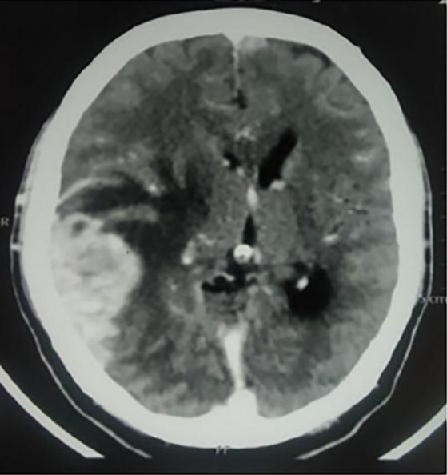
Figure 1: Contrast-enhanced MRI brain (Case 1) demonstrating a peripherally enhancing cystic space-occupying lesion in the right occipitoparietal region with surrounding perilesional oedema and mild effacement of the third ventricle, consistent with intracranial metastasis from prostate carcinoma.

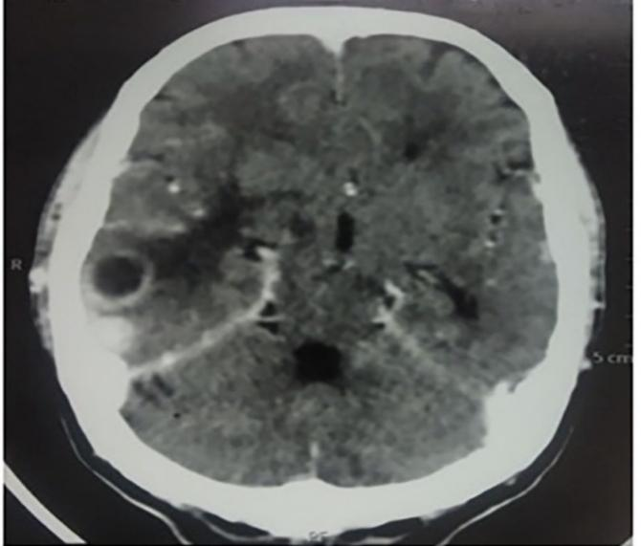
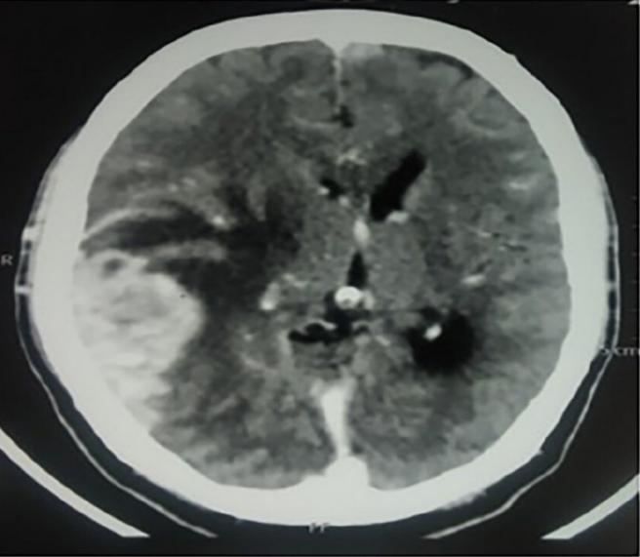
Figure 2: PSMA PET-CT (Case 1) demonstrating intense tracer-avid metastatic lesion in the right temporal region with associated mass effect on the third ventricle, confirming intracranial prostatic metastasis.

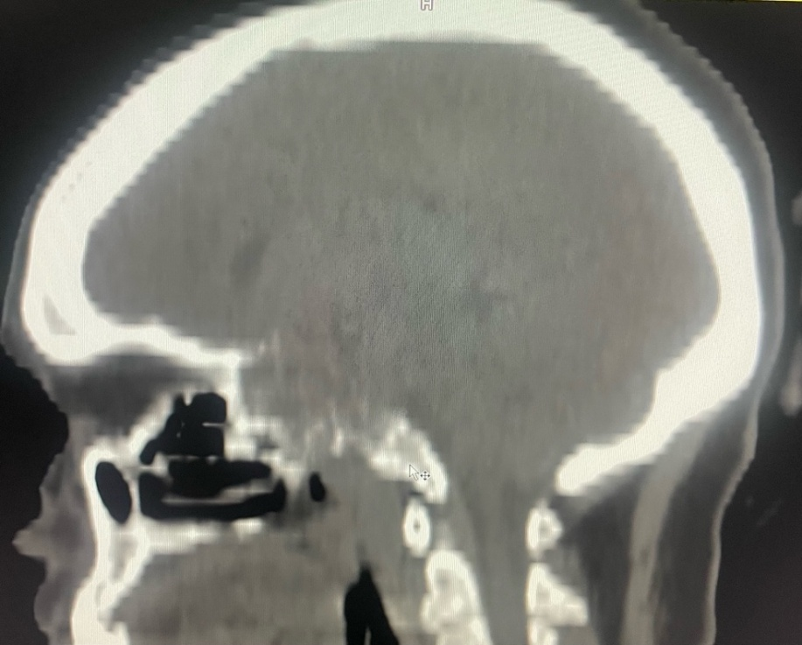
Figure 3: CT temporal bone (Case 3) demonstrating an infiltrative lesion involving the right petrous apex and clivus with destruction of surrounding osseous structures, consistent with metastatic prostate carcinoma.

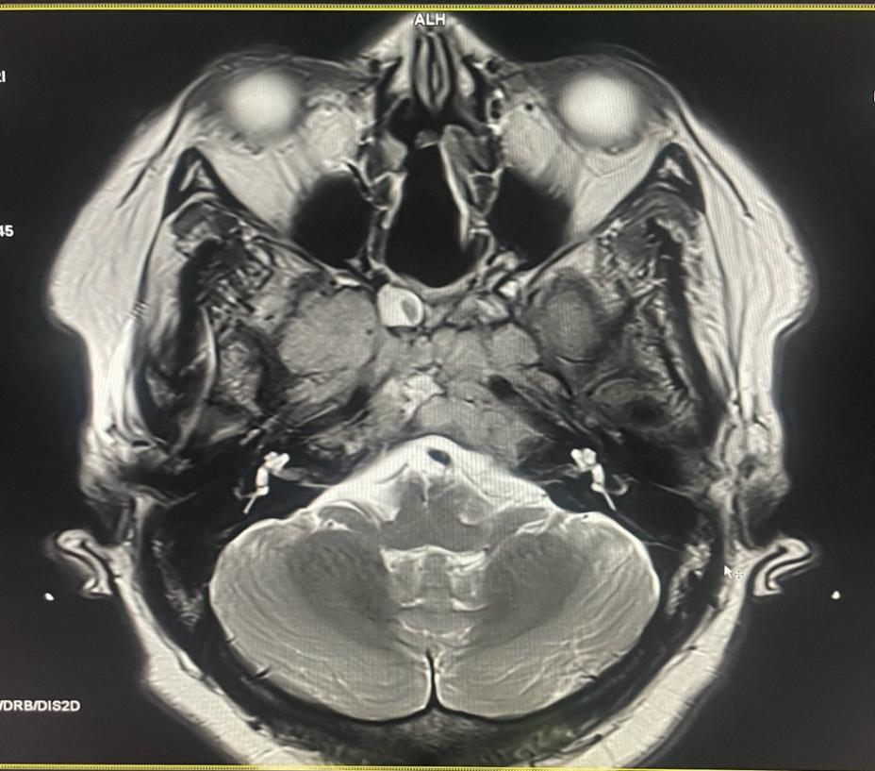
Figure 4: MRI brain (Case 3) showing bilateral Meckel’s cave encasement with compression of the trigeminal nerve on the right side, consistent with perineural spread of metastatic disease.

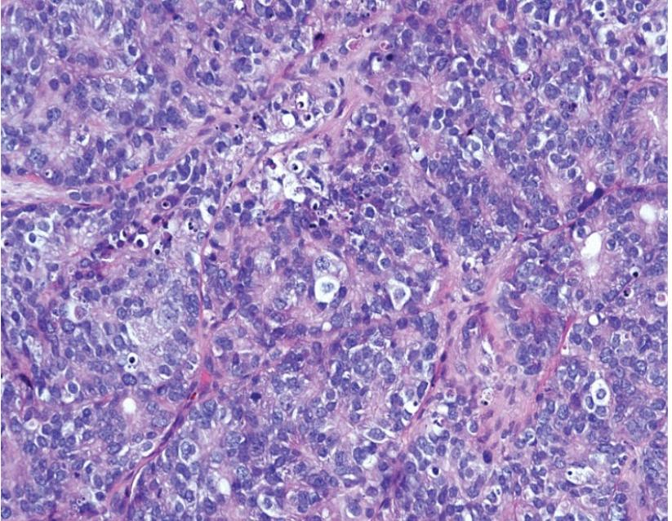
Figure 5: Fine needle aspiration cytology (FNAC) of the left supraclavicular lymph node (Case 4) demonstrating metastatic poorly differentiated adenocarcinoma; immunohistochemistry confirmed PSA and AMACR positivity, establishing prostatic origin.

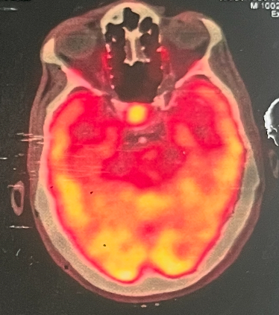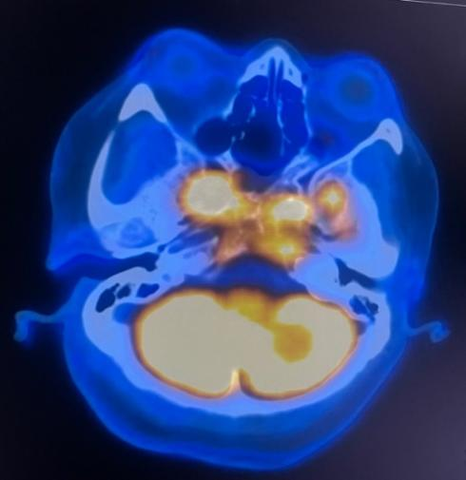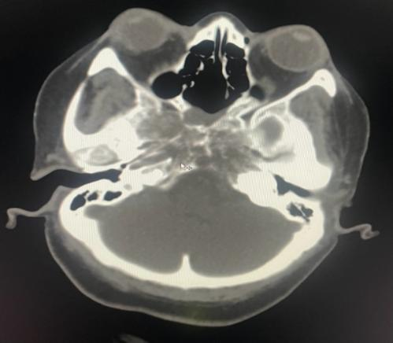
Figure 6: PSMA PET-CT (Case 5) demonstrating an intensely tracer-avid lytic lesion with sclerotic component in the calvarium, consistent with skeletal metastasis from prostate carcinoma. Multiple additional skeletal metastases were noted throughout the axial skeleton.

