Bilateral Orbital Cellulitis: A Case Report and Review of the Literature

ABSTRACT
Orbital cellulitis (OC) is a potentially life-threatening ophthalmic emergency characterised by rapid progression, which may result in severe visual impairment and serious systemic complications if not managed promptly. The condition is typically unilateral, with bilateral involvement being uncommon and generally associated with extension through the cavernous sinus. Bilateral orbital cellulitis secondary to rhinosinusitis is rare, although such cases have been documented in the literature from various regions. The present case underscores the critical importance of sound clinical judgement, early and accurate diagnosis, and timely therapeutic intervention in the effective management of bilateral orbital cellulitis, in order to prevent adverse visual and systemic outcomes. We present a 7-year-old boy who had catarrh, fever, headache, and right eye swelling, which later progressed to involve the left eye. An Orbital MRI was done, which showed bilateral orbital cellulitis with right intraocular collection extending into the right maxillary and ethmoidal sinuses. Management was both medical and surgical, using a multidisciplinary approach.
KEY WORDS: Cellulitis, antibiotics, sinuses, multidisciplinary.

INTRODUCTION
Orbital cellulitis is an acute, suppurative inflammatory condition involving the orbital and periorbital tissues, primarily of infectious origin. Clinically, the majority of cases reported in hospital settings and the literature are unilateral, with bilateral involvement typically occurring only when there is extension through the cavernous sinus. Bilateral orbital cellulitis secondary to rhinosinusitis is uncommon, although such cases have been documented in reports from various countries. Orbital cellulitis frequently arises as a complication of ethmoidal sinusitis and demonstrates a higher incidence in the paediatric population.¹˒² The infection may spread to the orbit via multiple routes, including ophthalmic, dental, cutaneous, or respiratory pathways. In such instances, normal commensal organisms from these sites may translocate locally or disseminate through haematogenous spread to involve the orbital tissues.³˒⁴ The pathophysiology of bilateral orbital involvement has been attributed to direct spread of infection through the ophthalmic veins to the cavernous sinus, followed by centrifugal extension to the contralateral orbit via dural connections. The venous drainage of the paranasal sinuses and the midfacial region predominantly occurs through the orbital veins, which communicate extensively with the pterygoid venous plexus and the cavernous sinus.³˒⁴˒⁵ This anatomical interconnection facilitates the rapid spread of infection, thereby contributing to the development of bilateral orbital cellulitis in rare cases. In the orbit, these veins lack valves, which may allow passage of infectious processes in both anterograde and retrograde directions. Multiple pathways have been proposed to explain the development of bilateral orbital cellulitis. In some cases, bilateral involvement occurs in the later stages of the disease and is associated with infection of the cavernous sinus.³˒⁴˒⁵ From an anatomical perspective, the paranasal sinuses constitute an integral component of the orbital region.⁴ The medial orbital wall, which separates the orbit from the ethmoidal sinus, is exceptionally thin—particularly in children—and contains multiple प्राकृतिक perforations that transmit valveless blood vessels and nerves.
This anatomical configuration, characterised by thin bony structures, natural dehiscences, and a loosely adherent periorbita, facilitates the spread of infectious and inflammatory processes between the ethmoidal air cells and the medial orbital compartment. Consequently, the medial orbital wall represents a common site for the development of subperiosteal abscesses. Furthermore, the orbital floor is also composed of relatively thin bone and is therefore susceptible to subperiosteal abscess formation secondary to adjacent maxillary sinusitis.⁴,21
The classification of orbital cellulitis depends on its relation to the orbital septum- preseptal or retroseptal cellulitis.⁵ Early diagnosis, high index of suspicion, effective and prompt treatment are essential to prevent rapid disease progression, morbidity, and impaired quality of life, including carvenous sinus thrombosis, meningitis, frontal abscess, osteomyelitis, loss of vision, and intracranial involvement with neurological sequelae.^{6,7} Most literature have reported unilateral orbital cellulitis; however, Achigbu et al had a similar case of bilateral orbital cellulitis. We describe the case of a 7-year-old boy with bilateral orbital cellulitis and an intraocular extension collection. This report aims to highlight the non-specific presenting symptoms, progression from unilateral to bilateral orbit, and the need for prompt diagnosis and management.

CASE SUMMARY
A 7-year-old boy presented with a 4-day history of catarrh, fever, headache, and right eyelid swelling. The catarrh was associated with non-foul-smelling yellow discharge. Fever, which was described as high-grade, continuous, and temporarily relieved by oral acetaminophen. The headache was described as pounding in nature and localized to the right temporal area. Swelling of the right eyelid was insidious and progressively increasing in size, with associated eye pain that rendered the patient unable to open the right eye; no eye discharge. There was associated vomiting, non-bilious, non-projectile, non-bloody, containing recently ingested food, with approximately three episodes over the two days preceding presentation. There was no history of sore throat or cough, convulsions, neck stiffness, or photophobia. There was no swelling in other parts of the body, no history of trauma to the eye or head, or insect bite. No known allergy and no previous history of similar occurrence. At the onset of the symptoms, he was placed on oral antibiotics, 2 days later, he presented again on account of worsening of symptoms (progressive right eyelid swelling with visual impairment).
On Physical Examination: He was acutely ill looking with ptosis and swollen right eye, afebrile, not pale, anicteric, acyanosed, not dehydrated.
On Eye Examination: Left Eye: Both eyelids are normal, extraocular muscles are intact, with eye movement appreciated. Right Eye: Marked swelling of the right eyelid, edematous and erythematous (Figure 1), scanty clear eye discharge, tender to touch, reduced eye movement, and unable to open the eye. Other systemic examinations were normal.
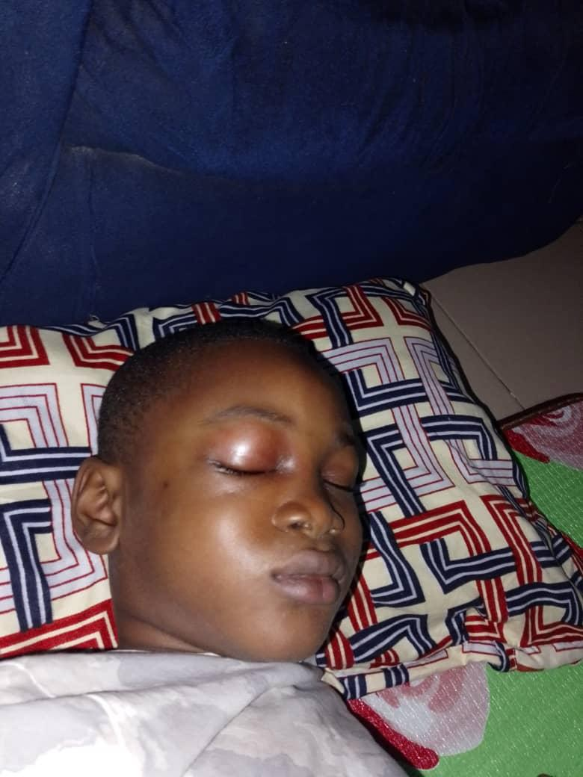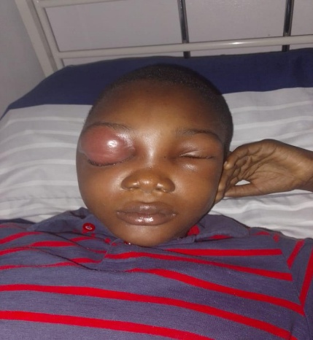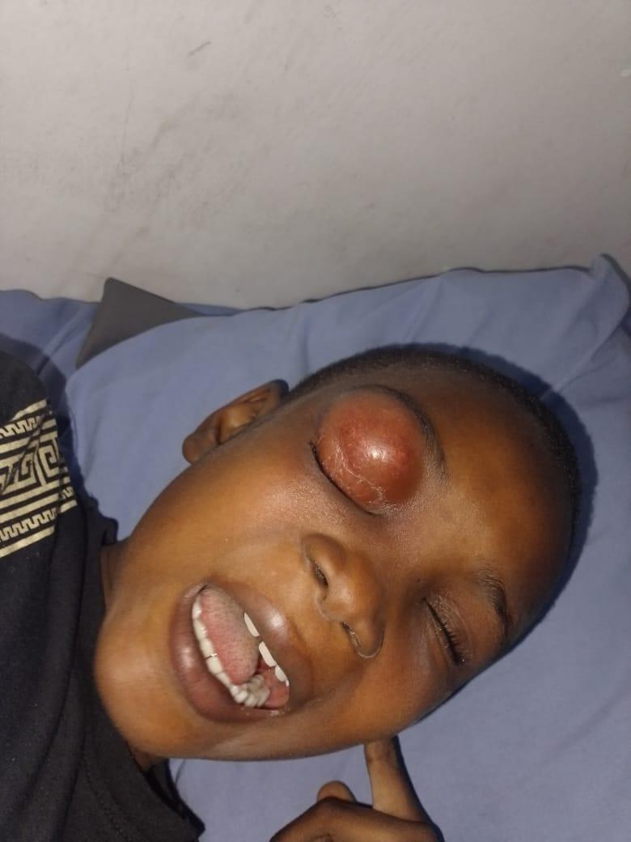
FIGURE 1: Right eye erythema and edema, with mild periorbital edema of the left eye

An assessment of pre-septal cellulitis, with suspected orbital cellulitis, was made.
Full blood count showed: total white blood cell counts 12600/mm3, PCV 33%, neutrophils 74%, lymphocytes 13%. Markedly raised C-Reactive protein -118.68mg/L (1-10mg/L) and Erythrocyte sedimentation rate - 125mm/hr (3-5mm/hr). Viral markers were all negative, and electrolytes were normal, and an eye swab was taken for MCS (Which showed no growth after 72hours)
He was admitted and commenced on intravenous Vancomycin, metronidazole, and analgesics. On the third day of admission, the left eye was noticed to have started swelling, while the right eye showed no improvement. An Orbital MRI reported bilateral orbital cellulitis with right intraocular collection extending into the right maxillary and ethmoidal sinuses (FIGURE 2). On the 4th day of admission, Periorbital swelling of both eyes was noticed to be increasing in size. The eye examination was done and showed
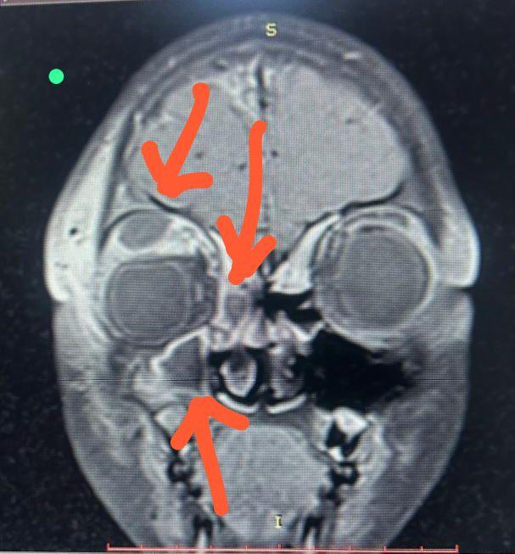A 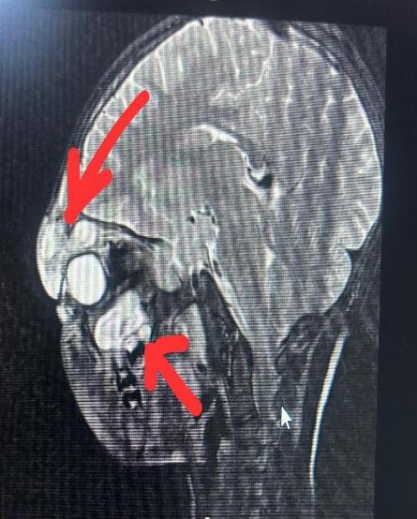B 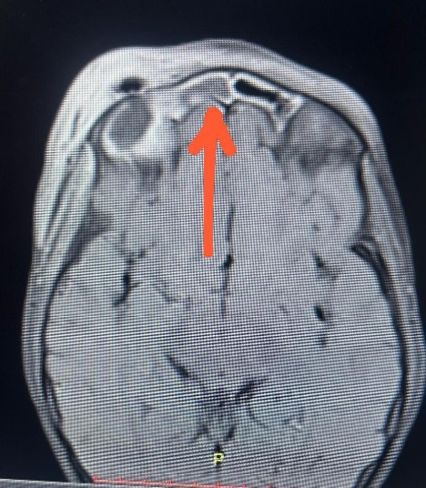C
FIGURE 2: A. Coronal contrast-enhanced T1-weighted MRI showing a heterogeneously enhancing soft-tissue lesion in the sinonasal/maxillary region with medial extension.
2B; Sagittal contrast-enhanced T2-weighted MRI showing homogenous bright lesions in the maxillary and orbital area.
2C; Axial contrast enhanced T-1 weighted MRI
On Eye Examination, Right: marked swelling of the eyelid, edematous and erythematous, with clear eye discharge; tender to touch; the patient was unable to open and turn the eyes. Left eye- Mild swelling of the eyelid, edematous with minimal clear discharge, tender, but the patient was able to open and move the eye. (Figures 1 and 3)

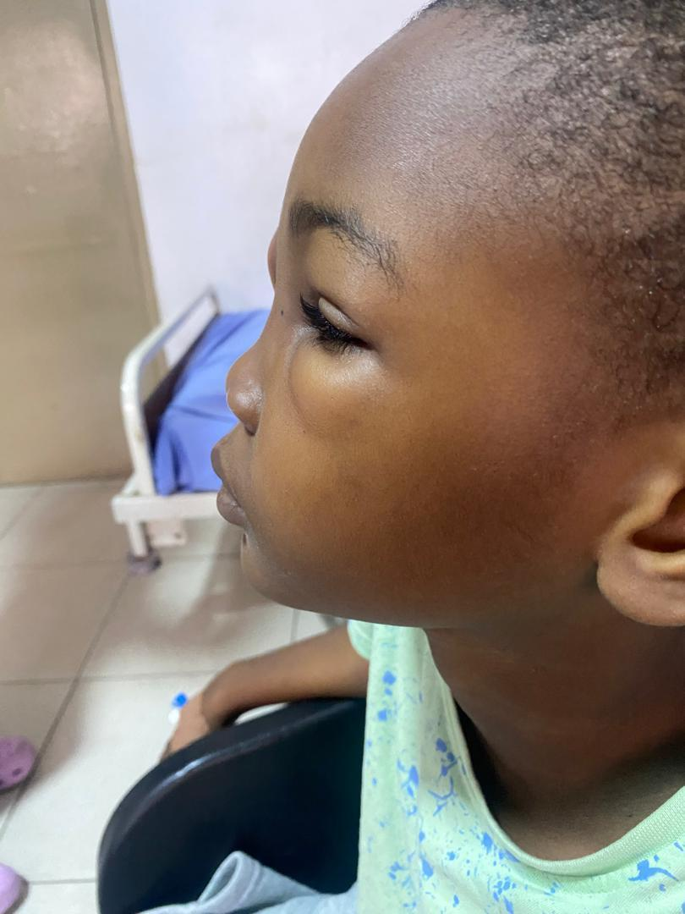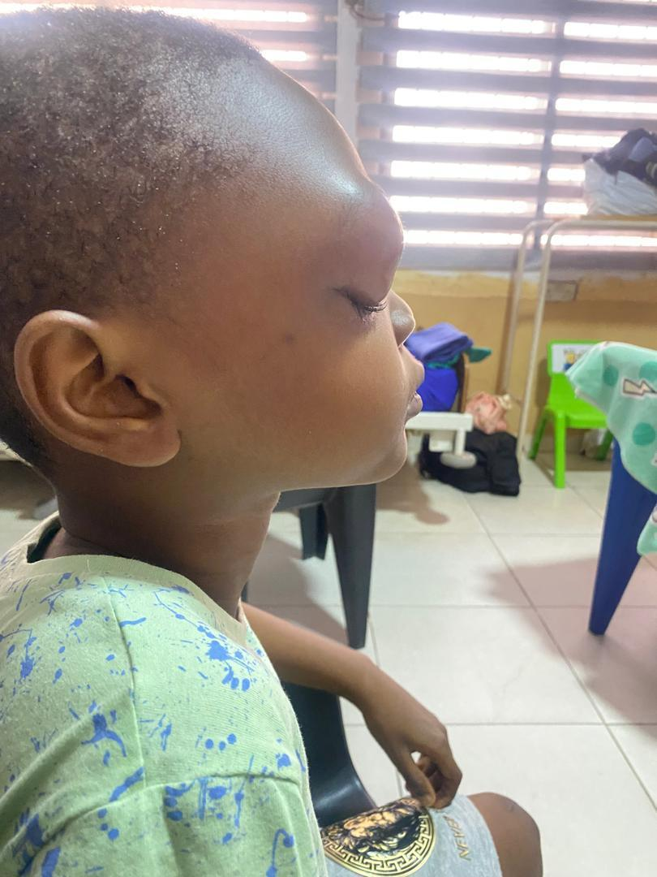
FIGURE 3: lateral view, showing bilateral periorbital edema
A multidisciplinary meeting was held involving the pediatrician, ophthalmologist, and ENT surgeon, and the patient was booked for an ethmoidectomy. He was commenced on analgesics and acetazolamide by the ophthalmologist following a review. The antibiotics were changed from Vancomycin and Ceftriaxone to Intravenous Amikacin and Meropenem. He also received intravenous steroids (Dexamethasone), Xylometazoline (Otrivin), and Betamethasone nasal drops. He had a surgery (Ethmoidectomy and right antrostomy) done, and 13mls of pus was aspirated from the periorbital and right maxillary sinus. The upper eyelid was incised, and gauze packing was done with wound dressing. The right anterior nasal packing was also done. The eye aspirate sample was taken and was negative for any organism.
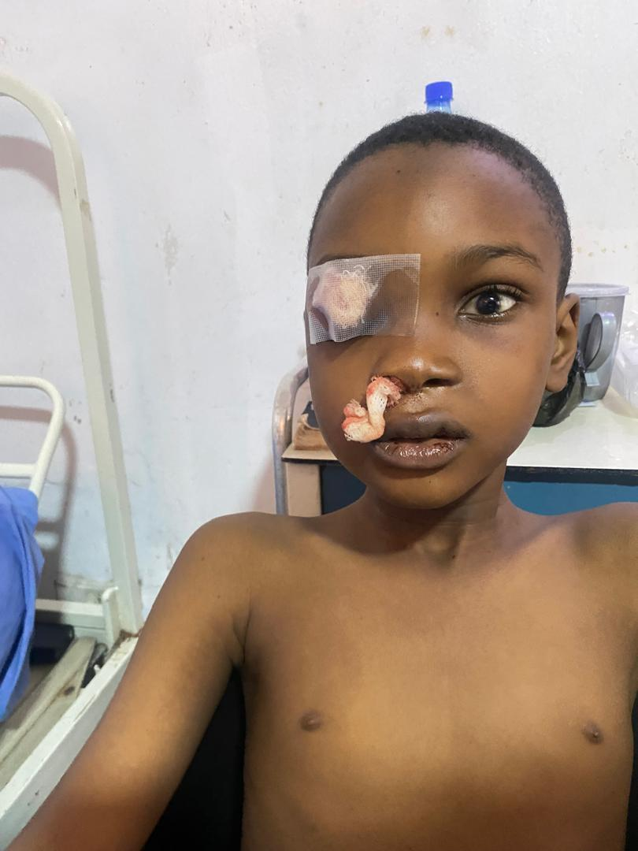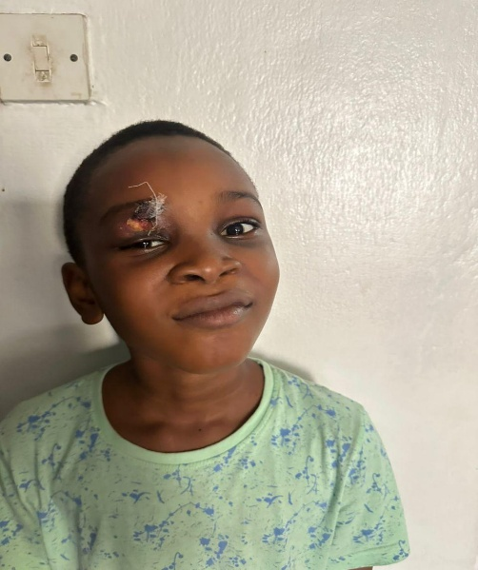
FIGURE 4: Post-surgical drainage of abscess
Post surgery, the patient's vital signs remained stable, and the nasal pack was to be removed the next day. On the 4th postop day, the right eye swelling remained the same size, with some difficulty opening the eye completely and reduced vision, but the eye discharge had resolved completely. The left eye was completely normal. The ENT surgeon and ophthalmologist did a further review, and a diagnosis of right upper eyelid abscess was made. The patient had incision and drainage of the right upper eyelid abscess (peri-orbital pus was drained). Patient continued with the intravenous antibiotics and other medications.
Thereafter, the patient's clinical condition remained stable, eye swelling completely resolved (figure 4), a repeat blood count was normal, and IV antibiotics were changed to oral antibiotics. He was discharged home after 15days on admission (7th day post-surgery). He is being followed up in the clinic and is doing well (figure 5).

FIGURE 5: on follow-up visit

DISCUSSION
Orbital cellulitis is a common yet potentially life-threatening infection involving the post-septal orbital tissues and represents one of the leading causes of orbital inflammation. It constitutes a medical emergency, necessitating early diagnosis and prompt initiation of effective treatment. Management often requires a multidisciplinary approach involving radiologists, ophthalmologists, otorhinolaryngologists (ENT surgeons), maxillofacial surgeons, and, in certain cases, neurosurgeons.⁸ The condition exhibits a peak incidence in children aged between 6 and 15 years, with a noted male predominance, which is consistent with the present case of a 7-year-old male child.⁹˒¹⁰
Orbital cellulitis is typically unilateral, with bilateral involvement occurring primarily in cases associated with cavernous sinus extension.¹¹ This may explain the clinical progression observed in the present case, where initial right-sided involvement subsequently extended to the left orbit. The spread of infection may occur through dehiscence in the orbital bony walls or via the venous drainage system of the orbit. These valveless veins communicate with the pterygoid venous plexus and the cavernous sinus, facilitating the dissemination of infection. Bilateral cavernous sinus involvement may result in contiguous spread to the contralateral orbit, representing a key mechanism in the development of bilateral orbital cellulitis. Such progression may also be associated with intracranial complications, including abscess formation and altered consciousness.¹²
The condition is most commonly precipitated by acute spread of infection from adjacent paranasal sinuses, the bloodstream, or facial skin. Additional sources include periorbital trauma and dental infections.¹³ In the present case, involvement of both the maxillary and ethmoidal sinuses was noted, with the ethmoidal sinus being the most frequent source of infection in paediatric patients due to the delayed development of the frontal and sphenoidal sinuses.
A variety of microbial agents have been implicated in orbital cellulitis. In paediatric populations, common causative organisms include Haemophilus influenzae, Staphylococcus aureus, Streptococcus species, and anaerobic bacteria.⁵˒¹⁴ Among culture-positive cases, S. aureus and Streptococcus species are most frequently identified. More recent studies have reported Staphylococcus species as the predominant isolates from orbital abscesses and sinus aspirates, including a significant proportion of methicillin-resistant S. aureus (MRSA), followed by Streptococcus species.¹⁵ Anaerobic organisms such as Peptococcus, Peptostreptococcus, and Bacteroides are less commonly encountered and are typically associated with infections following bites.¹⁵ Blood cultures, however, often yield negative results, particularly in older children, as observed in the present case. It has been suggested that endoscopically obtained sinus samples may provide higher diagnostic yield compared to blood or skin cultures. Infection may spread via direct extension or haematogenous routes, and in children, the relatively thin medial orbital wall, compounded by inflammatory oedema, contributes to the development of orbital and palpebral oedema.¹⁴
Clinically, orbital cellulitis presents with symptoms such as orbital pain, proptosis, globe displacement, diplopia, visual impairment, chemosis, and restricted extraocular movements (ophthalmoplegia). In the present case, the patient exhibited proptosis, visual loss, and ophthalmoplegia. A history of antecedent conditions such as headache, rhinitis, sinusitis, nasal discharge, or upper respiratory tract infection is often elicited, several of which were evident in this patient.¹⁶˒¹⁷ Visual deterioration may occur rapidly, emphasising the urgency of diagnosis and management. Diagnosis is primarily based on clinical evaluation, supported by radiological imaging. Computed tomography (CT) scanning remains a key diagnostic tool, enabling visualisation of orbital structures, identification of sinus involvement, and detection of orbital or subperiosteal abscesses.¹⁸˒¹⁹ Magnetic resonance imaging (MRI) offers superior soft tissue resolution and is particularly useful in evaluating intracranial extension or non-metallic foreign bodies, while avoiding radiation exposure.²⁰ In the present case, MRI was instrumental in identifying an orbital abscess following an inadequate response to antibiotic therapy, thereby guiding subsequent surgical intervention. However, limitations of MRI include longer acquisition times, potential need for sedation in paediatric patients, and limited availability in emergency settings.²⁰
Management of orbital cellulitis involves a combination of aggressive intravenous antibiotic therapy and, where indicated, surgical drainage of abscesses. Continuous monitoring of visual function and systemic signs is essential to evaluate treatment response.⁴ In this case, initial medical management was insufficient, as evidenced by persistent fever and progression of orbital swelling, necessitating further imaging and surgical intervention. Surgical management is indicated in cases of clinical deterioration, lack of response to antibiotics, worsening visual function, or abscess formation.⁴ The duration of therapy is determined by the patient’s clinical course and response to treatment.
The patient demonstrated significant clinical improvement following appropriate medical and surgical management and was discharged on oral therapy after a 15-day hospital stay. This duration is consistent with previous reports, which indicate an average hospital stay of 10–25 days.¹¹˒¹⁶ Early presentation and timely initiation of empirical treatment likely contributed to limiting disease progression and preventing severe complications. The favourable outcome in this case underscores the critical importance of prompt diagnosis, multidisciplinary management, and early therapeutic intervention in orbital cellulitis.
LIMITATION
A major limitation is financial constraints, as orbital cellulitis has the potential for significant visual and life-threatening complications. Prompt diagnosis and expeditious treatment are important in minimizing complications.
CONCLUSION
Orbital cellulitis is a common life-threatening infection of the post-septal tissues of the orbit and one of the common causes of orbital inflammation. It is an ophthalmologic emergency with life-threatening complications. An understanding of anatomic considerations, predisposing factors, diagnostic investigations is of great importance for prompt diagnosis, specific treatment, and preventing disease progression. A multidisciplinary approach is key to good outcomes.

Consent
As per international standards, parental written consent has been collected and preserved by the author(s).

Ethical Approval:

As per international standards or university standards written ethical approval has been collected and preserved by the author(s).

Disclaimer (Artificial intelligence)
Author(s) hereby declare that NO generative AI technologies such as Large Language Models (ChatGPT, COPILOT, etc.) and text-to-image generators have been used during the writing or editing of this manuscript.

REFERENCES
1. Burek AG, Melamed S, Liljestrom T, Qi J, Kelly TG, Suelzer E, Mitchell M, Harris GJ, Havens PL. Evaluation and medical management of the pediatric patient with orbital Cellulitis/Abscess: A Systematic Review. J Hosp Med. 2021;16(11):680-687.
2. Wong SJ, Levi J. Management of pediatric orbital cellulitis: A systematic review. Int J Pediatr Otorhinolaryngol. 2018;110(April):123-129.
3. Atfeh MS, Khalil HS. Orbital infections: Five-year case series, literature review, and guideline development. J Laryngol Otol. 2015;129(7):670-676.
4. Lee S, Yen MT. Management of preseptal and orbital cellulitis. Saudi J Ophthalmol. 2011;25(1):21-29.
5. Saadouli D, Yahyaoui S, Mansour KB, Masmoudi M, El Afrit MA, Sammoud. Les cellulites orbitaires chez l’enfant : À propos de 60 cas. Journal Français d'Ophtalmologie. 2019;42(10):1056-1061.
6. Meara DJ. Sinonasal disease and orbital cellulitis in children. Oral Maxillofac Surg Clin North Am. 2012;24(3):487-496.
7. Tsirouki T, Dastiridou AI, Ibánez Flores N, Cerpa JC, Moschos MM, Brazitikos P, et al. Orbital cellulitis. Surv Ophthalmol. 2018;63(4):534-553.
8. Chaudhry IA, Al-Rashed W, Arat YO. The hot orbit: Orbital cellulitis. Middle East Afr J Ophthalmol. 2012;19:34-42.
9.Ailal F, Bousfiha A, Jouhadi Z, Bennani M, Abid A. Cellulites orbitaires chez l’enfant: À propos d’une étude rétrospective de 33 cas. Medicine Tropicale. 2004;64(4):359-362.
10. Sobol ES, Marchand J, Tewfik LT, Manoukian JJ, Schoss DM. Orbital complications of sinusitis in children. The journal of otolaryngology. 2002;31(3):131-136.
11. Singh SK, James E, Sabarigirish K, Swami H, Sood T. Bilateral orbital complications of paediatric rhinosinusitis. Med J Armed Forces India 2014; 70: 68 - 72
12. Harrington JN. Orbital Cellulitis. Available from: http: //emedicine. medscape. com/article/1217858.
13. Kanski JJ. Orbit in Clinical Ophthalmology. 5th ed. gh, New York: Butterworth Heinemann. p.568 - 9.
14. Coulibaly S. Aspects épidémiologiques et cliniques des cellulites orbitaires au CHU-IOTA à propos de 30 cas; 2023.
15.McKinley S.H., Yen M.T. Microbiology of pediatric orbital cellulitis. Am. J. Ophthalmol. 2007;144(4):497–501
16. Schramm VL Jr, Curtin HD, Kennerdell JS. Evaluation of orbital cellulitis and results of treatment. Laryngoscope 1982; 92: 732.
17. Bergin DJ, Wright JE. Orbital cellulitis. Br J Ophthalmol 1986; 70: 174.
18. Eustis HS, Mafee MF, Walton C, Mondonca J. MR imaging and CT of orbital infections and complications in acute rhinosinusitis. Radiol Clin North Am 1998; 36: 1165 - 83.
19.Harris G.J. Subperiosteal abscess of the orbit: computed tomography and the clinical course. Ophthal. Plast. Reconstr. Surg. 1996;12:1–8
20.Mills D.M., Tsai S. Pediatric ophthalmic computed tomographic scanning and associated cancer risk. Am. J. Ophthalmol. 2006;142(6):1046–1053.
21. Achigbu, E. O., & Achigbu, K. I. (2017). Bilateral orbital cellulitis: A case report and management challenges. Nigerian Journal of Ophthalmology, 25(1), 52-55.

