Case report
Late-Onset Ocular Hypotony Revealing Post-Traumatic Cyclodialysis: A Case Report

ABSTRACT
Post-traumatic cyclodialysis is a rare entity resulting from a detachment of the ciliary body from the scleral spur, most often secondary to blunt trauma. This creates a shunt space between the anterior chamber and the suprachoroidal space, leading to variable ocular hypotony. Its significance lies in the potential consequences for the optic nerve and macula. We report a case of delayed hypotony in a 13-year-old child, in whom intraocular pressure decreased from 12 to 6 mmHg over fifteen days following trauma, with a visual acuity declining from 10/10 to 4/10 (0.0 to 0.4 LogMAR) .The diagnosed was made using gonioscopy and anterior segment optical coherence tomography (AS-OCT).The patient’s condition evolved favorably under conservative medical management with cycloplegia using atropine 1% for one month. This case highlights the importance of close monitoring and early diagnosis in pediatric post-traumatic cyclodialysis.
Keywords: cyclodialysis, ocular hypotony, ocular trauma.
INTRODUCTION
Post-traumatic cyclodialysis is a rare entity in ocular trauma, particularly in children (1), and should always be considered in cases of post-traumatic ocular hypotony, especially when it occurs late after closed-globe injury (2). The challenge of this condition lies in both its diagnostic and therapeutic management, as well as in its potential complications, which may affect both the functional and anatomical prognosis of the eye (3,4).
Cyclodialysis results from a disruption of the attachment between the ciliary body and the scleral spur, creating an abnormal pathway through which aqueous humor flows into the suprachoroidal space. This leads to a decrease in intraocular pressure (IOP), potentially resulting in severe hypotony. Clinical manifestations include a shallow anterior chamber, decreased visual acuity, macular folds, and occasionally papilledema.
Ultrasound biomicroscopy (UBM) is considered the gold standard for visualizing cyclodialysis clefts; however, anterior segment optical coherence tomography (AS-OCT) represents a useful non-invasive alternative, particularly in pediatric patients (5,6).
Management options include cycloplegia with atropine, laser photocoagulation, or surgical intervention in refractory cases. Cyclodialysis clefts are uncommon in pediatric ocular trauma, with a reported incidence ranging from 1% to 11% in trauma series (7,8).
We report this case to contribute to the limited literature and to further expand current knowledge on this rare condition in children.
CASE REPORT
A 13-year-old patient with no prior medical history presented to the ophthalmic emergency department following direct ocular trauma caused by a ball. Initial examination revealed preserved visual acuity of 10/10 (0.0 LogMAR). Slit-lamp examination showed a mild (+1) anterior chamber reaction with the presence of red blood cells. Intraocular pressure (IOP) was 12 mmHg, and fundus examination was unremarkable.
Topical dexamethasone was administered with progressive tapering, combined with a mydriatic agent to control inflammation, prevent synechiae, and provide analgesia.
On day 15, visual acuity decreased to 4/10(0.4 LogMAR). Examination revealed a very shallow anterior chamber and a decrease in IOP to 6 mmHg (Figure 1A). Fundus examination showed stage I papilledema and macular folds (Figure 2A). Gonioscopy revealed an exposed scleral band consistent with a cyclodialysis cleft extending from 9 to 3 o’clock, involving approximately 6 clock hours (180°). Anterior segment optical coherence tomography (AS-OCT) confirmed detachment of the ciliary body (Figures 3A and 3B).
Treatment with 1% atropine was initiated. After one month, the patient’s visual acuity fully recovered to 10/10. Intraocular pressure normalized, the anterior chamber reformed, and papilledema resolved. AS-OCT confirmed complete reattachment of the ciliary body.
DISCUSSION
Cyclodialysis represents a specific cause of hypotony, often underdiagnosed in the acute phase, particularly when the IOP initially remains normal. Complications of prolonged hypotony include retinal abnormalities or papilledema (9). Pediatric post-traumatic cyclodialysis is characterized by subtle clinical signs due to the elasticity of the sclera and ciliary body, atypical symptom presentation, and a higher risk of delayed diagnosis, making careful gonioscopy and AS-OCT assessment essential. Early recognition and management are crucial to ensure favorable anatomical and functional outcomes in this population (10).
In the literature, pediatric cases of post-traumatic cyclodialysis remain rare, with very few cases described to date. A recent case published by Alhijji et al. (11) reports a 360° cyclodialysis in a child successfully treated medically, where UBM confirmed the reattachment of the ciliary body without invasive surgery. In our case, the cyclodialysis was limited to only 180°, and AS-OCT allowed the diagnosis of this condition. Conversely, most series reporting adult patients involve ocular trauma with either open- or closed-globe injuries, which in most cases require surgical treatment (direct cyclopexy, cryotherapy, sutures) in order to restore intraocular pressure and achieve optimal functional recovery (12,13).
Current diagnostic tools emphasize UBM, although anterior segment OCT has established itself as the non-invasive examination of choice (14). Many recent cases highlight the use of advanced imaging to precisely visualize the extent of cyclodialysis, particularly when gonioscopy is challenging. The difference between these two paraclinical examinations is that AS-OCT remains a non-invasive, non-contact method, easy to perform in children, and can provide indirect information about anterior chamber depth and corneal changes related to hypotony, whereas UBM offers direct visualization of the cyclodialysis cleft, its extent in clock hours, and the condition of the ciliary body and angle, making it indispensable for diagnosis and management (15,16).Anyway, both explorations help guide therapeutic management as well as facilitate follow-up, whether in the short or long term.
For treatment, it depends on the extent of cyclodialysis. Atropine, by inducing cycloplegia, promotes the reattachment of the ciliary bodies. In cases of failure, laser photocoagulation may be used. Surgical cyclopexy remains reserved for extensive or complicated cases (17). Several surgical strategies have been described to manage traumatic cyclodialysis clefts when conservative measures fail, including direct cyclopexy, laser therapy, and newer techniques guided by gonioscopy. Gonioscopy-guided transscleral direct cyclopexy has shown high anatomical closure rates and improved intraocular pressure and visual outcomes in traumatic cases, making it a promising option for selected patients. A recent surgical review also emphasizes that the choice of treatment should be individualized based on cleft size, associated injuries, and response to initial medical management (18).

We opted for medical management in our pediatric series due to the limited extent of the clefts, the potential for spontaneous closure in children, and the desire to minimize surgical and anesthetic risks.This strategy allowed close monitoring of cleft resolution and anterior chamber status using AS-OCT and slit-lamp examination.
The prognosis of this pathology is generally favorable when the diagnosis is made early. Therefore, this case is particularly noteworthy, as cyclodialysis cleft is a rare complication of ocular trauma. In clinical series of trauma patients, the incidence of cyclodialysis has been reported to range between approximately 1% and 11% of cases, although specific pediatric prevalence data are limited due to the rarity of the condition in children (7,8).Therefore, this diagnosis should always be considered in cases of late-onset post-traumatic ocular hypotony, to optimize anatomical and functional recovery without intervention. A limitation of this case is that ultrasound biomicroscopy (UBM) was not performed, which could have provided detailed visualization of the cyclodialysis cleft and helped quantify its extent. Despite this, the diagnosis was confirmed based on clinical findings, anterior segment imaging (AS-OCT), and intraocular pressure measurements. While UBM can be valuable in planning surgical management, our case demonstrates that timely clinical decision-making can still be guided by clinical assessment and other imaging modalities. Future pediatric cases may benefit from incorporating UBM to enhance diagnostic precision and optimize treatment planning.
CONCLUSION
Post-traumatic cyclodialysis must be systematically investigated in any case of contusive trauma accompanied by hypotony. The use of OCT, UBM, and gonioscopy enables rapid diagnosis. Anterior segment OCT in children represents a key non-invasive tool and contributes to the diagnosis of this relatively rare condition. Conservative treatment may be adequate for localized forms. Early intervention helps prevent irreversible consequences associated with prolonged hypotony. This case demonstrates that, in similar pediatric presentations with moderate cyclodialysis clefts, non-surgical management can be both safe and effective, emphasizing the value of early detection and AS-OCT-guided follow-up.
CONSENT
As per international standards, written patient consent has been collected and preserved by the author(s).
ETHICAL APPROVAL
As per international standards or university standards, written ethical approval has been collected and preserved by the author(s).
DISCLAIMER (Artificial Intelligence)
The author(s) hereby declare that no generative AI technologies, such as large language models (ChatGPT, Copilot, etc.) and text-to-image generators, were used during the writing or editing of this manuscript.
COMPETING INTERESTS
The authors have declared that no competing interests exist.
REFERENCES
1. Messafi I, Chariba S, Mabrouki FZ, Maadane A, Sekhsoukh R. Epidemiological, clinical and therapeutic features of severe paediatric ocular traumas in Eastern Morocco [Internet]. 2023 [cited 2026 Mar 30]. Available from: http://dx.doi.org/10.2139/ssrn.4828160.
2. American Academy of Ophthalmology. Cyclodialysis clefts [Internet]. San Francisco: AAO; 2021 [cited 2021 Jan 15]. Available from: https://eyewiki.aao.org/Cyclodialysis_Clefts⁠.
3. Marks C, Vieville C, Dumortier E, Koch E, Rouland JF, Labalette P. La cyclodialyse : un diagnostic à évoquer devant une hypotonie post-traumatique. J Fr Ophtalmol. 2007;30(Suppl 2):2S276. doi: 10.1016/S0181-5512(07)80243-9.
4. Braudo S, Neuman G, Shitrit N, Goldberg M. Challenging diagnosis and repair of an extensive cyclodialysis cleft. JCRS Online Case Rep. 2024;12(3):e00125. doi: 10.1097/j.jcro.0000000000000125.
5. Teoh CS, Aquino MC, Lim DK, Chew P, Koh V. Use of anterior segment imaging and direct cyclopexy repair of cyclodialysis cleft. Taiwan J Ophthalmol. 2022;12(2):213-218. doi: 10.4103/tjo.tjo_24_21.
6. Berk TA, Peretz D, Mofti A, Des Marchais B, Saheb H. Non-invasive monitoring of cyclodialysis cleft using anterior segment optical coherence tomography and its role in informing clinical treatment decisions. Am J Ophthalmol Case Rep. 2022;26:101410. doi: 10.1016/j.ajoc.2022.101410.
7. Bourguignon C, Dequinze M, Marchand S. Fente de cyclodialyse post-traumatique [Post-traumatic cyclodialysis clefts]. Rev Med Liege. 2025 Jul;80(7-8):473-477. French. PMID: 40762331
8. Wang B, Feng K, Lu Y, et al. Gonioscopy-guided transscleral direct cyclopexy for traumatic cyclodialysis cleft: eye injury vitrectomy study. Graefes Arch Clin Exp Ophthalmol. 2026. doi: 10.1007/s00417-025-07049-4.
9. Küchle M, Naumann GO. Direct cyclopexy for traumatic cyclodialysis with persisting hypotony. Report in 29 consecutive patients. Ophthalmology. 1995 Feb;102(2):322-33. doi: 10.1016/s0161-6420(95)31021-4. PMID: 7862421.
10. Ganone T, Harba TT, Djimta M, Zenaba M, Adyl E, Choua O. Epidemiological, Clinical, and Therapeutic Aspects of Ocular Trauma in Children Aged 0 to 15 in Ndjamena: Aspects Épidémiologiques, Cliniques et Thérapeutiques des Traumatismes Oculaires chez les Enfants de 0 à 15 ans à Ndjamena. Health Res. Afr. [Internet]. 2025 Sep. 26 [cited 2026 Mar. 31];3(10). Available from: https://ams-hra.org/index.php/hra/article/view/7053.
11. Alhijji L, Alhaimi F, Alsuwailem G. Case report: Successful medical management of a traumatic 360-degree cyclodialysis cleft in a pediatric patient. Ann Case Rep. 2024;9:2106. doi: 10.29011/2574-7754.102106.
12. Kato T, Hayasaka S, Nagaki Y, Matsumoto M. Management of traumatic cyclodialysis cleft associated with ocular hypotony. Ophthalmic Surg Lasers. 1999;30(6):469-472. PMID: 10392735.
13. Agrawal P, Shah P. Long-term outcomes following the surgical repair of traumatic cyclodialysis clefts. Eye (Lond). 2013;27(12):1347-1352. doi: 10.1038/eye.2013.183. Epub 2013 Aug 30. PMID: 23989121; PMCID: PMC3869508.
14. Asadigandomani H, Momeni A, Nusair O, Daneshvar K, Esmaeilkhanian H, Ghochani G, et al. Clinical application of anterior segment optical coherence tomography in ocular emergencies: A comprehensive review. J Int Med Res. 2025;53(10):3000605251382298. doi: 10.1177/03000605251382298. Epub 2025 Oct 8. PMID: 41062104; PMCID: PMC12511730.
15. Morin A, Delbarre M, Friang C, Marechal M, Froussart-Maille F. Cyclodialyse : un challenge thérapeutique, revue de la littérature sur les pratiques actuelles. J Fr Ophtalmol. 2019;42(8):852-863. doi: 10.1016/j.jfo.2019.03.021.
16. Selvan H, Yadav S, Gupta V, Gupta S. Case report: Cyclodialysis cleft in a case of open-globe injury and role of swept-source anterior segment optical coherence tomography in diagnosis. Optom Vis Sci. 2020;97(6):395-399. doi: 10.1097/OPX.0000000000001518. PMID: 32511160.
17. Kudsieh B, Vega-Gonzalez R, Fernández-Vigo JI, Ruiz-Medrano J, Samaan M, Ruiz-Moreno JM. Surgical repair of traumatic cyclodialysis cleft guided by anterior segment ocular coherence tomography and intraoperative gonioscopy in a young patient: Case report. J Fr Ophtalmol. 2024;47(7):104161. doi: 10.1016/j.jfo.2024.104161.
18. Sethi A, Udenia H, Beri N, Angmo D, Bari A, Sharma N, et al. Surgical management of cyclodialysis cleft: an update. J Curr Glaucoma Pract. 2025 Jul-Sep;19(3):143-152. doi: 10.5005/jp-journals-10078-1469. Epub 2025 Oct 4. PMID: 41113793; PMCID: PMC12533715

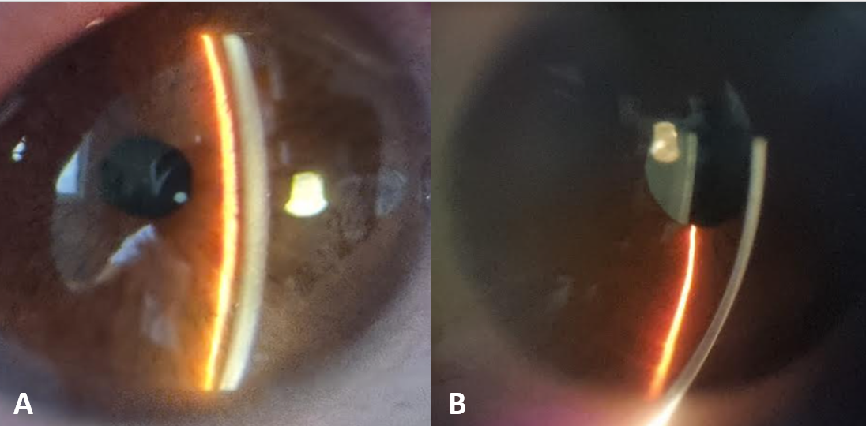
Figure 1: Slit-lamp photograph showing the depth of the anterior chamber. A: Image at admission with a reduced anterior chamber. B: Image day 30 of treatment with good anterior chamber depth.

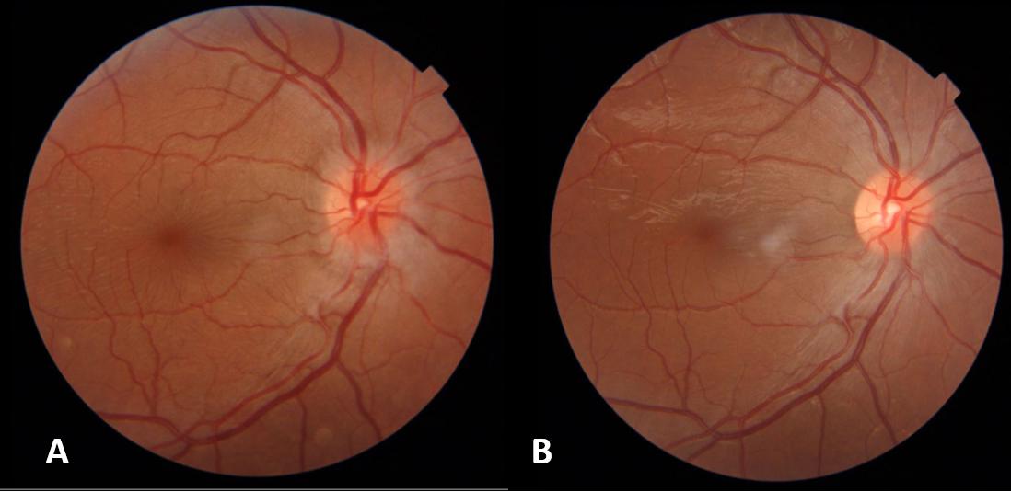
Figure 2: Fundus photograph of the right eye. A: Image at admission showing stage one of papilledema. B: Image at day 30 showing the disappearance of the papilledema.

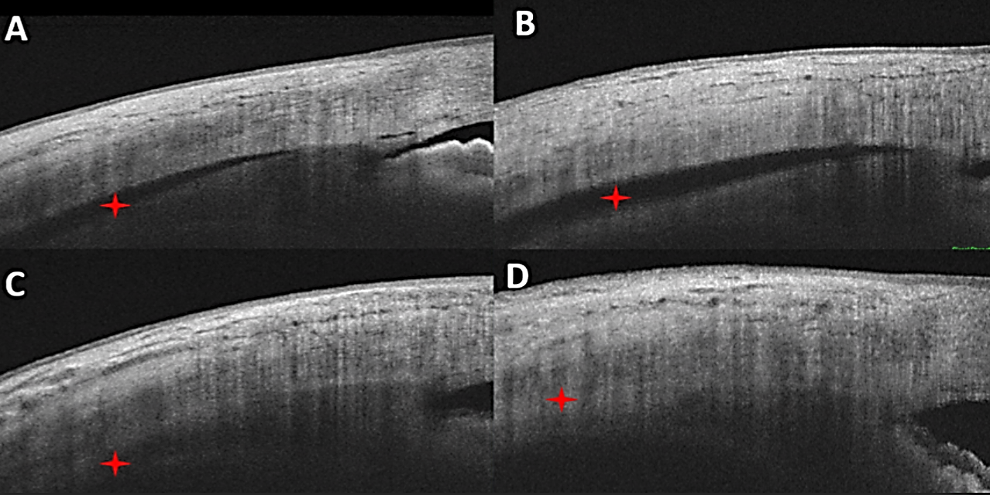
Figure 3: OCT image of the anterior segment. A and B Admission images showing a cyclodialysis (red star). C and D Images at day 30 showing the disappearance of the cyclodialysis (red star).

