Case report
“Tuck-in Tenon Patch Graft” Technique in Neurotrophic Keratitis: A Case Report
ABSTRACT
Neurotrophic keratitis (NK) is a rare but serious corneal disorder caused by impaired corneal sensory innervation, leading to defective epithelial healing. Neurotrophic corneal ulcers can progress to deep stromal thinning or perforation, posing a significant risk to vision. Therapeutic options include tear substitutes, biological agents, and surgical interventions.
Autologous Tenon’s patch graft has emerged as an effective alternative for managing refractory corneal ulcers, particularly when conventional therapies fail or donor tissue is unavailable. Its ability to provide stromal support and facilitate epithelial regeneration makes it especially valuable in resource-limited settings.
We report a case treated with an autologous Tenon’s capsule graft using the “Tuck-in Tenon Patch Graft” technique, resulting in favorable anatomical and functional outcomes over a 60-day follow-up. The patient had diabetes with suboptimal glycemic control and prior use of non-steroidal anti-inflammatory drugs (NSAIDs). Preoperative visual acuity was 20/200 (1.0 LogMAR), improving to 20/100 (0.7 LogMAR) postoperatively, corresponding to a gain of three lines. Minimal stromal thickness increased from 210 µm preoperatively to 410 µm on day 30.
Follow-up with anterior segment optical coherence tomography (AS-OCT) allowed precise, non-invasive monitoring of graft integration and stability.
The Tuck-in Tenon Patch Graft is a simple, autologous, and effective technique for refractory neurotrophic corneal ulcers, particularly when access to amniotic membrane or donor corneal tissue is limited.
Keywords: Neurotrophic keratitis – Corneal ulcer – Corneal perforation – Tenon graft
INTRODUCTION
Neurotrophic keratitis (NK) results from damage to the trigeminal nerve or its corneal branches. This sensory impairment leads to decreased reflex tear secretion, epithelial cell dysfunction, and a loss of trophic factors on the ocular surface. The causes are varied, including herpetic viral infections, diabetic neuropathies, eye surgeries, trauma, or prolonged use of toxic eye drops. The Mackie classification distinguishes three progressive stages, ranging from persistent erosion to full-thickness perforation. The advanced stage, characterized by severe corneal thinning, often necessitates surgical intervention.
Neurotrophic corneal ulcers remain a therapeutic challenge due to impaired corneal innervation and defective epithelial healing. Conventional management—including preservative-free lubricants, therapeutic contact lenses to enhance and accelerate healing while addressing corneal haze, autologous serum, and surgical interventions—often provides limited success in advanced stages. Recently, matrix regenerating agents (RGTA), such as Cacicol®, have emerged as a promising alternative by mimicking heparan sulfate components of the extracellular matrix, thereby protecting growth factors and promoting tissue repair. Several studies have reported encouraging outcomes with RGTA in resistant neurotrophic ulcers, with healing rates ranging from 65% to over 80% and significant reductions in ulcer size. These findings suggest that RGTA may represent an effective, non-invasive therapeutic option that can reduce the need for surgical procedures in selected cases [1–3].
However, these options are not always available, particularly in resource-limited facilities. In this context, autologous Tenon’s capsule grafting constitutes a reliable, economical, and immediately applicable alternative. In the literature, grafting with Tenon’s capsule has been described as an effective approach for managing corneal ulcers and perforations [4–6]. Several techniques have been reported for graft placement, including fixation with cyanoacrylate glue, suturing with 10/0 monofilament opposite the corneal defect, or the tuck-in Tenon patch graft technique, which involves securing the graft in a corneal pocket [7].
In our case, we opted for the tuck-in Tenon patch graft technique because it is one of the methods that allows better graft stability with fewer sutures and improved integration, achieving favorable anatomical and functional outcomes [8,9]. This case illustrates the effectiveness of the Tuck-in Tenon Patch Graft technique as an alternative surgical approach for advanced neurotrophic keratitis in resource-limited settings. Data on the management of neurotrophic ulcers remain scarce; therefore, we report this case to contribute to the existing evidence and to demonstrate the efficacy of autologous Tenon’s patch graft in the treatment of a refractory neurotrophic corneal ulcer, highlighting surgical technique, healing process, and short-term visual outcomes.
CASE REPORT
The patient in this case is a 63-year-old woman with poorly controlled diabetes and a history of chronic use of topical non-steroidal anti-inflammatory drugs. She presented with a red, painful eye associated with a progressive decrease in visual acuity. On examination, visual acuity was 20/200 (1.0 LogMAR). Anterior segment evaluation revealed a round, clean, non-infiltrated ulcer located in the inferotemporal corneal quadrant, measuring 1 × 1.5 mm, with markedly decreased corneal sensitivity in all four quadrants, qualitatively assessed using a cotton wisp (Figure 1). According to the Mackie classification, the patient was initially classified as stage 2 neurotrophic keratopathy, defined by a persistent epithelial defect without stromal melting. Initial anterior segment OCT (AS-OCT) demonstrated a corneal thickness of 493 μm (Figure 2A).
An intensive conservative treatment was initiated, including preservative-free artificial tears every two hours to maintain corneal hydration and reduce mechanical stress; topical aminoglycoside antibiotic drops (tobramycin) four times daily to prevent secondary bacterial infection; topical 20% autologous serum drops six times daily to provide growth factors and enhance epithelial regeneration; and the application of an eye patch as part of supportive management. Despite these measures, the ulcer progressed, enlarging to 2 × 2.5 mm. The patient subsequently developed stage 3 neurotrophic keratopathy with stromal melting and impending perforation. AS-OCT revealed a thinned cornea measuring 210 μm at the affected site (Figure 2B).
Given this progression, a Tenon’s capsule graft using the “Tuck-in Tenon Patch Graft” technique was performed. Under sterile conditions and local anesthesia, a fragment of Tenon’s capsule was harvested. After performing a conjunctival peritomy at the superotemporal quadrant, the Tenon’s capsule was carefully exposed. A 3 × 3 mm graft was dissected from the underlying Tenon’s tissue and gently slid into a 4 × 4 mm stromal pocket created at the periphery of the ulcer, allowing sufficient space for proper placement and fixation. The graft was secured with a 10/0 monofilament suture without tension. The objective of this procedure was to restore corneal tectonics by providing structural support and stimulating local healing.
Postoperatively, progressive healing was observed, with restoration of corneal thickness to 410 μm at day 30 and a functional visual gain of three lines (Figures 3 and 4). At the final follow-up on day 60, visual acuity improved to 20/100 (0.7 LogMAR). These results are consistent with published literature, emphasizing the efficacy and relevance of Tenon’s capsule grafting as a first-line surgical approach in selected cases of advanced neurotrophic keratopathy, particularly in resource-limited settings.
DISCUSSION
Neurotrophic ulcers represent both a therapeutic and diagnostic challenge due to the absence of pain, delayed epithelial healing, and the high risk of perforation [10]. They result from impaired corneal innervation, leading to decreased trophic support and subsequent epithelial breakdown. Chronic conditions such as diabetes contribute significantly to the development of neurotrophic keratopathy (NK) by causing peripheral neuropathy, which reduces corneal sensitivity and impairs epithelial healing. Similarly, prolonged use of topical non-steroidal anti-inflammatory drugs (NSAIDs) may exacerbate epithelial damage by inhibiting prostaglandin-mediated healing responses. These two factors are recognized as high-risk contributors to the development of neurotrophic ulcers, necessitating careful monitoring in these populations to prevent pathology that can compromise both anatomical structure and visual function [11,12].
Recent approaches have highlighted the potential role of neurotrophic factors, such as nerve growth factor (NGF), in promoting corneal healing [13–15]; however, their cost and limited availability restrict widespread use. Amniotic membrane grafting remains a gold standard but may not be accessible in all facilities [16]. Tenon’s capsule grafting provides a simple, autologous, biological, and effective alternative. Physiologically, Tenon’s capsule is connective tissue rich in fibroblasts, capable of promoting progressive stromal integration. The “Tuck-in Tenon Patch Graft” technique adds the advantage of stable mechanical reinforcement. Published results demonstrate improved epithelial healing, reduced risk of perforation, and minimal cost [17–19].
In the series reported by Chaudhary et al. [6], Tenon’s graft achieved corneal tectonic stability, allowing subsequent surgical interventions with favorable anatomical outcomes in patients with corneal perforation secondary to neurotrophic keratitis. In our case, follow-up was performed using anterior segment OCT (AS-OCT) to assess graft integration and corneal healing, demonstrating progressive integration of the graft and maintenance of globe integrity. This method, also used by Chaudhary et al. [6], provides an objective and reliable means of monitoring graft outcomes.
Although this case illustrates the successful use of the Tuck-in Tenon Patch Graft in a single patient, larger prospective studies are needed to confirm these findings and to assess long-term outcomes. This report has several limitations. Firstly, as it involves a single patient, the findings cannot be generalized. Secondly, the follow-up period was relatively short, limiting assessment of long-term outcomes and recurrence. Finally, the unique characteristics of this patient, including the underlying etiology and severity of the neurotrophic ulcer, may have influenced the results.
CONCLUSION
The “Tuck-in Tenon Patch Graft” technique represents a valuable surgical alternative for the management of advanced neurotrophic corneal ulcers, particularly in resource-limited settings. It provides a reliable, effective, and accessible solution, helping to prevent perforation and preserve visual function. Early diagnosis and timely management remain essential to optimize functional outcomes. The use of AS-OCT offers a novel methodological approach, allowing detailed and progressive assessment of Tenon’s graft integration and corneal recovery. Future studies involving larger cohorts and longer follow-up are warranted to validate the efficacy and safety of this technique in the management of neurotrophic corneal ulcers
CONSENT
In accordance with international standards, written informed consent was obtained from the patient and has been preserved by the author(s).
ETHICAL APPROVAL
This case was conducted following international ethical guidelines. Written informed consent was obtained from the patient, and confidentiality has been maintained.
DISCLAIMER (Artificial Intelligence)
The author(s) declare that no generative AI technologies, including large language models (e.g., ChatGPT, Copilot) or text-to-image generators, were used in the writing or editing of this manuscript.
COMPETING INTERESTS
The author(s) declare that no competing interests exist.
REFERENCES
1.Pereira S, Resende R, Coelho P, et al. Matrix Regenerating Agent (RGTA) in a Neurotrophic Corneal Ulcer. Cureus. 2020;12(10):e11167. doi:10.7759/cureus.1116
2.Cochener B, Zagnoli C, Hugny-Larroque C, Derrien S. Healing of resistant corneal neurotrophic ulcers using a matrix regenerating agent. J Fr Ophtalmol. 2019;42(2):159-165.
3.Salazar-Quiñones L, Molero-Senosiáin M, Aguilar-Munoa S, et al. Management of corneal neurotrophic ulcers with Cacicol®-RGTA: a case series. Arch Soc Esp Oftalmol. 2020;95(9):421-428. doi:10.1016/j.oftal.2020.04.015.
4. Gour A, Garg A, Singh K, Patel NV, Sangwan VS. A case-based approach to the management of corneal melts and perforations in ocular surface disorders. Cureus. 2025;17(3):e81293. doi:10.7759/cureus.81293.
5. Deshmukh R, Stevenson LJ, Vajpayee R. Management of corneal perforations: An update. Indian J Ophthalmol. 2020;68(1):7-14. doi:10.4103/ijo.IJO_1151_19.
6. Chaudhary S, Basu S, Donthineni PR. Long term outcome of Tenon’s patch graft in corneal perforation secondary to neurotrophic keratitis: a case report on a 4-year anatomical functional outcome. Int J Surg Case Rep. 2021;83:106046. doi:10.1016/j.ijscr.2021.106046.
7. Kate A, Vyas S, Bafna RK, Sharma N, Basu S. Tenon’s patch graft: a review of indications, surgical technique, outcomes and complications. Semin Ophthalmol. 2022;37(4):462-470. doi:10.1080/08820538.2021.2017470.
8. Sharma N, Singhal D, Maharana PK, Vajpayee RB. Tuck-in Tenon patch graft in corneal perforation. Cornea. 2019;38(8):951-954. doi:10.1097/ICO.0000000000001955.
9. Bafna RK, Kalra N, Rathod A, et al. Hitch suture assisted tuck-in Tenon’s patch graft for management of corneal perforations. Eur J Ophthalmol. 2022;32(6):3372-3382. doi:10.1177/11206721221078682.
10. NaPier E, Camacho M, McDevitt TF, Sweeney AR. Neurotrophic keratopathy: current challenges and future prospects. Ann Med. 2022;54(1):666–673. doi:10.1080/07853890.2022.2045035.
11. Meneux L, Michon F. Formation, maintenance et régénération de l'innervation cornéenne en contextes physiopathologiques [thèse]. Montpellier: Université Montpellier; 2024.
12. Wajnsztajn D, Faraj LA, Sanchez-Tabernero S, Solomon A. Neurotrophic keratitis: inflammatory pathogenesis and novel therapies. Curr Opin Allergy Clin Immunol. 2023 Dec 1;23(6):520-528. doi: 10.1097/ACI.0000000000000942. Epub 2023 Sep 7. PMID: 37694830.
13. Versura P, Giannaccare G, Pellegrini M, Sebastiani S, Campos EC. Neurotrophic keratitis: current challenges and future prospects. Eye Brain. 2018;10:37–45. doi:10.2147/EB.S117261.
14. Dohlman TH, Singh RB, Dana R. Advances in the medical management of neurotrophic keratitis. Semin Ophthalmol. 2021;36(4):335–340. PMID:33705259.
15. Gurnani B, Feroze KB, Patel BC. Neurotrophic keratitis. In: StatPearls [Internet]. Treasure Island (FL): StatPearls Publishing; 2026 Jan–. PMID: 28613758.
16. Nuzzi A, Pozzo Giuffrida F, Luccarelli S, Nucci P. Corneal epithelial regeneration: Old and new perspectives. Int J Mol Sci. 2022;23(21):13114. doi:10.3390/ijms232113114.
17.Bae JH, Seong HK, Kim HK, Nam WH. Use of autologous Tenon's capsule graft for repair of traumatic scleral perforation. J Korean Ophthalmol Soc. 2008;49(10):1706-1710. doi:10.3341/jkos.2008.49.10.1706.
18. Natarajan R, Nagpal N. Tectonic Tenon transplants for four different corneal melts. Indian J Ophthalmol Case Rep. 2022;2(1):59-60. doi:10.4103/ijo.IJO_1700_21.
19. Rani N, Sahu SK, Sahoo S. Autologous Tenon’s patch graft: techniques, clinical outcome, and complications in cases of immune corneal melt. Indian J Ophthalmol. 2025;73(4):563-566. doi:10.4103/IJO.IJO_1890_24.

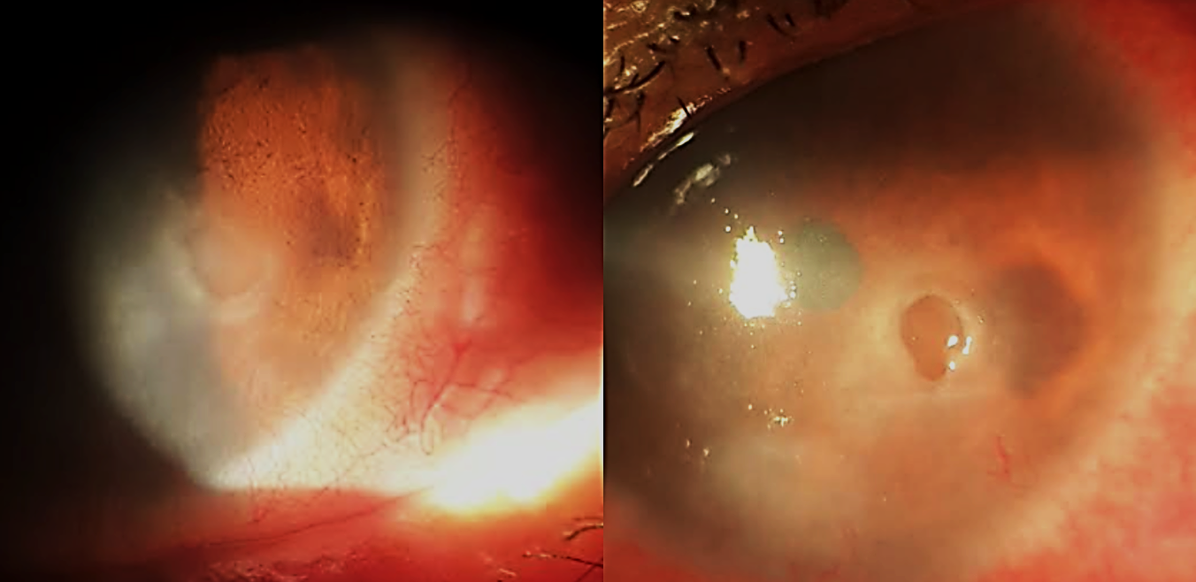
B
A
Figure 1: slit-lamp photographs of the anterior segment showing the appearance of the neurotrophic ulcer. A: Image at admission. B: Image after 15 days of medical treatment.

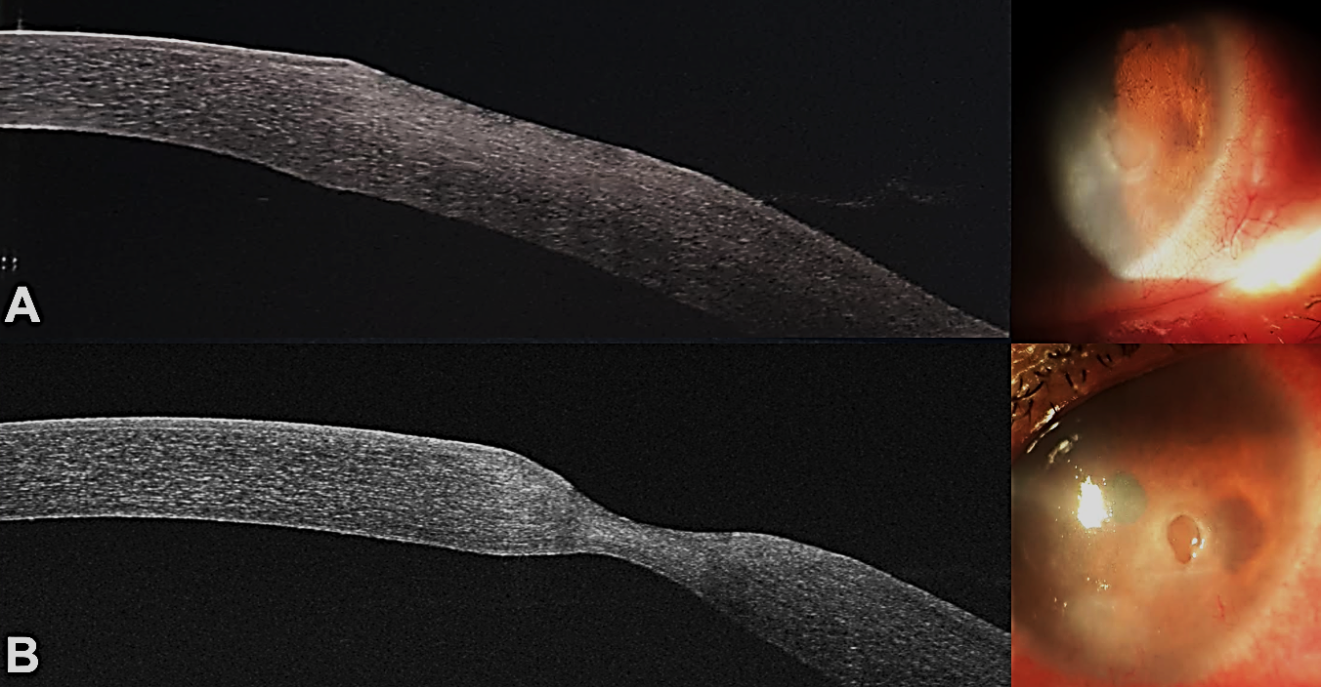
Figure 2: OCT image of the anterior segment showing corneal thinning of the neurotrophic ulcer. A: corneal thickness at 493 μm. B: corneal thickness at 210 μm.

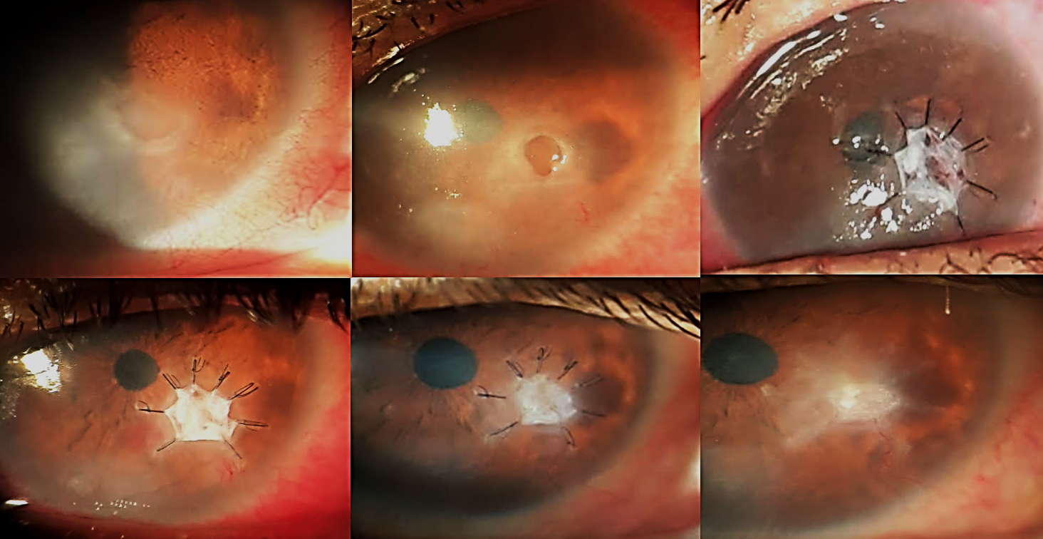
Figure 3: Slit-lamp photographs of the anterior segment showing the clinical evolution of the management of pre-perforation stage neurotrophic keratitis using the technique: Tuck-in Tenon patch graft.

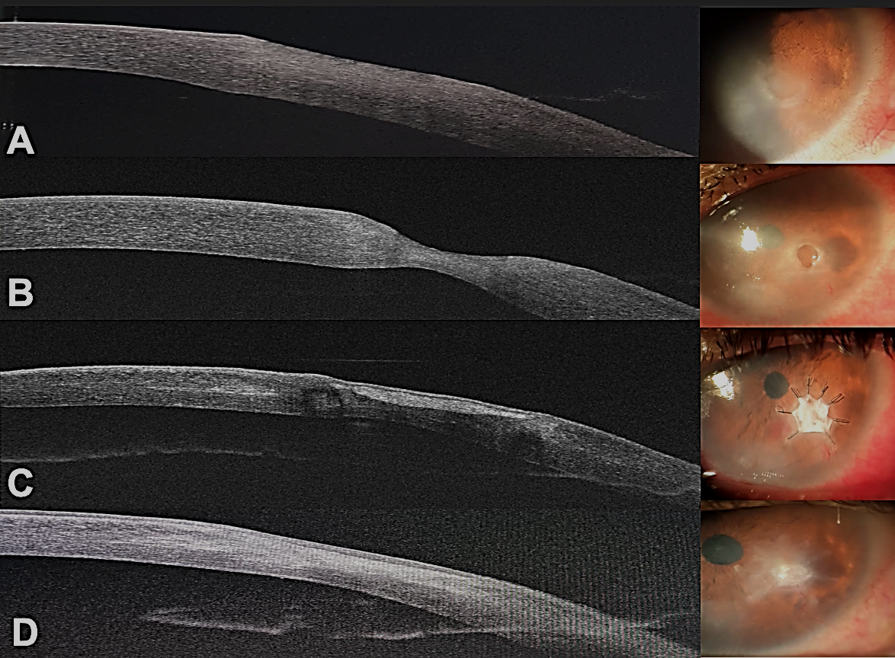
Figure 4: Anterior segment OCT image showing the evolution of corneal thickness as well as the integration of the Tenon's capsule over the ulcer to restore the corneal layers through a tectonic effect. A: OCT image at admission with a thickness of 493 μm. B: OCT image at 15 days of medical treatment with a thickness of 210 μm. C: OCT image at 15 days after Tenon's capsule graft with a thickness of 365 μm. D: Final OCT image at 60 days with a thickness of 410 μm.

