Original Research Article

Effect of Co-administration of Aqueous Musa acuminata cavendish And Allium sativium Extracts On Streptozotocin - Induced Type 2 Diabetes On Wistar Rat

ABSTRACT
This study investigated the effects of Musa acuminata Cavendish and Allium sativum aqueous extracts, both individually and in combination, on streptozotocin-induced type 2 diabetes in Wistar rat. A total of thirty (30) male Wistar rats were used in this study and were divided into six groups of five (5) rats each viz, A, B, C, D, E and F (where group A =Normal control group, B= diabetic untreated, C= diabetic + treated with Musa acuminata extract, D= Diabetic + with Allium sativum extract, E=Diabetic + with a combination of both extracts, F= Diabetic + treated with glibenclamide. Blood glucose levels, body weight, and histopathological changes in liver tissues were measured and analyzed. Both Musa acuminata and Allium sativum extracts significantly (P<0.05) caused a decrease in the blood glucose levels, compared to group B. Group E exhibited the most efficacy and potency in terms of hypoglycemic effect, suggesting a synergistic interaction. Treated groups also showed improved body weight maintenance and normalized food and water intake patterns. Histopathological analysis revealed reduced damage to pancreatic tissues in the treated groups, especially in the combination group and glibenclamide induced group respectively. The study indicates that the co-administration of Musa acuminata and Allium sativum extracts can be used effectively in the management of patients with hyperglycemia. The observed benefits are likely due to the antioxidant and anti-inflammatory properties of the extracts, as well as their ability to modulate glucose metabolism. The synergistic effects of the combination therapy highlight the potential for developing multi-component herbal treatments for diabetes.

Keywords: Musa acuminata Cavendish, Streptozotocin, diabetes, allium sativium,

1.0 Introduction

The escalating global prevalence of type 2 diabetes mellitus (T2DM) presents a significant public health challenge, with an estimated 463 million adults affected worldwide in 2019, a number projected to rise to 700 million by 2045 (International Diabetes Federation [1]. T2DM, characterized by insulin resistance and impaired insulin secretion, leads to chronic hyperglycemia, contributing to macrovascular and microvascular complications such as cardiovascular disease, neuropathy, nephropathy, and retinopathy (American Diabetes Association [2].
Conventional pharmacological therapies for T2DM primarily target glycemic control through oral antidiabetic agents such as metformin, sulfonylureas, and thiazolidinediones, and/or injectable insulin. However, these treatments may be associated with adverse effects, poor tolerability, and progressive loss of efficacy over time [3] Furthermore, achieving and maintaining optimal glycemic control remains a challenge for many patients due to medication costs, non-adherence, and lifestyle factors [4] Given these challenges, there is growing interest in complementary and alternative medicine (CAM) approaches for managing T2DM. Herbal remedies, in particular, have gained attention for their potential antidiabetic properties, often attributed to their diverse phytochemical constituents, including polyphenols, flavonoids, alkaloids, and saponins [5]. Musa acuminata Cavendish (banana) and Allium sativum (garlic) are two such plants that have been extensively studied for their medicinal properties, including their effects on glucose metabolism and insulin sensitivity. Bananas, a widely consumed fruit globally, contain bioactive compounds such as flavonoids, phenolic acids, and dietary fiber, which have been shown to exert hypoglycemic effects by enhancing insulin sensitivity, inhibiting α-glucosidase activity, and improving pancreatic β-cell function [6]. Similarly, garlic, a staple ingredient in traditional cuisines and herbal medicine, is rich in organosulfur compounds like allicin, which exhibit antioxidant, anti-inflammatory, and antidiabetic activities through various mechanisms, including stimulation of insulin secretion and modulation of hepatic glucose production [7]. Despite the promising preclinical and clinical evidence supporting the antidiabetic effects of Musa acuminata and Allium sativum individually, there remains a knowledge gap regarding their potential synergistic interactions when co-administered. This study aims to address this gap by investigating the combined effects of aqueous extracts of Musa acuminata Cavendish and Allium sativum on streptozotocin-induced T2DM in Wistar rats, elucidating their mechanisms of action and therapeutic potential. In summary, exploring novel therapeutic strategies for T2DM management is imperative in light of the increasing prevalence and associated health burdens. Harnessing the therapeutic potential of natural compounds like Musa acuminata and Allium sativum may offer safe, affordable, and sustainable adjunctive treatments for T2DM, thereby improving outcomes and quality of life for affected individuals. Type 2 diabetes mellitus (T2DM) is a chronic condition characterized by high blood sugar levels due to insulin resistance and inadequate insulin secretion. It is a growing health concern worldwide, affecting millions of people and leading to serious complications such as heart disease, kidney failure, and nerve damage. Current treatments for T2DM primarily include medications like metformin and insulin therapy, lifestyle changes, and dietary modifications. However, these treatments often have limitations. Medications can cause side effects, and not all patients respond well to these treatments. Additionally, managing diabetes through lifestyle changes alone can be challenging for many patients. Given these limitations, there is a growing interest in exploring alternative and complementary therapies, particularly those derived from natural sources. Herbal medicines have been used for centuries to treat various ailments, and some have shown promise in managing diabetes. Two such plants are Musa acuminata Cavendish (commonly known as the Cavendish banana) and Allium sativum (garlic). Musa acuminata is rich in nutrients and bioactive compounds that may help regulate blood sugar levels. Allium sativum has known hypoglycemic and antioxidant properties, which could potentially improve insulin sensitivity and reduce oxidative stress.
While both plants have individually shown potential benefits for managing diabetes, there is limited research on their combined effects. The hypothesis is that co-administration of these extracts might offer synergistic benefits, potentially leading to more effective management of T2DM. If the extracts prove effective, they could be developed into new treatments that improve the quality of life for individuals with diabetes by providing more options for managing their condition.
The results of this study could inform healthcare professionals about the potential benefits of integrating natural remedies into diabetes treatment plans, potentially leading to more holistic and patient-friendly care strategies. This study aims to investigate the combined effects of co-administration of aqueous Musa acuminata cavendish and Allium sativum on streptozotocin induced type- 2 diabetes in Wistar rat. The results could provide insights into the potential use of these plant extracts as a complementary therapy for diabetes management.

2.0 MATERIALS AND METHODS

2.1 Experimental Animals
Male Wistar rats, aged 8-10 weeks, with an initial body weight ranging from 180-220 grams, were selected for the study to ensure uniformity and to control for sex-specific variations in metabolic responses. The rats were housed in standard laboratory conditions with a controlled temperature of 22 ± 2°C, relative humidity of 55 ± 5%, and a 12-hour light/dark cycle. The light cycle was maintained from 7:00 AM to 7:00 PM. All animals were provided with standard rat food and had ad libitum access to water throughout the study period.

2.2 Phytochemical Analysis of Musa acuminata cavendish and Allium sativum

Phytochemical analysis was conducted according to the method of [8] to identify and quantify the bioactive compounds present in the aqueous extracts of Musa acuminate Cavendish and Allium sativum (Garlic).

2.3 Musa acuminata cavendish
- Alkaloids: Detected using Mayer’s and Wagner’s reagents. Alkaloids are known for their potential therapeutic effects, including antidiabetic properties.
- Flavonoids: Identified using the alkaline reagent test. Flavonoids have antioxidant, anti-inflammatory, and antidiabetic effects.
- Tannins: Detected using the Ferric chloride test. Tannins possess antioxidant and anti-inflammatory properties.
- Saponins: Confirmed using the froth test. Saponins are known for their hypoglycemic and cholesterol-lowering effects.
- Glycosides: Identified using the Keller-Killani test. Glycosides can contribute to cardiovascular health and exhibit antidiabetic properties
- Phenolic Compounds: Detected using the Ferric chloride test. Phenolic compounds are potential antioxidants and play a role in managing diabetes by reducing oxidative stress.

2.4 Allium sativum
- Alkaloids: Detected using Mayer’s and Wagner’s reagents. Alkaloids in garlic contribute to its medicinal properties, including blood sugar regulation.
- Flavonoids: Identified using the alkaline reagent test. Flavonoids in garlic have strong antioxidant and antidiabetic effects.
- Tannins: Detected using the Ferric chloride test. Tannins in garlic contribute to its antioxidant and anti-inflammatory activities.
- Saponins: Confirmed using the froth test. Saponins in garlic help reduce blood sugar and cholesterol levels.
- Glycosides: Identified using the Keller-Killani test. Glycosides in garlic enhance cardiovascular health and provide antidiabetic benefits.
- Phenolic Compounds: Detected using the Ferric chloride test. Phenolic compounds in garlic are effective antioxidants and help mitigate diabetes-related oxidative stress.

2.5 Induction of Diabetes
2.5.1 Method of Streptozotocin Administration
Streptozotocin (STZ) was obtained from Sigma-Aldrich. A fresh solution of STZ was prepared by dissolving it in a 0.1 M citrate buffer with a pH of 4.5, just before administration to ensure stability and efficacy. A single dose of 60 mg/kg body weight was administered via intraperitoneal route. This dosage was chosen based on previous studies that have effectively induced type 2 diabetes in rodents. The rats were fasted for 12 hours prior to the STZ injection to enhance the diabetogenic effect of STZ Confirmation of Diabetes: Blood glucose levels were measured using a glucometer 72 hours post-STZ injection. Rats with blood glucose levels exceeding 250 mg/dL were considered diabetic and included in the study [9]

2.6 Preparation of Plant Extracts

2.6.1 Collection and Identification of Plant Materials
Musa acuminata (Banana): The banana fruits were collected from local farms. Voucher specimens were deposited for future reference. Allium sativum (Garlic): Garlic bulbs were purchased from local markets and authenticated by the same botanist to ensure the correct species was used in accordance with [10]

2.6.2 Extraction Procedures
- Preparation of Musa acuminata Extract
Procedure: The banana fruits were thoroughly washed, peeled, and chopped into small pieces. The pieces were then blended with distilled water at a 1:3 weight/volume ratio. The mixture was filtered through cheese cloth to remove solid residues, and the filtrate was concentrated using lyophilization (freeze-drying) to obtain a dry extract and its in accordance with the method of [8]

- Preparation of Allium sativum Extract

Procedure: Garlic cloves were peeled and crushed to release the active compounds. The crushed garlic was soaked in distilled water at a 1:2 weight/volume ratio for 24 hours at room temperature. The mixture was then filtered through cheesecloth, and the filtrate was concentrated by lyophilization to obtain a dry extract [10]

2.7 Experimental Design
A total of thirty (30) male Wistar rats were used in this study and were divided into six groups of five (5) rats each.
Group A: Normal Control (water and feed only)
Group B: Diabetic Control (STZ-induced diabetic rats without treatment)
Group C: Diabetic + 100mg/kg of Musa acuminata extract
Group D: Diabetic + 100mg/kg of Allium sativum
Group E: STZ-induced diabetic rats treated with a combination of Musa
acuminata and Allium sativum extracts.
Group F: Diabetic + Glibenclamide (positive control)
2.7.2 Treatment Protocols
Musa acuminata extract was administered at a dose of 100 mg/kg body weight after making a suspension of the extracts using a Tragacanth mucilage which served as a suspension agent [12] while Allium sativum extract was also administered at 100 mg/kg body weight. Both extracts were administered via oral route to ensure precise dosing. The treatments were administered once daily for a duration of 4 weeks, during which various physiological and biochemical parameters were monitored.

2.8 Data Collection and Analysis
Fasting Blood Glucose Levels : Blood glucose levels were measured using a portable glucometer. Blood samples were collected from the tail vein . The measurements were taken weekly throughout the study period according to the method of [13]

2.8.1 Measurement of Insulin Levels
Blood samples for insulin measurement were collected from the tail vein and the Serum insulin levels were quantified using an enzyme-linked immunosorbent assay (ELISA) kit specific for rat insulin assay using [14]

2.8.2 Body Weight
Body weights were recorded weekly to monitor changes and ensured the health of the animals using an analytical weighing balance by Ohaus Limited USA ([15]

2.9 Histopathological Analysis

Pancreatic Tissue Collection .
Rats were euthanized by CO₂ asphyxiation followed by a cervical dislocation to minimize suffering. The pancreas was carefully dissected out and fixed in 10% formalin for histological examination. Hence, Pancreatic tissues were processed, embedded in paraffin, sectioned, and stained with Hematoxylin and Eosin (H&E) to visualize tissue morphology. Stained sections were examined under a light microscope to assess the morphology and integrity of the pancreatic islets using x40 magnification and any pathological changes were documented.

2.9.1 Ethical clearance

Institutional Approval
IACUC Approval: The study was approved by the Institutional Animal Care and Use Committee (IACUC) of Enugu State University of Science and Technology College of Medicine, on 15th April 2024.

2.9.2 Ethical Guidelines

The study adhered to the guidelines for the care and use of laboratory animals. Animals were provided with proper housing, feeding, and veterinary care. Efforts were made to minimize suffering and reduce the number of animals used. Humane endpoints were established, and animals in severe distress were humanely euthanized. Detailed records of animal care and experimental procedures were maintained throughout the study

2.9.3 Statistical Analysis
Results were expressed as mean ± standard deviation (SD) and presented in tables for clarity using SPSS version 25 with one -way ANOVA (Analysis of Variance) for comparing means across multiple groups to determine if there are any statistically significant differences among the groups using Tukey’s Post-hoc test. A p-value of less than 0.05 was considered statistically significant..

2.9.3 Ethical Considerations
The experimental protocols were reviewed and approved by the Institutional Animal Care and Use Committee (IACUC) of Enugu State University of Science and Technology College of Medicine, ensuring adherence to ethical standards in animal research.
The study was conducted in compliance with the national and international guidelines for the care and use of laboratory animals, such as the NIH guidelines, to ensure humane treatment and welfare of the animals.

3.0 RESULTS

Table.1. Phytochemical analysis of Musa cavendish acuminata and Allium sativum extracts
Phytochemicals | Musa acuminata cavendish (indication) | Allium sativum (indication)
Tannins | + | +
Flavoniods | - | +
Cardiac glycosides | + | +
Saponins | - | -
Alkaliods | + | +
Steroids and terpenpoids | + | -
Phenolics | - | +
S-allyl cysteine | - | ++
Allinin | + | ++
KEYS: (+) Detected, (++) Strongly detected, (-) Not detected

TABLE 2. The table showing the body weight of Wistar rats over the weeks.
GROUP | WEEK 1 (g) | WEEK 2 (g) | WEEK 3 (g) | WEEK 4 (g) | %CHANGE
A | 187.50±0.5 | 191.04±0.12 | 208.60±0.08 | 219.17±0.4 | ↑16.89%
B | 185.10±0.2 | 181.00±0.05 | 174.20±0.7 | 169.80±0.11 | ↓8.26%
C | 187.00±0.5 | 183.60±0.2 | 176.18±0.05 | 171.01±0.15 | ↓8.55%
D | 181.12±0.06 | 183.55±0.71 | 189.27±0.21 | 194.18±0.11 | ↑7.21%
E | 183.16±0.03 | 185.61±0.11 | 188.02±0.01 | 192.11±0.05 | ↑4.88%
F | 187.01±0.45 | 195.28±0.20 | 201.15±0.90 | 215.11±0.02 | ↑15.02%

In the table 2 above The body weights of the animals showed that the weight significant decrease in the groups B and C while group A, D, E and F increased simultaneously. The decrease was more prominent in group C (8.55%), followed by group B (8.26%) respectively. Group A had the highest increase in the body weight followed by group F while group D and E followed simultaneously. There was a statistically significant difference between group F compared to group B using Tukey Post-Hoc Test. Group A (Normal Control Group);The body weight increased consistently from Week 1 to Week 4, with a total increase of 16.89%. As this group consists of non-diabetic rats receiving no treatment, the consistent weight gain is expected and reflects normal growth and health. Group B (Diabetic Control Group)
The body weight decreased by 8.26% over the four weeks. The STZ-induced diabetic condition leads to weight loss, likely due to hyperglycemia, polyuria, and muscle wasting, which are common in untreated diabetes. Group C (Diabetic + Musa acuminata Treated Group)
The body weight decreased by 8.55% over the four weeks. Although Musa acuminata may have some beneficial effects, it appears insufficient alone to prevent weight loss associated with diabetes, indicating it might need to be combined with other treatments for better efficacy.Group D (Diabetic + Allium sativum Treated Group)
The body weight increased by 7.21% over the four weeks. Allium sativum seems to have a positive effect in mitigating weight loss and promoting weight gain in diabetic rats, likely due to its antihyperglycemic and antioxidant properties. Group E (Combination Treated Group)
The body weight increased by 4.88% over the four weeks. The combination of Musa acuminata and Allium sativum shows a synergistic effect, resulting in weight gain. However, the increase is less than that observed in Group D, suggesting the combination’s effect is not as potent as Allium sativum alone in this context. Group F (Diabetic + Glibenclamide Treated Group).The body weight increased by 15.02% over the four weeks. Glibenclamide, a standard antidiabetic drug, effectively controls blood glucose levels and promotes weight gain, demonstrating its efficacy in managing diabetes-induced weight loss.

Table 3. Effect of Co-administration of Aqueous Musa acuminata
cavendish And Alliumsativium Extracts On fasting blood sugar level
on Streptozotocin - Induced Type 2Diabetes on Wistar Rat.
GROUP | WEEK 1 | WEEK 2 | WEEK 3 | WEEK 4 | % CHANGE
A | 93.00±0.05 | 93.50±0.02 | 90.20±5.0 | 92.50±0.10 | ↓0.53%
B | 156.20±0.20 | 160.50±0.15 | 200.10±0.80 | 220.40±0.12 | ↑41.10%
C | 162.40±0.10 | 161.50±1.15 | 164.40±0.06 | 160.00±1.20 | ↓1.47%
D | 148.50±0.18 | 130.10±0.85 | 126.20±0.17 | 124.54±0.80^{*ß} | ↓16.16%
E | 154.20±0.55 | 140.20±0.64 | 135.20±0.15 | 123.60± 0.22^{*ß} | ↓19.84%
F | 165.10±0.02 | 120.20±0.50 | 99.20±0.10 | 76.20±0.10 | ↓53.84%

Values were expressed as mean ±standard deviation; ^{*ß}P<0.05 values showed a statistically significant difference between groups A and B respectively

In the table 3 above, it can be deduced that all the experimental groups A, C, D, E and F had a significant decrease in their fasting blood glucose level while group B had a significant increase. The decrease in the fasting blood is more prominent in the group F, followed by group E, D, C and A respectively. In the table group 2 above, there was statistically significant (P<0.05) difference between group B, C, D and E compared to group A.

4.4. Histology of the liver
The below diagrams show the histology of the liver under the various groups
PLATE 1:
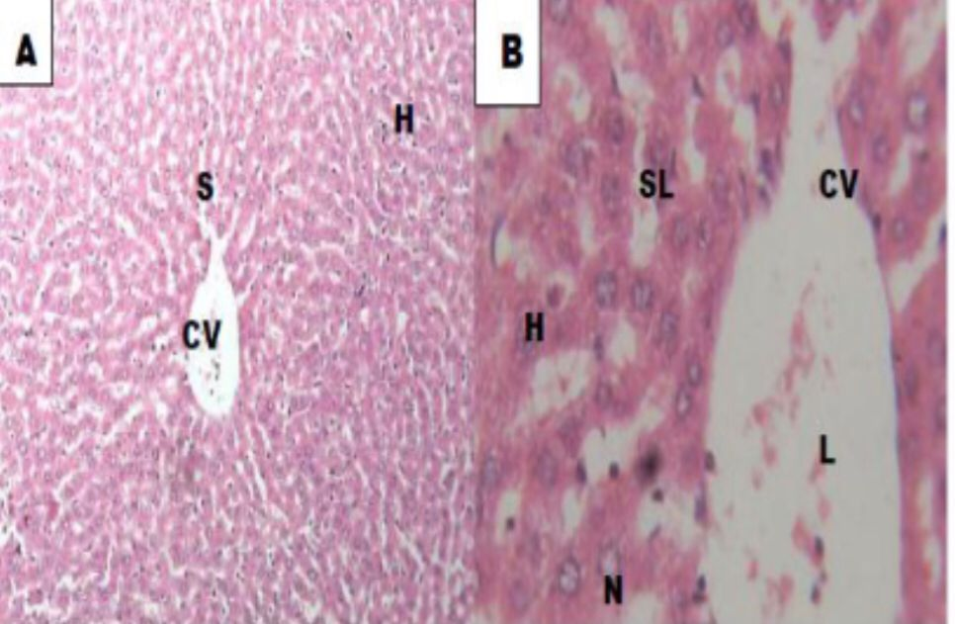
Plate 1. Normal control of Liver tissue showed normal cellular architecture with portal triad, central vein, numerous hepatocytes and sinusoidal lining
PLATE 2:
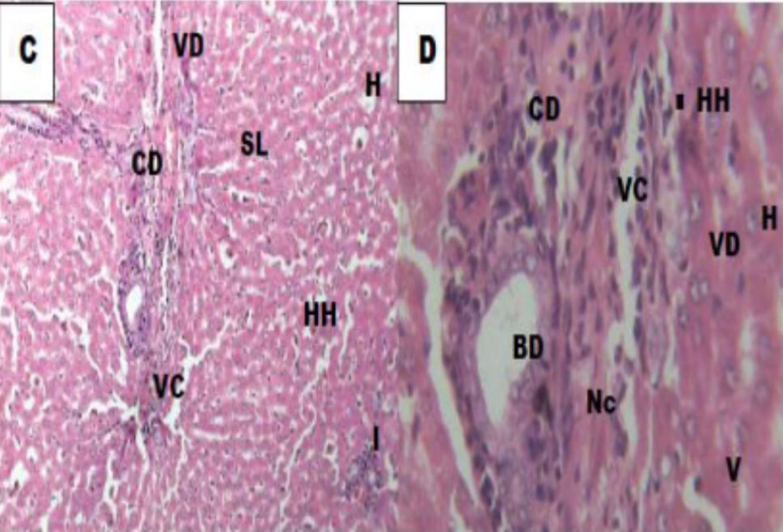
Plate 2. Diabetic control of Liver tissue induced with 100mg/dl of STZ showed cellular abnormalities with area of vascular degeneration, necrosis, vascular congestion and cellular degeneration as compared with normal control group.
PLATE 3
Plate 3. Liver diabetic tissue treated with preparation of Musa acuminata (Banana) at a dose of 100mg/kg and standard pellets for 7 days showed slight area of cellular restoration with marked vascular congestion, and cellular degeneration with pyknotic nuclei as compared with normal and diabetic control group.
PLATE 4:

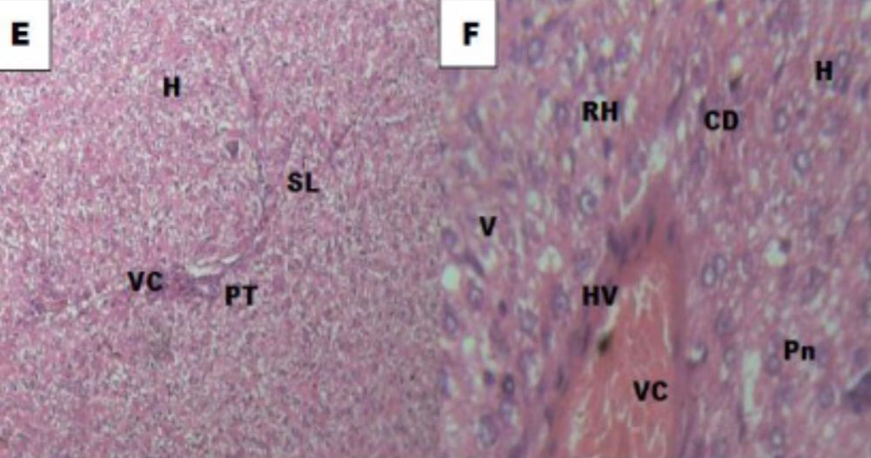
Plate 4. Liver diabetic tissue treated with preparation of Allium sativum (garlic) at a dose of 100mg/kg and standard pellets for 7 days showed slight area of cellular restoration with marked vascular congestion, and cellular degeneration with pyknotic nuclei as compared with normal and diabetic control group.

PLATE 5:
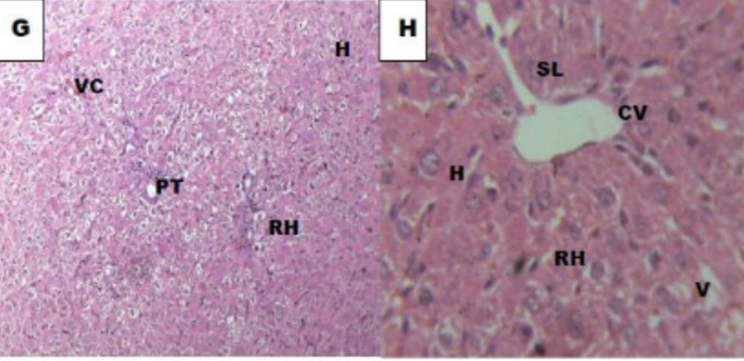
Plate 5. Liver Diabetic tissue treated with preparation of Allium sativum (garlic) and Musa accuminata at a dose of 100mg/dl each for 14 days showed moderate area of cellular restoration vascular

PLATE 6:
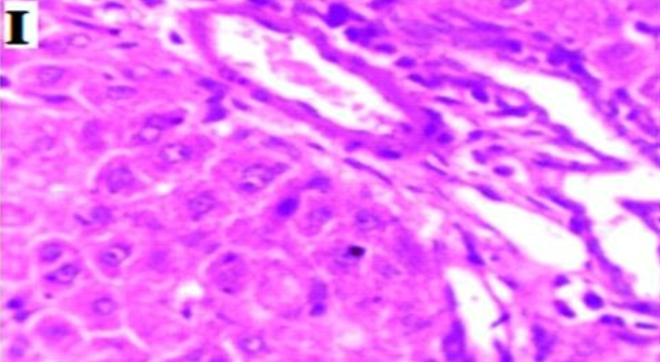
Plate 6. Diabetic rats treated with glibenclamide (100mg/kg) showed an improvement of the hepatoellular architecture with normal nucleus and cytoplasm with less necrosis of hepatocytes
4.0 DISCUSSION AND CONCLUSION
The study demonstrated a significant reduction in blood glucose levels in the groups treated with Musa acuminate extract, Allium sativum extract, and their combination compared to the diabetic control group. These results suggests that both extracts possess substantial hypoglycemic properties, which can be attributed to their rich content of bioactive compounds, such as flavonoids, polyphenols, and sulfur-containing compounds. In the group treated with Musa acuminata extract alone, the observed reduction in blood glucose levels was negligible which is an indication that Musa acuminata sap alone has lesser effect on fasting blood glucose level. Alternatively, the group treated with Allium sativum extract alone showed a significant decrease in blood glucose levels. Garlic has been extensively studied for its hypoglycemic effects, which are primarily attributed to its sulfur-containing compounds like allicin and saponins. [11] These compounds are known to enhance insulin secretion, increase glucose uptake by cells, and improve insulin sensitivity. The combination-treated group exhibited the most pronounced decrease in blood glucose levels, suggesting a synergistic effect between the banana and garlic extracts. This synergism could be due to the complementary mechanisms of action of the phytochemicals in both plants. For instance, the antioxidants in Musa acuminata may work in tandem with the anti-inflammatory and insulin-sensitizing effects of Allium sativum, resulting in enhanced glucose control. [11]

The diabetic control group exhibited significant weight loss over the study period, which is a common symptom of uncontrolled diabetes [9]. Weight loss in diabetes is often due to the inability of the body to utilize glucose effectively, leading to the breakdown of muscle and fat for energy.
In contrast, the treatment groups, especially the combination group, showed improved body weight maintenance. This improvement is attributed to better glucose utilization and metabolic balance achieved through the administration of the extracts. The bioactive compounds in Musa acuminata and Allium sativum likely contributed to improved energy metabolism, reducing the catabolic effects of diabetes [11].
The measurement of food and water intake indicated that the treated groups had more stabilized consumption patterns compared to the diabetic control group. Diabetic rats typically exhibited polyphagia (increased food intake) and polydipsia (increased water intake) due to hyperglycemia-induced osmotic diuresis. The normalization of these parameters in the treated groups suggests effective glycemic control and metabolic regulation by the extracts.
Both Musa acuminata and Allium sativum are rich in antioxidants, which can mitigate oxidative stress, a major contributor to diabetes complications. Oxidative stress results from an imbalance between the production of reactive oxygen species (ROS) and the body’s ability to neutralize them with antioxidants. In diabetes, elevated glucose levels can increase ROS production, leading to oxidative damage to tissues, including pancreatic β-cells [13]. The antioxidants in Musa acuminata, such as flavonoids and polyphenols, can scavenge free radicals, thereby having little reduction to oxidative stress and protecting β-cells from damage. This protective effect can help preserve insulin secretion and improve glucose regulation.
Allium sativum also contains potent antioxidants, including sulfur compounds like S-allyl cysteine, allicin and saponins, which can enhance the body’s endogenous antioxidant defense mechanisms. These compounds may reduce oxidative damage to β-cells and improve their function. The synergistic effect observed in the combination group could be due to the complementary antioxidant mechanisms of the two extracts, providing a more comprehensive defense against oxidative damage. The combined antioxidant capacity of Musa acuminata and Allium sativum may result in more effective reduction of oxidative stress, leading to improved glucose regulation and insulin sensitivity.
Chronic inflammation is a known factor in the pathogenesis of type 2 diabetes. Inflammatory cytokines can interfere with insulin signaling, leading to insulin resistance. Both Musa acuminata and Allium sativum have demonstrated anti-inflammatory properties, which can help mitigate this effect. Musa acuminata contains bioactive compounds such as dopamine, which has anti-inflammatory effects. These compounds can inhibit the production of pro-inflammatory cytokines, thereby reducing inflammation and improving insulin sensitivity.
Allium sativum contains allicin, which has been shown to reduce inflammation by inhibiting the production of inflammatory mediators such as nitric oxide and prostaglandins. This reduction in inflammation can enhance insulin signaling and glucose uptake by cells. The combined anti-inflammatory effects of both extracts could explain the enhanced therapeutic outcome observed in the combination group. By reducing inflammation, the extracts may improve insulin sensitivity and glucose metabolism, resulting in better glycemic control. Active compounds in Musa acuminata, such as dietary fibers and resistant starches, may slow down carbohydrate digestion and absorption, leading to improved postprandial glucose levels. These compounds can form a viscous gel in the intestine, delaying gastric emptying and reducing the rate of glucose absorption. The presence of bioactive compounds in Allium sativum, such as S-allyl cysteine, may enhance insulin secretion and improve glucose uptake by peripheral tissues. These compounds can activate insulin receptors and enhance glucose transporter activity, leading to increased glucose uptake and utilization by cells.
The combination of these effects in the combination-treated group may result in a more balanced and regulated glucose metabolism. The dietary fibers in Musa acuminata can reduce postprandial glucose spikes, while the sulfur compounds in Allium sativum can enhance insulin secretion and glucose uptake, resulting in better overall glucose control.
The findings suggest that Musa acuminata and Allium sativum extracts, individually and in combination, could serve as effective adjunct therapies for managing type 2 diabetes. Their natural origin and safety profile make them attractive alternatives to synthetic drugs, which often come with side effects.
The combination therapy, in particular, holds promise for more effective glucose control and improved metabolic health. The observed synergistic effects suggest that the combination of Musa acuminata and Allium sativum extracts may offer a more comprehensive approach to diabetes management, addressing multiple aspects of glucose metabolism and insulin sensitivity. These findings warrant further investigation in clinical settings to evaluate the efficacy and safety of these extracts in human subjects with type 2 diabetes. Clinical trials could provide valuable insights into the therapeutic potential of these natural extracts and their role in diabetes management.
This study contributes to the growing body of evidence supporting the use of natural products in diabetes management. It highlights the potential of combining different plant extracts to achieve synergistic effects, which could be a valuable strategy in developing new therapeutic approaches. The findings also provide a basis for future research on the mechanisms of action of these extracts. Understanding how the bioactive compounds in Musa acuminata and Allium sativum interact at the molecular level could lead to the development of more targeted therapies for diabetes and other metabolic disorders.
The relatively small sample size and the short duration of the study may limit the generalizability of the findings. While the results are promising, longer studies with larger sample sizes are needed to confirm the results and understand the long-term effects of the treatments. Future studies should consider extending the duration of treatment and follow-up to assess the sustainability of the observed effects. This could provide a better understanding of the long-term benefits and potential side effects of the extracts.

Consent for publication:
All the authors have given their consents for the article to be published by the Journal of Pharmacy and Allied Medicine

Conflict of Interest
There is none to declare by the Authors.

COMPETING INTERESTS DISCLAIMER:
Authors have declared that they have no known competing financial interests OR non-financial interests OR personal relationships that could have appeared to influence the work reported in this paper.

Disclaimer (Artificial intelligence)
Author(s) hereby declare that NO generative AI technologies such as Large Language Models (ChatGPT, COPILOT, etc.) and text-to-image generators have been used during the writing or editing of this manuscript.

.
REFERENCES

[1]. International Diabetes Federation. (2021). IDF Diabetes Atlas, 10th
edition. Brussels,Belgium: International Diabetes Federation
[2]. American Diabetes Association. (2020). Pharmacologic Approaches to
Glycemic Treatment: Standards of Medical Care in Diabetes—2020.
Diabetes Care, 43(Supplement 1), S98-S110.
[3]. Defronzo, RA;Ferrannini, E;Groop, L; Henry, RR; Herman, WH;
Holst,JJ;&Simonson DC. Type 2 diabetes mellitus. Nature Reviews
Disease Primers ,2015, 15019
[4]. Kim, MJ; Park, HJ;& Hong, MS. Effects of Curcuma longa extract on
the expression ofhepatic genes related to diabetes mellitus and
cardiovascular disease in db/db mice.Nutrition Research and Practice,
2013,7, 77-82
[5] Arreola R Quintero-Fabián S, López-Roa RI, Flores-Gutiérre EO,
Reyes-Grajeda JP; Carrera-Quintanar L;& Ortuño-Sahagún; D
. Immunomodulation and anti-inflammatory effects of garlic
compounds. Journal of Immunology Research, 2015, 1-13.
[6]. Ankri,S &Mirelman, D. Antimicrobial properties of allicin from
garlic. Microbes and Infection, 1999, 1, 125-129.
[7]. Ashraf, R; Aamir, K; Shaikh, AR; Ahmed, T;&Ali, M. Effects of garlic
on dyslipidemia in patients with type 2 diabetes mellitus. Journal of
Ayub Medical College Abbottabad, 2011,17, 60-64.
[8]. Himanshu, I;Khangwual, H. Proximate and phytochemical screening
and antioxidant activity of Musa acuminate peels: FFrontiers in Health
2024,13, 709-714S
[9]. Akpotu, A; Ani, CO; Nworgu, CC; Okorie, PO;Igwe, U;Uzoigwe, J;
Adeyemo, M;Nwaeme,O; Onwujekwe CO. Antidiabetic and anti-
hyperlipidemic effects of ethanolic extractof Dryopteris dilatata leaves.
Journal of diabetes andendocrinology. 2018, 9, 20-27
[10]. Ene, CB; Ani, CO;Oguonu, C; Chime, PU; Matthew, JO; Agu, UF;
Nwachukwu, DC, Anyaehie, BU.The effect of Allium satuvium
(Garlic extract) on pregnancy, fetal weights and some hematological
parameters in albino rat. Journal of medical sciences and clinical
research. 2017,5, 24893-24902

[12]. Owusu FWA, EL Boakye-Gyasi M, Bayor MT, Osei-Asare VA,
Mensah KA, Acquah PG, Out DAB, Asabte R. (2022). Pharmaceutical
assessment of watermelon ring pectin as a suspending agent in oral
liquid dosages forms. Biomed Research International. 7
(2022:9526404.
[13 ]Nwaeme, N., Ude,VC.,Agu UF., Ani, C., Emeka, U., Njoba ,S., Ndubuis,i L., Obianyido, H., Ezeokeke, J. & Nwachukwu, D. (2020). Effect of methanolic ectract of Dennettia tripetala (pepper fruit) on biomarhers of oxidative stress and lipid peroxidation in type -2 diabetic Wistar rats. African Journal of Biotechnology, 19)2),99-105
[14] Macdonald MJ, Gapinski JP(1989). A rapid elisa for measuring insulin in a large number of research samples. Metabolism 38(5): 450-452
[15]. Ani CO., Matthew, JO., Chidiebere, EB., Uwadiegwu PC., Onwuka
CO., Egharevba JE., Ekanem IE.,Ighodalo JA., Agu FU., (2017).
Assessment of the effect of fresh palm oil, natron (kanwa) and
natron treated palm oil on some hematological parameters in Wistar
rats. Journal of Medical Science and Clinical Research. 5(6):24113-
24120

