SHORT RESEARCH ARTICLE
Evidence of Shield-tailed snake (Uropeltis ellioti) remains in Sloth bear (Melursus ursinus) scats from Amrabad Tiger Reserve, India

ABSTRACT
The Sloth bear (Melursus ursinus) is a unique myrmecophagous ursid whose diet exhibits considerable seasonal and geographical variation across its range in the Indian subcontinent. This study presents the first systematic documentation of the seasonal diet composition of Sloth bears in Amrabad Tiger Reserve (ATR), Telangana, located in the Nallamala hills of the Eastern Ghats. The reserve, encompassing 2611 km² of Southern tropical dry deciduous forest and savanna habitat, supports a diverse assemblage of flora and fauna. From the 18 months study period, 143 Sloth bear scats were collected opportunistically along forest trails and analyzed to determine dietary composition. A significant novel finding was the presence of reptilian remains, specifically the Shield-tailed snake Uropeltis ellioti, identified in five scat samples through characteristic scales and vertebral fragments. To the best of our knowledge, this is among the first scat-based records suggesting the occurrence of Uropeltis remains in sloth bear diet.. The occurrence of this fossorial snake was largely restricted to the monsoon season, suggesting that increased soil moisture enhances accessibility of subterranean prey during digging for insects. These results demonstrate the high dietary flexibility and foraging plasticity of Sloth bears in a dry deciduous forest ecosystem. By exploiting a broad spectrum of food resources from insects and fruits to occasional vertebrates, Sloth bears exhibit adaptive strategies that likely contribute to their persistence in fragmented and resource-variable habitats. This study provides baseline data on the feeding ecology of Sloth bears in Amrabad Tiger Reserve and highlights the importance of conserving diverse microhabitats, including soil and litter layers, for the long-term survival of this Schedule I species.
Keywords: Uropeltis ellioti, droppings of Sloth bear, Myrmecophagy, Fossorial
1. INTRODUCTION:
The Sloth bear is widely distributed across the Indian subcontinent, including India, Nepal, Bhutan, Sri Lanka, Bangladesh, occupying habitats ranging from the foot hills of the Himalayas to the southern Western Ghats. Although historically widespread, Current population are increasingly fragmented, with a substantial proportion occurring outside protected areas in human dominated landscapes (Jhala et al., 2020). Habitat degradation, forest fragmentation, anthropogenic pressures have contributed to population declines across much of its range (Srivathsa et al., 2019). This species is listed under Schedule I of the Indian Wildlife (Protection) Act, 1972 and Appendix I of CITES, highlighting its high conservation priority.
Sloth bear is a specialized myrmecophagous omnivore, exhibiting unique morphological adaptations such as a protrusible snout, elongated lips, powerful forelimbs, reduced upper incisors, which facilitate efficient facilitate efficient feeding on social insects, particularly termites and ants. Despite this specialization, recent studies demonstrates that its diet is highly diverse and flexible, comprising insects, fruits, occasional vertebrates with composition varying across seasons and habitats (Dharmorikar et al., 2023). Such dietary plasticity allows the species to persist in resource variable environments, especially in tropical dry deciduous forests
Seasonal variation in food availability strongly influences foraging behaviour and diet composition, during dry periods, Sloth bears rely heavily on insects, whereas fruits and other plant materials become important during wetter seasons. Recent ecological studies further highlight the role of Sloth bears as important seed disperser, contributing to forest regeneration and ecosystem function. Additionally, emerging evidence suggests that the dietary breadth of omnivorous mammals is often underestimated due to methodological limitations, particularly in detecting rare or cryptic prey items.
The Amrabad Tiger reserve, located in the Nallamala Hills, supports a rich assemblage of flora and fauna, however detailed studies on the diet composition of Sloth bears in this landscape remain limited. Understanding dietary patterns in such dry forest ecosystem is essential for assessing ecological roles and conservation needs. This study provides scat-based evidence of Uropeltis ellioti remains in sloth bear (Melursus ursinus) scats from the Nallamala Hills, India, and presents a preliminary overview of dietary composition.
2. MATERIALS AND METHODS
2.1. STUDY AREA
Amrabad Tiger Reserve (ATR) is spread across 2166 km² the core area and 445 km² is the buffer area, India was selected for assessing the prey population densities in this study for several important reasons. Spread across 2611 km². in the new state of Telangana is one of the largest tiger reserves in India. It is part of the larger landscape which is spread across 6000 km². separated by River Krishna, Nagarjunasagar Tiger Reserve, India’s largest tiger reserve. Classified as Southern tropical dry deciduous forests it is India’s largest Savannah Forest patch. The vegetation of the reserve mainly consists of the Southern tropical dry deciduous forest (Champion and Seth., 1968). Comprising species like Terminalia tomentosa, Anogeisuss latifolia, Adina cordifolia, Hardwickia binate, Chloroxylon swietenia, Acacia sundra, Aegle marmelos, Dalbergia latifolia, Madhuca indica, among others, with patches of bamboo Bambusa arundinacea, Dendrocalamus strictus, with the forest thinning out to shrub savannas and grasslands. The natural vegetation is interspersed with forestry plantations of teak Tectona grandis (Reddy et al., 2004). Tigers Panthera tigris are the apex predator of the landscape. Other large carnivores that are found there are Dhole Cuon alpinus, Indian wolf Canis lupus pallipes, Leopard Panthera pardus and Sloth bear Melursus ursinus. Notable small and meso carnivores that are found there include Golden jackal Canis aureus, Jungle cat Felis chaus, and Rusty spotted cat Prionailurus rubiginosus, among others. The herbivore community includes Spotted deer Axis axis, Sambar Rusa unicolor, Four-horned antelope (Tetracerus quadricornis), Wild pig Sus scrofa, Nilgai Boselaphus tragocamelous, and Chinkara (Reddy et al., 2004). The research specifically investigated how the Sloth bears adapt their omnivorous diet to the fluctuating availability of resources across different seasons
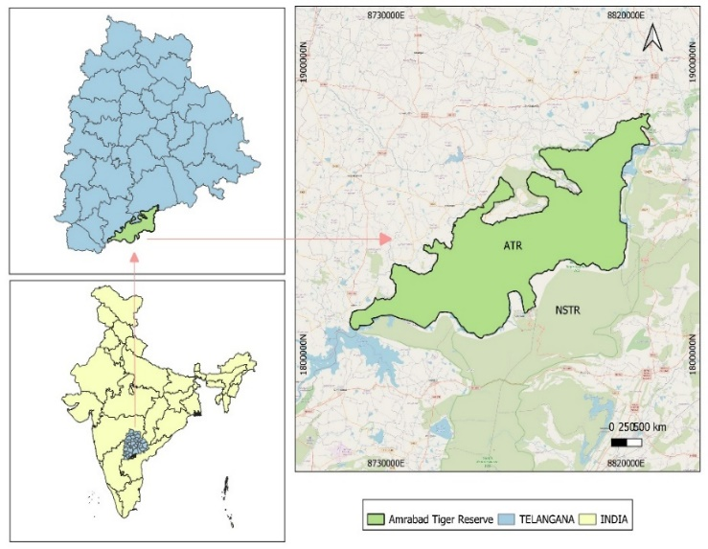
.

Fig.1. Map showing the Amrabad Tiger Reserve

2.2. METHODOLOGY
Scats were collected from various trails, including forest roads, natural trails and around water holes between July 2024 and December 2025, a total of 143 Sloth bear droppings were obtained via opportunistic sampling method. Each dropping was transferred to Zip-lock bags with silica gel for laboratory examination and noted date, location, status of dropping (fresh or old) and habitat along with geo-coordinates. Monthly efforts were undertaken to collect droppings in the entire study area. In laboratory, each dropping sample was transferred into plastic container and weighed, further, soaked in water for 24 hours. After soaking, the samples were thoroughly rinsed under running water using a two-stage sieve system (0.7 mm and 0.4 mm mesh) to separate undigested remains from fine soil and digested material (Mewada et al., 2015). After washing, the remaining material was weighed again. The contents were segregated and analysed to identify insect fragments, plant materials and other animal’s remains. Samples were identified based on morphological features of Shield tail, which found in droppings of Sloth bear. Uropeltis ellioti were identified through its characteristic features a distinctive yellow stripe on each side of neck and on the tail. venter is dark brown with small yellow dots, often with a yellow bank across the vent, fossorial snake with uniformly cylindrical body glossy dark brown or black scales with yellow dots (Cyriac et al.,2018). The present study represents the first systematic approach to document the feeding ecology of Sloth bears in Amrabad Tiger Reserve.
The diet composition was quantified using frequency of occurrence (FO%), Calculated as the percentage of scat samples in which each food item was present relative to the total number of samples analysed (N = 143), using the formula FO% = (n/N) × 100, where n is the number of samples containing a particular food item.
3. RESULTS AND DISCUSSION
A total of 143 scat samples of the Sloth bear (Melursus ursinus) were analysed to understand dietary composition in the study area. The analysis revealed a broad spectrum of food items (Table 1).
Table 1: The diet found in scat samples of Sloth bear (Melursus ursinus) between July 2024 and December 2025.
Sl. No | Food item | No. of samples (n) | FO (%)
1 | Black ants | 55 | 38.5
2 | Red ants | 36 | 25.2
3 | Millipede | 12 | 8.4
4 | Other beetles | 12 | 8.4
5 | Tenebrio molitor (larva) | 4 | 2.8
6 | Polyalthia cerasoides | 8 | 5.6
7 | Cassia fistula | 19 | 13.3
8 | Crab | 8 | 5.6
9 | Uropeltis ellioti (First record) | 5 | 3.5

A total of 143 scat samples of sloth bears were analyzed to determine dietary composition. Frequency of occurrence (FO%) analysis revealed that insects constituted the major component of the diet. Black ants were the most dominant food item (FO = 38.5%), followed by red ants (25.2%) and Cassia fistula (13.3%). Other dietary components included millipedes (8.4%), beetles (8.4%), crabs (5.6%), and plant species such as Polyalthia cerasoides (5.6%). Larvae of Tenebrio molitor were recorded less frequently (FO = 2.8%).
Uropeltis ellioti remains were detected in 5 out of 143 samples (FO = 3.5%) and in all cases co-occurred with other dietary components. Multiple food items were observed within scat samples, reflecting the opportunistic and omnivorous behaviour of Sloth bear. The sum of FO% exceeds 100% as multiple food items were present within individual samples
A notable observation was the presence of reptilian remains in five samples, identified as the shield-tailed snake Uropeltis ellioti (Figure 2).
Shield-tailed snakes are fossorial and rarely encountered above ground, spending most of their life within soil substrates (Whitaker & Captain, 2004). Seasonal variation in foraging behaviour shows that Sloth bears intensify excavation activities during periods when soil conditions are favourable, such as the monsoon, facilitating access to underground insect colonies (Dabhi et al., 2025). These observations are consistent with the possibility that soil excavation contributes to sloth bear foraging behaviour under favourable seasonal conditions.
The detection Uropeltis ellioti was largely confined to the monsoon season, indicating a strong seasonal influence on pray availability. Increased soil moisture during this period is known to enhance the surface activity of fossorial fauna, thereby increasing their susceptibility to predation. Recent studies have shown that seasonal rainfall significantly alters the activity patterns and detectability of subterranean vertebrates and invertebrates in tropical dry forest. In Sloth bear, dietary composition has been shown to shift in response to temporal fluctuations in food resources, particularly between dry and wet seasons. The occurrence of crabs in the diet further emphasizes the opportunistic feeding behaviour of the species, demonstrating its capacity prey when available.
The absence of prior records of this prey item highlights the ecological significance of the present finding. It suggests a broader tropic niche then previously recognized and indicates that feeding interaction of Sloth bears may extend into below-ground faunal communities. Recent ecological assessment have emphasized that omnivorous mammals in tropical ecosystem often exhibit underreported dietary breadth due to limitation of convention observation method. Accordingly, the occurrence of fossorial reptile remains in the samples indicates a potentially underreported component of sloth bear foraging ecology.
The dietary pattern observed in this study further demonstrates that Sloth bear is a highly adaptable and opportunistic feeder. Recent studies from other parts of the species’ range likewise support the view that sloth bears show considerable ecological flexibility. In central India, relative abundance has been evaluated in relation to biotic and abiotic factors in a human-dominated landscape, highlighting the importance of local habitat conditions in shaping bear occurrence (Chaudhuri et al., 2022). In western India, sloth bears avoided areas heavily infested by Prosopis juliflora, and their habitat use was positively associated with dense forest and open scrub (Rot et al., 2023). Additional observations from Gujarat and Rajasthan show that sloth bears may exploit unusual resources, including anthropogenic debris in eco-sensitive zones and carrion from ungulate carcasses, further supporting the opportunistic nature of their feeding behaviour (Mesaria et al., 2023; Panda et al., 2025).
Recent scat and stable isotope-based studies confirm that the species utilizes a wide spectrum of food resources, including insects, fruits, and occasional vertebrates, with flexibility drives by seasonal and habitat specific resources availability. Such dietary plasticity is considered a key ecological trait enabling persistence in the resource-variable environments of tropical dry deciduous forest. In landscapes such as the Amrabad Tiger Reserve, where seasonal fluctuation in food resources is pronounced, this adaptive foraging strategy likely plays a critical role in sustaining Sloth bear populations.

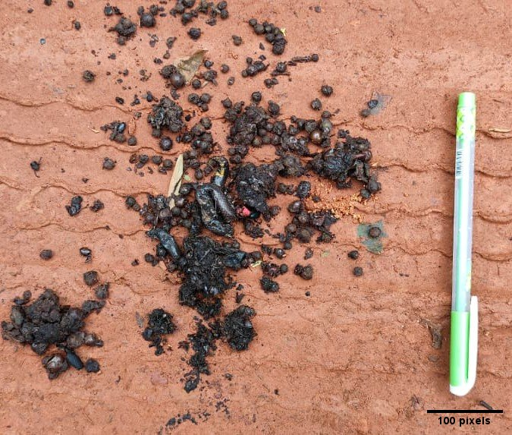 | 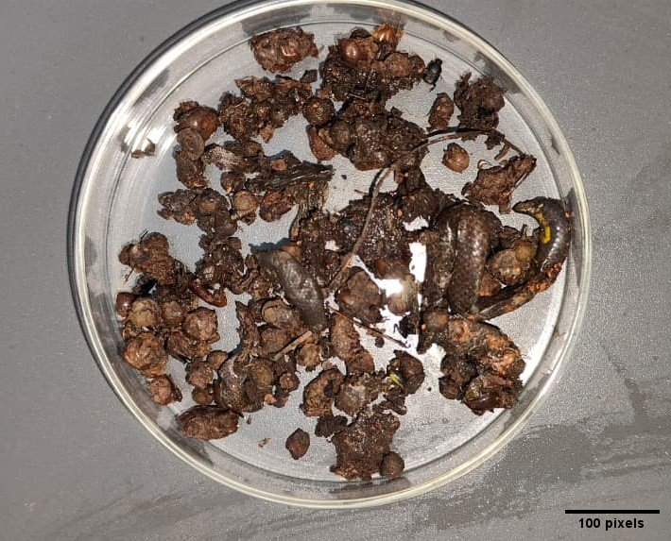
A. Presence of Uropeltis ellioti in droppings of Sloth bear in the filed | B. In Lab: Clear image of Uropeltis ellioti
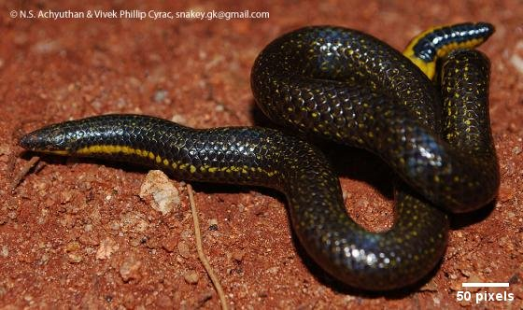 | 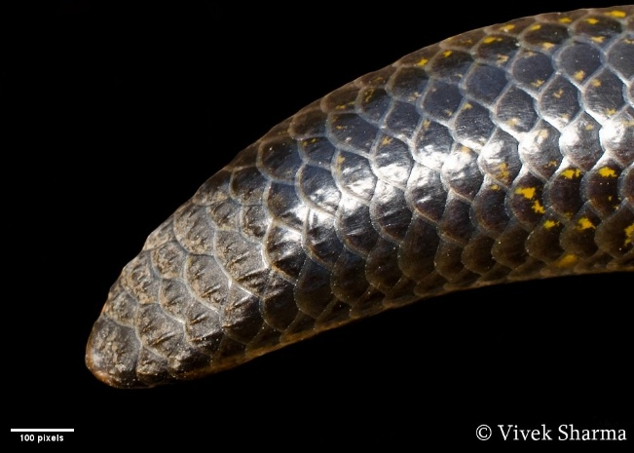
C. Uropeltis ellioti | D. Uropeltis ellioti

Figure 2: A and B- Uropeltis ellioti found in the Sloth bear droppings; C and D- Uropeltis ellioti images for comparison
4. CONCLUSION
The present study provides significant insights into the dietary ecology of Sloth bears in the Amrabad Tiger Reserve. These findings reflect the species’ ability to utilize a wide range of available food resources in a dry deciduous forest ecosystem. A notable finding of this study is the occurrence of shield-tailed snake (Uropeltis ellioti) remains in sloth bear scats collected from the study area. This observation suggests that sloth bears may occasionally exploit fossorial prey during foraging, although targeted behavioural or molecular evidence would be needed to confirm this pattern. The seasonal occurrence of such prey further emphasizes the species’ adaptability in response to changing environmental conditions and food availability. These observations confirm that Sloth bears are opportunistic feeders, with survival in resource-limited habitats largely dependent on their dietary flexibility. Their ability to switch between insectivore, frugivory, and occasional vertebrate predation highlights their ecological resilience. This study contributes preliminary information relevant to understanding sloth bear foraging ecology and habitat use in the study landscape. These findings support the need for continued ecological monitoring and habitat management for sloth bear conservation in dry forest landscapes. Equally important is fostering a deep-rooted commitment to biodiversity stewardship within local communities, ensuring the long-term conservation of Sloth bears and the ecosystems they inhabit.

5. LIMITATIONS AND FUTURE RESEARCH
This study has some limitations that should be acknowledged. Scat-based dietary analysis, while a standard non-invasive method, is subject to differential digestibility of prey remains, potentially leading to underrepresentation of soft-bodied food items and overrepresentation of hard-structured materials such as scales and chitinous insect fragments. The opportunistic sampling design, though practical in dense forest terrain, lacks systematic transect-based effort data, limiting the ability to assess detection probabilities or correct for spatial sampling bias. With only five positive records of Uropeltis ellioti across 143 samples, conclusions regarding predation frequency and seasonality remain preliminary and should be interpreted cautiously.
Future research should prioritise systematic, effort-standardised scat collection across all seasons to enable robust statistical comparisons of dietary composition. Genetic metabarcoding of scat contents would substantially improve prey identification accuracy, particularly for cryptic and soft-bodied taxa that leave few morphological traces. Camera trap deployment in foraging areas could provide direct behavioural evidence of below-ground excavation activity. Long-term dietary monitoring across multiple years would clarify whether the occurrence of fossorial reptiles in the Sloth bear diet represents a consistent ecological interaction or an opportunistic anomaly driven by exceptional monsoon conditions.

Ethical Approval
Animal Ethic committee approval has been collected and preserved by the author(s)

DISCLAIMER (ARTIFICIAL INTELLIGENCE)
The authors(s) hereby declare that generative AI technologies, including Large Language Models, were not used in the writing or editing of this manuscript.
COMPETING INTERESTS
Authors have declared that no competing interests exist
REFERENCES
- Champion, H.G. & Seth, S.K. (1968). A revised survey of the forest types of India. Government of India Press, New Delhi.
- Cyriac, Vivek & Kodandaramaiah, Ullasa. (2019). Conspicuous colours reduce predation rates in fossorial uropeltid snakes. PeerJ. 7. e7508. 10.7717/peerj.7508
- Chaudhuri, S., Rajaraman, R., Kalyanasundaram, S., Sathyakumar, S., & Krishnamurthy, R. (2022). N-mixture model-based estimate of relative abundance of sloth bear (Melursus ursinus) in response to biotic and abiotic factors in a human-dominated landscape of central India. PeerJ, 10, e13649. https://doi.org/10.7717/peerj.13649
- Dabhi, S., Williams, B. A., Bevins, J., & Dharaiya, N. (2025). Occurrence of human pathogenic bacteria and their antibiotic resistance in the gut of wild and captive sloth bears. Wildlife Biology, 2025(5), e01454. https://doi.org/10.1002/wlb3.01454
- Jhala, Y. V., Qureshi, Q., & Nayak, A. K. (2020). Status of tigers, co-predators and prey in India 2018. National Tiger Conservation Authority, India.
- Mewada, T.P. (2015). Index of relative importance of the dietary proportions of Sloth bear (Melursus ursinus) in semi-arid region. Notulae Scientia Biologicae, 7(3), 281–288. https://doi.org/10.15835/nsb739577
- Mesaria, S., Patel, S., Desai, P., & Dharaiya, N. A. (2023). Food from the neighbors: Sloth bear savoring the debris left by tourists and locals in eco-sensitive zone of Chhota Udepur District, Gujarat, India. Proceedings of the Zoological Society, 76, 202–204. https://doi.org/10.1007/s12595-023-00484-3

- Panda, D., Mohanty, S., Pandey, P., & Singh, R. (2025). Scavenging event of sloth bear (Melursus ursinus) in the semi-arid landscape of Rajasthan, India. Proceedings of the Zoological Society, 78, 50–53. https://doi.org/10.1007/s12595-024-00557-x
- Rot, J., Jangid, A. K., Singh, C. P., & Dharaiya, N. A. (2023). Escaping neobiota: Habitat use and avoidance by sloth bears in Jessore Sloth bear Sanctuary India. Trees, Forests and People, 13, 100400. https://doi.org/10.1016/j.tfp.2023.100400
- Ratnayeke, S., van Manen, F. T., & Padmalal, U. K. G. K. (2007). Home ranges and habitat use of sloth bears Melursus ursinus inornatus in Wasgomuwa National Park, Sri Lanka. Wildlife Biology, 13(3), 272–284. https://doi.org/10.2981/0909-6396(2007)13[272:HRAHUO]2.0.CO;2
- Reddy, H. S., Srinivasulu, C., & Rao, K. T. (2004). Prey selection by the Indian tiger (Panthera tigris tigris) in Nagarjunasagar Srisailam Tiger Reserve, India. Mammalian Biology, 69(6), 384–391. https://doi.org/10.1078/1616-5047-00160
- Srivathsa, A., Karanth, K. U., & Kumar, N. S. (2019). Ecology and conservation of sloth bears Melursus ursinus in human-dominated landscapes. Biological Conservation, 231, 203-211. https://doi.org/10.1016/j.biocon.2019.01.011
- Whitaker, R. & Captain, A. (2004). Snakes of India: The Field Guide. Draco Books, Chennai.

