Case report
Primary tuberculous pyomyositis of the thigh muscles in an immunocompetent patient: A case report

Abstract
Tuberculous pyomyositis occurs mainly in immunocompromised patients, either through hematogenous spread (secondary form) or following direct trauma. However, it may also occur in immunocompetent patients without an initial focus and without clinical or radiological evidence of infection. The report presents a case of primary tuberculous pyomyositis presenting as an abscess of the left thigh. Initial treatment with broad-spectrum antibiotics for presumed tropical pyomyositis caused by common bacteria proved ineffective, with persistence of clinical signs. Microbiological examination of the pus using the Xpert test identified Mycobacterium tuberculosis. Clinical evolution was favourable under antituberculosis therapy combined with abscess drainage.
Keywords: Pyomyositis, Tuberculosis, Immunocompetence, Thigh muscles

Introduction
Musculoskeletal tuberculosis is uncommon (1–3%), and the most frequent forms include spondylitis, osteomyelitis, and arthritis [1,2]. Musculoskeletal Tuberculosis (TB) affects the bones, joints and soft tissues. The onset of symptoms is usually insidious and nonspecific. It may lead to irreversible joint damage, deformities or neurological manifestations necessitating surgical and rehabilitative corrections due to delayed diagnosis and prolonged latency in the initiation of definitive medical treatment [25]. Pyomyositis is defined as an acute bacterial infection that occurs within skeletal muscles and usually results in abscess formation. Pyomyositis is seen in immunosuppressed individuals, such as people living with human immunodeficiency virus/acquired immunodeficiency syndrome (HIV/ AIDS), diabetes mellitus, leukaemia, cancer or malignancy, renal failures, and autoimmune diseases [27]. Tuberculous pyomyositis may be primary or secondary. Primary tuberculous pyomyositis is a rare infection constituting less than 1% of musculoskeletal tuberculosis [26]. Primary tuberculous pyomyositis occurs in the absence of an initial infectious focus. Secondary tuberculous pyomyositis results from tuberculous infection originating from an adjacent structure, such as a joint, bone, synovial membrane, cold abscess, or from hematogenous dissemination [3].
Primary tuberculous pyomyositis is a rare entity [4]. Most reported cases occur in immunocompromised patients, such as those with human immunodeficiency virus (HIV) infection, diabetes, cancer, renal transplantation, or rheumatoid arthritis [5]. We describe here a case of tuberculous pyomyositis in an immunocompetent patient.
Case presentation
We report the case of a 33-year-old woman who presented with a painful swelling of the left thigh, progressively increasing in size over three weeks. This was associated with evening fever without chills or night sweats and without weight loss. Her medical history revealed no trauma, previous tuberculosis, or contact with a person with tuberculosis. She had no specific risk factors such as HIV infection, diabetes, corticosteroid or immunosuppressive therapy, or chronic kidney disease. A BCG vaccination scar was present.
On physical examination, she presented with signs of systemic inflammatory response (temperature 38 °C, pulse 112 beats/min, respiratory rate 21 cycles/min) while her general condition was preserved. The anterolateral aspect of the left thigh, opposite the ipsilateral hip, showed a warm, painful swelling with shiny overlying skin and no tendency to fistulization (Figure 1). There were relative functional impairment of the left lower limb and no palpable inguinal lymphadenopathy. Examination of the other systems was unremarkable.
An initial diagnostic hypothesis of bacterial or tuberculous pyomyositis of the quadriceps muscle was considered.
Laboratory tests revealed leucocytosis of 12,000 /mm³ with neutrophil predominance (8,300 /mm³) and microcytic normochromic anaemia (haemoglobin 9.2 g/dL). Serum creatinine was normal (1.25 mg/dL). C-reactive protein was elevated at 164 mg/dL.
CT scan of the left hip (Figure 2) demonstrated a well-defined fluid collection in the peri-articular soft tissues, consistent with an abscess of the quadriceps muscle. The patient underwent incision and drainage under general anaesthesia, yielding 800 mL of pus. Bacteriological analysis of the pus, including Xpert MTB/RIF testing and culture, was negative for tuberculosis and for common pathogens (staphylococci, Streptococcus pyogenes).
HIV serology was negative, CD4 T-cell count was 625/mm³, glycated haemoglobin was 6%, and serum albumin was 38 g/L. Radiographs of the hip (Figure 3) and chest (Figure 4) were normal. Blood cultures and gastric aspirate Xpert testing for tuberculosis were also negative.
Ceftriaxone 2 g/day was initiated. Despite treatment, the patient continued to have febrile peaks, with persistent purulent discharge from the incision site. Given the lack of improvement under nonspecific antibiotic therapy, a second sample was obtained for Xpert MTB/RIF testing, which identified Mycobacterium tuberculosis sensitive to rifampicin.
The diagnosis of primary tuberculosis of the quadriceps muscle was confirmed, with no evidence of tuberculous infection elsewhere in the body.
Antituberculosis quadruple therapy was initiated with rifampicin (600 mg/day), isoniazid (300 mg/day, with vitamin B6 supplementation), pyrazinamide (1000 mg/day), and ethambutol (1200 mg/day).
The patient showed marked clinical improvement, with sustained apyrexia and disappearance of purulent discharge. Up to the sixth month of treatment, she reported no recurrence of fever, and the thigh swelling did not reappear.
Discussion
Primary tuberculous pyomyositis is a rare form of tuberculosis, occurring in fewer than 1% of affected patients [5–7]. Its rarity may be explained by the fact that skeletal muscle is an unfavourable environment for the survival and multiplication of Mycobacterium tuberculosis. Proposed explanations include the high lactic acid content of muscle, the absence of reticuloendothelial and lymphatic tissue, and the relatively low oxygen tension within muscle tissue [8,9].
The etiopathogenesis of primary muscular involvement by Mycobacterium tuberculosis remains poorly understood. Several mechanisms have been proposed, suggesting that infection may occur in previously compromised muscle tissue [10]. Reported predisposing factors include trauma, surgical procedures, the presence of foreign bodies, local ischemia, connective tissue disorders, and states of immunosuppression [11]. It is particularly associated with immunosuppressive therapy, chemotherapy, corticosteroids, HIV infection, and renal failure [11,12]. None of these risk factors were identified in our patient. Although any skeletal muscle may be affected, the lower limb muscles—particularly the quadriceps femoris—are most frequently involved [11,13].
The clinical manifestations of this form of tuberculosis are often nonspecific. Onset may be insidious, with a prolonged course and a median duration of symptoms of approximately 43.5 days [6,10]. General symptoms such as fever, night sweats, asthenia, and weight loss may be present. Local symptoms depend on the muscle involved and typically include painful swelling associated with limitation of movement of the adjacent joint. These features can easily be mistaken for more common conditions such as staphylococcal or streptococcal pyomyositis, leading to delays in diagnosis [3,6].
The diagnosis of muscular tuberculosis relies on clinical, radiological, and microbiological criteria [14]. Magnetic resonance imaging (MRI) is superior to computed tomography (CT) for assessing the extent of lesions and excluding tumour processes, although its sensitivity in differentiating tuberculous from bacterial pyomyositis remains moderate [15–17]. In resource-limited settings such as ours, however, CT still plays an important diagnostic role despite its lower sensitivity and specificity compared with MRI, as reported in several studies [16,18,19]. Demonstration of Mycobacterium tuberculosis in cases of pyomyositis requires specific microbiological tests, such as culture of pus or the Xpert MTB/RIF assay, which confirmed the diagnosis in our patient after an initially negative result. The rapid Xpert MTB/RIF diagnostic test, which detects M. tuberculosis DNA, is essential for confirming extrapulmonary forms of tuberculosis, although its sensitivity and specificity are slightly lower in extrapulmonary specimens [20,21]. The initial negative Xpert result in our case may be explained by low bacillary load, sampling issues, or thick caseous pus containing potential inhibitors such as proteins or cellular debris [22,23]. Histopathological examination of muscle biopsy specimens or culture of pus on specific media may also assist in diagnosis [12]. Tuberculous pyomyositis should therefore not be excluded solely based on negative microbiological tests, particularly in endemic settings and in cases of poor clinical response to empirical antibiotic therapy for presumed tropical pyomyositis [9].
Treatment of muscular tuberculosis follows the same principles as pulmonary tuberculosis, namely combination antituberculosis therapy administered over a sufficiently long period (typically six months) [6,24]. Although our patient had no obvious risk factors, primary tuberculous pyomyositis should be considered in any case of pyomyositis occurring in individuals living in endemic regions.
Conclusion
Muscular tuberculosis, although rare, remains an important diagnostic consideration in regions where tuberculosis is endemic, particularly when suggestive clinical symptoms are present. Diagnosis relies on clinical vigilance and the use of appropriate diagnostic tools, including the Xpert MTB/RIF assay and microbiological culture. Early initiation of antituberculosis therapy helps prevent serious complications and promotes complete recovery, as illustrated by the favourable outcome in this case.
Figures
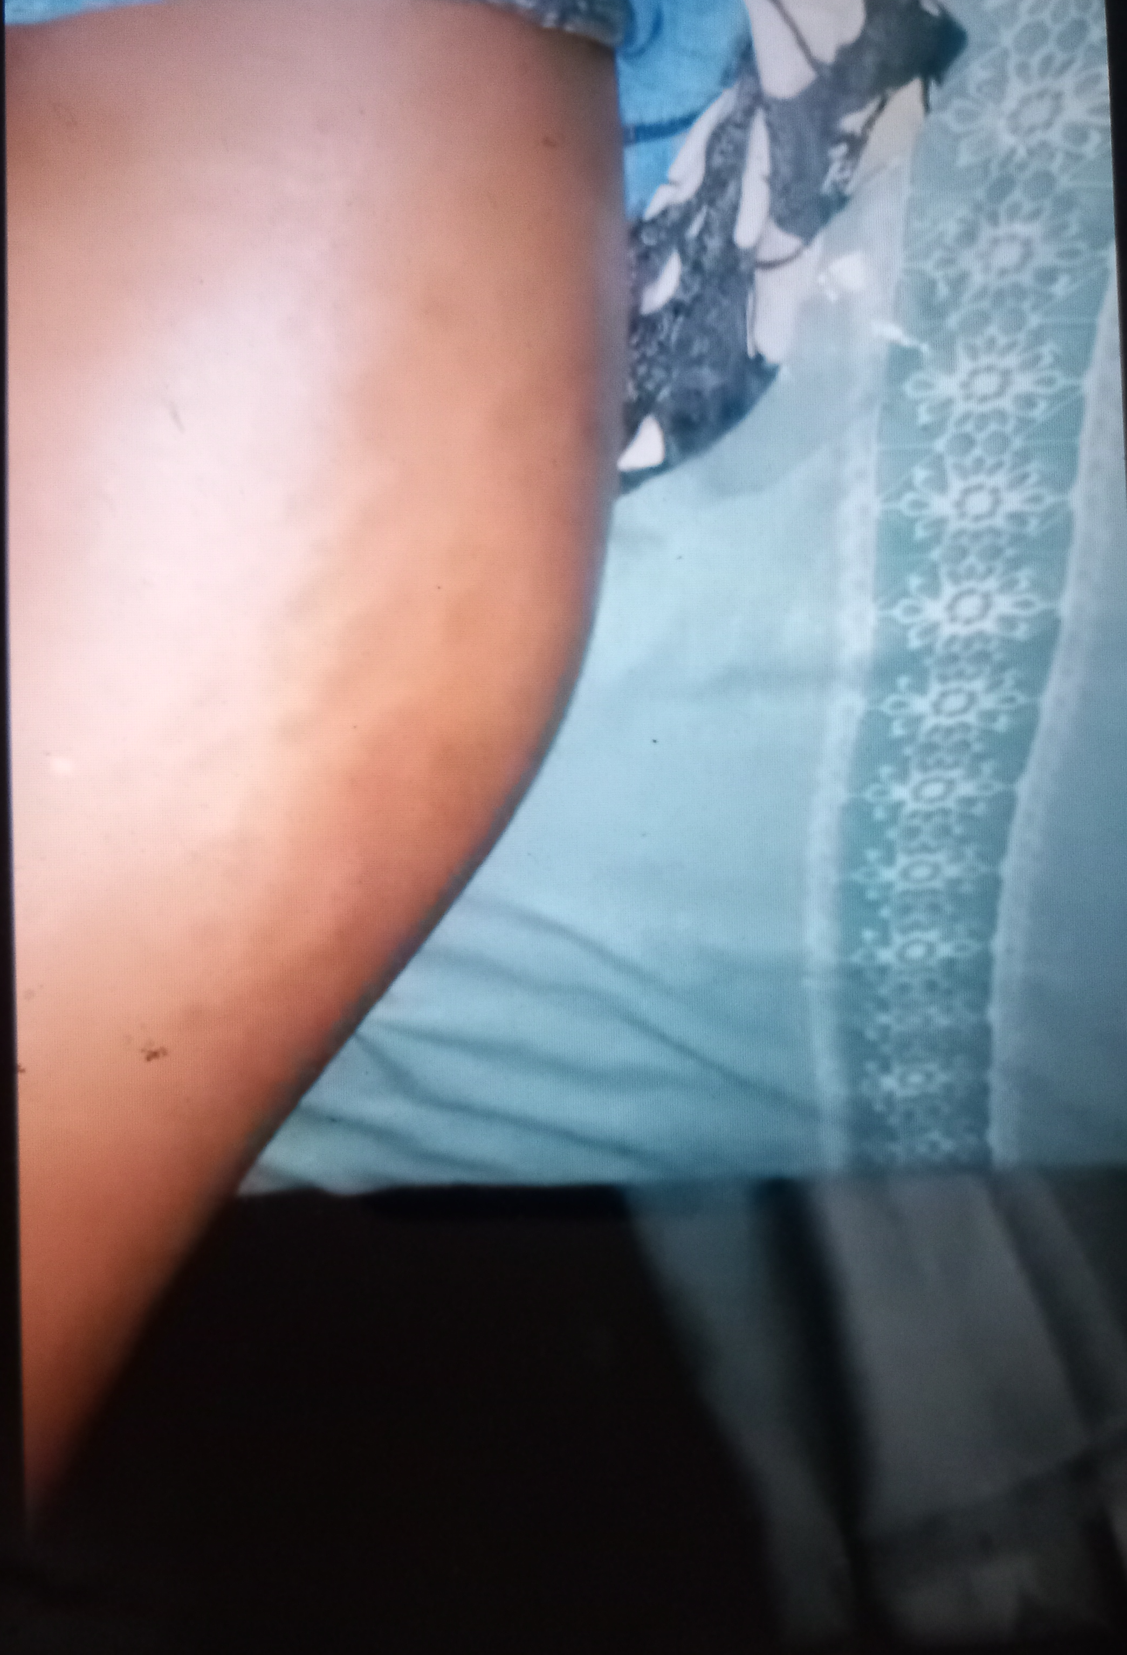
Figure 1 Swelling of the left thigh

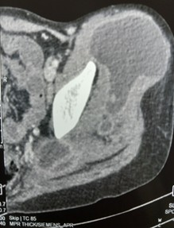
Figure 2 Abscess collection in the quadriceps muscle of the left thigh
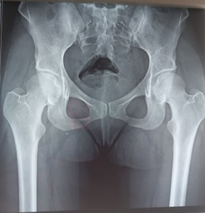
Figure 3 X-ray of the pelvis

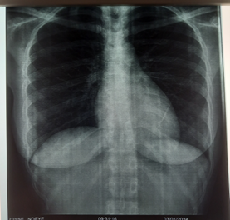
Figure 4 Chest X-ray

COMPETING INTERESTS DISCLAIMER:
Authors have declared that they have no known competing financial interests OR non-financial interests OR personal relationships that could have appeared to influence the work reported in this paper.

Disclaimer (Artificial intelligence)
Author(s) hereby declare that NO generative AI technologies such as Large Language Models (ChatGPT, COPILOT, etc.) and text-to-image generators have been used during the writing or editing of this manuscript.

References
1. Raut AA, Naphade PS, Ramakantan R. Imaging Spectrum of Extrathoracic Tuberculosis. Radiol Clin North Am. 2016 May;54(3) :475-501. doi: 10.1016/j.rcl.2015.12.013. Epub 2016 Mar 4. PMID: 27153784.
2. Modi MA, Mate AD, Nasta AM, Gvalani AK. Primary tuberculous pyomyositis of quadriceps femoris in an immunocompetent individual. Case Rep Infect Dis. 2013 ;2013 :723879. doi: 10.1155/2013/723879. Epub 2013 Dec 3. PMID: 24367732; PMCID: PMC3866826.
3. Al-Khazraji A, Takher J, Alkhawam H, Fabbri M. Primary Tuberculous Pyomyositis of the Calf Muscles. Am J Med Sci. 2017 Feb;353(2) :187-188. doi: 10.1016/j.amjms.2016.05.010. Epub 2016 May 19. PMID: 28183421.
4. Abdelwahab IF, Bianchi S, Martinoli C, Klein M, Hermann G. Atypical extraspinal musculoskeletal tuberculosis in immunocompetent patients: part II, tuberculous myositis, tuberculous bursitis, and tuberculous tenosynovites. Can Assoc Radiol J. 2006 Dec;57(5) :278-86. PMID: 17265982.
5. Pandiaraja J, Shalini A. Primary tuberculous pyomyositis in an immunocompetent individual. J Assoc Chest Physicians 2021 ;9 :80-2.
6. Kim JH, Lee JS, Choi BY, Cheon YH, Yoo SJ, Ju JH, Shin K, Kim ES, Baek HJ, Park W, Song YW, Hong WH, Lee YJ. Isolated Tuberculous Myositis: A Systematic Review and Multicenter Cases. J Rheum Dis. 2022 Oct 1 ;29(4) :243-253. doi: 10.4078/jrd.22.0014. Epub 2022 Jul 20. PMID: 37476423; PMCID: PMC10351410.
7. Yadav S, Jeyaraman M, Rawal G, Jeyaraman N. Spina Ventosa of the Left Ring Finger With Tuberculous Pyomyositis in the Forearm Muscles in a Young Immunocompetent Indian Male With No Pulmonary Involvement: A First Report of Its Type. Cureus. 2024 Aug 13;16(8): e66823. doi: 10.7759/cureus.66823. PMID: 39280424; PMCID: PMC11398727.
8. Cabo J, Martins L, e Castro AT, Maltez F. Multifocal subcutaneous and muscular tuberculosis in a immunocompetent man,Acta Med Port 2020 Jul-Aug;33(7-8) :516-520
9. Kumar R, Khosla P, Taneja V, Dessai R, Sondhi M. Tubercular pyomyositis: A case series. Indian J Tuberc. 2024 Oct;71(4) :492-495. doi: 10.1016/j.ijtb.2024.08.002. Epub 2024 Aug 10. PMID: 39278686.
10. Daghfous A, Bouzaidi K, Marhoul LR. Pyomyosite tuberculeuse primitive chez une patiente immunocompétente: à propos d'un cas [Primary tuberculous pyomyositis in an immunocompetent patient: report of a case]. Pan Afr Med J. 2014 Oct 24; 19:200. French. doi: 10.11604/pamj.2014.19.200.3099. PMID: 25821543; PMCID: PMC4369295.
11. Simon SP, Fodor D, Valasciuc R, Tamas MM, Rednic S. A rare case of primary tuberculous pyomyositis. Case report. Med Ultrason. 2011 Sep;13(3) :245-8. PMID : 21894298.
12. Simopoulou T, Varna A, Dailiana Z, Katsiari C, Alexiou I, Basdekis G, Malizos KN, Sakkas LI. Tuberculous pyomyositis: a re-emerging entity of many faces. Clin Rheumatol. 2016 Apr;35(4) :1105-10. doi: 10.1007/s10067-014-2564-8. Epub 2014 Mar 9. PMID: 24609759.
13. Ralandison S, Rakotoarivelo R, Rakotovao M, Raobison R, Andrianteloasy S, Rakotoarimanana S, Rapelanoro Rabenja F. Localisations inhabituelles de la tuberculose: à propos de trois observations [Unusual locations of tuberculosis: three case reports]. Rev Med Interne. 2009 Oct;30(10):917-9. French. doi: 10.1016/j.revmed.2009.01.002. Epub 2009 Feb 23. PMID: 19233520.
14. Krishnasamy V, Joseph M. Tuberculous pyomyositis: a rare but serious diagnosis. Case Rep Med. 2013; 2013:126952. doi: 10.1155/2013/126952. Epub 2013 Mar 24. PMID: 23634147; PMCID: PMC3619691.
15. Tirlangi PK, Sebastian A, Prabhu M M. Tropical pyomyositis. Best Pract Res Clin Rheumatol. 2025 May;39(2):102041. doi: 10.1016/j.berh.2025.102041. Epub 2025 Feb 18. PMID: 39971676.
16. Thammaroj P, Panitchote A, Muktabhant C, Chowchuen P. Discrimination between tuberculous and bacterial pyomyositis in magnetic resonance features. Eur J Radiol Open. 2020 Jan 28 ;7:100214. doi: 10.1016/j.ejro.2020.01.003. PMID: 33102635; PMCID: PMC7569411.
17. Somaraj M, Crasta GS, Bhat R. Tuberculous pyomyositis presenting as septic arthritis and multiple site pyomyositis. BMJ Case Rep. 2024 Mar 25 ;17(3): e258501. doi: 10.1136/bcr-2023-258501. PMID: 38531557; PMCID: PMC10966722.
18. Shukla RV, Dubey IP, Kumar A, Kompella KK, Khan S, Mohanan K, et al. Tropical Pyomyositis in Immunocompetent Hosts Posing Diagnostic Challenges: A Case Series. Journal of Marine Medical Society 26(1): p 127-131, Jan–Apr 2024. | DOI: 10.4103/jmms.jmms_6_23
19. Cherulil SJ, Sreelesh KP, Anuja MS. Tuberculous pyomyositis in acute leukaemia – A diagnostic quandary,Medical Reports,Volume 6,2024,100073,ISSN 2949-9186. Disponible sur: https://doi.org/10.1016/j.hmedic.2024.100073
20. Terzi HA, Aydemir Ö, Karakeçe E, Demiray T, Köroğlu M, Altındiş M. Evaluation of the Xpert MTB/RIF Test Performance in the Diagnosis of Suspected M. tuberculosis in Pulmonary and Extrapulmonary Clinical Specimens. Mediterr J Infect Microb Antimicrob. 2024; 13:23055.13.
21. Tadesse M, Abebe G, Bekele A, Bezabih M, Yilma D, Apers L, de Jong BC, Rigouts L. Xpert MTB/RIF assay for the diagnosis of extrapulmonary tuberculosis: a diagnostic evaluation study. Clin Microbiol Infect. 2019 Aug;25(8) :1000-1005. doi: 10.1016/j.cmi.2018.12.018. Epub 2018 Dec 22. PMID: 30583052.
22. Acharya KR, Dhand NK, Whittington RJ, Plain KM. PCR Inhibition of a Quantitative PCR for Detection of Mycobacterium avium Subspecies Paratuberculosis DNA in Feces: Diagnostic Implications and Potential Solutions. Front Microbiol. 2017 Feb 2; 8:115. doi: 10.3389/fmicb.2017.00115. PMID: 28210245; PMCID: PMC5288348.
23. Theron G, Peter J, Calligaro G, Meldau R, Hanrahan C, Khalfey H, Matinyenya B, Muchinga T, Smith L, Pandie S, Lenders L, Patel V, Mayosi BM, Dheda K. Determinants of PCR performance (Xpert MTB/RIF), including bacterial load and inhibition, for TB diagnosis using specimens from different body compartments. Sci Rep. 2014 Jul 11; 4:5658. doi: 10.1038/srep05658. PMID: 25014250; PMCID: PMC5375978.
24. Fernandes L, Reis Neto ET dos, Pereira MAP, Baretta MC da C, Andriolo A. Tuberculous pyomyositis: a casereport. J. Bras. Patol. Med. Lab. 58,2022. Disponible sur/ https://doi.org/10.1900/JBPML.2022.58.430
25. Subramanian, R., Prasad, S., & Mamadapur, M. (2025). Musculoskeletal manifestations in Tuberculosis. Best Practice & Research Clinical Rheumatology, 39(2), 102057. https://doi.org/10.1016/j.berh.2025.102057
26. Ahmad, J., Shrivastava, V. K., Ayaz, A., Singh, A. R., & Khanna, M. (2020). Tuberculous pyomyositis of upper and lower limb muscles-a prospective study.
27. Ngor, C., Hall, L., Dean, J. A., & Gilks, C. F. (2021). Factors associated with pyomyositis: A systematic review and meta‐analysis. Tropical Medicine & International Health, 26(10), 1210-1219.
‌

