Case Report
Vildagliptin Induced Bullous Vasculitis: A Case Report with Causality Assessment

Abstract:
Bullous vasculitis is a rare form of cutaneous small-vessel vasculitis characterized by blistering over inflamed skin. We report a 42-year-old woman with type 2 diabetes mellitus who had been on a vildagliptin-based oral antidiabetic regimen for six months. After discontinuing the medication on her own, 6 months after she developed bilateral lower limb swelling with painful ulcerations and bullae, which persisted in the setting of poor glycemic control. During hospitalization, rechallenge with vildagliptin led to a clear worsening of the lesions. The drug was subsequently withdrawn, following which gradual clinical improvement was observed. Histopathological findings were consistent with bullous leukocytoclastic vasculitis. Discontinuation of vildagliptin along with initiation of insulin therapy resulted in progressive healing of the ulcers. Causality assessment using the Naranjo Adverse Drug Reaction Probability Scale suggested a probable association. This case highlights the importance of recognizing drug-related cutaneous.
Keywords
Vildagliptin; bullous leukocytoclastic vasculitis; dipeptidyl peptidase-4 inhibitors; drug-induced vasculitis; adverse drug reaction
Introduction
Vildagliptin is a dipeptidyl peptidase-4 (DPP-4) inhibitor widely used in the management of type 2 diabetes mellitus. It improves glycemic control by enhancing the incretin-mediated insulin response and is generally considered safe and well tolerated (1). However, emerging evidence links DPP-4 inhibitors to dermatological adverse reactions ranging from pruritus and fixed drug eruptions to severe cutaneous adverse reactions. Among these, drug-induced bullous pemphigoid is the most commonly reported, whereas bullous vasculitis is exceedingly rare (1). Bullous vasculitis is a rare variant of cutaneous small-vessel vasculitis characterized by purpuric lesions accompanied by fluid-filled or haemorrhagic bullae due to immune complex-mediated vascular injury. While drug-induced vasculitis is well documented, only a few cases have been reported with DPP-4 inhibitors, primarily involving Sitagliptin. To date, no cases have implicated Vildagliptin in bullous vasculitis. We report the first such case temporally associated with vildagliptin therapy, supported by causality assessment.
CASE DESCRIPTION
A 42-year-old woman presented with a one-week history of bilateral lower limb edema and painful ulcers on her right ankle and left leg. She had been diagnosed with type 2 diabetes mellitus one year prior. Her treatment history included Mytopride-VD (vildagliptin 50 mg + metformin 500 mg) and Vogs-GM2 (voglibose 0.2 mg + glimepiride 2 mg + metformin 500 mg). She had previously discontinued these medications for six months but developed symptoms six months after resuming them. Physical examination revealed multiple ulcerative and bullous lesions with edema on both lower limbs. Her blood pressure was 150/110 mmHg and her heart rate was 102 beats per minute. All other vital signs were stable.
On physical examination, multiple bullous and ulcerative lesions were observed alongside bilateral pedal edema. Vital signs showed hypertension (150/110 mmHg) and tachycardia (102/min), while other parameters remained stable. Laboratory investigations revealed leukocytosis (WBC 12.5 ×10³/cumm) with relative lymphocytosis (41.9%) and an elevated absolute lymphocyte count (5.23 ×10³/cumm).
Additionally, aspartate aminotransferase (AST) was slightly reduced (13 U/L), and the albumin/globulin ratio was decreased (1.06), suggesting an inflammatory response consistent with bullous vasculitis.
Arterial Doppler of the right lower limb identified a monophasic flow pattern in the anterior tibial and dorsalis pedis arteries, though other vessels maintained biphasic or triphasic flow. In the left lower limb, most arteries showed normal triphasic flow, although the popliteal artery was inaccessible due to significant edema. Venous Doppler ruled out deep vein thrombosis in both limbs. While initially referred for suspected bilateral cellulitis, dermatological evaluation and clinical correlation led to a diagnosis of drug-induced bullous vasculitis.
Discussion
Mytopride-VD (vildagliptin 50 mg + metformin 500 mg) combines a DPP-4 inhibitor with metformin. Vildagliptin enhances GLP-1 activity, increasing insulin secretion and decreasing glucagon release in a glucose-dependent manner, while metformin improves insulin sensitivity and reduces hepatic glucose production. This combination effectively lowers fasting glucose, postprandial glucose, and HbA1c with a minimal risk of hypoglycemia or weight gain (2,3).
Vogs-GM2 (voglibose 0.2 mg + glimepiride 2 mg + metformin 500 mg) combines an α-glucosidase inhibitor, a sulfonylurea, and metformin. While this triple therapy effectively reduces glycemic parameters, it carries a higher risk of hypoglycemia compared to DPP-4 inhibitor-based regimens (4,5).
Bullous vasculitis is a rare variant of cutaneous small-vessel vasculitis characterized by typical purpuric lesions accompanied by fluid-filled or hemorrhagic bullae. These blisters result from significant damage and subsequent leakage within the dermal microvasculature.
In this case, the patient developed bilateral lower limb edema and painful ulcers. She had a history of type 2 diabetes managed with oral antidiabetic therapy, including Mytopride-VD. The ulceration worsened significantly upon the resumption of vildagliptin and improved only after switching to insulin therapy. This temporal relationship suggests a probable association between vildagliptin and the development of bullous vasculitis.
Vildagliptin likely triggered the vasculitis, with manifestation appearing after the initial period of use and exacerbating upon rechallenge. To date, only three cases of DPP-4 inhibitor-induced vasculitis have been documented all involving sitagliptin alongside one prior report of vildagliptin-induced leukocytoclastic vasculitis that resolved upon drug withdrawal (1). While vildagliptin-associated cutaneous vasculitis presenting as maculopapular lesions has been described, vildagliptin-induced bullous vasculitis has not. Consequently, this case represents a novel presentation of a rare adverse drug reaction (6).
In the present case, the patient's lesions worsened upon rechallenge [fig:1&2] with vildagliptin (Mytopride-VD) and subsequently improved following dechallenge [fig:3&4] and the initiation of insulin therapy. This clinical course indicates a delayed-onset reaction. The temporal relationship strongly supports vildagliptin as the likely causative agent, a finding consistent with the known immunologic side effects associated with DPP-4 inhibitors. This is further supported by a prior report of vildagliptin-induced cutaneous leukocytoclastic vasculitis, where skin lesions resolved immediately after the drug was discontinued.

Total score: 0 + 2 + 1 + 2 + 2 + 0 + 0 + 1+ 0 + 1 = 9
Final Interpretation
In contrast, metformin, voglibose, and glimepiride are rarely associated with dermatologic reactions and extremely rarely with vasculitis. While isolated case reports of glimepiride-induced vasculitis exist, the overall evidence is limited and the mechanistic explanations remain unclear (7). DPP-4 inhibitor-induced vasculitis, though uncommon, has been reported with sitagliptin, supporting a potential class effect (3). Thus, the temporal sequence specifically the worsening of symptoms upon rechallenge and improvement upon withdrawal combined with existing literature, justifies the diagnosis of probable vildagliptin-associated bullous vasculitis in this case.
Bullous vasculitis can be triggered by medications, infections, malignancies, or systemic autoimmune disorders. Drug-induced causes are the most frequent, typically occurring via immune complex-mediated small-vessel injury; implicated agents include antibiotics, NSAIDs, hydralazine, and allopurinol (8,9). While infections (such as hepatitis B/C or streptococcal infections) and autoimmune diseases (such as SLE, RA, or Sjögren’s) are known triggers, this patient had no recent infections or history of autoimmune disease, and the skin biopsy confirmed bullous vasculitis.
Initial management included bed rest, leg elevation, and meticulous wound care to promote healing and prevent secondary infections. For extensive disease, systemic corticosteroids were utilized: IV dexamethasone (1 cc daily) rapidly controlled inflammation with minimal fluid retention. Alternatively, oral prednisone (0.5–1 mg/kg/day) is an effective option, typically tapered over 3–6 weeks (10).
For chronic, recurrent, or steroid-dependent cases, steroid-sparing agents may be considered. These include colchicine (0.5–0.6 mg twice daily) for its anti-neutrophilic effects, dapsone (50–100 mg/day, with G6PD monitoring), azathioprine, mycophenolate mofetil, or methotrexate (10). IVIG or plasmapheresis may be reserved for refractory cases. Continuous wound care and infection monitoring remain essential to ensure recovery.
Although similar vasculitic reactions have been reported with other DPP-4 inhibitors, this is the first documented case associated with vildagliptin. As a single-patient report, these findings cannot be generalized. The rarity of this reaction limits comparative literature, and the causal association relies on temporal correlation and clinical judgment. Further studies and additional case reports are necessary to establish the definitive relationship between vildagliptin and bullous vasculitis.

Conclusion:
This case highlights a rare occurrence of bullous vasculitis potentially triggered by vildagliptin in a patient with type 2 diabetes mellitus. The temporal relationship between drug exposure, symptom exacerbation upon rechallenge, and healing after drug discontinuation suggests a probable causative role. Prompt recognition, withdrawal of the offending agent, and appropriate systemic therapy, such as corticosteroids, are essential for effective management and favourable clinical outcomes.

COMPETING INTERESTS DISCLAIMER:

Authors have declared that they have no known competing financial interests OR non-financial interests OR personal relationships that could have appeared to influence the work reported in this paper.
Consent: Written informed consent was obtained from the patient.
Disclaimer (Artificial intelligence)

Author(s) hereby declare that NO generative AI technologies such as Large Language Models (ChatGPT, COPILOT, etc.) and text-to-image generators have been used during the writing or editing of this manuscript.

REFERENCES
1. Zaresharifi S, Niroomand M, Borran S, Dadkhahfar S. Dermatological side effects of dipeptidyl Peptidase-4 inhibitors in diabetes management: a comprehensive review. Clin Diabetes Endocrinol. 2024 Mar 25;10(1):6. doi:10.1186/s40842-024-00165-w
2. Kalra S, Zargar AH, Sridhar G, Das AK, Ahmed J, Mohan JC, et al. Expert eValuation of Efficacy and Rationality of Vildagliptin “EVER-Vilda”: An Indian Perspective. Clin Med Insights Endocrinol Diabetes. 2024 Feb 22;17:11795514231203911. doi:10.1177/11795514231203911 PubMed PMID: 38405679; PubMed Central PMCID: PMC10893842.
3. Abubakar M, Priya BS, Himaja YS, Harini N, Abubakar M, Priya BS, et al. The Glycemic Outcomes of Metformin with Add-on Vildagliptin or Sitagliptin in T2DM. Glob J Obes Diabetes Metab Syndr. 2025 Aug 29;12(1):016–25. doi:10.17352/gjodms.000068
4. Parmar N, Gupta AK, Jhaveri K, A B, Chhaya G, Kansara S, et al. Real-World Assessment of Personalized Approach With Voglibose Fixed-Dose Combination in Type 2 Diabetes Mellitus. Cureus. 16(4):e57494. doi:10.7759/cureus.57494 PubMed PMID: 38707131; PubMed Central PMCID: PMC11066517.
5. Das AK, Wangnoo SK, Chawla R, Shaikh A, Bantwal G, Kalra P, et al. Expert Consensus on Triple Combination of Glimepiride, Metformin, and Voglibose Usage in Patients with Type 2 Diabetes Mellitus in Indian Settings. J Diabetol. 2022 Jun;13(2):145. doi:10.4103/jod.jod_118_21
6. Medicine Science | Vildagliptin induced cutaneous leukocytoclastic vasculitis: A case report [Internet]. [cited 2025 Dec 6]. Available from: https://www.medicinescience.org/article/1640?utm_source
7. Ben Salem C, Hmouda H, Bouraoui K. Glimepiride-induced vasculitis: a case report. Br J Clin Pharmacol. 2007 Jul;64(1):113–4. doi:10.1111/j.1365-2125.2007.02863.x PubMed PMID: 17324240; PubMed Central PMCID: PMC2000611.
8. Sargın G, Köse R, Şentürk T, Sargın G, Köse R, Şentürk T. Sitagliptin/Metformin Related Cutaneous Leukocytoclastic Vasculitis in a Patient with Type-2 Diabetes Mellitus. J Acad Res Med. 2020 Apr 30. doi:10.4274/jarem.galenos.2018.2019
9. Sharma S. A Rare Case Of Ibuprofen-induced Bullous Leukocytoclastic Vasculitis. J Hosp Med [Internet]. [cited 2025 Oct 6]. Available from: https://shmabstracts.org/abstract/a-rare-case-of-ibuprofen-induced-bullous-leukocytoclastic-vasculitis/
10. DermNet® [Internet]. 2023 [cited 2025 Oct 6]. Cutaneous small vessel vasculitis. Available from: https://dermnetnz.org/topics/cutaneous-small-vessel-vasculitis
11. Micheletti RG. Treatment of cutaneous vasculitis. Front Med. 2022 Nov 18;9:1059612. doi:10.3389/fmed.2022.1059612 PubMed PMID: 36465944; PubMed Central PMCID: PMC9716566.

Table 1: The probability of vildagliptin-induced bullous vasculitis was assessed using the Naranjo Adverse Drug Reaction scoring system
Question | Yes (Score) | No (Score) | Don’t Know (Score) | Answer | Score
1. Are there previous conclusive reports on this reaction? | +1 | 0 | 0 | No | 0
2. Did the adverse event appear after the suspected drug was given? | +2 | -1 | 0 | Yes | +2
3. Did the reaction improve when the drug was discontinued? | +1 | 0 | 0 | Yes | +1
4. Did the reaction reappear on rechallenge? | +2 | -1 | 0 | Yes | +2
5. Are there alternative causes that could explain the reaction? | -1 | +2 | 0 | No | +2
6. Did the reaction reappear with placebo? | -1 | +1 | 0 | Don’t know | 0
7. Was the drug detected in toxic concentrations? | +1 | 0 | 0 | Don’t know | 0
8. Was the reaction worse with dose increase or better with dose decrease? | +1 | 0 | 0 | Yes | +1
9. Did the patient have a similar reaction in the past to the same or similar drugs? | +1 | 0 | 0 | No | 0
10. Was the adverse event confirmed by objective evidence? | +1 | 0 | 0 | Yes | +1

Table 2: Naranjo Scale Interpretation
Score Range | Interpretation
≥ 9 | Definite ADR
5–8 | Probable ADR
1–4 | Possible ADR
≤ 0 | Doubtful ADR

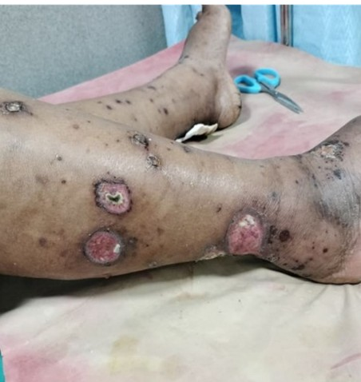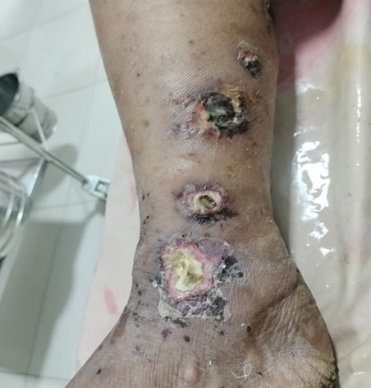
Figure 1&2: Bullous and ulcerative lesions over lower limbs at presentation.
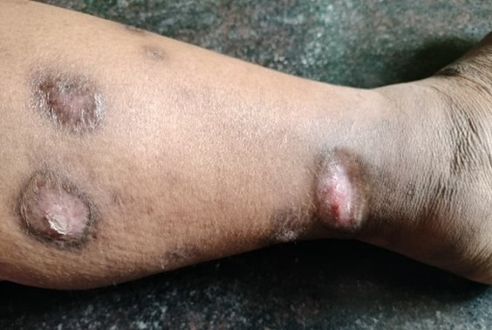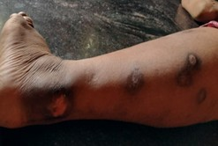
Figure 3&4: Clinical improvement of lesions after three months following discontinuation of vildagliptin.

Figure Legends
Figure 1&2: Bullous and ulcerative lesions over lower limbs at presentation.
Figure 3&4: Clinical improvement of lesions after three months following discontinuation of vildagliptin.

