AN 11-YEAR OLD BOY WITH A RARE COEXISTENCE OF HECK’S DISEASE AND EPIDERMODYSPLASIA VERRUCIFORMIS- A CASE REPORT

ABSTRACT:
Heck's disease is characterized by multiple, asymptomatic, soft papules on the oral mucosa, lips, and occasionally skin, commonly linked to Human papillomavirus HPV-13 and HPV-32. This report describes a case of a boy with coexisting Heck's disease and Epidermodysplasia Verruciformis (EDV), highlighting the clinical and histopathological findings. This study presents the case of an 11-year-old secondary school student who presented with a four-year history of recurrent, progressively generalised hypopigmented skin rashes associated with mild pruritus and photosensitivity. The lesions initially appeared on the neck and later became widespread. Histopathological examination of a skin punch biopsy revealed mild acanthosis, hyperkeratosis, and keratinocytes with blue-grey cytoplasm and perinuclear halos, consistent with EDV. After being lost to follow-up, he returned 13 months later with no clinical improvement. Subsequent management included topical tretinoin and high-SPF sunscreen, along with counseling on disease chronicity and photoprotection. This case highlights the chronic, treatment-resistant nature of EDV and underscores the importance of long-term follow-up, access to therapy, and early specialist involvement in management.
Keywords: Heck's disease, Epidermodysplasia Verruciformis, Skin disorders, Lesions

INTRODUCTION
Heck's disease (focal epithelial hyperplasia) and Epidermodysplasia Verruciformis (EV) are rare human papillomavirus (HPV)-associated skin disorders with distinct clinical and pathological features. The former was conventionally identified and named "Heck’s disease" by Archard, Heck, and Stanley in 1965. They identified it in Inuit and Indian children from North and
South America. However, it has been reported globally ever since. It is characterized by multiple, asymptomatic, soft papules on the oral mucosa, lips, and occasionally skin, commonly linked to HPV-13 and HPV-32 (1). Epidermodysplasia Verruciformis, first reported by Lewandowsky and Lutz in 1922, is a rare genodermatosis associated with susceptibility to cutaneous HPV infections (notably HPV-5 and HPV-8), presenting as widespread, flat, wart-like lesions and associated with a high risk of skin cancer (2,3).
Both conditions are linked to HPV but involve different pathogenetic mechanisms. Heck's disease is typically benign and self-limiting, while EDV has a propensity for malignant transformation. Coexistence of these entities is exceedingly rare, with no prior reports in literature, making it a diagnostically challenging and intriguing presentation. Futhermore, this highlights the need for comprehensive HPV typing and immune evaluation in such patients. This coexistence may very likely indicate an underlying immunocompromised state.
This report describes a case of a boy with coexisting Heck's disease and EDV, highlighting the clinical and histopathological findings.
.CASE REPORT
An 11 year old secondary school student who was referred from the paediatric clinic had complaint of recurrent skin rash of 4 years duration. The rash started from his neck and gradually became generalised. The lesions were pale coloured (hypopigmented). They were occasionally itchy and most times photosensitive. About the same time he noticed a growth on his lips which was fleshed coloured. The lesions began to increase in size and number. They were non tender but the appearance is discomforting to the patient. He had used Betriol N (Betamethasone/Calcipotriol combination cream) and Vaseline petroleum jelly but symptoms persisted.
A diagnosis of Heck’s disease (Focal epithelial hyperplasia and epidermodysplasia verruciformis (EDV) was made clinically. Skin punch biopsy and of the back was done a week later to confirm the diagnosis of EDV. The result of histology showed mild acanthosis and hyperkeratosis. In the epidermis is seen keratinocytes with blue grey cytoplasm and perinuclear halo with some pleomorphism. The dermis is scanty. This finding is in keeping with EDV. Retroviral screen, HbSAg and HCV antibodies were all seronegative.
He was placed on topical imiquimod and caps isotretinoin for a period of 6 weeks after which he was lost to follow up. He was also prescribed Cidofovir for his oral lesions. After 13 months he returned to the clinic alongside his care giver with complaints of not having any improvement in symptoms since commencement of treatment. He was unable to obtain cidofovir. He was placed on topical Tretinoin (Retin-A) cream applied twice daily and also on sun screen with sun protection factor 50 for 6 weeks . The care giver (patient’s father) and patient were counseled on the nature of the disease. The patient’s family was to relocate to another state with caregiver hence he was referred to a paediatric dermatologist for further management.

Fig:
A B C
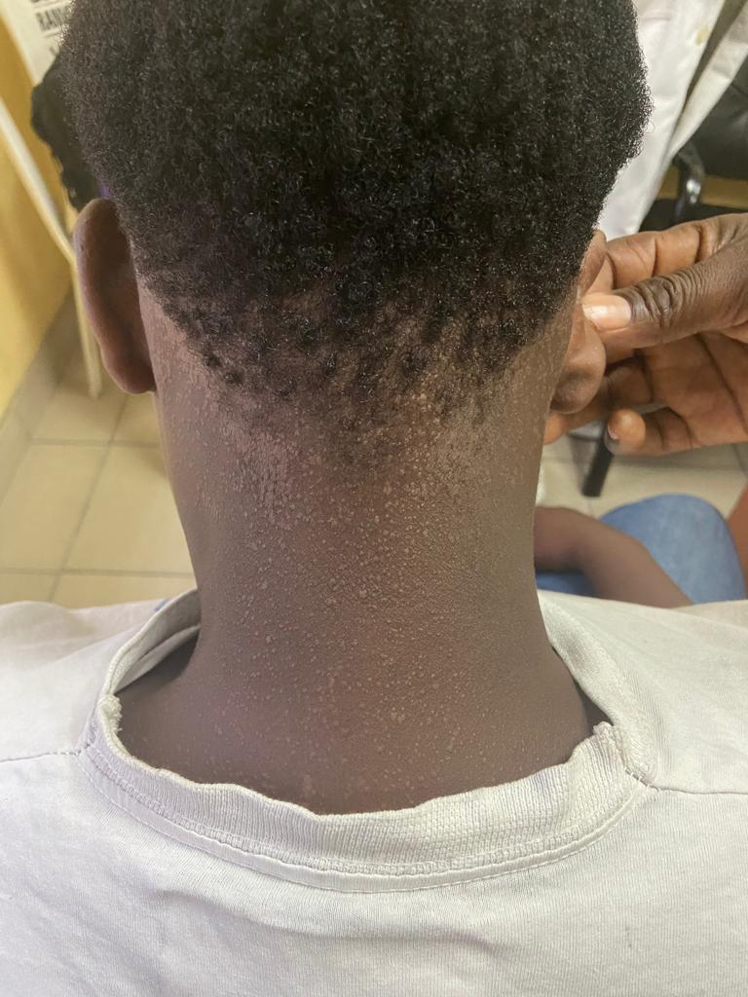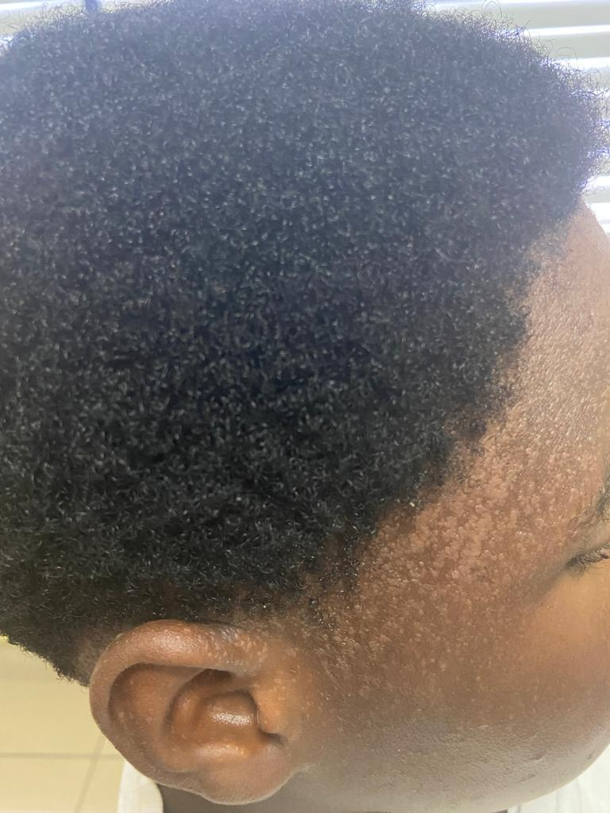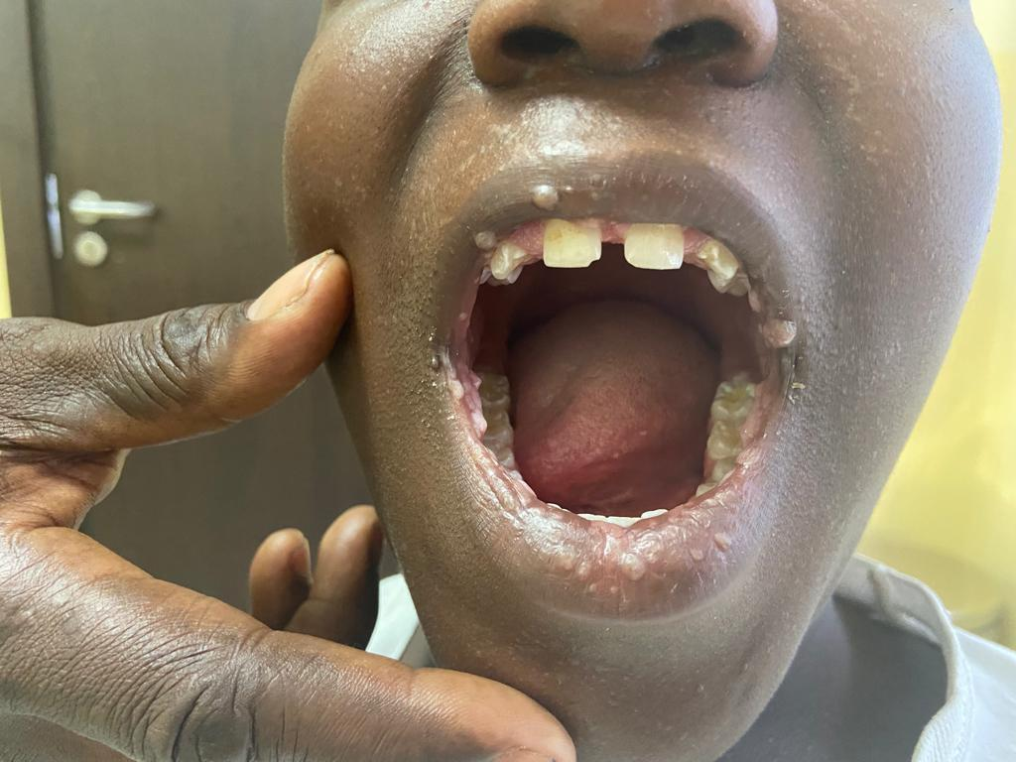
A & B-Epermodysplasia Verruciformis (hypopigmented flat scaly papules seen at the base of the neck and frontal lines)
C-Heck’s disease(Focal epithelial hyperplasia) flesh coloured papules on the lips.
DISCUSSION:
The coexistence of Epidermodysplasia Verruciformis (EDV) and Heck's disease (focal epithelial hyperplasia) in an 11-year-old male presents a unique clinical scenario, highlighting the complexities of managing HPV-related skin disorders. EDV is a rare genodermatosis characterized by susceptibility to cutaneous HPV infections, notably HPV-5 and HPV-8, leading to widespread, persistent, wart-like lesions and a high risk of skin cancer (4,5). Heck's disease, associated with HPV-13 and HPV-32, typically manifests as benign, multifocal papules on the oral mucosa and lips.(6)
Epidermodysplasia verruciformis is usually inherited as an autosomal recessive disease; (7) However, sporadic, sex-linked, and autosomal dominant inheritance have been described. In the cases of autosomal recessive inheritance, a history of consanguinity in the parents of the afflicted individual may be apparent. For those with atypical inheritance, there may be a possible association with chronic lymphopenias. Whatsoever of the mode of inheritance of the disease may be, the phenotype of the disease is characterized by a predisposition to and chronic infection with multiple types of HPV. Affected patients develop a generalised cutaneous eruptions of flat-to-papillomatous, wartlike lesions and reddish-brown pigmented plaques on the trunk, the hands, the upper and lower extremities, as well as the face.
Lesions in sun-exposed areas may develop into cancer (squamous cell carcinoma) after many years of sun exposure. This authenticates the synergistic effect of ultraviolet light and HPV infection in the development of skin cancer. Strict sun avoidance and protection, which should start as soon as the patient is diagnosed with EV is critical to prevent this lethal complication. made.
The patient's lesions, noticed four years prior to presentation, demonstrate the chronic nature of these conditions. The lack of response to topical imiquimod and isotretinoin underscores the challenge in treating EDV and coexisting HPV-related lesions. Imiquimod, an immune modulator, is often used for treating warts and skin cancers but may be less effective in EDV patients with inherent immune susceptibility [8,9]. Isotretinoin's failure suggests the need for alternative approaches, as seen in other reports where retinoids had variable success [10,11].

The patient's HIV seronegativity is notable, as EDV is often associated with genetic defects in EVER1/EVER2 genes affecting cellular immunity, rather than acquired immunosuppression like HIV. The coexistence of EDV and Heck's disease, though rare, may indicate a broader susceptibility to HPV infections, warranting close monitoring for skin cancer and consideration of genetic counseling.

Management of EDV often involves sun protection, regular skin checks, and treatments like cryotherapy, topical therapies, or systemic retinoids. Topical imiquimod, calcipotriol, and squaric acid dibutyl ester, vitamin D3, and fluorouracil are effective in individual cases. (12)
Heck’s disease (Focal epithelial hyperplasia) is a relatively benign condition of despite its viral aetiology , and in many patients, will spontaneously resolve on its owns; however ,this may take several months or even years(13). In contrast to EV, it has no malignant potential(14). It primarily occurs in `children with no gender predilection.
The diagnosis of Heck’s disease is mostly clinical. However, if in doubt, the lesion can be biopsied and subjected to a histopathological examination. This will reveal local epithelial hyperplasia, acanthosis and elongated ‘Bronze Age axe’ rete ridges, together with a ballooning type of nuclear degeneration. Koilocyte changes and mitosoid bodies are present in the superficial keratinocytes.(15).
This disease is a an asymptomatic condition that needs no treatment. However, the patient may require treatment in cases of functional impairment such as lesions that are prone to repeated bites or trauma or for aesthetic reasons. Heck's disease may regress spontaneously or require surgical removal for cosmetic or functional reasons . Treatment modalities range from benign neglect to an array of several invasive and non-invasive therapies. These include surgical excision, laser ablation, cryotherapy, electrocauterization, interferon, retinoic and CO2 laser surgery. Topical imiquimod is also an effective alternative therapy.(16)
Topical therapy with Cidofovir is also effective; however, failure of the patient to obtain this drug due to non-availability, highlights the problem of scarcity of essential and life-saving therapies in developing countries like ours.

CONCLUSION
This case highlights the diagnostic and therapeutic challenges of coexisting EDV and Heck's disease in a pediatric patient. The lack of response to standard treatments emphasizes the need for individualized, often multidisciplinary approaches. Long-term follow-up is crucial for skin cancer surveillance and managing potential complications. Genetic evaluation and counseling may be warranted given the rarity and implications of EDV. This coexistence of 2 rare cutaneous diseases is an exceptional phenomenon that requires further research into HPV related skin conditions.

Disclaimer (Artificial intelligence)

Author(s) hereby declare that NO generative AI technologies such as Large Language Models (ChatGPT, COPILOT, etc.) and text-to-image generators have been used during the writing or editing of this manuscript.

REFERENCES:
- Archard HO, Heck JW, Stanley HR. Focal epithelial hyperplasia: an unusual mucosal lesion found in Indian children. Oral Surg. 1965; 20:201–212.
2.) Lewandowsky F, Lutz W. Ein Fall einer bisher nicht beschriebenen Hauterkrankungn (Epidermodysplasia verruciformis) Arch Dermatol Syphilol. 1922;12:306–16.
3.) LutznerMA. Epidermodysplasia verruciformis. An autosomal recessive disease characterized by viral warts and skin cancer a model for viral oncogenesis. Bull Cancer. (1978) 65:169–82.
4) Patel T, Morrison LK, Rady P, Tyring S. Epidermodysplasia verruciformis and susceptibility to HPV. Dis Markers. 2010. 29(3-4):199-206..
5) Toyoda H, Ido M, Nakanishi K, Nakano T, Kamiya H, Matsumine A, et al. Multiple cutaneous squamous cell carcinomas in a patient with interferon gamma receptor 2 (IFN gamma R2) deficiency. J Med Genet. 2010 Sep. 47(9):631-4.
6) Henke RP, Guerin-Reverchon I, Milde-Langosch K, et al.
In situ detection of human papillomavirus types 13 and 32
in focal epithelial hyperplasia of the oral mucosa. J Oral
Pathol Med. 1989;18:419-421.
7) Yoshida R, Kato T, Kawase M, Honda M, Mitsuishi T. Two sisters reveal autosomal recessive inheritance of epidermodysplasia verruciformis: a case report. BMC Dermatol. 2014 Jul 21. 14(1):12
8) Janssen, K., Lucker, G.P.H., Houwing, R.H. and Van Rijssel, R. (2007), Epidermodysplasia verruciformis: unsuccessful therapeutic approach with imiquimod. International Journal of Dermatology, 46: 45-47.
9) Kim C, Hashemi P, Caglia M, Shulman K. Treatment of Imiquimod Resistant Epidermodysplasia Verruciformis With Ingenol Mebutate. J Drugs Dermatol. 2016 Mar;15(3):350-2. PMID: 26954321.

10) Anadolu R, Oskay T,Cenghizan E,Ayse B,Erdink T, Erbak G. Treatment of epidermodysplasia verruciformis with a combination of acitretin and interferon alfa-2a. _J Am Acad Dermatol_. 2001;45(2):296-299.
11) Bhat YJ, Ashraf S, Hassan I. Epidermodysplasia verruciformis in two siblings responding to retinoids. Indian J Paediatr Dermatol 2016;17:322–4.
12) Heratizadeh AA, Völker BB, Kupsch EE, et al. Successful symptomatic treatment of epidermodysplasia verrucifor mis with imiquimod 5% cream. Hautarzt. 2010;61(12):1052 1055.
13) Summersgill KF, Smith EM, Levy BT, et al. Human papillomavirus in the oral cavities of children and adolescents. Oral Surg Oral Med Oral Pathol Oral Radiol Endod. Jan 2001;91(1):62-69
14) Bennett LK, Hinshaw M. Heck's disease: diagnosis and susceptibility. Pediatr Dermatol. 2009 Jan-Feb;26(1):87-89.

15) González LV, Gaviria AM, Sanclemente G, Rady P, Tyring SK, Carlos R, Correa LA, Sanchez GI. Clinical, histopathological and virological findings in patients with focal epithelial hyperplasia from Colombia. Int J Dermatol. 2005 Apr;44(4):274-279.
16) Barikbin B, Tehranchinia Z, Mozafari N. Treatment of multifocal epithelial hyperplasia with imiquimod. Indian J Dermatol Venereol Leprol 2014;80:175-177

