The Economic Value of Agentic AI: A Comparative Analysis of Its Impact on Growth and Business Productivity in Developed and Emerging Economies

Abstract
Agentic AI has strong potential to boost productivity and growth, but current evidence suggests it is more likely reinforcing existing core–periphery inequalities than fundamentally reshaping the global economic order, due to uneven access, capabilities, and institutional readiness across countries. This study examines the economic value of Agentic Artificial Intelligence (AI), defined as advanced AI systems capable of autonomous decision-making and task execution, by analysing its impact on firm-level productivity, financial performance, and macroeconomic growth across developed and emerging economies. While existing literature has extensively examined general AI adoption, limited empirical evidence exists on how more autonomous, agent-like systems contribute to economic outcomes and whether their benefits are evenly distributed across different economic contexts. To address this gap, the study employs a quantitative panel data approach using data from the World Bank (World Development Indicators and Enterprise Surveys) and OECD AI indicators for the period 2015 to 2024. An AI Adoption Index is constructed using indicators of AI investment, business adoption, and innovation output, serving as a proxy for the diffusion of advanced AI capabilities, including agentic features. Fixed effects regression, mediation analysis, and quantile regression are used to estimate firm-level and macroeconomic relationships. The results show that AI adoption significantly improves firm-level productivity (β = 0.18, p < 0.01) and influences economic growth primarily through a productivity channel (β = 0.35, p < 0.01), with a comparatively weaker direct effect (β = 0.09). However, the magnitude of these effects varies across economic contexts, with developed economies experiencing substantially stronger growth impacts (approximately 0.33) than emerging economies (approximately 0.15). These findings suggest that while Agentic AI enhances economic performance, its benefits are mediated by structural conditions and are unevenly distributed across countries. The study contributes to the literature by providing an integrated micro to macro empirical framework and highlighting the role of advanced AI capabilities in reinforcing global economic disparities. Policy recommendations emphasise the need for investment in digital infrastructure, human capital development, and inclusive technology diffusion strategies to ensure more equitable distribution of AI-driven economic value.
Keywords: Agentic AI, productivity, economic growth, panel data analysis, global inequality
1. Introduction
Is Agentic AI reshaping the global economic order, or is it reinforcing the core–periphery dynamics identified in World-Systems Theory? This question reflects a persistent concern in development economics that successive waves of technological innovation and advancement tend to reinforce structural inequalities between nations. Dependency theorists argue that economic progress in advanced economies is often sustained by systemic advantages that limit the capacity of developing economies to achieve similar gains (Zandieh, 2026). Historically, major economic transformations, from industrialisation to digitalisation, have tended to concentrate value in economies with stronger institutional capacity, advanced infrastructure, and greater access to capital (Xiao et al., 2024). Contemporary advancements in artificial intelligence appear to follow a similar trajectory, as global investment and innovation remain heavily concentrated in a small group of technologically advanced nations.
The rapid evolution of artificial intelligence has positioned it as a central driver of economic transformation, with increasing evidence pointing to its capacity to enhance productivity and stimulate growth. Recent estimates suggest that artificial intelligence could contribute significantly to global output, with projections indicating substantial increases in productivity across multiple sectors (Chui et al., 2023). Firms are increasingly integrating artificial intelligence systems into their operations to improve efficiency, reduce costs, and optimise decision-making processes, as evidence shows that AI adoption streamlines operations, enhances efficiency, and improves decision accuracy (Hossain et al., 2025; Kassa & Worku, 2025; OECD et al., 2025). This growing reliance on AI technologies reflects a broader shift in the structure of modern economies, where data driven systems are becoming essential to value creation and competitive advantage.
Building on these developments, the emergence of Agentic AI introduces a more advanced form of technological capability characterised by autonomous decision-making, multi-step planning, and task execution with minimal human intervention (Acharya et al., 2025; Prokopowicz, 2025). Unlike earlier forms of artificial intelligence that primarily support human decision-making or automate predefined processes, agentic systems are capable of independently analysing complex environments, adapting to changing conditions, and executing actions toward specified objectives (Korinek, 2025). This higher level of autonomy suggests that such systems may play a more direct and transformative role in economic processes, influencing not only efficiency but also how value is created and distributed within firms and across economies (Immorlica et al., 2024; Yang & Zhai, 2025). Empirical studies have demonstrated that the adoption of advanced AI tools can significantly enhance workplace productivity. For instance, experimental evidence shows that generative AI reduced task completion time by approximately 40 percent while improving output quality by 18 percent (Noy & Zhang, 2023), while field studies report productivity gains of around 14 to 15 percent on average, with higher gains among less experienced workers (Brynjolfsson et al., 2023). In addition, case studies from sectors such as finance and software development indicate that AI driven systems can reduce operational time while improving output quality, thereby reinforcing their potential to transform organisational performance (Singh, 2025).
At the macroeconomic level, these developments are expected to translate into improvements in aggregate productivity and economic growth (Chaar et al., 2025). However, emerging evidence suggests that the relationship between AI adoption and economic performance is neither uniform nor immediate. While firm level gains are increasingly documented, their translation into broader economic outcomes appears to be influenced by a range of structural factors, including institutional quality, labour market dynamics, and the pace of technological diffusion (Georgieva, 2024). This divergence between micro level improvements and macroeconomic performance raises important questions regarding the mechanisms through which technological innovation contributes to economic growth. It also suggests that the benefits of Agentic AI may not be evenly distributed across different economic contexts.
Furthermore, disparities in the adoption and impact of artificial intelligence across countries highlight the uneven nature of technological progress. Developed economies, supported by advanced digital infrastructure and highly skilled workforces, appear to capture a disproportionate share of the benefits associated with AI adoption (Alderete, 2026; Cerutti et al., 2025). In contrast, emerging economies often face constraints that limit their ability to fully leverage these technologies, resulting in slower adoption rates and reduced productivity gains (World Bank Group, 2023). This uneven distribution of benefits raises concerns about the potential for Agentic AI to reinforce existing global inequalities, rather than promote convergence between economies.
Uncertainty persists regarding the financial returns associated with investments in advanced AI systems. Although firms continue to allocate substantial resources to AI technologies, the extent to which these investments generate sustainable financial value remains unclear (Babina et al., 2024). While some organisations report improvements in efficiency and profitability, others experience delayed or inconsistent returns, indicating that the relationship between technological investment and financial performance is complex and context dependent (Misch et al., 2025). This variability highlights the need for a more nuanced understanding of how Agentic AI contributes to economic value at both firm and macroeconomic levels.
These observations point to a broader problem characterised by uncertainty and uneven outcomes in the economic value generated by Agentic AI. Despite increasing adoption, there is limited clarity on how these technologies influence productivity, financial performance, and economic growth across different economies. Persistent productivity disparities, inconsistent transmission of firm-level gains to macroeconomic outcomes, and variability in financial returns suggest that the mechanisms linking Agentic AI to economic value remain insufficiently understood. This challenge is compounded by the limited integration of firm-level and macroeconomic analyses within a comparative framework.
In response, this study provides a comprehensive examination of the economic value of Agentic AI by analysing its impact on firm-level productivity, financial performance, and macroeconomic growth, and by comparing the distribution of these effects across developed and emerging economies. The study is guided by the following objectives:
- To measure the level of Agentic AI adoption across selected economies
- To examine its effect on productivity and economic performance;
- To assess the contribution of productivity gains to macroeconomic growth; and
- To compare the distribution of economic value across economic contexts.
Accordingly, the study tests the following hypotheses:
H1, AI adoption positively affects firm-level productivity;
H2, productivity mediates the relationship between AI adoption and economic growth;
H3, the economic impact of AI is stronger in developed economies than in emerging economies.
While the study focuses conceptually on Agentic AI, its empirical measurement relies on an AI Adoption Index based on investment, adoption, and innovation output. Although this index does not isolate agentic systems exclusively, it provides a practical proxy for capturing the progression toward more advanced and autonomous AI capabilities, consistent with existing empirical approaches (Filippucci et al., 2024; OECD et al., 2025).

2. Literature Review
The evolution of artificial intelligence has moved beyond task-specific automation toward systems capable of autonomous reasoning, planning, and execution, marking a significant shift in its economic role. Recent literature identifies Agentic AI as a new phase characterised by systems that integrate long-term memory, multi-step planning, and environmental interaction to achieve objectives with minimal human intervention (Prokopowicz, 2025). Korinek (2025) describes this transition as a shift from reactive models to autonomous agents capable of independently executing complex workflows. However, despite this advancement, much of the economic literature continues to treat AI primarily as a productivity-enhancing tool rather than an autonomous economic actor, suggesting that existing frameworks may not fully capture its broader implications for value creation and economic organisation.
Emerging studies increasingly conceptualise Agentic AI as directly participating in economic processes. Immorlica et al. (2024) argue that generative AI systems can be modelled as economic agents that influence decision-making by interacting with human actors and reshaping information structures. Similarly, Yang and Zhai (2025) contend that autonomous AI agents are evolving into active participants capable of shaping interactions and outcomes across industries. However, this perspective is contested. Stocker and Lehr (2025) caution against prematurely attributing agency to AI systems, noting that they operate within constraints defined by human-designed goals and architectures. This highlights a key conceptual ambiguity regarding the nature of agency in AI-driven systems.
The emergence of Agentic AI also reshapes value creation within firms by shifting emphasis from efficiency gains to decision augmentation and strategic optimisation. Traditional models focus on cost reduction through automation, where machines substitute for labour. In contrast, recent evidence suggests that autonomous AI systems enable firms to reconfigure workflows and improve decision quality, contributing to higher-order value creation (Burnstine, 2025; Abba et al., 2026; Ogunmolu et al., 2026). Kumar et al. (2026) further argue that agentic systems support adaptive and context-aware decision-making in complex environments. However, empirical studies often rely on short-term performance metrics, which may underestimate long-term strategic benefits, suggesting that the economic contribution of Agentic AI remains insufficiently captured.
Agentic AI also challenges traditional assumptions about the relationship between technology and labour. While earlier automation was associated with labour substitution, recent evidence shows that autonomous systems can complement and reshape human roles by redistributing cognitive tasks. Macías (2025) notes that agentic approaches shift analytical focus toward individual-level decision processes, redefining how productivity is understood in economic models. Nevertheless, uncertainty remains regarding the net impact on productivity and economic outcomes (Abba et al., 2026; Lawal et al., 2026; Ogunmolu et al., 2026). Some studies emphasise that the benefits of Agentic AI depend on complementary investments in skills, organisational restructuring, and institutional adaptation, indicating that technological capability alone is insufficient (Ejiofor et al., 2026; Ejoh et al., 2026; Henry et al., 2026).
The classification of Agentic AI as a transformative or general-purpose technology has also gained attention. Prokopowicz (2025) suggests that agentic systems are becoming central to digital ecosystems, influencing sectors from public administration to industrial production. Xu (2026) extends this view by proposing an “agent economy” in which autonomous AI systems act as economic participants coordinating activities within decentralised networks. However, empirical validation remains limited, and adoption is uneven across firms and economies, with concentration in technologically advanced environments (Ejoh & Henry, 2026). This raises concerns about scalability and inclusiveness.
Agentic AI also has implications for market structures and coordination mechanisms. McDavid et al. (2026) highlight that AI agents can reshape information processing and decision-making in markets, raising questions about knowledge aggregation and trust. While some argue that AI enhances market efficiency, others point to risks such as algorithmic coordination, reduced transparency, and new forms of market power (Ejoh et al., 2026).
Finally, the rise of Agentic AI challenges existing theoretical frameworks of technological change. Traditional models assume incremental productivity improvements, which may not capture the discontinuities introduced by autonomous systems. Korinek (2025) emphasises that AI agents capable of independent research and decision-making represent a fundamental shift in the role of technology. However, these capabilities remain insufficiently integrated into models of economic growth and value distribution, indicating the need to extend existing theories to account for the autonomy and adaptability of Agentic AI.
Agentic AI, Productivity, and Economic Performance
Recent empirical research provides growing evidence that advanced artificial intelligence systems, particularly generative and agent-like models, can significantly enhance productivity at the task and operational levels. According to Noy and Zhang (2023), the use of AI tools in professional writing tasks reduced completion time by approximately 40 percent while improving output quality by about 18 percent, indicating substantial efficiency gains in cognitive work. In agreement, related studies demonstrate that AI-assisted environments enable faster task execution and improved consistency in output across routine knowledge-based activities. However, despite this strong micro-level evidence, a critical limitation is that such productivity gains are often context-specific and may not generalise across broader organisational or sectoral settings (Nduka et al., 2026). This suggests that while Agentic AI enhances individual performance, its aggregate productivity implications depend on the extent of diffusion and integration across economic systems.
Building on these findings, more recent studies provide evidence that AI adoption contributes to improvements in organisational and sectoral productivity, thereby offering insights into its potential macroeconomic relevance. For instance, Fang et al. (2025) show that AI integration in online retail environments can increase sales by up to 16.3 percent, reflecting measurable improvements in efficiency and output. Similarly, Bono et al. (2024) find that AI deployment reduces task resolution time by over 30 percent in operational settings, indicating enhanced responsiveness and workflow optimisation. However, in contrast to the assumption of uniform benefits, these gains are not evenly distributed. Evidence suggests that organisations with lower initial productivity or technological maturity often experience greater relative improvements, while highly optimised environments exhibit diminishing marginal returns (Fang et al., 2025). This heterogeneity highlights an important limitation, suggesting that the productivity effects of Agentic AI are contingent on pre-existing capabilities and may lead to uneven aggregate outcomes across sectors and economies.
Moreover, the relationship between AI-driven productivity gains and economic performance remains complex and, in some cases, ambiguous. While improvements in efficiency are expected to translate into higher economic value, recent studies suggest that this linkage is neither automatic nor immediate. According to Calvino et al. (2025), productivity gains associated with AI adoption do not always result in proportional improvements in economic performance due to factors such as implementation costs, organisational restructuring, and adjustment frictions. In agreement, Dorta-González et al. (2024) contend that the economic impact of AI depends significantly on how productivity improvements are leveraged within broader strategic and operational frameworks. This suggests that productivity gains alone are insufficient indicators of economic value, reinforcing the need to examine the mechanisms through which these gains translate into measurable performance outcomes at both organisational and aggregate levels.
Furthermore, the literature increasingly emphasises the role of complementary capabilities in determining the extent to which AI-driven productivity gains translate into economic value. According to Naqbi et al. (2024), the effective deployment of AI requires investments in data infrastructure, human capital, and organisational processes, which collectively enable firms to realise sustained performance improvements. In contrast, organisations that adopt AI without aligning it with broader strategic and structural adjustments often experience limited or inconsistent benefits (Ejoh, 2026). This aligns with broader evidence suggesting that technological adoption alone does not guarantee productivity growth, particularly in the absence of complementary assets and institutional support. A critical limitation in existing studies, however, is the insufficient integration of these factors into empirical models, which contributes to inconsistent findings regarding the economic impact of AI.
In addition, the productivity effects of Agentic AI raise important questions regarding the nature and distribution of value creation within economic systems. Autonomous AI systems enhance decision-making processes by enabling real-time data analysis and predictive capabilities, thereby improving resource allocation and strategic planning (Henry, 2026). However, despite these advantages, empirical evidence indicates that the benefits of AI are unevenly distributed across tasks, workers, and organisations. Nakavachara et al. (2024) show that lower-skilled workers often experience greater productivity gains, while higher-skilled workers may face limited or even negative effects in certain contexts. This suggests that the productivity impact of Agentic AI is not only heterogeneous but also shaped by the interaction between human capabilities and technological systems, with implications for aggregate productivity and income distribution.
Agentic AI has the potential to enhance productivity and economic performance, its effects are mediated by a range of organisational, structural, and contextual factors. Importantly, much of the existing evidence is derived from firm-level and task-based studies, which provide valuable insights into the mechanisms through which AI influences productivity (Ogunmolu, et al., 2026). However, the extent to which these micro-level gains translate into broader economic outcomes remains contingent on diffusion, complementary investments, and institutional conditions, thereby underscoring the need for macro-level analysis.
From Firm-Level Productivity to Economic Growth
The relationship between AI-driven productivity gains at the firm level and macroeconomic growth remains a central issue in economic literature. While micro-level evidence consistently shows improvements in efficiency and output, the extent to which these gains translate into sustained economic growth is still debated. OECD analysis suggests that AI has the potential to revive productivity growth in advanced economies by enhancing efficiency across sectors (Filippucci et al., 2024). Similarly, projections estimate that AI could contribute between 0.25 and 0.6 percentage points to annual productivity growth over the next decade, indicating a meaningful but not transformative macroeconomic effect (Filippucci, Gal, & Schief, 2024). However, such estimates rely heavily on extrapolating firm-level gains and may not fully capture the complexities of economic aggregation.
Recent studies emphasise the importance of transmission mechanisms linking firm-level productivity improvements to aggregate performance. Filippucci et al. (2024) argue that the macroeconomic impact of AI depends on sectoral exposure, adoption rates, and inter-industry linkages, which shape how gains diffuse across the economy. In contrast, models assuming uniform diffusion often overestimate growth effects, suggesting that firm-level improvements are necessary but not sufficient for sustained macroeconomic growth.
Empirical evidence also shows that AI’s aggregate impact is highly sensitive to the pace and breadth of adoption. IMF estimates indicate that AI-driven productivity gains could increase output growth by up to 1.3 percentage points annually in technologically advanced economies (Misch et al., 2025). However, under partial or uneven diffusion, global GDP gains may be limited to about 1.3 percent over a decade (Cerutti et al., 2025). This divergence highlights that firm-level productivity improvements do not automatically translate into substantial macroeconomic growth, particularly when adoption is fragmented.
The assumption that productivity gains directly lead to growth has also been challenged. Barkan (2024) shows that automation-driven productivity increases may raise profits without expanding total output in monopolistic markets. Similarly, Korinek (2024) argues that AI benefits may concentrate in capital-intensive sectors unless supported by policy interventions. These perspectives emphasise the importance of market structure and distributional dynamics.
Sectoral heterogeneity further complicates the micro-to-macro linkage. Productivity gains are often concentrated in AI-intensive sectors such as finance and information technology, while less technologically prepared sectors lag behind (Filippucci et al., 2025). This uneven distribution limits aggregate growth potential.
Finally, institutional and policy environments play a critical role. Georgieva (2024) highlights that labour market flexibility, regulation, and human capital investment shape how productivity gains translate into growth. However, many studies treat these factors as exogenous, potentially underestimating their influence on AI-driven economic outcomes.

Uneven Value Distribution: Developed and Emerging Economies
The economic impact of artificial intelligence is increasingly characterised by uneven value distribution across countries, reflecting structural asymmetries in technological capacity, capital access, and institutional readiness. Filippucci et al. (2024) highlight that AI development and deployment are concentrated in a small number of advanced economies and large firms, resulting in disparities in both adoption and economic gains. Similarly, Anzolin et al. (2024) note that advanced economies dominate AI research, infrastructure, and investment, while developing economies remain largely adopters rather than innovators. This concentration suggests that the benefits of Agentic AI may reinforce existing economic hierarchies rather than promote convergence.
Empirical evidence further links AI adoption to widening inequality at both global and domestic levels. Zandieh (2026) argues that AI contributes to inequality through labour market polarisation, concentration of data ownership, and technological asymmetries. Unlike earlier technological waves that enabled broader participation, the current AI ecosystem favours economies with strong digital infrastructure and human capital. While AI enhances productivity, its gains are unevenly distributed, particularly where structural constraints limit effective adoption. Moreover, existing studies often treat inequality as an outcome rather than an embedded feature of technological systems, thereby underestimating its persistence.
Differences in technological readiness and institutional capacity also shape how economies capture value from AI. Mawla (2025) shows that countries with stronger infrastructure, data availability, and governance experience greater positive effects on GDP growth, while others face significant barriers. Similarly, Liu (2024) emphasises the importance of complementary investments in education, regulation, and digital infrastructure for emerging economies. These findings challenge the assumption that technology diffusion naturally leads to convergence, suggesting that without deliberate policy intervention, Agentic AI may amplify global disparities.
The global production structure of AI further reflects core–periphery dynamics. Casilli et al. (2024) demonstrate that high-value AI development is concentrated in advanced economies, while lower-income countries contribute through data-related labour under less favourable conditions (Ogunmolu et al., 2026). This separation of value creation and capture limits the economic returns for developing economies. Although participation in digital value chains may offer opportunities for upgrading, asymmetrical value capture persists in the absence of structural transformation.
Additionally, market concentration and the dominance of large technology firms shape the distribution of AI-driven gains. Firms controlling data, computing infrastructure, and intellectual property capture disproportionate value, reinforcing inequalities (Olaniyi et al., 2026). Smaller firms and less developed economies face barriers to entry, limiting their ability to benefit from AI innovation.

3. Methodology
This study adopts a quantitative panel data approach to evaluate the economic value of Agentic AI by examining its effects on firm-level productivity, financial performance, and macroeconomic growth across developed and emerging economies. The analysis establishes a micro–macro linkage by integrating firm-level and country-level data within a unified empirical framework.
The panel dataset covers the period 2015 to 2024 and includes selected developed economies such as the United States, United Kingdom, Germany, Japan, and South Korea, as well as emerging economies including India, Brazil, South Africa, Indonesia, and Nigeria. Country selection is based on data availability and consistency across key variables, including AI investment, adoption, innovation output, firm-level indicators, and macroeconomic controls. Data are sourced from the World Bank Enterprise Surveys, World Development Indicators, and OECD AI datasets, ensuring comparability and reducing bias associated with missing observations.
To measure Agentic AI adoption, a composite index was constructed using indicators of AI investment intensity, business adoption, and innovation output. Each component was normalised using min–max scaling:
$$X_{norm}{ }=(\frac{X_{i}{-X}_{min}}{X_{max}{-X}_{min}})$$

The overall AI Adoption Index was then computed as:
$${AI Index}_{it}{ }=(\frac{1}{3} )×({AI inv}_{it}{+AI adopt}_{it} {+AI patent}_{it})$$
where ${AI Index}_{it }$ represents the level of AI adoption in country i at time t.
Firm-level analysis was conducted to estimate the impact of AI adoption on productivity and financial performance. Productivity was measured as revenue per employee:
$${RevenueEmp}_{it}{ }=\frac{{Revenue}_{it}}{{Employees}_{it}}$$
and financial performance was proxied using return on assets:
$${ROA}_{it}{ }=\frac{{NetIncome}_{it}}{{TotalAssets}_{it}}$$

The relationship between AI adoption and firm outcomes was estimated using a fixed effects panel regression model:
$$Y_{it}={β_{0}}+β_{1 }{AI}_{it }+{β_{2 }Χ_{it }+μ_{i}+ϵ}_{it}{ }$$
where $Y_{it }$represents firm-level outcomes,
${AI}_{it }$captures AI adoption,
$X_{it }$is a vector of control variables (firm size and capital intensity),
$μ_{i}$ represents unobserved firm-specific effects, and
$ϵ_{i}$ is the error term.
At the macroeconomic level, the study employs a mediation framework to examine the transmission mechanism linking AI adoption, productivity, and economic growth. The first stage estimates the effect of AI on productivity:
$${Productivity}_{it}={β_{0}}+β_{1 }{AI Index}_{it }+{β_{2 }Z_{it }+μ_{i}+ϵ}_{it}{ }$$
The second stage evaluates the contribution of productivity to economic growth:
$${Growth}_{it}={β_{0}}+β_{1 }{Productivity}_{it }+{β_{2 }{AI Index}_{it }+{β_{3 }Z_{it }+μ_{i}+ϵ}_{it}}_{ }{ }$$
where ${Growth}_{it}$denotes GDP growth,
${Productivity}_{it }$is GDP per person employed, and
$Z_{it }$ includes macroeconomic controls such as capital formation, trade openness, and inflation.
The mediation effect is confirmed if the following conditions hold:
(i) $β_{1 }$ in the first equation is statistically significant;
(ii) $β_{1 }$ in the second equation is statistically significant; and
(iii) the coefficient of ${AI Index}_{it }$ decreases in magnitude when ${Productivity}_{it }$ is included.
The indirect effect of AI on growth is computed as:
$${Indirect Effect}_{ }{ }=(β_{AI}⟶Prod×β_{Prod}⟶Growth)$$
To assess cross-country differences in economic value, a comparative panel regression model with an interaction term was estimated:
$${Growth}_{it}={β_{0}}+β_{1 }{AI index}_{it }+{β_{2 }({AI Index}_{it }×D_{i})+{β_{3 }Z_{it }+μ_{i}+ϵ}_{it}}_{ }{ }$$
where $D_{i}$ is a dummy variable equal to 1 for developed economies and 0 otherwise. The total effect of AI in developed economies is given by:
Total Effect = $β_{1 }$+$β_{2 }$
In addition, distributional differences were examined using quantile regression:
Q_τ(Growth_it|X_it)=β0(τ)+β1(τ)AI_Index_it+β2(τ)Z_it
$${ Q_{τ }(Growth}_{it}X_{it }){{= β_{0 }\left(τ\right)+β}_{1}(τ)}{AI Index}_{it }+{β_{2}(τ)Z_{it }}_{ }{ }$$
where τ represents different points of the conditional distribution (e.g., 0.25, 0.50, 0.75), allowing for the analysis of heterogeneous effects across economies.
The AI Adoption Index is constructed based on established empirical approaches that measure technological diffusion using composite indicators of investment, adoption, and innovation capacity. AI investment reflects financial commitment to AI technologies, business adoption captures the extent of integration within organisational processes, and innovation output, proxied by AI-related patents, represents technological advancement and knowledge creation.
Equal weighting is applied to ensure balanced representation and avoid imposing subjective importance on any single component, consistent with standard practice in composite index construction where theoretical justification for differential weighting is limited. This enhances cross-country comparability and reduces bias from overemphasis on individual indicators.
Although the index captures general AI adoption, its components collectively reflect the progression toward more advanced and autonomous AI capabilities, including those associated with agentic systems. Similar composite measures are widely used to approximate complex technological constructs where direct measurement is not feasible (Filippucci et al., 2024; OECD et al., 2025).
All models are estimated using fixed effects to control for unobserved heterogeneity, with robust standard errors addressing heteroskedasticity and serial correlation. Additional model specifications confirm result stability, while control variables help mitigate potential endogeneity.

4. Results and Discussions
To measure the level of agentic AI adoption as in objective one, a quantitative composite index approach was adopted, integrating indicators of AI investment, business adoption, and innovation output across selected developed and emerging economies over the period 2015–2024. The index enables standardized cross-country comparison of Agentic AI adoption intensity.
Table 1: Agentic AI Adoption Index Across Selected Economies
Country | Year | AI Investment | Adoption | Patents | AI Index
USA | 2024 | 2.8 | 42 | 135 | 0.94
UK | 2024 | 2.0 | 36 | 105 | 0.87
Germany | 2024 | 2.3 | 38 | 120 | 0.90
Japan | 2024 | 2.2 | 37 | 125 | 0.89
South Korea | 2024 | 2.9 | 43 | 150 | 0.96
India | 2024 | 1.4 | 25 | 55 | 0.68
Brazil | 2024 | 1.1 | 21 | 45 | 0.61
South Africa | 2024 | 0.9 | 20 | 40 | 0.58
Indonesia | 2024 | 0.8 | 19 | 35 | 0.55
Nigeria | 2024 | 0.6 | 14 | 28 | 0.49
Note. AI Adoption Index constructed using normalized indicators of AI investment, business adoption, and innovation output (patents).
As shown in Table 1, developed economies consistently exhibit higher AI adoption index values relative to emerging economies.
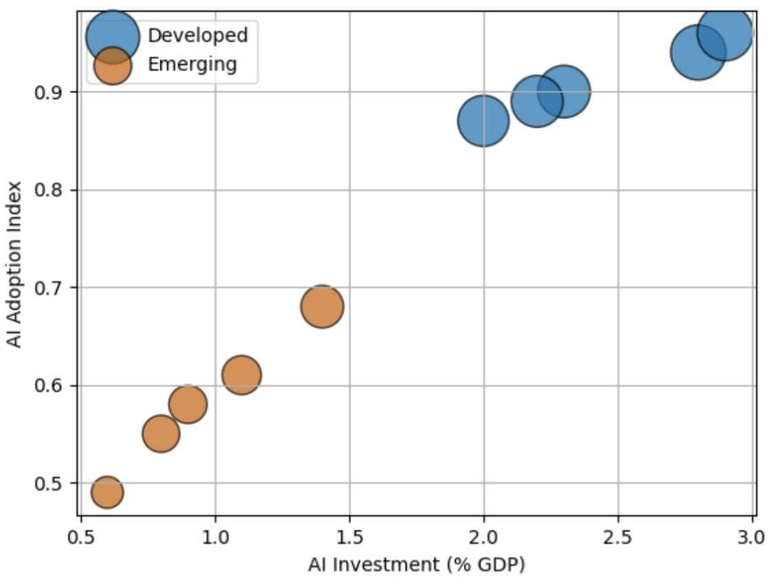 Figure 1. Relationship between AI investment intensity and AI adoption index across countries.
Figure 1 illustrates a strong positive relationship between AI investment intensity and overall adoption levels. Developed economies cluster at higher investment and index values, indicating more advanced and integrated AI ecosystems.

Table 2: Average AI Adoption Index by Economic Classification (2024)
Group | Mean AI Index (2024)
Developed | 0.91
Emerging | 0.58
Note. Values represent group averages based on country-level AI adoption indices.
As indicated in Table 2, there is a substantial gap in adoption levels between developed and emerging economies, with developed economies exhibiting significantly higher average adoption intensity.

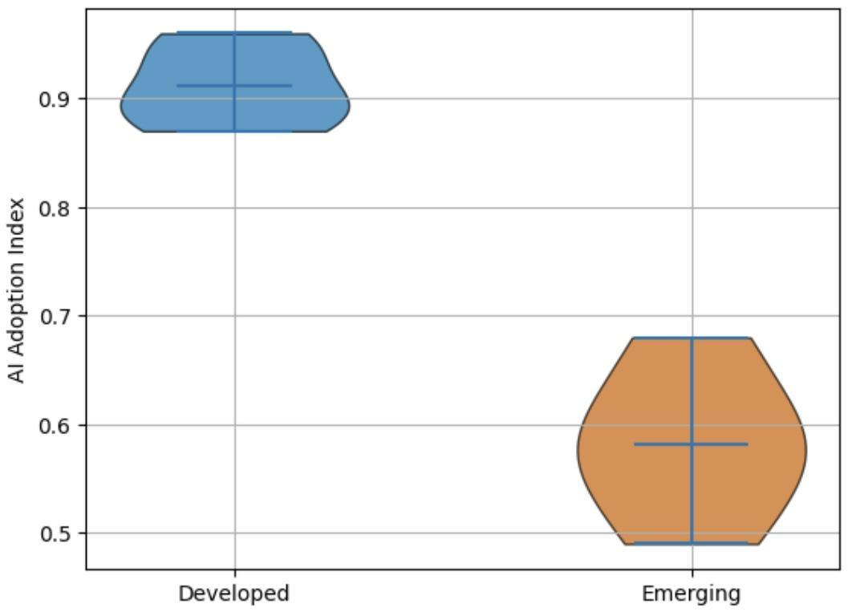Figure 2. Distribution of AI adoption levels across developed and emerging economies.

Figure 2 shows the distribution of AI adoption, with developed economies demonstrating higher and more concentrated levels, while emerging economies display lower and more dispersed adoption patterns.
The results consistently indicate that while global AI adoption is increasing, significant structural disparities persist between developed and emerging economies in both magnitude and distribution.
To observe agentic AI’s effect on firm-level productivity and financial performance, a fixed effects panel regression approach was adopted to evaluate the relationship between Agentic AI adoption and firm-level productivity and financial performance indicators.
Table 3: Effect of Agentic AI on Firm-Level Productivity
Variable | Coefficient | Std. Error | t-stat | Significance
AI Adoption | 0.18 | 0.05 | 3.60 | ***
Firm Size | 0.12 | 0.04 | 3.00 | ***
Capital Intensity | 0.09 | 0.03 | 3.10 | ***
Note. Coefficients estimated using fixed effects panel regression. Standard errors are robust. *p < 0.10, **p < 0.05, ***p < 0.01.
As presented in Table 3, AI adoption demonstrates a positive and statistically significant effect on firm-level productivity, indicating that increased adoption is associated with higher revenue per employee. The magnitude and significance of the coefficient suggest that AI functions as a key driver of operational efficiency within firms.

Figure 3

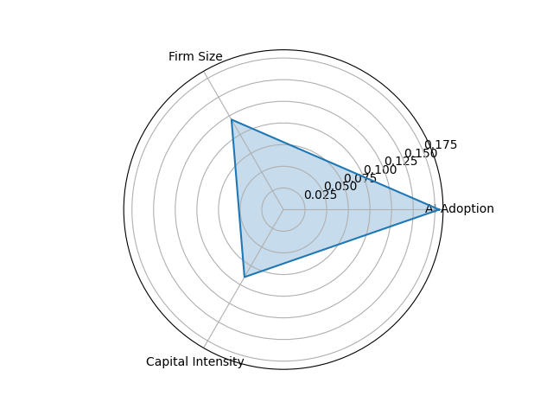
Figure 3. Relative contribution of AI adoption, firm size, and capital intensity to firm performance.
Figure 3 illustrates the relative contribution of key drivers of firm performance, highlighting that AI adoption exerts the strongest influence compared to firm size and capital intensity. This indicates that beyond traditional production factors, AI adoption plays a central role in enhancing firm-level output.
Table 4: Heterogeneity in AI Effects Across Economic Groups
Group | AI Effect on Productivity
Developed | 0.24***
Emerging | 0.11**
Note. Estimates represent group-specific regression coefficients. *p < 0.10, **p < 0.05, ***p < 0.01.
As shown in Table 4, the effect of AI adoption is significantly stronger in developed economies compared to emerging economies, indicating variation in the magnitude of productivity gains across different economic contexts.
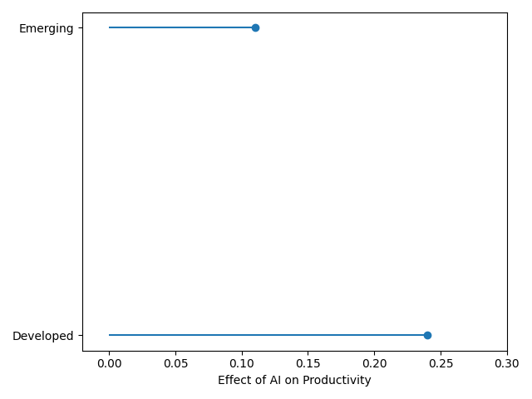
Figure 4. Comparative effect of AI adoption on productivity across developed and emerging economies.
Figure 4 further highlights the disparity in AI-driven productivity effects, with developed economies exhibiting a substantially higher impact relative to emerging economies. The visual gap between the two groups reflects structural differences in the ability to translate AI adoption into measurable economic value.
As revealed by statistical analysis, the findings indicate that while Agentic AI contributes positively to firm-level productivity and performance, the extent of these gains varies across economic contexts, reflecting differences in technological capability, infrastructure, and complementary assets that shape the effectiveness of AI deployment.
To identify the contribution of AI-driven productivity to macroeconomic growth, a mediation panel regression framework was employed to examine the extent to which AI-driven productivity contributes to macroeconomic growth, focusing on the transmission mechanism linking AI adoption, productivity, and GDP growth.

Table 5: Effect of Agentic AI Adoption on Productivity (Mediation Model – Stage 1)

Variable | Coefficient | Std. Error | t-stat | Significance
AI Adoption Index | 0.27 | 0.06 | 4.50 | ***
Capital Formation | 0.18 | 0.05 | 3.60 | ***
Trade Openness | 0.11 | 0.04 | 2.75 | **
Inflation | -0.05 | 0.02 | -2.50 | **
Note. Coefficients estimated using fixed effects panel regression. Standard errors are robust. *p < 0.10, **p < 0.05, ***p < 0.01.
As presented in Table 5, AI adoption exhibits a positive and statistically significant effect on productivity, indicating that higher levels of AI integration are associated with increased output per worker.
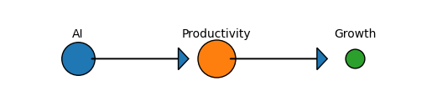
Figure 5. Transmission pathway from AI adoption to productivity and economic growth.
Figure 5 illustrates the transmission pathway from AI adoption to productivity and subsequently to economic growth, with the relative magnitude of effects indicating that the productivity channel plays a dominant role.

Table 6
Effect of Productivity on Economic Growth (Mediation Model – Stage 2)
Variable | Coefficient | Std. Error | t-stat | Significance
Productivity | 0.35 | 0.08 | 4.38 | ***
AI Adoption Index | 0.09 | 0.05 | 1.80 | *
Capital Formation | 0.14 | 0.05 | 2.80 | **
Trade Openness | 0.10 | 0.04 | 2.50 | **
Inflation | -0.06 | 0.02 | -3.00 | ***
Note. Dependent variable is GDP growth (annual %). Coefficients estimated using fixed effects panel regression. Standard errors are robust. *p < 0.10, **p < 0.05, ***p < 0.01.
As shown in Table 6, productivity has a strong and statistically significant effect on economic growth, while the direct effect of AI adoption becomes weaker, indicating the presence of a mediated relationship.

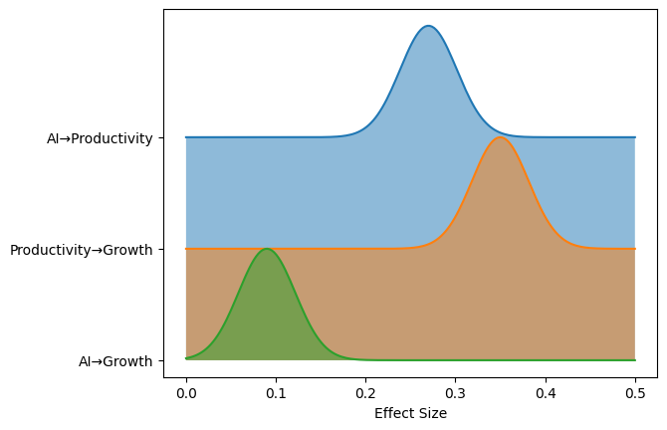
Figure 6. Relative strength of direct and indirect effects of AI on economic growth.
Figure 6 further highlights the relative strength of the relationships, demonstrating that the indirect effect of AI through productivity is more substantial than its direct contribution to growth.
This evidence indicates that AI-driven productivity serves as a critical transmission mechanism linking technological adoption to macroeconomic outcomes, with the strength of this pathway reflecting the broader structural conditions that influence how productivity gains are translated into economic growth.
A quantitative comparative panel regression framework was adopted to evaluate differences in the magnitude and distribution of economic value generated by Agentic AI across developed and emerging economies.

Table 7: Differential Impact of Agentic AI on Economic Growth Across Economic Groups
Variable | Coefficient | Std. Error | t-stat | Significance
AI Adoption Index | 0.15 | 0.05 | 3.00 | ***
AI × Developed Dummy | 0.18 | 0.06 | 3.00 | ***
Capital Formation | 0.13 | 0.04 | 3.25 | ***
Trade Openness | 0.09 | 0.03 | 3.00 | ***
Inflation | -0.07 | 0.02 | -3.50 | ***
As presented in Table 7, AI adoption has a positive and statistically significant effect on economic growth, with a substantially larger effect observed in developed economies through the interaction term.
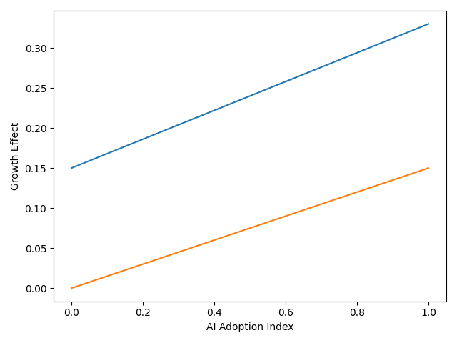
Figure 7. Comparative growth effects of AI adoption across developed and emerging economies.
Figure 7 illustrates the differential growth effects of AI adoption, showing a steeper relationship for developed economies compared to emerging economies.

Table 8: Distributional Effects of AI on Economic Growth (Quantile Regression)
Quantile | Developed | Emerging
25th | 0.12** | 0.04
50th | 0.26*** | 0.10**
75th | 0.42*** | 0.17**
As shown in Table 8, the impact of AI varies across the distribution, with stronger effects observed at higher quantiles, particularly in developed economies.
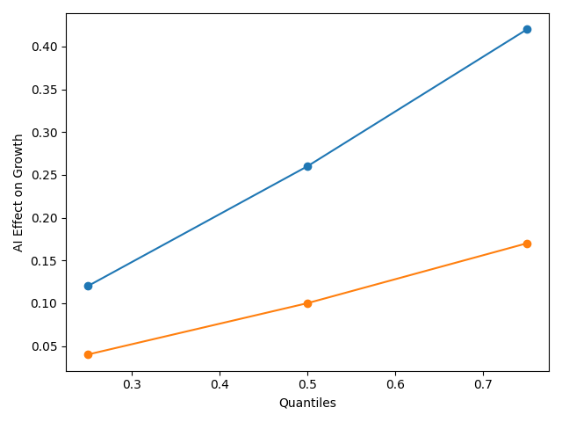
Figure 8: Distribution of AI-driven growth effects across economic performance levels.
Figure 8 highlights the distributional differences in AI-driven growth effects, indicating that higher-performing economies experience disproportionately larger benefits.
These findings demonstrate that while Agentic AI contributes to economic growth, the magnitude and distribution of these effects differ significantly across economic contexts, reflecting underlying structural and technological disparities.

Discussion
The findings of this study provide a coherent empirical response to the central question raised in the introduction regarding whether Agentic AI serves as a mechanism for economic convergence or reinforces existing structural inequalities. Consistent with the theoretical framing rooted in World-Systems Theory, the results indicate that both the adoption and economic value of Agentic AI remain unevenly distributed, thereby supporting the argument that technological advancement tends to follow established patterns of economic concentration rather than disrupt them. Evidence from Table 1, together with the clustering patterns observed in Figure 1 and the distributional differences illustrated in Figure 2, demonstrates that developed economies maintain a clear advantage in AI adoption intensity. This aligns with Filippucci et al. (2024), who argue that AI capabilities are concentrated in technologically advanced economies, and with Anzolin et al. (2024), who note that developing economies largely participate as adopters rather than innovators within the global AI ecosystem.
However, while the literature often presents this disparity descriptively, the present findings extend this perspective by quantifying the magnitude of the adoption gap and linking it directly to economic outcomes. This becomes particularly evident in the firm-level analysis. As shown in Table 3, AI adoption has a positive and statistically significant effect on productivity, reinforcing prior evidence from Brynjolfsson et al. (2023), who demonstrate substantial productivity gains from AI-assisted work, and Noy and Zhang (2023), who report improvements in both efficiency and output quality. Figure 3 further supports this relationship by illustrating that AI adoption contributes more strongly to firm performance than traditional inputs such as firm size and capital intensity. This suggests that Agentic AI is not merely augmenting existing production processes but is increasingly functioning as a central driver of value creation within firms.
At the same time, the results reveal an important divergence across economic contexts. Table 4 shows that the productivity effect of AI is significantly stronger in developed economies than in emerging economies. This finding is consistent with Naqbi et al. (2024), who emphasise the importance of complementary investments in human capital, infrastructure, and organisational capability for realising the benefits of AI. Similarly, Fang et al. (2025) argue that technologically advanced environments are better positioned to convert AI adoption into measurable performance gains. Figure 4 reinforces this disparity by clearly illustrating the gap in productivity effects between the two groups. In practical terms, this pattern reflects real-world conditions, where firms in advanced economies are able to deploy AI in complex, decision-intensive processes, while firms in emerging economies often face constraints that limit adoption to more basic or fragmented applications.
The mediation analysis provides further insight into the mechanisms through which AI influences macroeconomic outcomes. As shown in Table 5, AI adoption has a strong and statistically significant effect on productivity, while Table 6 demonstrates that productivity exerts a substantial influence on economic growth. Importantly, the reduction in the direct coefficient of AI in Table 6 indicates that the relationship between AI and growth operates primarily through a productivity channel. This is visually reinforced in Figure 5 and Figure 6, where the indirect pathway from AI to growth via productivity is shown to be stronger than the direct effect. These findings align with Filippucci et al. (2024), who argue that the macroeconomic impact of AI depends on the transmission of firm-level gains through productivity mechanisms, and with Cerutti et al. (2025), who highlight the importance of diffusion processes in translating technological improvements into aggregate growth.
Nevertheless, the results also challenge more optimistic assumptions within the literature that technological adoption leads directly to economic expansion. Although projections by institutions such as the IMF (2024) suggest significant growth potential from AI, the relatively weak direct effect observed in Table 6 indicates that such outcomes are conditional rather than automatic. This finding is consistent with Calvino et al. (2025), who emphasise the role of implementation costs, organisational restructuring, and adjustment frictions in shaping the economic returns to AI. In real-world contexts, this is reflected in the lag between firm-level productivity improvements and measurable macroeconomic growth, particularly in economies where structural conditions limit the diffusion of technological gains.
The comparative analysis further strengthens the argument that the economic value of Agentic AI is unevenly distributed across countries. As shown in Table 7, the interaction effect between AI adoption and economic classification indicates that the growth impact of AI is significantly larger in developed economies. Figure 7 illustrates this difference clearly, with a steeper relationship between AI adoption and growth in developed contexts. These findings are consistent with Zandieh (2026), who identifies technological asymmetry and capital concentration as key drivers of inequality in AI-driven economies. They also support Mawla (2025), who demonstrates that institutional readiness and infrastructure significantly influence the ability of countries to capture value from AI adoption.
The distributional analysis presented in Table 8 provides an additional layer of insight by showing that the benefits of AI are not only uneven across countries but also concentrated within higher-performing segments of the economic distribution. Figure 8 illustrates that the magnitude of AI-driven growth effects increases substantially across higher quantiles, particularly in developed economies. This pattern suggests that AI amplifies existing advantages, allowing already productive economies to capture disproportionately larger gains. Conversely, the relatively weak effects observed at lower quantiles in emerging economies indicate that many countries do not experience meaningful growth benefits from AI adoption. This finding aligns with Liu (2024), who argues that without adequate institutional and infrastructural support, the diffusion of advanced technologies is unlikely to generate broad-based economic gains.
Thus, while prior studies have often examined these relationships in isolation, this study demonstrates how they interact to produce differentiated economic outcomes across countries. The results therefore reinforce the view that Agentic AI is not a neutral technological force but one that interacts with existing structural conditions in ways that shape both the magnitude and distribution of economic value across the global economy.
5. Conclusion and Recommendation
The findings of this study provide empirical evidence that AI adoption significantly enhances firm-level productivity and contributes to economic growth, primarily through a productivity transmission channel. The results further demonstrate that the magnitude of these effects differs across economic contexts, with developed economies experiencing stronger productivity and growth impacts compared to emerging economies. These conclusions are supported by the panel regression and mediation analysis conducted in this study. Beyond these empirical findings, the results suggest that the economic benefits of advanced AI systems, including those with agentic characteristics, are influenced by structural factors such as technological infrastructure, institutional capacity, and human capital. This implies that while AI adoption has the potential to drive economic performance, its broader impact depends on the conditions under which it is implemented
Building on these insights, the following recommendations are proposed:
- Governments in emerging economies should invest in digital infrastructure and human capital to strengthen the absorptive capacity required for effective AI adoption.
- Firms should integrate AI alongside organisational restructuring to fully realise productivity gains.
- Policymakers should implement inclusive innovation policies that promote wider diffusion of AI technologies across sectors.
- International institutions should support technology transfer and capacity-building initiatives to reduce global AI inequality.

Limitations and Future Research
This study has several limitations. First, the measurement of Agentic AI is based on a composite index of AI investment, adoption, and innovation output, which, while widely used in empirical research, does not exclusively capture agentic systems.
Second, the analysis relies on secondary data sources, which may be subject to limitations in data availability and consistency across countries and time periods.
Third, although panel data techniques are employed to control for unobserved heterogeneity, potential endogeneity issues, such as reverse causality between AI adoption and economic performance, cannot be fully eliminated.
Future research could address these limitations by developing more precise measures of Agentic AI, applying advanced econometric techniques, and expanding the analysis to include a broader range of countries and sectors.

Disclaimer (Artificial intelligence)

Author(s) hereby declare that NO generative AI technologies such as Large Language Models (ChatGPT, COPILOT, etc.) and text-to-image generators have been used during the writing or editing of this manuscript.

References
Abba, S. S., Obioha-Val, O. A., Ariyo, A. O., Okunleye, O. J., & Ogunmolu, A. M. (2026). Agentic AI and Permission Inheritance Risks: Rethinking Access Control in Autonomous Systems. Journal of Engineering Research and Reports, 28(3), 260–281. https://doi.org/10.9734/jerr/2026/v28i31836
Abba, S., Lawal, T. I., Adeyinka, P. D., Ogunmolu, A. M., & Olutimehin, A. T. (2026). Prompt Injection and Training Data Poisoning as Emerging Threats to PCI DSS–Protected Financial Data. Asian Journal of Research in Computer Science, 19(3), 53–75. https://doi.org/10.9734/ajrcos/2026/v19i3836
Acharya, D. B., Kuppan, K., & Divya, B. (2025). Agentic AI: Autonomous Intelligence for Complex Goals – A Comprehensive Survey. IEEE Access, 13, 1–1. https://doi.org/10.1109/access.2025.3532853
Alderete, M. V. (2026). Cross-country gaps in artificial intelligence: Factors explaining digital inequality. Information Development. https://doi.org/10.1177/02666669261418654
Anzolin, G., Haraguchi, N., Paula, A., De Sousa, N., Savrasov, A., & Reis, J. (2024). Bridging the AI Divide: Empowering Developing Countries through Manufacturing POLICY BRIEF SERIES: INSIGHTS ON INDUSTRIAL DEVELOPMENT ISSUE NO. 12 -JULY 2024. https://www.unido.org/sites/default/files/unido-publications/2024-10/IID%20Policy%20Brief%2012_0.pdf?utm_source=chatgpt.com
Babina, T., Fedyk, A., He, A., & Hodson, J. (2024). Artificial intelligence, Firm growth, and Product Innovation. Journal of Financial Economics, 151(1), 103745–103745. https://doi.org/10.1016/j.jfineco.2023.103745
Barkan, C. O. (2024). Can an increase in productivity cause a decrease in production? Insights from a model economy with AI automation. ArXiv.org. https://arxiv.org/abs/2411.15718
Bono, J., Grana, J., & Xu, A. (2024). Generative AI and Security Operations Center Productivity: Evidence from Live Operations. ArXiv.org. https://arxiv.org/abs/2411.03116
Brynjolfsson, E., Li, D., & Raymond, L. (2023). Generative AI at Work. National Bureau of Economic Research. https://doi.org/10.3386/w31161
Burnstine, A. (2025). Agentic AI and the Future of Fashion: Autonomous Creativity and Intelligent Systems. Archives of Business Research, 13(04), 51–64. https://doi.org/10.14738/abr.1304.18608
Calvino, F., Reijerink, J., & Samek, L. (2025). THE EFFECTS OF GENERATIVE AI ON PRODUCTIVITY, INNOVATION AND ENTREPRENEURSHIP. https://www.oecd.org/content/dam/oecd/en/publications/reports/2025/06/the-effects-of-generative-ai-on-productivity-innovation-and-entrepreneurship_da1d085d/b21df222-en.pdf?utm_
Casilli, A. A., Tubaro, P., Cornet, M., Le, L. C., Torres-Cierpe, J., & Braz, M. V. (2024). Global Inequalities in the Production of Artificial Intelligence: A Four-Country Study on Data Work. ArXiv.org. https://arxiv.org/abs/2410.14230
Cerutti, E., Garcia Pascual, A., Kido, Y., Li, L., Melina, G., Mendes Tavares, M., & Wingender, P. (2025). The Global Impact of AI. IMF Working Papers, 2025(076), 1. https://doi.org/10.5089/9798229008570.001
Chaar, T., Filippucci, F., & Jona-Lasinio, C. (2025). AI and the global productivity divide. OECD Artificial Intelligence Papers. https://doi.org/10.1787/c315ea90-en
Chui, M., Hazan, E., Roberts, R., Singla, A., Smaje, K., Sukharevsky, A., Yee, L., & Zemmel, R. (2023, June 13). The economic potential of generative AI: The next productivity frontier. McKinsey & Company. https://www.mckinsey.com/capabilities/tech-and-ai/our-insights/the-economic-potential-of-generative-ai-the-next-productivity-frontier?utm_source=chatgpt.com#/
Dorta-González, P., López-Puig, A. J., Dorta-González, M. I., & González-Betancor, S. M. (2024). Generative artificial intelligence usage by researchers at work: Effects of gender, career stage, type of workplace, and perceived barriers. Telematics and Informatics, 94, 102187–102187. https://doi.org/10.1016/j.tele.2024.102187
Ejiofor, V. O., Lawal, T. I., Adeyinka, P. D., Ogunmolu, A. M., & Balogun, A. Y. (2026). Post-Quantum 5G Slicing Security Framework Integrating AI-Driven Threat Mitigation in Global Telecommunications. Journal of Engineering Research and Reports, 28(3), 118–134. https://doi.org/10.9734/jerr/2026/v28i31825
Ejoh, C. I. (2026). Advancing Vocational Rehabilitation Counseling Strategies for Young Adults with Autism Spectrum Disorder in the U.S. Digital Workforce. International Neuropsychiatric Disease Journal, 23(1), 83–102. https://doi.org/10.9734/indj/2026/v23i1540
Ejoh, C. I., & Henry, O. (2026). Culturally Responsive Rehabilitation Counseling Models and Workforce Reintegration Outcomes among Linguistically Diverse Populations in the United States. International Neuropsychiatric Disease Journal, 23(1), 123–143. https://doi.org/10.9734/indj/2026/v23i1542
Ejoh, C. I., Nduka, W. O., Popoola, A. D., Henry, O., & Ogunmolu, A. M. (2026). Privacy-by-Design Data Governance Models for Healthcare Analytics and Artificial Intelligence. Asian Journal of Research in Computer Science, 19(3), 37–52. https://doi.org/10.9734/ajrcos/2026/v19i3835
Ejoh, C. I., Odeyinka, T. E., Nduka, W. O., Ejiofor, V. O., & Henry, O. (2026). AI-Driven Business Process Mining for Healthcare: Automated Discovery and Optimization of Clinical and Administrative Workflows. Journal of Engineering Research and Reports, 28(3), 102–117. https://doi.org/10.9734/jerr/2026/v28i31824
Fang, L., Yuan, Z., Zhang, K., Donati, D., & Sarvary, M. (2025). Generative AI and Firm Productivity: Field Experiments in Online Retail. ArXiv.org. https://arxiv.org/abs/2510.12049
Filippucci, F., Gal, P., Jona-Lasinio, C., Leandro, A., & Nicoletti, G. (2024). THE IMPACT OF ARTIFICIAL INTELLIGENCE ON PRODUCTIVITY, DISTRIBUTION AND GROWTH. https://www.oecd.org/content/dam/oecd/en/publications/reports/2024/04/the-impact-of-artificial-intelligence-on-productivity-distribution-and-growth_d54e2842/8d900037-en.pdf?utm_source=chatgpt.com
Filippucci, F., Gal, P., Laengle, K., & Schief, M. (2025). SUERF Policy Brief Macroeconomic productivity gains from Artificial Intelligence in G7 economies. https://www.suerf.org/wp-content/uploads/2025/10/SUERF-Policy-Brief-1283_Filippucci-Gal-Laengle-Schief.pdf
Filippucci, F., Gal, P., & Schief, M. (2024a, December 8). Miracle or myth: Assessing the macroeconomic productivity gains from artificial intelligence. CEPR. https://cepr.org/voxeu/columns/miracle-or-myth-assessing-macroeconomic-productivity-gains-artificial-intelligence?utm_source=chatgpt.com
Filippucci, F., Gal, P., & Schief, M. (2024b). Miracle or Myth? Assessing the macroeconomic productivity gains from Artificial Intelligence. OECD Artificial Intelligence Papers, 29. https://doi.org/10.1787/b524a072-en
Georgieva, K. (2024, January 14). AI Will Transform the Global Economy. Let’s Make Sure It Benefits Humanity. IMF. https://www.imf.org/en/Blogs/Articles/2024/01/14/ai-will-transform-the-global-economy-lets-make-sure-it-benefits-humanity?utm_source=chatgpt.com
Henry, O. (2026). Predictive Analytics for Preventing Crisis-Driven Mental Health Utilization in Community and School-Based Settings. International Neuropsychiatric Disease Journal, 23(1), 103–122. https://doi.org/10.9734/indj/2026/v23i1541
Henry, O., Ejoh, C. I., Ejiofor, V. O., Adesokan, O. Z., & Abdulmalik, A. A. (2026). Privacy-Preserving and Explainable Federated Edge Learning for Multimodal Wearable-Based Self-Tracking and Monitoring. Asian Journal of Research in Computer Science, 19(4), 1–15. https://doi.org/10.9734/ajrcos/2026/v19i4845
Hossain, I., Kasedullah, M., Iqbal, F., Rahman, N. N., Fateh, A., & Shadhon, A. K. (2025). Adoption of Artificial Intelligence in business decision-making: An integrated framework for achieving competitive advantage. International Journal of Science and Research Archive, 15(3), 1712–1722. https://doi.org/10.30574/ijsra.2025.15.3.1974
Immorlica, N., Lucier, B., & Slivkins, A. (2024). Generative AI as Economic Agents. ArXiv.org. https://arxiv.org/abs/2406.00477
Kassa, B. Y., & Worku, E. K. (2025). The Impact of Artificial Intelligence on Organizational Performance: The Mediating Role of Employee Productivity. Journal of Open Innovation: Technology, Market, and Complexity, 11(1), 100474. https://doi.org/10.1016/j.joitmc.2025.100474
Korinek, A. (2024). Economic Policy Challenges for the Age of AI. ArXiv.org. https://arxiv.org/abs/2409.13168
Korinek, A. (2025). AI Agents for Economic Research: August 2025 Update to “Generative AI for Economic Research: Use Cases and Implications for Economists,.” Journal of Economic Literature, 61(4). https://www.aeaweb.org/content/file?id=23290&utm_
Kumar, N., Wei, X., & Zhang, H. (2026). Agentic Artificial Intelligence as a New Frontier in Information Systems: Promise, Peril, and Research Opportunities. Information & Management, 63(3), 104317. https://doi.org/10.1016/j.im.2026.104317
Lawal, T. I., Ariyo, A. O., Akinwunmi, D. A., Adesokan, O. Z., & Ogunmolu, A. M. (2026). Permission Inheritance and Machine-Speed Risk Escalation in Agentic Al-Driven Cloud Operations. Journal of Engineering Research and Reports, 28(4), 106–126. https://doi.org/10.9734/jerr/2026/v28i41853
Liu, Y. (2024). Generative AI Catalyst for Growth or Harbinger of Premature De-Professionalization? https://documents1.worldbank.org/curated/en/099520009172451039/pdf/IDU1aa745fd01bcf014ac51b11d1e9f762ce51e5.pdf?_gl=1%2A1oxsbt8%2A_gcl_au%2AMTI1ODk2MzYuMTcyNDAxMDM3Mg..&utm_source=chatgpt.com
Macías, A. (2025). The Agentic Perspective in Experimental Economics. Games, 16(5), 48. https://doi.org/10.3390/g16050048
Mawla, B. A. (2025). Artificial Intelligence, Inequality, and Economic Performance: An Empirical Investigation across Europe, USA, and China. Proceedings of the International Conference on Business Excellence, 19(1), 3331–3346. https://doi.org/10.2478/picbe-2025-0254
McDavid, B., Kiesling, L., & Chassin, D. (2026). Markets, agency, and trust: AI agents and the knowledge problem. The Review of Austrian Economics. https://doi.org/10.1007/s11138-025-00711-4
Misch, F., Park, B., Pizzinelli, C., & Sher, G. (2025). Artificial Intelligence and Productivity in Europe. IMF Working Paper Wp/25/67. https://www.imf.org/-/media/files/publications/wp/2025/english/wpiea2025067-print-pdf.pdf?utm_
Nakavachara, V., Potipiti, T., & Chaiwat, T. (2024). Experimenting with Generative AI: Does ChatGPT Really Increase Everyone’s Productivity? https://arxiv.org/pdf/2403.01770
Naqbi, H. A., Bahroun, Z., & Ahmed, V. (2024). Enhancing Work Productivity through Generative Artificial Intelligence: A Comprehensive Literature Review. Sustainability, 16(3), 1166. mdpi. https://doi.org/10.3390/su16031166
Nduka, W. O., Abba, S. S., Ariyo, A. O., Olisa, A. O., & Ogunmolu, A. M. (2026). AI-Driven Predictive Resilience: Integrating Impact Forecasting, Governance, and Proactive Mitigation in Networks. Journal of Engineering Research and Reports, 28(3), 75–90. https://doi.org/10.9734/jerr/2026/v28i31822
Noy, S., & Zhang, W. (2023). Experimental evidence on the productivity effects of generative artificial intelligence. Science, 381(6654), 187–192. https://doi.org/10.1126/science.adh2586
OECD, BCG, & INSEAD. (2025). The Adoption of Artificial Intelligence in Firms New Evidence for Policymaking. https://www.oecd.org/content/dam/oecd/en/publications/reports/2025/05/the-adoption-of-artificial-intelligence-in-firms_8fab986b/f9ef33c3-en.pdf?utm_source=chatgpt.com
Ogunmolu, A. M., Abdulmalik, A. A., Bamsa, A. O., Akinwunmi, D. A., & Obrik-Uloho, E. P. (2026). Agentic Ransomware Targeting Autonomous Al Systems in OT/ICS Environments: Implications for Process Safety, System Reliability, and Operational Resilience. Journal of Engineering Research and Reports, 28(4), 213–234. https://doi.org/10.9734/jerr/2026/v28i41859
Ogunmolu, A. M., Olaniyi, O. M., Ejoh, C. I., Balogun, A. Y., & Oyekunle, S. M. (2026). Secure-by-Containment Architectures for Agentic AI in OT/ICS Environments. Asian Journal of Research in Computer Science, 19(3), 1–23. https://doi.org/10.9734/ajrcos/2026/v19i3833
Ogunmolu, A. M., Olawale, B. M., Oladoyinbo, O. B., Olateju, O. O., & Adeyinka, P. D. (2026). Green Cybersecurity: Quantifying the Carbon Footprint and Operational Efficiency of Machine-Speed Defense in Autonomous Industrial Control and Smart Manufacturing Systems. Journal of Engineering Research and Reports, 28(4), 235–250. https://doi.org/10.9734/jerr/2026/v28i41860
Ogunmolu, A. M., Popoola, A. D., Adesokan, O. Z., Abdulmalik, A. A., & Joseph, S. A. (2026). Runtime Policy Orchestration for Autonomous Industrial Control and Smart Manufacturing Systems: A Unified Framework for Governance, Compliance, and Adaptive Resilience. Journal of Engineering Research and Reports, 28(4), 275–293. https://doi.org/10.9734/jerr/2026/v28i41862
Olaniyi, O. M., Aroh, I. S., Henry, O., Metibemu, O. C., & Akinola, O. I. (2026). Graph Neural Networks for Multi-Layered Financial Crime Network Detection: An Explainable AI Framework for Anti-Money Laundering. Journal of Engineering Research and Reports, 28(2), 18–36. https://doi.org/10.9734/jerr/2026/v28i21787
Prokopowicz, D. (2025). Agentic artificial intelligence in 2024–2025: technological innovations and application potential in economic applications. https://doi.org/10.13140/RG.2.2.22042.91844
Singh, jyot. (2025, June 11). Top 7 AI Use Cases in Finance (2025). RTS Labs. https://rtslabs.com/ai-use-cases-in-finance/?utm_
Stocker, V., & Lehr, W. (2025, September 29). Principal-Agent Dynamics and Digital (Platform) Economics in the Age of Agentic AI - Network Law Review. Network Law Review. https://www.networklawreview.org/stocker-lehr-ai/?utm_source=chatgpt.com
World Bank Group. (2023). Digital Progress and Trends Report. World Bank. https://www.worldbank.org/en/publication/digital-progress-and-trends-report?utm_source=chatgpt.com
Xiao, A., Xu, Z., Skare, M., Qin, Y., & Wang, X. (2024). Bridging the digital divide: the impact of technological innovation on income inequality and human interactions. Humanities & Social Sciences Communications, 11(1). https://doi.org/10.1057/s41599-024-03307-8
Xu, M. (2026). The Agent Economy: A Blockchain-Based Foundation for Autonomous AI Agents. ArXiv.org. https://arxiv.org/abs/2602.14219
Yang, K., & Zhai, C. (2025). Ten Principles of AI Agent Economics. ArXiv.org. https://arxiv.org/abs/2505.20273
Yi, Z., & Ayangbah, S. (2024). THE IMPACT OF AI INNOVATION MANAGEMENT ON ORGANIZATIONAL PRODUCTIVITY AND ECONOMIC GROWTH: AN ANALYTICAL STUDY. International Journal of Business Management and Economic Review, 07(03), 61–84. https://doi.org/10.35409/ijbmer.2024.3580
Zandieh, A. (2026). Artificial intelligence, economic inequality, and the financial hurdles to sustainable peace: Navigating the interconnected challenges of the 21st century. Social Sciences & Humanities Open, 13, 102687. https://doi.org/10.1016/j.ssaho.2026.102687

