Translating Braille Patterns into Arabic Text Using a Convolutional Neural Network

.
ABSTRACT

Considering optical Braille patterns has been investigated in several studies. There is a huge number of studies which analyzed Braille patterns in different natural languages. However, the Arabic patterns have not been examined as same as the other languages. This is due to the lack of the datasets of the Arabic patterns and the shortage of researches in this area. This study utilizes YOLOv11 model as a detection tool because of its relative effectiveness and the level of accuracy as well as the staged training approach with the AdamW optimizer and Automatic Mixed Precision. For the translation of the Arabic patterns into text, post-processing steps are performed including: detecting cells vertically clustered, horizontally sorted within a line, adaptively defined word boundaries, and corrected reading order of right-to-left. In the analysis of experiments, the best findings achieved is 0.99 of all the precision, recall, and F1 scores. Moreover, the framework-level runtime indicates that the total processing time (inference + post-processing for text extraction) ranges between 29 and 82 ms per image. The proposed framework has been examined with a primary dataset of 5924 pages of images of Braille patterns of 45 classes of Arabic letters and diacritics. The yielded results show that the proposed framework is a robust approach toward effective, scalable, responsive Arabic Braille recognition (OBR) for assistive technologies to be mobile and wearable. By building the first dedicated corpus in Arabic Braille and providing an end-to-end recognition suite, this study laid the groundwork for future research and applications in the field. This research bridges the accessibility gap, so of allow sighted individuals to access content encoded in Braille.

Keywords Arabic Braille, Optical Braille Recognition (OBR), YOLOv11m, deep learning, assistive technology, computer vision.

1. INTRODUCTION

  - Background about Braille

Writing represents one of the first intellectual milestones of humanity. It allows the transmission of knowledge between generations and civilizations. The scope of human writing is vast. It began with the first etchings on stones in Mesopotamia and has now arrived at the digital age. Writing has allowed people to document large-scale events and enabled early societies to communicate and preserve their beliefs and knowledge. Writing allows us to communicate our thoughts and ideas with a uniformity and structure that verbal communication does not possess. Writing is not simply a method of communication; it is the bedrock of civilization and enables the development of social institutions. The intricate web of education, science, and law that forms a society has its roots in writing. Great civilizations that have made colossal leaps in development all share one commonality: writing. The Ancient Egyptians, Greeks, and Islamic Arabs have all used writing to preserve and spread their culture. Writing is the bedrock of civilization, providing the ability to document and communicate. It allows large-scale societies to collaborate and organize.
For all the benefits of writing, access to it has always been inegalitarian. The blind and visually impaired have historically been excluded. Even in the nineteenth century, writing remained the privilege of the few. Educating blind individuals could only be done verbally, and interpreters were required to relay readings to them. This created a barrier to formally integrating blind individuals into societal roles. This situation persisted until 1819, when the first tactile reading system was published by Louis Braille (Ovodov, 2021). Pre-Braille systems stifled literacy, as they were touch-based systems not designed for writing. Post-Braille systems gave blind individuals the freedom to become literate and independent (Hsu, 2020). Braille has also helped increase the presence of blind individuals in sectors beyond literacy.
A Braille cell has a 3×2 matrix with a total of six raised dots, which determine the letter or number (Ovodov, 2021; Al-Salman & AlSalman, 2024; Hsu, 2020). The system was further refined to include eight-dot configurations, expanding its ability to represent symbols, notations, and commands used in science, computing, and modern communication. With this development, Braille is no longer just a marker of literacy; it should be considered a measure of achievement across academic and professional domains. Proficiency in Braille reading and writing directly impacts one’s potential for educational achievement, employment, and social inclusion.
According to 2019 and 2023 reports from the World Health Organization (WHO), approximately 1.3 billion people, out of whom 39 million are totally blind, face some level of vision loss. Despite the rapid development of digital technologies that increase accessibility to the blind and visually impaired community, the production of Braille resources remains limited, tedious, and expensive. For example, producing Braille materials for one volume of scientific or educational literature can cost over $15,000 and take several weeks to prepare (Raj, 2022). Such statistics highlight the continuing accessibility gap in a world of digital technologies.
Audiobooks, screen readers, and other assistive technologies, while helpful, do not replace the literacy benefits (cognition, language, and analysis) that come with being a Braille reader. Studies show that Braille readers outperform their audio peers in spelling, grammar, and reading comprehension (AlSalman et al., 2021). This emphasizes the role of Braille materials in education and the role of Braille itself in fostering an inclusive learning environment for blind or visually impaired students.
In the Arab world, a great deal of work has been done to bring together and standardize Arabic Braille, including the creation of the Unified Arabic Braille Portal (Othman & El Ghoul, 2021). Arabic Braille still has its own obstacles despite this progress. The direction of writing in the Arabic script is from right to left, in contrast with Arabic Braille, which conforms to the global left-to-right reading direction, which introduces additional complexity with respect to the representation, translation, and integration of the Arabic script in digital formats. Additionally, the Arabic script is highly dependent on contextual diacritical marks, called tashkeel. This requires even more processing to adequately integrate the spoken language with the correct processing needed to represent and capture the language. This is all to say that the complexity that is inherent in the language makes the development of Arabic Braille that can be efficiently recognized quite difficult.
There is a further complication of accessibility concerning scientific and mathematical notation. Sighted readers can view mathematical expressions as two-dimensional, but in Braille, the mathematics is entirely linear. Thus, building a mathematical model and presenting it in Braille requires significant additional complexity and highlights the need for systems to automatically recognize, translate, and convert tactile Braille patterns into a written format while preserving the essence and structure of the text (Bitter, 2013).
  - Critical Discussion about the Gap in Studies

Although there have been notable achievements in the development of OBR, and in contrast to the rapid development of other technologies in AI, computer technology, and pattern recognition over the last two decades, advancements are still much slower in the OBR of Braille. Arabic Braille, unlike English or East Asian Braille systems, has been developed much more slowly. Most of the early systems developed for Arabic Braille relied on imaging and processing scanned documents. Not to mention, these systems suffered from brittleness and low robustness to variations in the environment, such as inadequate or excessive lighting, pages not being flat, and embossing multiple pages (Li et al., 2019; Antonacopoulos & Bridson, 2004). These limitations heavily restricted the application range of the first generation of OBR technologies to a controlled laboratory environment.
We must specify that the analysis in this paper is conducted exclusively on single-sided Braille documents in order to maintain a controlled experimental design that enables a reliable assessment of the recognition system's performance. Challenges associated with more complex scenarios, such as double-sided blind embossing, are not considered in this paper and will be addressed in future research.
The most recent studies report that all OBR systems now use Deep Learning (DL)-based techniques, and in a recent paper. (Alufaisan et al., 2021) proposed a DL model, a Convolutional Neural Network (CNN) built on a Residual Network (ResNet) architecture, to recognize Arabic Braille digits using a dataset of 5000 images of Braille patterns under different conditions. The model achieved a very high degree of classification accuracy of 99%, which proves that DL techniques can effectively learn the patterns of Braille. A different study by (Farseen & Kumaraswamy, 2023) proposed a CNN model to recognize Braille characters that did not require any dot detection and structural reconstruction. The proposed model was reported to be robust to noise and skew; however, it was still, to some extent, not robust enough, as preprocessing steps were still required, implying that achieving full robustness under real conditions is still a work in progress.
The scenarios described above, in which OBR systems are employed on a variety of mobile devices in uncontrolled environments (such as offices, libraries, and public places), and due to the lighting conditions, reflections, and movement, present additional challenges in the real-world applications of OBR technologies. The majority of OBR algorithms lack successful application in real-world scenarios due to their development and testing in ideal environments. They (Lu et al., 2022) say that the translation of lab OBR systems to OBR systems working on natural images results in worse accuracy and reliability.
The development of methods and algorithms has been possible with the vast amounts of data available for English Braille. Research on Arabic Braille does not have this luxury due to the scarcity of data. Poorly curated and limited datasets are available. The DSBI 2019 has only a measly 114 images, and the NSBD 2022 has fewer than 300 images. The lack of a comprehensive and well-curated Arabic Braille dataset hinders progress in developing and evaluating recognition systems. The lack of data severely constrains the training of machine learning systems and the development of recognition systems that are robust and general.
Recent works have considered the use of object detection as an alternative to segmentation methods, particularly in practical applications. As an example, the system developed by (Nascimento et al., 2023) for Braille character recognition showed exemplary performance in controlled environments. They mentioned an F1-score of 0.99 as a result of data augmentation. Their system was effective in recognizing and transcribing Braille characters. (Meng et al. 2024) proposed a system with a hybrid architecture that used YOLOv8 for detection and CNN for classification, resulting in a successful detection and recognition system, including on real-world examination sheets. The potential of detection-based strategies in the development of OBR systems is illustrated in this study. However, the datasets used in these studies were notably small or limited to specific domains, which may impair the applicability of the suggested models in a variety of real-world settings (Roslaili et al., 2025)
The global OBR community lacks Arabic Braille studies. As Arabic is mostly excluded from OBR systems, this important linguistic population is overlooked (Shao et al., 2022; AlSalman et al., 2021). Arabic-speaking blind people lack educational resources in accessible formats, increasing the gap in education between sighted and visually impaired learners. Additionally, the gap of the communication between blind students and sighted teachers who are unable to read the students' Braille responses hinders inclusive education (Hsu, 2020). Asymmetric communication, the term used to describe this situation, signals the urgency of developing OBR systems that convert Braille into clear Arabic text for teachers and students.
Arabic OBR faces additional challenges posed by mathematical and scientific notation. While sighted people read formulas presented in a two-dimensional manner, Braille notation flattens the structure, which requires recognition systems to identify the order and relationships between symbols (Bitter, 2013). Poor handling of mathematical Braille can be a source of content misinterpretation and hinder blind students from learning STEM disciplines. Despite the urgency of the problem, little research has been conducted on the incorporation of Arabic mathematical Braille into recognition systems. Nonetheless, that paper examined only the recognition of Arabic Braille letters and diacritics, leaving mathematical notation unaddressed, which remains an open challenge and is left for future work.
The technology gaps are evident concerning the currently available machine learning techniques. While CNNs, in conjunction with state-of-the-art object detection frameworks, have proven successful at identifying small and densely clustered visual features, the majority of existing OBR systems are focused on English Braille. Clearly, transferring these systems to Arabic Braille is not straightforward, given the differences in scripting, density of dots, and contextual linguistic components. These gaps illustrate the fact that, in spite of the progress made in artificial intelligence (AI) and computer vision, there is still a lack of a comprehensive and scalable solution for Arabic Braille recognition.
In view of the abovementioned background and knowledge gaps, the current limitations of Arabic OBR systems have significant educational and societal impacts. The inability to access Braille educational resources constrains the opportunities of blind Arabic-speaking students in the mainstream educational system and impedes their participation in available professional opportunities. Moreover, the absence of automated Arabic OBR systems increases reliance on human intervention, which is time-consuming and expensive. A robust OBR system for Arabic is, therefore, a socio-political and technical imperative and addresses the existing inequity in educational opportunities and social participation.
A study of (Meng et al. 2024) is one of the most recent works in this area. They introduced a new segmentation-based shallow architecture, BddNet, and employed a Gaussian diffusion process to enhance Braille recognition on double-sided images, which is a challenging problem. The model described here shows phenomenal accuracy, achieving F1 scores above 99% for detecting dots and recognizing characters. This shows that advanced deep learning techniques show great promise for the recognition of complex patterns within the Braille system. It was, however, pointed out that the proposed frameworks are highly dependent on segmentation and post-processing, which may lead to excessive computational load. This suggests that almost all the practical work done in the realm of Optical Braille Recognition for Arabic Braille in real-world scenarios is not efficient, scalable, or robust. This is clearly a field that requires further research.

The scope of the current limitations in Arabic OBR goes beyond social and educational constraints. The inability to access educational resources in Braille creates a barrier for Arabic-speaking blind students, impacting their level of participation in mainstream education and access to further opportunities in their careers. The lack of automated Arabic OBR tools leads to time and cost burdens, creating a dependency on human intermediaries. Creating a sophisticated Arabic OBR system that solves all the linguistic, computational, and pragmatic barriers is of great technical value and social importance in helping to address inequity and exclusion in education.

The above-mentioned fundamental issues arising in Arabic OBR are pointed out, such as the lack of adequately diverse datasets, limitations in real-world imaging scenarios, and the absence of frameworks that combine precise detection with reliable spatial text reconstruction, as needed in the Arabic language.
such as its right-to-left writing direction, contextual letter shaping, and the use of diacritical marks. In addition, the relatively limited attention given to Arabic within existing OBR research further constrains progress in this area.
To address these issues, this study proposes a unified framework for Arabic Braille recognition that combines deep learning–based visual detection with a structured spatial post-processing stage. The proposed method focuses on accurately detecting Braille patterns and reconstructing readable Arabic text by organizing extracted characters according to their spatial positions, spacing, and line structure, while maintaining the correct reading direction.
Taken together, these observations aim to provide a robust and scalable solution for Arabic Braille recognition in real-world environments, while also contributing to research on spatial reconstruction of text from computer vision outputs. The details of the proposed methodology are presented in the following section.

2. Method and Dataset

This section presents the methodology adopted in this study and describes the dataset used for training and evaluation. The methodological design focuses on developing a robust and scalable framework for Arabic Braille recognition using supervised deep learning. The section is structured to explain the proposed framework, the data collection and preparation process, and the evaluation strategy, ensuring clarity, reproducibility, and scientific rigor.

2.1 The Proposed Framework

The proposed Arabic Braille recognition framework is designed as an integrated, end-to-end pipeline that transforms raw Braille images into readable Arabic text. The framework is grounded in supervised object detection and post-processing techniques and is structured to address the unique spatial, linguistic, and directional challenges associated with Arabic Braille.
The overall workflow of the system is illustrated in figure 1, which summarizes the main processing stages, starting from image acquisition and ending with reconstructed Arabic text.

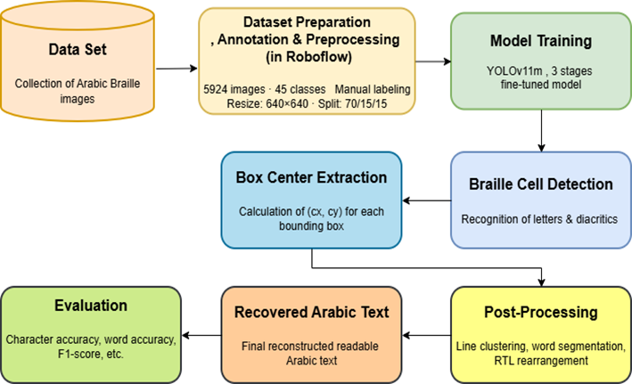

Fig. 1. Workflow for Arabic Braille detection and reconstruction using YOLOv11m

The first stage of the framework involves collecting Arabic Braille images under varied real-world conditions. These images are then prepared through resizing, annotation, and normalization to ensure compatibility with the detection model. Following dataset preparation, the YOLOv11m object detection model is configured and trained to identify individual Braille cells corresponding to Arabic letters and diacritical marks.
YOLOv11m was selected as the base detection model due to its proven ability to handle dense, overlapping, and small-scale visual patterns. Compared to lighter variants, it offers superior detection accuracy in complex scenes, while avoiding the computational overhead associated with heavier architectures. This balance makes it particularly suitable for deployment in assistive technologies, including mobile and embedded systems.
Once trained, the model detects Braille cells and outputs bounding boxes along with class predictions. The spatial centers of these bounding boxes are then extracted to preserve the geometric relationships between detected cells. These spatial relationships form the basis for subsequent text reconstruction.
A dedicated post-processing stage follows detection. In this stage, detected Braille cells are grouped into textual lines based on vertical alignment, after which horizontal ordering is applied. Word boundaries are identified through gap analysis between adjacent bounding boxes, and characters are reordered to match the natural right-to-left reading direction of Arabic. This stage is essential for reconstructing linguistically coherent Arabic text from isolated visual detections.
Finally, the framework outputs both annotated detection images and the reconstructed Arabic text. The entire pipeline is designed to operate automatically, enabling efficient processing of single images or complete datasets.

2.1 Dataset

The dataset used in this study was specifically constructed to support Arabic Braille recognition under realistic conditions. A total of 5924 images were collected, representing 45 distinct classes, consisting of 37 Arabic letters and 8 Arabic diacritical marks.
Data collection was conducted in collaboration with associations for the blind in Derna and Tripoli, Libya. Data was collected with prior consent from members of the associations, specifically from the Blind Association in Derna and the Al-Noor Association for the Blind in Tripoli, and supported by an official authorization issued by the authors’ affiliated institution, and the nature of the data used (educational Braille materials) did not raise any privacy or copyright concerns.

In the initial phase, Arabic Braille sheets were produced using a mechanical Braille typewriter. A total of sixty single-sided Braille sheets were generated, containing Arabic alphabets, diacritical marks, and several medium-length sentences. These sheets contained isolated letters, diacritical marks, and medium-length sentences, arranged at varying spatial densities to capture diverse layout configurations. Characters were deliberately positioned across different regions of the page, including centered, edge-aligned, and randomly distributed layouts.

Images were captured using a smartphone camera under a wide range of conditions. Each page was photographed several times using a Samsung Galaxy A10s (SM-A107F), which is equipped with a 13-megapixel (f/1.8 aperture) rear camera. Variations were introduced in lighting (natural and artificial), camera angles, distances, and page orientations to enhance dataset diversity and improve robustness under real-world imaging scenarios.

Additionally, part of the dataset was expanded using a first-grade Arabic Braille textbook consisting of two volumes (approximately 37 single-sided pages each), obtained from the Al-Noor Association for the Blind in Tripoli, to increase realism and variability. Representative examples of the collected Arabic Braille images are presented in Figure 2, as an example of the collected data.

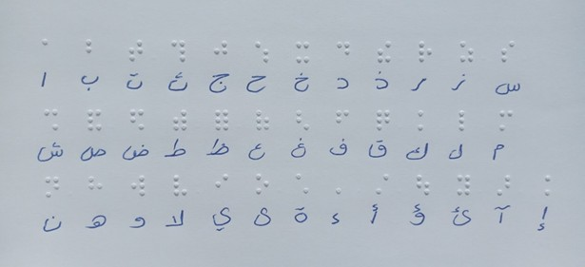

Fig. 2. Arabic Braille page with the full alphabet captured under non-uniform lighting

To maintain consistency during training, all images were resized to 640×640 pixels. The training images were manually annotated on the Roboflow platform by identifying each Braille cell with the corresponding Arabic letter or diacritical mark. An example of the annotation procedure is shown in Figure 3, which displays bounding boxes and class names for specific Braille cells. Since the platform does not support Arabic characters, a numeric label was assigned initially and was subsequently mapped to an Arabic symbol during model setup.

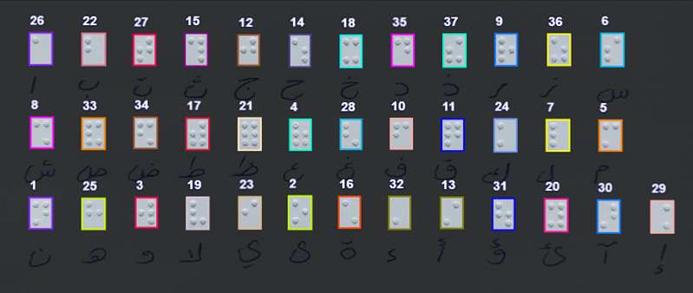

Fig. 3. Example of annotated Arabic Braille cells with bounding boxes and labels

The dataset was split into three subsets according to standard practice of allocating 70% of the data to training and splitting the remaining 30% equally between validation and testing. The training subset consisted of 4142 images and was used to train and optimize the parameters of the detection model. The validation subset consisted of 900 images and was used to monitor model performance during training and to prevent overfitting. The testing subset consisted of 882 images and was used to evaluate the framework. This provided a measure of the detection performance and the model's ability to generalize.
In order to maintain the integrity of the structure of the Braille patterns, extreme synthetic augmentations such as large-angle rotations and horizontal flipping were avoided. Instead, the augmentations were focused on adding natural variation that occurred during the data collection process. The pixels were normalized to the range of [0, 1] prior to training.

2.3 Evaluation Overview

Evaluation is conducted at the conclusion of the framework pipeline to assess both detection accuracy and overall system performance. Standard metrics, including Precision, Recall, F1-score, and mean Average Precision (mAP), are computed to evaluate Braille cell detection. In addition, inference time per image is measured to assess computational efficiency. The accuracy of the reconstructed Arabic text is also examined as an indicator of end-to-end framework effectiveness.

3. results and discussion

This section presents a comprehensive analysis of the experimental results obtained from evaluating the proposed Arabic Braille recognition framework. The discussion integrates quantitative performance metrics with qualitative observations to assess the effectiveness of the staged training strategy, the robustness of Braille cell detection, the reliability of post-processing for Arabic text reconstruction, and the practical feasibility of the proposed system under real-world imaging conditions.

3.1 Training Behavior and Model Convergence

The proposed framework, based on YOLOv11m, was trained using a multi-stage training approach to optimize convergence time and the speed of detection and generalization. The training was divided into three stages.
In the first stage of training, the model was trained with the default learning rate for 50 epochs. This provided a solid baseline for the learning of the features and allowed the model to learn the basics of the dot patterns of Braille for all the Arabic letters and diacritics. Both training and validation loss steadily decreased, indicating convergence and learning, and mAP values achieved at this stage confirm that the model successfully learned general Braille structures.
For the second training phase, an additional 30 epochs were assigned with the same learning rate. While the precision and recall were increased to the upper limits, a slight drop in mAP@0.5:0.95 was noted. This reflects the slight possibility that an aggressive training strategy may result in poor detections and worse localization for smaller or closely positioned Braille cells. The slight oscillations in loss observed during this stage may be due to the model beginning to overfit.
Lastly, for the final stage of the training process, to promote more stable convergence, 25 epochs with an increased number of epochs and a lower learning rate were utilized. The normalized precision and recall values, along with the highest recorded mAP@0.5:0.95, demonstrated the adjustment's impact on generalization. The improvement was largely due to increased robustness across different representations of the Braille symbols. Consequently, the model was selected as the final deployment model.
The loss curves in Figure 4 for both training and validation clearly show the absence of any significant overfitting and indicate smooth convergence.

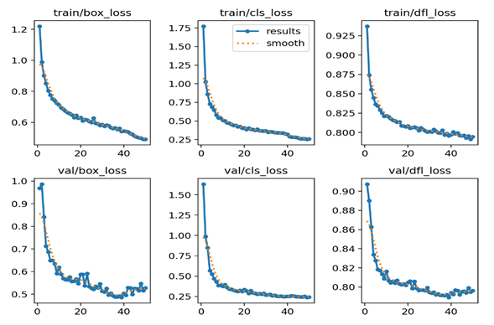

Fig. 4. Training and validation loss curves of YOLOv11m – Stage 3 (25 epochs), showing stable convergence

3.2 Overall Detection Performance

To determine accuracy and generalization with regard to detection, the final YOLOv11-M model was assessed using an independent test set of 882 unseen images. Additionally, standard object detection metrics, including precision, recall, F1-score, and mean Average Precision (mAP), were implemented.
Results show the proposed framework demonstrates high accuracy in Arabic Braille letters and diacritics. Precision and recall values of 0.994 illustrate both accurate identification of Braille cells and thorough detection coverage. An F1-score of 0.994 confirms that performance is balanced.
At an mAP of 0.994 at IoU 0.5, the model demonstrates remarkable localization at the standard overlap threshold; however, a notable decline was observed, and a lower mAP of 0.888 at IoU 0.5:0.95 illustrates the increased challenge of accurate localization of small and tightly grouped Braille dots under more rigorous evaluative conditions.

During the detection phase, the model had an estimated inference speed of 12.3 ms, thereby supporting the model's capability for real-time or near real-time utilization.

Table 1. Overall detection performance of the proposed Arabic Braille recognition framework, including Precision, Recall, F1-score, mAP metrics, and inference speed

Metric |  | Value
Precision |  | 0.994
Recall |  | 0.994
F1-score |  | 0.994
mAP@0.5 |  | 0.994
mAP@0.5:0.95 |  | 0.888
Inference Speed |  | ~12.3 ms/image

3.3 Framework Runtime Analysis

The observed difference between the reported inference time (12.3 ms) and the overall framework processing time (29–82 ms) is attributed to the inclusion of post-processing operations in the full pipeline, as well as variations in image complexity, character density, and input configuration, including isolated-character and full-page images.

In particular, post-processing contributes additional computational overhead for text reconstruction, including ordering, grouping, and spatial alignment of detected Braille elements, which becomes more significant in dense full-page documents.

3.4 Class-wise Performance Analysis

A detailed class-wise evaluation reveals variations in detection performance among Arabic letters and diacritical marks. Characters with distinctive and spatially complex Braille patterns achieved higher mAP@0.5:0.95 scores, while simpler characters and certain diacritics exhibited slightly lower performance.
These variations are consistent with the intrinsic structure of Arabic Braille, where minimal positional differences between dots can significantly affect visual separability. Despite these challenges, the model demonstrates strong generalization across all 45 classes, confirming its ability to learn subtle spatial relationships and handle linguistic diversity.
The consistently high precision and recall values across most classes further indicate that the annotation strategy and dataset diversity contributed positively to model robustness.

3.5 Post-processing and Arabic Text Reconstruction

While accurate Braille cell detection is essential, meaningful system performance ultimately depends on the ability to reconstruct coherent Arabic text. To address this requirement, a dedicated post-processing pipeline was implemented to transform raw detection outputs into readable Arabic text.
The pipeline organizes detected Braille cells into textual lines based on vertical alignment, identifies word boundaries using adaptive gap analysis, and reorders characters according to the right-to-left reading direction of Arabic. This process effectively resolves ambiguities that cannot be addressed by visual detection alone.
The results demonstrate that the post-processing stage significantly enhances end-to-end system performance, achieving 98% accuracy in line reconstruction and 96% accuracy in word segmentation. Mis-segmentation errors were limited to less than 2% of cases, primarily occurring in densely packed or poorly illuminated regions.
Figure 5 presents detection results with bounding boxes, while Figure 6 illustrates the corresponding reconstructed Arabic text.

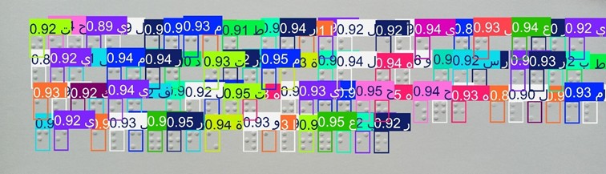

Fig. 5. Detection results showing localized Arabic Braille cells with bounding boxes

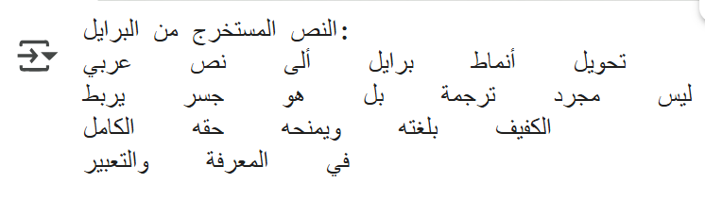

Fig. 6. Example of reconstructed Arabic text generated from detected Braille cells

3.6 Error Analysis and System Limitations

Despite the strong overall performance, several limitations were identified. Detection errors were more likely under non-uniform lighting conditions, extreme camera angles, and overlapping Braille dots. In some cases, these factors led to incorrect character ordering or partial misclassification, particularly for diacritical marks.
Resolution and capture method were also found to influence performance. Full-page captures occasionally introduced distortions, whereas half-page images and optimized aspect ratios produced more reliable results. These findings emphasize the importance of controlled image acquisition for optimal system performance.

3.7 Comparison with Existing Studies

To position the proposed framework within the existing body of Optical Braille Recognition research, a comparative analysis with selected recent studies was conducted. The comparison considers dataset characteristics, methodological design, and reported performance, with particular emphasis on linguistic coverage, dataset scale, and applicability to real-world imaging conditions.
As summarized in Table 2, most existing approaches are developed using relatively limited or language-specific datasets and are typically evaluated under controlled acquisition settings. In contrast, the proposed framework is designed using a large-scale Arabic Braille dataset captured under natural conditions and follows an end-to-end detection and reconstruction pipeline based on YOLOv11m with customized post-processing. This design supports improved robustness and practical deployment.

Table 2. Comparative Evaluation of Recent Optical Braille Recognition Studies

Ref | Dataset | Model / Approach | Metric | Value
(Lu et al., 2022) | NSBD + DSBI | Anchor-free ResNet-50 | Hmean = 0.689 | First Braille detection in natural scenes
(Nascimento et al., 2023) | Kaggle Braille (1,560 images) | YOLOv5 | F1 ≈ 0.990, mAP@0.5 ≈ 0.995 | YOLO-based Braille recognition for education
(Al-Salman & AlSalman, 2024) | Two custom datasets | Fly-LeNet (CNN + optimization) | Accuracy = 99.8%, F1 ≈ 0.997 | Multilingual Braille recognition pipeline
This Study | Arabic Braille (5,924 images, 45 classes) | YOLOv11-M + custom post-processing | F1 = 0.994, mAP@0.5 = 0.994 | First end-to-end Arabic Braille recognition framework

Table 2 shows that the suggested framework, when conducting more intricate and realistic analyses, still manages to match the accuracy of rival methodologies. Many studies boast unique accuracy or F1-score claims, but these usually stem from freestanding experiments, limited operational conditions, or other types of linguistic constraints. The suggested framework continues to demonstrate a firm defensive posture, maintaining its accuracy even as tasks become more complex and incorporate more classes, along with complete text reconstruction, as opposed to operating within the confines of a particular design.
The analysis of individual studies also become more pronounced. For example (Lu et al., 2022) proposed an anchor-free ResNet-50 design used for natural scene images of Braille and attained an H-mean of 0.689, with a relatively underwhelming recall of 0.555, which means that, to a large degree, Braille remained undetected even within more challenging scenarios. This design is primarily oriented towards detection and, as a result, does not offer a complete design or a means for text reconstruction. In contrast, the proposed framework incorporates detection along with the necessary post-processing structure to offer Latin text that is also visible while maintaining a left-to-right order.
Similarly, (Nascimento et al. 2023) applied a version of YOLOv5 for the recognition of Braille using the Portuguese alphabet, and while she achieved satisfactory results, they were obtained under a highly controlled and augmented context. This also comes with the caveat that the underlying dataset was relatively limited, as it was comprised of a collection of samples that existed in a structurally controlled environment. The proposed framework diverges from these themes to capture an array of disparate layouts in the primary dataset while also isolating a set of challenging imaging conditions in order to extend the purpose of fully reconstructing text beyond character-level detection.
The Fly-LeNet framework proposed by (Al-Salman & AlSalman, 2024) integrates Mayfly optimization with Braille cell segmentation and a LeNet-5 classifier, resulting in exceptional symbol-level accuracy. The only limitation in the evaluation is that it is performed on cropped Braille cells. This limits the evaluation due to a lack of consideration of the overall document structure and the inefficiencies caused by dependencies on boundary cell errors in segmentation. The proposed framework, however, adopts a detection-based approach, working with full-page inputs and removing segmentation, thus allowing efficient inference in a real-time context.
The Fly-LeNet framework reconstructs texts by merging independently classified symbols, a process deeply reliant on boundary segmentation. This segmentation is deficient and lacks a clear definition of spatial articulation. The proposed framework integrates structured post-processing to arrange the detected cells in specified rows and columns, maintaining the right-to-left sequence typical of Arabic text, leading to a more coherent and usable output.
Additionally, the real-time object detection framework enables efficient inference for full text reconstruction, setting this method apart from other segmentation-based or symbol-level methods. These traits exemplify the operational applicability of the framework in real-world scenarios for Arabic Braille.

3.8 Practical Implications

The proposed Arabic Braille recognition framework addresses the operational concerns of Arabic Braille recognition in assistive and educational frameworks. It demonstrates near real-time performance in converting images of Arabic Braille into readable text and is expected to bridge the communication gap between sighted teachers and visually impaired students, thus fostering an inclusive educational environment.

4. Conclusion and Future Work

This provides the first attempt to develop a deep learning approach to Arabic OBR using a modified YOLOv11-M architecture with a specifically defined post-processing pipeline. The first Arabic Braille dataset, comprising 5924 images and 45 classes (letters and diacritics), was created. This allowed for the first comprehensive assessment under the effect of varying natural imaging conditions.

Key findings include:
- High Detection Accuracy:
The YOLOv11-M model recorded a precision of 0.994, recall of 0.994, an F1 score of 0.994, and mAP@0.5 of 0.994 across 882 unseen test images. These results demonstrate the model's ability to accurately and reliably distinguish between 45 classes of Arabic Braille with few false detections.
- Robust Generalization:
The model was able to maintain performance levels across differing levels of light, shadow, and size, showing that the model is robust and appropriately trained for the target application.
- Effective Text Reconstruction:
The post-processing algorithm achieved an accuracy of 98% at the line level and 96% at the word level. This was achieved while maintaining the right-to-left language structure and the physical layout of the Arabic text.
- Efficient Real-Time Operation:
The processing time for the overall framework is between 29 and 82 ms per image, indicating that the framework is capable of operating in near real-time detection and reconstruction. This makes it appropriate for assistive applications that are mobile and embedded.

Contributions of the Study:
- Scientific: Placed Arabic Braille recognition within the domains of object detection and computer vision as a benchmark for reference in future works.
- Technical: Created the first fully integrated, end-to-end framework, from data collection through training the model to post-processing for text reconstruction.
- Dataset: Addressed concerns regarding Arabic Braille datasets in prior works, offering large-scale datasets in a variety of real-world conditions.
Practical & Humanitarian: Improved the ease of reconstructing Arabic texts for visually impaired students, facilitating access for teachers and parents to read translated Braille, and increasing overall access to Braille text.

Limitations and Future Work:
To enhance generalization and robustness for real-world scenarios, Braille datasets must include a greater variety of handwritten, multi-page, and double-sided samples.

- Post-processing can be improved by utilizing sequence-aware and transformational approaches for multi-column and complex layouts.
- The ability to be optimally embedded within low-resource platforms will enhance real-time processing and availability.
Impact:
This framework will positively influence inclusive educational practices, offering a helpful step toward increasing accessibility for Arabic Braille. The combination of YOLOv11-M with linguistically informed post-processing offers the first practical, scalable, and integrated Arabic Braille recognition system.

Disclaimer (Artificial intelligence)

Author(s) hereby declare that NO generative AI technologies such as Large Language Models (ChatGPT, COPILOT, etc.) and text-to-image generators have been used during the writing or editing of this manuscript.

References

Al Salman, A., & Alsalman, A. (2024). Fly LeNet: A deep learning–based framework for converting multilingual braille images. Heliyon, 10(4), e26155. https://doi.org/10.1016/j.heliyon.2024.e26155
Alufaisan, S., Albur, W., Alsedrah, S., & Latif, G. (2021). Arabic Braille numeral recognition using convolutional neural networks. In V. Bindhu, G. Chen, & X. Li (Eds.), International Conference on Communication, Computing and Electronics Systems (ICCCES 2020) (Lecture Notes in Electrical Engineering, Vol. 733, pp. 87–101). Springer. https://doi.org/10.1007/978-981-33-4909-4_7
Alsalman, A., Gumaei, A., Alsalman, A., & Al Hadhrami, S. (2021). A deep learning–based recognition approach for the conversion of multilingual braille images. Computers, Materials & Continua, 67(3), 3847–3864. https://doi.org/10.32604/CMC.2021.015614
Antonacopoulos, A., & Bridson, D. (2004). A robust braille recognition system. In Marinai, S., & Dengel, A. (Eds.), Proceedings of the International Workshop on Document Analysis Systems (DAS 2004) (Lecture Notes in Computer Science, Vol. 3163, pp. 533–545). Springer. https://doi.org/10.1007/978-3-540-28640-0_41
Bitter, M. (2013). Braille in mathematics education (Master’s thesis). Radboud University Nijmegen, Netherlands.
Farseen, A., & Kumaraswamy, S. (2023). Braille character recognition using deep learning techniques. International Journal of Scientific Development and Research (IJSDR), 8(3), 400–406. http://www.ijsdr.org/papers/IJSDR2303062.pdf
Hsu, B. M. (2020). Braille recognition for reducing asymmetric communication between the blind and non-blind. Symmetry, 12(7), 1069. https://doi.org/10.3390/sym12071069
Li, R., Liu, H., Wang, X., & Qian, Y. (2019). Effective optical braille recognition based on two-stage learning for double-sided braille image. In Kim, J., Chung, K. Y., & Pyun, K. (Eds.), Pacific Rim International Conference on Artificial Intelligence (PRICAI 2019) (Lecture Notes in Computer Science, Vol. 11643, pp. 150–163). Springer. https://doi.org/10.1007/978-3-030-29894-4_12
Lu, L., Wu, D., Xiong, J., Liang, Z., & Huang, F. (2022). Anchor-free braille character detection based on edge feature in natural scene images. Computational Intelligence and Neuroscience, 2022, 7201775. https://doi.org/10.1155/2022/7201775
Meng, Z., Cai, Z., Feng, J., Ma, H., Zhang, H., & Li, S. (2024). Braille character segmentation algorithm based on Gaussian diffusion. Computers, Materials & Continua, 79(1), 1482–1495. https://doi.org/10.32604/cmc.2024.048002
Nascimento, R. P., Reis, J. R., Aragão, L. A. F., Araújo, A. S., Heidrich, R., & Barone, D. A. C. (2023). Reconhecimento automático de caracteres braille utilizando rede neural convolucional YOLO. Revista Novas Tecnologias na Educação, 21(2), 131–140. https://doi.org/10.22456/1679-1916.137647
Othman, A., & El Ghoul, O. (2021). Unified Arabic braille portal by Mada: Innovative digital resource to reduce braille illiteracy in the Arab region. Nafath, 6(19), 35–40. https://mip.qa/nafath/
Ovodov, I. G. (2021). Optical Braille recognition using object detection neural network. In Proceedings of the IEEE/CVF International Conference on Computer Vision (ICCV 2021) (pp. 1741–1748). IEEE. https://doi.org/10.1109/ICCV48922.2021.00178
Raj, S. S. (2022). Braille convertor (Master’s thesis). Concordia University of Edmonton, Canada.
Roslaili, Y., Munandar, A., Mukdin, K., Suparwany, S. & Rahmi, M. (2025), Accessibility and effectiveness of qur’anic braille instruction for visually impaired students: A case study at bukesra, banda aceh’, Jurnal Ilmiah Al-Mu’ashirah: Media Kajian Al-Qur’an dan Al-Hadits Multi Perspektif 22(1), 1–13. https://doi.org/10.22373/jim.v22i1.28652
Shao, Z., Yu, Z., Gu, Y., & Wang, W. (2022). Braille to Chinese translation system based on optical braille recognition. In Proceedings of the 2022 2nd Asia Pacific Conference on Communications Technology and Computer Science (ACCTCS) (pp. 22–26). IEEE. https://doi.org/10.1109/ACCTCS53867.2022.00013
Suarjaya, I. M. A. D., Wiratama, B. A., & Wirdiani, A. (2024). Sistem pengenalan huruf Braille menggunakan metode deep learning berbasis website. JITSI: Jurnal Ilmiah Teknologi Sistem Informasi, 5(3), 93–99. https://doi.org/10.62527/jitsi.5.3.244

