Online disinformation detection through text analysis: a comparative study of supervised models with hyperparameter optimization

Abstract
The rapid spread of disinformation on social media poses a major challenge in the digital age, with significant impacts on public opinion and decision-making. In this context, this study proposes a machine learning-based approach for the automatic detection of online disinformation. A comparative analysis is conducted on several supervised learning models, including logistic regression, support vector machines (SVMs), random forests, and gradient boosting. The experiment is based on a real-world dataset of textual content from digital platforms, preprocessed using TF-IDF. Furthermore, hyperparameter optimization, primarily using Grid Search, is implemented to improve model performance. The results obtained reveal very high performance for all models, with accuracy values ​​exceeding 98% and areas under the ROC curve (AUC) close to 1. The Gradient Boosting model stands out as the best performer, offering an excellent balance between accuracy and generalization capabilities, while the Random Forest model, although exhibiting a perfect AUC, shows potential signs of overfitting. This study highlights the effectiveness of machine learning methods for disinformation detection and underscores the importance of hyperparameter optimization in improving model performance. It also opens up interesting avenues for integrating more advanced techniques, including deep learning and multimodal analysis, into disinformation countermeasures systems. The models were evaluated using data separation into training and test sets, allowing for a reliable estimation of their performance. The results show that hyperparameter optimization significantly improves the performance of classical models. However, certain limitations related to the diversity of data sources and methodological choices must be taken into account.
Keywords: Disinformation, Machine Learning, Hyperparameters, TF-IDF, Supervised Learning, fake-news detection.
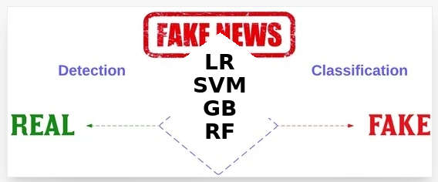
Fig1: Graphical summary

1. INTRODUCTION
The rapid rise of the internet and social media has profoundly transformed the ways in which information is produced, disseminated, and consumed worldwide. Platforms such as Facebook, Twitter, Instagram and WhatsApp now allow for the near-instantaneous circulation of content to a wide audience. However, this increased accessibility is accompanied by a worrying phenomenon: the massive spread of online disinformation commonly referred to as "fake news."
According to available statistics, the number of users of these platforms has grown exponentially in recent decades, reaching one billion active users across platforms such as Facebook, Twitter, and Instagram. This has facilitated instant communication and the rapid sharing of information, contributing to a more integrated and better-informed global society. However, this growth has also generated immense challenges, particularly regarding fake news and disinformation (Huiru Jin, 20025). Figure 2 illustrates the exponential growth in the number of media consumers (2013-2023), and if we add the figures for (2024-2026), well, that's another story.
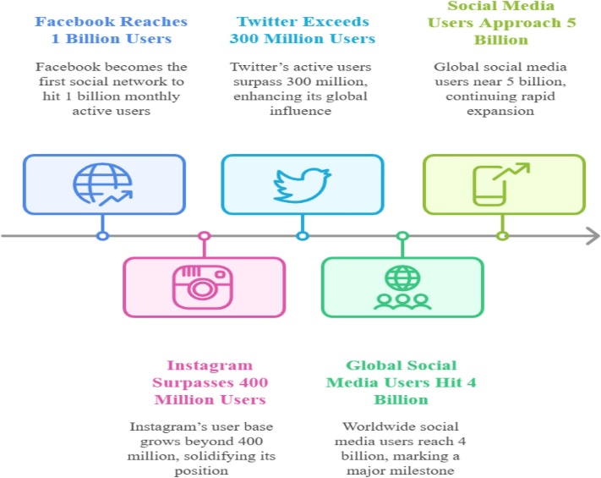
Fig. 2. Exponential Media Users
Disinformation disseminated on social media can influence public opinion, disrupt democratic processes, and lead to a loss of trust in institutions. Given the speed at which content spreads and the considerable volume of data generated daily, traditional methods of manual verification quickly prove insufficient. It is therefore essential to use automated approaches capable of efficiently detecting this content quickly and reliably.
Despite advances in artificial intelligence (AI), accurately detecting misinformation remains a major challenge. Current approaches often struggle to generalize to diverse linguistic and thematic contexts, and the trade-offs between accuracy, adaptability, and resource efficiency in models remain poorly understood. Furthermore, the high computational cost of fine-tuning large language models (LLMs) hinders their widespread adoption. Addressing these challenges is essential for developing reliable tools that strengthen information integrity within the media ecosystem (Roumeliotis, 2025).
In this context, machine learning techniques appear as promising solutions for the automatic detection of disinformation. In particular, supervised learning approaches enable the design of models capable of classifying textual content as reliable or misleading information. Commonly used algorithms include logistic regression, support vector machines (SVMs), random forests, and boosting methods, notably gradient boosting.
However, the performance of these models is highly dependent on the choice of their hyperparameters. Optimal tuning of these hyperparameters can significantly improve the accuracy, robustness, and generalizability of classification systems. To this end, optimization techniques such as grid search are widely used to identify the most effective configurations.
In this context, this study aims to evaluate and compare the performance of several supervised machine learning models in detecting online disinformation, with a particular focus on content from social media. Special attention is also paid to the impact of hyperparameter optimization on model performance.
That being said, the following objectives are pursued in this study:
- To evaluate and compare the performance of several supervised learning models (logistic regression, SVM, Random Forest, and Gradient Boosting) in detecting online disinformation;
- To analyze the impact of hyperparameter optimization, particularly through techniques such as grid search, on model performance;
- To identify the most effective model in terms of accuracy, robustness, and generalizability in a real-world context of social media data;
- To propose an effective approach that can serve as a basis for the development of automated disinformation detection systems.
In short, this article addresses a major current issue: the automatic detection of online disinformation using supervised machine learning techniques. It offers a structured comparative analysis of several widely used classifiers, integrated into a homogeneous pipeline based on the TF-IDF representation.
The originality of this study lies in its in-depth evaluation of the impact of hyperparameter optimization on the performance of classical models, highlighting their effectiveness in the context of massive datasets from social networks. Unlike much recent work focused on deep learning, this approach underscores the continued relevance of lighter and more interpretable methods.
Thus, it constitutes a valuable contribution to the scientific community, providing a robust and reproducible baseline for disinformation detection, while also offering practical insights for the development of effective automated systems.
2. THEORETICAL FRAMEWORK
2.1 Generalities and definition of disinformation
Online disinformation is a complex phenomenon that has attracted increasing interest in the scientific community in recent years. It is generally defined as the dissemination of false or misleading information, intentionally designed to manipulate public opinion or mislead users (Wimmer, 2025). It is important to distinguish between disinformation and misinformation, the latter referring to erroneous information disseminated without malicious intent. (Del Vicario, 2016).
While everyone has their own interpretation of what constitutes fake news, the term contains numerous subtleties that must be addressed before delving into existing research on the subject. In fact, the French term "infox" is preferred, according to the recommendations of the Académie française, but regardless, we will define it as is customary. An expression of English origin, fake news is any false information disseminated with the aim of manipulating or deceiving public opinion on a specific topic. (Bishop, 2006). Also known as disinformation, these fake news stories or fallacious information, massively relayed by social media (blogs, social networks,...), can originate from one or more individuals, the media themselves, public figures, or even a government.
Several theoretical frameworks have been developed to explain the mechanisms of misinformation formation and spread. Among these, the Information Deficit Model suggests that belief in false information stems primarily from a lack of knowledge or understanding on the part of individuals. However, recent research has challenged this approach by demonstrating that even well-informed individuals can be influenced by misleading content (Ecker, 2022).
2.2 Numerous Cases of “Successful” Disinformation
The Brexit vote in June 2016, or the successful use of fake news: this was one of the first times that fake news had such a significant influence on an election. The Sun's headline claiming that Queen Elizabeth II was pro-Brexit, or Turkey's potential entry into the EU, are just some examples of false information published in the British media and shared on social networks that influenced the vote. (CUMMINGS, 2026).
The 2016 US presidential election is also frequently cited as an example. The involvement of Russian trolls is highlighted: fake profiles impersonating real people on social media were identified and attributed to Russians to sow confusion and exacerbate internal American tensions during the election. These trolls disseminated anti-racism messages alongside messages about the threats of illegal immigration and Islam. The aim was to highlight the most controversial positions of both parties and to instill the idea that the danger comes from the neighbor. The US government reportedly identified at least 800 Twitter accounts controlled by Russian agents (GENTZKOW, 2026).
Finally, the last example is from 2019, when the spread of misinformation related to the pandemic was rampant. Indeed, disinformation is a major characteristic of the COVID-19 crisis. Bots on social media are estimated to be responsible for 45% to 60% of the content about the pandemic: the origin of the virus, treatments, vaccines, containment measures, and conspiracy theories. These same bots have been twice as active since the beginning of COVID-19 as during any other crisis or election. The private and public sectors were severely hampered, unsure how to combat this scourge. Much misinformation about the virus circulated even within university teams, to such an extent that a research project was launched to identify and characterize fake news about the coronavirus. This characterization focuses on the subject matter, the type of disinformation it contains, its methods, speed, and networks of dissemination (OMS, 2026). »
From a psychological perspective, the theory of motivated reasoning highlights the role of cognitive biases in the acceptance of misinformation. According to this approach, individuals tend to favor information that confirms their pre-existing beliefs, which promotes the spread and persistence of fake news. This dynamic is reinforced by the illusory truth effect, whereby the repetition of information, even false information, increases its perceived credibility. From a psychological perspective, the theory of motivated reasoning highlights the role of cognitive biases in the acceptance of misinformation. According to this approach, individuals tend to favor information that confirms their pre-existing beliefs, which promotes the spread and persistence of fake news. This dynamic is reinforced by the illusory truth effect, whereby the repetition of information, even false information, increases its perceived credibility (Fazio, 2015).
Furthermore, social media plays a central role in the spread of misinformation. Digital platforms facilitate the rapid and massive dissemination of content, thus creating environments conducive to virality. In this context, the theory of information contagion likens the spread of fake news to an epidemiological phenomenon, where information spreads through interactions between users. Moreover, the concept of "echo chambers" describes the tendency of individuals to primarily expose themselves to information that aligns with their existing opinions, which reinforces polarization and amplifies misinformation.
Faced with these challenges, computational approaches based on machine learning have emerged as effective solutions for the automatic detection of disinformation. Natural Language Processing (NLP) techniques make it possible to extract relevant features from textual data, thus facilitating content classification. Several studies have demonstrated the effectiveness of supervised algorithms, such as logistic regression, support vector machines (SVMs), and ensemble methods like Random Forest and Gradient Boosting, in detecting fake news.
However, the performance of these models depends heavily on the choice of hyperparameters. Optimizing these parameters is therefore a major challenge for improving the accuracy and robustness of detection systems. Techniques such as grid search are commonly used to identify optimal configurations. Despite the progress made, the combination of rigorous comparative model analysis and systematic hyperparameter optimization remains largely unexplored, thus justifying the relevance of this study.
We should also not The work of Hajjouz & Avksentieva (2024, 2025), Prayoga & Husni (2025), and Asaad & Avksentieva (2024) has highlighted the importance of hyperparameter optimization and feature selection for improving the performance of classification models. In particular, studies on CatBoost demonstrate that an optimized configuration allows for the accurate detection and classification of different types of attacks or content, while maintaining good model interpretability.
This work also demonstrates that classical and lightweight models, when properly parameterized, can achieve performance comparable to more complex approaches such as deep learning, while remaining more efficient in terms of computation time and reproducibility. Finally, adapting models to real-world data, including large quantities of observations, is crucial to ensuring the robustness of classification systems in practical contexts.
Thus, the study presented here is part of this dynamic by offering a comparative analysis of several classic models for the detection of disinformation, with a particular emphasis on the impact of hyperparameter optimization on their performance in a massive data environment from social networks.
2.3 Comparison of Machine Learning Algorithms Used for Online Disinformation Detection
Ensemble learning methods play a significant role in classification tasks, particularly due to their ability to improve predictive performance by combining multiple models. Among these approaches, Random Forest and Gradient Boosting algorithms stand out for their effectiveness in processing complex data, including textual data from social networks:
2.3.1. Logistic Regression
Logistic regression is a binary classification method that models the probability that an observation belongs to one of two classes. It uses a sigmoid function to transform input variables into probabilities and adjusts the coefficients to maximize the likelihood of the observed data. Simple and interpretable, it is commonly used for various binary classification problems. Its advantage lies in its ease of implementation and interpretability, making it a popular choice for binary classification problems. It is also quick to train on small datasets. However, it is limited in its ability to capture complex relationships in textual data, and its performance may decrease on larger or more complex datasets (K. P. Murphy, 2012).
2.3.2. Support Vector Machines (SVMs)
Support Vector Machines (SVMs) are a family of supervised classification algorithms designed to separate data into distinct classes by determining an optimal hyperplane that maximizes the margin between them. To handle nonlinear problems, SVMs use kernel functions that project the data into a higher-dimensional space. This capability allows them to achieve good performance in classifying complex data, especially when the boundaries between classes are well-defined. SVMs are particularly effective for binary classification problems and can be adapted to different contexts through the choice of appropriate kernels. However, their performance is highly dependent on the tuning of hyperparameters, and their use can become computationally expensive on large datasets (James, 2021).
2.3.3. Random Forest
Random Forest is a method based on the bagging principle, which consists of building a set of independent decision trees from random subsamples of the data. Each tree produces a prediction, and the final decision is obtained by majority vote. This approach reduces overfitting and improves the robustness of the model. In the context of text classification, particularly for misinformation detection, Random Forest proves effective at capturing non-linear relationships and handling high-dimensional data (Breiman, 2001).
2.3.4. Gradient Boosting
Gradient Boosting, on the other hand, relies on a sequential strategy where models are built iteratively. Each new tree aims to correct the errors made by previous ones by minimizing a loss function. This ability to learn progressively allows for the creation of very efficient models, often superior to bagging-based methods (Friedman, 2001). In disinformation detection tasks, Gradient Boosting is particularly valued for its high accuracy and ability to capture complex patterns in textual data (Chen, 2016).
3. METHODOLOGY
In this study, experiments will be conducted using the Python programming language, renowned for its wealth of libraries dedicated to data science and machine learning. The main libraries to be used include Pandas for data manipulation and analysis, NumPy for numerical computation, and Scikit-learn for implementing classification algorithms, including logistic regression, support vector machines (SVMs), random forests, and gradient boosting.
Textual data preprocessing will be performed using natural language processing techniques, specifically TF-IDF vectorization integrated into the Scikit-learn library. All experiments will be conducted using Microsoft Visual Studio Code, facilitating the execution and evaluation of the models.
3.1 Data
We will use two datasets, including the "Fake and Real News Dataset," which is widely used in disinformation detection work. It consists of news articles collected from various online sources and classified into two categories: reliable information (real) and disinformation (fake). Each observation in the dataset includes a title, text content, and a label indicating the veracity of the information. The target variable is binary, taking the value 0 for false information and 1 for real information. This dataset is particularly well-suited to text classification tasks and provides a relevant basis for evaluating machine learning models in the context of online disinformation detection.
3.2 Data Preprocessing
The text data will undergo several preprocessing steps to improve the quality of the information and make it usable by machine learning models. These steps include text cleaning, stop word removal, tokenization, and the transformation of text data into digital representations using the TF-IDF method.

3.3 Modeling
3.3.1 Classification
Classification is a fundamental task in supervised learning, consisting of assigning a predefined label or category to an observation based on its characteristics. In this type of problem, the model is trained on annotated data—that is, data for which the target class is known—in order to learn a prediction function capable of generalizing to new data (James G. W., 2021). In this study, classification is formulated as a binary problem aimed at distinguishing reliable information from disinformation. Machine learning models are trained to analyze the textual characteristics of articles and automatically predict their membership in one of two classes, namely "true" or "false," based on metrics.
3.3.2 Selected Models
In the context of online disinformation detection, several supervised machine learning models were selected to evaluate their ability to effectively classify textual content. Logistic regression was used as the base model due to its simplicity and interpretability, particularly in binary classification tasks. Support vector machines (SVMs) were incorporated for their efficiency in high-dimensional spaces, which are particularly well-suited to vectorized textual data (Shu, 2020). Furthermore, ensemble methods such as Random Forest and Gradient Boosting were employed for their ability to capture complex and nonlinear relationships in the data. Random Forest reduces overfitting by aggregating multiple decision trees, while Gradient Boosting progressively improves performance by correcting errors in previous models. The combined use of these approaches thus allows for the comparison of linear and nonlinear, simple and complex models, in order to identify the most effective ones in the specific context of automatic disinformation detection. The combined use of these approaches makes it possible to compare linear and non-linear, simple and complex models, in order to identify the most effective ones in the specific context of automatic disinformation detection (Al-Ahmadi, 2020).

3.4 Hyperparameter Optimization
To improve the performance of the classification models, a hyperparameter optimization phase was implemented. This step involves searching for the best parameter combinations for each algorithm, with the aim of obtaining more accurate results and better generalization capabilities. In this study, the grid search method was used, in combination with cross-validation. This approach allows for the systematic exploration of a set of predefined values ​​for each hyperparameter and the evaluation of the corresponding performance on several subsamples of the training data. The cross-validation method adopted relies on partitioning the data into several folds, thus ensuring a more robust estimation of the models' performance (Probst, 2019).
For the SVM model, the regularization parameter C was optimized to control the trade-off between the separation margin and classification errors. Regarding the Random Forest model, hyperparameters such as the number of trees (n_estimators) and the maximum tree depth (max_depth) were adjusted to improve model robustness and limit overfitting (Bergstra, 2019). For the Gradient Boosting model, several parameters were explored, including the number of iterations (n_estimators), the learning rate (learning_rate), and the depth of the trees, with the aim of progressively optimizing the model's performance (Yu, 2020) (Feurer, 2019).
This entire procedure was implemented using the GridSearchCV function from the Scikit-learn library, which automates the search for the best hyperparameters while incorporating cross-validation (Li, 2020).
This entire procedure was implemented using the GridSearchCV function from the Scikit-learn library, which automates the search for the best hyperparameters while incorporating cross-validation (Sokolova, 2009). Accuracy measures the overall proportion of correct predictions, while precision assesses the model's ability to avoid false alarms by focusing on the quality of positive predictions. Recall, meanwhile, measures the model's ability to correctly identify all positive instances. Finally, the F1 score, which is the harmonic mean of precision and recall, provides a balanced measure of model performance, particularly in contexts where careful attention must be paid to both false positives and false negatives. (Powers, 2011).
These indicators, also called metrics, are based on the confusion matrix and are calculated using the following formulas:
Table 1: Parameters of model performance evaluation metrics

Label | Predicted Fake (0) | Predicted True (1)
Fake réel (0) | TN (True Negative) | FP (False Positive)
True réel (1) | FN (False Negative) | TP (True Positive)

a) Accuracy: indicates the percentage of correct predictions. The closer it is to 1, the better the model. It is calculated by:
(1)
$$Accuracy=\frac{TP+TN}{TP+TN+FP+FN}$$
b) Precision: indicates how many of the positive predictions are correct. In other words, if the model says "True," how many are actually true.
(2)
$$Precision=\frac{TP}{TP+FP}$$
c) Recall: This is the ability to detect true positives. Specifically, among the true positives, how many did the model find.
(3)
$$Recall=\frac{TP}{TP+FN}$$
d) F1 score: this is the harmonic mean between "accuracy and recall". Furthermore, it represents the balance between accuracy and recall.
$$F1-score=2×\frac{Precision×Recall}{Precision+Recall}$$
(4)
Using these metrics will allow us to train the models in the following sub-point of the results.
4. RESULTS
The training of the different models was carried out using the Python language, relying on specialized libraries such as scikit-learn for the implementation and evaluation of the algorithms. The Microsoft Visual Studio Code development environment was used for the implementation, execution, and organization of the experimental code. The results presented in this section stem from this experimental framework and aim to evaluate the performance of classification models in disinformation detection. The analysis relies on several standard metrics as well as evaluation tools such as confusion matrices and ROC curves, allowing us to assess the accuracy, robustness, and generalizability of the approaches studied. Source code will be provided for some sub-sections.

4.1 Data Preprocessing and Dataset Loading

import pandas as pd
# Load the files
fake = pd.read_csv("Fake.csv")
true = pd.read_csv("True.csv")

# Verification
print("Fake shape:", fake.shape)
print("True shape:", true.shape)
fake.head()

# Add the Column
fake['label'] = 0 # Fake news
true['label'] = 1 # Real news
# Shuffle the data
data = pd.concat([fake, true], axis=0)
# Verify
data.shape
# check balance
data = data.sample(frac=1).reset_index(drop=True)

data.head()
# Keep the useful columns
data = data[['title', 'text', 'label']]

data.head()
# Check balance
print(data['label'].value_counts())

Table 2: Data preprocessing results
 | Title | Text | label
0 | BOMBSHELL: Devin Nunes’ Entire Net Worth Sunk... | If today s fiasco, which came courtesy of Hous... | 0
1 | Japan agrees with U.S. that North Korea's weap... | TOKYO (Reuters) - Japanese Foreign Minister Fu... | 1
2 | Trump talks tough on Pakistan's 'terrorist' ha... | ISLAMABAD (Reuters) - Outlining a new strategy... | 1
3 | Polls open as Slovenian president runs for his... | LJUBLJANA (Reuters) - Polls opened in the Slov... | 1
4 | Somalia's capital restricts movement of trucks... | MOGADISHU (Reuters) - Somali authorities impos... | 1

label
0 23481
1 21417
Name: count, dtype: int64

Commentary
Analysis of the target variable distribution shows that the dataset is relatively balanced, with 23,481 observations belonging to the false information class (label = 0) and 21,417 observations corresponding to true information (label = 1). Although a slight difference is observed between the two classes, this difference remains moderate and is not likely to introduce significant bias into model training. Thus, no specific data rebalancing techniques were deemed necessary.

4.2 Model Training

import pandas as pd
# Variables
X = data['text']
y = data['label']
# TF-IDF
from sklearn.feature_extraction.text import TfidfVectorizer
vectorizer = TfidfVectorizer(stop_words='english', max_df=0.7)
X = vectorizer.fit_transform(X)
# Train / Test
from sklearn.model_selection import train_test_split

X_train, X_test, y_train, y_test = train_test_split(
X, y, test_size=0.2, random_state=42
)
# Models
from sklearn.linear_model import LogisticRegression
from sklearn.svm import LinearSVC
from sklearn.ensemble import RandomForestClassifier, GradientBoostingClassifier

models = {
"Logistic Regression": LogisticRegression(max_iter=1000),
"SVM": LinearSVC(),
"Random Forest": RandomForestClassifier(),
"Gradient Boosting": GradientBoostingClassifier()
}
# Training vs evaluation
from sklearn.metrics import accuracy_score, precision_score, recall_score, f1_score

results = {}
for name, model in models.items():
model.fit(X_train, y_train)
y_pred = model.predict(X_test)

results[name] = {
"Accuracy": accuracy_score(y_test, y_pred),
"Precision": precision_score(y_test, y_pred, zero_division=0),
"Recall": recall_score(y_test, y_pred, zero_division=0),
"F1-score": f1_score(y_test, y_pred, zero_division=0)
}
# display
results_df = pd.DataFrame(results).T
results_df

Table 3: Model training results
Models | Accuracy | Precision | Recall | F1-score
Logistic Regression | 0.985189 | 0.982284 | 0.986654 | 0.984464
SVM | 0.994655 | 0.993226 | 0.995551 | 0.994387
Random Forest | 0.990423 | 0.988331 | 0.991571 | 0.989949
Gradient Boosting | 0.995323 | 0.991630 | 0.998595 | 0.995100

4.3 Hyperparameter Optimization
The Optimization Code for SVM and its Result

from sklearn.model_selection import GridSearchCV
from sklearn.svm import LinearSVC
param_svm = {
'C': [0.1, 1, 10]
}
grid_svm = GridSearchCV(LinearSVC(), param_svm, cv=3, n_jobs=-1)
grid_svm.fit(X_train, y_train)
print("Best SVM params:", grid_svm.best_params_)

RESULT: Best SVM params: {'C': 10}

The Optimization Code for RF and its Result

from sklearn.ensemble import RandomForestClassifier
param_rf = {
'n_estimators': [100, 200],
'max_depth': [None, 10, 20]
}
grid_rf = GridSearchCV(RandomForestClassifier(), param_rf, cv=3, n_jobs=-1)
grid_rf.fit(X_train, y_train)
print("Best RF params:", grid_rf.best_params_)
RESULT: Best RF params: {'max_depth': None, 'n_estimators': 200}

The Optimization Code for GB and its Result
from sklearn.ensemble import GradientBoostingClassifier
from sklearn.model_selection import RandomizedSearchCV
param_gb = {
'n_estimators': [100, 200],
'learning_rate': [0.05, 0.1],
'max_depth': [3, 5]
}
random_gb = RandomizedSearchCV(
GradientBoostingClassifier(),
param_gb,
n_iter=2,
cv=2,
n_jobs=-1,
random_state=42
)
random_gb.fit(X_train, y_train)
print("Best GB params:", random_gb.best_params_)

RESULT: Best GB params: {'n_estimators': 200, 'max_depth': 3, 'learning_rate': 0.1}

Table 4: Summary table of hyperparameter optimization results
Models | Optimal parameters | Observation
SVM | C = 10 | Stricter model (fewer errors)
RF | 200 trees, unlimited depth powerful model | powerful model
GB | 200 trees, lr=0.1, depth 3 | balanced model

Commentary
Hyperparameter optimization identified the best configurations for each classification model. The optimization results show that increasing model complexity improves performance. A high C=10 value for the SVM indicates that the model prioritizes reducing classification errors. Similarly, increasing the number of trees in Random Forest and Gradient Boosting improves model robustness.

Furthermore, the limited depth of Gradient Boosting suggests that shallow trees, combined iteratively, are sufficient to capture relevant structures in the data while avoiding overfitting.
These results demonstrate that hyperparameter optimization plays a crucial role in improving the performance of machine learning models.

4.4 Model Evaluation
a) Performance Comparison with the ROC Curve

AUC Logistic Regression: 0.9971735443753533
AUC SVM: 0.9993970228000754
AUC Random Forest: 1.0
AUC Gradient Boosting: 0.9999623139250048
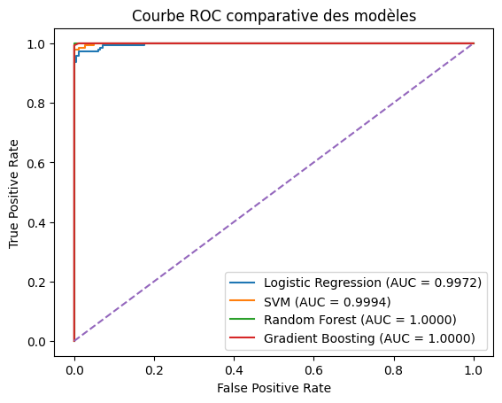
Fig. 3: ROC curve
b) Confusion matrices
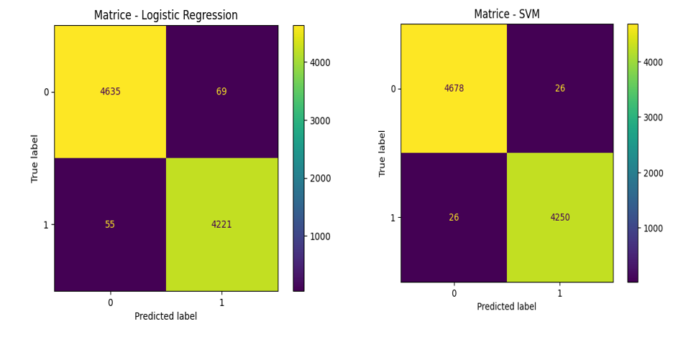

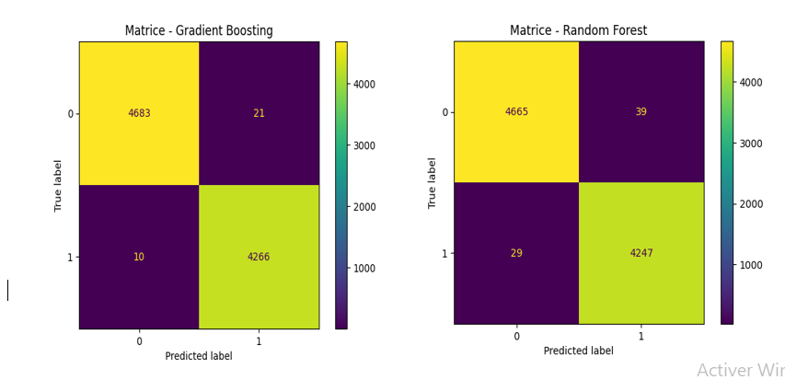
Fig.4: Confusion matrices

Commentary
A comparative analysis of the confusion matrices of the different models reveals that all the algorithms studied exhibit high performance in information classification and misinformation detection. However, significant differences emerge in terms of accuracy and generalization capabilities. Logistic regression, while simple, provides satisfactory results and serves as a good baseline. The SVM model shows a notable performance improvement, particularly due to its ability to efficiently separate classes in high-dimensional spaces. The Random Forest model also demonstrates high robustness by combining predictions from multiple decision trees. However, the Gradient Boosting model stands out clearly from the other approaches. The resulting confusion matrix highlights a very low error rate, with only a few false positives and false negatives. This performance is explained by the model's sequential learning mechanism, which allows for the progressive correction of errors from previous iterations.
In short, these results confirm that ensemble methods, especially Gradient Boosting, are particularly well-suited. Their ability to capture complex relationships in textual data gives them a significant advantage over simpler models. The Gradient Boosting model appears to be the most effective, with a remarkable ability to minimize classification errors, making it a particularly suitable solution for the automatic detection of online disinformation.

c) Comparative Performance Analysis of Classification Models
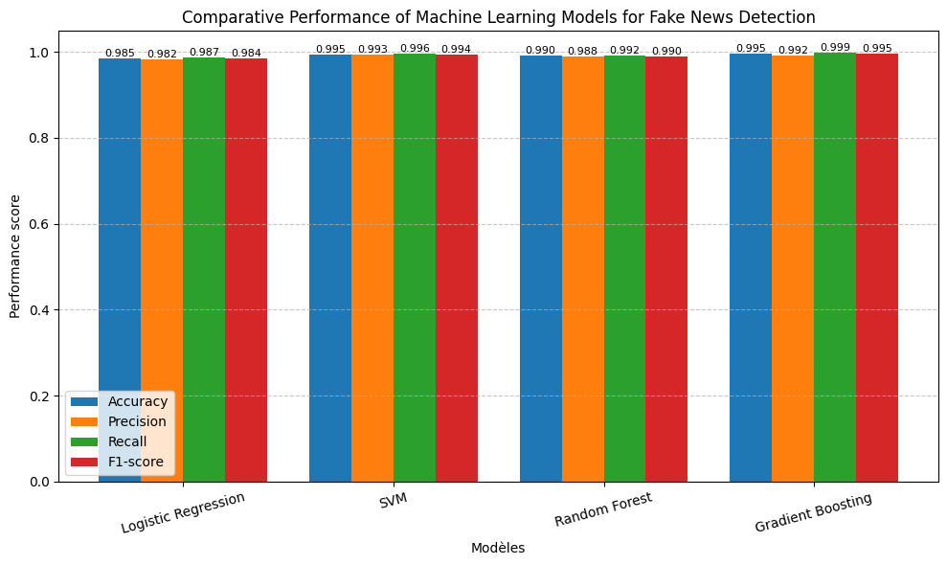
Fig.5: Model comparison chart
Commentary
The comparative performance histogram highlights overall very high results for all the evaluated models, confirming their effectiveness in the task of disinformation classification. The Gradient Boosting model slightly outperforms the other approaches on most metrics, particularly in terms of recall and F1 score, reflecting its ability to effectively identify disinformation content while minimizing classification errors. The SVM model also exhibits very similar performance, illustrating its robustness in handling high-dimensional textual data. Random Forest displays solid and consistent results, although it lags slightly behind the two previous models. Finally, logistic regression, while effective, remains the least efficient model in this comparison, which is explained by its linear nature limiting its ability to capture complex relationships. Overall, this graphical representation confirms the superiority of ensemble models and advanced approaches for automatic disinformation detection.
5. DISCUSSION
The results obtained in this study highlight the very high overall performance of all the evaluated models, confirming the effectiveness of classical machine learning approaches for the automatic detection of misinformation in textual data. However, the combined analysis of evaluation metrics, confusion matrices, and ROC curves reveals significant differences between the models in terms of accuracy, robustness, and generalization capacity.
The Gradient Boosting model stands out as the best performer, with an accuracy of 99.53%, an F1 score of 0.9951, and a near-perfect AUC of 0.99996. This superiority is explained by the boosting mechanism, which iteratively corrects the errors of previous models, thus enabling a better capture of the complex relationships present in the textual data. These observations are consistent with the work of Hajjouz and Avksentieva (2024, 2025) and Asaad and Avksentieva (2024), who demonstrated the effectiveness of CatBoost-based approaches in improving the accuracy and robustness of classification models.

SVM also exhibits remarkable performance (99.47% accuracy, F1 = 0.9944, AUC = 0.9994), confirming its ability to handle high-dimensional spaces, particularly after TF-IDF transformation. These results align with those of Prayoga and Husni (2025), who highlight the positive impact of hyperparameter optimization on the performance and generalization of supervised models.
The Random Forest model exhibits a perfect AUC (1.0), suggesting complete class separation. However, as Hajjouz and Avksentieva (2025) also observed, such performance can indicate overfitting, requiring cautious interpretation despite overall high metrics. Logistic regression, while effective (accuracy = 98.52%, AUC = 0.997), remains the least effective model due to its linear nature, which limits its ability to capture the complex relationships inherent in textual data from social networks.
Overall, these results confirm the superiority of ensemble methods, particularly Gradient Boosting, for misinformation detection tasks. They are consistent with recent work highlighting the crucial role of hyperparameter optimization in improving model performance (Poornima & Kumaravel, 2025). Indeed, these authors demonstrate that advanced techniques such as Bayesian optimization combined with Hyperband can achieve very high levels of accuracy, particularly for SVM and Random Forest models, which is consistent with the observations of this study.
Furthermore, more recent approaches based on hybrid deep learning architectures, such as the one proposed by Ayyasamy et al. (2025), combines LSTM models with metaheuristic optimization techniques to further improve detection performance. While these methods achieve highly competitive results, they generally involve higher computational complexity. In this regard, the results obtained in this study show that classical models, when properly optimized, can offer comparable performance in a textual framework, while retaining advantages in terms of simplicity, interpretability, and computational efficiency.
It is nevertheless important to highlight certain limitations of this study. The datasets used, although large and from public sources, may present biases related to their collection methods and representativeness. Furthermore, the very high performance observed, particularly the perfect AUC of the Random Forest model, should be interpreted with caution, as it may reflect overfitting. Additional validations on independent data would therefore be necessary to confirm the robustness and generalizability of the proposed models.
6. LIMITATIONS OF THE STUDY
Despite the encouraging results obtained, this study has some limitations that deserve to be highlighted. First, the data used is based on two datasets, each comprising approximately 300,000 observations and three variables, extracted from specialized online platforms. While these volumes are significant, these datasets come from specific sources and may not fully reflect the diversity of content disseminated across all social networks, which could limit the generalizability of the results.
Second, although several supervised learning models were evaluated, this study does not consider more advanced deep learning approaches, such as transformer-based models (e.g., BERT) or recurrent neural networks, which are better able to capture complex contextual relationships in textual data.
Furthermore, hyperparameter optimization was performed using grid search. Although this approach is widely used, it remains computationally expensive and does not guarantee an exhaustive exploration of the parameter space.
Finally, certain constraints related to computational resources have limited the exploration of more complex configurations and the evaluation on a wider range of models, which could influence the final observed performance.

7. IMPLICATIONS FOR RESEARCH AND PRACTICE
7.1 Implications for Research
This study highlights the central role of hyperparameter optimization in improving the performance of classification models. It illustrates that the precise tuning of parameters significantly influences the accuracy, robustness, and discriminatory power of the models, thus emphasizing the importance of systematic optimization strategies in future work on automatic content classification.
7.2 Implications for Practice
The results obtained offer concrete prospects for the development of automated systems for detecting disinformation on social media. Such systems can effectively contribute to limiting the spread of fake news, strengthening the reliability of online information, and supporting initiatives aimed at raising public awareness of the veracity of shared content.

9. CONCLUSION
This work aimed to evaluate the effectiveness of supervised machine learning techniques in the automatic detection of online disinformation, through a comparative study of several classical models. The results obtained confirm that these approaches achieve very high levels of performance, with near-perfect classification capabilities, and reinforce the idea that optimized models remain highly competitive against more complex deep learning solutions (Hajjouz & Avksentieva, 2024, 2025; Prayoga & Husni, 2025; Asaad & Avksentieva, 2024).
Among the models studied, Gradient Boosting proved to be the most effective, offering an excellent balance between accuracy, robustness, and generalization capabilities. The SVM also demonstrated high efficiency, confirming its suitability for processing high-dimensional text data after TF-IDF transformation. Although the Random Forest exhibited maximum performance in terms of AUC, its behavior suggests a potential risk of overfitting, requiring careful interpretation. Logistic regression, while effective, is a limited benchmark compared to more complex algorithms.
These results highlight the importance of hyperparameter optimization and appropriate model selection, consistent with recent findings on the efficiency and interpretability of optimized classifiers (Hajjouz & Avksentieva, 2024, 2025; Asaad & Avksentieva, 2024). They demonstrate that classical models, when properly parameterized, offer an effective trade-off between performance, robustness, and simplicity, which is crucial for the practical deployment of automated disinformation detection systems.
However, some limitations must be noted, particularly the dependence on the characteristics of the datasets used, which can influence the observed performance. Future work could explore the integration of more diverse data, the use of deep learning approaches such as LSTM or BERT, and the exploitation of multimodal data (text, image, video) to further improve the robustness and generalizability of the models.
In summary, this study constitutes a relevant scientific and applied contribution to the community, offering a reproducible comparative framework, highlighting the value of optimized classical models in disinformation detection, and providing a solid foundation for future research on the optimization, interpretability, and deployment of automated systems in real-world contexts.
10. RESEARCH IDEAS
The research perspectives arising from this study open the way to several avenues for improvement and further development. First, the integration of advanced deep learning techniques, such as LSTM recurrent neural networks and transformer-based models like BERT, could allow for a better capture of contextual and semantic dependencies in textual data.
Likewise, the use of multimodal data combining text, images, and videos represents a promising approach for improving disinformation detection, taking into account the diversity of formats disseminated on digital platforms. In this context, recent work has shown that integrating transformer-type models with advanced optimization strategies significantly improves detection accuracy, particularly in complex and heterogeneous environments (M, 2025). These approaches highlight the importance of combining advanced modeling and optimization techniques to better capture the inconsistencies characteristic of multimodal disinformation content.
Furthermore, extending the study to other social platforms would allow for an assessment of the robustness and generalizability of the models developed in diverse contexts. Finally, the use of advanced learning methods, particularly ensemble learning approaches such as stacking (Viviane Kaseka Katadi, 2026), could further optimize model performance by combining the strengths of multiple classifiers. Such an approach would bring the performance of classical approaches closer to that of more complex models, while maintaining a good balance between efficiency, interpretability, and computational cost.

Disclaimer (Artificial intelligence)
Author(s) hereby declare that NO generative AI technologies such as Large Language Models (ChatGPT, COPILOT, etc.) and text-to-image generators have been used during the writing or editing of this manuscript.

REFERENCES
Abdulkader Hajjouz, Elena Avksentieva,.(2024). Optimisation de la détection d'intrusion pour les sous-types d'attaques DoS, DDoS et Mirai à l'aide de la sélection hiérarchique de caractéristiques et de CatBoost sur l'ensemble de données CICIoT2023. Data & Metadata (DM). Vol. 3.https://doi.org/10.56294/dm2024577.
Abdulkader Hajjouz1, Elena Yu. Avksentieva. (2025). Enhancing and extending CatBoost for accurate detection and classification of DoS and DDoS attack subtypes in network traffic. Scientific and Technical Journal of Information Technologies, Mechanics and Optics, 25(1), 114–127.https://doi.org/10.17586/2226-1494-2025-25-1-114-127.
Al-Ahmadi, A. &. al (2020). Fake news detection using machine learning approaches. Applied Sciences.
Ahmad, I., Yousaf, M., Yousaf, S., & Ahmad, M. O. (2020). Fake news detection using machine learning ensemble methods. Complexity.
Ayyasamy, R. K., Ponnusamy, C., Bhargavi, K. N., Cherukuvada, S., Babu, G. C., Amutha, S., & Gamu, D. T. (2025). A hybrid deep learning framework for fake news detection using LSTM-CGPNN and metaheuristic optimization. Scientific Reports, 15, 41522
Bergstra, J. &. (2019). Random Search for Hyper-Parameter Optimization. Journal of Machine Learning Research.
Bishop, C. M. (2006). Pattern Recognition and Machine Learning,. Allemagne: Springer.
Breiman, L. (2001). Random Forests. Machine Learning.
Chen, H., Yu, Y., Guo, H., Hu, B., Hu, S., Hu, J., Lyu, S., Wu, X., Lin, C.-S., & Wang, X. (2025). A self-learning multimodal approach for fake news detection. Frontiers in Artificial Intelligence.
Chen, T. &. (2016). XGBoost: A scalable tree boosting system. KDD Conference.
CUMMINGS, D. (2026). La fin Justifie les moyens. le referendum en faveur du Brexit a valu des fake news et la manipulation des réseaux. La sortie coûte que coûte de l’Union vaut bien aujourd’hui une suspension du parlement. Plongée dans la psyché d’un Machavial moderne. www.lesEchos.fr, site consulté le 24/03/2026 à 04h02’.
Del Vicario, M. B. (2016). The spreading of misinformation online. Proceedings of the National Academy of Sciences.
Ecker, U. K. (2022). The psychological drivers of misinformation belief and its resistance to correction. Nature Reviews Psychology.
Fazio, L. K. (2015). Knowledge does not protect against illusory truth. Journal of Experimental Psychology: General.
Feurer, M. &. (2019). Hyperparameter optimization. In Automated Machine Learning (Springer).
Friedman, J. H. (2001). Greedy Function Approximation: A Gradient Boosting Machine. Annals of Statistics.
Galang Adira Prayoga1 and Emir Husni. (2025). An Inverse Problem of Determining The Parameters in Multiphysics Problem by Using Fractional Physics-Informed Neural Networks. International Journal of Electrical and Electronic Engineering and Informatics (IJEEI), 17(4). Vol.17.https://doi.org/10.15676/ijeei.2025.17.4.11.
GENTZKOW, H. A. (2026). Les réseaux sociaux et les fake news pendant les éléctions américaines de 2016. Consulté le 20/03/2026 à 4h35.
Huiru Jin, P. W. (2025). Fake news detection using triple-attention mechanism optimized by advanced optimization algorithm. . Egyptian Informatics Journal, 32, 100815.
James, G. W. (2021). An Introduction to Statistical Learning: with Applications . 2nd ed. Springer.
Jameleh Asaad ;Elena Avksentieva. (2024). Evaluating the Effectiveness of the CatBoost Classifier in Distinguishing Benign Traffic, FTP BruteForce and SSH BruteForce Traffic. In Proceedings of the IEEE International Conference on Signal and Image Processing (ICSIP). https://doi.org/10.1109/ICSIP61881.2024.10671552

K. P. Murphy. (2012). Murphy, Machine Learning: A Probabilistic Perspective. Cambridge,: MA.
Koehrsen, W. (2020). Hyperparameter tuning in machine learning models.
Li, L. J. (2020). Hyperband: A novel bandit-based approach to hyperparameter optimization. Journal of Machine Learning Research.
M, G. K. (2025). Hybrid optimization driven fake news detection using reinforced transformer models. Scientific Reports, 15, 14782.
Minaee, S., Kalchbrenner, N., Cambria, E., et al. (2021). Deep learning-based text classification: A comprehensive review. ACM Computing Surveys.
MDPI (2024). From Misinformation to Insight: Machine Learning Strategies for Fake News Detection
OMS, U. e. (2026). COVID-19 : info ou intox ? Disponible sur www.unric.org, consulté le 23/03/2026 à 4h59’.
Poornima, T. &. (2025). Efficient misinformation detection on Twitter using machine learning and Bayesian optimization with Hyperband. . International Journal for Research in Applied Science and Engineering Technology.
Powers, D. M. (2011). .Evaluation: From precision, recall and F-measure to ROC, informedness, markedness and correlation. Journal of Machine Learning Technologies.
Probst, P. W. (2019). Hyperparameters and tuning strategies for random forest. Wiley Interdisciplinary Reviews: Data Mining and Knowledge Discovery.
Procedia Computer Science (2025). Deep Learning for Fake News Detection: Analysing Facebook’s Misinformation Networks
Raja Nandini et al. (2025).Machine Learning and Deep Learning Approaches for Fake News Detection: Techniques, Challenges and Advancements.
Roumeliotis, K. I. (2025). Fake news detection and classification: A comparative study of convolutional neural networks, large language models, and NLP models. Future Internet, vol.17.
Sandu et al. (2024). Machine Learning and Deep Learning Applications in Disinformation Detection: A Bibliometric Assessmen
Shafek et Ahmed (2024).Enhancing Media Integrity: Leveraging Machine Learning for Accurate Detection of Fake News
Shu, K. S. (2020). Fake news detection on social media: A data mining perspective. ACM SIGKDD Explorations.
Sokolova, M. &. ( 2009). A systematic analysis of performance measures for classification tasks. Information Processing & Management,.
Viviane Kaseka Katadi, R. K.-N.-M. (2026). Hybrid Machine Learning Framework for Real-Time Inventory Optimization in Web-Based Decision Support System. Journal of Advances in Mathematics and Computer Science , Page 52-72.
Wimmer, J. (2025). Disinformation and misinformation in digital communication. Springer.
Yu, T. Z. (2020). Hyper-parameter optimization: A review of algorithms and applications.

