From Inflammation to Constriction: Tuberculous Pericarditis in a Young Postpartum Woman

Abstract
Tuberculous pericarditis remains a major cause of pericardial disease in endemic regions and continues to be associated with significant morbidity and mortality. Constrictive pericarditis represents one of its most severe complications and results from progressive pericardial inflammation leading to fibrosis, thickening, and impaired ventricular filling. We report the case of a 23-year-old pregnant woman who presented with febrile dyspnea and systemic inflammatory syndrome, whose clinical course was complicated by preterm labor and intrauterine fetal demise. Multimodal imaging revealed pericardial thickening, moderate pericardial effusion, respiratory variation of ventricular inflow velocities consistent with ventricular interdependence, and associated pleuropulmonary and lymph node involvement. Pleural fluid analysis demonstrated a lymphocyte-predominant exudate highly suggestive of tuberculous etiology in an endemic setting. Anti-tuberculous therapy combined with adjunctive corticosteroids was initiated promptly. This case highlights the diagnostic challenges of tuberculous constrictive pericarditis, particularly in young pregnant patients, and emphasizes the importance of early recognition of reversible inflammatory constriction to prevent progression toward irreversible fibrotic disease requiring pericardiectomy.

Keywords : Tuberculous pericarditis, pericardial disease, intrauterine fetal demise, pericardiectomy

Introduction
Constrictive pericarditis represents the end stage of a chronic inflammatory process involving the pericardium, characterized by fibrotic thickening, calcification, and loss of normal elasticity, leading to impaired ventricular filling and enhanced ventricular interdependence. This results in dissociation between intrathoracic and intracardiac pressures and ultimately produces a clinical syndrome dominated by right-sided heart failure (1,2).
The etiology of constrictive pericarditis varies according to geographic context. In industrialized countries, the most common causes include prior cardiac surgery, mediastinal radiotherapy, and idiopathic or viral pericarditis. In contrast, tuberculosis remains a leading cause in endemic regions, accounting for a substantial proportion of pericardial disease (1,3).
Tuberculous pericarditis follows a dynamic pathophysiological continuum beginning with an exudative phase, progressing to fibrin deposition and granulomatous inflammation, and ultimately leading to fibrotic constriction if untreated (4). However, recent studies have highlighted the existence of a reversible inflammatory phase, in which constrictive physiology is driven predominantly by active inflammation rather than fibrosis. Early recognition of this stage is crucial, as timely medical therapy may prevent progression to irreversible disease requiring pericardiectomy (5,6).
Despite advances in diagnostic tools, tuberculous pericarditis remains a diagnostic challenge due to the absence of a single reliable test and the limited sensitivity of microbiological confirmation (7). In endemic settings, clinical, biological, and imaging findings often guide early therapeutic decisions.
Pregnancy represents a particular clinical context characterized by relative immune tolerance, which may favor reactivation or dissemination of tuberculosis. However, tuberculous pericarditis during pregnancy remains rare and poorly described.
In this context, we report a case of tuberculous constrictive pericarditis in a young pregnant woman, highlighting diagnostic challenges, multimodal imaging findings, and the importance of early identification of reversible inflammatory constriction.

Case Presentation
A 23-year-old woman, gravida 1 para 0, at 27 weeks and 4 days of gestation, was admitted for progressive dyspnea associated with persistent fever evolving for approximately twenty days. Her past medical history was notable for hyperthyroidism treated with antithyroid medication, with recent thyroid function tests within normal limits.
She reported progressive exertional dyspnea that had recently become present at rest, intermittent fever with night sweats, generalized fatigue, anorexia, and unintentional weight loss. She also described constrictive, non-radiating chest pain that was not influenced by posture or respiration. There was no history of prior tuberculosis treatment.
During hospitalization, her pregnancy was complicated by preterm labor leading to intrauterine fetal demise, followed by spontaneous vaginal delivery.
On examination, she was febrile at 38.5°C and tachycardic at 110 beats per minute. Jugular venous distension was present, and heart sounds were distant. Mild bilateral lower limb edema was noted.
Laboratory investigations revealed a marked inflammatory syndrome with a C-reactive protein level of 169 mg/L. Hemoglobin was 8.1 g/dL, consistent with normocytic normochromic anemia of inflammation. Leukocyte and platelet counts were within normal limits. Renal and hepatic functions were preserved.
Electrocardiography demonstrated sinus tachycardia without specific abnormalities.(figure1)
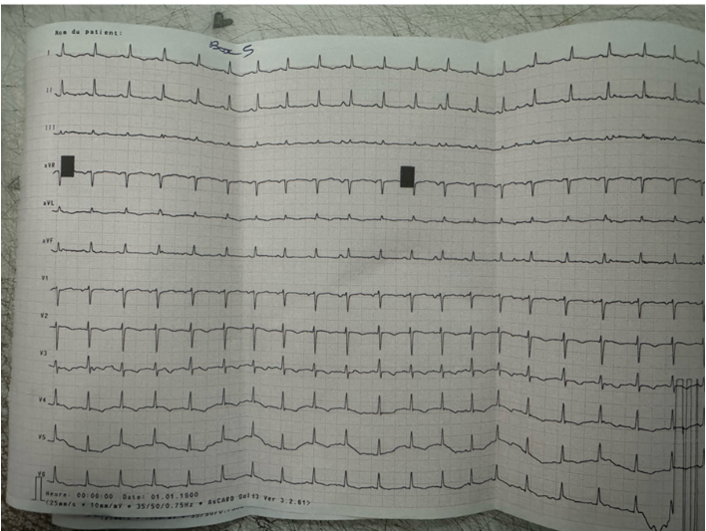
Figure 1 Electrocardiography Report
Transthoracic echocardiography revealed diffuse pericardial thickening associated with moderate circumferential pericardial effusion. Doppler analysis demonstrated significant respiratory variation (>25%) in mitral and tricuspid inflow velocities, consistent with ventricular interdependence. A septal bounce was observed, strongly suggestive of constrictive physiology (5,6).( figure 2)
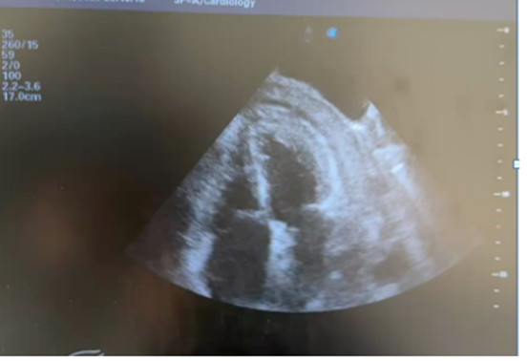
Figure 2 Transthoracic echocardiography report
Thoracic computed tomography confirmed diffuse pericardial thickening with moderate pericardial and bilateral pleural effusion, associated with pulmonary infiltrates and mediastinal, hilar, and axillary lymphadenopathy.(figure3)
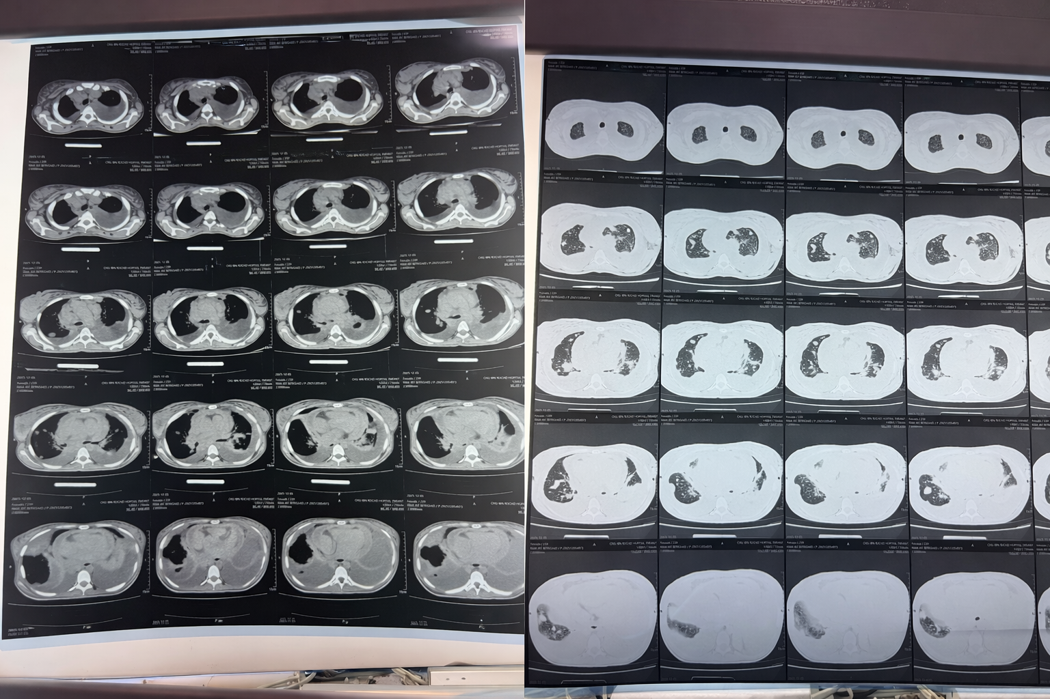
Figure 3 Computed Tomography Report
Diagnostic thoracentesis yielded an exudative pleural effusion with a protein concentration of 44 g/L and 100% lymphocytes, strongly suggestive of tuberculous etiology in an endemic context (4,7).
Given the high clinical suspicion, empirical anti-tuberculous therapy was initiated promptly, in combination with adjunctive corticosteroids.

Discussion
Tuberculous pericarditis remains one of the most severe forms of extrapulmonary tuberculosis and continues to represent a major cause of pericardial disease in endemic regions (3,8). The disease typically results from contiguous spread from infected mediastinal lymph nodes or hematogenous dissemination (4).
The natural history of tuberculous pericarditis is characterized by progression from pericardial effusion to constriction. However, recent evidence suggests that this progression is not always linear, and that some patients may present with inflammatory constrictive physiology, which is potentially reversible with appropriate therapy (5,6,9). This distinction is clinically crucial, as it directly influences management and prognosis.
In the present case, several features supported the diagnosis of inflammatory constriction, including acute symptom onset, marked inflammatory syndrome, absence of pericardial calcifications, and imaging findings suggestive of active disease.
Echocardiography remains the cornerstone of diagnosis, demonstrating characteristic findings such as septal bounce and exaggerated respiratory variation in transvalvular flow velocities (5). Multimodality imaging plays a key role, with computed tomography allowing evaluation of pericardial thickness and associated lymphadenopathy, while cardiac magnetic resonance imaging can identify pericardial inflammation through edema and late gadolinium enhancement (5,10).
The diagnosis of tuberculous pericarditis remains challenging. No single test provides sufficient sensitivity, and recent studies emphasize the role of combined diagnostic approaches, including molecular techniques such as PCR and GeneXpert, to improve diagnostic yield (7,11).
In endemic settings, however, a lymphocyte-predominant exudative effusion associated with systemic symptoms remains highly suggestive and often justifies empirical treatment (4).
Anti-tuberculous therapy remains the cornerstone of management. Adjunctive corticosteroids have been shown to reduce the incidence of constrictive pericarditis in selected patients, although their impact on mortality remains debated (12).
Pregnancy adds additional complexity. Immunological adaptations may facilitate disease progression, while physiological cardiovascular changes may delay diagnosis. In this case, intrauterine fetal demise likely reflects the severity of systemic inflammation and disease burden.
Pericardiectomy remains the definitive treatment for chronic constrictive pericarditis refractory to medical therapy, but is associated with significant morbidity and mortality (2). Therefore, early recognition of reversible inflammatory constriction is essential to avoid progression to irreversible disease and the need for surgical intervention.

Conclusion
Tuberculous pericarditis remains a significant cause of constrictive pericarditis in endemic regions. Early differentiation between reversible inflammatory constriction and chronic fibrotic disease is crucial, as it directly influences therapeutic strategy and prognosis. Prompt initiation of anti-tuberculous therapy combined with adjunctive corticosteroids may prevent progression to irreversible constriction requiring surgical intervention.

Consent
As per international standards or university standards, patient(s) written consent has been collected and preserved by the author(s).
Disclaimer (Artificial intelligence)
Author(s) hereby declare that NO generative AI technologies such as Large Language Models (ChatGPT, COPILOT, etc.) and text-to-image generators have been used during the writing or editing of this manuscript.

References (Optimized & Updated)
- Adler Y, Charron P, Imazio M, et al. 2015 ESC Guidelines for pericardial diseases. Eur Heart J. 2015.
- Welch TD. Constrictive pericarditis: diagnosis and management. Heart. 2018.
- Mayosi BM, Ntsekhe M. Tuberculous pericarditis. Circulation. 2013.
- Isiguzo G, Du Bruyn E, Ntsekhe M. Diagnosis and management of tuberculous pericarditis. Cardiol Clin. 2017.
- Klein AL, Abbara S, et al. Multimodality imaging in pericardial disease. JACC Cardiovasc Imaging. 2013.
- Imazio M, Gaita F. Reversible constrictive pericarditis. Eur Heart J. 2011.
- Reuter H, Burgess L, Doubell AF. Diagnostic approach to tuberculous pericarditis. Heart. 2020.
- Ntsekhe M, Mayosi BM. Epidemiology of tuberculous pericarditis. Heart Fail Rev. 2013.
- Miranda WR, Oh JK. Constrictive pericarditis: a contemporary review. JACC. 2020.
- Bogaert J, Francone M. Cardiac MRI in pericardial disease. JACC Imaging. 2013.
- Pandie S, et al. Improved diagnosis of tuberculous pericarditis using molecular tools. Eur Respir J. 2014.
- Mayosi BM, et al. Prednisolone in tuberculous pericarditis (IMPI trial). N Engl J Med. 2014

