Original Research Article
Development, Optimization and Biochemical Characterization of Bioplastic Films from Cassava Peels and False yam Tubers Starch.

.
ABSTRACT
The leaching of harmful chemicals from conventional plastics food packaging, into foods and their gradual accumulation in the living systems, has intensified concerns the use of plastics and its waste management control protocol. Their environmental persistence poses serious ricks to human health, environmental safety and aquatic. Therefore, study was set out to explored the development and analysis of starch extracted from cassava Manihot esculenta peels and false yam Icacina trichantha tubers to synthesize bioplastic films (C₀, F₀ and CF₀) and reinforced with 2.5% bleached fibre from bamboo stem (C_{2.5}, F_{2.5} and CF_{2.5}).The films were formed using glycerol as a plasticizer through solution casting technique. The developed films were analyzed for water barrier properties, mechanical, thermal, biochemical, and soil degradability. The incorporation of fibre into the starch matrices for bioplastic formulation significantly reduced the percentage of water absorption at 30, 40, 50 and 60ºC, while percentage water absorption increased as temperature increased. Ultimate tensile strength (UTS) and percentage elongation decreased on the addition of fibre reinforcement, with C₀ had the highest ultimate tensile strength (4.85 ± 0.12 MPa) while CF_{2.5} had the lowest (2.13 ± 0.28 MPa), CF₀ had the highest percentage elongation (22.22 ± 0.20%) while (CF_{2.5}) had the lowest (11.19 ± 0.32%). Film opacity increased with the addition of fibre reinforcement. Fourier Transform Infrared Spectroscopy (FTIR) analysis revealed that intermolecular hydrogen bonding occurred between glycerol and the two samples of starch extract and plasticizer. The synthesized bioplastic films showed similar thermal behaviour. The cross-sectional micrographs revealed that the films containing cassava peel starch showed higher homogeneity than films with false yam. The Gas chromatography mass spectrometer GC-MS analysis revealed high content of oleic acid which impacted on the structural integrity of synthesized bioplastic films. The degradation by films decreased with the addition of fibre reinforcement, C₀ had the highest degradation (43.52 ± 0.01%) at the 60 days. The findings of this research provide insights into the development of biodegradable medical products and food packaging bioplastic films.

Keywords: Bioplastic films, reinforcement, degradability, starch, fibre, characterization, agro-waste

1. INTRODUCTION

In modern society, plastic materials are widely used due to their favorable physicochemical properties, including excellent barrier performance, transparency, mechanical strength, and low production cost (Emadian et al., 2017). Conventional petroleum-based plastics such as polyethylene (PE), polypropylene (PP), and polyethylene terephthalate (PET) are extensively applied in food packaging, medical devices, construction, and consumer goods due to their versatility and thermal stability (Henning et al., 2022). However, their non-biodegradable nature has resulted in significant environmental challenges, including persistent accumulation in ecosystems, microplastic pollution, and adverse effects on human health and wildlife (Thomas, 2020; Bhuyan, 2022).
The environmental burden of plastic waste is particularly severe in developing countries. In Nigeria, large volumes of plastic waste are generated annually, with inadequate waste management practices contributing to marine pollution, blocked drainage systems, and increased flooding risks (Olanrewaju & Oyebade, 2019; Onaji-Benson & Ali, 2023). Additionally, plastic materials may contain toxic constituents capable of disrupting endocrine functions and causing long-term health effects (Okunola et al., 2019). These concerns have intensified the search for sustainable, biodegradable alternatives derived from renewable resources.
Bioplastic films produced from biomass-derived polymers such as starch, cellulose, and proteins have gained considerable attention due to their biodegradability, renewability, and environmental compatibility (Amin et al., 2019). Among these, starch is particularly attractive due to its abundance, low cost, and film-forming ability. However, starch-based films are inherently brittle and highly hydrophilic, which limits their mechanical performance and water resistance (Mendes et al., 2016). To overcome these limitations, reinforcement with natural fibres has been widely explored to improve structural integrity and functional properties.
The selection of cassava peel, false yam tuber starch, and bamboo fibre as raw materials in this study is driven by their availability, functional properties, and sustainability potential. Cassava peels, an abundant agro-industrial waste in cassava-processing regions, contain significant residual starch and provide a low-cost feedstock for bioplastic production while supporting waste valorization. False yam tubers represent an underutilized starch source with distinct amylose–amylopectin composition, which may enhance film-forming and structural characteristics. Bamboo fibre was incorporated as a natural reinforcement due to its high cellulose content, mechanical strength, and biodegradability, which can improve the mechanical stability and water resistance of starch-based films. The combined utilization of these materials therefore offers a sustainable strategy for developing cost-effective bioplastics with enhanced performance.
Despite growing interest in biomass-derived bioplastics, studies on the use of cassava peel starch remain limited, and the application of false yam tuber starch in bioplastic film development has been rarely explored. Therefore, this study aims to synthesize and characterize bioplastic films derived from cassava peel and false yam tuber starch, reinforced with bamboo fibre, with emphasis on their mechanical, physical, and functional properties
2. material and methods

2.1 Methodology
All reagents used were of analytical grade. Ethanol and glycerol were purchased from Guangdong Guanghua Sci-Tech Co., Ltd. (Shantou, Guangdong, China). Acetic acid solution (vinegar) was produced in the laboratory from bio-waste through a controlled fermentation and standardized to 38% (v/v) acetic acid prior to use.
2.1.1 Production of Bioplastic
The bioplastic films were produced by solution casting method as described by Prasteen et al. (2018) with slight modifications. The raw materials for bioplastic production included starch extracts of cassava peels and false yam tuber according to Abel et al. (2021), bamboo fibre Zhu et al. (2025), glycerol, vinegar and distilled water as displayed in list 1. Glycerol was used as a plasticizer, vinegar was used as a preservative and in addition to the dissolving effect of water. The effect of fibre as a reinforcement was determined.

List 1: Composition of prepared samples of bio-plastic films.
Sample | Cassava Peel Starch (g) | False Yam Starch (g) | Bamboo Fibre (g) | Distilled Water (mL) | Vinegar (mL) | Glycerol (mL)
Sample 1 (C₀) | 10 | 0 | 0 | 30 | 5 | 5
Sample 2 (C_{2.5}) | 7.5 | 0 | 2.5 | 30 | 5 | 5
Sample 3 (C₅) | 5 | 0 | 5 | 30 | 5 | 5
Sample 4 (F₀) | 0 | 10 | 0 | 30 | 5 | 5
Sample 5 (F_{2.5}) | 0 | 7.5 | 2.5 | 30 | 5 | 5
Sample 6 (F₅) | 0 | 5 | 5 | 30 | 5 | 5
Sample 7 (CF₀) | 5 | 5 | 0 | 30 | 5 | 5
Sample8 (CF_{2.5}) | 3.75 | 3.75 | 2.5 | 30 | 5 | 5
Sample 9 (CF₅) | 2.5 | 2.5 | 5 | 30 | 5 | 5

2.1.2 Bioplastic Characterization
2.1.2.1 Test for Mechanical Properties of Bioplastic
Mechanical properties were determined from the stress–strain curves generated by the Instron software. Force (N) and elongation (mm) data were converted to engineering stress and strain using standard relationships. Tensile stress (σ) was calculated as the applied force divided by the original cross-sectional area of the specimen, while tensile strain (ε) was obtained as the change in length divided by the original gauge length.
Ultimate tensile strength (UTS) was taken as the maximum stress recorded prior to specimen failure, while tensile yield strength was determined from the stress corresponding to the onset of permanent deformation (yield point). Elongation at break was calculated as the percentage increase in length at the point of fracture relative to the original gauge length.
Using the following calculation:
σ = F / A₀
ε = (L − L₀) / L₀ × 100
Elongation at break (%) = (L_{break} − L₀) / L₀ × 100
Where:
F = force (N)
A₀ = original cross-sectional area (mm²)
L₀ = initial gauge length (30 mm)
L_{break} = length at break

All reported values represent the mean of at least three independent measurements.

2.1.2.2 Film Opacity measurement
The optical opacity of the biofilms was determined according to Lescano et al. (2021). Film samples were cut into rectangular strips (10 × 80 mm) and placed in quartz cuvettes. Absorbance at 600 nm (A₆₀₀) was measured using a UV–Vis spectrophotometer (Genesys 10S UV-VIS, Thermo Fisher Scientific), with empty cuvettes used as blanks. Film thickness was measured using a digital micrometer at multiple points, and the average value was recorded.
Opacity was calculated using the following relationship:
$$Opacity= \frac{A_{600}}{Thickness (mm)} Equation 1$$
Results were expressed as A₆₀₀ mm⁻¹. All measurements were performed in triplicate and reported as mean values.
2.1.2.3 Water Absorption Test
Immersion method of Judawisastra et al. (2017) was adopted. Bioplastic sheets of known weights were immersed in distilled water at varying temperatures of 30, 40 and 50ºC for 60 min. The samples were taken out periodically at intervals of 0, 5, 10, 15, 20, 25, 30, 45 and 60 min, and weights were taken immediately after wiping out adsorbed water on the surface. The % water absorption by the bioplastic films were calculated using equation (2) shown below.
$\% Water absorption= \frac{W_{S}-W_{d}}{W_{S}} x 100 Equation 2$
Where $W_{S}$ is the weight after submersion and $W_{d}$ is the initial weight before submersion (dry weight).
2.1.2.4 Fourier Transform Infrared Spectroscopic (FTIR) Analysis
The functional group of the bioplastic films were assessed using using a FTIR model Vertex 70 Bruker spectrophotometer (Bruker, Germany). Spectra were recorded at a spectral range between of 4000 and 400 cm-1 and at a resolution of 4 cm-1 (Tarique et al., 2021; Weligama Thuppahige et al., 2023). The FTIR spectrum was employed in the transmittance mode. FTIR analyses were performed to ascertain the possible chemical interactions composite films.
2.1.2.5 Determination of Bioactive Compound in Bioplastic films
The assessment of bioactive compound of the synthesized bioplastic films was determined using a performed using an Agilent-6890 N gas chromatographer with an HP 5973 mass spectrometer detector. The identification of compounds in the bioplastic films was made by correlating mass spectra and retention times with that of pure compounds (Chandrasekar et al., 2023). Furthermore, the NIST (National Institute of Standards and Technologies, USA), mass spectra library, was also used for this analysis.
2.1.2.6 Scanning Electron Microscopic (SEM) Analysis of Bioplastic films
The surface morphology of the bioplastic films were studied using the method described by Tarique et al. (2021) using the Phenom XL G2 Desktop Scanning Electron Microscope (ThermoScientific). The fresh samples were fixed in 2.5% glutaraldehyde followed by dehydration using an ethanol series (range from 10% to 100%) and acetone (100%). The chemically treated samples were later dried using critical point drier. Then the samples were mounted on aluminium stubs using double-sided tapes and coated with a platinum layer (4 nm) to prevent charging. Samples were observed under the SEM at accelerating voltage of 15 kV, and the analysis was conducted under high vacuum mode. The SEM micrographs of 150µm magnification level was used to understand the morphological characterization.
2.1.2.7 Thermogravimetric analysis
Thermogravimetric analysis (TGA) were conducted according to Tarique et al. (2021) to ascertain the thermal stability and thermal decomposition of the bioplastic films using TGA Instruments (Mettler-Toledo AG, Schwerzenbach, Switzerland). The test parameters were taken as the temperature was varied from 25 to 600°C under a constant heating range of 10℃/min in a nitrogen gas medium. A 10 mg of the film sample was put and heated in the aluminium tray. The weight reduction versus temperature is illustrated in TGA analysis.
2.1.2.8 Soil Biodegradability Test
Biodegradability of synthesized bioplastic films were evaluated for 60 days through soil burial test method as described by Jangong et al. (2019). The bioplastic samples were oven dried at 70°C to remove any moisture until a steady weight was obtained and recorded as an initial weight of samples. This test was carried out by busrying the samples 30cm below the ground of a plantain plantation farm at Ikeduru Local Government Area of Imo State. An interval of 5 days was used after which the samples were taken out wiped with a clean soft brush to remove surface sand and debris that may add to the weight of the sample. The sample were then weighed and recorded as the final weight. The percentage degradability is calculated using the equation 3 below.
$$Degradability \%=\frac{W_{i}-W_{F}}{W_{i}} x 100 Equation 3$$
Where $W_{i}$ and $W_{f}$ denote weight before placement in soil and weight after the sample is taken out and cleaned respectively.
2.1.2.9 Statistical Analysis
Descriptive analysis was used to separate means and Turkey Post-Hoc test was used to compare the means aid of GraphPad version 9. Statistical significance was taken at p≤0.05. The results were presented in simple percentages and mean ± standard deviations.
3. results and discussion
The experimental results are presented in Figure 1 -17 and Table 1-8
Table 1: Showing the thickness, absorbance and opacity of various formulated Bio-plastic films.
 | Thickness (mm) | Absorbance | Opacity (mm⁻¹)
Samples
C₀ | 1.81 ± 0.09ª | 2.85 ± 0.07ª | 1.57 ± 0.02ª
F₀ | 1.77 ± 0.04ª | 2.82 ± 0.09ª | 1.59 ± 0.05ª
CF₀ | 1.88 ± 0.05ª | 2.99 ± 0.06ª | 1.59 ± 0.03ª
C_{2.5} | 1.90 ± 0.05ª | 3.97 ± 0.05^{b} | 2.09 ± 0.05^{b}
F_{2.5} | 1.80 ± 0.02ª | 3.91 ± 0.09^{b} | 2.17 ± 0.07^{b}
CF_{2.5} | 1.80 ± 0.03ª | 3.94 ± 0.08^{b} | 2.19 ± 0.06^{b}
Values bearing different alphabet letters per column are statistically significant (p<0.05) of bio-plastic films made from cassava peels and false yam tubers and reinforced with bamboo fibre. Where C₀=bio-plastic formulated from cassava peels starch, F₀ = bio-plastic formulated from false yam tubers starch, CF₀=bio-plastic formulated from an equal combination of false yam tubers starch and cassava peels starch, F_{2.5}= a combination of false yam tubers starch and 25% fibre reinforcement. C_{2.5} = 75% cassava peel starch and 25% fibre, CF_{2.5}=75% equal volume of cassava peel starch and false yam tubers and 25% fibre reinforcement.

Table 2. Mechanical properties of synthesized bioplastic films.
Test  Samples | UTS*, (N/mm²) | Yield strength  (x 10⁻¹ N/mm²) | Young's Modulus(Mpa) | % Elongation
C₀ | 4.85 ± 0.12ª | 0.35 ± 0.03ª | 5.56 ± 0.11ª | 20.34 ± 0.67ª
F₀ | 2.59 ± 0.17^{b} | 0.20 ± 0.01^{bc} | 3.24 ± 0.16^{bd} | 19.53 ± 0.22ª
CF₀ | 3.91 ± 0.11^{c} | 0.20 ± 0.01^{bc} | 14.33 ± 0.29^{c} | 22.22 ± 0.20^{b}
C_{2.5} | 3.22 ± 0.15^{d} | 0.17 ± 0.04^{bc} | 3.19 ± 0.88^{bd} | 15.68 ± 0.76^{c}
F_{2.5} | 2.86 ± 0.10^{bd} | 0.26 ± 0.02^{ac} | 14.25 ± 0.50^{c} | 13.89 ± 0.42^{d}
CF_{2.5} | 2.13 ± 0.28e | 0.61 ± 0.05^{b} | 4.13 ± 0.25^{b} | 11.19 ± 0.32^{ef}
Values are mean ± standard deviation of triplicate determinations. Values bearing different alphabet letters per column are statistically significant (p<0.05). UTS* (N/mm²) of bio-plastic films made from cassava peels and false yam tubers. Where C₀=bio-plastic formulated from cassava peels starch, F₀ = bio-plastic formulated from false yam tubers starch, CF₀=bio-plastic formulated from an equal combination of false yam tubers starch and cassava peels starch, F_{2.5}= a combination of false yam tubers starch and 25% fibre reinforcement. C_{2.5} = 75% cassava peel starch and 25% fibre, CF_{2.5}=75% equal volume of cassava peel starch and false yam tubers and 25% fibre reinforcement.

Figure 1: Showing the Ultimate Tensile strength of synthesized bioplastic films
UTS* is Ultimate tensile strength (N/mm²) of bioplastic films made from cassava peels and false yam tubers starch, reinforced with bamboo fibre. Bars are mean ± standard deviation of triplicate determinations. Bars bearing different alphabet letters per column are statistically significant (p<0.05). Where C₀=bioplastic formulated from cassava peels starch, F₀ =bioplastic formulated from false yam tubers starch, CF₀=bioplastic formulated from an equal combination of false yam tubers starch and cassava peels starch, F_{2.5}= a combination of false yam tubers starch and 25% fibre reinforcement. C_{2.5} = 75% cassava peel starch and 25% fibre, CF_{2.5}=75% equal volume of cassava peel starch and false yam tubers and 25% fibre reinforcement.C₀ presented a significantly higher ultimate tensile strength compared to other synthesized bioplastic film, CF_{2.5} had the lowest ultimate tensile strength.
(MPa)
Figure 2: Young’s Modulus of bioplastic films made from cassava peels and false yam tubers and reinforced with bamboo fibre.
Bars are mean ± standard deviation of triplicate determinations. Bars bearing different alphabet letters per column are statistically significant (p<0.05). Where C₀=bio-plastic formulated from cassava peels starch, F₀ = bio-plastic formulated from false yam tubers starch, CF₀=bio-plastic formulated from an equal combination of false yam tubers starch and cassava peels starch, F_{2.5}= a combination of false yam tubers starch and 25% fibre reinforcement. C_{2.5} = 75% cassava peel starch and 25% fibre, CF_{2.5}=75% equal volume of cassava peel starch and false yam tubers and 25% fibre reinforcement.

Figure 3: Percentage elongation of synthesized bioplastic films.
Bars are mean ± standard deviation of triplicate determinations. Bars bearing different alphabet letters per column are statistically significant (p<0.05). Where C₀=bio-plastic formulated from cassava peels starch, F₀ = bio-plastic formulated from false yam tubers starch, CF₀=bio-plastic formulated from an equal combination of false yam tubers starch and cassava peels starch, F_{2.5}= a combination of false yam tubers starch and 25% fibre reinforcement. C_{2.5} = 75% cassava peel starch and 25% fibre, CF_{2.5}=75% equal volume of cassava peel starch and false yam tubers and 25% fibre reinforcement.

Figure 4: Thickness of synthesized bioplastic films
Bars are mean ± standard deviation of triplicate determinations. Bars bearing different alphabet letters per column are statistically significant (p<0.05). Where C₀=bioplastic formulated from cassava peels starch, F₀ = bioplastic formulated from false yam tubers starch, CF₀=bioplastic formulated from an equal combination of false yam tubers starch and cassava peels starch, F_{2.5}= a combination of false yam tubers starch and 25% fibre reinforcement. C_{2.5} = 75% cassava peel starch and 25% fibre, CF_{2.5}=75% equal volume of cassava peel starch and false yam tubers and 25% fibre reinforcement.The thickness of the synthesized bioplastic films ranged from 1.5-2mm without any significant difference among them which indicated that the bioplastic films were consistently molded.

Figure 5: Absorbance of synthesized bioplastic films
Bars are mean ± standard deviation of triplicate determinations. Bars bearing different alphabet letters per column are statistically significant (p<0.05). Where C₀=bio-plastic formulated from cassava peels starch, F₀ = bio-plastic formulated from false yam tubers starch, CF₀=bio-plastic formulated from an equal combination of false yam tubers starch and cassava peels starch, F_{2.5}= a combination of false yam tubers starch and 25% fibre reinforcement. C_{2.5} = 75% cassava peel starch and 25% fibre, CF_{2.5}=75% equal volume of cassava peel starch and false yam tubers and 25% fibre reinforcement.
The absorbance varies significantly among the samples with lower absorbance reported among samples without the banboo fibre reinforcement (C₀), (F₀) and (CF₀) with values ranging between 2.82 to 2.99. Higher absorbance was reported among sample with bamboo fibre reinforcement (C_{2.5}), (F_{2.5}), (CF_{2.5}) with values ranging between 3.91-3.97. This suggests that the samples with reinforcement are more effective in absorbing light compared to samples without reinforcement.
Figure 6: Opacity of synthesized bioplastic films
Bars are mean ± standard deviation of triplicate determinations. Bars bearing different alphabet letters per column are statistically significant (p<0.05). Where C₀=bio-plastic formulated from cassava peels starch, F₀ = bio-plastic formulated from false yam tubers starch, CF₀=bio-plastic formulated from an equal combination of false yam tubers starch and cassava peels starch, F_{2.5}= a combination of false yam tubers starch and 25% fibre reinforcement. C_{2.5} = 75% cassava peel starch and 25% fibre, CF_{2.5}=75% equal volume of cassava peel starch and false yam tubers and 25% fibre reinforcement.
Opacity follows a similar trend to absorbance :Lower Opacity: ( C₀ ), ( F₀ ), ( C F₀ ) with values around 1.57 to 1.59.Higher Opacity: ( C_{2.5} ), ( F_{2.5} ), ( CF_{2.5} ) with values around 2.09 to 2.19.Higher opacity values indicate that samples ( C_{2.5} ), ( F_{2.5} ), and ( CF_{2.5}) are less transparent.

Figure 7. Percentage water absorption capacity of bioplastic films at 30°C for 60minutes.
Where C₀=bio-plastic formulated from cassava peels starch, F₀ = bio-plastic formulated from false yam tubers starch, CF₀=bio-plastic formulated from an equal combination of false yam tubers starch and cassava peels starch, F_{2.5}= a combination of false yam tubers starch and 25% fibre reinforcement. C_{2.5} = 75% cassava peel starch and 25% fibre, CF_{2.5}=75% equal volume of cassava peel starch and false yam tubers and 25% fibre reinforcement.
At 30°C, C₀ showed a gradual increase in water absorption, peaking at 45 minutes (2.7922%) and then decreasing. F₀ showed similar behavior with a peak at 45 minutes (1.7500%). CF₀ peaked at 60 minutes (1.8581%), indicating a delayed maximum absorption. C_{2.5} and F_{2.5} showed consistent increases, with C_{2.5} peaking at 55 minutes (1.7986%) and F_{2.5} at 45 minutes (2.0182%). CF_{2.5} peaked earlier at 30 minutes (1.6984%). Which was considered unusual.

Figure 8: Percentage water absorption capacity of bioplastic films at 40°C for 60minutes.
Where C₀ =bio-plastic formulated from cassava peels starch, F₀ = bio-plastic formulated from false yam tubers starch, CF₀=bio-plastic formulated from an equal combination of false yam tubers starch and cassava peels starch, F_{2.5}= a combination of false yam tubers starch and 25% fibre reinforcement. C_{2.5} = 75% cassava peel starch and 25% fibre, CF_{2.5}=75% equal volume of cassava peel starch and false yam tubers and 25% fibre reinforcement.
At 40°C, C₀ showed a peak at 35 minutes (2.7314%). F0 peaked at 55 minutes (2.0143%). CF₀ peaked at 35 minutes (2.1585%). C2.5 showed a steady increase, peaking at 60 minutes (2.2525%). F2.5 showed two peaks, at 45 minutes (1.8625%) and 55 minutes (2.0143%). CF _{2.5} peaked at 60 minutes (1.8222%).

Figure 9. Percentage water absorption capacity of bioplastic films at 50°c for 60minutes.
Where C₀=bioplastic formulated from cassava peels starch, F₀ = bioplastic formulated from false yam tubers starch, CF₀=bioplastic formulated from an equal combination of false yam tubers starch and cassava peels starch, F_{2.5}= a combination of false yam tubers starch and 25% fibre reinforcement. C_{2.5} = 75% cassava peel starch and 25% fibre, CF_{2.5}=75% equal volume of cassava peel starch and false yam tubers and 25% fibre reinforcement.
At 50°C, C₀ showed a peak at 35 minutes (3.5367%). F₀ peaked at 50 minutes (2.9443%). CF₀ showed a steady increase, peaking at 45 minutes (2.9039%). C_{2.5} had a steady increase, peaking at 55 minutes (2.2570%). F_{2.5} showed multiple peaks, with the highest at 35 minutes (2.3592%). CF_{2.5} peaked at 40 minutes (3.1846%).

Figure 10. Percentage water absorption capacity of bioplastic films at 60°C for 60minutes.
Where C₀=bioplastic formulated from cassava peels starch, F₀ = bioplastic formulated from false yam tubers starch, CF₀=bioplastic formulated from an equal combination of false yam tubers starch and cassava peels starch, F_{2.5}= a combination of false yam tubers starch and 25% fibre reinforcement. C_{2.5} = 75% cassava peel starch and 25% fibre, CF_{2.5}=75% equal volume of cassava peel starch and false yam tubers and 25% fibre reinforcement.

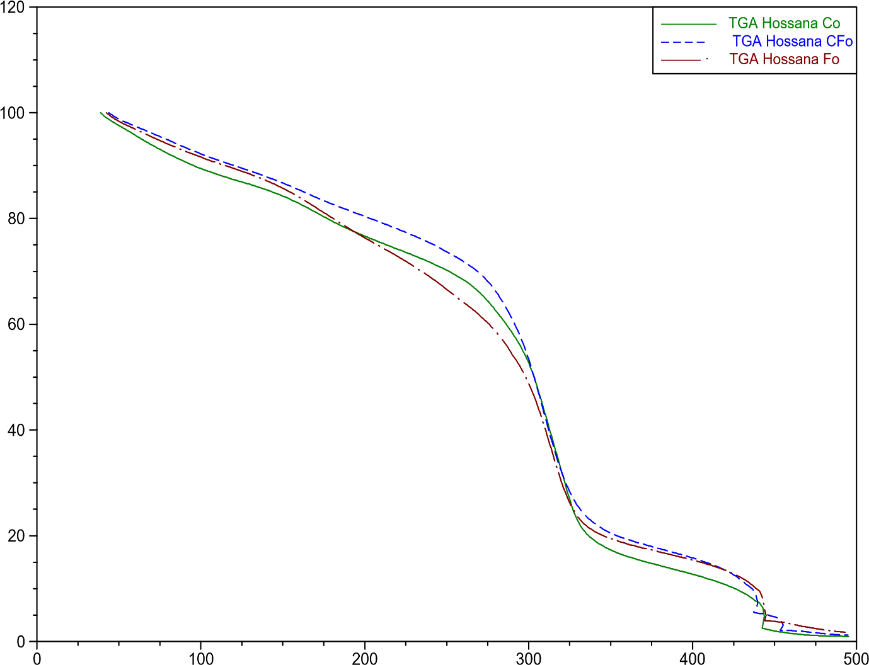
% Weight
Temperature (°C)
Figure 11. Thermogrametric analysis curves of synthesized bioplastic films.
Where C₀= Bioplastic film synthesized from cassava peels starch, F₀= Bioplastic film formulated from false yam starch and Cf₀= Bioplastic film formulated from equal combination of false yam starch and cassava peel starch. The three samples of bioplastic films all followed the same pattern of decomposition with sample CF₀ having a relatively higher percentage weight loss the samples behaved exactly the same way from 300ºC to 350ºC.
At 60°C, C₀ peaked at 30 minutes (3.9250%) and then dropped to 0%. F₀ showed an initial peak at 20 minutes (2.8639%) and then decreased to 0%. CF peaked at 40 minutes (2.0311%) and then decreased. C_{2.5} showed a peak at 35 minutes (3.8511%) and then dropped. F_{2.5} showed a peak at 35 minutes (2.8996%) and then decreased. CF_{2.5} peaked at 35 minutes (3.5206%).

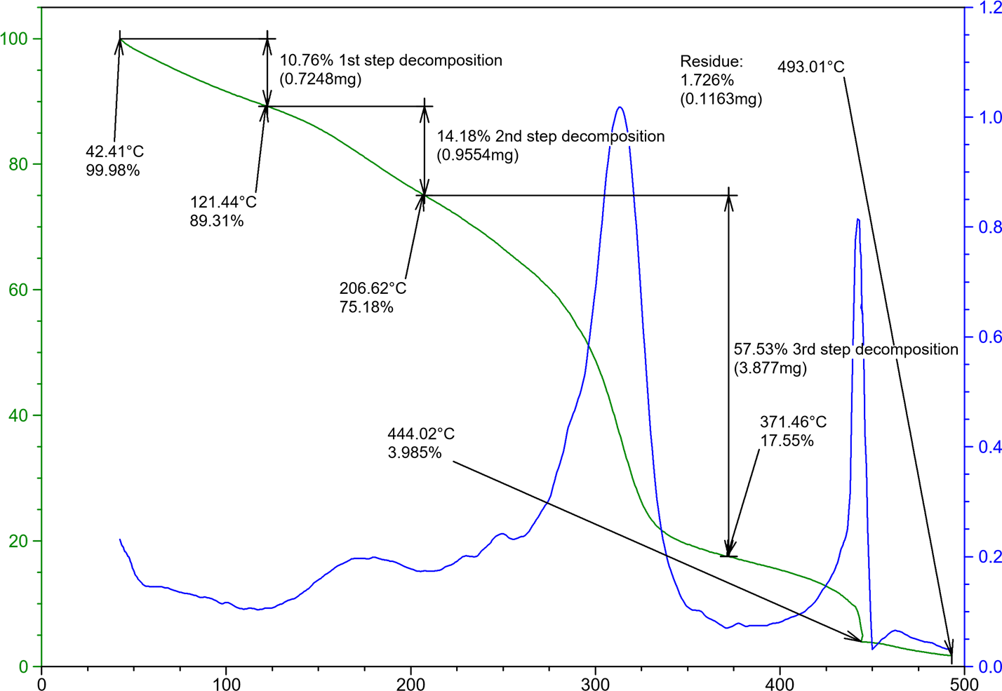
% Weight Loss
Derivative weight (%/min)
Temperature (°c)
FIGURE 12. Thermogravimetric analysis curve and the derivative weight loss of synthesized bioplastic films.
The graph showed three decomposition stages which is typical to bioplastic films. Decomposition at stage one began at 42.41ºC, with a 99.98% mass remaining, a 10.76% mass loss occurred at 121.44ºC. The second decomposition stage involved a 14.18% mass loss at 206.62ºC, while at stage three there was a corresponding weight loss of 57.53% at 371.46ºC

Table 3. Bioactive compounds present in synthesized bioplastic films from cassava peel starch (C₀).
S/N | Retention Time | Bioactive Components | % Report
1 | 5.533 | 4-Mercaptophenol | 0.14
2 | 6.375 | 2(3H)-Furanone | 0.29
3 | 6.788 | Cyclobut-1-enylmethanol | 0.02
4 | 7.061 | 3(2H)-Pyridazinone, 6-methyl- | 0.28
5 | 7.240 | 7-Oxabicyclo[4.1.0]heptan-2-one, 6-methyl- | 0.20
6 | 8.238 | D-Fructose, 1-O-methyl- | 5.50
7 | 8.361 | (R*,R*)-5-Hydroxy-4-methyl-3-heptanone | 7.38
8 | 9.066 | n-Nonadecanol-1 | 0.78
9 | 9.455 | Cyclohexanecarboxylic acid, 4-methyl-, methyl ester | 0.75
10 | 9.717 | Carbonic acid, but-2-yn-1-yl pentadecyl ester | 0.57
11 | 10.065 | 2-Hexyn-1-ol | 0.37
12 | 10.194 | 2-Hexyn-1-ol | 0.39
13 | 10.588 | Dodecane, 1-fluoro- | 4.83
14 | 10.949 | 3-Deoxy-d-mannoic lactone | 1.43
15 | 11.451 | Oxazole, 5-hexyl-2,4-dimethyl- | 1.63
16 | 11.802 | (1R,2R,8aS)-2,4,4,7a-Tetramethyl-1-(3-oxobutyl)-trans-hydrindan-2-carboxylic acid | 0.66
17 | 12.077 | 3-Methyl-4-(phenylthio)-2-prop-2-enyl-2,5-dihydrothiophene 1,1-dioxide | 0.27
18 | 12.160 | 1-Dodecanol, 2-hexyl- | 0.48
19 | 12.369 | Styracitol | 0.30
20 | 12.615 | Undecanoic acid | 0.50
21 | 12.771 | Lactose | 0.23
22 | 12.888 | Oleic acid | 0.20
23 | 13.151 | Hexadecanoic acid, methyl ester | 1.16
24 | 13.287 | 2-Methyl-Z,Z-3,13-octadecadienol | 0.30
25 | 13.763 | 1,2-Benzenedicarboxylic acid, butyl 2-methylpropyl ester | 0.63
26 | 13.931 | n-Hexadecanoic acid | 4.34
27 | 14.475 | n-Hexadecanoic acid | 0.18
28 | 14.685 | 7,11-Hexadecadienal | 0.50
29 | 15.085 | Cyclopropaneoctanal, 2-octyl- | 0.06
30 | 15.359 | Trifluoroacetoxy hexadecane | 0.24
31 | 15.530 | trans-13-Octadecenoic acid, methyl ester | 1.45
32 | 15.891 | N-Furfuryl-N'-(benzyl)oxamide | 2.47
33 | 16.413 | Oleic acid | 4.34
34 | 16.686 | Octadecanoic acid | 1.87
35 | 17.008 | cis-7,cis-11-Hexadecadien-1-yl acetate | 0.34
36 | 17.681 | 9,12-Octadecadienoic acid (Z,Z)- | 0.07
37 | 18.197 | Hexadecenoic acid, Z-11- | 0.06
38 | 18.396 | 6-Octadecenoic acid, (Z)- | 0.10
39 | 18.684 | 9,12-Octadecadienoic acid (Z,Z)- | 0.14
40 | 18.807 | Oleic acid | 0.16
41 | 19.367 | 9,12-Octadecadienoic acid (Z,Z)- | 0.12
42 | 19.864 | Oleic acid | 0.31
43 | 20.088 | cis-7,cis-11-Hexadecadien-1-yl acetate | 0.00
44 | 20.384 | 6-Octadecenoic acid | 0.16
45 | 20.450 | Cis-13-6-Octadecenoic acid | 0.06
46 | 20.571 | Oleic acid | 0.03
47 | 20.771 | 9-Octadecenoic acid | 0.16
48 | 21.060 | 9,17-Octadecadienal, (Z)- | 0.18
49 | 21.168 | Oleic acid | 0.08
50 | 21.391 | Oleic acid | 0.21
51 | 21.491 | Oleic acid | 0.04
52 | 21.582 | Oleic acid | 0.04
53 | 21.897 | 9-Octadecenal, (Z)- | 1.12
54 | 22.162 | 6-Octadecenoic acid, (Z)- | 0.63
55 | 22.488 | Oleic acid | 0.21
56 | 22.598 | Oleic acid | 0.02
57 | 22.846 | Oleic acid | 0.42
58 | 23.106 | 6-Octadecenoic acid, (Z)- | 0.27
59 | 23.430 | Oleic acid | 0.21
60 | 23.500 | Oleic acid | 0.09
61 | 23.615 | 1,2-Benzisothiazole, 3-(hexahydro- 1H-azepin-1-yl)-, 1,1-dioxide | 0.03
62 | 23.712 | Oleic acid | 0.18
63 | 23.876 | Hexadecenoic acid, Z-11- | 0.17
64 | 24.012 | Oleic acid | 0.18
65 | 24.314 | 6-Octadecenoic acid, (Z)- | 0.61
66 | 24.570 | 2,3-Dihydroxypropyl elaidate | 0.45
67 | 24.636 | Oleic acid | 0.27
68 | 24.705 | Cyclopropaneoctanal, 2-octyl- | 0.16
69 | 24.834 | Oleic acid | 0.68
70 | 25.386 | n-Propyl 11-octadecenoate | 1.30
71 | 25.518 | Oleic acid | 0.22
72 | 25.607 | Succinic acid, di(2-methoxyphenyl) ester | 0.24
73 | 26.171 | Oleic acid | 2.55
74 | 26.296 | Oleic acid | 0.26
75 | 26.686 | Nickel, (.eta.-4-diallyl ether)-(2,4-dimethyl-3-pentylisonitrile) | 2.12
76 | 27.405 | Oleic acid | 7.02
77 | 27.622 | Propanamide, N-(3-methoxyphenyl)-2,2-dimethyl- | 1.40
78 | 27.771 | Propanamide, N-(3-methoxyphenyl)-2,2-dimethyl- | 0.45
79 | 27.821 | 4-Quinolinecarboxylic acid, 2-chloro- | 0.30
80 | 27.868 | Propanamide, N-(3-methoxyphenyl)-2,2-dimethyl- | 1.35
81 | 28.034 | 1H-Indole-2-carboxylic acid, 6-(4-ethoxyphenyl)-3-methyl-4-oxo-4,5,6,7-tetrahydro-, isopropyl ester | 1.22
82 | 28.240 | Benzo[h]quinoline, 2,4-dimethyl- | 0.84
83 | 28.323 | Thymol, TBDMS derivative | 1.53
84 | 28.759 | Pyridine-3-carboxamide, oxime, N-(2-trifluoromethylphenyl)- | 1.74
85 | 28.834 | 1H-Indole-2-carboxylic acid, 6-(4-ethoxyphenyl)-3-methyl-4-oxo-4,5,6,7-tetrahydro-, isopropyl ester | 0.86
86 | 29.263 | Ethyl 2-acetamido-3,3,3-trifluoro-2-(4-fluoroanilino)propionate | 3.36
87 | 29.574 | Thymol, TBDMS derivative | 0.41
88 | 29.858 | Thymol, TBDMS derivative | 0.56
89 | 30.246 | Acetamide, 2-chloro-N-(3-cyano-4,6-dihydro-4,4,6,6-tetramethylthieno[2,3-c]furan-2-yl)- | 1.98
90 | 30.344 | Heptasiloxane, 1,1,3,3,5,5,7,7,9,9,11,11,13,13-tetradecamethyl- | 1.54
91 | 30.685 | Thymol, TBDMS derivative | 2.52
92 | 31.015 | Propanamide, N-(4-methoxyphenyl)-2,2-dimethyl- | 0.59
93 | 31.134 | 2-Ethylacridine | 0.53
94 | 31.200 | Thymol, TBDMS derivative | 1.36
95 | 31.651 | Propanamide, N-(3-methoxyphenyl)-2,2-dimethyl- | 1.04
96 | 31.989 | Ethyl 2-acetamido-3,3,3-trifluoro-2-(2-fluoroanilino)propionate | 0.24
97 | 32.586 | Propanamide, N-(3-methoxyphenyl)-2,2-dimethyl- | 0.26
98 | 32.744 | Thymol, TBDMS derivative | 0.18
99 | 32.796 | Thymol, TBDMS derivative | 0.14
100 | 32.863 | 1-methyl-4-phenyl-5-thioxo-1,2,4-triazolidin-3-one | 0.23
101 | 33.065 | 3-Quinolinecarboxylic acid, 6,8-difluoro-4-hydroxy-, ethyl ester | 0.26
102 | 33.214 | Nickel, (.eta.-4-diallyl ether)-(2,4-dimethyl-3-pentylisonitrile) | 0.22
103 | 33.366 | Bisnorandrostane, 3,12-diacetoxy-17-(1-methyl-4-oxo-5-phenylpentyl)- | 0.21
104 | 33.780 | Pyridine-3-carboxamide, oxime, N-(2-trifluoromethylphenyl)- | 1.23
105 | 33.847 | Ethyl 2-(2-chloroacetamido)-3,3,3-trifluoro-2-(3-fluoroanilino)propionate | 0.85
106 | 34.149 | Propanamide, N-(4-methoxyphenyl)-2,2-dimethyl- | 0.21
107 | 34.566 | Stigmasterol | 5.32
108 | 35.522 | Propanamide, N-(3-methoxyphenyl)-2,2-dimethyl- | 0.06
109 | 35.594 | 2,6-Lutidine, 3,5-dichloro-4-cyclohexylthio- | 0.09
110

Bioplastic films synthesized from cassava peel starch (C₀) bioplastic films presented 110 bioactive compounds. (R*,R*)-5-Hydroxy-4-methyl-3-heptanone and Oleic acid had the highest percentage report of 7.38% and 7.02% with retention time of 8.238 minutes and 27.405 minutes respectively. Propanamide, N-(3-methoxyphenyl)-2,2-dimethyl- had the lowest percentage report of 0.01% with a retention time of 35.770 minutes.

Table 4: Bioactive compounds present in bioplastic film synthesized from false yam tuber starch (F₀).
S/N | Retention Time | Bioactive Components | % Report
1 | 6.755 | 2-Fluorobenzyl alcohol | 0.13
2 | 7.115 | (1S,2R,4R,7R)-4-Isopropyl-7-methyl -3,8-dioxatricyclo [5.1.0.02,4]octane | 0.26
3 | 7.942 | 1-Nitro-2-acetamido-1,2-dideoxy-d-mannitol | 0.90
4 | 8.586 | Butanoic acid, 3-hydroxy-, ethyl ester | 0.39
5 | 8.675 | 2H-Azepin-2-one, hexahydro-1-(hydroxymethyl)- | 0.34
6 | 9.908 | 6-Acetyl-.beta.-d-mannose | 0.15
7 | 10.206 | Undec-10-ynoic acid, undecyl ester | 0.25
8 | 10.466 | Cyclononene | 0.29
9 | 10.705 | Dodecyl propyl ether | 0.28
10 | 10.819 | Decanoic acid, 2,3-dihydroxypropyl ester | 0.13
11 | 11.068 | Undecylenic acid | 0.36
12 | 11.377 | n-Hexadecanoic acid | 0.16
13 | 11.460 | d-Lyxose | 0.22
14 | 12.076 | Undec-10-ynoic acid, tetradecyl ester | 0.14
15 | 12.381 | Cyclopentadecanone, 2-hydroxy- | 0.14
16 | 12.550 | Undec-10-ynoic acid, undecyl ester | 0.10
17 | 13.156 | Hexadecanoic acid, methyl ester | 0.36
18 | 13.893 | n-Hexadecanoic acid | 1.97
19 | 14.292 | Z,Z-4,16-Octadecadien-1-ol acetate | 0.45
20 | 14.477 | 3-Dodecen-1-ol | 0.22
21 | 14.829 | (S,Z)-Heptadeca-1,9-dien-4,6-diyn-3-ol | 1.42
22 | 15.184 | 9-Octadecenal | 0.01
23 | 15.246 | Cyclopropaneoctanal, 2-octyl- | 0.01
24 | 15.528 | 11-Octadecenoic acid, methyl ester | 1.11
25 | 15.886 | Methyl stearate | 0.31
26 | 16.113 | cis-9,10-Epoxyoctadecan-1-ol | 0.12
27 | 16.406 | cis-13-Octadecenoic acid | 2.37
28 | 16.676 | Octadecanoic acid | 0.90
29 | 16.955 | Cyclopropaneoctanal, 2-octyl- | 0.37
30 | 17.714 | 11-Dodecen-1-ol trifluoroacetate | 0.16
31 | 17.768 | Cyclopropaneoctanal, 2-octyl- | 0.03
32 | 17.910 | 1,3,12-Nonadecatriene | 0.22
33 | 18.012 | Oleic acid | 0.08
34 | 18.431 | E-11-Hexadecenal | 0.16
35 | 18.610 | 9,17-Octadecadienal, (Z)- | 0.22
36 | 18.856 | Cyclopropaneoctanal, 2-octyl- | 0.09
37 | 18.902 | Oleic acid | 0.04
38 | 18.997 | (Z)-Tetradec-11-en-1-yl 2,2,2-trifluoroacetate | 0.02
39 | 19.124 | Oleic acid | 0.23
40 | 19.363 | Oleic acid | 0.06
41 | 19.447 | Oleic acid | 0.05
42 | 19.840 | 9-Octadecenoic acid, (E)- | 0.11
43 | 20.178 | Oleic acid | 0.16
44 | 20.502 | Oleic acid | 0.09
45 | 20.780 | Oleic acid | 0.07
46 | 20.871 | 6-Octadecenoic acid, (Z)- | 0.01
47 | 21.134 | 1-Cyclohexylnonene | 0.15
48 | 21.211 | Oleic acid | 0.03
49 | 21.517 | 6-Octadecenoic acid, (Z)- | 0.06
50 | 21.575 | 6-Octadecenoic acid, (Z)- | 0.22
51 | 21.960 | Oleic acid | 0.06
52 | 22.238 | 6-Octadecenoic acid, (Z)- | 0.33
53 | 22.536 | Propyleneglycol monoleate | 0.36
54 | 22.821 | 9-Octadecenoic acid (Z)-, 2-hydroxy-1-(hydroxymethyl)ethyl ester | 0.13
55 | 22.924 | Oleic acid | 0.14
56 | 23.210 | 9-Octadecenoic acid (Z)-, 2-hydroxy-1-(hydroxymethyl)ethyl ester | 0.21
57 | 24.000 | Acetamide, 2-chloro-N-(3-cyano-4,6 -dihydro-4,4,6,6-tetramethylthieno[2,3-c]furan-2-yl)- | 0.82
58 | 25.610 | Anthracene, 9-(2-propenyl)- | 6.79
59 | 25.777 | 1H-Indene, 2-butyl-5-hexyloctahydro- | 1.13
60 | 25.970 | Pyridine-3-carboxamide, oxime, N-(2-trifluoromethylphenyl)- | 0.77
61 | 26.143 | 2,6-Lutidine, 3,5-dichloro-4-cyclohexylthio- | 1.35
62 | 27.467 | 1H-Indene, 2-butyl-5-hexyloctahydro- | 25.02
63 | 28.294 | 2-Ethylacridine | 3.28
64 | 28.780 | Thymol, TBDMS derivative | 5.02
65 | 29.170 | Thymol, TBDMS derivative | 2.28
66 | 29.470 | Acetamide, 2-chloro-N-(3-cyano-4,6-dihydro-4,4,6,6-tetramethylthieno[2,3-c]furan-2-yl)- | 5.67
67 | 29.843 | Thymol, TBDMS derivative | 1.72
68 | 30.337 | Acetamide, 2-chloro-N-(3-cyano-4,6-dihydro-4,4,6,6-tetramethylthieno[2,3-c]furan-2-yl)- | 5.19
69 | 30.597 | Demecolcine | 1.41
70 | 30.796 | Benzo[h]quinoline, 2,4-dimethyl- | 2.95
71 | 31.356 | 6-Chloro-1-ethyl-4-oxo-N-(pyridin-4-ylmethyl)quinoline-3-carboxamide | 2.86
72 | 31.915 | Benzo[h]quinoline, 2,4-dimethyl- | 9.82
73 | 32.992 | Cyclopenteno[4.3-b]tetrahydrofuran, 3-[(4-methyl-5-oxo-3-phenylthio)tetrahydrofuran-2-yloxymethylene]- | 2.11
74 | 33.695 | Propanamide, N-(3-methoxyphenyl)-2,2-dimethyl- | 2.59
75 | 34.510 | 1,2-Benzenediol, 3,5-bis(1,1-dimethylethyl)- | 2.63
76 | 35.168 | Cyclopenteno[4.3-b]tetrahydrofuran, 3-[(4-methyl-5-oxo-3-phenylthio)tetrahydrofuran-2-yloxymethylene]- | 0.19
77 | 35.312 | 1H-Indole-2-carboxylic acid, 6-(4-ethoxyphenyl)-3-methyl-4-oxo-4,5,6,7-tetrahydro-, isopropyl ester | 0.17
78 | 35.425 | Thymol, TBDMS derivative | 0.28

The Table 4. presented 78 bioactive compounds for bioplastic film synthesized from false yam tuber starch (F₀). 1H-Indene, 2-butyl-5-hexyloctahydro-and Benzo[h]quinoline, 2,4-dimethyl-had significantly high % reports of 25.02% and 9.82% respectively.

Table 5: Bioactive compounds present in bioplastic film synthesized from starch extract of cassava peels and false yam tuber (CF₀).
S/N | Retention Time | Bioactive Components | % Report
1 | 8.120 | Hexadecane | 0.39
2 | 8.926 | Methyl tetradecanoate | 0.29
3 | 10.821 | Tetradecanal | 0.60
4 | 12.280 | 2-Heptadecanone | 1.30
5 | 12.676 | Hexadecanoic acid, methyl ester | 0.79
6 | 13.818 | n-Hexadecanoic acid | 15.90
7 | 15.142 | 9,12-Octadecadienoic acid (Z,Z)- | 1.72
8 | 15.425 | 9-Octadecenoic acid, methyl ester, (E)- | 2.70
9 | 15.755 | Methyl stearate | 0.40
10 | 16.614 | trans-13-Octadecenoic acid | 63.90
11 | 17.682 | 9,17-Octadecadienal, (Z)- | 3.12
12 | 19.692 | Oleic acid | 0.89
13 | 20.378 | 9-Octadecenal, (Z)- | 0.40
14 | 21.127 | 2-Methyl-Z,Z-3,13-octadecadienol | 1.27
15 | 24.150 | Oleic acid | 0.40
16 | 27.057 | Erucic acid | 2.59
17 | 30.006 | Z-2-Octadecen-1-ol | 0.93
18 | 30.256 | Oleic acid | 1.17
19 | 33.585 | Oleic acid | 0.85
20 | 34.956 | Oleic acid | 0.38

The result presented 20 bioactive compounds for bioplastic film synthesized from starch extract of cassava peels and false yam tuber (CF₀). A remarkably high % report was observed for trans-13-Octadecenoic acid (63.90%) and n-Hexadecanoic acid (15.90%) with retention time of 16.614min. and 13.818min. respectively

Table 6: FTIR identified functional groups of synthesized bioplastic film (F₀).
Wavelength (cm⁻¹) | Peak Area | Functional Group | Intensity | Interpretation
745 | 16 | C-H bending | Weak | Indicates the presence of alkane or aromatic structures, possibly C-H bending vibrations.
844 | 63 | C-H bending (out-of-plane) | Medium | Suggests the presence of aromatic compounds, especially mono-substituted benzene rings due to out-of-plane C-H bending.
1302 | 75 | C-N stretching | Medium | Indicates the presence of primary or secondary amines, likely due to C-N stretching vibrations.
1432 | 75 | CH₂ bending | Medium | Suggests alkane structures due to CH₂ bending vibrations.
1820 | 186 | C=C stretching | Strong | Indicates the presence of alkenes or aromatic compounds due to C=C stretching vibrations.
1991 | 166 | C≡C stretching | Strong | Indicates strongly the presence of alkynes due to C≡C.
2208 | 141 | C≡N stretching | Strong | Suggests the presence of nitriles due to C≡N stretching vibrations.
2509 | 91 | S-H stretching | Medium | Indicates the presence of thiols due to S-H stretching vibrations.
2741 | 184 | C-H stretching | Strong | Strong peak suggests the presence of aldehydes due to C-H stretching vibrations.
2919 | 177 | C-H stretching | Strong | Indicates the presence of alkanes due to C-H stretching vibrations.
3341 | 138 | N-H stretching  Possible | Strong | Suggests the presence of amines due to N-H stretching vibrations.
3438 | 19 | O-H stretching (broad) | Weak | Broad peak indicates the presence of alcohols or phenols due to O-H stretching vibrations.
3551 | 13 | O-H stretching | Weak | Indicates the presence of alcohols due to O-H stretching vibrations.
3815 | 10 | O-H stretching | Weak | Suggests the presence of free O-H groups in alcohols due to O-H stretching.
3884 | 11 | O-H stretching | Weak | Indicates the presence of alcohols due to O-H stretching vibrations.

Table7: FTIR identified functional groups of synthesized bioplastic film (C₀).
Wavelength (cm⁻¹) | Peak Area | Functional Group | Intensity | Interpretation
762 | 55 | C-H bending | Medium | Indicates the presence of alkane or aromatic structures, possibly C-H bending vibrations.
1228 | 125 | C-O stretching | Strong | Suggests the presence of alcohols, ethers, or esters due to C-O stretching vibrations.
1435 | 22 | CH₂ bending | Weak | Suggests alkane structures due to CH₂ bending vibrations.
1622 | 40 | C=C stretching | Medium | Indicates the presence of alkenes or aromatic compounds due to C=C stretching vibrations.
1841 | 207 | C=O stretching | Strong | Strongly indicates the presence of anhydrides or ketones due to C=O stretching vibrations.
1933 | 455 | C=O stretching | Very Strong | Very strong peak indicating the presence of anhydrides or other carbonyl-containing compounds due to C=O stretching vibrations.
2455 | 106 | S-H stretching | Strong | Indicates the presence of thiols due to S-H stretching vibrations.
2695 | 158 | C-H stretching | Strong | Suggests the presence of aldehydes due to C-H stretching vibrations.
2810 | 124 | C-H stretching | Strong | Indicates the presence of aldehydes or other hydrocarbons due to C-H stretching vibrations.
2997 | 144 | C-H stretching | Strong | Suggests the presence of alkanes due to C-H stretching vibrations.
3395 | 66 | O-H stretching | Medium | Indicates the presence of alcohols or phenols due to O-H stretching vibrations
3512 | 67 | O-H stretching | Medium | Suggests the presence of alcohols or phenols due to O-H stretching vibrations.

Table 8: FTIR identified functional groups of synthesized bioplastic film (CF₀).
Wavelength (cm⁻¹) | Peak Area | Functional Group | Intensity | Interpretation
809.66 | 66 | C-H (aromatic) Out-of-plane bending | Weak | Indicates the presence of aromatic compounds due to the low peak area.
1270 | 24 | C-O stretching | Very Weak | Stretching in alcohols, ethers, indicates a very weak presence of alcohols or ethers.
1385 | 71 | C-H (alkane) | Weak | Bending vibrations, indicates the presence of alkanes
1444 | 61 | C=C (aromatic) | Weak | Stretching in aromatics, indicates the presence of aromatic rings
1868 | 152 | C=O (anhydrides) | Strong | Indicates a strong presence of anhydrides
1968 | 215 | C=O (ketones) | Strong | Indicates a strong presence of ketones.
2079 | 20 | C≡C (alkyne) | Very Weak | Indicates a very weak presence of alkynes.
2160 | 83 | C≡N (nitriles) | Weak | Indicates the presence of nitriles with weak intensity.
2465 | 18 | C-H (alkyne) | Very Weak | Stretching vibrations, indicates a very weak presence of alkynes.
2589 | 137 | S-H (thiol) | Medium | Stretching vibrations, indicates a medium presence of thiols.
2790 | 94 | C-H (aldehyde) | Weak | Indicates the presence of aldehydes.
2914 | 83 | C-H (alkane)  Stretching | Weak | Indicates the presence of alkanes.
3034 | 65 | O-H (alcohol | Weak | Indicates the presence of alcohols
3236 | 83 | N-H (amine) | Weak | Indicates the presence of amines
3351 | 92 | O-H stretching | Weak | Indicates the presence of carboxylic acids.

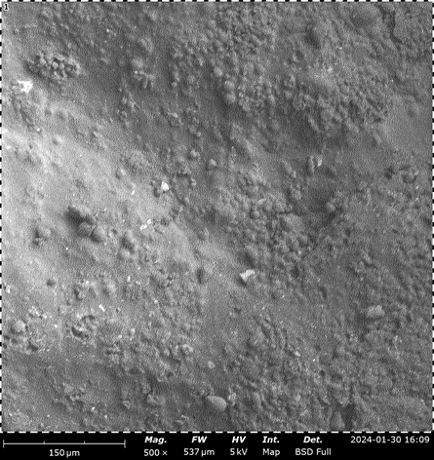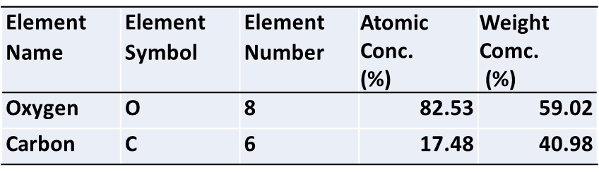
Figure 13: Scanning electron microscopy of synthesized bioplastic films from Cassava peel starch C₀ at 500x
The bioplastic film showed a cross-sectional areas of homogeneity and an area with slightly rough and porous texture having the individual granules clustered together, as seen in the outlined red circles on the micrograph. The table next to the image highlights the elemental composition of the bioplastic film, showing that it consists mainly of oxygen (82.53% atomic concentration) and carbon (17.48%) with a corresponding weight concentrations of 59.02% and 40.98% respectively

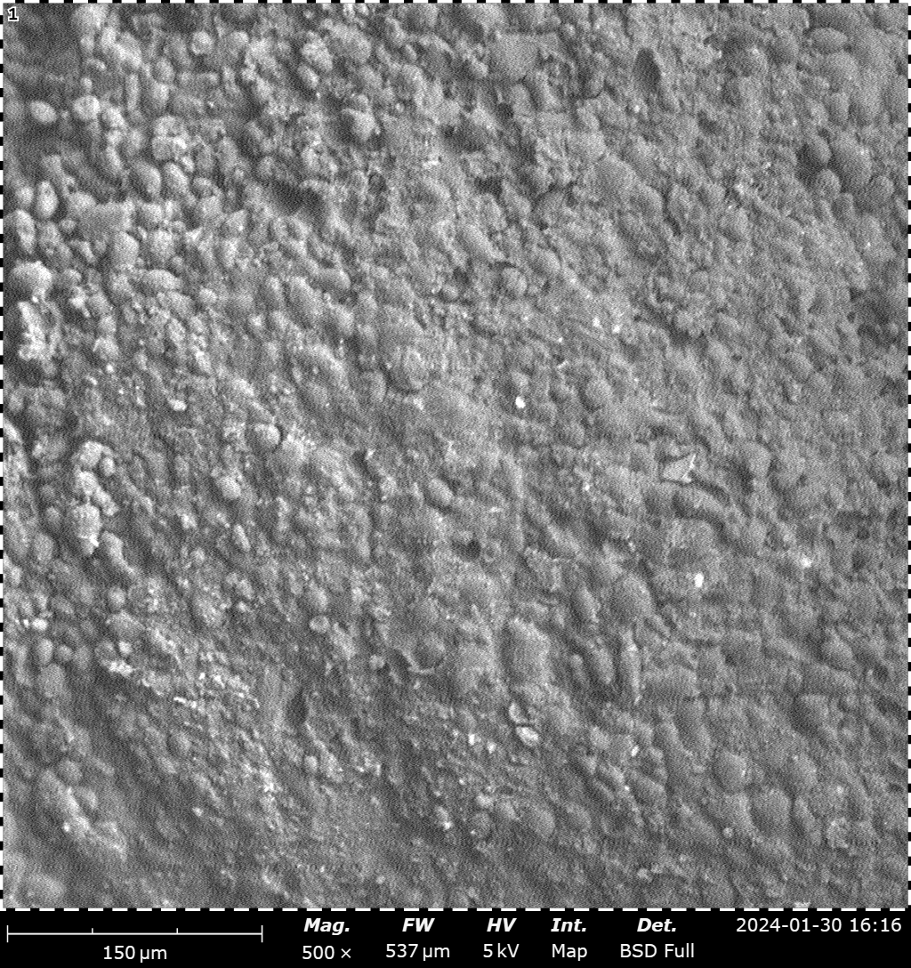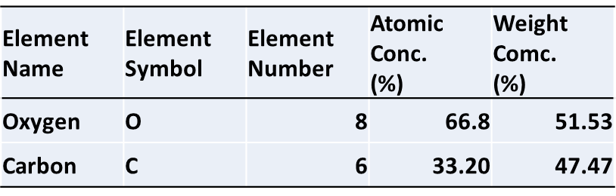
Figure 14: Scanning electron microscopy of synthesized bioplastic films from false yam starch F₀ at 150µm magnification.
The bioplastic film showed a cross-sectional areas of homogeneity and an area with slightly rough and porous texture having the individual granules clustered together, as seen in the outlined red circle on the top-left section of the image. The table next to the image highlights the elemental composition of the bioplastic film, showing that it consists mainly of oxygen (66.8% atomic concentration) and carbon (33.20%) with a corresponding weight concentrations of 55.53% and 47.47% respectively.
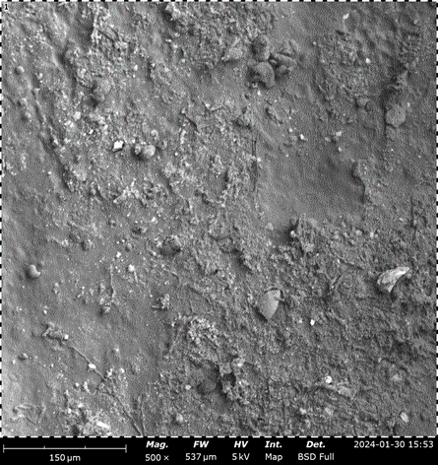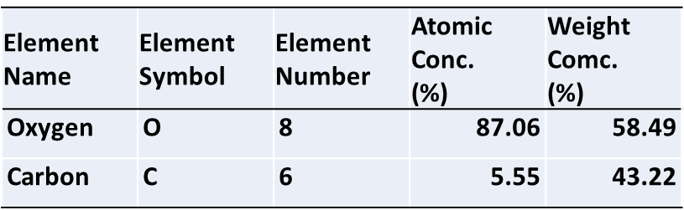Figure 15: Scanning electron microscopy of synthesized bioplastic film from a combination of an equal amount of cassava peel starch and false yam starch (CF₀) at 150µm magnification.

Figure 16: Percentage degradation of synthesized bioplastic, by soil burial method for 60 days.
C₀=bio-plastic formulated from cassava peels starch, F₀ = bio-plastic formulated from false yam tubers starch, CF₀=bio-plastic formulated from an equal combination of false yam tubers starch and cassava peels starch, F_{2.5}= a combination of false yam tubers starch and 25% fibre reinforcement. C_{2.5} = 75% cassava peel starch and 25% fibre, CF_{2.5}=75% equal volume of cassava peel starch and false yam tubers and 25% fibre reinforcement.
The graph summarized the percentage degradation of various bioplastic film formulations over a 60-day period. Seven samples were studied: conventional plastic, (C₀), (F₀), (CF₀), (C_{2.5}), (F_{2.5}), and (CF_{2.5}). Conventional Plastic showed negligible degradation throughout the 60-day period, with values staying as low as 0.44 ± 0.01%. This confirms the non-biodegradable nature of conventional plastic.

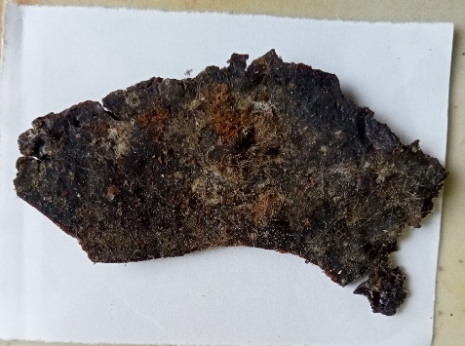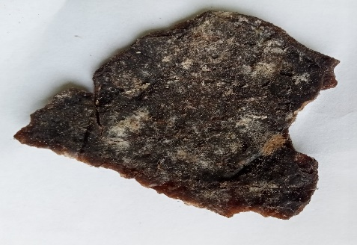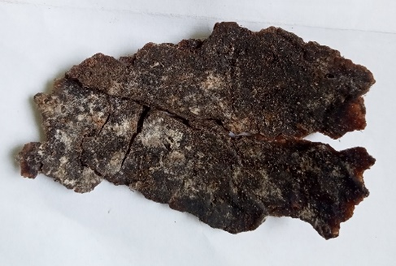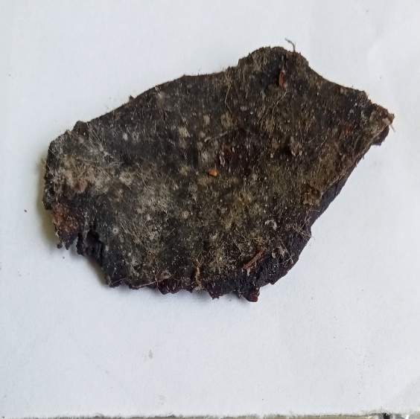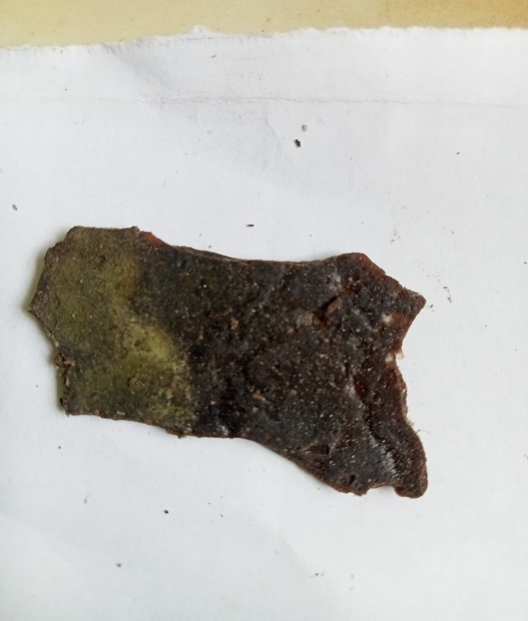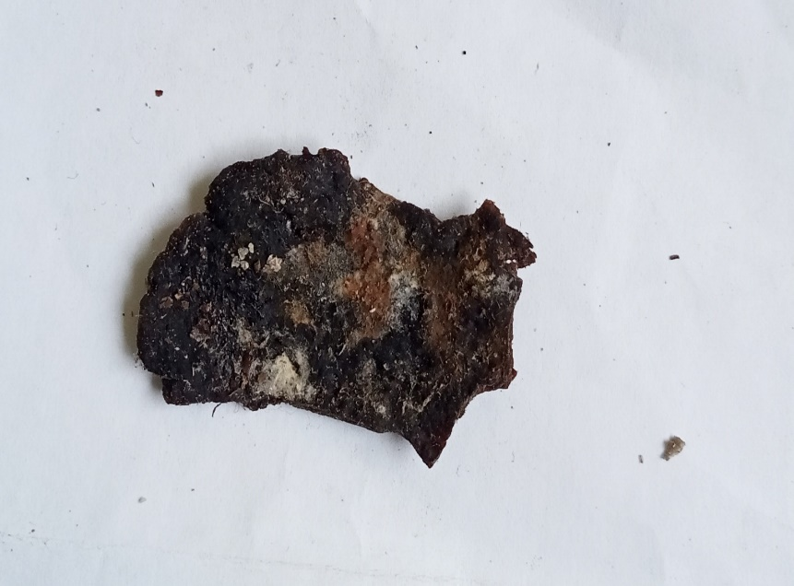
A
F
E
C
B
D
Figure 17: Degradation of bioplastic films after 60 days of soil burial
Where A=bioplastic formulated from cassava peels starch, B = bioplastic formulated from false yam tubers starch, C=bioplastic formulated from an equal combination of false yam tubers starch and cassava peels starch, D=a combination of false yam tubers starch and 25% fibre reinforcement. E = 75% cassava peel starch and 25% fibre, F=75% equal volume of cassava peel starch and false yam tubers and 25% fibre reinforcement.

3.2 Discussion of Result
3.2.1 Thickness, Absorbance and Opacity
Table 1 presents the thickness, absorbance, and opacity of the formulated bioplastic films. No significant differences in film thickness were observed among treatments (p> 0.05), indicating uniform film casting and consistent processing conditions. This suggests that formulation variations did not significantly influence film formation under identical preparation conditions.
The thickness values obtained fall within the typical range reported for starch-based and cassava bioplastic films (0.07–0.33 mm), which are influenced by plasticizer content, polymer concentration, and drying conditions (Galus & Lenart, 2013; Sanyang et al., 2015). Comparable thickness values have also been reported for modified cassava starch films, reaching up to ̴ 0.38 mm depending on formulation (Souza et al., 2012; Muller et al., 2009). The present results are therefore consistent with literature, confirming that the films conform to expected structural characteristics of starch-based bioplastics.
Since thickness showed no significant variation, differences in absorbance and opacity can be attributed primarily to compositional effects rather than geometrical differences. This ensures valid comparison of optical properties across treatments. Overall, the films exhibit thickness characteristics consistent with cassava starch-based bioplastics, supporting their suitability for biodegradable packaging applications. The absorbance varied significantly among the samples with lower absorbance reported among samples without the fibre reinforcement (C₀), (F₀) and (CF₀) with values ranging between 2.82 to 2.99. Higher absorbance was reported among sample with bamboo fibre reinforcement (C_{2.5}), (F_{2.5}) and (CF_{2.5}) with values ranging between 3.91 and 3.97Au. This suggests that the samples with reinforcement have components that could absorb more light compared to samples without reinforcement.
Color and opacity of the biodegradable film are important measures for acceptability as packaging materials. Normally, for good visual presentation of products, films intended for packaging should have high gloss and low opacity. The values for opacity follows a similar trend to absorbance with lower opacity seen in (C₀), (F₀) and (CF₀) with values ranging from 1.57 to 1.59 while higher opacity was seen in (C_{2.5}), (F_{2.5}) and (CF_{2.5}) with values ranging from 2.09 to 2.19. The opacity values indicate that samples (C_{2.5}), (F_{2.5}), and (CF_{2.5}) are less transparent, which could explain their higher absorbance values.
Samples (C_{2.5}), (F_{2.5}), and (CF_{2.5}) have higher absorbance and opacity, indicating that they are less transparent and absorb more light compared to samples (C₀), (F₀), and (CF₀). Thicknesses are relatively consistent across all samples, suggesting that differences in absorbance and opacity are due to other factors, like the composition or treatment of the samples.
The results from Table 1 showed that the reduction of opacity was attributed to cross-linking of the starch molecules and the increased concentration of fibre reinforcement, which can decrease the crystallinity of starch with an eventual decrease in opacity. This is in agreement with the report of Bidari et al. (2023) on the effect of starch and glycerol concentration on film opacity.
3.2.2 Ultimate Tensile Strength (UTS)
The ultimate tensile strength measures the maximum stress that a material can withstand while being stretched before breaking. As presented in
Table 2. The highest UTS was observed in sample C₀, with a value of (4.85±0.12 N/mm2) within the range of what Karnwal et al., (2025) reported for potato starch films indicating exceptional uniformity and consistency in the sample C₀ matrix. Conversely, sample CF_{2.5} exhibited the lowest UTS at (2.13 ± 0.28 N/mm²), suggesting a failure in the load transfer, likely cause by poor interfacial compatibility of the fibre and the starch. The UTS values for F₀, CF₀, C_{2.5}, and F_{2.5}, are 2.59 ± 0.17, 3.91 ± 0.11, 3.22 ± 0.15, and 2.86 ± 0.10 respectively. The values for C_{0,} F₀, CF₀, C_{2.5}, F_{2.5} and CF_{2.5} are higher than that report by Loo and Sarbon (2020) on gelatin-based films cross-linked with tapioca starch. A general trend observed was the decrease in UTS as the concentration of added fibre increased from 0 to 2.5g in the Cassava peel starch formulated bioplastic films, suggesting that higher concentrations may lead to weaker tensile properties. This this poor tensile strength may be attributed to discontinuities in the polymer matrix caused by the increased concentration of added fibre for reinforcement.
3.2.3 Yield Strength
Yield strength.is the stress at which a material begins to deform plastically. Sample CF₀ demonstrated the highest yield strength of (0.61 ± 0.05 N/mm²) as presented in Table 2. Suggests excellent resistance to plastic deformation. In contrast, sample CF₂.₅ had the lowest yield strength at (0.17 ± 0.04 N/mm²), reflecting poor deformation resistance. Sample F₀, and F_{2.5} showed an increase in yield strength with increase in the concentration fibre added, while the C₀ and CF₀ series displayed more variability, with CF_{2.5} having a notable increase in yield strength compared to its counterparts. This increase in yield strength in the F series can be attributed to the enhanced interaction between the polymer chains and the reinforcing fibre at higher concentrations, which restricts plastic deformation
3.2.4 Young’s Modulus
Young’s modulus measures the stiffness of a material. Sample CF₀ exhibited the highest Young’s modulus of (14.33±0.29 MPa) as presented in Table 2. Is similar to the values reported Karnwal et al., (2025) for potato and maize starch films, indicating significant rigidity. On the other hand, sample C_{2.5} had the lowest Young’s modulus at (3.19 ± 0.88 MPa), suggesting it is the most flexible among the samples. In the bioplastic films formulated with the combination of cassava peels starch and the false yam tuber starch, at zero concentration of added fibre (CF₀) was notably stiffer than the other samples, with stiffness generally decreasing with higher concentrations, especially in the false yam tuber starch formulated bioplastic films. The high stiffness of CF₀ could be attributed to the strong bonding and uniform distribution of the reinforcing fibre within the polymer matrix, which enhances the overall rigidity. In contrast, the decrease in stiffness at higher concentrations might be due to agglomeration of the reinforcing fibre, leading to less efficient stress transfer between the polymer matrix and the fibre.
3.2.5 Percentage Elongation at Break (EB)
Elongation at break assesses the flexibility and stretch ability of films; it represents the film elongation from the initial length to the breaking point. It is an important property because it evaluates the ability of a film to stretch and resist breakage during mechanical manipulation in industrial process. Figure 6 presented the percentage elongation at break result of synthesized bioplastic. The percentage elongation of samples C₀, F₀, CF₀, C_{2.5}, F_{2.5}, and CF_{2.5} are 20.34 ± 0.67%, 19.53 ± 0.22%, 22.22 ± 0.20%, 15.68 ± 0.76%, 13.89 ± 0.42%, 11.19 ± 0.32%, and 10.05 ± 0.49%, respectively. These values are less than the approximately 50 to 90 percent elongation at break for gelatin films cross-linked with tapioca starch reported by Loo and Sarbon (2020), but are similar to the approximately 10.21-22.71% reported by Cao and Song (2019) for non-conventional starch from loquat seed starch, gum karaya, oregano essential oil and tween 80.
3.2.6 Water Absorption
Water absorption is a critical parameter in evaluating the durability and stability of composite materials, especially in biocompatible applications where materials are exposed to aqueous environments such as in food packaging and drugs production. This study investigated the water absorption behavior of six composite materials (C₀, F₀, CF₀, C_{2.5}, _{F2.5}, and CF_{2.5}) at different temperatures (30°C, 40°C, 50°C, 60°C) over a period of 60 minutes, the percentage of water absorbed by each sample was recorded at 5-minute intervals.
At 30°C, C₀ showed a gradual increase in water absorption, peaking at 45 minutes (2.7922%) and then decreasing. F₀ showed similar behavior with a peak at 45 minutes (1.7500%). CF₀ peaked at 60 minutes (1.8581%), indicating a delayed maximum absorption. C_{2.5} and F_{2.5} showed consistent increases, with C_{2.5} peaking at 55 minutes (1.7986%) and F_{2.5} at 45 minutes (2.0182%). CF2.5 peaked earlier at 30 minutes (1.6984%). Which was considered unusual. At 40°C, C₀ showed a peak at 35 minutes (2.7314%). F₀ peaked at 55 minutes (2.0143%). CF₀ peaked at 35 minutes (2.1585%). C_{2.5} showed a steady increase, peaking at 60 minutes (2.2525%). F_{2.5} showed two peaks, at 45 minutes (1.8625%) and 55 minutes (2.0143%). CF_{2.5} peaked at 60 minutes (1.8222%). At 50°C, C₀ showed a peak at 35 minutes (3.5367%). F₀ peaked at 50 minutes (2.9443%). CF₀ showed a steady increase, peaking at 45 minutes (2.9039%). C_{2.5} had a steady increase, peaking at 55 minutes (2.2570%). F_{2.5} showed multiple peaks, with the highest at 35 minutes (2.3592%). CF_{2.5} peaked at 40 minutes (3.1846%). At 60°C, C₀ peaked at 30 minutes (3.9250%) and then dropped to 0%. F₀ showed an initial peak at 20 minutes (2.8639%) and then decreased to 0%. CF₀ peaked at 40 minutes (2.0311%) and then decreased. C_{2.5} showed a peak at 35 minutes (3.8511%) and then dropped. F_{2.5} showed a peak at 35 minutes (2.8996%) and then decreased. CF_{2.5} peaked at 35 minutes (3.5206%).
The report showed that, higher temperatures generally increase the water absorption rate initially. At 60°C, all samples showed a significant absorption drop after peaking, suggesting temperature-induced structural changes. All the bioplastic samples exhibited an initial increase in absorption, followed by a peak and then a decline. The time to peak absorption varied between samples and temperatures, with higher temperatures causing earlier peaks.
The water absorption behavior of composite materials is significantly influenced by both temperature and material composition. Higher temperatures accelerate the absorption process but can lead to structural changes that reduce long-term absorption capacity. The incorporation of fibre insignificantly decreases water absorption capacity of the film with fibre. These findings provide valuable insights for selecting appropriate composite materials for applications requiring exposure to aqueous environments.
3.2.7 Thermogravimetric Analysis (TGA)
TGA was done to investigate the thermal degradation and stability of synthesized bioplastic films. The decomposition of films (mg) as a function of temperature (℃) as displayed in Figure 12 and Figure 13. There were three steps in the thermal degradation of the films, as shown in TGA and DTG curves Figure.15. These three steps of thermal decomposition phenomena for most starch-based films were reported by
The first step of thermal decomposition of films happened below 42.41°C -121.44 ℃, which was approximately 0.7248mg mass loss, this was due to loss of moisture content from the films. Simultaneously, this step was also related to loss of mass that can also be attributed to the loss of the weak bond of water molecules as well as low molecular weight compounds in films. All films, including C₀, F₀ and CF₀, experienced the same situation.
The second step of thermal decomposition of synthesized bioplastic films happened in the range of 121.44°C- 206.62°C, with approximately 0.9554mg mass loss, which is related to the loss of glycerol compounds, including water molecules.
With further increase in the temperature, the DTG of the synthesized bioplastic films displayed two sharp peak at temperature range of 300-325°C, and 425- 450ºC leading to a weight loss of approximately 17.55% and 3.985% respectively, At a temperature of approximately 444.42ºC, there was a 3.985% mass loss of the bioplastic films, which displayed higher mass decomposition in the third step.
These results of thermal decomposition were in good agreement with the results of studies of Sanyang et al (2015),and Ilyas et al., 92018) who reported on G-plasticized sugar palm starch.
3.2.8 Film morphology (SEM)
The Figure 14. Scanning electron microscopic images of the cross-section of cassava peel starch bioplastic films (C₀) at 500× magnification. The image showed the formation of bioplastic films and the undissolved starch granules on the surface of the bioplastic. This suggests that the bioplastic films are rough and brittle. Although cross-sectional micrograph showed homogeneity on a large portion of the surface and below the surface of the film, the rough cross-sectioned structures might be attributed to low interfacial adhesion between cassava peel starch and glycerol plasticizer. A similar finding was observed by Abera et al., 2020 who reported that the biopolymers having 30% plasticizer were less homogeneous than 40% plasticized films. According to the result by the SEM-EDX of the film, carbon and oxygen were reported to be available in the cassava peel starch with a high atomic concentration of oxygen (82.53%) and a considerable amount of carbon (17.48%).
The Figure 15 presented the Scanning electron microscopic image of the cross-section of bioplastic films formulated with false yam tuber starch (F₀) at 500× magnification, containing atomic concentration of oxygen and carbon of 66.8% and 33.2% respectively. The image showed the formation of bioplastic films and the on the surface of the bioplastic film revealing a rough and brittle film surface. Although Cross-section micrograph showed incomplete gelatinization at the regions marked with a circle but the homogeneity is consistent in a large portion of the surface area. In Figure 1. The rough cross-section structures might be attributed to low interfacial adhesion between false yam tuber starch, the cassava peel starch and glycerol plasticizer. According to the result of the SEM-EDX of the film, the atomic concentration are 87.06% and 5.55% for oxygen and carbon SEM-EDX micrograph reported to be presence of oxygen and carbon alone all films analyzed.
3.2.9 Soil burial degradation
Figure 17 and Figure 18 showed the percentage degradation of the various bioplastic film formulations over a 60-day period. Seven samples were studied: conventional plastic, (C₀), (F₀), (CF₀), (C_{2.5}), (F_{2.5}), and (CF_{2.5}). Conventional plastic showed negligible degradation throughout the 60-day period, with values staying as low as 0.44 ± 0.01%. This confirms the non-biodegradable nature of conventional plastic.
Bioplastic film samples without bamboo fibre (C₀), (F₀), (CF₀) exhibited significant degradation compared to conventional plastic. Cassava peel starch without fibers (C₀): started at 1.33 ± 0.01% degradation at day 5 and increased progressively to 43.52 ± 0.01% by day 60. False yam starch without fibers (F₀): started at 1.11 ± 0.02% degradation at day 5 and increased to 38.38 ± 0.04% by day 60. The combination of cassava and false yam starch without fibers (CF₀): showed higher initial degradation (1.78 ± 0.03% at day 5) compared to (C₀) and (F₀), reaching 42.44 ± 0.02% by day 60.
Bioplastic samples with 2.5% bamboo fiber (C_{2.5}), (F_{2.5}), (CF_{2.5}) had improved biodegradability of the bioplastic films. Cassava peel starch with 2.5% bamboo fiber (C_{2.5}) showed degradation from 1.11 ± 0.02% at day 5 to 36.64 ± 0.02% by day 60. False yam starch with 2.5% bamboo fiber (F_{2.5}), started at 0.89 ± 0.01% degradation and increased to 32.63 ± 0.04% by day 60. The combination of cassava peels and false yam tuber starch with 2.5% bamboo fiber (CF_{2.5}, exhibited the highest overall degradation, from 1.11 ± 0.02% at day 5 to 34.66 ± 0.01% by day 60.
In the initial degradation days (Day 5 to Day 10), All bioplastic formulations exhibited low initial degradation rates compared to subsequent days, indicating a period of adaptation or conditioning for microbial activity. In the mid-term degradation (Day 15 to Day 30, there was a noticeable increase in degradation rates. This period marked the most rapid increase in biodegradation for most samples, especially those containing bamboo fibers. In the long-term degradation duration (Day 35 to Day 60), degradation rates continued to increase but at a slower rate compared to the mid-term period. By day 60, all bioplastic formulations exhibited significantly higher degradation compared to conventional plastic.
The percentage degradability of synthesized bioplastic films, (C₀), (F₀), (CF₀), (C_{2.5}), (F_{2.5}), and (CF_{2.5}), are higher than the 14.2% of 110 days duration reported by Gómez and Michel (2013) for starch-based bioplastic films and but lower than the 96% degradation reported by Jangong, et al. (2019) for starch and chitosan blend.
4. CONCLUSION
This study demonstrates that bamboo fibre reinforcement effectively enhances the functional performance of bioplastic films derived from cassava peel and false yam starch. Fibre incorporation improved water resistance and reduced hydrophilicity, without compromising film thickness and with a concurrent increase in opacity. The reduced water absorption and enhanced structural integrity of the fibre-reinforced films depict the role of bamboo fibre in strengthening the polymer matrix.
All films exhibited substantial biodegradability within 60 days, with fibre-reinforced variants showing accelerated degradation, confirming their environmental compatibility. Overall, the developed composites exhibit a balanced combination of mechanical stability, water resistance, and biodegradability, making them suitable for short-term biodegradable applications such as packaging and agricultural films.

The use of agro-waste materials further supports a sustainable and cost-effective approach to bioplastic production. Future work should focus on optimizing fibre loading and evaluating long-term performance under industrial conditions.

COMPETING INTERESTS DISCLAIMER:
Authors have declared that they have no known competing financial interests OR non-financial interests OR personal relationships that could have appeared to influence the work reported in this paper.

Disclaimer (Artificial intelligence)
Author(s) hereby declare that NO generative AI technologies such as Large Language Models (ChatGPT, COPILOT, etc.) and text-to-image generators have been used during the writing or editing of this manuscript.

References
Abel, O. M., Chinelo, S., & Chidioka, R. (2021). Enhancing Cassava Peels Starch as Feedstock for Biodegradable Plastic. Journal of Materials and Environmental Science, 12(02), 169–182.https://jmaterenvironsci.com/Document/vol12/vol12_N2/JMES-2021-12016-Abel.pdf
Alobi, N. O., Sunday, E. A., Magu, T. O., Oloko, G. O. & Nyong, B. K. (2017). Analysis of starch from non-edible root and tubers as sources of raw materials for the synthesis of biodegradable starch plastics. Journal of Basic Applied Research 3(1): 27 – 32.
Asgher, M., A., S., Bilal, M., & Iqbal, M. N. (2020). Bio-based active food packaging materials : Sustainable alternative to conventional petrochemical-based packaging materials. Food Research International, 137(August). https://doi.org/10.1016/j.foodres.2020.109625
Asgher, M., A., S., Bilal, M., & Iqbal, M. N. (2020). Bio-based active food packaging materials : Sustainable alternative to conventional petrochemical-based packaging materials. Food Research International, 137(August). https://doi.org/10.1016/j.foodres.2020.109625
Bidari, R., Abdillah, A. A., Ponce, R. A. B. & Charles, A. L. (2023). Characterization of Biodegradable Films Made from Taro Peel (Colocasia esculenta) Starch. Polymers, 15, 338. https://doi.org/10.3390/ polym15020338.
Cao, T. L., & Song, K. B. (2019). Effects of gum karaya addition on the characteristics of loquat seed starch films containing oregano essential oil. Food Hydrocolloids, 97. https://doi.org/10.1016/j.foodhyd.2019.105198.
Chandrasekar, C. M., Krishnamachari, H., Farris, S., & Romano, D. (2023). Development and characterization of starch-based bioactive thermoplastic packaging films derived from banana peels. Carbohydrate Polymer Technologies and Applications, 5(May), 100328. https://doi.org/10.1016/j.carpta.2023.100328
Emadian M.S., Onay T.T, & Demirel B. (2017). Biodegradation of Bioplastics in Natural Environments. Waste Management Review. 59, 526-536.
Galus, S. & Lenart, A. (2013). Development and characterization of composite edible films based on starch and chitosan. Journal of Food Engineering, 115(4), 459-465https://doi.org/10.1016/j.jfoodeng.2012.03.006
Henning, F. G., Ito, V. C., Demiate, I. M., & Lacerda, L. G. (2022). Non-conventional starches for biodegradable films: A review focusing on characterization and recent applications in food packaging. Carbohydrate Polymer Technologies and Applications, 100157. https://doi.org/10.1016/j.carpta.2021.100157
Jangong, O. S., Gareso, P. L., Mutmainna, I., & Tahir, D. (2019). Fabrication and characterization starch/chitosan reinforced polypropylene as biodegradable. Journal of Physics: Conference Series, 1341(8). https://doi.org/10.1088/1742-6596/1341/8/082022
Judawisastra H., Sitohang R. D. R., Marta L, & Mardiyati M. (2017) Water Absorption and its Effect on the Tensile Properties of Tapioca Starch/Polyvinyl Alcohol Bioplastics. Iop. Conference. Series Making Science Engineering 223:1-9.
Karnwal, A., Abdur R., Amar, Y. J., Abdel, R. M. S. A-T., Manickam, S., Piyush, K., Deepak, K. Tabarak, M. (2025). Advanced starch-based films for food packaging: Innovations in sustainability and functional properties. Food Chemistry, 102662 https://doi.org/10.1016/j.fochx.2025.102662
Lescano, M., Vásquez, N., Tarrillo, S., Yoplac, I., & Velásquez-Barreto, F. F. (2021). Development and Optimization of Biofilms Made from Potato or Arracacha Starch. Starch/Staerke, 73(9–10), 1–8. https://doi.org/10.1002/star.202100075
Loo, C.P., Sarbon N.M. (2020) Chicken skin gelatin films with tapioca starch. Food Bioscience, 35:100589. https://doi.org/10.1016/j.fbio.2020.100589
Mendes, J. F., Paschoalin, R. T., Carmona, V. B., Sena Neto, A. R., Marques, A. C. P., Marconcini, J. M., Mattoso, L. H. C., Medeiros, E. S., & Oliveira, J. E. (2016). Biodegradable polymer blends based on corn starch and thermoplastic chitosan processed by extrusion. Carbohydrate Polymers, 137, 452–458. https://doi.org/10.1016/j.carbpol.2015.10.093
Muller, C. M. O., Yamashita, F., & Laurindo, J. B. (2009). Effects of glycerol and sorbitol on cassava starch films. Polymers, 72(1), 82-87. https://doi.org/10.1016/j.carbpol.2007.07.026
Okunola A, A., Kehinde I, O., Oluwaseun, A., & Olufiropo E, A. (2019). Public and Environmental Health Effects of Plastic Wastes Disposal: A Review. Journal of Toxicology and Risk Assessment, 5(2). https://doi.org/10.23937/2572-4061.1510021
Olanrewaju, O. O., & Oyebade, D. (2019). Environmental Menace of Plastic Waste in Nigeria: Challenges, Policies and Technological Efforts Plastic Recycling and Reusability View project Wastewater Treatment View project. June. https://www.researchgate.net/publication/335989265
Onaji-benson, T., & Ali, P. A. (2023). Addressing the Plastic Waste Problem in Nigeria. Nigerian Economic Summit Group, November, 1–18.
Prasteen, P., Thushyanthy, H. Y., Mikunthan, T., & Prabhaharan, M. (2018). Bio-Plastics - An Alternative to Petroleum Based Plastics. International Journal of Research Studies in Agricultural Sciences, 4(1), 1–7. https://doi.org/10.20431/2454-6224.0401001
Sanyang, M. L., Sapuan, S. M., Jawaid, M., Ishak, M. R. & Sahari, j. (2015). Effect of plasticizer on starch-based films. Polymers 7(6), 1106-1124; https://doi.org/10.3390/polym7061106
Souza, A. C., Benze, R., Ferrao, E. S. Ditchfield, C. Coelho, A. C. V. & Tadini, C. C. (2012). Cassava starch biodegradable films: Influence of glycerol and clay nanoparticles content on tensile and barrier properties and glass transition temperature. LWT - Food Science and Technology, 28(2), 406–412. https://doi.org/10.1016/j.foodhyd.2011.12.006
Tarique, J., Sapuan, S. M., & Khalina, A. (2021). Effect of glycerol plasticizer loading on the physical, mechanical, thermal, and barrier properties of arrowroot (Maranta arundinacea) starch biopolymers. Scientific Reports, 11(1), 1–17. https://doi.org/10.1038/s41598-021-93094-y
Weligama Thuppahige, V. T., Moghaddam, L., Welsh, Z. G., Wang, T., & Karim, A. (2023). Investigation of critical properties of Cassava (Manihot esculenta) peel and bagasse as starch-rich fibrous agro-industrial wastes for biodegradable food packaging. Food Chemistry, 422(January), 136200.
Zhu L. Zhongwei W., Should Y., Ning J., & Dan L. (2025) Extraction Process Research and Characterization of Microcrystalline Cellulose Derived from Bamboo (Phyllostachys edulis (Carrière) J. Houz.) Fibers. Polymers, 17(9), 1143; https://doi.org/10.3390/polym17091143

