Original Research Article

Prevalence and Phenotypic Characterization of Candida Species Isolated from Raw Milk and Local Dairy Products

Abstract
Milk and traditional dairy products are essential nutritional sources, but their rich nutrient profile and high moisture content make them highly susceptible to fungal contamination. The presence of opportunistic yeasts in unpasteurized dairy poses significant public health risks to consumers and reduces the overall quality of the products. Therefore, this study aimed to isolate, phenotypically characterize, and determine the prevalence of Candida species in raw milk and locally produced cheese to comprehensively evaluate their microbial safety. A total of 150 dairy samples, comprising raw cow milk (n=40), raw buffalo milk (n=35), and local cheese (n=75), were analyzed using HiChrome™ Candida differential agar. The results revealed an alarming overall Candida prevalence of 54.0%. The maximum contamination rate was observed in local cheese (65.3%), followed by raw buffalo milk (45.7%) and raw cow milk (42.5%). From these samples, 235 Candida isolates were successfully recovered. Candida albicans emerged as the most dominant species, representing 30% of the total isolates, accompanied by a significant presence of non-albicans species including Candida krusei (20%), Candida glabrata (20%), Candida tropicalis (15%), and Candida parapsilosis (15%). Statistical evaluation using the Chi-square test demonstrated no significant variance (p > 0.05) in the distribution of Candida species across the three examined dairy sources. This indicates that the high fungal burden is not dependent on the animal species, but rather originates from shared unsanitary milking environments and unsterilized manual processing. In conclusion, these findings highlight a direct health hazard, necessitating the urgent implementation of strict hygienic measures and quality control protocols in local dairy manufacturing.
Keywords: Candida species; Raw milk; Local cheese; Fungal contamination; Phenotypic characterization; Public health.

Introduction
Milk and dairy products are crucial components of the human diet, playing a significant role in nutritional intake. Their consumption saw a notable increase following discoveries that highlighted milk's rich nutritional content. For thousands of years, milk has been recognized as nature's most perfectly balanced food (Górska-Warsewicz et al., 2019).
"Milk is a highly nutritious biological fluid secreted by the mammary glands of mammals, consisting of a complex mixture of lipids, proteins, and carbohydrates" (Quigley et al., 2013). Because of this rich nutrient profile and its high water activity, milk naturally serves as an optimal growth medium for a wide diversity of microorganisms, including both beneficial microbes and spoilage fungi. The dairy sector faces ongoing challenges in managing the microbial contamination of milk and its derivatives across the entire supply chain. Despite various processing techniques, microbial degradation continues to be a source of significant global losses (Ntuli et al., 2023).
Traditionally, synthetic antifungal preservatives have been used to increase the shelf life of milk and its products. However, there is growing concern about the safety of these chemicals and their potential health impacts. Natural alternatives, such as plant-derived essential oils, offer a safer and more sustainable solution for controlling fungal growth (Pandey & Gupta, 2025).
In a previous study about antimicrobial activity of methanolic extract from clove in the year 2022 in Egypt and its goal was to test the preservative power in Ras cheese, the researchers found that clove significantly inhibited microbial growth. This indicates that natural extracts can serve as effective bio-preservatives in local dairy systems (Osman et al., 2022).
The objective of the current study is to isolate and phenotypically characterize Candida species from raw milk and local dairy products. By determining the prevalence and identifying the specific species involved, this research aims to provide a clear understanding of the microbial quality and safety of locally available dairy items in the study area.

2 Methods

2.1. Sample Collection and Preparation
A total of 150 dairy samples, comprising locally produced cheese (n=75), raw buffalo milk (n=35), and raw cow milk (n=40), were collected for this study. To ensure the integrity of the microbial profile, strict hygienic measures were followed during the sampling process. As outlined in standard microbiological protocols for dairy evaluation, "samples... were collected from the different collection points... [and] examined by microbiological culture method" (El-Kholy et al., 2016). Upon arrival at the laboratory, the samples were kept under appropriate cold conditions and promptly prepared for serial dilution and subsequent mycological analysis.

2.2. Isolation and Phenotypic Identification
For the isolation and presumptive phenotypic identification of the yeast strains, HiChrome™ Candida differential agar was utilized. Appropriate dilutions of the milk and cheese samples were spread onto the agar plates. The inoculated plates were then subjected to an incubation period of 48 hours at a temperature of 37°C. The scientific basis for using this specific culture medium is well-documented in the literature: "chromogenic media allow rapid identification of yeast species based on colony color and morphology, as they contain specific chromogenic substrates that are hydrolyzed by species-specific enzymes" (Ghelardi et al., 2008). Relying on this principle, a total of 235 Candida isolates were differentiated. Candida albicans was identified by its emerald to light green colonies, Candida tropicalis by a grey-blue or metallic blue appearance, Candida krusei by dry, spreading colonies with pinkish-white margins, and Candida glabrata by glossy, off-white to cream-colored colonies.

2.3. Statistical Analysis
The collected data regarding the prevalence percentages and the distribution of the different Candida species across the three dairy sources were subjected to statistical evaluation. A Chi-square (χ²) statistical test was employed to analyze the relationships between the variables. According to standard biostatistical procedures used in biological research, "the Chi-square test of independence is used to determine if there is a significant relationship between two nominal (categorical) variables" (McHugh, 2013). In this study, it was used to determine whether the occurrence of specific Candida species was statistically dependent on or independent of the specific type of dairy product analyzed. The threshold for statistical significance was set at a p-value of less than 0.05 (p < 0.05).

3. Results

4.1. Isolation and Identification
A total of 235 Candida isolates were successfully recovered and identified from samples of locally produced cheese, raw buffalo milk, and raw cow milk. Following a 48-hour incubation period at 37°C, these isolates were distinguished using their specific colorations on HiChrome agar. Candida albicans displayed emerald to light green colonies, whereas Candida tropicalis presented a grey-blue or metallic blue appearance. Furthermore, Candida krusei developed spreading, dry colonies featuring pinkish-white margins, and Candida glabrata yielded glossy, off-white to cream-colored colonies, as illustrated in the colony morphology figure. The prevalence of these species fluctuated depending on the dairy source. C. albicans emerged as the dominant yeast, observed in relatively equal proportions across all samples. Both C. parapsilosis and C. tropicalis were detected in similar amounts, while C. glabrata and C. krusei were also isolated in significant numbers as shown in figure 1.
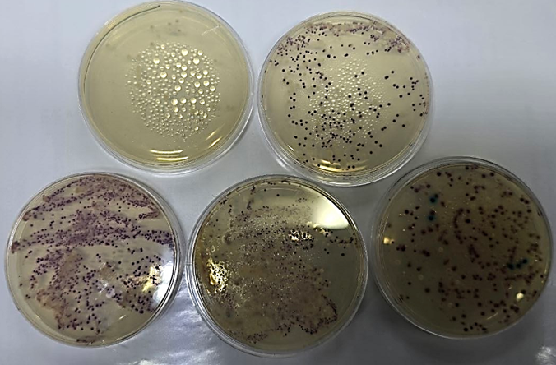
Figure (1): Isolation Candida species on HiChrome™ agar – colony morphology

4.2. Prevalence Data
Overall, 235 yeast isolates were retrieved from 150 different dairy specimens, comprising local cheese (n=75), raw buffalo milk (n=35), and raw cow milk (n=40). The general prevalence of Candida species among the tested samples reached 54.0%. The maximum contamination rate was noted in local cheese at 65.3%, succeeded by raw buffalo milk at 45.7% and raw cow milk at 42.5%. Of the recovered yeasts, Candida albicans constituted the majority, representing 30% of the total (71 isolates), peaking in local cheese samples with 32 isolates (42.7%). Both Candida glabrata and Candida krusei made up 20% of the isolates (47 isolates per species), whereas Candida parapsilosis and Candida tropicalis each contributed 15% (35 isolates per species) as shown in figure 2.
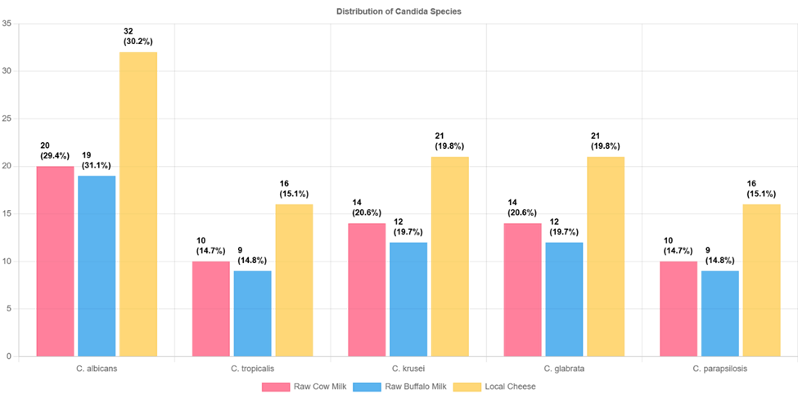
Figure (2): Histogram show the distribution of Candida Species in Milk and Dairy Products

4.3. Statistical Distribution
A Chi-square statistical evaluation demonstrated no significant variance regarding the distribution of Candida species across the three examined dairy sources (p > 0.05 across all species). This finding suggests that the presence of these fungal species is independent of the specific dairy product type analyzed. The exact statistical values and distribution patterns are detailed in the table below.
Table 1: Distribution and Prevalence of Candida Species Isolated from Raw Milk and Dairy Products
Candida Species | Raw Cow Milk (n=40) | Raw Buffalo Milk (n=35) | Local Cheese (n=75) | Total Isolates / Prevalence | Chi-Square Value (χ²) | p-Value
C. albicans | 20 (50%) | 19 (54.3%) | 32 (42.7%) | 71 (30%) | 1.284 | 0.526
C. tropicalis | 10 (25%) | 9 (25.7%) | 16 (21.3%) | 35 (15%) | 0.341 | 0.843
C. krusei | 14 (35%) | 12 (34.3%) | 21 (28%) | 47 (20%) | 0.891 | 0.640
C. glabrata | 14 (35%) | 12 (34.3%) | 21 (28%) | 47 (20%) | 0.891 | 0.640
C. parapsilosis | 10 (25%) | 9 (25.7%) | 16 (21.3%) | 35 (15%) | 0.341 | 0.843
Total Isolates | 68 | 61 | 106 | 235 (100%)

4. Discussion

4.1. Isolation and Prevalence of Candida Species
The current study revealed a high overall contamination rate, with Candida species present in 54.0% of the tested dairy samples. The highest prevalence was observed in local cheese (65.3%), followed by raw buffalo milk (45.7%) and raw cow milk (42.5%). Furthermore, Candida albicans was the most frequently isolated species, accounting for 30% of the total isolates (71 out of 235).
In a previous study about the prevalence of Campylobacter species in milk and dairy products in the year 2016 in the cities of El-Minia and Beni-Suef, Egypt, and its goal was to detect the prevalence of Campylobacters in milk and milk products, the researchers found that "the overall prevalence of Campylobacter species was 13% in raw milk, 52% in kareish cheese, 18% in Domiati cheese and 6% in ice-cream" (El-Kholy et al., 2016). This indicates that raw milk and traditionally processed cheeses in the region are highly susceptible to severe microbial contamination. Although their study focused on bacterial pathogens, it strongly agrees with the current study's findings regarding the high contamination rates in local dairy products, emphasizing a widespread issue with unsanitary handling during milking and traditional processing.
While another study, which aimed to characterize the fungal microflora in raw milk and specialty cheeses in the year 2012 in Quebec, Canada, found results that differed from the current study, as it found that "the yeast microflora was highly dominated by Debaryomyces hansenii and Geotrichum candidum," whereas Candida species were only isolated occasionally as a minor fraction of the microbiota (Lavoie et al., 2012). Perhaps this indicates that strict automated milking protocols, cooler geographical climates, and highly monitored hygienic measures on modern farms significantly suppress the proliferation of Candida compared to the traditional farming and retail conditions present in our study area.
Moreover, the statistical analysis in the current study showed no significant variance (p > 0.05) in the distribution of Candida species across the different dairy sources (raw cow milk, raw buffalo milk, and local cheese). This uniform distribution across different matrices can be explained by environmental factors. As noted in the literature, "the milking environment, the milking equipment and the milker all act as potential sources of contamination," leading to a ubiquitous and uniform cross-contamination of bulk milk and its subsequent dairy products (Quigley et al., 2013).
Similar patterns of microbial diversity have been documented globally in various dairy processing contexts. For instance, recent research on Italian Mediterranean buffalo milk and its derivatives highlights the natural presence of yeast communities in fresh buffalo milk, mature curd, and Buffalo Mozzarella cheese, demonstrating the persistence of these microbes throughout the production chain (Biondi et al., 2021). Furthermore, a study investigating white brined cheeses in Bulgaria emphasizes that production methods (artisanal versus industrial) and physicochemical parameters, such as salt content and acidity, significantly influence yeast ecology. The study identified diverse wild yeast microbiota, including Candida species like Candida sphaerica, confirming that artisanal cheeses harbor distinct yeast communities compared to industrial products (Ermenlieva et al., 2025). These international findings align with our results, confirming that traditional processing environments, along with the specific physicochemical properties of the dairy matrices, significantly contribute to the fungal load and yeast survival in local dairy products.
4.2. Species Diversity and Phenotypic Characterization
The phenotypic characterization using HiChrome agar successfully differentiated the Candida isolates based on colony pigmentation, confirming the presence of a highly diverse yeast population. Alongside the dominance of C. albicans, the recovery of non-albicans Candida (NAC) species is particularly noteworthy, including C. krusei (20%), C. glabrata (20%), C. tropicalis (15%), and C. parapsilosis (15%).
In a previous study about the dominant yeast community in raw milk in the year 2020 in Spain, and its goal was to identify potential transfers of yeast species in relation to farming practices, the researchers found that "milk contamination from the yeast species present in the dairy farm environment is reasonable, and certain farming practices favor the presence of desirable microbiota in milk" (Quintana et al., 2020). This indicates that raw milk and the traditional milking environment naturally harbor a high diversity of yeast strains. The aforementioned study agrees with the current study, confirming that the farm environment is a direct source of persistent contaminants in traditional dairy systems.
While another study, which aimed to identify and evaluate the thermotolerance of yeasts from raw milk exposed to high temperatures in the year 2023 in Brazil, found results that differed from the current study's unpasteurized samples, as it found that "among all the isolates submitted to heat treatment... none of them resisted the slow pasteurization," demonstrating a 0% survival rate for the diverse Candida microbiota under standard pasteurization protocols (Campos et al., 2023). Perhaps this indicates that the high contamination rates and yeast diversity observed in our study are exclusively linked to traditional, unpasteurized dairy practices and poor sanitation during manual milking, and could be completely eliminated through proper thermal processing.
Furthermore, the presence of these species raises significant public health concerns. As highlighted in recent literature, "Candida tropicalis (C. tropicalis) is a zoonotic pathogen that is widespread in the environment and in recent years an increasing number of dairy cows have been infected with the fungus causing mastitis in cows" (Jiang et al., 2024). Adding a personal comment to this finding: the widespread availability of these unpasteurized local dairy products poses a direct health hazard, necessitating the urgent implementation of stricter hygienic measures and quality control protocols in local dairy manufacturing to protect consumers from potential opportunistic foodborne mycoses.

4.3. Influence of Dairy Product Type and Processing on Contamination Levels
In the current study, although the Chi-square statistical evaluation demonstrated no significant variance (p > 0.05) across the three examined dairy sources, local cheese exhibited the highest numerical contamination rate (65.3%) compared to raw buffalo milk (45.7%) and raw cow milk (42.5%). This high fungal load in cheese suggests that traditional manufacturing practices might introduce additional vectors of contamination or provide a more concentrated matrix for yeast survival.
In a previous study about yeast ecology in white brined cheeses in the year 2025 in Bulgaria, and its goal was to investigate and compare the microbial load and yeast species composition in artisanal and industrial white brined cheeses, the researchers found that "Yeast counts were higher in cheeses with higher salt content, particularly in industrial samples" (Ermenlieva et al., 2025). This indicates that the concentration of components and the physicochemical parameters of cheese, such as salt addition during traditional curdling, do not deter but rather select for and support robust fungal communities. The aforementioned study agrees with the current study's observation of elevated contamination in local cheeses, confirming that processing steps and physicochemical properties like salt content play a key role in yeast survival rather than eliminating it.
While another study, which aimed to investigate the microbiological quality of raw milk after introducing a two-day collecting system in the year 2008 in Slovenia, found results that highlighted a widespread baseline contamination, as it found that "The mean numbers of... yeasts and molds together... were 2.3 log10 cfu/ml" in samples collected from farm bulk milk tanks, collecting points, and transportation tanks (Godič Torkar & Golc Teger, 2008). Perhaps this indicates that while the raw milk itself is initially contaminated on the farm, the prolonged holding times and subsequent traditional processing into local cheese act as compounding factors that exacerbate the environmental fungal load present in small-scale dairy units, explaining the numerical peak in our cheese samples compared to raw milk.
Furthermore, the lack of statistical difference between raw cow and buffalo milk suggests that the animal species itself is not the primary driver of contamination. Instead, it is the shared unsanitary milking environment. Adding a personal comment to this finding: focusing solely on improving the health of the dairy herds will be insufficient; comprehensive sanitation protocols covering the entire supply chain—from the milker's hands to the cheese processing environment—must be implemented to effectively reduce these opportunistic fungi in local markets.

4.4. Limitations of the Study
While this study provides significant insights into the prevalence of Candida species in local dairy products, it has some limitations. First, the identification was based primarily on phenotypic and chromogenic methods; incorporating molecular techniques like PCR or internal transcribed spacer (ITS) sequencing could provide even higher taxonomic resolution and strain differentiation. Second, the geographical scope was focused on specific local markets. Future research covering a wider range of industrial versus artisanal production systems across different seasons would further enhance the understanding of fungal dynamics and environmental influences on dairy contamination.

Conclusions
This study revealed an alarming 54.0% prevalence of Candida species in local dairy products, with artisanal cheese exhibiting the highest contamination levels compared to raw cow and buffalo milk. Candida albicans was the predominant isolate, accompanied by a significant presence of opportunistic non-albicans species. Statistical analysis demonstrated no significant difference among the dairy sources, indicating that fungal contamination is not driven by the animal species but rather stems from poor hygiene, unsanitary manual milking, and unsterilized traditional processing environments. Consequently, this high microbial burden poses a direct public health risk, necessitating urgent regulatory interventions and strict sanitation protocols throughout the dairy supply chain.
COMPETING INTERESTS DISCLAIMER:
Authors have declared that they have no known competing financial interests OR non-financial interests OR personal relationships that could have appeared to influence the work reported in this paper.
Disclaimer (Artificial intelligence)
Author(s) hereby declare that NO generative AI technologies such as Large Language Models (ChatGPT, COPILOT, etc.) and text-to-image generators have been used during the writing or editing of this manuscript.

References
Biondi, L., Fulgione, A., Capuano, F., Nappa, M., Citro, A. and Nava, D. (2021). 'Impact of Freezing on the Microbiological Quality and Physical Characteristics of Buffalo Mozzarella Cheese'. Animals, 11(12), p. 3502. Available at: https://doi.org/10.3390/ani11123502
Campos, J. S., et al. (2023). 'Identification and evaluation of thermotolerance of yeasts from milk in natura exposed to high temperature and slow and fast pasteurization'. Brazilian Journal of Microbiology, 54, pp. 2197–2208. Available at: https://pmc.ncbi.nlm.nih.gov/articles/PMC10234981/
El-Kholy, A. M., Meshref, A. M. S., El-Gedawy, A. A. and Esam, R. M. (2016). 'Prevalence of Campylobacter species in milk and some dairy products'. Journal of Veterinary Medical Research, 23(2), pp. 133-142. Available at: https://journals.ekb.eg/article_43234_62b4d980f95038617340568f0dcbe0a3.pdf
Ermenlieva, N., Stamova, S., Ivanova, N., Atanasova, P., Marinova, V., Ibryamova, S., Ivanov, I. and Georgieva, E. (2025). 'Yeast Ecology in White Brined Cheeses: Correlations with Physicochemical Parameters in Artisanal and Industrial Products'. Microorganisms, 13(9), p. 1965. Available at: https://doi.org/10.3390/microorganisms13091965
Ermenlieva, N., Stamova, S., Ivanova, N., Atanasova, P., Marinova, V., Ibryamova, S., Ivanov, I. and Georgieva, E. (2025). 'Yeast Ecology in White Brined Cheeses: Correlations with Physicochemical Parameters in Artisanal and Industrial Products'. Microorganisms, 13(9), p. 1965. Available at: https://doi.org/10.3390/microorganisms13091965
Ghelardi, E., Pichierri, G., Castagna, B., Barnini, S., Tavanti, A. and Campa, M. (2008). 'Efficacy of Chromogenic Candida Agar for Isolation and Presumptive Identification of Pathogenic Yeast Species'. Journal of Clinical Microbiology, 46(3), pp. 1159–1160. Available at: https://pmc.ncbi.nlm.nih.gov/articles/PMC2268339/
Godič Torkar, K. and Golc Teger, S. (2008). 'Microbiological quality of raw milk after introducing the two day's milk collecting system'. Acta agriculturae Slovenica, 92(1), pp. 77-88. Available at: https://doi.org/10.14720/aas.2008.92.1.15090
Górska-Warsewicz, H., Rejman, K., Laskowski, W. and Czeczotko, M. (2019). 'Milk and dairy products and their nutritional contribution to the average Polish diet'. Nutrients, 11(8), p. 1771. Available at: https://doi.org/10.3390/nu11081771
Jiang, C., Fang, W., Chen, S., Guo, X., Gao, X., Liu, P., Hu, G., Li, G., Mai, W. and Liu, P. (2024). 'Genetic framework sequencing analysis of Candida tropicalis in dairy cow mastitis and study of pathogenicity and drug resistance'. BMC Microbiology, 24, p. 428. Available at: https://doi.org/10.1186/s12866-024-03522-y
Lavoie, K., Touchette, M., St-Gelais, D. and Labrie, S. (2012). 'Characterization of the fungal microflora in raw milk and specialty cheeses of the province of Quebec'. Dairy Science & Technology, 92(5), pp. 455-468. Available at: https://doi.org/10.1007/s13594-011-0051-4
McHugh, M. L. (2013). 'The Chi-square test of independence'. Biochemia Medica, 23(2), pp. 143-149. Available at: https://pmc.ncbi.nlm.nih.gov/articles/PMC3900058/
Ntuli, V., Sibanda, T., Elegbeleye, J. A. and Mugadza, D. T. (2023). 'Present knowledge in microbial contamination of milk and its derivatives'. In: Microbial Contamination of Milk and its Derivatives. Elsevier, pp. 1–25. Available at: https://doi.org/10.1016/B978-0-12-824316-9.00010-4
Osman, A. H. A., Mansour, A. I. A. and Ahmed, A. M. (2022). 'Antimicrobial Activity of Methanolic Extract from Clove and the Test of Preservative Power of Ras Cheese'. Journal of Food and Dairy Sciences, 13(12), pp. 181-185. Available at: https://doi.org/10.21608/jfds.2022.172509.1077
Pandey, R. and Gupta, P. (2025). 'Reviewing the Therapeutic Potential of Plant-based Natural Products against Multidrug-resistant Bacteria (MDR)'. Current Drug Research Reviews, 17(2), pp. 191-205. Available at: https://doi.org/10.2174/0125899775267934240308065823
Quigley, L., O'Sullivan, O., Stanton, C., Beresford, T. P., Ross, R. P., Fitzgerald, G. F. and Cotter, P. D. (2013). 'The complex microbiota of raw milk'. FEMS Microbiology Reviews, 37(5), pp. 664-698. Available at: https://doi.org/10.1111/1574-6976.12030
Quintana, A. R., Perea, J. M., García-Béjar, B., Jiménez, L., Garzon, A. and Arias, R. (2020). 'Dominant Yeast Community in Raw Sheep’s Milk and Potential Transfers of Yeast Species in Relation to Farming Practices'. Animals, 10(5), p. 906. Available at: https://doi.org/10.3390/ani10050906

