Climate Smart Agroforestry for Sustainable Livelihoods: Evidence from Northwestern Tigray, Ethiopia

Abstract
Agroforestry is increasingly recognized as a vital strategy for smallholder farmers confronting the impacts of climate variability. However, empirical evidence on how indigenous agroforestry systems enhance climate resilience and livelihood security in Ethiopia remains limited. This study evaluated the role of local agroforestry practices in strengthening adaptive capacity and improving household livelihoods across different agro ecological zones in northwestern Tigray. Data were collected from 197 households through structured questionnaires, complemented by key informant interviews and field observations, and analyzed using descriptive statistics, Chi-square tests, ANOVA, Pearson’s correlation, and multinomial regression. The results reveal that farmers employ diverse climate adaptation strategies, including the diversification of crops, livestock, and tree species. Agroforestry emerged as the third most preferred adaptation option after livestock rearing and off-farm employment. On-farm trees were also ranked as the third most important livelihood asset, contributing approximately 34% of total household income. Beyond income generation, trees provided essential resources such as construction materials, livestock fodder, and fuelwood, while also enhancing soil fertility and stabilizing crop yields during drought periods. Statistical analyses further showed a significant positive relationship between tree abundance, crop productivity, and household income. These findings highlight the critical contribution of Agroforestry to Climate Change Adaptation and livelihood resilience in dryland farming systems. Strengthening indigenous agroforestry practices through targeted research, effective extension services, and supportive policy frameworks can substantially enhance climate resilience and sustainable rural development in Ethiopia’s vulnerable agricultural landscapes.
Keywords: Agroforestry, climate adaptation, livelihood resilience, indigenous knowledge, Tigray, smallholder farmers

1. Introduction
Climate change represents one of the most significant global challenges affecting agricultural production systems, ecosystem stability, and rural livelihoods. Increasing global temperatures, shifting precipitation patterns, and the rising frequency of extreme events such as droughts and floods are severely constraining agricultural productivity, particularly in developing regions where livelihoods depend heavily on rain-fed farming systems (IPCC, 2014; FAO, 2013; IPCC, 2021). Smallholder farmers in dryland areas are disproportionately affected due to limited access to adaptive technologies, weak institutional support, and high dependence on climate-sensitive resources.
In this context, Agroforestry has emerged as a key Climate Change Adaptation strategy that integrates trees with crops and livestock to enhance ecosystem resilience and livelihood sustainability. Agroforestry systems provide multiple ecological and socioeconomic benefits, including improved soil fertility, enhanced water infiltration, carbon sequestration, biodiversity conservation, windbreak effects, and microclimate regulation (Nair, 2011; Mbow et al., 2014; Jose, 2009; Lasco et al., 2013). In addition, they contribute to livelihood diversification by supplying food, fodder, fuelwood, timber, and income sources, thereby reducing household vulnerability to climate shocks (Montagnini & Nair, 2004; Verchot et al., 2007).
In sub-Saharan Africa, agroforestry is widely recognized as a climate-smart agricultural practice that supports both adaptation and mitigation objectives. Empirical evidence shows that agroforestry improves farm productivity, strengthens food security, and enhances household resilience under climate stress conditions (Garrity et al., 2010; Mbow et al., 2014; Ajayi et al., 2016).
In Ethiopia, agroforestry is deeply rooted in indigenous land-use systems and varies across agro ecological zones. Long-established traditional practices in regions such as Gedeo Zone, Oromia Region, and Tigray Region demonstrate its strong contribution to soil conservation, income generation, and livelihood diversification (Linger, 2014; Kebede & Shumeta, 2019; Negash, 2013; Alemu, 2016). These indigenous systems play a particularly important role in dryland environments, where agricultural systems are highly sensitive to rainfall variability and land degradation.
Despite this evidence, there remains a significant research gap regarding the household-level contribution of indigenous agroforestry systems to climate change adaptation and livelihood resilience, particularly in Northwestern Tigray, one of the most climate-vulnerable and ecologically fragile regions in the country. Existing studies have largely focused on general land-use patterns, with limited empirical quantification of how on-farm trees directly contribute to income, productivity, and adaptation strategies.
Therefore, this study aims to evaluate the role of indigenous agroforestry practices in enhancing Climate Change Adaptation and livelihood resilience across different agro ecological zones in northwestern Tigray. The findings are expected to generate robust empirical evidence to inform policymakers, researchers, and development practitioners in designing sustainable, climate-resilient agricultural interventions in Ethiopia’s dryland systems.

2. Materials and Methods
2.1. Study Area
The study was conducted in three districts of northwestern Tigray Region: Medebay Zana (highland), Tahtay Koraro (midland), and Tahtay Adiyabo (lowland). These districts represent distinct agro ecological zones, enabling comparative analysis of livelihood strategies and Agroforestry practices under varying environmental conditions.
Geographically, the study area lies between 12°–15° N latitude and 36°30′–40°30′ E longitude, with altitudes ranging from 500 to 4,000 meters above sea level. The area experiences a semi-arid to sub-humid climate, with mean annual rainfall ranging from 400 to 950 mm and average temperatures between 10°C and 30°C. Soils are predominantly Leptosols and Cambisols (FAO, 2006), which are generally shallow and moderately fertile, making them highly sensitive to erosion and climate variability.
The dominant farming system is mixed crop–livestock production integrated with indigenous agroforestry practices. Common multipurpose tree species include Eucalyptus globulus, Acacia abyssinica, Olea europaea subsp. cuspidata, Faidherbia albida, Boswellia papyrifera, and Ziziphus spina-christi. These species contribute significantly to soil fertility improvement, fodder supply, fuelwood production, income diversification, and climate risk reduction.
Fig 1 : Study Area Map
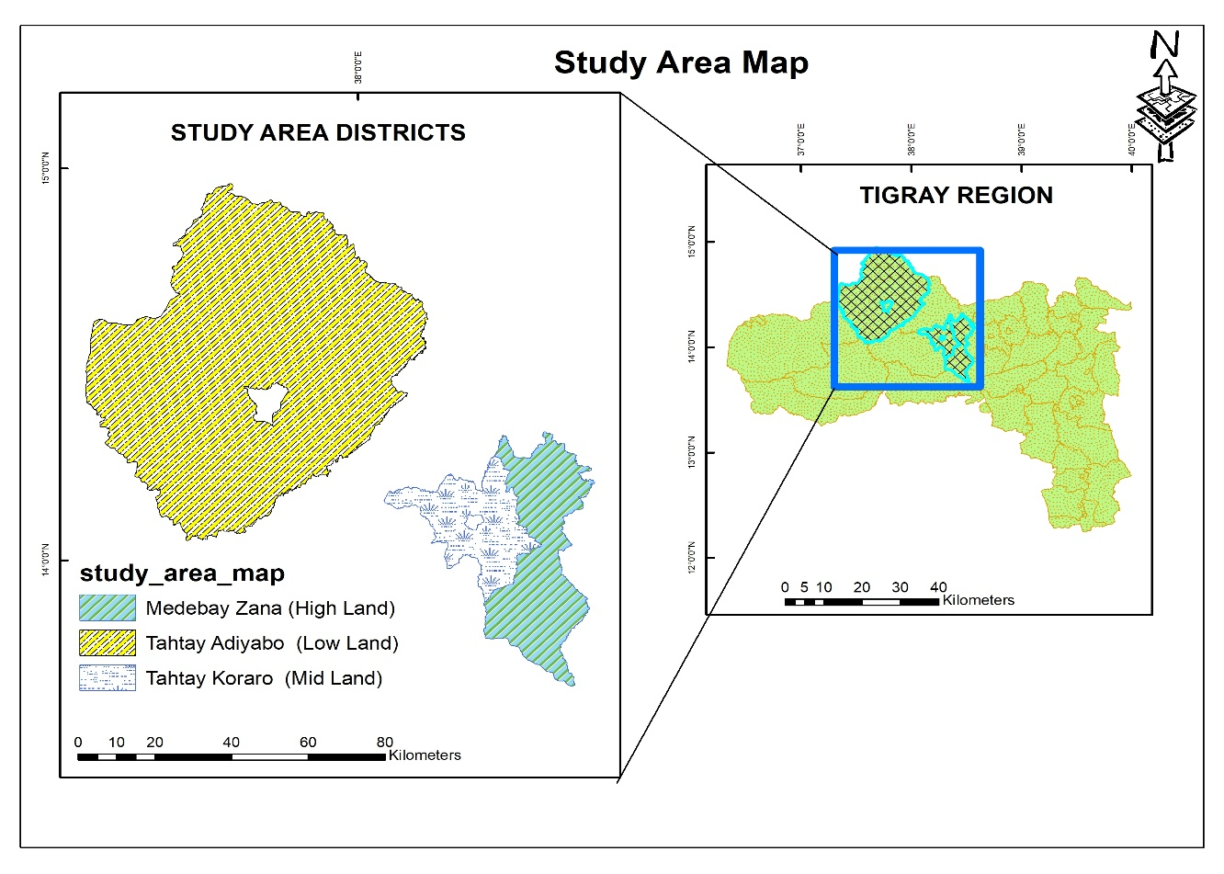
2.2. Sampling and Data Collection
A cross-sectional household survey design was employed to capture current agroforestry practices and climate adaptation strategies.
A multi-stage sampling technique was used:
- Stratification: The study area was stratified into three agro ecological zones (highland, midland, and lowland) to ensure environmental representativeness.
- District Selection: One district was randomly selected from each agro ecological zone.
- Household Selection: Within selected districts, households were selected using systematic random sampling from updated kebele household lists.
The sample size (n = 197) was determined using Yamane’s (1967) simplified formula:
$$n=\frac{Z^{2}.p.q}{e^{2}}$$
Where:
- n = Sample size
- z = Standard variate at a given confidence level
- p = Sample proportion
- q = 1 - p
- e = Precision level
The questionnaire captured information on household characteristics, benefits derived from agroforestry, adaptation strategies, and sources of income. Key informants including local elders, agricultural experts, and community leaders provided qualitative insights to complement quantitative data.
2.3. Data Sources and Data Collection Methods
Both primary and secondary data sources were used.
Primary Data
Primary data were collected through:
Structured household questionnaires (socioeconomic characteristics, agroforestry practices, income sources, and adaptation strategies)
Key informant interviews (local elders, agricultural experts, development agents, and community leaders)
Direct field observations (verification of tree–crop–livestock integration and land-use practices)
The questionnaire was pre-tested in a similar agro ecological setting to ensure clarity, consistency, and validity. Necessary adjustments were made before final data collection.
Secondary Data
Secondary data were obtained from district agricultural offices, published reports, and relevant literature to complement and contextualize primary findings.
2.4. Data Analysis Techniques
A mixed-method analytical framework was applied, combining quantitative statistical analysis with qualitative thematic interpretation to enhance robustness and triangulation.
2.4.1. Quantitative Analysis
Quantitative data were analyzed using IBM SPSS Version 26. The following statistical techniques were employed:
Descriptive statistics (mean, frequency, percentage, standard deviation): Used to summarize household characteristics, adoption levels of agroforestry, and adaptation strategies.
Chi-square (χ²) test: Applied to examine associations between categorical variables such as agro ecological zone and adaptation strategy choice.
One-way ANOVA: Used to test statistically significant differences in livelihood outcomes (e.g., income, crop productivity) across agro ecological zones and levels of tree density.
Pearson correlation analysis: Employed to assess linear relationships between key continuous variables such as tree abundance, household income, and crop productivity.
Multinomial logistic regression model: Used to identify determinants of household adaptation strategy choice (e.g., agroforestry, livestock diversification, off-farm activities). The model was appropriate because the dependent variable consisted of more than two categorical outcomes. Independent variables included household demographic, socioeconomic, and environmental factors.
Model robustness was evaluated using:
- Likelihood ratio tests
- Pseudo R² (Cox & Snell, Nagelkerke)
- Model classification accuracy

2.4.2. Qualitative Analysis
Qualitative data from key informant interviews were analyzed using thematic content analysis. Responses were transcribed, coded, and grouped into themes such as adaptation practices, perceived benefits of agroforestry, and local environmental changes. These qualitative insights were used to triangulate and enrich quantitative findings.

3. Results and Discussion
Most respondents were male and engaged primarily in mixed crop-livestock farming. Education levels were generally low, and the average household size was six members. Rainfed agriculture dominated livelihoods across all sites, supplemented by various agroforestry practices such as home gardens, woodlots, and boundary planting.
Nearly all respondents (94%) reported noticeable climate changes over the past three decades, primarily decreased rainfall, shortened rainy seasons, and rising temperatures. Drought was identified as the most prevalent hazard, especially in lowland areas. Farmers have developed diverse strategies to cope with climatic variability, including crop diversification, livestock adjustment, and agroforestry. Agroforestry ranked third among adaptation options.
Fig 2: Respondents from Lowland, Midland, and Highland Farm
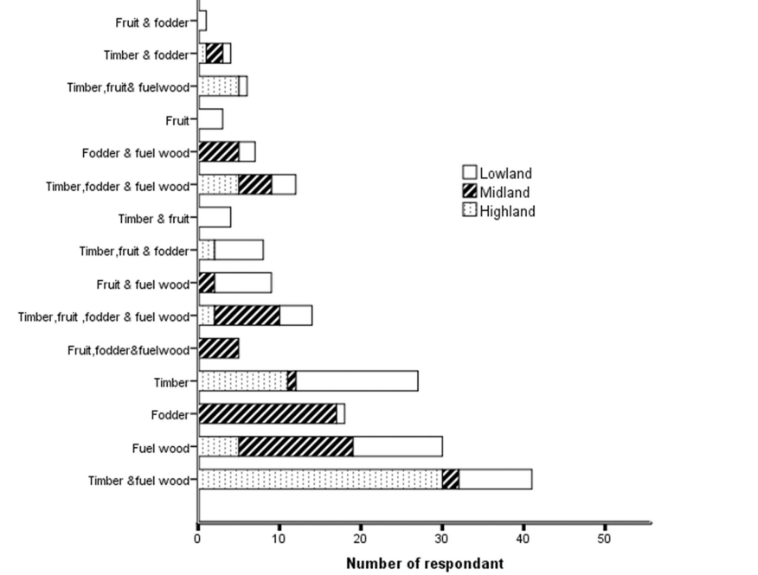
Agroforestry trees served multiple purposes: construction materials (30%), livestock feed (25%), and fuelwood (15%). Trees also provided essential resources for building and farming, reducing pressure on natural forests. About 73% of respondents agreed that on-farm trees enhance crop productivity, confirmed by significant positive correlations between tree abundance and both crop and total income (r = 0.37, p < 0.01; r = 0.55, p < 0.01). On average, trees contributed 34.35% of household income, underscoring their livelihood value.
Table 1. Type and source of material for house building and farm utilities
 |  |  | % of respondents
Type of material | Source |  | Highland |  | Midland | Lowland | Overall
farm utilities |  | open Forest |  | 21.5 | 21.9 | 17.6 | 20.3
 |  | own farm |  | 78.5 | 78.1 | 82.4 | 79.7
Most Material of wall a house |  | Wooden(with mud) |  | 79.7 | 21.9 | 13.2 | 37.8
 |  | Bricks/stones |  | 20.3 | 78.1 | 86.8 | 62.2
Most Material of wall a house |  | Wooden(with mud) |  | 9.5 | 59.4 | 61.8 | 43.9
 |  | Iron Sheet(with woo/timber/ |  | 90.6 | 40.6 | 38.2 | 56.1
The research also found that most residents use tree products from their farmland for constructing their houses. Respondents confirmed that more than two-thirds of their house walls are made from tree products sourced from their farmland. In the highland areas, most farmers use tree products for constructing house walls. However, in the lowland and midland areas, only 13.2% and 21.9% of respondents, respectively, use tree products for this purpose, as most house walls in these regions are made of stone or bricks. The use of tree products for house walls is significantly higher in the highland areas.
Additionally, 43.9% of total respondents stated that most of their house roofs are made of wood products. Farmers in the highland (9.4%), midland (59.4%), and lowland (61.8%) use tree products for roofing, with usage being higher in the midland and lowland areas. A majority of respondents also confirmed that they obtain farm tools from their farmland. Farmers across the highland, midland, and lowland areas primarily source farm tools from their land, while some respondents mentioned acquiring farm equipment from open forests (Table 1).
Most importantly, farmers acknowledged that the benefits of farm trees help them save money that would otherwise be spent on construction materials and farm tools, thereby enhancing their adaptive capacity. Responses from open-ended questions and interviews with elders revealed that trees on farmland tolerate drought one of the most frequent climate-related challenges allowing farmers to build shelters and obtain farm tools even during difficult periods. Farmers testified that by not purchasing construction or farm materials, they save money and time that would have otherwise been spent searching for resources in distant open forests. These savings provide financial security during challenging times. Despite a decline in tree product availability, farmers reported that they have never faced significant difficulties harvesting tree products (such as farm tools, timber, and forage), even during drought conditions.
Furthermore, 73.1% of respondents affirmed that the presence of trees on farmland improves crop production. The Pearson Correlation test confirmed that an increase in the number of trees on farmland leads to higher crop yields and increased household income. However, the chi-square test analysis results indicated a significant relationship between these factors.

Table 2. The relationship between trees in farmland and income (income from crop and total household income).
Variables | Income | Total Income
Abundance | .374** | .552**
Richness | .231** | .169*

**Correlation is significant at p < 0.01 and*p < 0.05
Table 3. Mean difference of on-farm trees and total household income in the three agro-ecologies.
Agro ecology | Total Household income(Us Dollar) | one Farm tree income
Highland | 622.19±434.99^{c} | 622.19±434.99c
Midland | 222.11±236.82ª | 222.11±236.82a
Lowland | 304.54±209.09^{b} | 304.54±209.09b
P-Value | 0.000 | 0.000
Similar letters indicate no significant difference and different letters indicate significant difference at p < 0.05. 1 US dollar ¼ 55.40 Ethiopian Birr (ETB) (Exchange rate as of November 29, 2023).

the study revealed significant differences in tree stand assets on farmland across different agro ecological zones. An increased number of tree species (higher diversity) on farmland was positively correlated with income from crop production and total household income (Table 2). With a moderate strength of correlation, an increase in tree abundance led to higher crop income and overall household income (p < 0.01). Similarly, increased tree species richness showed a weak but positive relationship with both crop income (p < 0.01) and total household income (p < 0.05). However, this positive relationship was only observed up to an optimal level of tree species richness.
The mean number of trees and the diversity of tree species on farmland varied significantly across different wealth categories. Notably, these two variables showed a significant difference between households in the poor and medium wealth categories.
The study also found that household income varied across agro ecological zones. The mean household income was highest in the highland ($622.19 ± 434.99), followed by the midland and lowland regions. The overall mean total household income was $382.57. Income from farm trees averaged $131.41, with the highest income reported in the highland ($202.63 ± 261.51), and followed by the midland and lowland agro ecologies. The contribution of on-farm trees to total household income was 32.57% in the highland, 39.05% in the midland, and 33.65% in the lowland. Overall, agroforestry practices in the studied agro ecological zones contributed 34.35% to total household income (Table 3).
Furthermore, interviewees from our study indicated that during climate shocks, trees on farmland played a crucial role in supporting farmers. During difficult times, particularly droughts, farmers harvested tree products such as timber, fuel wood, and forage, which served as a source of income and compensation for failed crop production. In times of extreme climate stress, farmers sold timber and fuel wood to meet their household's food and other essential needs. Additionally, trees provided a critical source of forage for cattle and sheep during droughts, helping farmers mitigate feed shortages.

Table 4. Percentage of respondents who ranked the main livelihood products based on their importance to their livelihood.
 |  | % of respondents
Agro ecology | Rank | Crop | Livestock | Non-Farm | Agroforestry
Highland | First | 93.8 | 1.6 | 1.6 | 3.1
 | Second | 6.8 | 54.2 | 6.8 | 32.2
 | Third | 31.4 | 0 | 9.8 | 58.8
Midland | First | 89.1 | 6.3 | 1.6 | 3.1
 | Second | 6.3 | 71.9 | 6.3 | 15.6
 | Third | 3.3 | 16.7 | 8.3 | 71.7
Lowland | First | 92.6 | 5.9 | 1.5 | 0
 | Second | 5.9 | 89.7 | 0 | 4.4
 | Third | 1.5 | 1.5 | 8.8 | 88.2
Overall | First | 91.8 | 4.6 | 1.5 | 2
 | Second | 6.3 | 72.8 | 4.2 | 16.8
 | Third | 1.7 | 15.1 | 8.9 | 74.3
This, in turn, helped mitigate food shortages for households. Additionally, respondents stated that income generated from trees during periods without climate challenges contributed to financial stability and improved resilience when climate shocks occurred. This finding highlights that trees on farmland, which are less affected by climate hazards, play a significant role in enhancing household income and livelihood resilience.
The study results indicated that income from on-farm trees varied across agro ecological zones (p < 0.05). A significant difference was observed in the mean income from trees between the highland and midland, as well as between the highland and lowland (p < 0.05). However, the mean income difference between the midland and lowland agro ecologies was not statistically significant (Table 3).
Furthermore, the study confirmed that on-farm trees are among the primary livelihood assets for households. Most respondents ranked crops, livestock, and trees as their first, second, and third most important livelihood assets, respectively. This pattern applied across all three agro ecological zones, except in the highland, where fewer respondents ranked trees as their third most important livelihood asset compared to the other zones. This finding underscores that trees on farmland are among the top three essential livelihood assets (Table 4).
Additionally, the total mean household asset value was estimated at $690.85 ± 524.72. The mean asset value of trees on farmland was $132.73, contributing 19.21% to the total household livelihood asset, ranking third after livestock ($369.86 ± 271.34) and crop production ($189.09 ± 211.69). The mean total livelihood asset value was highest in the highland ($795.86 ± 691.47), followed by the other agro ecological zones. Similarly, the mean tree stands asset value in the highland ($283.15 ± 409.66) was higher than in the midland and lowland. There was a significant difference (p < 0.05) in the mean values of all three main livelihood assets and total assets across the three agro ecological zones. However, the mean difference in total livelihood assets between the highland and lowland was not statistically significant at p < 0.05 (Table 5).
Interviews conducted during the study revealed that the increased income and productivity resulting from trees on farmland helped farmers enhance their adaptive capacity, making them more resilient to climate-related challenges.

Table 5. Mean difference of main household livelihood assets in different agro-ecologies (estimated in USD)
Agro ecology | Livestock asset |  | Crop production asset |  | Trees stand asset |  | Total main livelihood asset
Highland | 284.80 | ± 218.42ª | 238.39 | ± 279.41^{b} | 283.15 | ± 409.66^{c} | 795.86 | ± 691.47^{b}
Midland | 375.77 | ± 269.03^{b} | 120.28 | ± 156.78ª | 55.51 | ± 87.39ª | 555.59 | ± 380.09ª
Lowland | 444.21 | ± 298.07^{b} | 207.19 | ± 160.43^{b} | 73.99 | ± 72.16^{b} | 717.77 | ± 428.92^{b}
p-Value | 0.003 |  | 0.000 |  | 0.000 |  | 0.033
Similar letters indicate no significant difference and different letters indicate significant difference at p < 0.05.
The low vulnerability of trees to climate shocks has led farmers to consider them a primary livelihood asset and a crucial source of income. Interviewees highlighted that trees on farmland serve as a key livelihood asset and an essential source of livestock feed during droughts. This support helped farmers minimize livestock losses due to climate shocks and enabled them to meet their household food demands.
Additionally, respondents noted that accumulating agroforestry tree assets during periods without climate challenges provided them with a more resilient asset base during climate shocks. This, in turn, enhanced their adaptive capacity, allowing them to better withstand and recover from adverse climatic conditions.
Agroforestry was also identified as one of the top three livelihood assets—after livestock and crops—contributing nearly 20% to total household asset value. Trees provided a stable income source less sensitive to climate shocks, confirming agroforestry as a ‘natural insurance mechanism’ stabilizing rural livelihoods.

4. Conclusion and Recommendations
This study provides strong empirical evidence that indigenous Agroforestry systems play a central role in enhancing Climate Change Adaptation and livelihood resilience in northwestern Tigray, Ethiopia. The findings show that on-farm trees contribute substantially to rural livelihoods, accounting for approximately 34.35% of total household income and about 19.21% of total livelihood asset value, confirming their status as a key economic asset after livestock and crop production.
Statistical results further demonstrate that tree abundance is significantly and positively associated with both crop income (r = 0.374, p < 0.01) and total household income (r = 0.552, p < 0.01), indicating that increased tree density directly enhances household economic performance. In addition, agroforestry ranked as the third most important adaptation strategy, and on-farm trees were consistently identified as a critical source of construction materials, fuelwood, and livestock feed, particularly during drought periods. ANOVA results also revealed significant differences in income and asset values across agro ecological zones (p < 0.05), with the highest total household income observed in the highland areas.
Overall, these results confirm that agroforestry functions as a “natural insurance mechanism” that stabilizes livelihoods under climate stress by simultaneously supporting income generation, resource provision, and production stability. Strengthening indigenous agroforestry systems through targeted extension services, improved tree management practices, and supportive policy frameworks is therefore essential for building resilient agricultural systems in Ethiopia’s dryland regions.
Consent
As per international standards or university standards, respondents’ written consent has been collected and preserved by the author(s).
Declaration (Artificial Intelligence)
I hereby declare that I have not used any artificial intelligence tools, including generative AI systems (such as ChatGPT, Copilot, or text-to-image generators), in the writing, editing, or preparation of this manuscript. All work has been carried out solely by me.

6. References
Ajayi, O. C., Place, F., Akinnifesi, F. K., & Sileshi, G. W. (2016). Agricultural success from Africa’s drylands: The role of agroforestry in improving livelihoods and resilience. Agricultural Systems, 146, 11–22.
Alemu, B. (2016). The role of agroforestry practices in improving rural livelihoods in Ethiopia. Addis Ababa University Press.
Bekele, M. (2019). Agroforestry practices and their contribution to household income in rural Ethiopia. Journal of Environmental Management, 244, 272–281.
Food and Agriculture Organization (FAO). (2006). World reference base for soil resources: A framework for international classification, correlation and communication. Rome: FAO.
Food and Agriculture Organization (FAO). (2013). Climate-smart agriculture sourcebook. Rome: FAO.
Garrity, D. P., Akinnifesi, F. K., Ajayi, O. C., Weldesemayat, S. G., Mowo, J. G., Kalinganire, A., Larwanou, M., & Bayala, J. (2010). Evergreen agriculture: A robust approach to sustainable food security in Africa. Food Security, 2, 197–214.
Intergovernmental Panel on Climate Change (IPCC). (2014). Climate change 2014: Impacts, adaptation, and vulnerability. Cambridge University Press.
Intergovernmental Panel on Climate Change (IPCC). (2021). Climate change 2021: Impacts, adaptation and vulnerability. Cambridge University Press.
Jose, S. (2009). Agroforestry for ecosystem services and environmental benefits: An overview. Agroforestry Systems, 76, 1–10.
Kebede, B., & Shumeta, Z. (2019). Contribution of agroforestry systems to livelihood improvement in Ethiopia. Forest Policy and Economics, 98, 1–9.
Lasco, R. D., Delfino, R. J. P., & Catacutan, D. C. (2013). Agroforestry systems: Helping smallholders adapt to climate risks while mitigating climate change. Wiley Interdisciplinary Reviews: Climate Change, 5(6), 825–833.
Linger, E. (2014). Agroforestry practices and socio-economic roles of Cordia africana in Ethiopia. Journal of Agriculture and Rural Development in the Tropics and Subtropics, 115(1), 11–17.

Mbow, C., Smith, P., Skole, D., Duguma, L., & Bustamante, M. (2014). Achieving mitigation and adaptation to climate change through sustainable agroforestry practices in Africa. Current Opinion in Environmental Sustainability, 6, 8–14.
Mekonnen, M., Alemu, T., & Belay, K. (2018). Climate variability and drought impacts on rural livelihoods in Ethiopia. Climate and Development, 10(5), 1–12.
Montagnini, F., & Nair, P. K. R. (2004). Carbon sequestration: An underexploited environmental benefit of agroforestry systems. Agroforestry Systems, 61, 281–295.
Nair, P. K. R. (2011). Agroforestry systems and environmental sustainability. Springer.
Negash, M. (2013). Tree-based farming systems in Ethiopia: A review. Agroforestry Systems, 87, 1–15.
Teketay, D., & Tegineh, T. (1991). Traditional tree crop production practices in Ethiopia. Agroforestry Systems, 14, 71–83.
Verchot, L. V., Noordwijk, M., Kandji, S., Tomich, T., Ong, C., Albrecht, A., ... Palm, C. (2007). Climate change: Linking adaptation and mitigation through agroforestry. Mitigation and Adaptation Strategies for Global Change, 12, 901–918.
Yamane, T. (1967). Statistics: An introductory analysis (2nd ed.). New York: Harper and Row.

