Forest dependency among the indigenous communities of Karlapat wildlife sanctuary in Odisha state of India: An analysis of socio-economic parameters

ABSTRACT
Background: The forest dependence among communities indicates the human-environment inter-relationship, which demonstrates the degree of such reliance in various regions and in different time periods.
Aim: This study aims at understanding the purpose and frequency of forest dependence among indigenous communities of Karlapat wildlife sanctuary in relation to their socio-economic parameters.
Place and Duration of Study: The study was carried out inside Karlapat wildlife sanctuary, covering six village sites and the primary work was conducted from September 2024 to April 2025.
Methodology: The data were collected from 180 households in the concerned villages. Microsoft Office (Version.2010) was used to organise the data. Statistical Package for Social Sciences (SPSS version 20) was used for ordinal logistic regression to understand the connection between socio-economic parameters and the level of forest dependency.
Results: Fuel-wood was the primary reason for forest dependency, while in the summer months, slash cultivation was practised in small patches, as permission was restricted to small patches. Analysis revealed that the occupation of respondents showed a strong and significant effect on forest dependency. Considering the service with agriculture as base, the level of dependency increased significantly with occupational shift from service with agriculture to small business with agriculture (OR = 2.97), daily wage with agriculture (OR = 6.62) and agriculture only (OR = 94.60). The results showed that a transition from primary level of education (OR = 3.54) to no formal education (OR = 5.02) resulted in increasing forest dependency. Though respondents with higher education and high income level were more likely to less dependent on forests, almost all the respondents are forest dependent for firewood purposes.
Conclusion: This study shows an intrinsic relationship between accessing forest resources and the occupation of the population. The low-income group populations are more dependent on the forest for non-timber forest products like mushrooms, berries, plate-making leaves and tubers of numerous categories. Their forest reliance also represents a wide knowledge of traditional medicine species. The regulated way of forest conservation also signifies awareness of forest resource maintenance by the communities. The purpose of forest reliance does not compromise the environmental condition, though slash cultivation is practised in a few patches by a very small section of people.

Keywords: Forest dependency, Sustainable Livelihood, Indigenous communities, Karlapat wildlife sanctuary
1. INTRODUCTION
Forest dependence is a practice which interprets the concept of forest use and forest reliance as a distinct concept. Forest use indicates harvesting forest products, accessing water as a service, forest land for agriculture and use for other cultural observations Campbell, 2005). Forest reliance has been described as an economic assurance and a means of poverty reduction (Nerfa et al., 2020). Forest dependence generally is understood as the extent to which humans rely on forests for their well-being. It has been widely recognised as a valuable concept for understanding human communities’ well-being and vulnerability to shocks and changes (Frey et al., 2022). The forest dependence among communities indicates the human-environment inter-relationship, which demonstrates the degree of such reliance in various regions and in different time periods. Estimates suggest that around 275 million resource-poor individuals in India, mainly tribal communities, depend on forests for at least a part of their livelihood. As the path of forest dependency led to food security (Singh et al., 2024; Prateek and Punia, 2025), such a process paves the way for sustainable livelihood among various communities in terms of availability of essential products (Garekae et al., 2017; Miah et al., 2011; Mukul et al., 2016; Manohar et al., 2023). The diversity of forests represents a diversified field of forest reliance in various parts of India (Agarwal and Chandra, 2021). The forest and livelihood connection among communities represents sustenance, well-being (Jannat et al., 2018) and more particularly, livelihood improvement as it provides basic requirements for local communities, especially in developing nations (Bahuguna, 2000; Islam et al., 2015; Garekae et al., 2017). Attachment to the forest grows through the living period due to the availability of essential items like household material, firewood, fruits, flowers, tubers, medicinal plants and other non-timber forest products like resin, gum, honey, mushrooms, etc. (Miah et al., 2011; Soe & Yeo-chang, 2019). Bearing animistic philosophy and traditions, the native communities worship nature as well as maintain their forest ecosystem and do not pose a threat to its existence (Miah et al., 2011). However, the availability of wild products for consumption purposes seems to have decreased nowadays in various regions due to a long period of slash-and-burn cultivation as well as due to the influx of population towards the fringe areas of forests (Poudyal et al., 2018; Mantey & Teye, 2021). Very often, the activities around fringe areas are responsible for the exploitation of forests in terms of illegal logging for timber trade and encroachment (Gauriat, 2020; Vasile & Iordăchescu, 2022). More particularly, these activities have led to the implementation of several strict forest policies (Tacconi et al., 2019), which affect the livelihood practices of the native population (Banarjee et al., 2022). Maintaining some strict policies also gave ample chance to recreate the forest environment (Soman & Anitha, 2020). Policies concerning forest recreation are majorly supported by ethnic communities of India, who in turn have the responsibility to maintain the forest (Vasan et al., 2019)Given the significance of forests and their role in the livelihood maintenance structure of native communities (Grundel, 2022), certain works have assessed the forest produces and other related goods; this is a piece of work focusing on the socio-economic parameters determining the forest dependency of native indigenous communities inside of Karlapat wildlife sanctuary of Odisha state in India.
Karlapat Wildlife Sanctuary is a protected zone situated in the Kalahandi district of Odisha state in India. The geographical boundary of the wildlife sanctuary consists of the Nehela reserve forest, Shagada reserve forest, Jugasaipatna reserve forest, Jerka reserve forest and Karlapat reserve forest. The ethnic communities residing within the sanctuary include Kutia Kondh, Dongria Kondh and Sauras. Kui is the primary language for communication. Having dry deciduous forest cover, this sanctuary represents a variety of non-timber forest products. The non-timber forest products include plate-making leaves, seasonal berries, fruits, gum, resins, honey, wild tubers and mushrooms. Categorised as the KBK (Kalahandi-Bolangir-Koraput) planning region of India, this study aims at understanding the purpose and frequency of forest dependence among communities in relation to their socio-economic parameters.

2. material and methods
2.1 Study area
The study was conducted in the Karlapat wildlife sanctuary of Odisha state in India. Spanning over 175 square kilometres (Pattanayak, 2008), this sanctuary covers parts of four Community Development blocks, including Bhawanipatna, Junagarh, Thuamul Rampur and Lanjigarh. A river named Sagada, along with a few rivulets, serves as a source of water for the flora and fauna of the sanctuary. Officially established as a protected area on October 15, 1992, this sanctuary was designated as a wildlife sanctuary to protect and conserve the rich biodiversity. Widely known for conserving elephant, leopard, deer, and giant squirrel, Karlapat wildlife sanctuary is a protected zone situated in the Kalahandi district of Odisha state in India. There are eighteen villages located within the sanctuary, from which six villages, including Kiapadar, Sapamundi, Jakham, Urharanga, Belagarh, and Panchakula, were purposively selected on the basis of their location and dominance of the ethnic population. The map concerning the study area and selected study sites is prepared with ArcGIS 10.8

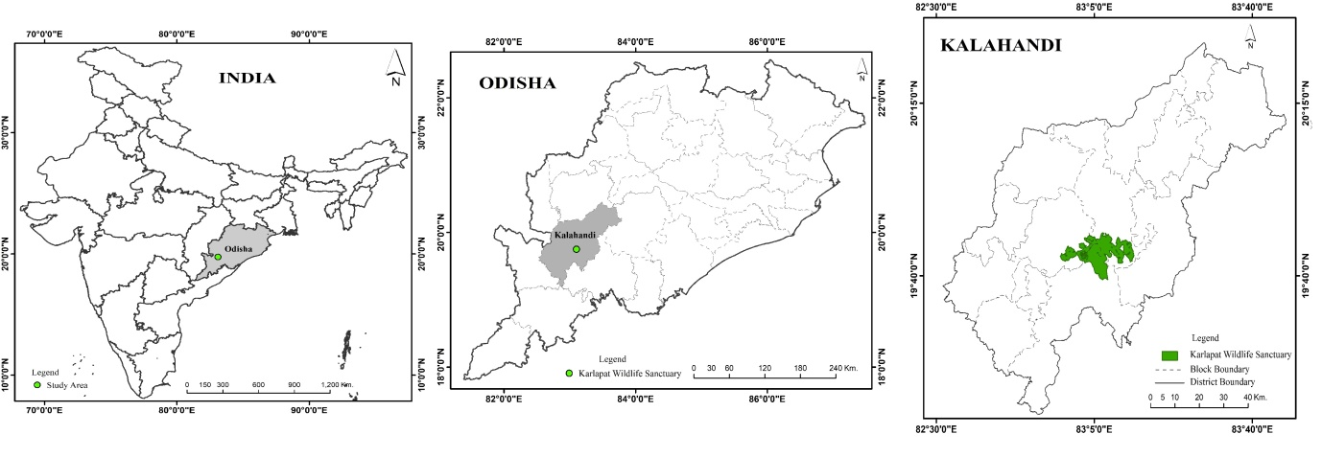Figure No 1: The study area
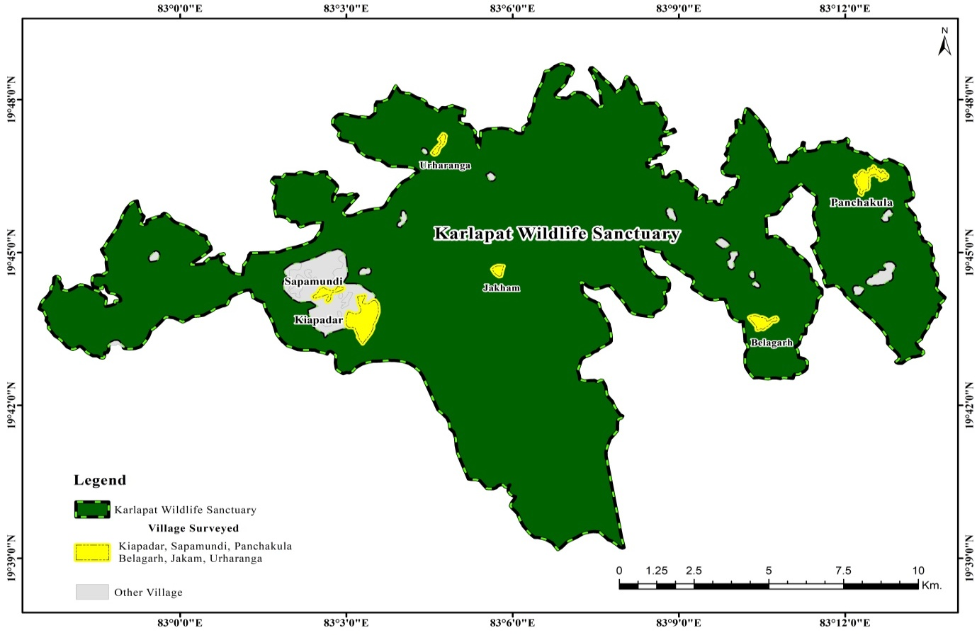
Figure 2: The surveyed villages
2.2 Sample Size:
Out of eighteen villages located within the sanctuary, six villages, including Kiapadar, Sapamundi, Jakham, Urharanga, Belagarh, and Panchakula, were purposively selected on the basis of their location and concentration of ethnic population. Random sampling method at the household level was applied to gather information on forest dependency and socio-economic parameters. The data was collected from 180 households in the concerned villages. 30 respondents at the household level were selected from each village.
2.3 Quantitative Analysis
Microsoft Office (Version.2010) was used to organise the data. Statistical Package for Social Sciences (SPSS version 20) was used for ordinal logistic regression to understand the connection between socio-economic parameters and the level of forest dependency.
Here, the dependent variable is the level of forest dependence, which was categorised into three groups: low, medium and high levels of forest dependence. Socio-economic variables are depicted in percentages.

3. results and discussion

Various reasons determine the forest dependency of local communities on the forest (Table .1). As several factors contribute to reliance on the forest, income and occupation remain a prominent factor for a long time (Chakraborty et al., 2018). Fuel-wood was the primary reason for forest dependency, while in the summer months, slash cultivation was practised in small patches, as permission was restricted to small patches. Gathering of fruits like Chahr (Buchanania lanzan), Aam or mango (Mangifera indica), Taynaa or cluster fig (Ficus racemosa) and Gunju or cashew apple (Anacardium occidentale) increased during the summer season. The early monsoon months of June and July increase the accessibility to fruits like pineapple, jackfruit, guava and blackberries. Wild tubers, including Pit kanda (Dioscorea oppositifolia) and Kardi (Bambusa tulda), were collected and seasonally sold in the local market. The seasonal mushroom collection, mostly during monsoon rainfall, is of utmost importance to these ethnic groups as the prices of such products increase at that time due to periodic availability. Most often, the dried bamboo shoots (locally called Hendua) are used for domestic purposes. The Resin, gum and mahua flowers were occasionally collected due to seasonal availability. Sap of sago palm tree (Caryota Urens L.), locally called Salap, is mostly collected and consumed for entertainment purposes (Figure 4).
Table No. 1: Frequency of household dependency on forest (N= 180)
Variables | Total | Percentage
Slash cultivation | 24 | 13.33%
Fuel wood | 169 | 93.88%
Fodder | 100 | 55.55%
Household materials | 82 | 45.55%
Medicinal plants | 67 | 37.22%
Wild tubers and mushrooms | 118 | 65.55%
Plate making leaves (Sargi and Siali) | 139 | 77.22%
Fruits and berries | 154 | 85.55%
Others (resin, gum, seeds and mahua flower) | 29 | 16.11%
Source: Primary survey conducted (September 2024 - April 2025)

Figure 3: Purpose of forest reliance

Table no 2: Socio-economic variables of the respondents (N=180)
Variables | Category | %
Age (in years) | 20-29 | 20.7%
 | 30-39 | 26.7%
 | 40-49 | 32.2%
 | >50 | 20.4%
Sex | Male | 55.7%
 | Female | 44.3%
Livestock Size | No livestock | 6%
 | 1-4 | 32.2%
 | 5-7 | 35.1%
 | 8 or more | 26.7%
Household Size | 1-3 | 12.3%
 | 4-5 | 50.4%
 | 6 and above | 37.2%
Educational Level | No Formal Education | 54.9%
 | Primary | 21.2%
 | Secondary | 15.9%
 | Intermediate and Above | 8%
Occupation | Agriculture | 33.8%
 | Daily Wage + Agriculture | 35.1%
 | Small business + Agriculture | 17.8%
 | Service + Agriculture | 13.3%
Approx. Annual Income (INR) | Low (15000- 60000) | 42.8%
 | Medium (60000-100000) | 43.2%
 | High (>100000) | 14%
Source: Primary survey conducted (September 2024 - April 2025)

Of the total respondents, around 55.7% were male, and 44.3% were female. The average age of respondents was 40.07, while the average household and livestock size was 4.86 and 5.50, respectively. As livestock like cows, buffalo, goats, sheep and domestic fowl are of high value in nearby urban areas, domestication of these livestock plays a major role in their household income. Most of the respondents fell into the category of 40-49 (32.2%), followed by 30-39 (26.7%) and >50 (24.4%). Around 54.9% of respondents did not receive any formal education, followed by primary (21.2%), secondary (15.9%) and intermediate groups (8%). 33.8% of respondents were engaged in agriculture, while a greater part were engaged on daily wages along with agriculture (35.1%). Around 13.30% of respondents were engaged in service in the agriculture category. These socio-economic variables were considered as determinants for the level of dependency on forests. The forest dependency was measured on a weekly (high), fortnightly (medium) and monthly (low) basis. Around 44.7% of households agreed to be highly dependent on the forest, while 34.2% and 21.1% households agreed to medium and low levels of forest dependency, respectively.

Table no 3: Logistic regression analysis for socio-economic parameters influencing forest dependence
Parameter |  | B | SE | Hypothesis Test |  |  | Exp(B)
 |  | B | SE | Wald | df | Sig. | Exp(B)
Threshold | Low Forest dependency | 1.29 | 0.84 | 2.34 | 1 | 0.12 | 3.66
Threshold | Medium Forest dependency | 4.09 | 0.88 | 21.63 | 1 | 0 | 59.9
Sex | (Male) | 0.47 | 0.24 | 3.86 | 1 | 0.04 | 1.60
Sex | (Female) | 0ª | . | . | . | . | 1
Age | (20-29) | 0.52 | 0.59 | 0.75 | 1 | 0.38 | 1.68
Age | (30-39) | 0.03 | 0.52 | 0.005 | 1 | 0.94 | 1.03
Age | (40-49) | -0.25 | 0.42 | 0.35 | 1 | 0.55 | 0.77
Age | (50 and above) | 0ª | . | . | . | . | 1
Education | (No Formal Education) | 1.61 | 0.71 | 5.17 | 1 | 0.02 | 5.02
Education | (Primary) | 1.26 | 0.64 | 3.85 | 1 | 0.05 | 3.54
Education | (Secondary) | 0.30 | 0.54 | 0.31 | 1 | 0.57 | 1.35
Education | (Intermediate and above) | 0ª | . | . | . | . | 1
Occupation | (Agriculture only) | 4.55 | 0.70 | 41.34 | 1 | 0 | 94.6
Occupation | (Dailywage +Agriculture) | 1.89 | 0.53 | 12.51 | 1 | 0 | 6.62
Occupation | (Smallbusiness +Agriculture) | 1.09 | 0.49 | 4.92 | 1 | 0.02 | 2.97
Occupation | (Service + Agriculture) | 0ª | . | . | . | . | 1
Livestock size | (No Livestock) | -0.63 | 0.47 | 1.73 | 1 | 0.18 | 0.53
Livestock size | (1-4) | 0.005 | 0.31 | 0 | 1 | 0.98 | 1.00
Livestock size | (5-7) | 0.006 | 0.29 | 0 | 1 | 0.98 | 1.00
Livestock size | (8 and above) | 0ª | . | . | . | . | 1
Aproximate annual inome (INR) | Low (15000-60000) | 1.02 | 0.46 | 4.81 | 1 | 0.02 | 2.78
Aproximate annual inome (INR) | Medium (60000-100000) | 0.61 | 0.31 | 3.71 | 1 | 0.05 | 1.84
Aproximate annual inome (INR) | High (>100000) | 0ª | . | . | . | . | 1
Household size | (>6) | 0.74 | 0.39 | 3.52 | 1 | 0.06 | 2.10
Household size | (4-5) | -0.12 | 0.34 | 0.13 | 1 | 0.71 | 0.88
Household size | (1-3) | 0ª | . | . | . | . | 1
B=Beta Coefficients, SE= Standard Error, Sig. =Significance (p= .05), Exp (B) =Odd ratio (OR), a=set to zero because this parameter is redundant, df= Degrees of freedom

Analysis revealed the occupation of respondents showed a strong significant effect on forest dependency. Considering the service with agriculture as base, the level of dependency increased significantly with occupational shift from service with agriculture to small business with agriculture (OR = 2.97), daily wage with agriculture (OR = 6.62) and agriculture only (OR = 94.60). Apart from occupation, educational level, and income, there was a weak effect on the level of forest dependency. The results showed that a transition from primary level of education (OR = 3.54) to no formal education (OR = 5.02) resulted in increasing forest dependency. Looking after the income level, a shift from medium (OR = 1.84) to high (OR = 2.78) income resulted in a decrease in forest dependency. Though respondents with higher education and high income level were more likely to less dependent on forests, almost all the respondents are forest dependent for firewood purposes.

4. Conclusion
As forests are regarded as a source of maintenance and livelihood for ethnic communities, this study shows an intrinsic relationship between accessing forest resources and the occupation of the population. The low-income group populations are more dependent on the forest for non-timber forest products like mushrooms, berries, plate-making leaves and tubers of numerous categories. Their forest reliance also represents a wide knowledge of traditional medicine species. This reflects a better sense of traditional ecological knowledge. The dependence on the forest was measured on a weekly (high), fortnightly (medium) and monthly (low) basis. An increase in educational level and income level depicts low forest dependency, thus regulating a path of natural forest conservation. The regulated way of forest conservation also signifies awareness of forest resource maintenance by the communities. The purpose of forest reliance does not compromise the environmental condition, though slash cultivation is practised in a few patches by a very small section of people. Accessing the forest by ethnic communities also depicts the awareness of natural resource management, as almost all major aspects of dependency do not hamper the ecological balance. Strict regulations by the forest authority also stopped illegal logging, which enables the forest dependency.

Competing interests
The authors confirm that they have no conflict of interest to declare.

COMPETING INTERESTS DISCLAIMER:
Authors have declared that they have no known competing financial interests OR non-financial interests OR personal relationships that could have appeared to influence the work reported in this paper.

Disclaimer (Artificial intelligence)

Author(s) hereby declare that NO generative AI technologies such as Large Language Models (ChatGPT, COPILOT, etc.) and text-to-image generators have been used during the writing or editing of this manuscript.

References

Agarwal, R & Chandra, V. (2021). Forest dependent livelihood in relation to socio-economic status of the people in Chopta-Mandal forests of Garhwal Himalayas, Uttarakhand. Asian Journal of Conservation Biology, 10 (2), 317-325. https://doi.org/10.53562/ajcb.66499
Bahuguna, V. K. (2000). Forests in the economy of the rural poor: An estimation of the dependency level. Ambio: A Journal of the Human Environment, 29(3), 126–129. https://doi.org/10.1579/0044-7447-29.3.126
Banerjee, S., Niyogi, R., Sarkar, M. S., John, R. (2022). Assessing the vulnerability of protected areas in the eastern Himalayas based on their biological, anthropogenic, and environmental aspects,Trees, Forests and People,8,https://doi.org/10.1016/j.tfp.2022.100228.
Campbell, M. O. N. (2005). Sacred groves for forest conservation in Ghana’s coastal
savannas: Assessing ecological and social dimensions. Singapore Journal of Tropical Geography, 26(2), 151–169.
Chakraborty, A., Joshi, P.K. & Sachdeva, K. (2018). Capturing forest dependency in the central Himalayan region:Variations between Oak (Quercusspp.) and Pine (Pinusspp.) dominated forest landscapes Ambio 2018, 47:504–522 https://doi.org/10.1007/s13280-017-0947-1
Garekae, H., Thakadu, O.T. & Lepetu, J. (2017). Socio-economic factors influencing household forest dependency in Chobe enclave , Botswana. Ecological Processes, 6(40). https://doi.org/ 10.1186/s13717-017-0107-3
Gauriat, V. (2020). Romania’s virgin forests ravaged by “wood mafia”. From Euronews.. https://www.euronews.com/my-europe/2020/03/13/romania-s-virgin-forests-ravaged-by-wood-mafia.
Grundel, I., Christenson, N., & Dahlstr, M. (2022) Identifying interests and values in forest areas through collaborative processes and landscape resource analysis. Forest Policy and Economics, 142, https://doi.org/10.1016/j.forpol.2022.102801
Jannat, M., Hossain, M. K., Uddin, M. M., Hossain, A., & Kamruzzaman, M. (2018). People’s dependency on forest resources and contributions of forests to the livelihoods : A case study in Chittagong hill tracts ( CHT ) of Bangladesh. International Journal of Sustainable Development & World Ecology. https://doi.org/ 10.1080/13504509.2018.1434571
Miah, M. D., Chakma, S., Koike, M., & Muhammed, N. (2011). Contribution of forests to the livelihood of the Chakma community in the Chittagong hill tracts of Bangladesh. Journal of Forest Research. https://doi.org/ 10.1007/s10310-011-0317-y
Mukul, S. A., Rashid, A. Z. M. M., Uddin, M. B., & Khan, N. A. (2016). Role of non-timber forest products in sustaining forest-based livelihoods and rural household's resilience capacity in and around protected area: A Bangladesh study. Journal of Environmental Planning and Management, 59(4), 628–642. https://doi.org/ 10.1080/09640568.2015.1035774
Nerfa, L., Rhemtulla, J. M., & Zerriffi, H. (2020). Forest dependence is more than forest income: Development of a new index of forest product collection and livelihood resources. World Development.125. https://doi.org/10.1016/j.worlddev.2019.104689

Pattanayak, M. (2008). The Forest resources of Kalahandi- Past, present and future. Orissa Review, 12, 18-21
Prateek, G & Punia, S. (2025). Forest dependency and food security: Diverse livelihoods in India's tribal heartland, Forest Policy and Economics,177, https://doi.org/10.1016/j.forpol.2025.103527.
Poudyal, M., Rakotonarivo, O. S., Raza, J. H., Hockley, N., & Jones, J. (2018). Household economy, forest dependency & opportunity costs of conservation in eastern rainforests of Madagascar. Scientific Data, 5. https://doi.org/ 10.1038/sdata.2018.225
Soe, K. T., & Yeo-chang, Y. (2019). Livelihood dependency on non-timber forest products : Implications for REDD +. Forests, 10(427), 1–25.
Soman, D and Anitha, V. (2020) Community dependence on the natural resources of Parambikulam Tiger reserve, Kerala, India. Trees, Forests and People, 2, https://doi.org/ 10.1016/j.tfp.2020.100014
Tacconi, L., Rodrigues, R. J., & Maryudi, A. (2019). Law enforcement and deforestation: Lessons for Indonesia from Brazil. Forest Policy and Economics, 108. https://doi.org/ 10.1016/j.forpol.2019.05.029
Vasan, S., Mehta V., & Tribhuvan, P. (2019). Characterising the relationship between forest dependent peoples and state forest management institutions in the Global South. Environmental Research Letters. 14 https://doi.org/10.1088/1748-9326/ab2925
Vasile, M., & Iordăchescu, G. (2022). Forest crisis narratives: Illegal logging, datafication and the conservation frontier in the Romanian Carpathian mountains. Political Geography, 96. https://doi.org/ 10.1016/j.polgeo.2022.102600
Frey, G. E., Kallayanamitra, C., Wilkens, P., & James, N. A. (2022). Defining and Measuring Forest Dependence in the United States: Operationalization and Sensitivity Analysis. Forests, 13(4), 577. https://doi.org/10.3390/f13040577
Singh, P., Dhuria, S. S., Soan, N., Chauhan, K., Kamesh, K., & Pandey, S. (2024). FOREST BASED LIVELIHOOD: OPPORTUNITIES AND CHALLENGES IN INDIA: A REVIEW. Plant Archives, 24(SI). https://doi.org/10.51470/plantarchives.2024.v24.sp-gabels.051
Mantey, P. P. K., & Teye, J. K. (2021). Forest dependence among rural households in southern Ghana: Implications for conservation and poverty reduction. Ghana Journal of Geography, 13(1), 1-24.
Islam, M. A., Quli, S. M. S., Sofi, P. A., Bhat, G. M., & Malik, A. R. (2015). Livelihood dependency of indigenous people on forest in Jharkhand, India. Vegetos, 28(3), 106-118.
Manohar M, & Rubeena T. A. (2023). Forest Dependent Communities and Forest Degradation in Thiruvananthapuram, South-India. Curr World Environ ;18(1). DOI:http://dx.doi.org/10.12944/CWE.18.1.34
‌

‌

