DELAYED REIMPLANTATION OF AN AVULSED MAXILLARY CENTRAL INCISOR FOLLOWING EXTENDED EXTRA-ORAL DRY TIME: A CASE REPORT
ABSTRACT –
Background:
Tooth avulsion is the complete displacement of a tooth from its alveolar socket, causing damage to the periodontal structures. Although relatively uncommon, it represents 1–16% of traumatic dental injuries and is most frequently seen in the maxillary anterior region. Immediate management is critical, particularly in children and adolescents, to improve the prognosis of replantation.
Case description -
A 14-year-old male patient presented with avulsion of the maxillary left central incisor following trauma. The tooth had been stored dry for approximately 12 hours prior to presentation, creating an unfavorable condition for replantation.
Intervention:
Despite the extended extra-oral dry time, replantation was performed considering the patient’s age and the need to maintain aesthetics, function, and psychological well-being.
Outcome:
The tooth was successfully replanted and managed, aiming to preserve alveolar bone structure and provide temporary functional and aesthetic rehabilitation, despite the guarded long-term prognosis.
Conclusion:
Delayed replantation may still be considered in young patients even under unfavorable conditions, as it can help maintain aesthetics, function, and psychological health while serving as a temporary solution until definitive treatment is feasible.
Keywords: Tooth avulsion, Traumatic management, Splinting, Dry storage, Traumatic dental injury (TDI), Periodontal ligament damage
INTRODUCTION –
Permanent tooth avulsion represents 0.5% to 16% of all cases of dental injury.¹ A sudden impact to the teeth and surrounding tissues can cause dento-alveolar trauma, which may result in various injuries, including the complete displacement of a tooth from its socket. Traumatic dental injuries are most commonly observed in individuals aged 7–11 years. The leading cause of these injuries is accidental falls, with other contributing factors including sports activities, road traffic accidents, and interpersonal violence.² Several studies have demonstrated that this injury is among the most severe, and the prognosis is heavily influenced by the immediate actions taken at the scene and shortly after the tooth is avulsed.¹
Tooth avulsion (exarticulation) is defined as the complete removal of a tooth from its alveolar socket due to trauma. Martins et al. reported that physical altercations and sports injuries are the primary causes of tooth avulsion in permanent dentition, whereas falls against hard surfaces are more prevalent in primary dentition. The distribution of etiological factors revealed that unknown causes and altercations were the most common, each accounting for 17% of cases. Contact sports contributed to 15.9%, followed by motor vehicle collisions (10.8%) and motorcycle accidents (10.4%). Ice hockey was a less frequent cause, representing 2.3% of cases.³
Avulsion constitutes the most severe injury to the periodontal ligament (PDL), with the timing of replantation being a crucial factor affecting prognosis. To optimize periodontal ligament cell survival before replantation, several storage protocols have been developed, including the use of storage media such as Hanks’ balanced salt solution (HBSS) and propolis.⁴ This injury most commonly happens in individuals aged 7–14 years, with the highest incidence observed in the maxillary central incisors.⁵
Twenty-five percent of children attending school sustain dental trauma, while thirty-three percent of the adult population report injuries to their permanent teeth. Globally, it is estimated that nearly one billion individuals have sustained traumatic dental injuries (TDIs)⁶ Effective splinting of teeth after trauma is a crucial predictor for the healing of both pulpal and periodontal tissues. The splints function to stabilize and protect the teeth, providing ideal conditions for the healing and regeneration of the surrounding supporting tissues.⁷
Effective immediate care for dental traumatic injuries relies on clear, evidence-based guidelines. Andreasen investigated the effects of extra-alveolar duration and storage conditions on periodontal and pulpal healing outcomes following the replantation of mature permanent incisors in a monkey model.³
This manuscript highlights the clinical relevance of attempting replantation even after delayed and unfavorable conditions, especially in young patients. It emphasizes the importance of preserving aesthetics, function, and psychological well-being despite a poor prognosis. The case adds practical insight for clinicians managing traumatic dental injuries when ideal treatment timelines are not possible.
This case report details the step-by-step management of a maxillary left central incisor that was successfully replanted despite an extended extra-oral dry time exceeding 13 hours.
CASE REPORT –
A 14-year-old male presented to the Department of Pedodontics and Preventive Dentistry, Sri Siddhartha Dental College and Hospital, Tumakuru, Karnataka, with a chief complaint of dental trauma and avulsion of the upper front teeth following a fall from a bicycle the previous night. Extraoral examination revealed bruises on the chin and a swollen upper lip. Intraoral examination showed avulsion of tooth 21, subluxation of tooth 11, extrusion of tooth 22, and Grade I mobility in teeth 11 and 12 (Fig. 1C). The patient also exhibited a deep traumatic bite. The patient had no significant past medical history; however, a booster dose of anti-tetanus vaccine was administered.
The patient’s attendant (mother) had retrieved the avulsed tooth, wrapped it in tissue paper (Fig. 1A), and presented to the department approximately 13 hours after the trauma. Upon receipt, the tooth was immediately placed in milk (Fig. 1D).
As the patient was young and concerned about the loss of the tooth, a decision was made to replant the avulsed tooth to alleviate psychological, esthetic, and functional consequences. The patient and guardian were informed about the possible complications associated with delayed replantation, including inflammatory resorption, replacement resorption (ankylosis), and discoloration of the tooth.
After obtaining informed consent, replantation of the avulsed tooth was planned. The tooth exhibited an intact crown and a fully formed root with a closed apex. Due to the prolonged extraoral duration (approximately 13 hours), the desiccated root surface was cleaned and gently debrided with a dental hand instrument (scaler) to eliminate adherent debris and necrotic periodontal ligament cells (Fig. 2A). The tooth was subsequently immersed in acidulated phosphate fluoride (APF) gel for 20 minutes.
Owing to the extended extraoral dry time, an extraoral root canal procedure was performed, involving biomechanical preparation (BMP) with irrigation using chlorhexidine (CHX) and normal saline. The canal was subsequently obturated with gutta-percha (Fig. 2A–D). The avulsed tooth was subsequently treated with a doxycycline solution prior to replantation into the socket (Fig. 2E).

FIGURE 1-
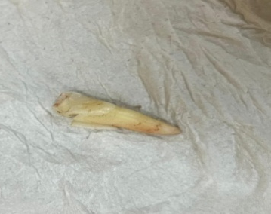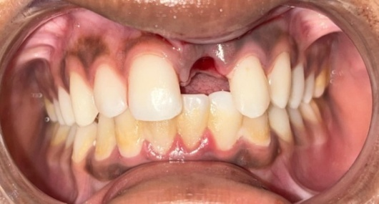
A C
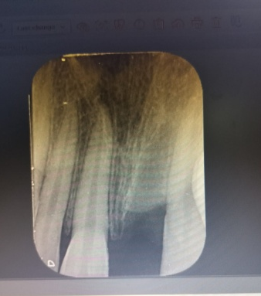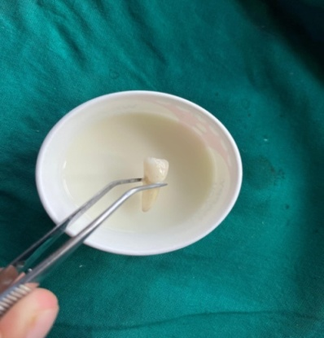
B D

FIGURE 1: (A) Avulsed tooth in tissue paper. (B) Pre-operative radiograph showing empty alveolar socket in 21 region. (C) Pre-operative clinical image. (D) Tooth preserved in milk following avulsion injury.

FIGURE 2-

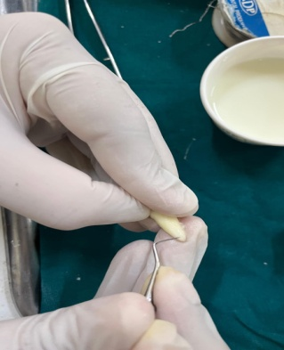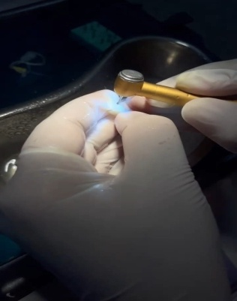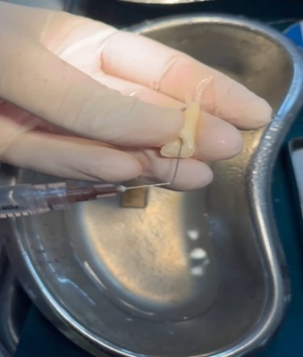
A B C
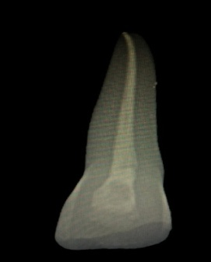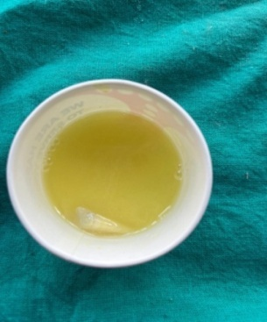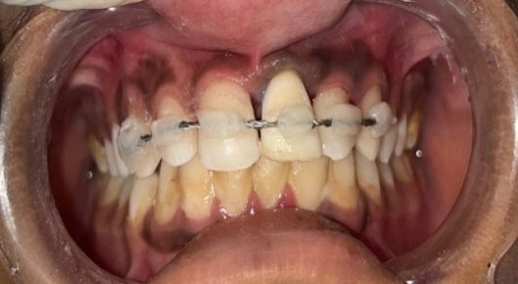
D E F
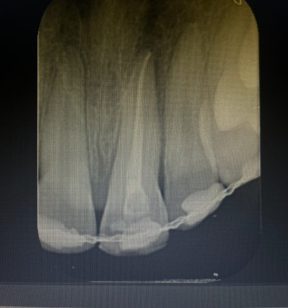
G

FIGURE 2- (A) Extra-oral root surface preparation. (B) Extra-oral Access opening done with 21. (C) Extra-oral Normal saline irrigation done. (D) Radiographic picture after Extra-Oral RCT. (E) After RCT Tooth preserved in Doxyclycline solution for 20 min.(F) Replanted tooth stabilised in place with composite wire splinting. (G) Post- operative radiograph of 21 immediately after replantation.

PREPARATION OF SOCKET AND REPLANTATION-
Local anesthesia was administered using 2% lignocaine without a vasoconstrictor through labial and palatal infiltration at the affected site to ensure adequate anesthesia prior to the procedure. The alveolar socket was gently irrigated with normal saline to remove any debris. The avulsed tooth was then carefully repositioned into the socket using gentle digital pressure (Fig. 2F), and its position was confirmed using radiograph (RVG) (Fig. 2G). After radiographic verification, the tooth was stabilized with a flexible splint made of 0.4 mm stainless steel orthodontic wire, secured using light-cured composite resin (Fig. 2F).
Postoperatively, the patient was prescribed antibiotics and analgesics. He was instructed to maintain a soft diet for two weeks and to practice good oral hygiene using a soft-bristled toothbrush along with a 0.12% chlorhexidine mouth rinse. The patient was recalled after three weeks, and the splint was removed. This was followed by vitality testing and a comprehensive clinical and radiographic evaluation.
The replanted tooth exhibited a normal root structure, an intact periodontal ligament, and no signs of periapical pathology. As the patient had a deep traumatic bite, an anterior bite plane combined with a passive labial bow appliance was fabricated and delivered (Fig. 4). The patient was subsequently placed on a regular follow-up schedule at three-month intervals.

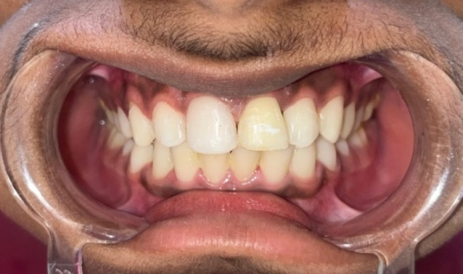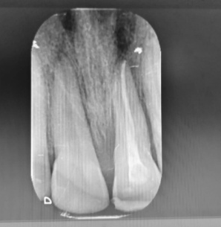
FIGURE 3- Intra-oral clinical image after 3 week removal of semi rigid composite splint.

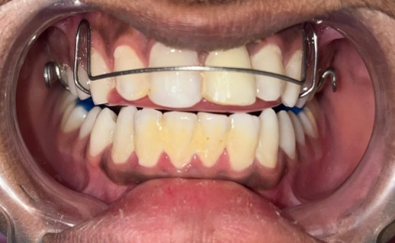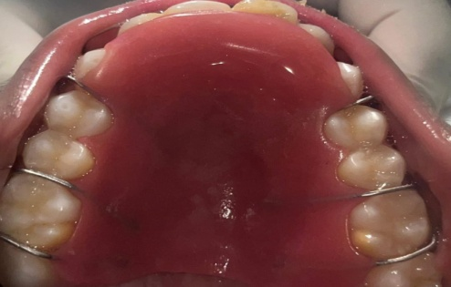
FIGURE 4- clinical image after insertion of anterior bite plane.
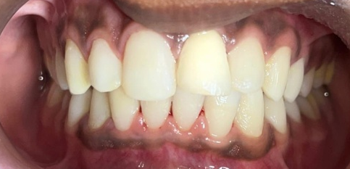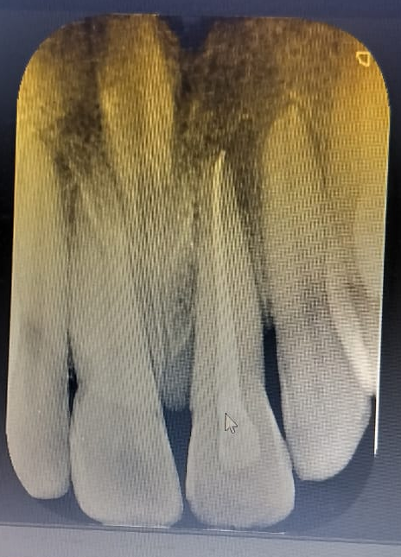

FIGURE 5-Intra-Oral Clinical and radiographic image after 18 month follow up

DISCUSSION-
Avulsion is regarded as the most serious type of dental injury. The maxillary central incisors are the teeth most frequently affected, especially as a result of sports-related trauma and automobile accidents. Timely and proper emergency care is crucial for achieving the best possible outcome following this injury.¹ The best treatment for an avulsion injury is to replant the avulsed tooth as soon as possible. However, this may not always be possible. This case report describes the replantation of an avulsed maxillary central incisor, following an extra-oral period exceeding 3 hours. Effective emergency management, well-planned treatment, and timely intervention are crucial for achieving a positive prognosis in avulsion injury cases.
Tooth replantation success depends on factors such as patient health, root development, storage medium, and extra-oral time, with the latter two being most critical. Damage to the periodontal ligament is the main cause of failure. Although Hank’s Balanced Salt Solution is the gold standard storage medium, it is often impractical, leading to the use of alternatives like milk, egg white, propolis, and coconut water, which show promising results.⁵
When an avulsed tooth is left in the air, the periodontal membrane dries out, leading to cell necrosis. Teeth that are replanted within 6 to 48 hours of avulsion and undergo endodontic treatment have been found to remain clinically functional for many years. The optimal extra-oral time is 20 minutes, while the maximum reported time in the literature is 48 hours.⁸ Prior to replantation, the avulsed tooth was immersed in a sodium fluoride solution. According to Andreasen and Andreasen, after planing the root to remove necrotic periodontal tissue, the tooth should be soaked in a 1.23% acidulated phosphate fluoride (APF) solution for 20 minutes prior to extra-oral root filling and replantation.⁹
Replanted teeth should be carefully monitored, with clinical and radiographic findings documented. Aminizadeh M et al. (2016) described a case involving delayed replantation of an avulsed maxillary central incisor after a prolonged dry extra-alveolar time. Their clinical and radiographic assessments over a 12-month follow-up revealed that the tooth remained stable and functional, although early signs of replacement resorption and ankylosis were detected.¹⁰ Splinting is the recommended treatment to restore normal occlusal function and provide necessary stimulation. In cases without alveolar fracture, a semi-rigid splint is considered the most appropriate choice.¹¹
In the presented case, the avulsed incisor exhibited a closed apex and had been subjected to prolonged air-drying, significantly reducing the likelihood of pulpal and periodontal healing. As a result, the management strategy deviated from the standard replantation protocol. The primary treatment goals were to retain the avulsed tooth for functional and aesthetic purposes, prevent inflammatory root resorption, and promote periodontal stabilization while accommodating the process of replacement root resorption.⁸
J.V. Setty et al. found that primary school teachers in Bangalore generally have only basic knowledge of managing dental avulsion emergencies. They recommended mandatory training in basic dental first aid for teachers and school staff, as children spend much of their time at school.¹² Rizwan Qureshi et al. (2024) conducted an observational study to assess awareness of the emergency management of avulsed teeth among dental interns. The study found that although interns have a fair level of knowledge, it does not meet the expected standards for proper management protocols. The authors concluded that improved training and education are needed for effective handling of avulsion cases.¹³
S.S. Pamnani et al. (2018) evaluated awareness of facial trauma and protective device use among sports participants and instructors aged 8–18 years. The study showed that although awareness of oro-facial injuries and mouth guards was high, their use was low, and knowledge about availability was limited. The authors recommended mandatory use of protective gear in contact sports to reduce oro-facial injuries.¹⁴
Even after a prolonged extra-alveolar dry storage period, delayed replantation of teeth can still result in them remaining stable and functional within the dental arch. For patients who have not yet completed craniofacial growth, maintaining the replanted tooth can serve as a temporary measure to preserve alveolar bone structure until implant placement becomes feasible.¹⁰
A key limitation of this case report is that it represents a single patient, which restricts the ability to generalize the findings to a broader population. The follow-up period, although extending to 18 months, may still be insufficient to fully assess long-term complications such as replacement resorption or ankylosis. Additionally, the favorable outcome despite prolonged dry storage may not be reproducible in all cases, as healing is influenced by multiple patient- and trauma-related factors. Therefore, larger studies and longer follow-up periods are needed to validate the predictability of such treatment approaches.
In this case we successfully achieved goals such as satisfactory aesthetic appearance, occlusal function, and positive healing. The patient remained asymptomatic and expressed full satisfaction with the treatment after a one-year follow-up.
CONCLUSION-
In cases where avulsed teeth have experienced a prolonged extra-oral period, replantation may still be a viable option despite the increased susceptibility to replacement resorption over time, culminating in eventual tooth loss. Replanting the tooth can help preserve aesthetics and occlusal function. However, continued observation with scheduled reviews clinical and radiographic evaluations is essential to monitor the outcome and assess the success of the treatment. The one-year follow-up in this case has shown favorable healing and a positive treatment outcome.
Consent
As per international standards, parental written consent has been collected and preserved by the author(s).
Ethical Approval:

As per international standards or university standards written ethical approval has been collected and preserved by the author(s).

Disclaimer (Artificial intelligence)
Author(s) hereby declare that NO generative AI technologies such as Large Language Models (ChatGPT, COPILOT, etc.) and text-to-image generators have been used during the writing or editing of this manuscript.

REFERENCE-
- Fouad AF, Abbott PV, Tsilingaridis G, Cohenca N, Lauridsen E, Bourguignon C, O'Connell A, Flores MT, Day PF, Hicks L, Andreasen JO, Cehreli ZC, Harlamb S, Kahler B, Oginni A, Semper M, Levin L. International Association of Dental Traumatology guidelines for the management of traumatic dental injuries: 2. Avulsion of permanent teeth. Dent Traumatol. 2020 Aug;36(4):331-342.
- Kadulkar N, Kataki R, Deka A, Thonai S. Replantation of an Avulsed Tooth: A Case Report. Cureus. 2023 May 18;15(5):e39198.
- Tadikonda DC, Pagadala S. Tooth avulsion-a review. Sch J Dent Sci. 2016;3(1):20-3.
- Aksel H, Zhu X, Gauthier P, Zhang W, Azim AA, Huang GT. A new direction in managing avulsed teeth: stem cell-based de novo PDL regeneration. Stem Cell Res Ther. 2022 Jan 28;13(1):34
- Mitthra S, Lukram N, Prakash V, Mary NB, Shuruthi J, Subbiya A. Avulsion–Histological Perspectives and Storage Media-A Review. Indian J Public Health Res Dev. 2019 Sep;10(9).
- Huang R, Zhou C, Zhan L, Liu Y, Liu X, Du Q, Wang J, Zhao W, Song G, Wu LA, Jiang B, Li Y, Zhang H, Zou J. Experts consensus on management of tooth luxation and avulsion. Int J Oral Sci. 2024 Sep 26;16(1):57.
- Sobczak-Zagalska H, Emerich K. Best Splinting Methods in Case of Dental Injury-A Literature Review. J Clin Pediatr Dent. 2020;44(2):71-78.
- Bhavana V, Durga Rao PV, Aruna Kumari G, Leneena G. Delayed replantation of an avulsed tooth: A case report. IP Ann Prosthodont Restor Dent. 2017 Oct-Dec;3(4):127–129.
- Desai PY, Patel S. Delayed replantation of avulsed tooth: A case report. Int J Adv Res. 2022;10(1):730–737.
- Aminizadeh M, Shojaiepoor R, Aminizadeh R. Delayed replantation of avulsed tooth: a case report. Anat Sci. 2016;13(2):131–135.
- Ali AA, Al Qooz F, Mustafa OS. Tooth avulsion: etiology and management. Bahrain Med Bull. 2020 Sep;42(3):206–208.
- Jyothsna VS. Knocked-out tooth: knowledge and attitudes. J Dent Sci Res. 2012;3(3):9–16.
- Qureshi R, Iqbal A, Siddanna S, Siddeeq U, Mushtaq F, Arjumand B, Khattak O, Sarfarz S, Aljunaydi NAN, Mohammed Alkhaldi AM, Altassan M, Attar EA, Issrani R, Prabhu N. Awareness about emergency management of avulsed tooth among intern dentists-a cross-sectional observational study. J Clin Pediatr Dent. 2024 Mar;48(2):64-71.
- Sunaina SP, Jyothsna VS, Srinivasan I, Dandamudi L. Oro-facial trauma – awareness amongst sports instructors and players aged 8 to 18 years. Int Educ Res J. 2018 Feb;4(2).
- Elbek Cubukcu C, Suer BT, Camasuvi Sonmez S. A rare dental avulsion case report highlighting the importance of rapid replantation for long-term survival. Ulus Travma Acil Cerrahi Derg. 2024 Jan;30(12):914-917.
- Kırzıoğlu Z, Erken Güngör Ö, Erdoğan Y. 16-Year follow-up of an avulsed maxillary central incisor after replantation following 10-h storage: An unusual case. Spec Care Dentist. 2017 Jul;37(4):199-203.
- Zerman N. Replantation After Dental Avulsion: A Scoping Review and Proposal of a Flow Chart. Eur J Paediatr Dent. 2024 Sep 3;25(3):244-249.
- Ulfat H, Javed MQ, Haq S. Delayed Replantation Of Avulsed Tooth With 22 Hours Dry Time: Four Years Follow-Up Of A Viable Treatment Modality. J Ayub Med Coll Abbottabad. 2021 Apr-Jun;33(2):341-343.
- Hasanuddin S, Reddy JS. Sequelae of delayed replantation of maxillary permanent incisors after avulsion: A case series with 24-month follow-up and clinical review. J Indian Soc Pedod Prev Dent. 2018 Oct-Dec;36(4):410-416.
- Roskamp L, Perin CP, Castro JP, Mattos NHR, Campos MCBP, Gabardo MCL, Ignácio SA, Locks MEN, Westphalen VPD, Baratto-Filho F. Retrospective analysis of survival of avulsed and replanted permanent teeth according to 2012 or 2020 IADT Guidelines. Braz Dent J. 2023 Mar-Apr;34(2):122-128.

