MANAGEMENT OF TRAUMATIC INJURIES IN VISUALLY IMPAIRED CHILD WITH MODIFIED BEHAVIOUR MANAGEMENT TECHNIQUES- A CASE REPORT

ABSTRACT-
The prevalence of childhood blindness varies worldwide, affecting approximately 0.3 per 1,000 children in industrialized nations, 1.2 per 1,000 in developing countries, and up to 1.7 per 1,000 in India. Visual impairment significantly impacts a child's ability to navigate their environment and perform daily activities, posing unique challenges in pediatric dental care. Effective management of these patients requires specialized behavior management strategies to facilitate communication and cooperation during treatment. One such approach is the Audio-Tactile Performance (ATP) technique, a multisensory oral health education method specifically developed for children with visual impairments. Instead of the conventional 'Tell-Show-Do' method, modified techniques such as 'Tell-Feel-Do' and 'Tell-Hear-Do' can be employed to familiarize the child with dental procedures in a manner tailored to their sensory abilities. This case report highlights the successful management of an Ellis Class IV fracture of the anterior teeth in a visually impaired child using these adapted behavioral strategies, demonstrating their effectiveness in achieving positive treatment outcomes.
Key words- Visual impairment, Pediatric Dentistry, Behavior management, Audio-Tactile Performance (ATP) technique ,Tell-Feel-Do, Tell-Hear-Do, Dental Trauma.
INTRODUCTION-
Visual impairment refers to a functional limitation of the eye caused by a disorder or disease, leading to a visual handicap. A visual disability is a physical limitation experienced by the individual, while a visual handicap refers to the resulting personal and social challenges. Although visual impairment does not directly affect the dentition, individuals with such impairments often face difficulties in maintaining oral hygiene. As a result, dental health is frequently neglected, which can lead to significant oral health problems over time.¹
Visually impaired children face significant challenges in interacting with their environment, as they are unable to see facial expressions or perceive social cues from parents, teachers, and peers. These limitations affect their social development and daily learning of essential life skills, including the maintenance of oral hygiene.²
According to the World Health Organization (WHO), an estimated 285 million people worldwide were visually impaired as of 2012, including 39 million who were blind and 246 million with low vision. In India alone, approximately 280,000 to 320,000 children are visually impaired. Importantly, the term visual impairment does not necessarily indicate a complete loss of sight; many affected individuals can still perceive images, light, colors, or read large print. To navigate their environment, visually impaired individuals often rely more heavily on their other—such as hearing, speech, and touch—for communication and orientation.³ One of the most important considerations when treating children with special health care needs, including those with visual impairments, is ensuring their access to preventive dental care. Modifications in behavior management strategies can further support the effective delivery of dental treatment. Additionally, treatment techniques should be carefully customized to meet the individual needs and abilities of each patient.⁴
Braille is a tactile writing system developed by Louis Braille, traditionally produced on embossed paper. It consists of small rectangular cells containing raised dots that represent letters of the alphabet. In 2011, Hebbal et al. introduced the Audio-Tactile Performance (ATP) technique—an oral health education method designed specifically for visually impaired individuals. This technique teaches tooth brushing skills using a combination of audio instructions and tactile aids.³
Visual impairment affects a significant number of individuals worldwide and is not an all-or-none condition. According to clinical definitions, a person is considered legally blind if their visual acuity does not exceed 20/200 in the better eye with the best possible correction, or if their visual field is restricted to 20 degrees or less, even if visual acuity is better than 20/200.⁵ Effective management of visually impaired children requires clear communication with both the child and their parents to ensure the maintenance of overall general and oral health.¹
This case report is important for the scientific and clinical community as it highlights practical, evidence-based adaptations in behavior management for visually impaired pediatric patients—an often underserved group in dental care. By demonstrating the successful use of Audio-Tactile Performance and modified communication techniques, it provides a reproducible framework that clinicians can apply in similar cases. The report also emphasizes the need for individualized, multisensory approaches in oral health education, contributing to more inclusive and patient-centered care. Ultimately, it reinforces the role of innovation in improving treatment outcomes and quality of life for children with special healthcare needs. Main objective to evaluate the effectiveness of modified behavior management techniques in the dental management of visually impaired children and to emphasize the role of individualized behavioral strategies in improving treatment outcomes.
The following case reports highlight the traumatic tooth management of children with visual impairments, emphasizing the use of appropriate and effective behavior management techniques

CASE REPORT-
A 14-year-old male child patient reported to the Department of Pediatric and Preventive Dentistry, with a complaint of pain and swelling in the upper front teeth region of the jaw for the past 1 week. The pain had a sudden onset and was short-lived. It was localized, dull aching, and occurred intermittently. The discomfort was triggered by mastication, lasting for a few minutes, and subsided upon removal of the stimulus. On chair side examination was done, which was Ellis Class IV fracture was observed in tooth #21, and an Ellis Class II fracture in tooth #11(Fig.1 C). All permanent teeth were present. Intraoral swelling was noted in relation to tooth #21. Additionally, extraoral swelling was evident on the left side of the upper lip, extending to the lateral border of the nose and the infraorbital region (Fig.1 A). The patient reported a history of trauma to the upper front tooth region two years ago, which resulted in an Ellis Class IV fracture of tooth #21. Radiographic evaluation revealed the presence of a periapical abscess associated with tooth #21 (Fig. 1B). Vitality testing was performed, and the tooth was found to be non-vital. The delayed onset of pain after two years can be attributed to pulp necrosis following the initial trauma, which gradually progressed to a chronic periapical infection, ultimately resulting in abscess formation and symptomatic discomfort.
The patient was well-oriented and cooperative, corresponding to a rating of “++” on Frankel’s behavior rating scale. Behavioral management was initiated using the “Tell-Feel-Do” technique along with the use of euphemistic language to reduce anxiety. The child was introduced to the dental chair and surrounding equipment with a detailed explanation of the chair positioning and clear, simple instructions. All sharp instruments were cautiously kept out of reach to ensure safety.
The initial oral inspection was performed without the use of any instruments. Subsequently, a mouth mirror was introduced only after the child was allowed to touch and feel it. Verbal communication was maintained continuously to provide reassurance and guidance throughout the procedure. During the first visit, a general examination was conducted, and necessary clinical records were obtained. The child was diagnosed with Ellis class IV fracture with respect to 21 and Ellis class II with respect to 11. Treatment plan was formulated, composite restoration with 11 and Root canal treatment (RCT) with 21 followed by anterior esthetic restoration.
Given the patient’s visual impairment and inability to perceive facial expressions, a friendly and positive voice modulation was used to maintain a calm and reassuring environment throughout the appointment. Rapport was established by engaging the child in conversation about his interests, including singing, creating jingles, and mimicry, which he was encouraged to perform during the visit. The dental team provided enthusiastic reinforcement, transforming the appointment into an enjoyable and interactive experience. Storytelling and riddles were incorporated to sustain a cheerful atmosphere. Parents were instructed to maintain a weekly diet chart, and dietary modifications were recommended as needed. Oral hygiene instructions were demonstrated using the Audio-Tactile Performance (ATP) technique, ensuring guidance was delivered through sensory feedback.¹
The patient remained cooperative throughout the appointment, reflecting the effectiveness of the adapted behavior management strategies. To familiarize him with procedures, his teeth were initially wiped with a cotton pellet to provide a tactile experience. Before using the ultrasonic scaler intraorally, its tip was gently applied to his fingernails, allowing him to acclimate to the vibration and sensation, which helped reduce anxiety and build trust. Care was taken to avoid sudden movements, unexpected sounds, or startling stimuli, ensuring a controlled and safe environment. Morning appointments were scheduled to coincide with the child’s peak alertness and optimal cooperation.¹
The patient was introduced to the Airotor using the “Tell-Feel-Do” technique (Fig.2 A,B,E) by allowing him to touch and familiarize himself with the instrument. To ease anxiety, the sound of the Airotor was explained using the euphemism of a “whistling train” Tell-Hear-Do( Fig.2 A,D,E) . Dental materials such as cements were introduced through their scent, encouraging the child to smell them as part of the Tell-Smell-Do (Fig.2A,C,E) approach. Throughout the procedure, reassuring physical contact was maintained, ensuring that no sudden grabbing or movements occurred without prior warning. Positive reinforcement was given consistently in the form of gentle pats on the back and encouraging words, promoting cooperation and good behavior.
Access opening was performed using an Airotor, followed by drainage of purulent discharge. Working length determination was carried out (Fig.3 A), and biomechanical preparation of the root canal system was completed up to hand file size #80. After thorough cleaning and shaping, Triple Antibiotic Paste (TAP) was placed inside the canal as an intracanal medicament, and a temporary restoration was placed. The patient was recalled after 10 days for further treatment. At the follow-up visit, gutta-percha obturation was completed (Fig.3B), and postoperative instructions were provided. The patient was scheduled for a one-month follow-up visit for permanent restoration, during which a radiograph was taken to assess the resolution of the periapical radiolucency. (Fig.3 C). An anterior esthetic Composite restoration done and ultrasonic scaling was done both upper and lower arch (Fig.4), and postoperative instructions were provided to the patient. The patient was rewarded with gifts and toys as positive reinforcement.

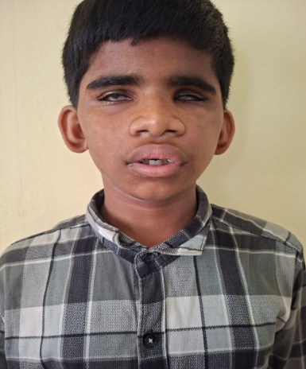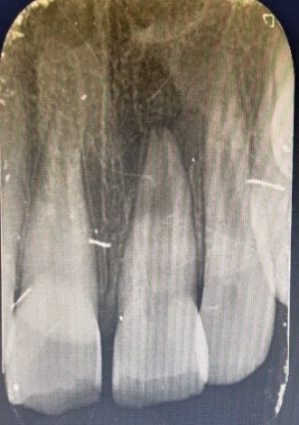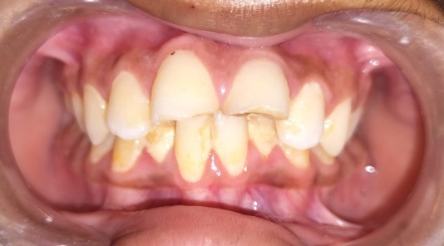
[Type a quote from the document or the summary of an interesting point. You can position the text box anywhere in the document. Use the Text Box Tools tab to change the formatting of the pull quote text box.]
[Type a quote from the document or the summary of an interesting point. You can position the text box anywhere in the document. Use the Text Box Tools tab to change the formatting of the pull quote text box.]
(A ) (B) (C)
Figure 1- A) Extra-oral swelling upper front teeth region. B) Preoperative radiograph. C ) Preoperative photograph

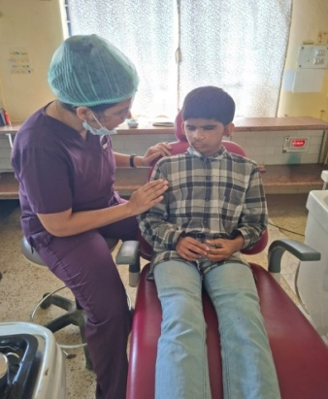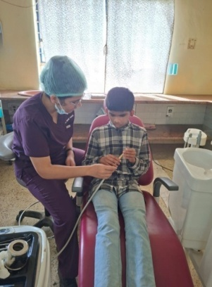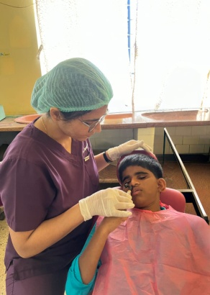
(A) (B) (C)
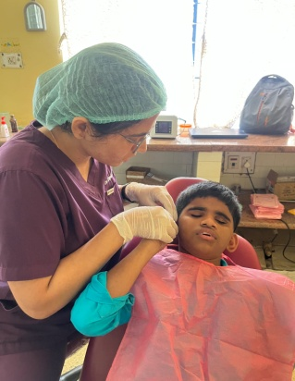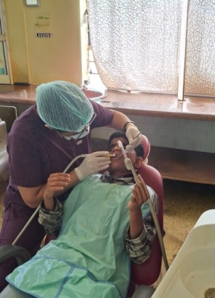
(D) (E)
Figure 2- A) Tell B) Feel C) Smell D) Hear E) Do
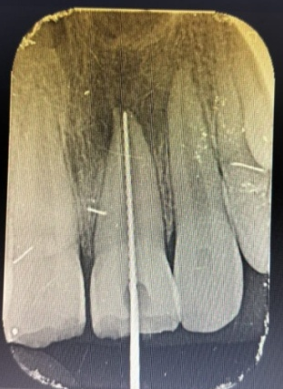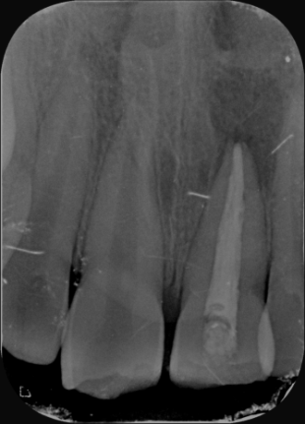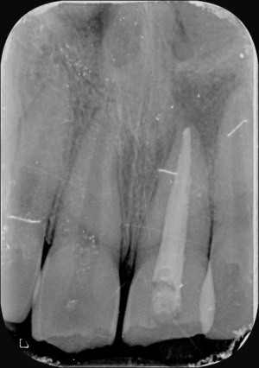
(A ) (B) (C)
Figure 3- A) WLD B) Post-obturation C) Radiographic image -1month follows up.

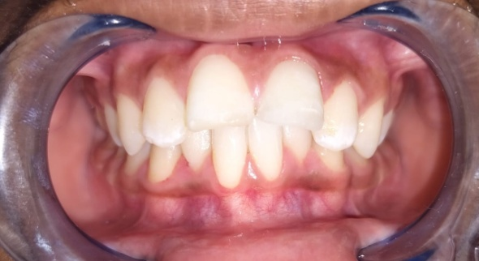
Figure 4-Postoperative Photograph

DISCUSSION-
The Audio-Tactile Performance (ATP) technique, a specially designed health education method, was employed to teach children about oral hygiene maintenance.¹ This approach involves initially providing verbal information about the importance of teeth and proper brushing techniques. Following this, the children are encouraged to explore the teeth on a large-sized dental model using their fingers to better understand the size and shape of teeth. They are then guided to practice brushing on the model using the Fones’ method with assistance. This process is repeated until the children are able to perform the brushing technique independently and confidently.¹
Visual impairment relates to a person’s eyesight, which cannot be corrected to normal vision. Instructions should be clear and simple, tailored to each child’s individual needs, educational level, and cognitive ability , with continuous reinforcement to ensure understanding and adherence.² Conventional oral health education methods primarily rely on visual cues to identify early signs of dental disease, which presents a significant challenge for visually impaired individuals. Therefore, customized educational and motivational approaches are essential to effectively promote and maintain proper oral hygiene in this population.³
Numerous behavior management techniques have been documented in the literature for pediatric patients. However, children with visual impairments may not respond effectively to all conventional methods. Therefore, it is essential to customize and combine various techniques based on the individual needs and acceptance of each patient. Some of the techniques that can be successfully implemented in clinical practice are outlined below.⁴
- Tell- Feel- Do
- Ask- Tell- Ask
- Contingency Management
- Distraction
- Voice control
- Aversive conditioning
- Pharmacological techniques
The key to successful oral hygiene programs for individuals with visual impairments lies in creating adaptations and structured routines that promote independence and foster a sense of pride in personal care. This involves selecting appropriate oral hygiene aids, ensuring materials are clearly labeled or stored systematically to prevent misplacement, guiding effective brushing techniques for all areas of the mouth, and establishing methods to self-assess the adequacy of oral hygiene practices.⁵
Brahmanna Chowdary P et.al , Various studies have investigated different types of instructions (direct/indirect) such as personal instruction, audio-visual aids, and self-educational manuals method similarly in our case report we used tell –feel- smell –here -do techniques.²
The primary goal of the dentist or dental hygienist should be to train and empower visually impaired individuals to perform oral hygiene tasks independently. Promoting self-reliance is especially important, as it is often a deeply valued and sensitive aspiration in the lives of those with visual impairments. Every achievement—whether small or significant—can have a profound positive impact on the individual's self-esteem and confidence, reinforcing their motivation to maintain good oral health.¹
This case report has certain limitations that should be considered while interpreting the findings. As it is based on a single patient, the results cannot be generalized to the broader population of visually impaired children. Additionally, the absence of a control or comparison group limits the ability to objectively assess the effectiveness of the modified behavior management techniques over conventional methods. Furthermore, the relatively short follow-up period restricts the assessment of long-term treatment success and the sustainability of behavioral improvements.
CONCLUSION-
This case report demonstrates that the use of modified behavior management techniques, such as Audio-Tactile Performance (ATP), Tell-Feel-Do, and Tell-Hear-Do, can significantly enhance communication, cooperation, and overall treatment outcomes in visually impaired pediatric patients. The successful management of an Ellis Class IV fracture in the present case highlights the effectiveness of a multisensory, patient-centered approach in overcoming the challenges associated with visual impairment. Furthermore, the incorporation of individualized behavioral strategies and preventive education promotes better oral hygiene practices and long-term dental health. These findings underscore the importance of adapting conventional dental techniques to meet the unique needs of children with special healthcare requirements, thereby improving both clinical efficiency and patient experience.

Disclaimer (Artificial intelligence)

Author(s) hereby declare that NO generative AI technologies such as Large Language Models (ChatGPT, COPILOT, etc.) and text-to-image generators have been used during the writing or editing of this manuscript.

REFERENCES-
- Dambare A, Mhatre S, Jayanna R, Razdan P. Full Mouth Rehabilitation in visually impaired children with modified behaviour management techniques: A Case Series. UNIVERSITY JOURNAL OF DENTAL SCIENCES. 2024 Apr 16;10(1).
- Chowdary BP, Uloopi KS, Vinay C, Rao VV, Rayala C. Impact of verbal, braille text, and tactile oral hygiene awareness instructions on oral health status of visually impaired children. Journal of Indian Society of Pedodontics and Preventive Dentistry. 2016 Jan 1;34(1):43-7.
- Nair DJ, Shetty AA, Hegde AM. Efficacy of a modified audio-tactile performance technique with braille (ATPb) on the oral hygiene status of visually-impaired children. Journal of Clinical Pediatric Dentistry. 2021 Jan 1;45(1):15-21.
- Nair DJ, Shetty AA, Hegde AM. Comprehensive dental management of visually impaired children: A brief review. IJMSIR. 2018;3:235-43.
- Nirmala SV, Saikrishna D. Oral health and dental care of children with visual impairment--An over view. EC Dental Science. 2019;18(5):848-53.
- Widdo et al. The effect of braille 3g modified audio tactile media on dental health satus of visually impaired children.Odonto: Dental Journal , v.10, n,1,p.108-116, July 2023.
- Bane S P, Thosar N R, Rathi N V, et al. (August 20, 2022) Comparative Evaluation of Antibacterial Efficacy of Emblica Officinalis Lollipop Against Streptococcus Mutans Counts in Institutionalized Visually Impaired Children. Cureus 14(8): e28207.
- Krishnakumar R, Silla SS, Durai SK, Govindarajan M, Ahamed SS, Mathivanan L. Comparative evaluation of audio and audio - tactile methods to improve oral hygiene status of visually impaired school children. CHRISMED J Health Res 2016;3:55-9.
- Fageeh HN, Mansour MA, Muyidi HM, et al. Impact of Verbal and Braille Text Oral Hygiene Instructions on Visually Impaired Individuals: A Randomized Clinical Trial. World J Dent 2020;11(6):439–445.
- Dagar DS, Kakodkar PV, Shetiya SH. Effectiveness of instructed tooth brushing on plaque and oral hygiene among the visually impaired children from a residential blind school in Pune – An interventional study. Med J DY Patil Vidyapeeth 2021;14:180-4.

