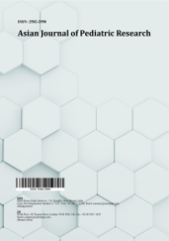
Asian Journal of Pediatric Research

Volume XXX, Issue XX, Page XX-XX, 20YY; Article no.AJPR.153409
ISSN: 2582-2950

Acute Cerebellar Ataxia-uncommon Neurologic Manifestation of Enteric Fever

Authors’ Name……………………………………………………

Affiliations……………………………………………………….………………

Authors’ contributions

This work was carried out in collaboration among all authors. All authors read and approved the final manuscript.

Article Information

DOI: 10.9734/AJPR/2026/XXXXX

Open Peer Review History:
This journal follows the Advanced Open Peer Review policy. Identity of the Reviewers, Editor(s) and additional Reviewers, peer review comments, different versions of the manuscript, comments of the editors, etc are available here:

Received: DD/MM/20YY
………… Article
Published: DD/MM/20YY

Abstract

Typhoid fever is a common cause of febrile illness, caused by Salmonella enterica serovar Typhi (S. Typhi), which employs specialized mechanisms to invade the intestinal mucosa and subsequently disseminates to the reticuloendothelial system. Neurological complications are uncommon and typically manifest during the second week of illness. Acute cerebellar ataxia, occurring as an isolated neurological manifestation of enteric fever, is particularly rare and is usually characterised by abnormalities in gait and speech. In the reported case, the diagnosis of enteric fever was confirmed through a positive blood culture. The primary clinical features included rapid onset of gait ataxia, limb ataxia, and dysarthria. Cerebellar involvement was observed during the second week of illness, with progression over one to two days. The symptoms remained stable for approximately one week, followed by gradual recovery under appropriate antibiotic treatment. These findings indicate that timely diagnosis and administration of suitable antibiotics are associated with favourable neurological recovery in patients with cerebellar complications of enteric fever.

Keywords: Acute Cerebellar ataxia; reticulo-endothelial system; neurological manifestation; bacteremia.

1. Introduction

Enteric fever is a significant infectious disease, with approximately 80% of cases reported in Asian countries (Kumar and Kumar, 2017). The condition is primarily caused by Salmonella enterica serovar Typhi (S. Typhi) and, less frequently, by Salmonella paratyphi serovars A, B, and C. Clinical manifestations of typhoid fever can vary considerably depending on the age of the patient, with children under five years of age often experiencing more severe disease. The incubation period of enteric fever is typically 7–14 days, although it can range from 3 to 30 days, depending on the infective dose. The clinical presentation is highly heterogeneous, ranging from mild illness characterised by low-grade fever and general malaise to severe disease marked by pronounced abdominal discomfort, systemic involvement, and the occurrence of multiple complications. This broad clinical spectrum highlights the critical importance of early diagnosis and timely management in order to minimise morbidity and avert potentially life-threatening outcomes. Although advances in antibiotic therapy have markedly reduced the incidence of complications, such complications continue to contribute significantly to disease-related morbidity and mortality. Neurological complications in enteric fever are relatively uncommon but well documented, encompassing manifestations from mild confusion and delirium to severe encephalopathy. Additional neurological sequelae include meningitis and myelitis, while cerebellar ataxia remains a rare but recognised presentation (Soni et al., 2025).

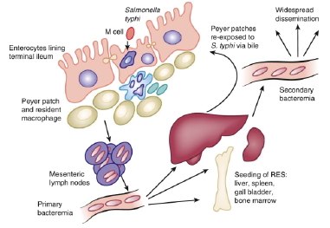
Please replace this Fig. with clear view picture
Fig. 1. Pathogenesis of enteric fever

2. Pathogenesis

Following ingestion, Salmonella enterica serovar Typhi (S. Typhi) invades the intestinal mucosa of the terminal ileum, primarily via microfold (M) cells overlying gut-associated lymphoid tissue. Invasion may also occur through direct translocation across enterocytes or via paracellular pathways. The pathogen utilises type III secretion systems to deliver effector proteins into host cells, thereby inducing complex alterations in host cellular processes. These include rearrangement of the actin cytoskeleton, enhanced bacterial internalisation, and membrane ruffling leading to phagosome formation that facilitates intracellular survival.
After traversing the intestinal epithelium, S. Typhi enters the mesenteric lymphatic system and subsequently disseminates into the bloodstream via lymphatic drainage. This initial (primary) bacteraemia is typically asymptomatic, and blood cultures obtained during this phase are often negative. The organism then disseminates systemically, with a predilection for reticuloendothelial tissues, where it replicates intracellularly within macrophages. Following this replication phase, bacteria are released back into the circulation, resulting in secondary bacteraemia, which coincides with the onset of clinical manifestations and marks the end of the incubation period. A distinguishing feature of S. Typhi infection is its ability to colonise the gallbladder, potentially leading to chronic carriage and sustained bacterial shedding, thereby posing a significant public health risk. In addition to bacterial virulence determinants, host-related factors—including immune status, genetic predisposition, and the composition of the gut microbiota—play a critical role in influencing susceptibility to infection and determining disease severity.

3. Clinical Features

The incubation period of typhoid fever typically ranges from 7 to 14 days, although it is influenced by the infecting dose and can vary between 3 and 30 days. Clinical presentation is highly variable, ranging from mild illness with low-grade fever and general malaise to severe disease characterised by profound abdominal discomfort and multiple systemic complications. Characteristic features of enteric fever include sustained fever, anorexia, vomiting, hepatomegaly, splenomegaly, abdominal pain, and headache. In some patients, the pathognomonic “rose spots” may appear on the trunk around the 7th to 10th day of illness. Unlike the diarrhoeal symptoms commonly associated with gastroenteritis caused by non-typhoidal Salmonella, typhoid and paratyphoid infections may present with abdominal pain without diarrhoea, fever without an obvious focus, and/or extraintestinal foci of infection. Complications of enteric fever are generally uncommon but may include hepatitis, jaundice, and cholecystitis. Rare cardiovascular complications include toxic myocarditis, which can manifest as arrhythmias, sinoatrial block, or cardiogenic shock. In infants, disseminated intravascular coagulation (DIC) appears to occur more frequently, whereas neurological complications, intestinal bleeding, and other systemic manifestations are less common in children. Neurological complications, although uncommon in paediatric patients, may include delirium, psychosis, raised intracranial pressure, acute cerebellar ataxia, chorea, deafness, and Guillain–Barré syndrome. Other infrequent complications reported in typhoid fever include fatal bone marrow necrosis, haemolytic–uraemic syndrome, pyelonephritis, endocarditis, parotitis, orchitis, and suppurative lymphadenitis. Ocular complications may involve eyelid abscesses, corneal ulcers, uveitis, and vitreous or retinal haemorrhages. Overall, mortality in paediatric populations is generally less than 1%, although higher rates are observed in infants due to increased vulnerability to severe complications.

4. Diagnosis

The definitive diagnosis of typhoid fever is primarily established through the isolation of Salmonella Typhi or Salmonella Paratyphi from blood or other clinical specimens. Blood cultures yield positive results in approximately 40–60% of patients during the early phase of illness; however, repeated high-volume sampling may be required to enhance the detection of bacteraemia. Stool and urine cultures typically become positive after the first week of infection. Bone marrow culture remains the most sensitive diagnostic modality, with a positivity rate of approximately 90%, and may remain positive in more than 50% of cases even following several days of antibiotic therapy. Other laboratory investigations generally produce non-specific findings and thus have limited diagnostic utility. In this context, the present study reports the case of a 12-year-old child diagnosed with enteric fever complicated by acute cerebellar ataxia, thereby highlighting a rare neurological manifestation of this systemic infection.

5. Case Presentation

A 12 year old boy presented with C/O fever with loose stools and loss of appetite since 7 days with h/o slurring of speech and imbalance while walking since 1 day. There was no history of loss of consciousness, seizures, headache, vomiting, and deviation of eyes or angle of the mouth, diplopia, diminished vision, nasal regurgitation, ear discharge, or rash. No history of any trauma, drug intake or similar episode in the past. H/O similar complaints in father associated with hyponatremia

6. Clinical Findings

On clinical examination, the child was conscious, alert, and oriented, with a recorded temperature of 100.7 °F and a pulse rate of 98 bpm; all other vital signs were within normal limits. There was no evidence of pallor, jaundice, lymphadenopathy, cyanosis, or rash. Examination of the abdominal, respiratory, and cardiovascular systems revealed no abnormalities. Neurological assessment showed that all cranial nerves were intact, and there were no signs of meningeal irritation. Muscle bulk and tone were normal in all four limbs, with power graded 5/5 bilaterally. Plantar reflexes were flexor on both sides, and sensory examination was unremarkable. Cerebellar dysfunction was evident, characterised by a broad-based gait, slurred speech, limb ataxia, impaired tandem walking, dysdiadochokinesia, and positive finger-to-nose tests in both upper limbs. Evaluation of vestibular function was normal, indicating that the ataxia was of cerebellar origin rather than vestibular in nature.

7. Diagnostic Assessment

Haematological investigations revealed a haemoglobin level of 14.22 g/dL and a total leucocyte count of 6,600/mm³, with a differential count showing 36% neutrophils, 57% lymphocytes, and 5.2% monocytes. Platelet count was reduced at 80,000/mm³ (Table 1). Liver function tests indicated mildly elevated transaminases, with an SGPT of 51 U/L. Serum electrolyte analysis demonstrated hyponatraemia, with a sodium level of 124 mmol/L. Neuroimaging with plain magnetic resonance imaging (MRI) was unremarkable (Figs. 1, 2, 3). Blood culture yielded growth of Salmonella Typhi, which was sensitive to all tested antibiotics (pan-sensitive). Follow-up investigations showed improving trends in both platelet count and serum electrolyte levels, indicating a positive response to ongoing management.

Table 1. Pathological result of Complete blood count

S.NO | Observed value
Hemoglobin (Hb) | 14.22g/dL
Total leucocyte counts (TLC) | 6600/mm3
Differential leucocyte counts (DLC) | N-36%, L-57%, M-5.2%
Platelet counts | 80k

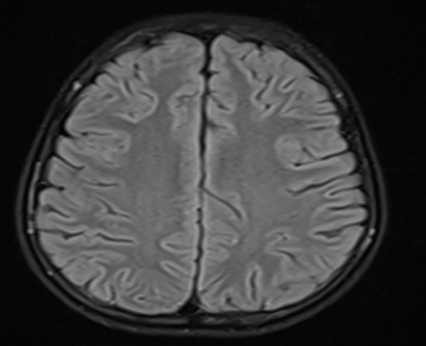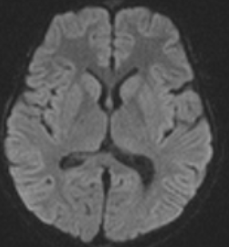

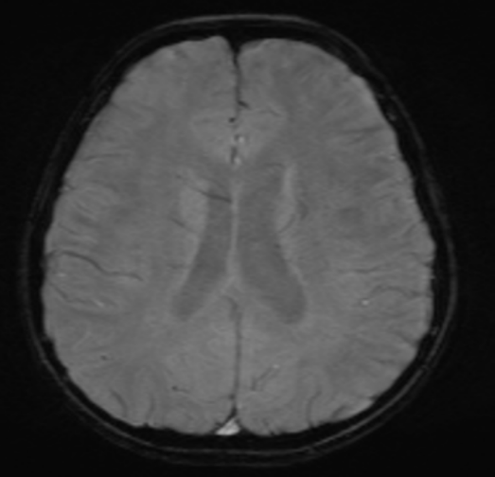

Figs. 2-4. Neuroimaging Findings

A diagnosis of enteric fever complicated by acute cerebellar ataxia was established. The child was treated with intravenous ceftriaxone for approximately one week and closely monitored. At follow-up, the neurological symptoms remained stable initially, but the child subsequently demonstrated complete resolution of cerebellar signs and full clinical recovery within two weeks.

8. Discussion

Enteric fever remains a significant public health concern in India (Kumar and Kumar, 2017). Complications typically arise during the second week of illness and affect approximately 10–15% of patients (Parry et al., 2002). Neurological manifestations associated with typhoid fever are diverse and include toxic encephalopathy, elevated intracranial pressure, cerebral thrombosis, acute cerebellar ataxia, chorea, aphasia, transverse myelitis, and optic neuritis (Kumar and Kumar, 2017). Central nervous system (CNS) involvement is a recognised complication, with reported incidence ranging from 5–35% in adults and 2.1–2.7% in children (Kundu and Yelwale, n.d.). Clinically, cerebellar ataxia commonly presents with dysarthria and gait instability (Dewan et al., 2009). Neurological complications generally emerge during the second week of illness, with encephalopathy representing the most frequently observed presentation. Although the precise pathophysiological mechanisms remain incompletely understood, several hypotheses have been proposed, including metabolic disturbances, hyperpyrexia, dehydration, electrolyte imbalances, toxaemia, and non-specific cerebral changes such as oedema and haemorrhage (Biswal et al., 1994). Radiological imaging, including computed tomography (CT) and magnetic resonance imaging (MRI), is often unremarkable in cases of acute cerebellar ataxia. In some instances, CT may demonstrate mild cerebral oedema or subtle abnormalities, whereas MRI findings in enteric fever are infrequently documented (Cohen et al., 1987). Ahmed et al. reported a fatal case of S. Typhi-associated encephalopathy in which MRI revealed diffuse hyperintense signals on fluid-attenuated inversion recovery (FLAIR) sequences involving the centrum semiovale, periventricular and deep white matter, as well as the splenium of the corpus callosum, accompanied by restricted diffusion in the corresponding regions (Sejvar et al., 2012).
Given the acute onset, self-limiting course, and presence of cerebrospinal fluid (CSF) pleocytosis, a para- or post-infectious demyelinating process has been suggested as a potential mechanism for cerebellar ataxia in enteric fever (Ahmed et al., 2011). Management primarily involves appropriate antibacterial therapy, with cerebellar symptoms generally not requiring additional interventions such as corticosteroids. However, some reports advocate the adjunctive use of dexamethasone in patients with severe neurological complications (Scragg et al., 1969). The prognosis of neurological deficits secondary to typhoid fever is generally favourable. Most patients experience slow but complete recovery, although persistent deficits have been reported in a minority of cases (Girgis et al., 1993, Singh et al., 1993).

9. Conclusion

Acute cerebellar ataxia is an uncommon manifestation of enteric fever and may occasionally present as early as the first week of illness. This case underscores the clinical importance of recognising enteric fever as a potential cause of cerebellar ataxia in febrile children presenting with acute neurological symptoms. Given that enteric fever is a treatable condition, it should be included in the differential diagnosis when evaluating paediatric patients with fever and new-onset cerebellar ataxia, to ensure timely initiation of appropriate antimicrobial therapy and prevent unnecessary morbidity.

Consent
As per international standards, parental written consent has been collected and preserved by the author(s).

Ethical Approval:

As per international standards or university standards written ethical approval has been collected and preserved by the author(s).

Disclaimer (Artificial Intelligence)

Author(s) hereby declare that NO generative AI technologies such as Large Language Models (ChatGPT, COPILOT, etc) and text-to-image generators have been used during writing or editing of this manuscript.

Competing Interests

Authors have declared that no competing interests exist.

References

Ahmed, M., Sureka, J., Mathew, V., Jakkani, R. K., & Abhilash, K. P. (2011). Magnetic resonance imaging findings in a fatal case of Salmonella typhi-associated encephalopathy: A case report and literature review. Neurology India, 59(2), 270–272. https://doi.org/10.4103/0028-3886.79145
Biswal, N., Mathai, B., Bhatia, B. D., Srinivasan, S., & Nalini, P. (1994). Enteric fever: A changing perspective. Indian Pediatrics, 31, 813–819.
Cohen, J. I., Bartlett, J. A., & Corey, G. R. (1987). Extra-intestinal manifestations of salmonella infections. Medicine, 66(5), 349–388. https://doi.org/10.1097/00005792-198709000-00003
Dewan, P., Pooniya, V., Kaushik, J. S., et al. (2009). Isolated cerebellar ataxia: An early neurological complication of enteric fever. Annals of Tropical Paediatrics, 29, 217–219.
Girgis, N. I., Farid, Z., Sultan, Y., & Hibbs, R. G. (1993). Use of dexamethasone in treatment of enteric fever complicated by cerebellar involvement. Transactions of the Royal Society of Tropical Medicine and Hygiene, 87, 690–691.
Kumar, P., & Kumar, R. (2017). Enteric fever. Indian Journal of Pediatrics, 84(3), 227–230.
Kumar, P., & Kumar, R. (2017). Enteric fever. Indian Journal of Pediatrics, 84(3), 227–230. https://doi.org/10.1007/s12098-016-2246-4
Kundu, R., & Yelwale, V. N. (Year not specified). Textbook of pediatric infectious diseases (2nd ed.).
Parry, C. M., Hien, T. T., Dougan, G., White, N. J., & Farrar, J. J. (2002). Typhoid fever. New England Journal of Medicine, 347(22), 1770–1782.
Scragg, J., Rubidge, C., & Wallace, H. L. (1969). Typhoid fever in African and Indian children in Durban. Archives of Disease in Childhood, 44, 18–28.
Sejvar, J., Lutterloh, E., Naiene, J., Likaka, A., Manda, R., Nygren, B., et al. (2012). Neurologic manifestations associated with an outbreak of typhoid fever, Malawi–Mozambique, 2009: An epidemiologic investigation. PLoS ONE, 7(12), e46099. https://doi.org/10.1371/journal.pone.0046099
Singh, S., Gupta, A., & Marwaha, R. K. (1993). Wenckebach phenomenon and motor aphasia in enteric fever. Indian Journal of Paediatrics, 60(1), 147–149.
Soni, V. K., Batra, T., & Kakar, A. (2025). Acute cerebellar ataxia in a case of enteric fever. Journal of the Association of Physicians of India, 73(9S), 33–34.

Disclaimer/Publisher’s Note: The statements, opinions and data contained in all publications are solely those of the individual author(s) and contributor(s) and not of the publisher and/or the editor(s). This publisher and/or the editor(s) disclaim responsibility for any injury to people or property resulting from any ideas, methods, instructions or products referred to in the content.

© Copyright (2026): Author(s). The licensee is the journal publisher. This is an Open Access article distributed under the terms of the Creative Commons Attribution License (http://creativecommons.org/licenses/by/4.0), which permits unrestricted use, distribution, and reproduction in any medium, provided the original work is properly cited.

