Spatial Fertility Patterns in North-East India: A State-Level Clustering Analysis

ABSTRACT
Background: Examining regional fertility trends is crucial for shaping informed demographic strategies and policy decisions. This research calculates the state-level Age-Specific Fertility Rate (ASFR) across India’s eight northeastern states and employs cluster analysis to group them by their fertility lines. The method reveals distinct clusters with comparable fertility behaviours, shedding light on both regional disparities and evolving demographic shifts. The results highlight marked differences in fertility rates across these states, underscoring the role of socio-economic and cultural factors in shaping these variations.
Methods: The eight northeastern states were divided into discrete clusters using the K-means clustering method.
Results: By examining the calculated single-year ASFRs, we grouped the eight north-eastern states into four distinct clusters. Cluster 1, predominantly tribal and Christian, shows relatively high education levels and moderate contraceptive use, while Cluster 2, primarily Hindu and rural, displays a higher proportion of anaemia and lower education levels, reflecting traditional fertility patterns. Cluster 3, with its high fertility rates, is marked by low contraceptive use and high parity, while on the other hand Cluster 4, with its Buddhist majority and high contraceptive adoption, demonstrates a strong preference for smaller family sizes. This distinction highlights the importance of socio-demographic factors in shaping these regional fertility trends.
Conclusion: The eight northeastern states can be categorized into four distinct clusters, each of which can be characterized by markedly divergent fertility trends and maternal demographic profiles. These insights offer a basis for developing focused reproductive health strategies in the region.
Keywords: Age-Specific Fertility Rate; Multivariate Analysis; Cluster Analysis; Demography

INTRODUCTION
Regional fertility patterns are central to demographic planning and policy design, as fertility levels shape household composition, economic development, allocation of resources, and long-term population stability. India, home to nearly one-fifth of the world’s population, is undergoing a major demographic transition marked by a sustained decline in fertility. Since 1980, the country’s total fertility rate (TFR) has fallen by more than half and is now close to the replacement level, indicating a significant shift in population dynamics. However, this national decline masks substantial regional variation. Fertility transition has progressed at very different speeds across states, resulting in a highly uneven demographic landscape. These differences are driven by variation in access to healthcare, effectiveness of policy implementation, levels of education, and deeply rooted cultural practices. While global demographic trends provide a broader context, it is India’s regional socio-economic and cultural diversity that ultimately shapes fertility behaviour at the local level. This diversity underscores the importance of tailored approaches in addressing fertility challenges, ensuring sustainable demographic transitions across the country.¹

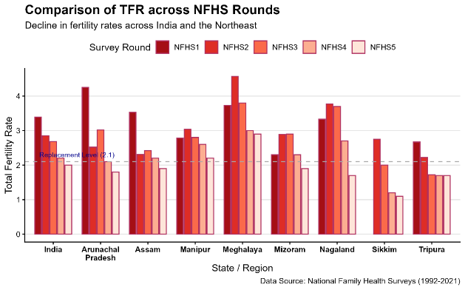
Figure 1: Trend in Fertility Decline of India as well as north-eastern states. From 1992-93 (Round 1) to 2019-21 (Round 5)
Understanding India’s fertility transition requires moving beyond national averages to consider the substantial variation across states and districts. These differences arise from unequal socioeconomic development, diverse cultural norms, and variations in policy implementation. As a result, India exhibits a heterogeneous demographic landscape, in which some regions have already attained replacement-level fertility, while others continue to record persistently higher fertility levels.²
India has experienced a major decline in fertility rates over the past several decades as part of its demographic transition. The fertility decline represents one of the most dramatic demographic transformations globally, with the Total Fertility Rate falling from 5.89 births per woman in the early 1960s to 2.0 by 2019-21.³⁻⁵ This decline has been consistent across multiple decades, dropping from 5.2 in 1971 to 2.2-2.3 by 2015-16.^{6,7} Most significantly, India has now joined over 80 countries with sub-replacement fertility, achieving a TFR below the replacement level of 2.1 for the first time in its history.^{8,9}
The fertility decline has been universal across Indian society, occurring among rich and poor, literate and non-literate, upper and lower castes, and across different religious groups.⁶ Currently, in India, 30 of the 36 states have achieved below-replacement fertility, with only Bihar, Uttar Pradesh, Jharkhand, Manipur, and Meghalaya remaining above this threshold (See Figure 1).^{4,8} The decline has been particularly steep in rural areas where two-thirds of Indians reside, though urban areas continue to show lower fertility rates, with urban TFR at 1.6 compared to 2.1 in rural areas.^{3,9}
This fertility transition has been characterized by notable regional convergence, with states that historically had higher fertility rates showing faster decline rates, leading to gradual convergence across states.¹⁰ The southern states led this transition, reaching replacement level fertility as early as 1990, followed by western and northern states, while central, eastern, and northeastern regions have shown slower but steady progress.^{6,11} The decline has been attributed primarily to government family planning programs and population policies rather than purely socioeconomic changes, representing a success story of targeted governmental intervention.^{9,10,12}
The northeastern region of India presents a unique fertility profile that distinguishes it from other regions of the country. As of 2015, the northeast region had higher fertility levels compared to the south, west, and north, ranking second only to the central region in terms of Total Fertility Rate.¹¹ By 2019-21, while most of India achieved sub-replacement fertility, Manipur and Meghalaya in the northeast remained among the five states that had not yet reached replacement-level fertility.⁴
The fertility landscape across the northeastern states reveals remarkable heterogeneity that reflects the complex interplay of cultural, social, and economic factors within the region. According to NFHS data, fertility rates span a considerable range, from just below replacement level in Sikkim to as high as approximately 3 children per woman in Meghalaya.^{13,14} This variation represents one of the most diverse fertility patterns found within any single geographic region of India, creating distinct demographic profiles that lend themselves well to statistical clustering approaches. The substantial differences in total fertility rates across neighbouring states suggest that despite shared geographic proximity, each northeastern state follows unique reproductive trajectories influenced by their specific ethnic compositions and cultural practices. This heterogeneity in fertility outcomes provides an excellent foundation for applying K-means clustering analysis, as the age-specific fertility rate patterns likely form distinct groupings that can reveal underlying demographic similarities and differences among these states.
This study seeks to examine disparities in fertility curves across the eight northeastern states of India and to assess associated socio-demographic contrasts, as well as whether these differences are statistically significant. However, analysing and comparing all eight states individually may be methodologically cumbersome and analytically limited, potentially obscuring underlying patterns. To address this, the states were grouped according to similarities in their fertility trends, enabling more meaningful comparisons and improving interpretability of the results.
A variety of clustering techniques have been used in the literature to classify Indian states and districts according to different characteristics. Among these methods, agglomerative hierarchical clustering is both widely used and conceptually simple, as it starts with individual observations and progressively merges similar clusters into a single group. In the Indian context, hierarchical clustering has been effectively used to examine COVID-19 patterns, district-level nutritional status, and trends in missing children’s cases.¹⁵⁻¹⁷
Studies showed that the Indian states and UTs can be grouped into three distinct clusters according to COVID-19 pandemic outbreak, with all eight northeastern states belonging to the same cluster¹⁵. According to under-five child growth and nutritional status India shows 3 distinct clusters, with Assam and Tripura in a different cluster and the remaining northeastern states in a different cluster¹⁶. As per endemicity trends of missing and unrecovered children in India, all northeastern states were found to be member of the same cluster with low endemicity¹⁷.
The non-hierarchical k-means clustering method is another frequently applied technique for analysing Indian states. This approach has been used to classify areas based on infrastructure development levels, analyse COVID-19 data across states and union territories, and identify flood risk zones.¹⁸⁻²⁰ One of its key advantages is its capacity to create well-defined clusters, which can guide evidence-based policymaking. While earlier research focused on clustering of districts within Assam based on single-year ASFR¹, the present study is an attempt to expand the methodology to the broader northeaster stated of India for a more generalized finding.
Analysing age-specific fertility rates (ASFRs) reveals important insights into fertility patterns across different age groups within regions. This research focuses on state-level ASFRs, using cluster analysis to categorize them into distinct groups with comparable fertility trends. The K-means clustering method was selected for this analysis because it effectively organizes numeric data. K-means is particularly well-suited for this study since it excels with numerical information.²¹ Given that we are examining single-year ASFR data to identify similarities among states, K-means provides a clear and efficient way to group these states into meaningful clusters.

METHODOLOGY
Source of Data: The National Family Health Survey (Round-5, 2019-2021) dataset for the eight Northeastern states collectively provides a comprehensive sample of women in the 15–49 age group.¹⁴ The total female sample across these states ranges from 4,220 in Sikkim to 34,979 in Assam, with a substantial subset consisting of ever-married women (e.g., 27,215 in Assam and 2,752 in Sikkim). These sample sizes were deemed sufficient for state-level Age-Specific Fertility Rate (ASFR) estimation under the NFHS-5 stratified sampling design. For the calculation of Single-Year ASFRs, the study utilized de-identified NFHS-5 microdata accessed through the DHS Program, following ethical approval and guidelines established by the International Institute for Population Sciences (IIPS).¹⁴
Age Specific Fertility Rate: The age‑specific fertility rate (ASFR) reflects the number of births per k women (usually per 1,000) in a given area and period. Adding the ASFRs across all ages yields the total fertility rate (TFR). We calculated single‑year ASFRs for ages 15–49 with calc_asfr() from the demogsurv package.²² The TFR was obtained by summing these ASFRs for ages 15–49 and expressing the result per woman, in line with standard demographic methods.^{23,24}
$$ASFR_{x}=\frac{Total No of Children born to mother of age x}{Total Population of Women age x}×k$$
$$TFR=\sum_{x=15}^{49}{ASFR_{x}}$$
K-Means Clustering: To uncover latent sub‑groups among northeastern states we applied k‑means clustering, a classic unsupervised algorithm that splits a data set into k non‑overlapping clusters.^{25,26} The method works well with large, continuous data sets and seeks to minimise the within‑cluster sum of squares (WCSS), thereby maximizing similarity inside clusters and separation between them. The K-means algorithm was used to classify regional fertility patterns, as it excels at identifying compact, spherical clusters within continuous numerical datasets. This approach allowed us to derive distinct cluster centroids, providing a robust statistical basis for comparing demographic variations across the study area.
Before applying the K-means clustering algorithm, few critical assumptions were evaluated to ensure the validity and robustness of the outcome. At first all continuous variables were standardised (using the z-score normalization) to yield a mean of zero and a standard deviation of one, thereby satisfying the assumption of equal variance and preventing variables with larger scales from disproportionately influencing the distance metrics. Further, the multi-collinearity was assessed via a correlation matrix. Variables exhibiting high correlation were addressed to ensure the independence of dimensions in the Euclidean space. A visual inspection of the feature space confirmed that the data formed roughly spherical distributions with relatively equal densities, aligning with the geometric assumptions of the k-mean algorithm. Finally, the optimal number of clusters (k) was determined empirically. Choosing the right number of clusters (k) is a prerequisite for reliable results. We evaluated three widely accepted criteria. First, the Elbow Method examines how WSS declines as the number of clusters (k) increases; the optimal k lies at the point where the reduction in WSS begins to flatten.²⁷ Second, the Average Silhouette Method computes silhouette widths for each k; the value that maximises the average silhouette indicates the best‑fitting cluster count.²⁸ Third, the Gap Statistic compares observed WSS with that expected under a null reference distribution; the k producing the largest gap signals a meaningful clustering structure.²⁹
The number of clusters was chosen by triangulating the elbow plot, silhouette analysis, and the gap statistics along with the Krzanowski‑Lai (KL) index.³⁰ This combination balances within‑cluster homogeneity against between‑cluster dispersion and yields a data‑driven partition for subsequent comparisons.
The KL index proposed by Krzanowski and Lai is defined as
$$KL_{\left(q\right)}=\left|\frac{DIFF_{q}}{DIFF_{q+1}}\right|$$
Where, $DIFF_{q}={\left(q-1\right)}^{2/p} \text{trace}\left(W_{q-1}\right)-q^{2/q} \text{trace}\left(W_{q}\right)$
The mathematical foundation of the KL index relies on the principle that when there exists an optimal clustering solution with q groups, the value of DIFF_{q} should be comparably large and positive, while values of DIFF_{q} for q > q* will have rather small values (possibly even negative) (Albaum et al., 2011). The KL criterion is designed to detect the “elbow” in the within-cluster sum of squares curve by examining changes in W_{q}, and it attains large values when such an elbow occurs (Poulsen et al., 2018). The value of q, maximizing $KL_{\left(q\right)}$ is regarded as specifying the optimal number of clusters.³¹ For our analysis we ran the NbClust package (Version 3.0.1) with its default settings (Euclidean distance, minimum = 2 clusters, method = “kmeans”). NbClust evaluates nearly 30 criteria, including the elbow, silhouette, gap statistic, and KL index to suggest the best‑fitting number of clusters.³² Convergence among these metrics guided the final selection of k.

Results
Age Specific Fertility Rate: We calculated the single-year ASFRs for India, and all northeastern states of India, which include Assam, Arunachal Pradesh, Manipur, Meghalaya, Mizoram, Nagaland, Sikkim, and Tripura from the individual record data of the fifth round of NFHS [see Table 1, Figure 3].
The ASFRs reveals substantial heterogeneity in fertility behaviour across India and the eight North-Eastern states, reflecting differences in the timing, intensity, and overall level of childbearing. At the national level, fertility follows a relatively standard age pattern, with low rates in the teenage years, a peak during the early to mid-twenties (around ages 22–24), and a steady decline thereafter. This pattern is broadly indicative of delayed marriage, declining adolescent fertility, and concentration of births within the prime reproductive ages.
Assam broadly mirrors the national age pattern but exhibits noticeably higher fertility at younger ages, particularly between 15 and 19 years, indicating a relatively higher prevalence of early marriage and adolescent childbearing. Although fertility peaks in the early twenties, the decline after age 30 is more gradual compared to the national average, suggesting prolonged childbearing spans. Despite these features, Assam’s total fertility rate (TFR) of 1.87 remains below replacement level, pointing to an ongoing fertility transition.
Arunachal Pradesh and Manipur display distinct fertility schedules. Arunachal Pradesh shows moderate adolescent fertility but relatively elevated fertility across a wider age range, extending into the late thirties and even forties, which contributes to a TFR of 1.81. Manipur, in contrast, exhibits a pronounced concentration of fertility in the late twenties and early thirties, with comparatively lower adolescent fertility but sustained childbearing at older ages, resulting in a TFR of 2.17, slightly above replacement level. This pattern may reflect delayed marriage combined with extended reproductive behaviour.
Meghalaya stands out with consistently high fertility rates across almost all reproductive ages, particularly between 20 and 34 years, and a relatively slower decline at older ages. This broad-based fertility schedule culminates in the highest TFR among the North-Eastern states (2.89), indicating limited fertility decline. The pattern is consistent with the state’s distinct socio-cultural context, including matrilineal traditions and comparatively lower uptake of modern contraceptive methods. Mizoram, Nagaland, Sikkim, and Tripura exhibit more advanced fertility transitions. Mizoram shows low adolescent fertility and a moderate peak during the mid-to-late twenties, followed by a steady decline, yielding a TFR of 1.86. Nagaland presents a similar but slightly earlier concentration of fertility, with relatively low teenage childbearing and a TFR of 1.71. Sikkim demonstrates the most compressed fertility pattern, characterised by very low fertility at younger ages, a modest peak in the late twenties, and a sharp decline, thereafter, resulting in the lowest TFR (1.04) among all states considered. Tripura, despite relatively high adolescent fertility, particularly at ages 15–19, experiences a rapid decline after the mid-twenties, leading to a sub-replacement TFR of 1.71. (See Table 1, Figure 2).

Table 1: Single Year ASFR (per 1000 women) of India and the North-Eastern States
Age  (in years) | India | Assam | Arunachal  Pradesh | Manipur | Meghalaya | Mizoram | Nagaland | Sikkim | Tripura
15 | 2.84 | 9.85 | 4.33 | 5.4 | 4.52 | 0 | 0 | 0 | 28.51
16 | 10.38 | 20.14 | 8.96 | 24.69 | 14.15 | 5.78 | 2.84 | 7.33 | 52.23
17 | 29.13 | 64.94 | 32.07 | 43.94 | 39.05 | 26.48 | 10.82 | 3.92 | 104.52
18 | 64.86 | 89.73 | 61.51 | 62.86 | 78.32 | 41.24 | 34.86 | 54.33 | 133.07
19 | 109.17 | 117.31 | 83.21 | 76.73 | 113.56 | 43.75 | 41.42 | 36.94 | 135.55
20 | 142.93 | 133.9 | 92.18 | 97.32 | 149.94 | 83.01 | 69.79 | 65.39 | 152.77
21 | 163.11 | 135.41 | 96.67 | 119.31 | 140.2 | 80.25 | 80.07 | 45.33 | 134.79
22 | 175.69 | 142.37 | 116.61 | 92.84 | 155.14 | 71.07 | 96.55 | 81.06 | 111.52
23 | 174.43 | 134.58 | 111.79 | 106.81 | 128.54 | 120.92 | 95.09 | 53.14 | 77.14
24 | 168.97 | 128.19 | 112.47 | 131.44 | 144.63 | 112.11 | 111.81 | 41.19 | 118.07
25 | 155.67 | 122.3 | 109.58 | 126.79 | 146.33 | 115.84 | 83.86 | 54.77 | 112.06
26 | 141.12 | 102.95 | 108.52 | 93.32 | 142.29 | 119.07 | 113.02 | 71.79 | 81.7
27 | 118.81 | 100.1 | 101.86 | 133.46 | 154.79 | 97.12 | 118.7 | 93.46 | 78.69
28 | 103.75 | 94.84 | 87.25 | 129.24 | 135.32 | 85.69 | 92.45 | 74.02 | 64.08
29 | 84.59 | 75.82 | 100.74 | 124.03 | 128.55 | 97.39 | 116.17 | 52.71 | 52.93
30 | 74.17 | 74.52 | 82.68 | 126.78 | 155.86 | 100.14 | 82.27 | 44.16 | 65.29
31 | 60.11 | 62.52 | 70.88 | 107.18 | 136.42 | 101.69 | 89.79 | 23.76 | 50.31
32 | 47.29 | 52.95 | 74.74 | 103.27 | 99.42 | 75.92 | 76.74 | 73.61 | 40.68
33 | 38.26 | 43.09 | 61.26 | 73.3 | 136.71 | 72.49 | 89.43 | 36.5 | 29.13
34 | 30.67 | 36.09 | 63.42 | 87.52 | 107.57 | 95.98 | 68.3 | 42.07 | 21.84
35 | 22.8 | 37.55 | 42.41 | 93.11 | 101.4 | 78.32 | 52.92 | 20.78 | 9.15
36 | 17.49 | 23.77 | 44.21 | 63.99 | 78.82 | 60.94 | 65.58 | 18.2 | 20.6
37 | 12.99 | 15.4 | 32.2 | 50.19 | 80.92 | 42.23 | 17.05 | 26.62 | 2.15
38 | 10.37 | 19.72 | 13.48 | 35.34 | 69.69 | 43.31 | 27.03 | 3.81 | 8.25
39 | 6.76 | 7.1 | 16.92 | 26.97 | 48.95 | 33.13 | 16.91 | 4.19 | 10.53
40 | 5.57 | 4.7 | 16.84 | 13.47 | 46.7 | 16.35 | 19.44 | 6.57 | 2.87
41 | 3.65 | 6.39 | 5.42 | 3.52 | 47.84 | 8.82 | 19.19 | 3.48 | 2.03
42 | 2.55 | 2.87 | 7.61 | 8.49 | 31.75 | 20.83 | 5.47 | 0 | 2.21
43 | 1.68 | 5.56 | 6.92 | 3.78 | 21.7 | 4.87 | 6.44 | 0 | 2.1
44 | 1.79 | 1.48 | 10.44 | 2.09 | 14.42 | 3.32 | 2.33 | 5.52 | 0
45 | 1.17 | 1.78 | 4.07 | 1.91 | 20.78 | 1.64 | 0 | 0 | 0
46 | 0.33 | 0 | 4.78 | 1.53 | 2.27 | 0 | 3.08 | 0 | 0
47 | 0.55 | 0 | 5.48 | 0.67 | 10.78 | 0 | 0 | 0 | 1
48 | 0.3 | 0 | 1.25 | 0 | 3.21 | 0 | 0 | 0 | 0
49 | 0.46 | 0 | 17.67 | 0 | 0 | 0 | 0 | 0 | 0
TFR | 2.00 | 1.87 | 1.81 | 2.17 | 2.89 | 1.86 | 1.71 | 1.04 | 1.71
Source: National Family Health Survey 5 (2019-2021)
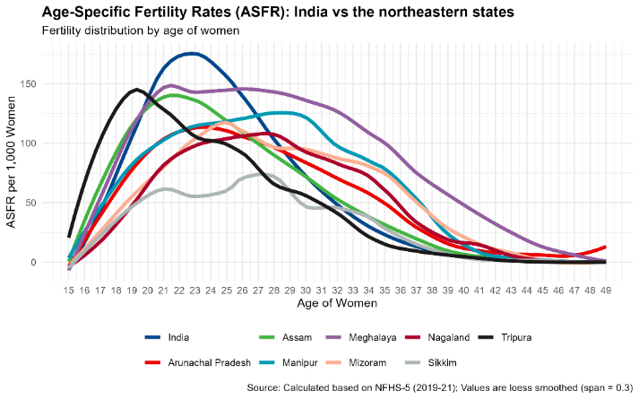
Figure 2: A line plot of the ASFR of the eight northeastern states in comparison to national fertility trend calculated based on the fifth round of NFHS (2019-21)
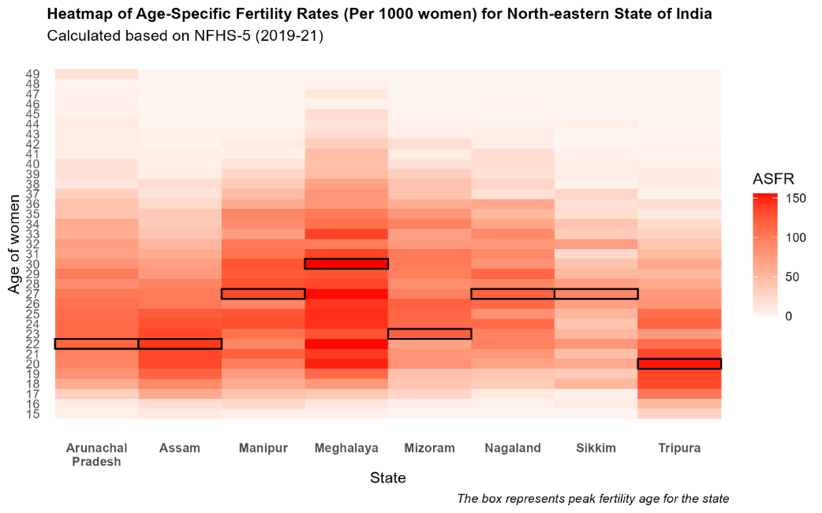
Figure 3: A heatmap for the ASFR’s (per 1000 women) of all the northeastern states of India calculated from NFHS-5 data. The rectangular box indicates the highest fertility rate (modal age of fertility curve).

State Level K-Means Clustering: To determine whether the data had a meaningful cluster structure (i.e., non-randomness), the Hopkins statistic was calculated. The value of the statistic was found as, H = 0.73, which is significantly greater than the 0.5 threshold, suggesting a high likelihood of grouping and hence supporting the use of a clustering algorithm.^{33,34}
A visual inspection using “silhouette” (for average silhouette width), “wss” (for total within sum of square), and “gap_stat” (for gap statistics) along with the KL Index [Figure 4a] suggests that four clusters are optimum to capture the distinct fertility pattern of the states. Accordingly, K-mean clustering is performed in R with four centres. The spherical clusters are found to be non-overlapping, indicating maximum between cluster distance and minimal within cluster distance [Figure 4b]. Sensitivity analyses using hierarchical clustering confirmed the robustness of the four-cluster solution, with similar state groupings (results available upon request).
At the national level, ASFRs follow a U-shaped curve, with low teenage fertility, a peak around 22–24, and a gradual decline, reflecting delayed marriage and concentrated childbearing in prime reproductive years. The four clusters show distinct trajectories: Cluster 1 (orange) features high adolescent fertility, peaking in the early 20s, suggesting early marriage and prolonged childbearing. Cluster 2 (blue) displays a moderate rise with a later peak (25–27), indicating a more balanced fertility schedule. Cluster 3 (red) shows sustained fertility across 20–35, pointing to delayed marriage or extended reproductive behaviour. Cluster 4 (green) has the lowest overall rates, with a sharp peak in the mid-20s followed by rapid decline, reflecting advanced fertility transitions [See Figure 5]
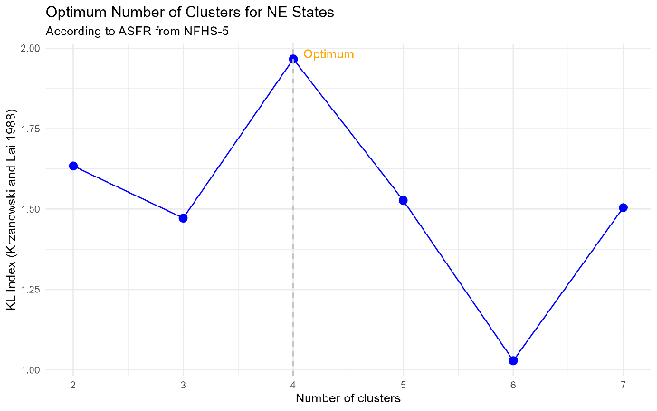 | 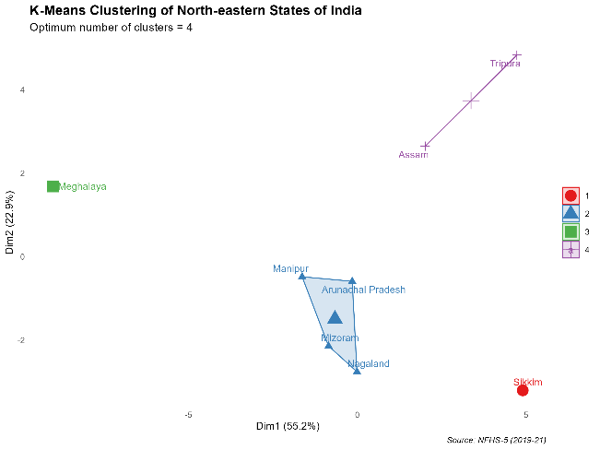
4(a): Optimum number of clusters for the states based on KL Index. | 4(b): A visual presentation of the K-Mean Clustering for the northeastern states.
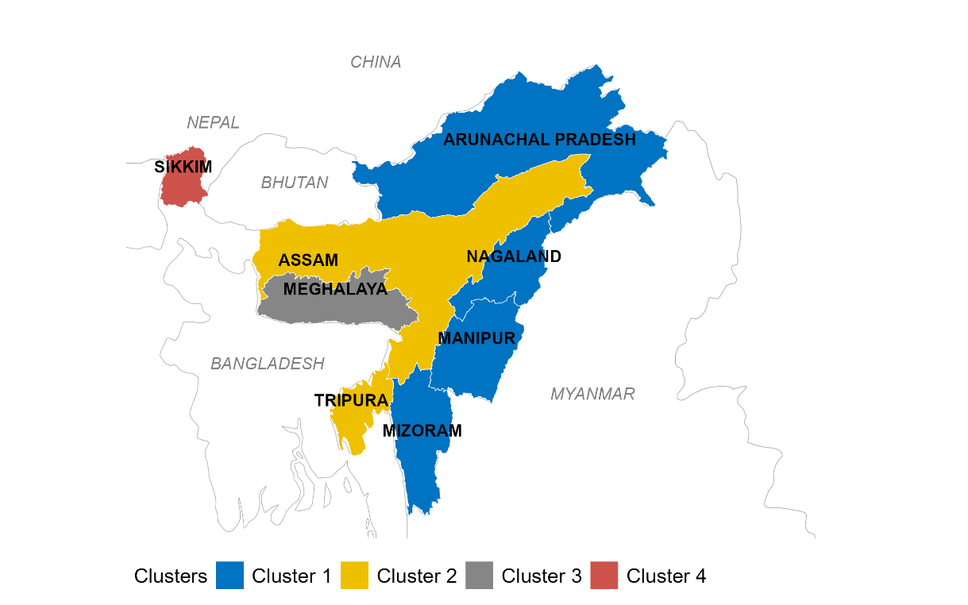
4(c): A Spatial presentation of the four clusters of northeastern states
Figure 4: Cluster Analysis of the eight northeastern states of India based on their fertility curve.

Table 2: Member states in the clusters
Clusters | States
Cluster 1 | Arunachal Pradesh, Manipur, Mizoram, Nagaland
Cluster 2 | Assam, Tripura
Cluster 3 | Meghalaya
Cluster 4 | Sikkim

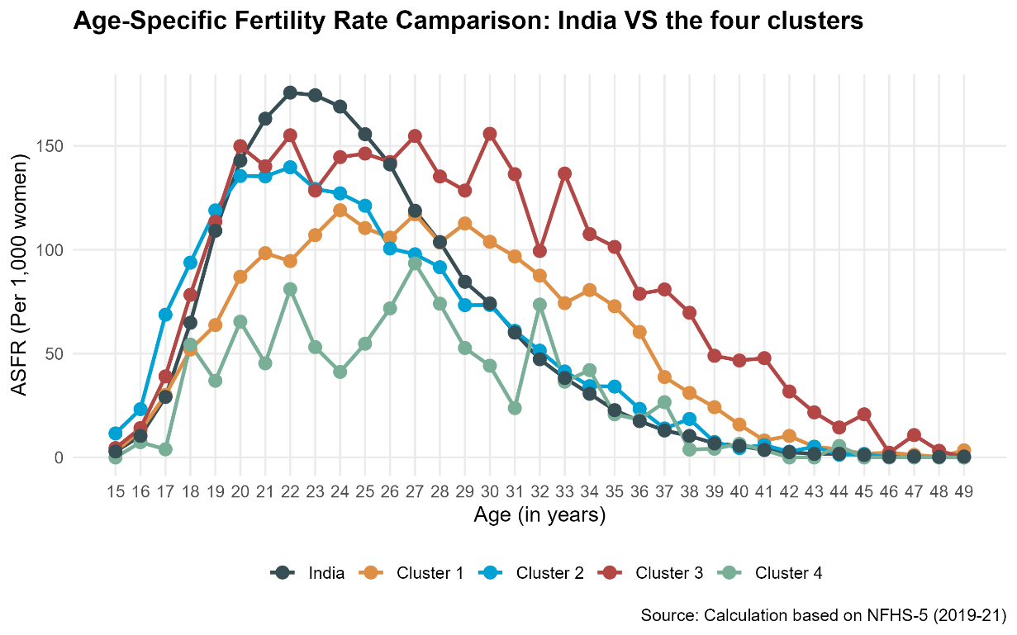
Figure 5: A comparison of the ASFR pattern between the four clusters of ne states with that of India.

Between Cluster Comparison: Pearson’s Chi Square test of independence has been used to compare a few socio - demographic characteristics, which may affect the fertility of the women in the four clusters for a better characterization of the clusters. Chi-square tests assume independence of observations, which may be violated due to geographic clustering. Future studies should validate findings with larger samples. Initially a median test using the Wilcoxon signed rank test was performed to compare the total children ever born and the total number of living children of mothers in the two clusters but since the median and inter-quartile range (IQR) are identical we opted for the Yuen’s robust t-test for trimmed mean.³⁵ [See Table 3].

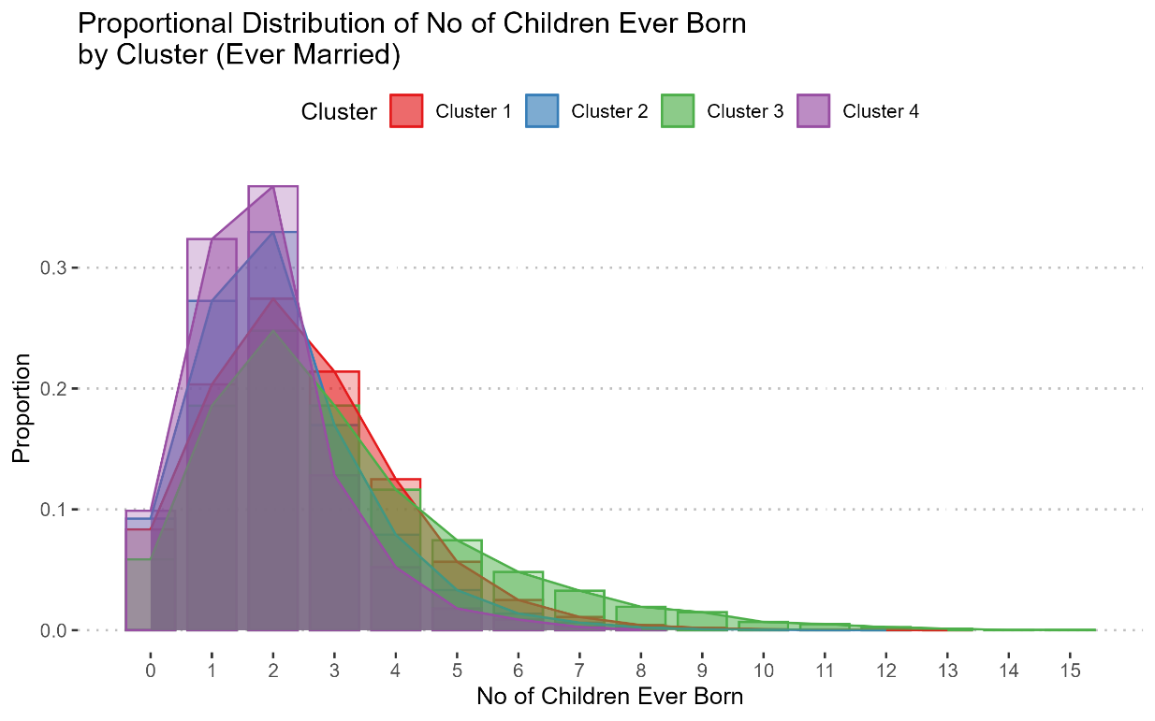
Figure 6: An area plot comparing the distribution of number of children ever born among the four cluster of northeastern states.

DISCUSSION
The study found that the eight northeastern states can be grouped into 4 clusters. Prior studied showed that all northeastern states have similar pattern and belongs to the same cluster according to COVID-19 outbreak¹⁵. A Geo-spatial visualization of the clusters showed a distinct pattern. States in a particular belt or region are found to be members of the same cluster. While cluster 1 of states share international border with Myanmar (Burma), states in cluster 2 and 3 share international border with Bangladesh. On the other hand, cluster 4 (Sikkim) share international border with Nepal and Bhutan [See Figure 4c].
Cluster 4 (purple), characterized by the lowest overall fertility rates, exhibits a pronounced concentration of women with fewer children, particularly those having one or two offspring. The distribution peaks sharply at lower birth counts, with a steep decline in proportions as the number of children increases, indicating a strong preference for smaller family sizes and rapid fertility decline. Cluster 1 (red) and Cluster 2 (blue) display more moderate distributions, though Cluster 1 shows a slightly higher proportion of women with two to three children. Both clusters demonstrate a broader spread of reproductive outcomes compared to Cluster 4, with a noticeable presence of women having four or more children, though still maintaining a higher proportion of lower birth counts than Cluster 3. Cluster 3 (green), which exhibits the highest fertility rates, presents a more dispersed distribution with a significant proportion of women having three to five children. The curve is relatively flatter across higher birth counts, suggesting a greater prevalence of extended family sizes and a less abrupt fertility transition compared to the other clusters [See Figure 6].

Table 3: Comparison of some key socio-demographic characteristic of the women in the four clusters.

Demographic  Characteristic | N | Overall | Cluster 1 | Cluster 2 | Cluster 3 | Cluster 4 | Comparison among  the clusters
Demographic  Characteristic | N | Northeast India | N = 44,780 | N = 42,293 | N = 13,089 | N = 3,271 | Comparison among  the clusters
Highest educational level, n(%) | 1,03,433 |  |  |  |  |  | 1575 (<0.001)¹
No education |  | 16,337 (15.79%) | 6,760 (15.10%) | 7,409 (17.52%) | 1,844 (14.09%) | 324 (9.91%)
Primary |  | 14,504 (14.02%) | 5,242 (11.71%) | 6,098 (14.42%) | 2,576 (19.68%) | 588 (17.98%)
Secondary |  | 61,879 (59.83%) | 26,835 (59.93%) | 25,597 (60.52%) | 7,611 (58.15%) | 1,836 (56.13%)
Higher |  | 10,713 (10.36%) | 5,943 (13.27%) | 3,189 (7.54%) | 1,058 (8.08%) | 523 (15.99%)
Type of place of residence, n(%) | 1,03,433 |  |  |  |  |  | 3264 (<0.001)¹
Urban |  | 19,994 (19.33%) | 12,238 (27.33%) | 5,638 (13.33%) | 1,598 (12.21%) | 520 (15.90%)
Rural |  | 83,439 (80.67%) | 32,542 (72.67%) | 36,655 (86.67%) | 11,491 (87.79%) | 2,751 (84.10%)
Religion, n(%) | 1,03,433 |  |  |  |  |  | 72210 (<0.001)¹
Buddhist |  | 4,894 (4.73%) | 3,391 (7.57%) | 338 (0.80%) | 1 (0.01%) | 1,164 (35.59%)
Christian |  | 40,951 (39.59%) | 27,697 (61.85%) | 1,839 (4.35%) | 11,030 (84.27%) | 385 (11.77%)
Hindu |  | 38,901 (37.61%) | 7,411 (16.55%) | 28,755 (67.99%) | 1,056 (8.07%) | 1,679 (51.33%)
Muslim |  | 12,598 (12.18%) | 930 (2.08%) | 11,321 (26.77%) | 314 (2.40%) | 33 (1.01%)
Others |  | 6,089 (5.89%) | 5,351 (11.95%) | 40 (0.09%) | 688 (5.26%) | 10 (0.31%)
Ethnicity, n(%) | 1,03,433 |  |  |  |  |  | 48106 (<0.001)¹
Caste |  | 34,291 (33.15%) | 7,865 (17.56%) | 23,388 (55.30%) | 594 (4.54%) | 2,444 (74.72%)
Tribe |  | 54,651 (52.84%) | 35,425 (79.11%) | 6,474 (15.31%) | 12,050 (92.06%) | 702 (21.46%)
Others |  | 14,491 (14.01%) | 1,490 (3.33%) | 12,431 (29.39%) | 445 (3.40%) | 125 (3.82%)
Wealth index combined, n(%) | 1,03,433 |  |  |  |  |  | 6463 (<0.001)¹
Poorest |  | 29,455 (28.48%) | 9,513 (21.24%) | 15,604 (36.89%) | 4,214 (32.19%) | 124 (3.79%)
Poorer |  | 33,102 (32.00%) | 13,396 (29.92%) | 14,173 (33.51%) | 4,715 (36.02%) | 818 (25.01%)
Middle |  | 22,531 (21.78%) | 10,993 (24.55%) | 7,479 (17.68%) | 2,734 (20.89%) | 1,325 (40.51%)
Richer |  | 13,547 (13.10%) | 7,873 (17.58%) | 3,781 (8.94%) | 1,094 (8.36%) | 799 (24.43%)
Richest |  | 4,798 (4.64%) | 3,005 (6.71%) | 1,256 (2.97%) | 332 (2.54%) | 205 (6.27%)
Anemia level, n(%) | 1,00,435# |  |  |  |  |  | 9124 (<0.001)¹
Severe |  | 1,686 (1.68%) | 470 (1.08%) | 908 (2.22%) | 253 (1.99%) | 55 (1.81%)
Moderate |  | 24,394 (24.29%) | 6,038 (13.82%) | 14,165 (34.57%) | 3,617 (28.45%) | 574 (18.84%)
Mild |  | 24,276 (24.17%) | 8,627 (19.74%) | 11,933 (29.13%) | 3,112 (24.48%) | 604 (19.83%)
Not anemic |  | 50,079 (49.86%) | 28,571 (65.37%) | 13,965 (34.09%) | 5,730 (45.08%) | 1,813 (59.52%)
Current contraceptive method, n(%) | 75,743* |  |  |  |  |  | 3866 (<0.001)¹
Not using any method |  | 34,799 (45.94%) | 14,515 (46.93%) | 13,032 (39.04%) | 6,681 (73.02%) | 571 (24.98%)
Traditional method |  | 11,011 (14.54%) | 4,501 (14.55%) | 5,687 (17.04%) | 482 (5.27%) | 341 (14.92%)
Modern method |  | 29,933 (39.52%) | 11,911 (38.51%) | 14,661 (43.92%) | 1,987 (21.72%) | 1,374 (60.10%)
Total children ever born, median(IQR) | 75,743* | 2 (1, 3) | 2 (1, 3) | 2 (1, 3) | 3 (2, 4) | 2 (1, 2) | 30.32 (<0.001)²
Number of living children, median(IQR) | 75,743* | 2 (1, 3) | 2 (1, 3) | 2 (1, 3) | 2 (1, 4) | 2 (1, 2) | 31.91 (<0.001)²
¹n (%); Median (Q1, Q3)
¹Pearson's Chi-squared test; ²Yuen’s test for trimmed means, #Total measured sample, *Ever married sample

A further investigation revealed some key difference between the clusters. Cluster 2 has the highest proportion women with no education (17.52%), in contrast cluster 4 has the highest proportion (approx. 16%) of women with higher education. Religious affiliation varies substantially among the clusters, Buddhism is most prevalent in Cluster 4 (35.6 %), Christianity dominates Cluster 1 (61.9 %) and Cluster 3 (84.3 %), whereas Hinduism is the majority religion in Cluster 2 (68 %) and Cluster 4 (51 %). Ethnicity is strongly tribal in Cluster 4 (92 %) and Cluster 3 (74 %), whereas Cluster 1 is predominantly caste (17.6 %) and Cluster 2 (55 %) is mixed. Wealth distribution shows a higher concentration of the poorest and poorer families in Clusters 1 and 3 (approx. 21–37 %), whereas Cluster 4 has a larger middle‑class share (40.5 %) and a small proportion of the richest (6 %).
Anaemia status reveals a higher proportion of moderate and mild anaemia in Clusters 1 and 2 (≈ 34–35 %) than in Cluster 4 (≈ 19 %), while the proportion of non‑anaemic women is highest in Cluster 1 (65 %) and lowest in Cluster 4 (59.5 %). Contraceptive use patterns differ markedly: Cluster 3 has the lowest modern method uptake (21.7 %) and the highest non‑use (73 %), whereas Cluster 4 achieves the highest modern method adoption (60 %) and lowest non‑use (25 %). Traditional methods are low across all clusters. The median number of children ever born is 2 in Clusters 1–3 and 3 in Cluster 4, with inter‑quartile ranges reflecting greater variation in Cluster 3. Living children mirror this pattern, with a slightly wider IQR in Cluster 3.
Our findings support existing literature, which highlights how contraceptive use varies by region within India.¹ This variation may explain why Cluster 1, where fertility rates are lower shows higher adoption of contraception. Cluster 1 (Arunachal Pradesh, Manipur, Mizoram, and Nagaland) can be categorized as predominantly tribal Christian, with secondary level of education, moderate parity and relatively high modern contraceptive use. Cluster 2 (Assam and Tripura) can be categorized as mostly Hindu non-tribal, lower‑educated, with low parity and high modern contraceptive uptake and highest anaemic population, reflecting a more traditional fertility pattern. Cluster 3 (Meghalaya) can be categorized as tribal‑majority, well‑educated, Christian, high parity, and low contraceptive use, suggesting a high fertility region. Finally, Cluster 4 (Sikkim) is Tribal‑majority, highly‑educated, Buddhist, highest non-anaemic population with the lowest parity and highest modern contraceptive use, representing the lowest fertile region.
Each of the cluster constructed possess their unique characteristics. A common policy will fail to address all the diverse issues and pattern. While Cluster 3 needs special focus on reducing the fertility, cluster 4 need to address the significantly low below replacement TFR. In essence, adopting zone-specific policies that consider the unique characteristics of each cluster will be crucial in effectively managing and supporting their developmental trajectories. These tailored approaches can ensure more equitable resource distribution and maximize the positive impact on community well-being across both clusters.
Despite using K-means in identifying inherent fertility grouping the eight states and ensuring the statistical assumption of the algorithm, the results are constrained by the data quality of the NFHS-5. Specifically, recall bias and birth displacement in pregnancy histories may affect the precision of single-year ASFR estimates. Furthermore, the geographical complexities of North-East India may result in localized under-coverage, suggesting that the identified clusters should be interpreted as indicative of broad demographic trends rather than absolute vitals.

CONCLUSION
This study identified four distinct fertility zones from the 8 northeastern states of India, Cluster 1 (Arunachal Pradesh, Manipur, Mizoram, Nagaland), Cluster 2 (Assam, Tripura), Cluster 3 (Meghalaya), and Cluster 4 (Sikkim). Each cluster exhibits significantly different fertility curves, contraceptive use, and socio-economic profiles. Cluster 3, with Meghalaya, stands out as the highest fertility zone, characterized by high parity, low contraceptive adoption, and a predominantly tribal Christian population. Conversely, Cluster 4, encompassing Sikkim, exhibits the lowest fertility rates, driven by high contraceptive use, a Buddhist majority, and a strong tribal presence. The socio-economic and cultural factors significantly influence fertility behaviours. Cluster 1, predominantly tribal and Christian, shows relatively high education levels and moderate contraceptive use, aligning with the literature.¹ Cluster 2, primarily Hindu and rural, displays a higher proportion of anaemia and lower education levels, reflecting traditional fertility patterns. Cluster 3, with its high fertility rates, is marked by low contraceptive use and high parity, suggesting cultural and religious influences on family planning. Cluster 4, with its Buddhist majority and high contraceptive adoption, demonstrates a strong preference for smaller family sizes.
The study underscores the necessity of zone-specific policies to address fertility and socio-economic disparities. For Cluster 3, interventions should focus on increasing contraceptive adoption, improving maternal healthcare access, and addressing cultural barriers to family planning. Cluster 4, with its low fertility rates, may require dedicated policies to prevent further decline. Cluster 1 and Cluster 2, with moderate fertility and socio-economic challenges, should benefit from targeted health and education programs to enhance contraceptive use and reduce anaemia. Future research should explore longitudinal trends in ASFRs and incorporate additional variables such as contraceptive access, maternal healthcare utilization, and economic development indicators. This will provide deeper insights into the causal pathways influencing fertility behaviours and help refine policy interventions.

Individual Authors’ Contributions: CB: Analysis and Writing of the article, RT: Manuscript editing and review, SS: Analysis of data in R programming.
Availability of Data: The NFHS data can be downloaded after approval from the DHS Program (https://dhsprogram.com/data/availabledatasets.cfm)
Conflict of Interest: We declare that there are no conflicts of interest associated with this study.

Disclaimer (Artificial intelligence): This article was prepared without the use of generative AI tools for content creation, analysis, or data generation. All findings and interpretations are based solely on the authors’ independent work and expertise.

REFERNCES
- Baruah C, Talukdar R, Sarma S, Understanding Fertility Trends of Assam: A District-Level Spatial Analysis Through K-Means Clustering. Natl J Community Med 2025;16(9):895-906. DOI: https://doi.org/10.55489/njcm.160920255794
- Joshi S, Uttamacharya, Borkotoky K, Gautam A, Datta N, Achyut P, Nanda P, Verma R. Spatial Variation in Contraceptive Practice Across the Districts of India, 1998 2016. Spat Demogr. 2021;9(2):241-269. DOI: https://doi.org/10.1007/s40980-021-00092-9 PMid:34722854 PMCid:PMC8549954
- Vailaya, CGR, Vailaya, CRS. Study of number of children preferred and knowledge, attitude, and practice regarding birth spacing and contraception among primigravida in an urban setting. Int J Contemp Pediatr, 2020;7(4):757-63. DOI: https://doi.org/10.18203/2349-3291.ijcp20201003
- Visaria, L. India’s date with second demographic transition. China Population and Development Studies, 2022;6(3):316–337. DOI: https://doi.org/10.1007/s42379-022-00117-w
- Tiwari, AK, Maurya, RK, Singh, PK. Proximate determinants of fertility in India and estimation of total fertility rate. Brazilian Journal of Biometrics, 2025;43(1): 1–15. DOI: https://doi.org/10.28951/bjb.v43i3.771
- Halli SS, et al. Fertility and family planning in Uttar Pradesh, India: major progress and persistent gaps. Reprod Health. 2019;16(1):1-10. DOI: https://doi.org/10.1186/s12978-019- 0790-x PMid:31443724 PMCid:PMC6706892
- Goli S, James KS, Singh D, Srinivasan V, Mishra R, Rana MJ, et al. Economic returns of family planning and fertility decline in India, 1991–2061. Journal of Demographic Economics. 2023;89(1):29–61. DOI: https://doi.org/10.1017/dem.2021.3
- Park N, Vyas S, Broussard K, Spears D. Near-universal marriage, early childbearing, and low fertility: India’s alternative fertility transition. Demogr Res. 2023;48(34):945-956. DOI: https://doi.org/10.4054/DemRes.2023.48.34.
- Menon, RJ. (2025). Reimagining Ageing and Later-Life Care: The Perspectives of Childfree Adults in Urban India. Soc, 2025;62:183–194. DOI: https://doi.org/10.1007/s12115-025-01065-0
- Chakravorty S, Goli S, James KS. Family demography in India: emerging patterns and its challenges. Sage Open. 2021;11(2). DOI: https://doi.org/10.1177/21582440211008178
- Bharti A, Kumar A, Singh BP. Trend of Synthetic Parity Progression Ratio (SPPR) Of India: Evidence from National Family Health Surveys. JRSS. 2019;12(02):153-72. DOI: https://doi.org/10.13052/jrss2229-5666.12212
- Majumder N, Ram F. Explaining the role of proximate determinants on fertility decline among poor and non-poor in Asian countries. PLoS ONE, 2015;10(2):e0115441. DOI: https://doi.org/10.1371/journal.pone.0115441
- Gietel-Basten S, Scherbov S. Is half the world’s population really below ‘replacement-rate’? PLoS ONE, 2019;14(12): e0224985. DOI: https://doi.org/10.1371/journal.pone.0224985
- International Institute for Population Sciences (IIPS). National Family Health Survey (NFHS 5) 2019-20: India Report. IIPS; 2021. Available from: https://www.dhsprogram.com/pubs/ pdf/FR375/FR375.pdf [Accessed on April 05, 2025]
- Chakraborty S. Monitoring COVID-19 cases and vaccination in Indian states and union territories using unsupervised machine learning algorithm. Ann Data Sci. 2022;10(5):967-989. DOI: https://doi.org/10.1007/s40745-022-00404-w
- Striessnig E, Bora JK. Under-five child growth and nutrition status: spatial clustering of Indian districts. Spat Demogr. 2020;8(1):63-84. DOI: https://doi.org/10.1007/s40980-020-00058-3
- J T, Kumar S, Panda PS, et al. Geospatial hotspot analysis and endemicity trends of missing and unrecovered children in India. Cureus. 2023;15(6):e39955. DOI: https://doi.org/10.7759/cureus.39955 PMID: 37416019; PMCID: PMC10319941.
- Dube M, Yadav SK, Singh V. Uncovering regional disparities in infrastructural development of Uttar Pradesh: an exploratory factor analysis. J Reliab Stat Stud. 2022;15(1):21-36. DOI: https://doi.org/10.13052/jrss0974-8024.1512
- Kumar S. Monitoring novel corona virus (COVID-19) infections in India by cluster analysis. Ann Data Sci. 2020;7(3):417-425. DOI: https://doi.org/10.1007/s40745-020-00289-7
- Matheswaran K, Alahacoon N, Pandey RK, Amarnath G. Flood risk assessment in South Asia to prioritize flood index insurance applications in Bihar, India. Geomat Nat Hazards Risk. 2018;10(1):26-48. DOI: https://doi.org/10.1080/19 475705. 2018.1500495
- Adolfsson A, Ackerman M, Brownstein NC. To cluster, or not to cluster: an analysis of clusterability methods. Pattern Recognit. 2019;88(1):13-26. DOI: https://doi.org/10.1016/j.patcog. 2018.10.026
- Eaton J, Masquelier B. demogsurv: Demographic analysis of DHS and other household surveys [R package]. Version 0.2.6. 2025 [cited 2025 Jul 16]. Available from: https://github.com/ mrc-ide/demogsurv/tree/0389352e6cdd366f9b1324a0ffe 837081c587d86
- Bongaarts J. Human population growth and the demographic transition. Philos Trans R Soc Lond B Biol Sci. 2009; 364(1532):2985-2990. DOI: https://doi.org/10.1098/rstb. 2009.0137 PMid:19770150 PMCid:PMC2781829
- Coale AJ, Hill AG, Trussell TJ. A new method of estimating standard fertility measures from incomplete data. Population Index. 1975;41(2):182-210. DOI: https://doi.org/10.2307/ 2734617
- Hartigan JA, Wong MA. Algorithm AS 136: a K means clustering algorithm. J R Stat Soc Ser C Appl Stat. 1979;28(1):100- 108. DOI: https://doi.org/10.2307/2346830
- MacQueen J. Some methods for classification and analysis of multivariate observations. In: Proceedings of the Fifth Berkeley Symposium on Mathematical Statistics and Probability, Vol 1. Berkeley (CA): Univ Calif Press; 1967. p. 281-297. Available from: http://projecteuclid.org/euclid.bsmsp/12005 12992
- Onumanyi AJ, Molokomme DN, Isaac SJ, et al. AutoElbow: An automatic elbow detection method for estimating the number of clusters in a dataset. Appl Sci. 2022;12(15):7515. DOI: https://doi.org/10.3390/app12157515
- Rousseeuw PJ. Silhouettes: a graphical aid to the interpretation and validation of cluster analysis. J Comput Appl Math. 1987;20(1):53-65. DOI: https://doi.org/10.1016/0377-0427 (87)90125-7
- Tibshirani R, Walther G, Hastie T. Estimating the number of clusters in a dataset via the gap statistic. J R Stat Soc Ser B Stat Methodol. 2001;63(2):411-426. DOI: https://doi.org/10. 1111/1467-9868.00293
- Krzanowski W, Lai Y. A criterion for determining the number of groups in a data set using sum of squares clustering. Biometrics. 1988;44(1):23-34. DOI: https://doi.org/10.2307/ 2531893
- Patil C, Baidari I. Estimating the optimal number of clusters k in a dataset using data depth. Data Sci Eng. 2019;4(2):132- 140. DOI: https://doi.org/10.1007/s41019-019-0091-y
- Charrad M, Ghazzali N, Boiteau V, Niknafs A. NbClust: An R package for determining the relevant number of clusters in a data set. J Stat Softw. 2014;61(6):1-36. DOI: https://doi.org/ 10.18637/jss.v061.i06
- Hopkins B, Skellam JG. A new method for determining the type of distribution of plant individuals. Ann Bot. 1954;18(2):213- 228. DOI: https://doi.org/10.1093/oxfordjournals.aob.a08 3391
- Lawson RG, Jurs PC. New index for clustering tendency and its application to chemical problems. J Chem Inf Comput Sci. 1990;30(1):36-41. DOI: https://doi.org/10.1021/ci00065 a010
- Yuen KK. The Two-Sample Trimmed t for Unequal Population Variances. Biometrika, 1974;61(1): 165–170. DOI: https://doi.org/10.2307/2334299

