Clustering-Based Assessment of Vadodara’s Urban Parks: A Case Study

Abstract:
Urban parks play a crucial role in conserving biodiversity and providing green spaces that enhance the mental well-being of urban residents. Vadodara, one of the top four metropolitan cities in Gujarat, has expanded its horizon exponentially over the past decades. There are more than 75 urban parks scattered throughout the city. It is interesting to know about the biodiversity of the urban parks in the city. Understanding the biodiversity of these parks is essential for ecological conservation and sustainable urban planning. This study aims to conduct the biodiversity of 43 urban parks in the city, out of the total 75 parks, only those having an area of more than 5000 square meters were selected for the present study, assessing the distribution of species in terms of richness and evenness. Therefore, four key biodiversity diversity indices are calculated. To explore species similarity and ecological clustering, two clustering algorithms were applied. The optimal distance metric for each clustering method was determined using the Monte Carlo simulation method, ensuring the most accurate representation of the species relationships. Based on the best-performing distance metric, graphical visualizations were created to interpret the grouping of species within urban parks. The results highlight key biodiversity patterns across the north, east and west similar and diversity of species is high whether the south zone has less species diversity, this study will help to implicate for the sustainability of the urban ecosystem and are also helpful in urban planning and biodiversity conservation in Vadodara.

Keywords: Urban Parks, Biodiversity Index, urbanization, Clustering. Statistical assessment
- INTRODUCTION
Urban parks, serving as crucial habitats within urban environments, play a pivotal role in conserving biodiversity. These green spaces, characterized by vegetation and water features, provide essential habitats for species in densely populated urban areas. Research has consistently shown that parks act as biodiversity hotspots within cities [8, 25, 33, 35].
Defined as defined urban open spaces reserved for public use, urban parks contribute significantly to preserving biodiversity amid rapid urban development. During the last few decades, in many parts of the world, rapid growth due to industrialization has destroyed the balance of natural processes and, consequently, the quality of natural and urban landscapes. However, landscape ecologists have strongly supported the importance of open spaces and green spaces in cities because of their ecological functioning. Rapid conversion of land in urban areas has had significant impacts, particularly on landscapes and it, and results in a loss of natural habitats and heterogeneity in urban habitats [12, 39, 20, 15]. The proliferation of land conversion actions has led to a decrease in the comfort of urban spaces [3]. To counter these negative effects and enhance urban biodiversity along with the mental well-being of individuals, the creation of green spaces has become essential. These spaces, filled with vegetation, play a crucial role in enhancing safety, comfort, welfare, and the aesthetic appeal of urban environments. Urban parks, as integral components of infrastructure, contribute to the sustainable biodiversity of flora and fauna within cities, alongside other natural and human-made green spaces such as parks, riverbanks, and forests [1].
Biodiversity plays a fundamental role in ecosystem functioning at all levels. Access to green spaces such as urban parks has been associated with improved mental well-being and helps reduce stress levels by providing opportunities for relaxation, exercise, social gatherings, and recreational activities, ultimately leading to a better quality of life in urban areas [11, 41]. By offering habitats for various flora and fauna species to coexist with human populations, urban parks support biodiversity conservation efforts.
While biodiversity encompasses ecosystem, species, and genetic diversity, much research on urban biodiversity has focused on the species level due to its clarity, quantifiability, and ease of monitoring [9, 40]. Nevertheless, biodiversity provides invaluable opportunities for scientific research and discovery, enabling a better understanding of ecological processes and evolution within diverse ecosystems.
This paper aims to understand the diversity of plants in parks in terms of their distribution known as richness and evenness within a defined location at a specific time point.
- METHODS AND MATERIALS

Vadodara, one of the top four metropolitan cities in Gujarat, has expanded its horizon exponentially over the past decades. In total 77 parks are developed and maintained by the department of parks and parks of the Vadodara Municipal Corporation (VMC). Few of these parks are maintained by private bodies in various zones, scattered in and around the city. Further in this study, the city region (study area) was divided into four zones: North, South, East, and West. Within zones, parks whose area was at least 5000 sq.m were considered under the study.
The parks satisfying the defined criteria in the respective zones are listed in Table 1. The sample size was calculated using the proportional allocation technique (Stratified Sampling) and the same is represented in the following Table 1, along with the names of the parks that are selected in the sample.
Stratified sampling was adopted by dividing city into distinct geographical zones (North, South, East, and West), and biodiversity may vary across these zones due to differences in land use patterns, and management practices. By dividing the population of parks into homogeneous strata (zones) and selecting samples proportionally from each stratum, this method ensures better representation of all zones, improves precision of estimates, and reduces sampling bias compared to simple random sampling.
Further, quadrat sampling was used for data collection to assess biodiversity within each selected park. Quadrat sampling is a standard ecological method in which a fixed-area plot (quadrat) is laid down, and all plant species present within that area are identified and counted. This method provides reliable estimates of species richness, abundance, and evenness, and is widely recommended for vegetation analysis and biodiversity studies [42]
Biodiversity can be quantified by calculating different diversity indices, and in this paper, we have calculated alpha indices (Simpson, Shannon-Wiener, McIntosh, Pielou Evenness Index) [22].

Table 1. Number and name of park selected to collect data
Zones | No. of parks whose area is more than 5000 sq.m. | No. parks were selected in the sample | Name of Park
East Zone | 10 | 2 | Park 1 - Harni Sculpture Park
East Zone | 10 | 2 | Park 2 - Jubilee Park
North Zone | 6 | 2 | Park 3 - Veer Sawarkar Park
North Zone | 6 | 2 | Park 4 -Dr. Hedgewar Park
South Zone | 12 | 3 | Park 5 -Palika Udyan Park
South Zone | 12 | 3 | Park 6 -Kachan Bhagat Park
South Zone | 12 | 3 | Park 7 - Lal Baug Park
West Zone | 15 | 4 | Park 8 -Sahyog Park
West Zone | 15 | 4 | Park 9 -Sardar Park
West Zone | 15 | 4 | Park 10 -Diwalipura park
West Zone | 15 | 4 | Park 11 -VMC Palika Udyan Park

2.1 Biodiversity Indices
Biodiversity indices are quantitative measures that capture the variety and distribution of species within an ecological community. It is essential tools for quantifying species richness, evenness, and ecological balance within habitats [10]. It provides simplified numerical values that allow comparisons across ecosystems, making them useful for conservation and ecological assessment. The simplest measure of species diversity is species richness, but a good case can be made for giving some weight to evenness as well. Diversity indices are mathematical functions that combine richness and evenness in a single measure, although usually not explicitly. There is no universal index suitable for all theoretical or real cases in ecological research, although some of them may appear more widely used in literature. There are many biodiversity indices, but the most used diversity indices in ecology are Shannon diversity, Simpson diversity, McIntosh Diversity Index and Pielou Evenness Index [7]. These indices not only simplify complex ecological data into interpretable values but also support decision-making in biodiversity conservation and management.
    - Simpson's Diversity Index
Named after the ecologist Edward H. Simpson, it is a measure used to quantify the diversity or richness of a community. It is commonly employed in ecology to assess species diversity within a habitat. The index considers both the number of different species present (species richness) and their relative abundances, where the index ranges from 0 to 1, with 0 indicating no diversity (only one species present) and 1 indicating maximum diversity (all species present in equal abundance). Simpson's index is defined as
D = 1 - $\sum_{i=1}^{s}{{π_{i}}^{2}}$ (1)
where $π_{i}$ is the probability that a randomly selected tree belongs to species $i, i=1,2,…,s$, s is the total number of species in that Park.
The ML estimate of D is
$\hat{D}=1-\sum_{i=1}^{s}{({\frac{n_{i}}{n})}^{2}}$ (2)
Where, $n_{i}$ is the number of individuals of a particular species $i$ , $n$ is the total number of individuals in that park [14].
2.1.2 Shannon-Wiener Biodiversity Index
It is commonly referred to as Shannon's Diversity Index or simply Shannon-Wiener Index and is a widely used measure of species diversity in ecological studies. It provides a quantitative assessment of the diversity within a community by considering both the number of species present and their relative abundances.
The index is named after Claude Shannon and Warren Weaver, who introduced it in the field of information theory, and Otto Ludwig Wiener, who independently developed it in the context of ecology [14]. The Shannon-Wiener biodiversity index is defined as
$H=-\sum{π_{i}lnπ_{i}}$ (3)
The Maximum likelihood estimator (MLE) of H is
$\hat{H}=-\sum{(\frac{n_{i}}{n})ln⁡(\frac{n_{i}}{n}}$) (4)
The following table helps to categorize parks according to the Shannon-Wiener biodiversity index [1].
Table 2. Shannon-Winner Index Value interpretation table
Index Value range | Category
0-1 | Low diversity, low distribution of the number of individuals per species, and low community stability.
1-3 | The diversity is medium, the distribution of the number of individuals of each species is moderate, and the strength of the community is moderate.
>3 | High diversity, high distribution of individual numbers of each species, and increased community stability.

2.1.3 McIntosh Diversity Index
The McIntosh Diversity Index is an ecological measure used to quantify biodiversity within a community, and it was proposed by Robert. P. McIntosh in 1967 [19]. This index of diversity is derived from the distance measure of similarity which is the special case in this McIntosh diversity index. This index is designed to provide the evenness (how evenly the individuals are distributed among those species) of a community [4]. The values range from 0 to 1. If the value is closer to one, meaning that plants are evenly distributed in the community [34]. The McIntosh Diversity Index is defined as follows:
$M_{c}=\frac{[N-\sqrt{{n_{i}}^{2}}]}{[N-\sqrt{N}]}$ (5)
$M_{c}$ : McIntosh Diversity Index
$n_{i}$ : Number of individuals belonging to $i$ species
$N$ : Total number of individuals
2.1.4 Pielou Evenness Index
The Pielou Evenness Index (J') is a measure used to quantify how evenly individuals are distributed across the different species in a community [36]. It is derived from the Shannon-Wiener Diversity Index (H') and gives an idea of the relative abundance of species. The values range from 0 to 1. A value closer to 1 indicates that the species are evenly distributed, whereas a value closer to 0 indicates that the species are unevenly distributed species [34].
$J^{'}=\frac{H}{H_{max}}$ (6)
$J^{'}$ : Pielou Evenness index
$H$ : The observed value of Shannon index $H$
$H_{max}$ : $ln⁡(S)$
$S$: Total no. of species
2.2 Monte Carlo simulation

Monte Carlo simulation provides an effective way to approximate tricky functions and replicate complex systems using random sampling and suitable statistical techniques. Much like running random experiments where results aren't predictable upfront, it skips rigid deterministic answers. Instead, it creates a huge array of possible scenarios by pulling random values from probability distributions tailored to real-world messiness. From this, you get a clear picture of the output distribution, highlighting variability, uncertainty, and the range of what could happen.
At its heart, Monte Carlo repeatedly draws inputs from distributions that capture real uncertainties, plugs them into your model to generate outputs, and pools all those results into an empirical distribution. This lets you estimate averages, spreads, probabilities, and confidence intervals—handy when closed-form solutions are out of reach. This method really comes into its own with high uncertainty, risk analysis, multidimensional headaches, or problems too tough (or pricey) to solve analytically. It's a go-to for small-sample ecological work, like in urban parks, where patchy data makes it hard to extrapolate biodiversity indices reliably due to sampling quirks.
Take urban parks with limited species data: Monte Carlo sidesteps sampling bias by resimulating distributions and recomputing diversity indices repeatedly. These results in Steady, trustworthy estimates with solid confidence bounds, letting you confidently scale up to bigger areas. Simulating tweaks in abundance under different environmental scenarios, for example, smooths out the wild swings you'd see from sparse observations alone.

In this study, Monte Carlo sampling tackles sampling variability by repeatedly simulating draws from the underlying distributions. As outlined earlier, this iterative process yields more reliable and robust statistical estimates. Specifically, it overcomes the challenges of limited samples to deliver stable biodiversity index estimates [30]. Through ongoing simulations of species distributions and recalculations of diversity metrics, we achieve a steadier evaluation of ecological diversity [16,43] .
2.3 Clustering Algorithm
Clustering algorithms are powerful unsupervised machine learning techniques that are used to group data points based on their similarities. The purpose of cluster analysis is to discover a system of organizing observations in which members of the group share specific properties in common. Cluster analysis is a class of techniques that classifies cases into groups that are relatively homogeneous within themselves and relatively heterogeneous between each other [23]. Cluster analysis has a simple goal of grouping cases into homogeneous clusters.
Clustering algorithms are widely used in biodiversity assessment to understand patterns in complex ecological data, such as grouping species with similar habitats and classifying regions with comparable biodiversity characteristics. By analyzing biodiversity indices such as Simpson’s, Shannon’s, or Pielou’s, clustering can describe the distribution of species in each zone. This approach helps to understand the interactions between species, assess the impact of environmental factors, and support conservation efforts by providing information on health and resilience.
2.3.1 k-means clustering
It is one of the simplest algorithms that are used in clustering. The initial k centers must be specified. Then we associate each dataset point with the nearest center. After assigning all points, re-computing k new centroids. After assigning all points, recomputing k new centroids. Re-assign the points to the new centroids. The process is repeated until there are no changes. The goal of the clustering stage is to associate cells with the same species together. Ideally, the process results in one cluster for each species [29]. To determine the number of clusters, we experimented with two methods: the elbow method and the silhouette Score Analysis.

Elbow method
This approach focuses on the change in variance as the number of clusters increases. The model accuracy increases as the number of clusters increases; however, after some point, adding clusters will not yield a better model. The mean squared error is plotted against the number of clusters. The point where the graph tends to be flat is the optimal value of the number of clusters, which is referred to as the elbow criterion [29].

Silhouette Score Analysis
It is a machine learning algorithm which is used to find the optimal number of clusters. While most of the performance evaluation methods need a training set, the Silhouette index does not need a training set to evaluate the clustering results. It is a metric used to evaluate the clustering quality in unsupervised learning. It measures how well data points are assigned to their clusters by comparing intra-cluster cohesion (how close points in the same cluster are) and inter-cluster separation (how far they are from other clusters). The Silhouette Score ranges from -1 to 1, where: 1 indicates well-clustered data, 0 suggests overlapping clusters, and -1 implies incorrect clustering. This makes it more appropriate for a clustering task. We use the Silhouette index to evaluate the clustering performance [32].

Distance Metrics
A distance matrix is a square, symmetric matrix that shows the pairwise distances between data points in a dataset. The distance measure forms the basis for defining how similar or dissimilar the different cases. The distance matrix plays a crucial role in measuring similarity among objects. Each entry $d(i,j)$ in the matrix represents the distance between object $i$ and object $j$, with values closer to zero indicating greater similarity. Distance matrix should satisfy some properties like symmetry, non-negativity, identification, definiteness and triangle inequality [21]. It is evident that these properties express characteristics that are fundamental to a measure of distance. Several distance methods are available, out of which four are discussed below.

Euclidean distance
Euclidean distance or Euclidean metric is the minimum distance between two objects [31], which is the clearest way of representing the distance between two points. If points ($x_{1}$, $y_{1}$) and ($x_{2}$, $y_{2}$) are in 2-dimensional space, then the Euclidean distance d between them is [13].
$d= \sqrt{{\left(x_{2}-x_{1}\right)}^{2}+{\left(y_{2}-y_{1}\right)}^{2}}$ (7)
Manhattan Distance
In the Manhattan distance function [5], the distance between two points is the sum of the absolute differences of their Cartesian coordinates. Simply it is the sum of the difference between the x-coordinates and y-coordinates [13]. It is also known as City-Block distance method. Thus, the Manhattan distance $d(x,y)$ can be defined as
$d\left(x,y\right)=\sum_{i=1}^{k}{|x_{i}-y_{i}|}$ (8)
Minkowski Distance
Minkowski Distance [6] is described as a generalization of two matrices: Euclidean distance metrics and Manhattan distance [13]. Minkowski’s distance has some advantages over the Euclidean distance that is used in the k-means clustering methods. The formula for calculating Minkowski distance $D(x,y)$ is given as follows:
$D\left(x,y\right)={(\sum_{i=1}^{k}{{(\left|x_{i}-y_{i}\right|)}^{q})}}^{\frac{1}{q}}$ (9)
Mahalanobis Distance
Mahalanobis Distance is a statistical measure used to determine the distance between a point and a distribution. It accounts for correlations between variables and scales distances based on the variance of the data [27].
$D_{m}\left(x,y\right)=\sqrt{\sum_{i=1}^{p}{({x_{i}-y_{i})}^{T}Σ^{-1}(x_{i}-y_{i})}}$ (10)
2.3.2 Hierarchical Clustering Algorithm
A hierarchical clustering algorithm is recommended for users to develop a customized urban habitat classification. Hierarchical clustering starts by treating each unit as a separate cluster, and then repeatedly merges the two most similar clusters. This continues until all clusters are merged, resulting in a nested hierarchical structure of the clusters [24]. Hierarchical clustering can be performed with either a distance matrix or raw data. When raw data is provided, the algorithm requires a specified distance method to convert them to a distance matrix. Clustering is achieved at multiple levels. Hierarchical methods are classified as Agglomerative Methods and Divisive Methods.
Agglomerative clustering works in a “bottom-up manner". That is, each object is initially considered a single-element cluster (leaf). At each step of the algorithm, the two clusters that are the most similar are combined into a new bigger cluster (nodes). This procedure is iterated until all points are members of a single large cluster (root). The inverse of agglomerative clustering is divisive clustering and works “top-down”. It begins with the root, where all objects are included in a single cluster. The process is iterated until all objects are in their cluster [17].
Hierarchical clustering can be represented diagrammatically using a diagram called a dendrogram. A dendrogram is a visual representation of hierarchical clustering using a tree-like diagram. The branches of this tree represent clusters. The height of the dendrogram node represents the distance between the two clusters formed at that node.
In hierarchical clustering, various linkage methods are employed to determine the distance between clusters during merging. The single linkage (nearest neighbor) considers the shortest distance between points, producing elongated clusters prone to chaining. Complete linkage (the nearest neighbor) uses the longest distance, favoring compact, well-separated clusters, but is sensitive to outliers. The average linkage method, also known as the Unweighted Pair Group Method with Arithmetic Mean (UPGMA), calculates the average distance between all pairs of observations from two clusters. Centroid linkage method is based on the distance between the centroids of the cluster, while the Ward method minimizes the variance within the cluster, producing compact spherical clusters [37, 26]. The choice of method affects the resulting cluster structure, which makes it important to align with the objective of the study.
In hierarchical clustering, various linkage methods are employed to determine the distance between clusters during merging. Ward’s distance method minimizes variance within the cluster, producing compact, spherical clusters. Which is the most frequently used distance method? The choice of method affects the resulting cluster structure, which makes it important to align with the objective of the study [37]. All analyses were performed in Python and libraries used are pandas, NumPy, matplotlib, scipy and scikit learn packages.
2.3.3 Performance evaluation
The performance of four different clustering methods was evaluated using two criteria: (a) species representativeness, measured by the number of species represented when selecting a single site randomly from each class, and (b) Biodiversity indices, used to assess the evenness of different domains within each zone.
First, species representativeness was used to check how well a clustering method captures overall species richness. For each clustering method, the zone is divided into several clusters. From each cluster, one site is picked at random, and the total number of different species found across these selected sites is counted. Since the result can change depending on which sites are chosen, this random selection was repeated 1,000 times using a Monte Carlo simulation. The average number of species obtained from these repetitions is reported as the average species representativeness. A higher value means that the clustering method can represent more species even when only one site is chosen from each cluster. To asure that results obtained are unbiased, random clusters with same structure were created. This also adds on in displaying the detailed performance matrix of each clustering methods against baseline as displayed in table 3 to 6.[18]
Second, biodiversity indices were used to understand how balanced the species distribution is within the clusters. Several standard indices were calculated. Simpson’s index tells us, if few species dominate the area of study or species are evenly present in area of interest Shannon’s index reflects both the number of species and how evenly they are distributed. Pielou’s index directly measures evenness, with values closer to one indicating a more uniform distribution. The McIntosh index also looks at species abundance and overall community structure. Together, these indices do not just help one to explain how many species are present but also tell us how well they are spread within the defined area.
The clustering algorithms were ranked on a scale of 1 to 4 based on their relative performance for each method. To make comparison easy, a ranking system was used. For species representativeness, the clustering method with the highest average number of species was given Rank 1, the next best Rank 2, and so on up to Rank 4. This is shown as the Species Rank in the table 3 to 6. The same ranking approach was applied separately to each biodiversity index.
Finally, the Total Rank was calculated by combining the ranks from all criteria (species representativeness and all biodiversity indices). Final rank was obtained by averaging the individual ranks obtained at every iteration in the simulation. A lower total rank means better overall performance, because it shows that the method performs well across multiple aspects. The same method is applied to evaluate different distance methods for clustering parks.

3. RESULTS AND DISCUSSION
In the above (Fig.1) the value of the Shannon-Wiener index was between 1.14 to 2.89, indicating a moderate to high level of diversity. The lowest value was for Park 6, which indicates lower species diversity and Park 4 has the highest species diversity, suggesting that the park has a distribution of species abundance is relatively high. Similarly, Simpson’s index shows that Park-2 (0.89) and Park-4 (0.92) tells that no species dominate the park and that many different species are present in similar locations, while Park-6 (0.65) has fewer dominating species. Pielou’s evenness index shows that Park-4 shows the richest species distribution (0.92) and Park-6 the least (0.65), indicating an imbalance in species diversity. In all respects, the McIntosh index highlights Park-4 (0.87) as having the most balanced combination of species richness and evenness, while Park-7 (0.46) remains the least diverse, where a few species may dominate.

In general, Park-4 consistently ranks highest across all indices, suggesting a diverse ecosystem. Park-6 consistently ranks lowest, indicating that the park is dominated by one or a few species and that other species are relatively rare. Parks like Park-2 and Park-3 also demonstrate relatively stable ecosystems.
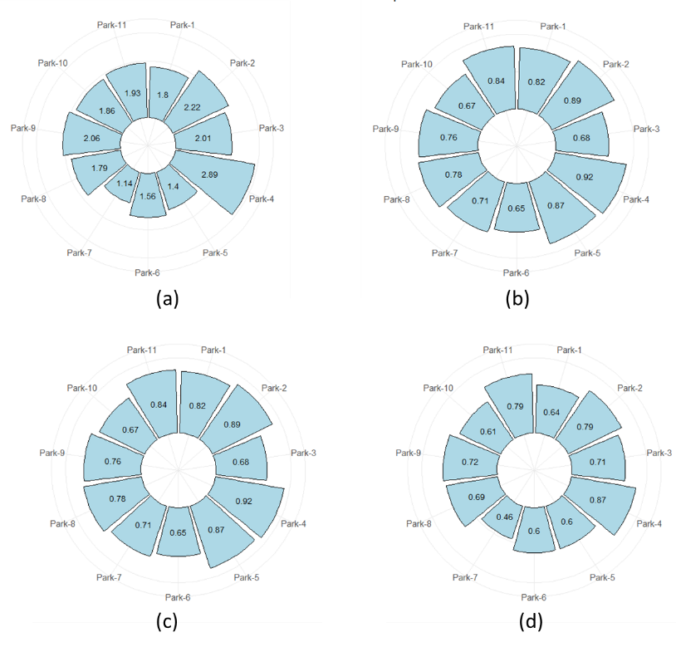
Figure 1. Circular bar diagram of 11 urban parks (a) Shannon-Wiener index, (b) Simpson index, (c) Pielou index, (d) McIntosh index
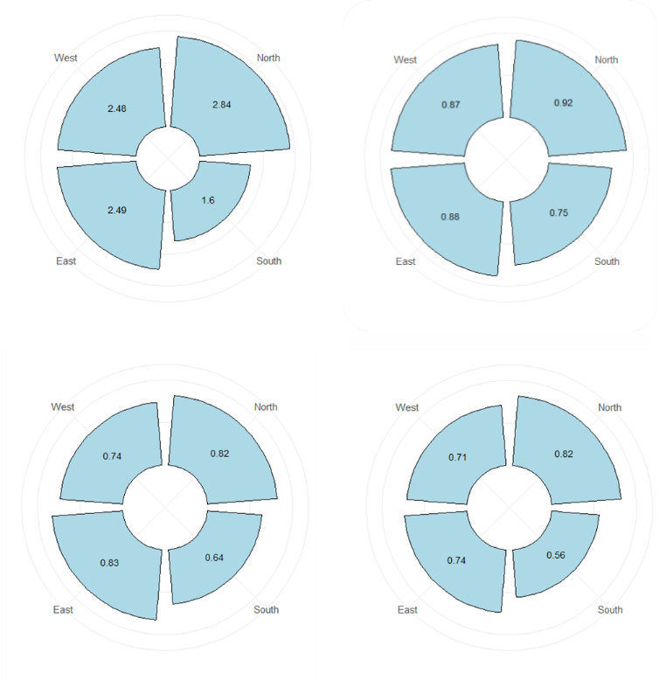
(c)
(d)
(b)
(a)
Figure 2. Circular bar diagram of 4 different zones (a) Shannon-Wiener index, (b) Simpson index, (c) Pielou’s index, (d) McIntosh index

In the above (Fig. 2) the diversity indices across different zones (West, North, East, and South) show the differences in species diversity and their distribution. The Shannon-Wiener index indicates that the north zone has the highest species diversity (2.84), followed by the East (2.49) and West (2.48) zones, while the south zone shows much lower diversity (1.6). This trend is consistent with Simpson’s index, where the north zone again suggests the highest diversity of species and lower dominance of species (0.92). The West and East zones have moderate diversity values (0.87 and 0.88, respectively), while the South zone scores the lowest (0.75), showing greater species dominance and reduced species diversity.
Pielou’s evenness index further supports the above findings, showing that species in the North (0.82) and East (0.83) zones are more evenly distributed compared to the West (0.74) and South (0.64) zones. The McIntosh index, which considers both richness and evenness, also identifies the north zone as the most diverse (0.82), followed by the east (0.74) and west (0.71) zones, and the south zone again having the lowest diversity (0.56).

The North zone consistently shows the highest species diversity and evenness across all indices, making it the most balanced and diverse area in the study. However, the South Zone has the lowest diversity and uneven species distribution, indicating potential ecological challenges. The East and West zones display moderate levels of diversity, with similar patterns in all indices. These results highlight significant ecological differences between the zones, suggesting that the South Zone may require focused conservation efforts to enhance species balance and ecosystem health

Table 3. Summary of the ranks of all different combinations of the number of classes and distance method of k-means clustering algorithm used in the performance evaluation for zones. Each algorithm was ranked 1–4 according to its relative efficiency in clustering scheme, for each of the two performance evaluation measures (average representativeness, biodiversity index).
Clustering Algorithm | Average Species Representativeness | Simpson's index | Shannon's index | Pielou's index | McIntosh index | Species Rank | Total Rank
Mahalanobis | 22.9857 | 0.9818 | 4.1337 | 0.9763 | 0.9853 | 4 | 7
Euclidean | 23.5737 | 0.9647 | 3.4899 | 0.8242 | 0.9612 | 3 | 9
Manhattan | 23.71 | 0.9647 | 3.4899 | 0.8242 | 0.9612 | 2 | 8
Minkowski | 23.8599 | 0.9647 | 3.4899 | 0.8242 | 0.9612 | 1 | 7

Table 4. Summary of the ranks of all different combinations of the number of classes and distance method of hierarchical clustering algorithm used in the performance evaluation for zones. Each algorithm was ranked 1–4 according to its relative efficiency in clustering scheme, for each of the two performance evaluation measures (average representativeness, biodiversity index).
Clustering Algorithm | Average Species Representativeness | Simpson's index | Shannon's index | Pielou's index | McIntosh index | Species Rank | Total Rank
Ward | 41.62 | 0.9724 | 3.6509 | 0.8622 | 0.9796 | 1 | 7
Complete | 41.43 | 0.9724 | 3.6509 | 0.8622 | 0.9796 | 3 | 9
Average | 41.52 | 0.9724 | 3.6509 | 0.8622 | 0.9796 | 2 | 8
Centroid | 23.25 | 0.9818 | 4.1337 | 0.9763 | 0.9833 | 4 | 7

Table 5. Summary of the ranks of all different combinations of the number of classes and distance method of k-means clustering algorithm used in the performance evaluation for parks. Each algorithm was ranked 1–4 according to its relative efficiency in clustering scheme, for each of the two performance evaluation measures (average representativeness, biodiversity index).

Clustering Algorithm | Average Species Representativeness | Simpson's index | Shannon's index | Pielou's index | McIntosh Index | Species Rank | Total Rank
Mahalanobis | 41.808 | 0.9715 | 3.6591 | 0.7846 | 0.988 | 4 | 20
Euclidean | 62.528 | 0.9824 | 4.0997 | 0.8791 | 0.985634 | 1 | 5
Manhattan | 60.963 | 0.9818 | 4.0691 | 0.8725 | 0.985697 | 2 | 11
Minkowski | 60.811 | 0.9817 | 4.067 | 0.8721 | 0.9788 | 3 | 14

Table 6. Summary of the ranks of all different combinations of the number of classes and distance method of hierarchical clustering algorithm used in the performance evaluation for parks. Each algorithm was ranked 1–4 according to its relative efficiency in clustering scheme, for each of the two performance evaluation measures (average representativeness, biodiversity index).
Clustering Algorithm | Average Species Representativeness | Simpson's index | Shannon's index | Pielou's index | McIntosh Index | Species Rank | Total Rank
Ward | 57.07 | 0.9811 | 4.0135 | 0.8606 | 0.9894 | 4 | 17
Complete | 62.825 | 0.9827 | 4.1062 | 0.8805 | 0.9876 | 1 | 6
Average | 60.219 | 0.98126 | 4.048 | 0.8681 | 982267 | 2 | 12
Centroid | 60.146 | 0.98124 | 4.0473 | 0.8678 | 0.98229 | 3 | 15

Clustering of K-means and hierarchical clustering were applied to the data using four discrete distance matrices for each technique. Mahalanobis, Euclidean, Manhattan, and Minkowski for K-means; Ward's, Complete, Average, and Centroid for hierarchical. Followed by the evaluation of the performance of each method based on species representativeness, biodiversity indices (Simpson’s, Shannon’s, Pielou and McIntosh) and species rank.
The above (Table 3 and Table 4) represents the Monte Carlo simulation which revealed that Ward’s clustering method in hierarchical clustering and the Minkowski distance method in K-means was the most efficient algorithm to represent species when the zones are considered for clustering, representing an average of 42% and 24% respectively of the target species for the three-class scheme and suggests that it grouped similar species more effectively. The Ward method and the Minkowski method were superior to the other methods.
However, it showed the lowest values for biodiversity indices for both methods, which may indicate less diverse clustering compared to other methods. Whether Centroid clustering resulted in the highest Shannon index (4.13) and Pielou index (0.98), and in K-means clustering the Mahalanobis distance method has the highest value of biodiversity index indicating better species diversity and richness.
Similarly, when parks are considered for the performance evaluation of distance methods, Tables 5 and Table 6 show that the Monte Carlo simulation suggests that the complete linkage method in hierarchical clustering and the Euclidean distance method in k means were the most efficient method in representing species and biodiversity indices. The average species representatives of the complete linkage method are found to be 62 \% and for the Euclidean distance method it is recorded as 62 \% where the diversity index value is higher than all other distance methos in both clustering algorithms.
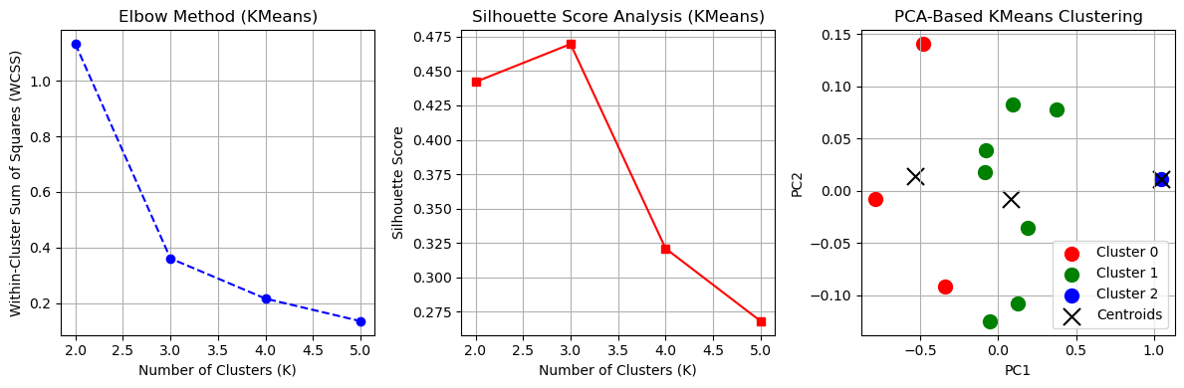
(c)
(b)
(a)
Figure 3. K means clustering of Parks according to their index values and reflects biodiversity levels (a) Elbow method, (b) Silhouette Score Analysis, (c) PCA-Based K-Means Clustering (Euclidean)
Clustering analysis was performed using the Minkowski distance method for the K-Means clustering algorithm to identify distinct biodiversity patterns among parks. Figures 3(a) and 3(b) indicate that the optimal number of clusters is three, each represented by a centroid that serves as the central point of the respective cluster. K-Means groups similar data points by minimizing the intracluster distance between the data points and their corresponding centroid. Figure 3(c) shows the biodiversity distribution in different parks. The clusters are visually represented using different colors: green indicates high diversity, red indicates low diversity, while blue represents moderate diversity. Three clusters were identified. Parks 5, 6, and 7 form a single cluster, indicating a lower biodiversity index and more evenness between the species. Another cluster of parks 1, 2, 3, 8, 9, 10, and 11, suggests a moderate level of species richness. Park 4, forming a separate cluster, represents the highest species richness, indicating a highly diverse ecological composition. The clustering results highlight areas with varying levels of species richness, which can inform targeted conservation efforts.
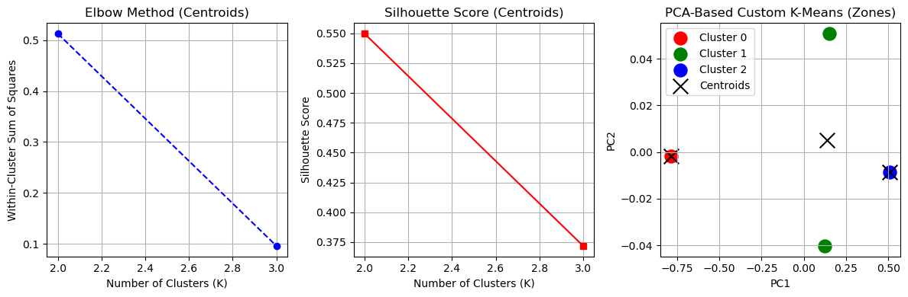
(c)
(b)
(a)
Figure 4. K means clustering of zones according to their index values and reflects biodiversity levels (a) Elbow method, (b) Silhouette Score Analysis, (c) PCA-Based K-Means Clustering (Minkowski)
Clustering analysis was performed using the Minkowski distance method for the K-Means clustering algorithm to identify distinct biodiversity patterns among different zones. Figures 4(a) and 4(b) indicate that the optimal number of clusters is three. Figure 4(c) shows the biodiversity distribution in different zones. The clusters are visually represented using different colors: green indicates moderate diversity, red indicates low diversity, while blue represents high diversity. Three clusters were identified. The cluster was formed by east and west zones, suggesting a moderate level of species richness. North and south form a separate cluster, which represents the highest species richness, indicating a highly diverse ecological composition in the north zone, and in the south zone it has a lower biodiversity index, and the evenness between species is greater. The clustering results highlight areas with varying levels of species richness, which can inform targeted conservation efforts.

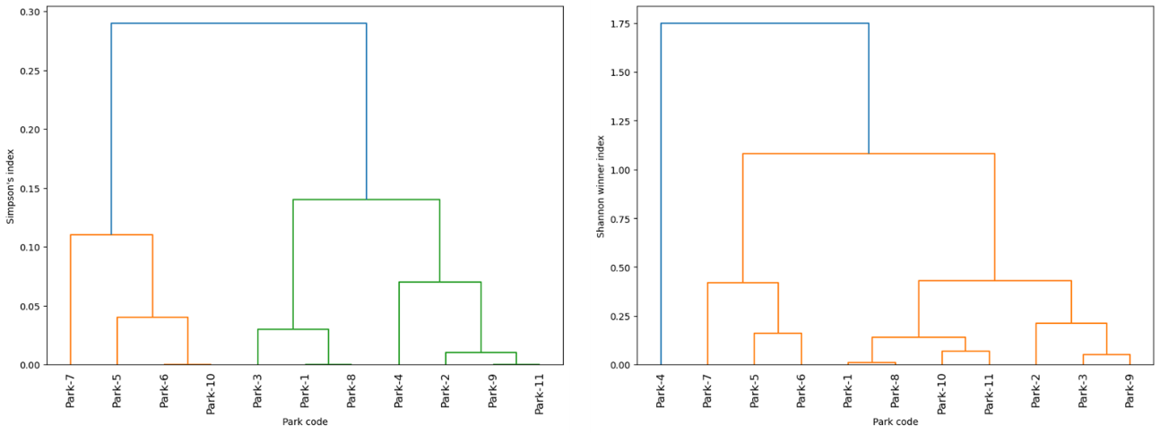
(a)
(b)

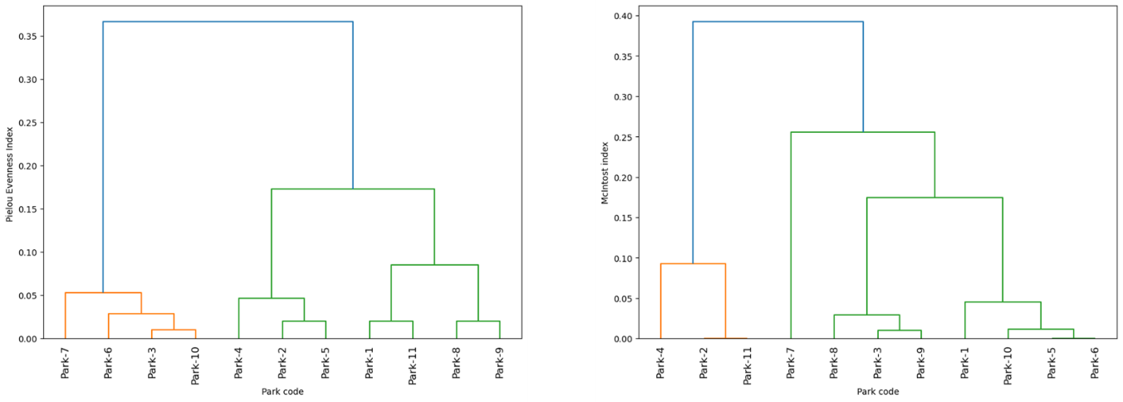
(d)
(c)

Figure 5. Hierarchical clustering parks according to their index values and reflect biodiversity levels (a) Shannon-Wiener index, (b) Simpson index, (c) Pielou index, (d) McIntosh index
Hierarchical cluster analysis across all four dendrograms shows the relationships among the parks. Parks that merge at a lower height are more similar in terms of species evenness. In Figure 5(a) Park 9 and Park 11 are identified as the most similar and form the first group. This is followed by the clustering of Park 6 and Park 10, and then Park 1 and Park 8 which also group and form another. This suggests a high level of similarity in their ecological characteristics or biodiversity. As hierarchical clustering progresses, park 2 consistently merges with the cluster containing Park 9 and Park 11, while Parks 1 and 8 subsequently combine with park 3 to form a larger cluster. Similarly, Parks 6 and 10 eventually merge with Park 5 in each dendrogram, reinforcing their relative similarities as the clusters expand.
Similarly in Figure 5(b), Park 1 and Park 8 are identified as the most similar and form the first cluster. This is followed by the clustering of Park 5 and Park 6, Park 10 and Park 11 and then Park 3 and Park 9 which also group and form another. This suggests a high level of similarity in their ecological characteristics or biodiversity. As the hierarchical clustering progresses, park 7 consistently merges with the cluster containing Park 5 and Park 6, while Parks 1, 8,9 and 11 subsequently combine with Park 2,3 and 9 to form a larger cluster. Then, all the parks eventually merge with Park 4 in each dendrogram, reinforcing their relative similarities as the clusters expand.
In Figure 5(c) Park 7, Park 6, and Park 3 are very close, they have similar evenness values and form a single cluster. This is followed by the clustering of Park 4 and Park 2 clusters together, which also shows similar evenness. The tree was split into two major clusters: Cluster 1: Park 7, Park 6, Park 3, Park 10, Park 4, Park 2, Park 5 and Cluster 2: Park 11, Park 8, Park 9. This means that Parks 11, 8, and 9 are more distinct in evenness compared to the rest. Cluster 1 suggests a greater similarity of species among those parks similarly for cluster 2.
In Figure 5(d) Park 2 and Park 11 are identified as the most similar and form the first cluster. This is followed by the clustering of Park 3 and Park 9, then Park 5 and Park 6 which also group and form another. This suggests a high level of similarity in their ecological characteristics or biodiversity. As hierarchical clustering progresses, park 10 consistently merges with the cluster containing Park 5 and Park 6, again Park 1 merges with these three parks and forms a larger cluster, while Parks 3 and 9 subsequently combine with Park 8 and Park 7 to form a larger cluster. Similarly, Parks 2 and 11 eventually merge with Park 4 in each dendrogram, reinforcing their relative similarities as the clusters expand. Across the four dendrograms, Park 4 consistently emerges as the most distinct park, showing the highest index value, indicating its significant differentiation from the other parks. It is likely to show greater biodiversity observed in park 4.
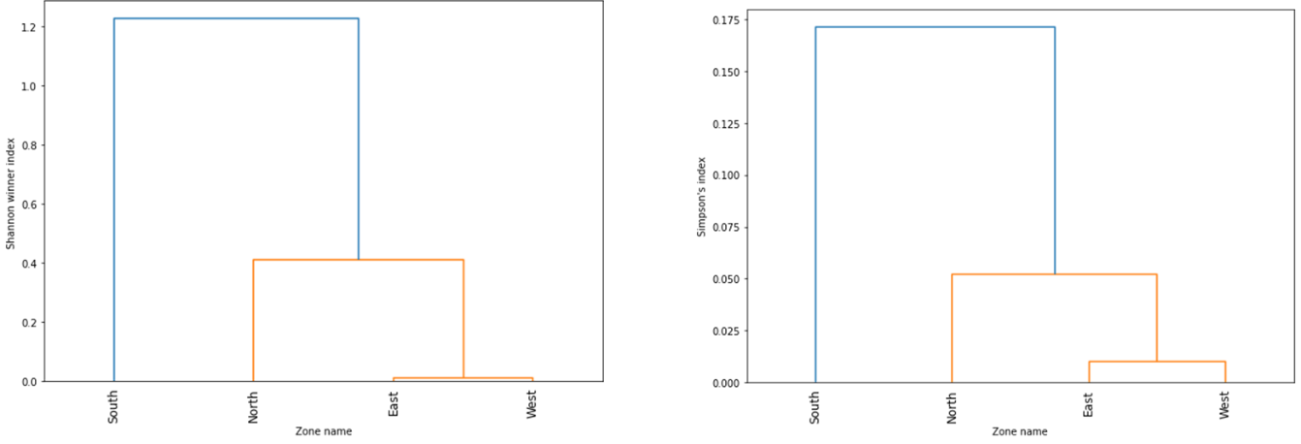
(b)
(a)

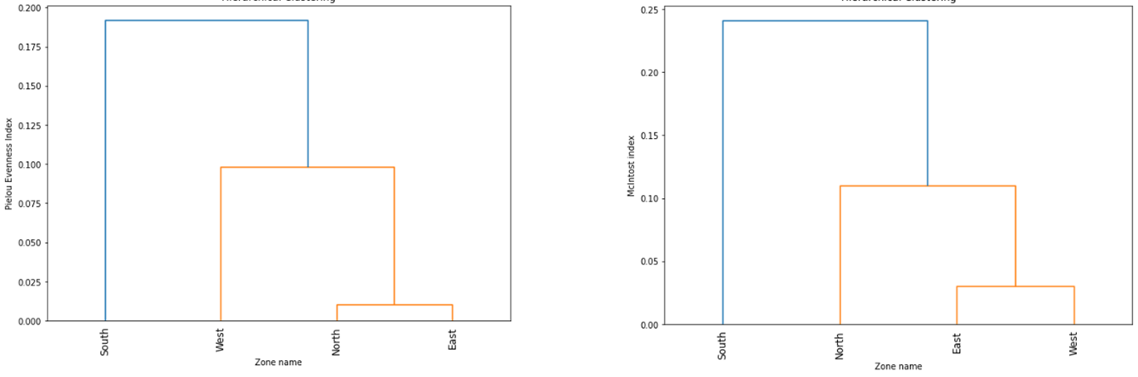
(d)
(c)
Figure 6. Hierarchical clustering of zones according to their index values reflects biodiversity levels (a) Shannon-Wiener index, (b) Simpson index, (c) Pielou index, (d) McIntosh index
Hierarchical cluster analysis across all four dendrograms shows the relationships among the different zones. In all four dendrograms two clusters are formed in Figure 4 (a), (b), and (d) east and west zones combine and form one cluster, which subsequently combines with the north zone to form a larger cluster. In Figure 6(c), the north and east zones combine and form a cluster, eventually merging with the west zone and forming a larger cluster. This suggests a high level of similarity between the diversity of the east, west and north zones. Across the four dendrograms, the south zone consistently emerges as the most distinct zone, showing the lowest index value, indicating its significant differentiation from the other zones. It is likely to show greater species dominance and reduced diversity.
4. CONCLUSION

The study of biodiversity in Vadodara's urban parks reveals a significant variation in species richness and evenness across the city's four zones: north, south, east and west in 11 parks. Total of 59 species were recorded, with biodiversity indices generally falling in the moderate to high range [2]. The richness of the species among the sites varies significantly; Dr. Hedgewar Park, located in the north zone, had the highest diversity in terms of evenness and richness that may lead to a stable ecosystem in the surrounding by providing suitable habitat for humans and most importantly to native flora and fauna. However, Lal Baug Park located in the south zone, 180° opposite to the previous one, had a completely different scenario. Placed in the lowest position across all indices, indicating an ecological imbalance in the diversity of the plants. One reason of the several may of uneven distribution and selection of plants diversity by experts. Hierarchical cluster analysis (Ward's method) confirmed these patterns, forming three clusters based on index similarities: north zone falls under Cluster 1 which has high diversity, east and west zone falls under cluster 2 which has moderate diversity, represents a healthier and more balanced ecosystem, whether the south zone defined in the separate cluster 3 which has low diversity. This suggests that the vegetation in the north zone is not only rich, but also ecologically balanced, contributing positively to the general environmental health of the city. This study emphasizes the importance of maintaining and enhancing plant diversity in urban spaces, particularly in zones where species richness and evenness are lower, to support sustainable urban ecosystems. Such imbalances are critical because diverse and evenly distributed plant communities create habitats for native birds and insects, improve air quality, and reduce the urban heat island effect more effectively than landscapes dominated by a few species.

Focus on the spatial distribution of plant species within the 11 parks under study. 59 distinct tree species were identified in all parks, of which the most common species reported from the collected data were Cocos nucifera (Coconut (102)), Bauhinia forficate (Cow’s foot (49)), Peltophorum pterocarpum (Copper pod (33)), Polyalthia longifolia (Aasopalav (30)) and Azadirachta indica (Neem (21)) in all zones. Although 12 species were found, the least with count 1 in a single park during data collection are the Ficus carica (Anjir), Kolkwitzia amabilis (Beauty bush), Brahea armata(Blue plam), Pterospermum acerifolium (Dinner plate), Ficus microcarpa (Indian laurel), Alnus cordata( Italian elder), Pinus pinea (Italian stone pine), Mammea, Phytolacca dioica(Ombu), Pinus (Pine), Phoenix reclinata (Senegal date palm), Salvia officinalis(wild sage). Of 59, 17 tree species (listed in the table provided in the supplementary material) are such that were present in the parks but were not considered in data collection because they did not fall under the marked area of data collection.
Often, biodiversity studies focus on species richness abundance [8]. Although detailed biodiversity studies are central in accurately describing urban habitats, they can be time and resource intensive [28]. Furthermore, specialist ecological studies may not be easily understood by planners [38]. So, to facilitate the integration of planning and biodiversity, simple ecological methods that produce accurate descriptions of urban habitats, in a manner that is understandable with minimal effort by non-ecologists, are needed.
This study can play a pivotal role for urban planners and landscape ecologists in planning a green sustainable urban area for future generations, that offers well balanced ecosystem to humans and native flora and fauna. Through hierarchical cluster analysis, the research identifies ecologically balanced parks, such as Dr. Hedgewar Park in the North zone, and ecologically imbalance parks, such as Lal Baug Park in the South zone. This classification provides municipal authorities and urban planners with a data-driven framework to prioritize such areas which are ecologically imbalance. Making efforts to increase the number of plants that create balance ecosystem by selecting appropriate species and implementing correct planting strategies. The study further supports conservation-oriented management of urban green spaces.

Importantly, the research fills the gap between complex ecological assessment and balance ecosystem in city planning. By using simple biodiversity indices and clustering methods, the study makes ecological information accessible to non-specialists, enabling planners and policymakers to incorporate biodiversity considerations into the city’s master plan with minimal technical barriers. This approach promotes environmental equity by advocating for a more balanced distribution of ecosystem services such as cooling, air purification, and habitat support across all zones of the city.

This work reinforces the idea of sustainable urban growth using the mantra of lean, green and clean ecosystem. The study supports the development of urban parks as living systems that enhance human well-being, support native biodiversity, and strengthen the cities for rapid urbanization.

CONFLICTS OF INTEREST
The author(s) did not report any potential conflict of interest.
AUTHOR CONTRIBUTIONS
Sheetal Rabindra Prasad: Data collection, Conceptualization, methodology, analysis, Writing and Original draft.
Shrey Pandya: Conceptualization, Editing.
Mangala Shah: Validation and proofreading.
DATA AVAILABILITY
Data sharing is not applicable to this article.
ACKNOWLEDGMENT
The authors thank the team of students, namely Shailesh Limje, Priyank Limbachiya, Hirva Jambucha, and Deep Shekh for taking up this topic as an academic project and helping with data collection. We also thank anonymous referees and the editorial board for their careful reading and helpful suggestions that have substantially improved the presentation of this work.
Disclaimer (Artificial intelligence)
Author(s) hereby declare that NO generative AI technologies such as Large Language Models (ChatGPT, COPILOT, etc.) and text-to-image generators have been used during the writing or editing of this manuscript.

REFERENCES
[1] D. Adelia. Analysis of vegetation biodiversity and urban park connectivity as land- scape services provider in bogor city. In IOP Conference Series: Earth and Environ- mental Science, 2021.
[2] I. V. Ardelean, C. Keller, and C. Scheidegger. Effects of management on lichen species richness, ecological traits and community structure in the rodnei mountains national park (romania). PLoS One, 10(12):e0145808, 2015.
[3] Z. Baruch et al. Increased plant species richness associates with greater soil bacterial diversity in urban green spaces. Environmental Research, 196:110425, 2021.
[4] M. J. Bollarapu and K. Ramarao. Biodiversity measures–mathematical evaluation of various indices. Oeconomia Copernicana, 12(4):46–59, 2021.
[5] Dibya Jyoti Bora and Devakant Gupta. Effect of different distance measures on the performance of k-means algorithm: an experimental study in Matlab. arXiv preprint arXiv:1405.7471, 2014.
[6] B. Charulatha, P. Rodrigues, T. Chitralekha, and A. Rajaraman. A comparative study of different distance metrics that can be used in fuzzy clustering algorithms. In- ternational Journal of Emerging Trends & Technology in Computer Science, 2(4):53–58, 2013.
[7] Robert K. Colwell. Biodiversity: concepts, patterns, and measurement. In Simon A. Levin, editor, The Princeton Guide to Ecology, pages 257–263. Princeton University Press, Princeton, NJ, 2009.
[8] J. Cornelis and M. Hermy. Biodiversity relationships in urban and suburban parks in flanders. Landscape and Urban Planning, 69(4):385–401, 2004.
[9] P. Farinha-Marques, J. Lameiras, C. Fernandes, S. Silva, and F. Guilherme. Urban biodiversity: a review of current concepts and contributions to multidisciplinary ap- proaches. Innovation: The European Journal of Social Science Research, 24(3):247– 497 271, 2011.
[10] P. Fedor and M. Zvaríková. Biodiversity indices. Encyclopedia of Ecology, 2:337–346, 499 2019.
[11] J. A. Figueroa, S. A. Castro, M. Reyes, and S. Teillier. Urban Park area and age determine the richness of native and exotic plants in parks of a latin american city: Santiago as a case study. Urban Ecosystems, 21:645–655, 2018.
[12] Z. Gao et al. Drivers of spontaneous plant richness patterns in urban green space within a biodiversity hotspot. Urban Forestry & Urban Greening, 61:127098, 2021.
[13] Talal M. Ghazal. Performances of k-means clustering algorithm with different distance metrics. Intelligent Automation & Soft Computing, 30(2):735–742, 2021.
[14] A. Gore and S. Paranjpe. A course in mathematical and statistical ecology, volume 42. Springer Science & Business Media, 2000.
[15] Peter M Groffman, J Cavender-Bares, Neil D Bettez, J Morgan Grove, Sharon J Hall, James B Heffernan, Sarah E Hobbie, K L Larson, J L Morse, Christopher Neill, Kristin Nelson, J O’Neil-Dunne, Laura Ogden, Diane E Pataki, Colin Polsky, Rinku Roy Chowdhury, and M K Steele. Ecological homogenization of urban USA. Frontiers in Ecology and the Environment, 12(1):74–81, 2014.
[16] Robert L. Harrison. Introduction to monte carlo simulation. In AIP Conference Proceedings, volume 1204, pages 17–21. AIP Publishing, January 2010.
[17] A. Kassambara. Practical guide to cluster analysis in R: Unsupervised machine learning, volume 1. Sthda, 2017.
[18] Rafi Kent and Yohay Carmel. Evaluation of five clustering algorithms for biodiversity surrogates. Ecological Indicators, 11(3):896–901, 2011.
[19] K. Kitikidou, E. Milios, A. Stampoulidis, E. Pipinis, and K. Radoglou. Using biodiversity indices effectively: Considerations for forest management. Ecologies, 5(1):42–51, 2024.
[20] Jari Kotze, Stephen Venn, Jari Niemelä, and John Spence. Effects of urbanization on the ecology and evolution of arthropods. In Urban Ecology, pages 159–166. Oxford University Press, 2011.
[21] Vijay Kumar, J. K. Chhabra, and Dinesh Kumar. Impact of distance measures on the performance of clustering algorithms. In Intelligent Computing, Networking, and Informatics: Proceedings of the International Conference on Advanced Computing, Networking, and Informatics, India, June 2013, pages 183–190. Springer India, New Delhi, 2014.
[22] M. D. Lakićević et al. Biodiversity indices for the futog park (novi sad, serbia). Zbornik Matice srpske za prirodne nauke, (140):127–135, 2021.
[23] Sabine Landau and Brianne Chis Ster. Cluster analysis: Overview. In Penelope Peterson, Eva Baker, and Barry McGaw, editors, International Encyclopedia of Education, volume 1, pages 72–83. Elsevier, Oxford, 2010.
[24] E. Li, S. S. Parker, G. B. Pauly, J. M. Randall, B. V. Brown, and B. S. Cohen. An urban biodiversity assessment framework that combines an urban habitat classification scheme and citizen science data. Frontiers in Ecology and Evolution, 7:277, 2019.
[25] W. Li, Z. Ouyang, X. Meng, and X. Wang. Plant species composition in relation to green cover configuration and function of urban parks in beijing, china. Ecological Research, 21(2):221–237, 2006.
[26] M. Mouchet et al. Towards a consensus for calculating dendrogram-based functional diversity indices. Oikos, 117(5):794–800, 2008.
[27] Jacob D. Nelson. On k-means clustering using Mahalanobis distance. PhD thesis, North Dakota State University, Fargo, ND, 2012.
[28] E. J. Pharo, A. J. Beattie, and D. Binns. Vascular plant diversity as a surrogate for bryophyte and lichen diversity. Conservation Biology, 13(2):282–292, 1999.
[29] K. V. S. N. Rama Rao, Saurabh Garg, and James Montgomery. Investigation of unsupervised models for biodiversity assessment. In Tanja Mitrović, Bing Xue, and Xiaodong Li, editors, AI 2018: Advances in Artificial Intelligence. Lecture Notes in Computer Science, volume 11320, pages 160–171. Springer, Cham, 2018.
[30] Samik Raychaudhuri. Introduction to monte carlo simulation. In 2008 Winter Simulation Conference, pages 91–100. IEEE, December 2008.
[31] Saad Saqib, Ahsan Ditta, Muhammad A. Khan, Syed A. R. Kazmi, and Hussain Alquhayz. Intelligent dynamic gesture recognition using cnn empowered by edit distance. CMC-Computers, Materials & Continua, 66(2):2061–2076, 2021.
[32] Marwan Shutaywi and Nezamoddin N. Kachouie. Silhouette analysis for performance evaluation in machine learning with applications to clustering. Entropy, 23(6):759, 2021.
[33] R. Tonietto, J. Fant, J. Ascher, K. Ellis, and D. Larkin. A comparison of bee communities of chicago green roofs, parks and prairies. Landscape and Urban Planning, 103(1):102–108, 2011.
[34] G. Türkmen and N. Kazanci. Applications of various biodiversity indices to benthic macroinvertebrate assemblages in streams of a national park in turkey. Review of Hydrobiology, 3(2), 2010.
[35] F. Vilisics and E. Hornung. Urban areas as hot spots for introduced and shelters for native isopod species. Urban Ecosystems, 12:333–345, 2009.
[36] N. Xiao, X. Sun, G. Liu, and H. Li. Assessment of urban biodiversity: A case study of beijing city, china. In Floristic Diversity-Biology and Conservation. IntechOpen, 2023.
[37] O. Yim and K. T. Ramdeen. Hierarchical cluster analysis: comparison of three linkage measures and application to psychological data. The Quantitative Methods for Psychology, 11(1):8–21, 2015.
[38] V. Yli-Pelkonen and J. Niemelä. Linking ecological and social systems in cities: urban planning in finland as a case. Biodiversity & Conservation, 14:1947–1967, 2005.
[39] Shuqing Zhao, Liangjun Da, Zhiyao Tang, Hong Fang, Kang Song, and Jingyun Fang. Ecological consequences of rapid urban expansion: Shanghai, china. Frontiers in Ecology and the Environment, 4(7):341–346, 2006.
[40] Mir, R. A., Jyotsna, N., Singh, P., Awasthi, N., & Mahdi, A. S. (2025). Biodiversity conservation and its role in maintaining ecosystem services: Implications for human well-being. International Journal of Environmental Sciences, 11(24 s), 4259-4267.
[41] Bazmi, F. D., Charpe, G., Kulkarni, S. M., Kohli, D., Acharya, S., & Desale, S. V. (2025). Biodiversity and ecosystem management: Fundamental and challenges. International Journal of Environmental Sciences, 11(13 s), 757-771.
[42] Curtis, J. T., & McIntosh, R. P. (1950). The interrelations of certain analytic and synthetic phytosociological characters. Ecology, 31(3), 434-455.
[43] Harrison, R. L. (2010, January). Introduction to monte carlo simulation. In AIP conference proceedings (Vol. 1204, p. 17).[44] Raychaudhuri, S. (2008, December). Introduction to monte carlo simulation. In 2008 Winter simulation conference (pp. 91-100). IEEE.

