Review Article

CERVICAL SPINE TRAUMA: A Comprehensive Literature Review

.
.
ABSTRACT

Background: Cervical spine trauma includes a wide range of injuries, from mild ligament and muscle damage to vertebral fractures and dislocations that may cause serious spinal cord injury.
Aims: This review aims to comprehensively explore cervical spine trauma, including its definition, epidemiology, classification, diagnostic approaches, management strategies, and prognosis.
Methodology: A comprehensive literature search was conducted using electronic databases including PubMed, Scopus, and Google Scholar. Relevant articles on cervical spine trauma published between 2000 and 2024 were reviewed.
Results: Cervical spine trauma has an annual incidence of approximately 12/100,000 population. Spinal cord injury occurs in 12-50% of patients. Upper cervical injuries account for 83.5% of cases. Classification systems including AO Spine and SLIC guide treatment decisions. Management ranges from non-operative treatment with cervical collars to operative interventions including fusion and stabilization.
Conclusion: Cervical spine trauma represents a significant cause of morbidity and mortality worldwide. Early recognition, accurate classification, and appropriate management are crucial for optimizing outcomes.

Keywords: cervical spine trauma, spinal cord injury, cervical fracture, atlantoaxial instability, spinal trauma classification

1. INTRODUCTION

Cervical spine trauma represents a serious medical condition characterized by injuries to the cervical vertebrae, often leading to severe consequences such as neurological deficits, chronic pain, and diminished quality of life (Shaharudin et al., 2025). The cervical spine consists of seven vertebrae (C1-C7) with a unique structure that provides a balance between stability and flexibility, making it highly susceptible to traumatic forces. Injuries can range from minor soft tissue damage to complex fractures and dislocations that may compromise the spinal cord (Negrelli et al., 2018; Torretti and Sengupta, 2007).
Cervical spine trauma has an incidence of approximately 12 per 100,000 population, frequently caused by traffic accidents and falls (Futch et al., 2024). The majority of patients are male, with age distribution peaks at 15-45 years and 65-80 years. Spinal cord injury is reported in 12-50% of patients, resulting in significant morbidity and mortality (Linnerud et al., 2012; Utheim et al., 2022).
In developed countries, motor vehicle accidents are the primary cause, while fall-related injuries dominate in older populations. Sports-related injuries also contribute significantly, especially among younger age groups (Zileli et al., 2020). In Indonesia, data from Dr. Soetomo Hospital Surabaya in 2020 recorded 85 cases (67.5%) of cervical spine injuries caused by trauma, with upper cervical injuries dominating at 83.5% (Widhiyanto et al., 2021). Understanding spinal trauma through the academic literature enables healthcare professionals to enhance their knowledge of injury mechanisms, classification and associated risk factors. This academic literature facilitates accurate diagnosis and timely intervention, reducing the risk of complications and improving patient outcomes.

2. material and methods

This literature review was conducted by searching electronic databases such as PubMed, Scopus, and Google Scholar for articles related to cervical spine trauma. Articles published between 2000 and 2024 were include, with placed on original research, systematic reviews, and clinical practice guidelines.

3. results and discussion

3.1 Definition and Epidemiology
Cervical spine trauma includes a wide range of injuries, from mild ligament and muscle damage to vertebral fractures and dislocations that may cause serious spinal cord injury. Although the cervical spine’s ligamentous and bony structure allows for a wide range of motion, it also makes the area more vulnerable to injury from mechanisms such as hyperflexion, hyperextension, axial loading, rotation, and distraction. (Beeharry et al., 2021).
The annual incidence of traumatic spinal cord injury worldwide is approximately 45-80 cases per million, with low- and middle-income countries (LMIC) experiencing up to 130 cases per million population. Additional reports confirm that spinal trauma rates are 1.6 times higher in LMIC than in high-income countries. In the United Kingdom, cervical spine injuries account for half of all spinal injuries, with approximately 500-600 people experiencing acute traumatic spinal cord injury each year (Herkowitz et al., 2011).
Upper cervical spine injuries are commonly found in children and the elderly over 60 years of age. Motor vehicle accidents account for 38% of cervical injuries in children. Pediatric cervical spine injuries occur in approximately 1-9% of all reported spinal trauma cases, with 56-73% representing upper cervical injuries. In elderly adults over 60 years, C1-C2 injuries account for 69.8% of cases. Odontoid fractures themselves account for 57% of all cervical injuries in this age group.
Unlike children and young adults, upper cervical injuries in the elderly are usually caused by minor trauma such as falls from standing height. Lower energy trauma directly correlates with lower rates of nerve injury. However, when neurological deficits occur, they result in poor prognosis in these patients. In this elderly group, mortality rates of 26-28% due to upper cervical trauma have been reported, with a 2-year survival rate of 59% (Herkowitz et al., 2011).

3.2 Anatomy of the Cervical Spine
3.2.1 Bony Anatomy
The cervical spine consists of seven vertebrae (C1-C7), which among smallest vertebrae. The cervical vertebrae are characterized by small rectangular bodies that are wider laterally than anteroposteriorly. The vertebral arches are large, and the transverse processes contain foramina for the passage of the vertebral arteries (Pearce, 2009).
Anatomically, the cervical vertebrae are divided into two regions: the upper cervical region (C1 and C2) and the lower cervical region (C3 to C7). Among these vertebrae, three have unique anatomical structures and have been given special names: C1 is called the atlas, C2 is called the axis, and C7 is called the vertebra prominens. Vertebrae C3-C6 are considered typical cervical vertebrae as they possess common characteristics (Pearce, 2009).

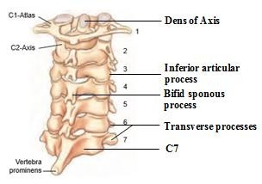
Fig. 1. The cervical spine. (Source: Pearce, 2009)

The atlas (C1) has a ring-like structure without a vertebral body and has a very short spinous process. It consists of an anterior arch, posterior arch, two lateral masses, and two transverse processes. The ring shape divides the anterior and posterior portions, with the transverse atlantal ligament crossing between them. The anterior portion of the atlas ring receives the dens (odontoid process) from the axis, while the posterior portion transmits the spinal cord (Netter, 2011).
The axis (C2) is characterized by the presence of the dens or odontoid process, which is a bony projection extending upward from the superior surface of the body. The anterior and posterior surfaces of the dens contain articular facets called the anterior and posterior articular facets (Ombregt, 2013).
The typical cervical vertebrae (C3-C6) have small bodies with short vertebral bodies, square-shaped with slightly rounded corners when viewed from above, and the anterior and posterior body thickness are equal. The spinous processes are bifid (split into two), and the transverse processes contain foramina for the vertebral arteries (Ombregt, 2013). C7 (vertebra prominens) has a characteristic longer spinous process that distinguishes it from other cervical vertebrae (Ombregt, 2013).

3.2.2 Ligamentous Structures
The cervical vertebrae are stabilized by a complex network of ligaments. The occipitoatlantoaxial complex includes ligaments connecting the occiput to the atlas and axis: the anterior atlanto-occipital membrane, posterior atlanto-occipital membrane, and tectorial membrane. Ligaments connecting the axis to the occiput include the apical ligament, longitudinal components of the cruciform ligament, and alar ligaments. The atlantoaxial complex includes the transverse ligament, two accessory atlantoaxial ligaments, and ligamentum flavum. The ligamentum nuchae attaches to the external occipital protuberance, lies in the sagittal plane, and merges with the interspinous and supraspinous ligaments (Ombregt, 2013).
The anterior longitudinal ligament (ALL) is a primary stabilizer of intervertebral joints, originating from the anterior base of the occipital bone and extending to the anterior sacrum. The posterior longitudinal ligament (PLL) is another major stabilizer, located on the posterior surface of the vertebral bodies and forming the anterior border of the spinal canal (Ombregt, 2013).

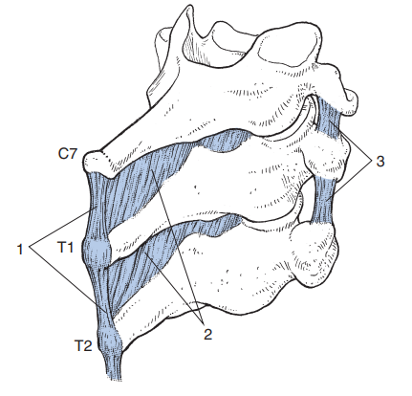
Fig. 2. Posterior ligamentous complex. (Source: Ombregt, 2013)

The ligamentum flavum controls excessive flexion movements and reinforces the facet capsular joint. The interspinous ligaments connect adjacent spinous processes, while the supraspinous ligament attaches to the tips of spinous processes from C7 to the sacrum. The intertransverse ligaments connect adjacent transverse processes (Ombregt, 2013).

3.2.3 Muscular Anatomy
The cervical muscles are categorized according to their function such as flexion, extension, or rotation. Muscles and ligaments work together to stabilize the spine, maintain posture, and control movement. The cervical muscles include the sternocleidomastoid (C2, C3), scalenus muscles (lower cervical), spinalis cervicis and capitus (middle/lower cervical), semispinalis cervicis and capitus, splenius cervicis, longus colli cervicis (C2-C7), longus capitus (C1-C3), rectus capitus anterior and lateralis (C2, C3), and the suboccipital muscles (Ombregt, 2013).

3.2.4 Vascular and Neural Anatomy
The circulation of the head and neck can be divided into anterior (carotid) and posterior (vertebrobasilar) circulations. The anterior circulation consists of the internal carotid artery (ICA), which divides into the anterior cerebral artery (ACA) and middle cerebral artery (MCA). The posterior circulation consists of the vertebral arteries (VA), which arise from the subclavian arteries and join to form the basilar artery (BA) (Santillan et al., 2011).
There are 31 pairs of spinal nerves, including 8 cervical pairs (C1-C8). The cervical plexus is formed by C1-C4 nerves and innervates the neck, scalp, neck muscles, and chest. The phrenic nerve (C3-C5) innervates the diaphragm. The brachial plexus is formed by C5-T1 roots and innervates the upper extremities (Ombregt, 2013).

3.3 Classification of Cervical Spine Trauma
Cervical spine trauma is classified based on injury mechanism, anatomical location, and stability (Huang et al., 2025). The AO Spine classification system, which incorporates morphology, neurological status, and clinical modifiers, is widely used to guide treatment decisions (Table 1).

Table 1. Classification of Cervical Spine Trauma
Category | Type | Description
Mechanism of Injury | Flexion Injuries | Result from forward bending forces, leading to anterior compression fractures, subluxations, or dislocations
 | Extension Injuries | Caused by backward bending forces, often resulting in posterior element fractures or ligamentous injuries
 | Axial Compression Injuries | Result from vertical forces, causing burst fractures or comminuted vertebral body fractures
 | Rotational Injuries | Involve torsional forces leading to unilateral facet dislocations or fractures
Anatomical Location | Upper Cervical (C1-C2) | Includes atlas fractures, odontoid fractures, Hangman fractures
 | Lower Cervical (C3-C7) | Includes subaxial cervical injuries
Stability | Stable Injuries | Preserve the alignment of the spinal column without significant risk of neurological compromise
 | Unstable Injuries | Disrupt the posterior ligamentous complex or spinal alignment, posing a high risk of neurological injury
3.4 Upper Cervical Trauma
3.4.1 Occipital Condyle Fractures
Anderson and Montesano developed the first widely accepted classification system for occipital condyle fractures, presenting a 3-part scheme distinguishing fracture types based on injury mechanism: type 1-impaction injury with comminution, type 2-direct blow with linear fracture extension from the occiput to the condyle, and type 3-rotational injury associated with alar ligament avulsion (Fig. 3). Type 1 and 2 injuries are generally considered stable and can be managed nonoperatively, while type 3 injuries are potentially unstable, often indicating surgical intervention (Bransford et al., 2014; Vaccaro et al., 2022).

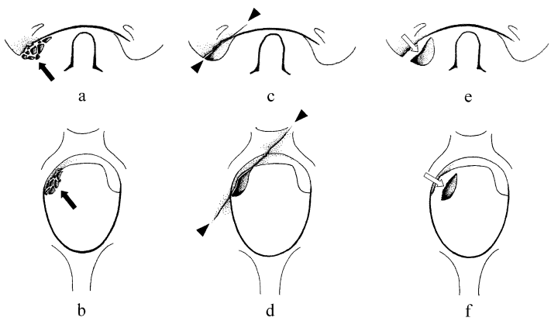
Fig. 3. Classification of Occipital Condyle Fractures. (Source: Leone et al., 2000)

Most occipital condyle fractures can be treated nonoperatively. Rigid cervical collar for 8 to 12 weeks is usually sufficient for Anderson type I and II injuries. For type III fractures due to potential instability, halo vest immobilization or operative treatment is indicated. Operative treatment with occipitocervical fusion is indicated for unstable injuries with MRI evidence of tectorial membrane disruption (Lightsey et al., 2025).

3.4.2 Atlanto-occipital Dislocation
Traynelis et al. designed the initial classification of atlanto-occipital dissociation focused on the direction of occiput displacement relative to the cervical spine: anterior (I), longitudinal (II), and posterior (III) (Fig. 4). These injuries are highly unstable and require surgical stabilization (Dahlan et al., 2019).
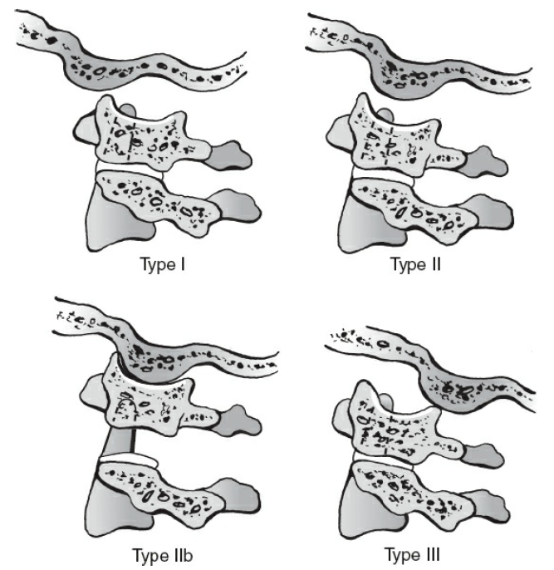

Fig. 4. Traynelis classification of atlanto-occipital dislocation. (Source: Lightsey et al., 2025)

Nonoperative treatment has a limited role. Halo immobilization is most often used as temporary stabilization until surgery can be safely performed. Definitive treatment is posterior occipitocervical fusion with occipital plate and screw-rod construct (Lightsey et al., 2025).

3.4.3 Atlas Fractures
Classification of atlas fractures was pioneered by Jefferson, then by Gehweiler, and later Landells described anatomical locations. Levine and Edwards classified atlas fractures based on severity. The Jefferson fracture involves both anterior and posterior arches (Fig. 5) (Baker and Khan, 2024).

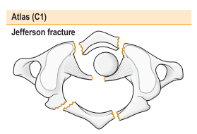

Fig. 5. Jefferson fracture. (Source: Baker and Khan, 2024)

For stable C1 burst (Jefferson) fractures without more serious cervical injury, most surgeons recommend nonoperative management with rigid cervical collar for 8 to 12 weeks. Unstable fractures can be reduced with halo traction and definitively managed with halo vest for 12 weeks. Surgical stabilization is indicated in cases following failure of nonoperative management or when injuries are accompanied by transverse ligament disruption (Lightsey et al., 2025).

3.4.4 Odontoid Fractures
The Anderson and D'Alonzo classification remains the most common system: type 1-oblique fracture of the odontoid tip, type 2-horizontal fracture at the odontoid waist, and type 3-horizontal fracture extending into the axis body (Fig. 6). Modifications by Grauer et al. have attempted to subclassify type 2 fractures based on orientation, displacement, and comminution (Marcon et al., 2013; Vaccaro et al., 2022).

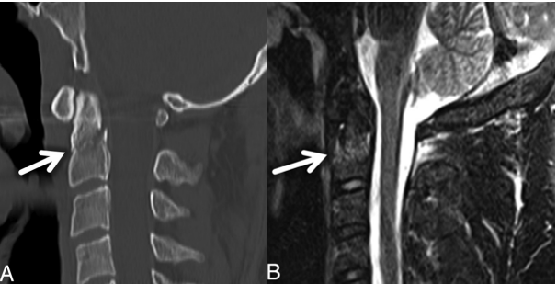

Fig. 6. Odontoid fracture classification. (Source: Herkowitz et al., 2011)

Rigid collar should be considered for elderly low-demand patients with nondisplaced odontoid fractures. For nondisplaced type II fractures, some believe halo vest is more appropriate due to reported high nonunion rates. Type III fractures generally heal better with external orthosis than type II injuries. Surgical indications in younger patients include fracture displacement >5 mm, angulation >10 degrees, neurological deficit, substantial comminution, or multisystem trauma. Surgical options include anterior odontoid screw fixation and posterior C1-C2 fusion (Lightsey et al., 2025). In elderly patients with upper cervical trauma, particularly odontoid fractures, management remains controversial. Conservative treatment with rigid immobilization may be appropriate for selected nondisplaced fractures and frail low-demand patients, whereas surgical stabilization may provide better mechanical stability and earlier mobilization in selected cases. However, both approaches are associated with considerable morbidity and mortality in this age group, so treatment decisions should be individualized based on fracture pattern, stability, comorbidities, and functional status.

3.4.5 Hangman Fractures
Traumatic spondylolisthesis of the axis, known as Hangman fracture, is best classified using a modification of the Effendi classification system (Fig. 7). Type I fractures occur bilaterally through the pars interarticularis with translation <3 mm and no angulation. Type II fractures have translation and angulation of C2 on C3 >3 mm. Type IIA shows significant angulation but minimal translation with significant disc disruption. Type III fractures are highly unstable with severe displacement and angulation associated with unilateral or bilateral facet dislocation (Bernstein and Baxter, 2012; Herkowitz et al., 2011).
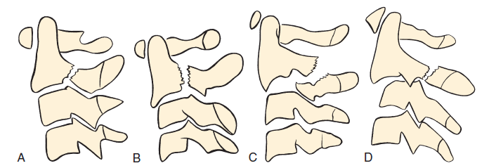

Fig. 7. Hangman fracture classification. (Source: Lightsey et al., 2025)

Most hangman fractures without neurological deficit can be managed nonoperatively. Type I injuries respond well to cervical collar. Type II fractures are best managed with traction followed by halo vest immobilization. However, in type IIA fractures, traction should be avoided as it may worsen deformity. Surgical treatment is indicated for type III injuries with facet dislocation, neurological deficit, or when nonoperative management fails. Surgical options include anterior C2-C3 fusion and posterior C1-C3 fusion (Lightsey et al., 2025).

3.4.6 Atlantoaxial Subluxation and Dislocation
Fielding and Hawkins presented the most commonly used classification for rotatory atlantoaxial injuries: type I-pure rotational injury, type II-rotational malalignment with anterior atlas displacement <3-5 mm, type III-rotational subluxation with displacement >5 mm, and type IV-rotational malalignment with posterior displacement (Bransford et al., 2014; Herkowitz et al., 2011).
Acute rotatory atlantoaxial dislocation can be successfully managed nonoperatively with traction reduction followed by immobilization (Li et al., 2025). Surgical treatment is indicated for cases involving spinal cord injury, significant dynamic instability, or when nonoperative methods fail, with posterior C1-C2 fusion using lateral mass and pedicle screws (Lightsey et al., 2025).

3.5 Lower Cervical Trauma
Classification systems for lower cervical spine injuries include CSISS (Cervical Spine Injury Severity Score), SLIC (Subaxial Cervical Spine Injury Classification), and the AO classification. CSISS analyzes four anatomical columns: anterior, posterior, and two lateral columns (Camino-Willhuber et al., 2026). SLIC evaluates fracture morphology, discoligamentous complex, and neurological function to guide treatment decisions (Fig. 8) (Herkowitz et al., 2011).
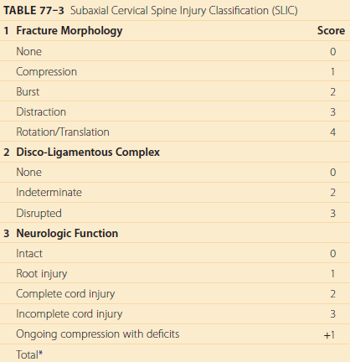

Fig. 8. SLIC classification system. (Source: Herkowitz et al., 2011)

3.5.1 Anterior Column Injuries
Compression Fractures: Compression fractures occur due to hyperflexion and/or axial loading forces. Radiographically, anterior wedging and superior endplate fracture are seen (Fig. 9). Isolated compression fractures without posterior ligamentous injury can be managed nonoperatively with external orthosis. When associated with posterior ligamentous injury or facet perching, scores indicate moderate instability requiring surgical stabilization (Herkowitz et al., 2011; Lightsey et al., 2025).

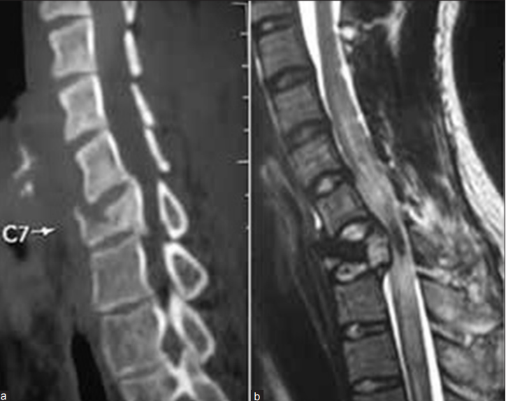

Fig. 9. Compression fracture with posterior ligamentous disruption. (Source: Zaveri and Das, 2017)

Burst Fractures: Burst fractures result from rapid increase in intradiscal pressure causing superior endplate failure (Fig. 10). Nonoperative management may be considered in patients without neurological deficit, with minimal vertebral body comminution, mild canal compromise, kyphosis <5 degrees, and without posterior ligamentous injury. Patients with neurological deficit require surgical stabilization, with anterior corpectomy being the preferred approach for direct canal decompression (Feuchtbaum et al., 2016; Lightsey et al., 2025).
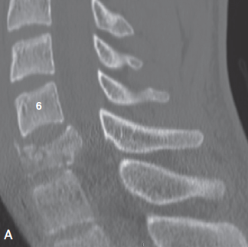
Fig. 10. Burst fracture on CT scan. (Source: Herkowitz et al., 2011)

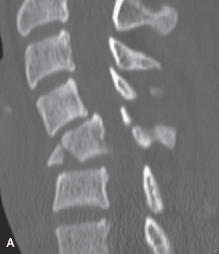
Teardrop Fractures: Flexion-axial loading injuries, also called teardrop fractures, represent severe injuries with high propensity for neurological deficit (Fig. 11). The injury occurs due to compressive force applied obliquely downward and posteriorly. Nonoperative management has a limited role. For patients with neurological deficit, anterior corpectomy with strut graft and rigid plate fixation is indicated. For neurologically intact patients with minimal vertebral height loss and <30% inferior endplate involvement, posterior stabilization may be considered (Herkowitz et al., 2011; Lightsey et al., 2025).
Fig. 11. Teardrop fracture. (Source: Herkowitz et al., 2011)

Disc Distraction Injuries: Disc distraction injuries occur due to hyperextension forces, often in spondylotic spines. These injuries are difficult to diagnose and easily missed even with CT; MRI is essential (Yong et al., 2025). Management depends on stability and neurological status (Herkowitz et al., 2011).

3.5.2 Posterior Column Injuries
Isolated posterior column injuries include spinous process fractures, lamina fractures, and posterior ligamentous injury without subluxation. These generally have low CSISS and SLIC scores and can be managed nonoperatively with cervical collar, though MRI is important to assess associated ligamentous injury (Herkowitz et al., 2011).

3.5.3 Lateral Column Injuries
Isolated Facet Fractures: Isolated facet fractures occur due to forced impact against the adjacent facet. Without subluxation, these have low scores and are considered stable, managed with rigid cervical collar for 6-12 weeks. Some surgeons recommend operative treatment due to potential ligamentous instability, with anterior interbody fusion being preferred over posterior approaches (Herkowitz et al., 2011; Lightsey et al., 2025).
Lateral Mass Fractures: Kotani et al. identified four types: type I-split fracture, type II-comminuted fracture, type III-vertical split fracture, and type IV-traumatic spondylolisthesis. Management depends on fracture type and associated instability (Kotani et al., 2005).
Facet Dislocations: Unilateral facet dislocation results in 10-25% vertebral body translation (Fig. 12). Associated disc disruption occurs in most cases, with frank herniation in a minority. Bilateral facet dislocation is a severe injury often resulting in quadriplegia. There is always associated posterior ligamentous complex disruption. Vertebral body translation is at least 50%. These injuries have the highest CSISS (15-20) and SLIC (6-10) scores and are considered unstable, requiring surgical intervention (Herkowitz et al., 2011; Mubark et al., 2021).

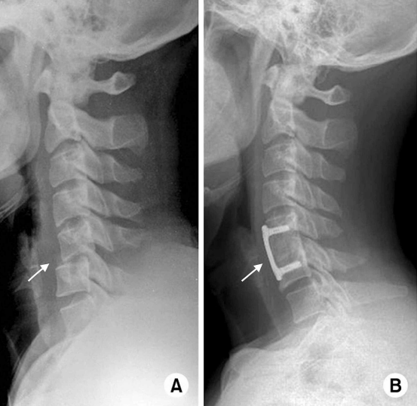
Fig. 12. Unilateral facet dislocation. (Source: Mubark et al., 2021)

3.6 Prognosis

The prognosis of cervical spine trauma is significantly influenced by several key factors. Neurological status at presentation plays a crucial role, with patients experiencing complete spinal cord injury (ASIA Grade A) having a much poorer prognosis compared to those with incomplete injuries. Age and comorbidities also affect recovery potential, as older patients and individuals with pre-existing medical conditions often experience reduced healing and functional outcomes (Talbott et al., 2025). Additionally, the mechanism of injury is an important determinant, as high-energy trauma is often associated with more severe injuries and consequently worse prognosis. Studies show that early surgical intervention for unstable injuries with neurological deficits can improve outcomes. Rehabilitation also plays a critical role in maximizing functional recovery and minimizing long-term disability (Jaja et al., 2025). Despite advances in care, complete recovery is rare in severe cases, underscoring the importance of prevention and early management (Herkowitz et al., 2011). This literature review has several limitations. As a narrative review, it is subject to potential selection bias and author interpretation in the identification and synthesis of the included literature. Furthermore, variations in study design, patient populations, clinical settings, and reported outcomes among the reviewed articles may have introduced heterogeneity into the evidence presented. The absence of quantitative synthesis or meta-analysis also limits the ability to statistically evaluate and compare the effectiveness of different diagnostic and management strategies. Accordingly, the findings of this review should be interpreted in light of these limitations.

4. Conclusion

Cervical spine trauma is a significant cause of morbidity and mortality, with injury patterns ranging from stable soft tissue lesions to unstable fractures and dislocations that may compromise the spinal cord. A thorough understanding of cervical anatomy, injury mechanisms, and classification systems such as AO Spine, SLIC, and CSISS is essential for accurate diagnosis and appropriate management. Treatment should be tailored to injury stability, neurological status, and patient factors, ranging from conservative immobilization to surgical stabilization. Ultimately, early recognition and appropriate intervention are crucial to improve outcomes and reduce long-term disability in patients with cervical spine trauma.

Disclaimer (Artificial intelligence)
Author(s) hereby declare that NO generative AI technologies such as Large Language Models (ChatGPT, COPILOT, etc.) and text-to-image generators have been used during the writing or editing of this manuscript.

References

- Baker, A. D., & Khan, S. (2024). Spine. In T. O. White & S. P. Mackenzie (Eds.), McRae's Orthopaedic Trauma and Emergency Fracture Management (4th ed., p. 307). Edinburgh: Elsevier Ltd.
- Beeharry, M. W., Moqeem, K., & Rohilla, M. U. (2021). Management of Cervical Spine Fractures: A Literature Review. Cureus, 13(4).
- Bransford, R. J., Alton, T. B., Patel, A. R., & Bellabarba, C. (2014). Upper Cervical Spine Trauma. American Academy of Orthopaedic Surgeons, 22(11), 718-729.
- Camino-Willhuber G, Dandurand C, Scherer J, et al. AO Spine Clinical Practice Recommendations for the Management of Subaxial Spine Fractures. Global Spine Journal. 2026. doi:10.1177/21925682261421911
- Dahlan, R. H., Ompusunggu, S. E., Baselim, I. M., & Arimbawa, I. B. G. (2019). Cervical Spine Trauma. Asian Australasian Neuro and Health Science Journal, 01(02).
- Feuchtbaum, E., Buchowski, J., & Zebala, L. (2016). Subaxial cervical spine trauma. Current Reviews in Musculoskeletal Medicine, 9, 496-504.
- Futch BG, Seas A, Ononogbu-Uche FC, et al. Shifting Trends in the Epidemiology of Cervical Spine Injuries: An Analysis of 11,822 Patients from the National Electronic Injury Surveillance System over Two Decades. Journal of Neurotrauma. 2024. doi:10.1089/neu.2024.0194
- Herkowitz, H. N., Garfin, S. R., Eismont, F. J., Bell, G. R., & Balderston, R. A. (Eds.). (2011). Rothman-Simeone The Spine (6th ed.). Philadelphia: Elsevier.
- Huang X, Zhang Y, Xiao H, Chen J, Jiang Y. The evolution of cervical spine trauma classification: a paradigm shift from morphological description to clinical decision-making. Frontiers in Neurology. 2025;16. doi:10.3389/fneur.2025.1728720
- Jaja PT, Iroegbu-Emeruem L, Kulsoom I, Odeku A. Clinical epidemiology, management and outcomes of traumatic cervical spinal-cord and spine injuries: a systematic review of 1645 pooled cases. Journal of Neurosurgical Sciences. 2025;69(2):187-199. doi:10.23736/S0390-5616.25.06404-5
- Leone, A., Cerase, A., Colosimo, C., et al. (2000). Occipital Condylar Fractures: A Review. Radiology, 216(24), 635-644.
- Lightsey, H. M., Harris, M. B., & Tobert, D. G. (2025). Principles of Spine Trauma Care. In P. Tornetta et al. (Eds.), Rockwood and Green's Fractures in Adults (10th ed., p. 2114). Philadelphia: Wolters Kluwer.
- Li G, Zhang H, Wang Q. Imaging and classifications of atlantoaxial dislocation: a narrative review. EFORT Open Reviews. 2025;10(7):551-561. doi:10.1530/EOR-2024-0061
- Linnerud, H., Ali, S., Rizvi, M., & Grøgaard, B. (2012). The epidemiology of traumatic cervical spine fractures: a prospective population study from Norway. Scandinavian Journal of Trauma, Resuscitation & Emergency Medicine, 20(85), 1-7.
- Marcon, R. M., Fogac, I. A., Teixeira, I. W. J., & Cristante, A. F. (2013). Fractures of the cervical spine. Clinics, 68(7), 1455-1461.
- Mubark, I., Abouelela, A., Hassan, M., & Alkhawashki, H. (2021). Sub-Axial Cervical Facet Dislocation: A Review of Current Concepts. Cureus, 13(1), 1-10.
- Negrelli, M. A. C., Oliveira, R. G., Rocha, I. D., & Santos, P. M. (2018). Traumatic Injuries of the Cervical Spine: Current Epidemiological Panorama. Acta Ortopedica Brasileira, 26(2), 123-126.
- Netter, F. H. (2011). Atlas of Human Anatomy. Philadelphia: Elsevier Saunders.
- Ombregt, L. (2013). Applied anatomy of the cervical spine. In A System of Orthopaedic Medicine (pp. 1-12).
- Pearce, E. C. (2009). Anatomi Dan Fisiologi Untuk Paramedis. Jakarta: Gramedia.
- Torretti, J. A., & Sengupta, D. K. (2007). Cervical spine trauma. Indian Journal of Orthopaedic, 41(4).
- Shaharudin NS, Dunseath OA, Azmi NA, et al. The Initial Assessment and Management of Cervical Spine Injuries: A Comprehensive Review. Cureus. 2025;17(7):e88805.
- Utheim, N. C., Helseth, E., Stroem, M., & Rønning, P. (2022). Epidemiology of traumatic cervical spinal fractures in a general Norwegian population. Injury Epidemiology, 9(10), 1-13.
- Talbott JF, Ramachandran A, Gandhi S. MR Imaging in Cervical Spine Trauma: What You Need to Know in 2025! Magnetic Resonance Imaging Clinics of North America. 2025. doi:10.1016/j.mric.2025.01.009
- Vaccaro, A. R., Karamian, B. A., Levy, H. A., & Schroeder, G. D. (2022). Update on Upper Cervical Injury Classifications. Clinical Spine Surgery, 35(6), 249-255.
- Widhiyanto, L., Japamadisaw, A., & Hernugrahanto, K. D. (2021). A demographic profile of cervical injury: an Indonesian single tertiary hospital study. The Egyptian Journal of Neurology, Psychiatry and Neurosurgery, 57(176), 1-5.
- Yong JH, Tan JH, Chen J, Hey HWD. Computed tomography versus magnetic resonance imaging of the cervical spine in the spinal clearance of trauma patients: a systematic review and meta-analyses. European Spine Journal. 2025;34:3127-3170.
- Zaveri, G., & Das, G. (2017). Management of Sub-axial Cervical Spine Injuries. Indian Journal of Orthopaedic, 51, 633-652.
- Zileli, M., Konovalov, N., & Sharif, S. (2020). Cervical Spine Trauma and Spinal Cord Injury Recommendations. Neurospine, 17(4), 704-707.

Definitions, Acronyms, Abbreviations

ACDF: Anterior Cervical Discectomy and Fusion
ALL: Anterior Longitudinal Ligament
CSISS: Cervical Spine Injury Severity Score
CT: Computed Tomography
MRI: Magnetic Resonance Imaging
PLL: Posterior Longitudinal Ligament
SCI: Spinal Cord Injury
SLIC: Subaxial Injury Classification

