Physicochemical Characterization and Spatial Variability of Leachate and Its Environmental Implications at Aluu Municipal Dumpsite, Port Harcourt, Nigeria

.
ABSTRACT

Background: Leachate from open, unlined landfills, particularly in tropical regions like the Niger Delta, contains high levels of toxic and poorly biodegradable contaminants. Its infiltration into soil and water systems poses serious environmental and public health risks.
Aim: This study aimed to characterize the physicochemical composition of leachate, determine its spatial variability, and evaluate its environmental implications at the Aluu municipal dumpsite, Port Harcourt, Nigeria.

Study design: This study employed a field-based sampling and laboratory analytical design combined with geospatial and statistical analysis.

Place and Duration of Study: The study was conducted at the Aluu municipal dumpsite, Obio/Akpor Local Government Area, Rivers State, Nigeria. Sampling and laboratory analyses were carried out over a period of three months.

Methodology: Leachate samples were collected as grab samples from four spatial locations within the dumpsite corresponding to the cardinal directions (North, South, East, and West). Samples were analyzed for pH, total suspended solids (TSS), total dissolved solids (TDS), biochemical oxygen demand (BOD₅), and chemical oxygen demand (COD) following Standard Methods (APHA, 2017). COD/BOD₅ ratios were computed to assess leachate biodegradability. Spatial distribution patterns were evaluated using Golden Surfer software (version 20), and descriptive statistics including coefficient of variation (CV%) were calculated to quantify spatial variability.

Results: Results revealed significant spatial variation in leachate quality across the dumpsite. TDS ranged from 747 to 1,579 mg/L, with values at L1 and L4 exceeding FAO irrigation water quality thresholds. BOD₅ values ranged from 7.45 to 18.6 mg/L, and COD ranged from 90 to 2,156 mg/L, all exceeding NESREA effluent discharge limits. pH (7.50–8.15) and TSS (0.001–2.1 mg/L) remained within acceptable limits. COD/BOD₅ ratios (12.1–265.5) confirmed the leachate as intermediate to stabilized and predominantly non-biodegradable. Spatial analysis identified the eastern and northern sections as primary contamination hotspots, with COD exhibiting the highest spatial variability (CV = 105.4%).

Conclusion: The leachate from the Aluu dumpsite poses significant environmental risks due to elevated organic and chemical loads, particularly in the eastern and northern zones. Given the high COD/BOD₅ ratios indicating poor biodegradability, physicochemical treatment approaches including coagulation-flocculation, Fenton oxidation, and membrane bioreactors are recommended, with estimated treatment costs ranging from USD 0.50 to 8.00/m³ depending on the technology applied. Multi-seasonal sampling incorporating ammonia, nitrate, and heavy metal analyses is recommended for future studies.

Keywords: Leachate characterization; physicochemical parameters; spatial variability; open dumpsite; Niger Delta; COD/BOD₅ ratio; leachate treatment; environmental contamination

1. INTRODUCTION

Population growth and the rapid evolution of economic activities worldwide are driving a significant increase in municipal solid waste (MSW) generation, placing enormous pressure on waste management systems, particularly in developing countries (Kjeldsen et al., 2002; Ngah and Otei-Nda, 2017). The Niger Delta region of Nigeria exemplifies this challenge, where high annual rainfall and limited engineered waste-management infrastructure significantly enhance leachate generation and contaminant migration from open dumpsites (Abam and Unachukwu, 2009; Nwankwoala et al., 2022). In many urban and peri-urban communities across the region, MSW is still disposed of in open, unengineered dumpsites that lack leachate liners or collection systems, creating anaerobic storage conditions that facilitate leachate generation and biogas production, with consequent detrimental effects on soils, surface water, groundwater, and ultimately human health (Adepegba, 2012; Esonanjor and Ohanuna, 2021).
Leachate is the liquid formed when water particularly rainfall in open landfills percolates through waste materials, extracting and mobilizing dissolved and suspended constituents (Christensen et al., 1992). In open, unlined dumpsites, rainwater infiltrates freely through solid waste layers, mixing with leachate rich in toxins, which disrupts surrounding environmental systems and complicates any downstream waste treatment effort. The chemical composition of leachate varies widely depending on waste type, landfill age, decomposition stage, climatic conditions, and operational practices (Kjeldsen et al., 2002; Bikash et al., 2014). Tropical regions such as the Niger Delta, characterized by intense rainfall and high humidity, are particularly susceptible to elevated leachate generation, especially where landfills remain uncovered and unmanaged (Ngah and Otei-Nda, 2017).
Leachate represents a highly complex matrix with high concentrations of ammonia, metallic elements, phenols, and poorly biodegradable organic matter, reflected in elevated biochemical oxygen demand (BOD) and chemical oxygen demand (COD), as well as dissolved inorganic ions and potentially toxic metals (Abel et al., 2023; Christensen et al., 1992). This complexity is particularly pronounced where household waste is collected and co-disposed with industrial waste, rendering conventional treatment technologies largely ineffective for leachate management. These contaminants pose substantial ecological and public health concerns, particularly when leachate infiltrates shallow aquifers or enters drainage systems used by local communities (Akudo et al., 2010; Uma et al., 1989). The Aluu municipal dumpsite in Port Harcourt exemplifies such high-risk conditions: it is unlined, unmanaged, and located near residential buildings, schools, and other sensitive land uses (Udom et al., 2004).
Previous studies in the Niger Delta have primarily focused on groundwater contamination around dumpsites (Akudo et al., 2010; Nwankwoala et al., 2022); however, fewer studies have quantitatively characterized leachate chemistry within dumpsites or integrated these results with spatial interpolation techniques to delineate intra-site variability and potential contamination hotspots. Limited data exist on the quality of leachate produced in Nigerian dumpsites that could inform the selection of appropriate treatment technologies. This study addresses these gaps by characterizing leachate from four spatial locations within the Aluu dumpsite to enrich the existing database on leachate quality in developing countries and to provide data that informs which treatment methods best minimize environmental risks.
Accordingly, the specific objectives of this study are to:
- Characterize the physicochemical composition of leachate from four spatial locations within the Aluu municipal dumpsite;
- Determine spatial variability patterns across the dumpsite using geospatial interpolation; and
- Evaluate the environmental implications of the observed leachate quality and recommend appropriate treatment approaches to mitigate associated risks.
1.2 Study Location

The study was conducted at the government-approved municipal dumpsite located along Aluu Road in Obio/Akpor Local Government Area, within the Port Harcourt metropolis, Rivers State, Nigeria. The site lies at approximately latitude 4.92078° N and longitude 6.91881° E, with an elevation of about 15.2 m above sea level. The dumpsite occupies an estimated surface area of 160 × 35 m and represents one of the major waste disposal points serving the surrounding communities (Udom et al., 2004).
The area around the dumpsite is predominantly residential, with a church located roughly 150 m from the site. Important institutions including the University Demonstration Secondary School (UDSS), approximately 800 m away, and the University of Port Harcourt, about 3 km from the site, fall within the zone potentially affected by leachate migration (Udom et al., 2004; Adeyemi et al., 2021). The proximity of these sensitive receptors underscores the importance of assessing contamination risks within the area.
Aluu experiences a humid tropical climate characterized by an average annual rainfall of about 240 cm, relative humidity exceeding 90%, and mean annual temperatures of approximately 27°C (NIMET, 2019). These climatic factors, combined with the unlined and un-engineered nature of the dumpsite and the relatively flat topography, create favourable conditions for surface runoff and subsurface leachate migration (Nwankwoala et al., 2022).
To support spatial analysis, four sampling points were established within the dumpsite along the cardinal directions (East, West, South, and North), and their GPS coordinates in the local grid system used for Surfer mapping are presented in Table 1.

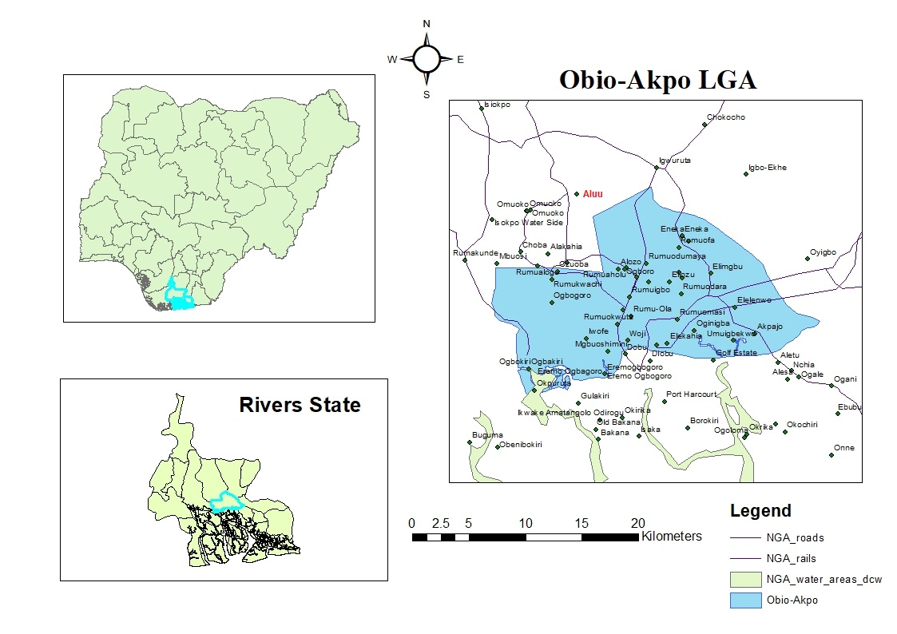
Figure 1. Map of the Study area
2. material and methods

2.1 Materials

The study was conducted at the government-approved dumpsite along Aluu Road in Obio/Akpor Local Government Area, Rivers State, Nigeria. The research involved a combination of field, laboratory, spatial, and statistical procedures, requiring the following materials:

Field equipment included:
Global Positioning System (GPS) unit for recording sampling coordinates and elevation, Polyethylene sampling bottles (1 L) for leachate collection, Sterile syringes for sub-sampling, Portable pH meter for in-situ pH measurement, Digital Total Dissolved Solids (TDS) meter for in-situ TDS measurement and Personal Protective Equipment (PPE), including gloves, safety boots, and nose masks.

Laboratory equipment included:
Conical flasks, beakers, amber bottles, filter papers, funnels, burettes, retort stands, pipettes, measuring cylinders, and drying ovens.

Chemical reagents used were:
Sulfuric acid (H₂SO₄), potassium dichromate (K₂Cr₂O₇), potassium iodate (KIO₃), sodium hydroxide (NaOH), Winkler reagents I and II, sodium thiosulfate (Na₂S₂O₃), starch indicator, mercuric sulfate (HgSO₄), ferrous ammonium sulfate, and ferroin indicator. All reagents were of analytical grade.

Software tools included:
Surfer (Golden Software) version 20 for spatial distribution mapping, Microsoft Excel for data processing, and SPSS (version 26) for statistical analysis.

2.2 Field Methods

2.2.1 Sampling Strategy

Four sampling locations were established along cardinal directions within the dumpsite to enable spatial characterization of leachate quality and support interpolation-based variability mapping. The sampling locations and their GPS coordinates in the local grid system used for Surfer mapping are as follows:

- L1 (Eastern section): 269241 E, 544219 N, elevation 20 m
- L2 (Western section): 269161 E, 544170 N, elevation 11 m
- L3 (Southern section): 269157 E, 544179 N, elevation 17 m
- L4 (Northern section): 269271 E, 544237 N, elevation 15 m
The Aluu dumpsite has been in operation for several years and receives a mixture of household and commercial waste. Based on the high COD/BOD₅ ratios observed across sampling locations (ranging from approximately 12 to 266), the leachate is classified as intermediate to old/stabilized, indicating poorly biodegradable organic matter that has undergone significant decomposition; a characteristic that has direct implications for treatment technology selection.

In-situ measurements included:
- pH, measured with a calibrated portable pH meter;
- TDS, measured using a digital TDS meter.
Leachate samples were collected as grab (instantaneous) samples using sterile syringes and transferred into 50-mL sample bottles. All samples were properly labeled, sealed, preserved on ice, and transported to the laboratory within the same day to prevent degradation. Sampling was conducted during a single field campaign; it is acknowledged that composite sampling (e.g., 1 L/hour over 4–24 hours) would better capture temporal variability in leachate composition, and that multi-seasonal campaigns would provide a more comprehensive diagnosis of leachate quality. These are recommended for future studies.

2.3 Analytical Methods

All laboratory analyses were conducted in accordance with the Standard Methods for the Examination of Water and Wastewater (APHA, 2017). Samples were transported in clean, cooled containers and analyzed within 24 hours of collection to maintain sample integrity.
pH was determined in situ using a calibrated portable digital pH meter (Hanna Instruments HI98129), calibrated with standard buffer solutions of pH 4.0, 7.0, and 10.0. Total Dissolved Solids (TDS) was also measured in situ using a calibrated digital TDS meter (HM Digital COM-100). Total Suspended Solids (TSS) was determined gravimetrically by vacuum filtration through pre-weighed Whatman GF/C glass-fiber filters, followed by oven drying at 103–105°C to constant weight. Biochemical Oxygen Demand (BOD₅) was determined using the standard 5-day incubation method at 20°C, with dissolved oxygen measured before and after incubation using the Winkler titration method, and calculated as BOD = DO₁ − DO₅ (mg/L). Chemical Oxygen Demand (COD) was determined using the closed reflux titration method, involving digestion with excess potassium dichromate in concentrated sulfuric acid with silver sulfate as catalyst, followed by back-titration with ferrous ammonium sulfate using ferroin indicator. All analyses were performed in triplicate, and analytical blanks and standard reference materials were included in each batch to ensure accuracy and reliability. All reagents were of analytical grade.
It is acknowledged that ammonia (NH₃-N) and nitrate (NO₃⁻) were not included in this analytical campaign due to equipment and reagent constraints. Given that ammonia is one of the most environmentally significant components of leachate particularly in stabilized/old leachate and that nitrate data are essential for designing nitrification-denitrification treatment systems, their inclusion is strongly recommended in future studies for a comprehensive leachate quality diagnosis.

2.4 Spatial Analysis

Golden Surfer software (version 20, Golden Software LLC) was employed to generate spatial distribution maps illustrating contamination patterns across the study area. GPS coordinates recorded at each sampling location were integrated with the corresponding analytical results to create interpolated surfaces representing the spatial distribution of each physicochemical parameter. The Kriging interpolation method was applied to delineate intra-site variability and identify zones of elevated contamination across the dumpsite.

2.5 Statistical Analysis

Statistical analysis was performed using Microsoft Excel and SPSS (version 26). Descriptive statistics: including mean, minimum, maximum, and coefficient of variation (CV%) were calculated for all physicochemical parameters to characterize data spread and variability. Pearson correlation analysis was conducted to assess relationships between parameters. The coefficient of variation was used to quantify the degree of spatial variability among sampling locations, with higher CV values indicating greater heterogeneity across the dumpsite.

3. results and discussion

Table 1 presents the physicochemical parameters of leachate samples collected from the four sampling locations within the Aluu municipal dumpsite, along with their computed COD/BOD₅ ratios.

Table 1: Physicochemical Analysis Results"
Location | Easting | Northing | Elevation (m) | pH | TSS (mg/L) | TDS  (mg/L) | BOD  (mg/L) | COD (mg/L) | COD/BOD₅ Ratio
L1 (East) | 269241 | 544219 | 20 | 7.75 | 0.4 | 1502 | 8.12 | 2156 | 265.5
L2 (West) | 269161 | 544170 | 11 | 8.00 | 0.001 | 747 | 7.45 | 90 | 12.1
L3 (South) | 269157 | 544179 | 17 | 8.15 | 2.1 | 1236 | 9.74 | 690 | 70.8
L4 (North) | 269271 | 544237 | 15 | 7.50 | 1.6 | 1579 | 18.6 | 548 | 29.5

Table 2: Comparison of Leachate Parameters with FAO Irrigation Guidelines and NESREA Effluent Limits (FAO, 1994; NESREA, 2011)
Parameter | Study Range | FAO Irrigation Guideline | NESREA Effluent Limit | Exceeds FAO? | Exceeds NESREA?
pH | 7.50 -8.15 | 6.5–8.5 | 6.5–8.5 | No | No
TSS (mg/L) | 0.001–2.1 | No strict limit (<10 suggested) | Not specified | No | No
TDS (mg/L) | 747–1,579 | ≤1,000 desirable, ≤1,500 max | <450 mg/L (slight restriction) | Some exceed | All exceed
BOD (mg/L) | 7.45–18.6 | <3 typical | <30 mg/L | All exceed | All exceed
COD (mg/L) | 90–2,156 | <10–40 typical | 40 mg/L | All exceed | All exceed

Table 2 compares the measured leachate parameters against FAO irrigation water quality guidelines (FAO, 1994) and NESREA effluent discharge limits (NESREA, 2011), which represent more appropriate reference standards for evaluating the environmental implications of leachate from an unlined open dumpsite.

3.2 pH Analysis

The pH values across all sampling locations (7.50–8.15) were neutral to slightly alkaline, consistent with intermediate to stabilized leachate conditions. Similar pH ranges have been reported in leachate studies from other Nigerian dumpsites; Ngah and Otei-Nda (2017) recorded pH values of 7.2–8.4 at the Eneka dumpsite in Port Harcourt, while Nwankwoala et al. (2022) reported values between 7.0 and 8.1 at Igwuruta. The slightly alkaline nature of the leachate reflects active carbonate buffering during organic matter decomposition and has implications for the mobility of heavy metals, whose solubility generally decreases under alkaline conditions (Kjeldsen et al., 2002).

3.3 Total Suspended Solids (TSS)

TSS concentrations were consistently low across all locations (0.001–2.1 mg/L), indicating that the bulk of contaminants exist in dissolved rather than particulate form. This is characteristic of older, more stabilized leachates where suspended matter has largely settled or been filtered through the waste mass (Bikash et al., 2014). Comparable low TSS values have been documented by Esonanjor and Ohanuna (2021) in leachate from Port Harcourt dumpsites, suggesting this is a regional characteristic of municipal leachate in the Niger Delta.

3.4 Total Dissolved Solids (TDS)

TDS ranged from 747 mg/L at L2 (West) to 1,579 mg/L at L4 (North), with locations L1 and L4 exceeding the FAO irrigation guideline threshold of 450 mg/L for slight-to-moderate restriction, indicating potential risk to soil structure and crop productivity if leachate migrates to irrigated land. Elevated TDS in leachate is commonly attributed to the dissolution of inorganic salts, carbonates, and mineral constituents from decomposing waste (Kjeldsen et al., 2002). Similar TDS values ranging from 980 to 2,100 mg/L were reported by Akudo et al. (2010) in leachate-impacted groundwater around the Onitsha landfill, confirming that high TDS is a consistent feature of Nigerian municipal dumpsite leachate.

3.5 Biochemical Oxygen Demand (BOD)

BOD₅ values ranged from 7.45 mg/L at L2 to 18.6 mg/L at L4, all remaining below the NESREA effluent discharge limit of 30 mg/L; however, these values still represent a considerable organic load relative to uncontaminated water. The highest BOD was recorded at L4 (North), likely reflecting fresher or more actively decomposing waste inputs in that zone. Comparatively, Ngah and Otei-Nda (2017) reported BOD values of 12–45 mg/L at the Eneka dumpsite, while Abel et al. (2023) documented BOD concentrations exceeding 50 mg/L in leachate from combustion residue sites, suggesting the Aluu leachate represents a moderate organic pollution level relative to other documented sites.

3.6 Chemical Oxygen Demand (COD)

COD values exhibited the greatest spatial variability across the dumpsite, ranging from 90 mg/L at L2 (West) to 2,156 mg/L at L1 (East), with a coefficient of variation of 105.4% — the highest among all parameters. All locations exceeded the NESREA effluent discharge limit of 40 mg/L. The exceptionally high COD at L1 may reflect the influence of industrial or commercial waste inputs concentrated in the eastern section of the dumpsite. The COD/BOD₅ ratios across all locations (12.1–265.5) confirm that the leachate is predominantly non-biodegradable, indicating that biological treatment alone would be insufficient and that physicochemical treatment processes such as coagulation-flocculation or advanced oxidation would be required (Kjeldsen et al., 2002; Abel et al., 2023). Comparably high COD values of 800–3,500 mg/L have been reported in stabilized leachate from sub-Saharan African dumpsites (Bikash et al., 2014).

3.7 Environmental Implications:

The physicochemical results collectively indicate that leachate from the Aluu dumpsite poses significant environmental risks to the surrounding area. While pH and TSS values remained within acceptable limits, the elevated TDS at L1 and L4 exceeds FAO irrigation water quality thresholds, suggesting potential adverse effects on soil structure and agricultural productivity in areas receiving leachate-impacted drainage (FAO, 1994). The substantially high COD concentrations recorded particularly at L1 (2,156 mg/L), exceed NESREA effluent discharge limits by more than 50-fold, reflecting an intense chemical pollution load consistent with findings from comparable unlined dumpsites in Nigeria (Akudo et al., 2010; Nwankwoala et al., 2022).

Although direct assessment of groundwater and surface water quality was beyond the scope of this study, the unlined and unengineered nature of the Aluu dumpsite, combined with the high annual rainfall characteristic of the Niger Delta region, creates conditions highly conducive to subsurface leachate migration. The elevated BOD and COD concentrations observed suggest a considerable potential for oxygen depletion and chemical contamination in any receiving water bodies, with particular risk to communities relying on shallow wells in the vicinity. a concern previously documented at similar sites in the region (Esonanjor and Ohanuna, 2021; Akudo et al., 2010).

3.8 Spatial Distribution Analysis

Golden Surfer software analysis revealed distinct spatial patterns in contamination distribution across the Aluu dumpsite.

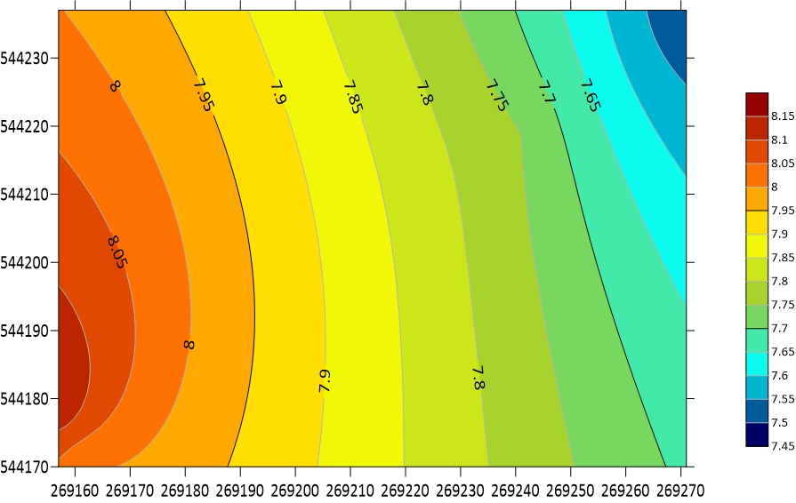
Figure 2: Spatial distribution of pH values across the study area

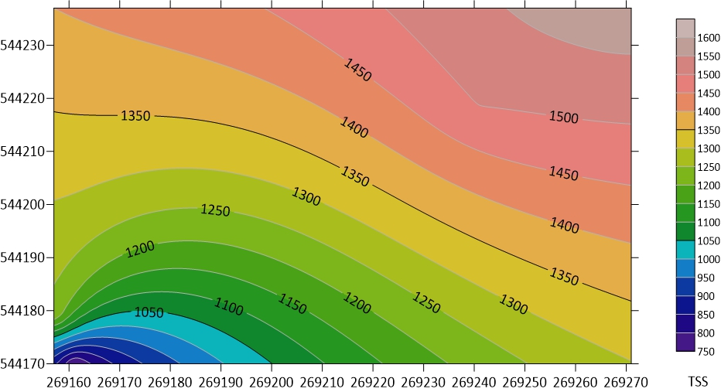
Figure 3: Spatial distribution of Total Suspended Solids (TSS) values across the study area

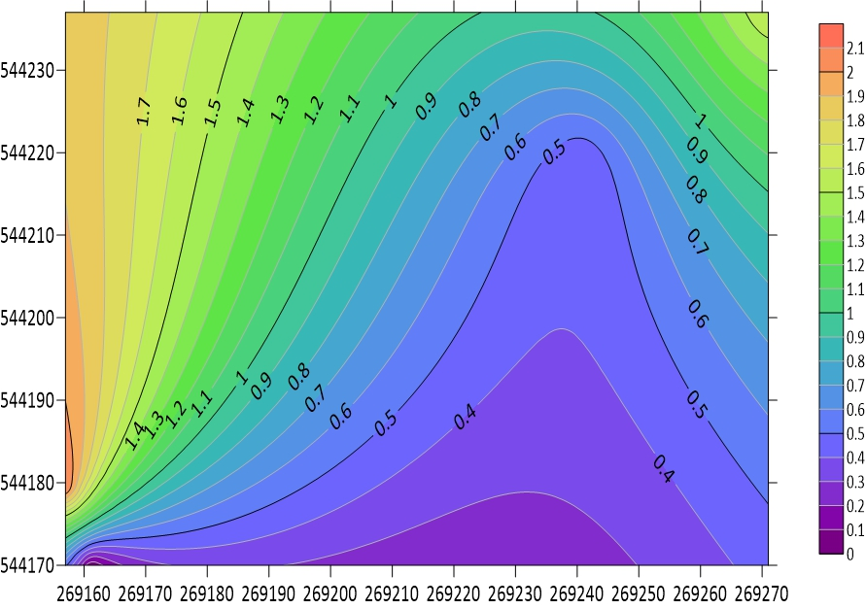
Figure 4: Spatial distribution of Total Dissolved Solids (TDS) values across the study area

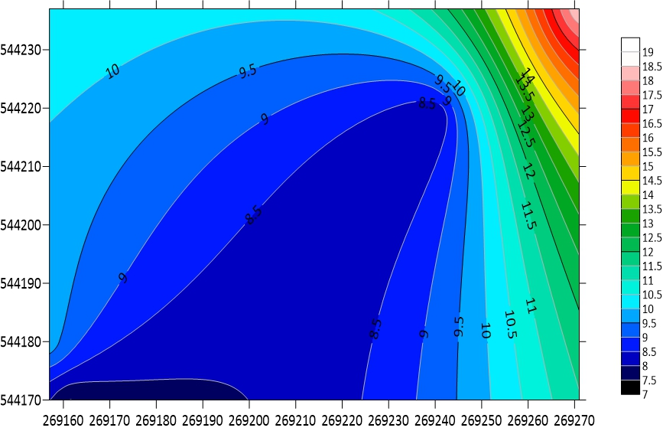
Figure 5: Spatial distribution of Biochemical Oxygen Demand (BOD) values across the study area

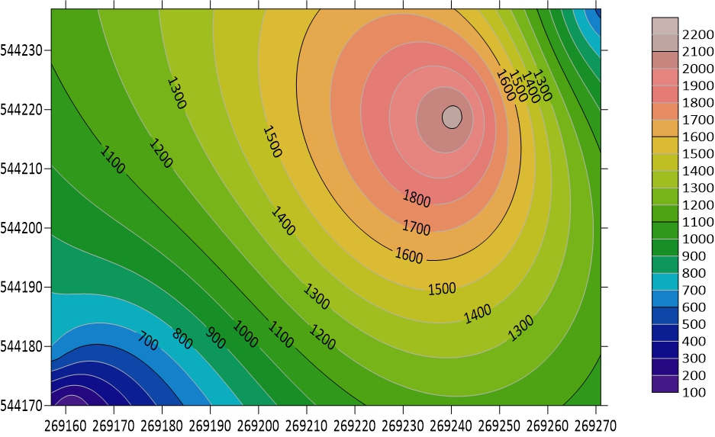
Figure 6: Spatial distribution of Chemical Oxygen Demand (COD) values across the study area

High-resolution interpolation highlights clear zones of elevated pollutant concentrations, underscoring variability in waste composition and leachate generation across the four sampling locations

3.8.1 High Contamination Zones

Eastern Section (L1): This area exhibits the highest COD value (2,156 mg/L) alongside substantially elevated TDS (1,502 mg/L). The exceptionally high COD suggests intensive influx of chemically reactive organic and inorganic pollutants, typical of industrial waste contributions or concentrated chemical spills. TDS levels further support a substantial dissolved load in the leachate, indicative of active degradation processes or ongoing waste input.
Northern Section (L4): L4 registers the peak TDS (1,579 mg/L) and the highest BOD (18.6 mg/L). These readings point to fresh organic waste deposition, most likely linked to recent household, market, or food waste disposal. The elevated BOD confirms active microbial decomposition and a high potential for oxygen depletion if this leachate reaches surface water sources.
3.8.2 Moderate Contamination iZone

Southern Section (L3): This zone is characterized by intermediate values for most parameters, with TSS peaking at 2.1 mg/L, the highest among all sampled locations. The combination of moderate BOD, COD, and elevated TSS suggests mixed waste composition, reflecting both organic and inert materials. The data possibly indicate a maturing landfill segment or transitional waste layering.
    - Low Contamination iZone

Western Section (L2): Leachate here shows the lowest TDS (747 mg/L), BOD (7.45 mg/L), and COD (90 mg/L). Such low values typically manifest in older, stabilized landfill sections where waste has undergone extensive decomposition and leachate production has diminished. The reduced contaminant load signifies past waste input or effective natural attenuation processes.
    - Contamination Source Assessment

Analysis of spatial distribution maps supports the inference of multiple, localized contamination sources across the dumpsite:
Eastern Zone (L1): The markedly elevated COD and TDS strongly suggest influence by industrial or commercial waste, potentially from nearby workshops or dumping of chemical-laden refuse. The spatial hotspot indicates concentrated leachate generation and limited dilution, warranting targeted containment or remediation efforts.
Northern Zone (L4): High BOD and TDS levels are aligned with ongoing deposition of fresh organic waste, such as food scraps, vegetation, and market residue. The microbiological activity implied by these readings highlights the need for enhanced monitoring and periodic waste sorting to interrupt further contamination cycles.
Southern Zone (L3): The mixture of moderate contamination including the highest TSS values points to a segment where waste characteristics are variable, potentially reflecting alternating layers of newly deposited and older wastes, as well as contributions from inert materials such as plastics, glass, and construction debris.
Western Zone (L2): The spatial low in all measured parameters is indicative of an aged landfill zone where leachate-generating processes have mostly subsided. The predominance of stabilized waste and attenuated contaminant flux support ongoing natural remediation.

3.9 Descriptive Statistics
Table 3: Descriptive Statistics for Leachate Parameters
Parameter | Mean | Median | Std Dev | Min | Max | CV(%)
pH | 7.85 | 7.88 | 0.27 | 7.50 | 8.15 | 3.4
TSS (mg/L) | 1.03 | 1.00 | 0.97 | 0.001 | 2.1 | 94.2
TDS (mg/L) | 1266 | 1369 | 372 | 747 | 1579 | 29.4
BOD₅ (mg/L) | 10.98 | 8.93 | 5.26 | 7.45 | 18.6 | 47.9
COD (mg/L) | 871 | 619 | 918 | 90 | 2156 | 105.4

The descriptive statistics reveal considerable variability in leachate quality across the dumpsite. pH exhibited the lowest coefficient of variation (CV = 3.4%), indicating relative spatial uniformity in acidity/alkalinity across all locations consistent with the buffering capacity of decomposing waste reported by Kjeldsen et al. (2002). In contrast, COD recorded the highest CV (105.4%), reflecting extreme spatial heterogeneity driven primarily by the exceptionally elevated value at L1 (East), and confirming that chemical contamination is highly localized rather than uniformly distributed across the site. TSS also showed high variability (CV = 94.2%), suggesting inconsistent particulate matter distribution, likely linked to differences in waste type and compaction across zones (Bikash et al., 2014). BOD exhibited moderate variability (CV = 47.9%), while TDS showed relatively lower spatial variation (CV = 29.4%), indicating a more uniform dissolved mineral load across the dumpsite. These patterns of spatial heterogeneity are consistent with findings from similar unmanaged dumpsites in sub-Saharan Africa, where localized waste inputs and variable decomposition stages drive uneven contaminant distribution (Nwankwoala et al., 2022; Esonanjor and Ohanuna, 2021).

4. Conclusion

This study characterized the physicochemical composition and spatial variability of leachate at the Aluu municipal dumpsite, Port Harcourt, Rivers State, through integrated field sampling, laboratory analysis, and geospatial mapping. Results revealed significant spatial variation in leachate quality, with the eastern section (L1) recording the highest COD (2,156 mg/L) and the northern section (L4) exhibiting the highest BOD (18.6 mg/L) and TDS (1,579 mg/L), identifying these zones as primary contamination hotspots. While pH (7.50–8.15) and TSS (0.001–2.1 mg/L) remained within acceptable limits, TDS values at L1 and L4 exceeded FAO irrigation water quality thresholds, and COD concentrations across all locations surpassed NESREA effluent discharge limits in some cases by more than 50-fold underscoring a pronounced chemical and organic pollution load.
The COD/BOD₅ ratios recorded across all locations (12.1–265.5) confirm that the leachate is predominantly non-biodegradable and consistent with intermediate to stabilized leachate characteristics. This has critical implications for treatment technology selection: conventional biological treatment alone would be insufficient given the low biodegradability indicated by these ratios. Based on the leachate characteristics observed, the following treatment approaches are recommended in order of suitability:
- Coagulation-flocculation followed by sedimentation effective for reducing TDS, TSS, and partially COD; estimated treatment cost approximately USD 0.50–2.00/m³ (Abel et al., 2023)
- Advanced oxidation processes (Fenton oxidation), highly effective for non-biodegradable COD reduction in stabilized leachate; estimated cost approximately USD 1.50–4.00/m³ (Kjeldsen et al., 2002)
- Membrane bioreactors (MBR) combining biological and physical treatment for comprehensive pollutant removal including residual BOD and dissolved solids; estimated cost approximately USD 3.00–8.00/m³, making it the most comprehensive but capital-intensive option (Abel et al., 2023)
- Constructed wetlands a lower-cost passive treatment option suitable for polishing effluent after primary treatment; estimated cost approximately USD 0.10–0.50/m³ (Bikash et al., 2014)
Spatial analysis confirmed that contamination heterogeneity across the dumpsite is linked to differences in waste composition, age, and likely industrial inputs in the eastern zone. Although direct assessment of groundwater and surface water quality was beyond the scope of this study, the unlined and unengineered nature of the dumpsite combined with the high annual rainfall of the Niger Delta region suggests a significant potential for subsurface leachate migration and associated environmental risks to surrounding receptors (Nwankwoala et al., 2022; Esonanjor and Ohanuna, 2021).

Future studies should incorporate ammonia, nitrate, and heavy metal analyses, conduct multi-seasonal sampling campaigns, and evaluate the effectiveness of the recommended treatment technologies under local conditions

Disclaimer (Artificial intelligence)
Author(s) hereby declare that NO generative AI technologies such as Large Language Models (ChatGPT, COPILOT, etc.) and text-to-image generators have been used during the writing or editing of this manuscript.

References

- Abam, T. K. S., & Unachukwu, G. O. (2009). Hydrogeologic and geotechnical properties of the Niger Delta sediments at Port Harcourt and environs. Environmental Geology, 58(6), 1251–1263. https://doi.org/10.1007/s00254-008-1627-z
- Abel, C., Rellergert, D., Grol, E., & Mazzon, V. (2023). Assessment of combustion residual leachate volume, composition and treatment cost. Journal of Hazardous Materials, 12, 459. https://doi.org/10.1016/j.jhazmat.2023.459
- Adepegba, O. (2012). Leachate recirculation practice and views. https://leachate.co.uk/main/leachate-management/
- Adeyemi, A. Y., Agbede, O. A., & Udeze, A. O. (2021). GIS-based assessment of solid waste management in Port Harcourt metropolis, Rivers State, Nigeria. Environmental Management and Sustainable Development, 10(2), 45–62. https://doi.org/10.5296/emsd.v10i2
- Akudo, E. O., Ozulu, G. U., & Osadebe, C. C. (2010). Assessment of groundwater contamination by leachates around Onitsha north landfill, south-eastern Nigeria. International Journal of Environmental Science and Technology, 7(4), 777–787. https://doi.org/10.1007/BF03326183
- American Public Health Association (APHA). (2017). Standard methods for the examination of water and wastewater (23rd ed.). American Public Health Association.
- Bikash, A., Khet, R. D., & Sanjay, N. K. (2014). Factors affecting the composition of municipal solid waste landfill leachate. International Journal of Emerging Science and Information Technology, 3(5), 123–135.
- Christensen, T. H., Cossu, R., & Stegmann, R. (1992). Landfill leachate: An introduction to landfilling of waste leachate. Journal of Applied Sciences, 2, 3–14.
- Esonanjor, E. E., & Ohanuna, C. (2021). Effect of waste dumpsite on groundwater quality of shallow aquifer in Port Harcourt, SE Nigeria. Environmental Contaminants Reviews, 4(1), 29–32. https://doi.org/10.26480/ecr.01.2021.29.32
- Food and Agriculture Organization of the United Nations (FAO). (1994). Water quality for agriculture (FAO Irrigation and Drainage Paper No. 29, Rev. 1). FAO. https://www.fao.org/3/T0234E/T0234E00.htm
- Kjeldsen, P., Barlaz, M. A., Rooker, A. P., Baun, A., Ledin, A., & Christensen, T. H. (2002). Present and long-term composition of MSW landfill leachate: A review. Critical Reviews in Environmental Science and Technology, 32(4), 297–336. https://doi.org/10.1080/10643380290813462
- National Environmental Standards and Regulations Enforcement Agency (NESREA). (2011). National environmental (surface and groundwater quality control) regulations. Federal Republic of Nigeria Official Gazette.
- Ngah, S. A., & Otei-Nda, P. (2017). Characterization of municipal solid waste leachate from Eneka dumpsite in Port Harcourt. International Journal of Environmental Science, 2(3), 145–158.
- Nigerian Meteorological Agency (NIMET). (2019). Annual weather summary report for Rivers State. Federal Ministry of Aviation.
- Nwankwoala, H. O., Onyughel, O., & Udom, G. J. (2022). Assessment of the effect of leachate on groundwater quality in Igwuruta, Ikwerre Local Government Area of Rivers State, Nigeria. Environmental Science and Engineering, 15(3), 142–156.
- Udom, G. J., Etu-Efeotor, J. O., & Esu, E. O. (2004). Hydrogeochemical evaluation of groundwater in parts of Port Harcourt and Tai-Eleme Local Government Areas, Rivers State, Nigeria. Global Journal of Geological Sciences, 2(1), 1–8.
- Uma, K. O., Onuoha, K. M., & Egboka, B. C. E. (1989). New statistical grain-size method for evaluating the hydraulic conductivity of sandy aquifers. Journal of Hydrology, 108, 343–366. https://doi.org/10.1016/0022-1694(89)90294-5

