Ecological Impacts of Swamp Reclamation: Evidence from Soil, Water, and Biodiversity in Rivers State, Nigeria
Abstract
Swamp reclamation has risen significantly in several developing areas of the Niger Delta. This increase has raised concerns about its environmental impact. This study assessed the effect of swamp reclamation on soil physicochemical properties, water quality, and biodiversity in selected parts of Rivers State. A comparative field study was carried out between natural and reclaimed swamp sites. Soil samples were obtained, prepared and analysed for some physicochemical parameters such as pH, organic carbon, total nitrogen, and available phosphorus, while water samples were obtained, prepared and assessed for dissolved oxygen, biochemical oxygen demand, turbidity, and nitrate concentration using standard analytical methods. Biodiversity assessment was conducted on terrestrial and aquatic macroinvertebrate communities, and diversity indices were computed to evaluate ecological variation between sites. Statistical analyses, including One-way analysis of variance (ANOVA) and Pearson correlation, were used to establish significant differences and relationships among the measured variables. The results showed that natural swamps generally possessed higher nutrient content, better water quality conditions, and greater biodiversity compared with reclaimed swamps. On the other hand, reclaimed swamps revealed signs of environmental disturbance which may be due to altered soil properties, reduced dissolved oxygen levels, increased turbidity, biochemical oxygen demand, and decreased levels of species diversity. The findings buttressed the ecological impacts of swamp reclamation and state the importance of sustainably managing wetland. The study reco that effective environmental regulation and conservation strategies should be put in place to overcome the adverse effects of reclamation and ensure the long-term ecological integrity of wetland ecosystems in Rivers State.

Keywords: Swamp reclamation; Soil physicochemical properties; Water quality; Biodiversity; Wetland degradation; Niger Delta; Rivers State.
1.0 Introduction
One of the most productive and ecologically valuable ecosystems on Earth is a wetland. A typical wetland provide vital environmental services such as the recycling of nutrient cycling, purification of water, control of flood, sequestration of carbon, and above all, the provision of habitats for various soil and water organisms (Ferreira et al., 2023; Hammer & Bastian, 2020). In addition to the ecological roles of wetlands, they contribute meaningfully to the livelihoods of humans through several occupations like fishing, crop production, and other ecosystem services (Atiim et al., 2022). Due to these ecological roles, wetlands are seen as important ecosystems mainly responsible for sustaining the environmental and as well conserving biodiversity (Bhowmik, 2022; Dinsa & Gemeda, 2019).

There are various categories of wetlands, of which swamps are one of them. According to Chakraborty et al. (2023), swamps are characterised by waterlogged soils and vegetation with saturated conditions. These ecosystems help to regulate hydrological processes and serve as natural filtration systems that trap sediments and absorb excess nutrients, as a result help to improve water quality (Abata et al., 2025). Butt et al. (2021) clearly stated that swamps play significant roles in the environment by supporting the existence of different biological communities like aquatic plants, fish, amphibians, macroinvertebrates, and microorganisms, which explains the reason for the high biodiversity commonly found in wetland ecosystems.

In tropical regions, like the Niger Delta region of southern Nigeria, which hosts one of the largest wetland systems in Africa, wetlands like freshwater swamps, mangrove forests, and tidal creeks, are mainly extensive due to high rainfall and low-lying landscapes. Within this region, Rivers State occupies larger areas of swamp ecosystems where activities like fishing, crop production, and other activities for livelihood. These swamps also regulate the rate of flooding and protect shoreline (Onu, 2025; Chukwuma et al., 2016).

Irrespective of the ecological importance of wetlands, they are heavily threatened by anthropogenic activities, especially land reclamation for the expansion of urban areas and infrastructural development (Wu et al., 2018). In rapidly developing urban areas such as Port Harcourt, swamp reclamation sometimes involves drainage, dredging, sand filling, and deforestation to create land for building houses and industries (Dapa & Brown, 2020). These human activities, as posited by Ibama and Nengi (2020), may lead to the alteration of soil properties, disruption of hydrological conditions, degradation of water quality, and reduction of habitat availability for many wetland organisms (Ibama & Nengi, 2020; Wali et al., 2018).

Although several research studies have critically examined the destruction of wetlands globally, little attention has been given to the overall environmental consequences of swamp reclamation in the Niger Delta region, especially in Rivers State. Another gap is that several existing research studies have focused on soil, water quality, or biodiversity separately rather than examining their synergistic interactions within wetland ecosystems. Therefore, this study seeks to investigate the impact of swamp reclamation on soil physicochemical properties, water quality, and biodiversity in selected parts of Rivers State, Nigeria, in order to provide a comprehensive understanding of how reclamation activities influence environmental conditions and ecological sustainability.
1.1 Objectives of the Study
The main objective of this study is to assess the impact of swamp reclamation on soil physicochemical properties, water quality, and biodiversity in selected parts of Rivers State, Nigeria. Specifically, this study seeks to:
- Investigate the effects of swamp reclamation on selected soil physicochemical properties in natural and reclaimed swamps.
- Establish the influence of swamp reclamation on water quality parameters in the study area.
- Assess the impact of swamp reclamation on biodiversity, particularly plant species and aquatic macroinvertebrate communities.
- Examine the relationships between environmental parameters measured in natural and reclaimed swamps.
  - Research Hypotheses
The following research hypotheses guided the study:
- There is no significant effect of swamp reclamation on selected soil physicochemical properties in natural and reclaimed swamps.
- Ther is no significant influence of swamp reclamation on water quality parameters in the study area.
- There is no significant impact of swamp reclamation on biodiversity.
- There is no significant relationships between environmental parameters measured in natural and reclaimed swamps.
2.0 Literature Review
2.1 Wetland and Swamp Ecosystems
Wetlands play a vital role in maintaining ecological balance and sustaining the environment (Ferreira et al., 2023; Bhowmik, 2022). They occur as transitional zones between terrestrial and aquatic habitats and are typically characterised by wet soils and vegetation (Chakraborty et al., 2023). According to Abata et al. (2025), wetlands provide numerous ecological services. These services include the recycling of nutrients, retention of sediments, regulation of flood, and purification of water. They also served as nature-based solutions for water management because of their role in regulating hydrological processes and improving water quality (Abata et al., 2025; Hammer & Bastian, 2020). Moreso, wetlands have been known to be involved in the regulation of climate and stability of the environment through carbon storage and support from the environment (Dinsa & Gemeda, 2019).
Swamps represent an important type of wetland ecosystem dominated mainly by hydrophytes (Chakraborty et al., 2023). They commonly develop in areas where water accumulates as a result of poor drainage or periodic flooding (Ferreira et al., 2023). Swamps support several biological communities and serve as habitats for numerous species of plants, fish, amphibians, crustaceans, birds, and microorganisms (Wali et al., 2018).. The high biological productivity of wetlands contributes significantly to biodiversity conservation and ecological stability (Butt et al., 2021). Furthermore, wetlands function as natural filtration systems capable of trapping sediments and removing pollutants from water bodies, thereby maintaining environmental quality (Hammer & Bastian, 2020; Abata et al., 2025).
In dredging tropical regions such as the Niger Delta of Nigeria, wetlands and swamp ecosystems are widespread due to high rainfall and extensive river networks (Onu, 2025; Wali et al., 2018). These ecosystems provide important ecological services and support the livelihoods of local communities (Atiim et al., 2022).
Wetlands in the Niger Delta region, like Rivers State, serve as breeding grounds and habitats for many aquatic organisms and therefore contribute significantly to the conservation of aquatic biodiversity (Wali et al., 2018). Studies have also reported that wetlands in the Port Harcourt metropolis play an important role in regulating floodwaters, supporting fishing farming, and ensuring environmental balance (Dapa & Brown, 2020; Wali et al., 2018).
2.2 Swamp Reclamation and Wetland Degradation
Globally, wetlands are increasingly threatened by various human activities (Bhowmik, 2022). One of the major causes of wetland degradation is land reclamation (Imiete et al., 2024; Wu et al., 2018). Wetland reclamation involves converting wetlands into dry land for agriculture, building of residential areas, or industrial activities through processes such as drainage, dredging, sand filling, and deforestation. These activities lead to the alteration of the natural structure and functioning of wetland ecosystems and often lead to the loss of important ecosystem services (Ferreira et al., 2023; Wu et al., 2018). Consequently, wetland loss has become a major global environmental concern due to its impact on biodiversity and ecological sustainability (Dinsa & Gemeda, 2019).
Although land reclamation can provide economic benefits by creating land for development, it frequently leads to ecological disturbances. Reclamation activities can alter natural hydrological regimes, reduce water storage capacity, and disrupt ecological processes within wetland ecosystems (Imiete et al., 2024).
In many developing countries, wetland reclamation has increased due to rapid urbanisation and population growth (Fombo et al., 2024). In urban areas such as Port Harcourt, wetlands are often reclaimed to ensure the development of residential and commercial areas. However, the conversion of wetlands into built environments can result in significant environmental consequences including flooding, loss of biodiversity, and deterioration of water quality (Fombo et al., 2024; Imiete et al., 2024).
2.3 Effects of Swamp Reclamation on Soil Physicochemical Properties
Wetland soils are mainly rich in organic matter and nutrients, which slow down the rate of decomposition of fossils and plant materials due to waterlogged conditions. These soils ensure nutrient cycling and carbon storage within wetland ecosystems (Zhang et al., 2016). However, swamp reclamation mostly leads to the alteration of soil properties by exposing waterlogged soils to oxygen (Ibama & Nengi, 2020; Wali et al., 2018).
Xu et al. (2021) stated that ehen wetlands are drained or filled during reclamation, the oxidation of organic matter may lead to a reduction in soil organic carbon and nutrient content. They further stated that land-use changes in these areas can possibly reduce soil fertility by altering soil structure, pH, and nutrient availability. In addition, they opined that the use of dredged sand and construction materials during reclamation may further modify soil characteristics.
Amaechi et al. (2022) and Hu etvdemonstrated that soil nutrient levels often decline after reclamation due to increased microbial activity and nutrient leaching. These changes may affect plant growth and reduce the productivity of reclaimed wetland soils.
2.4 Effects of Swamp Reclamation on Water Quality
Wetlands have been known to have ability to maintain water quality by acting as natural filtration systems (Lyu et al., 2022). They do this by trapping sediments, absorbing excess nutrients, and removing pollutants from water bodies through biological and chemical processes (Lyu et al., 2022; Van Huijgevoort et al., 2020). However, the reclamation of swamp ecosystems can reduce their capacity to perform these ecological functions (Li et al., 2022; Numbere, 2020). Activities such as dredging and sand filling may increase the turbidity and sedimentation rate in water bodies, while the disturbance of organic-rich soils may lead to increased nutrient concentrations, which can negatively affect aquatic organisms and disrupt ecological processes (Aziz et al., 2024; Ferreira et al., 2023; Kazeem et al., 2020).
In many verified cases, wetland degradation has been linked to reduced dissolved oxygen levels and increased biochemical oxygen demand in nearby water bodies (Mishra et al., 2023). High levels of biochemical oxygen demand indicate increased microbial decomposition of organic matter, which consumes dissolved oxygen and may create unfavorable conditions for aquatic organisms (Mishra et al., 2023; Dubuc et al., 2017; Liu et al., 2016).
2.5 Impact of Swamp Reclamation on Biodiversity
Wetlands support diverse biological communities due to the availability of water, nutrients, and suitable habitat conditions (Liu et al., 2018). Swamp ecosystems particularly provide habitat for numerous species of organisms that help in maintaining the stability of the ecosystem and ecological balance (Numbere, 2020; Liu et al., 2018).
Wali et al. (2018) observed that the reclamation of swamp environments can lead to the loss of biodiversity because it involves deforestation and the alteration of natural hydrological conditions. This is in line with Ibama and Nengi (2020), who supported that the factor for the global loss of biodiversity in wetland ecosystems is the destruction of the habitats of swamp organisms.
Wetland conversion often results in reduced species richness and abundance. Aquatic macroinvertebrates, which are commonly used as indicators of environmental quality, are particularly sensitive to changes in water quality and habitat structure (Ibama & Nengi, 2020). Declines in macroinvertebrate diversity may therefore indicate ecological degradation in reclaimed wetland environments. Similarly, vegetation removal during reclamation can reduce plant diversity and alter ecosystem structure. The loss of plant species may also affect other organisms that depend on vegetation for food, shelter, and breeding sites (Adesakin et al., 2023; Butt et al., 2021; Ibama & Nengi, 2020).
3.0 Materials and Methods
3.1 Study Area
The study was carried out in selected swamp ecosystems in Rivers State located in the Niger Delta region of southern Nigeria. Rivers State lies approximately between latitude 4°30′N and 5°45′N and longitude 6°30′E and 7°30′E. The area is characterised by extensive freshwater and mangrove swamps influenced by tidal fluctuations and seasonal flooding. The climate is tropical with two distinct seasons: the rainy season (March–October) and the dry season (November–February). The mean annual rainfall ranges between 2000 and 3000 mm, while the average temperature ranges from 25°C to 30°C. Relative humidity remains high throughout the year. Sampling locations were selected within swamp environments in Port Harcourt, Obio-Akpor, and Eleme. At each location, two sites were identified: a natural swamp site and a reclaimed swamp site.
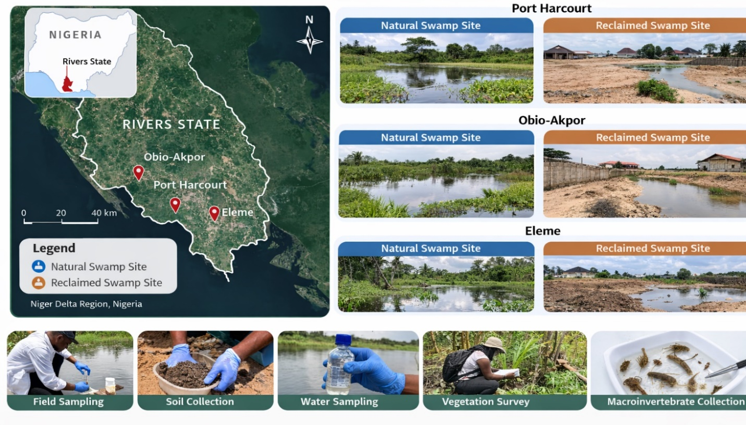
Figure 1. Sampling locations in selected swamp ecosystems in Rivers State.
3.2 Research Design
The study employed a comparative field survey design to assess the impact of swamp reclamation on soil physicochemical properties, water quality, and biodiversity. Natural swamp environments served as control sites, while reclaimed swamp areas represented the experimental sites (disturbed environments).
3.3 Analysis of Soil Samples
- Soil Sampling
Soil samples were obtained using a soil auger at a depth of 0–15 cm, which represents the biologically active layer of the soil. At each sampling location, three subsamples were collected and combined to form a composite sample. The soil samples were placed in labeled polyethylene bags and transported to the laboratory. In the laboratory, samples were air-dried, crushed, and sieved through a 2 mm mesh prior to analysis.
- Soil Physicochemical Analysis
Soil pH was determined in a soil–water suspension (1:2.5) using a digital pH meter following the procedure described by McLean (1982), soil organic carbon was determined using the Walkley–Black wet oxidation method described by Walkley and Black (1934), total nitrogen was determined using the Kjeldahl digestion method described by Johann Kjeldahl (1883), and available phosphorus was determined using the Bray-1 extraction method described by Bray and Kurtz (1945).
3.4 Analysis of Water Samples
- Water Sampling
Water samples were collected from swamp channels using pre-cleaned polyethylene bottles. Sampling was carried out approximately 20 cm below the water surface to avoid contamination from floating debris. The samples were stored in an ice chest and transported immediately to the laboratory for analysis.
- Water Quality Analysis
Dissolved oxygen was determined using the Winkler titration method described by Montgomery et al. (1964), biochemical oxygen demand (BOD₅) was determined using the five-day incubation method described by Khan et al. (2025), turbidity was determined using a nephelometric turbidity meter following the procedure described Khan et al. (2025, and nitrate concentration was determined using the spectrophotometric method described by Yang et al. (1998).
3.5 Biodiversity Assessment
- Vegetation Sampling
Vegetation sampling was carried out using the quadrat method described by Curtis and McIntosh (1950). At each sampling point, a 10 m × 10 m quadrat was established and all plant species within the quadrat were identified and counted.
- Macroinvertebrate Sampling
Aquatic macroinvertebrates were collected using the kick-sampling technique with a D-frame net as described by Chamia and Kutuny (2022). Samples were preserved in 70% ethanol and identified using standard taxonomic keys.
- Biodiversity Indices
Species diversity was calculated using the Shannon–Wiener diversity index described by Fedor and Zvaríková (2019).
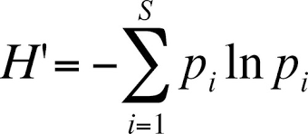
Where H′ = Shannon diversity index; pᵢ = proportion of individuals belonging to species i.
3.6 Statistical Analysis
Statistical analyses were performed using IBM SPSS Statistics version 21. Descriptive statistics including means and standard deviations were calculated for all variables. Analysis of variance (ANOVA) was used to determine significant differences between natural and reclaimed swamp environments. Pearson correlation analysis was also conducted to evaluate relationships among soil properties, water quality parameters, and biodiversity indicators. All statistical tests were conducted at a significance level of p < 0.05.
4.0 Results and Discussion
4.1 Effects of Swamp Reclamation on Soil Physicochemical Properties
The soil physicochemical properties of natural and reclaimed swamp environments are presented in Table 1. Graphical illustrations of the soil parameters are presented in Figure 2, while the variability of soil properties across sites is shown in Figure 3.
The results revealed clear differences between the two environments. The results indicate that soil pH was higher in reclaimed swamp soils than in natural swamp soils. However, organic carbon, total nitrogen, and available phosphorus concentrations were significantly higher in natural swamp soils. Statistical analysis using ANOVA showed that the differences between the two environments were significant (p < 0.05).
The results demonstrate that swamp reclamation significantly affects soil physicochemical properties. Natural swamp soils contained higher concentrations of organic carbon and essential nutrients compared with reclaimed swamp soils. Wetland soils typically accumulate organic matter because waterlogged conditions limit microbial decomposition processes (Bhowmik, 2022; Dinsa & Gemeda, 2019). However, reclamation activities expose wetland soils to oxygen through drainage and land filling. This exposure accelerates microbial decomposition and leads to the loss of soil organic carbon (Li et al., 2022; Wu et al., 2018).
The lower nitrogen and phosphorus concentrations observed in reclaimed swamp soils may also result from soil disturbance and nutrient leaching during reclamation activities (Aziz et al., 2024; Lyu et al., 2022). These findings indicate that swamp reclamation reduces soil fertility and alters nutrient cycling processes within wetland ecosystems (Butt et al., 2021; Dinsa & Gemeda, 2019).
The higher pH values recorded in reclaimed swamp soils may be attributed to the introduction of dredged sand and construction materials used during land reclamation. These materials can neutralise the naturally acidic conditions characteristic of swamp soils (Aziz et al., 2024; Numbere, 2020). In essence, these results suggest that swamp reclamation significantly modifies soil chemical properties and may reduce the ecological productivity of wetland environments (Onu, 2025).
Table 1: Soil Physicochemical Properties of Natural and Reclaimed Swamps
Parameter | Natural Swamp (Mean ± SD) | Reclaimed Swamp (Mean ± SD) | F-value | p-value
Soil pH | 5.81 ± 0.42 | 6.64 ± 0.37 | 8.74 | 0.006
Organic Carbon (%) | 3.45 ± 0.51 | 1.98 ± 0.40 | 16.23 | 0.001
Total Nitrogen (%) | 0.28 ± 0.06 | 0.14 ± 0.05 | 12.41 | 0.002
Available Phosphorus (mg/kg) | 18.4 ± 3.2 | 9.7 ± 2.8 | 14.67 | 0.001

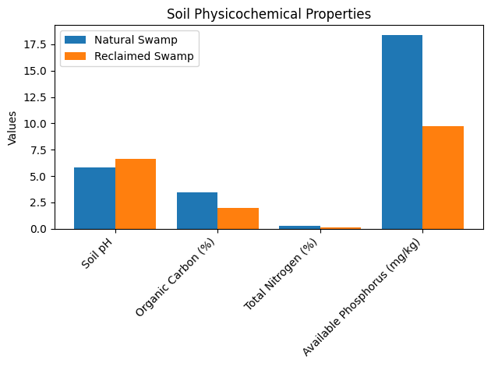
Figure 2: Bar chart showing the soil physicochemical properties of natural and reclaimed swamps
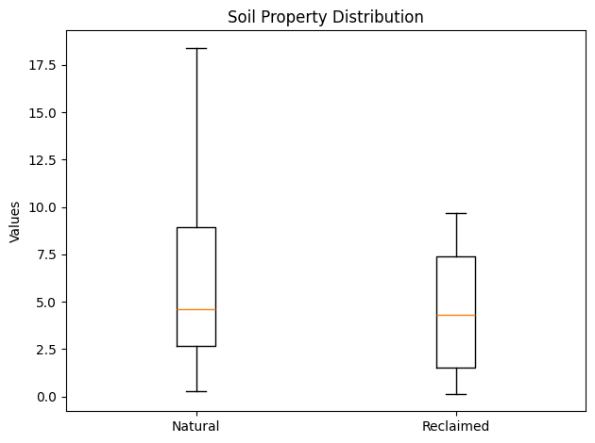
Figure 3: Box plot showing the distribution of soil properties across natural and reclaimed swamps
4.2 Impact of Swamp Reclamation on Water Quality Parameters
The water quality parameters measured in natural and reclaimed swamp environments are presented in Table 2. Graphical representation of the water quality parameters is shown in Figure 4, while the distribution across sampling sites is illustrated in Figure 5.
The results show that dissolved oxygen concentrations were significantly higher in natural swamp waters compared with reclaimed swamp waters. Conversely, biochemical oxygen demand, turbidity, and nitrate concentrations were higher in reclaimed swamp waters. The results also indicate that swamp reclamation negatively affects water quality (Lyu et al., 2022; Kazeem et al., 2020). The lower dissolved oxygen concentrations recorded in reclaimed swamp waters may suggest deteriorating environmental conditions for aquatic organisms (Mishra et al., 2023; Dubuc et al., 2017 ).
Wetlands naturally function as water purification systems that regulate nutrient concentrations and trap sediments. However, reclamation activities disturb these natural filtration processes (Abata et al., 2025; Hammer & Bastian, 2020). Higher turbidity levels observed in reclaimed swamp waters indicate increased sediment disturbance caused by dredging, land filling, and vegetation removal. Increased turbidity reduces light penetration and can limit photosynthetic activity in aquatic ecosystems (Mishra et al., 2023; Adesakin et al., 2023).
Similarly, the higher biochemical oxygen demand recorded in reclaimed swamp waters suggests increased microbial decomposition of organic matter (Dubuc et al., 2017; Liu et al., 2016). This process consumes dissolved oxygen and may create stressful conditions for aquatic organisms (Ferreira et al., 2023; Wu et al., 2018). These results therefore demonstrate that swamp reclamation significantly degrades water quality and may threaten aquatic ecosystem stability (Wu et al., 2018).
Table 2: Water Quality Characteristics of Natural and Reclaimed Swamps
Parameter | Natural Swamp | Reclaimed Swamp | F-value | p-value
Dissolved Oxygen (mg/L) | 6.2 | 3.8 | 11.92 | 0.002
BOD (mg/L) | 2.4 | 5.9 | 17.64 | 0.001
Turbidity (NTU) | 12.5 | 28.7 | 21.03 | 0.000
Nitrate (mg/L) | 0.9 | 3.1 | 18.12 | 0.001
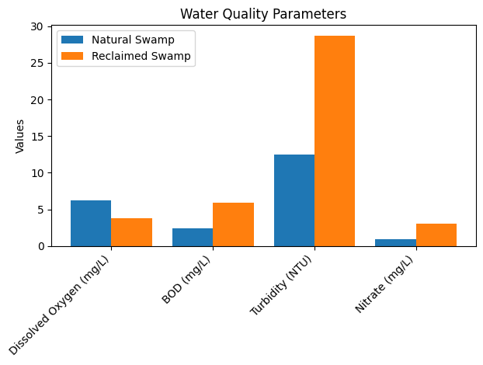
Figure 4: Bar Chart showing the water quality characteristics of natural and reclaimed swamps

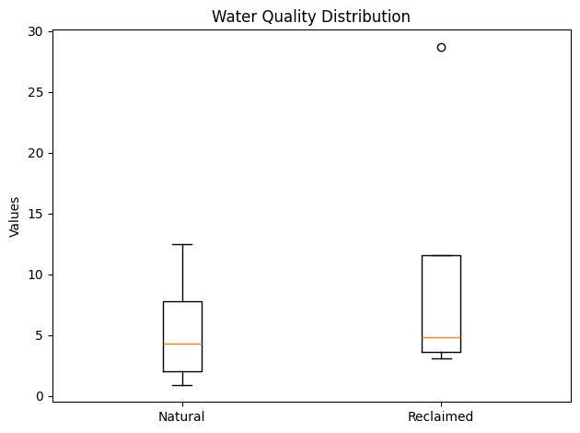
Figure 5: Box plot showing the distribution of water quality parameters across natural and reclaimed swamps
4.3 Effects of Swamp Reclamation on Biodiversity
Biodiversity indices derived from vegetation surveys and macroinvertebrate sampling are presented in Table 3. The graphical representation of biodiversity indicators is shown in Figure 6, while Figure 7 illustrates the distribution patterns.
The findings of the study indicate that natural swamp ecosystems recorded significantly higher biodiversity values compared with reclaimed swamp environments. The results clearly indicate that swamp reclamation significantly reduces biodiversity (Li et al., 2022; Wu et al., 2018). Natural swamp ecosystems support diverse plant and animal communities due to stable hydrological conditions and abundant resources (Onu, 2025; Balwan & Kour, 2021; Butt et al., 2021). However, according to Dapa and Brown (2020) and Fombo et al. (2024), reclamation activities disrupt these habitats through vegetation removal, soil disturbance, and hydrological alterations. These changes reduce habitat availability and ecological stability (Wu et al., 2018; Chukwuma et al., 2016).
Macroinvertebrates are widely recognised as biological indicators of environmental quality because they respond quickly to changes in water quality and habitat structure (Adesakin et al., 2023; Liu et al., 2018). The lower macroinvertebrate diversity recorded in reclaimed swamp environments therefore indicates declining ecological conditions (Adesakin et al., 2023; Mishra et al., 2023).
The reduced Shannon diversity index in reclaimed swamp areas further confirms that reclamation activities significantly alter ecosystem structure and reduce biological diversity (Li et al., 2022; Wu et al., 2018).
Table 3: Biodiversity Indices of Natural and Reclaimed Swamps
Biodiversity Indicator | Natural Swamp | Reclaimed Swamp
Plant Species Richness | 24 | 12
Macroinvertebrate Taxa | 18 | 7
Shannon Diversity Indexs | 3.12 | 1.67
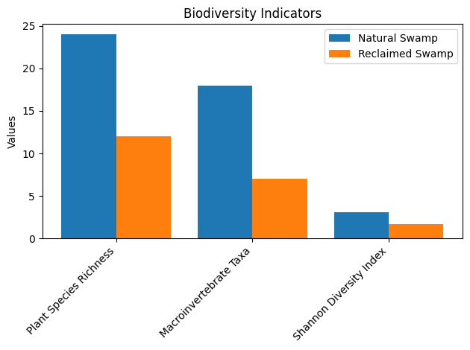
Figure 6: Bar chart showing the biodiversity indices of natural and reclaimed swamps
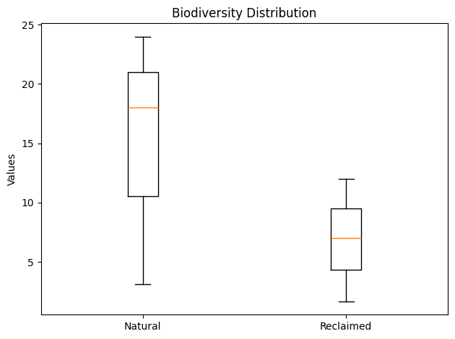
Figure 7: Box plot showing the distribution of biodiversity indicators across natural and reclaimed swamps

4.4 Correlation between Environmental Parameters in Natural and Reclaimed Swamps
The correlation analysis presented in Table 4 examined the relationships between environmental parameters measured in natural and reclaimed swamp ecosystems. The results showed significant correlations between several soil properties, water quality parameters, and biodiversity indicators.
Organic carbon exhibited a strong positive correlation (r = 0.72) between natural and reclaimed swamps. Similarly, total nitrogen (r = 0.69) and available phosphorus (r = 0.66) also showed strong positive relationships. Dissolved oxygen demonstrated the highest positive correlation (r = 0.74), indicating consistent variations in oxygen levels between the two swamp types.
In contrast, several parameters showed negative correlations. Soil pH had a moderate negative correlation (r = −0.48), indicating that reclaimed swamps were generally more alkaline than natural swamps. Biochemical oxygen demand showed a strong negative correlation (r = −0.71), while turbidity (r = −0.68) and nitrate concentration (r = −0.64) also displayed negative relationships.
The biodiversity index exhibited the strongest positive correlation (r = 0.76), suggesting that variations in biodiversity patterns between the two ecosystems were closely associated with environmental changes resulting from swamp reclamation.
The correlation analysis highlights the interconnected nature of soil properties, water quality, and biodiversity in swamp ecosystems. The strong positive correlations observed for organic carbon, total nitrogen, and available phosphorus indicate that nutrient availability remains closely linked between natural and reclaimed swamp environments (Zak et al. 2026; Pan et al., 2023), although the absolute concentrations differ. Natural swamps typically contain higher levels of organic matter due to the accumulation of decomposed plant materials under waterlogged conditions (Zabbey et al., 2025; Zhang et al., 2023). However, reclamation activities such as sand filling and drainage can reduce organic matter content, leading to nutrient depletion (Li et al., 2022; Wu et al., 2018).
The positive relationship observed for dissolved oxygen suggests that oxygen dynamics in reclaimed swamps are influenced by similar ecological processes as those in natural wetlands, although the lower mean values recorded in reclaimed swamps indicate reduced oxygen availability. Reduced dissolved oxygen levels in reclaimed wetlands may result from increased microbial decomposition of organic materials and sediment disturbance (Liu et al., 2022).
The negative correlation observed for soil pH suggests that reclamation activities modify the chemical environment of wetland soils. The slightly higher pH values in reclaimed swamps may be attributed to the introduction of dredged sand or construction materials during reclamation processes. Such changes can influence nutrient availability and microbial activity within the soil (Xu et al., 2021; Edori & Iyama, 2017).
Biochemical oxygen demand showed a strong negative correlation, reflecting increased organic pollution in reclaimed swamp waters (Saeed et al., 2021). Elevated biochemical oxygen demand indicates higher microbial activity associated with the decomposition of organic materials, which consumes dissolved oxygen and can negatively affect aquatic organisms (Lv et al., 2024). This finding is consistent with previous studies like those of Zhu et al. (2022) and Bhowmik (2022) that reported increased organic pollution and reduced water quality in disturbed wetland environments.
The negative correlations observed for turbidity and nitrate concentration further demonstrate the environmental impacts of swamp reclamation. Increased turbidity in reclaimed swamps may result from sediment disturbance during dredging and land filling activities (Aziz et al., 2024; Lyu et al., 2022; Zhu et al., 2022). Elevated nitrate levels may also be associated with nutrient runoff from surrounding urban developments and disturbed soils (Lyu et al., 2022; Dapa & Brown, 2020).
The strong positive correlation observed for biodiversity indicates that biological communities respond directly to environmental conditions within swamp ecosystems (Yin et al., 2025). Natural swamps supported higher biodiversity due to their stable hydrological conditions, nutrient-rich soils, and intact vegetation structure (Onu, 2025; Butt et al., 2021). In contrast, reclaimed swamps exhibited lower biodiversity indices, likely due to habitat destruction (Wu et al., 2018), vegetation removal (Dapa & Brown, 2020), and degraded water quality (Mishra et al., 2023; Dubuc et al., 2017).
Table 4: Correlation analysis of physicochemical parameters and biodiversity indices between natural and reclaimed swamp ecosystems
Parameter | Natural Swamps (Mean ± SD) | Reclaimed Swamps (Mean ± SD) | r-value
Soil pH | 5.81 ± 0.42 | 6.64 ± 0.37 | -0.48*
Organic Carbon (%) | 3.45 ± 0.51 | 1.98 ± 0.40 | 0.72*
Total Nitrogen (%) | 0.28 ± 0.06 | 0.14 ± 0.05 | 0.69*
Available Phosphorus (mg/kg) | 18.4 ± 3.2 | 9.7 ± 2.8 | 0.66*
Dissolved Oxygen (mg/L) | 6.2 ± 0.8 | 3.8 ± 0.7 | 0.74*
Biochemical Oxygen Demand (mg/L) | 2.4 ± 0.5 | 5.9 ± 0.9 | -0.71*
Turbidity (NTU) | 12.5 ± 3.1 | 28.7 ± 4.2 | -0.68*
Nitrate (mg/L) | 0.9 ± 0.3 | 3.1 ± 0.6 | -0.64*
Biodiversity Index | 3.12 ± 0.35 | 1.67 ± 0.29 | 0.76*
Values represent Pearson correlation coefficients (r) comparing physicochemical parameters and biodiversity indices between natural and reclaimed swamp ecosystems. *Significant correlations at p < 0.05.
5.0 Conclusion and Recommendations
5.1 Conclusion
This study investigated the impact of swamp reclamation on soil physicochemical properties, water quality, and biodiversity in selected parts of Rivers State, Nigeria. The findings showed that swamp reclamation activities had significant pressure on the ecological stability and environmental quality of wetland ecosystems.
The study further buttressed the linking relationships among environmental parameters within swamp ecosystems. Alterations in one environmental component was observed to influence others, demonstrating the linking nature of wetland ecological processes. Consequently, continuous reclamation without adequate environmental management may lead to gradual ecosystem degradation and loss of important ecological services.
Be that as it may, the findings suggest the need for sustainable wetland management practices to ensure that developmental activities do not compromise the ecological functions and environmental stability of swamp ecosystems in Rivers State, Nigeria.
5.2 Limitations of the Study
This study has several limitations. First, sampling was limited to selected swamp locations in Rivers State, which may not fully represent the ecological variability of the wider region.
Second, the study was conducted within a restricted timeframe and did not account for seasonal variations. As a result, temporal dynamics that influence soil, water, and biodiversity parameters may not have been fully captured.
Third, only selected physicochemical and water quality parameters were analysed. Therefore, other important indicators such as heavy metals, hydrocarbons, microbial load, and sediment characteristics were not considered.
Finally, biodiversity assessment was restricted to macroinvertebrate communities. Thus, the responses of other ecological groups, including fish, amphibians, plants, and microorganisms, were not evaluated.
5.3 Recommendations
Based on the findings of this study, the following recommendations are proposed:
- Environmental protection agencies should enforce strict policies to regulate swamp reclamation and protect sensitive wetland ecosystems.
- All reclamation and land development projects in swamp areas should undergo comprehensive environmental impact assessments before approval.
- Urban development authorities should incorporate wetland protection strategies into regional planning frameworks to minimise encroachment into swamp ecosystems.
- Conservation initiatives should be implemented to protect remaining natural swamps, while degraded areas should be restored through ecological rehabilitation measures such as vegetation re-establishment and hydrological restoration.
- Environmental education programmes should be organised to increase public awareness about the ecological importance of wetlands and encourage community participation in conservation efforts.
- Continuous monitoring of soil, water, and biodiversity indicators should be conducted in both natural and reclaimed swamp ecosystems to track environmental changes and guide management decisions.
- Additional studies should investigate the long-term ecological consequences of swamp reclamation and explore other environmental indicators such as heavy metal accumulation, sediment dynamics, and microbial diversity.
- Disclaimer (Artificial intelligence)
Author hereby declares that NO generative AI technologies such as Large Language Models (ChatGPT, COPILOT, etc.) and text-to-image generators have been used during the writing or editing of this manuscript.

References
Abata, O. E., Adesorioye, K. C., Babaniyi, E. E., & Adebomi, J. I. (2025). Constructed wetlands for wastewater treatment and role of wetlands in water quality improvement and filtration. In Wetland ecosystems: conservation strategies, policy management and applications (pp. 297-323). Cham: Springer Nature Switzerland. https://doi.org/10.1007/978-3-031-91982-4_14
Adesakin, T. A., Erhomosele, E. I., Ogunrinola, O. F., Oloyede, O. O., Adedeji, A. A., Odufuwa, P. T., ... & Adewumi, E. A. (2023). Using benthic macroinvertebrates as bioindicators to evaluate the impact of anthropogenic stressors on water quality and sediment properties of a West African lagoon. Heliyon, 9(9). https://doi.org/10.1016/j.heliyon.2023.e19508
Atiim, J. A. N., Alhassan, E. H., & Abobi, S. M. (2022). Evaluating the contribution of wetlands to food security and livelihoods improvement in the Savelugu Municipality, Ghana. Wetlands Ecology and Management, 30(3), 561-577. https://doi.org/10.1007/s11273-022-09881-5
Aziz, H. A., Ariffin, K. S., Wang, M. H. S., & Wang, L. K. (2024). Dredging and mining operations, management, and environmental impacts. In Industrial Waste Engineering (pp. 333-396). Cham: Springer International Publishing. https://doi.org/10.1007/978-3-031-46747-9_12
Balwan, W. K., & Kour, S. (2021). Wetland-an ecological boon for the environment. East African Scholars Journal of Agriculture and Life Sciences, 4(3), 38-48.
Bhowmik, S. (2022). Ecological and economic importance of wetlands and their vulnerability: A review. Research anthology on ecosystem conservation and preserving biodiversity, 11-27. https://doi.org/10.4018/978-1-6684-5678-1.ch002
Bray, R.H. & Kurtz, L. T. (1945). Determination of total, organic, and available forms of phosphorus in soils. Soil Science, 59(1), 39–46.
Butt, M. A., Zafar, M., Ahmed, M., Shaheen, S., & Sultana, S. (2021). Importance of Biodiversity in Wetlands. In Wetland Plants: A Source of Nutrition and Ethno-medicines (pp. 55-74). Cham: Springer International Publishing. https://doi.org/10.1007/978-3-030-69258-2_4
Chakraborty, S. K., Sanyal, P., & Ray, R. (2023). Diversity and classification of wetlands in international and national perspectives. In Wetlands ecology: Eco-biological uniqueness of a Ramsar site (East Kolkata wetlands, India) (pp. 167-226). Cham: Springer International Publishing. https://doi.org/10.1007/978-3-031-09253-4_3
Chamia, L. K., & Kutuny, G. K. (2022). Assessment of benthic macroinvertebrates as bioindicators of water quality in river Naka, Chuka, Tharaka-Nithi, Kenya. Journal of Environmental Sustainability Advancement Research, 8, 1-9.
Chukwuma, B. E., Ekene, G. A., & O., B. N. (2016). Importance of wetland resources, their threats and the need to protect them. Journal of Ecology and Ecosystems, 3(3), 185–197.
Curtis, J. T., & McIntosh, R. P. (1950). The interrelations of certain analytic and synthetic phytosociological characters. Ecology, 31(3), 434-455.
Dapa, N., & Brown, I. (2020). The boom, the blunder and the brunt of Wetlands conversion and urbanisation in Port Harcourt Municipality. Int. J. Hydrol, 4(5), 243-252. https://doi.org/10.15406/ijh.2020.04.0025
Dinsa, T. T., & Gemeda, D. O. (2019). The role of wetlands for climate change mitigation and biodiversity conservation. Journal of Applied Sciences and Environmental Management, 23(7), 1297-1300. https://doi.org/10.4314/jasem.v23i7.
Dubuc, A., Waltham, N., Malerba, M., & Sheaves, M. (2017). Extreme dissolved oxygen variability in urbanised tropical wetlands: The need for detailed monitoring to protect nursery ground values. Estuarine, Coastal and Shelf Science, 198, 163-171.
Edori, O. S., & Iyama, W. A. (2017). Assessment of physicochemical parameters of soils from selected abattoirs in Port Harcourt, Rivers State, Nigeria. Journal of Environmental Analytical Chemistry, 4(3), 1-5.
Fedor, P., & Zvaríková, M. (2019). Biodiversity indices. Encycl. Ecol, 2, 337-346.
Ferreira, C. S., Kašanin-Grubin, M., Solomun, M. K., Sushkova, S., Minkina, T., Zhao, W., & Kalantari, Z. (2023). Wetlands as nature-based solutions for water management in different environments. Current Opinion in Environmental Science & Health, 33, 100476. https://doi.org/10.1016/j.coesh.2023.100476
Fombo, U. S., Numbere, A. O., & Udi, E. (2024). Impact of urbanization on mangrove wetland at Eagle Island, Rivers State, Nigeria. Global Journal of Earth and Environmental Science, 9(4), 121-134. https://doi.org/10.31248/GJEES2024.160
Hammer, D. A., & Bastian, R. K. (2020). Wetlands ecosystems: natural water purifiers? In Constructed wetlands for wastewater treatment (pp. 5-19). CRC Press.
Ibama, B., & Nengi, D. I. (2020). There is a price to pay for every wetland reclamation and conversion: Experiences from Port Harcourt Municipality. MOJ Eco Environ Sci, 5(5), 221-228.
Imiete, G., Johnbull, S. W., & Perri, T. (2024). Assessing the environmental impact of land reclamation in Ogbunabali, Port Harcourt. Global Scientific Journal, 12(2), 568-583.
Kazeem, R., Abir, I. A., & Qadir, A. (2020). Effect of land reclamation on water using remote sensing techniques. Indian Journal of Ecology, 47(2), 290–294.
Khan, N., Hadeed, M. Z., Khan, H. A., Yaqoob, H., Idrees, M., Khan, Z., & Khan, A. A. (2025). Assessment of physicochemical characteristics of wastewater from selected vehicle service stations in Peshawar. Frontiers in Medical and Health Research, 3(8), 397.
Kjeldahl, J. (1883). Neue Methode zur Bestimmung des Stickstoffs in organischen Körpern. Zeitschrift für Analytische Chemie, 22, 366–382. https://doi.org/10.1007/BF01338151⁠�
Li, L., Li, G., Du, J., Wu, J., Cui, L., & Chen, Y. (2022). Effects of tidal flat reclamation on the stability of coastal wetland ecosystem services: A case study in Jiangsu Coast, China. Ecological Indicators, 145, 109697. https://doi.org/10.1016/j.ecolind.2022.109697
Liu, H., Hu, Z., Zhang, J., Ngo, H. H., Guo, W., Liang, S., ... & Wu, H. (2016). Optimizations on supply and distribution of dissolved oxygen in constructed wetlands: a review. Bioresource Technology, 214, 797-805. https://doi.org/10.1016/j.biortech.2016.05.003
Liu, S., He, G., Fang, H., Xu, S., & Bai, S. (2022). Effects of dissolved oxygen on the decomposers and decomposition of plant litter in lake ecosystem. Journal of Cleaner Production, 372, 133837.
Liu, Z., Chen, M., Li, Y., Huang, Y., Fan, B., Lv, W., ... & Zhao, Y. (2018). Different effects of reclamation methods on macrobenthos community structure in the Yangtze Estuary, China. Marine pollution bulletin, 127, 429-436. https://doi.org/10.1016/j.marpolbul.2017.12.038
Lv, Z., Ran, X., Liu, J., Feng, Y., Zhong, X., & Jiao, N. (2024). Effectiveness of chemical oxygen demand as an indicator of organic pollution in aquatic environments. Ocean-Land-Atmosphere Research, 3, 0050.
Lyu, H., Song, D., Zhang, S., Wu, W., & Bao, X. (2022). Compound effect of land reclamation and land-based pollutant input on water quality in Qinzhou Bay, China. Science of The Total Environment, 826, 154183. https://doi.org/10.1016/j.scitotenv.2022.154183
McLean, E. O. (1982). Soil pH and lime requirement. In A. L. Page, R. H. Miller, & D. R. Keeney (Eds.), Methods of soil analysis. Part 2: Chemical and microbiological properties (2nd ed., pp. 199–224). American Society of Agronomy.
Mishra, A. P., Kumar, S., Patra, R., Kumar, A., Sahu, H., Chandra, N., ... & Alshehri, F. (2023). Physicochemical parameters of water and its implications on avifauna and habitat quality. Sustainability, 15(12), 9494. https://doi.org/10.3390/su15129494
Montgomery, H., Thom, N. S., & Cockburn, A. (1964). Determination of dissolved oxygen by the Winkler method and the solubility of oxygen in pure water and sea water. Journal of Applied Chemistry, 14(7), 280-296.
Numbere, A. O. (2020). The Impact of Landscape Reclamation on Mangrove. Landscape Reclamation: Rising From What's Left, 53.
Onu, B. (2025). A Review on the Role of Swamps and Wetlands in the Conservation of Aquatic Biodiversity in the Niger Delta Region of Nigeria. Greener Journal of Ecology and Ecosolution, 6(1), 15-24. https://doi.org/10.15580/gjee.2025.1.081525121
Pan, Y., Zhang, Z., Zhang, M., Huang, P., Dai, L., Ma, Z., & Liu, J. (2023). Climate vs. nutrient control: A global analysis of driving environmental factors of wetland plant biomass allocation strategy. Journal of Cleaner Production, 406, 136983.
Saeed, T., Miah, M. J., Majed, N., Alam, M. K., & Khan, T. (2021). Effect of effluent recirculation on nutrients and organics removal performance of hybrid constructed wetlands: Landfill leachate treatment. Journal of Cleaner Production, 282, 125427.
Van Huijgevoort, M. H., Voortman, B. R., Rijpkema, S., Nijhuis, K. H., & Witte, J. P. M. (2020). Influence of climate and land use change on the groundwater system of the Veluwe, The Netherlands: A historical and future perspective. Water, 12(10), 2866.
Wali, E., Phil-Eze, P. O., & Nwankwoala, H. O. (2018). Saltwater–freshwater wetland ecosystem and urban land use change in Port Harcourt metropolis, Nigeria. Earth Sciences Malaysia, 2(1), 1–7. https://doi.org/10.26480/esmy.01.2018.01.07
Walkley, A., & I Black, A.I. (1934). An examination of the Degtjareff method for determining soil organic matter and a proposed modification of the chromic acid titration method. Soil Science, 37(1), 29–38. https://doi.org/10.1097/00010694-193401000-00003⁠�
Wu, W., Yang, Z., Tian, B., Huang, Y., Zhou, Y., & Zhang, T. (2018). Impacts of coastal reclamation on wetlands: Loss, resilience, and sustainable management. Estuarine, Coastal and Shelf Science, 210, 153-161. https://doi.org/10.1016/j.ecss.2018.06.013
Xu, Y., Pu, L., Zhang, R., Zhu, M., Zhang, M., Bu, X., ... & Wang, Y. (2021). Effects of agricultural reclamation on soil physicochemical properties in the mid-eastern coastal area of China. Land, 10(2), 142.
Yang, J. E., Kim, J. J., Skogley, E. O., & Schaff, B. E. (1998). A simple spectrophotometric determination of nitrate in water, resin, and soil extracts. Soil Science Society of America Journal, 62(4), 1108-1115.
Yin, X., Yu, X., Qin, L., Jiang, M., Lu, X., & Zou, Y. (2025). Reclamation leads to loss of soil organic carbon and molecular complexity: Evidence from natural to reclaimed wetlands. Soil and Tillage Research, 248, 106436.
Zabbey, N., Akokhia, F., Nwipie, G. N., Nkeeh, D. K., Keke, U. N., Okoro, C. M., & Eziefule, G. C. (2025). Relationship between habitat factors, nutrient loads, and plankton community structure in varied mangrove swamps. Ecohydrology & Hydrobiology, 25(2), 367-376.
Zak, D., Tschikof, M., Natho, S., Petersen, R. J., Kronvang, B., Hoffmann, C. C., ... & Kaden, U. S. (2026). Floodplains and coastal wetlands as nutrient sinks: a restoration perspective. Nature Conservation, 62, 175-193.
Zhang, T., Song, B., Han, G., Zhao, H., Hu, Q., Zhao, Y., & Liu, H. (2023). Effects of coastal wetland reclamation on soil organic carbon, total nitrogen, and total phosphorus in China: a meta‐analysis. Land Degradation & Development, 34(11), 3340-3349.
Zhu, Liqin, Haikuo Zhang, Yiping Li, Wei Sun, Congqing Song, Ling Wang, Guanchao Du, Shijiao Qiao, Jiaxin Sun, and Linda A. Nuamah. "Dredging effects on nutrient release of the sediment in the long-term operational free water surface constructed wetland." Journal of Environmental Management 322 (2022): 116160.
Zhu, X., Wang, L., Zhang, X., He, M., Wang, D., Ren, Y., ... & Pan, H. (2022). Effects of different types of anthropogenic disturbances and natural wetlands on water quality and microbial communities in a typical black-odor river. Ecological indicators, 136, 108613.

