Hydrogeochemical Evaluation and Groundwater Quality Assessment for Drinking and Irrigation Purposes of Lokapavani River Basin, Mandya District, Karnataka, India
Abstract
Groundwater is a vital resource for domestic and agricultural use in semi-arid regions such as the Lokapavani River Basin, Mandya District, Karnataka. This study evaluates the hydrogeochemical characteristics and suitability of groundwater collected from 41 locations during the pre-monsoon and post-monsoon seasons of 2023. Physicochemical parameters were analyzed using standard methods and water quality was assessed using the Water Quality Index (WQI) and irrigation indices such as SAR, Na%, PI, RSC and Kelly’s Ratio.
The WQI values ranged from 16.79 to 106.16, indicating water quality from excellent to unsuitable for drinking. Most samples fall under good to poor categories, while a few locations showed unsuitable quality due to high salinity and ion concentration. The fluoride (F) concentration ranges from 0.22 to 1.90 mg/L, slightly elevated concentrations in some locations may pose potential health risks if consumed over long periods. Irrigation indices indicate low sodium hazard but moderate salinity hazard. The Piper diagram shows dominance of Ca–Mg–HCO₃ facies, suggesting silicate weathering and rock-water interaction. Seasonal variation indicates improved quality during the post-monsoon due to dilution. The study highlights the need for regular monitoring and sustainable groundwater management.
Keywords: Groundwater quality, Hydrogeochemistry, Water Quality Index (WQI), Irrigation suitability, Lokapavani River Basin.

1. Introduction
Groundwater is one of the most important freshwater resources for drinking, irrigation and industrial use, particularly in semi-arid and hard rock regions where surface water availability is limited. In India, a significant proportion of domestic and agricultural water demand is met through groundwater resources, making its quality and sustainability a critical concern (Bureau of Indian Standards, 2012; Anjali et al., 2025). In recent decades, rapid population growth, urbanization, increased per capita water consumption and industrial expansion have significantly elevated the demand for groundwater ( Lalitha et al., 2021). This growing dependence has raised global concerns over water scarcity and declining water quality, necessitating effective groundwater management strategies for sustainable development (Anjali et al., 2025). To support long-term sustainability, it is essential to assess the suitability of groundwater for agricultural and domestic use (Girish et al., 2013)
The chemical composition of groundwater is primarily controlled by natural hydrogeochemical processes such as mineral weathering, dissolution, ion exchange and evaporation. In crystalline hard rock terrains, groundwater chemistry is largely influenced by the interaction between water and silicate minerals, resulting in the dominance of calcium, magnesium and bicarbonate ions (Appelo and Postma, 2005; Wu et al., 2024). In addition to natural processes, anthropogenic activities such as excessive use of fertilizers, sewage discharge and irrigation return flow can lead to increased concentrations of nitrate, chloride and dissolved salts in groundwater (Li et al., 2021).
Recent studies on Indian and global river basins have highlighted the growing concern of groundwater contamination due to both geogenic and anthropogenic factors. Elevated levels of total dissolved solids (TDS), electrical conductivity (EC) and hardness have been reported in several regions, often exceeding permissible limits for drinking water (Promilton et al., 2025; Chandra Bhushan et al., 2025). Seasonal variations also play a crucial role, with higher ion concentrations observed during the pre-monsoon period due to increased mineralization and reduced dilution, while post-monsoon recharge leads to improved water quality (Pant et al., 2026).
Assessment of groundwater quality for drinking and irrigation purposes requires the integration of physicochemical analysis with water quality indices and hydrochemical tools. The Water Quality Index (WQI) provides a simplified representation of overall water quality, while irrigation indices such as Sodium Adsorption Ratio (SAR), Sodium Percentage (Na%), Permeability Index (PI) and Residual Sodium Carbonate (RSC) are widely used to evaluate irrigation suitability (Richards, 1954; Doneen, 1964; Govindhan Perumal, 2025). In addition, graphical methods such as Piper, USSL (United States Salinity Laboratory) and Wilcox diagrams are effective in identifying hydrochemical facies and classification of groundwater (Wilcox, 1955; Chandra Bhushan et al., 2025). Recent studies in Indian river basins have reported increasing trends of salinity, nitrate and fluoride contamination, which pose risks to human health and agricultural sustainability (Subba Rao, 2022; Singh et al., 2023). Therefore, systematic evaluation using hydrogeochemical techniques and water quality indices is essential for sustainable water resource management.

2. STUDY AREA
The Lokapavani River is a perennial tributary of the Cauvery River, located in the Mandya District of Karnataka, India. The river originates near Honakere and flows through the Arighatta Hills before joining the Cauvery River at Sangam near Srirangapatna. The basin encompasses four taluks that are Nagamangala, Pandavapura, Srirangapatna and Mandya, and traverses approximately 150 villages along its course. Geographically, the Lokapavani River Basin lies between 12°30′ to 12°45′ North latitudes and 76°25′ to 76°50′ East longitudes, occupying a central position within the Cauvery River Basin in Karnataka. The basin covers an area of about 483.69 km² with a perimeter of 122.55 km. The river itself is approximately 48.59 km in length and has an average width of about 150 feet (figure 1).
The elevation within the basin ranges from a minimum of 668m above mean sea level 2 (MSL) to a maximum of 1109 m MSL, reflecting moderate topographic variation. The annual rainfall in the catchment area ranges between 700 mm to 900 mm, with the majority of precipitation occurring during the southwest monsoon season (June–September), This seasonal rainfall plays a significant role in sustaining surface flow and recharging groundwater. Groundwater in the basin occurs predominantly in weathered and fractured zones of hard rock aquifers and its availability largely depends on the degree of weathering and fracture development.
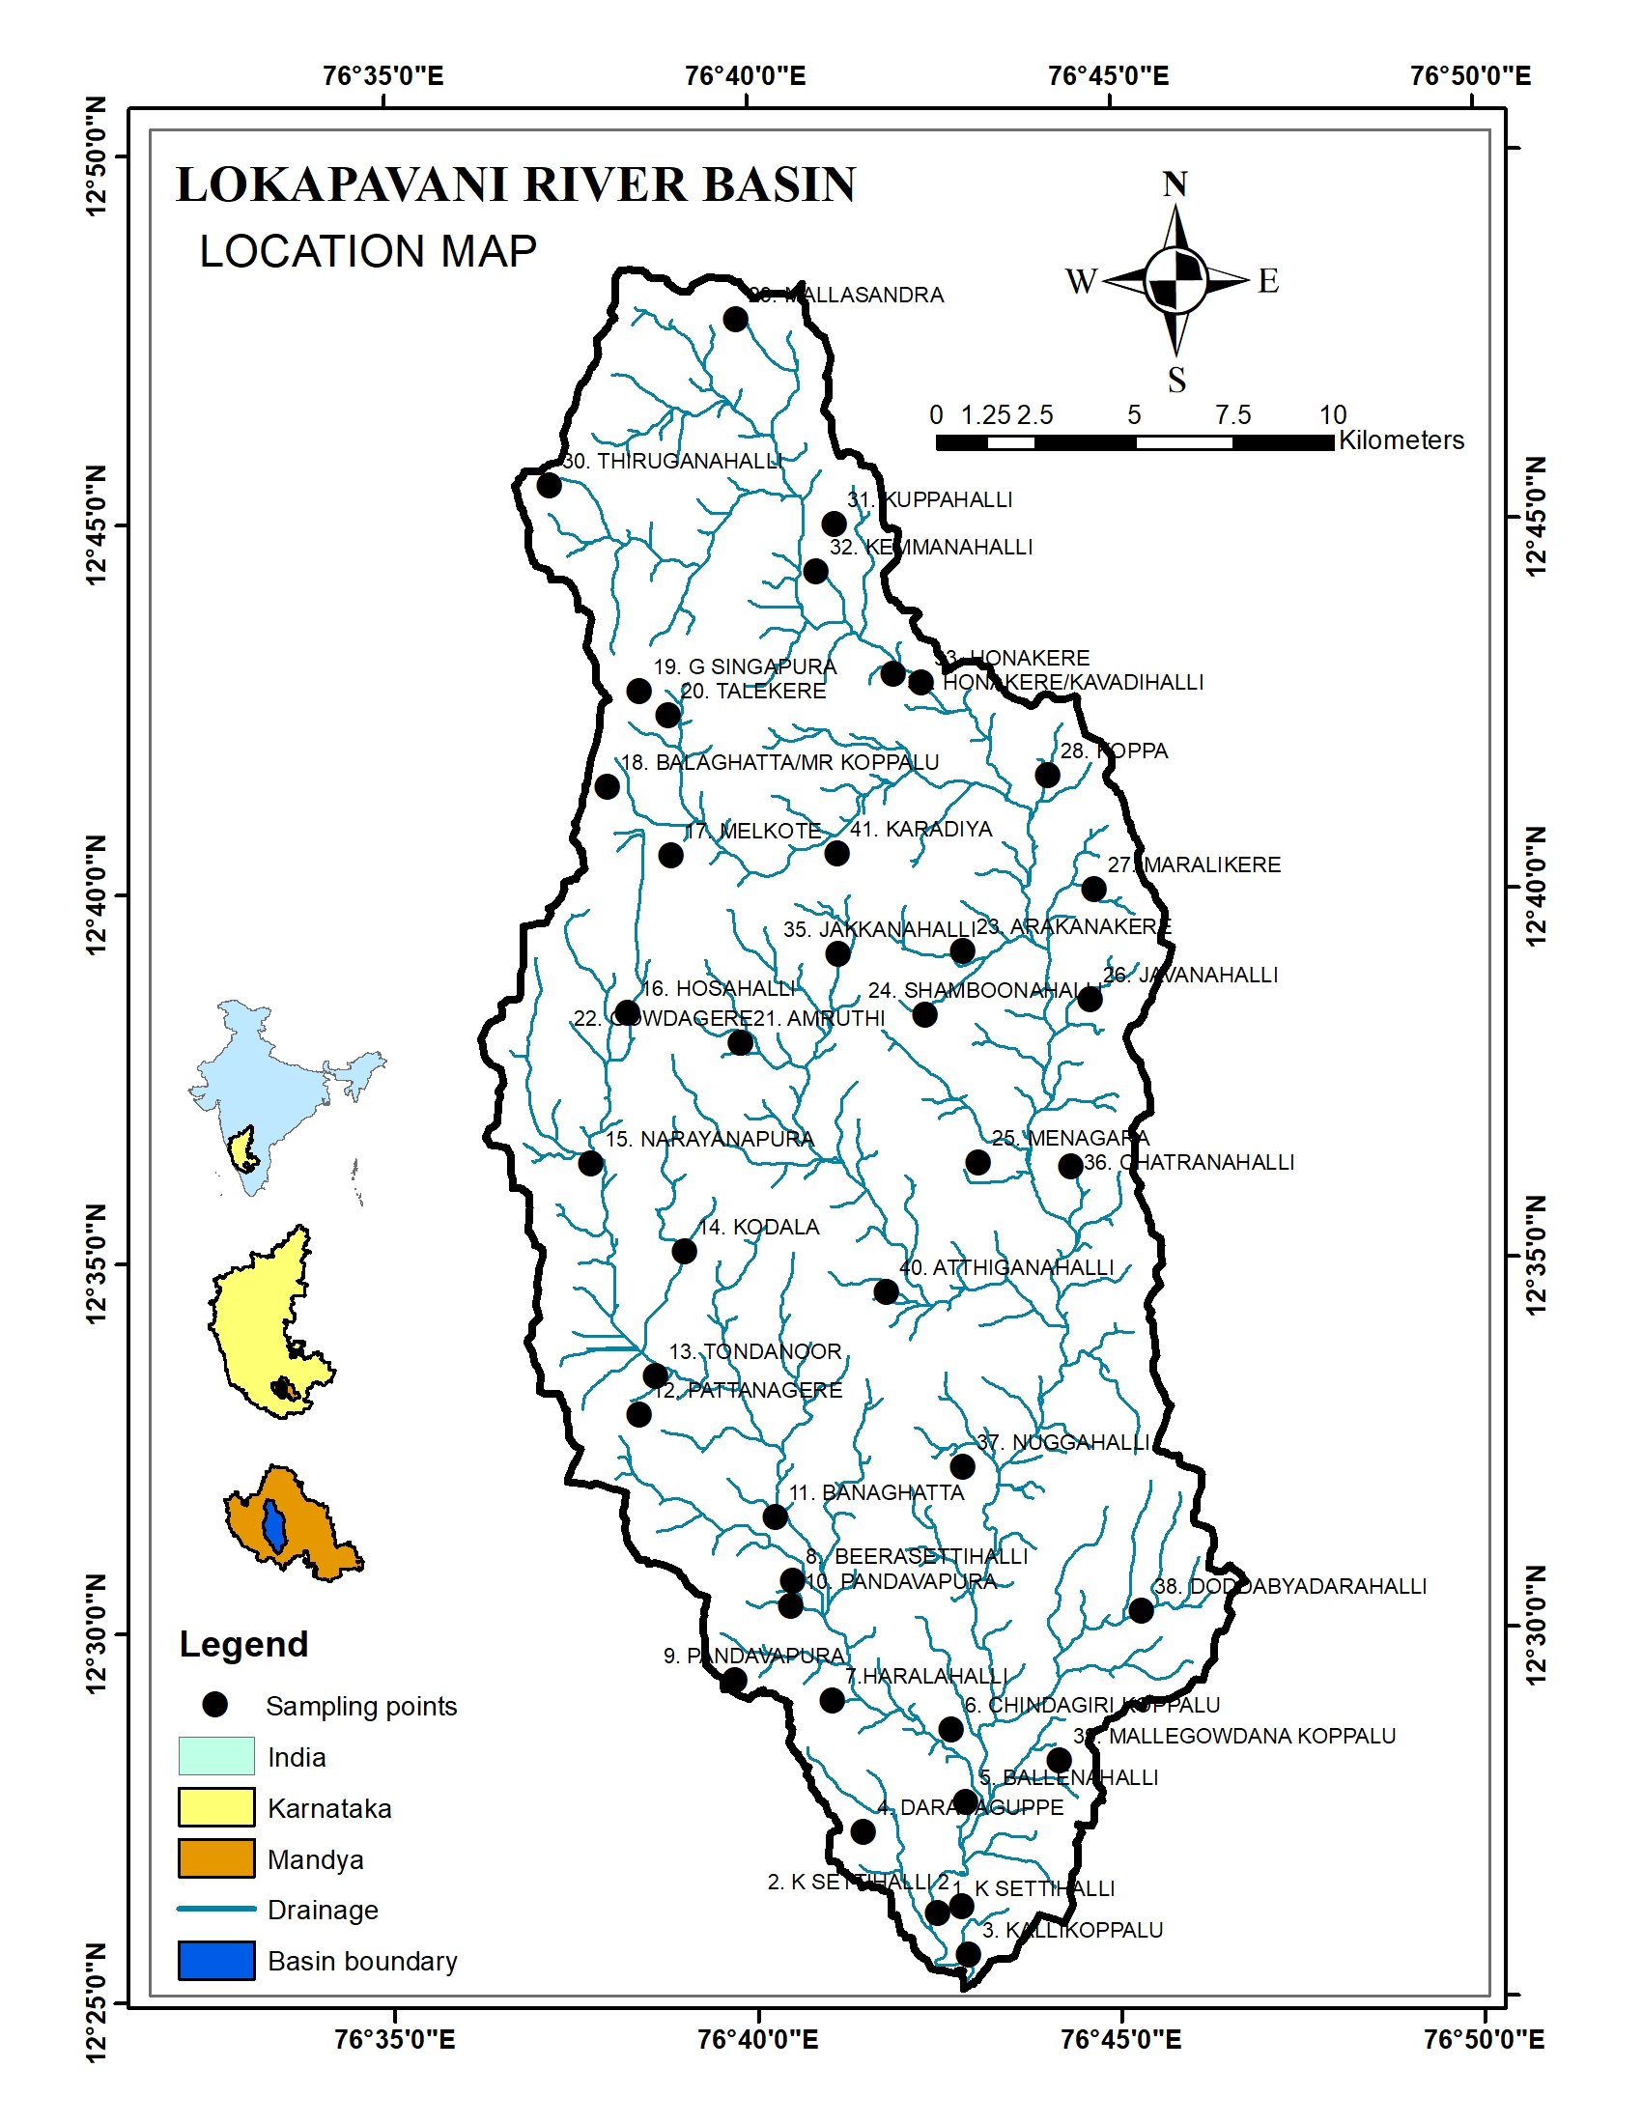
Figure 1. Location map of the study area showing sample location points.
3 Geology and Hydrogeology
The Lokapavani River Basin located in Mandya District of Karnataka, forms part of the Precambrian crystalline terrain of the southern Indian Peninsular Shield. The geology of the area is predominantly composed of granitic gneiss, schist and migmatite formations of Archean age, which are characteristic of hard rock terrains in southern India. These formations play a crucial role in controlling the occurrence, movement and storage of groundwater in the region (Pragadeeshwaran et al., 2026). The rocks are generally characterized by the presence of fractures, joints and weathered zones, which act as secondary porosity structures and facilitate groundwater storage and circulation. Since primary porosity is negligible in crystalline rocks, groundwater occurrence is largely dependent on these secondary structures, especially in hard rock aquifers of peninsular India (Gautam et al., 2023).
Groundwater in the basin occurs mainly within two distinct hydrogeological zones: the weathered zone and the fractured zone. The weathered zone typically extends to a depth of about 10–30m, forming the primary aquifer for shallow groundwater, while deeper groundwater occurs in fractured formations. The occurrence and movement of groundwater in such terrains are strongly influenced by lithology, fracture density and geomorphological conditions (Subramani et al., 2024).
Hydrogeochemical processes such as silicate weathering, ion exchange and water–rock interaction play a significant role in controlling groundwater chemistry in hard-rock aquifers. These processes contribute to the enrichment of major ions such as calcium (Ca²⁺), magnesium (Mg²⁺), sodium (Na⁺), and bicarbonate (HCO₃⁻), which are typical of crystalline aquifer systems (Kumar et al., 2024).
4 Materials and Methods
Groundwater samples were collected from 41 locations in the Lokapavani River Basin, Mandya district, Karnataka, during the pre-monsoon and post-monsoon seasons of 2023 to evaluate the hydrochemical characteristics and water quality of the region. The sampling locations were selected to represent different hydrogeological conditions within the basin. Groundwater samples were collected from bore wells, which are commonly used for domestic and irrigation purposes.
Before sampling, the wells were pumped for several minutes to remove stagnant water and obtain representative groundwater samples. Water samples were collected in clean polyethene bottles that had been previously rinsed with distilled water and the sample water to avoid contamination. The samples were transported to the laboratory for analysis and stored under appropriate conditions until further analysis.
The physicochemical parameters analyzed in this study include pH, Electrical conductivity (EC), Total dissolved solids (TDS), Total hardness (TH), Calcium (Ca²⁺), Magnesium (Mg²⁺), Sodium (Na⁺), Potassium (K⁺), Chloride (Cl⁻), Nitrate (NO₃⁻), Sulfate (SO₄²⁻), Bicarbonate (HCO₃⁻) and Fluoride (F⁻). Laboratory analyses were carried out following the standard procedures recommended by the American Public Health Association (APHA, 2017).
To evaluate groundwater suitability for drinking and irrigation purposes, the following methods were adopted.
4.1 Drinking water quality indices
- Water Quality Index (WQI)
The Weighted Arithmetic Index method was used to calculate the Water Quality Index.
WQI = ∑Qi Wi
———
∑Wi
where Qi = Quality rating of each parameter
Wi = Unit weight of parameter
4.2 Irrigation Water Quality Indices
- Sodium Adsorption Ratio (SAR)
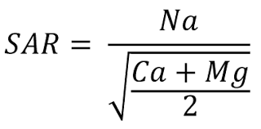

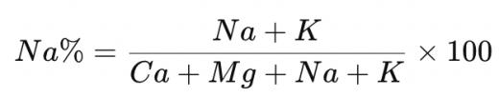
- Sodium Percentage

- Permeability Index (PI)

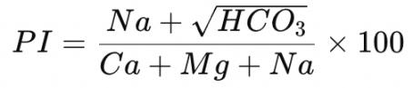

For irrigation water quality, all the ionic concentrations were converted to meq/L before calculation. The USSL diagram, Wilcox diagram and Piper trilinear diagrams were plotted. These indices provide a comprehensive understanding of groundwater suitability for agricultural applications.
The calculated results were compared with the drinking water standards recommended by the World Health Organization (WHO, 2022) and the Bureau of Indian Standards (BIS, 2012) to determine groundwater suitability for domestic use.
5 Results and Discussion
5.1 Drinking Water Suitability Based on WHO and BIS Standards
The physicochemical characteristics of groundwater samples collected from 41 locations (figure 1) during the pre-monsoon and post-monsoon seasons were analyzes and summarized in table 2, and are compared with the drinking water standards recommended by the World Health Organization (WHO) and the Bureau of Indian Standards (BIS) (table.1). The pH values of groundwater samples ranged from approximately 6.98 to 7.94, indicating slightly acidic to mildly alkaline conditions. All samples fall within the acceptable drinking water limit of 6.5–8.5 prescribed by WHO and BIS, suggesting that the groundwater is chemically stable with respect to acidity and alkalinity (World Health Organization, 2022; Bureau of Indian Standards, 2012).
The total dissolved solids (TDS) values ranged from about 310 mg/L to 1110 mg/L, indicating that groundwater varies from fresh to moderately mineralized water. According to BIS and WHO standards, the desirable limit for TDS in drinking water is 500 mg/L, while the permissible limit in the absence of an alternative source is 2000 mg/L. Many groundwater samples exceed the desirable limit, particularly in locations such as Melkote, Gowdagere, Doddabyadarahalli and Banaghatta, indicating higher mineralization due to water–rock interaction, mineral dissolution and possible anthropogenic influences (Li et al., 2021; Bellal Hamma et al., 2024).
The total hardness (TH) values range from approximately 157 to 572 mg/L, indicating that groundwater in the study area varies from moderately hard to very hard water. Hardness is mainly controlled by calcium and magnesium ions derived from carbonate and silicate mineral dissolution. Although hard water does not pose significant health risks, it may affect domestic uses such as soap consumption and scaling in pipelines (World Health Organization, 2022).
The Total Alkalinity (TA) values ranges from 122 to 486 mg/L, most groundwater samples exhibit moderate to high alkalinity, indicating the dominance of bicarbonate ions derived from weathering of silicate and carbonate minerals in the aquifer system, suggest intense water–rock interaction and longer residence time of groundwater.
Electrical conductivity values ranged from approximately 470 µS/cm to 1711 µS/cm, indicating moderate to high ionic concentration in groundwater. Higher EC values generally reflect greater mineralization and dissolution of rock-forming minerals within the aquifer system (Li et al., 2021). The presence of major cations such as calcium and magnesium suggest that groundwater chemistry in the basin is influenced by weathering of silicate and carbonate minerals, which is typical of crystalline rock terrains (Appelo & Postma, 2005; Promilton et al., 2025).
The concentrations of major cations such as calcium (Ca²⁺), magnesium (Mg²⁺) and sodium (Na⁺) generally fall within the permissible limits recommended by BIS. However, slightly elevated sodium concentrations observed in some locations may be associated with ion exchange processes and weathering of feldspar minerals (Appelo and Postma, 2005). Similarly, the concentrations of chloride (Cl⁻) remain mostly within the permissible limit of 250 mg/L, indicating limited influence of saline intrusion or anthropogenic contamination.
Among the anions, bicarbonate (HCO₃⁻) is the dominant ion in most groundwater samples, indicating that groundwater chemistry is largely controlled by carbonate weathering and rock–water interaction processes (Subba Rao et al., 2022). Chloride and sulfate concentrations are generally within acceptable limits, although slightly elevated values observed in some locations may be associated with agricultural activities, fertilizer usage and anthropogenic influences (Zhang et al., 2023).
The nitrate (NO₃⁻) concentrations vary from about 2 to 52 mg/L, and a few locations approach or slightly exceed the WHO permissible limit of 45 mg/L. Elevated nitrate concentrations in Javanahall and Karadiya may indicate agricultural fertilizer leaching or contamination from domestic wastewater sources (Zhang et al., 2023).
The fluoride (F⁻) concentration ranges from 0.22 to 1.90 mg/L, and although most samples fall within the permissible limit of 1.5 mg/L, slightly elevated concentrations in some locations, such as Melkote, G. Singapura and Athiganahalli, may pose potential health risks if consumed over long periods.
Overall, the comparison with WHO and BIS drinking water standards indicates that most groundwater samples in the study area are suitable for drinking with minor treatment, while some locations with higher mineralization or nitrate concentrations require appropriate water treatment and continuous monitoring. Seasonal variations show slightly improved water quality during the post-monsoon period due to dilution effects caused by rainfall recharge (Subba Rao et al., 2022).

Table 1. Drinking water quality standards according to BIS and WHO.
Parameter | Unit | BIS acceptable limit | WHO guideline
PH | mg/L | 6.5-8.5 | 6.5-8.5
Total Dissolved Solids | mg/L | 500 | 500
Electrical Conductivity | µS/cm | 400 | 400
Total Hardness | mg/L | 200 | 200
Total Alkalinity | mg/L | 200 | 200
Calcium | mg/L | 75 | 75
Magnesium | mg/L | 30 | 30
Sodium | mg/L | 200 | 200
Potassium | mg/L | 12 | 12
Chloride | mg/L | 250 | 250
Nitrate | mg/L | 45 | 45
Sulphate | mg/L | 200 | 200
Bicarbonates | mg/L | 200 | 200
Fluoride | mg/L | 1-1.5 | 1-1.5

Table 2. Water quality results of Pre-monsoon and Post monsoon seasons.

LOCATIONS | SEASONS | pH | TDS | TA | TH | EC | Ca | Mg | Na | K | Cl | NO3 | SO4 | HCO3 | F | WQI
1. K SETTIHALLI  Latitude:12.436  Longitude:76.708 | PRE-MONSOON | 7.42 | 450 | 184.1 | 222.7 | 708 | 49.2 | 24.2 | 41.1 | 3.6 | 85.2 | 5.3 | 12.3 | 224.6 | 0.56 | 37.3
1. K SETTIHALLI  Latitude:12.436  Longitude:76.708 | POST MONSOON | 7.37 | 438 | 178.8 | 219.2 | 674 | 45.5 | 21.2 | 32.3 | 2.9 | 81.2 | 4.6 | 12.2 | 231.2 | 0.44 | 30.42
2. K SETTIHALLI 2  Latitude:12.43729  Longitude:76.71363 | PRE-MONSOON | 7.59 | 940 | 401 | 536.8 | 1466 | 135.2 | 48.3 | 56.2 | 8.4 | 143.6 | 17.4 | 42.1 | 489.2 | 0.96 | 66.8
2. K SETTIHALLI 2  Latitude:12.43729  Longitude:76.71363 | POST MONSOON | 7.59 | 960 | 486 | 572 | 1510 | 110.1 | 44.1 | 48.3 | 8.4 | 137.8 | 15.5 | 42.5 | 414.2 | 0.91 | 63.25
3. KALLIKOPPALU  Latitude:12.426591  Longitude:76.715125 | PRE-MONSOON | 7.15 | 410 | 173 | 212.8 | 624 | 51.2 | 20.6 | 36.4 | 2.9 | 76.4 | 4.4 | 15.4 | 211.1 | 0.41 | 27.12
3. KALLIKOPPALU  Latitude:12.426591  Longitude:76.715125 | POST MONSOON | 7.12 | 415 | 166.6 | 210.3 | 590 | 46.4 | 16.9 | 34.3 | 2.6 | 69.3 | 4.3 | 15.8 | 210.2 | 0.34 | 22.87
4. DARASAGUPPE  Latitude:12.454291  Longitude:76.691174 | PRE-MONSOON | 7.39 | 970 | 414.2 | 536.6 | 1510 | 150.1 | 39.2 | 66.3 | 5.6 | 132.1 | 12.1 | 69.5 | 505.3 | 0.78 | 54.48
4. DARASAGUPPE  Latitude:12.454291  Longitude:76.691174 | POST MONSOON | 7.29 | 920 | 412.3 | 519.5 | 1460 | 141.3 | 35.8 | 58.8 | 5.5 | 126.4 | 12.4 | 66 | 428.3 | 0.56 | 42.41
5. BALLENAHALLI  Latitude:12.460842  Longitude:76.714712 | PRE-MONSOON | 7.1 | 370 | 146.4 | 177.5 | 598 | 41.2 | 18.1 | 38.2 | 2.4 | 76.3 | 3.9 | 10.6 | 178.6 | 0.36 | 23.45
5. BALLENAHALLI  Latitude:12.460842  Longitude:76.714712 | POST MONSOON | 7.13 | 355 | 139.5 | 169.2 | 465 | 36.6 | 17.1 | 38.1 | 2.2 | 75.6 | 4.8 | 10.4 | 186.6 | 0.22 | 16.79
6. CHINDAGIRI KOPPALU  Latitude:12.477257  Longitude:76.711522 | PRE-MONSOON | 7.11 | 360 | 144.4 | 192.5 | 574 | 43.6 | 20.3 | 27.5 | 1.5 | 72.6 | 2.8 | 11.2 | 176.2 | 0.41 | 25.66
 | POST MONSOON | 7.1 | 355 | 143.2 | 174.4 | 510 | 41.1 | 19.2 | 25.4 | 1.4 | 69.1 | 2.3 | 11.1 | 177.9 | 0.36 | 22.91
7.HARALAHALLI  Latitude:12.483933  Longitude:76.68416 | PRE-MONSOON | 7.38 | 570 | 227.3 | 259.7 | 895 | 56.3 | 28.9 | 67.3 | 6.5 | 97.4 | 8.8 | 39.6 | 277.3 | 0.63 | 43
7.HARALAHALLI  Latitude:12.483933  Longitude:76.68416 | POST MONSOON | 7.29 | 558 | 220.6 | 225.4 | 860 | 52.8 | 26.6 | 63.2 | 6.2 | 95.7 | 8.1 | 39.3 | 289.2 | 0.46 | 33.71
8. BEERASETTIHALLI  Latitude:12.511138  Longitude:76.675178 | PRE-MONSOON | 7.24 | 360 | 144.6 | 187.6 | 576 | 39.8 | 21.4 | 26.7 | 3.2 | 67.5 | 6.2 | 10.6 | 176.4 | 0.45 | 29.63
8. BEERASETTIHALLI  Latitude:12.511138  Longitude:76.675178 | POST MONSOON | 7.16 | 370 | 189.7 | 183.2 | 580 | 73.2 | 28.2 | 29.4 | 4.7 | 87.4 | 7.5 | 17.2 | 210.2 | 0.61 | 38.75
9. PANDAVAPURA  Latitude:12.488584  Longitude:76.661945 | PRE-MONSOON | 7.49 | 370 | 155.2 | 186 | 572 | 45.6 | 17.5 | 35.6 | 4.4 | 98.6 | 5.1 | 14.2 | 189.3 | 0.39 | 29.16
9. PANDAVAPURA  Latitude:12.488584  Longitude:76.661945 | POST MONSOON | 7.44 | 375 | 162.2 | 175.2 | 548 | 41.2 | 16.1 | 33.8 | 4.1 | 93.3 | 4.7 | 13.7 | 198.2 | 0.32 | 25.03
10 PANDAVAPURA  Latitude:12.505392  Longitude:76.674904 | PRE-MONSOON | 7.28 | 540 | 250.5 | 238.3 | 958 | 51.2 | 26.8 | 54.3 | 4.1 | 58.4 | 13.2 | 23.6 | 243 | 0.54 | 36.48
10 PANDAVAPURA  Latitude:12.505392  Longitude:76.674904 | POST MONSOON | 7.19 | 524 | 233 | 236 | 980 | 27 | 27.8 | 53.2 | 4.8 | 52 | 12.6 | 18.2 | 208 | 0.51 | 34.17
11. BANAGHATTA  Latitude:12.525536  Longitude:76.671469 | PRE-MONSOON | 7.75 | 845 | 338 | 444.4 | 1320 | 126.4 | 31.2 | 66.2 | 7.2 | 136.2 | 14.2 | 49.5 | 412.3 | 0.87 | 60.59
11. BANAGHATTA  Latitude:12.525536  Longitude:76.671469 | POST MONSOON | 7.41 | 320 | 225 | 248 | 514 | 37.3 | 37.7 | 24.1 | 4.12 | 124.3 | 4.5 | 23 | 137.2 | 0.53 | 37.03
12. PATTANAGERE  Latitude:12.548629  Longitude:76.640233 | PRE-MONSOON | 7.54 | 430 | 161.1 | 218.9 | 675 | 51.2 | 22.1 | 38.6 | 2.6 | 89.6 | 3.9 | 14.5 | 196.5 | 0.42 | 30.87
12. PATTANAGERE  Latitude:12.548629  Longitude:76.640233 | POST MONSOON | 7.52 | 425 | 157.6 | 193.3 | 627 | 43.3 | 21.8 | 38.2 | 2.2 | 86.5 | 4.3 | 14.6 | 210.3 | 0.23 | 21.4
13. TONDANOOR  Latitude:12.557426  Longitude:76.644154 | PRE-MONSOON | 7.81 | 625 | 349 | 433 | 910 | 118 | 38.2 | 48.6 | 3.4 | 56 | 29.8 | 31 | 140 | 0.98 | 64.62
13. TONDANOOR  Latitude:12.557426  Longitude:76.644154 | POST MONSOON | 7.4 | 472 | 290 | 389 | 745 | 103 | 34 | 41 | 2.4 | 44 | 29.2 | 22 | 179 | 0.79 | 50.84
14. KODALA  Latitude:12.585526  Longitude:76.651006 | PRE-MONSOON | 7.72 | 830 | 346.1 | 444.2 | 1273 | 121.4 | 34.2 | 58.4 | 5.6 | 121.6 | 8.5 | 53.6 | 422.3 | 0.75 | 53.87
14. KODALA  Latitude:12.585526  Longitude:76.651006 | POST MONSOON | 7.67 | 470 | 268 | 358 | 730 | 55.3 | 52.5 | 56.9 | 10.4 | 42 | 9.7 | 42 | 163 | 0.78 | 56.62
15. NARAYANAPURA  Latitude:12.605313  Longitude:76.629578 | PRE-MONSOON | 7.51 | 490 | 200.9 | 265 | 758 | 57.6 | 29.4 | 45.1 | 5.1 | 112.7 | 5.1 | 15.3 | 245.1 | 0.65 | 43.95
15. NARAYANAPURA  Latitude:12.605313  Longitude:76.629578 | POST MONSOON | 7.28 | 380 | 215 | 262 | 612 | 46 | 35.7 | 30.63 | 1.78 | 37.5 | 22.1 | 41.2 | 131.2 | 0.73 | 45.1
16. HOSAHALLI  Latitude:12.639304  Longitude:76.638186 | PRE-MONSOON | 7.7 | 630 | 228.4 | 294.1 | 975 | 61.2 | 34.3 | 71.5 | 5.4 | 116.5 | 11.6 | 48.6 | 278.6 | 0.42 | 36.34
16. HOSAHALLI  Latitude:12.639304  Longitude:76.638186 | POST MONSOON | 7.2 | 678 | 319 | 368 | 990 | 51 | 60.8 | 92 | 7.6 | 68 | 15 | 34.4 | 196 | 1.1 | 68.08
17. MELKOTE  Latitude:12.674693  Longitude:76.648418 | PRE-MONSOON | 7.36 | 1050 | 419.9 | 569.1 | 1643 | 155.8 | 43.7 | 72.6 | 6.1 | 164.2 | 19.6 | 61.2 | 512.3 | 1.62 | 95.16
17. MELKOTE  Latitude:12.674693  Longitude:76.648418 | POST MONSOON | 6.98 | 940 | 346 | 486 | 1137 | 78.5 | 70.5 | 146.5 | 5.9 | 243 | 24.2 | 105.3 | 211 | 1.9 | 106.16
18. BALAGHATTA/MR KOPPALU  Latitude:12.690258  Longitude:76.63382 | PRE-MONSOON | 7.42 | 490 | 194.1 | 249.6 | 783 | 56.4 | 26.4 | 42.3 | 3.9 | 91.2 | 4.7 | 16.4 | 236.8 | 0.54 | 37.02
 | POST MONSOON | 7.4 | 485 | 178.9 | 233.2 | 697 | 51 | 24.1 | 38.2 | 3.3 | 88.4 | 5.3 | 19.4 | 227.8 | 0.46 | 32.36
19. G SINGAPURA  Latitude:12.711827  Longitude:76.641382 | PRE-MONSOON | 7.73 | 410 | 182.9 | 200.1 | 645 | 49.6 | 18.5 | 46.3 | 2.6 | 65.3 | 9.6 | 21.3 | 223.1 | 1.49 | 82.53
19. G SINGAPURA  Latitude:12.711827  Longitude:76.641382 | POST MONSOON | 7.45 | 395 | 228.6 | 223.3 | 638 | 42.2 | 22.4 | 63.3 | 3.5 | 17.5 | 8.8 | 33.5 | 210.2 | 1.51 | 81.83
20. TALEKERE  Latitude:12.706318  Longitude:76.648003 | PRE-MONSOON | 7.48 | 630 | 214.2 | 267.2 | 985 | 63.5 | 26.4 | 74.1 | 6.5 | 112.3 | 14.3 | 52.3 | 261.3 | 0.85 | 54.41
20. TALEKERE  Latitude:12.706318  Longitude:76.648003 | POST MONSOON | 7.44 | 620 | 212 | 242.2 | 948 | 56.8 | 26.8 | 65.8 | 6.1 | 109.4 | 13.8 | 56 | 243.3 | 0.88 | 55.07
21. AMRUTHI  Latitude:12.637145  Longitude:76.680534 | PRE-MONSOON | 7.73 | 670 | 267.6 | 325.4 | 1052 | 72.3 | 35.1 | 65.2 | 4.9 | 124.6 | 8.6 | 43.6 | 326.5 | 0.63 | 46.57
21. AMRUTHI  Latitude:12.637145  Longitude:76.680534 | POST MONSOON | 7.56 | 625 | 270.4 | 388.7 | 974 | 68.4 | 42.2 | 63.8 | 1.23 | 67 | 32.6 | 45 | 220.5 | 1.32 | 77.47
22. GOWDAGERE  Latitude:12.632381  Longitude:76.664103 | PRE-MONSOON | 7.63 | 910 | 403.8 | 466.2 | 1407 | 123.1 | 38.5 | 70.2 | 4.3 | 109.2 | 10.3 | 54.1 | 492.6 | 1.12 | 70.86
22. GOWDAGERE  Latitude:12.632381  Longitude:76.664103 | POST MONSOON | 7.56 | 720 | 289.3 | 423.2 | 980 | 81.1 | 43.2 | 66.4 | 5.12 | 79.2 | 14.2 | 73.6 | 289.4 | 1.01 | 64.51
23. ARAKANAKERE  Latitude:12.65269  Longitude:76.715276 | PRE-MONSOON | 7.26 | 380 | 166.7 | 210 | 589 | 48.6 | 21.5 | 22.3 | 2.9 | 59.4 | 4.3 | 13.5 | 203.4 | 0.39 | 27.01
23. ARAKANAKERE  Latitude:12.65269  Longitude:76.715276 | POST MONSOON | 7.22 | 375 | 162.2 | 199 | 524 | 43.3 | 18.2 | 21.1 | 2.6 | 54.7 | 4.5 | 17.6 | 212.2 | 0.21 | 17.58
24. SHAMBOONAHALLI  Latitude:12.6385  Longitude:76.706555 | PRE-MONSOON | 7.53 | 520 | 217.3 | 251.5 | 795 | 52.2 | 29.4 | 49.6 | 5.6 | 71.2 | 8.1 | 43.5 | 265.1 | 0.5 | 37.45
24. SHAMBOONAHALLI  Latitude:12.6385  Longitude:76.706555 | POST MONSOON | 7.43 | 510 | 210 | 236.4 | 764 | 44.5 | 27.3 | 43.3 | 5.2 | 68.7 | 7.2 | 42.3 | 254.4 | 0.29 | 26.04
25. MENAGARA  Latitude:12.60506  Longitude:76.71849 | PRE-MONSOON | 7.4 | 660 | 247.9 | 327.1 | 1041 | 65.8 | 39.5 | 65.2 | 6.4 | 134.1 | 29.5 | 40.2 | 302.4 | 0.42 | 36.1
25. MENAGARA  Latitude:12.60506  Longitude:76.71849 | POST MONSOON | 7.28 | 580 | 235.2 | 334.3 | 860 | 72.2 | 28.2 | 57.8 | 4.4 | 76.5 | 28.6 | 55.4 | 213.3 | 0.72 | 46.54
26. JAVANAHALLI  Latitude:12.64163  Longitude:76.744437 | PRE-MONSOON | 7.56 | 660 | 267.6 | 315.8 | 1078 | 67.4 | 35.8 | 69.5 | 4.9 | 112.6 | 7.1 | 43.6 | 326.5 | 0.96 | 60.56
26. JAVANAHALLI  Latitude:12.64163  Longitude:76.744437 | POST MONSOON | 7.47 | 645 | 259.6 | 277.4 | 925 | 55.6 | 31.1 | 66.7 | 4.5 | 106.6 | 6.8 | 47.8 | 278.8 | 0.78 | 50.1
27. MARALIKERE  Latitude:12.666634  Longitude:76.745502 | PRE-MONSOON | 7.48 | 540 | 247.6 | 262.2 | 860 | 56.1 | 29.6 | 50.2 | 3.5 | 72.8 | 11.3 | 18.6 | 302.1 | 0.57 | 39.7
27. MARALIKERE  Latitude:12.666634  Longitude:76.745502 | POST MONSOON | 7.44 | 536 | 233 | 233.8 | 780 | 53.3 | 26.8 | 46.6 | 3.4 | 66.8 | 10.4 | 22.6 | 310.4 | 0.43 | 32.25
28. KOPPA  Latitude:12.692278  Longitude:76.734957 | PRE-MONSOON | 7.63 | 420 | 183.8 | 191.5 | 676 | 48.4 | 17.1 | 39.4 | 4.1 | 51.2 | 9 | 21.4 | 224.2 | 0.54 | 37.57
28. KOPPA  Latitude:12.692278  Longitude:76.734957 | POST MONSOON | 7.59 | 412 | 177.7 | 188.2 | 642 | 43.4 | 16.2 | 34.4 | 3.8 | 45.8 | 8.5 | 24.8 | 233.2 | 0.45 | 32.63
29. MALLASANDRA  Latitude:12.795595  Longitude:76.663961 | PRE-MONSOON | 7.12 | 700 | 243 | 307.1 | 1093 | 74.2 | 29.5 | 87.6 | 6.4 | 132.6 | 15.2 | 65.2 | 296.4 | 0.63 | 42.01
29. MALLASANDRA  Latitude:12.795595  Longitude:76.663961 | POST MONSOON | 7.12 | 710 | 235.4 | 286.4 | 955 | 62.2 | 27.2 | 83.1 | 6.3 | 127.6 | 14.6 | 75.3 | 288.9 | 0.61 | 40.37
30. THIRUGANAHALLI  Latitude:12.758397  Longitude:76.620878 | PRE-MONSOON | 7.24 | 320 | 132.1 | 179.3 | 512 | 34.1 | 22.9 | 32.5 | 2.4 | 73.2 | 3.9 | 12.2 | 161.2 | 0.42 | 27.72
30. THIRUGANAHALLI  Latitude:12.758397  Longitude:76.620878 | POST MONSOON | 7.22 | 320 | 124 | 157.9 | 470 | 32.1 | 20.4 | 33.4 | 2.4 | 68.9 | 4.3 | 14.6 | 145.3 | 0.31 | 21.98
31. KUPPAHALLI  Latitude:12.749213  Longitude:76.68629 | PRE-MONSOON | 7.78 | 498 | 232 | 232 | 778 | 49.6 | 28.4 | 78 | 6.3 | 127 | 6.6 | 18.8 | 248 | 0.56 | 42.44
31. KUPPAHALLI  Latitude:12.749213  Longitude:76.68629 | POST MONSOON | 7.8 | 480 | 2OO | 227 | 756 | 46.2 | 28 | 72 | 6.2 | 134 | 5.5 | 16 | 244 | 0.49 | 39.05
32. KEMMANAHALLI  Latitude:12.738644  Longitude:76.682188 | PRE-MONSOON | 7.38 | 620 | 226.6 | 289.8 | 946 | 66.1 | 30.2 | 71.2 | 7.6 | 129.9 | 11.1 | 36.8 | 276.5 | 0.58 | 41.77
32. KEMMANAHALLI  Latitude:12.738644  Longitude:76.682188 | POST MONSOON | 7.35 | 615 | 222 | 266.5 | 890 | 56.8 | 28.6 | 67.4 | 6.8 | 124.3 | 10.7 | 44.1 | 243.3 | 0.39 | 31.69
33. HONAKERE  Latitude:12.713365  Longitude:76.705993 | PRE-MONSOON | 7.33 | 510 | 209.1 | 273.1 | 802 | 54.7 | 33.1 | 41.4 | 6.9 | 86.3 | 4.1 | 34.6 | 255.1 | 0.94 | 57.31
33. HONAKERE  Latitude:12.713365  Longitude:76.705993 | POST MONSOON | 7.36 | 495 | 199.8 | 256 | 725 | 52.9 | 29.8 | 44.5 | 6.8 | 83.6 | 4.7 | 33.3 | 246.7 | 0.84 | 52.33
34. HONAKERE/KAVADIHALLI  Latitude:12.715363  Longitude:76.699746 | PRE-MONSOON | 7.42 | 810 | 283.4 | 442.7 | 1321 | 109.2 | 41.2 | 61.2 | 8.4 | 165.4 | 13.5 | 54.2 | 345.8 | 0.85 | 58.15
 | POST MONSOON | 7.44 | 790 | 266.9 | 440 | 1210 | 98.8 | 36.7 | 55.8 | 7.8 | 158.3 | 12.3 | 52.3 | 341.2 | 0.74 | 51.95
35. JAKKANAHALLI  Latitude:12.652395  Longitude:76.686645 | PRE-MONSOON | 7.58 | 710 | 256.2 | 338.9 | 1092 | 79.4 | 34.1 | 70.6 | 5.1 | 116.2 | 112 | 68.2 | 312.6 | 1.38 | 56.55
35. JAKKANAHALLI  Latitude:12.652395  Longitude:76.686645 | POST MONSOON | 7.36 | 800 | 336 | 472 | 1291 | 89.7 | 60.3 | 82.4 | 4.7 | 74 | 104.2 | 128 | 201.3 | 1.45 | 90.42
36. CHATRANAHALLI  Latitude:12.60414  Longitude:76.739662 | PRE-MONSOON | 7.26 | 860 | 369.8 | 486.7 | 1353 | 129.5 | 39.6 | 54.3 | 5.8 | 124.3 | 16.3 | 58.1 | 451.2 | 0.96 | 61.4
36. CHATRANAHALLI  Latitude:12.60414  Longitude:76.739662 | POST MONSOON | 7.38 | 920 | 412 | 522 | 1326 | 72.4 | 76.5 | 56.6 | 9.7 | 112.2 | 48.9 | 78.8 | 220.3 | o.64 | 79.77
37. NUGGAHALLI  Latitude:12.535672  Longitude:76.714506 | PRE-MONSOON | 7.3 | 520 | 192.3 | 263.9 | 796 | 54.4 | 31.1 | 46.3 | 6.2 | 82.4 | 10.1 | 51.2 | 234.6 | 0.65 | 43.18
37. NUGGAHALLI  Latitude:12.535672  Longitude:76.714506 | POST MONSOON | 7.29 | 490 | 188.2 | 244.6 | 735 | 50.9 | 27.7 | 44.5 | 6.2 | 85.4 | 10.2 | 51.3 | 233.3 | 0.58 | 39.27
38. DODDABYADARAHALLI  Latitude:12.503876  Longitude:76.755213 | PRE-MONSOON | 7.64 | 1110 | 443.6 | 586.3 | 1711 | 150.2 | 51.2 | 84.2 | 9.1 | 164.8 | 15.3 | 83.6 | 541.2 | 0.84 | 63.07
 | POST MONSOON | 7.94 | 920 | 395 | 480 | 1400 | 129 | 42.8 | 72.2 | 8.7 | 157.8 | 13.3 | 72.3 | 328.9 | 0.78 | 60.02
39. MALLEGOWDANA KOPPALU  Latitude:12.470145  Longitude:76.736287 | PRE-MONSOON | 7.55 | 450 | 173.9 | 235.3 | 712 | 54.1 | 24.3 | 42.3 | 4.6 | 92.3 | 11.2 | 19.6 | 212.1 | 0.42 | 32.7
 | POST MONSOON | 7.49 | 442 | 169.3 | 224.6 | 680 | 51.2 | 23.1 | 39.2 | 4.2 | 89.4 | 10.8 | 22.3 | 218.4 | 0.33 | 27.55
40. ATTHIGANAHALLI  Latitude:12.57609  Longitude:76.697133 | PRE-MONSOON | 7.42 | 823 | 479 | 486 | 1164 | 102 | 28 | 122.2 | 7.4 | 87.6 | 29 | 109.4 | 230.4 | 1.59 | 91.37
40. ATTHIGANAHALLI  Latitude:12.57609  Longitude:76.697133 | POST MONSOON | 7.34 | 760 | 344 | 322 | 1174 | 106 | 49 | 144 | 8.5 | 65 | 36 | 175.4 | 210 | 1.06 | 69.17
41. KARADIYA  Latitude:12.675057  Longitude:76.686495 | PRE-MONSOON | 7.52 | 860 | 410 | 530.5 | 1350 | 86.8 | 78 | 82.2 | 6.6 | 101 | 42.3 | 133.2 | 278 | 0.83 | 62.71
41. KARADIYA  Latitude:12.675057  Longitude:76.686495 | POST MONSOON | 7.47 | 820 | 390 | 546 | 1267 | 73.7 | 88 | 75.4 | 5.4 | 95 | 46.76 | 142.4 | 238 | 0.7 | 56.63

5.2 Water Quality Index (WQI)
The Water Quality Index (WQI) was calculated to evaluate the overall suitability of groundwater for drinking purposes (table.1 and figure 2). The WQI values for the study area range from 16.79 to 106.16 during the pre- and post-monsoon seasons. the seasonal variation is shown in figure 3. According to the WQI classification (table 3), Most of the groundwater samples in the study area fall within the good to poor water quality categories (WQI <25). Several locations such as Ballennahalli, Arakanakere, Chindagiri Koppalu, Pattanagere and Kallikoppalu, exhibit excellent water quality during the post-monsoon season. However, a few locations show very poor to unsuitable water quality particularly Melkote (95.16–106.16), G. Singapura (82), Atthiganahalli (91) and Jakkanahalli (90.42) indicating higher mineralization and possible anthropogenic influences such as agricultural activities and domestic wastewater inputs. Overall, the results suggest that groundwater quality in the study area is generally suitable for drinking, although some sites like Melkote, Atthiganahalli, Jakkanahalli and G Singapura require treatment before consumption. Similar trends of elevated WQI values in agricultural regions have been reported by Singh et al. (2023) and Promilton et al. (2025), where intensive land use practices contributed to groundwater quality degradation.
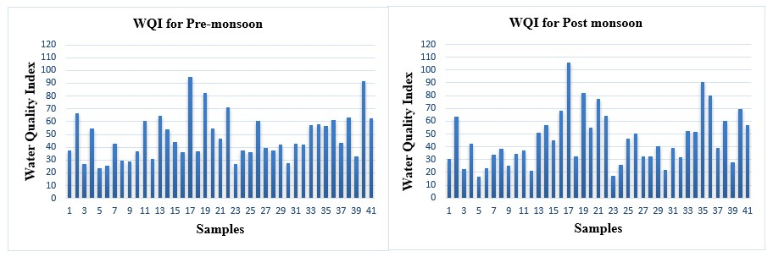
Figure 2. WQI for Pre-monsoon and Post monsoon samples.
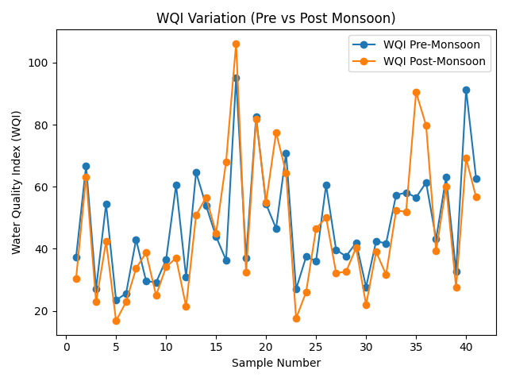
Figure 3. Seasonal variation of Water Quality Index (WQI) for Pre-monsoon and Post monsoon.
Seasonal comparison indicates that groundwater quality improves during the post-monsoon season, which can be attributed to dilution effects caused by recharge from rainfall. This observation is consistent with findings from other semi-arid regions, where seasonal recharge significantly reduces ion concentration (Pant et al., 2026; Chaudhary et al., 2024).

Table 3. WQI Water quality classification.
WQI  (Value Range) | Water class | Pre-monsoon  (No. of samples) | Post monsoon  (No. of samples)
<25 | Excellent | 1 | 7
26-50 | Good | 23 | 18
51-75 | Poor | 14 | 11
76-100 | Very poor | 3 | 4
>100 | Unsuitable | 0 | 1

5.3 Irrigation Water Quality Assessment
Groundwater suitability for irrigation was evaluated using several widely accepted indices, including Sodium Adsorption Ratio (SAR), Sodium Percentage (Na%), Permeability Index (PI), USSL (United States Salinity Laboratory) diagram, Wilcox diagram and Piper trilinear diagram. These indices help determine the potential effects of irrigation water on soil structure, permeability and crop productivity (Li et al., 2021; Singh et al., 2022). The results are tabulated in the table 4.

Table 4. Results of Irrigation water quality indices.
Location | SEASONS | PI | %NA | SAR | RSC | Kelly's ratio
1. K SETTIHALLI | PRE-MONSOON | 59.45 | 29.69 | 1.2 | -0.77 | 0.40
1. K SETTIHALLI | POST MONSOON | 61.83 | 26.90 | 0.99 | -0.22 | 0.35
2. K SETTIHALLI 2 | PRE-MONSOON | 40.07 | 19.85 | 1.06 | -2.70 | 0.23
2. K SETTIHALLI 2 | POST MONSOON | 41.93 | 20.22 | 0.98 | -2.33 | 0.23
3. KALLIKOPPALU | PRE-MONSOON | 59.02 | 28.03 | 1.09 | -0.79 | 0.37
3. KALLIKOPPALU | POST MONSOON | 64.41 | 29.58 | 1.1 | -0.26 | 0.40
4. DARASAGUPPE | PRE-MONSOON | 42.36 | 22.00 | 1.24 | -2.43 | 0.27
4. DARASAGUPPE | POST MONSOON | 41.47 | 21.23 | 1.14 | -2.98 | 0.26
5. BALLENAHALLI | PRE-MONSOON | 64.77 | 32.68 | 1.25 | -0.62 | 0.47
5. BALLENAHALLI | POST MONSOON | 69.64 | 34.61 | 1.3 | -0.17 | 0.51
6. CHINDAGIRI KOPPALU | PRE-MONSOON | 57.42 | 24.28 | 0.86 | -0.96 | 0.31
6. CHINDAGIRI KOPPALU | POST MONSOON | 59.38 | 23.88 | 0.82 | -0.71 | 0.30
7. HARALAHALLI | PRE-MONSOON | 62.34 | 37.33 | 1.82 | -0.64 | 0.56
7. HARALAHALLI | POST MONSOON | 65.05 | 37.58 | 1.77 | -0.08 | 0.57
8. BEERASETTIHALLI | PRE-MONSOON | 58.3 | 24.89 | 0.85 | -0.86 | 0.31
8. BEERASETTIHALLI | POST MONSOON | 43.22 | 18.96 | 0.74 | -2.53 | 0.21
9. PANDAVAPURA | PRE-MONSOON | 62.87 | 30.87 | 1.14 | -0.61 | 0.42
9. PANDAVAPURA | POST MONSOON | 67.46 | 31.75 | 1.13 | -0.13 | 0.43
10. PANDAVAPURA | PRE-MONSOON | 61.18 | 34.11 | 1.53 | -0.78 | 0.50
10. PANDAVAPURA | POST MONSOON | 69.93 | 40.11 | 1.72 | -0.23 | 0.64
11. BANAGHATTA | PRE-MONSOON | 46.61 | 25.63 | 1.51 | -2.12 | 0.32
11. BANAGHATTA | POST MONSOON | 42.37 | 18.85 | 0.75 | -2.71 | 0.21
12. PATTANAGERE | PRE-MONSOON | 57.39 | 28.50 | 1.23 | -1.15 | 0.38
12. PATTANAGERE | POST MONSOON | 62.64 | 30.26 | 1.25 | -0.51 | 0.42
13. TONDANOOR | PRE-MONSOON | 32.55 | 19.57 | 1.12 | -6.74 | 0.23
13. TONDANOOR | POST MONSOON | 35.96 | 18.84 | 1.01 | -5.00 | 0.22
14. KODALA | PRE-MONSOON | 45.31 | 23.20 | 1.34 | -1.95 | 0.29
14. KODALA | POST MONSOON | 43 | 27.89 | 1.33 | -4.41 | 0.35
15. NARAYANAPURA | PRE-MONSOON | 54.66 | 28.30 | 1.21 | -1.28 | 0.37
15. NARAYANAPURA | POST MONSOON | 42.62 | 20.83 | 0.87 | -3.08 | 0.25
16. HOSAHALLI | PRE-MONSOON | 58.38 | 35.57 | 1.75 | -1.31 | 0.53
16. HOSAHALLI | POST MONSOON | 50.16 | 35.71 | 2.13 | -4.33 | 0.53
17. MELKOTE | PRE-MONSOON | 41.68 | 22.54 | 1.58 | -2.97 | 0.28
17. MELKOTE | POST MONSOON | 51.15 | 40.14 | 2.65 | -6.26 | 0.66
18. BALAGHATTA/MR KOPPALU | PRE-MONSOON | 55.8 | 27.98 | 1.31 | -1.10 | 0.37
18. BALAGHATTA/MR KOPPALU | POST MONSOON | 58.06 | 27.80 | 1.16 | -0.79 | 0.37
19. G SINGAPURA | PRE-MONSOON | 65.31 | 34.20 | 1.47 | -0.34 | 0.50
19. G SINGAPURA | POST MONSOON | 68.77 | 41.83 | 1.84 | -0.50 | 0.70
20. TALEKERE | PRE-MONSOON | 61.79 | 38.79 | 2.08 | -1.05 | 0.60
20. TALEKERE | POST MONSOON | 61.49 | 37.43 | 1.9 | -1.05 | 0.57
21. AMRUTHI | PRE-MONSOON | 55.17 | 31.29 | 1.55 | -1.15 | 0.44
21. AMRUTHI | POST MONSOON | 48.4 | 28.93 | 1.43 | -3.27 | 0.40
22. GOWDAGERE | PRE-MONSOON | 47.67 | 25.33 | 1.61 | -1.24 | 0.33
22. GOWDAGERE | POST MONSOON | 48.29 | 28.40 | 1.46 | -2.86 | 0.38
23. ARAKANAKERE | PRE-MONSOON | 54.13 | 19.91 | 0.76 | -0.86 | 0.23
23. ARAKANAKERE | POST MONSOON | 60.81 | 21.18 | 0.73 | -0.18 | 0.25
24. SHAMBOONAHALLI | PRE-MONSOON | 59.06 | 31.39 | 1.28 | -0.68 | 0.43
24. SHAMBOONAHALLI | POST MONSOON | 61.81 | 31.08 | 1.12 | -0.30 | 0.42
25. MENAGARA | PRE-MONSOON | 54.02 | 31.44 | 1.57 | -1.58 | 0.43
25. MENAGARA | POST MONSOON | 51.95 | 30.69 | 1.43 | -4.50 | 0.36
26. JAVANAHALLI | PRE-MONSOON | 57.17 | 33.26 | 1.69 | -2.43 | 0.42
26. JAVANAHALLI | POST MONSOON | 61.18 | 36.10 | 1.62 | -0.96 | 0.48
27. MARALIKERE | PRE-MONSOON | 59.42 | 30.25 | 1.36 | -0.76 | 0.54
27. MARALIKERE | POST MONSOON | 62.13 | 30.27 | 1.29 | -0.29 | 0.42
28. KOPPA | PRE-MONSOON | 65.58 | 32.21 | 1.32 | 0.22 | 0.42
28. KOPPA | POST MONSOON | 69.09 | 31.26 | 1.24 | -0.15 | 0.45
29. MALLASANDRA | PRE-MONSOON | 60.5 | 39.30 | 2.41 | 0.32 | 0.43
29. MALLASANDRA | POST MONSOON | 64.64 | 41.38 | 2.3 | -1.28 | 0.62
30. THIRUGANAHALLI | PRE-MONSOON | 60.78 | 29.12 | 1.07 | -0.61 | 0.68
30. THIRUGANAHALLI | POST MONSOON | 63.29 | 31.56 | 1.12 | -0.94 | 0.39
31. KUPPAHALLI | PRE-MONSOON | 65.92 | 42.45 | 2.14 | -0.90 | 0.44
31. KUPPAHALLI | POST MONSOON | 66.28 | 41.62 | 2.01 | -0.75 | 0.71
32. KEMMANAHALLI | PRE-MONSOON | 58.84 | 36.24 | 2.08 | -0.61 | 0.68
32. KEMMANAHALLI | POST MONSOON | 60.69 | 37.42 | 1.95 | -1.26 | 0.54
33. HONAKERE | PRE-MONSOON | 53.01 | 26.59 | 1.12 | -1.20 | 0.57
33. HONAKERE | POST MONSOON | 56.15 | 29.27 | 1.2 | -1.27 | 0.33
34. HONAKERE/KAVADIHALLI | PRE-MONSOON | 43.84 | 24.53 | 1.33 | -1.05 | 0.38
34. HONAKERE/KAVADIHALLI | POST MONSOON | 46.17 | 24.81 | 1.22 | -3.17 | 0.30
35. JAKKANAHALLI | PRE-MONSOON | 54.21 | 32.08 | 1.55 | -2.36 | 0.31
35. JAKKANAHALLI | POST MONSOON | 41.46 | 28.17 | 1.51 | -1.65 | 0.45
36. CHATRANAHALLI | PRE-MONSOON | 42.05 | 20.50 | 1.15 | -6.13 | 0.38
36. CHATRANAHALLI | POST MONSOON | 35.26 | 21.46 | 1.03 | -2.32 | 0.24
37. NUGGAHALLI | PRE-MONSOON | 54.54 | 29.15 | 1.21 | -6.29 | 0.25
37. NUGGAHALLI | POST MONSOON | 57.6 | 30.27 | 1.16 | -1.43 | 0.38
38. DODDABYADARAHALLI | PRE-MONSOON | 43.2 | 24.94 | 1.61 | -0.99 | 0.40
38. DODDABYADARAHALLI | POST MONSOON | 41.69 | 25.22 | 1.39 | -2.84 | 0.31
39. MALLEGOWDANA KOPPALU | PRE-MONSOON | 56.64 | 29.38 | 1.18 | -4.57 | 0.32
39. MALLEGOWDANA KOPPALU | POST MONSOON | 58.38 | 28.89 | 1.14 | -1.22 | 0.39
40. ATTHIGANAHALLI | PRE-MONSOON | 57.1 | 42.64 | 2.76 | -0.88 | 0.38
40. ATTHIGANAHALLI | POST MONSOON | 52.08 | 40.98 | 2.9 | -3.62 | 0.72
41. KARADIYA | PRE-MONSOON | 39.85 | 25.82 | 1.54 | -5.88 | 0.67
41. KARADIYA | POST MONSOON | 37 | 23.82 | 1.4 | -6.19 | 0.33

- Sodium Adsorption Ratio (SAR)
The Sodium Adsorption Ratio (SAR) is an important parameter used to assess the sodium hazard of irrigation water. SAR values in the study area range from approximately 0.73 to 2.90 (table 4), and the seasonal variation of SAR is shown in figure 4. According to irrigation water classification (table 5), SAR values less than 10 indicate excellent water quality with minimal sodium hazard to soils (Richards, 1954; Singh et al., 2022). All the samples fall within the less than 10 value, indicating low sodium hazard. The low SAR values suggest that sodium accumulation in soils is unlikely to affect soil permeability or crop growth significantly. Therefore, groundwater in the study area can generally be considered safe for irrigation with respect to sodium hazard.

Table 5. SAR Water quality classification
SAR  (Value Range) | Water class | Pre-monsoon  (No. of samples) | Post monsoon  (No. of samples)
0-10 | Excellent | 41 | 41
10-18 | Good | 0 | 0
18-26 | Doubtful | 0 | 0
>26 | Unsuitable | 0 | 0

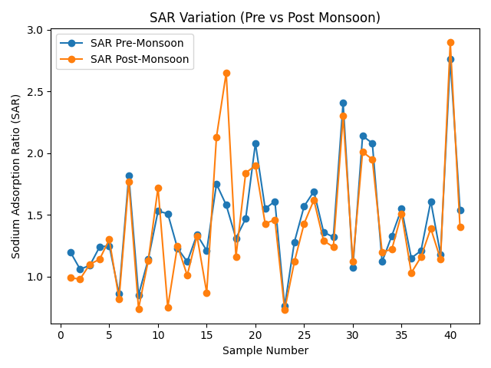
Figure 5. Seasonal variation of Sodium Adsorption Ratio for Pre-monsoon and Post monsoon.
- Sodium Percentage (Na%)
According to irrigation water classification (table 6), (Wilcox, 1955; Ravikumar & Somashekar, 2021). The sodium percentage (Na%) values in the study area ranges from 18.84% to 42.64%, indicating that groundwater falls within the excellent to permissible category for irrigation.
Table 6. %NA Water quality classification
NA%  (Value Range) | Water class | Pre-monsoon  (No. of samples) | Post monsoon  (No. of samples)
0-20 | Excellent | 3 | 3
20-40 | Good | 36 | 32
40-60 | Permissible | 2 | 6
60-80 | Doubtful | 0 | 0
>80 | Unsuitable | 0 | 0

However, higher Na% values observed in locations such as Atthiganahalli and G. Singapura may indicate moderate sodium hazard, which may pose a moderate risk of soil alkalinity if used continuously without proper management practices.
Seasonal variation (figure 6) shows that Na% values are slightly higher in the post-monsoon season at some locations, which may be attributed to leaching of sodium ions from soil and agricultural return flow. However, overall variations between seasons are not significant, indicating relatively stable hydrochemical conditions.
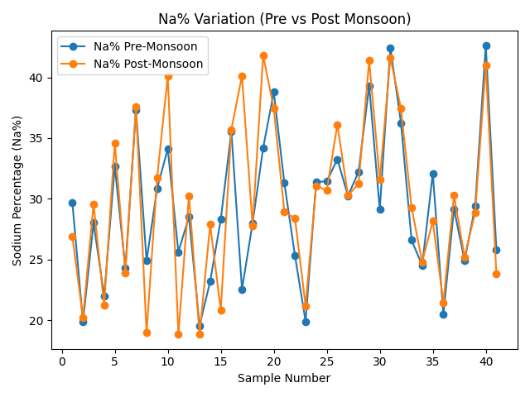
Figure 6. Seasonal variation of Sodium percentage (Na%) for Pre-monsoon and Post monsoon.
- Permeability Index (PI)
The Permeability Index (PI) was calculated to evaluate groundwater suitability for irrigation based on the influence of sodium, calcium, magnesium and bicarbonate ions on soil permeability. The PI values in the study area range from 32.55 to 69.93 for both pre-monsoon and post-monsoon seasons (table.4 and figure 7).
According to the Doneen classification, irrigation water is divided into three classes (table 7):
Table 7. Water quality classification.
PI  (Value Range) | Water class | Pre-monsoon  (No. of samples) | Post monsoon  (No. of samples)
>75% (Class I) | Excellent | 0 | 0
25-75% (Class II) | Suitable | 41 | 41
<25% (Class III) | Permissible | 0 | 0

All groundwater samples in the study area fall within the Class II category (PI 25–75), indicating that the groundwater is generally suitable for irrigation purposes. Locations such as Pandavapura, Kuppahalli, and Koppa show relatively higher PI values (above 65), suggesting better permeability characteristics of irrigation water. The absence of Class III water indicates that groundwater in the study area does not pose significant permeability hazards to soils.

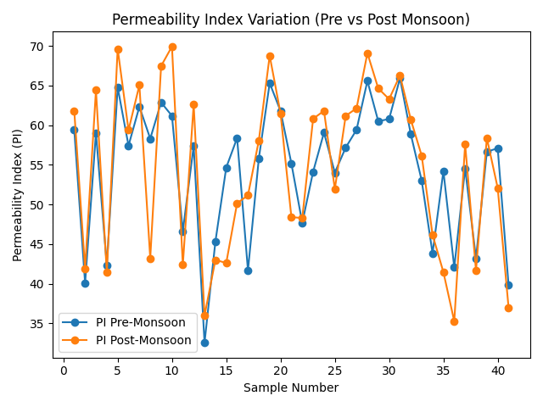
Figure 7. Seasonal variation of Permeability Index (PI) for Pre-monsoon and Post monsoon.
- Residual Sodium Carbonate (RSC)
Residual Sodium Carbonate (RSC) values in the study area are predominantly negative (table 4), indicating an excess of calcium and magnesium over carbonate and bicarbonate ions, which is favorable for irrigation. According to Ayers R. S. and Westcot D. W. (1985), RSC values less than 1.25 meq/L are considered safe; hence, the observed values suggest minimal risk of sodium accumulation and soil alkalinity. Only a few locations show slightly positive RSC, but they remain within permissible limits, suggesting overall suitability for irrigation use.
- Kelly’s Ratio (KR)
Kelly’s Ratio (KR) values across all sampling sites are less than 1 (table 4), indicating that sodium levels are lower than calcium and magnesium, making the water suitable for irrigation. As per W. P. Kelly (1963), KR < 1 signifies good quality irrigation water, while values >1 indicate unsuitability. The consistency of KR within safe limits suggests no significant sodium hazard and supports the suitability of groundwater for long-term agricultural use.
5.4 USSL (United States Salinity Laboratory) Diagram
The irrigation suitability was further evaluated using the USSL (United States Salinity Laboratory) diagram which classifies irrigation water based on electrical conductivity (EC) and sodium adsorption ratio (SAR) (Richards, 1954). In the present study, the pre-monsoon groundwater quality samples are represented in the blue color dots and the post monsoon samples are in the red color dots (figure 8).
The most groundwater samples fall within the C2–S1 and C3–S1 classes in both the seasons, indicating medium to high salinity hazard with low sodium hazard. Water belonging to these classes can generally be used for irrigation under moderate soil drainage conditions and salt-tolerant crops. The results indicate that salinity rather than sodium hazard may represent the primary concern for irrigation in certain locations.
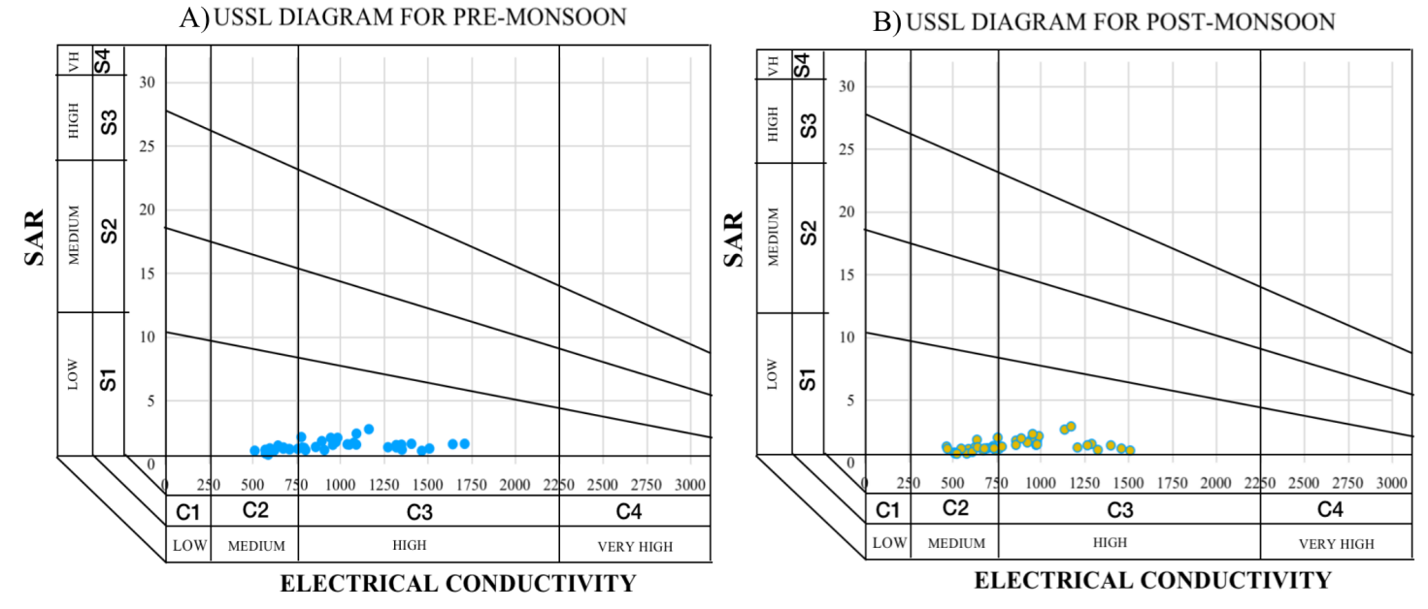
Figure 8. A and B showing USSL diagram for Pre-monsoon and Post monsoon samples.

5.5 Wilcox Diagram
The Wilcox diagram is widely used to evaluate the suitability of groundwater for irrigation by plotting sodium percentage (Na%) against electrical conductivity (EC) (Wilcox, 1955). This diagram helps assess the combined influence of sodium hazard and salinity hazard on soil permeability and crop productivity (Robert S. Ayers and David W. Westcot, 1985). Based on this diagram, the red color dots showing pre-monsoon samples and blue dots color shows post monsoon seasonal variations of groundwater quality for 41 samples (figure 9). most groundwater samples fall within the excellent to good irrigation water categories. However, the EC values indicate medium to high salinity conditions, which may affect soil salinity when used continuously for irrigation. These findings are consistent with studies conducted in similar hydrogeological environments (Wilcox, 1955). Therefore, irrigation using such groundwater may require proper drainage and suitable soil management practices to prevent salinity accumulation. Overall, the Wilcox diagram suggests that groundwater in the study area is generally suitable for irrigation with appropriate agricultural management practices. (Zhang et al., 2023).
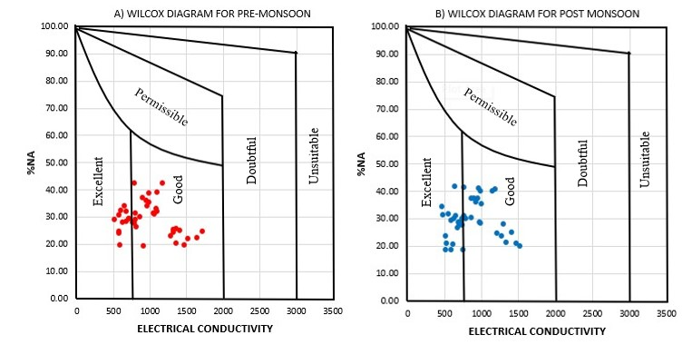
Figure 9. A and B showing Wilcox diagram for Pre-monsoon and Post monsoon samples.
5.6 Piper Diagram
The Piper trilinear diagram is a widely used graphical method for identifying hydrochemical facies and understanding groundwater evolution based on the relative proportions of major cations and anions (Piper, 1944). In the present dataset, Series 1 represents pre-monsoon samples and Series 2 represents post-monsoon samples plotted on the Piper diagram to examine seasonal variations in groundwater chemistry (figure 10).
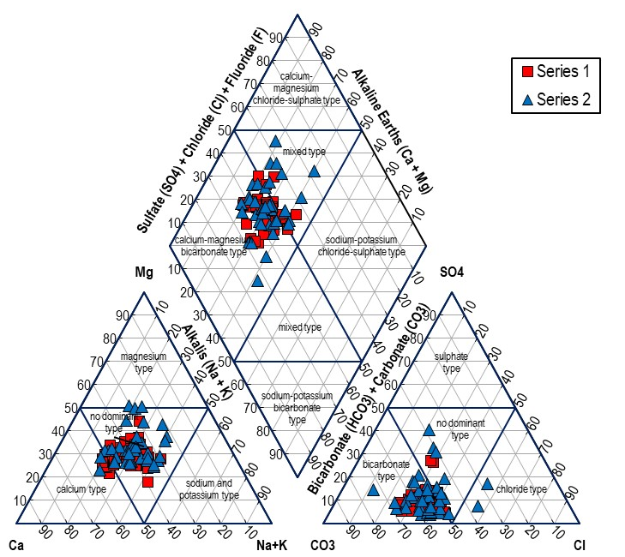
Figure 10. Piper Diagram for Pre-monsoon and Post monsoon seasons.
The cation triangle indicates that most groundwater samples plot toward the calcium (Ca²⁺) and magnesium (Mg²⁺) fields, showing the dominance of alkaline earth metals over alkali metals. This suggests that groundwater chemistry is mainly controlled by carbonate dissolution and silicate weathering processes in the aquifer system (Panchabhai and Mondal, 2024; Mishra et al., 2025).
In the anion triangle, the majority of samples are concentrated in the bicarbonate (HCO₃⁻) region, indicating that bicarbonate ions derived from carbonate mineral dissolution and soil CO₂ interaction dominate the groundwater chemistry. Such hydrochemical signatures are typical of recharge-dominated groundwater systems in hard-rock and sedimentary aquifers (Zhao et al., 2025). A few samples shift toward the chloride and sulphate zones, which may indicate minor anthropogenic influences such as agricultural activities or evaporation effects. These variations may also result from ion-exchange reactions between groundwater and aquifer materials (Islam et al., 2025).
In the central diamond field of the Piper diagram, most samples fall in the calcium–magnesium bicarbonate facies, which represents relatively fresh groundwater and active recharge conditions. The pre-monsoon samples show relatively higher dispersion, indicating increased mineralization due to evaporation and prolonged water–rock interaction during dry seasons. In contrast, post-monsoon samples are more concentrated within the bicarbonate facies, suggesting dilution and recharge from rainfall during the monsoon period. Seasonal dilution effects caused by rainfall are commonly reported in hydrogeochemical studies of groundwater systems (Mishra et al., 2025).

7 Conclusion
The present study provides a comprehensive evaluation of groundwater quality in the Lokapavani River Basin, Mandya District, Karnataka, based on physicochemical parameters, water quality indices, and hydrogeochemical analysis for the year 2023. The results indicate that groundwater in the study area is generally slightly alkaline and moderately mineralized, with dominant ions being calcium, magnesium and bicarbonate, suggesting that groundwater chemistry is primarily controlled by silicate weathering and water–rock interaction processes.
The Water Quality Index (WQI) values reveal that groundwater quality ranges from excellent to unsuitable for drinking, with most samples falling under good to poor categories. A few locations, such as Melkote, Atthiganahalli, G. Singapura and Jakkanahalli exhibit higher WQI values, indicating deterioration in water quality due to increased dissolved ions, which may be influenced by both geogenic and anthropogenic factors.
Evaluation of irrigation water quality indices shows that Sodium Adsorption Ratio (SAR) values fall within the low sodium hazard category, indicating minimal risk to soil structure. The Sodium Percentage (Na%) values classify most groundwater samples as good to permissible for irrigation, while the Permeability Index (PI) indicates that the majority of samples fall under Class I and Class II categories, confirming their suitability for irrigation. The predominantly negative Residual Sodium Carbonate (RSC) values suggest that groundwater does not pose significant alkalinity hazards to soils.
The USSL and Wilcox diagrams further support that most groundwater samples fall under medium to high salinity with low sodium hazard categories, indicating that groundwater is generally suitable for irrigation with proper salinity management practices. The Piper diagram reveals that the dominant hydrochemical facies is Ca–Mg–HCO₃ type, which is typical of hard rock aquifers.
Seasonal analysis indicates that groundwater quality improves during the post-monsoon period due to dilution effects, whereas higher concentrations of dissolved ions are observed during the pre-monsoon season due to evaporation and prolonged water–rock interaction.
Overall, groundwater in the Lokapavani River Basin is suitable for irrigation purposes, while its suitability for drinking varies across locations. Regular monitoring, controlled fertilizer usage, control of anthropogenic activities and sustainable groundwater management practices are recommended to maintain water quality and ensure long-term availability.

Limitations of the Study
This study is based on groundwater samples collected from 41 locations during the pre-monsoon and post-monsoon seasons of 2023, which may not fully represent long-term temporal variations in groundwater quality. The analysis focuses primarily on physicochemical parameters and does not include microbiological or heavy metal assessments, which are also important for comprehensive water quality evaluation.
Additionally, the spatial distribution of sampling points may not capture all localized variations within the basin. Seasonal analysis was limited to two periods, and inclusion of monsoon data could provide a more detailed understanding of groundwater dynamics. Future studies should incorporate long-term monitoring, advanced geochemical modeling and isotopic analysis to better understand groundwater evolution and contamination sources.

Disclaimer (Artificial intelligence)
Author(s) hereby declare that NO generative AI technologies such as Large Language Models (ChatGPT, COPILOT, etc.) and text-to-image generators have been used during the writing or editing of this manuscript.

8 Reference
- Anjali, N., Achu, A. L., Aju, C. D. and Girish Gopinath. (2025). Hydrogeochemical Processes and Physicochemical Parameters Controlling the Groundwater Chemistry of a Tropical River Basin, Southern India. Journal of Discover Geoscience. Vol. 3(204). Pp 1-24. https://doi.org/10.1007/s44288-025-00311-6.
- Appelo, C. A. J. and Postma, D. (2005). Geochemistry, Groundwater and Pollution (2nd edition). CRC Press.
- Ayers, R. S. and Westcot, D.W. (1985). Water Quality for Agriculture. FAO Irrigation and Drainage. Pp 29.
- Bellal Hamma., Abdullah Alodah., Foued Bouaicha., Mohamed Faouzi Bekkouche., Ayoub Barkat. and Enas E. Hussein. (2024). Hydrochemical Assessment of Groundwater Using Multivariate Statistical Methods and Water Quality Indices (WQIs). Journal of Applied Water Science. Vol. 14(33), Pp 1-18. https://doi.org/10.1007/s13201-023-02084-0.
- Bureau of Indian Standards (2012). IS 10500: Drinking Water Specification.
- Chandra Bhushan., Ashish Pratap Patel., Arun Kumar., Vivek Kumar Pandey., Pavitra, V. Kumar., Pankaj Kumar. and Ashwani Kumar Tiwari. (2025). Hydrogeochemical Characterisation and Human Health Risk Assessment of Groundwater in Sultanpur District, Uttar Pradesh, India. Journal of Frontiers in Water, Vol. 7. Pp 1-5. https://doi.org/10.3389/frwa.2025.1639708.
- Deepa Subramani., Pradeep Kamaraj., Umayadoss Saravana Kumar. and Chidambaram Sabarathinam. (2024). Mapping of Groundwater Recharge Zones in Hard Rock Aquifer Through Analytic Hierarchy Process in Geospatial Platform. Journal of Water. Vol. 16, Pp 1-28. https://doi.org/10.3390/w16111484.
- Doneen, L. D. (1964). Notes on Water Quality in Agriculture. Department of Water Science and Engineering, University of California.
- Girish Gopinath, Resmi, T. R. and Seralathan, P. (2013). Assessment of Groundwater Quality in Kavaratti Island in the Lakshadweep Archipelagos, India. Journal of Chemistry and Ecology. Vol. 29, Pp 309–319. https://doi.org/10.1080/02757540.2012.760546.
- Govindhan Perumal. (2025). Geo-Statistical Analysis and Hydrochemical Characterization of Groundwater Quality in the Tuticorin Coastal Region, Tamil Nadu. Journal of Regional Studies in Marine Science. Vol 90, Pp 1-5. https://doi.org/10.1016/j.rsma.2025.104603.
- Islam, Rafiqul., Habib, Mohammad Ahsan. and Islam, MD. Nazrul. et al. (2025). Integrated Evaluation of Groundwater Hydrochemistry and Water Quality Using Piper Diagram and Statistical Approaches. Journal of Environmental Science and Pollution Research. Vol. 32, Pp 45612–45628. doi: 10.1038/s41598-025-09874-3.
- Kelly, W. P. (1963). Use of saline irrigation water. Journal of Soil Science, Vol. 95, Pp 355–391.
- Lalitha M, Dharumarajan S, Kalaiselvi B, Shivanand K, Koyal A, Kaliraj S, and Rajendra Hegde. (2021). Hydrochemical Characterization and Groundwater Quality in Cauvery Deltaic Fluvial Plains of Southern India. Journal of Environmental Science Pollution Research. Vol. 28, Pp 44861–44876. doi: 10.1007/s11356-021-13467-8.
- Li, Peiyue., Wu, Jianhua. & Qian, Hailong (2014). Groundwater Quality Assessment Based on Entropy Weighted Osculating Value Method: A Case Study in an Industrial Park, Northwest China. Journal of Environmental Monitoring and Assessment. Vol. 186, Pp 6937-6945. 10.1007/s10653-013-9590-3.
- Panchabhai, R. C., Mondal, N. C. (2024). Hydrochemical Insights of Groundwater for Drinking, Agriculture and Potential Nitrate Threats in Western India. Journal of Environmental Earth Sciences. Vol. 83, Pp 450-462. https://doi.org/10.1007/s12665-024-11758-0.
- Pant, R. R., Chen zeng., Faizan Ur Rehman., Mahesh Prasad Awasthi., Kiran Bishwakarma., qianggong Zhang. and Ahmad M. Saqr. (2026). Hydrogeochemistry and water quality in the transboundary Koshi Basin, central Himalayas. Journal of Mountain Science.Vol. 23, Pp 559-582. https://doi.org/10.1007/s11629-025-9919-2.
- Piper, A. M. (1944). A Graphic Procedure in the Geochemical Interpretation of Water Analyses. Journal of Transactions, American Geophysical Union. Vol. 25, Pp 914–928.
- Prabuddh Kumar Mishra., Ashutosh Mishra., Prabuddh Kumar Mishra., Anupam Mishra and H. K. Pandey. (2025). Spatio-temporal characterization of groundwater hydrogeochemistry using GIS, multivariate statistics and geochemical modeling in the Lower Ganga-Yamuna Doab region, India. Journal of Applied Water Science. Vol. 15(262), Pp 148-162. DOI: 10.1007/s13201-025-02448-8.
- Pragadeeshwaran, K., Gurugnanam, B., Bagyaraj, M., Bairavi, S., Karunanidhi, D and Berihu Abadi Berhe. (2026). Groundwater Potential Zones Demarcation in the Hard Rock Province of South India: Insights from Remote Sensing, GIS and AHP Techniques. Journal of Scientific Reports. Vol. 16, Pp 1-13. https://doi.org/10.1038/s41598-026-35734-9.
- Promilton, A. A. A., Ravindran, A. A., Pitchaimani, V. S., Kingston, J. V. and Karuppannan, S. (2025). Comprehensive Hydrogeochemical Characterization and Seasonal Water Quality Index Analysis for Sustainable Groundwater Management in Valliyur Region, Southern Tamil Nadu, India. Journal of Scientific Reports. Vol. 15, Pp 1-26. https://doi.org/10.1038/s41598-025-18285-3
- Rajesh Kumar., Sugeeta Sharma. and Manthena Prashant. (2024) Assessment of Groundwater Quality for Drinking, Irrigation and Industrial Purposes in Aik Watershed, Jammu and Kashmir, India. Journal of Discover Geoscience. Vol. 2, Pp 1-21. https://doi.org/10.1007/s44288-024-00065-7.
- Rakshita Chaudhary., Nisha Gaur. and Mohit yadav. (2024). Hydrogeochemical analysis of groundwater quality during the pre- monsoon season of Manipur, India. Journal of Water Science. Vol. 38(1), Pp 274-292. https://doi.org/10.1080/23570008.2024.2341369.
- Ravikumar, P. and Somashekar, R. K. (2021). Evaluation of Groundwater Quality Using Water Quality Index Methods. Journal of Environmental Monitoring and Assessment. Vol. 193, Pp 1–15.
- Richards, L.A. (1954). Diagnosis and Improvement of Saline and Alkali Soils. USDA Agricultural Handbook No. 60.
- Singh, S., Kumar, A. and Singh, R. (2022). Irrigation Water Quality Assessment Using Hydrochemical Indices. Journal of Environmental Earth Sciences. Vol. 81, P 420.
- Subba Rao, N., Chaudhary, M., & Rao, P. (2019). Hydrogeochemical Processes Regulating the Spatial Distribution of Groundwater Contamination, Using Pollution Index of Groundwater (PIG) and Hierarchical Cluster Analysis (HCA): A Case Study. Journal of Groundwater for Sustainable Development. Vol. 9. https://doi.org/10.1016/j.gsd.2019.100238.
- Todd, D. K. and Mays, L.W. (2005). Groundwater Hydrology, (3rd Edition). John Wiley & Sons.
- Ubuoh, E. A., Okeke, Chinedu E. and Nwankwo, Samuel O. (2024). Evaluation of hydro-chemical facies and surface water quality dynamics using multivariate statistical approaches in Southern Nigeria. Journal of Environmental Monitoring and Assessment. Vol. 196, Pp 312–328.
- Vasanthavigar, M., Srinivasamoorthy, K., Vijayaragavan, K., Rajiv Gandhi, R., Chidambaram, S., Anandhan, P., Manivannan, R. And Vasudevan, S. (2010). Application of Water Quality Index for Groundwater Quality Assessment: Thirumanimuttar Sub-basin, Tamil Nadu, India. Journal of Environmental Monitoring and Assessment. Vol. 171, Pp 595–609. doi: 10.1007/s10661-009-1302-1.
- Vinay Kumar Gautam., Chaitanya, B., Pande., Mahesh Kothari., Pradeep Kumar Singh and Abhishek Agrawal. Exploration of Groundwater Potential Zones Mapping for Hard Rock Region in the Jakham River Basin Using Geospatial Techniques and Aquifer Parameters. Journal of Advances in Space Research. Vol. 71, Pp 2892-2908. https://doi.org/10.1016/j.asr.2022.11.022
- Wilcox. (1955). Classification and Use of Irrigation Waters. U.S. Department of Agriculture. Circular 969.
- World Health Organization (2022). Guidelines for Drinking-Water Quality, 4th Edition.
- Zhang, Y., Guo, H. and Li, P. (2023). Hydrochemical Characterization and Groundwater Quality Evaluation. Journal of Hydrology. Vol. 620, Pp 129422.
- Zhao, Yong., Guo, Qiang. and Li, Xiaoming. (2025). Shallow Groundwater Hydrochemical Facies and Nitrate Contamination Mechanisms. Sustainability, Vol. 17, Pp 10834-10848.

