Analysis of fertilizing nutrient contents and efficacy of composts based on cow Dung, manure, and poultry Manure in the Peri-urban Area of Niamey

Original Research Article

.
ABSTRACT
In Niger, soil degradation is a major problem for agricultural production. To address this issue, a number of technologies, including composting technique, are being evaluated. These techniques are being promoted and implemented on a larger scale to improve soil fertility, which is severely threatened by climate variability. This study, conducted in the peri-urban area of Niamey, aims to: (i) examine the production parameters of composts made from cow dung, manure, and poultry droppings; (ii) compare the nutrient content of these composts; and (iii) discuss the effectiveness of the resulting composts on different crop types. It consisted of producing composts in 5-compartment composters of 5 m3 each, with a system for recovering liquid manure. The composts are turned from one compartment to another every week throughout the composting process. At each turning, the composts are thoroughly mixed and moistened with water. When mature, the composts were sampled and air-dried for laboratory analysis. Thus, the physico-chemical properties of the composts produced according to the composting duration showed that all three composts produced have an alkaline pH (pH > 7). Indeed, the composts based on cow dung (C1), manure (C2), and poultry droppings (C3) have respective pH values of 8.4, 7.3, and 8. The mineral nutrient contents (nitrogen, phosphorus, and potassium) from the analyses of the produced composts indicate that manure has more nutrients (1.23% nitrogen, 8.50% phosphorus, and 1.28% potassium) than cow dung (0.16% nitrogen, 3.75% phosphorus, and 0.20% potassium) and poultry droppings (0.80% nitrogen, 5.57% phosphorus, and 0.66% potassium). Agronomic trials will help confirm the effect of these composts on the fertilization of different crops and the properties of degraded soils.

Keywords: Composts, cow dung, manure, poultry droppings, Nutrient fertilizers and Niamey-Niger.
.

1. INTRODUCTION
An essential factor in economic development, agriculture plays a central role in wealth production worldwide; it accounted for 4% of the global gross domestic product (GDP) in 2018 (World Bank, 2018). In Niger, agriculture is the main activity employing more than 85% of the active population; it is the main source of income and contributes more than 32% of the total GDP (Zakari et al., 2016). Agricultural production depends primarily on the size of cultivable areas, and cultivated lands are continuously shrinking due to the combined effects of recurring droughts, which accelerate the desertification process, and demographic pressure (INS, 2023). Indeed, for several decades, agriculture has been in a crisis situation, thus affecting the country's economy. This is one of the consequences of land degradation, which results in a continuous decline in agricultural yields, leading to an increase in poverty and vulnerability of the population (FAO, 2025).
The persistence of the rainfall deficit in recent years has focused research and development work on the problem of soil fertility and the mineral nutrition of crops. The extensive nature of this agriculture, combined with unfavorable climatic conditions and the low level of soil fertility, is of great importance for the country's food self-sufficiency (Zakari et al., 2016).
The restoration of soil fertility through the recycling of organic waste could improve the physico-chemical and biological properties. Thus, producers very often resort to organic fertilization (Useni et al., 2013); organic fertilizers have the ability to improve soil structure and enrich it with nutrient elements necessary for plant nutrition (Temgoua et al., 2014).
However, the direct use and application of these organic wastes in production, as practiced in the field, not only constitutes a relatively slow source of nutrients or a potential source of contamination for cultivated plants, but also and above all a source of soil acidification and the spread of pathogenic bacteria, which very often reduces yields (Métras, 2019).
Also, to address these problems and increase agricultural production, composting these organic wastes would be a good alternative; composting has the advantage of limiting pathogens, improving the fertilizing value of organic waste, and accelerating the availability of the nutrients contained to plants (Ihihi et al., 2014; Ouédraogo, 2016).
There is little scientific information on the composting time of organic manures that can release nutrients into the soil and make the maximum amount available to crops. That is why it is necessary to provide technologies that allow producers to better control the technique and the maximum time for composting organic manures. Compost ensures the maintenance or even the improvement of soil productivity and yields (Temgoua et al., 2014; Temgoua et al., 2012). It is therefore necessary to study the diversity of nutrient contents in composts made from cow dung, manure, and poultry droppings in the peri-urban area of Niamey, in order to provide users with composts of good nutritional quality.
This study aims to contribute to the sustainable improvement of soil fertility at a lower cost, through the use of local resources as fertilizers. More specifically, it involves: (i) examing the production parameters of composts made from cow dung, manure, and poultry droppings; (ii) comparing the nutrient content of these composts, and (iii) discusing the effectiveness of the resulting composts on different crop types.

- material and methods

  - Experimental site
The study was conducted at the Integrated Farm for Agri-Food Training (FIFAA) of the NGO N-Dev. in the peri-urban area of Niamey, located 30 km along the national road RN125, to the East.

  - Materials et methods
    - Materiel
Biological material consists of substances including manure, cow dung, and poultry droppings (Fig. 1). Other various materials have also been used. These include, among others: (i) a composter, (ii) a moisture and pH tester, (iii) a PT100 probe thermometer or temperature sensor, (iv) shovels, wheelbarrows, and forks.
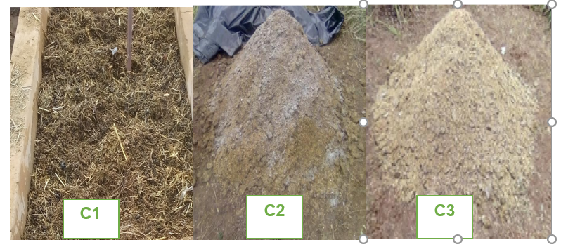
Fig. 1. The biological material (C1 = manure, C2 = cow dung, and C3 = poultry droppings)

    - Methodology
      - Composting by aeration and temperature measurement in a compost bin
The composting technique used was pit composting. Indeed, a compost bin with five (5) compartments of 5 m³ each was used for the preparation of each of the composts.
The five (5) compartment compost bin was modified by reducing the length by 1 m on both sides, with bricks leaving holes to promote air circulation in the pits (Fig. 2).
Temperatures were recorded every week before turning using a probe thermometer. The thermometer probe is attached to a stick allowing it to be plunged into the pit and the temperature to be read from the screen (Fig. 3). The organic manures mainly consist of cow dung, manure, and poultry droppings.

      - Turning of the compost, and measurement of pH and moisture
The composts are turned weekly from one compartment to another throughout the entire composting process. At each turning, the composts are thoroughly mixed and moistened with water (Figure 4). The pH and moisture are measured with the tester each week before turning the compost; the tester consists of two forks that are plunged into the compost and the measurements are taken on the screen (Fig. 5).
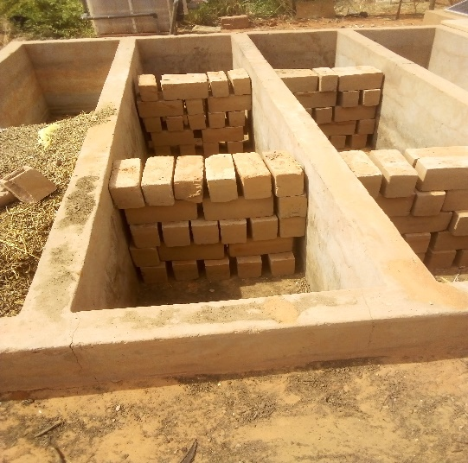
Fig. 2 : Five-compartment composter
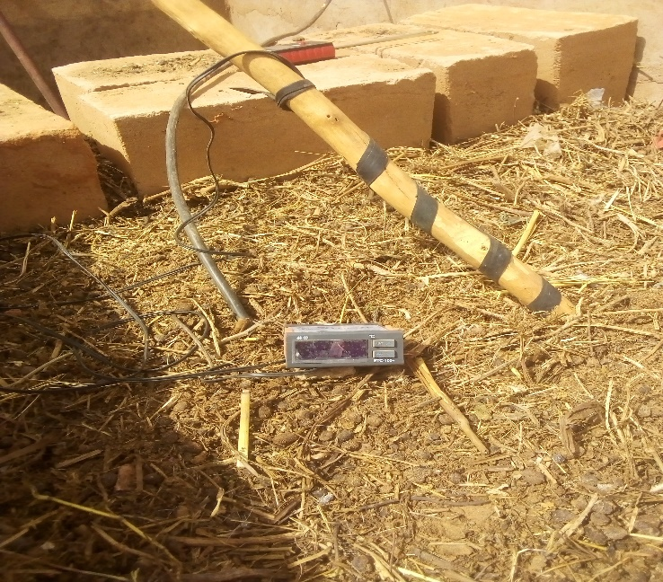
Fig. 3. PT100 probe thermometer
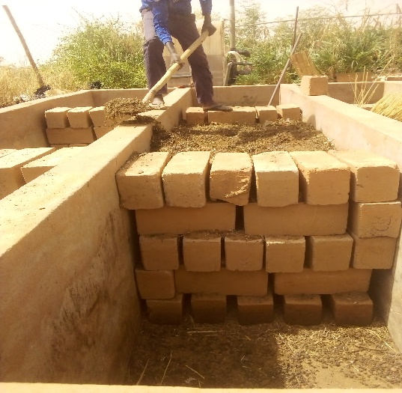
Figure 4: Turning of the compost
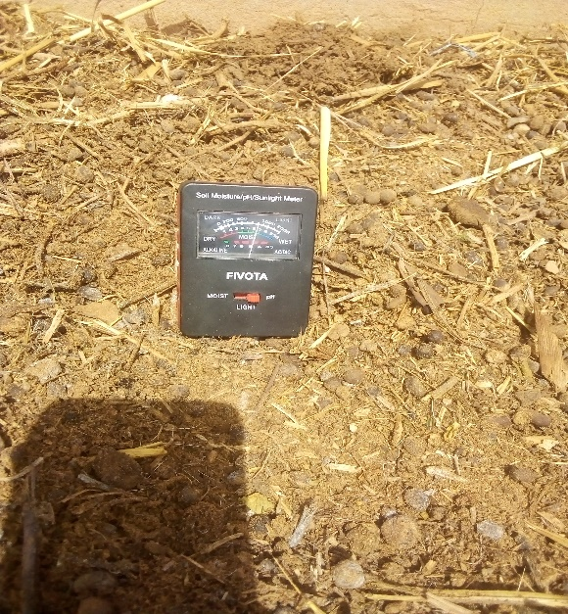
Fig. 5: Measurement of pH and humidity
2.2.2.3. Analysis of the physicochemical and physical properties of composts in the laboratory
The NPK and pH levels of the composts produced were determined by the INRAN soil laboratory (CERRA in Niamey). Five hundred grams (500 g) of manure compost, cow manure, and poultry manure (filtered soluble form) were sampled, respectively, and their physicochemical properties analyzed. This allowed for a discussion of their effectiveness on different crop categories.

- results and discussion
3.1 Results
3.1.1. Obtained composts
Regular visual observations carried out at the compost bin made it possible to note the maturation of the composts in production. Indeed, a mature compost has specific characteristics such as: (i) an ammonia smell, (ii) a temperature similar to room temperature, (iii) a granular appearance, black color, and a pleasant smell (Fig. 6).

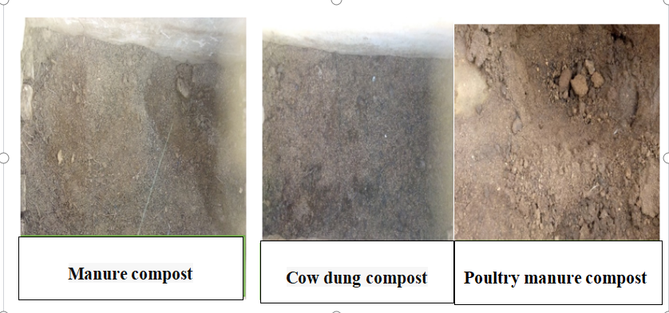Figure 6 : Types of compost obtained poultry manure compost
The composting of the different organic materials is carried out during the times given in Table 1, below:
Table 1: Composting time of different organic materials

Organic matter | Manure | Cow dung | Poultry droppings
Composting duration (in weeks) | 8 | 7 | 11

The analysis of this table shows that cow dung has a shorter composting duration (7 weeks) than manure (8 weeks) and poultry droppings (11 weeks).

3.1.2. Physical aspects and physico-chemical properties of composts
3.1.2.1. Temperature Changes
The temperature changes during the composting process are illustrated in Figure 7 below.
.

Manure
Pouultry droppings

Cow dung
Figure 7 : Temperature changes in compost
Temperature trends during the composting process show that during the mesophilic phase (start-up phase), temperatures are low, with a maximum of 45°C.
Analysis of the curves reveals that the composting temperature of poultry manure is higher than that of cow manure, with a peak of 78.3°C in the sixth week. From the third through the sixth week, corresponding to the thermophilic phase, the temperature drops and then stabilizes, following a slowdown in microbial activity. This slowdown is linked to the stabilization of the organic matter in the compost.
3.1.2.2. Changes in pH
The results showing changes in the pH of the composts are presented in Fig. 8.
Pouultry droppings

Manure

Cow dung
Fig. 8: pH trend curve
Analysis of the pH trend curve during the composting process shows that the pH of poultry manure is more acidic (pH = 2) during the mesophilic phase than that of cow manure. From the mesophilic through to the maturation phases, the pH of poultry manure rises slowly and becomes alkaline starting in the 10th and 11th weeks.
3.1.2.3. Humidity changes
The results showing composts humidity changes are presented in Fig. 9.

Pouultry droppings

Manure
Cow dung

Fig. 9: Changes in composts humidity
An analysis of this graph shows that at the start of the composting process, moisture content is very high (75–80%) in all composts. After this mesophilic phase, moisture content in all three composts drops steadily until the end of the composting process. Moisture is essential during this process to support the metabolic activity of microorganisms.
3.1.2.4. Chemical composition of composts
Table 2 below shows the nutrient mineral contents of the three compost samples analyzed.
Table 2: Nutrient mineral contents of the three compost samples analyzed.
Identification | Contents (%) |  |  |  | pH
Identification | N | P205 | K20 | Standard | pH
Cow dung | 0,80 | 5,57 | 0,66 | 0,5 | 7,28
Manure | 1,23 | 8,50 | 1,28 | 0,5 | 8,44
Poultry droppings | 0,16 | 3,75 | 0,20 | 0,5 | 7,98
An analysis of this table shows that manure contains more nutrients than cow dung and poultry droppings. Specifically, the nutrient content is as follows:
- manure : 1.23%, nitrogen 8.50% phosphorus, and 1.28% potassium ;
- cow manure : 0.80% nitrogen, 5.57% phosphorus, and 0.66% potassium ;
- poultry manure, 0.16% nitrogen, 3.75% phosphorus, and 0.20% potassium.
As for pH, it is alkaline at maturity for all three composts.
3.2. Discussion
The technique used in this study follows the composting principles established by Ihihi et al., (2014) and Ouédraogo (2016); these principles are based on the Carbon/Nitrozen (C/N) ratio, moisture content, aeration, microbial succession, temperature control, and the quality of the final compost, while ensuring environmental and health safety. This enables the production of a stable organic soil amendment that is beneficial for sustainable agriculture.
In our study, the composting process generally resulted in the decomposition of organic matter and mineralization, releasing nutrients rich in humic acids, mineral salts, carbohydrates, proteins, and microorganisms. It is the release of these nutrients during the composting process that accounts for the increase in the levels of physicochemical parameters (pH, moisture, nitrogen, phosphorus, etc.) in the composts produced from manure, cow dung, and poultry droppings. These results are comparable to those of Tahirou (2012), who reported that good compost is dark, black in color, and has an earthy, woody odor, indicating that it has fermented well and is fully decomposed. Indeed, if the material retains a foul odor despite its color, this indicates that it has not yet decomposed; therefore, the decomposition process must be improved.
The results of the temperature changes in the composts during the process showed that, during the mesophilic phase, temperatures ranged between 40 and 50°C. These results differ from those of Misra et al. (2005), who concluded that the ideal temperature for the initial phase of composting is 20 to 45°C. In this study, temperatures in manure-based compost were higher than those in compost made from cow manure and poultry manure. The pH of poultry manure-based compost was more acidic (pH = 2) during the mesophilic phase than that of composts made from cow manure and manure. The acidity of poultry manure is due to its high ammonia content. These results are similar to those of N’Ganzoua (2023), who, by comparing the pH values of poultry manure and cow manure at different composting stages, reported that the pH of cow manure is significantly higher than that of laying hen manure regardless of the composting time. This variation in pH values also showed that the pH of raw, uncomposted cattle manure (pH = 8.1) corresponds to the pH of laying hen manure composted for 56 days (pH = 8.1).
The results showing the moisture content trends of the three composts produced indicated that moisture levels were high during the initial composting phase, at 80%; after this phase, they were maintained between 50% and 60%. These results are similar to those of Mustin (2018), who reported that maintaining adequate moisture is necessary for the composting process to proceed properly. Moisture levels must be maintained between 50% and 60%; watering the compost is necessary to offset water loss. These losses are primarily due to exothermic fermentation reactions, climatic conditions, and the turning of the compost.
Laboratory analyses of the compost produced indicate that manure contains more nutrients (nitrogen, phosphorus, potassium) than cow manure and poultry manure. These results differ from those of Agnadjènou (2023), who showed that composted poultry manure has higher nutrient levels than composted cow manure. However, composted cow manure contains more stable organic matter than composted poultry manure. Similarly, Kouame (2020) reported that cow manure contains primary fertilizer elements, which play a major role in the development of agricultural crops. These include nitrogen in its various forms (NO3-, NO2-, and NH4+), phosphorus, and potassium. Cow manure also contains secondary nutrients such as calcium (Ca), magnesium (Mg), sodium (Na), sulfate (S), and trace elements including copper, iron, and manganese. As for chicken manure, it is rich in primary nutrients such as nitrogen (in the form of nitrate, nitrite, and ammonium), phosphorus (P), and potassium (K). These results suggest that cow manure contains significant amounts of all the primary fertilizer elements and secondary nutrients essential for agricultural crops.
Analysis of the manure filtrate showed that the concentration of primary minerals in the fertilizers present in this filtrate is quite high. In addition, secondary nutrients such as calcium (Ca), magnesium (Mg), sodium (Na), sulfate (SO42-), and trace elements including copper (Cu), iron (Fe), and manganese (Mn) are also present. As for the chicken manure filtrate, it exhibits concentrations of primary minerals (NO3-: 34 ± 3.00 mg/L, NO2-: 1.08 ± 0.02 mg/L, NH4+: 5.99 ± 1.09 mg/L, and PO43-: 265.00 ± 2.00 mg/L) that are higher than those in cow manure (NO3-: 15 ± 1.00 mg/L, NO2-: 0.27 ± 0.02 mg/L, NH4+: 5.41 ± 0.14 mg/L, and PO43: 65 ± 2.00 mg/L). The nature and quality of the fertilizers contained in the compost produced suggest that these composts could be used to improve the fertility and quality of cultivated soils.
The pH levels of the composts produced are all above 7, indicating that they are all mature. These results are similar to those reported by Albrecht (2007) and Temgoua et al. (2012), who noted that composting releases exchangeable cations contained in the composted materials and yields pH values close to 8 in the resulting composts. These pH values are important for assessing compost quality. This criterion is essential for the safe and optimal use of composts to improve soil fertility, and compost serves as a source of nutrients for plants (Attrassi et al. 2007; Tengoua et al., 2014).

4. Conclusion
The study showed that the composting time for cow manure is shorter than that for horse manure and poultry droppings. Additionally, horse manure contains more mineral nutrients than cow manure and poultry droppings. Each of the three composts has a pH higher than 7. This suggests that they could improve the physicochemical properties of degraded soils and enrich poor soils.
Promoting livestock farming alongside agriculture would help ensure the availability of the organic matter essential for producing these three types of compost in sufficient quantity and quality. Similarly, the application of organic amendments is comparable to that of chemical fertilizers, which would allow for a sustainable and effective improvement in soil fertility.

Disclaimer (Artificial intelligence)
Author(s) hereby declare that NO generative AI technologies such as Large Language Models (ChatGPT, COPILOT, etc.) and text-to-image generators have been used during the writing or editing of this manuscript.

References

Agnadjènou, M. (2023). Comparative Study of the Efficacy of Two Types of Organic Compost on the Agro-economic Performance of Amaranth (Amaranthus cruentus L.) in Home Gardens in Benin, 1127 p.
Albrecht, R. (2007). Co-composting of Sewage Sludge and Green Waste: A New Methodology for Monitoring Organic Matter Transformations. Doctoral Thesis, Paul Cézanne University Aix-Marseille III, 189 p.
Attrassi, B., Krimou, D., & Mrabet, L. (2007). Study on the Agronomic Valorization of Household Waste Compost. Revue de Microbiologie Industrielle, Sanitaire et Environnementale, 43 p.
FAO (2025). On-Farm Composting Methods, 8 p.
Ihihi, A., Kitane, M., Lakhtib, I., Bahloul, A., & Benqlilou, C. (2014). Production of a New Balanced Compost from the Fermentable Fraction of Household Waste and Chicken Manure. Scientical Editions Mersenne, 1(1312), 12 p.
INS (2023). Harmonized Survey on Household Living Conditions in Niger, 89 p.
Kouame, K. (2020). Effects of Azolla-based Biofertilizers and Composts on Tomato Cultivation [Solanum lycopersicum L. (Solanaceae), Variety: Boomerang F1] in West-Central Côte d’Ivoire. Doctoral Thesis, 63 p.
Metras, B. (2019). Study and Evaluation of Various Organic Materials via Composting. Master’s Thesis in Agronomy, 27 p.
Misra, R., Roy, N., & Hiraoka, H. (2005). On-farm composting methods. FAO Technical Papers, Land and Water Working Papers, 48 ​​p.
Mustin, M. (1987). Compost: Organic Matter Management, pp. 6–9.
N’Ganzoua, K. (2023). Comparative Effect of Composting Duration on the Chemical Fertility of Two Organic Fertilizers Commonly Used in Market Gardening in Daloa, Côte d’Ivoire, 114 p.
Ouedraogo, R. (2016). Evaluation of the effects of poultry manure, cow manure, and pig manure on bacterial wilt in tomatoes. Final-year thesis for the Diploma in Rural Development Engineering (Agronomy Option). Polytechnic University of Bobo-Dioulasso, Institute of Rural Development, 48 p.
Tahirou, T. (2012). Composting Techniques, 11 p.
Temgoua, E., Ntangmotsafack, H., & Njine, T. (2012). Vegetable production systems in urban swamp zones in Western Cameroon: The case of Dschang. Universal Journal of Research and Technology, 2(2): 83–92.
Temgoua, E., Ngnikam, E., Dameni, H., & Kouedeu Kameni, G.S. (2014). Valorization of household waste through composting in the city of Dschang, Cameroon. TROPICULTURA, 32(1): 28–36.
Useni, S. (2013). Use of recycled human waste to increase maize (Zea mays L.) production on a Ferralsol in southeastern DR Congo. Journal of Applied Biosciences, 66 p.
Zakari, A., Mahamadou, B., & Adam, T. (2016). Agricultural production systems in Niger facing climate change: Challenges and prospects. Int. J. Biol. Chem. Sci. 10(3): 1262-1272, DOI: http://dx.doi.org/10.4314/ijbcs.v10i3.28

