Migratory Waterbirds in Asan Wetland, Uttarakhand, India: Ecology and Conservation Status of a Ramsar Site

Abstract
The Asan Conservation Reserve, a human-engineered freshwater wetland located in the Shivalik foothills of Uttarakhand, India, has been designated as a Ramsar site since 2020 and serves as an important habitat within the Central Asian Flyway (CAF). The wetland supports over 330 avian species, including globally threatened taxa such as Aythya baeri, Aquila nipalensis, and Haliaeetus leucoryphus, highlighting its international conservation significance. This review synthesizes existing literature and recent datasets to evaluate avian diversity, migration dynamics, and ecological processes at the site. Standardized observations from the Asian Waterbird Census indicate that 5,806 individuals across 126 species were recorded in January 2026, confirming the wetland’s continued importance as a wintering ground for migratory waterbirds. Analysis of recent studies (2023–2025) suggests that waterbird distribution and abundance are closely associated with key environmental variables, including water level fluctuations, nutrient availability, and habitat heterogeneity. However, increasing anthropogenic pressures, such as unregulated tourism, habitat disturbance, and the spread of invasive macrophytes, are altering habitat structure and influencing species composition. Despite improvements in monitoring following Ramsar designation, a gap persists between data generation and effective ecological management. The findings emphasize the need for integrated, science-based conservation strategies that incorporate hydrological regulation, habitat restoration, and long-term ecological monitoring. Strengthening such approaches is essential to maintaining the ecological integrity and functional sustainability of this globally significant wetland within the Central Asian Flyway.
Keywords: Asan Wetland; Ramsar Site; migratory Waterbirds; Central Asian Flyway; Wetland ecology; Asian Waterbird Census; Habitat heterogeneity
1. Introduction
Wetlands are among the most ecologically significant ecosystems on Earth, characterized by hydrological regimes that regulate their physical, chemical, and biological processes. These ecosystems provide essential services such as flood mitigation, groundwater recharge, nutrient cycling, and carbon sequestration, particularly through the retention and transformation of nitrogen and phosphorus. In addition, wetlands function as major carbon sinks and play a crucial role in regulating local and global climate systems under changing environmental conditions (Moomaw et al., 2018). Owing to their high primary productivity and structural heterogeneity, wetlands support diverse biological communities, especially avifauna, by providing critical habitats for feeding, breeding, and migratory stopovers (Kumar & Gupta, 2009; Newton, 2008).
Avian migration is a key ecological strategy that enables birds to exploit seasonal resource availability across geographically distinct regions (Newton, 2008). The Indian subcontinent serves as a major wintering ground within the Central Asian Flyway (CAF), a transcontinental migratory route linking Arctic and sub-Arctic breeding areas with South Asian wetlands (BirdLife International, 2023). Migratory waterbirds, particularly those belonging to the family Anatidae, depend on a network of ecologically interconnected wetlands that function as staging and wintering sites during energetically demanding trans-Himalayan migrations (Miyabayashi & Mundkur, 1999). These species exhibit strong site fidelity, returning to the same wetlands annually, thereby making the ecological stability of these habitats critical for maintaining population dynamics at the flyway scale (Newton, 2008). Habitat characteristics such as water depth gradients, macrophyte density, and invertebrate availability play a decisive role in determining species distribution and abundance patterns (Kumar & Gupta, 2009).
The Asan Conservation Reserve (ACR), located in the Western Doon Valley of Uttarakhand, represents a key freshwater wetland within the Central Asian Flyway network. This human-engineered ecosystem, formed at the confluence of the Asan and Yamuna rivers, covers approximately 444.4 hectares and was designated as a Ramsar Site in 2020 (Ramsar Convention Secretariat, 2021). The wetland exhibits significant habitat heterogeneity, including deep open water, shallow marshes, and emergent vegetation dominated by Typha and Phragmites, with water depths typically ranging from approximately 0.5 m in littoral zones to over 5 m in deeper sections (Ramsar Convention Secretariat, 2021). These conditions support more than 330 avian species and sustain over 1% of the biogeographic population of certain migratory waterbirds, notably the Ruddy Shelduck (Tadorna ferruginea) (Ramsar Convention Secretariat, 2021; Sondhi & Kumar, 2025). Standardized monitoring through the Asian Waterbird Census has recorded peak winter assemblages exceeding 5,800 individuals across more than 120 species, highlighting the site’s ecological importance at both regional and global scales (Asian Waterbird Census, 2026).
Despite its international recognition, the ecological integrity of the Asan Conservation Reserve is increasingly threatened by anthropogenic pressures. Land-use changes, including livestock grazing and unregulated tourism, contribute to habitat disturbance and nutrient enrichment (Singh & Bhatt, 2025). The proliferation of invasive macrophytes such as Eichhornia crassipes further alters habitat structure and reduces foraging efficiency for waterbirds (Naik et al., 2022). In addition, hydrological regulation through barrage operations results in abrupt water level fluctuations, which can negatively affect feeding habitats, particularly for wading species (Sharma et al., 2024). Although recent studies have improved the documentation of species diversity and seasonal dynamics, a critical gap remains in understanding how environmental variables interact to shape avian community structure (Bhatt & Rawat, 2024; Pathak et al., 2025).
The present review aims to synthesize existing scientific literature and recent monitoring data to evaluate patterns of avian diversity, migration ecology, and ecological pressures at the Asan Conservation Reserve. Furthermore, the study seeks to identify key knowledge gaps and provide a conceptual framework for linking environmental variables with avian community dynamics, thereby contributing to the development of adaptive wetland management strategies within the Central Asian Flyway.
Study Area
The Asan Conservation Reserve, located in the Western Doon Valley of Uttarakhand, is a human-engineered freshwater wetland formed at the confluence of the Asan and Yamuna rivers (Fig. 1). The reserve covers approximately 444.4 hectares and lies at an elevation of 380-400 m (Ramsar Convention Secretariat, 2021).
The wetland experiences a humid subtropical climate with annual rainfall ranging from 1800 to 2200 mm. Hydrological conditions are influenced by both monsoonal inputs and barrage regulation, resulting in seasonal variation in water levels. The site supports diverse habitats, including open water, marshes, and emergent vegetation dominated by Typha and Phragmites, which contribute to ecological heterogeneity.
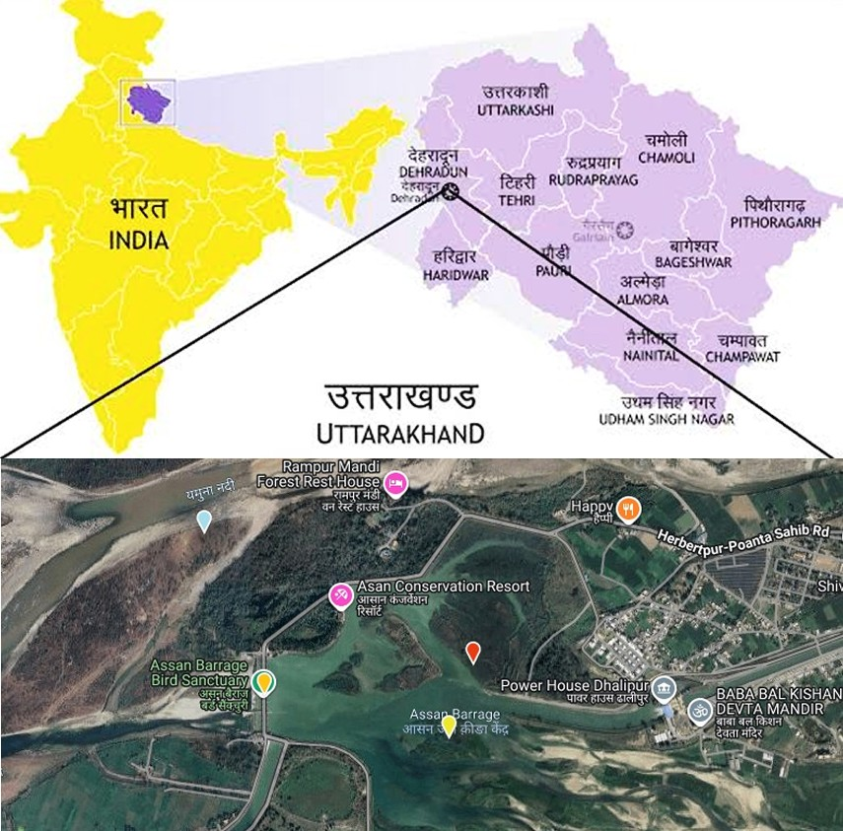
Fig. 1: Location Map of Asan Wetland, Uttarakhand, India

Methodology:
A systematic review of published literature was conducted to synthesize information on wetland ecology, avian diversity, and migration patterns associated with the Asan Conservation Reserve. Relevant studies published between 1995 and 2026 were retrieved from major academic databases, including Scopus, Web of Science, and Google Scholar, along with institutional repositories such as the Ramsar Sites Information Service, Wetlands International, and the Zoological Survey of India. A structured keyword-based search strategy was applied using Boolean operators, with search strings including combinations such as “Asan Conservation Reserve” and “waterbird diversity”, “wetland ecology” and “avian migration”, and “Central Asian Flyway” and “waterbirds”. The identified studies were screened based on relevance and scientific quality through a two-stage process involving title and abstract screening followed by full-text evaluation. Only studies focusing on wetland ecology, waterbird diversity, and migration patterns, and providing quantitative or observational ecological data relevant to the Central Asian Flyway, were included, along with reports from recognized organizations such as the Asian Waterbird Census and Ramsar Convention. Non-peer-reviewed sources, anecdotal records, and duplicate or outdated studies were excluded. The selected literature was synthesized using a thematic approach, focusing on avian diversity, migration dynamics, habitat utilization, and anthropogenic pressures, with recent datasets from the Asian Waterbird Census (2024-2026) incorporated to support temporal analysis of population trends.

Findings and Discussion
Avian Diversity and Population Trends
Recent assessments from the Asian Waterbird Census (AWC) provide a robust baseline for evaluating avian diversity at the Asan Conservation Reserve. During the 2025-2026 winter cycle, a total of 5,806 individuals representing 126 species were recorded in 2026, compared to 5,225 individuals and 117 species in 2025, indicating a moderate increase in both population abundance and species richness (Table 1). This upward trend suggests relatively favourable ecological conditions during the study period, although such inter-annual fluctuations are characteristic of migratory bird populations and are often influenced by climatic variability and habitat conditions across the flyway (Newton, 2008).
Table 1: Recent quantitative data from Asian Waterbird Census (AWC) 2025-26.
Census | Total Individuals | Species Count | Notable Global Taxa
2025 | 5225 | 117 | Sarus Crane, Black-necked Stork, Northern Pintail
2026 | 5806 | 126 | Steppe Eagle, Common Pochard, Ferruginous Duck
The avian community at Asan is strongly dominated by waterfowl, particularly members of the family Anatidae, which constitute the largest proportion of winter migrants. This dominance reflects the suitability of the wetland’s hydrological conditions and food availability for dabbling and diving ducks. Field observations of mixed-species aggregations, where multiple taxa utilize shared foraging and resting grounds, further indicate efficient resource partitioning and collective anti-predator strategies, both of which enhance survival during energetically demanding wintering periods (Fig. 2).
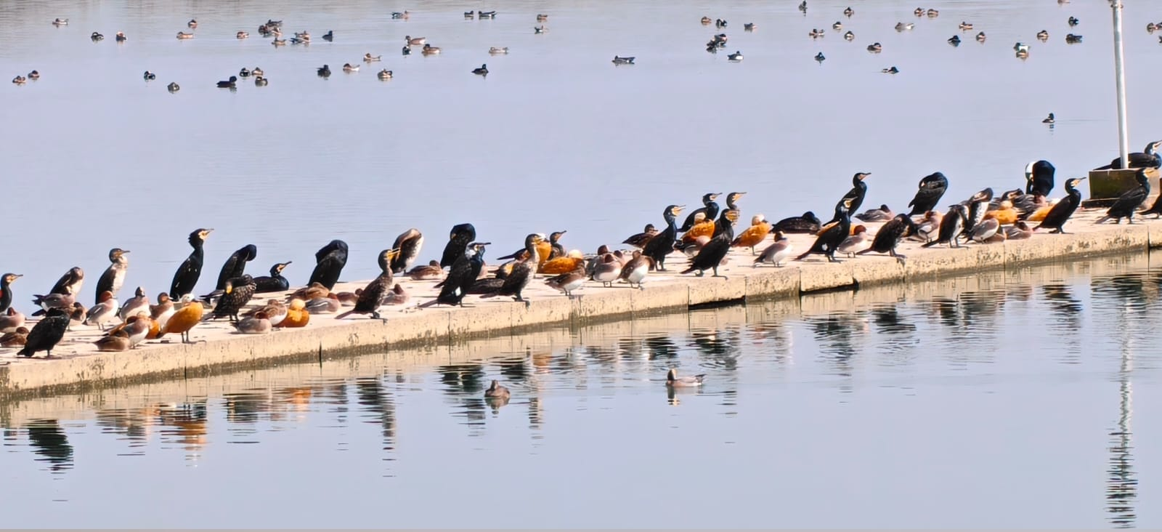
Fig. 2: A mixed flock of migratory waterbirds resting and foraging on the Asan Barrage
Despite the observed increase in overall abundance, the composition of species assemblages may vary annually, with certain taxa showing fluctuations in occurrence and visibility. Such variation highlights the dynamic nature of wetland ecosystems and underscores the importance of long-term monitoring datasets, such as those provided by the AWC, for accurately assessing population trends and ecological stability. Overall, the consistently high species richness and population density recorded at Asan reinforce its role as a critical wintering habitat within the Central Asian Flyway.
Functional Guild Structure and Trophic Organization
The ecological guild classification of waterbirds at the Asan Conservation Reserve reveals a well-structured trophic organization supported by habitat heterogeneity. Based on functional roles, the avian community is categorized into herbivores/omnivores (dabbling and diving ducks), grazers (geese), benthic feeders (waders), piscivores (cormorants and herons), and apex predators (raptors), as presented in Table 2. The dominance of herbivorous and omnivorous taxa, particularly members of the Anatidae, reflects the availability of aquatic vegetation and primary productivity within the wetland. Shallow littoral zones and mudflats support benthic feeders such as waders, which rely on macroinvertebrate-rich substrates. In contrast, deeper water zones sustain piscivorous species, indicating vertical niche partitioning within the habitat. The presence of raptors such as Haliaeetus leucoryphus further suggests the existence of higher trophic levels and a relatively intact food web.
Table 2: Ecological guild classification of waterbirds at Asan Wetland based on taxonomic groups and functional roles
Group | Representative Families | Ecological Role
Dabbling and Diving Ducks | Anatidae (Aythya, Anas) | Herbivore, Omnivore
Geese | Anatidae (Anser) | Grazing
Waders | Scolopacidae, Charadriidae | Benthic Feeders
Piscivorous Birds | Ardeidae, Phalacrocoracidae | Fish Predation
Raptors | Accipitridae | Top Predators

This distribution of functional guilds indicates efficient energy transfer across trophic levels and highlights the ecological stability of the wetland system. However, increasing macrophyte density and habitat modification may gradually shift guild composition by reducing open foraging areas, particularly for waders and diving species. Such structural changes could alter trophic interactions and impact overall ecosystem functioning over time.
Species Composition and Conservation Significance
The taxonomic composition of waterbirds at the Asan Conservation Reserve demonstrates a high proportion of migratory species originating from Central Asia, Eurasia, and adjoining regions, reflecting its strategic location within the Central Asian Flyway. A detailed ecological and conservation profile of major species is presented in Table 3.
Table 3: Taxonomic and ecological profile of major waterbird species at Asan Wetland

Common Name | Scientific Name | IUCN Status | Migration Status | Flyway Origin | Habitat Use
Ruddy Shelduck | Tadorna ferruginea | Least Concern | Winter Migrant | Central Asia | Open water
Bar-headed Goose | Anser indicus | Least Concern | Long-distance Migrant | Tibet/Mongolia | Shallow wetlands
Greylag Goose | Anser anser | Least Concern | Migratory | Eurasia | Wet grasslands
Common Pochard | Aythya ferina | Vulnerable | Migratory | Europe/  Central Asia | Deep Water
Ferruginous Duck | Aythya nyroca | Near Threatened | Migratory | West Asia | Marshes
Red-crested Pochard | Netta rufina | Least Concern | Migratory | Central Asia | Lakes
Northern Pintail | Anas acuta | Least Concern | Migratory | Arctic Eurasia | Shallow wetlands
Gadwall | Mareca strepera | Least Concern | Migratory | Eurasia | Freshwater wetlands
Eurasian Wigeon | Mareca penelope | Least Concern | Migratory | Northern Eurasia | Wetlands
Tufted Duck | Aythya fuligula | Least Concern | Winter migrant | Central Asia /Eurasia | Deep water (diving duck)
Common Teal | Anas crecca | Least Concern | Winter migrant | Eurasia | Shallow wetlands
Northern Shoveler | Spatula clypeata | Least Concern | Migratory | Eurasia | Shallow water (filter feeding)
Mallard | Anas platyrhynchos | Least Concern | Winter migrant | Eurasia | Open Freshwater wetlands
Common Merganser | Mergus merganser | Least Concern | Winter migrant | Central Asia / Eurasia | Deep open water (fish-eating)
Great Crested Grebe | Podiceps cristatus | Least Concern | Winter migrant | Eurasia | Deep open water
Eurasian Coot | Fulica atra | Least Concern | Migratory / Resident | Eurasia | Open water & marsh edges
Great Cormorant | Phalacrocorax carbo | Least Concern | Resident / Migratory | Eurasia | Open water (piscivorous)
River Lapwing | Vanellus duvaucelii | Near Threatened | Resident /Migrant | South Asia | Riverbanks
Black-bellied Tern | Sterna acuticauda | Endangered | Migratory | South Asia | Riverine
Pallas’s Fish Eagle | Haliaeetus leucoryphus | Endangered | Migratory | Central Asia | Large water bodies

The wetland supports several globally threatened species, underscoring its international conservation importance. Notably, species such as Aythya baeri (Critically Endangered), Haliaeetus leucoryphus (Endangered), and Aythya ferina (Vulnerable) have been recorded, indicating the availability of suitable habitats for sensitive and declining taxa. Additionally, Near Threatened species including Aythya nyroca, Vanellus duvaucelii, and Mycteria leucocephala are regularly observed, further emphasizing the ecological value of the site.
Among all species, the Ruddy Shelduck (Tadorna ferruginea) remains the most dominant in terms of abundance, consistently exceeding the 1% biogeographic population threshold required for Ramsar designation. This not only validates the international status of the wetland but also highlights its role in supporting key populations within the migratory network.
Overall, the presence of both common and threatened species, along with a diverse migratory assemblage, indicates that the Asan wetland functions as a critical refuge within the flyway. However, continued monitoring is essential, as shifts in species composition may serve as early indicators of ecological change and habitat degradation.
Seasonal Dynamics and Migration Patterns
Waterbird populations at the Asan Conservation Reserve exhibit pronounced seasonal variation aligned with migration cycles within the Central Asian Flyway. The seasonal abundance pattern shows a gradual increase in species richness and population size beginning in October, followed by a peak during December-January, and a subsequent decline toward March-April as birds initiate return migration (Fig. 3).
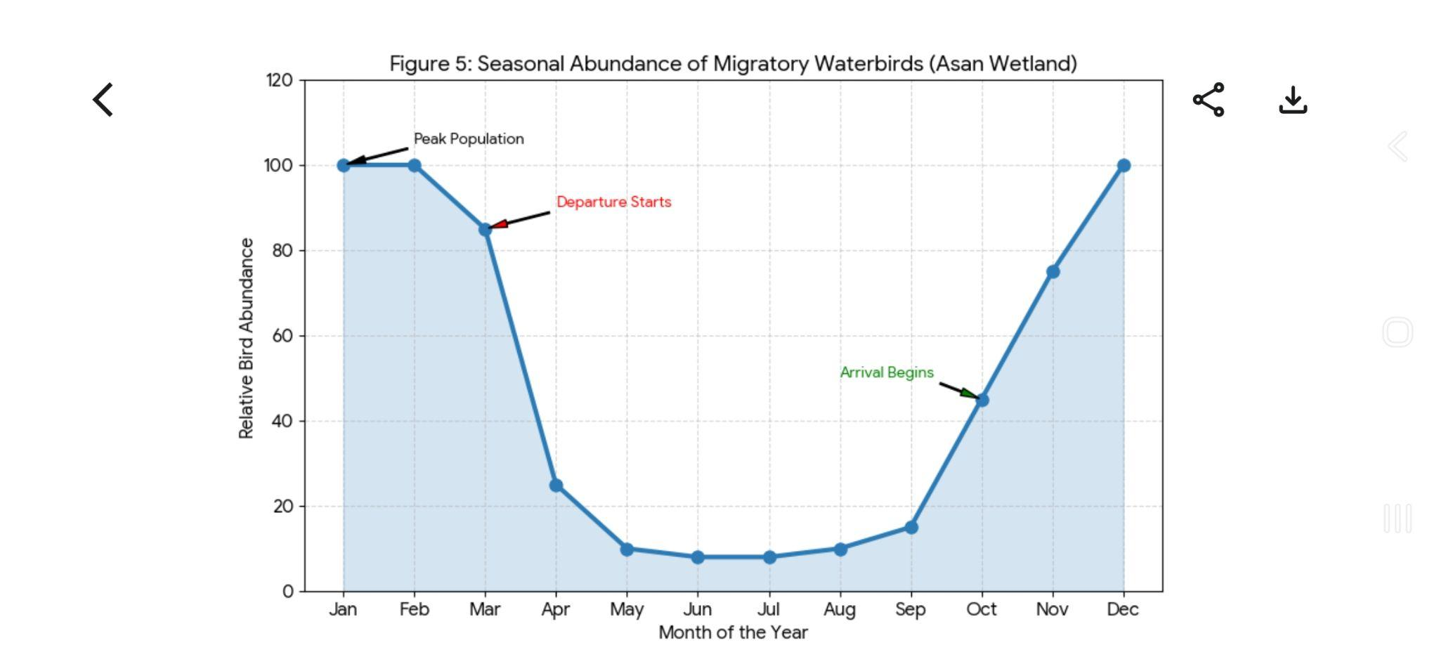
Fig. 3. Seasonal Abundance of Migratory Waterbirds in Asan Wetland

This temporal pattern reflects the synchronization between migratory arrival and optimal habitat conditions. During mid-winter, relatively stable water levels, moderate temperatures, and increased food availability particularly aquatic vegetation and macroinvertebrates-create favourable conditions for large congregations of waterbirds. In contrast, the decline in abundance after February corresponds with rising temperatures and physiological triggers for northward migration to breeding grounds (Newton, 2008).
The observed seasonal dynamics also indicate that habitat suitability at Asan is temporally structured, with different guilds utilizing the wetland at varying intensities across the winter period. Dabbling ducks and waders, for instance, show peak activity when shallow feeding zones are most accessible. Such patterns highlight the importance of maintaining stable hydrological conditions during critical winter months to support peak biodiversity.
Flyway Connectivity and Migration Ecology
The Asan Conservation Reserve functions as an important wintering and stopover site within the Central Asian Flyway, supporting migratory connectivity between breeding regions in northern Eurasia and wintering grounds in the Indian subcontinent. The spatial linkage of these migratory routes is illustrated in Fig. 4, which highlights the dependence of waterbirds on a network of ecologically interconnected wetlands across international boundaries.
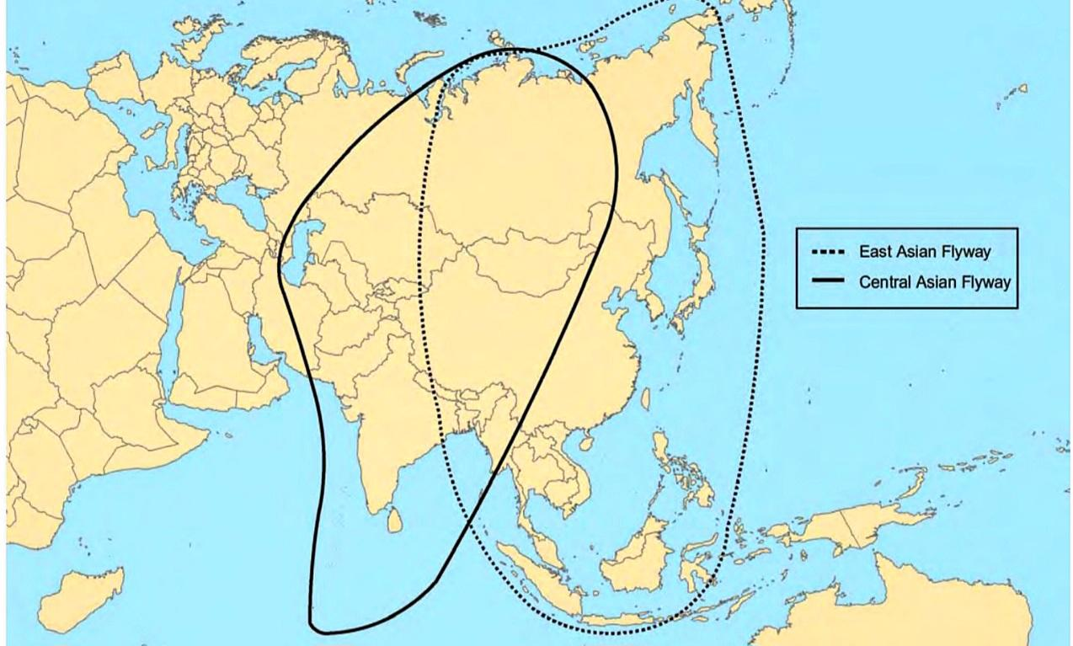
Fig. 4. Central Asian Flyway Map (Source: Miyabayashi & Mundkur 1999)

Migratory species utilizing Asan undertake long-distance trans-Himalayan flights and rely on wetlands such as this for energy replenishment and survival during migration (Miyabayashi & Mundkur, 1999). The repeated annual use of the site by many species indicates strong site fidelity, emphasizing its ecological reliability within the flyway system (Newton, 2008).
Advancements in migration research, including bird banding and tracking techniques, have significantly improved the understanding of migration routes, stopover ecology, and population connectivity. These methods provide critical insights into species movement patterns and are essential for developing coordinated conservation strategies at the flyway scale.
Overall, the ecological role of Asan extends beyond a local wetland, functioning as a vital node within a broader migratory network. Any degradation of such sites may have cascading impacts on migratory populations across the entire flyway, underscoring the need for integrated and transboundary conservation approaches.
Anthropogenic Pressures and Ecological Implications
Despite its ecological significance, the Asan Conservation Reserve is increasingly influenced by anthropogenic pressures that affect habitat quality and avian community structure. One of the primary stressors is unregulated tourism, including boating and vehicular movement, which generates frequent disturbances. Such disturbances often cause repeated flushing of sensitive species (e.g., dabbling ducks), leading to reduced feeding efficiency and increased energy expenditure during the critical wintering period (Singh & Bhatt, 2025).
Land-use practices within and around the wetland further exacerbate habitat degradation. Intensive livestock grazing and biomass extraction alter vegetation structure and contribute to nutrient enrichment through organic waste inputs. This process accelerates eutrophication, promoting excessive growth of macrophytes and reducing open water availability.
The spread of invasive species, particularly Eichhornia crassipes, represents a significant ecological challenge. Dense mats of this species restrict light penetration, decrease dissolved oxygen levels, and physically limit access to foraging habitats for waterbirds, especially dabbling ducks and waders (Naik et al., 2022). In addition, native macrophytes such as Typha angustifolia can become overly dominant under nutrient-rich conditions, further contributing to habitat homogenization.
Hydrological regulation through barrage operations introduces abrupt water level fluctuations, which disrupt feeding habitats, particularly shallow mudflats used by waders (Sharma et al., 2024). Such fluctuations can alter prey availability and reduce habitat suitability during peak migratory periods.
Collectively, these pressures indicate that while the wetland continues to support high biodiversity, its ecological balance is increasingly vulnerable. If not managed effectively, these stressors may lead to long-term shifts in species composition, particularly affecting specialist and sensitive taxa.
Pre- and Post-Ramsar Ecological Assessment
A comparative analysis of ecological conditions before and after the Ramsar designation (2020) reveals a notable shift in monitoring practices and data availability at the Asan Conservation Reserve (Table 4).
Prior to Ramsar recognition, ecological assessments were largely qualitative and irregular, primarily consisting of species checklists and opportunistic observations. In contrast, the post-Ramsar phase has been characterized by systematic and standardized monitoring, particularly through the Asian Waterbird Census (AWC), resulting in more reliable and comparable datasets on species richness and population trends.

Table 4. Changes at Asan Conservation Reserve Pre and Post Ramsar Designation
Aspect | Parameter | Pre-Ramsar  (~2020) | Post Ramsar (2020-2026) | Reference
Avian diversity | Total bird species | ~330 sp. known | ~330 sp. confirmed | Ramsar Sites Information Service, 2020
Waterbird census | Counts | Irregular | Annual systematic counts (~126–141 species) | Asian Waterbird Census (AWC), 2024; 2026
Migration ecology | Migration & flyway data | Limited systematic data | Quantitative seasonal AWC data | Asian Waterbird Census (AWC), 2026
Habitat & management | Habitat monitoring | Limited | Improved under Ramsar status | Ramsar Sites Information Service, 2020
Pollution/  disturbance | Monitoring | Limited | Some monitoring, ongoing | -
Conservation status | Legal protection | Conservation Reserve | Ramsar Site designation (Jul 2020) | Ramsar Sites Information Service, 2020
Scientific monitoring | Data type/quality | Qualitative | Quantitative system (AWC) | Asian Waterbird Census (AWC), 2026
This transition has significantly improved the scientific understanding of avian diversity and seasonal dynamics at the site. However, despite advancements in monitoring, there is limited evidence of corresponding improvements in on-ground habitat management. Key ecological issues such as invasive species proliferation, hydrological instability, and anthropogenic disturbances remain persistent. This disconnect highlights a clear policy-practice gap, where increased institutional recognition and data generation have not yet translated into effective conservation outcomes. While Ramsar designation has strengthened the framework for monitoring and reporting, its success ultimately depends on the implementation of adaptive management strategies that address site-specific ecological challenges.
Therefore, bridging this gap requires integrating scientific data with practical conservation actions, including habitat restoration, regulation of human activities, and long-term ecological monitoring. Without such interventions, the ecological gains achieved through Ramsar recognition may remain largely administrative rather than functional.
Conclusion
The synthesis of recent datasets and published literature indicates that the Asan Conservation Reserve functions as a structurally complex and ecologically significant wetland within the Central Asian Flyway. While current observations suggest that the wetland continues to sustain diverse waterbird assemblages, underlying ecological processes reveal emerging vulnerabilities linked to habitat modification and hydrological instability.
A key insight from this review is that avian diversity at the site is not solely dependent on species presence, but on the dynamic interaction between hydrological regimes, habitat heterogeneity, and food resource availability. Subtle shifts in these factors particularly vegetation overgrowth have the potential to alter functional guild composition and long-term community structure.
Despite advancements in standardized monitoring following Ramsar designation, conservation outcomes remain constrained by limited integration between scientific data and management actions. This highlights the need to move beyond descriptive assessments toward process-based and adaptive ecological management. Therefore, the long-term sustainability of the Asan wetland depends on maintaining ecological functionality rather than solely preserving species counts.

Recommendations
Effective conservation of the Asan Conservation Reserve requires a shift toward integrated, process-oriented management strategies:
- Functional Habitat Management: Rather than only controlling invasive species, management should focus on maintaining habitat heterogeneity, particularly the balance between open water and vegetated zones.
- Targeted Conservation for Sensitive Guilds: Monitoring programs should prioritize guild-level responses (e.g., waders, diving ducks) as early indicators of ecological change.
- Disturbance Zonation: Spatial zoning of human activities should be implemented to create low-disturbance refuges during peak migratory periods.
- Integrated Monitoring Framework: Future monitoring should link avian data with environmental variables such as water depth, nutrient levels, and vegetation dynamics to enable predictive ecological assessments.
- Flyway-Scale Coordination: Given its ecological role, conservation planning should align with broader Central Asian Flyway initiatives to ensure continuity of migratory pathways.

Disclaimer (Artificial intelligence)
Author(s) hereby declares that NO generative AI technologies such as Large Language Models (ChatGPT, COPILOT, etc.) and text-to-image generators have been used during the writing or editing of this manuscript.

References
- Asian Waterbird Census. (2026). Status of waterbirds in the wetlands of India: Annual report 2024–2026. Wetlands International South Asia. https://south-asia.wetlands.org/publications/
- Bhatt, D., & Rawat, G. S. (2024). Longitudinal shifts in avian community structure at Asan Conservation Reserve: A three-decade meta-analysis. Journal of Himalayan Ecology, 12(3), 145–162.
- BirdLife International. (2023). State of the world's birds: Annual review of global flyways. Cambridge, UK: BirdLife International. https://www.birdlife.org/projects/state-of-the-worlds-birds/
- Kumar, A., & Gupta, S. (2009). Habitat selection and foraging ecology of migratory waterfowl in the Shivalik foothills. Indian Journal of Forestry, 32(4), 589–598.
- Miyabayashi, Y., & Mundkur, T. (1999). Atlas of key sites for Anatidae in the East Asian Flyway. Wetlands International, Japan, 1–148.
- Moomaw, W. R., Chmura, G. L., Davies, G. T., Finlayson, C. M., Middleton, B. A., Natali, S. M., ... & Sutton-Grier, A. E. (2018). Wetlands in a changing climate: Science, policy and management. Wetlands, 38(2), 183–205.
- Naik, S., Prasad, K., & Negi, R. S. (2022). Impact of invasive Eichhornia crassipes on the foraging behavior of wintering Anatidae in Ramsar sites of North India. Aquatic Botany and Management, 28(1), 44–53.
- Newton, I. (2008). The migration ecology of birds. Academic Press, London, 1–984.
- Pathak, H., Sharma, G., & Kumar, R. (2025). Non-random habitat utilization and seasonal phenology of waterbirds at the Asan Barrage, Uttarakhand. Journal of Threatened Taxa, 17(2), 24102–24118.
- Ramsar Convention Secretariat. (2021). Ramsar Information Sheet (RIS): Asan Conservation Reserve, India (Site No. 2437). Gland, Switzerland. https://rsis.ramsar.org/ris/2437
- Sharma, P., Joshi, K., & Gairola, S. (2024). Hydrological regulation and its impact on the feeding ecology of migratory waders in human-engineered wetlands. Wetland Ecology and Management, 32(5), 677–692.
- Singh, V., & Bhatt, D. (2025). Influence of water quality and nutrient loading on avian diversity in the Western Doon Valley. Environmental Monitoring and Assessment, 197(1), 12–28.
- Sondhi, S., & Kumar, S. (2025). An annotated checklist of the birds of Uttarakhand. Bishen Singh Mahendra Pal Singh, Dehradun, 1–320.

