Changes in physico-chemical properties of sesame seed oil due to infestation of Aspergillus flavus Link. and Penicillium implicatum Biourge

ABSTRACT
Sesame seeds (Sesamum indicum L.) are nutritionally rich but highly susceptible to seed-borne fungi, which reduce seed viability and degrade oil quality. Fungal infestation, particularly by Aspergillus and Penicillium species, causes significant physicochemical changes in oil, including increased acidity and altered fatty acid composition. The present study was undertaken to investigate the seed-borne mycoflora associated with sesame (Sesamum indicum L.) and to evaluate the impact of fungal infestation on the physico-chemical properties of sesame seed oil. Seed samples were collected from four districts of Rajasthan, namely Jodhpur, Bikaner, Udaipur, and Chittorgarh. Mycoflora were isolated using standard blotter and agar plate methods, both with and without surface sterilization using 0.1% mercuric chloride. A total of 23 fungal species belonging to 18 genera were identified, with Aspergillus, Fusarium, Penicillium, and Alternaria were the most prevalent genera. The incidence of mycoflora was comparatively lower in pretreated seeds than in untreated seeds, indicating the effectiveness of surface sterilization. The seed germination percentage ranged from 32% to 87% using the blotter method and from 30% to 90% using the agar plate method, higher germination was observed in pretreated seeds. The effect of two storage fungi, Aspergillus flavus and Penicillium implicatum, on oil quality was evaluated. Both fungi reducted in oil content, with P. implicatum causing greater deterioration. A significant increase in free fatty acid content was observed, particularly in seeds infected with A. flavus, indicating lipid hydrolysis. The saponification value increased with fungal infestation, suggesting the formation of lower-molecular-weight fatty acids, whereas iodine value decreased, reflecting a reduction in unsaturated fatty acids. The study highlights the critical role of seed-borne fungi in degrading seed quality and oil composition, emphasizing the need for proper storage and management practices to ensure seed health and oil quality.
Keywords: Sesame, seed borne mycoflora, fatty acids, saponification value, Iodine value.

1. INTRODUCTION
Sesame (Sesamum indicum L.), belonging to the family Pedaliaceae, is one of the oldest cultivated oilseed crops. It holds significant agricultural, nutritional, and economic importance worldwide. It is widely grown in tropical and subtropical regions, with India being one of the leading producers (Bedigian, 2012; FAO, 2010; DOR, 2013; DRMR, 2015). Sesame seeds are rich in oil (44–58%), proteins, carbohydrates, minerals, and bioactive compounds such as lignans, tocopherols, and phytosterols. These compounds contribute to sesame seeds antioxidant and therapeutic properties (Amienyo et al., 2015; Chavan, 2011; Ghosh et al., 2018; Srivastava et al., 2021).
Despite their high nutritional value, sesame seeds are highly susceptible to deterioration during storage due to infestation by seed-borne fungi. These fungi adversely affect seed viability, germination, and biochemical quality (Christensen, 1957; Jyoti and Malik, 2013; McDonald, 1999). A wide range of fungal genera, including Aspergillus, Penicillium, Fusarium, Alternaria, and Rhizopus, have been reported in association with sesame and other oilseeds (Mishra and Kanaujia, 1973; Altaf et al., 2004; Kumar et al., 1984; Rao et al., 2015; Reddy, 1993). Similar observations have been reported in other oilseed crops across different agro-climatic regions (Chukunda et al., 2015; Dawar and Ghaffar, 1991; Nandi et al., 1982; Ghosh et al., 2018).
The seed mycoflora may originate from field conditions, harvesting processes, or storage environments. Its development is largely influenced by environmental factors such as moisture, temperature, and storage duration (Mondal et al., 1981; Nandi et al., 1982). Prolonged storage under unfavorable conditions promotes fungal growth and mycotoxin production, which poses serious risks to seed quality and human health (Alemayehu et al., 2023; Ouali et al., 2023). Fungal invasion - depletes seed reserves, as microorganisms utilize lipids, proteins, and carbohydrates for their metabolic activities (Kakde et al., 2012; Kakde and Chavan, 2011; Mukherjee et al., 1992).
Standard seed health testing techniques, such as the blotter and agar plate methods, are commonly used for the detection of seed-borne fungi (De Tempe, 1953; Anonymous, 1966; Muskett, 1948; ISTA, 1976). However, the efficiency of these methods varies depending on fungal growth characteristics (Kaur et al., 1990; Khattak et al., 1993). Seed pretreatment methods have been shown to reduce the fungal load and improve germination (Enikuomehin, 2010; Upadhyay and Singh, 1978).
Fungal infestation also causes significant physico-chemical changes in oil quality. The lipolytic enzymes secreted by fungi hydrolyze triglycerides into free fatty acids, leading to increased acidity and oil deterioration (Mbah and Akueshi, 2001; Sharma, 1977). Changes in saponification and iodine values further indicate the breakdown of fatty acids and a reduction in unsaturation (Chavan, 2011; Sarkate and Badar, 2022). Previous studies have identified storage fungi such as Aspergillus flavus and Penicillium spp. as major contributors to oil degradation (Begum et al., 2013; Mbah and Akueshi, 2001).
Given the economic importance of sesame and the detrimental effects of fungal infestation, this study aims to investigate the seed mycoflora associated with sesame seeds from different districts in Rajasthan and to evaluate changes in physico-chemical properties of sesame oil caused by A. flavus and P. implicatum.

2. MATERIALS AND METHODS
2.1 Isolation of seed mycoflora and their percentage frequency
2.1.1 Incubation test- Standard International rules for seed testing (ISTA, 1976) has been followed throughout these studies. These rules were used to determine the range of mycoflora associated with the seeds. Samples were used separately. Seed mycoflora was isolated by two methods: the Blotter Test and Agar Plate test.
2.1.1.1 The Blotter Test- The blotter test is a combination of in vitro and in vivo principles of investigation. In these studies, sterilized blotters of the size of the Petri plates were placed in sterilized Petri plates and moistened. Two hundred (200) seeds of each sample were tested. Twenty-five (25) seeds were kept in each petriplate containing moist blotters. The plates were incubated in a growth chamber at 28°C under alternate cycle of 12 hours of lights and 12 hours of darkness. Seven days after planting, the fungal growth from the seeds was examined under a microscope to identify the types of spores produced. Final observations were recorded after fifteen days and percentage seed germination was also recorded after fifteen days. The same procedure was repeated when seeds were pretreated with 0.1 percent mercuric chloride for two minutes followed by three washing with sterile distrilled water.

2.1.1.2 The Agar Plate test
Two hundred seeds from each sample were tested without pretreatment with 0.1 percent mercuric chloride for two minutes followed by three washing in sterile distilled water. Twenty-five seeds were kept in each petriplate containing Potato Dextrose Agar (PDA). The plates were then incubated in growth chamber under alternate cycle of 12 hours of light and 12 hours of darkness. Seven days after planting, the fungal growth from the seeds was examined under a microscope for the types of spores produced and the percentage of seed germination was also recorded.
2.2 Seed Inoculation and Incubation
Healthy Sesamum seeds (25 g) were sterilized by autoclaving at 15 lbs pressure for 15 min and placed in 250 ml conical flasks. The seeds were separately inoculated with A. flavus and P. implicatum under aseptic conditions. The inoculated samples were then incubated at room temperature with approximately 65% relative humidity (Ward and Diener, 1961). Uninoculated sterilized seeds served as the control.

2.3 Oil Extraction
Oil was extracted from inoculated and control seeds after 7 and 14 days of incubation using petroleum ether in a Soxhlet apparatus for 8 h (Meara, 1955).
2.4 Free Fatty Acid Content
Free fatty acid (FFA) content was determined following A.O.A.C. (1960). Oil samples were heated with a mixture of 95% ethanol and ether (1:1, v/v), cooled, and titrated against 0.1 N KOH using phenolphthalein as an indicator.
2.5 Iodine Value
The iodine value was determined according to A.O.A.C. (1960) method. A known quantity of oil was dissolved in chloroform and treated with iodine monochloride solution. The mixture was kept in the dark for 30 min with intermittent shaking. The potassium iodide and distilled water were added, and the liberated iodine was titrated with 0.1 N sodium thiosulphate using starch as an indicator until the endpoint was reached.
2.6 Saponification Value
The saponification value was determined by refluxing the oil sample with alcoholic KOH for 30 min. After cooling, the excess alkali was titrated with 0.5 N HCl using phenolphthalein as an indicator (A.O.A.C., 1960).
3. RESULT
3.1 Mycoflora on seed samples
Fungal isolates were identified based on their morphological and cultural characteristics following standard taxonomic keys and manuals (Barnett & Hunter, 1972). Identification criteria included colony morphology, colour, texture, growth pattern, and microscopic features such as conidiophores, conidia, septation, and spore arrangement.
23 different fungal species of 18 genera were isolated using blotter and Agar Plate tests, both with pretreatment and without pretreatment with 0.1 percent HgCl₂ solution (Fig. 1, 2).

- Alternaria alternata (Fr.) Keissler
- Alternaria sesami (Kawamura) Mohanty & Behera
- Aspergillus fumigatus Fresenius
- Aspergillus niger Van Tieghem
- Aspergillus flavus Link.
- Aspergillus terreus Thom
- Chaetomium globosum Kunze
- Cladosporium cladosporioides (Fres.) de Vries
- Colletotrichum gloeosporioides (Schw.) Atr
- Curvularia lunata (Wakker) Boedijn
- Drechslera tetramera (McKinney) Subram. & B.L. Jain,
- Fusarium oxysporum f.sp. vasinfectum (G.F. Atk.) W.C. Snyder & H.N. Hansen
- Gonatobotrys simplex corda
- Macrophomina phaseolina (Tassi) Goid
- Memmoniella echinata (Rivolta) L.D. Galloway
- Penicillium implicatum Biourge
- Penicillium variabile Sopp
- Phoma exigua Desm
- Pyrenochaeta lycopersici R.W. Schneid. & Gerlach
- Rhizoctonia bataticola (Taub.)Butl.
- Rhizopus nigricans Ehrenb.
- Stachybotrys atra Corda
- Trichothecium roseum (Pers) Link.

Tables 1 and 2 show the percentage of frequency of the different mycoflora isolated from the various seed samples. The percentage of association of the mycoflora was lower in the pretreated seeds as compared to untreated seeds in all samples using both the methods.
Table-1: Mycoflora associated with seeds of different samples of Sesame by STD. Blotter Method (in%)
Fungi Isolated | Seed samples
Fungi Isolated | Jodhpur |  | Bikaner |  | Udaipur |  |  | Chittorgarh
Fungi Isolated | P | U | P | U | P |  | U |  | P | U
Aspergillus spp. | 48 | 57 | 11 | 30 | 6 |  | 8 |  | 7 | 17
Alternaria spp. | - | 15 | 10 | - | 16 | 10 |  | 16 |  | 42
Chaetomium globosum | - | 2 | - | 8 | - | - |  | - |  | -
Cladosporium cladosporioides | 2 | - | - | - | 8 | - |  | 7 |  | -
Curvularia lunata | - | 4 | - | 7 | - | - |  |  |  | 2
Colletotrichum gloeosporioides | - | - | - | 8 | - | - |  | 2 |  | -
Drechslera tetramera | - | - | - | 8 | - | - |  | - |  | -
Fusarium vasinfectum | 4 | 18 | 38 | 6 | 22 | 35 |  | 28 |  | 40
Gonatobotrys simplex | - | - | - | - | - | 2 |  | - |  | -
Penicillium spp. | - | 3 | 10 | 20 | 14 | 6 |  | - |  | -
Phoma exigua | - | - | 3 | 8 | 1 | 9 |  | 2 |  | 5
Pyrenochaeta lycopersici | - | - | - | 5 | - | - |  | - |  | -
Macrophomina phaseolina | - | 20 | - | - | - | - |  | - |  | -
Memnoniella echinata | 12 | 15 | 7 | - | 16 | 22 |  | 20 |  | 30
Rhizoctonia bataticola | - | 20 | 7 | 31 | 9 | 17 |  | 10 |  | 15
Stachybotrys atra | - | - | 4 | 8 | - | - |  | - |  | -
Trichothecium roseum | - | - | 10 | 15 | - | - |  | - |  | -
U = Untreated seeds P = Pretreated seeds

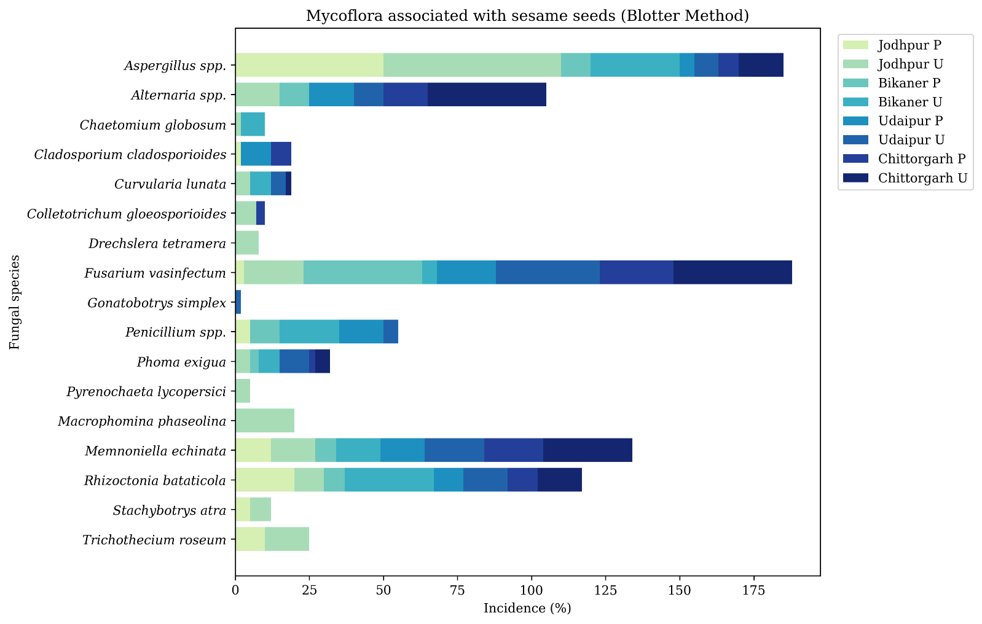

Fig. 1. Mycoflora Associated with Sesamum Seeds by Location and Condition (Blotter Method)

Table-2: Mycoflora associated with seeds of different samples of Sesamum by Agar Plate method (in%)

Fungi Isolated |  | Seed samples
 |  | Jodhpur |  | Bikaner |  | Udaipur |  | Chittorgarh
 |  | P | U | P | U | P | U | P | U
1. | Alternaria spp. | 5 |  | 6 | 12 | 2 | 4 | 33 | 4
2. | Aspergillus spp. | 32 | 51 | 34 | 37 | 32 | 34 | 27 | 31
3. | Cladosporium cladosporioides | 10 | 15 | 7 | 9 | - | 10 | 20 | 35
4. | Curvularia lunata | - | 10 | - | - | - | - | - | -
5. | Drechslera tetramera | - | 2 | - | 10 | - | - | - | -
6. | Fusarium vasinfectum | - | - | - | 2 | - | 24 | 2 | 10
8. | Penicillium spp. | 28 | 32 | 22 | 23 | 37 | 40 | - | 8
7. | Phoma exigua | - | - | - |  | - | 2 | - | -
10. | Rhizoctonia bataticola | - | - | 13 | 19 | 3 | 8 | - | -
9. | Rhizopus nigricans | - | 12 | 2 | 4 | - | 6 | - | 13
11. | Trichothecium roseum | - | - | 3 | 10 | - | - | - | 2
U = Untreated seeds P = Pretreated seed

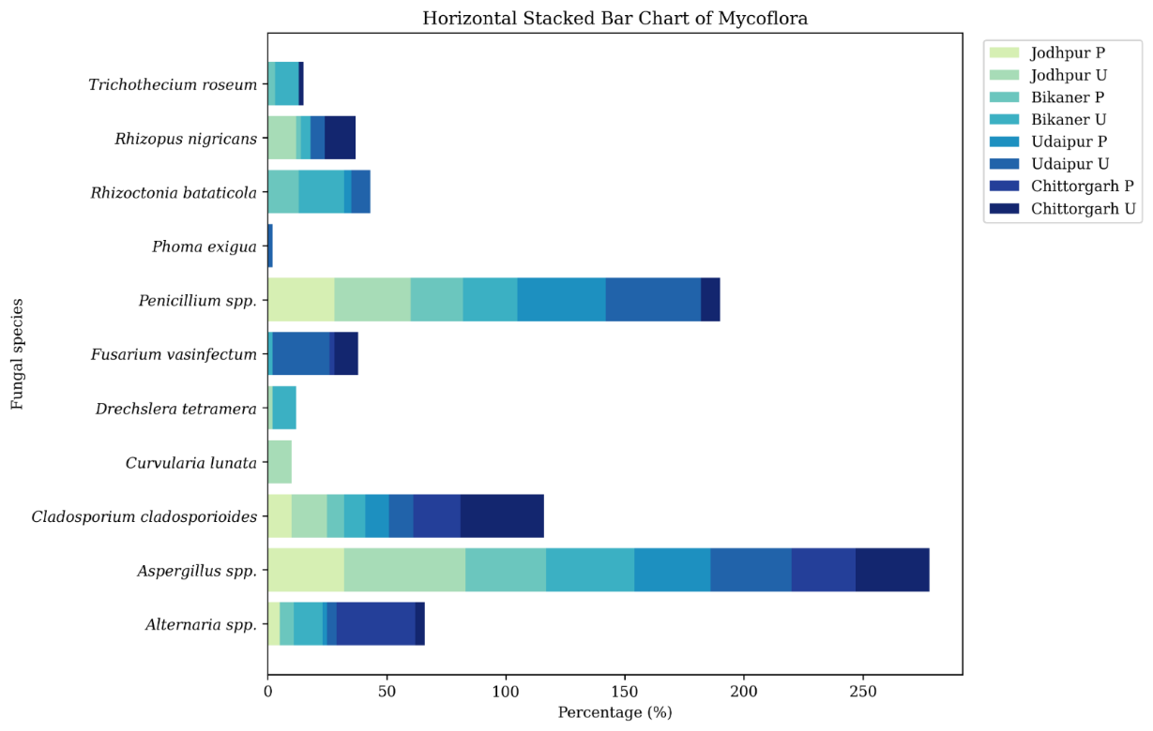

Fig. 2. Graph showing Mycoflora Associated with Sesamum Seeds by Location and Condition (Agar Plate Method)

3.2 Germination percentage of seeds
The germination percentage of seeds ranged from 32 (Untreated seeds from the Chittorgarh district) to 87 (Pretreated seeds from the Bikaner district) on blotter method and 30% to 90% in Agar medium. Furthermore, pretreatment of seeds enhanced germination percentage and resulted in lesser number of mycoflora in all the samples. (Table 3, Fig.3)

Table-3: Germinating percentage of different seed samples
Seed samples | Treatment | Germination Percent (%)
Seed samples | Treatment | On Blotter | On Agar Medium
Jodhpur | P | 80 | 68
Jodhpur | U | 66 | 45
Bikaner | P | 87 | 92
Bikaner | U | 70 | 80
Udaipur | P | 82 | 81
Udaipur | U | 78 | 68
Chittorgarh | P | 62 | 42
Chittorgarh | U | 32 | 30

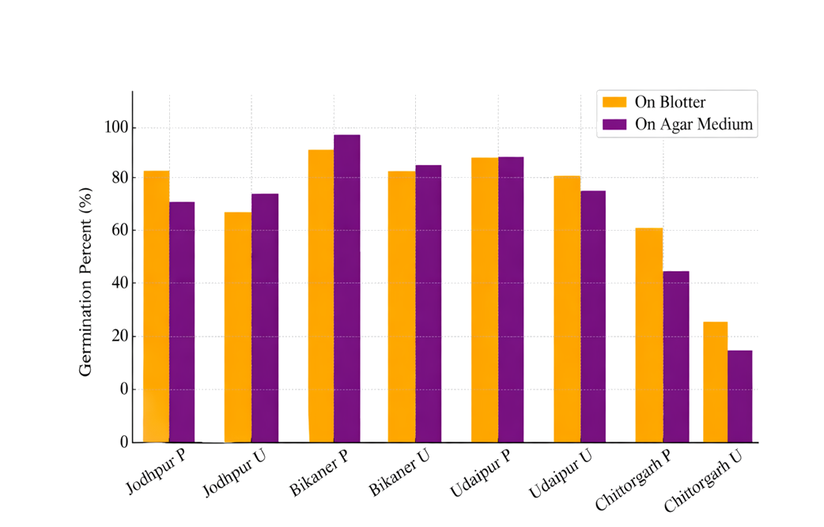

Fig. 3. Graph showing the Germination Percentage of Different Seed Samples

3.3 Changes in physico-chemical properties of sesame seed oil due to fungal infestation
The effect of A. flavus and P. implicatum on the oil content, free fatty acid content, saponification value and iodine value of sesame seed oil were observed. It is evident that a considerable amount of decrease in oil content of seed was caused by P. implicatum whereas A. flavus caused the minimum reduction (Table 4, Fig. 4).

Table-4. Changes in oil contents
Fungi | 7 days |  | 14 days
Fungi | % oil | % increase (+) or decrease (-) over control | % oil | % increase (+) or decrease (-) over control
Aspergillu flavus | 45.2 | -6.22 | 43.7 | -9.34
Penicillium implicatum | 42.8 | -11.20 | 38.6 | -19.92
Control | 48.2 | - | 48.2 | -

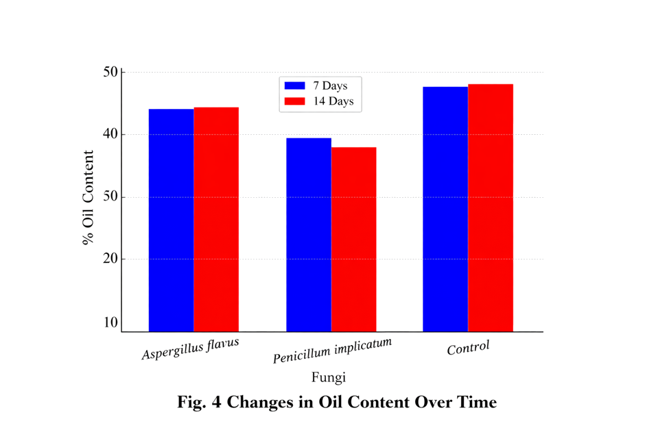

Fig. 4. Graph showing the Changes in Oil Content Over Time

3.3.1 Effect on chemical properties of oil
3.3.1.1 Free fatty acids Oils extracted from seeds infested with different seed borne fungi showed a significant increase in free fatty acid contents. A. flavus caused the severe damage and a very large increase in the free fatty acid content was observed even on the seventh day of incubation. However, P. implicatum caused comparatively lower increase in free fatty acid content than A. flavus (Table 5, Fig. 5).

Table-5. Changes in free fatty acid contents
Fungi | 7 days |  | 14 days
Fungi | % free fatty acid | % increase (+) or decrease (-) over control | % free fatty acid | % increase (+) or decrease (-) over control
Aspergillu flavus | 30.8 | 266.75 | 43.6 | 419.05
Penicillium implicatum | 28.2 | 235.75 | 29.1 | 246.43
Control | 8.4 | - | 8.4 | -

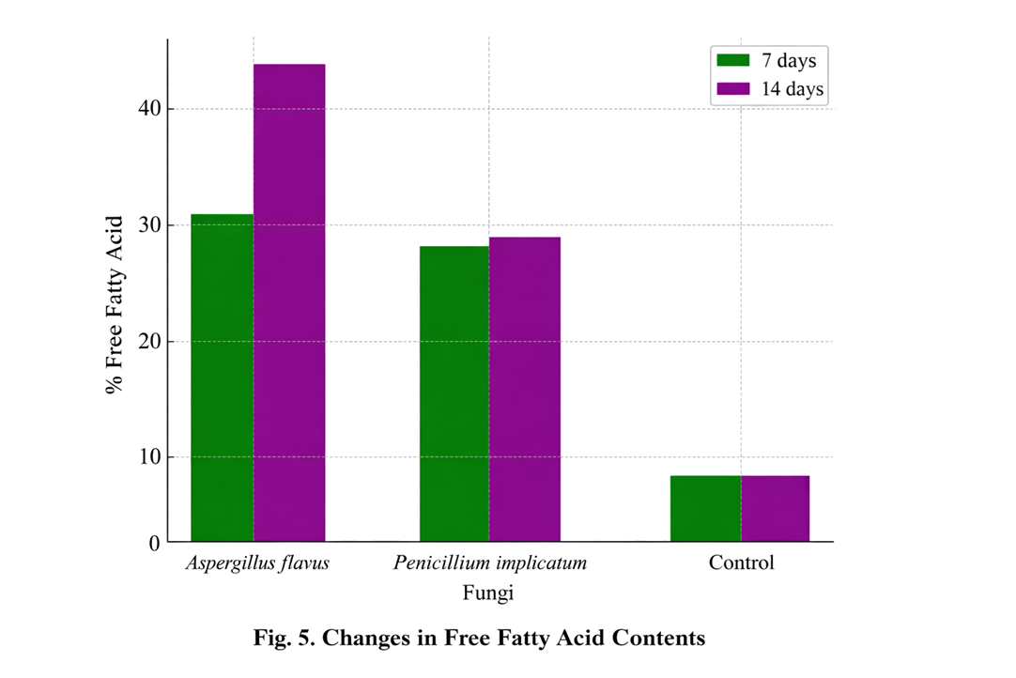

Fig. 5. Graph showing the Changes in Free Fatty Acid Contents

3.3.1.2 Saponification value
In the saponification value the maximum increase was caused by A. flavus while P. implicatum resulted in a comparatively lower increase in saponification value (Table 6, Fig. 6).

Table-6. Changes in Saponification value
Fungi | 7 days |  | 14 days
Fungi | Saponification value | % increase (+) or decrease (-) over control | Saponification value | % increase (+) or decrease (-) over control
Aspergillu flavus | 208.5 | 9.51 | 219.8 | 15.42
Penicillium implicatum | 204.6 | 7.68 | 216.2 | 13.55
Control | 190.4 | - | 190.4 | -

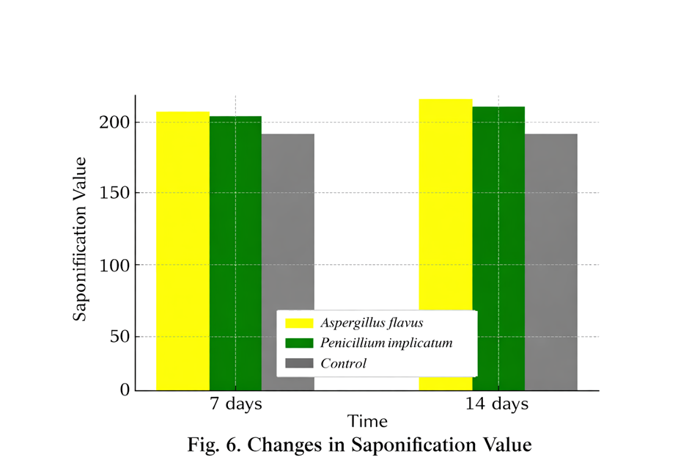

Fig. 6. Graph showing the Changes in Saponification Value

3.3.1.3 Iodine value
The iodine number of oil extracted from infested sesamum seeds by A. flavus and P. implicatum was assessed. Table 7 clearly reveals that both the fungi viz. A. flavus and P. implicatum reduced the iodine number appreciably in the seeds of sesame (Fig. 7).

Table-7. Changes in Iodine value
Fungi | 7 days |  | 14 days
Fungi | Saponification value | % increase (+) or decrease (-) over control | Saponification value | % increase (+) or decrease (-) over control
Aspergillu flavus | 119.9 | -0.58 | 114.7 | -4.89
Penicillium implicatum | 101.7 | -15.65 | 99.8 | -17.25
Control | 121.0 | - | 121.0 | -

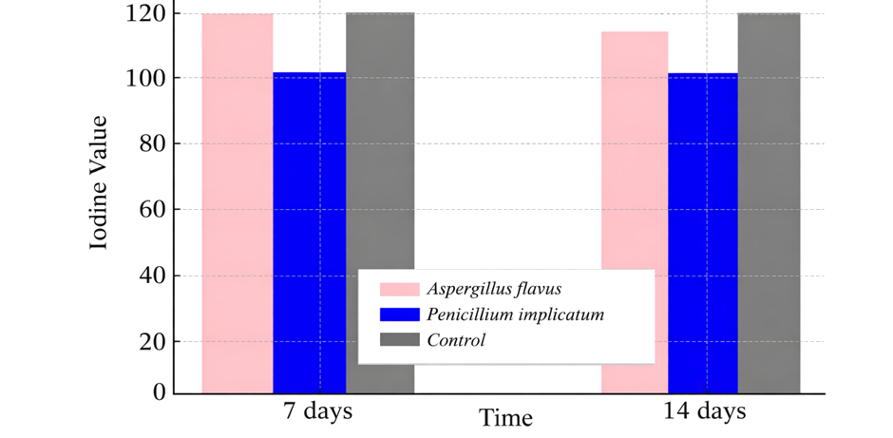

Fig. 7. Graph showing the Changes in Iodine value

4. Discussion
The present investigation revealed a wide diversity of seed-borne fungi associated with sesame seeds collected from different districts in Rajasthan. These fungi belong to 18 genera and 23 species . Similar diversity has been reported in oilseeds, indicating that oil-rich substrates favour fungal colonization (Altaf et al., 2004; Kumar et al., 1984; Mishra and Kanaujia, 1973; Rao et al., 2015; Ghosh et al., 2018). The predominance of the genera such as Aspergillus, Fusarium, Penicillium, and Alternaria observed in this study is consistent with previous findings on storage fungi (Chavan, 2011; Kakde et al., 2012; Khan et.al., 2024).
The variation observed between the blotter and agar plate methods supports previous findings that different detection techniques influence the recovery of seed mycoflora (Kaur et al., 1990; Khattak et al., 1993). The absence of certain fungi in agar plate cultures may be due to the rapid growth of dominant fungi such as Aspergillus and Rhizopus, which suppress slower-growing species. Similar observations have been reported by Dawar and Ghaffar (1991), Chukunda et al. (2015), and Ghosh et al. (2018), emphasizing the importance of using multiple detection methods.
This study demonstrated that seed pretreatment significantly reduced fungal incidence and enhanced germination percentage. These results align with previous reports that surface sterilization improves seed viability by reducing pathogen load (Enikuomehin, 2010; Upadhyay & Singh, 1978). Improved germination may also be attributed to reduced fungal competition and lower accumulation of toxic metabolites (Ali et.al., 2026;Jyoti & Malik, 2013; Kapoor et al., 2011; Sha et al., 2025; Temesgen et al., 2025).
The deterioration of oil quality observed in this study due to fungal infestation aligns with previous research on oilseed storage. The reduction in oil content caused by A. flavus and P. implicatum may be attributed to lipid utilization by fungi as a carbon source (Amienyo et al., 2015; Mukherjee et al., 1992; Sarkate and Badar, 2022). The greater reduction caused by P. implicatum suggests variability in metabolic efficiency among fungal species (Kakde and Chavan, 2011).
A significant increase in free fatty acid content, particularly in seeds infected with A. flavus, indicates active lipid hydrolysis due to lipase activity (Mbah and Akueshi, 2001; Sharma, 1977). Similar increases have been reported in various oilseeds (Chavan, 2011; Sarkate and Badar, 2022). These variations among fungi may be due to differences in enzymatic activity and metabolic potential.
The increase in saponification value observed in the present study suggests the formation of lower-molecular-weight fatty acids due to lipid degradation, which is consistent with earlier findings (Chavan, 2011; Sarkate and Badar, 2022). The progressive increase with incubation time further confirms continuous oil degradation during storage.
The decrease in iodine value reflects a reduction in unsaturated fatty acids, indicating oxidative and enzymatic degradation of lipids. Similar results have been reported by Mukherjee et al. (1992) and Sarkate and Badar (2022), suggesting a decline in oil stability and nutritional quality.
Overall, the observed changes in physico-chemical properties of sesame seed oil can be attributed to the metabolic activities of storage fungi, which utilize seed reserves for growth and proliferation (Christensen, 1957; McDonald, 1999; Nandi et al., 1982). Environmental factors such as temperature, humidity, and storage duration play a crucial role in determining the extent of fungal infestation (Alemayehu et al., 2023; Ouali et al., 2023).
This study highlights the importance of proper storage conditions and seed treatment strategies to minimize fungal infestation. Effective management of seed-borne fungi is essential for maintaining seed viability, preserving oil quality, ensuring food safety, and reducing post-harvest losses (Enikuomehin, 2010; Upadhyay and Singh, 1978).

5. CONCLUSION
The present investigation demonstrated that sesame seeds harbour a diverse range of seed-borne fungi. The study confirmed that both the blotter and agar plate methods are effective for detectiing mycoflora, although variations exist depending on the growth characteristics of fungi. Seed pretreatment with mercuric chloride proved to be effective in reducing fungal incidence and enhancing germination, indicating the importance of seed sanitation in maintaining seed viability. Additionally, the study revealed that storage fungi, particularly Aspergillus flavus and Penicillium implicatum, significantly influence the physico-chemical properties of sesame seed oil.
Fungal infestation resulted in a reduction in oil content, an increase in free fatty acid content and saponification value, and a decrease in iodine value, indicating deterioration in oil quality. These changes can be attributed to the metabolic and enzymatic activities of fungi, especially lipase-mediated lipid degradation. Overall, these findings highlight the importance of effective storage practices, proper seed treatment, and fungal management strategies to minimize post-harvest losses, maintain oil quality, and ensure food safety. Improving seed health is essential not only for better crop productivity but also for enhancing the economic value of sesame as an important oilseed crop.

DISCLAIMER (ARTIFICIAL INTELLIGENCE)
Author(s) hereby declares that NO generative AI technologies such as Large Language Models (ChatGPT, COPILOT, etc.) and text-to-image generators have been used during the writing of this manuscript. For Grammar corrections ChatGPT 5.2 is used.

6. REFERENCES
- Adithya, G., Rajeshwari, B., Keshavulu, K., Sudini, H., & Swathi, Y. (2017). Mycoflora associated with groundnut seeds collected from selected groundnut growing districts of Telangana State, India. International Journal of Current Microbiology and Applied Sciences, 6(7), 4335–4342.
- Afzal, R., Mughal, S. M., Munir, M., Sultana, K., Qureshi, R., Arshad, M., et al. (2010).
Mycoflora associated with seeds of different sunflower cultivars and its management. Pakistan Journal of Botany, 42(1), 435–445.
- Alemayehu, S., Abera, F. A., Ayimut, K. M., Darnell, R., Mahroof, R., Harvey, J., & Subramanyam, B. (2023). Effects of storage duration and structures on sesame seed germination, mold growth, and mycotoxin accumulation. Toxins, 15(1), 39. https://doi.org/10.3390/toxins15010039
- Ali, J., Ikram, M., Zahoor, M., & Alotaibi, A. (2026). Role of phytochemicals in controlling toxigenic fungi and inhibition of aflatoxin biosynthesis. Journal of Fungi, 12(2), 145. https://doi.org/10.3390/jof12020145
- Altaf, N., Khan, S. A., Ahmed, M., Asghar, R., Ahmed, R. A., Shaheen, S., Zafar, M., & Saqib, M. (2004). Seed-borne mycoflora of sesame (Sesamum indicum L.) and their effect on germination and seedling. Pakistan Journal of Biological Sciences, 7, 243–245.
- Ameer Junaithal Begum, M., Venudevan, B., & Jayanthi, M. (2013). Storage fungi in groundnut and associated seed quality deterioration. Plant Pathology Journal, 12, 127–134.
- Amienyo, C. A., Gugu, M., & Oshatuyi, M. (2015). Effects of fungal deterioration on lipid content of sesame seeds (Sesamum indicum L.). International Journal of Phytopathology, 4, 1–4. https://doi.org/10.33687/phytopath.004.01.0872
- AOAC. (1960). Official methods of analysis of the Association of Official Agricultural Chemists.
- Barnett, H. L., & Hunter, B. B. (1972). Illustrated genera of imperfect fungi (3rd ed.). Burgess Publishing Company.
- Bedigian, D. (2012). Sesame: The genus Sesamum. CRC Press.
- Chavan, A. M. (2011). Nutritional changes in oilseeds due to Aspergillus spp. Journal of Experimental Sciences, 2, 29–31.
- Chavan, A. M., & Kakde, R. B. (2008). Studies on abnormal oilseed mycoflora from Marathwada region. Bionano Frontier, 2(2), 101–104.
- Christensen, C. M. (1957). Deterioration of stored grain by fungi. Botanical Review, 23, 108–134.
- Chukunda, F. A., Emri, U. N., & Ukoima, H. N. (2015). Studies of seed-borne mycoflora of castor bean (Ricinus communis L.). Academic Journal of Microbiology Research, 3(1), 6–9.
- Dawar, S., & Ghaffar, A. (1991). Detection of seed-borne mycoflora of sunflower. Pakistan Journal of Botany, 23(2), 173–178.
- De Tempe, J. (1953). The blotter method of seed health testing. Proceedings of the International Seed Testing Association, 21, 133–151.
- Directorate of Oilseeds Research (DOR). (2013). Vision 2050. ICAR-IIOR.
- Directorate of Rapeseed-Mustard Research (DRMR). (2015). Vision 2050. ICAR-DRMR.
- Enikuomehin, O. A. (2010). Seed sorting of sesame by salt density and control of seed-borne fungi. Archives of Phytopathology and Plant Protection, 43(6), 573–580.
- FAO. (2010). Production crops: Sesame seeds. Food and Agriculture Organization of the United Nations.
- Ghosh, T., Biswas, M. K., & Aikat, K. (2018). Seed-borne mycoflora associated with oilseed crops: A review. International Journal of Pure and Applied Bioscience, 6(1), 1526–1538.
- International Seed Testing Association. (1996). International rules for seed testing. Seed Science and Technology, 4, 51–177.
- Jyoti, & Malik, C. P. (2013). Seed deterioration: A review. International Journal of Life Sciences Biotechnology and Pharma Research, 2(3), 374.
- Kakde, R. B., Badar, K. V., Pawar, S. M., & Chavan, A. M. (2012). Storage mycoflora of oilseeds: A review. International Multidisciplinary Research Journal, 2(3), 39–42.
- Kakde, R. B., & Chavan, A. M. (2011). Deteriorative changes in oilseeds due to storage fungi. Current Botany, 2, 17–22.
- Kapoor, N., Arya, A., Siddiqui, M. A., Kumar, H., & Amir, A. (2011). Biochemical changes during seed deterioration in rice. American Journal of Plant Physiology, 6, 28–35.
- Kaur, J., Chahal, S. S., & Aulakh, K. S. (1990). Efficiency of methods for detection of seed-borne fungi in sunflower. Plant Disease Research, 5(1), 53–58.
- Khan, M. A., Khan, I. A., Tahir, A. H., & Rehman, H. (2024). Isolation and identification of fungi associated with stored grains and their impact on quality deterioration. Journal of Stored Products Research, 104, 102190. https://doi.org/10.1016/j.jspr.2023.102190
- Khattak, I., Hussain, S., Ali, A., & Shah, S. J. A. (1993). Methods for studying seed-borne microflora of soybean. Sarhad Journal of Agriculture, 9, 45–48.
- Kumar, K., Singh, J., & Saksena, H. K. (1984). Fungi associated with sesame seeds and their control. Indian Phytopathology, 37, 330–332.
- Mbah, M., & Akueshi, C. (2001a). Physico-chemical changes induced by fungi on sesame. Journal of Science, Agriculture, Food Technology and Environment, 1, 65–69.
- Mbah, M., & Akueshi, C. (2001b). Effect of seed-borne fungi on germinability of sesame seeds. Nigerian Journal of Horticultural Science, 4, 57–64.
- McDonald, M. B. (1999). Seed deterioration: Physiology, repair, and assessment. Seed Science and Technology, 27, 177–237.
- Meara, M. L. (1955). Fats and other lipids. In K. Paech & M. V. Tracey (Eds.), Modern methods of plant analysis (pp. 317–402). Springer.
- Mishra, R. R., & Kanaujia, R. S. (1973). Seed-borne fungi on oilseeds. Indian Phytopathology, 25, 284–294.
- Mondal, G. C., Nandi, D., & Nandi, B. (1981). Deterioration of oilseeds in storage. Mycologia, 73(1), 157–166.
- Mukherjee, P. S., Nandi, S. K., & Nandi, B. (1992). Deteriorative changes in groundnut seeds. Journal of Mycopathological Research, 30(2), 113–119.
- Muskett, A. E. (1948). Techniques for examination of seed-borne fungi. Transactions of the British Mycological Society, 30, 74–83.
- Nandi, D., Mondal, G. C., & Nandi, B. (1982). Effect of storage conditions on oilseeds. Seed Science and Technology, 10, 141–150.
- Ouali, D., Zida, P., Soalla, W., & Guissou, K. (2023). Morphological identification of fungi associated with sesame. American Journal of Plant Sciences, 14, 882–895. https://doi.org/10.4236/ajps.2023.148059
- Rao, T. V., Rajeswari, B., Keshavulu, K., & Varma, V. S. (2015). Seed-borne fungi of soybean. International Journal of Agriculture and Environmental Science, 2(1), 16–24.
- Reddy, M. J. (1993). Varietal differences in seed mycoflora of sunflower. Seeds and Farms, 15, 17–20.
- Sarkate, P. S., & Badar, K. V. (2022). Impact of storage fungi on biochemical changes in oilseeds.
- Sharma, K. D. (1977). Biochemical changes in stored oilseeds. Indian Journal of Agricultural Research, 11, 134–144.
- Sha, T., Zhang, Y., Liu, X., Chen, J., & Wang, Q. (2025). Physicochemical control of mold contamination in stored grains. Foods, 14(6), 961. https://doi.org/10.3390/foods14060961
- Srivastava, S., Bindal, S., Gopalakrishnan, P., Kumar, R., & Rana, M. (2021).
Seed-borne mycoflora of edible oilseed crops of India. In Advances in plant pathology. https://doi.org/10.1007/978-981-15-4198-8_14
- Temesgen, B. A., Nigussie, A., Beyene, B. B., & Teklemichael, A. M. (2025).
Mycotoxin contamination in food: Impacts, challenges, and mitigation strategies. Food Control, 171, 111066.
- Upadhyay, R. S., & Singh, D. B. (1978). Seed mycoflora of mustard. Journal of Scientific Research BHU, 29, 171–181.
- Ward, H. S., & Diener, U. L. (1961). Biochemical changes in peanuts caused by fungi. Phytopathology, 51, 244–250.

