Growth and Yield Response of Mucuna pruriens Plants to Soil Moisture Variation in the Cotton Production Zone of Mali, West Africa
ABSTRACT
In the cotton production zone of Mali, livestock farming faces many challenges, including forage constraints. This study aims to understand better the variations in Mucuna pruriens production in response to high rainfall variability and, consequently, in soil moisture. The systems used for this study comprised two measurement sites in Mali’s cotton production zone (Béguéné and Ziguéna) and a third at the Sotuba agronomic research centre in Bamako. The approach adopted was to take hemispherical photographs of pure Mucuna pruriens in parallel with soil moisture measurements. These measurements were taken in 9 plots of 25 x 25 m (3/site) at Sotuba, Béguéné, and Ziguéna. Remote sensing data the Leaf Area Index (LAI), and soil moisture were also used to monitor the seasonal dynamics of these two variables. The study showed that the yield of Mucuna pruriens is only weakly correlated with the annual rainfall. Dry sequences of 3 days were in the majority at all three sites, representing up to 79% of the total recorded at Sotuba, 76% at Béguéné, and 78% of the total recorded at Ziguéna during the same year. In contrast, those longer than 10 days represented only 4%, 11%, and 10% of the total in Sotuba, Béguéné, and Ziguéna, respectively. The linear regression between the average soil moisture (120 days after sowing) at each site and the maximum leaf area index explains 41% of this variability. The results revealed a relationship between the annual rainfall and the rainfall intensity in the study area. It also shows that the dynamics of Mucuna pruriens are weakly linked to annual rainfall, as they do not depend solely on soil moisture, and other factors can influence them.
Keywords: Mucuna pruriens ; soil moisture ; LAI ; yield ; cotton production zone ; Mali.
- INTRODUCTION
It is estimated that about 60 per cent of rural households in developing countries depend wholly or partially on livestock for their livelihoods, which provide essential protein and micronutrients for poor populations. On a global scale, livestock farming is a key mechanism for reducing stunting and wasting in children. Therefore, the livestock sector can play an important role in eliminating hunger, malnutrition, and child development, which in turn can be an engine for the fulfilment of various SDGs (Torres et al., 2022; Van‐Heurck et al., 2020). Livestock plays an important role in the household economy in Mali (Wane, 2006 ; Diawara et al., 2021). The estimated ruminant herds are 12,848,696 cattle, 21,149,809 sheep, and 29,201,079 goats (DNPIA, 2022). Livestock feed relies almost exclusively on forage resources, whether natural or cultivated (Ba et al., 2022). However, the productivity of these pastures is highly variable in time and space due to rainfall variability (Coulibaly et al., 2017; Diawara et al., 2020).
The interannual rainfall variability was high in the study area, as observed elsewhere in the sub-humid zone. The average rainfall rate was 14.19% over the 2012/2021 period in Béguéné, located in the north of Mali’s cotton production zone, for an average rainfall of 810.35 mm per year. In addition to temporal variability, there is considerable spatial heterogeneity (Traoré et al., 2022).
Many authors agree on the importance of rainfall distribution and volume for the dynamics of forage resources in sub-humid zones (Le Barbé & Lebel, 1997; Beyene, 2015). Breman and De Ridder (1991) added the influence of runoff and drainage in the Sahelian region.
It has also been established that the level of plant cover production depends much more on the water status of the soil than on the level of precipitation. Soil water availability results from both rainfall patterns and the redistribution of water through runoff and infiltration (De Rosany et al., 2009).
Soil water availability is influenced by the storage and transport characteristics of the soil itself (Cornet, 1981 ; Diawara et al., 2020). According to the same author, there may have been differences related to the texture and organic matter content.
The major challenges identified in livestock farming systems are a lack of pasture and quality feed, scarcity of water resources, climate change, undeveloped breeding and management of livestock, poor marketing and trade, and socioeconomic constraints (Eeswaran et al., 2022; Erdaw, 2023). In Mali’s cotton production zone, livestock farming faces many challenges, including forage constraints (Ba et al., 2022). The forage stock built up at the end of the growing season for annual grasses and at the end of the harvest for rainfed crops decreases throughout the dry season under the influence of grazing by domestic ruminants and other factors such as winds, bush fires, and termites. In southern Mali, the expansion of cultivated land has considerably reduced the rangeland areas (Coulibaly et al., 2017 ).
Forage grasses can help reduce the vulnerability of livestock systems to recurrent seasonal forage shortages in the southern Mali zone (Traoré et al., 2020). Forage development strategies have been introduced and popularised for about five decades in the country’s crop-livestock production systems (Tulu et al., 2023). This study is part of the activities of the AgrECo project (Projet d’Appui à la Transition Agro-Ecologique en zone cotonnière du Mali). It aims to gain a better understanding of the variation in the production of Mucuna pruriens, a forage plant, in response to the high variability of rainfall and consequently of soil water reserves in Mali’s cotton production zone.
- MATERIAL AND METHODS
  - Study area and data acquisition
The systems used for this study comprised two measurement sites in Mali’s cotton production zone (Béguéné and Ziguéna) and a third at the Sotuba agronomic research centre in Bamako (Fig. 1). At Béguéné, in addition to the pure Mucuna pruriens formation, herbaceous measurements were conducted in a fallow area located close to the field. Given the remoteness of the sites from one another, two methods of data collection were used : one based on field or in situ data collection and another based on remote sensing.
  - Methodology
    - Estimating the biomass yield
The biomass was estimated using the integral harvesting method (Djitèye, 1988). Within each 1x1 m plot, biomass was harvested at the ground level. The green weight of each plot is determined. A 500 g sample of biomass from each plot was collected and placed in a Cretonne bag, followed by a label bearing all the information (survey number, fresh weight of sample, species, tec.). The samples were oven-dried at 105°C for 48 h to determine the weight of the dry matter (DM).
    - Hemispherical photographs
The approach consisted of taking hemispherical photographs above the plant cover (a pure Mucuna pruriens formation at the three sites and fallow at Béguéné) at the study sites. Photographs were taken every 10 m along diagonals and on the sides in 25 x 25 m meshes (three meshes per site). This dimension was chosen so that the in situ data could be compared with the satellite data. The photographs were analysed using Can-Eye software to estimate the leaf area index (LAI).
    - Estimation of the Leaf Area Index (LAI)
Vegetation dynamics in pure Mucuna pruriens were documented using Leaf Area Index values derived from satellite reflectance measurements in the green and red channels, which can be related to the green vegetation density. The use of this index has been accepted by the scientific community in vegetation monitoring studies (Mougin et al., 2019). In this study, we chose to use the LAI product delivered by the MODIS TERRA satellite, which offers sufficiently fine spatial resolution to work at the scale of a 25 x 25 m grid. Green vegetation dynamics were monitored using maximum LAI values, averaged over 4 days during the growth phase, and data were obtained through the http://daac.oml.gov/modiswebservice website.
    - Estimation of the soil moisture
Several methods were used to measure the soil moisture in the study. Gravimetric measurements consisted of taking a known volume of soil samples (100 cm boxes) from a pit at different depths on the surface and then every 10 cm to calculate the dry bulk density and volumetric water content. The oven (at the Laboratoire Sol-Eau-Plante in Sotuba) was used to calculate the mass of water in the soil. The volumetric moisture values obtained were first compared with those obtained using the probe and with those derived from the satellite. Second, they were used to establish the relationships between Mucuna pruriens dynamics and the soil water content.
We also had a portable probe to measure the surface soil moisture (0 cm to 6 cm) on the move. This probe was used to measure using the same 25 x 25 m plot. Oven drying (at the Soil-Water-Plant laboratory in Sotuba) was used to calculate the volumetric water content of the soil. The output signal is a voltage in mV. The HH2 box converts the voltage to the water content. The water content is a dimensionless quantity, expressing a ratio of 2 volumes, that of the water to that of the sample. The ML2x probe yielded an average value over the electrode length of 6 cm (Gaskin and Miller, 1996). The value is expressed as a percentage by volume. Variation in the soil water content was also determined using data derived from the SMAP (Soil Moisture Active and Passive mission) satellite. SMAP is placed in a sun-synchronous orbit. SMAP provides almost complete coverage of the globe, passing over the same area every 2 to 3 days. It provides soil moisture measurements with an accuracy of 4% in the top 5 cm of the soil at various latitudes.
  - Data analysis
To establish the relationship between LAI and soil moisture, linear regression was performed using R (RCRAN https://cran.r-project.org/Card). The descriptive statistics were also calculated using the same software. To understand the intra-seasonal rainfall fluctuations at the studied sites and determine the variables characteristic of the rainy season, the daily rainfall recorded at the Sotuba, Beguéné, and Ziguéna rainfall stations was analysed. The approach adopted was to determine the annual rainfall totals and then to break down the season's total rainfall into rainfall events of varying intensity (less than 5 mm, from 5 to 9 mm, from 10 to 19 mm, and greater than 20 mm). The agronomic start-up date is otherwise defined by the so-called significant rains that trigger the first germination of annual herbaceous plants. A rain-free period of 20 consecutive days beyond mid-August marks the end of the rainy season (Balme et al., 2005). This agronomic approach was used to determine the start and end dates of the rainy season, as well as the other variables presented above. To assess the influence of soil moisture on Mucuna pruriens dynamics, regressions were established between MODIS-derived LAI and SMAP-derived moisture.
- RESULTS
  - Intraseasonal rainfall distribution
The analyses were used to determine the characteristic variables for the 2021 rainy season based on data from three rainfall stations. The results of these analyses are presented in Table 1. The Ziguéna site in Mali’s pre-Guinean zone received the highest rainfall of the three in 2021, with 1,168 mm. It is followed in Sotuba in the Sudanian zone, with an annual total of 1,043 mm. The Béguéné site, located in the Sudano-Sahelian zone, recorded only 563 mm in 2021. The highest number of rainfall events was recorded in Sotuba (88), although 38% were of low intensity (< 5mm). Despite the large differences in their annual rainfall, the Ziguéna and Béguéné sites recorded 60 and 52 rainfall events, respectively. Over 20 mm were recorded daily: 23 in Ziguéna, 18 in Sotuba, and 10 in Béguéné. Dry sequences of 3 days were in the majority at all three sites, representing up to 79% of the total recorded at Sotuba, 76% at Béguéné, and 78% at Ziguéna during the same crop year. In contrast, those longer than 10 days represented only 4%, 11%, and 10% of the total in Sotuba, Béguéné, and Ziguéna, respectively.
  - Soil moisture dynamics
Table 2 shows the weight moisture profiles (10 - 100 cm) at the study sites. Vertical soil moisture profiles drawn up based on soil samples taken in the first week of August 2021 show wide variations depending on the site and the sampling horizon. At Sotuba, the maximum soil moisture was recorded at 100 cm. At Ziguéna and Beguéné, maximums were observed at depths of 60 and 40 cm, respectively. The average in Beguéné was 12.56 m³/m³, compared to 2.30 and 3.37 m³/m³ in Sotuba and Ziguéna. Fig. 2 shows the temporal variation in the soil water reserve measured in the field during the 2021-2022 rainy season from the SMAP satellite-derived data. Soil moisture in the 2-6 cm layer shows strong variation over the season, according to the intraseasonal distribution of rainfall. The maximum soil moisture derived from SMAP recorded at Beguéné was 19.60 m³/m³, compared to 23.11 m³/m³ at Sotuba and 23.28 m³/m³ at Ziguéna. Peak soil moisture was reached around day 228 (August 16) at all three sites. The relationship established between the SMAP satellite-derived soil moisture and that measured in the field shows a good match between the two methods (r = 0.81; n = 12).
  - Seasonal variation in the leaf area index
The relationship established between the leaf area index (LAI) derived from the hemispherical photographs and that of the MODIS sensor shows a good match (r = 0.69; n=16). Therefore, the comparative dynamics of the Mucuna pruriens LAI presented in Fig. 3 are based on the LAI values obtained from this sensor. The estimated LAI derived from the MODIS data varied greatly from site to site. This variation was high during the main growth phase (61% on average from sowing to day 45). Peak growth was reached only 45 days after sowing at Sotuba and Beguéné, with a maximum LAI of 0.7 and 1.6 m²/m², respectively. In Ziguéna, further south, the maximum LAI was reached 60 days after sowing, with a maximum LAI of 2.6 m²/m². The leaf area index at Sotuba represents only 35% of the maximum LAI estimated at the Beguéné site, which recorded twice as much rainfall. This inter-site variation is superimposed by the strong intrasite variations in LAI.
  - Dry matter yield (kg DM/ha)
Yields after sun-drying vary according to site (Fig. 4). The variability observed between yields is not statistically significant (p = 0.18). The Ziguéna site has the highest average yield, at 4.9 tons DM/ha. It is followed by the Sotuba site with an average yield of 4 tons DM/ha. The Béguéné site has the lowest yield, with an average of just 2.90 tons DM/ha.
  - Relationship between the soil moisture and the leaf area index
Fig. 5 shows the relationship between soil moisture and the leaf area index at the study sites. For the Sotuba site, the soil moisture measured explains 54% of the leaf area index dynamics. In contrast, the Beguéné site explains only 8% of the seasonal dynamics of LAI. The soil moisture determinism for Mucuna pruriens dynamics for the Ziguéna site is close to that for Sotuba, with a coefficient of determination R² = 0.50. The linear regression established between the average soil moisture (120 days after sowing) at each site and the maximum leaf indices at the same sites showed a positive correlation between the two variables with R² = 0.41.
- DISCUSSION
A comparison of the number of rainfall events over the season and annual accumulations revealed a strong spatial variation according to the bioclimatic gradient. Rainfall events are less numerous but more intense from south to north, and they determine the annual precipitation totals. These variables, which are characteristic of the rainy season, allow us to understand the spatio-temporal variation in soil moisture and to establish relationships between this variable and plant production, particularly that of pure Mucuna pruriens formations.These results agree with those of Lawin et al. (2010), who found a similarity between the Sudanian and Sahelian systems in terms of the relationship between the annual rainfall and the rain intensity. The dominance of dry sequences ≤ 3 days during the 2021 rainy season is not exceptional in the region. This result is close to that reported by Traoré et al. (2022), who showed that dry sequences ≤ 5 days are most numerous in the first half of the rainy season. However, Sissoko et al. (2020) showed that dry sequences at the start of the cropping season can affect the soil moisture levels in the 0-10 cm layer.
The gravimetric soil moisture values estimated for the Sotuba site seem relatively low for the sub-humid zone in August, especially as the site received 50 mm of rain on August 4, just two days before soil sampling. As soil moisture increased with depth (maximum estimated at 100 cm depth), this could be explained by infiltration, as shown by Shukla and Lai (2002). A study conducted by the CILSS (2012) also corroborates this result. In this study, the authors show that tillage, particularly ridging and ploughing, can improve the physical properties of the soil by slowing runoff and promoting infiltration. Although too low for the area, the estimated values for Ziguéna agree with the seasonal rainfall distribution. Soil sampling followed a 9-day dry sequence.
The analyses established a relationship between the seasonal dynamics of the leaf area index (LAI) and soil moisture. They showed that the average humidity during the main growth period explains 41% of the variation in the maximum LAI. The dynamics of Mucuna pruriens at the three study sites during the 2021 growing season show that the production of this forage crop depends on both the rainfall distribution during the season and other factors. The leaf area index estimated for the Sotuba site represents only 35% of the maximum LAI estimated for Beguéné, which recorded half as much rainfall. This intersite variation is superimposed by the strong intrasite variations in LAI. The infiltration and runoff characteristics of rainwater are linked to the soil texture mentioned above (Doorenbos and Kassam, 1987).
The average LAI estimated for the fallow area around the growth peak represents 1/3 of that estimated for the formation of pure Mucuna pruriens in the same period. This difference can be explained by the structure of the vegetation in the two types of formations and by the ability of Mucuna pruriens in pure cultivation to conserve soil moisture (Sissoko et al., 2020). Previous studies on the relationship between the nature of vegetation cover and the behaviour of water from precipitation (Beauchamp, 2006; Sissoko et al., 2020) point in the same direction, showing that vegetation opposes surface runoff and favours infiltration. The stems act as obstacles to surface runoff, reducing the speed of water flow. Roots increase soil permeability. The presence and type of crop greatly influence the effects of precipitation on the soil. Indeed, according to Beauchamp (2006), the consequences of rainfall are greater for a plot under cultivation than for a rangeland. It has been established that a meadow will protect the soil so that only 5% of it will be affected by rainwater, compared with 50% for a forage grass.
Globally, the leaf area index values obtained in this study agree with the phytomass estimated in a previous study (Traoré et al., 2021). In this study, the average yield of Mucuna pruriens in pure cultivation was 2347 and 4508 kg DM/ha, respectively, at Beguéné and Ziguéna, while the herbaceous phytomass obtained on the same sites during the same cropping season (2015 - 2016) was 733 and 1521 kg DM/ha (Ba et al., 2022).
- CONCLUSION
This study was part of the AgrECo project and aimed to gain a better understanding of the variation in the production of Mucuna pruriens, a forage grass, in response to the high variability of rainfall and consequently of the soil water content in Mali’s cotton production zone. The results revealed a relationship between the annual rainfall and the rainfall intensity in the study area. It also shows that the dynamics of Mucuna pruriens are weakly linked to annual rainfall, as they do not depend solely on soil moisture, and other factors can influence them. The leaf area index values obtained for the three sites indicate that Mucuna pruriens is a very interesting forage grass in all three bioclimatic zones.
DISCLAIMER (ARTIFICIAL INTELLIGENCE)
Author(s) hereby declare that NO generative AI technologies such as Large Language Models (ChatGPT, COPILOT, etc.) and text-to-image generators have been used during the writing or editing of this manuscript.
ACKNOWLEDGEMENTS
The authors thank the Agence Française de Développement (AFD) and the Government of Mali for funding the activities through the Support to the Projet d'Appui à la Transition Agro-Ecologique en zone cotonnière du Mali (AgrECo) project. The authors also thank the collaborating producers at the study sites for their availability and patience.

REFERENCES
- Achard, F., Hiernaux, P. and Banoin, M. (2001). Natural and improved fodder fallows in West Africa. 2:201-40.
- Ali, A. (2004). Modeling the scale invariance of Sahelian rainfed fields. Application to estimation algorithms and climate variability studies. PhD thesis, LTHE;130p.
- Autfray, P., Sissoko, F., ​​Falconnier, G., Ba, A., Dugué, P. (2012). Uses of crop residues and integrated soil fertility management in mixed crop-livestock systems: A case study in southern Mali. Cah Agric;21:225-34. doi: 10.1684/agr.2012.0568
- Ba, A., Koné, A.K., Diawara, M.O., Diarra, H.D. & Traoré, S.O. (2022). Fodder Potential Evaluation of Agro-Pastoral Sites Using Spatial Imagery Technology in the Cotton Production Zone of Mali, West Africa. East African Journal of Agriculture and Biotechnology; 5(1), 150-161.
- Ba, A. (2011). Cattle Farming in the Cotton-Growing Zone of Southern Mali. PhD Thesis, Montpellier SupAgro; 170p.
- Balme, M., Lebel, T. and Amani, A. (2006). Dry Years and Wet Years in the Sahel: Quo Vadimus? Journal of Hydrological Sciences; 51(2).
- Balme, M., Galle, S. and Lebel, T. (2005). Onset of the Rainy Season in the Sahel: Variability at Hydrological and Agronomic Scales, Analyzed Using EPSAT-Niger Data; Drought 16 (1): 15-22.
- Beauchamp, J. (2006). Online Pedology Course; http://www.UPicardie.fr/Beauchamp/accessed 12/25/2021 at 10:45 AM.
- Behnke, R.H., Scoones, I. and Kerven, C. (1993). Range Ecology at Disequilibrium: New Models of Natural Variability and Pastoral Adaptation in African Savannas. Overseas Development Institute, London. 1993.
- Bernus, E. and Boutrais, J. (1994). Crises and Issues of African Pastoralism. C.R. Acad.agric. Française, Paris; 8: 105-119
- Blanchard, M. (2010). Soil fertility management and the role of the herd in cotton-cereal-livestock systems in southern Mali: local technical knowledge and practices for integrating agriculture and livestock. PhD thesis, Université Paris-Est, Créteil; 300p.
- Boudet, G. (1989). Evolution of Sahelian rangeland vegetation and rehabilitation possibilities. Forages; 120, 401-415.
- Breman, H. and De Ridder, N. (1991). Handbook on rangelands in Sahelian countries, Paris-Wageningen (Netherlands), A.CrT-cabo-Dio-CTA, Karthala; 485p.
- Chirat, G. (2010). Description and modeling of the spatial and feeding behavior of cattle herds in free-range pastures in a dry tropical zone. PhD thesis, SupAgro, Montpellier; 207p.
- CILSS. (2012). Good agro-sylvo-pastoral practices for sustainable improvement of soil fertility in Burkina Faso. Ouagadougou; 194p.
- CIRAD. (2012). The cotton-growing zone of Mali. Report of the World Agriculture Observatory; 40p.
- Cornet, A. (1981). The water balance and its role in the production of the herbaceous layer of some Sahelian phytocenoses in Senegal; PhD thesis, University of Languedoc, Montpellier, 353p.
- Coulibaly, D., Sissoko, F., ​​Doumbia, S., Ba, A. & Dembélé, B. (2017). Evaluation of the effect of mineral fertilization on the production of improved maize varieties and fodder availability in the cotton-growing zone of southern Mali (Mali). African Agronomy; 29(1), 109-117.
- Delabre, E. (1998). Characterization and evolution of anthropized Sahelian ecosystems: post-cultural environments in southwestern Niger, Th.doct. Univ. Paris VI; 282p.
- De Rosnay, P., Gruhier, C., Timouk, F., Baup, F., Mougin, E., Hiernaux, P. et al. (2009). Multiscale soil moisture measurements at the Gourma mesoscale site in Mali. Journal of Hydrology; 375(1 2):241 52.
- Diawara, M.O., Ba, A., Sissoko, S., Hiernaux, P., Diakité, H.S., Soumaguel, N. and Coulibaly, D. (2021). Pastoral livestock farming in the Eastern Malian Sahel (Hombori): Survey on flows in two livestock markets. International Journal of Livestock Production. 12(4) 176-182.
- Diawara, M.O., Hiernaux, P., Sissoko, S., Mougin, E., Ba, A., Soumaguel, N. & Diakité, H.S. (2020). Sensitivity of herbaceous production to rainfall variability in the Sahel (Agoufou, Mali): a modeling approach. Int. J. Biol. Chem. Sci. 14(4): 1341-1353.
- Djiteye, M. (1988). Composition, structure, and production of Sahelian plant communities: application to the Niono area (Mali). Doctoral thesis, Paris; 150p.
- DNPIA. (2019). Annual report (Bamako: National Directorate of Animal Production and Industries). 2020; Avenue de la Liberté, Route de Koulouba. PO Box: 265; Bamako, Mali, Annual Report, 142p.
- Eeswaran, R., Nejadhashemi, A. P., Faye, A., Min, D., Prasad, P. V., & Ciampitti, I. A. (2022). Current and future challenges and opportunities for livestock farming in West Africa: Perspectives from the case of Senegal. Agronomy, 12(8), 1818.
- Erdaw, M. M. (2023). Contribution, prospects and trends of livestock production in sub-Saharan Africa: a review. International Journal of Agricultural Sustainability, 21(1), 2247776.
- FAO. (2009). The State of Food and Agriculture. Livestock in Focus; 202p.
- FAO. (2007). Ruralities on the Move in West Africa. International Conference on Agrarian Reform and Rural Development, March 7-10, Porto Alegre, Brazil; 73p.
- Guérin, H., Friot, D., M'Baye, N.D., Fall, S.T., Richard, D., Diop, M., Correa, A., Ndiaye, I. and Ba, T.M. (1987). Ingestion of forage from natural rangelands in the Sahelian zone: measurements in stables and on pasture. Reproduction Nutrition Development; 27, no. 1B: 197–198.
- Haro, H., Semde, K., Bahadio, K. (2020). Sanon KB. Effect of mycorrhizal inoculation with strains of arbuscular mycorrhizal fungi on the growth of Mucuna pruriens (L.) DC under controlled conditions. Int. J. Biol. Chem. Sci; 14(3): 1065–1073.
- Hervé, D. (1998). Cap Animal loading capacity or indicator of pressure on forage resources. In Pressure on resources and scarcities. Montpellier: ORSTOM; pp. 37-49.
- Beyene, F. (2015). Determinants of food security under changing land-use systems among pastoral and agro-pastoral households in eastern Ethiopia. Environment, Development and Sustainability, 17(5), 1163-1182.
- Hiernaux, P., Mougin, E., Diawara, M., Soumaguel, N. and Diarra, L. (2013). How much does grazing contribute to herbaceous decay during the dry season in Sahel rangelands? Livestock Climate and Society, ECliS 3.4, Géosciences Environnement Toulouse, GET, Toulouse, France; 22p.
- Hiernaux, P., Mougin, E., Diarra, L., Soumaguel, N., Lavenu, F., Tracol, Y., Diawara, M. (2009). Sahelian rangeland response to changes in rainfall over two decades in the Gourma region, Mali. Journal of Hydrology; 375(12):114 27.
- Hiernaux, P.H.Y., Cissé, M.I., Diarra, L., De Leeuw, P.N. (1994). Seasonal fluctuations in the foliage of Sahelian trees and shrubs. Implications for the quantification of forage resources. Rev Elev Med Vet Pays Trop; 47(1):117 25.
- IUCN. (1989). Sahelian Demography. Arid Zones Programme. IIED;No. 13
- Koutou, M., Havard, M., Ouedraogo, D., Sangaré, M., Toillier, A., Thombiano, T., Vodouhé, S.D. (2016). Factors for the adoption of innovations integrating agriculture and livestock: the case of Mucuna pruriens in the western cotton-growing zone of Burkina Faso. Tropicultura; 34(4): 424-439.
- Lawin EA, Afouda A, Gosset M, and Lebel T. Event-based characteristics of rainfall in the Sudanian zone: Contribution of high-resolution data. Annales des Sciences Agronomiques; 13: No. 1.
- Le Barbé, L. and Lebel, T. (1997). Rainfall climatology of the HAPEX-Sahel region during the years 1950-1990. Journal of Hydrology; 188-189, 43-73.
- Lebel, T. and Ali, A. (2009). Recent trends in the central and western Sahel rainfall regime (1990-2007). Journal of Hydrology; 375, No. 1-2: 52-64.
- Mathon, V., Laurent, H. and Lebel, T. (2002). Mesoscale convective system rainfall in the Sahel. J. Appl. Meteorol; 41:1081-1092
- Mougin, E., Demarez, V., Diawara, M., Hiernaux, P., Soumaguel, N. and Berg, A. (2014). Estimation of LAI, fAPAR and fCover of the Sahel rangelands (Gourma, Mali). Agricultural and Forest Meteorology;198 199:155 67.
- Mougin, E., Diawara, M.O., Soumaguel, N., Maïga, A.A., Demarez, V., Hiernaux, P., Grippa, M., Chaffard, V. and Ba, A. (2019). A leaf area index data set acquired in the Sahelian rangelands of Gourma in Mali over the 2005–2017 period. Earth System Sci Data; 11(2):675 86.
- Niel, H., Leduc, C. and Dieulin, C. (2005). Characterization of the spatial and temporal variability of annual precipitation in the Lake Chad Basin during the 20th century. Journal of Hydrological Sciences; 50 no. 2.
- Pradère, J. (2007). Performance and constraints of livestock production in Mali. African Agriculture Support Project: Improving agricultural policies in West and Central African countries, IFAD, France, OECD, and Dakar Rural Hub; 73p.
- Prévost, Y. (1989). Spatial analysis of animal pressure as a factor in desertification in northern Senegal. France, P. and JM. Dubois. Contributions of Remote Sensing to Drought Control. Proceedings of the Thies Scientific Days; 21–24.
- Sissoko, F., ​​Traoré, A., Ouattara, B. & Ouédrago, S. (2020). Analysis of water flows in sorghum-based cropping systems in a context of climate change (N’Tarla, Mali). In Climate Risks and Agriculture in West Africa, IRD Editions.
- Soumaré, M. (2006). Project: Characterization of Agrarian Dynamics in Cotton-Growing Areas of Mali. Agro-ecological Zoning. IER. Bamako; 77 p.
- Torres, B., Andrade, V., Heredia-R, M., Toulkeridis, T., Estupiñán, K., Luna, M., ... & García, A. (2022). Productive livestock characterisation and recommendations for good practices focused on the achievement of the SDGs in the Ecuadorian Amazon. Sustainability, 14(17), 10738.
- Toutain, B., Marty, A., Bourgeot, A., Ickowicz, A. and Lhoste, P. (2012). Pastoralism in Drylands. The Case of Sub-Saharan Africa. French Scientific Committee on Desertification (CSFD); No. 9.
- Traoré, S.S., Guindo, S., Thiombiano, B.A., Dembélé, S., Diakité, C.H. (2022). Between decreasing rainfall and increasing temperature: the poor perception of climate variability among local communities in Benguéné (Mali) and their adaptation strategies. African Scientific Journal; Volume 03, Issue 12, pp: 122-140.
- Traoré, L., Bello, O.D., Balogoun, I., Chabi, F., Issifou, Y., Moumouni, Y.I., Ahoton, E.L, Saidou, A. (2022). Intra-seasonal variability of rainfall and sorghum production in the Sudanian and Sahelian zones of Mali. ESI Preprints; 20 22.
- Traoré, S.O., Ba, A., Coulibaly, D., Koné, A.K., Koné, B., Dembélé, N.F. (2021). Production of Mucuna pruriens fodder for animal feed and its gross margin in the cotton-growing area of ​​Mali. International Journal of Biological and Chemical Sciences; 15(1); 117-128.
- Truong, T. (2010). Estimating soil water status in West Africa using space-based remote sensing. Sciences of the Universe [physics]. University of Grenoble, France; 219p.
- Tulu, D., Gadissa, S., Hundessa, F., & Kebede, E. (2023). Contribution of climate‐smart forage and fodder production for sustainable livestock production and environment: Lessons and challenges from Ethiopia. Advances in Agriculture, 2023(1), 8067776.
- Van‐Heurck, M., Alegre, J., Solis, R., Del Castillo, D., Pérez, L., Lavelle, P., & Quintero, M. (2020). Measuring sustainability of smallholder livestock farming in Yurimaguas, Peruvian Amazon. Food and Energy Security, 9(4), e242.
- Wane, A. (2006). Economics of Pastoralism: A Literature Review. Global Initiative for Sustainable Pastoralism; IUCN EARO, 28p.
- Watson, D.J. (1947). Comparative physiological studies in the growth of field crops. I. Variation in net assimilation rate and leaf area between species and varieties, and within and between years. Ann; Bot., 11, 41–76.
- Weiss, M. & Baret, F. (2017). CAN_EYE V6.4.91 USER MANUAL. www.avignon.inra.fr/can-eye/
- Wint, W. and Bourn, D. (1994). Anthropogenic and environmental correlates of livestock distribution in sub-Saharan Africa. A comparative analysis of livestock surveys in Mali, Niger, Nigeria, Sudan and Chad. O.D. Administration, London, UK.

Table 1. Number of rainfall events and duration of dry sequences during the 2021 rainy season
Rainfall /Sites | Sotuba | Beguéné | Ziguéna
Rainfall /Sites | Number of rain events
< 5 mm | 33 | 23 | 14
5 – 9 mm | 12 | 7 | 9
10 – 19 mm | 15 | 12 | 14
> 20 mm | 18 | 10 | 23
Annual rainfall | 1043 | 563 | 1168
Length of dry sequences | Number of dry sequences
≤ 3 days | 37 | 19 | 31
4 – 6 days | 8 | 3 | 4
7 – 9 days | 0 | 1 | 2
>10 days | 2 | 2 | 3

Table 2. Moisture content profiles (% vol) at study sites
Sampling depth (cm) / Sites | Sotuba  August 6, 2021 | Beguéné  August 8, 2021 | Ziguéna  August 10, 2021
10 | 0.46 | 13.31 | 1.80
20 | 2.20 | 14.26 | 0.74
30 | 3.58 | 14.47 | 3.21
40 | 0.95 | 15.00 | 5.63
60 | 1.99 | 8.98 | 6.27
100 | 4.61 | 9.37 | 2.55
Average (% vol) | 2.30 | 12.56 | 3.37
Sd | 1.57 | 2.68 | 2.17

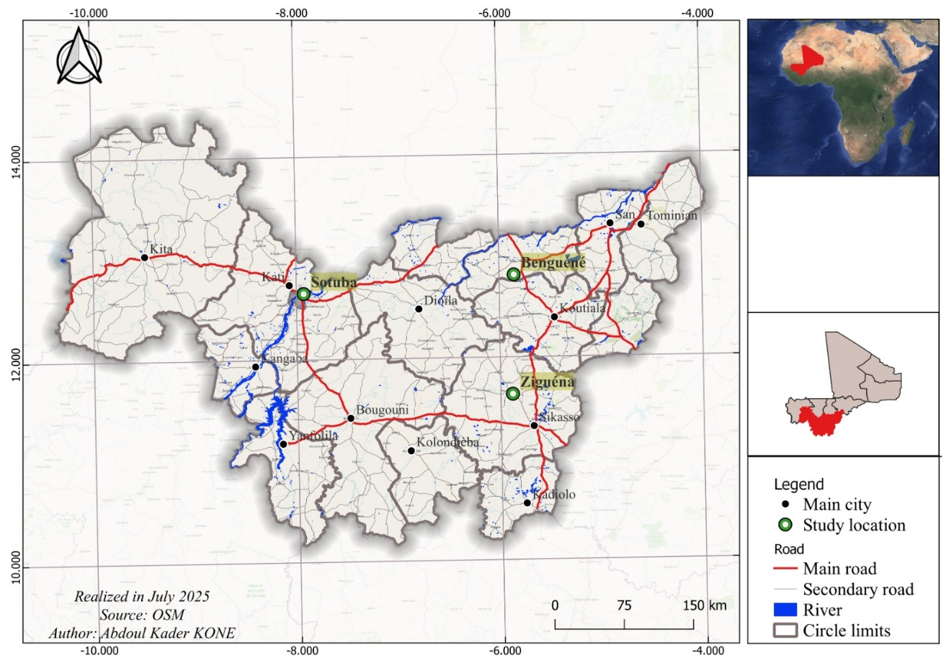
Fig.1. Location of the study area

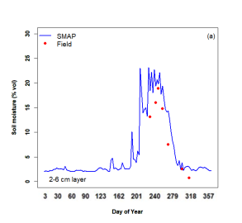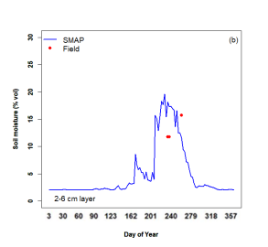
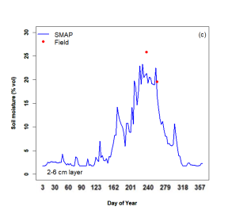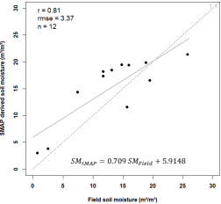
Fig.2. Temporal variation of water reserve in the root layer 2 - 6 cm at Sotuba (a) Beguéné (b) and Ziguéna (c)

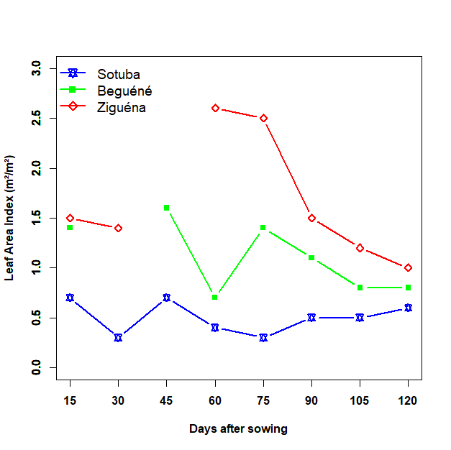
Fig. 3. Seasonal dynamics of LAI derived from the MODIS sensor at the study sites in 2021
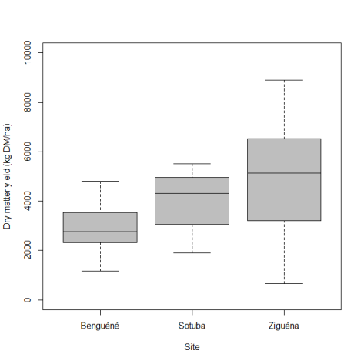
Fig. 4. Variation in dry matter yields according to the site

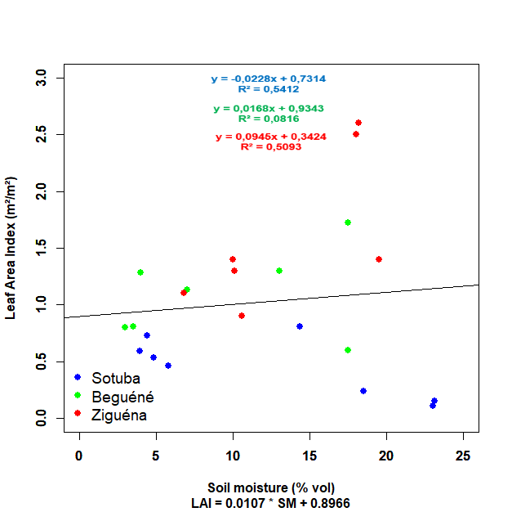
Fig. 5. Relationship between soil moisture and leaf area index (LAI)

