Assessing and Predicting Urban Growth in Kolkata Municipal Corporation (KMC) Using Spatio-temporal Analysis and Mann–Kendall Trend

Abstract
Remote sensing and geospatial technologies have emerged as essential tools for monitoring such changes due to their ability to provide consistent, multi-temporal, and large-scale observations. This study investigates the spatiotemporal dynamics of urban expansion in Kolkata Municipal Corporation (KMC) from 1990 to 2025 using multi-temporal Landsat data within a cloud-based geospatial framework. We extracted built-up areas using the Normalised Difference Built-up Index (NDBI) and analysed their temporal evolution through statistical methods, including linear regression, the Mann–Kendall trend test, and Sen’s slope estimator. The NDBI-based results indicate a substantial increase in built-up extent, with a clear transition from fragmented urban patches in 1990 to a more contiguous and intensified urban fabric by 2025. Quantitatively, built-up area increased from approximately 4,153 ha in 1990 to over 6,198 ha in 2025, reflecting sustained urban growth. Trend analysis confirms a statistically significant upward trend (Z = 3.75, P < 0.001), with Sen’s slope indicating an average annual expansion rate of ~47.65 ha/year, closely supported by regression results (~52 ha/year; R² = 0.48). Future projections based on Sen’s slope suggest continued expansion, potentially reaching ~9,772 ha by 2100 under a monotonic growth assumption. The integration of spatial (NDBI) and statistical (trend and regression) analyses demonstrates a consistent and robust pattern of urbanisation driven by long-term structural factors. However, the projected growth highlights potential challenges related to land resource pressure and environmental sustainability. The study provides a reliable methodological framework for assessing urban dynamics and offers critical insights for sustainable urban planning and policy formulation in rapidly expanding metropolitan regions.
Keywords: NDBI, Urban expansion, Spatio-temporal change, Remote Sensing, Mann–Kendall test
- Introduction:
Urbanisation is one of the most significant global transformations of the 21st century, reshaping land-use patterns, ecological processes, and socio-economic systems (Taubenböck et al., 2024). Rapid urban expansion has been particularly pronounced in developing countries, where population growth and economic development have accelerated the conversion of natural and agricultural land into built-up areas (Liu et al., 2025). Remote sensing and geospatial technologies have emerged as essential tools for monitoring such changes due to their ability to provide consistent, multi-temporal, and large-scale observations (A. Zhang et al., 2025). Spectral indices, especially the Normalised Difference Built-up Index (NDBI), have been widely applied to delineate urban areas by exploiting the distinct spectral response of built-up surfaces in the SWIR and NIR bands (Zha et al., 2003). In parallel, many researchers extensively used statistical approaches such as the Mann–Kendall trend test and Sen’s slope estimator to detect and quantify long-term trends in environmental and urban datasets (Hamed & Ramachandra Rao, 1998; Yue & Wang, 2004) .
In the Indian context, metropolitan regions have experienced rapid and often unplanned urban growth, leading to significant transformations in land use and environmental conditions (Randolph, 2024). Kolkata, one of the largest and oldest metropolitan cities in eastern India, has undergone substantial spatial expansion and densification over the past few decades (Mandal et al., 2019). Previous studies have highlighted the role of remote sensing in capturing urban growth dynamics and the effectiveness of multi-temporal satellite data in quantifying built-up expansion (Taubenböck et al., 2009; Q. Zhang & Seto, 2011). Furthermore, global assessments of urban expansion have demonstrated that cities are likely to continue expanding significantly in the coming decades, with implications for biodiversity, climate, and resource management (Angel et al., 2011; Seto et al., 2012). Despite these advances, city-level analyses that integrate spatial indices and robust statistical trend methods remain limited in many Indian urban centres, including Kolkata.
Although numerous studies have examined urban growth using either remote sensing indices or statistical techniques independently, there is a lack of integrated approaches that combine spatial mapping and temporal trend analysis to provide a comprehensive understanding of urban dynamics. In particular, long-term assessments (spanning more than three decades) that utilise cloud-based platforms such as Google Earth Engine are still relatively scarce for Kolkata. Additionally, limited attention has been given to linking spectral index–derived built-up patterns with statistically validated trends and future projections, which are essential for informed urban planning and policy-making.
To fulfil these gaps, our study objectives are to (i) identify the built-up area expansion between 1990 and 2025 using NDBI, (ii) statistically analyse the trends of urban expansion, and (iii) linear future prediction using Mann-Kendall and Sen’s Slope model. The objective of this study is to present an integrated analysis of urban expansion in the Kolkata Municipal Corporation (KMC) from 1990 to 2025 using multi-temporal Landsat data within the Google Earth Engine environment. We extracted Built-up areas using the NDBI and evaluated their temporal dynamics using the Mann–Kendall trend test, Sen’s slope estimator, and linear regression analysis. Furthermore, projected future urban growth is analysed using trend-based extrapolation methods. By combining spatial and statistical approaches, this study provides a robust framework for understanding long-term urbanisation patterns and offers critical insights for sustainable urban planning and management.
- Study area:
The study focuses on Kolkata Municipal Corporation (KMC), located in the eastern part of India within the state of West Bengal (Fig. 1) (Das & Jain, 2022). Kolkata, the capital of West Bengal, is one of the largest metropolitan cities in India and serves as a major economic, cultural, and administrative hub in the eastern region (Gorai et al., 2024). Geographically, the KMC area lies along the eastern bank of the Hooghly River, a distributary of the Ganges, and is part of the lower Gangetic plain, characterised by flat topography and alluvial soils (Mandal et al., 2019). The municipal area extends between latitudes 22°27′N and 22°39′N and longitudes 88°15′E and 88°30′E, covering about 205 km². The city is administratively divided into 16 boroughs and 144 wards, which exhibit heterogeneous land-use patterns ranging from dense urban cores to relatively less developed peripheral zones (Chakraborti et al., 2017).
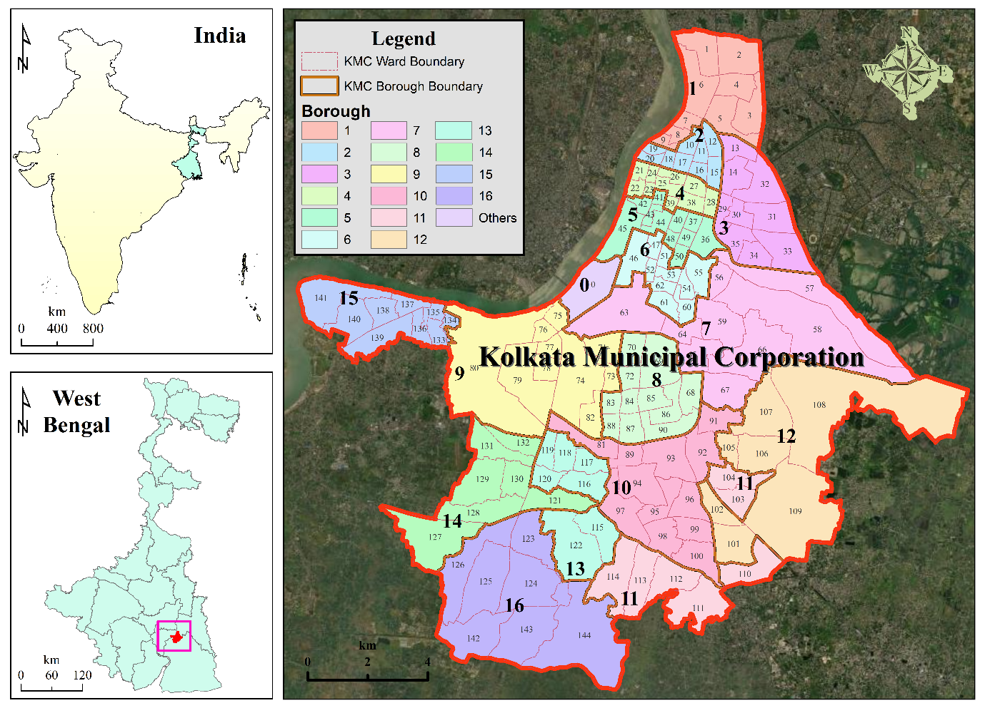
Figure 1: Spatial extent and administrative divisions of Kolkata Municipal Corporation
Kolkata experiences a tropical wet-and-dry climate, with hot, humid summers, a monsoon season characterised by southwest monsoon rainfall, and mild winters. The average annual rainfall exceeds 1,500 mm, primarily occurring between June and September, which significantly influences urban hydrology and land-use dynamics (Mahata et al., 2024). The city has undergone rapid urbanisation over the past few decades, driven by population growth, economic activities, and infrastructural development (Mandal et al., 2019). According to the Census of India, Kolkata has one of the highest population densities among Indian metropolitan cities, resulting in intense pressure on land resources and urban infrastructure (Mahata et al., 2024). The spatial expansion of built-up areas has transformed open spaces, wetlands, and peri-urban regions into urban land, making KMC an important case study for analysing long-term urban growth and land-use change using geospatial techniques.
- Methodology:
  - Data used:
We used Multi-temporal satellite data from the United States Geological Survey Landsat program to analyse urban expansion in the Kolkata Municipal Corporation (KMC) over the period 1990–2025. Surface reflectance products from Landsat 5 TM, Landsat 7 ETM+, and Landsat 8 OLI/TIRS were accessed and processed through the Google Earth Engine (GEE) to ensure radiometric consistency and efficient time-series analysis. We selected the images based on minimal cloud cover and acquired them primarily during similar seasonal windows to reduce phenological variability. Pre-processing steps included cloud and shadow masking, atmospheric correction (using Collection 2 Level-2 datasets), and band harmonisation across sensors to maintain cross-temporal comparability.
  - Methodology
The overall methodology illustrates Figure 2.
    - NDBI
The Normalized Difference Built-up Index (NDBI) was calculated to extract built-up areas using the normalised difference between the shortwave infrared (SWIR) and near-infrared (NIR) bands (Zha et al., 2003) . The formula for calculating NDBI is in Eq. 1.
$$\begin{aligned}NDBI=\frac{SWIR-NIR}{SWIR+NIR} \#\left(1\right)\end{aligned}$$
    - Mann-Kendall Test (Trend Detection)
The trend in built-up area was assessed using the Mann–Kendall test, a non-parametric method suitable for detecting monotonic trends in time-series data. The test statistic (S) was computed based on pairwise comparisons of observations (Eq. 2-4), and its significance was evaluated using the standardized Z-value (Eq. 5). The magnitude of the trend was estimated using Sen’s slope estimator, which calculates the median of all pairwise slopes (Eq. 6). Future built-up area was projected using a linear extrapolation based on Sen’s slope, assuming a consistent long-term trend (Eq. 7). The Mann-Kendall Statistic S is calculated using Eq. 2.
$$\begin{aligned}S=\sum_{i=1}^{n-1}{\sum_{j=i+1}^{n}{sgn\left(x_{j}-x_{i}\right)}} \#\left(2\right)\end{aligned}$$
Where,
$$\begin{aligned}sgn\left(x_{j}-x_{i}\right)=\left\{\begin{matrix}+1 & if x_{j}-x_{i}>0 \\ 0, & if x_{j}-x_{i}=0 \\ -1 & if x_{j}-x_{i}<0\end{matrix}\right. \#\left(3\right)\end{aligned}$$
Variance of S:
$$\begin{aligned}Var \left(S\right)= \frac{n\left(n-1\right)\left(2n+5\right)}{18} \#\left(4\right)\end{aligned}$$
Standardized test statistic (Z):
$$\begin{aligned}Z= \left\{\begin{matrix}\frac{S-1}{\sqrt{Var\left(S\right)}}, & S>0 \\ 0, & S=0 \\ \frac{S+1}{\sqrt{Var\left(S\right)}}, & S<0\end{matrix}\right. \#\left(5\right)\end{aligned}$$
If the $Z>0$, then the trend is increasing, while if $Z<0$, then the trend is decreasing.
    - Sen’s slope estimator (Magnitude of Trend)
The Sen’s slope $Q$ is the median of all data pairs is computed using Eq. 6:
$$\begin{aligned}Q=median\left(\frac{x_{j}-x_{i}}{j-i}\right), for i<j \#\left(6\right)\end{aligned}$$
The unit is hectares per year (ha/year).
    - Future Prediction Equation
Once Sen’s slope is obtained, the future built-up area is estimated using Eq. 7:
$$\begin{aligned}B_{t}=B_{0}+Q\left(t-t_{0}\right) \#\left(7\right)\end{aligned}$$
Where,
$B_{t}=$ predicted built-up area for the year $t$
$B_{0}$ = built-up area in the last observed year (2025)
$Q$ = Sen’s slope
$t-t_{0}$ = number of years after 2025
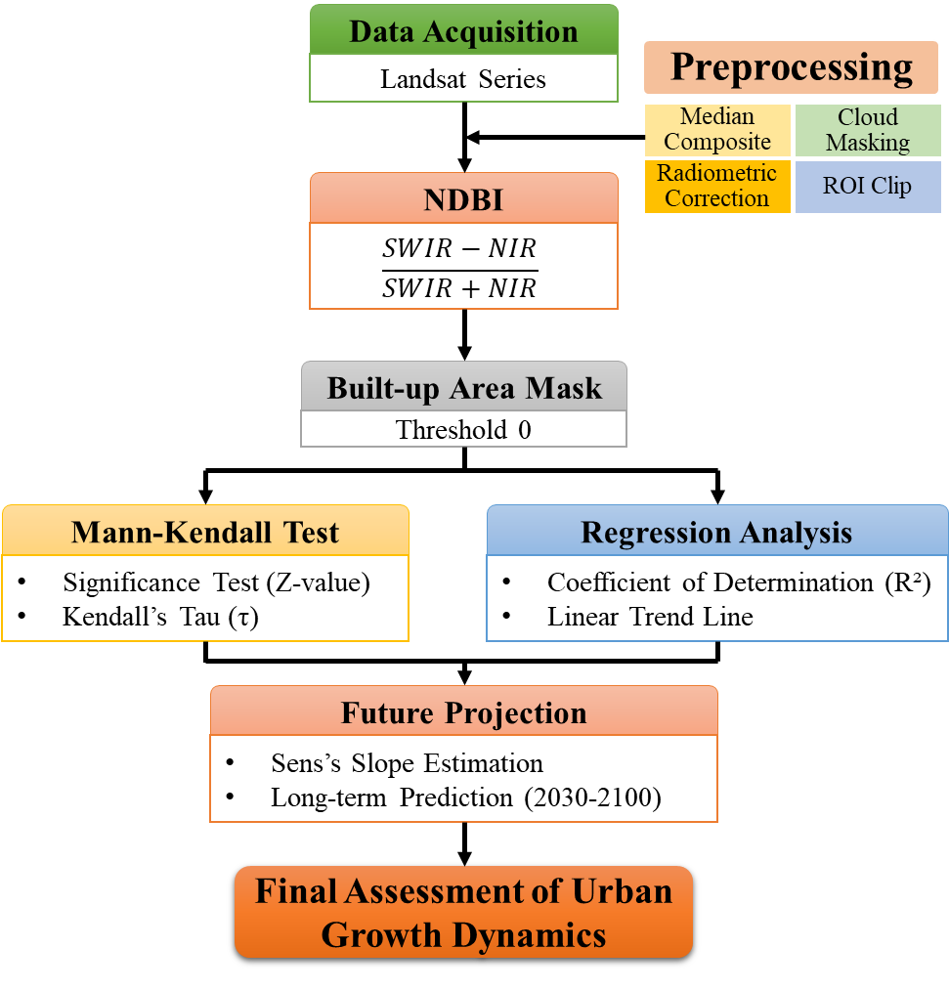
Figure 2: Methodological flowchart
- Results and discussion
  - NDBI-based urban growth assessment
The spatiotemporal distribution of the Normalised Difference Built-up Index (NDBI) reveals a clear and persistent expansion of built-up areas within Kolkata Municipal Corporation (KMC) from 1990 to 2025 (Fig. 3). The NDBI maps indicate that higher values (positive range, shown in orange–red tones) progressively intensify and spread across the central and northern parts of the city over time, while lower values (negative range, green tones) remain largely confined to peripheral and vegetated zones. In 1990, built-up areas were relatively concentrated, with moderate NDBI values (maximum ≈ 0.13), primarily occupying the urban core. By 2000 and 2005, there was a noticeable increase in both the spatial extent and intensity of positive NDBI values, reflecting rapid urban infill and expansion. This trend continues through 2010 and 2015, where the built-up footprint becomes more contiguous, indicating the consolidation of the urban fabric and the reduction of open or vegetated land. By 2020 and 2025, the maximum NDBI values increase further (up to ≈ 0.20), and the spatial dominance of built-up areas becomes pronounced across most administrative units, confirming extensive urbanisation. These observations are consistent with the quantitative increase in urban area from approximately 4,153 ha in 1990 to over 6,198 ha in 2025, demonstrating a substantial long-term transformation of land use.
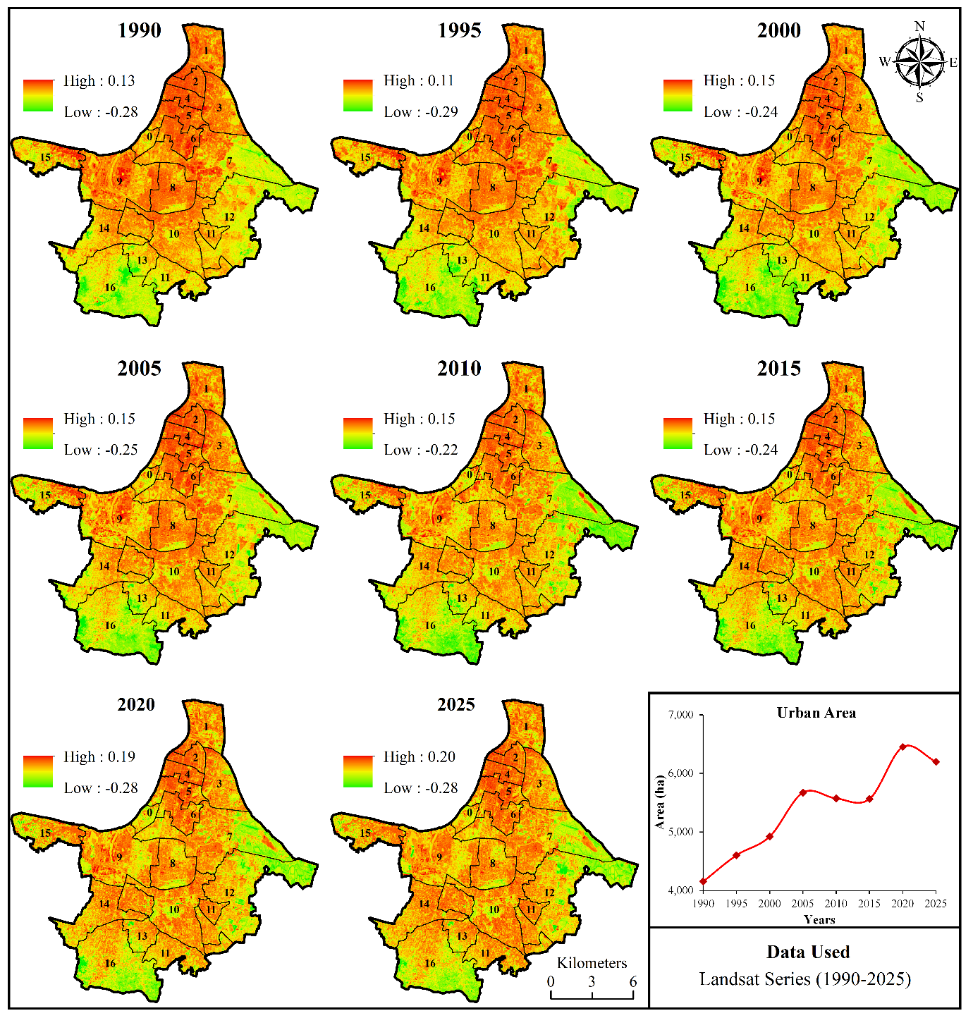
Figure 3: Spatio-temporal variation of urban areas from 1990 to 2025 using NDBI
The observed pattern of increasing NDBI values and spatial expansion aligns with established findings in the urban remote sensing literature, where NDBI has been widely used to effectively delineate built-up areas because urban materials exhibit higher reflectance in the SWIR band than in the NIR band (Zha et al., 2003). The progressive intensification of built-up signatures in KMC reflects typical metropolitan growth processes, including densification of the urban core and outward expansion toward peri-urban regions. Similar patterns have been reported in rapidly urbanising regions worldwide, where continuous land conversion and infrastructure development drive increases in built-up indices over time (Seto et al., 2012; Taubenböck et al., 2009). The temporal fluctuations observed in certain years (e.g., minor declines around 2012–2016) may be attributed to classification variability, atmospheric conditions, or transitional land-use changes; however, the overall trend remains strongly increasing, as supported by statistical analysis.
Table 1: Temporal variation of built-up area in Kolkata Municipal Corporation (1990–2025)
Year | Urban Area (ha) | Year | Urban Area (ha) | Year | Urban Area (ha) | Year | Urban Area (ha)
1990 | 4,153.65 | 2000 | 4,921.92 | 2010 | 5,571.89 | 2020 | 6,449.81
1991 | 4,455.49 | 2001 | 6,010.62 | 2011 | 6,385.59 | 2021 | 6,444.85
1992 | 2,881.98 | 2002 | 5,194.83 | 2012 | 5,527.70 | 2022 | 6,204.53
1993 | 4,503.75 | 2003 | 6,221.44 | 2013 | 5,492.30 | 2023 | 5,918.57
1994 | 4,353.98 | 2004 | 5,065.92 | 2014 | 5,860.56 | 2024 | 6,184.95
1995 | 4,602.57 | 2005 | 5,671.10 | 2015 | 5,564.19 | 2025 | 6,198.47
1996 | 4,983.83 | 2006 | 6,251.74 | 2016 | 5,112.67
1997 | 5,493.73 | 2007 | 5,562.76 | 2017 | 5,942.65
1998 | 4,485.72 | 2008 | 5,835.75 | 2018 | 5,556.16
1999 | 6,473.75 | 2009 | 5,585.02 | 2019 | 5,493.01
The integration of NDBI-based spatial analysis with temporal urban area statistics highlights a near-linear growth trajectory, particularly after 2000, suggesting sustained urban pressure within the KMC region. This expansion has important implications for environmental sustainability, including the loss of green spaces, increased surface temperatures, and altered hydrological processes. While the NDBI approach provides a robust and efficient method for mapping built-up areas, it is important to acknowledge potential limitations, such as confusion with bare soil or dry land surfaces, which may exhibit spectral responses similar to those of built-up areas. Therefore, the results should ideally be interpreted in conjunction with other indices (e.g., NDVI or NDWI) for improved classification accuracy. Overall, the findings demonstrate that KMC has undergone significant urban transformation over the past three decades, and the continued increase in built-up areas underscores the need for sustainable urban planning and land management strategies.
  - Statistical analysis of urban expansion
The linear regression analysis of built-up area against time for Kolkata Municipal Corporation (KMC) reveals a statistically significant increasing trend in urban expansion over the study period (Fig. 4). The model explains approximately 48.03% of the total variance in built-up area (R² = 0.480), indicating a moderate explanatory power of time as a predictor variable. The Multiple R value (0.693) suggests a moderately strong positive correlation between year and urban area, reflecting a consistent growth pattern despite inter-annual fluctuations. The overall model is highly significant, as indicated by the F-statistic (F = 31.42) and its associated p-value (P < 0.001), confirming that the regression relationship is not due to random chance. These findings align with typical urban growth studies, which show that temporal progression alone captures a substantial portion of expansion dynamics. However, additional drivers (e.g., socio-economic and policy factors) may further explain the remaining variability.

Figure 4: Kolkata urban expansion trends (1990-2025)
The regression coefficient for the year variable (β = 52.00 ha/year) indicates that, on average, the built-up area in KMC has increased by approximately 52 hectares annually during the study period. This estimate is statistically significant (t = 5.61, P < 0.001), and the 95% confidence interval (33.15–70.85 ha/year) confirms the robustness of the positive growth rate. The intercept value (-98924.12) is not directly meaningful in a physical sense but serves as a parameter within the regression equation. The relatively high standard error (578.21 ha) reflects temporal variability and potential nonlinearity in urban growth patterns, which are common in rapidly developing metropolitan regions. Compared with Sen’s slope estimate (~47.65 ha/year), the regression-derived growth rate shows strong agreement, reinforcing the reliability of the observed expansion trend. Overall, the statistical analysis confirms that urban growth in KMC has followed a significant and sustained upward trajectory, supporting the results of the non-parametric trend analysis and highlighting the progressive transformation of land use in the region.
Table 2: Regression statistics
Regression Statistics
Multiple R | 0.693013527
R Square | 0.480267749
Adjusted R-Square | 0.464981506
Standard Error | 578.2154544
Observations | 36
Table 3: Significant test
 | df | SS | MS | F | Significance F
Regression | 1 | 10504177.81 | 10504178 | 31.41829941 | 2.80725E-06
Residual | 34 | 11367325.8 | 334333.1
Total | 35 | 21871503.6
Table 4: Coefficients, standard error, t-stat and p value
 | Coefficients | Standard Error | t Stat | P-value | Lower 95% | Upper 95% | Lower 95.0% | Upper 95.0%
Intercept | -98924.12 | 18623.25 | -5.31 | 6.76079E-06 | -136771.13 | -61077.12 | -136771.13 | -61077.12
Year | 52.00 | 9.28 | 5.61 | 2.80725E-06 | 33.15 | 70.85 | 33.15 | 70.85

  - Future prediction of KMC
The Mann–Kendall analysis reveals a statistically significant increasing trend in built-up area within the KMC region from 1990 to 2025. The positive Z-statistic (Z = 3.75) and very low p-value (P < 0.001) confirm that the observed trend is highly significant, indicating a persistent expansion of urban land over time. The Kendall’s Tau coefficient (τ = 0.445) suggests a moderate to strong positive association, reflecting a consistent upward trajectory despite short-term fluctuations. The positive S-statistic (S = 265) further reinforces the dominance of increasing trends in the time series. The Sen’s slope estimator indicates an average annual increase of approximately 47.65 ha/year, highlighting steady urban growth. These findings are consistent with established urbanisation patterns reported in rapidly developing cities, where long-term land-use change is driven by population growth and infrastructure expansion. Similar statistically significant increasing trends in built-up areas have been reported using Mann–Kendall and Sen’s slope approaches in urban studies (Mandal et al., 2019), demonstrating the robustness of non-parametric trend detection in capturing urban dynamics.
Table 5: Results of the Mann–Kendall trend test and Sen’s slope estimator for built-up area dynamics (1990–2025)
Parameter | Value | Interpretation
Trend | Increasing | Positive monotonic trend
h (Significance) | True | Trend is statistically significant
p-value | 0.00018 | Significant at P < 0.001
Z-statistic | 3.749 | Strong positive trend
Kendall’s Tau (τ) | 0.445 | Moderate to strong correlation
S-statistic | 265 | Dominance of increasing pairs
Variance of S | 4958.33 | Variability of S
Sen’s Slope (ha/year) | 47.65 | Annual rate of built-up expansion
Intercept | 4754.06 | Baseline value
Table 6: Long-term projections of built-up area based on Sen’s slope linear extrapolation.
Year | Predicted Built-up Area (ha)
2030 | 6436.74
2040 | 6913.29
2050 | 7389.84
2060 | 7866.38
2070 | 8342.93
2080 | 8819.47
2090 | 9296.02
2100 | 9772.57
The projected built-up area based on Sen’s slope indicates a continued expansion trend, reaching approximately 6,913 ha by 2040 and 9,772 ha by 2100. This near-linear increase suggests that urban growth in KMC is likely to persist if historical patterns remain unchanged. Comparable long-term projections of urban expansion have been documented in studies using remote sensing and geospatial modelling, which highlight the sustained conversion of non-built-up land into urban fabric in metropolitan regions (Angel et al., 2011; Seto et al., 2012). The observed growth trajectory aligns with findings from Indian urban contexts, where continuous densification and peri-urban expansion contribute to increasing built-up extents (Taubenböck et al., 2009). However, it is important to note that the projections assume a monotonic trend and do not incorporate potential future interventions such as policy regulations, environmental constraints, or shifts in development patterns. Therefore, while the results provide a reliable baseline scenario, they should be interpreted within the broader framework of dynamic urban systems. The findings underscore the necessity for sustainable urban planning and land management strategies to mitigate environmental impacts and ensure balanced urban development in KMC.
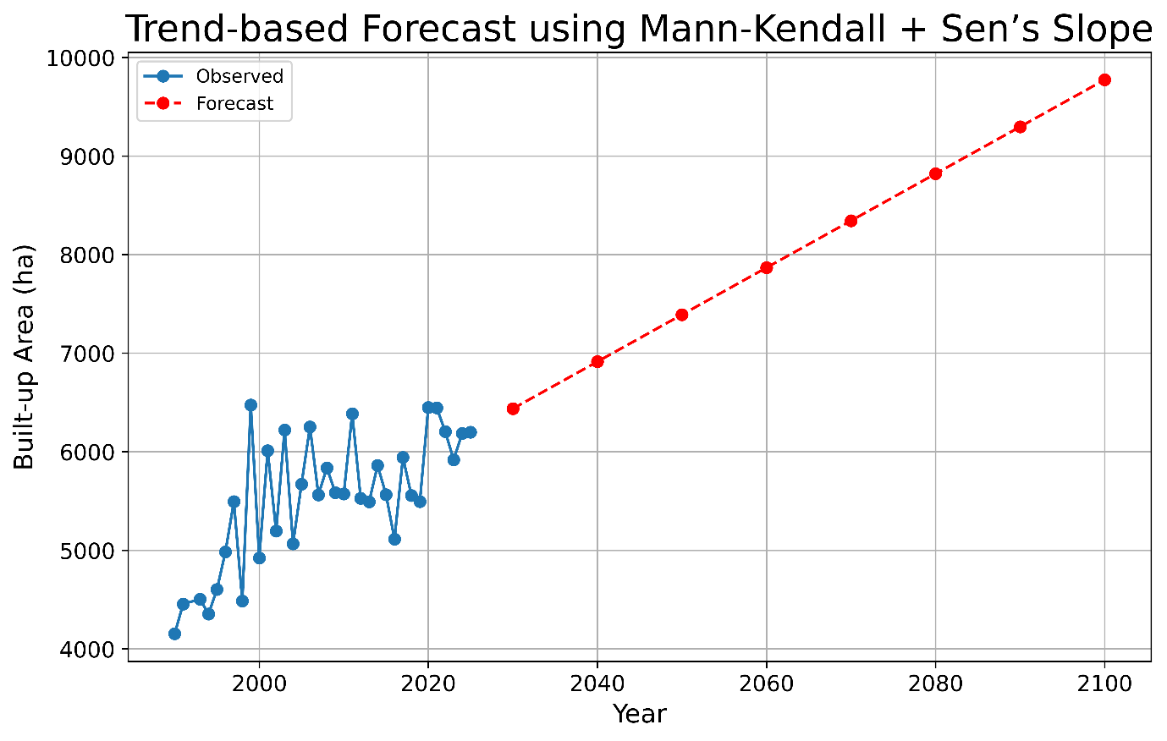
Figure 5: Linear trend-based forecast of the KMC urban area using Mann-Kendall and Sen's slope
- Conclusions
This study provides a comprehensive assessment of urban expansion in the Kolkata Municipal Corporation (KMC) from 1990 to 2025 by integrating remote-sensing–based index analysis with statistical trend analysis. The NDBI results reveal a substantial increase in built-up area, characterised by both spatial intensification and outward expansion. The Mann–Kendall test confirms that this growth is statistically significant and monotonic, while the Sen’s slope quantifies a steady annual increase of approximately 47.65 ha/year. Complementary regression analysis further validates this trend, indicating a consistent and sustained urban growth trajectory.
The integration of spatial and statistical approaches demonstrates that urban expansion in KMC is both systematic and persistent, with projections indicating continued growth in the coming decades. However, such expansion poses significant challenges, including pressure on land resources, reduction of green spaces, and potential environmental degradation. While the applied methods provide a robust baseline for understanding long-term urban dynamics, future studies should incorporate additional variables such as socio-economic drivers, policy interventions, and climate-related factors to enhance predictive accuracy. Overall, the findings emphasize the urgent need for sustainable urban planning and land management strategies to balance development with environmental conservation in the KMC region.
Competing Interests
Authors have declared that no competing interests exist.

Disclaimer (Artificial intelligence)
Author(s) hereby declare that NO generative AI technologies such as Large Language Models (ChatGPT, COPILOT, etc.) and text-to-image generators have been used during the writing or editing of this manuscript.
References
Angel, S., Parent, J., Civco, D. L., Blei, A., & Potere, D. (2011). The dimensions of global urban expansion: Estimates and projections for all countries, 2000–2050. Progress in Planning, 75(2), 53–107. https://doi.org/https://doi.org/10.1016/j.progress.2011.04.001
Chakraborti, D., Das, B., Rahman, M. M., Nayak, B., Pal, A., Sengupta, M. K., Ahamed, S., Hossain, Md. A., Chowdhury, U. K., Biswas, B. K., Saha, K. C., & Dutta, R. N. (2017). Arsenic in groundwater of the Kolkata Municipal Corporation (KMC), India: Critical review and modes of mitigation. Chemosphere, 180, 437–447. https://doi.org/10.1016/j.chemosphere.2017.04.051
Das, S., & Jain, G. V. (2022). Assessment and Prediction of Urban Expansion Using CA-Based SLEUTH Urban Growth Model: A Case Study of Kolkata Metropolitan Area (KMA), West Bengal, India. Journal of the Indian Society of Remote Sensing, 50(12), 2277–2302. https://doi.org/10.1007/s12524-022-01602-y
Gorai, N., Bandyopadhyay, J., Halder, B., Ahmed, M. F., Molla, A. H., & Lei, T. M. T. (2024). Spatio-Temporal Variation in Landforms and Surface Urban Heat Island in Riverine Megacity. Sustainability, 16(8), 3383. https://doi.org/10.3390/su16083383
Hamed, K. H., & Ramachandra Rao, A. (1998). A modified Mann-Kendall trend test for autocorrelated data. Journal of Hydrology, 204(1), 182–196. https://doi.org/https://doi.org/10.1016/S0022-1694(97)00125-X
Liu, L., Wang, L.-J., Ma, S., Hao, Y., Hu, H., & Jiang, J. (2025). Unraveling the Dual Impacts of Urbanization on Agricultural Habitats: A Telecoupling Perspective From Zhejiang Province, China. Land Degradation & Development, 36(18), 6367–6379. https://doi.org/10.1002/ldr.70075
Mahata, D., Shekhar, S., & Ravi, K. (2024). Urban expansion influences on land use and land cover changes in Kolkata metropolitan region: a geo-spatial study. GeoJournal, 89(6), 237. https://doi.org/10.1007/s10708-024-11236-x
Mandal, J., Ghosh, N., & Mukhopadhyay, A. (2019). Urban Growth Dynamics and Changing Land-Use Land-Cover of Megacity Kolkata and Its Environs. Journal of the Indian Society of Remote Sensing, 47(10), 1707–1725. https://doi.org/10.1007/s12524-019-01020-7
Randolph, G. F. (2024). Does urbanization depend on in-migration? Demography, mobility, and India’s urban transition. Environment and Planning A: Economy and Space, 56(1), 117–135. https://doi.org/10.1177/0308518X231180609
Seto, K. C., Güneralp, B., & Hutyra, L. R. (2012). Global forecasts of urban expansion to 2030 and direct impacts on biodiversity and carbon pools. Proceedings of the National Academy of Sciences, 109(40), 16083–16088. https://doi.org/10.1073/pnas.1211658109
Taubenböck, H., Mast, J., Geiß, C., Wurm, M., Esch, T., & Seto, K. C. (2024). Global differences in urbanization dynamics from 1985 to 2015 and outlook considering IPCC climate scenarios. Cities, 151, 105117. https://doi.org/10.1016/j.cities.2024.105117
Taubenböck, H., Wegmann, M., Roth, A., Mehl, H., & Dech, S. (2009). Urbanization in India – Spatiotemporal analysis using remote sensing data. Computers, Environment and Urban Systems, 33(3), 179–188. https://doi.org/10.1016/j.compenvurbsys.2008.09.003
Yue, S., & Wang, C. (2004). The Mann-Kendall Test Modified by Effective Sample Size to Detect Trend in Serially Correlated Hydrological Series. Water Resources Management, 18(3), 201–218. https://doi.org/10.1023/B:WARM.0000043140.61082.60
Zha, Y., Gao, J., & Ni, S. (2003). Use of normalized difference built-up index in automatically mapping urban areas from TM imagery. International Journal of Remote Sensing, 24(3), 583–594. https://doi.org/10.1080/01431160304987
Zhang, A., Tariq, A., Quddoos, A., Naz, I., Aslam, R. W., Barboza, E., Ullah, S., & Abdullah-Al-Wadud, M. (2025). Spatio-temporal analysis of urban expansion and land use dynamics using google earth engine and predictive models. Scientific Reports, 15(1), 6993. https://doi.org/10.1038/s41598-025-92034-4
Zhang, Q., & Seto, K. C. (2011). Mapping urbanization dynamics at regional and global scales using multi-temporal DMSP/OLS nighttime light data. Remote Sensing of Environment, 115(9), 2320–2329. https://doi.org/10.1016/j.rse.2011.04.032

