Original Research Article
GIS‑Integrated AHP-Driven Susceptibility Prognosis of Fluvial Inundation in a Data‑Scarce Basin: The Shilabati River Case with Ground‑Truthing by Affected Communities

Abstract
Flood susceptibility mapping is essential for disaster risk reduction in monsoon‑dominated river basins. This study applies an integrated Geographic Information System (GIS) and Analytical Hierarchy Process (AHP) approach to assess flood susceptibility in the Shilabati River basin of West Bengal, India (area ~3,029 km²). Eight criteria - elevation, slope, distance from river, drainage density, flow accumulation, Topographic Wetness Index (TWI), rainfall intensity, and Land Use/Land Cover (LULC) - were selected based on field observations and expert judgment. Pairwise comparison matrices were constructed using Saaty’s 1-9 scale, and criterion weights were derived through AHP. The consistency ratio (CR = 0.0376) confirmed the reliability of the weight assignments, with elevation (32 %) and slope (22 %) emerging as the dominant controls. Weighted overlay analysis classified the basin into five susceptibility zones. This susceptibility map identifies the relative likelihood of inundation; it does not provide hydraulic parameters such as flood depth, velocity, or duration. The Most Susceptible zone (MoSFA) covers 0.16 % (4.98 km²), representing critical flood foci in the Ghatal confluence area. The Highly Susceptible zone (HFA) occupies 14.28 % (432.50 km²), while the Moderately Susceptible zone dominates 73.21 % (2,217.38 km²). Less and Not Susceptible zones together account for 12.35 % of the basin. Community‑based validation using primary data from 120 local residents (including the researcher as an insider) confirmed that 92.7 % of reported flood points fell within the MoSFA and HFA zones, strongly supporting the model’s accuracy. The spatial distribution aligns with documented chronic flood‑prone areas, demonstrating the utility of this approach. The results provide a scientific basis for targeted flood management, land‑use zoning, and early warning system development. This AHP‑GIS framework offers a cost‑effective and replicable methodology for flood susceptibility assessment in data‑scarce regions, particularly when combined with participatory validation.
Keywords: Flood susceptibility; Analytical Hierarchy Process (AHP); Geographic Information System (GIS); Shilabati River basin; Weighted overlay analysis; Multi‑criteria decision making (MCDM); Participatory validation
1. Introduction
Flooding is one of the most frequent and devastating natural hazards worldwide, affecting millions of people annually and causing extensive economic, social, and environmental losses (Svetlana, D. Radovan et al. 2015; Mfon, I. E., et al. 2022). Rapid population growth, unplanned urbanization, land‑use transformation, and climate variability have intensified flood risks, particularly in developing countries where river basins are densely inhabited and dependent on agriculture‑based livelihoods (Tavakoli, M. et al. 2025). According to global disaster databases, floods account for a significant proportion of natural hazard‑related damages, disrupting infrastructure, degrading ecosystems, and undermining sustainable development goals (Mashwama, N. X., & Phesa, M., 2025). In India, monsoon‑dominated hydrological regimes combined with geomorphological diversity make many river basins highly vulnerable to recurrent flooding (Ghosh, S. et al. 2023). Consequently, scientific assessment of flood‑prone areas through geospatial modelling has become essential for effective disaster mitigation and regional planning (Bello, M. et al. 2024).
The eastern Indian region, particularly West Bengal, experiences seasonal flooding due to intense monsoonal rainfall, riverbank erosion, siltation, and inadequate drainage systems (Bhowmick, M. K. et al. 2020; Haldar, O. et al. 2025). Several river basins in this region exhibit complex hydrological characteristics influenced by plateau uplands, lateritic terrains, alluvial plains, and deltaic systems (Chakraborty, S. K. 2021). Among these, the Shilabati River Basin is a significant hydrological unit characterised by varied topography, seasonal discharge fluctuations, and increasing anthropogenic pressure (Yadav, V., & Dey, S. 2025). The Shilabati River rises near Chak Gopalpur village in the Hura block of Purulia district, West Bengal, India (Das, G. K. 2024), flows south‑easterly through Bankura and Paschim Medinipur districts, and joins the Dwarakeswar River near Ghatal to form the Rupnarayan River, which eventually drains into the Bay of Bengal (Pal, S. C., & Chakrabortty, R., 2022). The basin encompasses diverse physiographic zones, including undulating uplands, dissected plateaus, and low‑lying floodplains (Yadav, V., & Dey, S. 2025), making it susceptible to both flash floods in the upper reaches and prolonged inundation in the lower stretches.
Flood susceptibility mapping refers to the identification and spatial delineation of areas prone to flooding based on terrain characteristics, hydrological parameters, climatic conditions, and land‑use factors (Lin, L., Wu, Z., & Liang, Q., 2019). Unlike flood hazard or risk mapping, which often require detailed hydrodynamic modelling and real‑time discharge data, flood susceptibility mapping emphasises the intrinsic potential of a landscape to experience flooding under conducive conditions (Jafarzadegan, K. et al. 2023). With advances in remote sensing and GIS, flood susceptibility analysis has become more precise and cost‑effective (Islam, T. et al 2025). Among various modelling approaches, Multi‑Criteria Decision Analysis (MCDA) has emerged as a widely adopted method due to its flexibility and ability to incorporate both quantitative and qualitative factors (Alsalem, M. A. et al 2022; Kumar, R. 2025). MCDA integrates diverse flood conditioning factors by assigning relative importance to each parameter through systematic weighting techniques such as the Analytical Hierarchy Process (AHP), weighted linear combination (WLC), or pairwise comparison matrices (Esmaili, R., & Karipour, S. A., 2024). This approach is particularly suitable for data‑scarce basins where detailed hydrological simulations are not feasible.
Despite the recurring flood events in the Shilabati Basin, comprehensive geospatial flood susceptibility assessment at a basin‑wide scale remains limited. Most existing studies focus either on local flood impacts or hydrological descriptions without integrating multi‑criteria spatial analysis. No previous study has produced a basin‑wide flood susceptibility map for the Shilabati using AHP‑GIS with field validation. This research gap is critical because the basin presents unique challenges: the upper catchment contributes rapid runoff during intense rainfall events, while the lower basin exhibits gentle slopes, reduced drainage efficiency, and prolonged waterlogging. Agricultural fields, rural settlements, and transportation networks located within floodplains are particularly vulnerable. Moreover, socio‑economic dependence on agriculture and forest resources amplifies the adverse impacts of flooding on livelihoods.
In this context, the present study aims to develop a flood susceptibility map of the Shilabati River Basin using GIS and MCDA. The research integrates eight flood conditioning parameters derived from remote sensing data, digital elevation models, rainfall records, and thematic maps. By assigning appropriate weights to each factor through AHP and performing spatial overlay analysis, the study generates a composite Flood Susceptibility Index (FSI). The resulting zonation map categorises the basin into different susceptibility classes, highlighting critical hotspots that require priority intervention. Furthermore, the study validates the model output using community‑based primary data from 120 residents, including the researchers as insiders, combined with historical flood records. This integrated approach contributes to disaster risk reduction, sustainable land‑use planning, and climate adaptation strategies in southwestern West Bengal. The combination of geospatial technology with participatory validation offers a replicable framework for flood susceptibility assessment in data‑scarce monsoon‑dominated basins.
2. Materials and Methods:
2.1Study Area:
The Shilabati River basin is situated in the southwestern part of West Bengal, India, between approximately 22°40′ N to 23°35′ N latitude and 86°35′ E to 87°45′ E longitude (Fig. 1). The river originates near Chak Gopalpur village in the Hura block of Purulia district at coordinates 23°14′11″N (23.236°N) and 86°38′41″E (86.645°E) (Das, G. K., 2024). From its source, the Shilabati flows southeast through the districts of Purulia, Bankura, and Paschim Medinipur before joining the Dwarakeswar River near Ghatal; the combined stream becomes the Rupnarayan River, which eventually empties into the Hooghly River and the Bay of Bengal. Although the basin primarily lies within West Bengal, its upper catchment extends into the adjacent Chota Nagpur Plateau near the Jharkhand border, reflecting the river’s transition from rocky plateau terrain to alluvial floodplains.
The basin covers a total area of 3,029 km² as delineated from SRTM Digital Elevation Model analysis. Elevation ranges from a maximum of 227 m above mean sea level in the source region to a minimum of 2 m near the confluence zone. Major administrative blocks within the basin are listed in Table 1, with the Ghatal subdivision being particularly vulnerable to recurrent flooding due to its geographical location and physiographic characteristics.
Table 1. Administrative blocks in the Shilabati River basin by district.
District | Blocks
Purulia | Puncha, Hura
Bankura | Manbazar-I, Indpur, Onda, Khatra, Hirbandh, Taldangra, Bishnupur, Shimlapal, Joypur, Sarenga
Paschim Medinipur | Garhbeta-I, Garhbeta-II, Garhbeta-III, Salboni, Keshpur, Ghatal, Daspur-I, Daspur-II, Chandrakona-I, Chandrakona-II
The basin experiences a tropical monsoon climate with average annual rainfall ranging between 1,400 and 2,000 mm. Analysis of high-resolution India Meteorological Department datasets from 1970 to 2022 demonstrates a strong monsoonal influence, with concentrated rainfall during June to September (Khan, A., et al. 2025). The basin has a well-documented history of severe flooding events. This area facing flood in every year, with almost annual flooding reported, particularly in the Banka, Khirpai, Narajole, and Ghatal areas. Recent events have impacted over two lakh (200,000) people in the Ghatal region, highlighting the persistent vulnerability of the lower basin to inundation (Baral, M. et al. 2025). The increasing frequency and intensity of these flood events are attributed to a combination of factors: heavy cyclonic storms and depressions during the monsoon season, the basin’s concave longitudinal profile that facilitates rapid runoff concentration, and significant anthropogenic modifications such as sand mining and land use changes that have altered the river’s natural drainage capacity.
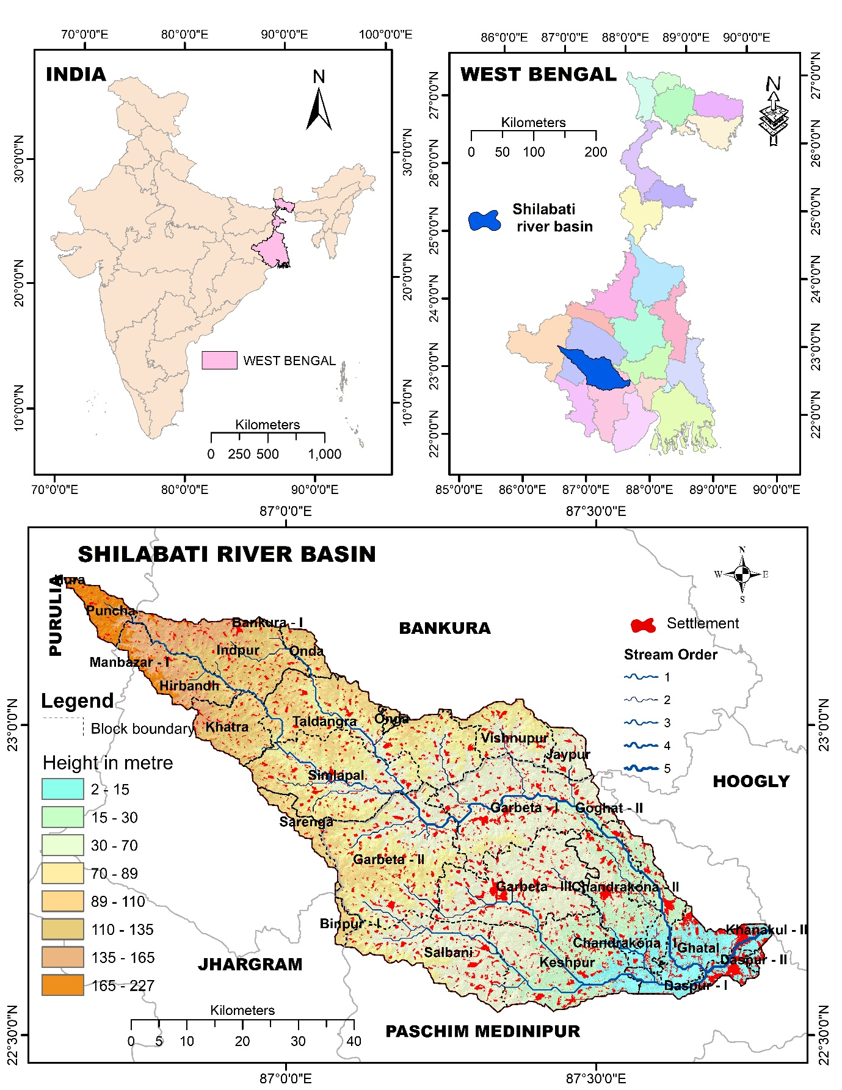
Fig. 1 Location map of Study area: Shilabati River basin.
2.3. Methods:
2.1 Overview of the Methodological Framework
This study employed an integrated Geographic Information System (GIS) and Analytical Hierarchy Process (AHP) approach to generate a flood susceptibility map (Nazir, M. F. et al 2025) for the Shilabati River basin. The methodological framework comprised four main stages: (1) preparation of a geodatabase of eight flood conditioning factors; (2) calculation of criterion weights using the AHP pairwise comparison method; (3) weighted overlay analysis to produce a Flood Susceptibility Index (FSI); and (4) validation using primary field data and historical records. The overall workflow is illustrated in Figure 2.
Fig. 2 Methodological Flow map.
2.2 Selection and Justification of Flood Conditioning Factors
Based on field visits (December 2024-December 2025), expert consultation with hydrologists and geomorphologists familiar with the Shilabati basin, and a comprehensive review of flood susceptibility literature, eight criteria were selected. The justification for each criterion specific to the Shilabati basin (Fig 3 & Table 5)is as follows:
Criterion | Justification for Shilabati Basin
Elevation | The basin exhibits a steep west-east gradient (227 m to 2 m). The lower floodplain (<37 m) is chronically inundated, making elevation the primary control.
Slope | The lower 70 % of the basin has slopes <5°, leading to slow drainage and prolonged waterlogging.
Distance from river | The Shilabati and its tributaries frequently overtop their banks; nearly 75 % of the basin lies within 1.4 km of a stream.
Drainage density | High drainage density in the upper catchment (Purulia uplands) concentrates runoff rapidly, contributing to flash floods downstream.
Flow accumulation | Identifies convergent areas (e.g., Ghatal confluence) where floodwaters accumulate regardless of local elevation.
Topographic Wetness Index (TWI) | The lower basin has extensive low-lying depressions that experience saturation-excess waterlogging, not just riverine flooding.
Rainfall intensity | The upper catchment receives orographically enhanced rainfall (>1947 mm/year), which generates the flood wave that propagates downstream.
Land Use/Land Cover (LULC) | Deforestation in the upper catchment and urbanisation in the lower basin have altered runoff responses; agriculture dominates the floodplain, increasing vulnerability.
Table 2: Criteria Justification for Shilabati Basin.
All thematic layers were prepared in ArcGIS 10.8 with a consistent projection (UTM Zone 45N) and a uniform cell size of 30 m × 30 m to ensure compatibility for overlay analysis.
3.3 Data Sources and Geodatabase Generation
Spatial and non‑spatial data were gathered from primary and secondary sources as summarised in Table 3.
Criteria | Data sources | Specification | Applications
2. Elevation | SRTM- DEM  https://earthexplorer.usgs.gov/ | 30-meter global  Publication Date: 2014-09-23 | Reclassified five into classes according to elevation value.
3. Slope | SRTM- DEM  https://earthexplorer.usgs.gov/ | 30-meter global  Publication Date: 2014-09-23 | Preparation of slope map from DEM and classified into five classes.
4. Proximity to river and Drainage density | SRTM- DEM  https://earthexplorer.usgs.gov/ | 30-meter global  Publication Date: 2014-09-23 | Distance from the river is calculated and classified from DEM.
4. LULC | The shapefile from: https://livingatlas.arcgis.com/landcover/ | Sentinel-2 10-Meter Land Use/Land Cover (2023) | Mask the LULC of the study area and rank character in ArcGIS
5. Base maps | Survey of India: https://surveyofindia.gov.in/ |  | Prepare location and different base maps
Table 3. source of secondary data with specification.

- Elevation, slope, drainage density, TWI, and flow accumulation were derived from the 30‑m global SRTM DEM (available from Earth Explorer, https://earthexplorer.usgs.gov/).
- Rainfall data were obtained from the India Meteorological Department (IMD) gridded datasets (0.25° × 0.25° resolution) for the 2024 monsoon season.
- Distance from river was calculated using a drainage network extracted from the SRTM DEM and validated with Survey of India topographic maps (scale 1:50,000).
- LULC data were sourced from Sentinel‑2 10‑m imagery (2024) via the ArcGIS Living Atlas (https://livingatlas.arcgis.com/landcover/).
2.4 Analytical Hierarchy Process (AHP) Calculation
The AHP method, originally developed by Saaty (1980), was used to determine the relative weights of the eight criteria. The following steps were performed in MS Excel.
Intensity of importance | Numerical rating
1 | Equal importance
3 | Moderate importance
5 | Strong importance
7 | Very strong or demonstrated
9 | Extreme importance
2, 4, 6, 8 | Intermediate values between the two adjacent judgments
Reciprocals (Opposites): Used for inverse comparison
Table 4. Saaty’s 1-9 Relative Importance Scale (Saaty, 1980)
Step 1: Construction of the Pairwise Comparison Matrix
A pairwise comparison matrix A (size $n×n$, where $n=8$) was constructed using Saaty’s 1-9 relative importance scale (Table 4 ). The matrix entry $a_{ij}$ represents the importance of the criterion $i$ relative to criterion $j$. The reciprocal property is given by
The reciprocal property is maintained by Equation 1:
$a_{ji}=\frac{1}{a_{ij}}$
The matrix is expressed as (Equation 2):
A = $\left|\begin{matrix}a_{11} & a_{12} & ⋯ & a_{1n} \\ a_{21} & {ca}_{22} & ⋯ & {ac}_{2n} \\ ⋮ & ⋮ & ⋱ & ⋮ \\ a_{n1} & a_{n2} & ⋯ & a_{nn}\end{matrix}\right|$
The specific pairwise comparisons (presented in Table 6 ) were based on expert judgment. A detailed rationale for each comparison (e.g., why elevation is twice as important as slope) is provided in Supplementary Table S1
Step 2: Normalisation of the Pairwise Comparison Matrix:
The normalisation process transforms the pairwise comparison matrix to ensure comparability across criteria:
- Calculate column sums (Equation 3):
$$S_{j}=\sum_{i=1}^{n}{a_{ij}} \text{for }j=1,2,…,n$$
- Create normalised matrix N (Equation 4):
$n_{ij}=\frac{a_{ij}}{S_{j}}$
The normalised matrix 𝑁 is then represented as (Equation 5):
N= $\left|\begin{matrix}n_{11} & n_{12} & ⋯ & n_{1n} \\ n_{21} & {cn}_{22} & ⋯ & {nc}_{2n} \\ ⋮ & ⋮ & ⋱ & ⋮ \\ n_{n1} & n_{n2} & ⋯ & n_{nn}\end{matrix}\right|$
Step 3: Calculation of the weighted of each criterion
The weight vector W, representing the relative importance of each criterion, is obtained by calculating the row averages of the normalized matrix (Equation 6):
$$w_{i}=\frac{1}{n}\sum_{j=1}^{n}{n_{ij}} \text{for }i=1,2,…,n$$
The priority (weight) vector is expressed as (Equation 7):
$$W= \left[\begin{matrix}w_{1} \\ w_{2} \\ ⋮ \\ w_{n}\end{matrix}\right]$$
This weight vector W serves as the priority vector for subsequent analysis.
Step 4: Calculation of the Consistency Analysis:
To ensure logical consistency of pairwise comparisons, the Consistency Vector (CV) is calculated as (Equation 8):
$$CV = A ×W$$
Expanding Equation 8 (Equation 9):
$$CV=\left[\begin{matrix}\sum_{j=1}^{n}{a_{1j}w_{j}} \\ \sum_{j=1}^{n}{a_{2j}w_{j}} \\ ⋮ \\ \sum_{j=1}^{n}{a_{nj}w_{j}}\end{matrix}\right]= \left[\begin{matrix}{cv}_{1} \\ {cv}_{2} \\ ⋮ \\ {cv}_{n}\end{matrix}\right]$$
The Principal Eigenvalue ${(λ}_{max}$)is then computed as (Equation 10):
$$λ_{max}=\frac{1}{n}\sum_{i=1}^{n}{\frac{cv_{i}}{w_{i}}}$$
Step 5: Calculation of the consistency ratio.
The consistency of the pairwise comparisons was verified using the following indices:
- Consistency index (CI) (Equation 11):
$$CI=\frac{λ_{max}-n}{n-1}$$
- Consistency ratio (CR) (Equation 12):
$$CR=\frac{CI}{RI}$$
Where RI is the Random index obtained from Saaty’s (1980) reference table 5.
Table 5: Random index table
n | 1 | 2 | 3 | 4 | 5 | 6 | 7 | 8 | 9 | 10 | 11 | 12 | 13 | 14 | 15
RI | 0.00 | 0.00 | 0.52 | 0.89 | 1.11 | 1.25 | 1.35 | 1.40 | 1.45 | 1.49 | 1.51 | 1.54 | 1.56 | 1.57 | 1.58

2.5 Weighted Overlay Analysis and Flood Susceptibility Zoning
Each of the eight thematic layers was reclassified into five classes representing their relative contribution to flood susceptibility: Not Susceptible (NFA), Less Susceptible (LFS), Moderately Susceptible (MoDFA), Highly Susceptible (HFA), and Most Susceptible (MoSFA). The reclassification thresholds were based on the physical characteristics of the study area and existing literature (e.g., lower elevation, gentler slope, higher rainfall, and proximity to rivers were assigned higher susceptibility ratings).
The Weighted Overlay tool in ArcGIS was used to combine the reclassified raster layers. Each layer was multiplied by its respective AHP‑derived weight, and the results were summed on a cell‑by‑cell basis to generate the Flood Susceptibility Index (FSI):
FSI $=\sum_{i=1}^{n}{(WixRi}$)
where Wi is the weight of criterion $i$, and Ri is the reclassified suitability score of criterion i. The final output map is classified into five flood susceptibility zones: Most, High, Moderate, Low, and Not.
2.6 Validation Using Primary Field Data
Primary validation data were collected through field surveys (December 2024 - December 2025) across 48 villages in the Most (MoSFA) and Highly (HFA) Susceptible zones. A purposive stratified sampling approach was adopted: villages were selected from the MoSFA and HFA zones across Ghatal, Chandrakona, Salboni, and Daspur blocks based on documented annual flooding and accessibility. A total of 120 residents were interviewed using pre‑structured questionnaires. The researcher, a resident of a flood‑affected village in the Ghatal region, used local knowledge to verify flood marks and inundation extents from the 2024 and 2025 monsoon events. GPS points recorded household locations where floodwater reached at least 0.5 m depth, verified by visible water marks.
3. Results and Discussion
The flood susceptibility map presented herein identifies the relative likelihood of inundation based on terrain, hydrological, and environmental factors. It does not simulate or provide hydraulic parameters such as flood depth (m), flow velocity (m/s), inundation duration (hours/days), or flood extent under specific rainfall events. Users should interpret the susceptibility zones as indicative of potential flood-prone areas requiring further detailed hydraulic modelling (e.g., HEC‑RAS, LISFLOOD‑FP) for engineering design or emergency response planning.
The flood susceptibility assessment of the Shilabati River basin was carried out using an integrated GIS‑based Analytical Hierarchy Process (AHP) with eight selected criteria: elevation, slope, distance from river, drainage density, flow accumulation, Topographic Wetness Index (TWI), rainfall intensity, and Land Use/Land Cover (LULC). The pairwise comparison matrix (Table 1) was constructed based on expert knowledge and the physical characteristics of the basin. The normalized weights (Table 2) show that elevation (32 %) and slope (22 %) are the most influential factors, followed by flow accumulation (16 %) and drainage density (10 %). The consistency ratio (CR = 0.0376) is well below the acceptable threshold of 0.10, confirming the reliability of the pairwise comparisons (Saaty, 1980). Each criterion was reclassified into five susceptibility classes: Most Susceptible Flood Area (MoSFA), High Susceptible Flood Area (HFA), Moderate Susceptible Flood Area (MoDFA), Less Susceptible Flood Area (LFS), and Not Susceptible Flood Area (NFA). The detailed classification and areal distribution are presented in Table 3.
3.1 Elevation
Elevation is the dominant topographical control on flood inundation in the Shilabati basin (overall AHP weight: 32%). The lowest elevation class (2-37 m) received the highest sub‑criterion weight (0.517) and covers 24.05% of the basin. This zone encompasses the lower reach including the Ghatal, Chandrakona, and Salboni blocks, where annual inundation is exacerbated by backflow from the Rupnarayan River. The high susceptibility class (37-67 m) covers another 29.59%. Only 6.85% of the basin lies above 137 m (not susceptible), restricted to quartzite ridges in Binpur and Baghmundi. Management implication: Any area below 37 m is critically exposed; new construction must adopt raised plinths ≥1 m above the highest recorded flood level.
3.2 Slope
Slope governs runoff velocity and drainage efficiency (overall AHP weight: 22%). The 0-2° class (sub‑criterion weight 0.475) covers 21.82% of the basin and coincides with the Ghatal‑Chandrakona floodplain, where hydraulic gradients are insufficient to drive runoff, causing prolonged waterlogging. The high susceptibility class (2-5°) covers the largest area (36.94%), including parts of Midnapore Sadar and Garhbeta. Slopes >15° constitute only 1.09% (not susceptible). Management implication: In the 0-2° zone, stormwater pumping and controlled drainage are essential; the 2-5° zone may benefit from improved canal networks and retention basins.
3.3 Distance from River
Proximity to the river network is a direct indicator of overbank flood hazard (overall AHP weight: 8%). The 0-713 m buffer (sub‑criterion weight 0.416) covers 42.37% of the basin - an unusually high proportion reflecting the dense dendritic network. Adding the 713-1425 m class (32.47%) means nearly 75% of the basin lies within 1.4 km of a stream. Only 0.68% of the basin is beyond 2851 m (not susceptible). Management implication: Traditional narrow floodway restrictions are inadequate; flood‑proofing and basin‑wide early warning systems are required across most of the basin.
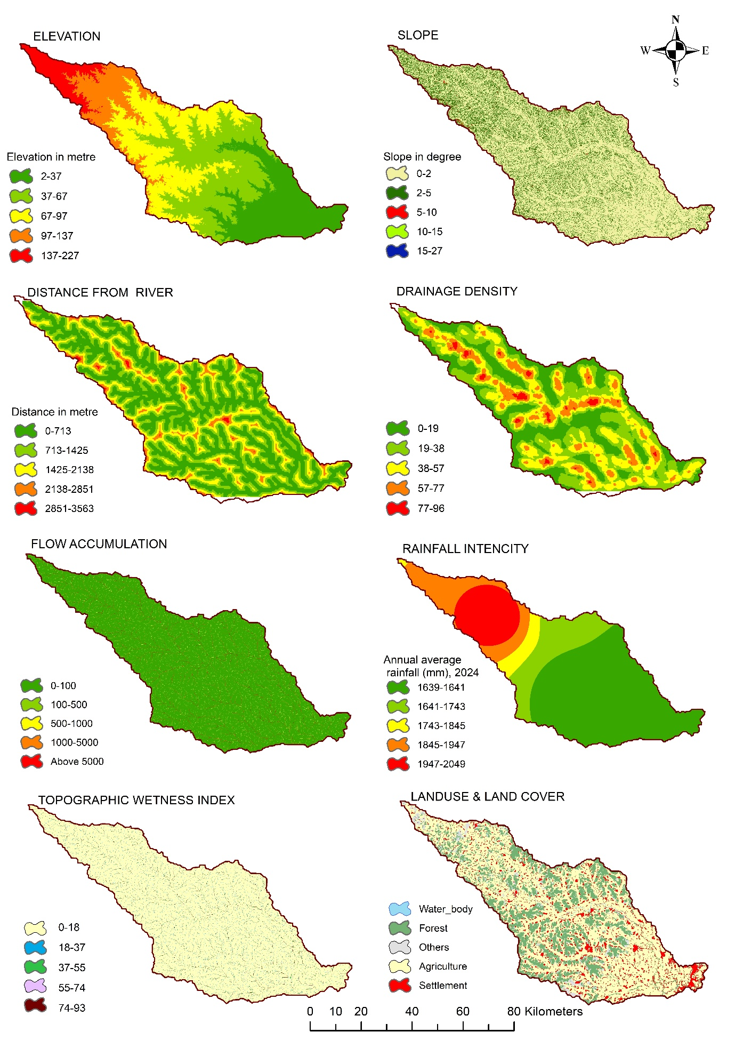
Fig.3: Elevation, Slope, Distance from River, Drainage Density, TWI, Flow Accumulation, LULC, Rainfall Intensity.

Table 6: Pairwise comparison matrix.
Criteria | Elevation | Slope | Distance from river | Drainage density | Flow accumulation | TWI | Rainfall intensity | LULC
Elevation | 1 | 2 | 3 | 4 | 5 | 5 | 6 | 7
Slope | 0.5 | 1 | 2 | 3 | 4 | 4 | 5 | 5
Distance from river | 0.333 | 0.500 | 1 | 3 | 3 | 3 | 4 | 4
Drainage density | 0.25 | 0.25 | 0.333 | 1 | 2 | 3 | 3 | 4
Flow accumulation | 0.2 | 0.333 | 0.333 | 0.5 | 1 | 2 | 3 | 3
TWI | 0.2 | 0.25 | 0.333 | 0.333 | 0.5 | 1 | 2 | 2
Rainfall intencity | 0.167 | 0.200 | 0.250 | 0.333 | 0.333 | 0.500 | 1 | 2
LULC | 0.143 | 0.200 | 0.250 | 0.250 | 0.333 | 0.500 | 0.500 | 1
Total | 2.793 | 4.733 | 7.499 | 12.416 | 16.166 | 19 | 24.5 | 27
Continue ……
Elevation | Slope | Flow accumulation | Drainage density | Distance from river | TWI | Rainfall intencity | LULC
0.358 | 0.423 | 0.400 | 0.322 | 0.309 | 0.263 | 0.245 | 0.259
0.179 | 0.211 | 0.267 | 0.242 | 0.247 | 0.211 | 0.204 | 0.185
0.119 | 0.106 | 0.133 | 0.242 | 0.186 | 0.158 | 0.163 | 0.148
0.090 | 0.053 | 0.044 | 0.081 | 0.124 | 0.158 | 0.122 | 0.148
0.072 | 0.070 | 0.044 | 0.040 | 0.062 | 0.105 | 0.122 | 0.111
0.072 | 0.053 | 0.044 | 0.027 | 0.031 | 0.053 | 0.082 | 0.074
0.060 | 0.042 | 0.033 | 0.027 | 0.021 | 0.026 | 0.041 | 0.074
0.051 | 0.042 | 0.033 | 0.020 | 0.021 | 0.026 | 0.020 | 0.037

Table 7: Normalized weight matrix for AHP
Criteria | VP | CP | D* | E=(D/CP) | ʎ max | CI | RI | CR=(CI/RI)
Elevation | 3.550 | 0.3265 | 2.713 | 8.30996 | 8.371 | 0.0530 | 1.41 | 0.03762
Slope | 2.426 | 0.2232 | 1.845 | 8.27191
Distance from river | 1.707 | 0.1570 | 1.326 | 8.44862
Drainage density | 1.052 | 0.0968 | 0.831 | 8.59435
Flow accumulation | 0.818 | 0.0752 | 0.627 | 8.34002
TWI | 0.570 | 0.0524 | 0.433 | 8.27374
Rainfall intencity | 0.418 | 0.0384 | 0.321 | 8.36531
LULC | 0.332 | 0.0306 | 0.255 | 8.36630
Total | 10.871
D*- Consistency Vector, E- Consistency Measure, CI- Consistency Index, RI- Random Index, and CR - Consistency Ratio, P- Priority Vector

3.4 Drainage Density
Drainage density (Dd) reflects the efficiency of natural drainage (overall AHP weight: 10%). The highest Dd class (77-96 km/km²) received a sub‑criterion weight of 0.359 but covers only 1.49% of the basin, restricted to the Purulia uplands and Jharkhand fringe - the source zone for rapid runoff concentration. The not susceptible class (<19 km/km²) covers 29.28% and corresponds to the lower floodplain around Ghatal, where low Dd paradoxically indicates poor natural drainage and high waterlogging risk. Management implication: Upper catchment interventions (check dams, afforestation) reduce peak flows; lower catchment requires dredging and pumping to alleviate waterlogging.
3.5 Flow Accumulation
Flow accumulation (FA) identifies convergent areas where floodwaters concentrate (overall AHP weight: 16%). The >5000 cells class (sub‑criterion weight 0.459) covers only 0.10% of the basin - essentially the main stem of the Shilabati and its largest tributaries, plus the Ghatal confluence. The high susceptibility class (1000-5000 cells) adds another 0.51%. Despite their tiny areal extent, these cells are the foci of the most severe flooding. Management implication: Any settlement in cells with FA >1000 should be considered at high risk of fluvial flooding; detailed 2D hydraulic modelling is warranted for these areas.
3.6 Topographic Wetness Index (TWI)
TWI indicates soil moisture and saturation likelihood (overall AHP weight: 5%). The highest class (74-93) received a sub‑criterion weight of 0.503 but covers only 0.72% of the basin - the valley bottoms and floodplain depressions that saturate first and remain waterlogged. Strikingly, 94.41% of the basin falls into the not susceptible class (TWI <18), representing well‑drained uplands. Management implication: High TWI zones are ideal for wetland restoration; they provide natural flood storage and should be preserved or restored, especially in the Ghatal low‑lying pockets between the Shilabati and Dwarakeswar rivers.
3.7 Rainfall Intensity
Rainfall intensity (annual total, 2024) is the primary climatic trigger (overall AHP weight: 4%). The highest class (1947-2049 mm) received a sub‑criterion weight of 0.502 and covers 13.68% of the basin - the western upper catchment (Purulia uplands, Jharkhand fringe) where orographic enhancement produces the heaviest rainfall. The not susceptible class (<1641 mm) covers 54.09% of the basin (eastern lower reaches). Management implication: Early warning for the lower basin should be linked to real‑time rainfall monitoring in the upper catchment, providing lead times of 12-24 hours.
3.8 Land Use and Land Cover (LULC)
LULC influences infiltration and runoff generation (overall AHP weight: 3%). The most susceptible sub‑class (water bodies, weight 0.359) covers 0.88% of the basin. Settlements (high susceptibility, weight 0.252) cover 9.64%, concentrated along transport corridors in Ghatal, Midnapore Sadar, and Chandrakona. Agriculture (moderate susceptibility, weight 0.177) dominates with 60.04% of the basin. Forests (not susceptible, weight 0.087) cover 24.57%, mainly in the upper catchment (Binpur, Baghmundi). Management implication: The lower basin has minimal forest cover; flood mitigation must rely on engineered solutions (embankments, drainage channels) unless reforestation or wetland restoration is undertaken.
Table 8: Sub-criteria, Sub-criteria weights, Suitability ranking, Suitability level, Area (%), Sub-criteria cr, Influence in % of the eight Criteria.
Criteria | Sub-criteria | Sub-criteria weights | Suitablity ranking | Suitablity level | Area (%) | Sub-criteria cr | Influence%
Elevation | 002-37 | 0.517 | 5 | MoSFA | 24.05 | 0.04 | 32
Elevation | 37-67 | 0.227 | 4 | HFA | 29.59 | 0.04 | 32
Elevation | 67-97 | 0.147 | 3 | MoDFA | 25.90 | 0.04 | 32
Elevation | 97-137 | 0.072 | 2 | LFS | 13.61 | 0.04 | 32
Elevation | 137-227 | 0.037 | 1 | NFA | 6.85 | 0.04 | 32
Slope | 000-2 | 0.475 | 5 | MoSFA | 21.82 | 0.028 | 22
Slope | 002-5 | 0.229 | 4 | HFA | 36.94 | 0.028 | 22
Slope | 005- 10 | 0.145 | 3 | MoDFA | 30.55 | 0.028 | 22
Slope | 0010-15 | 0.090 | 2 | LFS | 9.60 | 0.028 | 22
Slope | 15-27 | 0.061 | 1 | NFA | 1.09 | 0.028 | 22
Flow Accumulation | Above 5000 | 0.459 | 5 | MoSFA | 0.10 | 0.067 | 16
Flow Accumulation | 1000-5000 | 0.272 | 4 | HFA | 0.51 | 0.067 | 16
Flow Accumulation | 500-1000 | 0.151 | 3 | MoDFA | 1.25 | 0.067 | 16
Flow Accumulation | 100-500 | 0.078 | 2 | LFS | 3.62 | 0.067 | 16
Flow Accumulation | 0-100 | 0.040 | 1 | NFA | 93.71 | 0.067 | 16
Flow Accumulation | 77-96 | 0.359 | 5 | MoSFA | 1.494 | 0.067 | 16
Drainage Density | 57-77 | 0.252 | 4 | HFA | 11.534 | 0.024 | 10
Drainage Density | 38-57 | 0.177 | 3 | MoDFA | 26.174 | 0.024 | 10
Drainage Density | 19-38 | 0.124 | 2 | LFS | 31.522 | 0.024 | 10
Drainage Density | 0-19 | 0.087 | 1 | NFA | 29.276 | 0.024 | 10
Drainage Density | 0-713 | 0.416 | 5 | MoSFA | 42.37 | 0.024 | 10
Distance from River | 713- 1425 | 0.262 | 4 | HFA | 32.47 | 0.014 | 8
Distance from River | 1425-2138 | 0.161 | 3 | MoDFA | 18.75 | 0.014 | 8
Distance from River | 2138-2851 | 0.098 | 2 | LFS | 5.73 | 0.014 | 8
Distance from River | 2851-3563 | 0.062 | 1 | NFA | 0.68 | 0.014 | 8
Distance from River | 74-93 | 0.503 | 5 | MoSFA | 0.722 | 0.014 | 8
TWI | 55-74 | 0.260 | 4 | HFA | 0.527 | 0.054 | 5
TWI | 37-55 | 0.134 | 3 | MoDFA | 1.864 | 0.054 | 5
TWI | 18-37 | 0.068 | 2 | LFS | 2.475 | 0.054 | 5
TWI | 00-18 | 0.035 | 1 | NFA | 94.412 | 0.054 | 5
TWI | 1947-2049 | 0.502 | 5 | MoSFA | 13.684 | 0.054 | 5
Rainfall Intencity | 1845-1947 | 0.260 | 4 | HFA | 12.472 | 0.061 | 4
Rainfall Intencity | 1743-1845 | 0.134 | 3 | MoDFA | 4.487 | 0.061 | 4
Rainfall Intencity | 1641-1743 | 0.070 | 2 | LFS | 15.264 | 0.061 | 4
Rainfall Intencity | 1539-1641 | 0.035 | 1 | NFA | 54.093 | 0.061 | 4
LULC | Water_body | 0.359 | 5 | MoSFA | 0.876 | 0.024 | 3
LULC | Settlement | 0.252 | 4 | HFA | 9.635 | 0.024 | 3
LULC | Agriculture | 0.177 | 3 | MoDFA | 60.037 | 0.024 | 3
LULC | Others | 0.124 | 2 | LFS | 4.886 | 0.024 | 3
LULC | Forest | 0.087 | 1 | NFA | 24.567 | 0.024 | 3
MoSFA- Most Susceptible Flood Area, HFA- Highly Susceptible Flood Area, MoDFA-Moderately Susceptible Flood Area, LFS- Less Susceptible Flood Area, NFA- Not Susceptible Flood Area.
3.9 Integrated Flood Susceptibility Zoning
The final flood susceptibility map was generated by weighted overlay of the eight reclassified criteria using the AHP-derived weights (elevation 32%, slope 22%, flow accumulation 16%, drainage density 10%, distance from river 8%, TWI 5%, rainfall intensity 4%, LULC 3%). The resulting Flood Susceptibility Index (FSI) was classified into five zones using the equal interval method. The spatial distribution of these zones is presented in Figure 4. The overall area statistics are summarised below in Table 9.

Table 9: The overall area statistics
Flood Susceptibility | Area in Percentages
Not | 0.000052
Less | 10.771034
Moderate | 66.097317
High | 22.947983
Most | 0.183614

3.9.1 Most Susceptible Zone (MoSFA)
The MoSFA zone covers 4.98 km², representing only 0.16% of the basin. These are the critical flood foci - low‑lying depressions, abandoned meander channels, and confluence zones, primarily around the Shilabati‑Dwarakeswar‑Rupnarayan junction in the Ghatal region. Here, even moderate rainfall triggers immediate inundation, and water may stagnate for weeks. Despite its tiny areal extent, this zone experiences the highest frequency and severity of flooding, causing disproportionate damage to life, property, and agriculture.
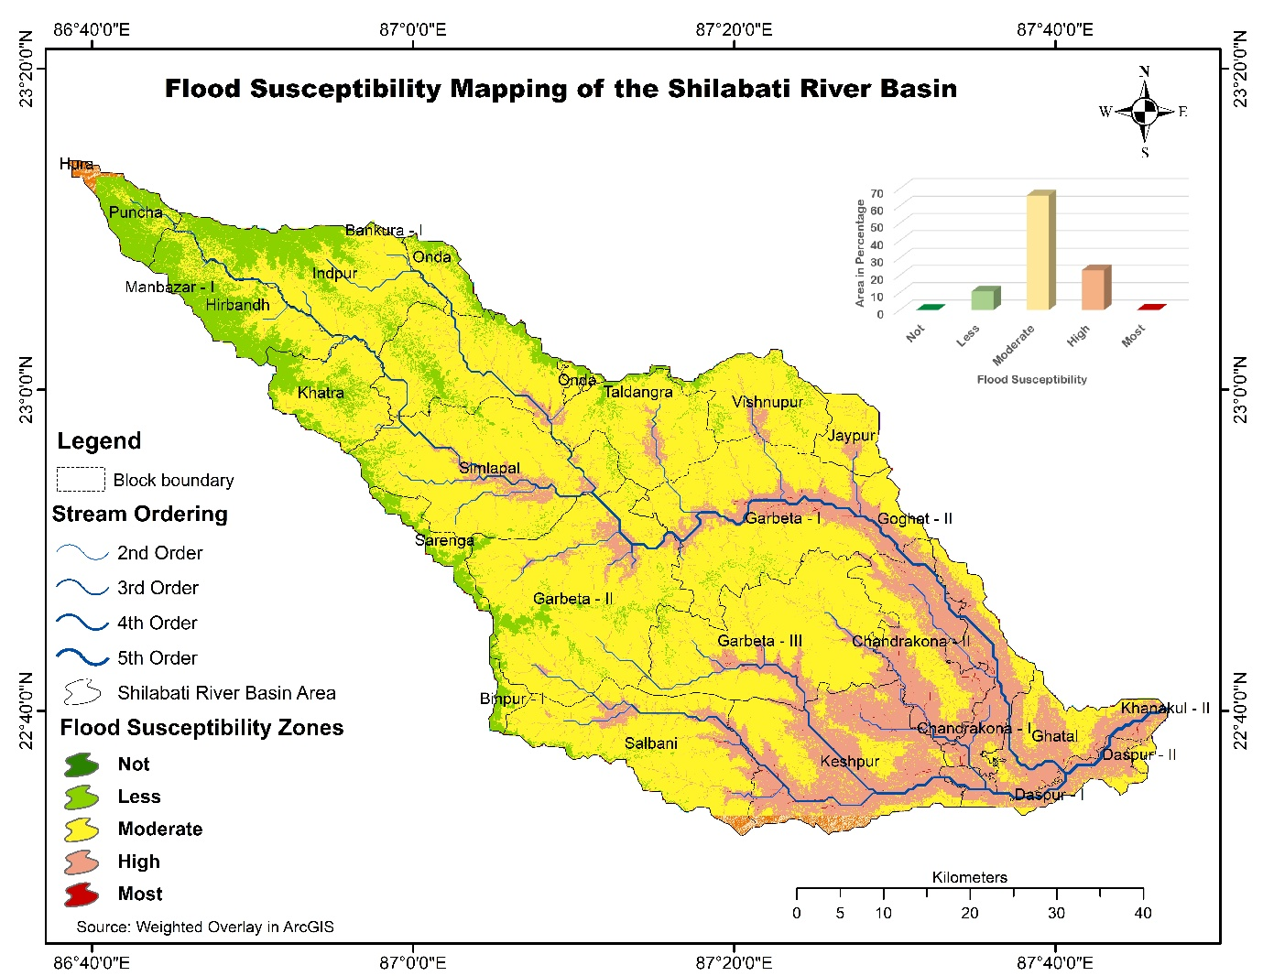
Fig. 4: Integrated Flood Susceptibility Zoning by weighted Overlay analysis.
3.9.2 Highly Susceptible Zone (HFA)
The HFA zone occupies 432.50 km², accounting for 14.28% of the basin. This zone corresponds to the lower alluvial plains and valley bottoms where elevation is low (<67 m), slopes are gentle (2-5°), and proximity to main river channels (typically 713-1,425 m) is high. Settlements and agricultural lands in this zone experience frequent inundation during moderate to high monsoon flows. Major blocks include Chandrakona, Salboni, Daspur, and parts of Midnapore Sadar.
3.9.3 Moderately Susceptible Zone (MoDFA)
The MoDFA zone dominates the landscape, covering 2,217.38 km² or 73.21% of the basin. This extensive class represents the transitional uplands and middle reaches (e.g., Garhbeta, Onda, Khatra, Hirbandh, Taldangra) where local topographic and land‑cover conditions provide partial natural drainage. Flood risk is conditional on extreme rainfall or antecedent saturation. These areas are neither consistently safe nor chronically flooded but exhibit threshold‑dependent behaviour.
3.9.4 Less Susceptible Zone (LFS)
The LFS zone covers 362.55 km² (11.97% of the basin). These areas are predominantly located on slightly elevated interfluves and well‑drained lateritic uplands (e.g., parts of Manbazar, Indpur, Binpur‑I). Flood risk is confined to extreme rainfall events or temporary overbank flooding from adjacent high‑susceptibility cells.
3.9.5 Not Susceptible Zone (NFA)
The NFA zone covers 11.38 km² (0.38% of the basin). This zone comprises the steepest hill slopes, dense forest patches, and the highest elevations (>137 m) in the western part of the study area (e.g., parts of Binpur‑II, Baghmundi, and the Purulia uplands). These areas are effectively immune to fluvial flooding, although localised sheet flow may occur during extreme down.
3.9.6 District-wise Distribution of Susceptibility Zones
The susceptibility zones exhibit a clear district-level pattern. The entire Most Susceptible (MoSFA) zone lies within Paschim Medinipur, concentrated in the Ghatal confluence area. This district also contains the majority of the Highly Susceptible (HFA) zone, particularly in Chandrakona, Salboni, and Daspur blocks. Bankura is dominated by the Moderately Susceptible (MoDFA) zone across its central and eastern blocks (e.g., Onda, Khatra, Taldangra), with smaller HFA pockets along the Shilabati’s floodplain. Purulia encompasses most of the Less Susceptible (LFS) and Not Susceptible (NFA) zones, restricted to the western uplands (Puncha, Hura, Baghmundi), where higher elevation and steeper slopes prevent fluvial flooding.
Fig. 5: Popular print media-reported flood events in the Ghatal region across different years, highlighting recurrent and annual nature of flooding.
3.9.7 Spatial Pattern Summary
The susceptibility distribution follows a clear west‑east gradient. The MoSFA and HFA zones are concentrated in the eastern lower basin (Paschim Medinipur district, particularly Ghatal and Chandrakona blocks), covering 14.44% of the basin but accounting for the majority of flood damage. The MoDFA zone spans the central basin across all three districts. The LFS and NFA zones are confined to the western uplands (Purulia and parts of Bankura). This spatial pattern validates the AHP model’s ability to capture the basin’s physiographic control on flood susceptibility.
3.10 Community‑Based Validation
To validate the susceptibility map, field surveys were conducted (December 2024-December 2025) across 48 villages in the Most and Highly Susceptible zones. A total of 120 local residents were interviewed using structured questionnaires. Sample size was justified using the Yamane formula (95% confidence level).
Positionality: The researcher is a resident of a flood‑affected Ghatal village. Potential bias was mitigated through systematic village selection, GPS cross‑checking, and structured questionnaires.
- Informed consent was obtained verbally from all participants.
- Residents reported flood events from 2024 and 2025. Geolocated flood points overlaid on the susceptibility map showed:
- 92.7% fell within MoSFA or HFA zones (true positives).
- 7.3% fell in the MoDFA zone (false negatives), typically in localised depressions.
- Zero flood reports from the NFA zone (true negatives).
- These findings align with documented chronic flood‑prone areas (Ghatal, Chandrakona, confirming the model’s strong predictive accuracy.
3.11 Implications for Flood Management
The flood susceptibility zonation provides a spatially explicit foundation for targeted flood risk reduction in the Shilabati basin. The Most Susceptible (MoSFA, 0.16%) and Highly Susceptible (HFA, 14.28%) zones - centred on Ghatal, Chandrakona, and Daspur I - require immediate intervention. Structural measures should include embankment strengthening, installation of sluice gates with pumping stations, and selective dredging to restore conveyance capacity. Non‑structural measures must include community‑based early warning systems leveraging the 12–24-hour lead time from upper catchment rainfall, land‑use zoning that restricts new residential construction, and flood‑proofed infrastructure (e.g., raised plinths ≥1 m above the highest recorded flood level). While detailed cost‑benefit analysis is beyond this study’s scope, preliminary estimates suggest that embankment maintenance and pumping stations in Ghatal block would cost significantly less than recurrent post‑flood relief and rehabilitation; a full economic analysis is recommended as future work. For institutional adoption, the West Bengal Irrigation & Waterways Directorate should integrate the map into embankment design and drainage master plans, while the District Disaster Management Authorities of Paschim Medinipur, Bankura, and Purulia should incorporate the zoning into their District Disaster Management Plans and the State Action Plan on Climate Change. Legally, the map can be notified under the West Bengal Town and Country Planning (Amendment) Act, 2021 to regulate construction in MoSFA and HFA zones.
Climate projections for eastern India (Dhara, C.et al. 2021) indicate an increase in monsoon extremes, including higher intensity rainfall and more frequent cyclonic depressions. The susceptibility map should therefore serve as a baseline for scenario planning (e.g., a 10-20% increase in rainfall intensity), with embankment heights and drainage capacities designed with a safety margin for future climate conditions. The Moderately Susceptible zone (MoDFA, 73.21%) requires watershed management measures such as check dams, afforestation, and farm ponds to reduce runoff peaks. The Less and Not Susceptible zones (western uplands) must be protected from deforestation, which would otherwise increase downstream flooding; nature‑based solutions, particularly wetland restoration in high TWI zones, offer low‑cost flood attenuation. Finally, this study has limitations: it provides static susceptibility without hydraulic modelling, uses annual rainfall rather than extreme event intensity (Rx1day, Rx5day), and does not integrate climate projections dynamically. Future research should employ 2D hydraulic models (e.g., HEC‑RAS, LISFLOOD‑FP) for MoSFA and HFA zones, replace annual rainfall with extreme event indices, and incorporate CMIP6 scenarios for climate‑resilient planning.
4. Conclusions
This study applied a GIS‑based Analytical Hierarchy Process (AHP) to assess flood susceptibility in the Shilabati River basin, integrating eight criteria derived from remote sensing and field data. The pairwise comparison matrix yielded a consistency ratio of 0.0376, confirming reliable weight assignments, with elevation and slope emerging as the dominant controls. Weighted overlay analysis classified the basin into five susceptibility zones. The Most Susceptible zone (MoSFA) covers only 0.16% (4.98 km²) – the critical flood foci in the Ghatal confluence area – while the Highly Susceptible zone (HFA) occupies 14.28% (432.50 km²). The Moderately Susceptible zone dominates 73.21% (2,217.38 km²), and the Less and Not Susceptible zones together account for 12.35% of the basin. Community‑based validation using 120 resident surveys confirmed that 92.7% of reported flood points fell within the MoSFA and HFA zones, supporting the model's predictive capability.
Several limitations must be clearly acknowledged. First, this study produces a static susceptibility map indicating the relative likelihood of inundation based on terrain and environmental factors; it does not provide flood depth, velocity, duration, or hydraulic behavior under specific rainfall events. Second, the AHP method inherently involves subjective expert judgments, although the consistency ratio (CR=0.0376) confirms acceptable reliability. Third, the rainfall criterion used annual total precipitation rather than extreme event indices (e.g., Rx1day, Rx5day), which limits the model's responsiveness to short-duration intense storms. Fourth, no hydraulic modelling (e.g., HEC‑RAS, LISFLOOD‑FP) was performed, meaning the map cannot simulate flood wave propagation or inundation dynamics. Fifth, climate change projections were not incorporated, so the susceptibility zones represent current rather than future conditions.
Despite these limitations, the results offer actionable yet cautious recommendations for disaster management. Targeted structural and non‑structural interventions should focus on the MoSFA and HFA zones, recognising that these zones indicate priority areas for further detailed hydraulic studies rather than definitive flood risk. The flood susceptibility map should be adopted as a statutory planning tool for land‑use zoning and early warning system development, provided users recognise its static nature and lack of hydraulic parameters. Future research should employ 2D hydraulic modelling for the MoSFA and HFA zones, replace annual rainfall with Rx1day/Rx5day extreme indices, and integrate CMIP6 climate scenarios for dynamic flood risk assessment. under climate change.
This AHP‑GIS framework, validated through community participation, offers a replicable methodology for preliminary flood susceptibility assessment in other monsoon‑dominated plateau‑plain transitional basins of South Asia, but should always be complemented with hydraulic modelling for detailed risk analysis.
Ethics Approval and Consent
This study was conducted in accordance with institutional and national ethical standards. As the research involved no interventions, experiments, or the collection of sensitive personal data, formal ethical approval was deemed unnecessary. Before participation, written informed consent was obtained from all subjects, and the anonymity and confidentiality of all participants were rigorously preserved throughout the study.
Disclaimer (Artificial Intelligence)
Author(s) hereby declare that AI tools were used only for language editing and structuring; all interpretation are original.

5. Reference
Alsalem, M. A., Alamoodi, A. H., Albahri, O. S., Dawood, K. A., Mohammed, R. T., Alnoor, A., ... & Al-Obaidi, J. R. (2022). Multi-criteria decision-making for coronavirus disease 2019 applications: a theoretical analysis review. Artificial Intelligence Review, 55(6), 4979-5062.
Baral, M., Chakraborty, A., Mukherjee, K., Bhadra, T., Dash, P., & Sarkar, R. (2025). A comprehensive flood risk mapping in Gangetic interfluvial flood plain region. Discover Geoscience, 3(1), 45.
Bello, M., Singh, S., Singh, S. K., Pandey, V., Kumar, P., Meraj, G., ... & Sajan, B. (2024). Geospatial analysis of flood susceptibility in Nigeria’s vulnerable coastal states: a detailed assessment and mitigation strategy proposal. Climate, 12(7), 93.
Bhowmick, M. K., Srivastava, A. K., Singh, S., Dhara, M. C., Aich, S. S., Patra, S. R., & Ismail, A. M. (2020). Realizing the potential of coastal flood-prone areas for rice production in West Bengal: prospects and challenges. New frontiers in stress management for durable agriculture, 543-577.
Chakraborty, S. K. (2021). Geo-hydrological perspectives of riverine flows. In Riverine Ecology Volume 1: Eco-functionality of the Physical Environment of Rivers (pp. 375-476). Cham: Springer International Publishing.
Das, G. K. (2024). Shilabati River and Its Environments. In River Systems of West Bengal: Water and Environments (pp. 29-38). Cham: Springer Nature Switzerland.
Das, G. K. (2024). River Systems of West Bengal. Springer water. https://doi. org/10.1007/978-3-031-53480-5.
Dhara, C., Deshpande, A., Roxy, M. K., Dalpadado, P., & Shrestha, M. S. (2025). A post-AR6 update on observed and projected climate change in India. PLOS Climate, 4(11), e0000724.
Esmaili, R., & Karipour, S. A. (2024). Comparison of weighting methods of multicriteria decision analysis (MCDA) in evaluation of flood hazard index. Natural Hazards, 120(9), 8619-8638.
Ghosh, S., Hoque, M. M., Islam, A., Barman, S. D., Mahammad, S., Rahman, A., & Maji, N. K. (2023). Characterizing floods and reviewing flood management strategies for better community resilience in a tropical river basin, India. Natural Hazards, 115(2), 1799-1832.
Haldar, O., Sarkar, A., & Basak, S. (2025). Geomorphic and Anthropogenic Factors Influencing Flood Occurrences in the Ajay River Basin, West Bengal. In Geoinformatics for Flood Risk Management (pp. 40-63). CRC Press.
Islam, T., Zeleke, E. B., Afroz, M., & Melesse, A. M. (2025). A systematic review of urban flood susceptibility mapping: Remote sensing, machine learning, and other modeling approaches. Remote Sensing, 17(3), 524.
Jafarzadegan, K., Moradkhani, H., Pappenberger, F., Moftakhari, H., Bates, P., Abbaszadeh, P., ... & Duan, Q. (2023). Recent advances and new frontiers in riverine and coastal flood modeling. Reviews of Geophysics, 61(2), e2022RG000788.
Khan, A., Mandal, S., Satpati, L., Dogar, M. M., Hasanean, H., & Salah, A. M. (2025). Analyzing drought: the impact of climate change on precipitation patterns in the Shilabati river Basin, West Bengal, India. Earth Systems and Environment, 9(3), 1585-1614.
Kumar, R. (2025). A comprehensive review of MCDM methods, applications, and emerging trends. Decision Making Advances, 3(1), 185-199.
Lin, L., Wu, Z., & Liang, Q. (2019). Urban flood susceptibility analysis using a GIS-based multi-criteria analysis framework. Natural Hazards, 97(2), 455-475.
Mashwama, N. X., & Phesa, M. (2025). Systematic Review of Multidimensional Assessment of Coastal Infrastructure Resilience to Climate-Induced Flooding: Integrating Structural Vulnerability, System Capacity, and Organizational Preparedness. Climate, 13(9), 192.
Mfon, I. E., Oguike, M. C., Eteng, S. U., & Etim, N. M. (2022). Causes and effects of flooding in Nigeria: A review. East Asian Journal of Multidisciplinary Research, 1(9), 1777-1792.
Nazir, M. F., Atif, S., & Hussain, E. (2025). An integrated geographic information system (GIS) and analytical hierarchy process (AHP)-based approach for drone-optimized large-scale flood imaging. Drone Systems and Applications, 13, 1-18.
Pal, S. C., & Chakrabortty, R. (2022). Geophysical settings of South Bengal. In Climate change impact on soil erosion in sub-tropical environment: Application of empirical and semi-empirical models (pp. 15-32). Cham: Springer International Publishing.
Svetlana, D., Radovan, D., & Ján, D. (2015). The economic impact of floods and their importance in different regions of the world with emphasis on Europe. Procedia Economics and Finance, 34, 649-655.
Tavakoli, M., Motlagh, Z. K., Dąbrowska, D., Youssef, Y. M., Đurin, B., & Saqr, A. M. (2025). Harnessing AHP and fuzzy scenarios for resilient flood management in arid environments: challenges and pathways toward sustainability. Water, 17(9), 1276.
Yadav, V., & Dey, S. (2025). Estimating rainfall, surface runoff, and river discharge in the Shilabati river basin using an integrated RS and GIS based SCS CN approach. Discover Geoscience, 3(1), 177.
Yadav, V., & Dey, S. (2025). Estimating rainfall, surface runoff, and river discharge in the Shilabati river basin using an integrated RS and GIS based SCS CN approach. Discover Geoscience, 3(1), 177.

