Original Research Article
Spatio-Temporal Analysis of Land Use/Land Cover Change and Urban Expansion in Bankura Municipality, India
Abstract:
This work focuses on land use land and cover (LULC) change and the growth of the urban area surrounding Bankura municipality during a 30-year period (1991–2021). The objectives include determining directional urban growth and quantifying land use and land cover (LULC) transformations. Satellite images from 1991, 2001, 2013, and 2021 have been used for land use change detection and to analyse urban expansion. For land use classification mapping, the Maximum Likelihood Classifier tools of ArcGIS 10.8 have been used and prepared supervised maps of different land classes (water body, bare land, built-up, vegetation, agricultural land and sand). Accuracy assessment is checked by overall accuracy and the Kappa coefficient. The study results indicate significant positive change of built-up area, vegetation and agricultural land and drastic negative change of bare land. Urbanisation, population growth, migration, economic growth, location and accessibility are the main causes of land use changes. The urban expansion of the study area, about 518 hectares in 2021, was found in the North-Northwest direction of the study area. The lowest built-up area has been observed in the South-South-West direction, and the area is about 20 hectares. The highest expansion of about 313 hectares was observed in the NNE direction from 2013 to 2021. For the purpose to achieve balanced regional growth, the study emphasizes the rapid urban transformation and suggests sustainable land-use planning and ongoing GIS monitoring.

Keywords: LULC, Maximum Likelihood Classification, Supervised maps, Urbanisation, Urban Expansion

- Introduction
Rapid urbanisation is a widespread phenomenon in developing countries such as India. In conjunction with unscientific anthropogenic activities, it has led to land use and land cover (LULC) change emerging as one of the most significant drivers of global environmental change (Lambin et al., 2001; Lambin and Geist, 2006). According to Lambin and Geist (2006), key human-induced drivers of LULC change include migration, population growth, globalisation, technological development, and human responses to changing economic conditions. Over the past three centuries, LULC change has increasingly been regarded as a major global concern, often characterised by deforestation and the expansion of agricultural land, thereby constituting a form of environmental degradation affecting common resources (Houghton, 2003). According to the United Nations (2018), approximately 55 per cent of the global population currently resides in urban areas, a proportion projected to rise to 68 per cent by 2050. Vitousek et al. (1997) further demonstrate that human activities have significantly altered approximately 50 per cent of the ice-free terrestrial surface, while between 10 and 55 per cent of net primary productivity is appropriated through land-use practices. Over recent decades, LULC dynamics have been characterised by a decline in rural land cover and a corresponding expansion of urban areas, particularly in developing countries, driven by rapid urbanisation processes (Dewan and Yamaguchi, 2009a, b). Although urban areas currently occupy only about 3 per cent of the Earth’s land surface, more than half of the global population now resides in urban settlements (Herold et al., 2003). Weng (2007) similarly observed that increasing anthropogenic pressure has significantly transformed land use and landscape patterns at both local and global scales, thereby altering ecosystem structure, function, and dynamics. Consequently, accurate and timely monitoring of urban LULC change is essential for understanding the impacts of human activities on urban ecological systems and for informing sustainable environmental management strategies (Dewan and Yamaguchi, 2009a, b).
The population of the country increasing very fast rate and now the Indian population is about 1.5 billion which is 17.78% of the World population. According to World Bank collection 2.25% urban growth was reported in 2023. Around 908.8 million people in India lived in rural areas in 2022, a decrease from 2021 which was 909.38 million, and in urban areas, 508.37 million people lived in 2022, an increase from 2018 which was 465.87 million. Urban growth is a dynamic and complex process and through these processes, the urban area transforms into the urban landscape. According to Dadras et al. (2015) urban expansion can be imagined as centre development process of urban areas. Due to the urban growth and decreasing rate of vegetation in the cities of Bangladesh urban heat rising (Dewan et al.,2021). Hassan et al. (2021) observed that the changing nature of land use land cover enhances the albedo which extremely effects on local environment of Alberta, Canada. According to Yohannes et al., (2021), the hydrological ecosystem has been immensely decayed by agricultural land and plantation in the Beressa watershed of the Blue Nile basin. Gradually increasing urbanization and scarcity of annual rainfall changed the water availability of the upper catchment of the Bagmati River basin (Tuladhar et al. 2019). Rahman et al. (2021) show in their study that in growing population and urban expansion negatively affect the waterbodies and farmland and also increase the food susceptibility in Sunamganj, Bangladesh.
The study area has reported urban expansion and consequent land use and land cover changes. The anthropogenic factors play a vital role in LULC change. The built-up and agricultural land expanded excessively in the land three decades. In contrast, natural bare land, and sandy land decreases over the year. The urban built-up area has expanded rapidly and haphazardly in the last three decades. In this study area, the land is also affected by the growth of population and haphazard expansion of built-up areas. However, less attention has been paid to the changing pattern of the processes and patterns of urban growth and LULC changes of the area of Bankura Municipality and its surroundings areas during the transitional economy. In this paper, we employed the Maximum Likelihood Classification approach to identify the specific characteristics of LULC change, characterizing the underlying driving forces in the Bankura Municipality area and its surroundings. Objectives of the study are 1. To map and monitor land use/land cover change in Bankura Municipality and its vicinity from 1991 to 2021. 2. To analyse the spatial and temporal patterns and characteristics of urban expansion in that time period.
- Study area
Bankura is a city and municipality located in the state of West Bengal, India, serving as the administrative headquarters of Bankura district. The municipality is situated at the confluence of the Gandheswari and Dwarkeswar rivers. Bankura district lies in the north-western part of West Bengal and forms part of the Bardhaman Division, within the physiographic region known as “Rarh”. The district is geographically positioned at 23.25°N latitude and 87.07°E longitude. The Damodar River flows along its northern boundary. Bankura district is bordered by Purba Bardhaman and Paschim Bardhaman districts to the north and east, Paschim Medinipur to the south, and Purulia district to the west (Fig. 1). Forested areas account for approximately 21 per cent of the total district area; however, parts of these forests have experienced degradation due to anthropogenic pressure and overexploitation of resources. The district experiences a predominantly hot climatic regime during summer and moderately cool conditions in winter. The monsoon season extends primarily from June to September, during which the majority of the annual rainfall—approximately 1,500 mm—is received. The region has recorded extreme temperature variations, with the highest temperature of 47.4 °C observed on 8 May 1977 and the lowest temperature of 4.8 °C recorded on 9 January 2013 (up to 2020). Notably, Bankura holds two state temperature records, with the highest recorded temperatures for February (39.3 °C) and April (46.7 °C) in West Bengal.
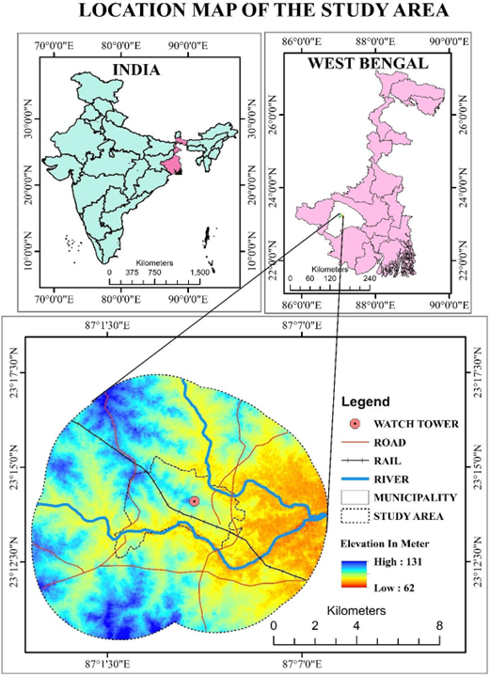
The Bankura city is divided into 23 wards for which elections are held every 5 years. The Bankura Municipality has a population of 137,386, of which 69,843 are males, while 67,543 are females, as per a report released by Census India 2011. For the study of the LULC change and urban expansion, Bankura municipality and the surrounding buffer area of 4 kilometres have been selected.

Fig. 1 Study area map
Bankura Municipality has a total administration of over 29,807 houses to which it supplies basic amenities like water and sewerage. It is also authorised to build roads within the Municipality's limits and impose taxes on properties coming under its jurisdiction.
- Materials and methodology
All acquired imageries were registered in the UTM/WGS 1984 projected coordinate system. Landsat TM, ETM+ and Oli sensors imageries have been chosen to carry out the LULC classifications and Blue, Green, Red and Near Infrared (NIR) bands were used to prepare composite images. For land use land cover change supervised image classification (Maximum Likelihood Classification method) have been used using Arc GIS 10.8 software. As per Vivekananda et al. (2021), supervised, unsupervised, and object-based image classification may be used for classification of remote sensing images. Supervised classification has been acknowledged in recent years as a significant and successful technique for automatically producing LULC classification of large geographic regions (Richards and Jia 2006). Maximum Likelihood Classification (MLC) is a most popular and common supervised classification for image analysis in remote sensing (Bolstad and Lillesand 1991; Richards and Jia 2006) and it is widely used in the moderate- resolution satellite image (Strahler 1980; Bayarsaikan et al. 2009; Vivekananda et al. 2021, Kastha and Khatun 2022).
For image classification, training sample selection has been made for each selected year (1991, 2001, 2013, 2021) in the selected area of Bankura Municipality and its vicinity. More than 30 training samples were assigned for the class with extensive each area (Agricultural land, vegetation, Built-up, water, bare land and sand). Then, training samples were merged for producing six classes. Then, total four signature files (.sig) were created for the LULC change study of three decades (1991–2021). Lastly, four LULC maps have been prepared using those signature flies before accuracy assessment. Table. 2 shows the LULC types and their description. After producing all LULC maps, the accuracy assessment of classified images for selected years (2013, 2021) has been attained using the Arc GIS 10.8 software. Here Error matrix and Kappa coefficient (k) are applied for accuracy assessment (see Table 5).
For built up area extraction 4km buffer of Bankura Municipality and its surrounding has been taken. Here, the selected center point was watch tower, located in Bankura Machan tola. The center point of the study area was selected because of its social, cultural and economic importance. The urban expansion was happened from the center point from the early period. Here the expansion of the built-up area represented with the help of concentric buffers and directional zones.
The concentric buffer wise built-up areas were shown by multiple ring buffers, from 0.5km to 0.85km. The intersect tool in Arc GIS is used to get the built-up areas as per the multi ring buffers for showing the buffer wise built-up expansion from 1991 to 2021.
The directional zone wise built-up areas were shown with the help of 8th directional zones, that are North North-West, West North-West, West South-West, South South-West, South South- East, East South-East, East North-East, and North North-East.
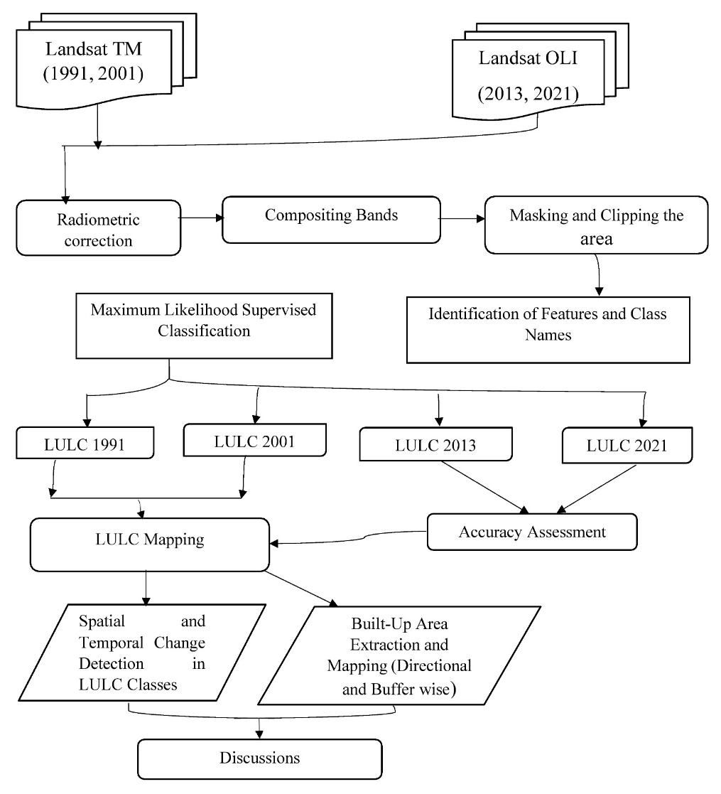
For change detection analysis a post-classification comparison matrix was generated of classified images from 1991 to 2001, 2001 to 2013, 2013 to 2021, and finally 1991 to 2021 by using the Arc GIS 10.8 and MS-Excel 2019 software for evaluating aggregate changes in the study area. After that, in 1990 and 2021, both the years have been selected for showing land transformation over three decades in the selected areas.
Fig. 2 Flow chart of methodology
Table 1: Details of the adopted satellite images.
Satellite | Sensor | Spatial resolution | Path/  row | Acquisition date | Source
Landsat 5 | TM | 30 m | 139/44 | 1991-11-08 | USGS Earth Explorer  (https://earthexplorer.usgs.gov/)
Landsat 7 | ETM+ | 30 m | 139/44 | 2001-12-29 | USGS Earth Explorer  (https://earthexplorer.usgs.gov/)
Landsat 8 | OLI | 30 m | 139/44 | 2013-12-22, 2021-11-10 | USGS Earth Explorer  (https://earthexplorer.usgs.gov/)

Table 2 Types of LULC and their characteristics
LULC Type | Description
Agricultural land | Cropland and pasture, Orchards, groves, vineyards, nurseries, and ornamental horticultural areas.
Vegetation | Natural vegetation, homesteads with trees, plantations, etc.
Built-up area | Residential, commercial, industrial, transportation and built-up land.
Bare land | Brick fields, grazing fields, yard, waste-dumping sites, agricultural fallow land etc.
Waterbody | Streams, channels, lakes, reservoirs, etc.
Sand | Riverine sandy areas and other sandy land.

Results and discussions

4.1 Temporal changes of land use and land cover
Over three decades, the LULC status of different selected years (1991, 2001, 2013, and 2021) has been assessed in the study area. Multiband satellite images of Landsat have been used. The images were classified and evaluated in six classes, i.e. Water body, bare land, built-up, vegetation, agricultural land and sand. The supervised land use land cover maps are shown in Fig no 3, 4, 7, 8, and Tables 3 and 4 show the change matrix for varying areas from one class to another class from 1991 to 2021. The area has been calculated in hectare units and also shown the percentage of the area (Fig 5, 6, 9, and 10). The result come out from landform transformation during the year 1991, 2001, 2010 and 2021 that decreasing in waterbody, bare land and vegetation and increasing in built up area and agricultural land (Fig.11). Table 3 shows the changes of bare land in the study area 7128.50 ha (49.41%), 6810.48 ha (47.21%), 7015.80 ha (48.63%) and 3034.15 ha (21.03%) during the year 1991, 2001, 2013 and 2021, respectively. Bare land suddenly low down in 2021, and this land use was converted to agricultural land and built-up area. Built-up area gradually increased during the study period, i.e. 347.33ha (2.41%) in 1991; 744.05 ha (5.16%) in 2001; 1881.51ha (13.04%) in 2013 and 2398.82 ha (16.63%) in 2021. Agricultural land also changed, i.e. 2778.20 ha (19.26%), 2318.11ha (16.07%), 1180.37 ha (8.18%), 4425.99 ha (30.68%) in the years 1991, 2001, 2013 and 2021, respectively. The most significant changes in land use of agricultural land and built-up area were observed in 2021 due to extensive farming practices, growth of population and urbanization. The vegetation cover increased in 2021 than 2013 because of plantation, agro-forestry, joint forest management, etc. Lastly, the study found that the water body of the study area decreased in 2021 due to water scarcity (insufficient rainfall and drought conditions).
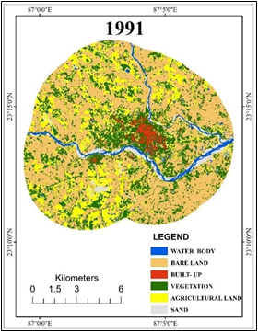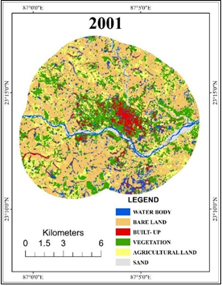
Fig 3. Land Use Land Cover Maps of 1991 Fig. 4. Land Use Land Cover Maps of 2001
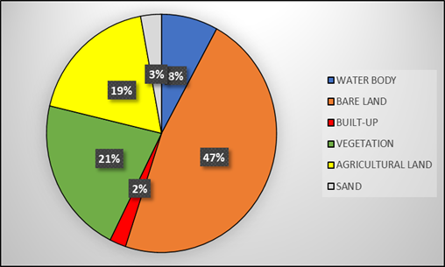
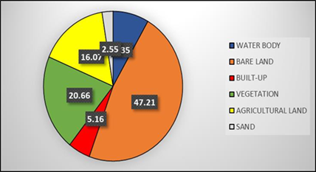

Fig 5. Percentage of Land Use and Land Cover in 1991 Fig. 6. Percentage of Land Use and Land Cover in 2001

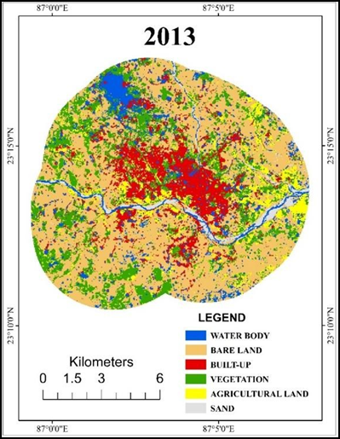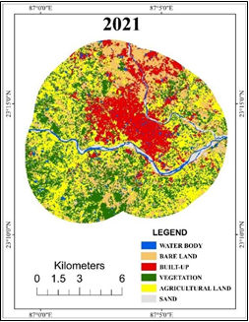
Fig 7. LULC map of 2013 Fig 8. LULC map 2021

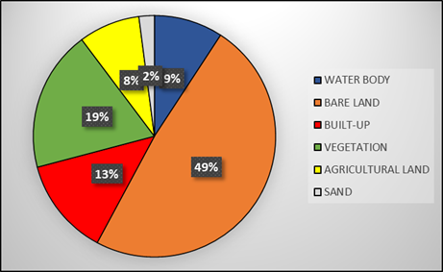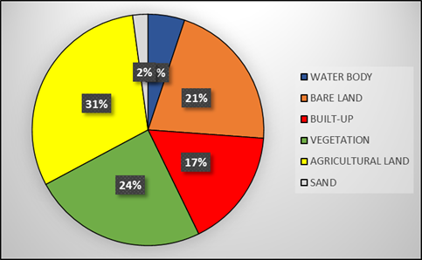
Fig 9. LULC in 2013 (%) Fig 10. LULC in 2021(%)

Table 3 Distribution of land use/land cover (area in hectare and percentage)
LULC | 1991(ha) | 1991(%) | 2001(ha) | 2001(%) | 2013(ha) | 2013(%) | 2021(ha) | 2021(%)
Water Body | 502.29 | 3.48 | 1204.23 | 8.35 | 1326.70 | 9.20 | 739.60 | 5.13
Bare Land | 7128.50 | 49.41 | 6810.48 | 47.21 | 7015.80 | 48.63 | 3034.15 | 21.03
Built-up | 347.33 | 2.41 | 744.05 | 5.16 | 1881.51 | 13.04 | 2398.82 | 16.63
Vegetation | 3227.97 | 22.38 | 2980.83 | 20.66 | 2725.13 | 18.89 | 3520.70 | 24.40
Agricultural land | 2778.20 | 19.26 | 2318.11 | 16.07 | 1180.37 | 8.18 | 4425.99 | 30.68
Sand | 442.07 | 3.06 | 367.69 | 2.55 | 296.54 | 2.06 | 307.29 | 2.13
Table 4 Land use / land cover change assessment
LULC CLASS | 1991 to 2001(%) | 2001 to 2013 (%) | 2013 to 2021 (%)
Water body | 4.87 | 0.85 | -4.07
Bare land | -2.20 | 1.42 | -27.6
Built-up | 2.75 | 7.88 | 3.59
Vegetation | -1.71 | -1.77 | 5.51
Agricultural land | -3.19 | -7.89 | 22.5
Sand | -0.52 | -0.49 | 0.07
Changes in area from 1991 to 2021
30
20
10
0
-10
Water body Bare land
Built-up
Vegetation
Agricultural land
Sand
-20
-30
-40
1991 to 2001 (%)
LULC Class

2001 to 2013 (%)
2013 to 2021 (%)

Fig 11. Change in area (%) of LULC

Accuracy assessment
Accuracy assessment of classified LULC maps was carried out for the years 2013 and 2020. The accuracy assessment of 1990 and 2000 could not be performed due to the low-resolution Google Earth images. During the time of accuracy assessment, several misclassifications were noticed between ground truth data and classified images, such as bare land considered agricultural land and built-up area. Moreover, built-up area is considered vegetation and water bodies. Bare land is sometimes classified as a waterbody because of the misclassification in the transitional fallow land zone surrounding the waterbody.
In this study, the overall accuracy was very good, ranging from 86 to 93%. The Kappa Coefficient is also admissible, for which a range from 0.6 to 0.8 is considered moderate (Table 5).
Year | Overall Accuracy | Kappa Coefficient
2013 | 86% | 0.75
2021 | 93% | 0.80
Table 5: Overall Accuracy and Kappa Coefficient of 2013 and 2021

4.2 Urban expansion of the study area
The Bankura Municipality and its surrounding areas are rapidly growing and urbanising. Moreover, Bankura town is the sub-divisional headquarters of the Bankura district. Thus, the built-up areas of the municipality continue to increase every year in each direction along with the distances in different periods of time (Fig.12). This municipality contains the largest housing project of the government. So, the area has the largest floating population in the district. It is also playing a significant role in expanding the built-up area in the district.
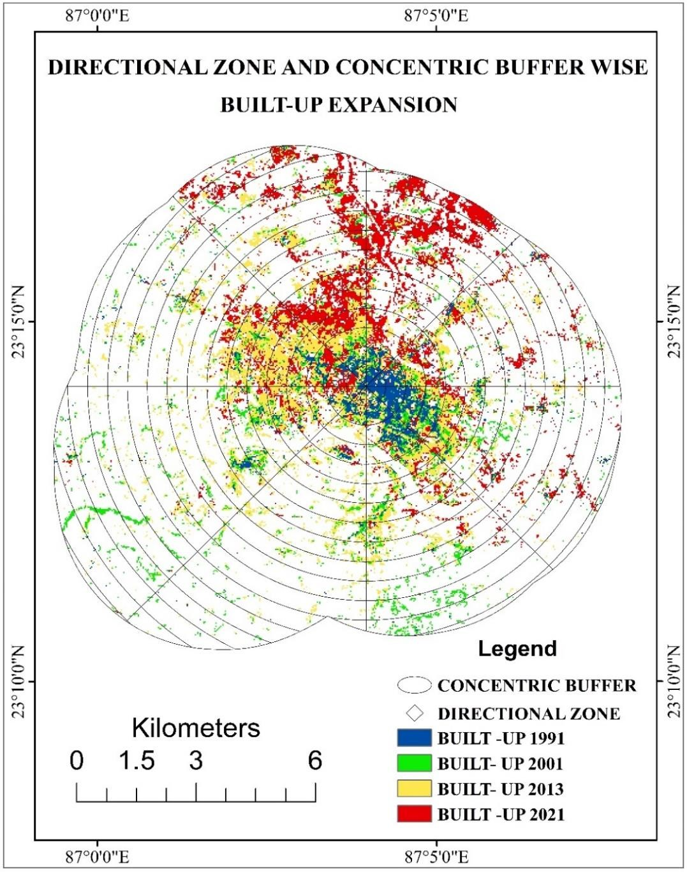
Fig 12. Expansion of Built–Up Area (1991 – 2021)

4.3 Direction of urban expansion
The municipality and its surrounding areas are situated in the Southern part of the district. Thus, urbanisation started from the central point of the city (Fig.13 and 14). The area then expanded towards the East South-East, South South-East, West South-West, West North-West and North North-West directions in the given period of time between1991 to 2013. On the other side, from 2013 to 2021, the built–up area expanded towards the North North-East, East North-East, East South-East, West North-West and North North-West direction (Table 6 and Fig.15). As the regional railway provides access to the North-East part of the district. Another railway runs in the South-Eastern direction. The municipality has good connectivity with Durgapur and another important industrial city. In 2021, the highest built-up area was found in North north-northwest direction, and the area was about 518 hectares. The lowest built-up area has been observed in South South-South-West direction, and the area is about 20 hectares. On the other side, the highest expansion of about 313 hectares was observed in the NNE direction from 2013 to 2021.
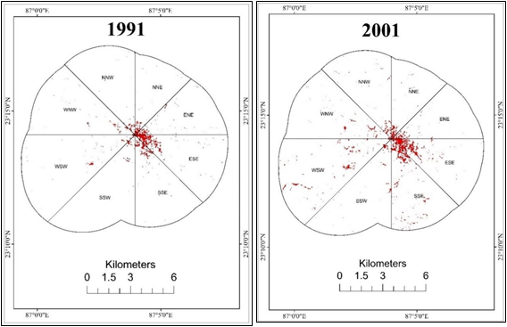

Fig. 13 Directional zone-wise built-up expansion in the study area from 1991 to 2021

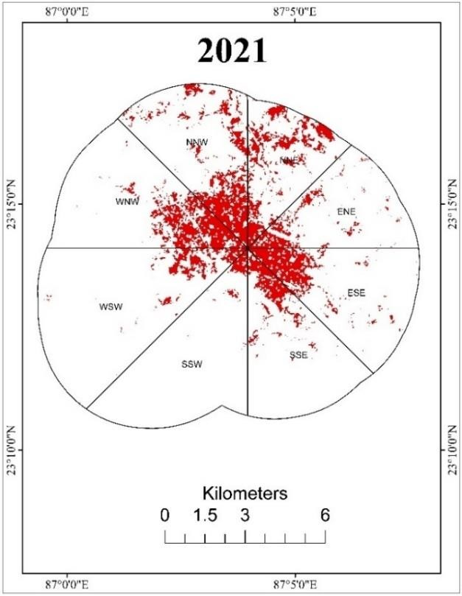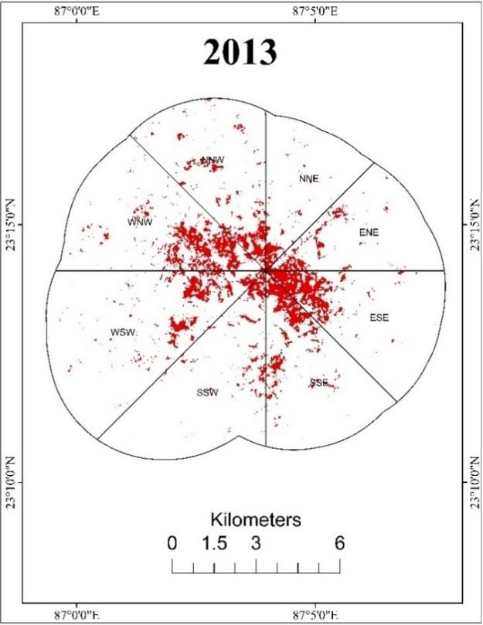
Fig. 14 Directional Zone-Wise Built-Up Expansion in the Study Area from 1991 to 2021
Table 6 Direction-wise built–up expansion
Direction | 1991  (Hectors) | 2001  (Hectors) | 2013  (Hectors) | 2021  (Hectors)
NNW | 24.10279 | 60.63567 | 239.161363 | 518.065571
WNW | 37.483274 | 76.07906 | 384.34228 | 432.688766
WSW | 38.866297 | 139.1105 | 312.793196 | 203.756886
SSW | 20.722655 | 55.96671 | 170.361692 | 65.462315
SSE | 58.83942 | 157.5281 | 272.659156 | 233.503891
ESE | 96.530734 | 154.3708 | 258.663541 | 321.070277
ENE | 44.874133 | 58.35855 | 150.192298 | 224.374264
NNE | 25.861277 | 41.6729 | 93.185315 | 408.117513
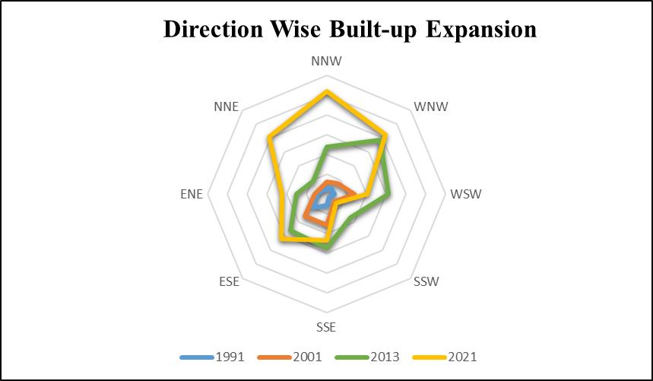
Fig 15. Direction-Wise Built-Up Land Distribution in the Study Area (1991-2021)

4.4 Concentric buffer-wise assessment of the urban expansion
In terms of concentric zones, the area is bound by the 0.5-kilometre radius circles drawn in Fig.16. As shown in the built-up map of 2021, the 0.5 to 3.5 km circle has the largest built-up area, which was about 1644 hectares. This zone covers the Howrah railway station, on the Adra-Chakradharpore section of the South Eastern Railway. On the other side, the central point of the area (i.e., 0.5 kilometres to 4.5-kilometre circle of the area), the urban expansion was not good in the given period of time from 1991 to 2013, because this zone was not well-connected with other cities or towns. This observation indicates that the built-up map of 2021 plays a vital role in developing good connectivity in increasing the built-up area expansion. The highest expansion of the urban area was observed in a 2.5-kilometre buffer area, which was about 196 hectares(Fig.17).
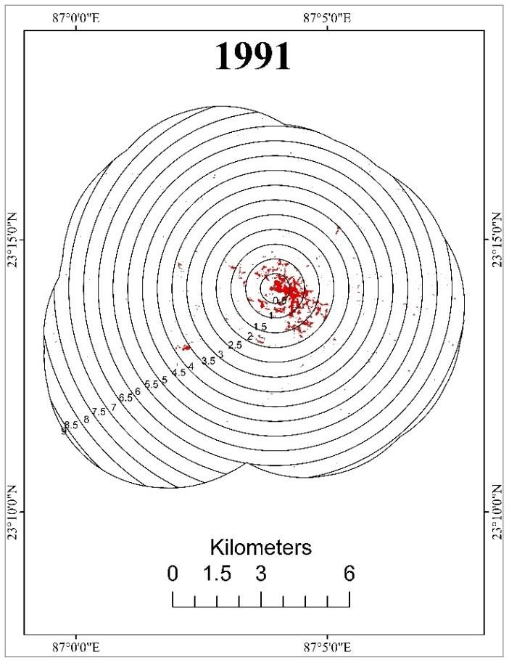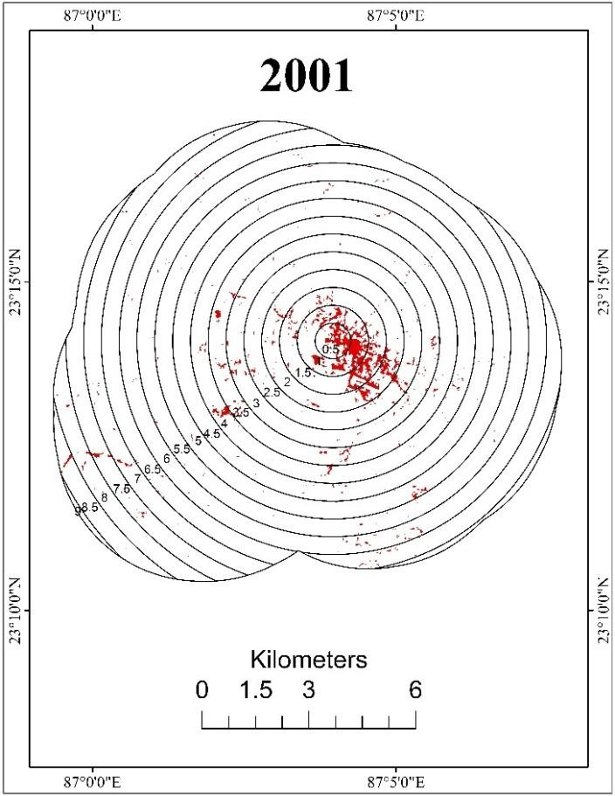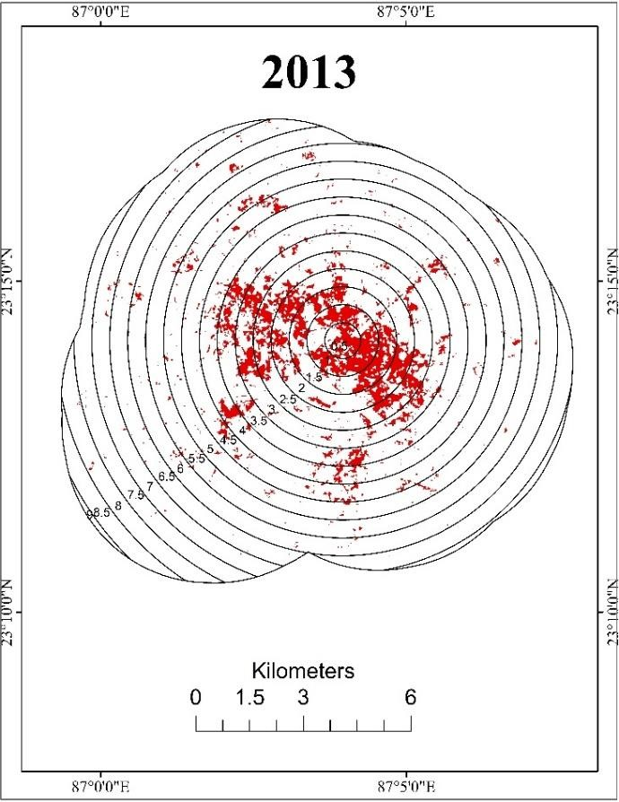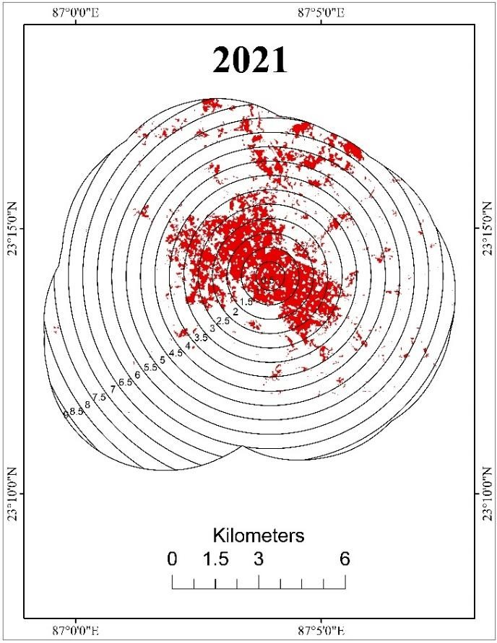
Fig 16. Concentric Buffer Wise Representation of Built-Up Area 1991 to 2021

Table 7 Distribution of built-up areas by concentric buffer distances
Distance  (Km) | 1991  (ha) | 2001  (ha) | 2013  (ha) | 2021  (ha)
0.5 | 38.233356 | 38.83198 | 55.37748 | 71.93178
1.0 | 96.765888 | 101.6914 | 171.2129 | 206.8844
1.5 | 58.079045 | 86.6036 | 207.0879 | 256.7172
2.0 | 50.171321 | 73.95986 | 223.3099 | 323.1977
2.5 | 15.10657 | 42.458 | 238.2388 | 317.7745
3.0 | 18.430856 | 53.17946 | 214.3597 | 279.9252
3.5 | 14.24572 | 61.37554 | 197.5526 | 192.6931
4.0 | 16.356285 | 51.18052 | 152.5181 | 179.673
4.5 | 5.971525 | 27.27581 | 125.1168 | 156.9647
5.0 | 6.537319 | 34.78602 | 104.929 | 114.6203
5.5 | 9.573863 | 33.36245 | 63.35595 | 156.0347
6.0 | 4.142539 | 39.82172 | 47.95415 | 55.90776
6.5 | 6.460878 | 37.34805 | 36.92532 | 64.67577
7.0 | 3.314026 | 20.71866 | 25.14469 | 16.64253
7.5 | 1.429889 | 20.75267 | 8.645778 | 0.119255
8.0 | 1.529164 | 13.01143 | 6.599406 | 4.328838
8.5 | 0.999163 | 6.939727 | 2.681813 | 0.057635
9.0 |  | 0.72067 | 0.450397 | 0.408947
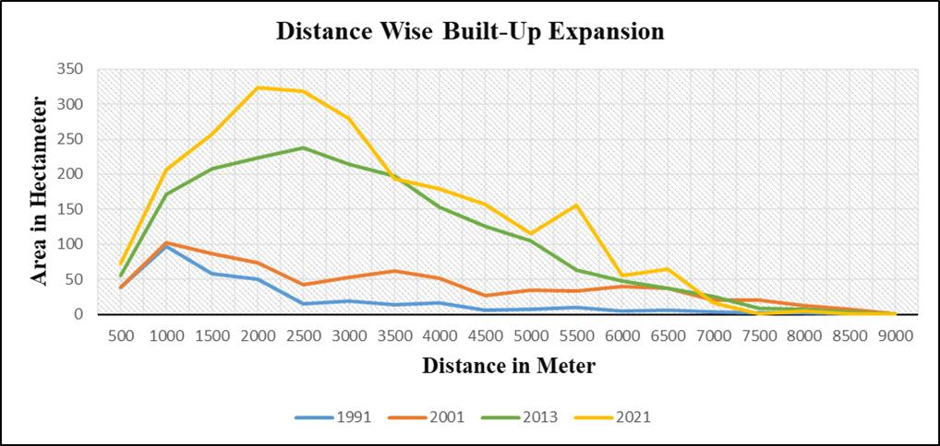
Fig 17. Graphical Representation of Built-Up Area by Distance

Using Landsat imagery for the years 1991, 2001, 2013, and 2021, the present study identified six major land use and land cover (LULC) classes in the surrounding area of Bankura Municipality, namely water bodies, bare land, built-up areas, vegetation, agricultural land, and sand. These classes exhibited substantial temporal changes, reflecting rapid urban expansion driven primarily by population growth and economic development within Bankura Municipality. Consistent with previous studies (Garg et al., 2019; Liu et al., 2020), the findings indicate that anthropogenic activities were the dominant drivers of LULC transformation in Bankura Municipality and its surrounding regions, particularly in relation to the expansion of agricultural land and built-up areas (Alam et al., 2019; Sánchez-Cuervo et al., 2020; Seyam et al., 2023; Shahfahad et al., 2024; Acharyya et al., 2024). Among the most notable changes observed was the conversion of bare land into agricultural land, man-made vegetation, and other green spaces, alongside a continuous increase in built-up areas over the three-decade study period. Demographically, Bankura district recorded a population of approximately 3,596,674 in 2011. The 2001 Census reported a population growth rate of 13.82 per cent compared with 1991. In response to this demographic expansion, extensive infrastructural development took place between 1991 and 2021 in and around Bankura Municipality. This included the construction of residential complexes, commercial establishments, hotels, restaurants, healthcare facilities, and other social infrastructure to accommodate the growing population and support emerging socio-economic needs.
Furthermore, the government’s land grant policy and interest-free loan schemes have facilitated land acquisition and home ownership among middle- and low-income households. Concurrently, the development of urban infrastructure—including roads, highways, educational institutions, residential hotels, banking facilities, shopping centres, and healthcare services—has significantly contributed to the rapid urban expansion observed in the study area.
The major findings of the study can be summarised as follows. First, during the period 1991–2021, a decline was observed in certain land cover classes, notably bare land (−28.38%) and sand (−0.93%), while marginal increases were recorded in water bodies (1.64%) and vegetation (2.03%). In contrast, substantial increases were observed in built-up areas and agricultural land, collectively accounting for an increase of approximately 14.22% over the study period. Agricultural land alone increased by 11.42%. These findings are consistent with previous studies (Abebe et al., 2023; Petrovszki et al., 2024; Zhou et al., 2026). Similar trends of increasing agricultural and built-up land have also been reported in other regions, including the Greater Shawnee National Forest, USA (Thapa et al., 2026). Within the study area, a major proportion of bare land was converted into agricultural land, particularly between 2013 and 2021.
Second, the study examined the spatial direction and distance patterns of urban sprawl within the selected area. The results indicate that built-up expansion was relatively limited during 1991 and 2001; however, a marked acceleration in urban growth occurred during 2013 and 2021, largely attributed to the increased availability of infrastructural and socio-economic facilities in the peri-urban zones of the municipality.
Third, from an urban planning perspective, the results reveal significant LULC transformation and rapid urban sprawl, underscoring the need for systematic and sustainable planning of future development activities. Such alterations in the natural landscape are likely to have affected local hydrological processes, including drainage and flood regulation, as evidenced by recent occurrences of flash flooding following intense summer rainfall events. In addition, rapid urban expansion has placed considerable strain on transportation networks, water supply systems, sewage infrastructure, and other public utilities, as reflected in recurring traffic congestion in the central town during peak hours, intermittent water supply, and inadequate healthcare service provision.

Conclusions and Recommendations
This study aimed to quantify land use and land cover (LULC) changes and patterns of urban expansion using remote sensing and GIS techniques, along with multi-temporal Landsat imagery, for Bankura Municipality over the period 1991 to 2021. The study also examined the influence of population growth on changes in the conventional LULC configuration of the area. The overall results indicate that agricultural land underwent the most substantial transformation during the study period, with a net decrease of 4,425.999759 hectares. In contrast, vegetation and built-up areas exhibited increasing trends; however, the increase in vegetation was largely attributable to homestead-based tree plantation activities. The findings further suggest that population growth is one of the key driving forces behind observed LULC changes. The expansion of built-up areas over the study period reflects pronounced urbanisation. Economic development, locational advantages, and accessibility were identified as the primary factors driving urban growth, with agricultural land serving as the principal source of land conversion into urban uses. The extent of urban area was found to be greatest during the 2013–2021 period. In 2021, bare land declined to 21.03 per cent, although this reduction is interpreted as a transitional outcome of ongoing urbanisation processes. Spatial analysis of urban expansion revealed a pattern of outward growth along active built-up zones and major transportation corridors, including the Howrah–Adra–Chakradharpur section of the South Eastern Railway network. Overall, the findings demonstrate significant urban expansion in the study area, highlighting the need to incorporate environmental considerations into regional planning frameworks in alignment with Sustainable Development Goals (SDGs). As the satellite imageries help to maintain a truthful record of terrain during that period, it can be used to check the deviations in the land uses, to identify the changes in land use and land cover and to take appropriate action immediately, to maintain the green cover of vegetation and agricultural land. So, proper use of land should be implemented by which was not found in the last three decades. Haphazard and Unplanned built-up expansion was a significant problem in the study area. Hence, planners and Govt officials should adopt exact, sustainable, eco-friendly urban development planning for future developments. Land use and land cover patterns of the study area will help in the formulation of policies and programs for developmental planning.

Limitations
The accuracy assessment of categorized land use and land cover maps was conducted for the years 2013 and 2021. Standard accuracy assessment was not possible due to the lack of credible historical ground truth data and high-resolution reference photography between 1991 and 2001. This is typical problem in multi-temporal LULC research based on historical satellite data. Maximum likelihood classification has limitations in classifying Landsat imageries. Several misclassifications between ground truth data and classified images were observed during the accuracy assessment. For example, riparian unexposed bedrock was occasionally classified as settlement and built up, and riverside sandy land was sometimes classified as agricultural land as well as built up as bare land. Additionally, due of the juxtaposition in some areas, waterbodies are considered fallow and barren land. Furthermore, the lack of high-quality Landsat satellite imageries of 2011 makes decadal studies impractical.

Competing Interests: The corresponding author, representing all authors, confirms that there are no conflicts of interest to disclose.

Disclaimer (Artificial intelligence):
Author(s) hereby declare that NO generative AI technologies such as Large Language Models (ChatGPT, COPILOT, etc.) and text-to-image generators have been used during the writing or editing of this manuscript.

References
- Abebe, B. G., Gemeda, B. S., & Sisay, G. (2023). Analysing land use land cover (LULC) dynamics by using remote sensing and GIS techniques: the case of Dukem town, Oromia special zone. Geocarto International, 38(1). https://doi.org/10.1080/10106049.2023.2210523
- Acharyya, R., Majumder, A., Pramanick, N., Mukhopadhyay, A., Pramanik, M., & Dhungana, G. (2024). Object-Based Classification to Evaluate LULC Changes and Socio-Economic Mobility with Google Earth Engine: A Case Study of Rajarhat-New Town Agglomeration, Kolkata, India. Qeios. https://doi.org/10.32388/O9B0X5
- Alam A, Bhat M, Maheen M (2019) Using Landsat satellite data for assessing the land use and land cover change in Kashmir valley. GeoJournal 85(6):1529–1543. https:// doi. org/ 10. 1007/s10708- 019- 10037-x
- Anderson JR, Hardy EE, Roach JT, Witmer RE (1976) A land use and land cover classification system for use with remote sensor data. US Govt Print Off. https:// doi. org/ 10. 3133/ pp964
- Bayarsaikan U, Boldgiv B, Kim K, Park K, Lee D (2009) Change detection and classification of land cover at Hustai national park in Mongolia. Int J Appl Earth Obs Geoinf 11(4):273–280. https:// doi. org/ 10. 1016/j. jag. 2009. 03. 004
- Bolstad PV, Lillesand TM (1991) Rapid maximum likelihood classification. Photogramm Eng Remote Sens 57(1):67–74
- Dadras, M., Shafri, H. Z. M., Ahmad, N., Pradhan, B., & Safarpour, S. (2015). Spatio-temporal analysis of urban growth from remote sensing data in Bandar Abbas city, Iran. The Egyptian Journal of Remote Sensing and Space Science, 18(1), 35–52. https://doi.org/10.1016/J.EJRS.2015.03.005
- Dewan, A. M., & Yamaguchi, Y. (2009a). Using remote sensing and GIS to detect and monitor land use and land cover change in Dhaka Metropolitan of Bangladesh during 1960–2005. Environmental Monitoring and Assessment, 150(1–4), 237–249.
- Dewan, A.M.,&Yamaguchi, Y. (2009b). Land use and land coverchange in Greater Dhaka, Bangladesh: using remote sensing to promote sustainable urbanization. Applied Geography, 29(3), 390–401.

- Dewan A, Kiselev G, Botje D (2021) Diurnal and seasonal trends and associated determinants of surface urban heat islands in large Bangladesh cities. Appl Geogr 135:102533. https:// doi. org/ 10.1016/j. apgeog. 2021. 102
- Garg, V., Nikam, B. R., Thakur, P. K., Aggarwal, S. P., Gupta, P. K., & Srivastav, S. K. (2019). Human-induced land use land cover change and its impact on hydrology. HydroResearch, 1, 48–56. https://doi.org/10.1016/J.HYDRES.2019.06.001
- Hassan Q, Ejiagha I, Ahmed M, Gupta A, Rangelova E, Dewan A (2021) Remote sensing of local warming trend in Alberta, Canada during 2001–2020, and its relationship with large-scale atmospheric circulations. Remote Sens 13(17):3441. https:// doi. org/ 10.3390/ rs131 73441
- Herold,M., Scepan, J., & Clarke, K. C. (2002). The use of remote sensing and landscape metrics to describe structures and changes in urban land uses. Environment and Planning, 34(8), 1443–1458
- Houghton RA (1999) The annual net flux of carbon to the atmosphere from changes in land use 1850–1990. Tellus B 51(2):298–313. https:// doi. org/ 10. 1034/j. 1600- 0889. 1999. 00013.x
- Kastha, S., & Khatun, S. (2022). Quantifying and assessing land use and land cover changes around the critical waterbodies—A case study of Bhagirathi-Hooghly floodplain, East India. Applied Geomatics, 14(2), 315–334. https://doi.org/10.1007/s12518-022-00435-1
- Lambin EF, Geist HJ (2006) Land use and land cover change. Springer,Berlin
- Lambin E, Turner B, Geist H, Agbola S, Angelsen A, Bruce J, Coomes O, Dirzo R, Fischer G, Folke C, George P, Homewood K, Imbernon J, Leemans R, Li X, Moran E, Mortimore M, Ramakrishnan P, Richards J, Skanes H, Steffen W, Stone G, Svedin U, Veldkamp T, Vogel C, Xu J (2001) The causes of land-use and landcover change: moving beyond the myths. Glob Environ Chang 11(4):261–269. https:// doi. org/ 10. 1016/ S0959- 3780(01) 00007-3
- Rahman M, Ningsheng C, Mahmud G, Islam M, Pourghasemi H, Ahmad H et al (2021) Flooding and its relationship with landcover change, population growth, and road density. Geosci Front 12(6):101224. https:// doi. org/ 10. 1016/j. gsf. 2021. 101224
- Richards JA, Jia X (2006) Remote sensing digital image analysis an introduction. Springer, Germany
- Sanchez-Cuervo A, de Lima L, Dallmeier F, Garate P, Bravo A, Vanthomme H (2020) Twenty years of land cover change in the southeastern Peruvian Amazon: implications for biodiversity conservation. Reg Environ Chang 20(1). https:// doi. org/ 10.1007/ s10113- 020- 01603-y
- Seyam, M. M. H., Haque, M. R., & Rahman, M. M. (2023). Identifying the land use land cover (LULC) changes using remote sensing and GIS approach: A case study at Bhaluka in Mymensingh, Bangladesh. Case Studies in Chemical and Environmental Engineering, 7, 100293. https://doi.org/10.1016/J.CSCEE.2022.100293
- Shahfahad, Naikoo, M. W., Das, T., Talukdar, S., Asgher, M. S., Asif, & Rahman, A. (2024). Prediction of land use changes at a metropolitan city using integrated cellular automata: past and future. Geology, Ecology, and Landscapes, 8(3), 287–305. https://doi.org/10.1080/24749508.2022.2132010
- Strahler AH (1980) Use of prior probabilities in maximum likelihood classification of remotely sensed data. Remote Sens Environ 10:135–163
- Thapa, S., Gibson, D. J., & Li, R. (2026). Forest Transition Under Climate Pressure: Land Use Land Cover Change in the Greater Shawnee National Forest. Remote Sensing 2026, Vol. 18, Page 1079, 18(7), 1079. https://doi.org/10.3390/RS18071079
- Tuladhar D, Dewan A, Kuhn M, Corner JR (2019) The influence of rainfall and land use/land cover changes on river discharge variability in the mountainous catchment of the Bagmati River. Water 11(12):2444. https:// doi. org/ 10. 3390/ w1112 2444
- Vitousek, P. M., Mooney, H. A., Lubchenco, J., & Melillo, J. M. (1997). Human domination of Earth’s ecosystems. Science, 277(5325), 494–499. https://doi.org/10.1126/science.277.5325.494
- Vivekananda GN, Swathi R, Sujith AVLN (2021) Multi-temporal image analysis for LULC classification and change detection. Eur J Remote Sens 54(sup2):189–199. https:// doi. org/ 10. 1080/ 22797254. 2020. 17712 15
- Weng, Y. C. (2007). Spatiotemporal changes of landscape pattern in response to urbanization. Landscape and Urban Planning, 81(4), 341–353.
- Yohannes H, Soromessa T, Argaw M, Dewan A (2021) Impact of landscape pattern changes on hydrological ecosystem services in the Beressa watershed of the Blue Nile Basin in Ethiopia. Sci Total Environ 793:148559. https:// doi. org/ 10. 1016/j. scito tenv. 2021.14855
- Zhou, Y., Zhang, J., Liu, G., Song, K., Zhu, B., Li, S., Shao, S., Li, Y., & Han, B. (2026). The paradox of rural depopulation and built-up growth: Insights from two decades of settlement change in China (2000–2020). Land Use Policy, 167, 108048. https://doi.org/10.1016/J.LANDUSEPOL.2026.108048

