Evaluating the Influence of Natural Conditions and Development Activities on Landslide Dynamics in the Bhagirathi Valley, India

Abstract
In the Himalayan region, where complex geological formations, steep topography, heavy monsoonal precipitation, and growing human activity all contribute to slope instability, landslides are one of the most serious geomorphic risks. Situated in the tectonically active Garhwal Himalaya, the Bhagirathi Valley in Uttarakhand is especially vulnerable to frequent landslides that undermine delicate mountain ecosystems, disrupt transportation networks, harm hydropower infrastructure, and put human settlements at risk. Using an integrated methodological approach that integrates field-based geological and geomorphological investigations with GIS and remote sensing techniques, this study offers a thorough assessment of both natural and man-made factors influencing landslide dynamics in the Bhagirathi Valley. Lithology, structural discontinuities, slope gradient, rainfall patterns, hydrological conditions, seismic activity, and river incision are among the important natural factors examined. Concurrently, human-caused elements like road building, deforestation, unplanned urbanization, and hydropower development are scrutinized. The results show that the intricate interaction between the valley's natural geological fragility and outside human influences controls the frequency of landslides. The study emphasizes that landslides in the Bhagirathi Valley are the outcome of interrelated human–environment interactions rather than just being natural occurrences. A sustainability-focused approach that incorporates ecosystem-based mitigation techniques, hazard-informed land-use planning, and active community involvement to reduce future hazards is suggested as a solution. In general, the study supports sustainable development in Himalayan high areas and aids in attempts to reduce the danger of disaster.
Keywords: Geomorphic hazards, Utrakhand, Bhagirathi valley, Ecosystem, Landslide factors, Sustainable development.

1. Introduction
One of the most damaging natural dangers in the world, landslides are a basic geomorphic process in hilly areas. Through mass wasting and sediment redistribution, landslides greatly contribute to the evolution of landscapes over geological timeframes; but, at human timescales, they pose major risks to infrastructure, ecological systems, and human life. According to Petley (2012) and Guzzetti et al. (2012), landslides cause thousands of deaths worldwide each year as well as significant economic losses. Developing nations are disproportionately affected, as rapid population growth and infrastructure expansion increasingly encroach upon unstable slopes.
Because of the combined effects of active tectonics, steep and rugged topography, weak and extensively fractured lithology, high seismicity, and severe monsoon precipitation, landslides are among the most common and destructive natural hazards in the Indian Himalayan region. Himalayan slopes are naturally unstable due to these fundamental geological and climatic factors (Sundriyal et al., 2015; Owen et al., 2008). The central Himalayan state of Uttarakhand is especially susceptible and has seen a number of devastating landslide and debris-flow incidents in recent years, underscoring the mounting vulnerability and sensitivity of mountain communities to slope failures (Martha et al., 2013).
This susceptibility is best illustrated by the Bhagirathi Valley, which makes up a significant portion of the upper Ganga basin. The valley is home to vital transportation systems, hydropower plants, pilgrimage routes, and quickly growing communities. Frequent landslides often cause long-term socioeconomic consequences, ruin infrastructure, isolate isolated communities, and interfere with transportation connectivity. Furthermore, material from landslides greatly raises river sediment loads, which has a negative impact on reservoir capacity, aquatic ecosystems, and downstream water management systems (Sharma et al., 2018).
The majority of the literature now in publication focuses on spatial prediction using GIS-based statistical or heuristic models, despite the fact that many studies have examined landslide susceptibility and hazard zonation in the Himalayan region. Although these methods are useful for locating landslide-prone locations, they frequently offer little understanding of the causative mechanisms and physical processes controlling slope instability. Furthermore, the significance of manmade activities—such as road construction, deforestation, and hydropower development—in enhancing natural susceptibility is often overlooked when treating landslides as solely natural phenomena (Gerrard, 1994; Haque et al., 2016).
It is becoming more well acknowledged that landslides in mountain environments are the result of coupled natural–human systems in the context of growing climate variability and rapid infrastructure development. Therefore, in order to design effective, sustainable, and resilient landslide risk management techniques in fragile Himalayan landscapes, an integrated assessment of both natural and anthropogenic factors impacting landslide processes is crucial.
By methodically examining the main natural elements that regulate slope instability—geological, geomorphological, hydrological, and climatic controls—the current study seeks to thoroughly investigate landslide processes in the Bhagirathi Valley. Simultaneously, it assesses how much land-use change, slope alteration, infrastructure development, and other anthropogenic activities contribute to the start and acceleration of landslide episodes. Building on this integrated assessment, the study also aims to create a sustainability-focused framework that encourages hazard-informed land-use planning, enables efficient landslide risk reduction, and improves long-term resilience in the ecologically delicate Himalayan mountain environment.

2. Regional Setting and Study Area Characteristics
The Upper Ganga Basin, or Bhagirathi Valley in Uttarakhand, will be the study region. From Bhatwari to Tehri, the region will be covered.

Figure:1, Study area

2.1 Physiography and Topography
With elevations rising from about 1,000 meters in the lower valley reaches to more than 6,000 meters in the high-altitude glaciated zones, the Bhagirathi Valley exhibits notable physiographic variability. Sharp ridgelines, steep valley flanks, tight and deeply ingrained gorges, and actively carving river systems are all examples of this great relief. Because of the increased gravitational loads caused by such rough terrain, slopes are far more prone to instability. In areas where natural slopes are significantly altered by human activity, such as along riverbanks and transit corridors, slope gradients often surpass 30 to 45 degrees.

2.2 Geological Framework
These environments provide favorable circumstances for a range of mass movement activities due to the existence of thin and irregular soil cover over heavily worn bedrock and strong environmental forcing. Particularly frequent are shallow translational landslides, rock falls, and debris flows, which are frequently caused by times of heavy or protracted rainfall when pore-water pressures rise and shear strength decreases (Guzzetti et al., 2005; Pradhan, 2010; Sundriyal et al., 2015).
The Bhagirathi Valley is geologically situated within the Lesser and Higher Himalayan tectonic domains, characterized by a diverse collection of metamorphic and minor sedimentary rocks, such as phyllites, schists, quartzites, gneisses, and granitic intrusions. These lithological units demonstrate marked variations in strength, fabric, and resistance to weathering, which greatly influence slope stability. Fine-grained, foliated rocks such as phyllites and schists are particularly prone to mechanical breakdown and weathering, rendering them very susceptible to landslide initiation under gravitational and hydrological pressures (Valdiya, 1980).
Major Himalayan tectonic structures, most notably the Main Central Thrust and its related shear zones, traverse this structurally complex area. The rock mass has been severely fractured by prolonged tectonic deformation along these structures, resulting in tightly spaced joints, foliations, fault planes, and zones of crushed rock. Translational and rotational slope failures are made easier by these discontinuities, which function as favored planes of weakness. Therefore, by preconditioning slopes to failure and intensifying the effects of rainfall, river incision, and human perturbations, the inherited tectonic fabric plays a vital role in controlling landslide processes (Gansser, 1964; Valdiya, 2015).



Figure:2 Geological framework of the Study area

2.3 Climate and Hydrology
The southwest monsoon, which brings around 70–80% of the yearly precipitation between June and September, is a major factor in the hydroclimatic regime of the Bhagirathi Valley. By raising the pore-water pressure in slope materials, intense monsoonal rainfall—which frequently manifests as brief cloudbursts and extended wet spells—plays a crucial role in the start of landslides. In worn and structurally unstable lithologies in particular, elevated pore-water pressure increases the risk of slope failure by reducing effective normal stress and shear strength. Slope instability in the valley is significantly influenced by river processes in addition to rainfall. Mass wasting is encouraged by the Bhagirathi River and its tributary network's active incision of valley floors, which causes toe erosion and the gradual oversteepening of nearby slopes. Seasonal snowmelt and glacial meltwater supply additional hydrological inputs at higher elevations, maintaining high groundwater levels throughout the pre-monsoon and monsoon seasons. Hydrological factors are one of the main controls on landslide processes in the area because of the extremely unfavorable slope stability conditions created by the combined effects of monsoonal rainfall, river undercutting, and meltwater-driven saturation (Martha et al., 2013; Sundriyal et al., 2015; IMD, 2019).

2.4 Land Use and Human Activities
The Bhagirathi Valley's land use is a patchwork of terraced agricultural fields, dense forested slopes, quickly growing human settlements, vast road networks, and substantial hydroelectric facilities. Significant slope alteration, extensive removal of stabilizing vegetation, and disturbance of natural surface and subsurface drainage systems have resulted from rapid changes in land-use and land-cover over the past few decades. These changes, which were often made without a thorough geotechnical study or hazard assessment, have significantly increased the region's susceptibility to landslides and slope instability. Since incorrect drainage concentration and slope cutting frequently act as direct triggers for landslide initiation, the growth of linear infrastructure, such as highways and tunnels, has had a particularly significant impact. Naturally vulnerable slopes become high-risk areas as a result of these human disturbances interacting with the valley's delicate geological and climatic circumstances (Martha et al., 2013; Pradhan, 2010; Sundriyal et al., 2015).
Landslide research has advanced considerably from early descriptive geomorphological interpretation to more integrated, process-based, and data-intensive analytical frameworks. Contemporary research increasingly treats landslides not merely as isolated slope failures, but as the outcome of interacting geological, geomorphic, hydrological, climatic, and anthropogenic controls operating across multiple spatial and temporal scales. Recent studies emphasize that landslide susceptibility in mountain regions is strongly influenced by slope gradient, lithology, drainage characteristics, rainfall intensity, land-use change, and structural discontinuities, all of which jointly determine the degree of slope instability rather than acting independently (Qi et al., 2024; Sonker et al., 2024). This reflects a broader shift in landslide science from single-factor explanation toward multi-factor system analysis.
Within the Himalayan region, recent work continues to highlight the exceptional fragility of mountain slopes under conditions of active tectonics, steep topography, fractured bedrock, and monsoon-dominated hydroclimatic forcing. Studies in Uttarakhand and adjacent Himalayan sectors show that terrain instability is especially severe in areas where structurally weak rock masses coincide with rapid incision, intense rainfall, and anthropogenic disturbance (Mey et al., 2024; Sonker et al., 2024). Such findings are highly relevant to the Bhagirathi Valley, where tectonic deformation, steep valley walls, and river erosion together create a landscape already predisposed to slope failure. In this sense, recent Himalayan landslide research supports the interpretation that many slope failures are not anomalous events, but rather expressions of ongoing landscape adjustment in a tectonically active mountain system.
A major development in recent years has been the widespread application of GIS, remote sensing, and machine learning for landslide susceptibility mapping and hazard zonation. These methods have significantly improved the ability to generate inventories, identify high-risk terrain, and integrate multiple environmental variables into predictive models. Recent studies have successfully used frequency ratio, ensemble machine learning, positive-unlabeled learning, and InSAR-assisted classification approaches to improve spatial prediction and model performance (Sonker et al., 2024; Vaka et al., 2024; Zhang et al., 2024). For example, Sonker et al. (2024) demonstrated the utility of morphological and hydrological indicators in susceptibility mapping in the Sikkim Himalaya, while Zhang et al. (2024) showed that positive-unlabeled machine learning can improve susceptibility prediction in data-limited Himalayan terrain such as Chamoli, Uttarakhand. Similarly, Vaka et al. (2024) illustrated the growing importance of combining ground deformation monitoring and machine learning through InSAR-based approaches for more refined hazard detection.
Despite these methodological advances, recent scholarship also raises important conceptual and practical limitations in landslide susceptibility research. Several studies argue that many predictive models, although statistically robust, remain insufficient for long-term hazard management because they often prioritize classification accuracy over geomorphic understanding (Qi et al., 2024; Zhang et al., 2024). In other words, susceptibility maps may successfully identify where landslides are likely to occur, yet still fail to explain the underlying process mechanisms, threshold conditions, and evolving human disturbances responsible for slope failure. This critique is particularly important in the Himalayan context, where unstable slopes are continuously modified by both natural forcing and development activity.
Another major theme emerging from recent 2024 literature is the growing recognition that anthropogenic interventions are increasingly central to landslide generation and risk amplification. In fragile mountain environments, activities such as road widening, slope cutting, forest clearance, drainage disruption, hydropower development, and unplanned urbanization have been repeatedly identified as critical destabilizing agents (Mey et al., 2024; Zhang et al., 2024). A particularly important study by Mey et al. (2024) along the Rishikesh–Joshimath (NH-7) corridor in Uttarakhand reported extremely high roadside landslide densities and demonstrated how infrastructure expansion can intensify slope instability in already hazard-prone Himalayan terrain. This insight is especially relevant to the Bhagirathi Valley, where transport corridors, hydropower infrastructure, and settlement growth increasingly intersect with geologically weak and hydrologically sensitive slopes.
Overall, recent literature indicates that the most effective direction for landslide research is not simply more accurate susceptibility prediction, but a more integrated understanding of landslide processes as socio-environmental phenomena. This requires combining field-based geomorphic and geological observations with geospatial analysis, machine learning, and critical evaluation of human landscape modification. The present study is situated within this emerging research direction and contributes by examining how natural slope predisposition and development-related disturbance jointly shape landslide dynamics in the Bhagirathi Valley.

3. Review of Literature
From early descriptive geomorphological investigations to sophisticated quantitative modeling and integrated risk assessment frameworks, landslide research has developed throughout time. In order to provide a basis for process-based research, Cruden and Varnes (1996) suggested a widely accepted taxonomy of landslides based on movement type and material. The main factors influencing the incidence of landslides in mountainous areas have consistently been shown to include lithology, structure, slope gradient, and rainfall (Guzzetti et al., 2005). Studies on the Himalayas highlight how seismicity, heavy monsoonal rainfall, and active tectonics precondition slopes for failure (Sundriyal et al., 2015). The development of GIS and remote sensing has revolutionized landslide research by making it possible to map susceptibility at the regional level and create inventories. Methods including machine learning, fuzzy logic, logistic regression, and frequency ratio have been used extensively (Pradhan, 2010). Critics counter that many susceptibility studies are less effective for long-term mitigation planning since they place more emphasis on prediction accuracy than physical comprehension. The involvement of human causes in increasing the risk of landslides is becoming more and more apparent in recent study. In Uttarakhand, landslides have been found to be significantly triggered by road construction, deforestation, hydropower development, and unplanned urbanization (Martha et al., 2013).
Landslide research has evolved substantially from descriptive geomorphological interpretation to increasingly sophisticated process-based, geospatial, and data-driven analytical frameworks. Recent studies emphasize that landslide occurrence in mountain environments is governed by the interaction of lithology, slope gradient, rainfall, drainage, land cover, and tectonic instability, rather than by any single controlling variable (Mey et al., 2024; Qi et al., 2024; Sonker et al., 2024). In the Himalayan context, recent research continues to demonstrate that active tectonics, structurally weak rock masses, intense monsoonal precipitation, and river incision create highly unstable slope systems, particularly in road-connected and rapidly modified terrain (Mey et al., 2024; Sonker et al., 2024).
The rapid advancement of GIS, remote sensing, and machine learning techniques has significantly transformed landslide susceptibility assessment by improving inventory generation, spatial prediction, and factor integration. Recent studies have increasingly employed frequency ratio models, ensemble learning, positive-unlabeled learning, and InSAR-assisted susceptibility mapping to identify high-risk zones with greater spatial precision (Vaka et al., 2024; Zhang et al., 2024; Sonker et al., 2024). However, a growing body of recent literature also critiques the overreliance on predictive accuracy, arguing that many susceptibility models remain less effective for long-term risk reduction because they often underrepresent causal geomorphic processes and anthropogenic disturbance (Qi et al., 2024; Zhang et al., 2024).
Recent Himalayan studies further highlight that human interventions are increasingly central to landslide generation, especially in fragile mountain corridors. Road widening, slope excavation, vegetation removal, drainage disruption, and unregulated infrastructure growth have been identified as major destabilizing agents in Uttarakhand and adjoining Himalayan regions (Mey et al., 2024; Zhang et al., 2024). In particular, Mey et al. (2024) demonstrated that road widening along NH-7 in Uttarakhand significantly increased roadside landslide occurrence, underscoring how development pressures can intensify naturally preconditioned instability. These findings strongly support the need for integrated landslide research that combines physical slope processes, geospatial technologies, and human-environment interactions within a sustainability-oriented hazard framework.

4. Materials and Methods

4.1 Integrated Methodological Framework
This study uses an integrated methodological framework that integrates GIS and remote sensing analysis with field-based geological and geomorphological investigations. Instead of depending only on statistical prediction, the framework places an emphasis on comprehending landslide processes through the interaction of natural and manmade elements.

4.2 Field-Based Investigations
Extensive field surveys were conducted across representative sections of the valley. Observations included:
- Identification of landslide types and dimensions
- Characterization of slope geometry and failure surfaces
- Measurement of discontinuity orientations (joints, foliations, faults)
- Assessment of weathering profiles and soil thickness
- Documentation of drainage conditions and anthropogenic modifications
Field evidence of past landslide activity, such as scarps, displaced material, tilted trees, and damaged infrastructure, was systematically recorded.

4.3 GIS and Remote Sensing Analysis
Thematic layers such as slope, aspect, curvature, drainage density, and land-use/land-cover were extracted using digital elevation models (DEM) and multispectral satellite data (Landsat and Sentinel). Visual interpretation backed by field validation was used to map the landslide inventory.
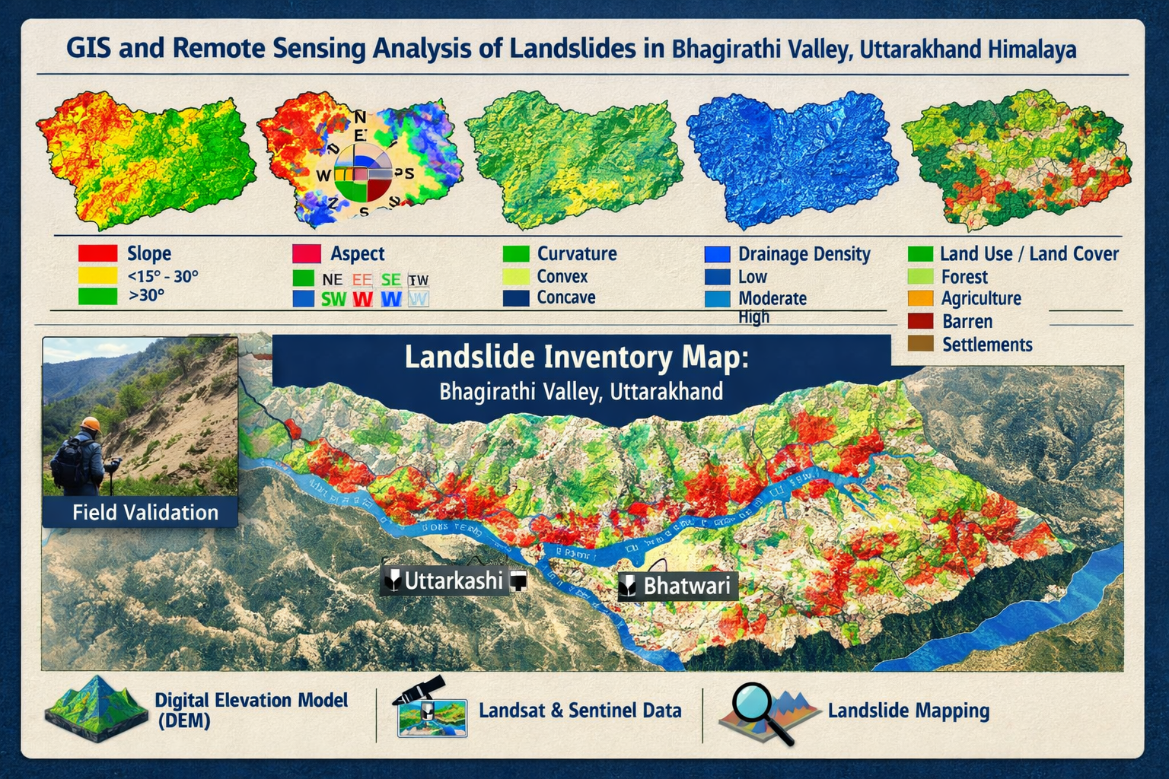

Figure:3, GIS and Remote Sensing based map of Study area

4.4 Evaluation of Causative Factors
To determine their relative impact on landslide processes, manmade elements (roads, settlements, deforestation, hydropower infrastructure) and natural factors (lithology, slope, structure, rainfall, drainage, seismicity) were examined using spatial overlay and qualitative interpretation.

5. Natural Factors Influencing Landslide Processes

5.1 Lithology and Weathering
Phyllites and schists are examples of weak, heavily worn lithologies that have low shear strength and are especially prone to slope failure. By producing differences in material strength within slopes, differential weathering exacerbates instability even further.

5.2 Structural Controls and Tectonics
Foliation planes, joints, and fault zones provide preferential failure surfaces. Active tectonic deformation continuously weakens slopes and contributes to long-term landslide susceptibility.

5.3 Topography and Slope Gradient
Steep slopes generate high gravitational stresses that favour both shallow and deep-seated landslides. Over-steepened slopes along river valleys and road cuts are especially prone to failure.
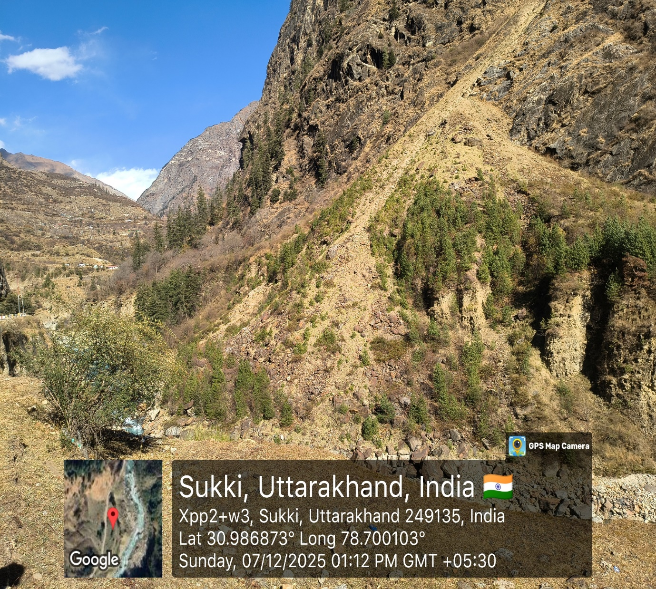

Figure:4, Topography and slop of the Study area

5.4 Rainfall, Hydrology, and Seismicity
Intense monsoonal rainfall increases pore-water pressure and reduces effective stress. River undercutting removes lateral support, while seismic shaking contributes to long-term slope weakening.
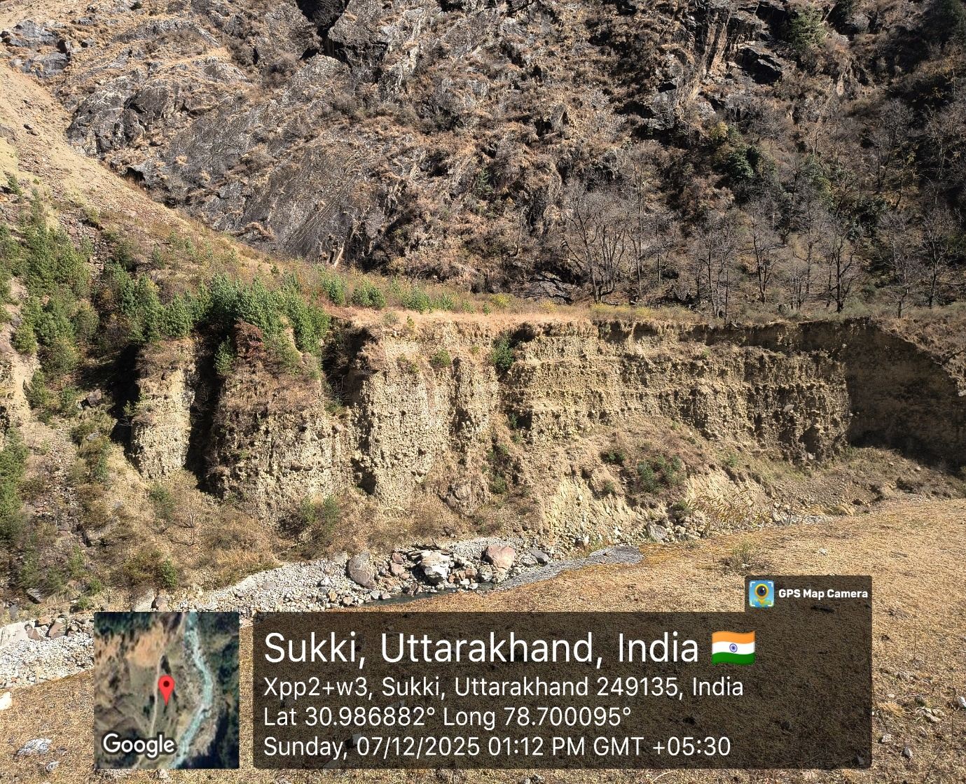

Figure:5,Rainfall system of the Study area

6. Anthropogenic Factors Influencing Landslide Processes

6.1 Road Construction and Slope Cutting
Road construction involves extensive excavation and slope steepening, often without adequate stabilization measures. Improper drainage along roads exacerbates water infiltration and slope failure.
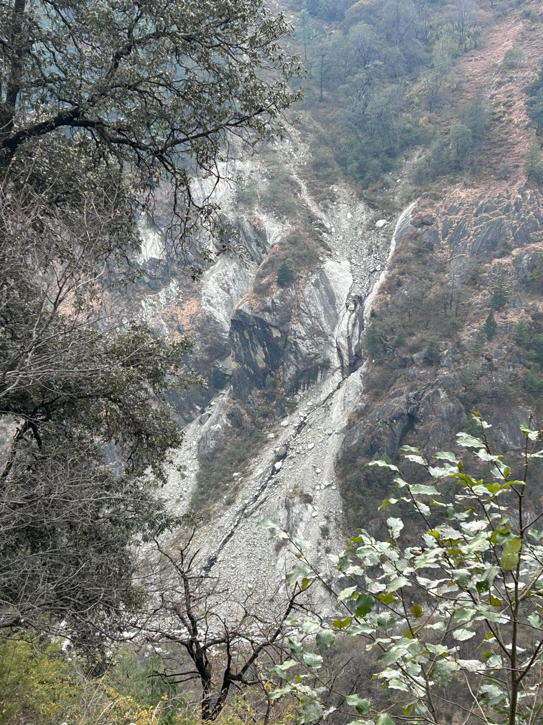

Figure:6,Slop cutting of the Study area

6.2 Deforestation and Land-Use Change
Vegetation removal reduces root reinforcement and increases surface runoff, accelerating erosion and instability. Conversion of forest land to agriculture or settlements intensifies landslide risk.
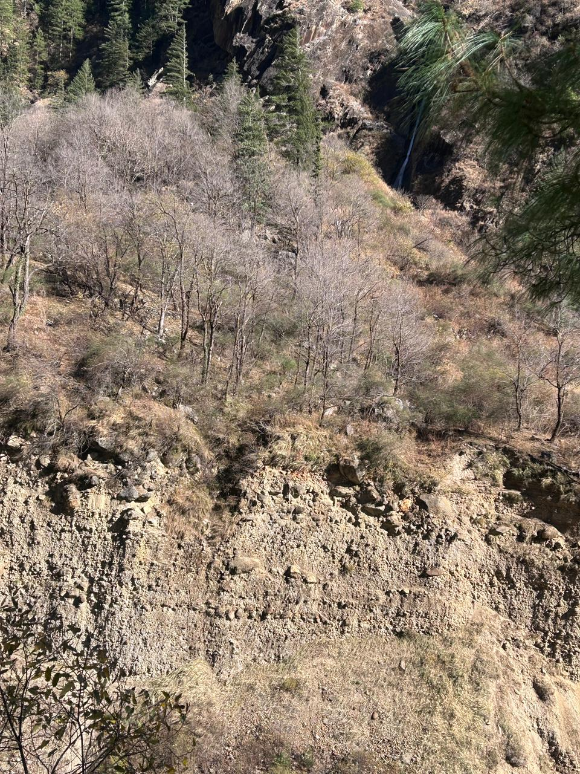

Figure:7, Deforestation of the Study area

6.3 Hydropower Development
Tunneling, blasting, and reservoir impoundment associated with hydropower projects alter subsurface stress regimes and groundwater flow, contributing to slope instability.

6.4 Urban Expansion and Infrastructure Growth
Unplanned construction in landslide-prone zones increases both landslide frequency and human vulnerability, transforming natural processes into disasters.
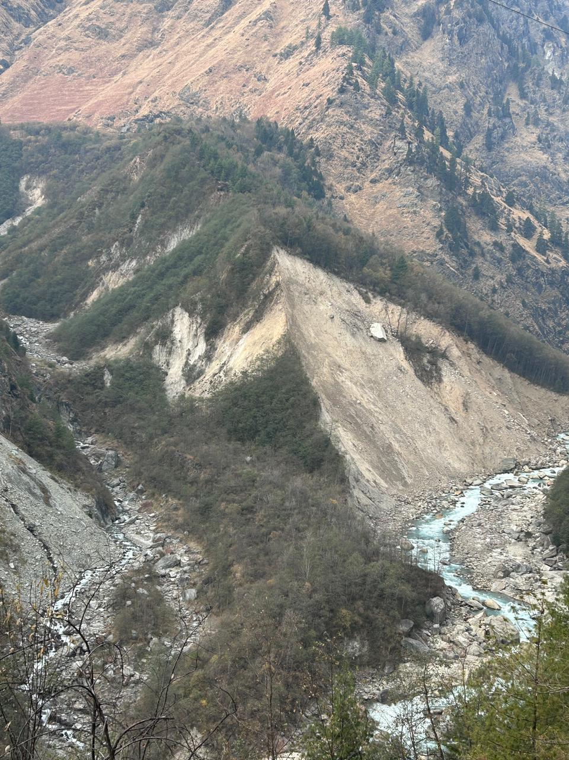

Figure:8,Urban development of the Study area
From a natural systems perspective, the study confirms that lithology and tectonic structure are foundational controls on slope instability. The prevalence of landslides in areas underlain by phyllites, schists, and highly fractured metamorphic rocks supports earlier Himalayan studies showing that foliated and weathered lithologies possess low shear strength and are especially vulnerable to failure under gravitational and hydrological loading (Gansser, 1964; Valdiya, 1980, 2015). The role of structural discontinuities—particularly joints, foliations, faults, and thrust-related shear zones—is equally significant, as these features provide pre-existing planes of weakness that facilitate both translational and rotational failures. This observation aligns closely with the process-based interpretation of slope failure advanced by Cruden and Varnes (1996) and later elaborated in geomorphic hazard frameworks by Guzzetti et al. (2005).
Topographic and hydrological conditions further intensify this inherent susceptibility. The concentration of failures along steep valley flanks and incised river corridors demonstrates the importance of slope angle, relief energy, and toe erosion in destabilizing hillslopes. In particular, active incision by the Bhagirathi River and its tributaries removes basal support, thereby increasing the probability of slope collapse. Similar relationships between river incision, oversteepening, and landslide concentration have been documented in Himalayan terrain response studies (Sundriyal et al., 2015). Moreover, the observed temporal clustering of landslides during the monsoon season highlights the critical role of rainfall as an immediate trigger. High-intensity rainfall events likely increase pore-water pressure, reduce effective stress, and mobilize weathered regolith and debris mantles, a mechanism widely recognized in Himalayan landslide studies (Martha et al., 2013; Owen et al., 2008; Sharma et al., 2018). Thus, the study supports the interpretation that natural conditions establish the baseline instability threshold, while hydro-climatic events often determine the timing of slope failure.
However, one of the most important contributions of this study is its clear demonstration that anthropogenic modifications are increasingly converting susceptibility into disaster. The findings reveal that road construction, slope cutting, deforestation, settlement growth, and hydropower development have substantially altered slope geometry and drainage pathways throughout the valley. These activities not only disturb slope equilibrium but also create artificial stress concentrations and expose weathered materials to accelerated erosion. Such findings are strongly consistent with earlier Himalayan research showing that infrastructure development often acts as a direct trigger or accelerator of slope failure, particularly where engineering practices are poorly adapted to mountain terrain (Gerrard, 1994; Martha et al., 2013; Pradhan, 2010). In this sense, the Bhagirathi Valley reflects a broader Himalayan pattern in which development is often undertaken on geologically sensitive terrain without adequate hazard appraisal.
A particularly critical insight emerging from this study is that landslides in the valley are not merely natural hazards; they are increasingly socio-environmental disasters. This distinction is important because it shifts the analytical focus from predicting where landslides may occur to understanding why vulnerability continues to increase despite known hazard conditions. The expansion of roads, hydropower infrastructure, and unplanned settlements into unstable zones suggests that risk is being systematically reproduced through land-use decisions. This interpretation is consistent with recent hazard scholarship, which argues that disaster risk in mountain regions is often embedded in governance failures, fragmented planning, and short-term development priorities (Haque et al., 2016; Sharma et al., 2018).

7. Results and discussions
The findings of the present study indicate that landslide occurrence in the Bhagirathi Valley is not governed by a single dominant factor but rather by the interaction of geological fragility, geomorphic forcing, hydro-climatic triggers, and anthropogenic disturbance. This reinforces the growing understanding that Himalayan landslides are manifestations of a coupled human–environment system, where natural instability is increasingly amplified by development interventions (Gerrard, 1994; Haque et al., 2016; Sharma et al., 2018). The Bhagirathi Valley exemplifies this interaction particularly well because it lies within an actively deforming mountain belt while simultaneously experiencing rapid infrastructure expansion and land-use transformation. In this context, the results also expose a limitation of many conventional GIS-based susceptibility studies. While spatial prediction methods are valuable for identifying landslide-prone areas, they often underrepresent the dynamic role of human disturbance and may treat causative variables as static rather than evolving (Pradhan, 2010). The present study therefore supports a more integrated, process-oriented, and sustainability-focused framework in which geological mapping, geomorphic interpretation, remote sensing, and field validation are combined with land-use and infrastructure assessment. Such an approach is especially necessary in fragile Himalayan valleys where hazard, exposure, and ecological degradation are tightly interlinked. Overall, the discussion suggests that future landslide risk in the Bhagirathi Valley will likely increase unless development is made more geologically informed and ecologically sensitive. The findings therefore justify a shift from reactive engineering responses toward preventive landscape-scale management, including hazard-informed planning, drainage-sensitive road design, vegetation restoration, and stricter geotechnical evaluation of all major slope interventions.
The findings show that anthropogenic disturbance and natural susceptibility combine to control landslide dynamics in the Bhagirathi Valley. Slope failure is accelerated by human activity, although baseline instability is established by geological and climatic processes. Effective landslide risk management requires a combined human-environment viewpoint.

8. Sustainability-Oriented Landslide Management
A sustainability-focused strategy prioritizes community involvement, hazard-informed land-use planning, and ecosystem-based mitigation. Slope stability is improved while maintaining ecological integrity by bio-engineering methods, native species afforestation, and regulated drainage.

9. Policy Implications and Management Strategies
The study emphasizes the necessity of requiring landslide hazard evaluations before building infrastructure, including GIS-based hazard maps into regional planning, encouraging environmentally friendly stabilization methods, and enhancing institutional cooperation for disaster risk reduction.

10. Conclusions
This study provides a thorough assessment of the natural and man-made elements influencing landslide processes in the Himalayan region's Bhagirathi Valley. The results show that landslides are not isolated occurrences but rather the consequence of a complex interaction between natural geological vulnerabilities, dynamic meteorological conditions like heavy rainfall, and growing human-caused disturbances like land-use changes and infrastructure expansion. These variables work together to cause slope instability and the frequency and severity of landslides. In order to accurately identify and monitor hazards, the study emphasizes the vital need for an integrated assessment strategy that integrates geoscientific analysis with cutting-edge techniques like GIS and remote sensing. It also highlights the significance of using sustainability-oriented management techniques, such as community involvement, ecosystem-based mitigation, and hazard-informed land-use planning. These steps are crucial for reducing the likelihood of landslides in the future and encouraging resilient and sustainable mountain development throughout the delicate Himalayan region.

Disclaimer (Artificial intelligence)

Author(s) hereby declare that NO generative AI technologies such as Large Language Models (ChatGPT, COPILOT, etc.) and text-to-image generators have been used during the writing or editing of this manuscript.

References

- Cruden, D. M., & Varnes, D. J. (1996). Landslide types and processes. Transportation Research Board Special Report, 247, 36–75.
- Gansser, A. (1964). Geology of the Himalayas. London, UK: Interscience Publishers.
- Gerrard, J. (1994). The landslide hazard in the Himalayas: geological control and human action. In Geomorphology and natural hazards (pp. 221-230). Elsevier.
- Guzzetti, F., Reichenbach, P., Cardinali, M., Galli, M., & Ardizzone, F. (2005). Probabilistic landslide hazard assessment at the basin scale. Geomorphology, 72(1–4), 272–299. https://doi.org/10.1016/j.geomorph.2005.06.002
- Fausto Guzzetti, Paola Reichenbach, Mauro Cardinali, Mirco Galli, Francesca Ardizzone, Probabilistic landslide hazard assessment at the basin scale, Geomorphology, Volume 72, Issues 1–4, 2005, Pages 272-299, ISSN 0169-555X,
- Haque, U., Blum, P., Da Silva, P. F., Andersen, P., Pilz, J., Chalov, S. R., ... & Keellings, D. (2016). Fatal landslides in Europe. Landslides, 13(6), 1545-1554.
- India Meteorological Department (IMD). (2019). Climatological normals (1981–2010): Uttarakhand. Government of India.
- Martha, T. R., Roy, P., Govindharaj, K. B., Kumar, K. V., Diwakar, P. G., & Dadhwal, V. K. (2015). Landslides triggered by the June 2013 extreme rainfall event in parts of Uttarakhand state, India. Landslides, 12(1), 135-146.
- Mey, J., Guntu, R. K., Plakias, A., de Almeida, I. S., & Schwanghart, W. (2024). More than one landslide per road kilometer – Surveying and modeling mass movements along the Rishikesh–Joshimath (NH-7) highway, Uttarakhand, India. Natural Hazards and Earth System Sciences, 24, 3207–3234. https://doi.org/10.5194/nhess-24-3207-2024
- Owen, L. A., Kamp, U., Khattak, G. A., Harp, E. L., Keefer, D. K., & Bauer, M. A. (2008). Landslides triggered by the 8 October 2005 Kashmir earthquake. Geomorphology, 94(1–2), 1–9. https://doi.org/10.1016/j.geomorph.2007.04.007
- Petley, D. (2012). Global patterns of loss of life from landslides. Geology, 40(10), 927–930. https://doi.org/10.1130/G33217.1
- Pradhan, B. (2010). Landslide susceptibility mapping of a catchment area using frequency ratio, fuzzy logic and multivariate logistic regression approaches. Journal of the Indian Society of Remote Sensing, 38(2), 301-320.
- Qi, T., Meng, X., & Zhao, Y. (2024). Landslide susceptibility assessment in active tectonic areas using machine learning algorithms. Remote Sensing, 16(15), 2724. https://doi.org/10.3390/rs16152724
- Sharma, S., Sati, S. P., Sundriyal, Y. P., Sharma, V., & Dobhal, H. (2021). Quest for disaster-resilient roads in the Himalaya. Current Science, 121(11), 1399-1401.
- Sonker, I., Tripathi, J. N., & Swarnim. (2024). Landslide susceptibility mapping using morphological and hydrological parameters in Sikkim Himalaya: Frequency ratio model and geospatial technologies. Natural Hazards, 120, 6797–6832. https://doi.org/10.1007/s11069-024-06491-7
- Sundriyal, Y. P., Shukla, A. D., Rana, N., Jayangondaperumal, R., Srivastava, P., Chamyal, L. S., ... & Juyal, N. (2015). Terrain response to the extreme rainfall event of June 2013: Evidence from the Alaknanda and Mandakini River Valleys, Garhwal Himalaya, India. Episodes Journal of International Geoscience, 38(3), 179-188.
- Vaka, D. S., Yaragunda, V. R., Perdikou, S., & Papanicolaou, A. (2024). InSAR integrated machine learning approach for landslide susceptibility mapping in California. Remote Sensing, 16(19), 3574. https://doi.org/10.3390/rs16193574
- Valdiya, K. S. (1980). Geology of Kumaun Lesser Himalaya. Dehradun, India: Wadia Institute of Himalayan Geology.
- Valdiya, K. S. (2015). The making of India: geodynamic evolution. Springer.
- Zhang, D., Jindal, D., Roy, N., & Vangla, P. (2024). Enhancing landslide susceptibility mapping using a positive-unlabeled machine learning approach: A case study in Chamoli, India. Geoenvironmental Disasters, 11, Article 21. https://doi.org/10.1186/s40677-024-00281-w

