Original Research Article
Rural-Urban Disparity in Child Sex Ratio of Punjab: A Spatio-Temporal Investigation

Abstract
This study examines rural-urban disparities in the child sex ratio (0-6 age group) in Punjab and analyses their spatial and regional variations over the period 1991-2011. The study is based on secondary data obtained from the Census of India for 1991, 2001, and 2011, with tehsils used as the primary unit of analysis. To ensure temporal comparability, earlier census data were harmonised with the 2011 tehsil boundaries. The rural-urban disparity in child sex ratio was measured by comparing the difference between rural and urban child sex ratios across tehsils, and the spatial pattern of these disparities was examined through choropleth mapping. The analysis reveals that rural-urban disparities in child sex ratio were present throughout the study period, although their magnitude and spatial concentration varied over time. In 1991, tehsils with relatively high rural-urban disparity were widely distributed across the state. In 2001, relatively high disparities were more evident in the foothill zone of the Himalayas. By 2011, higher disparities were concentrated in the southern and eastern fringes of Malwa, along with parts of north-eastern Doaba and Majha. The study also shows that the spatial extent of low child sex ratio expanded in both rural and urban Punjab during the study period. Overall, the findings highlight persistent gender imbalance and marked regional variation in Punjab. The paper argues that these patterns should be understood in relation to broader socio-cultural and economic contexts, while recognising that the present analysis is primarily descriptive and does not establish causal relationships.
Keywords: Rural-urban disparity, spatial and regional variations, spatially spread.
1. Introduction
The problem of an unbalanced child sex ratio is especially serious in South Asian countries. Amartya Sen (1990), in his well-known study “100 Million Missing Women,” pointed out the sharp drop in the child sex ratio due to gender discrimination. South Asia has long faced gender inequality, particularly between boys and girls. Even though women’s overall welfare has improved, the child sex ratio keeps falling, showing that deep-rooted inequality remains (Larsen and Hatti, 2008). In India, the declining child sex ratio is a major concern for demographers and scholars, as it brings serious social, economic, cultural, and demographic effects (WHO, 2011).
The Organisation for Economic Co-operation and Development (2018) notes that many Asian countries have made strong progress in education, urban growth, and economic development. Still, gender discrimination against girls is very high, especially in China and India. These countries have deep-rooted patriarchal systems, family structures, and male-dominated societies (Callen and Kee, 1981; Guilmoto and Oliveau, 2007). Because of this, women’s status has not improved much, even with overall development.
Punjab, a state in north-western India, shows this problem clearly with its low child sex ratio. The 2011 Census reported Punjab’s child sex ratio as 846, down from 901 in 1961, showing how serious the issue is. While there was some improvement from 798 in 2001 to 846 in 2011, the number is still much lower than in the past. These trends run counter to what demographic transition theory would predict. The uneven ratio is mainly due to practices like female infanticide and foeticide, often made easier by technologies such as amniocentesis and ultrasound (Mohan, et al., 2024). Population control policies and stronger patriarchal systems have also increased the preference for sons (Mies, 2014). As prosperity has grown, sex-selection technologies have become more available (Kaur, 2015). Son preference, sex-selective abortions, and other social and economic factors also cause differences in the child sex ratio across the state. Recent research further shows that India’s sex-ratio imbalance remains closely tied to fertility decline, birth order, and the uneven social uptake of sex-selection practices. Using nationally representative birth histories, Saikia et al. (2021) estimate that missing female births in India remained substantial over 1987-2016, with a large share concentrated at higher birth orders following earlier daughters. Aksan (2021) similarly argues that declining fertility can intensify son preference through a “fertility squeeze,” as families seeking smaller family size become more likely to resort to sex selection, with urban areas often leading this transition. More recent evidence also indicates that the sex composition of births in India continues to vary across regions and social groups despite legal and policy efforts, while gender-biased fertility strategies remain linked to wider inequalities in children’s outcomes (Congdon Fors & Lindskog, 2023; Mohan et al., 2024). These studies reinforce the need to examine sub-state rural-urban differences in Punjab more closely.
The widespread misuse of pre-conception and prenatal diagnostic methods has contributed to a persistent demographic disadvantage for girls in Punjab (Department of Health and Family Welfare, Government of Punjab, 2007). New reproductive technologies have made the gender gap even wider. Punjab was one of the first states to use these technologies, and ads for sex-selective abortions became common in Delhi and Punjab in the late 1970s and early 1980s (Patel, 2007). The first ultrasound clinic in the state opened in the late 1970s (Purewal, 2010), and soon many more clinics appeared, especially in cities. These practices not only violate the basic right to life for girls but also lead to an unbalanced sex ratio, creating long-term problems for sustainable development (Gupta and Li, 1999; Cai and Lavely, 2003; Banister, 2004). The ongoing patriarchal mindset and strong preference for sons keep driving the use of these technologies, so there are always fewer girls than boys in the state.
Both rural and urban areas in Punjab show a strong preference for sons. The child sex ratio varies by region and between rural and urban areas. The 2011 Census shows that about 37.48 percent of people live in cities, while 62.52 percent live in villages. Rural Punjab had 844 girls per 1,000 boys, while urban areas had a slightly higher ratio of 852 girls per 1,000 boys. These differences are shaped by social, cultural, economic, and political factors. As a result, girls remain marginalized across the state. It is important to understand the rural-urban gap in the child sex ratio in Punjab. These differences are not just numbers; they reflect deeper social, cultural, and economic forces that shape gender outcomes.
2. Review of the Literature
Arokiasamy and Goli (2012) in their paper entitled “Explaining the Skewed Child Sex Ratio in Rural India: Revisiting the Landholding-Patriarchy Hypothesis” examined the direct relevance of the landholding patriarchy hypothesis for the dynamics of sex discrimination and family building strategies mainly in rural India. The study indicated that the child sex ratio varies greatly over time when household landholdings are stratified by size. The study also attempted to correlate the historical context of the sex ratio disparities with present socio-economic, demographic and cultural factors that persists in society. The authors further argued that the ownership of land rights only to males weakens the ties of daughters to their natal families after their marriage. It creates unfavourable social, economic and political systems within the society for a female. The authors concluded that women who lived in large landholding families have less socio-economic freedom or decision-making power as compared to women who lived in marginal or landless families.
Gill (2013) in his research paper entitled “Female Foeticide in India: Looking beyond Son Preference and Dowry” examined the basal factors which are responsible for female foeticide in India. The study mainly focused on two questions i.e., (i) Is son preference the major factor of female foeticide in India? and, (ii) is dowry also responsible for female foeticide in India? He observed that the patriarchal system is the key feature that strengthened son preference in the society for social power and socio-economic security. Each family hopes to achieve these powers through a male child. The author further pointed out that in a patriarchal system, the marriage migration of women further contributes to male power within ‘sending family’ as well as ‘receiving family’. He identified that in case of India, son preference appears at a pathological level, a big response for the birth of the son as compared to the birth of the daughter. On the other hand, the rapid rise in the demand of dowry also changed the people’s attitudes and their mindset regarding females. The author further observed that in India ‘honour and shame’ issues are the most important factors responsible for the son preference in socio-religious bedrock. If all children in the family are sons, then there is no risk of losing honour but if all are girls, the situation is reversed, and it naturally leads to daughter aversion. So, exogamy, hypergamy and dowry are the three major compulsions which contribute to disvalue of girl child in the family.
Mukherjee (2013) in his research paper “Women’s Empowerment and Gender Bias in the Birth and Survival of Girls in Urban India” investigated the survival of girls in urban India in times of urbanisation and rapid economic growth by using data from 1991 and 2001 Census of India. He discussed that when the level of women’s education increases, discrimination against girls also increases through prenatal sex selection especially, in the urban areas. The author observed that the gender bias is more pronounced in urban areas particularly in northern, north-western and western parts of the country. He pointed out that the areas with greater opportunities for men’s employment are disadvantageous to women. The author concluded that the well-off families have little preference for daughters even though they can educate, afford dowry and provide all basic amenities.
Kaur (2015) in her research paper “Sex Ratio of Scheduled Caste Population in Punjab: 2011” has examined the sex ratio imbalance within the scheduled caste population of Punjab which has been historically influenced by feudal society. She identified the root causes of sex ratio differentials based on her personal observations. She further addressed the two basic research questions i.e., (i) Does caste play any role in the determination of the state’s sex ratio? and, (ii) why the sex ratio of the scheduled caste population spatially varies? The author further identified that the literacy rate or education is negatively correlated with the sex ratio. She pointed out that the scheduled caste population of Punjab have changed their mindset easily about their daughters because they do not have landed property and are far from the notion of patriarchy. On the other hand, it has also been observed that people with the landed property change their mind about their daughters because their sons migrated to other countries. They faced old age insecurity and at the end, the duty is performed by a daughter of the family. The author observed that the low literacy rate or education levels are the factors responsible for the low sex ratio in the scheduled caste population. On the other hand, their less exposure, weak economic condition, and fear of God are the other factors responsible for the relatively high sex ratio among the illiterate scheduled castes. She further pointed out that the male domination in society and their old mindsets are the basic reasons for the desire of at least one son, especially in those areas where the population is dense and has limited resources. As a result, the people are under pressure to limit their family size norms.
3. Objectives
- To examine the scenario of the child sex ratio of the last few decades in both rural and urban areas of Punjab.
- To analyse the spatial as well as regional variations in the child sex ratio across rural and urban Punjab and to access the spatial spread of child sex ratio in both the areas.
- To identify the underlying socio-economic, cultural, and demographic factors responsible for rural-urban disparity in child sex ratio.
4. Materials and Methods
The present study is primarily based on secondary data collected from the Census of India (1991, 2001, and 2011). These datasets have been used to examine rural-urban disparities in the child sex ratio (0–6 age group) across Punjab over a two-decade period. The selection of these census years ensures temporal comparability and facilitates the analysis of long-term demographic trends. Tehsil-level data serve as the basic spatial unit of analysis, providing a more detailed, micro-level understanding of spatial variation than broader administrative levels such as districts or states. To analyse spatial patterns and the diffusion of low child sex ratio, choropleth maps have been prepared for each census year.
Because administrative boundaries of tehsils have changed over time, comparability across census years was ensured by standardizing and adjusting the 1991 and 2001 data according to the 2011 tehsil boundaries. This harmonization process involved re-aligning earlier data to match the most recent administrative units, thereby ensuring consistency in spatial analysis.
The child sex ratio (CSR) is defined as the number of female children (0–6 years) per 1,000 male children in the same age group. To assess rural-urban disparities, the difference between rural and urban CSR was computed for each tehsil.
A key limitation of this study is the unavailability of data from the 2021 census, which was not conducted due to circumstances related to COVID-19. Additionally, the analysis is restricted to three census years, as tehsil-wise 0–6 age group data have been available only since the 1991 census.
5. Results and Discussion
5.1. Rural-Urban Disparity in Child Sex Ratio: 1991-2011
India as a whole recorded 13 points of disparity in the rural-urban child sex ratio in 1991. A decade later, in 2001, the rural-urban disparity in India’s child sex ratio increased to 31 points. But in 2011, the rural-urban disparity in India’s child sex ratio dropped to 18 points. On the other hand, in the case of Punjab, the rural-urban disparity in the child sex ratio was 12 points in 1991, 3 points in 2001, and 8 points in 2011, which was always lower than the national average during this period.
It is worthwhile to mention here that there was no rural-urban disparity in the child sex ratio recorded in Gurdaspur and Batala tehsils in 1991. However, in 2001, not a single tehsil reported rural-urban disparity in this regard during this period. In 2011, there was no rural-urban disparity in the child sex ratio recorded in two tehsils of the state, namely, Amloh and Patran (Table 1).
On the basis of rural-urban disparity in child sex ratio during the study period, the state can be classified into the following three categories:
- Areas with relatively high rural-urban disparity in child sex ratio (above 20 points);
- Areas with moderate rural-urban disparity in child sex ratio (between 10-20 points);
- Areas with relatively low rural-urban disparity in child sex ratio (below 10 points).
I. Areas with relatively high rural-urban disparity in child sex ratio (above 20 points):
In 1991, out of all the seventy-seven tehsils of Punjab, forty-two tehsils reported relatively high rural-urban disparity in child sex ratio. The highest disparity (181 points) in this regard was observed in Dhar Kalan tehsil, followed by Jalalabad (109 points), Lehra (84 points), Khamanon (75 points), and Mukerian (71 points). About fifty-eight percent of the tehsils of Majha, fifty-four percent of Malwa, and fifty-three percent of Doaba belonged to this category. Tehsils that recorded relatively high rural-urban disparity in child sex ratio were found scattered across the study area (Map 1).
In 2001, about sixty-two percent of the state's tehsils emerged with relatively high rural-urban disparity in the child sex ratio. Baba Bakala tehsil reported the highest rural-urban disparity (95 points) in this regard, followed by Dhar Kalan (93 points), Dera Bassi (73 points), Ludhiana West (72 points), and Nihal Singhwala (67 points). About seventy-five percent of the tehsils of Majha, sixty percent of Doaba, and sixty percent of Malwa recorded relatively high rural-urban disparity in child sex ratio. It is worth noting that almost all areas in the foothill zone of the Himalayas exhibits relatively high rural-urban disparities in child sex ratio (Map 2).
In 2011, about forty-seven percent of the tehsils of the state recorded relatively high rural-urban disparity in child sex ratio (Table 1). Out of these, Nihal Singhwala recorded a high rural-urban disparity (120 points), followed by Malerkotla (84 points), Khamanon (67 points), Anandpur Sahib (65 points), Khanna (51 points), Dasua (51 points), Fazilka (49 points), Rupnagar (45 points), Gidderbaha (44 points), and Fatehgarh Sahib (43 points). About fifty-three percent of the tehsils of Doaba, forty-eight percent of Malwa, and thirty-three percent of Majha lie in this category. In this way, the southern and eastern fringes of Malwa, parts of north-eastern Doaba, and Majha fall in this category (Map 3).

Table 1
Rural-Urban Disparity in Child Sex Ratio of Punjab: 1991-2011
Sr. | District/State | Tehsils | 1991 | 2001 | 2011
1 | Amritsar | (i) Ajnala | 57 | 8 | 8
 |  | (ii) Amritsar -I | 51 | 12 | 10
 |  | (iii) Amritsar- II | 14 | 21 | 1
 |  | (iv) Baba Bakala | 28 | 95 | 28
2 | Barnala | (i) Barnala | 21 | 5 | 10
 |  | (ii) Tapa | 14 | 40 | 6
3 | Bathinda | (i) Rampura Phul | 13 | 16 | 19
 |  | (ii) Bathinda | 23 | 46 | 2
 |  | (iii) Talwandi Sabo | 26 | 8 | 28
4 | Faridkot | (i) Faridkot | 8 | 23 | 11
 |  | (ii) Jaitu | 7 | 39 | 6
5 | Fatehgarh Sahib | (i) Bassi Pathana | 10 | 15 | 18
 |  | (ii) Fatehgarh Sahib | 22 | 46 | 43
 |  | (iii) Amloh | 14 | 37 | 0
 |  | (iv) Khamanon | 75 | 36 | 67
6 | Firozpur | (i) Zira | 13 | 10 | 4
 |  | (ii) Firozpur | 26 | 3 | 9
 |  | (iii) Jalalabad | 109 | 49 | 15
 |  | (iv) Fazilka | 22 | 6 | 49
 |  | (v) Abohar | 16 | 7 | 16
7 | Gurdaspur | (i) Dhar Kalan | 181 | 93 | 25
 |  | (ii) Pathankot | 29 | 51 | 18
 |  | (iii) Gurdaspur | 0 | 25 | 13
 |  | (iv) Batala | 0 | 26 | 32
 |  | (v) Dera Baba Nanak | 24 | 31 | 29
8 | Hoshiarpur | (i) Dasua | 34 | 36 | 51
 |  | (ii) Mukerian | 71 | 34 | 35
 |  | (iii) Hoshiarpur | 10 | 28 | 15
 |  | (iv) Garhshankar | 28 | 46 | 28
9 | Jalandhar | (i) Shahkot | 26 | 41 | 31
 |  | (ii) Nakodar | 25 | 9 | 19
 |  | (iii) Phillaur | 3 | 27 | 13
 |  | (iv) Jalandhar - I | 21 | 28 | 28
 |  | (v) Jalandhar - II | 11 | 9 | 42
10 | Kapurthala | (i) Bhulath | 15 | 33 | 19
 |  | (ii) Kapurthala | 21 | 2 | 42
 |  | (iii) Sultanpur Lodhi | 20 | 2 | 17
 |  | (iv) Phagwara | 12 | 24 | 6
11 | Ludhiana | (i) Samrala | 26 | 30 | 5
 |  | (ii) Khanna | 7 | 38 | 51
 |  | (iii) Payal | 31 | 16 | 23
 |  | (iv) Ludhiana (East) | 24 | 10 | 14
 |  | (v) Ludhiana (West) | 7 | 72 | 32
 |  | (vi) Raikot | 15 | 27 | 32
 |  | (vii) Jagraon | 19 | 2 | 22
12 | Mansa | (i) Sardulgarh | 50 | 59 | 14
 |  | (ii) Budhlada | 55 | 8 | 29
 |  | (iii) Mansa | 50 | 18 | 24
13 | Moga | (i) Nihal Singhwala | 47 | 67 | 120
 |  | (ii) Bagha Purana | 60 | 30 | 14
 |  | (iii) Moga | 11 | 21 | 8
14 | Patiala | (i) Samana | 30 | 40 | 38
 |  | (ii) Patran | 37 | 30 | 0
 |  | (iii) Nabha | 8 | 53 | 17
 |  | (iv) Patiala | 9 | 6 | 34
 |  | (v) Rajpura | 23 | 52 | 11
15 | Rupnagar | (i) Anandpur Sahib | 59 | 18 | 65
 |  | (ii) Nangal | 25 | 43 | 17
 |  | (iii) Rupnagar | 5 | 45 | 45
 |  | (iv) Chamkaur Sahib | 5 | 54 | 7
16 | S.A.S Nagar | (i) Kharar | 3 | 26 | 34
 |  | (ii) S.A.S Nagar (Mohali) | 26 | 5 | 36
 |  | (iii) Dera Bassi | 55 | 73 | 39
17 | Sangrur | (i) Malerkotla | 8 | 49 | 84
 |  | (ii) Dhuri | 1 | 56 | 1
 |  | (iii) Sangrur | 42 | 25 | 18
 |  | (iv) Sunam | 15 | 16 | 22
 |  | (v) Lehra | 84 | 21 | 12
 |  | (vi) Moonak | 14 | 12 | 22
18 | S.B.S Nagar | (i) Nawanshahr | 15 | 4 | 16
 |  | (ii) Balachaur | 37 | 15 | 38
19 | Muktsar | (i) Malout | 40 | 5 | 26
 |  | (ii) Gidderbaha | 2 | 9 | 44
 |  | (iii) Muktsar | 24 | 33 | 5
20 | Tarn Taran | (i) Patti | 34 | 22 | 14
 |  | (ii) Tarn Taran | 8 | 30 | 20
 |  | (iii) Khadur Sahib | A.R* | A.R* | A.R*
PUNJAB |  |  | 12 | 3 | 8
INDIA |  |  | 13 | 31 | 18
Source: District Census Handbooks of Punjab, 1991, 2001 and 2011.
A.R* stands for All Rural.

Map 1
Source: District Census Handbooks of Punjab, 1991.

Map 2
Source: District Census Handbooks of Punjab, 2001.

Map 3
Source: District Census Handbooks of Punjab, 2011.

Mainly, socio-cultural and economic factors are responsible for widening this rural-urban gap in the child sex ratio. Relatively low educational levels among rural females are one of the leading factors behind this disparity. Due to their low levels of education, females in rural areas have relatively low awareness about their rights. In some settings, daughters may continue to be viewed less favourably than sons because of entrenched socio-cultural norms and economic considerations. Generally, they follow the patriarchal norms, which are male dominated due to their limited exposure to education. Consequently, due to prevailing patriarchal norms, the disparity in the rural-urban child sex ratio has increased. Another interesting finding is that a relatively high rural-urban disparity was observed in most areas located far from their district headquarters. The restrictions on rural females’ mobility from their homes are also responsible for lower awareness of their rights. Whereas relatively high levels of awareness among the urban females awaken them to their rights. Consequently, it contributes to this disparity index.
It has also been observed that sex-selective abortions are practiced in rural areas. Over time, several sex determination centres were established, even in the state's rural areas. In this context, a joint team of the Haryana Health Department and Speed Network, Chandigarh, nabbed a gang that has been involved in conducting illegal gender determination tests by installing ultrasound centres at unknown rural localities in Sangrur, Ludhiana, Patiala, and Mansa districts of the Malwa belt (The Tribune, September 23, 2020). Thus, the rapid mushrooming of sex determination centres and their easy availability even in rural areas is also responsible for high rural-urban disparity.
Some studies have reported that, in certain rural settings, harmful practices contributing to excess female child mortality persisted in covert forms at the local level (Aravamudan, 2007). These local methods, which are performed by dais (midwives) to neglect the girl child in remote areas, ultimately contribute to this disparity index.
On the other hand, urban areas have a high concentration of private hospitals, diagnostic centres, and ultrasound clinics. This easy availability of medical technology makes it more convenient to determine the sex of the foetus, despite legal restrictions. As a result, sex-selective abortions tend to be more prevalent in cities compared to rural areas. Moreover, urban households generally have higher incomes and purchasing power. This enables families to afford expensive diagnostic tests and procedures related to sex selection. Economic prosperity, rather than eliminating gender bias, sometimes facilitates its perpetuation through technology. It ultimately leads to rural-urban disparity in the child sex ratio.
Besides, urban families of the study area tend to prefer fewer children due to higher living costs, career priorities, and changing lifestyles. When family size is limited (often one or two children), the pressure to have at least one son increases. This leads to deliberate planning and, in some cases, sex-selective practices to ensure a male child. Additionally, urban populations are generally more aware of reproductive health and medical options. However, this awareness does not always translate into gender equality. Instead, knowledge is sometimes misused to make informed but biased reproductive choices. Consequently, skewed sex ratios have been found in urban settings. Recent evidence from India supports this interpretation, while also showing that sex-ratio imbalance is highly birth-order-specific and socially differentiated. National analyses have found that missing female births remain concentrated among second- and third-order births after earlier daughters, with Punjab among the states showing persistently skewed patterns. More recent work also shows that repeated sex-selective abortion is heterogeneous across socio-demographic groups, that gender-biased fertility strategies continue to shape later inequalities in education and household investments, and that distorted sex ratios can feed back into fertility preferences and gender norms over time (Saikia et al., 2021; Dimri et al., 2024; Congdon Fors & Lindskog, 2023; Clément et al., 2025).
It has been observed that areas with higher female work participation rates tend to exhibit relatively higher child sex ratios in Punjab (Singh, 2025). Female work participation is generally greater in urban areas compared to rural areas. Increased participation of women in economic activities enhances their socio-economic status within both the household and society. Higher levels of female employment, particularly in urban areas, may contribute to greater valuation of daughters and a reduction in son preference. In contrast, rural areas often experience lower female work participation, which may reinforce traditional gender biases. It ultimately leads to rural-urban differences in child sex ratio.
II. Areas with moderate rural-urban disparity in child sex ratio (between 10-20 points):
About twenty-three percent of the tehsils had shown moderate rural-urban disparity in child sex ratio in 1991. Out of these, about forty-eight percent of the tehsils were from Malwa and twenty-six percent from Doaba. Surprisingly, only one tehsil of Majha belonged to this category (Table 1). Sultanpur Lodhi tehsil was at the top in this regard.
In 2001, after one decade, only 11 tehsils recorded moderate rural-urban disparity in child sex ratio. Among these, Mansa and Anandpur Sahib were at the highest position in this respect with 18 points each. About eighteen percent of the tehsils of Malwa reported moderate rural-urban disparity in child sex ratio. Only one tehsil each from Majha and Doaba had reported in this regard.
In 2011, almost one-third of the state's tehsils reported moderate rural-urban disparity. The top position in this regard was occupied by Tarn Taran tehsil with 20 points, followed by Nakodar, Bhulath, Rampura Phul, Bassi Pathana, Pathankot, Nangal, Nabha and Sultanpur Lodhi. About forty-two percent of the tehsils of Majha, forty percent of Doaba and twenty-eight percent of Malwa emerged with moderate rural-urban disparity in child sex ratio (Table 1).
III. Areas with relatively low rural-urban disparity in child sex ratio (below 10 points):
Among the state's total tehsils, sixteen showed relatively low rural-urban disparity in the child sex ratio in 1991. Dhuri tehsil recorded the lowest rural-urban disparity in the state, closely followed by Gidderbaha, Kharar and Phillaur. About twenty-five percent of the tehsils in Majha and twenty-four percent in Malwa registered relatively low rural-urban disparity in child sex ratio. Only one tehsil of Doaba was found in the same category (Map 1).
During 1991-2001, seventeen tehsils in the study area reported relatively low rural-urban disparity in child sex ratio. About thirty-three percent of Doaba and twenty-two percent of Malwa showed relatively low rural-urban disparity in child sex ratio during this decade. On the other hand, only one tehsil in Majha falls into this category. In 2001, the lowest rural-urban disparity in the child sex ratio was observed in the Kapurthala, Sultanpur Lodhi, and Jagraon tehsils (Table 1).
In 2011, after 20 years, about nineteen percent of the state's tehsils had relatively low rural-urban disparity in the child sex ratio. Among these, Amritsar-II and Dhuri tehsils recorded the lowest rural-urban disparity in child sex ratio in the state, followed by Bathinda, Zira, Samrala, Muktsar, Jaitu and Phagwara. In this category, twenty-four percent of the tehsils of Malwa showed relatively low rural-urban disparity in this regard. However, only two tehsils in Majha and one in Doaba reported relatively low rural-urban disparity in the child sex ratio (Table 1).
The data reveals some interesting findings that the maximum number of tehsils in the state, which recorded relatively high rural-urban disparity (above 20 points) also recorded relatively low child sex ratio in the rural areas. It has also been observed that the large number of tehsils with relatively low rural-urban disparity (below 10 points) also recorded a low child sex ratio in both the rural and urban areas. It is notable that Majha and Malwa had always recorded low rural-urban disparity in child sex ratio as compared to Doaba, except in 2001 (Map 1, 2 and 3).
5.2. Spatial Spread of Relatively Low Child Sex Ratio (Below 850) in Rural and Urban Punjab
The data indicates that relatively low child sex ratio spread spatially at fast pace from 1991 to 2011 in rural and urban areas of Punjab. The process of spread also helps to understand the dispersal of cultural traits and technology from one area to another. It also affected the child sex ratio of different parts of the state.
In case of rural Punjab, only one tehsil namely, Bhulath registered relatively low child sex ratio in 1991. In spite of official claims regarding improvement in female status in the state the situation has become more worse. The proportion of girl child had sharply declined. In 2001, all the tehsils of rural Punjab except one tehsil found relatively low child sex ratio (Map 4 (b)). But a decade later in 2011, the situation of child sex ratio among the rural areas had improved somewhat. Forty-four tehsils of the study area reported relatively low rural child sex ratio in 2011. Majha emerged as the most unfortunate region wherein all the tehsils were in the lowest child sex ratio category (Map 4 (c)). On the other hand, about fifty-eight percent tehsils of Malwa and twenty percent of Doaba registered improvement in this regard. Moreover, almost all the areas along the international border with Pakistan and inter-state border with Haryana had shown relatively low rural child sex ratio. Because the state of Haryana was already on bottom rank in terms of child sex ratio as per the census 2011. These adjoining areas may reflect broader regional clustering of low child sex ratio across the inter-state border. As a result, the inter-state border areas of Punjab were severely affected by lowest child sex ratio which further affected the core areas of the state. Moreover, the northern, north-western, southern and south-eastern areas of the state also experienced relatively high spread of low rural child sex ratio (Map 4).
In urban Punjab, twenty-two tehsils recorded relatively low child sex ratio in 1991. The highest spread of relatively low urban child sex ratio was reported in Majha followed by Malwa and Doaba (Map 5 (a)). A decade later in 2001, relatively low child sex ratio among the urban areas had been witnessed in ninety-one percent tehsils of the state. Major role in this regard was played by Malwa followed by Doaba and Majha (Map 5 (b)). After twenty years in 2011, fifty-two percent tehsils of the study area had come under relatively low urban child sex ratio category. During these two decades, relatively low urban child sex ratio had spatially spread from north to south and west to east of the state (Map 5). About eighty-three percent tehsils of Majha, more than fifty percent tehsils of Malwa and one-third tehsils of Doaba emerged with relatively low urban child sex ratio even after two decades.

Map 4
Spatial Spread of Relatively Low Child Sex Ratio in Rural Punjab: 1991-2011
(Data by Tehsils)
a) 1991  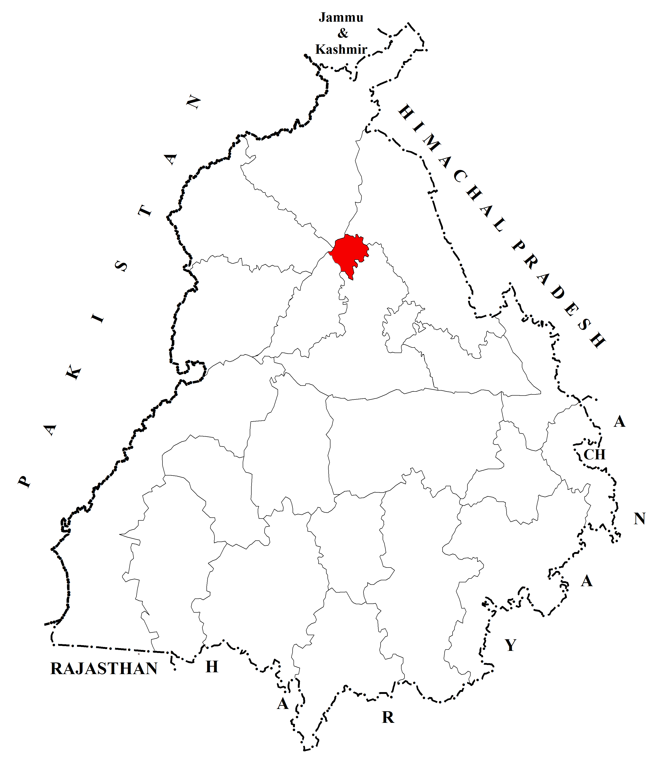 | b) 2001  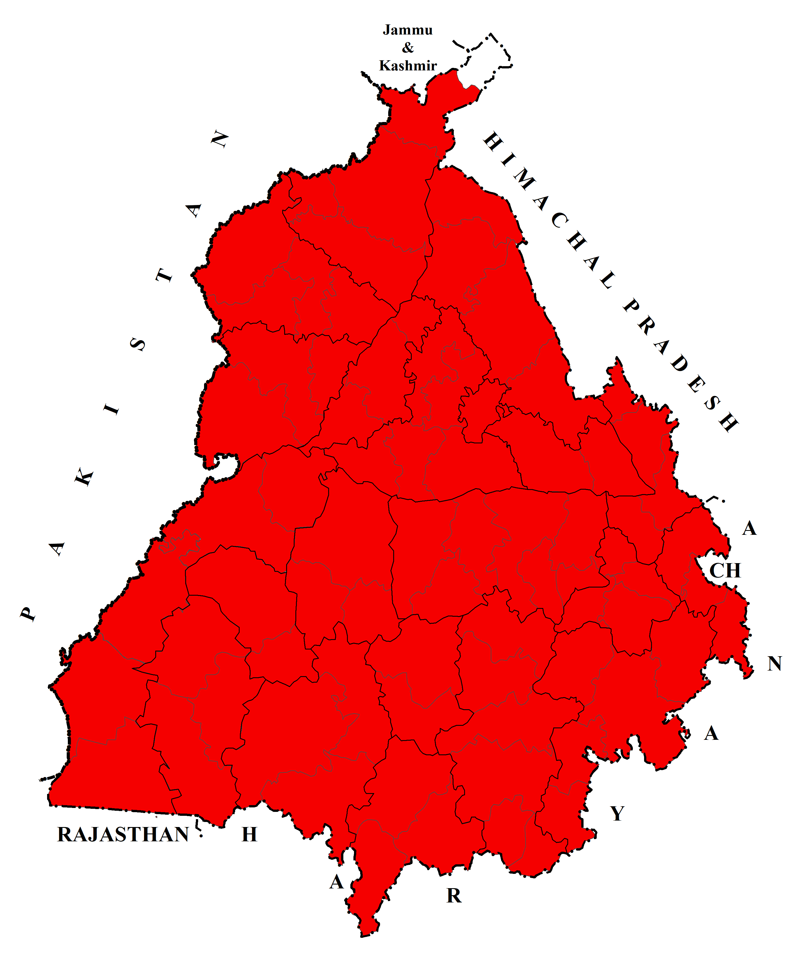
c) 2011  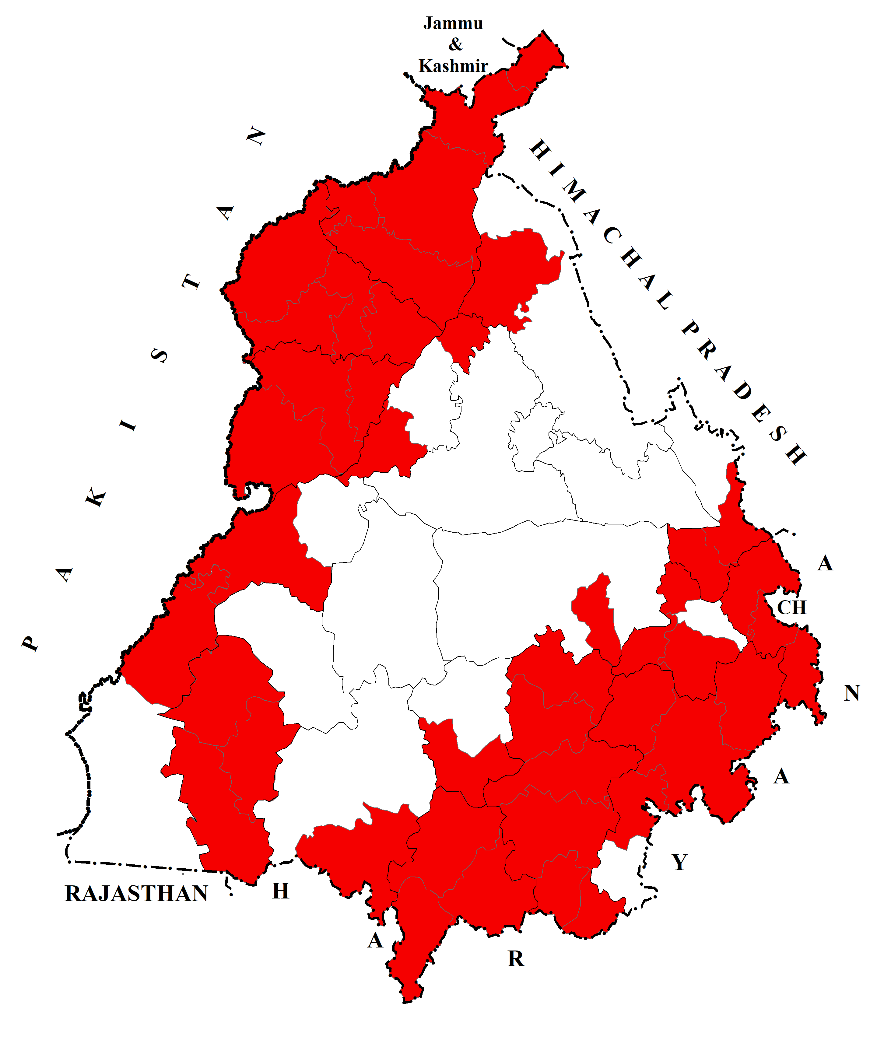 | 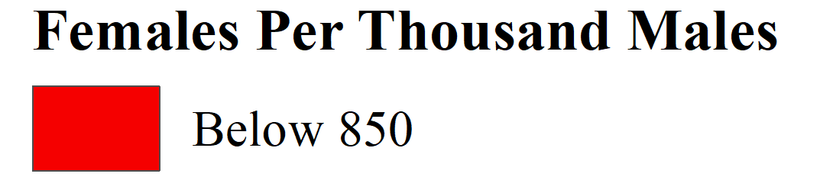  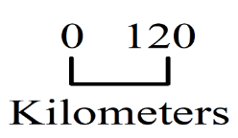
Source: District Census Handbooks of Punjab, 1991, 2001 and 2011.

Map 5
Spatial Spread of Relatively Low Child Sex Ratio in Urban Punjab: 1991-2011
(Data by Tehsils)
a) 1991  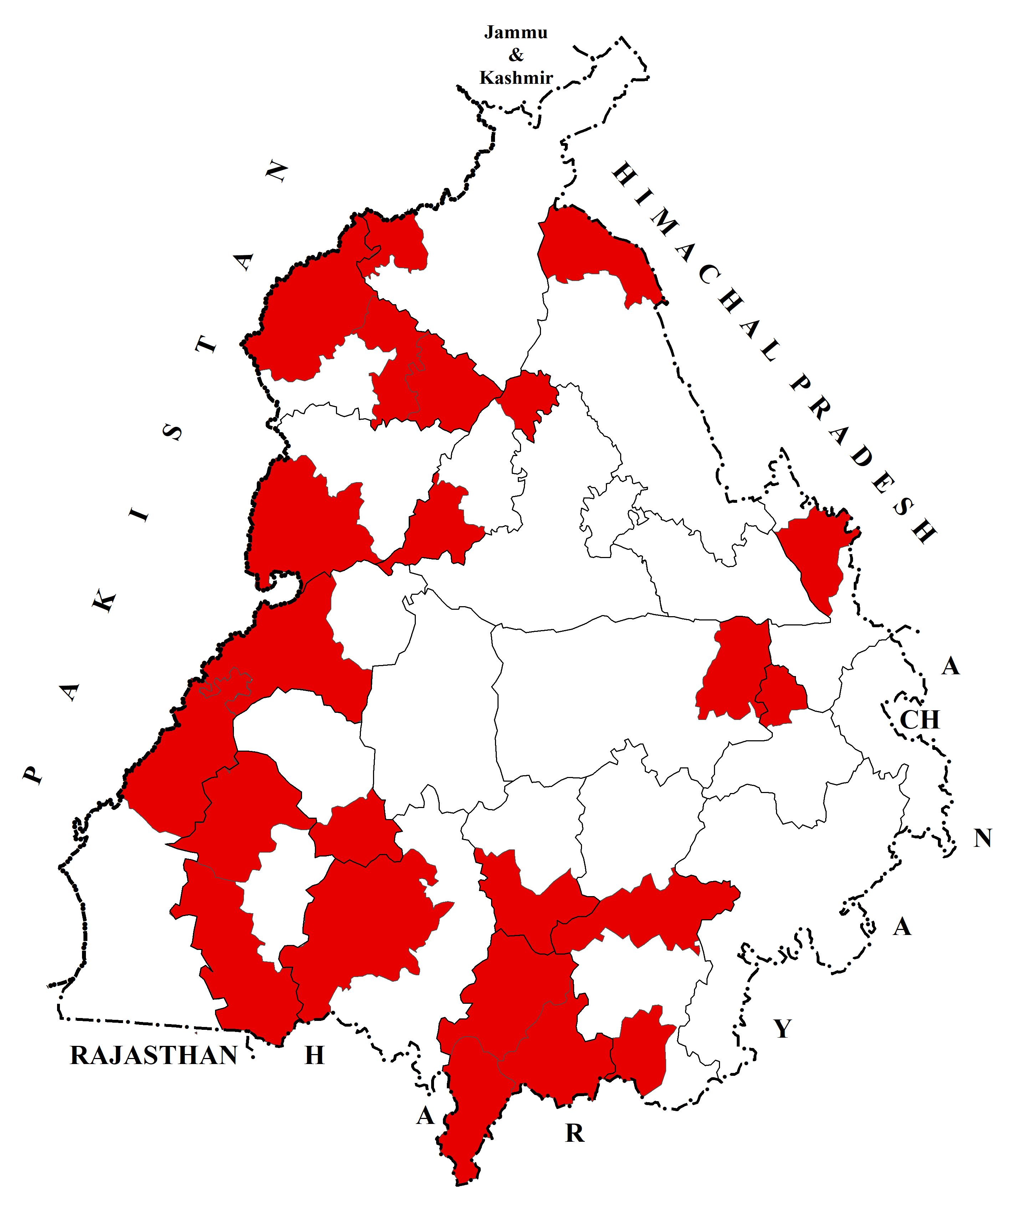 | b) 2001  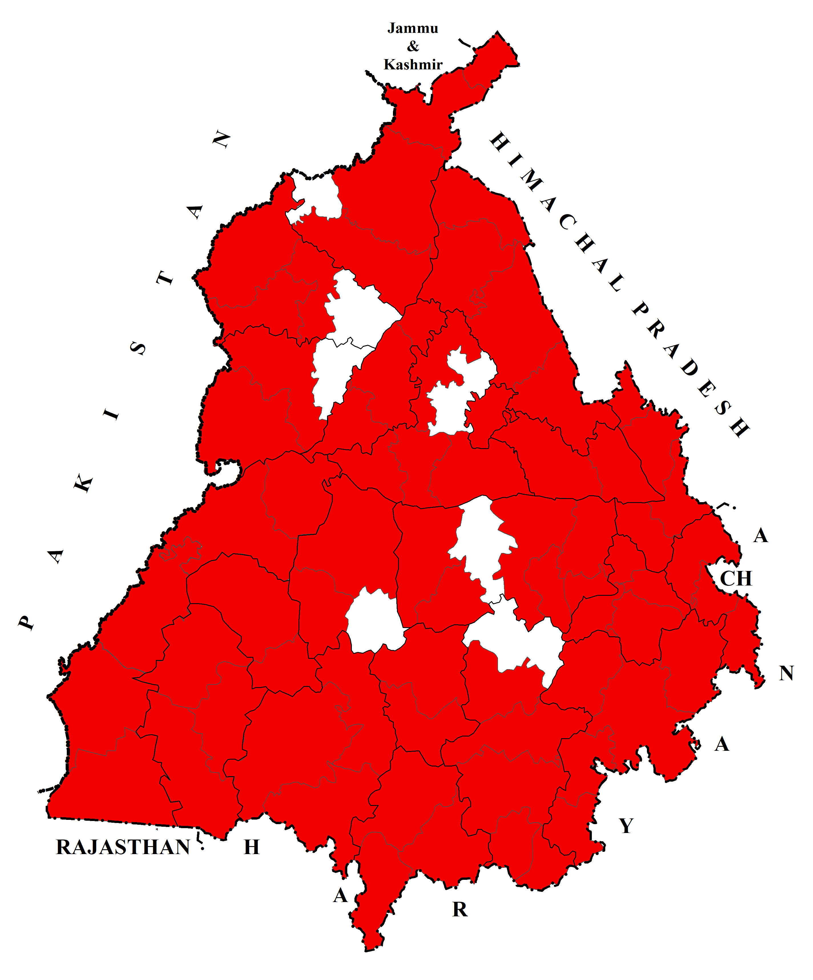
c) 2011
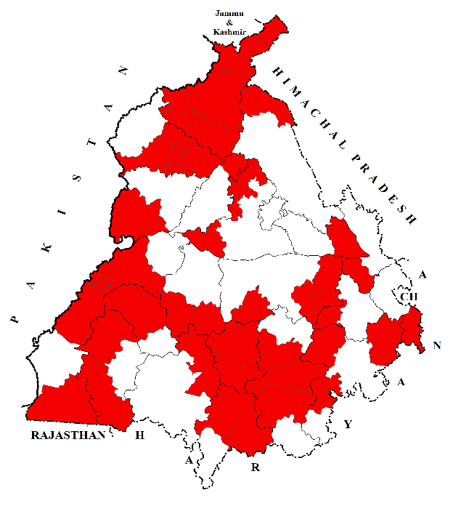
Source: District Census Handbook of Punjab, 1991, 2001 and 2011.

All those tehsils recorded relatively low child sex ratio, where there was low urban child sex ratio in 1991. This suggests that patterns of low child sex ratio became increasingly visible in rural areas over time, alongside their continued presence in urban areas. The study points to an expansion in the spatial extent of relatively low child sex ratio across the state over the study period. It has been observed that malpractice of female foeticide was responsible for the deterioration of urban as well as rural child sex ratio. The persistence of patriarchal norms, together with access to sex-selection techniques, may have contributed to the continued deterioration of child sex ratio in both rural and urban areas.
6. Conclusion
This study examined rural-urban disparities in the child sex ratio in Punjab at the tehsil level using Census data from 1991, 2001, and 2011. The analysis demonstrates that the child sex ratio in Punjab showed clear spatial and regional variation over time, with notable differences between rural and urban areas. In 1991, tehsils with high rural-urban disparity were widely scattered across the state. In 2001, relatively high disparities were concentrated particularly in the foothill zone of the Himalayas, while in 2011 such disparities were more evident in the southern and eastern parts of Malwa, as well as in parts of north-eastern Doaba and Majha. The study also shows an expansion in the spatial extent of low child sex ratio in both rural and urban Punjab during the study period. However, this pattern should be interpreted as a spatial-temporal trend rather than as conclusive evidence of diffusion from urban to rural areas. Since the analysis is based on descriptive mapping and census tabulation, the socio-economic and cultural factors discussed in the paper should be treated as plausible explanatory contexts rather than empirically verified determinants. Overall, the findings highlight the persistence of gender imbalance in Punjab and underline the need for more detailed future research using explanatory and spatial-statistical methods.
7. Limitations and Future Research
This study has certain limitations that should be acknowledged. First, the analysis is based entirely on secondary Census data for 1991, 2001, and 2011, as tehsil-level child sex ratio data were not available before 1991 and the 2021 Census was not conducted. Second, the study is primarily descriptive and relies on tabulation and choropleth mapping; therefore, the patterns observed should not be interpreted as definitive evidence of causal relationships or spatial diffusion processes. Third, although the paper discusses socio-economic, cultural, and demographic influences, these factors were not tested through independent statistical modelling at the tehsil level. Changes in tehsil boundaries over time may also affect comparability, despite efforts at harmonisation. Future research should incorporate post-2011 data when available, use spatial-statistical and multivariate techniques, and examine the role of education, female work participation, migration, health infrastructure, and social norms through more rigorous explanatory frameworks.

Competing Interests
Authors have declared that no competing interests exist.

Disclaimer (Artificial intelligence)

Author(s) hereby declare that NO generative AI technologies such as Large Language Models (ChatGPT, COPILOT, etc.) and text-to-image generators have been used during the writing or editing of this manuscript.
References
Aksan, A.-M. (2021). Son preference and the fertility squeeze in India. Journal of Demographic Economics, 87(1), 67-106. https://doi.org/10.1017/dem.2020.5.
Aravamudan, G. (2007). Disappearing Daughters. Gurgaon, Penguin Books.
Arokiasamy, P., & Goli, S. (2012). Explaining the Skewed Child Sex Ratio in Rural India: Revisiting the Landholding-Patriarchy Hypothesis. Economic and Political Weekly, XLVII(42), 85-94.
Banister, J. (2004). Shortage of Girls in China Today. Journal of Population Research, 21(1), 19-45.
Cai, Y., & Lavely, W. (2003). China’s missing girls: Numerical estimates and effects on population growth. The China Review, 2(3), 13-29.
Callen, V. J., & Kee, P. G. (1981). Sons and Daughters? Cross-Cultural Comparisons of the Sex Preference of Australia, Greek, Italian, Malay, Chinese and Indian Parents in Australia and Malaysia. Population and Environment, 4(2), 97-108.
Clément, M., Levasseur, P., & Seetahul, S. (2025). Sex ratio and fertility preferences in India: A longitudinal analysis. World Development, 192, 107046. https://doi.org/10.1016/j.worlddev.2025.107046.
Congdon Fors, H., & Lindskog, A. (2023). Son preference and education inequalities in India: The role of gender-biased fertility strategies and preferential treatment of boys. Journal of Population Economics, 36, 1431-1460. https://doi.org/10.1007/s00148-023-00941-5.
Department of Health and Family Welfare, Government of Punjab. (2007). Combating Female Foeticide: A Perspective Plan. Chandigarh, Institute for Development and Communication.
Dimri, A., Gille, V., & Ketz, P. (2024). Measuring sex-selective abortion: How many women abort? Journal of Development Economics, 171, 103342. https://doi.org/10.1016/j.jdeveco.2024.103342.
Gill, M. S. (2013). Female Foeticide in India: Looking beyond Son Preference and Dowry. The Mankind Quarterly, 53(3&4), 281-305.
Guilmoto, C. Z., & Oliveau, S. (2007). Sex Ratio Imbalances Among Childern At Micro-Level: China and India Compared. New York, Population Association of America 2007 Annual Meeting Proceedings, 1-18.
Gupta, M. D., & Li, S. (1999). Gender bias in China, South Korea and India 1920-1990: The effects of war, famine, and fertility decline. Development and Change, 30(3), 619-652.
Kaur, B. (2015). Sex Ratio of Scheduled Caste population in Punjab: 2011. Population Geography, 37(1&2), 73-86.
Larson, M., & Hatti, N. (2008). Intergenerational Interests, Uncertainty and Discrimination - I: Conceptualising the Process of Declining Child Sex Ratios in India. Sociological Bullentin, 57(1), 82-96.
Mies, M. (2014). Patriarchy and Accumulation on the world scale: Women in the International division of Labour. London, Zed Books.
Mohan, D., et al. (2024). Changes in sex composition of births across regions and subgroups in India from an analysis of birth histories from National Family Health Surveys. Scientific Reports, 14, 30817. https://doi.org/10.1038/s41598-024-81137-z.
Mukherjee, S. S. (2013). Women's Empowerment and Gender Bias in the Birth and Survival of Girls in Urban India. Feminist Economics, 19(1), 1-28.
Organisation for Economic Co-operation and Development (OECD). (2018). Economic Policy Reforms Interim Report, Paris, OECD Publishing.
Patel, T. (ed.). (2007). Sex-Selective Abortion in India: Gender, Society and New Reproductive Technologies. New Delhi, Sage Publications.
Purewal, N. K. (2010). Son Preference: Sex Selection, Gender and Culture in South Asia. New York, Berg Publication.
Saikia, N., et al. (2021). Trends in missing females at birth in India from 1981 to 2016: Analyses of 2.1 million birth histories in nationally representative surveys. The Lancet Global Health, 9(6), e813-e821. https://doi.org/10.1016/S2214-109X(21)00094-2.
Singh, Harpreet. (2025). Spatial and Regional Variations in Impacts of Female Work Participation Rate on Child Sex Ratio of Punjab. International Journal of Research Publication and Reviews, 6(8), 2026-2031.
World Health Organisation. (2011). Preventing Gender-Biased Sex Selection. Geneva, Switzerland, W.H.O. Retrieved on 21, 01, 2020, from https://apps.who.int/iris/bitstream/handle/10665/44577/9789241501460_eng.pdf;jsessionid=7130A85B7C475D75FB370420C2B1204F?sequence=1.

