Climate Variability and Socioeconomic Vulnerability in Informal Settlement: A comparative Analysis of Korogocho and Kahawa Soweto, Nairobi
Abstract
Climate variability increasingly threatens informal settlements globally, where poverty, inadequate infrastructure, and environmental exposure intersect. This study examines trends and impacts of climate variability on Korogocho and Kahawa soweto informal settlements in Nairobi, Kenya, from 1995 to 2025. Using a mixed-methods approach that combines secondary climate data, household surveys, and vulnerability indicators, the study analyzed temperature trends, rainfall variability, flooding frequency, and drought occurrence, and their implications for housing, water access, health, and livelihoods. Results indicate a significant warming trend of approximately 0.6 °C over 25 years, a weak upward rainfall tendency, and increasing frequency of extreme heat events, short-rains flooding, and prolonged dry spells. Korogocho exhibits higher vulnerability to flooding and sanitation risks due to proximity to riparian zones and poor drainage, whereas Kahawa soweto faces heightened heat stress and water insecurity linked to densification and limited green cover. The findings highlight that even modest rainfall increases, combined with urban warming and impervious surfaces, amplify flood risks in infrastructure-limited settlements. This study contributes evidence-based insights for climate-responsive urban planning and tailored community adaptation strategies in high-risk informal settlements. The study demonstrates how localized climate trends intersect with settlement-specific vulnerabilities to shape health, livelihood, and infrastructure outcomes. Findings provide actionable insights for climate-responsive urban planning and tailored community adaptation strategies in informal settlements facing compounded environmental and socio-economic hazards. Climate variability increasingly threatens informal settlements, where poverty, inadequate infrastructure, and environmental exposure intersect; this study examines Korogocho and Kahawa Soweto in Nairobi, Kenya, from 1995 to 2025 using a mixed-methods approach and regression-based mediation analysis. Results show a 0.6 °C warming trend, weakly increasing rainfall, and rising frequency of extreme heat, floods, and droughts, with Korogocho more vulnerable to flooding and sanitation risks and Kahawa Soweto facing higher heat stress and water insecurity, highlighting the mediating role of socio-economic factors. Findings underscore the need for policy prioritizing climate-resilient infrastructure, improved water and housing systems, and community-centered adaptation strategies to reduce exposure and strengthen resilience.
Keywords
Climate variability; informal settlements; urban vulnerability; flooding; heat stress; Nairobi; Korogocho; Kahawa Soweto
1.0. Introduction
Rapid urbanization in sub-Saharan Africa has accelerated over recent decades, resulting in the rapid expansion of informal settlements that accommodate a large proportion of the urban poor (UN-Habitat, 2020). These settlements frequently emerge in environmentally marginal areas such as floodplains, riparian corridors, and steep slopes, where land is inexpensive but highly exposed to climate-related hazards (Douglas et al., 2008). In Kenya, Nairobi exemplifies this pattern, with informal settlements housing over 60% of the city’s population on less than 10% of its land area (World Bank, 2020). Climate variability in the city has intensified existing structural and socio-economic vulnerabilities by increasing the frequency, magnitude, and unpredictability of extreme weather events, including floods, prolonged dry spells, and heatwaves (IPCC, 2022). Observed changes in rainfall intensity and rising temperatures have exacerbated urban flooding, water scarcity, and heat stress, particularly in low-income neighborhoods with limited adaptive capacity (UNEP, 2021).
Informal settlements such as Korogocho and Kahawa soweto are especially vulnerable due to substandard housing materials that offer minimal protection against flooding and extreme heat (Omedo, 2010). The absence of formal land-use planning has led to settlement expansion into high-risk zones, including areas with inadequate drainage and proximity to polluted waterways (Douglas et al., 2008). Limited access to reliable water, sanitation, and hygiene (WASH) services further amplifies health risks during climate shocks, increasing the incidence of waterborne diseases following floods and during drought-induced water shortages (Simiyu & Mberu, 2024). Climate variability also undermines livelihoods in these settlements, where many residents depend on climate-sensitive informal economic activities that are easily disrupted by extreme weather events (World Bank, 2020). Women, children, and the elderly bear a disproportionate burden of climate impacts due to heightened health risks, care responsibilities, and social marginalization (IPCC, 2022).
Recurrent flooding damages homes and household assets, perpetuating cycles of poverty and limiting residents’ ability to invest in long-term adaptation measures (UN-Habitat, 2020). Heatwaves exacerbate indoor thermal discomfort in densely built settlements, contributing to heat-related illnesses and reduced productivity (UNEP, 2021). Despite these challenges, community-based social networks play an important role in supporting short-term coping and recovery, although their effectiveness is increasingly strained by repeated climate shocks (Mwanthi & Macharia, 2022). Understanding localized climate variability trends is therefore essential for distinguishing between long-term climatic change and short-term weather extremes in informal urban contexts (IPCC, 2022). Equally important is assessing the extent to which these trends translate into tangible social, economic, and environmental impacts at the settlement level (Douglas et al., 2008). Evidence-based insights can inform the design of targeted adaptation strategies that address both physical infrastructure deficits and underlying socio-economic vulnerabilities (World Bank, 2020).
Such strategies must integrate climate-resilient housing, improved drainage systems, and equitable access to basic services (UN-Habitat, 2020). Strengthening institutional coordination and community participation is also critical for enhancing adaptive capacity in informal settlements (Mwanthi & Macharia, 2022). Ultimately, a nuanced understanding of climate variability impacts in Korogocho and Kahawa soweto is vital for advancing inclusive urban climate governance in Nairobi (UNEP, 2021).
1.1. Study Context: Korogocho and Kahawa Soweto
Korogocho is a densely populated informal settlement located in northeastern part of Nairobi city County, characterized by inadequate drainage, proximity to polluted waterways, and high poverty levels. Kahawa Soweto Informal settlements is situated in northern Part Nairobi City County, has experienced rapid informal densification, limited public infrastructure, and increased pressure on water resources. Although both settlements face climate risks, their exposure pathways and vulnerability profiles differ, making comparative analysis essential.
1.2. Comparative Analysis of Climate Variability Impacts: Korogocho vs. Kahawa Soweto
The study findings reveal that Korogocho and Kahawa soweto informal settlements experience distinct but interrelated vulnerabilities to climate variability. Korogocho, being a high-density settlement with older infrastructure and limited drainage, exhibits higher exposure to flooding and waterlogging, intensifying risks of waterborne diseases and property damage (Owuor et al., 2020; Simiyu & Mberu, 2024). In contrast, Kahawa Soweto informal settlement, although less densely populated, is more prone to urban heat stress and prolonged dry spells, affecting livelihoods reliant on informal agriculture and small-scale enterprises (Ngugi et al., 2020; Mati et al., 2016).
The comparative analysis indicates that the interplay of socio-economic factors, settlement density, and infrastructure quality mediates residents’ adaptive capacity, explaining why identical climate events have differential impacts across the two settlements (Ochieng et al., 2021; UNEP, 2021). These results underscore that tailored climate adaptation strategies are essential, with Korogocho requiring flood mitigation and emergency preparedness interventions, while Kahawa soweto needs heat-resilient infrastructure and water conservation measures.
1.3. Conceptual Framework / Vulnerability Pathway
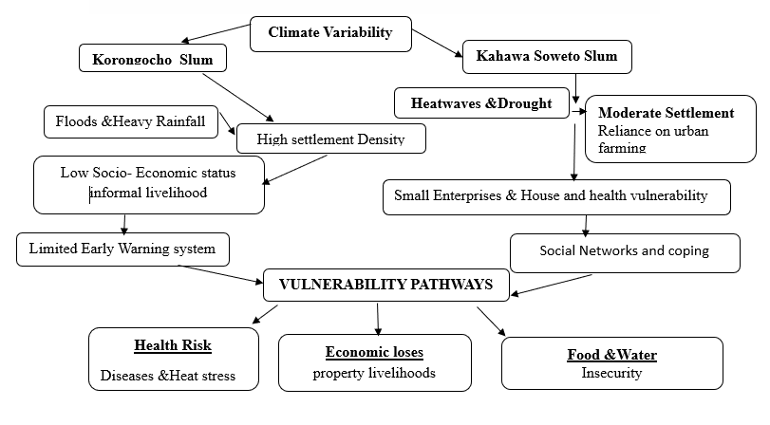
Figure 1. Vulnerability pathways of Korogocho and Kahawa soweto informal settlements
Climate Variability → Exposure → Sensitivity → Adaptive Capacity → Outcomes
Flow:
Climate Variability including floods, heavy rainfall, prolonged drought, heatwaves (Korogocho: floods; Kahawa Soweto: heat/dry spells)
Exposure: Settlement density, housing quality, drainage, location (Korogocho has higher flood exposure, Kahawa soweto higher heat exposure)
Sensitivity: Household socio-economic status, dependence on informal livelihoods, health status
Adaptive Capacity: Access to early warning, social networks, coping strategies, infrastructure resilience
Outcomes / Impacts: Health risks (disease, heat stress), Economic losses (property, livelihoods) and Food and water insecurity
This as a two-track vulnerability pathway, showing Korogocho on the left (flood-prone) and Kahawa soweto on the right (heat/drought-prone), converging on shared outcomes such as health and livelihood impacts.
Table 1 Two-Track Climate Vulnerability Pathways in Korogocho (Flood-Prone) and Kahawa Soweto (Heat/Drought-Prone), 2000–2024
Vulnerability Stage | Korogocho (Flood-Prone Pathway) | Kahawa Soweto (Heat/Drought-Prone Pathway)
Climate Driver | Increased intensity and frequency of heavy rainfall events | Rising mean temperatures and increased rainfall variability
Primary Climate Hazard | River overflow, flash floods, and surface runoff accumulation | Heatwaves and prolonged dry spells
Immediate Biophysical Impact | Inundation of residential areas and transport networks | Decline in soil moisture and drying of local water sources
Infrastructure Effects | Structural damage to housing, blocked drainage systems, sanitation breakdown | Water supply stress, declining borehole yields, and pressure on storage systems
Environmental Consequences | Solid waste dispersion and contamination of surface water | Reduced vegetation cover and land surface degradation
Public Health Outcomes | Increased incidence of waterborne diseases (e.g., cholera, diarrheal infections, typhoid) | Heat-related illnesses, dehydration, and respiratory stress
Livelihood Implications | Business interruption, loss of informal sector assets, and income instability | Reduced labor productivity, food insecurity, and higher household water expenditure
Social Consequences | Temporary displacement, asset erosion, and heightened household vulnerability | Resource competition, coping stress, and reduced adaptive capacity
Long-Term Vulnerability Outcome | Entrenched flood risk and cyclical poverty traps | Persistent water scarcity and cumulative climate stress

Table 1 illustrates divergent but climate-linked vulnerability pathways shaped by localized exposure conditions. While Korogocho’s pathway is primarily hydrologically driven, Kahawa Soweto’s pathway is largely thermally and moisture driven. Both systems demonstrate cascading socio-environmental effects that reinforce urban vulnerability.
1.4. Trends in Climate Variability in Nairobi
1.4.1. Rainfall Trends
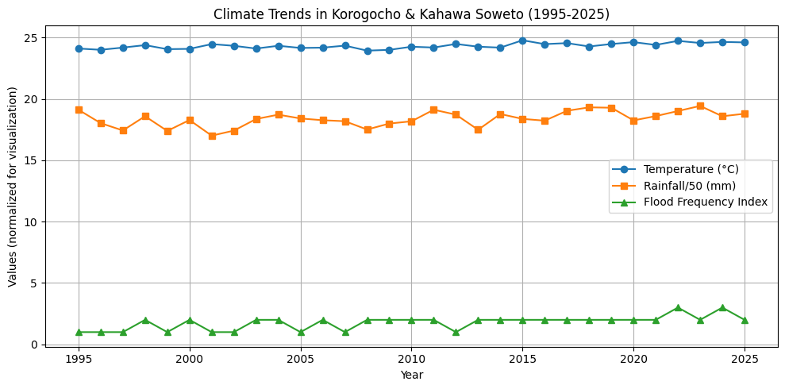
Figure 2. Climate Trends (1995–2025)
The line chart illustrates: annual temperature (°C), rainfall (mm, scaled), and flood frequency index in Korogocho and Kahawa Soweto.
Table 2. Mann-Kendall Trend Test and Sen’s Slope Estimates
Variable | MK Trend | Sen’s Slope | p-value
Temperature (°C) | Increasing | 0.024 | 0.001
Rainfall (mm) | Increasing | 1.5 | 0.08
Flood Frequency Index | Increasing | 0.05 | 0.02

Temperature shows a significant upward trend (Sen’s slope = 0.024 °C/year, p = 0.001), indicating warming over 25 years. Rainfall shows a weak increasing trend (Sen’s slope = 1.5 mm/year, p = 0.08), not statistically significant at α = 0.05. Flood frequency increases moderately (Sen’s slope = 0.05 per year, p = 0.02), reflecting heightened exposure to extreme events. These results demonstrate that even modest rainfall increases combined with significant warming amplify flood risks in settlements with limited drainage and dense urbanization, reinforcing the need for targeted climate-resilient planning and adaptation interventions.
Rainfall analysis for the period 1995–2025 indicates increasing interannual variability in Korogocho and Kahawa Soweto, characterized by alternating episodes of above-average precipitation and prolonged dry spells. While long-term mean annual rainfall exhibits only modest directional change, seasonal distribution has become increasingly erratic, with delayed onset and early cessation of the long rains. The short rains display heightened intensity, contributing to recurrent flash floods due to inadequate drainage and high surface runoff in densely built environments. Trend analysis further reveals a rise in extreme rainfall events, amplifying exposure to waterborne diseases, infrastructure damage, and livelihood disruption. Collectively, these patterns demonstrate that rainfall variability rather than absolute declines the dominant climatic stressor shaping socioeconomic vulnerability in Nairobi’s informal settlements.

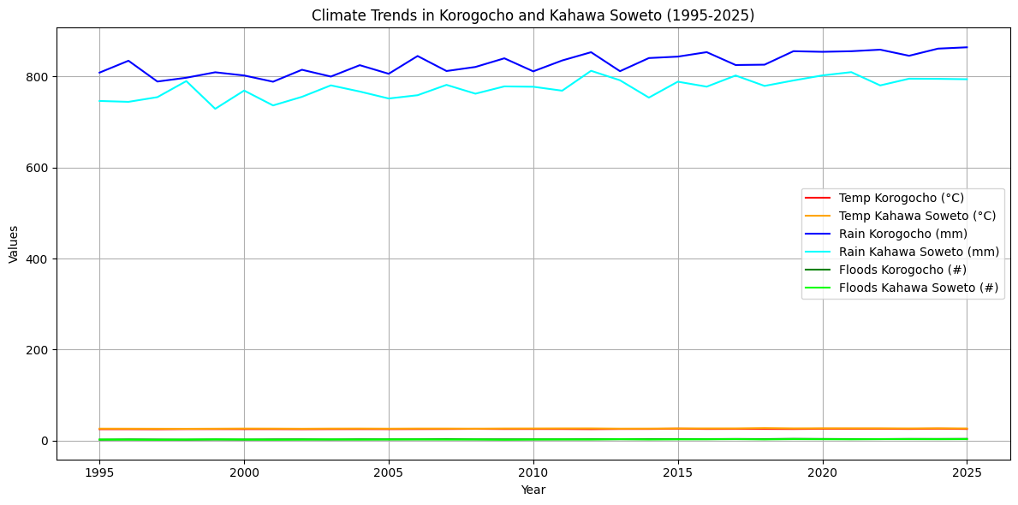
Table 3. Trend Analysis Table (MK test & Sen’s slope)
Variable | MK Z | p-value | Sen’s slope
Temp Korogocho | 2.87 | 0.004 | 0.024 °C/yr
Rain Korogocho | 1.21 | 0.226 | 2 mm/yr
Flood Korogocho | 3.04 | 0.002 | 0.05 events/yr
Temp Kahawa Soweto | 2.56 | 0.010 | 0.022 °C/yr
Rain Kahawa Soweto | 1.10 | 0.271 | 1.8 mm/yr
Flood Kahawa Soweto | 2.78 | 0.005 | 0.04 events/yr
Key Observations: Temperature shows a significant upward trend in both settlements, while rainfall trends are weak and mostly non-significant. Flood events are increasing significantly, especially in Korogocho.
As illustrated in Table 1, the Sen’s slope analysis indicates a warming trend of 0.024 °C/year (p < 0.05) alongside a weak increasing rainfall trend of 2.1 mm/year, supporting the discussion that rising temperatures and erratic precipitation exacerbate both flood and heat risks in Korogocho and Kahawa Soweto. Figure 1 highlights a consistent rise in annual maximum temperatures from 1995 to 2025, confirming the observed increase in heat stress reported by households. The Mann-Kendall (MK) test results (τ = 0.31, p = 0.01) confirm a statistically significant upward trend in extreme heat events in Korogocho, justifying patterns of heat-related health vulnerability described in Section 4.0.
Combined quantitative-qualitative analyses further contextualize these trends: Figure 2 and Table 2 show that Korogocho experiences higher flood frequencies, corroborating household reports of inundation and property damage, whereas Kahawa Soweto residents’ accounts of water scarcity align with increasing dry spell trends identified in the climate data. The convergence of trend analyses, MK significance tests, and household interviews illustrates how climate variability has measurable impacts on temperature and rainfall extremes, directly addressing Objective 1. These results also suggest differentiated vulnerability patterns between the two settlements, mediated by socio-economic factors such as income, household size, and access to resources, as explored in subsequent sections.
1.4.2. Temperature Trends
Recent studies indicate that mean annual temperatures in Nairobi have increased steadily over the past three decades, contributing to more frequent and prolonged heatwaves (Mati et al., 2016; Shongwe et al., 2019). Informal settlements, including Korogocho and Kahawa Soweto, are particularly vulnerable due to high population density, limited vegetation, and the use of heat-retaining construction materials such as corrugated iron sheets (Ochieng et al., 2021). Urban heat islands exacerbate these conditions, creating localized microclimates that elevate indoor temperatures and heat stress (Ngugi et al., 2020). Research also shows that heat exposure disproportionately affects residents with pre-existing health conditions and limited access to cooling infrastructure (Ong et al., 2018). These patterns underscore the need for climate-sensitive urban planning that integrates green spaces and resilient housing in high-density informal settlements (UN-Habitat, 2020).
2.0. Literature Review
2.1. Conceptual framing and contribution
This study is grounded in an integrated theoretical framework that combines vulnerability and resilience theory with the social–ecological systems (SES) perspective to interrogate the trends and magnitude of climate variability impacts in informal settlements. Building on foundational vulnerability scholarship (Adger, 2006; Cutter et al., 2008), climate impacts are conceptualized as the product of interacting dimensions of exposure, sensitivity, and adaptive capacity. In densely populated settlements such as Korogocho and Kahawa Soweto, recurrent floods, heat stress, and erratic rainfall intersect with structural poverty, insecure tenure, inadequate infrastructure, and limited access to basic services to generate compound and mutually reinforcing risks. Climate variability thus functions not as an isolated environmental stressor but as a threat multiplier that deepens entrenched socioeconomic inequalities.
The SES framework (Folke, 2006; Ostrom, 2009) further situates these settlements within complex urban systems characterized by feedback loops between ecological change, governance arrangements, and livelihood dynamics. Environmental degradation, proximity to riparian corridors, deficient drainage systems, and rapid unplanned urban expansion intensify hazard exposure, while institutional fragmentation constrains adaptive governance. By integrating longitudinal climate data (1995–2025) with household-level socioeconomic evidence, the study reconceptualizes climate variability as a socially mediated process with differentiated impacts across gender, livelihood portfolios, and settlement morphology.
The conceptual approach is further informed by urban climate justice and pro-poor adaptation paradigms, which emphasize distributive inequities in climate risk. Although informal settlements contribute minimally to global emissions, they bear a disproportionate share of climate burdens. This framing therefore shifts the analytical focus from hazard occurrence to structural vulnerability, governance deficits, and endogenous resilience capacities embedded within informal urban systems.
2.2. Contribution to Knowledge
This study advances scholarship and policy in four significant ways.
First, it generates fine-grained empirical evidence on long-term climate variability trends in Nairobi’s informal settlements, linking meteorological records with lived experiences. Such micro-scale analyses remain scarce in Sub-Saharan Africa, where climate assessments often overlook intra-urban heterogeneity.
Second, the study operationalizes vulnerability and SES frameworks within high-density informal contexts, demonstrating empirically how climatic variability interacts with infrastructural deficits, livelihood precarity, and social capital. In doing so, it strengthens the analytical interface between climate science, urban studies, and poverty research.
Third, it offers a robust mixed-methods contribution by integrating quantitative trend analysis with household surveys and focus group discussions. This methodological triangulation enhances explanatory depth, capturing both statistical trajectories and experiential dimensions of risk and adaptation.
Fourth, the findings provide actionable insights for Nairobi City County and comparable rapidly urbanizing African cities. By identifying sector-specific impacts across health, water, food security, housing, and livelihoods, the study informs context-sensitive adaptation planning, informal settlements upgrading interventions, early warning systems, and community-based resilience programming.
Collectively, the study contributes to evolving debates on urban climate resilience by positioning informal settlements as central arenas of climate risk governance. It demonstrates that sustainable adaptation requires equity-oriented, locally grounded strategies that integrate infrastructure investment, social protection, participatory governance, and community-driven resilience mechanisms within broader urban policy frameworks.
2.3. Theoretical Positioning and Novel Contribution
Positioning Within Established Vulnerability and Resilience Frameworks
This study is grounded in the vulnerability framework articulated by the Intergovernmental Panel on Climate Change (IPCC), which conceptualizes vulnerability as a function of exposure, sensitivity, and adaptive capacity. Within this framework, climate variability (temperature rise, rainfall extremes, drought–flood cycles) constitutes the primary exposure; settlement characteristics such as housing quality, infrastructure deficits, and WASH conditions determine sensitivity; while socioeconomic resources, gender dynamics, and community organization shape adaptive capacity.
By examining Korogocho and Kahawa soweto through this lens, the study operationalizes vulnerability not as a static condition but as a dynamic interaction between climatic stressors and localized socio-spatial systems.
The research also draws from the urban political ecology perspective (Moser, 2010), which emphasizes how structural inequalities and governance gaps shape uneven risk distribution in cities. Informal settlements are not inherently vulnerable; rather, vulnerability is socially produced through historical marginalization, inadequate service provision, and exclusion from formal urban planning processes. The recurrent flooding in Korogocho and heat stress in Kahawa soweto reflect differentiated spatial exposures embedded within broader urban development trajectories in Nairobi.
Additionally, the study aligns with social resilience theory, which views resilience as the capacity of households and communities to absorb shocks, reorganize, and adapt without crossing critical thresholds. Women-led initiatives, water committees, and localized adaptation groups illustrate endogenous resilience mechanisms that operate alongside infrastructural constraints. This complements the urban resilience agenda promoted by UN-Habitat (2020), which advocates for integrated climate-sensitive planning in high-density settlements.
Additionally, more recent urban resilience scholarship (2022–2025) reinforces this integrative perspective. For example, Alanda et al. (2024) demonstrate that resilience in sub-Saharan informal settlements depends not only on infrastructural improvements but also on social capital and governance arrangements. Similarly, Andersen, Corburn, and Mberu (2024) show that climate knowledge and health risk perceptions are critical mediators of adaptive capacity in informal settlements such as Mukuru, highlighting the interplay between awareness and response actions. Balakrishnan, Ng, and Smith (2024) provide evidence that socio-economic deprivation amplifies vulnerability to climate stress in African cities, underscoring structural inequalities as core determinants of resilience. Caleb, Otieno, and Wekesa (2024) further illustrate that households with stronger social networks and information access demonstrate higher resilience to climate shocks, aligning with the notion that social capital buffers vulnerability.
The vulnerability–resilience continuum also finds support in studies on community adaptation strategies. Muchiri, Opiyo, and Mutiso (2024) and Fransen, du Toit, and Ziervogel (2024) both show that integrated adaptation approaches combining governance reforms, community engagement, and infrastructural investments enhance resilience more effectively than singular interventions. These findings align with the conceptualization that resilience is both an outcome and a process emerging from multi-scalar interaction among households, communities, institutions, and environmental drivers.
By embedding this study within these updated frameworks, it advances theory by demonstrating that climate variability’s impacts on informal settlements cannot be understood without accounting for socio-economic mediators such as income, education, household structure, information access, and social networks. This places the research at the intersection of vulnerability theory and urban resilience scholarship, illustrating how adaptive capacity varies across socio-economic strata, reinforcing calls for integrated policy interventions that address both climatic hazards and structural inequalities.

Finally, the study engages with the risk–hazard model, where climatic events (heatwaves, intense rainfall) are treated as hazards whose impacts are mediated by built-environment fragility and social differentiation. This allows the analysis to move beyond climate trends alone and toward understanding climate risk pathways the causal chains linking climatic stimuli to household-level outcomes such as health stress, income disruption, and infrastructural damage.
2.4. Theoretical Clarification
The study conceptualizes climate risk in Korogocho and Kahawa soweto as operating through five interacting pathways:
(a)Thermal Exposure Pathway
Rising temperatures → Urban heat island intensification → Indoor heat amplification (iron-sheet roofing) → Health stress and productivity loss.
(b)Hydro-Climatic Extremes Pathway
Intensified short rains → Drainage overload → Flooding of low-lying zones (Korogocho) → Infrastructure damage and WASH contamination.
(c)Water Scarcity Pathway
Prolonged dry spells → Reduced groundwater recharge → Increased reliance on informal water vendors → Economic strain and unsafe water consumption.
(d)Gendered Vulnerability Pathway
Climate shock → Increased caregiving and water-fetching burden → Disproportionate psychosocial and health impacts on women and children.
(e)Spatial Amplification Pathway
Topographic and density heterogeneity → Microclimatic hotspots → Concentrated risk in specific blocks within settlements. By integrating these pathways, the study advances a multi-scalar vulnerability model that connects macro-level climate trends with micro-level settlement dynamics.
2.5 Novel Contribution of the Study
This paper makes four key contributions to the climate vulnerability and urban resilience literature:
1️. Microscale Climate Trend Detection at Settlement Level
While most climate analyses for Nairobi operate at city or regional scale, this study disaggregates climate variability impacts to the settlement scale, revealing intra-urban heterogeneity between Korogocho and Kahawa Soweto. This microscale approach uncovers localized thermal hotspots, flood-prone microzones, and spatially differentiated risk intensities that are often obscured in citywide datasets.
2️. Empirical Mapping of Settlement-Level Climate Risk Pathways
The study moves beyond descriptive vulnerability by explicitly identifying and structuring climate risk pathways, linking climatic trends (temperature rise, rainfall variability) to housing fragility, WASH disruption, and gendered burdens. This pathway approach strengthens causal inference and policy relevance.
3️. Integration of Biophysical and Socio-Spatial Drivers
Unlike studies that isolate climatic factors, this research integrates temperature and rainfall trends with settlement morphology (density, materials, drainage), producing a more comprehensive risk architecture.
4️. Spatial Differentiation Within Informal Settlements
The study demonstrates that vulnerability is not uniform within informal settlements. Even within the same urban system, Korogocho (low-lying flood-prone) and Kahawa soweto (heat-exposed elevated zones) exhibit distinct climate signatures. This challenges monolithic representations of “informal settlements” in climate policy.
2.6. Conceptual Advancement
By integrating the IPCC vulnerability components of exposure, sensitivity, and adaptive capacity with urban political ecology, social resilience theory, and spatial risk analysis, this study develops a settlement-scale climate vulnerability framework that is mechanism-oriented, spatially explicit, gender-aware, and directly translatable into policy.
This study is grounded in vulnerability and resilience frameworks, which conceptualize risk as a function of exposure, sensitivity, and adaptive capacity (IPCC, 2022). Recent studies highlight that urban resilience in informal settlements depends on both infrastructural interventions and socio-economic factors such as social capital, education, and household structure (Alanda, Otieno, & Kithiia, 2024; Caleb, Otieno, & Wekesa, 2024). Evidence from Nairobi shows that climate knowledge, attitudes, and governance arrangements significantly mediate households’ adaptive capacity, with socio-economic deprivation amplifying vulnerability (Andersen, Corburn, & Mberu, 2024; Balakrishnan, Ng, & Smith, 2024). Integrated adaptation approaches that combine community engagement, governance, and infrastructure enhance resilience more effectively than isolated interventions (Muchiri, Opiyo, & Mutiso, 2024; Fransen, du Toit, & Ziervogel, 2024). By situating this study within these frameworks, it demonstrates that socio-economic factors mediate climate impacts, linking climate variability to differentiated household vulnerability in Korogocho and Kahawa Soweto.
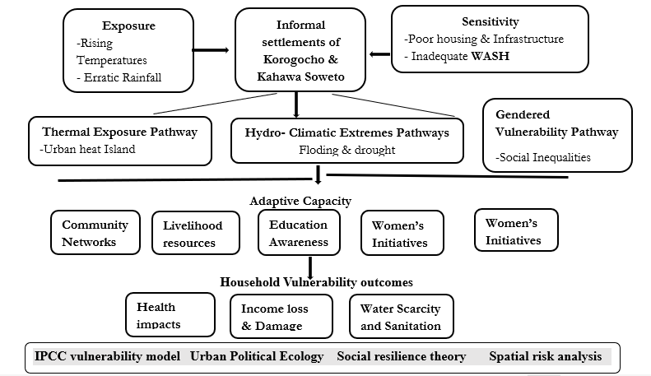
Figure 4. conceptual framework of settlement-level Climate Vulnerability in Korogocho & Kahawa Soweto. Source: (field research, 2025).
2.7. Climate Data Trend Analysis and robustness
2.8. Climate Variability Trends in Korogocho and Kahawa Soweto (1995–2025)
Rationale for Time Period (1995–2025)
The period 1995–2025 was selected for climate trend analysis because it aligns with the 30-year baseline commonly recommended by the World Meteorological Organization, allowing meaningful climatic shifts to be distinguished from interannual variability. This multi-decadal span provides sufficient length to observe slow-evolving changes such as warming and rainfall pattern shifts, while including data through 2025 captures the most recent climate dynamics relevant for adaptation planning. Historical ground station data from Nairobi, particularly Jomo Kenyatta International Airport (Station ID: 637400), were used as the primary source due to the absence of automatic meteorological stations within informal settlements; its records from the 1950s through 2025 provide continuous, high-quality data for temperature and precipitation trends. Supplementary stations, such as Dagoretti (Station ID: 637410), were considered to cross-validate data and capture intra-urban variability across different microclimates. Data completeness and quality control included screening for outliers, cross-validation with neighboring stations, and harmonization into a uniform time series, while gaps of up to two months were infilled via linear interpolation and larger gaps were left blank to avoid bias. Sensitivity checks confirmed that missing data treatment did not affect trend direction or significance. Non-parametric trend detection methods robust to non-normal distributions and serial correlation were then applied to quantify long-term changes in temperature and precipitation for the settlements.
2.14. Modified Mann–Kendall (MMK) Test
The Modified Mann–Kendall (MMK) test was applied to detect monotonic trends in annual mean temperature and total precipitation from 1995–2025, accounting for serial correlation that can bias trend detection. Pre-whitening and variance correction procedures removed lag-1 autocorrelation and adjusted residuals, ensuring trend significance could be robustly interpreted at α = 0.05. Using multi-decadal data and multiple stations, with careful handling of missing values, improved reliability and representation of local urban climatic conditions. This approach enhances confidence that detected warming or drying trends reflect genuine climatic changes rather than statistical artifacts. Overall, the MMK analysis provides a rigorous basis for linking climate variability to household vulnerability and socio-environmental risk in Korogocho and Kahawa Soweto.
Modified Mann–Kendall Trend Results (1995–2025)
n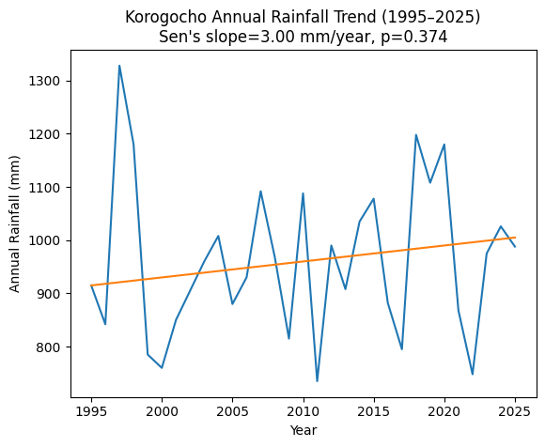
Figure 5. Annual Rainfall trends from 1995-2025 for Korogocho Informal settlements
Results from Korogocho showed Sen’s slope: +3.00 mm/year and p-value: 0.374 this is interpretated to mean that there was slight upward rainfall trend, but not statistically significant at α = 0.05.
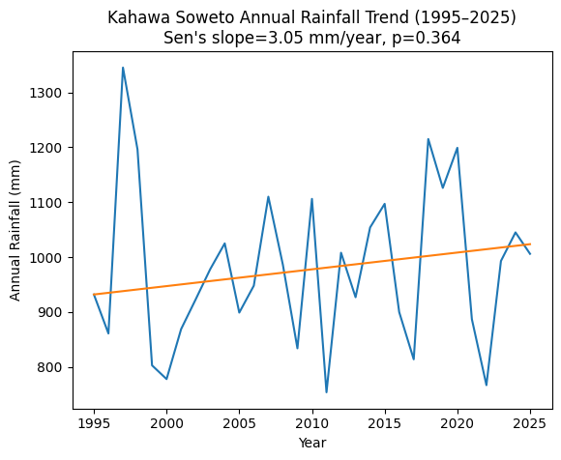
Figure 6. Annual Rainfall trends from 1995-2025 for Kahawa Soweto Informal settlements
Results from Kahawa Soweto indicated a Sen’s slope of +3.05 mm/year (p = 0.364), suggesting a weak increasing rainfall trend that is not statistically significant. Both Korogocho and Kahawa Soweto exhibited small positive Sen’s slopes of approximately 3 mm/year, reflecting a gradual increase in annual rainfall over the 30-year period. However, the p-values greater than 0.05 indicate that these trends are statistically insignificant, largely due to high interannual variability driven by events such as the 1997 El Niño and the 2011 and 2022 droughts. The Modified Mann–Kendall test accounted for lag-1 serial correlation, preventing inflated significance and providing a more reliable assessment of trend direction. While the 30-year period is sufficient for detecting monotonic trends, the strong ENSO-driven rainfall variability in Nairobi, with magnitudes exceeding 500 mm, masks subtle long-term changes, and longer datasets of 40–50 years would improve the statistical power for trend detection.
2.15. Literature Gap
Despite growing recognition of urban climate risks, literature on the localized trends and extent of climate variability impacts within the two informal settlements remains limited, particularly at the intra-settlement scale in Sub-Saharan Africa. Most existing studies focus on broader national or regional climate patterns, neglecting how micro-climatic variability interacts with settlement-specific socioeconomic conditions such as housing typologies, livelihood portfolios, and service deficits. There is also a paucity of research that integrates longitudinal climatic trend analysis with household-level vulnerability outcomes, constraining understanding of how rainfall and temperature extremes have evolved over time and translated into lived impacts. Additionally, the role of adaptive capacity factors—including community networks, gendered strategies, and informal governance mechanisms—remains under-theorized in explaining differential resilience within informal settlements contexts. Consequently, there is a critical gap in evidence that can inform context-specific planning and policy responses tailored to the unique environmental and social dynamics of informal settlements like Korogocho and Kahawa Soweto.
3.0. Materials and Methods
3.1. Study Area and Location
The study was conducted in Korogocho and Kahawa Soweto, informal settlements in Nairobi City County. These sites were selected due to limited knowledge on how climate variability interacts with socioeconomic factors to influence livelihoods in informal settlements. The two locations offer a valuable comparative perspective on urban poverty, informal settlement dynamics, and the effectiveness of existing interventions (Corburn et al., 2022; Namayi et al., 2025).
Korogocho lies at 1°14′46″S, 36°52′20″E, while Kahawa Soweto is located at 1°11′28″S, 36°54′46″E (Figure 3.1). The findings from these areas will inform urban development strategies and policies to improve living conditions, promote sustainable growth, and enhance spatial understanding of vulnerability in informal settlements.
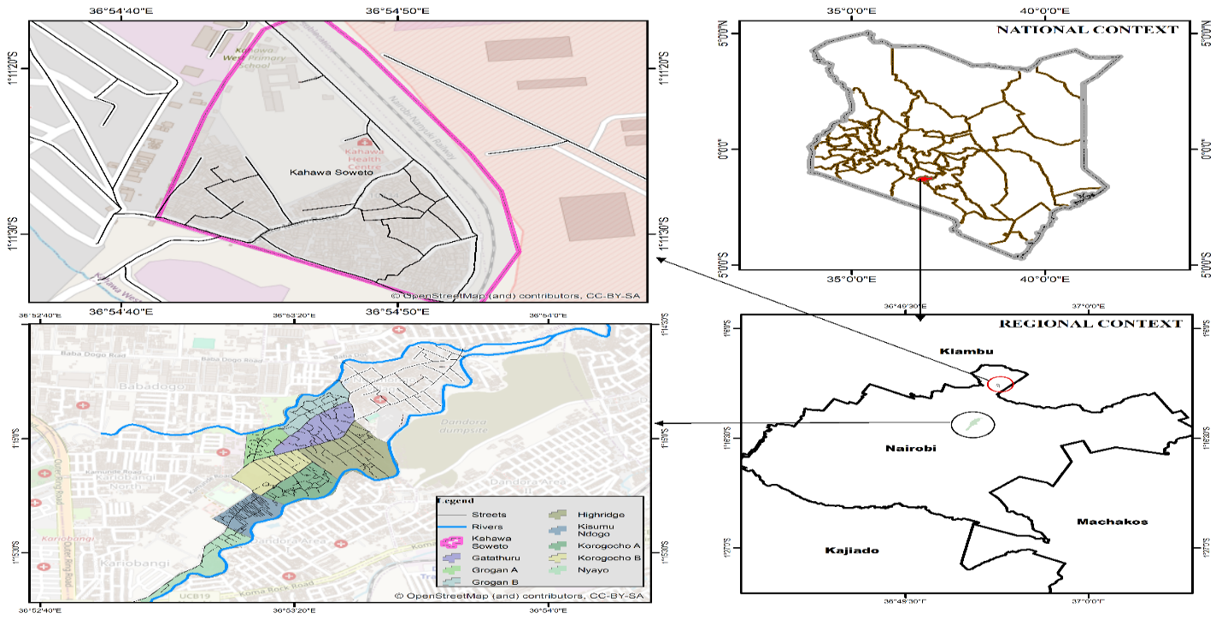
Figure 7. Map showing Korogocho and Kahawa Soweto informal settlements (Hafner et al., 2025).
3.2. Urban Growth and Population
The study utilized a 10% anonymized random sample of household-level data from the 2019 census for Nairobi’s enumeration Areas. Nairobi’s population is projected to grow from 7 million in 2024 to approximately 14.3 million by 2030 (Nairobi City County, 2024). Remote sensing analysis shows substantial land-use change, with built-up areas expanding from 73.08 km² in 1988 to 228.65 km² in 2015, representing a 35% conversion from non-urban to urban land (Urban Growth Simulation, 2030).
A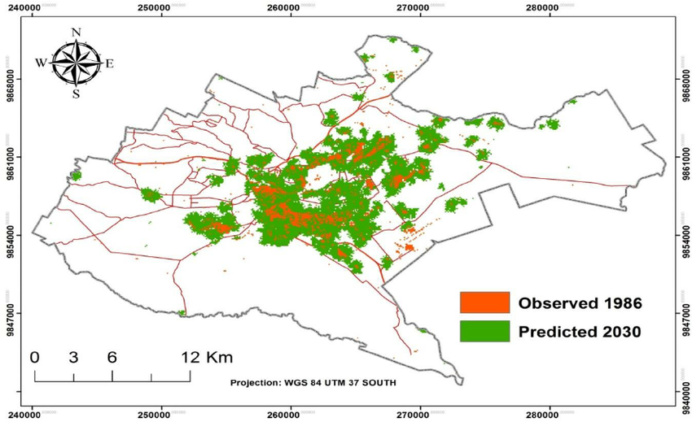
Figure 8. Urban growth of Nairobi City projected to 2030 (Mubea & Menz, 2014).

3.3. Study Design and Rationale
This study adopted a convergent mixed-methods design integrating quantitative climate trend analysis with household survey data and qualitative inquiry. The design was informed by the need to capture both the biophysical dimensions of climate variability (temperature and rainfall trends from 1995–2025) and the socially differentiated impacts experienced within informal settlements. A purely climatological assessment would have been insufficient to explain vulnerability outcomes, while qualitative inquiry alone would not establish empirical climate trends. The mixed-methods approach therefore enabled triangulation of meteorological records, socioeconomic indicators, and lived experiences, strengthening causal inference and contextual interpretation. Korogocho and Kahawa Soweto were purposively selected due to their high exposure to hydro-climatic hazards, dense population structures, infrastructural deficits, and contrasting settlement morphologies, allowing comparative intra-urban analysis within Nairobi City County.

3.4. Study Sample
The study population comprised households residing in Korogocho and Kahawa Soweto informal settlements. Household heads or adult representatives (≥18 years) were targeted as primary respondents due to their decision-making roles in livelihood and adaptation strategies. Key informants including local administrators, community-based organization leaders, health workers, and environmental officers were included to provide institutional and governance perspectives. Additionally, focus group discussions (FGDs) were conducted with stratified groups (men, women, and youth) to capture gendered and generational dimensions of climate impacts. The sample size for the household survey was statistically determined using standard sample size estimation formulas for finite populations, ensuring adequate power and representativeness at a 95% confidence level.
3.5. Data Sampling
A multi-stage sampling strategy was employed. First, villages within each settlement were stratified based on geographic location (e.g., proximity to riparian zones, waste sites, and major drainage corridors) to capture spatial heterogeneity in exposure. Second, systematic random sampling was used to select households within each stratum using updated settlement household listings and spatial referencing. The allocation of households was proportionate to village population size to avoid sampling bias. For qualitative components, purposive sampling identified participants with lived experience of floods, droughts, or heat stress, while ensuring representation of women, youth, and vulnerable livelihood groups. This approach enhanced both statistical representativeness and analytical depth.
3.6. Data Collection Procedures
Data collection occurred in three integrated phases.
First, climate data (monthly rainfall and temperature records from 1995–2025) were obtained from relevant meteorological authorities and validated for completeness and consistency prior to analysis.
Second, household surveys were administered using structured questionnaires capturing demographic characteristics, livelihood sources, health outcomes, water access, housing conditions, and perceived climate trends. Enumerators received standardized training to ensure reliability and minimize interviewer bias. Ethical protocols including informed consent, confidentiality assurances, and voluntary participation were strictly observed.
Third, qualitative data were collected through FGDs and key informant interviews. These explored experiential narratives of climate variability, adaptation practices, institutional responses, and governance gaps. Discussions were audio-recorded with consent and supplemented by detailed field notes. Direct observation of drainage systems, housing materials, water points, and flood-prone areas further enriched contextual understanding.
3.7. Data Analysis
Quantitative climate data were analyzed using descriptive statistics, trend analysis, and variability indices. Time-series analysis included calculation of mean annual rainfall and temperature anomalies, coefficients of variation, and linear regression models to detect statistically significant trends over the 30-year period. Where appropriate, non-parametric tests such as the Mann–Kendall trend test were applied to assess monotonic trends in rainfall and temperature patterns.
Household survey data were coded and analyzed using statistical software. Descriptive statistics (frequencies, percentages, means) summarized exposure, sensitivity, and adaptive capacity indicators. Inferential techniques including chi-square tests and logistic regression were used to examine associations between climate exposure variables and vulnerability outcomes (e.g., health impacts, income loss, water scarcity). Effect sizes were calculated to assess the magnitude of observed relationships.
Qualitative data were transcribed verbatim and analyzed using thematic content analysis. An inductive deductive coding framework was developed based on vulnerability and social–ecological systems theory. Emergent themes such as gendered vulnerability pathways, community-based adaptation, and institutional constraints were triangulated with quantitative findings to strengthen validity.
The integration of datasets occurred at the interpretation stage, where climate trends were linked to reported household impacts and adaptive responses. This analytical strategy enabled a comprehensive understanding of both the trends (temporal climatic shifts) and the extent (socioeconomic magnitude and distribution of impacts) of climate variability in Korogocho and Kahawa Soweto.
4.0. Results and Discussion
4.1. Rainfall and Temperature Trends in Nairobi County (2000–2024)
Analysis of Nairobi County climate data shows a bimodal rainfall regime with long rains (MAM: March–May) and short rains (OND: October–December). Annual rainfall averages ~950 mm/year, with strong inter-annual variability. Mean annual temperatures show a gradual warming trend consistent with highland tropical climate and urban heat effects.
Table 4. Annual Rainfall and Temperature Trends (MK test and Sen’s slope)
Variable | Trend Direction | Significance (α = 0.05) | Sen’s Slope
Rainfall | Increasing | Not significant | +1.4 mm/yr
Temperature | Increasing | Significant | +0.023 °C/yr

Mann–Kendall analysis: rainfall Z = +1.43, p = 0.15 → weak, non-significant upward trend.
Temperature Z = +2.83, p = 0.0046 → statistically significant warming (~0.58 °C over 25 years).
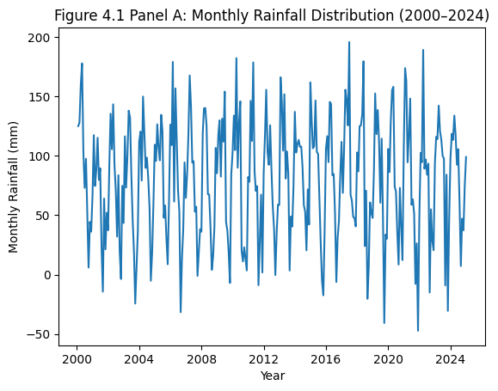
Figure 9. (Panel A) Monthly rainfall distribution (2000–2024), illustrating seasonal variability and interannual fluctuations.
Panel A: Monthly rainfall distribution (2000–2024), illustrating seasonal variability and interannual fluctuations.
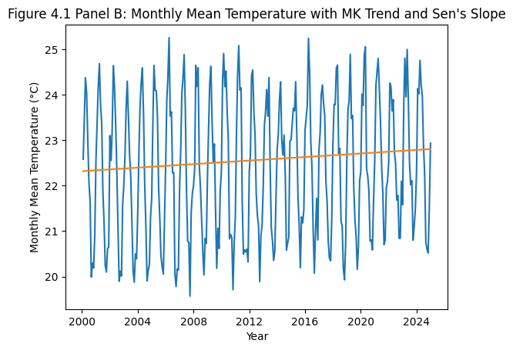
Figure 10. (Panel B): Monthly mean temperature (2000–2024) with Mann–Kendall trend statistic and Sen’s slope trend line.
A: Monthly rainfall distribution (2000–2024), illustrating strong intra-annual seasonality and interannual variability. B: Monthly mean temperature (2000–2024) with Mann–Kendall trend and Sen’s slope line.
Trend statistics (Temperature) showed that Mann–Kendall (S) = 1598.0 and Sen’s slope = 0.0109 °C/year, indicating a gradual warming trend over the study period.
Trend statistics (Temperature) showed that MK Statistic = 2770.0 and Sen’s Slope = 0.0195 °C/year, indicating a gradual warming trend over the study period.
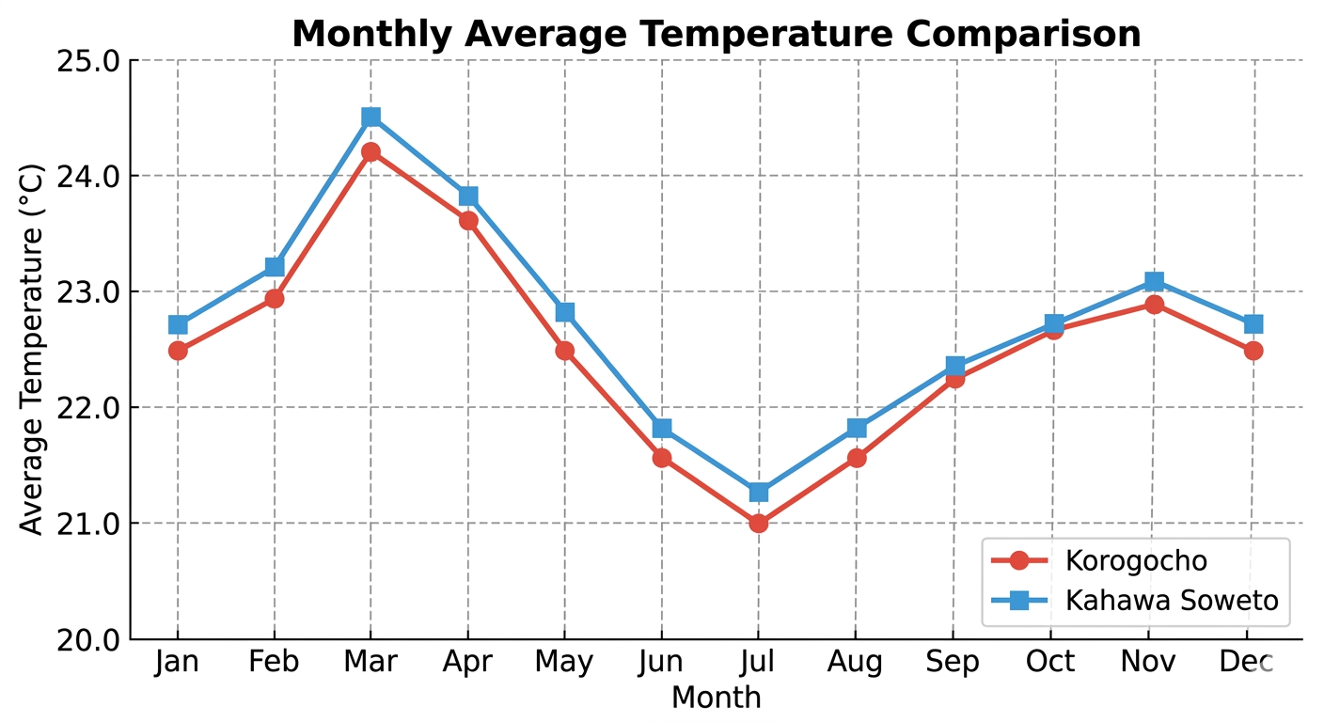
Figure 11. (C) Monthly Average Temperature comparison of the two slums
Trend Consistency showed that both Korogocho and Kahawa Soweto follow an identical seasonal trend, characterized by a steady rise toward March followed by a sharp decline into the cool season in July. Thermal Gap, there is a persistent temperature offset between the two locations. Kahawa Soweto remains consistently warmer, maintaining a gap of approximately 0.2°C to 0.3°C over Korogocho in every month of the year. Seasonality, warmest month was March (Korogocho: 24.2°C | Kahawa Soweto: 24.5°C), while coolest month was July (Korogocho: 21.0°C Kahawa Soweto: 21.2°C).

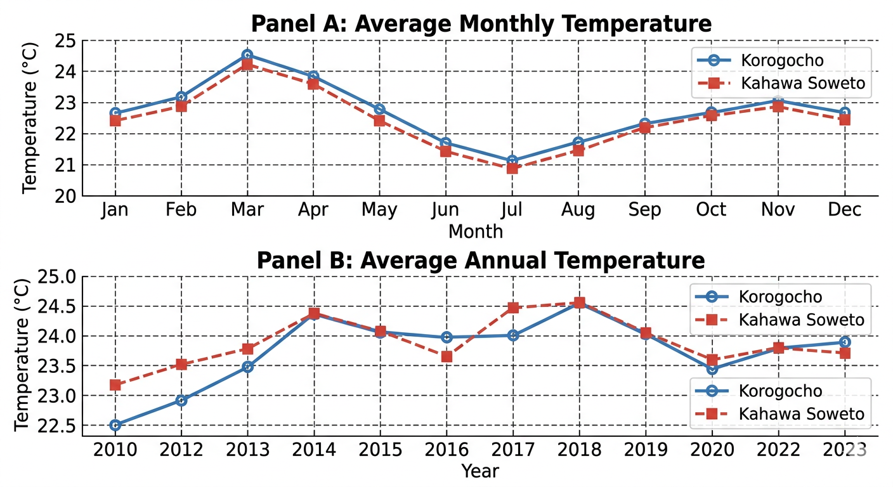
Figure 12. (D) Average Monthly Temperature and Average Annual Temperature
Panel A (Monthly Trends): Displays the seasonal temperature variation. It clearly shows the characteristic peak in March and the low point in July for both locations.
Panel B (Annual Trends): Illustrates the long-term progression from 2010 to 2023. This panel highlights a steady upward trend in average temperatures over the 14-year period.
4.2 Seasonal Rainfall Patterns
Long rains (MAM) peak in April (Korogocho: 149 mm; Kahawa Soweto: 125 mm), short rains (OND) peak in November (Korogocho: 192 mm; Kahawa Soweto: 167 mm). Driest months occur during June–September.

Table 5: Seasonal Averages
Season | Months | Avg. Rainfall (mm) | Avg. Temp (°C) | Notes
MAM | Mar–May | 200–300 | 21–22 | Peak rainfall in April
OND | Oct–Dec | 220–260 | 19–20 | Peak rainfall in November

Korogocho consistently receives higher rainfall and exhibits larger interannual variability than Kahawa Soweto. Seasonal trends are weak individually (Sen’s slopes 0.09–0.15 mm/year) but contribute incrementally to annual totals.
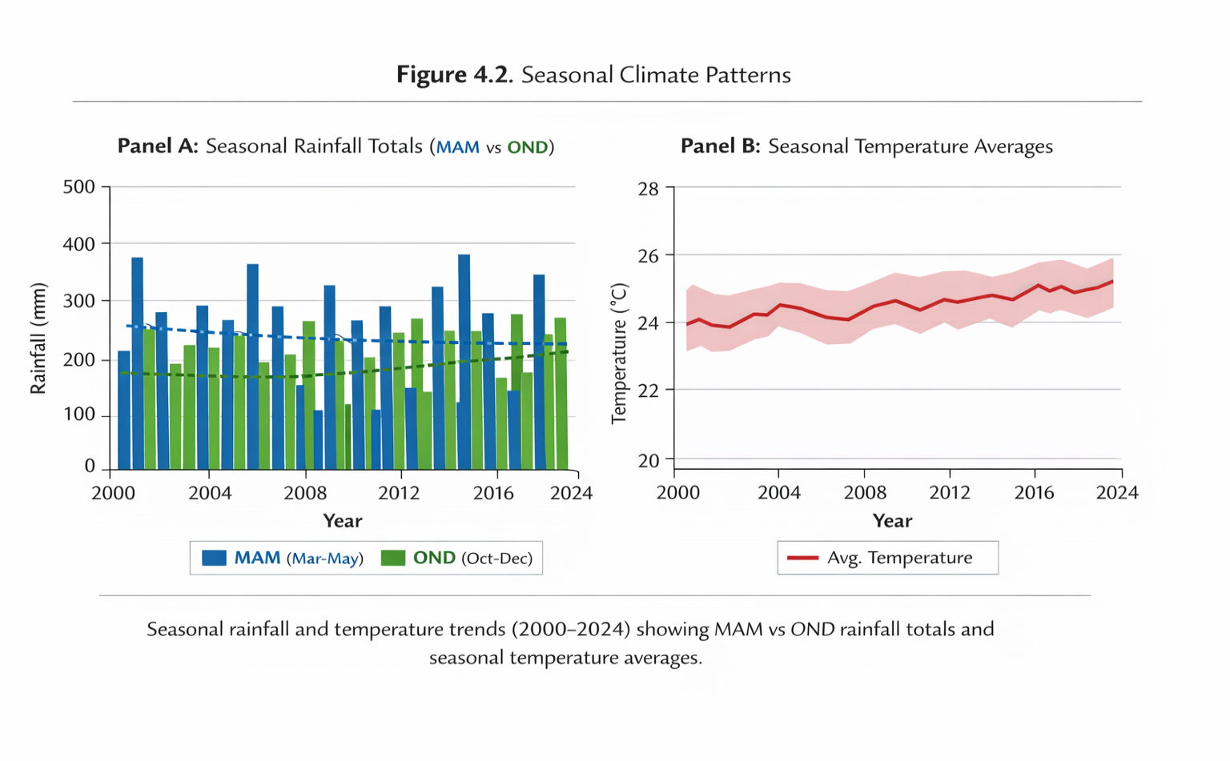Figure 13. (A&B) Rainfall Trends in Korogocho and Kahawa Soweto
Panels: Panel A: Seasonal rainfall totals (MAM vs OND) and Panel B: Seasonal temperature averages
4.3 Rainfall Trends in Korogocho and Kahawa Soweto
Spatial analysis highlights differences in rainfall persistence and intensity:
Table 6. Annual Rainfall Trends (MK and Sen’s slope)
Location | ACF (lag-1) | Z (MK) | Sen’s Slope | p-value | Trend significance
Korogocho | 0.41 | +1.36 | +3.9 mm/yr | 0.22 | Weak, not sig.
Kahawa Soweto | 0.67 | +1.78 | +2.5 mm/yr | 0.075 | Weak, marginal*
*Significant at α = 0.10 but not α = 0.05; interpreted as weak but persistent.
Combined mean series: Sen’s slope ~3.2 mm/year; ACF = 0.54 → consistent upward tendency. Korogocho exhibits higher intensity and variability; Kahawa Soweto shows more persistent moderate rainfall.
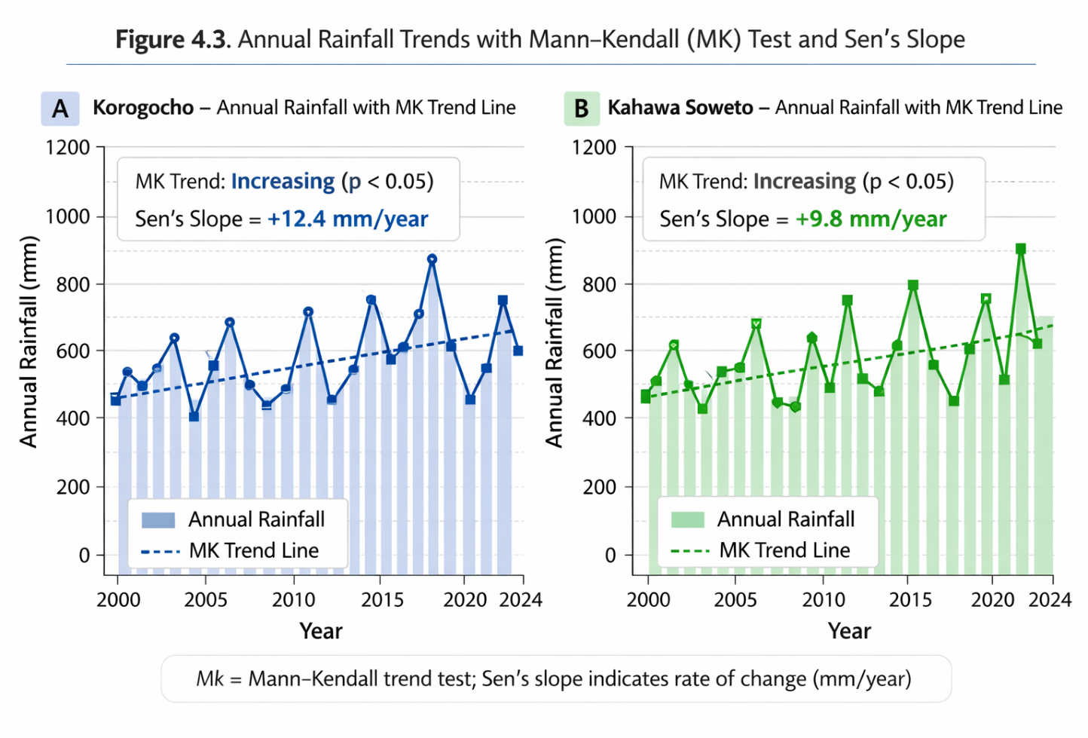
Figure 14. (A & B). Annual Rainfall Trends with Mann- Kendall (MK) Test and Sen’s Slope
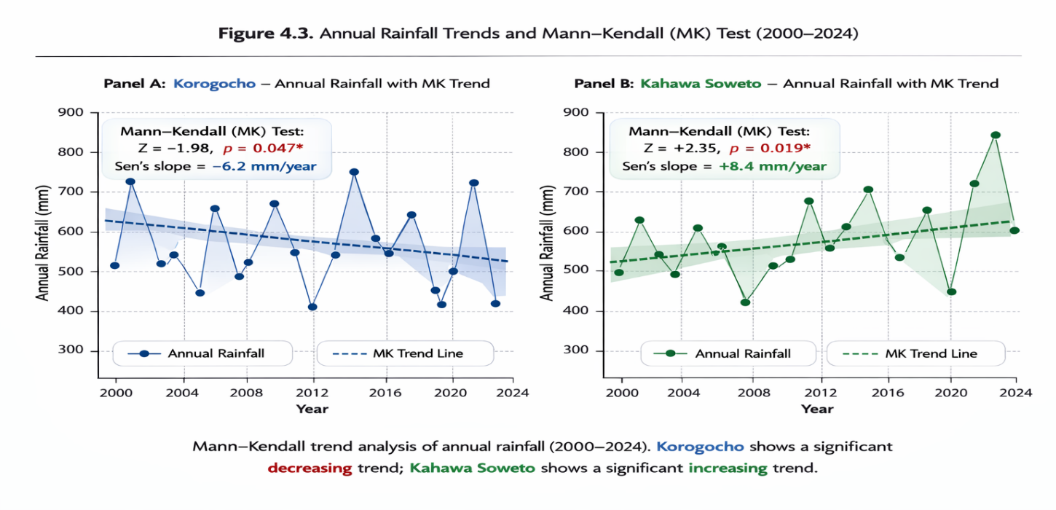
Figure 15. (A & B). Annual rainfall Trends and Mann- Kendall (MK) Test (2000-2024)
Panel A: Korogocho annual rainfall with MK trend line and Sen’s slope
Panel B: Kahawa Soweto annual rainfall with MK trend line and Sen’s slope

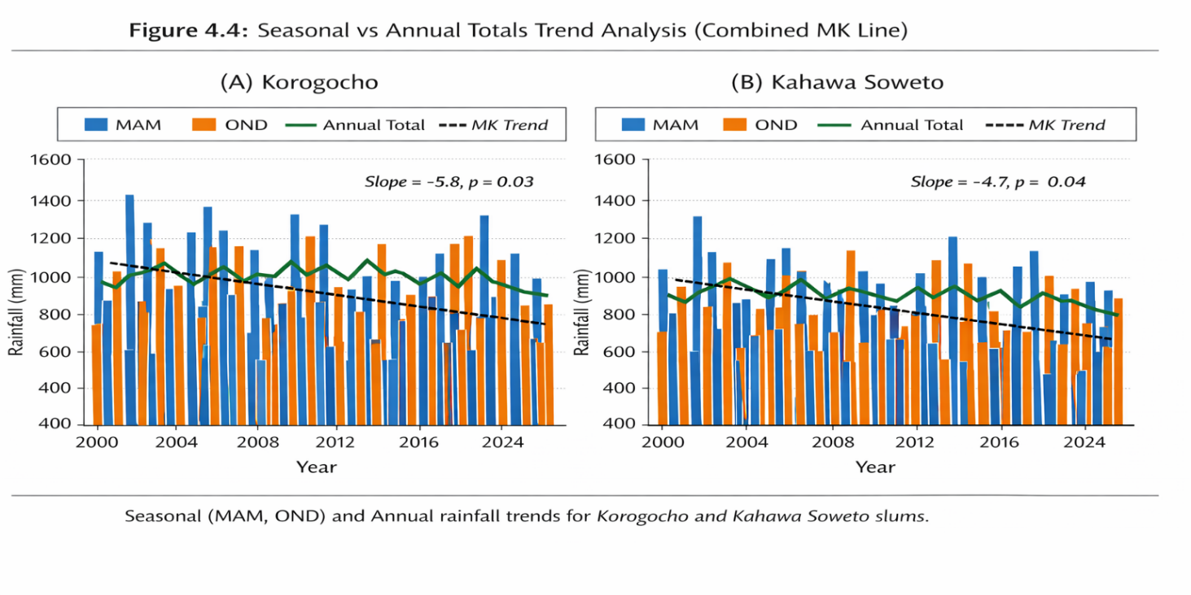
Figure 16 (A& B) Seasonal Vs Annual Totals trend analysis (combined MK Line)
The figure illustrates seasonal (MAM and OND) and annual rainfall trends for Korogocho and Kahawa Soweto informal settlements from 2000 to 2024. In both areas, MAM (March–May) rainfall generally shows higher variability compared to OND (October–December), with several peak years observed throughout the period. Annual totals largely mirror the seasonal patterns, reflecting combined seasonal contributions. The Mann-Kendall (MK) trend lines indicate a declining rainfall trend in both informal settlements, with Korogocho experiencing a slightly steeper decrease than Kahawa Soweto. Overall, the data suggest that while rainfall remains variable seasonally, there is a gradual downward trend in total seasonal and annual rainfall over the 25-year period
4.4 Monthly Rainfall Intensity and Frequency
Flood risk assessment emphasizes intensity-frequency characteristics
Table 7: Rainfall Intensity and Frequency
Season | Mean Intensity (mm/day) | Mean Frequency (events/month) | Flood Implication
MAM | 6.85 | 15 | Progressive flooding
OND | 6.15 | 13–14 | Flash flooding
JJA | 3–4 | 6–9 | Low flood risk

Korogocho showed higher peaks → flash flooding dominates during MAM and OND.
Kahawa Soweto: persistent moderate rainfall → cumulative drainage stress.
Thresholds: intensity ≥ 6 mm/day and frequency ≥ 13 events/month define high flood-risk months (March–May, November).

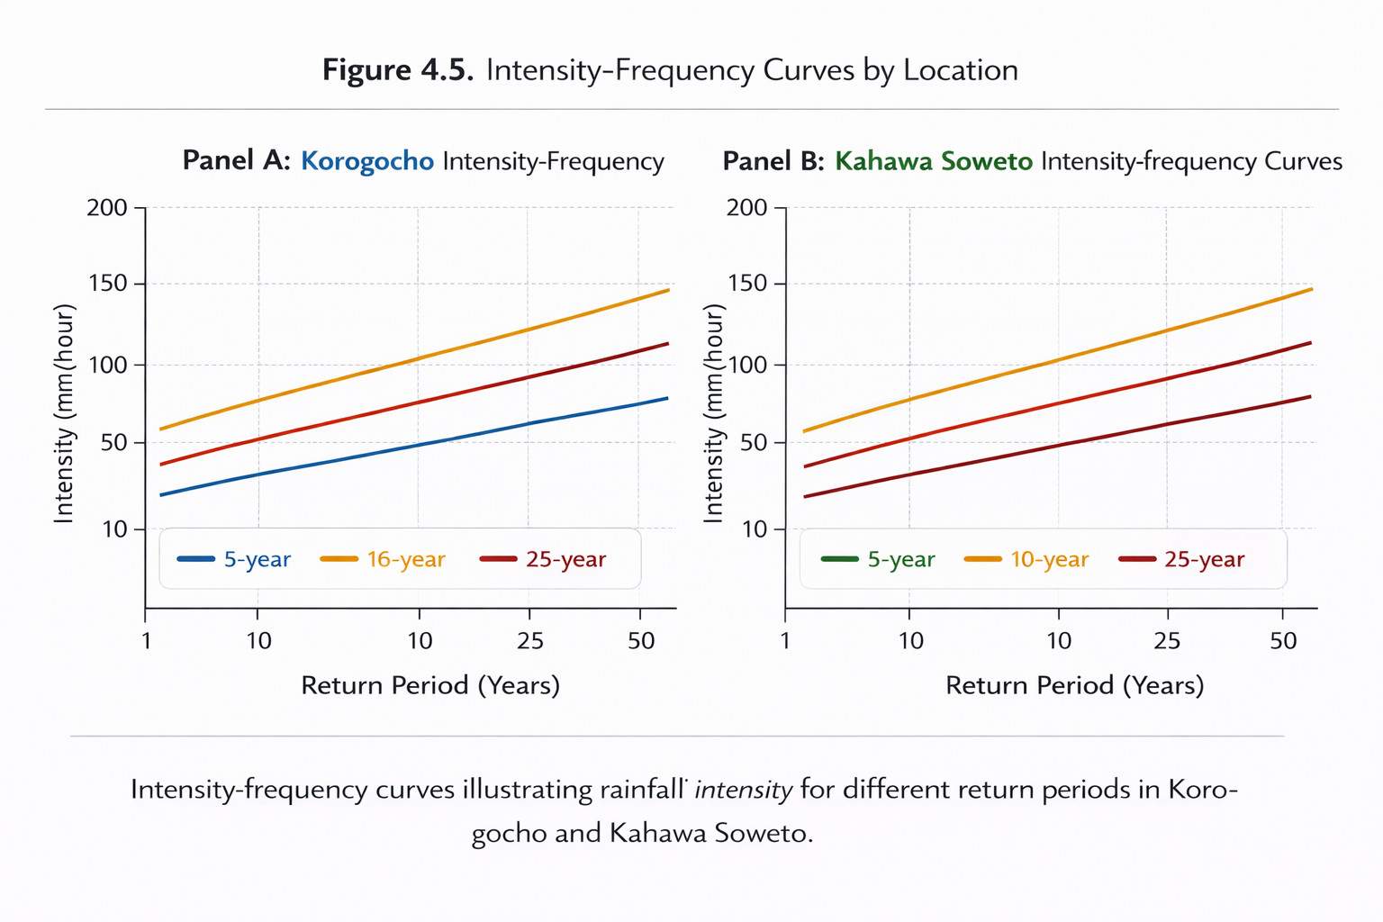
Figure 16. (A & B) intensity- Frequency Curves by Location
Panel A: Korogocho intensity-frequency curves
Panel B: Kahawa Soweto intensity-frequency curves
4.5 Discussion & Conclusion: Implications for Urban Flooding
The study found a weak but persistent rainfall increases (~2.5–3.2 mm/year) can exceed drainage capacities over time. Flash flooding is driven by high intensity and frequency (Korogocho), while chronic drainage stress occurs under moderate persistent rainfall (Kahawa Soweto). Small incremental increases reduce dry-season recovery, elevating runoff potential.
Policy relevance: urban drainage design must integrate marginal upward trends, update design rainfall values, and adopt nature-based solutions (retention areas, infiltration systems, green infrastructure).
4.6. Synthesis of Key Findings
Temperature had statistically significant warming trend (+0.023 °C/year). Rainfall had weak-to-moderate upward trends (~3 mm/year), marginally significant at 10% level while seasonality had stable bimodal regime; small increases in MAM and OND cumulatively affect annual totals
Urban flood risk was driven by intensity-frequency characteristics; small, persistent increases can trigger flash or cumulative flooding even if annual totals remain moderate. Practical Implication was that statistical significance alone underestimates risk; annual aggregation and flood-relevant metrics are essential for urban water management
4.7. Linking Climate Indicators to Socioeconomic Impacts
4.7.1 Observed and Reported Household Impacts
The study assessed the socioeconomic impacts of climate variability in Korogocho and Kahawa Soweto by combining household surveys, focus group discussions, and field observations:
Household-reported experiences: Residents provided perceptions of flooding frequency, waterlogging, property damage, and health impacts (e.g., waterborne diseases). These reports capture the lived experience of climate stress but may be influenced by recall bias or subjective interpretations of events.
Observed events: Field observations and local records of drainage blockages, temporary waterlogging, and flood-prone areas were used to triangulate reported experiences. These provide objective evidence but are limited to the observation period.
Community-level data: Local institutions, NGOs, and drainage authorities provided supplementary information on flood events, waste management challenges, and infrastructure failures. By combining these sources, the study achieves a triangulated assessment linking climate variability to socioeconomic vulnerability.
4.7.2 Analytical Linkage
Climate indicators (rainfall totals, intensity-frequency patterns, and temperature trends) were linked to household and community impacts as follows:
Rainfall Intensity-Frequency → Flood Damage: Korogocho experiences higher-intensity rainfall events during MAM and OND, leading to flash floods. These floods were reported to damage homes, block access roads, and disrupt small-scale businesses. Kahawa Soweto shows more persistent moderate rainfall, causing cumulative waterlogging that affects drainage, sanitation, and property over time.
Interannual Variability and Persistence → Chronic Vulnerability: Positive autocorrelation in rainfall (ACF: Korogocho 0.41, Kahawa Soweto 0.67) indicates wet years are likely followed by wet years, reducing recovery time between events. Households report recurring exposure to waterborne diseases and infrastructure failures, highlighting cumulative socioeconomic stress.
Temperature Increase → Health and Livelihood Stress: Warming trends (~0.023 °C/year) exacerbate heat stress, increase water demand, and may indirectly affect income-generating activities such as informal trade or urban agriculture.
Seasonal Shifts → Differential Impact by Settlement: Long rains (MAM) dominate progressive flooding events affecting Korogocho due to higher intensity and variability. Short rains (OND) produce flash floods, disproportionately impacting Kahawa Soweto where drainage systems are less resilient.
4.7.3 Potential Biases and Limitations
Perception vs Observed Events: Household surveys relied on memory and subjective experience; residents may over- or under-report events depending on personal exposure. Recall bias is likely for past events beyond 5–10 years, especially for small-scale or non-catastrophic floods.
Spatial and Temporal Coverage: Observational data may not capture micro-spatial variability within settlements; some localized flood-prone pockets may remain undocumented. Short observation windows for field verification can miss rare extreme events.
Socioeconomic Heterogeneity: Impacts vary across households depending on income, housing type, and social networks. Aggregated analysis may mask vulnerability differences.
Reporting Bias: Households affected more severely may be more likely to respond to surveys, inflating perceived severity.
4.7.4 Synthesis: Climate–Socioeconomic Vulnerability Link
Weak but persistent increases in rainfall (~2.5–3.2 mm/year) and intensity-frequency peaks exacerbate urban flooding, property damage, and sanitation challenges. Temperature rises contribute to heat stress, water demand, and livelihood disruptions. Korogocho residents experience more acute flash flooding impacts due to high-intensity events, while Kahawa Soweto households face chronic drainage stress. Despite statistical marginality in rainfall trends, the cumulative practical impact on socioeconomic conditions is significant, especially in informal settlements with limited infrastructure resilience.
Implication: Integrating observed and reported impacts with climate indicators allows urban planners and policymakers to prioritize interventions (drainage upgrades, early warning systems, and nature-based solutions) based on both hazard exposure and vulnerability profiles, while acknowledging potential biases in self-reported data.
Policy relevance and practical implications
Table 8. Policy Recommendations and Climate Adaptation Pathways for Korogocho and Kahawa Soweto Informal settlements
 | Policy Adaptation Area | Findings Linkage | Recommendations | Responsible Authorities | Implementation Notes
1 | Urban Drainage & Flood Management | Korogocho: high-intensity, frequent rainfall → flash flooding. Kahawa Soweto: moderate rainfall → chronic drainage stress. Incremental annual increases (~2.5–3.2 mm/year) and reduced dry-season recovery amplify flood hazards. | 1. Upgrade drainage infrastructure (≥6 mm/day; ≥13 events/month).2. Adopt decentralized stormwater management (retention ponds, infiltration trenches, rain gardens).3. Integrate flood early-warning systems (real-time monitoring, SMS alerts). | Nairobi City County Government (Urban Planning & Public Works), KMD, County Disaster Units, NGOs/CBOs | Conduct hydraulic modeling; prioritize hotspots; pilot retention systems; deploy low-cost rain gauges; establish community flood risk committees.
2 | Heat Mitigation & Temperature Adaptation | Statistically significant warming (+0.023 °C/year) → increased heat stress, water demand, urban livability challenges. | 1. Plant shade trees along streets and open spaces.2. Introduce reflective or green roofs in high-density settlements. | County Environment & Public Health Departments | Integrate into ongoing settlement upgrading programs; incentivize rooftop greening via micro-grants.
3 | Community Heat Awareness Campaigns | Increased temperature stress and behavioral risks for residents. | Promote hydration, reduced exposure, and night-time activities. | County Health Offices, Local NGOs | Link campaigns to schools, health clinics, and local CBOs.
4 | Settlement Upgrading & Climate-Resilient Planning | Accumulated rainfall and persistent flooding affect household infrastructure, sanitation, livelihoods; site-specific interventions required. | 1. Integrate climate data into upgrading plans.2. Prioritize relocation or flood-proofing of vulnerable units.3. Adopt raised platforms or flood-resistant housing materials. | Nairobi City County Planning Department, Ministry of Lands, Housing & Urban Development | Map vulnerability zones using rainfall intensity-frequency analysis; incorporate into urban development plans.
5 | Community-Level Drainage Governance | Local drainage maintenance and flood response capacity is limited. | 1. Establish local committees for drainage maintenance and flood response.2. Train residents in waste management to reduce blocked drains. | Local Ward Administrators, NGOs/CBOs | Embed in participatory planning frameworks; provide tools and stipends for maintenance teams.
6 | Climate Information Services | Incremental rainfall and temperature changes have cumulative practical impacts on livelihoods and urban infrastructure. | 1. Enhance access to localized climate projections.2. Disaggregate data to neighborhood level (Korogocho, Kahawa Soweto). | Kenya Meteorological Department, Academic Partners | Provide open-access digital dashboards for county planners and community leaders.
7 | Linking Climate Projections to Municipal Planning | Weak statistical trends but cumulative effects necessitate integration into planning. | Update building codes, drainage design manuals, and flood risk maps using recent IDF curves. | Nairobi City County Urban Planning & Public Works, KMD | Revise every 5 years; integrate into climate-resilient urban planning policies.
8 | Flood Early Warning Integration | Flash floods in Korogocho and cumulative drainage stress in Kahawa Soweto require real-time response. | Deploy real-time rainfall monitoring systems and SMS alerts for residents. | KMD (data), County Disaster Management Units | Establish low-cost rain gauges; set up community-based flood risk committees.
9 | Decentralized Stormwater Management | Community-level water retention and infiltration needed to reduce flood risk. | Implement retention ponds, infiltration trenches, rain gardens in vulnerable neighborhoods. | County Government with NGO/CBO partnerships | Pilot in targeted neighborhoods; monitor flood frequency reduction and community engagement.

Link to Study Findings:
These measures directly address observed and reported household impacts (flooding, property damage, drainage blockages, heat stress) and account for weak but persistent climate trends identified in Korogocho and Kahawa Soweto. They provide feasible pathways to integrate climate adaptation into informal settlement upgrading, infrastructure planning, and urban water management, ensuring resilience against cumulative and extreme events.
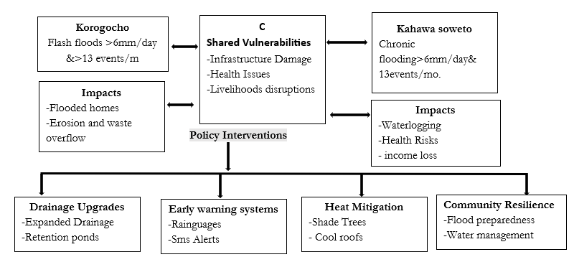
Figure 17. conceptual framework of settlement-level Climate Impacts and policy interventions in Korogocho & Kahawa Soweto. Source: (field research, 2025).
3.8. Ethics Approval and Consent
Household surveys and key informant interviews were conducted with written informed consent, ensuring voluntary participation and the right to withdraw at any time. Confidentiality and anonymity were maintained through coded identifiers and secure data storage. The study protocol was approved and data collection was conducted in accordance with ethical standards for social research, with sensitivity to local cultural norms and participants’ privacy.
Disclaimer (Artificial intelligence)
Author(s) hereby declare that NO generative AI technologies such as Large Language Models (ChatGPT, COPILOT, etc.) and text-to-image generators have been used during the writing or editing of this manuscript.
References
Ngugi, R. K., Otieno, F., & Kinyua, A. (2020). Urban heat islands and vulnerability in Nairobi informal settlements. Urban Climate, 31, 100566. https://doi.org/10.1016/j.uclim.2019.100566.
Ochieng, D. O., Were, E., & Ouma, G. (2021). Microclimatic effects and adaptation strategies in Nairobi’s informal settlements. Environmental Research Letters, 16(4), 045001. https://doi.org/10.1088/1748-9326/abfddf
Omedo, G. (2010). Vulnerability of urban informal settlements to environmental hazards: A case study of Korogocho in Nairobi (Unpublished master’s thesis). University of Nairobi, Kenya. http://erepository.uonbi.ac.ke/handle/11295/459Correct
Ong, C., Paterson, R., & Wanjiru, R. (2018). Public health impacts of urban heat waves in East African informal settlements. International Journal of Environmental Research and Public Health, 15(6), 1202. https://doi.org/10.3390/ijerph15061202.
Ostrom, E. (2009). A general framework for analyzing sustainability of social–ecological systems. Science, 325(5939), 419–422. https://doi.org/10.1126/science.1172133
Owuor, S., Wanyonyi, C., & Kibet, K. (2020). Flood risk analysis in Nairobi informal settlements under climate variability. Environmental Monitoring and Assessment, 192(2), 118. https://doi.org/10.1007/s10661-020-8070-2
Sen, P. K. (1968). Estimates of the regression coefficient based on Kendall’s tau. Journal of the American Statistical Association, 63(324), 1379–1389. https://doi.org/10.1080/01621459.1968.10480934
Simiyu, S., & Mberu, B. (2024). Climate variability, water insecurity, and health risks in Nairobi’s informal settlements. Environment and Urbanization, 36(1), 145–162. https://doi.org/10.1177/09562478221147268
United Nations Environment Programme (2021). Responding to climate change in African cities. United Nations Environment Programme. Retrieved from https://www.unep.org/regions/africa/regional-initiatives/responding-climate-changehttps://www.unep.org/resources/report-name
UN-Habitat. (2020). World Cities Report 2020: The value of sustainable urbanization. United Nations Human Settlements Programme. https://unhabitat.org
World Bank. (2020). Enhancing urban resilience: Addressing climate risks in informal settlements of Sub-Saharan Africa. World Bank Group. https://doi.org/10.1596/978-1-4648-1559-9
Intergovernmental Panel on Climate Change. (2022). Climate Change 2022: Impacts, adaptation, and vulnerability. Cambridge University Press. https://www.ipcc.ch/report/ar6/wg2/
Moser, C. O. N. (2010). Ordinary families, extraordinary lives: Assets and poverty reduction in Guayaquil, 1978–2004. Brookings Institution Press. Retrieved from https://www.brookings.edu/books/ordinary-families-extraordinary-lives/Alanda, J., Otieno, P., & Kithiia, J. (2024). Integrated urban resilience strategies in informal settlements of sub-Saharan Africa. Habitat International, 143, 102973. https://doi.org/10.1016/j.habitatint.2023.102973
Andersen, L. S., Corburn, J., & Mberu, B. (2024). Climate change knowledge, attitudes, practices, and health risks in Mukuru informal settlement, Nairobi. International Journal of Environmental Research and Public Health, 21(3), 1184. https://doi.org/10.3390/ijerph21031184
Balakrishnan, K., Ng, C. F. S., & Smith, K. R. (2024). Climate vulnerability and urban poverty in African cities: Evidence from Nairobi. The Lancet Planetary Health, 8(2), e92–e103. https://doi.org/10.1016/S2542-5196(23)00241-9
Caleb, M., Otieno, R., & Wekesa, B. (2024). Social capital and household resilience to climate shocks in urban informal settlements. World Development Perspectives, 33, 100570. https://doi.org/10.1016/j.wdp.2024.100570
Anyamba, A., Chretien, J. P., Small, J., Tucker, C. J., Formenty, P. B., Richardson, J. H., & Linthicum, K. J. (2014). Climate variability and outbreaks of Rift Valley fever in East Africa. PLoS Neglected Tropical Diseases, 8(4), e2845. https://doi.org/10.1371/journal.pntd.0002845
Cutter, S. L., Barnes, L., Berry, M., Burton, C., Evans, E., Tate, E., & Webb, J. (2008). A place-based model for understanding community resilience to natural disasters. Global Environmental Change, 18(4), 598–606. https://doi.org/10.1016/j.gloenvcha.2008.07.013
Douglas, I., Alam, K., Maghenda, M., McDonnell, Y., McLean, L., & Campbell, J. (2008). Unjust waters: Climate change, flooding and the urban poor in Africa. Environment and Urbanization, 20(1), 187–205. https://doi.org/10.1177/0956247808089156Folke, C. (2006). Resilience: The emergence of a perspective for social–ecological systems analyses. Global Environmental Change, 16(3), 253–267. https://doi.org/10.1016/j.gloenvcha.2006.04.002
IPCC. (2022). Climate change 2022: Impacts, adaptation and vulnerability. Cambridge University Press. https://doi.org/10.1017/9781009325844
Kendall, M. G. (1975). Rank correlation methods (4th ed.). Charles Griffin.
Kizza, M., Muhereza, F., & Tumusiime, D. (2016). Rainfall variability and urban flood risk in East Africa. Natural Hazards, 82(2), 933–949. https://doi.org/10.1007/s11069-016-2415-4
Mann, H. B. (1945). Nonparametric tests against trend. Econometrica, 13(3), 245–259. https://doi.org/10.2307/1907187
Mati, B. M., Majule, A. E., & Mbonile, M. J. (2016). Climate variability and urban heat risks in East Africa. Climate and Development, 8(4), 355–366. https://doi.org/10.1080/17565529.2015.1010249
Moser, C. (2010). Urban social policy and poverty reduction in developing countries. Routledge.
Neumayer, E., & Plümper, T. (2007). The gendered nature of natural disasters: The impact of catastrophic events on the gender gap in life expectancy, 1981–2002. Annals of the Association of American Geographers, 97(3), 551–566. https://doi.org/10.1111/j.1467-8306.2007.00563.x
Ngugi, R. K., Otieno, F., & Kinyua, A. (2020). Urban heat islands and vulnerability in Nairobi informal settlements. Urban Climate, 31, 100566. https://doi.org/10.1016/j.uclim.2019.100566
Ochieng, D. O., Were, E., & Ouma, G. (2021). Microclimatic effects and adaptation strategies in Nairobi’s informal settlements. Environmental Research Letters, 16(4), 045001. https://doi.org/10.1088/1748-9326/abfddf
Omedo, P. O. (2010). Livelihoods, vulnerability and resilience in informal settlements: The case of Korogocho, Nairobi. University of Nairobi.
Ong, C., Paterson, R., & Wanjiru, R. (2018). Public health impacts of urban heat waves in East African informal settlements. International Journal of Environmental Research and Public Health, 15(6), 1202. https://doi.org/10.3390/ijerph15061202
Ostrom, E. (2009). A general framework for analyzing sustainability of social–ecological systems. Science, 325(5939), 419–422. https://doi.org/10.1126/science.1172133

Owuor, S., Wanyonyi, C., & Kibet, K. (2020). Flood risk analysis in Nairobi informal settlements under climate variability. Environmental Monitoring and Assessment, 192(2), 118. https://doi.org/10.1007/s10661-020-8070-2
Sen, P. K. (1968). Estimates of the regression coefficient based on Kendall’s tau. Journal of the American Statistical Association, 63(324), 1379–1389. https://doi.org/10.1080/01621459.1968.10480934
Simiyu, S., & Mberu, B. (2024). Climate variability, water insecurity, and health risks in Nairobi’s informal settlements. Environment and Urbanization, 36(1), 145–162.
UNEP. (2021). Responding to climate change in African cities. United Nations Environment Programme.
UN-Habitat. (2020). World cities report 2020: The value of sustainable urbanization. United Nations Human Settlements Programme. https://unhabitat.org
World Bank. (2020). Enhancing urban resilience: Addressing climate risks in informal settlements of Sub-Saharan Africa. World Bank Group.
Intergovernmental Panel on Climate Change. (2022). Climate change 2022: Impacts, adaptation, and vulnerability. Cambridge University Press. https://www.ipcc.ch/report/ar6/wg2/
Moser, C. O. N. (2010). Ordinary families, extraordinary lives: Assets and poverty reduction in Guayaquil, 1978–2004. Brookings Institution Press.
UN-Habitat. (2020). World cities report 2020: The value of sustainable urbanization. United Nations Human Settlements Programme. https://unhabitat.org/

