Impact of a Local Ingredient-Based Diet on the Performance of Isa Brown Laying Hens in Ngozi, Northern Burundi

.
ABSTRACT

The aim of this study was to assess the effects of different diets formulated using local ingredients on the growth of hens and their egg production, with a view to contributing to food security. Feeding laying hens with locally produced oilseed cakes will improve egg availability, thereby contributing to food security for the population. The study was conducted in the town of Ngozi, the administrative headquarters of the province of Butanyerera, located in northern Burundi. It lasted seven months, from 5 October 2023 to 31 May 2024.

This study was conducted on a total population of 190 ISA Brown hens housed in three separate henhouses, each receiving feed formulated from local resources. The sample size of 128 hens was calculated using the formula developed by Morgan and Krejcie. Next, a stratified sampling method was used to select the hens constituting this sample. The parameters measured included the nutritional composition of the cakes (protein, fat and calcium), weight and egg production. The protein content of the feeds cake was determined using the Kjeldahl method, and the calcium content was measured using atomic absorption spectrophotometry. The determination of fat content was carried out using methods for analyzing directly extractable fats. The data obtained were then analyzed using repeated-measures ANOVA, and a Mauchly’s sphericity test was also used to compare the variances between the different chicken coops. A Bonferroni correction and a post-hoc test were applied.

The feeds cakes formulated for the Livestock of henhouse 1 had the highest proteins and fat content (14, 8 percent and 8, 96 percent respectively) while the highest content of calcium was found in the feeds cakes made for Livestock of henhouse 2. Farmhouse 1 (fed a diet of maize, soya and sunflower seeds) performed significantly better, producing 4,199 eggs during the study period. The performances of henhouses 2 and 3 were significantly lower, with delayed egg-laying and low egg yields (1,035 and 334 eggs respectively) during the same period. The first experimental henhouse generated high income (2,939,300 BIF) while this period.
Balanced feeding of ISA Brown laying hens significantly improves their productivity and effectively contributes to household food security through increased egg availability. Appropriate nutritional supplementation of chicken is essential to optimize their zootechnical performances.

Keywords: Rearing of laying hens, ISA Brown breed, feedings formulation, egg production and food security

1. INTRODUCTION

Food security remains a major challenge in many parts of the world, despite advances in agricultural production. According to the Food and Agriculture Organization of the United Nations (FAO), around 735 million people were still facing acute food insecurity in 2022, revealing that access to sufficient and nutritious food remains limited for a significant proportion of the world’s population (FAO et al., 2023). In this context, increasing animal protein production, particularly through egg production, is a key strategy for improving households’ nutritional availability(FAO, 2011) acknowledging that egg consumption remains modest on a global scale, estimated in 2020 at 185 eggs per capita per year(Guyonnet, 2023).
.
In Africa, poultry production is increasing, but it remains insufficient to meet demand. Data indicate that average egg consumption in Africa is around 36 eggs per person per year(Tukhur, 2011). In sub-Saharan Africa, poultry farming systems are often characterized by suboptimal feeding practices, a lack of quality inputs and limited technical knowledge, which negatively affects hen productivity(Adjei-mensah et al., 2024).
In Burundi, particularly in Butanyerera province, poultry farming is a major source of income and nutrition for many households. However, despite the increasing use of high-performance breeds such as ISA Brown, the productivity of laying hens remains variable, largely due to diets that are often unsuitable(Mugenzi, 2024). Furthermore, the diet of laying hens is a key determinant of their productivity, directly influencing the number of eggs produced and, by extension, the food security of the population(Bouvarel et al., 2010).
However, on small-scale poultry farms in Ngozi, the capital of Butanyerera Province in the north of the country, the hens’ feed consists mainly of local resources (rice bran, kitchen scraps, unprocessed maize), which are often deficient in protein, energy, vitamins and minerals. This has a negative impact on egg availability in the study area. There is a gap in the local literature regarding the effect of different diets on egg production and how this production contributes to improving local community food security.
The objectives of this research is to analyze the quality of layer feed formulated using local ingredients, and its impact on the growth and egg production of ISA Brown hens, thereby enhancing food security.
This understanding will not only help to fill these scientific gaps, but also guide appropriate technical interventions for local poultry farmers and policy-makers to strengthen food security.

2. material and methods
2.1. Study area and period

The study was conducted in the town of Ngozi, the administrative headquarters of the province of Butanyerera in northern Burundi. It lasted seven months, from 5 October 2023 to 31 May 2024.

2.2. Study type

This is a longitudinal experimental study of ISA Brown laying hens reared in three separate henhouses. Each of these henhouses used a specific diet formulated using locally sourced feed.

2.3. Reference population

The study population was made up of 190 hens housed in three different henhouses:
- Henhouse number 1, located in the Gisagara quarter: 75 hens;
- Henhouse number 2, located in the Kinyami quarter: 65 hens;
- Henhouse number 3, located in the Rubuye quarter: 50 hens.

2.4. Materials

- Weighing and temperature measurement: logbook, precision scales and wall-mounted thermometer
- For collecting and transport: egg pallet;
- For watering and feeding: feeders, drinkers, jerry cans, buckets, sacks

2.5. Methods

2.5.1. Calculation of sample size

Our sample size was calculated using the Morgan and Krejcie formula(Ahmad & Halim, 2017):
$$n=\frac{χ^{2}*N*P(1-P)}{d^{2}\left(N-1\right)+χ^{2}*P(1-P)}$$
Where:
n = required sample size
$χ^{2}=$the table value of chi-square for 1 degree of freedom at the desired confidence level of .05= (3.841)
N = the population size
P = the population proportion (assumed to be .05 since this would provide maximum sample size
d = the degree of accuracy expressed as a proportion (.05).
Thus, the sample
$$n=\frac{{1.96}^{2}*190*0.5(1-0,5)}{{0.05}^{2}*\left(190-1\right)+{1.96}^{2}*0.5(1-0.5)}=128 hens$$

Growth data were measured for the 128 hens selected as the sample for this study.

2.5.2. Sampling method

A stratified sampling technique(Anderson et al., 2007) was used to identify the 128 hens comprising our sample and to ensure that the various henhouses were represented. We therefore calculated the number of hens to be selected from each henhouse by multiplying the sample size by the total number of hens in the henhouse in question, divided by the overall population.
The weighted averages of the sample sizes obtained are: 50 hens for henhouse number 1; 44 hens for henhouse number 2 and 34 hens for henhouse number 3. These hens, which make up our sample, are chosen at random from each henhouse. We therefore assigned numbers to the hens in each henhouse and selected the n statistical units constituting our sample from a table of random numbers.

2.5.2.1. Inclusion criteria

Laying hens must be of the ISA Brown strain and reared in the three experimental henhouses.

2.5.2.1. Exclusion criteria

- Laying hens of the ISA Brown strain that are not reared in the three experimental henhouses;
- Other strains of laying hens;
- Other breeds of hen.

2.5.2. Experimental chicken coops

Three experimental chicken coops were set up at the same time (on 5 October 2023) and housed the same breed of hens, ‘ISA Brown’. This breed was imported from Belgium. In each henhouse, the hens are fed various types of feed (oilseed meal) produced according to formulae elaborated by poultry farmers

2.5.3. Diet used in this study

The feed pellets given to the experimental hens are composed of different ingredients depending on the producer (Table 1, Table 2, and Table 3).

Table 1: Feed formula for hens reared in Poultry House 1
Table 2: Feed formula for hens reared in Poultry House 2

Table 3: Feed formula for hens reared in Poultry House 3
The three types of chicken feed produced constituted their diet throughout the study period.
Samples of the three formulated feed recipes were harvested and sent to the Soil and Agri-Food Products Analysis Laboratory at the Burundi Institute of Agricultural Sciences to determine their fat, protein and calcium content. All the laying hens in the three chicken coops received the same preventive health treatment.

2.6. Biochemical analysis of the poultry feeds formulated
2.6.1 Sample preparation

The samples were prepared for analysis in accordance with Association of Official Analytical Chemists (AOAC) International Official Method 922.02(AOAC, 2019). For animal feeding stuff, prepare the test sample as specified in ISO 6498(International Organization for Standardization, 2012).

2.6.2. Fat content analysis

Fat was determined according to the Determination of Fat in Cereals and Cereal -based Products by Randall Extraction-method FSSAI 03.038(Food Safety and Standards Autority of India, 2022). Fat is extracted using light petroleum as a solvent and the Randall modification of the Soxhlet method. A dried, ground test portion of 5 g of feed is extracted by a 2-step process: In the first step, the thimble containing the test portion is immersed into the boiling solvent. The intermixing of matrix with hot solvent ensures rapid solubilization of extractables. The thimble is then raised above the solvent and the test portion is further extracted by a continuous flow of condensed solvent. The solvent is evaporated and recovered by condensation. The resulting crude fat residue is determined gravimetrically after drying.

2.6.3. Determination of protein content

The protein content of the samples was determined from total nitrogen measured using the Kjeldahl method as described in method FSSAI 03.016(Food Safety and Standards Autority of India, 2022).The method is based on the principle that concentrated sulphuric acid in the presence of a catalyst helps in the digestion of food. All of the nitrogen is converted ammonium sulphate. By distillation in the presence of a base such as NaOH it is converted into ammonia. The ammonia is trapped in an acid (e.g. Boric acid), and titrated against 01N hydrochloric acid. The nitrogen is converted into protein by multiplying with a conversion factor 6.25.

2.5.4. Determination of the calcium content

Calcium content in all the samples were estimated by Inductively Coupled Argon Plasma Optical Emission Spectrophotometer (ICP-OES) ICAP 6000 series(AOAC, 2019).
2.7. Data collection

- Growth monitoring data were collected through monthly measurements until the start of egg-laying on 2 March 2024;
- From that date onwards, data on egg-laying trends were collected on a daily basis until 31 May 2024.

2.8. Data entry and cleaning

The data obtained was then entered manually into Microsoft Excel and any errors were corrected.

2.9. Statistical analysis of data

The data from this study were analyzed using Python software. Specifically, the growth data for the hens were subjected to a repeated measures ANOVA. The Mauchly test was used to verify the hypothesis of equal variances of the differences between successive measurements, and the post hoc test with Bonferroni correction was used to compare the henhouses in pairs.

3. results and discussion

Feeding laying hens three types of feed produced from local grains allowed us to assess their effects on growth, egg-laying performance, and egg production, and consequently on the availability of eggs for human consumption to ensure food security for the population. The study focused on three chicken coops, one of which belonged to the student and the other two to private farmers. A total of 190 ISA Brown chicks were purchased for the project. Chicken coop 1 housed 75 chicks; chicken coops 2 and 3 shared the remainder, with 65 and 50 chicks, respectively. Each farm manager formulated the feed for their own coop.

3.1. Quality of formulated oilseed meal

Analysis of the meal samples intended for the three cohorts of hens reveals variations in their nutritional composition, including protein, fat, and calcium (Table 4).

Table 4: Nutrient composition (protein, fat and calcium) of the formulated feed cakes
The calcium content results were calculated with an uncertainty of ±0.04%, indicating good measurement accuracy for this mineral.

3.1.1. Protein content of formulated oilseed meal

Protein levels vary considerably among the chicken coops: Coop 1 had the highest content, followed by Coop 3, while Coop 2 shows a lower value (Table 1). This disparity is attributed to differences in the composition of the raw materials used to produce the meal, as well as variations in manufacturing processes (particularly cooking). Only the feed for chicken coop 1 contained the protein content required for the production diet of laying hens(Medjdoub & Imarazene, 2023).
A lower protein content in chicken house 2 could limit the growth or production of the hens, especially if protein requirements are not met by other sources. The protein content in Chicken House 1 meets the recommended protein range for growing hens (11–17 weeks) (H&N International, 2020), whereas the feeds in Chicken Houses 2 and 3 do not meet the required protein levels at any stage of a hen’s life.

3.1.2. Fat content of formulated oilseed meal

Fats content have a similar trend to that of protein: House 1 had the highest levels, while Houses 2 and 3 show lower values that are relatively close to each other (Table 1). Fat is an important source of energy. A higher fat content in henhouse 1 could therefore be beneficial for animals with increased energy needs (for example, during laying or growth periods). Conversely, a lower fat content in henhouses 2 and 3 could be insufficient if the diet is not supplemented with other energy sources. Our results for the fat content in the meal from poultry house 1 are similar to those found in cashew meal (Ouattara, 2023), while the other groups have lower levels.

3.1.3. Calcium content of formulated oilseed meal

Calcium is essential, particularly for eggshell formation. The results show moderate variability (Table 1). As the measurement uncertainties (±0.04%) are identical for all three henhouses, the observed differences are indeed real. Only the feed for chicken coop 2 contained the calcium content required for the production diet of laying hens(Medjdoub & Imarazene, 2023). Housing 2 receives a meal higher in calcium, which could be an advantage if the hens in this housing are in an intense laying phase. In contrast, henhouse 3 has a calcium content slightly lower than that of henhouse 1, which might require supplementation if requirements are high. This calcium content is sufficient for hens aged 25–27 weeks, consistent with the opinion suggested in other research(Korver et al., 2019).

The poultry feed from the first chicken coop is more suitable for raising laying hens intended for egg production. Other feeds (from chicken coops 2 and 3) are less nutritious and do not fully meet the nutritional requirements of ISA Brown laying hens. The hypothesis that meal produced from local feed ingredients contains the required concentrations of protein, fat, and calcium is partially validated. The performance data from Poultry House 1 (Gisagara) demonstrate that a diet primarily based on corn, soybeans, and sunflower seeds can effectively meet the nutritional needs of ISA Brown laying hens. This suggests the need to train poultry farmers in methods for formulating feed pellets for laying hens using local ingredients.

3.2. Effect of formulated feed cakes on the body weight of hens reared during five first months of farm

The growth curves for the chickens of the three coops are different (figure 1). The growth trend shows a gradual increase in the weight of the hens in the three chicken coops over the observation period.
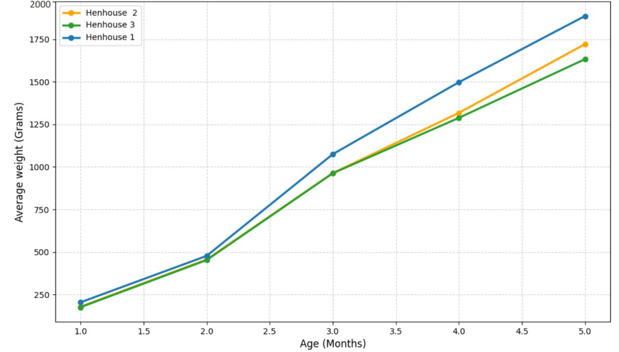
Figure 1: Weight Growth evolution of chickens in the three experimental henhouses
Despite receiving the same amount of feed, differences in growth are observed among the chicken coops. The hens in the Gisagara coop (Henhouse 1) have higher average weights, followed by those in Kinyami (Henhouse 2), while those in Rubuye (Henhouse 3) show relatively lower growth performance. These differences suggest a probable influence of the nutritional composition of the cake used. Statistical tests (ANOVA, P< 0.001) revealed significant differences in weight gain between the chicken coops (table 6).

3.2. Statistical tests
3.2.1 Results of Mauchly's sphericity test

A Mauchly sphericity test was carried out to check the homogeneity of the variances in the weight differences across the levels of the time factor (months).

Table 5: Results of Mauchly's Sphericity Test
As the p-value is significantly less than 0.05, the assumption of sphericity is rejected. Consequently, a correction for degrees of freedom (the Greenhouse-Geisser correction) was applied to the ANOVA to ensure the validity of the results.
The results of the mixed ANOVA presented in Table 6 show the effects of two factors (Housing and Month) and their interaction on the measured variable (hen weight).

Table 6: results of ANOVA
The ANOVA results show highly significant effects for the ‘Housing’ factor, the ‘Time’ factor, and their ‘interaction’. This means that the differences in weight between the housing groups are statistically significant. Weight changes significantly over time, and this change is not the same for all housing groups.

3.2.2. Results of Post-hoc tests

Post-hoc tests with Bonferroni correction were carried out to identify specifically how the growth of the hens from the three henhouses differed among themselves.

Table 7: Post-hoc test comparing the growth of hens from the three chicken coops
Comparison between Poultry Houses:
- Chicken coop 2 and chicken coop 3: no statistically significant difference (P > 0.05) over the entire cycle, although chicken coop 2 performed slightly better.
- Chicken coop 1 and chicken coop 3: Significant difference (P < 0.05). The growth of the hens in the chicken coop 1 surpasses that of the hens in the chicken coop 3.
- Chicken coop 1 and chicken coop 2: Significant difference (P < 0.05). The hens from the Chicken coop 1 grew faster than those from the Chicken coop 3.
This suggests that the Chicken coop 1 farm performs better overall and that the differences between the Chicken coop 2 and Chicken coop 3 farms are less significant.

3.2. Egg production for the three experimental henhouses

The production phase was monitored on a daily basis across the three henhouses for three months of laying, recording the number of eggs collected since the start of the laying period (figure 2).

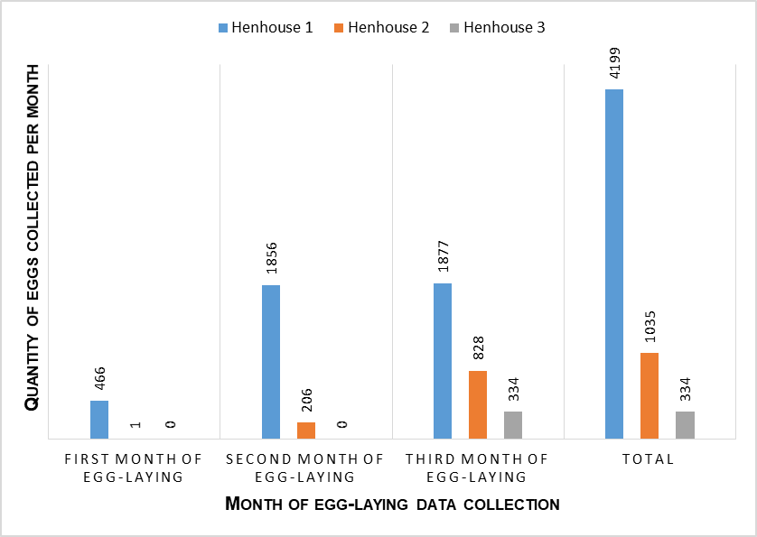
Figure 2: egg production from the three experimental henhouses

Housing 1 is characterized by early and high-volume egg production, with output remaining at a very high level since the second month. Henhouse 2 shows a late start (virtually zero in the first month) but a steady increase over the months. Henhouse 3 has an even later start (no eggs for the first two months) and modest production in the third month. This is due to the quality of the feed.

3.3. Evolution of the egg-laying rate per henhouse

This study shows that the feed provided to the hens in poultry house 1 had a more positive effect on the laying rate of ISA Brown laying hens than the other diets in poultry houses 2 and 3 (figure 2).
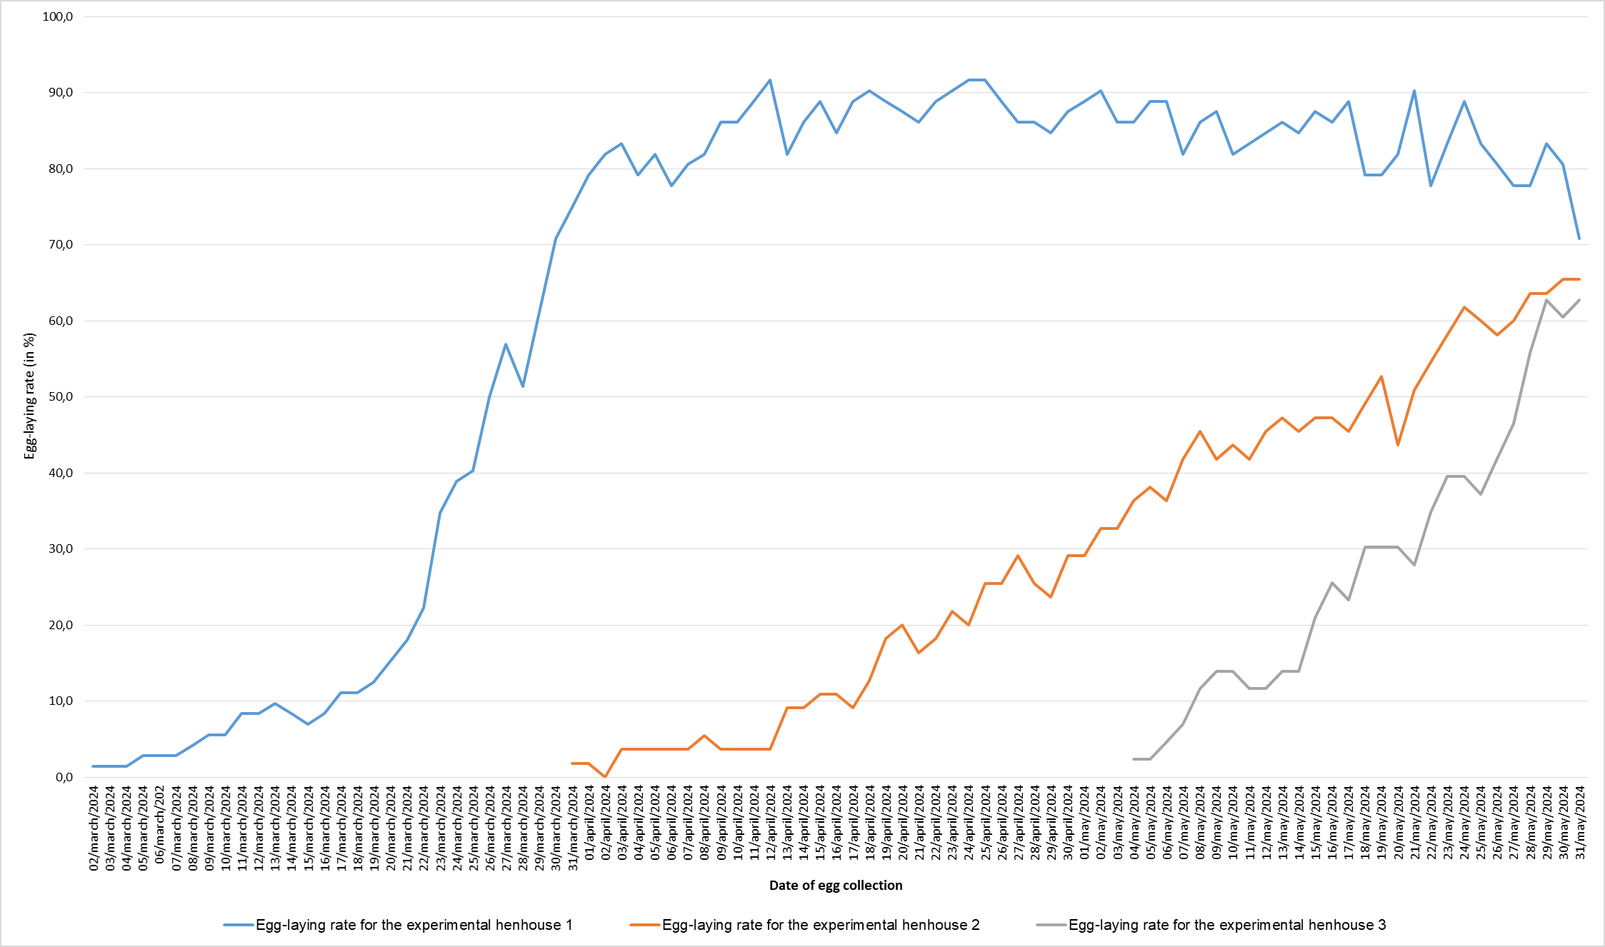
Figure 3: Evolution of egg-laying rates in the three experimental henhouses

The trends in egg-laying curves over the study period for the three experimental henhouses are markedly different. These differences in egg production can be explained by the nutrient content, particularly the protein, calcium and fat content, of the hens’ daily feed. Our results are similar to those found in previous research conducted with different varieties of maize(Guedou et al., 2018). The egg-laying trends observed at henhouse 1 effectively improve food security for the farmer and the surrounding population through high egg production.

According to the figure 3, the first egg was harvested the second day of march 2024 (at the age first egg laying of 22th week) for first henhouse, the 31th day of March 2024 (at the age first egg laying of 26th week) for the second henhouse and the 4th day of May 2024 (at the age first egg laying of 31^{rst} week) for the third henhouse (figure 3). The age at first lay in house 1 suggests good performance compared with the other two houses. This is in line with the findings of the authors, who highlighted that age at first lay (AFP) is an economically important trait in the production of breeding chickens(Ma et al., 2024). Furthermore, this age is linked to feed quality and offers advantages in terms of reproductive performance(Tan et al., 2021).

3.4. Use of the experimentation's production

Eggs from the three chicken coops (figure 2) were primarily consumed by the investors’ families and sold to local households. In addition, the generated manure was sold, and this boosted the income of the exploitations concerned. This supports the assertion that one of the key roles of agriculture is to provide nutritious food to the households that produce it (Haddad, 2013). The increasing of the egg-laying industry is therefore expected to contribute to food and nutritional security, both directly (for example, through subsistence consumption) and indirectly (for example, through income generation).

3.4.1. Consumption of eggs produced in the three experimental henhouses

All family members of the poultry farmers at the three experimental poultry houses appreciate the importance of rearing laying hens by eating omelets made with their eggs, which contribute to their nutrition bearing in mind that consumption of one egg per day per person described as moderate in most nutritional studies can in fact make a significant contribution to the consumer’s nutritional requirements, particularly in terms of various minerals, vitamins and carotenoids of interest (Nau, 2024). The local community also benefits from these farms by buying eggs for consumption. This importance of rearing hen with feeds quality reduce the constraint of egg consumption in study area knowing that the limitations of egg consumption are basically linked to two main factors of availability and utilization(Guyonnet, 2020).

3.4.2. Income from the three experimental farm

The feed costs for each of the three experimental chicken coops and the income generated during the study period are reported in Figure 4. The poultry farmer from the first chicken coop spent more money in Burundian(International Standard Organisation, 2015) francs (BIF) on high-quality feed than the other two farmers, and he also earned higher profits during the study period.

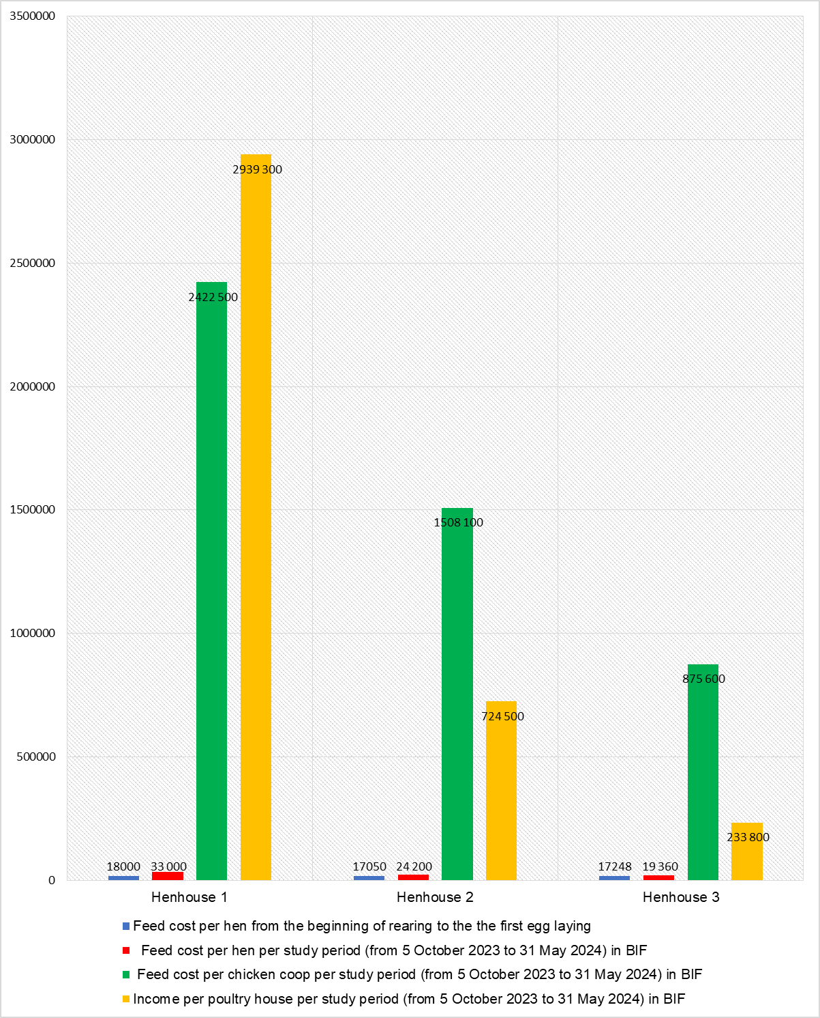
Figure 4: Feed costs and income of the three experimental chicken coops
The results showed that the feed cost per hen from the start of rearing until laying age was high in the first henhouse, as was the feed cost during the study period. This increase in feed cost was due to the quality of the ingredients used in the formulation of the feed pellets intended for the hens on this farm. Consequently, this farm generated more revenue during the study period. At the end of this study, the poultry farmer running this henhouse had already recouped the full cost of the feed invested and even had a surplus (figure 4). This corroborated with the suggestions of others authors who indicated that the poultry farming industry is a substantial contributor to economy(Haruna et al., 2025).

In contrast, the other two farmers used few resources when formulating the feed cakes, resulting in mixtures that were less rich in the nutrients the hens need to develop zootechnical performance, particularly good growth and egg production. This caused delays and even losses for these chicken farmers, such that by the end of this study, they had not yet recouped the cost of the feed they had invested (figure 4). Nevertheless, all three farmers incurred almost the same feed cost per hen from the start of rearing until laying (figure 4).This highlights the importance of formulating high-quality feed cakes to optimize the rearing objectives for hens, particularly ISA Brown laying hens. This study highlighted the impact of the formulation of quality feed pellets on hen production. This corroborated with findings of others researchers in which authors found that the egg production is hampered by an insufficient supply of feed(Akinola & Essien, 2011), the variable quality of animal feed(Diarra, 2017).

The cost of feeding a hen (33,000 BIF) nourished with cake (figure 4), which yielded good egg production in this study (cake from poultry house 1) over a seven-month period, highlights the importance of rearing hens with minimal financial resources in a household. With 100,000 BIF, for example, a household can feed three hens, ensuring a supply of eggs and diversifying the family’s income according to the suggestion of others authors who told that sufficient capital is crucial for a firm to operate efficiently and the financial resources a corporation allocates will influence its revenue generation (Adila & Mustahidda, 2024). Furthermore, this enables them to access animal protein through the consumption of the eggs produced. The development of chicken feed formulations would enable local households to boost poultry production. This is in line with the views of Mamoudou Ba, who stated that helping farming households to improve and expand their livestock herds is a way of addressing the challenges posed by multiple climatic and economic shocks, and thereby reducing food insecurity(Ba, 2020).

According to this research, a capacity-building in the formulation of layer feed is key to ensuring a nutrient-rich diet and optimizing egg availability in the local area, thereby promoting egg consumption and food security for the population. The enrichment of laying hens’ diets through the formulation of high-quality oilseed cakes may therefore provide a solution to the challenges of egg production in Ngozi, thereby reducing local food insecurity and contributing to the national vision of making Burundi an ‘emerging country by 2040 and a developed country by 2060, with 90% and 98% of the population, respectively, enjoying food security’(Nikobamye et al., 2026). This project of rearing hen also created jobs for environment population of layer breeders ; helping to the unemployment relief, and development strategy(Haruna et al., 2025).

4. Conclusion

The raising of laying hens particularly the ISA Brown breed promotes egg availability to the population and diversification of poultry farmers’ income, thereby ensuring food security. This research focuses on the role of local foods in boosting egg production at the study site. Results showed that the oilseed cake used in henhouse 1 was rich in fat and protein; the oilseed cake given to the chickens of henhouse 2 had highly calcium content. The hens reared in Poultry House 1 had good growth and egg-laying performance. At the end of the study period, the poultry farmer from the first henhouse had already benefited more than the cost of feed invested through the sale of the eggs produced. This is due to the quality of the animal feed, which is made from local ingredients. The formulation of high-quality oilseed meal enhances the performance of laying hens and, indirectly, food and economic security for the local population. Support initiatives for the poultry sector are crucial to its development and to meeting local and even national demand of eggs.

DISCLAIMER (ARTIFICIAL INTELLIGENCE)

Author(s) hereby declare that no generative AI technologies such as Large Language Models (ChatGPT, COPILOT, etc.) and text-to-image generators have been used during the writing or editing of this manuscript.

References

FAO, FIDA, OMS, PAM, & UNICEF. (2023). The State of Food Security and Nutrition in the World: Urbanisation, the transformation of agri-food systems and access to healthy food along the rural-urban continuum (FAO (ed.)). https://doi.org/10.4060/cc3017fr
FAO. (2011). Animal husbandry and global food security.
Guyonnet, V. (2023). World Egg Production and Marketing Trends. In Handbook of Egg Science and Technology (pp. 9–26). https://doi.org/10.1201/9781003254430-3
Tukhur, H. . (2011). Egg production in Africa. In Improving the safety and quality of eggs and egg products (Issues 27–38). Woodhead Publishing. https://doi.org/10.1533/9780857093912.1.27
Adjei-mensah, B., Kpomasse, C. C., Talaki, E., & Tona, K. (2024). Challenges of Small-Scale Broiler Production in Rural West Africa. In IntechOpen (Ed.), Animal Husbandry – Beliefs. Facts and Reality. https://doi.org/http://dx.doi.org/10.5772/intechopen.1006894disease
Mugenzi, I. (2024). Assessment of the contribution of poultry farming to rural household incomes: The case of Gitaramuka. University of Burundi.
Bouvarel, I., Nys, Y., Panheleux, M., & Lescoat, P. (2010). How a hen's diet affects egg quality ? INRA Prod. Anim, 23(2), 167–182.
Ahmad, H. Bin, & Halim, H. B. (2017). Determining Sample Size for Research Activities : The Case of Organizational Research. Selangor Business Review, 2(1), 20–34.
Anderson, D. R., Sweeney, D. J., & Williams, T. A. (2007). Statistics for Economics and Management (2nd ed.). De Boeck Superieur. https://search.ebscohost.com/login.aspx?direct=true&scope=site&db=nlebk&db=nlabk&AN=3109254
AOAC. (2019). Official Methods of Analysis (21st ed.). AOAC Newsletter.
International Standard Organisation. (2015). Codes for the representation of currencies (No. 4217; 18th ed.). https://standards.iteh.ai/catalog/standards/sist/883c2db4-4cca-4664-8865-f6420818cd81/iso-4217-2015%0AReference
Food Safety and Standards Autority of India. (2022). Manual of methods of analysis of foods-Cereal ana cereal products
Medjdoub, N., & Imarazene, M. (2023). Current situation of laying hen farming in the wilaya of Tizi-Ouzou. University of Mouloud Mammeri of Tizi-Ouzou.
H&N International. (2020). New Farming Guide.
Ouattara, A. (2023). Effects of cashew cake (Anacardium occidentale L) on the zootechnical and economic performance and egg quality of laying hens (ISA Brown). University of Jean Lorougnon Guede.
Korver, D. R., Pongmanee, K., & Kuhn, I. (2019). Effects of phytase supplementation on eggshell and bone quality , and phosphorus and calcium digestibility in laying hens from 25 to 37 wk of age. Poultry Science, 99, 2595–2607. https://doi.org/10.1016/j.psj.2019.12.051
Guedou, M. S. E., Kouato, G. O., Houndonougbo, M. F., Chrysostome, C. A. A. M., & Mensah, G. A. (2018). Laying performance and egg quality of laying hens fed with foods based of different varieties of maize grains. International Journal of Biological and Chimical Sciences, 12(6), 2846–2855. https://doi.org/https://dx.doi.org/10.4314/ijbcs.v12i6.29
Ma, X., Ying, F., Li, Z., Bai, L., Wang, M., Zhu, D., Liu, D., Wen, J., Zhao, G., & Liu, R. (2024). New insights into the genetic loci related to egg weight and age at first egg traits in broiler breeder. Poultry Science, 103(103613). https://doi.org/10.1016/j.psj.2024.103613
Tan, Y. G., Xu, X. L., Cao, H. Y., Zhou, W., & Yin, Z. Z. (2021). Effect of age at fi rst egg on reproduction performance and characterization of the hypothalamo − pituitary − gonadal axis in chickens Evaluation of Reproduction Traits. Pultry Science, 100(101325), 1–8. https://doi.org/10.1016/j.psj.2021.101325
Haddad, L. (2013). From nutrition plus to nutrition driven: How to realize the elusive potential of agriculture for nutrition? Food and Nutrition Bulletin, 34(1), 39–44. https://doi.org/10.1177/156482651303400105
Nau, F. (2024). The egg: a food with proven nutritional qualities. Nutrition Practices: Health and Food, 79, 37–41. https://doi.org/10.1016/j.pranut.2024.06.010
Guyonnet, V. (2020). World Egg Production and Marketing Trends. In Handbook of Egg Science and Technology. https://doi.org/10.1201/9781003254430-3
International Organization for Standardization. (2012). Animal feeding stuffs- Guidelines for sample preparation (ISO 6498:2012(E)). https://standards.iteh.ai/catalog/standards/sist/bf3689dc-7900-440c-bd40- ef432b1f51d3/iso-6498-2012
Haruna, A. W., Salam, M., Sulaiman, A. A., Rahmadanih, R., Jamil, M. H., Pakiding, W., Tenriawaru, A. N., Akhsan, A., Mahyuddin, M., Busthanul, N., Fudjaja, L., Heliawaty, H., Muslim, A. I., Ali, H. N. B., & Ridwan, M. (2025). Examining the effect of farmer ’ s characteristics and production costs on the income of the layer chicken farm : on the lookout for an applicable management plan for boosting the breeder ’ s income. Frontiers in Sustainable Food Systems, September, 1–15. https://doi.org/10.3389/fsufs.2025.1555709
Diarra, S. S. (2017). Poultry industries in the South Pacific region: Issues and future direction. World’s Poultry Science Journal, 73(2), 293–300. https://doi.org/10.1017/S0043933916001070
Adila, A. B. N., & Mustahidda, R. (2024). The influence of business capital, labor, on income with length of business as a moderation variable. Journal Ekonomics, 13(3). https://doi.org/10.54209/ekonomi.v13i03
Ba, M. (2020). Does livestock ownership have an impact on food security? The case of rural Mauritania. https://univ-pau.hal.science/hal-03088715v1
Nikobamye, A., Karikurubu, J. F., Macumi, J. B., & Manirakiza, L. (2026). Contribution of Avocado ( Persea americana ) to the Nutrition of Rural Households in Burundi : The Case of Tangara Commune in Butanyerera Province. Asian Journal of Food Research and Nutrition, 5(1), 231–241. https://doi.org/10.9734/ajfrn/2026/v5i1373

