Original Research Article

Fish Assemblage Structure and Biodiversity in the Han and Cu De Rivers, Central Vietnam

.
ABSTRACT

Estuarine ecosystems are among the most biodiverse yet increasingly threatened environments worldwide, particularly in tropical coastal regions where river and marine systems interact. This study investigated the structure, species composition, and seasonal variation of fish assemblages in the Han and Cu De Rivers in Da Nang City, central Vietnam. Field surveys were conducted during the rainy season (September–December 2024) and dry season (March–June 2025) at major fish landing sites and aquatic product collection points along the two river basins. A total of 957 specimens were collected and analyzed using standard morphological taxonomy, and community patterns were analyzed using Bray–Curtis similarity and Principal Component Analysis (PCA). Overall, 166 fish species belonging to 122 genera, 64 families, and 21 orders were recorded. Species richness differed between rivers, with 109 species in the Han River and 99 in the Cu De River, and only 42 shared species, indicating clear spatial differentiation. The Han River assemblage was dominated by estuarine and marine-associated taxa (e.g., Acanthuriformes and Carangiformes), whereas the Cu De River was characterized by freshwater taxa, particularly Cypriniformes (28.3%). Seasonal variation was pronounced, with 121 species recorded in the dry season compared to 75 in the rainy season. These findings demonstrate that the study area functions as an estuarine transition zone with strong environmental gradients shaping fish communities. The results provide essential baseline data for biodiversity conservation and fisheries management, while highlighting the importance of hydrological connectivity and seasonal dynamics in coastal river ecosystems.

Keywords: Fish assemblage; species composition; estuarine; seasonal variation; central Vietnam

1. INTRODUCTION

Freshwater and estuarine ecosystems support a disproportionately high share of global biodiversity despite occupying a limited portion of the Earth's surface. Among these ecosystems, coastal rivers and estuaries particularly important because they function as ecological transition zones linking terrestrial, freshwater, and marine environments. These systems regulate hydrological processes, transport nutrients and sediments, and biogeochemical cycling, while simultaneously providing critical habitats for aquatic organisms. Fish communities play a central role in ecosystem functioning and are widely recognized as reliable indicators of ecological integrity due to their sensitivity to environmental gradients and anthropogenic disturbances (Karr, 1981; Moyle & Cech, 2004).

Fish assemblage structure in river and estuarine ecosystems is governed by complex interactions among hydrological regimes, salinity gradients, habitat heterogeneity, and seasonal variability. In tropical regions, these drivers are especially dynamic, leading to pronounced spatial and temporal changes in species composition. Estuarine environments often support higher biodiversity than purely freshwater systems because they allow the coexistence of freshwater, estuarine, and marine-associated species (Blaber, 2000; McDowall, 1976; Whitfield et al., 2023) (Karr, 1981; Moyle & Cech, 2004). At the same time, seasonal hydrological fluctuations, particularly in monsoon-driven regions, strongly influence fish migration, recruitment, and habitat use.

Despite their ecological importance, coastal river and estuarine ecosystems are increasingly threatened by anthropogenic pressures, including rapid urbanization, industrialization, land-use change, and hydrological modification have significantly altered many river systems, leading to habitat degradation, and water pollution (Dudgeon et al., 2006; Vörösmarty et al., 2010). These stressors can disrupt ecological connectivity, alter habitat structure, and ultimately reduce biodiversity (Dudgeon, et al., 2006; Vörösmarty, et al., 2010). In Southeast Asia, where river systems support both high biodiversity and dense human populations, such impacts are particularly pronounced. Vietnam, with its extensive network of short, steep coastal rivers, represents a key region for understanding the interactions between environmental gradients and aquatic biodiversity.

Central Vietnam is characterized by river systems that originate from the Truong Son mountain range and flowing directly into the East Sea, creating sharp environmental gradients over relatively short distances. These conditions promote the development of mixed fish assemblages that integrate freshwater and marine ecosystems (Nguyen & De Silva, 2006; Rainboth, 1996), making the region a biogeographical transition zone. However, compared with major river basins such as the Mekong and Red River, coastal rivers in central Vietnam remain poorly studied, particularly with respect to fish assemblage structure and biodiversity patterns.

The Han and Cu De Rivers in Da Nang City provide an ideal model system for investigating these dynamics. The Han River is strongly influenced by tidal processes and urban activities, resulting in pronounced estuarine characteristics, whereas the Cu De River retains predominantly freshwater conditions and experiences lower levels of anthropogenic disturbance. These contrasting environmental settings are expected to shape distinct fish assemblages, yet comprehensive and systematic assessments of fish diversity in these systems remain limited.

Previous studies in the region have largely focused on hydrology, water resources, or environmental quality, with relatively few investigations addressing fish community structure using standardized ecological approaches. Moreover, baseline data on species composition, spatial differentiation, and seasonal variability are still lacking, hindering effective biodiversity conservation and fisheries management.

Therefore, the study aims to identify the species composition and taxonomic diversity of fish communities in the two river systems; and to evaluate the ecological and conservation significance of fish biodiversity within these coastal river ecosystems. By integrating field surveys, taxonomic identification, and multivariate analysis, this study provides essential baseline information on fish biodiversity in central Vietnamese coastal rivers and contributes to a better understanding of ecological processes governing river–estuary systems. The findings are expected to support biodiversity conservation and sustainable fisheries management in the context of increasing environmental pressures.

2. material and methods

2.1 Study period, study area, and target organisms

Study period: Field surveys were conducted during two sampling campaigns representing the main seasonal hydrological conditions in central Vietnam. The first campaign was carried out from September to December 2024, corresponding to the rainy season, whereas the second campaign was conducted from March to June 2025, representing the dry season. Each campaign lasted four months, with sampling activities performed twice per month in order to capture temporal variability in fish assemblages.

Study area: Sampling was conducted at fish landing sites, fishing ports, and major aquatic product collection points distributed along the Han River and Cu De River basins in Da Nang City, central Vietnam. These locations represent important areas where locally captured fish are concentrated and traded, thereby allowing efficient collection of representative fish specimens from different fishing activities occurring along the rivers. The Han River serves as the principal drainage outlet of the Vu Gia River system and flows through the urban center of Da Nang before discharging into the East Sea. Due to its urban setting, the river is influenced by various anthropogenic activities including urban wastewater discharge, tourism development, and transportation. In contrast, the Cu De River, located in the northern part of Da Nang, drains a relatively smaller and less urbanized watershed. This river system retains more natural environmental characteristics and has been identified as a key freshwater supply source for the city under regional water resource planning. The two rivers therefore represent distinct ecological settings that may influence fish diversity and community composition.

Target organisms: The study focused on fish species composition and economically valuable fish groups occurring within the Han River and Cu De River systems. Both freshwater and estuarine fish species captured by local fisheries were included in the investigation.

2.2 Field survey and specimen collection

Sample collection and preservation: Fish specimens were obtained through field surveys conducted at fishing ports and landing sites where local fishermen landed their catches. Specimens representing different species were selected from the catches and immediately processed in the field. Each specimen was photographed for documentation, labeled with a unique identification code, and temporarily preserved under cold storage conditions during transport to the laboratory. This procedure ensured that morphological characteristics remained intact for subsequent taxonomic analysis.

Interviews and local ecological knowledge: To complement field sampling, direct interviews with local fishermen were conducted to obtain additional information regarding fish diversity and fishery resources in the study area. Fishermen provided valuable insights on commonly encountered species, seasonal occurrence, and economically important fish species in both river systems. Such information was used to supplement the species inventory and to identify key fishery resources in the region.

2.3 Laboratory processing and specimen identification

A total of 957 fish specimens were collected during the study period (Table 1). All specimens were transported to the laboratory of the University of Science and Education – The University of Danang for detailed examination.

Table 1. Sampling period, study sites, and number of collected specimens

Sampling period | Number of specimens (n) |  | Total (n)
Sampling period | Han River | Cu De River | Total (n)
Rainy season (Sep–Dec 2024) | 235 | 140 | 375
Dry season (Mar–Jun 2025) | 312 | 270 | 582
Total | 547 | 410 | 957

In the laboratory, each specimen underwent morphometric measurements and meristic counts following standard ichthyological procedures. Morphological characteristics including body length, fin ray counts, scale counts, and other diagnostic features were recorded to facilitate species identification.

After analysis, the specimens were fixed and preserved in 4–10% formalin solution to ensure long-term storage and to allow future verification or reference.

2.4 Study period, study area, and target organisms

Fish specimens were identified to the lowest possible taxonomic level based on morphological characteristics and meristic measurements. The identification process followed established taxonomic keys and reference literature including works by Allen (1985), Böhlke & McCosker (2001), Mai et al. (1992), Shen et al. (1993), Truong & Tran (1993), Rainboth (1996), Allen (1997) Allen et al. (2015), Carpenter & Niem (1999a, 1999b, 2001a, 2001b), Böhlke & McCosker (2001), Nguyen (1999, 2001a), Nguyen (2001b, 2008), Nguyen & Ngo (2001), Nakabo (2002), Nguyen (2005a, 2005b), Do (2007), Nguyen & Truong (2007), Nguyen et al. (2007), Rainboth et al. (2012), Smith (2012), Tran et al. (2013), Kimura et al. (2018), Smith et al. (2019), Koeda & Ho (2020a, 2020b), Shibukawa (2021), Nguyen (2022), and Apinun & Utsugi (2023).

To ensure taxonomic consistency and accuracy, the scientific names of all recorded fish species were verified and standardized according to the FishBase database (Froese & Pauly, 2025). This process helped eliminate taxonomic synonyms and update species names to their currently accepted nomenclature, thereby ensuring the reliability of the species checklist.

2.5 Data analysis and statistical processing

All collected data were compiled and organized using Microsoft Excel to generate the primary dataset, including species presence, abundance, sampling period, and sampling location. Prior to statistical analysis, the data matrix consisting of species abundance per sampling site and season was standardized to minimize the influence of highly abundant species and to improve comparability among samples.

Community analysis: The similarity in species composition between the Han River and Cu De River was evaluated using the Bray–Curtis similarity index, which is commonly used in ecological community analysis due to its sensitivity to species abundance patterns (Clarke & Warwick, 2001). The similarity matrix was calculated using PRIMER-E version 6.0 (Clarke & Gorley, 2006). Cluster analysis and similarity matrices were then used to examine the degree of similarity in fish assemblage structure between sampling sites and seasons.

Multivariate analysis: To further explore patterns in fish community composition and identify major gradients influencing species distribution, Principal Component Analysis (PCA) was performed using CANOCO version 4.5. PCA is an unconstrained ordination technique that reduces multidimensional ecological data into a smaller number of orthogonal axes, thereby facilitating interpretation of species–site relationships and community patterns (Legendre & Legendre, 1998; ter Braak & Smilauer, 2002).

Analytical framework: All multivariate analyses followed the methodological frameworks described by (Legendre & Legendre, 1998) for numerical ecology and (ter Braak & Smilauer, 2002) and (Lepš & Šmilauer, 2003) for community ordination analysis. These approaches are widely used in aquatic ecology to examine patterns in species assemblages and to interpret ecological gradients influencing community structure.

2.6 Ethics statement

This study was conducted in accordance with standard ethical practices for field-based ecological research. Fish specimens were obtained from commercial catches at local landing sites and fish collection points; no experimental manipulation or targeted harvesting of live animals was performed for research purposes. Therefore, no additional harm or stress was imposed beyond routine fishing activities. All procedures complied with relevant institutional and national guidelines for biodiversity research and the ethical use of aquatic organisms.

3. results and discussion

3.1 Taxonomic structure and diversity of the fish fauna

Based on the combined results of field surveys conducted during the rainy season and dry season, a total of 166 fish species were identified from the Han River and Cu De River basins in Da Nang City. These species belong to 21 orders, 64 families, and 122 genera (Table 2 and Appendix).

Table 2. Taxonomic structure of fish fauna in the Han and Cu De River, Da Nang

No. | Order | Families |  | Genera |  | Species
No. | Order | n | % | n | % | n | %
1 | Osteoglossiformes | 1 | 1.6 | 1 | 0.8 | 1 | 0.6
2 | Elopiformes | 1 | 1.6 | 1 | 0.8 | 1 | 0.6
3 | Anguilliformes | 4 | 6.3 | 5 | 4.1 | 5 | 3.0
4 | Clupeiformes | 3 | 4.7 | 8 | 6.6 | 9 | 5.4
5 | Cypriniformes | 7 | 10.9 | 24 | 19.7 | 32 | 19.3
6 | Siluriformes | 5 | 7.8 | 8 | 6.6 | 12 | 7.2
7 | Aulopiformes | 1 | 1.6 | 3 | 2.5 | 3 | 1.8
8 | Gobiiformes | 3 | 4.7 | 12 | 9.8 | 16 | 9.6
9 | Syngnathiformes | 1 | 1.6 | 1 | 0.8 | 1 | 0.6
10 | Scombriformes | 2 | 3.1 | 2 | 1.6 | 2 | 1.2
11 | Synbranchiformes | 2 | 3.1 | 3 | 2.5 | 3 | 1.8
12 | Anabantiformes | 3 | 4.7 | 3 | 2.5 | 4 | 2.4
13 | Carangiformes | 8 | 12.5 | 12 | 9.8 | 19 | 11.4
14 | Atheriniformes | 1 | 1.6 | 1 | 0.8 | 1 | 0.6
15 | Beloniformes | 3 | 4.7 | 3 | 2.5 | 4 | 2.4
16 | Cichliformes | 1 | 1.6 | 2 | 1.6 | 3 | 1.8
17 | Mugiliformes | 2 | 3.1 | 4 | 3.3 | 10 | 6.0
18 | Perciformes | 2 | 3.1 | 3 | 2.5 | 4 | 2.4
19 | Centrachiformes | 1 | 1.6 | 3 | 2.5 | 4 | 2.4
20 | Acanthuriformes | 11 | 17.2 | 16 | 13.1 | 24 | 14.5
21 | Tetraodontiformes | 2 | 3.1 | 7 | 5.7 | 8 | 4.8
Total |  | 64 | 100 | 122 | 100 | 166 | 100

Analysis of the taxonomic structure indicates that the fish fauna in the study area is relatively diverse but strongly dominated by several major taxonomic groups.

Order-level diversity: Fish assemblages were largely dominated by six orders: Cypriniformes, Acanthuriformes, Carangiformes, Gobiiformes, Siluriformes, and Mugiliformes. Among these, Cypriniformes exhibited the highest diversity, comprising 32 species (19.3%), as well as the highest diversity of families and genera. Other relatively abundant groups included Clupeiformes and Tetraodontiformes, accounting for 4.8–5.4% of the total species richness. The remaining 13 orders were represented by only 1–5 species each, accounting for 0.6–3.0% of the total species (Table 2).

Family-level diversity: Among the 64 recorded families, species richness was concentrated in several families characteristic of freshwater and estuarine habitats. The most diverse family was Cyprinidae, with 16 species (9.6%) distributed across 12 genera. This was followed by Gobiidae (11 species; 6.6%), Carangidae (8 species; 4.8%), and Tetraodontidae (7 species; 4.2%). Most of the remaining families were represented by 1–4 species, indicating a relatively even but dispersed taxonomic distribution.

Genus-level diversity: A notable characteristic of the fish fauna in the study area is the high proportion of monotypic genera. Among the 122 recorded genera, 94 genera (77.0%) were represented by only a single species. In contrast, 23 genera contained two species (e.g., Oreochromis, Sardinella, Balitora, Cobitis, Misgurnus, Cyprinus, Onychostoma, Poropuntius, and Tor), while only a few genera contained 3–4 species, such as Ambassis, Lutjanus, and Tachysurus.

This pattern indicates that although the fish fauna exhibits high taxonomic diversity, it also reflects strong local ecological specialization, where each river basin hosts distinctive assemblages. Such taxonomic patterns are typical of tropical aquatic ecosystems, where species richness is high but many taxa have relatively restricted distributions.

3.2 Spatial distribution patterns and ecological characteristics of the fish fauna

Although the Han River and Cu De River are located within the same geographic region of Da Nang City, the fish species composition between the two river systems shows clear spatial ecological differentiation. Out of the 166 recorded species, only 42 species (25.3%) were found in both river systems. Meanwhile, 67 species (40.4%) were recorded exclusively in the Han River and 57 species (34.3%) were found only in the Cu De River. The relatively low proportion of shared species indicates substantial differences in environmental conditions, hydrological regimes, and habitat structures between the two river basins. These environmental differences have shaped distinct fish assemblages in each river system, leading to clear spatial differentiation in fish community structure even within the same geographic region.

The Han River exhibited relatively high diversity, with 109 species belonging to 53 families and 86 genera. The fish assemblage was dominated by marine and estuarine-associated taxa, particularly Acanthuriformes (20.2%), Carangiformes (12.8%), and Gobiiformes (10.1%). Other notable groups included Cypriniformes (8.3%), Mugiliformes (7.3%), and Clupeiformes (5.5%) (Figure 1). This taxonomic composition clearly reflects the estuarine–marine transitional nature of the Han River, where tidal influence and connectivity with coastal waters allow the occurrence of many marine or euryhaline species.

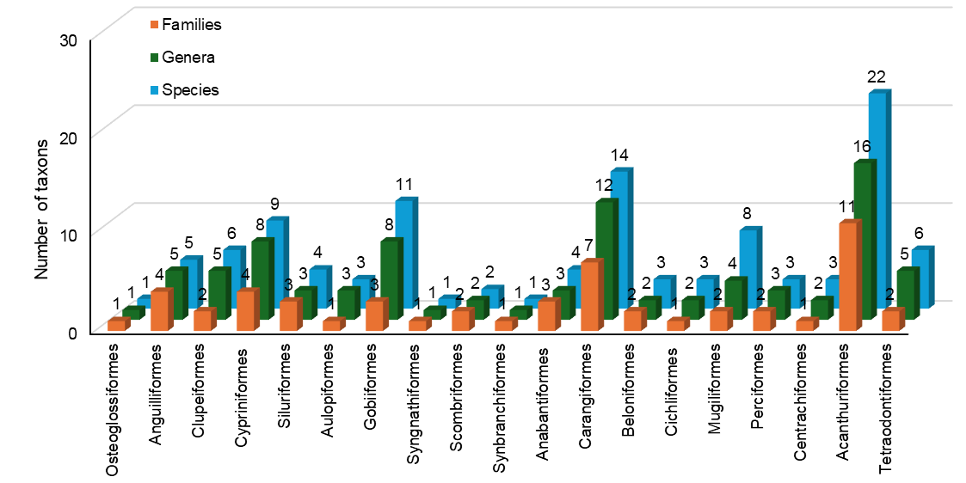

Figure 1. Taxonomic structure of the fish community in the Han River

In contrast, the Cu De River supported 99 species belonging to 45 families and 80 genera. The fish assemblage exhibited characteristics typical of freshwater river ecosystems, with Cypriniformes dominating (28.3%), followed by Carangiformes (10.1%), Siluriformes, and Gobiiformes (9.1%) (Figure 2). Compared to the Han River, marine influence in the Cu De River is relatively limited, and the fish fauna is primarily composed of freshwater species adapted to riverine habitats, especially those associated with fast-flowing upstream environments.

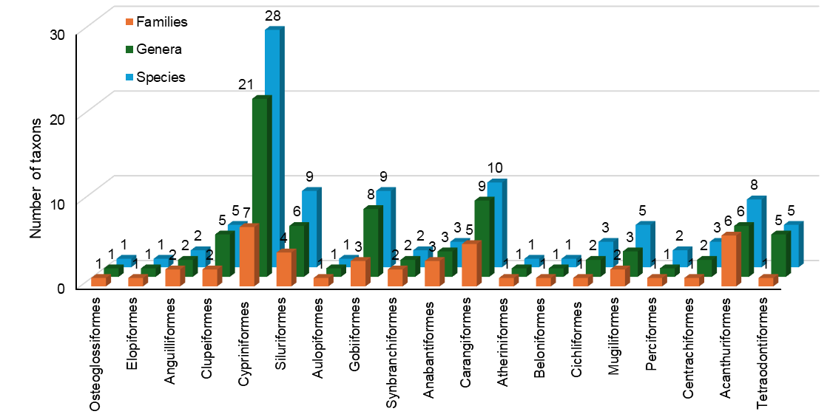

Figure 2. Taxonomic structure of the fish community in the Cu De River

3.3 Seasonal variation in species richness and taxonomic composition

Seasonal variation in fish assemblages was clearly observed in the study area. The total number of recorded species during the dry season reached 121 species, which was approximately 1.6 times higher than that recorded during the rainy season (75 species).

A similar trend was observed in both river systems, Han river having 81 species in dry season and 46 species in rainy season, whereas Cu De River having 70 species in dry season and 44 species in rainy season. Interestingly, the number of species occurring in both seasons was relatively low (30 species in the dry season and 15 species in the rainy season) (Figure 3).

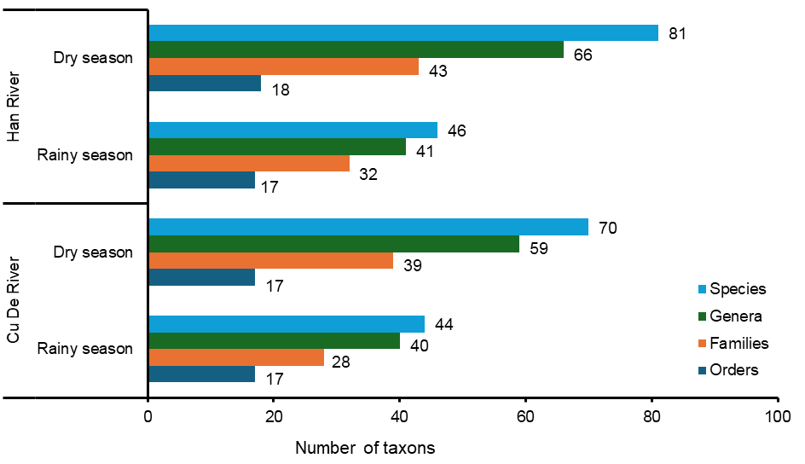

Figure 3. Seasonal variation in taxonomic structure (rainy vs. dry season) in the Han and Cu De Rivers

This pronounced seasonal variation likely reflects fish migration patterns associated with spawning, feeding, and avoidance of unfavorable environmental conditions. During the rainy season, increased river discharge, high turbidity, and sudden changes in salinity may cause many fish species to migrate toward more stable habitats such as estuarine or coastal waters. In contrast, the dry season typically provides more stable environmental conditions, allowing greater species diversity to be recorded in the river systems.

3.4 Comparison of fish assemblages with other river systems in Vietnam

To better understand the biogeographical characteristics of the fish fauna in the study area, species composition was compared with fish assemblages reported from six other river systems in Vietnam: O Lau River, Truoi River (Hue City), Ba River (Dak Lak – Phu Yen), Soai Rap River (Ho Chi Minh City), Co Chien River (Ben Tre), and Cai Lon River (An Giang–Kien Giang). Cluster analysis based on species similarity revealed two major ecological–geographical groups of fish assemblages: Group 1 (Soai Rap River and Co Chien River) and Group 2 (Truoi River, O Lau River, Ba River, Han River, Cu De River, Phan River, and Cai Lon River) (Figure 4).

The similarity index among river systems ranged from 0.0% to 53.2%, indicating considerable geographical differentiation in fish assemblages (Table 3). The highest similarity values were observed between O Lau – Truoi (53.2%), Cu De – Han (40.4%), Cu De – Truoi (40.0%), O Lau – Ba River (39.4%), O Lau – Cu De (36.9%), and Truoi – Han (36.1%). These results reflect the shared hydrological characteristics of central Vietnamese rivers, which are generally short, steep, and discharge directly into the sea. In contrast, the Phan River showed very low similarity with southern river systems (0.0–9.2%), reflecting strong ecological differentiation between northern inland rivers and southern estuarine systems influenced by tidal regimes (Table 3 and Figure 4).

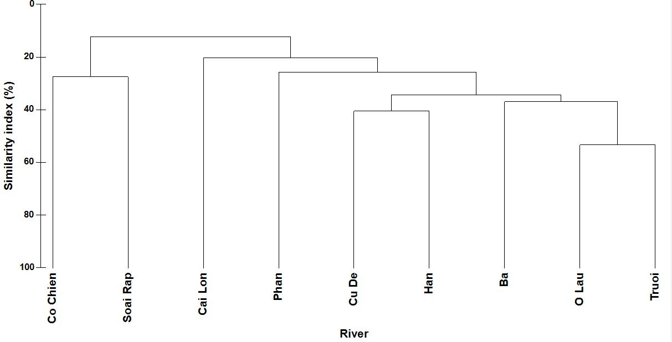

Figure 4. Percent similarity of fish assemblages among study sites.

Table 3. Bray–Curtis similarity index of fish assemblages among rivers

Rivers | Ba | Cai Lon | Co Chien | Cu De | Han | O Lau | Phan | Soai Rap | Truoi
Ba
Cai Lon | 29.2
Co Chien | 13.4 | 27.1
Cu De | 31.7 | 16.7 | 14.9
Han | 29.9 | 26.7 | 26.3 | 40.4
O Lau | 39.4 | 21.5 | 11.2 | 36.9 | 30.6
Phan | 21.8 | 9.2 | 3.0 | 23.1 | 19.3 | 34.1
Soai Rap | 9.3 | 8.2 | 27.4 | 13.2 | 20.3 | 3.4 | 0.0
Truoi | 34.3 | 17.9 | 10.1 | 40.0 | 36.1 | 53.2 | 30.1 | 10.7

The fish diversity recorded in the Han River and Cu De River (166 species) reflects a relatively high level of biodiversity compared with many other surveyed river systems in Vietnam. For example, surveys conducted in the Red River basin in Yen Bai Province identified approximately 110 fish species belonging to 69 genera and 20 families, with Cypriniformes being the dominant order in terms of species richness.

Similarly, earlier investigations in the Dong Nai River basin reported around 107–130 species of freshwater and brackish-water fishes, highlighting the ecological importance of large river systems in southern Vietnam for maintaining fish diversity.

Compared with these systems, the diversity recorded in the present study is relatively high despite the smaller watershed area of the Han and Cu De rivers. This pattern may partly reflect the strong connectivity between freshwater and marine environments, particularly in the Han River estuary, which allows the coexistence of freshwater, estuarine, and marine-associated species. In many tropical river systems, such connectivity significantly increases species richness because estuarine areas function as ecological transition zones where species from multiple habitats overlap.

Another important feature shared between the present study and other Vietnamese river studies is the dominance of Cypriniformes in freshwater habitats. Numerous investigations across Vietnam consistently report Cypriniformes as the most species-rich order in inland waters due to the ecological adaptability and evolutionary diversification of the family Cyprinidae in Southeast Asian river systems. This pattern has been observed not only in the Red River basin but also in mountainous river systems across northern and central Vietnam.

Furthermore, the relatively high proportion of monotypic genera (77%) recorded in the present study is consistent with biodiversity patterns in tropical river ecosystems, where many fish taxa have restricted distributions and are often confined to specific river basins or habitat types. Studies of riverine biodiversity in the central Truong Son region have similarly reported that several fish species are restricted to particular river sections or drainage systems, reflecting strong environmental filtering and local adaptation.

Overall, these comparisons suggest that the fish fauna of the Han and Cu De rivers represents a transitional ichthyofaunal assemblage combining characteristics of freshwater upland rivers and coastal estuarine systems, which contributes to the relatively high species richness observed in the study area.

3.5 Threatened species and economically important fish species

Under increasing pressures from habitat alteration and fishing activities, the study identified 12 fish species of conservation concern in the study area according to the IUCN Red List 2025 (Table 4, Figure 5). Among them, four species are listed in the Vietnam Red Data Book (2024): Anguilla marmorata – Endangered (EN); Poropuntius deauratus – Vulnerable (VU), Sewellia lineolata – VU, Tor sinensis – VU. These species are considered important targets for conservation due to their ecological significance and declining populations.

Table 4. Fish species of conservation concern in the study area

No | Scientific name | Vietnam Red Data Book (2024) | IUCN 2025
1 | Anguilla marmorata Quoy & Gaimard, 1824 | EN | LC
2 | Sewellia lineolata (Valenciennes, 1846) | VU | VU
3 | Poropuntius deauratus (Valenciennes, 1842) | VU | EN
4 | Tor sinensis Wu, 1977 | VU | VU
5 | Tenualosa reevesii (Richardson, 1846) |  | LC
6 | Megalobrama terminalis (Richardson, 1846) |  | NE
7 | Megalops cyprinoides (Broussonet, 1782) |  | DD
8 | Konosirus punctatus (Temminck & Schlegel, 1846) |  | LC
9 | Onychostoma gerlachi (Peters, 1881) |  | NT
10 | Onychostoma laticeps Günther, 1896 |  | NE
11 | Spinibarbus denticulatus (Oshima, 1926) |  | LC
12 | Tor tambroides (Bleeker, 1854) |  | DC
Notes: EN: Endangered; VU: Vulnerable; LC: Least Concern; NT: Near Threatened; CR: Critically Endangered; DD: Data Deficient; NE: Not Evaluated.
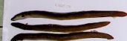  Anguilla marmorata Quoy & Gaimard, 1824 | 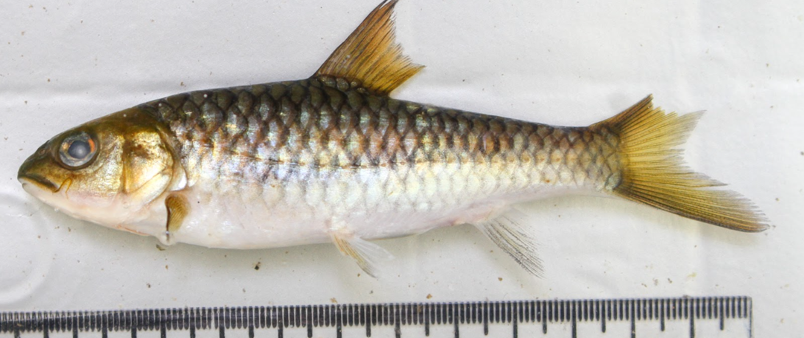  Spinibarbus denticulatus Oshima, 1926
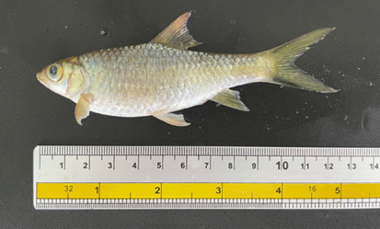Poropuntius deauratus (Valenciennes, 1842) | 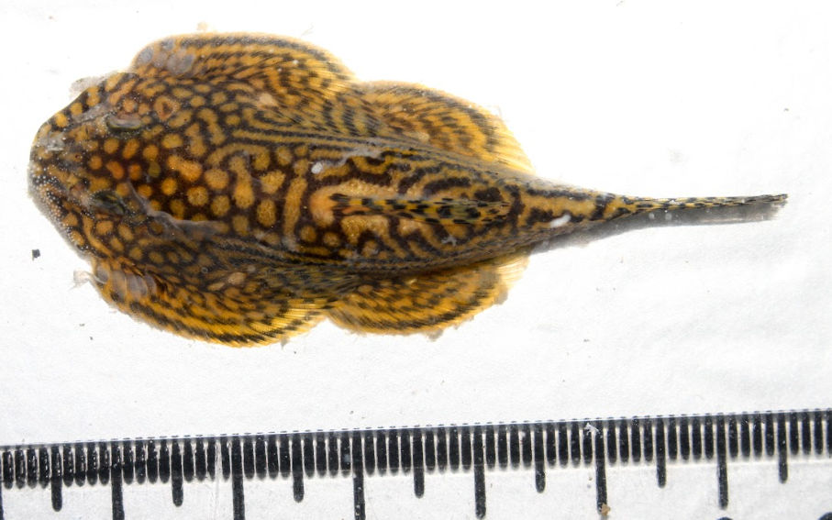  Sewellia lineolata Valenciennes, 1846
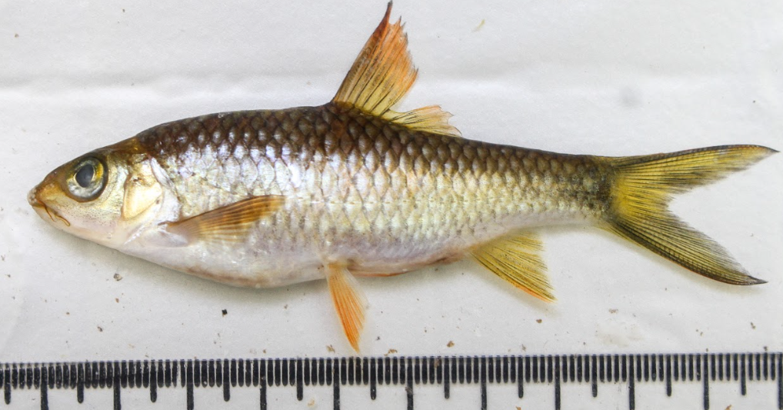  Tor sinensis Wu, 1977 | 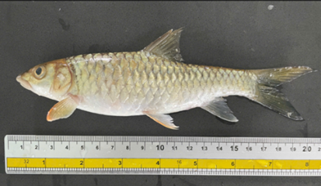  Tor tambroides (Bleeker, 1854)
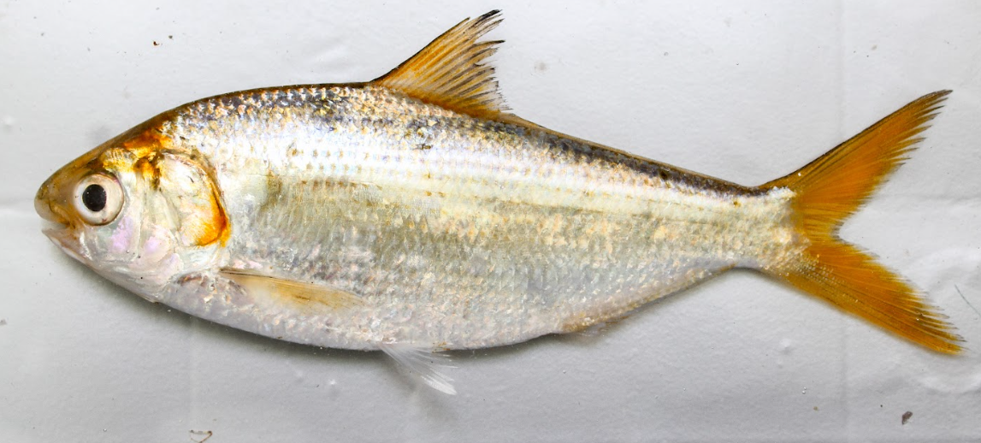  Konosirus punctatus (Temminck & Schlegel, 1846) | 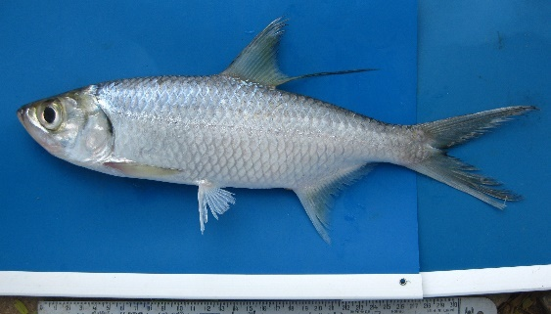  Megalops cyprinoides (Broussonet, 1782)
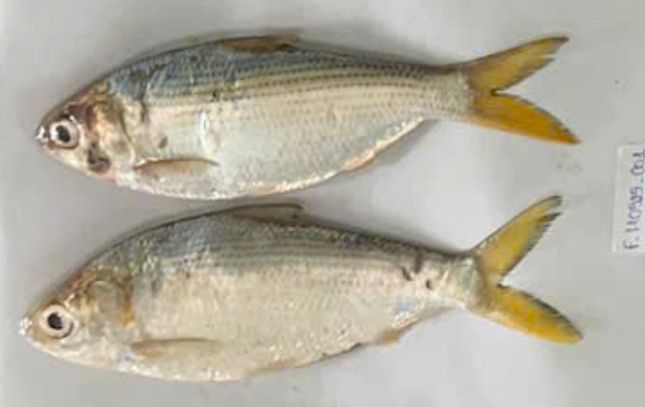  Tenualosa reevesii (Richardson, 1846) | 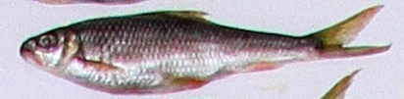  Onychostoma laticeps (Günther, 1896)

Figure 5. Fish species of conservation concern
Based on specimen records and market observations, most fish species recorded in the study area (91.2%) are used as food fish. In contrast, a small proportion (8.8%) consists of species containing potentially dangerous toxins, particularly pufferfishes (order Tetraodontiformes), which are not recommended for consumption.

From an economic perspective, 68 out of 166 species (41.0%) belonging to 16 orders and 40 families were identified as commercially valuable species. These species were primarily distributed in the Han River (83.8%) and Cu De River (60.3%).

The composition of economically important species reflects the ecological characteristics of each river system. In the upper reaches of the Cu De River, fisheries resources are dominated by freshwater species adapted to flowing waters, such as: Onychostoma spp., Spinibarbus denticulatus, Tor tambroides, Barbodes semifasciolatus, Puntius brevis, Carassius auratus. In contrast, the middle and lower reaches of the Han River are dominated by freshwater and estuarine commercial species, including: Anguilla marmorata, Channa striata, Cyprinus carpio, Oreochromis spp., Monopterus albus, Mugilidae, Polynemidae, Lutjanus spp., Gerreidae, Sillago sihama.

Several families such as Gobiidae, Mugilidae, Gerreidae, Leiognathidae, Sparidae, Dorosomatidae, Sciaenidae, and Carangidae play particularly important roles in local fisheries due to their stable catch yields and high market value. These species groups contribute significantly to the income and livelihoods of fishing communities along the Han River and Cu De River basins in Da Nang City.

3.6 Discussion

This study reveals a high level of fish biodiversity (166 species) within the Han and Cu De river systems, underscoring the ecological significance of coastal rivers in central Vietnam as biodiversity hotspots. Despite their relatively small catchment areas, the observed species richness is comparable to or exceeds that reported in larger Vietnamese river systems, suggesting that river–estuary connectivity plays a critical role in enhancing biodiversity. Similar patterns have been reported in in tropical estuarine systems and Southeast Asia (Dudgeon, et al., 2006; Nguyen & De Silva, 2006; Rainboth, 1996), where where the overlap of freshwater, estuarine and marine species contributes to elevated species richness and functional diversity (Blaber, 2000; Whitfield et al., 2021).

A key ecological pattern identified of this study is the the pronounced spatial differentiation between the two river systems, with only 25.3% of species shared. This divergence reflects fundamental differences in hydrological regimes, salinity gradients, and habitat structure. The Han River, characterized by strong tidal influence, supports a diverse assemblage of euryhaline and marine-associated taxa, whereas the Cu De River maintains a predominantly freshwater assemblage dominated by Cypriniformes. This pattern aligns with to the river continuum concept (Vannote et al., 1980), and its extension to estuarine systems, where longitudinal gradients in environmental conditions structure biological communities. In coastal rivers, these gradients are further intensified by salinity intrusion and tidal mixing, leading to distinct ecological zonation (Elliott & McLusky, 2002).

Seasonal variation emerged as another major driver of fish assemblage dynamics. Species richness during the dry season was approximately 1.6 times higher than in the rainy season, reflecting increased environmental stability and habitat availability. In contrast, high discharge, turbidity and salinity fluctuations during the rainy season likely constrain species occurrence and trigger migration toward more stable estuarine or coastal habitats. Such seasonal shifts are characteristic of tropical river systems influenced by monsoonal hydrology and have been linked to life-history strategies involving migration, spawning, and resource utilization (Blaber, 2000; Lowe-McConnell, 1987). The low overlap in species composition between seasons further supports the importance of hydrological variability in regulating fish assemblages.

From a biogeographical perspective, the fish assemblages observed the Han and Cu De rivers reflect the transitional nature of central Vietnam between inland freshwater and coastal marine faunal regions. The coexistence of taxa such as Cyprinidae, Gobiidae, and Carangidae indicates strong ecological connectivity across habitat boundaries (Nguyen & De Silva, 2006). The high proportion of monotypic genera (77%) further suggests localized ecological specialization and potential endemism, which are common features of tropical river systems with heterogeneous habitats and strong environmental filtering (Dudgeon, et al., 2006). These findings reinforce the role of central Vietnamese rivers as important biogeographical transition zones.

The ecological importance of river-estuary connectivity is further emphasized by the presence of both conservation-priority species and economically valuable taxa. Migratory species such as Anguilla marmorata and Tor spp. depend on longitudinal connectivity for completing their life cycles, making them particularly vulnerable to habitat fragmentation and hydrological alteration. Similar declines in freshwater and diadromous fish populations have been reported globally in response to dam construction, water extraction, and habitat degradation (Grill et al., 2019; Vörösmarty, et al., 2010). At the same time, the high proportion of commercially important species highlights the socio-economic value of these systems, particularly in supporting small-scale fisheries and local livelihoods.

The findings of this study have important implications for ecosystem management. Maintaining hydrological connectivity, preserving habitat heterogeneity, and minimizing anthropogenic disturbances are critical for sustaining fish biodiversity in coastal river systems. In rapidly urbanizing regions such as Da Nang, integrated management approaches that consider both ecological integrity and socio-economic demands are essential. The contrasting characteristics of the Han and Cu De rivers also suggest that management strategies should be tailored to local environmental conditions rather than adopting a uniform approach.

Despite these contributions, several limitations should be acknowledged. The sampling design, based primarily on landing sites, may not fully capture habitat-specific assemblages, and the temporal scope, limited to two seasonal periods, may not reflect interannual variability. Future research should prioritize long-term monitoring, expand spatial coverage across habitat types, and incorporate advanced techniques such as environmental DNA (eDNA) and quantitative sampling methods. Integrating ecological modeling and remote sensing approaches would further enhance the ability to assess biodiversity patterns and predict responses to environmental change.

Thus, fish assemblage structure in the Han and Cu De rivers is shaped by the interaction of hydrological connectivity, environmental gradients, and seasonal variability. These drivers operate across multiple spatial and temporal scales, reinforcing general ecological principles observed in river–estuary systems worldwide. Understanding and preserving these processes will be essential for maintaining biodiversity and ecosystem services in coastal rivers under increasing anthropogenic and climatic pressures.

4. Conclusion

This study provides the first comprehensive assessment of fish diversity in the Han River and Cu De River systems in Da Nang City. A total of 166 fish species belonging to 122 genera, 64 families, and 21 orders were documented across the two river basins. The Han River supported 109 species, while the Cu De River contained 99 species, reflecting clear spatial differentiation in fish community structure. The Han River was dominated by euryhaline and estuarine-associated taxa, particularly members of Acanthuriformes, Carangiformes, and Gobiiformes, indicating strong marine influence driven by tidal dynamics. In contrast, the Cu De River exhibited characteristics typical of a freshwater inland river system, with Cypriniformes representing the most species-rich taxonomic group. Comparative analyses with other Vietnamese river systems further confirmed that the fish assemblages of the study area represent a distinct ichthyofaunal structure characteristic of central Vietnamese coastal rivers.

Seasonal variation was pronounced, with higher species richness observed during the dry season, reflecting the influence of hydrological conditions on fish distribution and migration patterns. The relatively low proportion of shared species between the two rivers further emphasizes the role of environmental gradients, habitat heterogeneity, and river–estuary connectivity in structuring fish communities. In addition, the identification of 12 species of conservation concern and a high proportion of economically valuable species underscores the ecological and socio-economic importance of these river systems. The findings demonstrate that the Han and Cu De rivers function as a biogeographical transition zone integrating freshwater and marine elements, contributing to their elevated biodiversity. Maintaining ecological connectivity, habitat diversity, and stable hydrological regimes will be essential for sustaining fish assemblages and supporting local fisheries.

While this study provides important baseline information, some limitations related to spatial coverage and temporal replication remain. These limitations and future research directions are now clarified in the revised manuscript, emphasizing the need for expanded habitat-based sampling, long-term monitoring, and the integration of advanced approaches such as environmental DNA (eDNA) and ecological modeling. Such efforts will provide a stronger scientific basis for biodiversity conservation and sustainable fisheries management in central Vietnam.

Disclaimer (Artificial intelligence)

Authors hereby declare that NO generative AI technologies such as Large Language Models (ChatGPT, COPILOT, etc.) and text-to-image generators have been used during the writing or editing of this manuscript.

AcknowledgEments

Authors should like to thank the project of “Survey of aquatic resources in the river systems of Da Nang” from Da Nang City for their supports.

References

Allen, G.-R. (1985). FAO species catalogue. Vol.6. Snappers of the world: An annotated and illustrated catalogue of lutjanid species known to date. Rome, Italy: FAO - the Food and Agriculture Organization of the United Nations.
Allen, G., Steen, R., Humann, P. & DeLoach, N. (2015). Reef Fish Identification – Tropical Pacific. 2nd ed. Singapore: New World Publications.
Allen, G.R. (1997). Marine fishes of tropical Australia and South-East Asia. Perth, W.A.: Western Australian Museum.
Apinun, S. & Utsugi, K. (2023). A Field guild of the Northern Thai Fishes. Ubon Ratchathani University, Thailand: UBU Press.
Blaber, S.J.M. (2000). Tropical Estuarine Fishes: Ecology, Exploitation and Conservation. Great Britain, UK: Blackwell Science. https://doi.org/10.1002/9780470694985.
Böhlke, E.B. & McCosker, J.E. (2001). The moray eels of Australia and New Zealand, with the description of two new species (Anguilliformes: Muraenidae). Records of the Australian Museum, 53(1), 71–102. https://doi.org/10.3853/j.0067-1975.53.2001.1325.
Carpenter, K.E. & Niem, V.H. (1999a). FAO species identification guide for fishery purposes. The living marine resources of the Western Central Pacific. Volume 3. Batoid fishes, chimaeras and bony fishes part 1 (Elopidae to Linophrynidae). Rome, Italy: Food and Agriculture Organization of the United Nations.
Carpenter, K.E. & Niem, V.H. (1999b). FAO species identification guide for fishery purposes. The living marine resources of the Western Central Pacific. Volume 4. Bony fishes part 2 (Mugilidae to Carangidae). Rome, Italy: Food and Agriculture Organization of the United Nations.
Carpenter, K.E. & Niem, V.H. (2001a). FAO species identification guide for fishery purposes. The living marine resources of the Western Central Pacific. Volume 5. Bony fishes part 3 (Menidae to Pomacentridae). Rome, Italy: Food and Agriculture Organization of the United Nations.
Carpenter, K.E. & Niem, V.H. (2001b). FAO species identification guide for fishery purposes. The living marine resources of the Western Central Pacific. Volume 6. Bony fishes part 4 (Labridae to Latimeriidae), estuarine crocodiles, sea turtles, sea snakes and marine mammals. Rome, Italy: Food and Agriculture Organization of the United Nations.
Clarke, K. & Gorley, R.N. (2006). PRIMER v6: user manual/tutorial. Plymouth: PRIMER-E.
Clarke, K. & Warwick, R.M. (2001). Change in Marine Communities: An Approach to Statistical Analysis and Interpretation (2nd Edition). Plymouth, UK: PRIMER-E.
Do, T.N.N. (2007). Fauna of Vietnam. Ha Noi, Vietnam: Science and Technology Publishing House.
Dudgeon, D., Arthington, A.H., Gessner, M.O., Kawabata, Z.-I., Knowler, D.J., Lévêque, C., Naiman, R.J., Prieur-Richard, A.-H., Soto, D., Stiassny, M.L.J. & Sullivan, C.A. (2006). Freshwater biodiversity: importance, threats, status and conservation challenges. Biological Reviews, 81(2), 163-182. https://doi.org/10.1017/S1464793105006950.
Elliott, M. & McLusky, D.S. (2002). The Need for Definitions in Understanding Estuaries. Estuarine, Coastal and Shelf Science, 55(6), 815-827. https://doi.org/10.1006/ecss.2002.1031.
Froese, R. & Pauly, D. (2025). FishBase. World Wide Web electronic publication. www.fishbase.org. (11/2025).
Grill, G., Lehner, B., Thieme, M., Geenen, B., Tickner, D., Antonelli, F., Babu, S., Borrelli, P., Cheng, L., Crochetiere, H., Ehalt Macedo, H., Filgueiras, R., Goichot, M., Higgins, J., Hogan, Z., Lip, B., McClain, M.E., Meng, J., Mulligan, M., Nilsson, C., Olden, J.D., Opperman, J.J., Petry, P., Reidy Liermann, C., Sáenz, L., Salinas-Rodríguez, S., Schelle, P., Schmitt, R.J.P., Snider, J., Tan, F., Tockner, K., Valdujo, P.H., van Soesbergen, A. & Zarfl, C. (2019). Mapping the world’s free-flowing rivers. Nature, 569(7755), 215-221. https://doi.org/10.1038/s41586-019-1111-9.
Karr, J.R. (1981). Assessment of Biotic Integrity Using Fish Communities. Fisheries, 6(6), 21-27. https://doi.org/10.1577/1548-8446(1981)006<0021:AOBIUF>2.0.CO;2.
Kimura, S., Imamura, H., Quan, N.V. & Duong, P.T. (2018). Fishes of Ha Long Bay: the World Natural Heritage Site in Northern Vietnam. hima, Japan.: Fisheries Research Laboratory, Mie University.
Koeda, K. & Ho, H.C. (2020a). Fishes of southern Taiwan, 2nd edition. Pingtung, Taiwan: National Museum of Marine Biology & Aquarium.
Koeda, K. & Ho, H.C. (2020b). Fishes of southern Taiwan, 2nd edition. Pingtung, Taiwan: National Museum of Marine Biology & Aquarium.
Legendre, P. & Legendre, L.F.J. (1998). Numerical Ecology (2nd ed). Amsterdam, the Netherlands: Elsevier Science.
Lepš, J. & Šmilauer, P. (2003). Multivariate Analysis of Ecological Data using CANOCO. Cambridge: Cambridge University Press. https://doi.org/10.1017/CBO9780511615146.
Lowe-McConnell, R.H. (1987). Ecological Studies in Tropical Fish Communities. Cambridge Tropical Biology Series. Cambridge: Cambridge University Press. https://doi.org/10.1017/CBO9780511721892.
Mai, D.Y., Nguyen, V.T., Nguyen, V.T., Le, H.Y. & Hua, B.L. (1992). Định loại các loài cá nước ngọt Nam Bộ [Identification of freshwater fish species of southern Vietnam]. Hanoi, Vietnam: Science and Technology Publishing House.
McDowall, R.M. (1976). The role of estuaries in the life cycles of fishes in New Zealand. Proceedings of the New Zealand Ecological Society. JSTOR, 27-32.
Moyle, P.B. & Cech, J.J. (2004). Fishes: An Introduction to Ichthyology: Pearson Prentice Hall.
Nakabo, T. (2002). Fishes of Japan with pictorial keys to the species, English edition. Tokyo, Japan: Tokai University Press.
Nguyen, H.P. (1999). Checklist of Marine Fishes of Vietnam. Hanoi, Vietnam: Science and Technology Publishing House.
Nguyen, H.P. (2001a). Marine fish section: Orders Elopiformes, Anguilliformes, Clupeiformes, and Gonorhynchiformes. Fauna of Vietnam: Marine Fishes. Ha Noi, Vietnam: Science and Technology Publishing House.
Nguyen, K.H. (2022). Rare and Economically Valuable Fish Orders and Families in the East Sea and Southwestern Waters of Vietnam. Monograph Series on Natural Resources and Environment of Vietnam. Ha Noi, Vietnam: Publishing House for Natural Science and Technology.
Nguyen, K.H. & Truong, S.K. (2007). Fauna of Vietnam: Marine Fishes. Ha Noi, Vietnam: Science and Technology Publishing House.
Nguyen, N.T. (2001b). Fauna of Vietnam: Marine Fishes – Suborder Gobioidei. Ha Noi, Vietnam: Science and Technology Publishing House.
Nguyen, N.T. (2008). Marine Fishes of Vietnam. Ha Noi, Vietnam: Science and Technology Publishing House.
Nguyen, T.T.T. & De Silva, S.S. (2006). Freshwater finfish biodiversity and conservation: an asian perspective. Biodiversity & Conservation, 15(11), 3543-3568. https://doi.org/10.1007/s10531-005-0312-8.
Nguyen, V.H. (2005a). Class Chondrichthyes and Four Superorders of Osteichthyes—Notopteroidei, Clupeoidei, Elopoidei, and Cyprinoidei. Freshwater Fishes of Vietnam. Ha Noi, Vietnam: Agriculture Publishing House.
Nguyen, V.H. (2005b). Three Superorders of Osteichthyes—Anabantoidei, Synbranchoidei, and Percoidei. Freshwater Fishes of Vietnam. Ha Noi, Vietnam: Agriculture Publishing House.
Nguyen, V.H. & Ngo, S.V. (2001). Family Cyprinidae. Freshwater Fishes of Vietnam. Ha Noi, Vietnam: Agriculture Publishing House.
Nguyen, V.L., Le, T.T.T. & Nguyen, P.U.V. (2007). Fauna of Vietnam: Marine Fishes (Order Perciformes)—Families Chaetodontidae and Labridae). Ha Noi, Vietnam: Science and Technology Publishing House.
Rainboth, W.J. (1996). FAO Species Identification Field Guide for Fishery Purposes. Fishes of the Cambodian Mekong. Rome, Italy: FAO - the Food and Agriculture Organization of the United Nations.
Rainboth, W.J., Vidthayanon, C. & Yen, M.D. (2012). Fishes of the Greater Mekong Ecosystem with Species List and Photographic Atlas: Ann Arbor: Museum of Zoology, University of Michigan.
Shen, S.C., Lee, S.C., Shao, K.T., Mok, H.C., Chen, C.H., Chen, C.C. & Tzeng, C.S. (1993). Fishes of Taiwan. Taipei: Department of Zoology, National Taiwan University.
Shibukawa, K. (2021). Fishes of the Indochinese Mekong. Tokyo, Japan: Nagao Natural Environment Foundation.
Smith, D. (2012). A checklist of the moray eels of the World (Teleostei: Anguilliformes: Muraenidae). Zootaxa, 3474, 1-64. https://doi.org/10.1097/01.ede.0000416893.50277.7e.
Smith, D.G., Bogorodsky, S.V., Mal, A.O. & Alpermann, T.J. (2019). Review of the moray eels (Anguilliformes: Muraenidae) of the Red Sea, with description of a new species. Zootaxa, 4704(1), 1–87. https://doi.org/10.11646/zootaxa.4704.1.1.
ter Braak, C.J.F. & Smilauer, P. (2002). CANOCO Reference Manual and CanoDraw for Windows User's Guide: Software for Canonical Community Ordination (version 4.5). Ithaca NY, USA: Microcomputer Power.
Tran, D.D., Shibukawa, K., Nguyen, T.P., Ha, P.H., Tran, X.L., Mai, V.H. & Uehara, K. (2013). Taxonomic Identification and Description of Fishes of the Mekong Delta, Vietnam. Can Tho, Vietnam: Can Tho University Publishing House.
Truong, T.K. & Tran, T.T.H. (1993). Identification of freshwater fishes of the Mekong Delta. Can Tho, Vietnam: Faculty of Fisheries, Can Tho University.
Vannote, R.L., Minshall, G.W., Cummins, K.W., Sedell, J.R. & Cushing, C.E. (1980). The River Continuum Concept. Canadian Journal of Fisheries and Aquatic Sciences, 37(1), 130-137. https://doi.org/10.1139/f80-017.
Vörösmarty, C.J., McIntyre, P.B., Gessner, M.O., Dudgeon, D., Prusevich, A., Green, P., Glidden, S., Bunn, S.E., Sullivan, C.A., Liermann, C.R. & Davies, P.M. (2010). Global threats to human water security and river biodiversity. Nature, 467(7315), 555-561. https://doi.org/10.1038/nature09440.
Whitfield, A., Elliott, M., Blaber, S.J.M. & Able, K. (2021). Fish and Fisheries in Estuaries: A Global Perspective: Wiley.
Whitfield, A.K., Able, K.W., Barletta, M., Blaber, S.J.M. & Harrison, T.D. (2023). Life-history guilds of fishes associated with estuaries: opportunism versus dependency. Estuarine, Coastal and Shelf Science, 292, 108456. https://doi.org/10.1016/j.ecss.2023.108456.

APPENDIX

Appendix. Species composition of fish assemblages in the Cu De and Han rivers, Da Nang City.
No | Scientific name | English name | Rivers |  |  |  | Economic species
No | Scientific name | English name | Cu De |  | Han |  | Economic species
No | Scientific name | English name | Rainy season | Dry season | Rainy season | Dry season | Economic species
A | Actinopteri- Teleostei | Teleosts
I | Osteoglossiformes | Bony tongues
1 | Notopteridae | Featherbacks or knifefishes
1 | Notopterus notopterus (Pallas, 1769) | Bronze featherback | + | + | + | + | +
II | Elopiformes | Tarpons and tenpounders
2 | Megalopidae | Tarpons
2 | Megalops cyprinoides (Broussonet, 1782) | Indo-Pacific tarpon | +
III | Anguilliformes | Eels and morays
3 | Anguillidae | Freshwater eels
3 | Anguilla marmorata Quoy & Gaimard, 1824 | Giant mottled eel | + | + |  | + | +
4 | Muraenidae | Moray eels
4 | Strophidon sathete (Hamilton, 1822) | Slender giant moray |  | + |  | +
5 | Uropterygius concolor Rüppell, 1838 | Unicolor snake moray |  |  |  | +
5 | Ophichthidae | Snake eels
6 | Pisodonophis boro (Hamilton, 1822) | Rice-paddy eel |  |  | + |  | +
6 | Muraenesocidae | Pike congers
7 | Muraenesox cinereus (Forsskål, 1775) | Daggertooth pike conger |  |  |  | + | +
IV | Clupeiformes | Herrings
7 | Engraulidae | Anchovies
8 | Stolephorus commersonnii Lacepède, 1803 | Commerson's anchovy |  |  |  | + | +
9 | Thryssa hamiltonii Gray, 1835 | Hamilton's thryssa |  |  | + | +
8 | Ehiravidae | River sprats
10 | Corica laciniata Fowler, 1935 | Bangkok river sprat |  | + |  |  | +
9 | Dorosomatidae | Gizzard shads and sardinellas
11 | Escualosa thoracata (Valenciennes, 1847) | White sardine |  |  | + | + | +
12 | Herklotsichthys quadrimaculatus  (Rüppell, 1837) | Bluestripe herring | + |  | +
13 | Konosirus punctatus  (Temminck & Schlegel, 1846) | Dotted gizzard shad |  | + |  |  | +
14 | Sardinella albella (Valenciennes, 1847) | White sardinella |  |  |  | +
15 | Sardinella gibbosa (Bleeker, 1849) | Goldstripe sardinella | + | + |  | + | +
16 | Tenualosa reevesii (Richardson, 1846) | Reeves shad |  | +
V | Cypriniformes | Carps
10 | Cobitidae | Spined loaches
17 | Cobitis sinensis Sauvage & Dabry de Thiersant, 1874 | Siberian spiny loach |  | +
18 | Cobitis taenia Linnaeus, 1758 | Spined loach |  | +
19 | Misgurnus anguillicaudatus (Cantor, 1842) | Pond loach | + | + |  | +
20 | Misgurnus mizolepis Günther, 1888 | Chinese muddy loach | +
11 | Gastromyzontidae | Hillstream loaches
21 | Sewellia lineolata (Valenciennes, 1846) | Hillstream loaches |  | +
22 | Sewellia speciosa Roberts, 1998 | Hillstream loaches |  | +
12 | Balitoridae | River loaches
23 | Balitora brucei Gray, 1830 | Gray's stone loach |  | +
24 | Balitora kwangsiensis (Fang, 1930) | Sucker-belly loach |  | +
13 | Nemacheilidae | Brook loaches
25 | Traccatichthys taeniatus (Pellegrin & Chevey, 1936) | Brook loaches |  | +
14 | Cyprinidae | Minnows or carps
26 | Acrossocheilus aluoiensis (Nguyen, 1997) | Minnows or carps |  | + |  |  | +
27 | Barbodes semifasciolatus (Günther, 1868) | Chinese barb | + |  |  |  | +
28 | Carassioides acuminatus (Richardson, 1846) | Harilik idakoger |  |  | +
29 | Carassius auratus (Linnaeus, 1758) | Goldfish |  | + | + |  | +
30 | Cyprinus carpio Linnaeus, 1758 | Common carp |  | + |  | + | +
31 | Cyprinus melanes (Mai, 1978) | Minnows or carps |  |  |  | +
32 | Henicorhynchus siamensis (Sauvage, 1881) | Siamese mud carp | + |  | +
33 | Onychostoma gerlachi (Peters, 1881) | Minnows or carps | + |  |  |  | +
34 | Onychostoma laticeps Günther, 1896 | Minnows or carps |  | + |  |  | +
35 | Osteochilus salsburyi Nichols & Pope, 1927 | Minnows or carps |  | +
36 | Poropuntius angustus Kottelat, 2000 | Lauge poorpuntius | +
37 | Poropuntius deauratus (Valenciennes, 1842) | Goldbarbe | + |  |  |  | +
38 | Puntius brevis (Bleeker, 1849) | Swamp barb | + |  | + |  | +
39 | Spinibarbus denticulatus (Oshima, 1926) | Minnows or carps |  | + |  |  | +
40 | Tor sinensis Wu, 1977 | Red mahseer |  | +
41 | Tor tambroides (Bleeker, 1854) | Thai mahseer | +
15 | Xenocyprididae | East Asian minnows
42 | Hainania serrata Koller, 1927 | Hainan minnow | +
43 | Megalobrama terminalis (Richardson, 1846) | Black Amur bream |  |  | +
44 | Metzia lineata (Pellegrin, 1907) | East Asian minnows |  | +
45 | Opsariichthys bidens Günther, 1873 | East Asian minnows |  | +
46 | Sinibrama macrops (Günther, 1868) | East Asian minnows | +
16 | Gobionidae | Gudgeons
47 | Microphysogobio labeoides (Nichols & Pope, 1927) | Gudgeon |  |  |  | +
48 | Squalidus atromaculatus (Nichols & Pope, 1927) | Gudgeon |  | +
VI | Siluriformes | Catfishes
17 | Plotosidae | Eeltail catfishes
49 | Plotosus lineatus (Thunberg, 1787) | Striped eel catfish |  |  | + |  | +
18 | Bagridae | Bagrid catfishes
50 | Mystus gulio (Hamilton, 1822) | Long whiskers catfish |  | +
51 | Tachysurus fulvidraco (Richardson, 1846) | Yellow catfish |  | +
52 | Tachysurus sinensis Lacepède, 1803 | Bagrid catfishes |  | +
53 | Tachysurus vachellii (Richardson, 1846) | Bagrid catfishes |  | +
54 | Tachysurus virgatus (Oshima, 1926) | Bagrid catfishes |  | +
19 | Siluridae | Sheatfishes
55 | Pterocryptis cochinchinensis (Valenciennes, 1840) | Catfish |  | +
56 | Silurus asotus Linnaeus, 1758 | Amur catfish |  | +
20 | Clariidae | Airbreathing catfishes
57 | Clarias fuscus (Lacepède, 1803) | Hong Kong catfish |  | + |  | + | +
58 | Clarias gariepinus (Burchell, 1822) | North African catfish |  |  | +
21 | Ariidae | Sea catfishes
59 | Arius arius (Hamilton, 1822) | Threadfin sea catfish | +
60 | Netuma thalassina (Rüppell, 1837) | Giant catfish |  |  |  | + | +
VII | Aulopiformes | Grinners
22 | Synodontidae | Lizardfishes
61 | Harpadon nehereus (Hamilton, 1822) | Bombay-duck |  |  | +
62 | Saurida tumbil (Bloch, 1795) | Greater lizardfish |  | + |  | +
63 | Trachinocephalus myops (Forster, 1801) | Snakefish |  |  |  | +
VIII | Gobiiformes | Gobies
23 | Eleotridae | Bully sleepers
64 | Eleotris balia Jordan & Seale, 1905 | Sleeper |  |  |  | +
65 | Eleotris fusca (Forster, 1801) | Dusky sleeper | + | +
66 | Eleotris melanosoma Bleeker, 1853 | Broadhead sleeper |  | + |  | + | +
24 | Butidae | Gudgeon gobies
67 | Butis butis (Hamilton, 1822) | Duckbill sleeper | + |  | + |  | +
68 | Oxyeleotris marmorata (Bleeker, 1852) | Marble goby |  | + |  | + | +
25 | Gobiidae | Gobies
69 | Acentrogobius caninus (Valenciennes, 1837) | Tropical sand goby |  |  | + | +
70 | Arcygobius baliurus (Valenciennes, 1837) | Isthmus goby |  |  |  | + | +
71 | Aulopareia janetae Smith, 1945 | Scalycheek goby | +
72 | Exyrias puntang (Bleeker, 1851) | Puntang goby | +
73 | Glossogobius aureus Akihito & Meguro, 1975 | Golden tank goby |  |  | + |  | +
74 | Glossogobius giuris (Hamilton, 1822) | Tank goby |  | + |  | + | +
75 | Odontamblyopus rubicundus (Hamilton, 1822) | Gobies |  | +
76 | Oligolepis acutipennis (Valenciennes, 1837) | Sharptail goby | +
77 | Oxyurichthys microlepis (Bleeker, 1849) | Maned goby |  |  | +
78 | Oxyurichthys tentacularis (Valenciennes, 1837) | Mollon |  |  |  | +
79 | Rhinogobius giurinus (Rutter, 1897) | Gobies |  |  |  | +
IX | Syngnathiformes | Pipefishes and seahorses
26 | Mullidae | Goatfishes
80 | Upeneus sulphureus Cuvier, 1829 | Sulphur goatfish |  |  |  | + | +
X | Scombriformes | Mackerels
27 | Scombridae | Mackerels, tunas, bonitos
81 | Rastrelliger kanagurta (Cuvier, 1816) | Indian mackerel |  |  |  | +
28 | Trichiuridae | Cutlassfishes
82 | Lepturacanthus savala (Cuvier, 1829) | Savalai hairtail |  |  |  | + | +
XI | Synbranchiformes | Spiny eels
29 | Mastacembelidae | Spiny eels
83 | Mastacembelus armatus (Lacepède, 1800) | Zig-zag eel |  | +
30 | Synbranchidae | Swamp-eels
84 | Monopterus albus (Zuiew, 1793) | Asian swamp eel | + |  |  |  | +
85 | Ophisternon bengalense McClelland, 1844 | Bengal eel |  |  | +
XII | Anabantiformes | Gouramies, snakeheads
31 | Anabantidae | Climbing gouramies
86 | Anabas testudineus (Bloch, 1792) | Climbing perch | + | + | + | + | +
32 | Osphronemidae | Gouramies
87 | Trichopodus microlepis (Günther, 1861) | Moonlight gourami |  |  | +
88 | Trichopodus trichopterus (Pallas, 1770) | Three spot gourami | + |  | +
33 | Channidae | Snakeheads
89 | Channa striata (Bloch, 1793) | Striped snakehead | + | + | + | + | +
XIII | Carangiformes | Jacks
34 | Latidae | Lates perches
90 | Lates calcarifer (Bloch, 1790) | Barramundi |  |  | + |  | +
35 | Lactariidae | False trevallies
91 | Lactarius lactarius (Bloch & Schneider, 1801) | False trevally |  |  |  | +
36 | Sphyraenidae | Barracudas
92 | Sphyraena jello Cuvier, 1829 | Pickhandle barracuda |  | + | + |  | +
37 | Polynemidae | Threadfins
93 | Eleutheronema tetradactylum (Shaw, 1804) | Fourfinger threadfin |  |  |  | + | +
94 | Polydactylus plebeius (Broussonet, 1782) | Striped threadfin |  |  | +
38 | Paralichthyidae | Large-tooth flounders
95 | Pseudorhombus neglectus Bleeker, 1865 | Largetooth flounder |  | +
96 | Tephrinectes sinensis (Lacepède, 1802) | Chinese Brill | + | +
39 | Soleidae | Soles
97 | Brachirus harmandi (Sauvage, 1878) | Soles |  | +
98 | Brachirus orientalis (Bloch & Schneider, 1801) | Oriental sole | + | +
99 | Synaptura commersonnii (Lacepède, 1802) | Commerson's sole |  |  | +
40 | Toxotidae | Archerfishes
100 | Toxotes microlepis Günther, 1860 | Smallscale archerfish |  | + |  | + | +
41 | Carangidae | Jacks and pompanos
101 | Megalaspis cordyla (Linnaeus, 1758) | Torpedo scad | + |  |  | + | +
102 | Platycaranx chrysophrys (Cuvier, 1833) | Longnose trevally |  |  | + | + | +
103 | Platycaranx malabaricus (Bloch & Schneider, 1801) | Malabar trevally | + | + |  | + | +
104 | Platycaranx talamparoides (Bleeker, 1852) | Imposter trevally |  |  | +
105 | Scomberoides lysan (Forsskål, 1775) | Doublespotted queenfish |  |  |  | +
106 | Scomberoides tol (Cuvier, 1832) | Needlescaled queenfish | +
107 | Scyris indica Rüppell, 1830 | Indian threadfish |  |  |  | +
108 | Selaroides leptolepis (Cuvier, 1833) | Yellowstripe scad |  | + |  | + | +
XIV | Atheriniformes | Silversides
42 | Atherinidae | Silversides
109 | Atherinomorus forskalii (Rüppell, 1838) | Red Sea hardyhead silverside |  | +
XV | Beloniformes | Needle fishes
43 | Belonidae | Needlefishes
110 | Strongylura strongylura (van Hasselt, 1823) | Spottail needlefish |  |  | +
44 | Hemiramphidae | Halfbeaks
111 | Hyporhamphus limbatus (Valenciennes, 1847) | Congaturi halfbeak |  |  | +
112 | Hyporhamphus unifasciatus (Ranzani, 1841) | Common halfbeak |  |  |  | +
45 | Zenarchopteridae | Internally fertilized halfbeaks
113 | Zenarchopterus dunckeri Mohr, 1926 | Duncker's river garfish | +
XVI | Cichliformes | Cichlids, convict blennies
46 | Cichlidae | Cichlids
114 | Coptodon rendalli (Boulenger, 1897) | Redbreast tilapia |  | + |  | + | +
115 | Oreochromis mossambicus (Peters, 1852) | Mozambique tilapia | + | + | + | + | +
116 | Oreochromis niloticus (Linnaeus, 1758) | Nile tilapia | + | + | + | + | +
XVII | Mugiliformes | Mullets
47 | Ambassidae | Asiatic glassfishes
117 | Ambassis gymnocephalus (Lacepède, 1802) | Bald glassy |  |  |  | +
118 | Ambassis kopsii Bleeker, 1858 | Singapore glassy perchlet | + |  | +
119 | Ambassis miops Günther, 1872 | Flag-tailed glass perchlet | + | + | + | +
120 | Ambassis vachellii Richardson, 1846 | Vachelli's glass perchlet |  |  |  | +
48 | Mugilidae | Mullets
121 | Mugil cephalus Linnaeus, 1857 | Flathead grey mullet |  |  |  | + | +
122 | Osteomugil cunnesius (Valenciennes, 1836) | Longarm mullet |  | + |  | + | +
123 | Osteomugil engeli (Bleeker, 1858) | Kanda |  |  |  | +
124 | Planiliza haematocheilus (Temminck & Schlegel, 1845) | So-iuy mullet |  | + |  |  | +
125 | Planiliza macrolepis (Smith, 1846) | Largescale mullet | +
126 | Planiliza subviridis (Valenciennes, 1836) | Greenback mullet |  |  |  | +
XVIII | Perciformes
49 | Epinephelidae | Groupers
127 | Cephalopholis boenak (Bloch, 1790) | Chocolate hind |  |  |  | +
128 | Epinephelus coioides (Hamilton, 1822) | Orange-spotted grouper |  |  | + | + | +
50 | Platycephalidae | Flatheads
129 | Platycephalus endrachtensis  Quoy & Gaimard, 1825 | Bar-tailed flathead | +
130 | Platycephalus indicus (Linnaeus, 1758) | Bartail flathead |  | + |  | + | +
XIX | Centrachiformes | Basses
51 | Terapontidae | Grunters or tigerperches
131 | Helotes sexlineatus (Quoy & Gaimard, 1825) | Eastern striped grunter |  | +
132 | Pelates quadrilineatus (Bloch, 1790) | Fourlined terapon |  |  |  | +
133 | Terapon jarbua (Fabricius, 1775) | Jarbua terapon |  | + |  | + | +
134 | Terapon theraps Cuvier, 1829 | Largescaled terapon | + |  | + | + | +
XX | Acanthuriformes | Surgeonfishes
52 | Gerreidae | Mojarras
135 | Gerres filamentosus Cuvier, 1829 | Whipfin silverbiddy |  | + | + | + | +
136 | Gerres japonicus Bleeker, 1854 | Japanese silver-biddy |  | +
137 | Gerres oyena (Fabricius, 1775) | Common silver-biddy |  |  |  | +
53 | Sillaginidae | Smelt-whitings
138 | Sillago sihama (Fabricius, 1775) | Silver sillago |  |  |  | + | +
54 | Sciaenidae | Drums or croakers
139 | Dendrophysa russelii (Cuvier, 1829) | Goatee croaker |  |  | + |  | +
140 | Johnius belangerii (Cuvier, 1830) | Belanger's croaker |  |  | + | +
141 | Nibea soldado (Lacepède, 1802) | Soldier croaker |  |  | + |  | +
142 | Otolithes ruber (Bloch & Schneider, 1801) | Tigertooth croaker |  |  | + | + | +
55 | Haemulidae | Grunts
143 | Pomadasys argenteus (Forsskål, 1775) | Silver grunt | + | + |  | +
56 | Monodactylidae | Moonyfishes or fingerfishes
144 | Monodactylus argenteus (Linnaeus, 1758) | Silver moony | + | + | + | + | +
57 | Caesionidae | Fusiliers
145 | Caesio cuning (Bloch, 1791) | Redbelly yellowtail fusilier |  |  | + |  | +
58 | Lutjanidae | Snappers
146 | Lutjanus argentimaculatus (Forsskål, 1775) | Mangrove red snapper |  |  |  | + | +
147 | Lutjanus fulviflamma (Forsskål, 1775) | Dory snapper | + |  |  | + | +
148 | Lutjanus johnii (Bloch, 1792) | John's snapper |  |  |  | + | +
59 | Leiognathidae | Slimys, slipmouths, or ponyfishes
149 | Eubleekeria splendens (Cuvier, 1829) | Splendid ponyfish |  |  |  | +
150 | Leiognathus brevirostris (Valenciennes, 1835) | Shortnose ponyfish |  |  | + | + | +
151 | Leiognathus equula (Forsskål, 1775) | Common ponyfish |  |  | + | + | +
152 | Photopectoralis bindus (Valenciennes, 1835) | Orangefin ponyfish |  |  |  | +
60 | Sparidae | Porgies
153 | Acanthopagrus berda (Fabricius, 1775) | Goldsilk seabream |  | + |  |  | +
154 | Acanthopagrus latus (Houttuyn, 1782) | Yellowfin seabream |  | + |  | + | +
61 | Siganidae | Rabbitfishes
155 | Siganus canaliculatus (Park, 1797) | White-spotted spinefoot |  |  |  | + | +
156 | Siganus guttatus (Bloch, 1787) | Orange-spotted spinefoot |  |  |  | + | +
157 | Siganus virgatus (Valenciennes, 1835) | Barhead spinefoot |  |  |  | +
62 | Scatophagidae | Scats
158 | Scatophagus argus (Linnaeus, 1766) | Spotted scat |  | + |  | + | +
XXI | Tetraodontiformes | Puffers and filefishes
63 | Triacanthidae | Triplespines
159 | Triacanthus biaculeatus (Bloch, 1786) | Short-nosed tripodfish |  |  |  | +
64 | Tetraodontidae | Puffers
160 | Arothron hispidus (Linnaeus, 1758) | White-spotted puffer |  | + |  | +
161 | Auriglobus nefastus (Roberts, 1982) | Greenbottle pufferfish |  | +
162 | Chelonodontops patoca (Hamilton, 1822) | Milkspotted puffer |  | + |  | +
163 | Dichotomyctere fluviatilis (Hamilton, 1822) | Green pufferfish |  |  |  | +
164 | Lagocephalus spadiceus (Richardson, 1845) | Half-smooth golden pufferfish | +
165 | Takifugu oblongus (Bloch, 1786) | Lattice blaasop | + |  | +
166 | Takifugu ocellatus (Linnaeus, 1758) | Eclipse Puffer |  |  |  | +
Total |  |  | 44 | 70 | 46 | 81

