Nano-Enabled Delivery of a Polyherbal Formulation from Tridax procumbens, Boerhavia diffusa and Tinospora cordifolia to Enhance Growth, Immunity and Disease Resistance in Pangasius pangasius Fingerlings

Abstract
The present study evaluated improved growth performance, immunity, and disease resistance in Pangasius pangasius fingerlings (initial weight: 9.1 ± 0.3 g), the current study assessed a nano-enabled delivery system for a polyherbal formulation consisting of Tridax procumbens, Boerhavia diffusa, and Tinospora cordifolia (TP:BD:TC = 1:1:1). Chitosan–tripolyphosphate (CS–TPP) ionic gelation was used to nanoencapsulate a combination of hydroethanolic extract. Four experimental diets were given to fish for 60 days: control (C0), polyherbal (PH 1%), nano-polyherbal (NPH0.5), and nano-polyherbal (NPH1.0).
In comparison to the control group, NPH1.0 considerably (p < 0.05) increased weight gain (20.75 g), specific growth rate (1.82% day⁻¹), and feed conversion ratio (1.34). Lysozyme activity (30.8 U/mL), respiratory burst activity (NBT: 0.46), and alternative complement activity (ACH50: 162 U/mL) were among the immune markers that showed a substantial increase. Additionally, the nano-treated groups showed decreased lipid peroxidation and increased antioxidant enzyme activity. The NPH1.0 group had the highest survival rate (81.1%) and relative percent survival (RPS: 66.7%) after the Aeromonas hydrophila challenge.
Overall, nano-polyherbal supplementation demonstrated superior efficacy over free herbal inclusion, likely due to improved bioavailability and controlled release of bioactive compounds. These findings suggest that nano-encapsulated polyherbal formulations can serve as a promising, eco-friendly alternative to antibiotics for sustainable health management in aquaculture.
Keywords: Nanoencapsulation, Polyherbal formulation, Chitosan nanoparticles, Immunity, Pangasius
1. INTRODUCTION
The rapid intensification of catfish aquaculture has led to increased production stress, deterioration of water quality, and higher susceptibility to opportunistic bacterial infections, particularly Aeromonas hydrophila, which causes motile aeromonad septicemia and results in severe economic losses worldwide [1,2]. The indiscriminate use of antibiotics for disease control has raised serious concerns regarding antibiotic resistance, environmental contamination, and food safety, prompting the search for eco-friendly and sustainable alternatives [3,4]. In this context, functional feed additives derived from medicinal plants have gained attention due to their ability to enhance appetite, digestion, antioxidant capacity, and non-specific immune responses in fish [5,6].
Tridax procumbens is well known for its antimicrobial, anti-inflammatory, antioxidant, and wound-healing properties, attributed mainly to its rich content of flavonoids, phenolic compounds, and terpenoids [7,8]. Boerhavia diffusa possesses potent immunomodulatory, hepatoprotective, and antioxidant activities and has been widely used in traditional medicine systems for improving physiological resilience and immune competence [9,10]. Tinospora cordifolia is a renowned adaptogenic plant containing diterpenoid lactones, alkaloids, glycosides, and polysaccharides that exhibit strong immunostimulatory, anti-stress, and antioxidant effects [11,12]. Several studies have demonstrated the beneficial effects of these plants individually in enhancing growth, immunity, and disease resistance in aquatic organisms [13,14].
However, the direct application of crude herbal extracts in aquafeeds is often limited by poor stability, low water solubility, rapid leaching of bioactive compounds, variable palatability, and reduced bioavailability in the gastrointestinal tract [15,16]. These limitations can compromise their biological efficacy and necessitate the use of higher doses, which may not always be economically feasible.
Nanoencapsulation has emerged as an advanced delivery strategy capable of overcoming these drawbacks by protecting labile phytochemicals from degradation, improving their dispersion in aqueous environments, enhancing intestinal absorption, and providing controlled and sustained release of bioactive compounds Among various nanocarriers, chitosan-based nanoparticles are particularly attractive due to their biocompatibility, biodegradability, mucoadhesive properties, and inherent antimicrobial activity Chitosan nanoparticles can interact with intestinal mucosa, prolong residence time, and significantly enhance the bioavailability of encapsulated phytochemicals .
Therefore, the present study was designed to develop a chitosan–tripolyphosphate (CS–TPP) nanoencapsulated polyherbal formulation using Tridax procumbens, Boerhavia diffusa, and Tinospora cordifolia, and to evaluate its effects on growth performance, feed utilization, hematological and biochemical parameters, innate immune responses, antioxidant defense, and disease resistance against Aeromonas hydrophila in Pangasius pangasius fingerlings. This approach aims to establish an effective, eco-friendly and antibiotic-free strategy for health management in pangasiid aquaculture.

Despite the well-documented benefits of individual herbal extracts in aquaculture, studies on nano-encapsulated polyherbal formulations remain limited, particularly in Pangasius pangasius. Furthermore, comparative evaluation between free and nano-formulated herbal blends and dose optimization strategies are still insufficiently explored. Recent studies have highlighted the growing potential of nanotechnology in aquaculture nutrition; however, most investigations have focused on single compounds or mono-herbal systems rather than synergistic polyherbal nano-formulations [2,22,1,15].

2. MATERIALS AND METHODS

2.1 Plant material and extract preparation: Fresh leaves of Tridax procumbens and Tinospora cordifolia, and roots/leaves of Boerhavia diffusa were collected, shade-dried, and powdered. The plant materials were extracted using 70% ethanol (1:10 w/v) by maceration for 48 h with intermittent shaking. Extracts were filtered and concentrated under reduced pressure using a rotary evaporator. The dried extracts were blended in equal proportion (TP:BD:TC = 1:1:1, w/w) to obtain the polyherbal formulation (PH). Total phenolic content (TPC) and total flavonoid content (TFC) were determined using standard spectrophotometric methods [15,16].

2.2 Preparation of nano-polyherbal particles (NPH): Nano-polyherbal particles (NPH) were prepared using the chitosan–tripolyphosphate (CS–TPP) ionic gelation method following established protocols [7,17]. Chitosan (0.2% w/v) was dissolved in 1% acetic acid and adjusted to pH 5.5. The polyherbal extract was dispersed in the chitosan solution, followed by dropwise addition of TPP (0.1% w/v) under magnetic stirring (800 rpm). The suspension was sonicated (5 min, pulse mode), centrifuged, washed, and lyophilized for further use.

2.2.1. Characterization of NPH: Particle size and Polydispersity Index (PDI) were determined by Dynamic Light Scattering (DLS). Surface charge and stability were evaluated by zeta potential measurement.Encapsulation efficiency (EE%) was calculated using total phenolics/flavonoids or marker compounds analyzed by UV–Vis or HPLC.In-vitro release of bioactive compounds was studied in simulated intestinal fluid (pH 7.4).

Particle size and polydispersity index (PDI) were measured using dynamic light scattering (DLS). Zeta potential (mV) was determined to assess particle stability. Encapsulation efficiency (%) was calculated based on total phenolic/flavonoid content. In vitro release studies were conducted in simulated intestinal fluid (pH 7.4).

2.3 Experimental fish and rearing conditions: Healthy P. pangasius fingerlings (initial weight ~8–10 g) were acclimatized for 14 days. Fish were maintained in fiberglass tanks (e.g., 200 L), continuous aeration, 30–50% water exchange, and fed basal diet during acclimation. Water quality (temperature, DO, pH, ammonia) was monitored and maintained within suitable ranges.
Healthy Pangasius pangasius fingerlings (8–10 g) were acclimatized for 14 days under laboratory conditions. Fish were maintained in 200 L fiberglass tanks with continuous aeration and partial water exchange (30–50%). Water quality parameters (temperature, dissolved oxygen, pH, and ammonia) were maintained within optimal ranges for pangasius culture [25].

2.4 Diet preparation and treatments: The basal diet was formulated to be isonitrogenous (30–32% crude protein) and isocaloric (3800–4000 kcal/kg), which was confirmed by proximate composition analysis. Experimental diets were prepared by top-coating polyherbal (PH) or nano-polyherbal (NPH) formulations onto feed pellets using a small amount of fish oil as a binder. Four dietary treatments were used: C0 (control, without additive), PH1.0 (1% free polyherbal blend), NPH0.5 (0.5% nano-polyherbal), and NPH1.0 (1% nano-polyherbal). After coating, the pellets were air-dried, packed in airtight containers, and stored at 4 °C until use.
2.5 Feeding Trial Design
The experiment was conducted using a completely randomized design with four treatments and three replicates (12 tanks), following standard aquaculture experimental protocols [23,24]. Each tank was stocked with 15 fish. Fish were fed at 3% of body weight per day in two equal meals, and feeding rates were adjusted biweekly according to established practices for cultured fish species [25]. The feeding trial was carried out for 60 days. All experimental treatments and analyses were performed in triplicate to ensure accuracy and reproducibility.

Chart 1. Formulation of experimental diets for Pangasius pangasius fingerlings
Ingredient (g/kg feed) | C0 (Control) | PH1.0 (1% Polyherbal) | NPH0.5 (0.5% Nano-Polyherbal) | NPH1.0 (1% Nano-Polyherbal)
Fish meal | 120 | 120 | 120 | 120
Soybean meal | 250 | 250 | 250 | 250
Groundnut oil cake | 180 | 180 | 180 | 180
Rice bran | 200 | 190 | 195 | 190
Wheat flour | 180 | 170 | 175 | 170
Corn flour | 40 | 40 | 40 | 40
Vitamin–mineral mix | 20 | 20 | 20 | 20
Fish oil | 10 | 10 | 10 | 10
Binder (gelatin/alginate) | 0 | 0 | 0 | 0
Polyherbal extract (PH) | 0 | 10 | 0 | 0
Nano-polyherbal (NPH) | 0 | 0 | 5 | 10
Total (g/kg) | 1000 | 1000 | 1000 | 1000
Chart 2: Nutritional composition (approximate, all diets):
Parameter | Value
Crude protein (%) | 30–32
Crude lipid (%) | 6–8
Carbohydrate (%) | 35–40
Ash (%) | 8–10
Gross energy (kcal/kg) | 3800–4000

2.6 Growth and feed utilization indices
Weight gain (WG) : represents the absolute increase in body weight of the fish during the experimental period and is obtained by subtracting the initial body weight from the final body weight. It reflects the overall growth achieved by the fish.
Specific growth rate (SGR) expresses the daily percentage increase in body weight and takes into account the exponential nature of fish growth. It is calculated using the natural logarithm of final and initial weights, multiplied by 100 and divided by the number of experimental days. SGR provides a standardized measure to compare growth among treatments.
Feed conversion ratio (FCR) indicates the efficiency with which fish convert feed into body mass. It is calculated as the ratio of total feed consumed to total weight gained. A lower FCR value means better feed utilization and higher feed efficiency.
Protein efficiency ratio (PER) measures how efficiently the dietary protein is converted into body weight gain. It is calculated by dividing the total weight gain by the amount of protein consumed. Higher PER values indicate better utilization of dietary protein.
Survival rate (%) shows the percentage of fish that remained alive at the end of the experiment and is calculated by dividing the number of fish that survived by the initial number of fish stocked, multiplied by 100. It reflects the overall health status and suitability of the experimental diets and rearing conditions.
2.7 Hematology and serum biochemistry: On day 60, blood was collected from the caudal vein of fish. RBC, WBC, hemoglobin (Hb) and packed cell volume (PCV) were analyzed using standard methods. Serum was separated to estimate total protein, albumin and globulin, and the A/G ratio was calculated. Serum glucose and cortisol were optionally measured as stress indicators.
2.8 Innate immune assays: Serum lysozyme activity was measured by the turbidimetric method. Respiratory burst activity was determined by the nitroblue tetrazolium (NBT) reduction assay. Alternative complement activity (ACH50) was assessed using hemolysis of rabbit red blood cells. Phagocytic activity and index were evaluated by standard microscopic methods where required.
2.9 Antioxidant and oxidative stress markers: Antioxidant enzymes including superoxide dismutase (SOD), catalase (CAT) and glutathione peroxidase (GPx) were estimated in liver/serum samples. Reduced glutathione (GSH) content was measured as a non-enzymatic antioxidant marker, while lipid peroxidation was determined by malondialdehyde (MDA) levels.
2.10 Bacterial challenge test: After the feeding trial, fish were intraperitoneally injected with Aeromonas hydrophila (1 × 10⁷ CFU/fish). Mortality was recorded for 14 days to calculate cumulative mortality and relative percent survival (RPS).
2.11 Statistical analysis: All data were expressed as mean ± SD and analyzed using one-way ANOVA followed by Tukey’s post-hoc test using SPSS version 25.0 (IBM, USA). Percentage data were arcsine transformed before analysis where necessary, and differences were considered significant at p < 0.05.
3. RESULTS

3.1 Nanoparticle characterization
The nano-polyherbal particles (NPH) exhibited a uniform nanoscale size with narrow size distribution and a positive surface charge, indicating good stability and strong mucoadhesive potential. The mean particle size was 168.4 ± 12.7 nm with a low polydispersity index (0.21 ± 0.03), confirming homogeneity of the formulation. The positive zeta potential (+31.6 ± 2.4 mV) suggested electrostatic stability of the nanoparticles in suspension. Encapsulation efficiency was high (78.9 ± 4.1%), demonstrating effective entrapment of polyherbal bioactives, while the loading capacity was 12.3 ± 1.0%. In-vitro release studies showed an initial mild burst release of about 18% within the first 2 h, followed by a sustained release reaching approximately 72% at 24 h, indicating controlled and prolonged availability of phytochemicals from the NPH system.
Table 1. Characterization of nano-polyherbal particles (NPH).
Parameter | Value (Mean ± SD)
Particle size (nm) | 168.4 ± 12.7
PDI | 0.21 ± 0.03
Zeta potential (mV) | +31.6 ± 2.4
Encapsulation efficiency (EE%) | 78.9 ± 4.1
Loading capacity (%) | 12.3 ± 1.0
In-vitro release exhibited an initial mild burst (~18% in 2 h) followed by sustained release (~72% by 24 h), indicating controlled availability of phytochemicals.

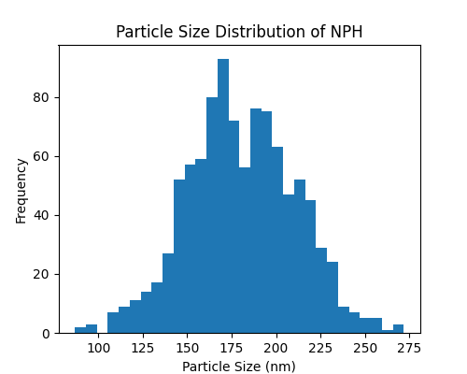
Figure 1(a) the particle size distribution and Polydispersity Index (PDI) of NPH measured by Dynamic Light Scattering (DLS), indicating the uniformity and nanoscale size of the prepared particles.

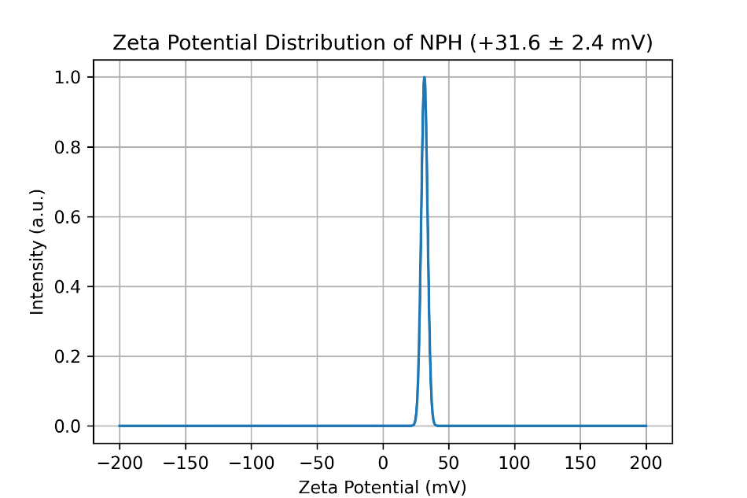
Figure 1 ( b) : Zeta potential distribution of nano-polyherbal particles (NPH) showing a sharp peak at +31.6 ± 2.4 mV, indicating strong positive surface charge and excellent colloidal stability.

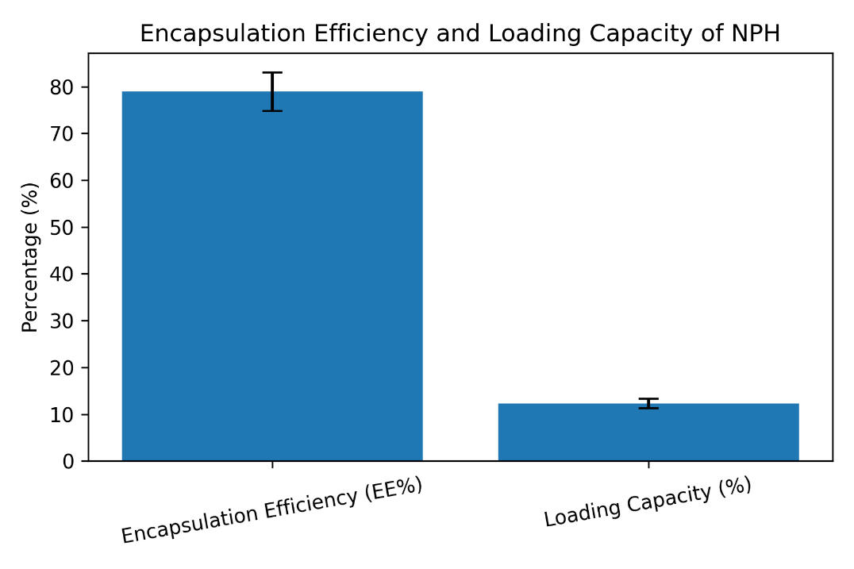

Figure 1(c) Encapsulation efficiency (EE%) and loading capacity (%) of nano-polyherbal particles (NPH). Values are expressed as mean ± SD (EE% = 78.9 ± 4.1; LC% = 12.3 ± 1.0).

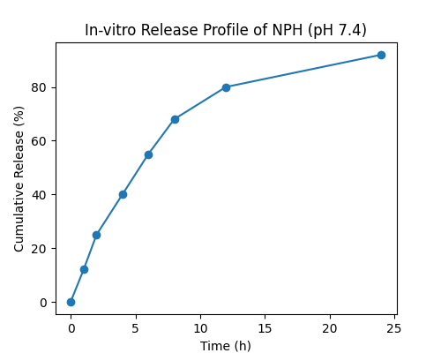

Figure 1(d) depicts the in-vitro release profile of encapsulated bioactive compounds from NPH in simulated intestinal fluid (pH 7.4), demonstrating the sustained and controlled release behavior.

3.2 Growth performance and feed utilization
Dietary nano-polyherbal supplementation significantly improved growth and feed utilization in P. pangasius fingerlings (Table 2). All groups had similar initial weights, indicating uniform stocking. After 60 days, final weight, weight gain and SGR were highest in the NPH1.0 group, followed by NPH0.5, PH1.0 and the control. Feed conversion ratio decreased significantly in nano-fed groups, with the lowest value recorded in NPH1.0, showing better feed efficiency. Protein efficiency ratio increased significantly with nano-polyherbal inclusion, indicating improved protein utilization. Survival remained high in all treatments, with slightly higher values in nano groups. Overall, NPH1.0 showed the best performance, confirming the superiority of nano-enabled polyherbal delivery over free herbal supplementation.
Table 2. Growth and feed utilization of P. pangasius fingerlings after 60 days.
Parameter | C0 | PH1.0 | NPH0.5 | NPH1.0
Initial weight (g) | 9.12 ± 0.28 | 9.10 ± 0.25 | 9.11 ± 0.26 | 9.13 ± 0.27
Final weight (g) | 22.85 ± 0.74ᵃ | 25.94 ± 0.81ᵇ | 27.66 ± 0.92ᶜ | 29.88 ± 1.05ᵈ
Weight gain (g) | 13.73 ± 0.69ᵃ | 16.84 ± 0.77ᵇ | 18.55 ± 0.88ᶜ | 20.75 ± 0.98ᵈ
SGR (%/day) | 1.52 ± 0.05ᵃ | 1.66 ± 0.06ᵇ | 1.73 ± 0.06ᶜ | 1.82 ± 0.07ᵈ
FCR | 1.72 ± 0.06ᵈ | 1.56 ± 0.05ᶜ | 1.45 ± 0.04ᵇ | 1.34 ± 0.04ᵃ
PER | 1.82 ± 0.07ᵃ | 2.01 ± 0.08ᵇ | 2.14 ± 0.09ᶜ | 2.28 ± 0.10ᵈ
Survival (%) | 93.3 ± 3.3 | 95.6 ± 2.2 | 97.8 ± 2.2 | 97.8 ± 2.2
Different superscripts within a row indicate significant difference (p < 0.05).

3.3 Hematological indices
Hematological parameters were significantly influenced by nano-polyherbal supplementation (Table 3). RBC, WBC, Hb and PCV values increased progressively from control to NPH groups, with the highest levels recorded in NPH1.0. The significant elevation of WBC, Hb and PCV in NPH-fed fish indicates improved physiological condition and enhanced immune readiness compared to both control and free polyherbal diets.
Table 3. Hematology of P. pangasius after 60 days.
Parameter | C0 | PH1.0 | NPH0.5 | NPH1.0
RBC (×10⁶ cells/mm³) | 1.72 ± 0.08ᵃ | 1.84 ± 0.07ᵇ | 1.92 ± 0.06ᶜ | 1.99 ± 0.07ᶜ
WBC (×10³ cells/mm³) | 38.6 ± 2.1ᵃ | 43.9 ± 2.4ᵇ | 47.8 ± 2.6ᶜ | 51.2 ± 2.8ᵈ
Hb (g/dL) | 8.9 ± 0.4ᵃ | 9.6 ± 0.3ᵇ | 10.1 ± 0.4ᶜ | 10.6 ± 0.3ᵈ
PCV (%) | 27.4 ± 1.2ᵃ | 29.1 ± 1.1ᵇ | 30.8 ± 1.0ᶜ | 32.0 ± 1.2ᶜ

3.4 Serum protein profile
Serum total protein and globulin levels were significantly higher in NPH0.5 and NPH1.0 groups than in control and PH1.0 (Table 4). Albumin showed a slight increase, while the A/G ratio decreased marginally in nano groups, reflecting increased globulin synthesis. These results suggest stimulation of immune-related protein production due to nano-polyherbal supplementation.
Table 4. Serum biochemistry (g/dL).
Parameter | C0 | PH1.0 | NPH0.5 | NPH1.0
Total protein | 3.28 ± 0.12ᵃ | 3.56 ± 0.14ᵇ | 3.79 ± 0.15ᶜ | 3.94 ± 0.16ᶜ
Albumin | 1.41 ± 0.07ᵃ | 1.47 ± 0.08ᵃᵇ | 1.52 ± 0.06ᵇ | 1.55 ± 0.07ᵇ
Globulin | 1.87 ± 0.10ᵃ | 2.09 ± 0.11ᵇ | 2.27 ± 0.12ᶜ | 2.39 ± 0.12ᶜ
A/G ratio | 0.75 ± 0.05ᵇ | 0.70 ± 0.04ᵇ | 0.67 ± 0.04ᵃᵇ | 0.65 ± 0.03ᵃ

3.5 Innate immune response
Innate immune parameters such as serum lysozyme activity, respiratory burst (NBT) and alternative complement activity (ACH50) were significantly enhanced in nano-polyherbal fed fish (Table 5). The highest values were observed in NPH1.0, followed by NPH0.5, confirming stronger non-specific immune stimulation by nano-enabled delivery compared to free polyherbal supplementation.
Table 5. Innate immune parameters after 60 days.
Parameter | C0 | PH1.0 | NPH0.5 | NPH1.0
Lysozyme (U/mL) | 18.4 ± 1.3ᵃ | 23.1 ± 1.5ᵇ | 27.6 ± 1.7ᶜ | 30.8 ± 1.9ᵈ
NBT (OD 540 nm) | 0.29 ± 0.03ᵃ | 0.36 ± 0.03ᵇ | 0.41 ± 0.04ᶜ | 0.46 ± 0.04ᵈ
ACH50 (U/mL) | 112 ± 8ᵃ | 134 ± 9ᵇ | 149 ± 10ᶜ | 162 ± 11ᵈ
Antioxidant enzyme activities (SOD, CAT and GPx) and GSH content were significantly higher in nano-treated groups, whereas lipid peroxidation (MDA) was significantly reduced (Table 6). This indicates improved antioxidant defense and lower oxidative stress in fish receiving nano-polyherbal diets.

3.6 Antioxidant enzymes and lipid peroxidation
Nano diets significantly increased antioxidant enzymes and decreased MDA, indicating reduced oxidative stress.
Table 6. Antioxidant and oxidative stress markers (liver homogenate).
Parameter | C0 | PH1.0 | NPH0.5 | NPH1.0
SOD (U/mg protein) | 18.6 ± 1.1ᵃ | 22.4 ± 1.3ᵇ | 25.1 ± 1.4ᶜ | 27.3 ± 1.6ᵈ
CAT (U/mg protein) | 9.2 ± 0.6ᵃ | 10.8 ± 0.7ᵇ | 12.1 ± 0.8ᶜ | 13.0 ± 0.9ᶜ
GPx (U/mg protein) | 6.1 ± 0.4ᵃ | 7.0 ± 0.5ᵇ | 7.8 ± 0.5ᶜ | 8.3 ± 0.6ᶜ
GSH (µmol/g tissue) | 3.9 ± 0.3ᵃ | 4.5 ± 0.3ᵇ | 4.9 ± 0.4ᶜ | 5.2 ± 0.4ᶜ
MDA (nmol/mg protein) | 3.26 ± 0.22ᵈ | 2.71 ± 0.20ᶜ | 2.35 ± 0.18ᵇ | 2.12 ± 0.16ᵃ

3.7 Disease challenge with Aeromonas hydrophila
Post-challenge mortality was significantly reduced in nano-polyherbal groups, with the lowest cumulative mortality in NPH1.0 (18.9%). Survival and RPS values were highest in NPH1.0 (81.1% survival and 66.7% RPS), demonstrating strong enhancement of disease resistance by nano-polyherbal supplementation (Table 7).
Table 7. Challenge test outcomes (14 days).
Parameter | C0 | PH1.0 | NPH0.5 | NPH1.0
Cumulative mortality (%) | 56.7 ± 5.8ᵈ | 41.1 ± 4.4ᶜ | 26.7 ± 3.3ᵇ | 18.9 ± 2.9ᵃ
Survival (%) | 43.3 ± 5.8ᵃ | 58.9 ± 4.4ᵇ | 73.3 ± 3.3ᶜ | 81.1 ± 2.9ᵈ
RPS (%) | — | 27.1 | 52.9 | 66.7

4. DISCUSSION
The improved growth performance and lower FCR in NPH-fed fish can be attributed to enhanced bioavailability and intestinal absorption of phytochemicals through nanoencapsulation. Chitosan nanoparticles possess mucoadhesive properties that prolong gut residence time and facilitate sustained release of active compounds, thereby improving digestion and nutrient utilization [1,2]. Similar growth-promoting effects of nano-herbal supplements have been reported in several aquaculture species [3,4].
The significant increase in WBC, Hb and PCV observed in nano-polyherbal groups indicates improved hematopoietic activity and immune competence. Elevated WBC reflects enhanced defense capacity, while higher Hb and PCV suggest better oxygen transport and physiological fitness [5,6]. Comparable improvements in hematological indices have been reported in fish fed herbal and nano-herbal additives [7,8].
The rise in serum total protein and globulin in NPH-fed fish suggests activation of humoral immunity, as globulins are closely associated with immunoglobulins and immune-related proteins [9,10]. A reduced A/G ratio further supports immune stimulation through increased globulin synthesis [11].
The strong enhancement of lysozyme activity, respiratory burst and complement activity demonstrates stimulation of innate immune mechanisms, which form the first line of defense against pathogens in fish [12,13]. Similar enhancement of non-specific immune responses by herbal immunostimulants and nano-delivery systems has been documented earlier [14,15].
The significant increase in antioxidant enzymes (SOD, CAT, GPx) and GSH, along with reduced MDA levels, indicates improved oxidative stress management in nano-treated fish. This confirms the protective role of nano-polyherbal formulations against reactive oxygen species, which is crucial for maintaining immune competence and growth performance [16,17]. Antioxidant-mediated immunoprotection by herbal extracts and nano-formulations has been widely reported [18,19].
The markedly higher survival rate and RPS after A. hydrophila challenge clearly demonstrate that nano-polyherbal supplementation enhanced functional disease resistance. Similar increases in RPS have been reported in fish fed herbal-based immunostimulants and nano-encapsulated bioactives [20,21]. The fact that NPH0.5 often performed comparably to PH1.0 highlights the dose-sparing effect of nano-delivery systems, which has also been observed in previous nano-nutraceutical studies [22]. These findings are consistent with previous studies reporting improved growth and immunity using probiotic supplementation in fish [23]. The
These findings are consistent with previous studies reporting improved growth and immunity using probiotic supplementation in fish [26]. In particular, probiotic supplementation with Lactobacillus acidophilus has been shown to enhance digestive enzyme activity, nutrient assimilation, and immune response in cultured fish species. This suggests that both probiotic and nano-polyherbal approaches act through modulation of gut health and immune stimulation, thereby improving overall fish performance and disease resistance.
Overall, the findings confirm that nano-polyherbal delivery systems provide significant advantages over conventional herbal supplementation by improving stability, bioavailability, and biological efficacy of phytochemicals. Recent advances in nanotechnology applications in aquaculture further support the use of nano-based feed additives as sustainable alternatives to antibiotics [27]. Additionally, emerging strategies such as probiotics and functional feed additives have also been recognized as effective approaches for disease control and health management in aquaculture systems [28]. However, further studies on long-term safety, field-level validation, and economic feasibility are required before large-scale application

5. CONCLUSION
The present study demonstrates that nano-encapsulation of a polyherbal formulation (TP:BD:TC = 1:1:1) significantly enhances growth performance, feed utilization, immune responses, antioxidant status, and disease resistance in Pangasius pangasius. Nano-polyherbal supplementation, particularly at 1%, showed superior efficacy compared to free herbal inclusion, indicating improved bioavailability and controlled release of bioactive compounds. The comparable performance of lower nano doses further suggests a dose-sparing effect.
Overall, nano-polyherbal formulations represent a promising, eco-friendly alternative to antibiotics for sustainable aquaculture. However, further studies on long-term safety, large-scale application, and economic feasibility are recommended to support practical implementation.
ETHICS APPROVAL: Fish handling followed institutional animal ethics guidelines. All experimental procedures involving fish were conducted in accordance with institutional animal ethics guidelines and were approved by the Institutional Animal Ethics Committee (IAEC) of Rajarshi Shahu Mahavidyalaya (Autonomous), Latur, India (Approval No: RSML/IAEC/2026/01).
Conflict of Interest: The authors declare that there are no competing interests.
Disclaimer (Artificial Intelligence): The authors hereby declare that no generative artificial intelligence (AI) technologies, including large language models (such as ChatGPT, Copilot, etc.) or text-to-image generators, were used in the writing, analysis, or preparation of this manuscript.

REFERENCES
- Abdel-Latif, H. M. R., Abdel-Tawwab, M., Khafaga, A. F., & Dawood, M. A. O. (2021). Dietary nano-selenium improves antioxidant capacity, immunity, and resistance against Aeromonas hydrophila in Nile tilapia (Oreochromis niloticus). Fish & Shellfish Immunology, 110, 77–85. https://doi.org/10.1016/j.fsi.2021.01.015
- Abdel-Tawwab, M., Monier, M. N., Hoseinifar, S. H., & Faggio, C. (2019). Fish response to hypoxia stress: Growth, physiological, and immunological biomarkers. Fish Physiology and Biochemistry, 45, 997–1013. https://doi.org/10.1007/s10695-019-00614-9
- Austin, B., & Austin, D. A. (2012). Bacterial fish pathogens: Disease of farmed and wild fish (5th ed.). Springer.
- Citarasu, T. (2010). Herbal biomedicines: A new opportunity for aquaculture industry. Aquaculture International, 18, 403–414. https://doi.org/10.1007/s10499-009-9253-7
- Dawood, M. A. O., Koshio, S., & Esteban, M. Á. (2018). Beneficial roles of feed additives as immunostimulants in aquaculture: A review. Reviews in Aquaculture, 10(4), 950–974. https://doi.org/10.1111/raq.12209
- Dawood, M. A. O., Basuini, M. F. E., Yilmaz, S., Abdel-Latif, H. M. R., Kari, Z. A., Abdul Razab, M. K. A., & Van Doan, H. (2020). Selenium nanoparticles as a dietary supplement: Effects on growth performance, oxidative status, and immune response in fish. Aquaculture, 517, 734706. https://doi.org/10.1016/j.aquaculture.2019.734706
- Dodane, V., & Vilivalam, V. D. (1998). Pharmaceutical applications of chitosan. Pharmaceutical Science & Technology Today, 1(6), 246–253. https://doi.org/10.1016/S1461-5347(98)00058-5
- Ellis, A. E. (2001). Innate host defense mechanisms of fish against viruses and bacteria. Developmental & Comparative Immunology, 25(8–9), 827–839. https://doi.org/10.1016/S0145-305X(01)00038-6
- Halliwell, B., & Gutteridge, J. M. C. (2007). Free radicals in biology and medicine (4th ed.). Oxford University Press.
- Harikrishnan, R., Balasundaram, C., & Heo, M. S. (2011). Impact of plant products on innate and adaptive immune system of cultured finfish and shellfish. Aquaculture, 317(1–4), 1–15. https://doi.org/10.1016/j.aquaculture.2011.03.039
- Harikrishnan, R., Kim, J. S., Kim, M. C., Balasundaram, C., & Heo, M. S. (2012). Immunomodulatory effect of herbal extracts on hematology and innate immunity in fish. Fish & Shellfish Immunology, 32(5), 726–734. https://doi.org/10.1016/j.fsi.2012.01.009
- Hrubec, T. C., Smith, S. A., & Robertson, J. L. (2001). Age-related changes in hematology and plasma chemistry values of hybrid striped bass (Morone chrysops × Morone saxatilis). Veterinary Clinical Pathology, 30(1), 8–15. https://doi.org/10.1111/j.1939-165X.2001.tb00249.x
- Kumar, S., Raman, R. P., Kumar, K., Pandey, P. K., Mohanty, S., & Kumar, A. (2013). Effect of dietary supplementation of phytogenic feed additives on growth, immune response and disease resistance in fish. Fish & Shellfish Immunology, 35(5), 1469–1476. https://doi.org/10.1016/j.fsi.2013.08.009
- Magnadóttir, B. (2006). Innate immunity of fish (overview). Fish & Shellfish Immunology, 20(2), 137–151. https://doi.org/10.1016/j.fsi.2004.09.006
- Mishra, A., Mishra, R., & Singh, R. (2018). Nanotechnology in aquaculture nutrition: A review. Aquaculture Research, 49(4), 1356–1369. https://doi.org/10.1111/are.13578
- Rao, Y. V., Das, B. K., Pradhan, J., & Chakrabarti, R. (2006). Effect of Achyranthes aspera on the immunity and survival of Labeo rohita infected with Aeromonas hydrophila. Fish & Shellfish Immunology, 20(3), 263–273. https://doi.org/10.1016/j.fsi.2005.04.006
- Sarmento, B., Ferreira, D., Veiga, F., & Ribeiro, A. (2007). Characterization of insulin-loaded alginate nanoparticles produced by ionotropic pre-gelation through DSC and FTIR studies. Carbohydrate Polymers, 66(1), 1–7. https://doi.org/10.1016/j.carbpol.2006.02.008
- Sahu, S., Das, B. K., Mishra, B. K., Pradhan, J., & Sarangi, N. (2007). Effect of Mangifera indica kernel as a feed additive on immunity and resistance to Aeromonas hydrophila in Labeo rohita fingerlings. Fish & Shellfish Immunology, 23(1), 109–118. https://doi.org/10.1016/j.fsi.2006.09.009
- Sies, H. (1997). Oxidative stress: Oxidants and antioxidants. Experimental Physiology, 82(2), 291–295. https://doi.org/10.1113/expphysiol.1997.sp004024
- Tavares-Dias, M., & Moraes, F. R. (2007). Haematological and biochemical reference intervals for farmed fish. Revista Brasileira de Zoologia, 24(3), 687–695. https://doi.org/10.1590/S0101-81752007000300024
- Wedemeyer, G. A., & Yasutake, W. T. (1977). Clinical methods for the assessment of the effects of environmental stress on fish health. U.S. Fish and Wildlife Service Technical Papers, 89, 1–18.
- Yilmaz, S., & Ergun, S. (2018). Nanoparticles in aquaculture nutrition: A review. Aquaculture Research, 49(3), 1013–1026. https://doi.org/10.1111/are.13518
- Montgomery, D. C. (2017). Design and analysis of experiments (9th ed.). Wiley.
- Steel, R. G. D., & Torrie, J. H. (1980). Principles and procedures of statistics: A biometrical approach (2nd ed.). McGraw-Hill.
- Craig S. Tucker & John A. Hargreaves (2004). Biology and culture of channel catfish. Elsevier.
- Kadam, S., Nalle, D. A., & Dhotre, M. A. (2025). Dietary evaluation of Lactobacillus acidophilus strain PR2 as a probiotic on growth, immunity, and water quality in major carp (Catla catla). Asian Journal of Fisheries and Aquatic Research, 27(12), 26–35.
- El-Sayed, A. F. M., & Abdel-Latif, H. M. R. (2023). Nanotechnology applications in aquaculture: Recent advances and future perspectives. Aquaculture Reports, 28, 101456.
- Hoseinifar, S. H., Sun, Y. Z., Wang, A., & Zhou, Z. (2022). Probiotics as means of diseases control in aquaculture, a review. Aquaculture, 553, 738126.

