Effects of Zeolite Dietary Supplementation in Nile Tilapia (Oreochromis niloticus Linnaeus 1758) on Zootechnical and Histopathological Parameters

Abstract:
In order to investigate the effects of zeolite incorporation in the diet of Nile tilapia on growth performance, body composition, survival rate, and histopathology, five experimental diets were formulated. Diet 1 contained groundnut cake without zeolite (0% Zeo), Diet 2 contained 0.5% zeolite (0.5% Zeo), Diet 3 contained 1% zeolite (1% Zeo), Diet 4 contained 1.5% zeolite (1.5% Zeo), and Diet 5 contained 2% zeolite (2% Zeo). The experiment was conducted in an open system at Cheikh Anta Diop University and lasted for two months. Prior to the feeding trial, fish were subjected to an acclimation period. Each diet was randomly assigned to three tanks, with a stocking density of 20 fish per tank, for a total of 300 fry with an initial mean weight of 0.3 g. Fish were reared in 50-L plastic tanks and fed three times daily (09:00, 13:00, and 17:00) at feeding rates of 15%, 12%, and 10% of body weight during the first, second, third, and fourth two-week periods, respectively. Water temperature and dissolved oxygen were monitored twice daily (morning and evening). The results indicated that growth parameters (final mean weight, absolute mean weight gain, and relative mean weight gain) of fish fed diets containing 1%, 1.5%, and 2% zeolite did not show any significant differences. Fish fed the diet containing 0.5% zeolite exhibited the lowest growth performance. Feed conversion ratio (FCR) did not differ significantly among fish fed diets containing 0%, 1%, and 1.5% zeolite. Fish fed the diet containing 2% zeolite showed the best FCR, whereas those fed the 0.5% zeolite diet exhibited the poorest FCR. Survival rates ranged from 70% to 88.33%. Fish fed the diet containing 2% zeolite showed the lowest survival rate, while those fed diets containing 0.5% and 1.5% zeolite recorded the highest survival rate (88.33%). Villus degeneration in the small intestine was observed in fish fed diets containing 0%, 0.5%, and 1% zeolite. The posterior intestine of fish fed the 2% zeolite diet displayed a normal histological structure.
Keywords: Oreochromis niloticus, zeolite, growth, dose, histopathology.

Introduction
The development of aquaculture is essential to meet the increasing global demand for fishery products and to strengthen food security. As capture fisheries production has remained largely stagnant over recent decades, aquaculture is expected to play a central role in ensuring a stable supply of aquatic foods (FAO, 2020). At the global level, aquaculture is currently the fastest-growing food production sector (Garlock et al., 2020), offering significant opportunities to satisfy rising food demand while helping to alleviate nutritional deficiencies.
Fish meal has traditionally been the main protein source in aquaculture feeds because of its well-balanced amino acid composition, high digestibility, and strong palatability. However, its long-term sustainability is increasingly questioned due to pressure on marine resources, unstable availability, and escalating costs. These constraints have created an urgent need to identify affordable and efficient alternative protein sources for aquafeeds. In this context, plant-based proteins have received considerable attention because of their improved nutritional value, broad availability, and relatively low cost (Mugwanya et al., 2022). Consequently, the partial or complete replacement of fish meal with plant protein ingredients is now considered a technically feasible and practical strategy for more sustainable aquaculture feed production (Hussain et al., 2024).
Despite these advantages, the greater incorporation of plant-derived raw materials such as groundnut cake, soybean meal, maize flour, and rice bran increases the risk of mycotoxin contamination. Plant ingredients are particularly vulnerable to fungal growth during production, storage, and transport, which may lead to the presence of harmful secondary metabolites such as aflatoxins, fumonisins, ochratoxin A, and zearalenone (Oliveira et al., 2020).
Among these contaminants, aflatoxin B1 (AFB1) represents one of the most serious threats to aquaculture production. It is the most common and most toxic aflatoxin congener, with well-documented carcinogenic, teratogenic, and mutagenic properties (Ziarati et al., 2024). Chronic or acute exposure to AFB1 can impair fish growth, compromise immune function, damage vital organs, and reduce survival, thereby causing substantial economic losses and food safety concerns.
Several strategies have been investigated to mitigate the adverse effects of aflatoxins in aquaculture systems. Ayyat et al. (2013) reported that treatment with clay and coumarin reduced aflatoxin residues in fish. In particular, natural clays such as zeolites and bentonites are promising adsorbent materials because they can bind mycotoxins in the digestive tract, thereby reducing their bioavailability and toxicity. Their use in aquafeeds may therefore contribute to improved fish health and safer products for human consumption.
Recent studies have also highlighted the effectiveness of nano-zeolite in alleviating AFB1 toxicity in Oreochromis niloticus. Hassaan et al. (2020) showed that nano-zeolite supplementation helped counteract the negative effects of AFB1 and improved the overall health status of Nile tilapia.
Based on this background, the present study investigates whether dietary zeolite supplementation can reduce aflatoxin contamination and its adverse effects in Nile tilapia feeds. Specifically, the study evaluates the influence of zeolite inclusion on growth performance, body composition, survival rate, and intestinal histopathological responses in juvenile Nile tilapia.

2. Materials and Methods

2.1. Diet Formulation and Preparation
Five experimental diets were formulated (table 1) with graded levels of zeolite inclusion: Diet 1 (0% zeolite, control), Diet 2 (0.5% zeolite), Diet 3 (1.0% zeolite), Diet 4 (1.5% zeolite), and Diet 5 (2.0% zeolite). All formulations were prepared using Diet Formulator software. The principal feed ingredients included groundnut cake, rice bran, millet bran, maize flour, fish meal, fish oil, and vegetable oil. The diets were identical in composition except for the level of zeolite incorporated. The detailed ingredient composition of the five experimental diets is presented in Table 1.
All dry ingredients were first finely ground using a mortar and pestle and then passed through a 1 mm sieve to ensure uniform particle size. The sieved ingredients were thoroughly mixed before the required quantities of zeolite, fish oil, and vegetable oil were added according to the formulation shown in Table 1. Water was then incorporated at approximately 30% of the dry matter weight to obtain a homogeneous and workable dough.
The prepared dough was pelleted by extrusion through a 3.0 mm die using a Moulinex meat grinder, producing spaghetti-like strands. The pellets were subsequently air-dried for two days in a well-ventilated area protected from direct sunlight. After drying, the feed was re-ground to obtain particles of suitable size for fish ingestion. Finally, the prepared diets were stored in airtight containers at room temperature until use. During the feeding trial, measured quantities were withdrawn regularly and offered to the fish throughout the experimental period.
Table 1. Percentage composition of experimental diets (% dry matter).
Ingredient | Diet 1 (0% Zeolite) | Diet 2 (0.5% Zeolite) | Diet 3 (1% Zeolite) | Diet 4 (1.5% Zeolite) | Diet 5 (2% Zeolite)
Fish meal (g) | 25 | 25 | 25 | 25 | 25
Yeast (g) | 4 | 4 | 4 | 4 | 4
Groundnut cake (g) | 20 | 20 | 20 | 20 | 20
Rice bran (g) | 15 | 15 | 15 | 15 | 15
Maize flour (g) | 20 | 20 | 20 | 20 | 20
Vitamins (g)ᵃ | 1 | 1 | 1 | 1 | 1
Minerals (g)ᵇ | 1 | 1 | 1 | 1 | 1
Fish & vegetable oil (1:1) (mL) | 2 | 2 | 2 | 2 | 2
Zeolite (%) | 0 | 0.5 | 1 | 1.5 | 2
Millet bran (g) | 10 | 10 | 10 | 10 | 10
CMC binder (g) | 2 | 2 | 2 | 2 | 2
TOTAL | 100 | 100 | 100 | 100 | 100
Crude protein (%) | 33.82 | 33.82 | 33.82 | 33.82 | 33.82
Crude lipid (%) | 8.73 | 8.73 | 8.73 | 8.73 | 8.73

a Vit A 250,000 IU; Vit D₃ 250,000 IU; Vit E 5,000 mg; Vit B₁ 100 mg; Vit B₂ 400 mg; Niacin 1,000 mg; Ca pantothenate 2,000 mg; Vit B₆ 300 mg; Vit K₃ 1,000 mg; Vit C 5,000 mg; Biotin 15 mg; Choline 100 mg; BHT 1,000 mg.
b Phosphorus 7%; Calcium 17%; Sodium 1.5%; Potassium 4.6%; Magnesium 7.5%; Manganese 738 mg; Zinc 3,000 mg; Iron 4,000 mg; Copper 750 mg; Iodine 5 mg; Cobalt 208 mg; Calcium and ground attapulgite qs 1,000 g; Fluoride 1.5%.

2.2. Rearing Conditions

The feeding trial was conducted over an eight-week period at the Prof. Omar Thiom Thiaw Aquaculture Station of the Institute of Fisheries and Aquaculture, Cheikh Anta Diop University of Dakar. Nile tilapia fingerlings were obtained from the station’s broodstock population. Before the experiment began, the fish were acclimated for two weeks and fed the control diet.

At the start of the trial, fish with an initial mean body weight of 0.3 g were randomly assigned to 15 plastic tanks (50 L capacity) at a stocking density of 20 fish per tank. The five experimental diets were each tested in triplicate, resulting in three replicate tanks per dietary treatment.

Water quality management was carried out twice daily, in the morning and evening before feeding. This included monitoring key physicochemical parameters (temperature and pH), siphoning waste materials, and renewing water as needed. Continuous aeration was provided in each tank through air diffusers connected to an air compressor.

Fish were fed daily at 15% of total body weight, with the ration divided into three equal meals administered at 09:00, 13:00, and 17:00 h. Every two weeks, feeding levels were progressively adjusted downward according to biomass changes during growth.

Feeding was stopped 12 h before each weighing session to minimize variation associated with gut content. At sampling, all fish from each tank were collected for group biochemical assessment. The fish were then euthanized, and three individuals per tank were dissected to remove a section of the posterior intestine for histopathological examination. The remaining carcasses were frozen and preserved for subsequent flesh composition analysis.

2.2.1 Physicochemical parameters
Water temperature and dissolved oxygen concentration were measured twice daily using a multi-parameter probe waterproof pHep by HANNA.

2.3. Biochemical Analysis of Fish Flesh

At the end of the feeding trial, all surviving fish from each dietary treatment were individually weighed and euthanized. The carcasses were then pooled by treatment group, packaged in labeled bags, and stored for subsequent proximate composition analysis.

Flesh composition analysis was performed at ENSA de Thiès according to standard analytical procedures (Arsalan et al., 2023). Moisture content was determined by oven drying at 105 °C for 12 h. Ash content was measured after combustion at 540 °C in a muffle furnace. Crude protein content was estimated from total nitrogen (N × 6.25) using the micro-Kjeldahl method (Kjeltec System 1002 Distilling Unit, Tecator, Hoeganaes, Sweden). Crude lipid content was determined by solvent extraction using the Soxhlet method (Soxtec System, Foss, Model HT, Sweden).

2.4. Growth, Survival, and Feed Efficiency Parameters
Changes in the growth performance of Nile tilapia fingerlings were assessed at the beginning and at the end of the experiment using standard procedures (Hussain et al., 2015). Fish were individually weighed, and mortalities were recorded before each calculation. Following sampling, the fish were returned to cleaned tanks containing fresh water. Total biomass in each tank was then determined in order to adjust the daily feeding ration accordingly.
Absolute weight gain (AWG):
AWG (g) = Final Average Weight – Initial Average Weight

Relative mean weight gain (RMWG)
$$RMWG (\%) = \frac{FAW-IAW }{IAW}×100$$
Specific Growth Rate (SGR)
$$SGR\left(\%/day \right)=\frac{(\ln\left(FAW\right)-\ln\left(IAW\right)}{rearing duration} x 100$$
Survival Rate (SR)
$Survival Rate \left(\%\right)=\frac{Final number of fish}{Initial number of fish}x 100$

2.5 Determination of feed efficiency parameters
Feed Conversion Ratio (FCR)
$$FCR=\frac{Amount of feed distributed per fish }{AWG }$$

2.6. Histopathological Analysis

Histological analysis focused on the posterior intestine of Nile tilapia. At the end of the experiment, three fish from each dietary treatment were dissected, and a section of the posterior intestine was collected for microscopic examination. The samples were initially preserved in test tubes containing 10% formalin prepared with distilled water.

Tissue fixation, a critical step for preserving cellular integrity and tissue architecture, was subsequently carried out by immersion in Dubosq–Brasil fixative. Small tissue fragments were used to facilitate efficient penetration of the fixative, with a fixative volume maintained at least 20 times greater than the tissue volume. Fixation time varied according to sample size, ranging from a few hours for small fragments to several days for larger samples.

Following fixation, the tissues were washed in running water and dehydrated through a graded alcohol series consisting of two to three baths of 96% ethanol, followed by three baths of absolute ethanol. The dehydrated tissues then underwent progressive impregnation in a butanol–paraffin mixture (1:1) and were kept overnight in an oven at 56–60 °C to allow complete infiltration. Thereafter, the samples were transferred through three successive paraffin baths, the final bath containing pure paraffin. The embedded tissues were trimmed and sectioned at a thickness of 4–6 µm using a microtome.

For slide preparation, glass slides were cleaned with 70% alcohol and coated with a thin layer of albumin to improve section adhesion. A drop of distilled water was added, and tissue sections were carefully mounted onto the slides. Excess water was removed, and the slides were dried on a heating plate before labeling for identification.

The sections were then subjected to deparaffinization and rehydration. Slides were successively immersed in two toluene baths (5 min each), two butanol baths (5 min each), 95% alcohol (5 min), 70% alcohol (5 min), and finally rinsed in running water. After staining, the sections were dehydrated again through ascending alcohol baths, cleared in butanol and toluene, and prepared for permanent mounting.

Finally, the stained sections were mounted with coverslips using Canada balsam as mounting medium and dried in an oven at 37 °C for at least 24 h. Histological observations were performed using a Beda optical microscope.

2.7. Statistical Analysis
Data were recorded and calculated using Microsoft Excel. Statistical analysis was performed using the Statistical Analysis System software (SAS-PC) (Joyner, 1985) and subjected to one-way analysis of variance (ANOVA). Duncan’s multiple range test was used to compare differences among treatments. A significance threshold of P < 0.05 was applied.

3. Results and Discussion

3.1. Results

3.1.1. Physicochemical Parameters
Table 2 indicates that water temperature remained relatively stable among dietary treatments, varying from 27.04 ± 0.05 °C to 27.46 ± 0.07 °C, with an overall mean of 27.25 °C. Although the observed differences were statistically significant, the variation was biologically limited.
The pH values also showed only slight variation between treatments, ranging from 8.43 ± 0.02 to 8.61 ± 0.04, with a mean value of 8.55. A slight decreasing trend in pH was observed with increasing levels of zeolite inclusion.
Table 2. Summary of mean water temperature and pH values across dietary treatments.
Diet | Mean water temperature (°C) | pH
0% Zeolite | 27.04 ± 0.05^{b} | 8.61 ± 0.04^{ab}
0.5% Zeolite | 27.46 ± 0.07ª | 8.53 ± 0.04^{bc}
1% Zeolite | 27.19 ± 0.18^{ab} | 8.43 ± 0.02^{d}
1.5% Zeolite | 27.41 ± 0.06ª | 8.49 ± 0.04^{cd}
2% Zeolite | 27.43 ± 0.15ª | 8.43 ± 0.02^{d}
Values sharing the same superscript letter are not significantly different (P < 0.05).

3.1.2. Growth Performance, Survival Rate, and Feed Efficiency
Data relating to absolute weight gain (AWG), relative weight gain (RWG), specific growth rate (SGR), feed conversion ratio (FCR), and survival rate (SR) are presented in Table 3.

Table 3. Growth performance, feed efficiency, and survival parameters.
Parameter | 0% Zeolite | 0.5% Zeolite | 1% Zeolite | 1.5% Zeolite | 2% Zeolite
IMW (g) | 0.30 | 0.30 | 0.30 | 0.30 | 0.30
FMW (g) | 2.63±0.37ª | 2.34±0.23ª | 2.49±0.11ª | 2.40±0.28ª | 2.49±0.08ª
AWG (g) | 2.33±0.38ª | 2.03±0.23ª | 2.18±0.10ª | 2.10±0.28ª | 2.19±0.08ª
RWG (%) | 765.4±127.7ª | 671.1±76.1a | 717.2±36.0a | 691.9±91.3a | 721.0±28.3ª
SGR (%/day) | 3.84±0.27ª | 3.64±0.18ª | 3.75±0.08ª | 3.69±0.20ª | 3.75±0.06ª
FCR | 2.56±0.24^{ab} | 2.79±0.31ª | 2.56±0.19^{ab} | 2.70±0.15^{ab} | 2.35±0.10^{b}
SR (%) | 75.0±5.0^{bc} | 83.3±5.8^{ab} | 75.0±8.7^{bc} | 88.3±2.9ª | 70.0±5.0^{c}
IMW: Initial mean weight; FMW: Final mean weight; AWG: Absolute weight gain; RWG: Relative weight gain; SGR: Specific growth rate; FCR: Feed conversion ratio; SR: Survival rate.
Values sharing the same superscript letter are not significantly different (P < 0.05).
No significant differences were detected among dietary treatments for the measured growth performance indicators, including final mean weight (FMW), absolute weight gain (AWG), relative weight gain (RWG), and specific growth rate (SGR).
Survival rates varied from 70.00% to 88.33% across treatments. The highest survival was recorded in fish fed diets containing 0.5% and 1.5% zeolite, with values of 83.33% and 88.33%, respectively. However, no significant differences in survival were observed among fish receiving the 0%, 1%, and 2% zeolite diets.
Regarding feed utilization, fish fed diets containing 0%, 1%, and 1.5% zeolite showed similar feed conversion ratio (FCR) values, with no significant differences among these groups. In contrast, a significant difference in FCR was found between fish fed the 2% zeolite diet and those fed the 0.5% zeolite diet.

3.1.3. Flesh Composition
Proximate composition results after eight weeks of experimentation are presented in Table 4.
Table 4. Proximate composition of fish flesh (% dry matter).
Zeolite inclusion (%) | Ash (%) | Crude protein (%) | Crude lipid (%)
0% Zeolite | 3.51±0.10ª | 16.14±0.10^{d} | 8.58±0.18^{c}
0.5% Zeolite | 3.59±0.08ª | 15.92±0.09e | 9.15±0.10^{b}
1% Zeolite | 3.55±0.06ª | 16.63±0.09^{c} | 9.20±0.10^{b}
1.5% Zeolite | 3.43±0.09ª | 16.81±0.10b | 9.05±0.12^{b}
2% Zeolite | 3.44±0.08ª | 17.36±0.06ª | 9.93±0.09ª
Values sharing the same superscript letter are not significantly different (P < 0.05).

Ash content in fish flesh did not differ significantly among the dietary treatments. The highest crude protein level was observed in fish fed the diet containing 2% zeolite, whereas the lowest value was recorded in fish fed the control diet (0% zeolite).

Crude lipid content also showed no significant differences among fish receiving diets supplemented with 0.5%, 1.0%, and 1.5% zeolite. However, the highest lipid content was found in fish fed the diet containing 2% zeolite.

3.1.4. Histopathological Analysis

The fish intestine is a complex and multifunctional organ. In addition to its primary roles in digestion and nutrient absorption, it is critically involved in immune defense, regulation of fluid and electrolyte balance, endocrine control of digestion, and metabolic processes (Jiao et al., 2023).

Histopathological examination is widely regarded as a valuable integrative approach for detecting tissue alterations induced by chemical contaminants or biological infectious agents (Orbea et al., 2022). In the present study, intestinal histology was assessed in juvenile tilapia after 56 days of feeding under each dietary treatment.

In fish fed the control diet (0% zeolite), the intestinal villi showed pronounced pathological alterations, including marked necrosis and epithelial desquamation. Necrotic lesions extended throughout the intestinal mucosa, accompanied by the accumulation of enterocytes and cellular debris within the intestinal lumen. In addition, a substantial reduction in villus length was observed (Figures 1 and 2).
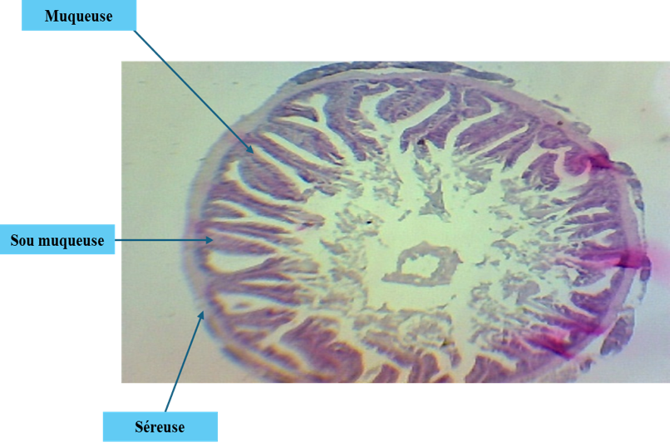
Mucosa
Submucosa

Serosa

Figure 1: Light microscopy observation of the small intestine of a fish fed the 0% zeolite diet. (light microscope ×40).
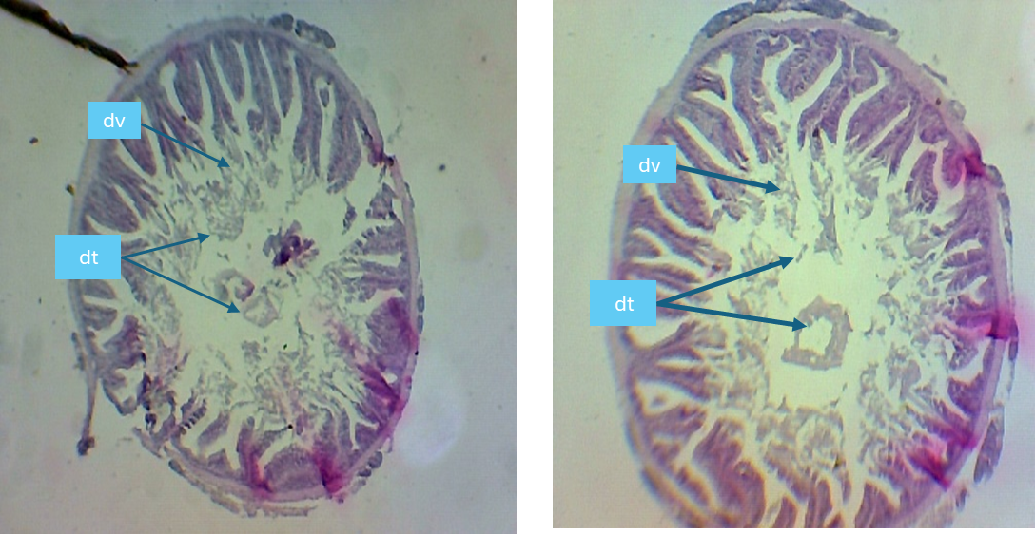
dv : villus degeneration dt : tissue debris
Figure 2: Histological sections of the intestinal epithelium showing villus degeneration in fish fed the 0% zeolite diet (light microscope ×40). dv: villus degeneration; dt: tissue debris.
Similar lesions were observed in fish fed diets containing 0.5%, 1%, and 1.5% zeolite; however, the severity of tissue damage decreased progressively with increasing zeolite inclusion levels (Figures 3, 4, 5, and 6).
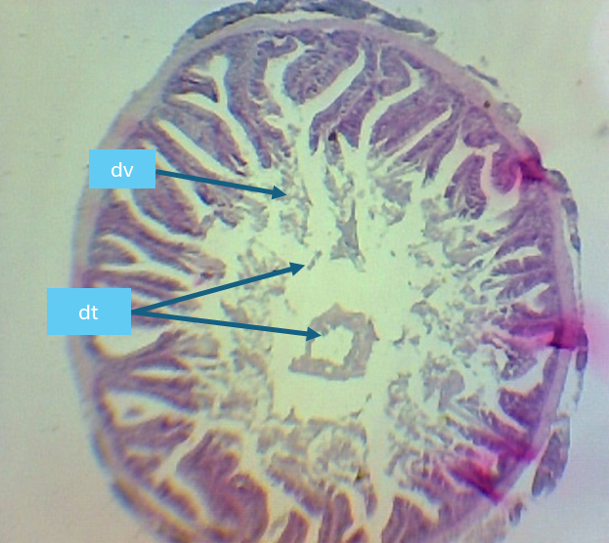
Figure 3: Histological sections of the intestinal epithelium showing villus degeneration in fish fed the 0.5% zeolite diet (light microscope ×40).
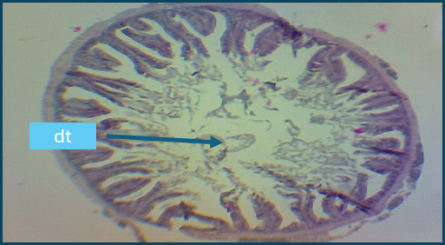
Figure 4: Histological sections of the intestinal epithelium showing villus degeneration in fish fed the 1% zeolite diet (light microscope ×40).

Figure 5: Histological sections of the intestinal epithelium showing villus degeneration in fish fed the 1.5% zeolite diet (light microscope ×40).

Serosa
Muscularis

Mucosal layer

Villus

Goblet cells

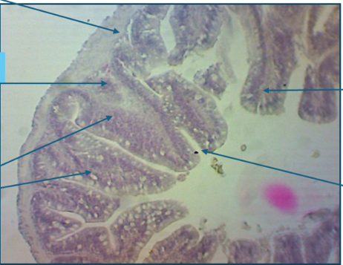

Figure 6: Histological sections of the intestinal epithelium in fish fed the 2% zeolite diet (light microscope ×40).

The posterior intestine of fish fed the diet containing 2% zeolite exhibited a normal and well-preserved histological architecture. The mucosa, submucosa, muscularis, serosa, and intestinal villi remained intact, with no evident pathological lesions. Notably, goblet cell density was markedly higher than that observed in the control group (0% zeolite), suggesting an enhanced protective mucosal response (Figure 6).

3.2. Discussion

In aquaculture, physicochemical parameters such as temperature and pH are key indicators of water quality and of the suitability of the culture environment for aquatic organisms. The mean values recorded in the present study were within the recommended ranges for the rearing of Nile tilapia (Oreochromis niloticus) (Naiel et al., 2022; Lazard, 2009), namely 26–32 °C and pH 8.41–8.69. Likewise, the pH values obtained are consistent with the optimal range of 6.5–9.0 reported for fish culture by El-Sayed (2020) and Konan et al. (2017). These results indicate that water quality remained favorable throughout the experimental period and was unlikely to confound the dietary effects observed.

Regarding feed utilization, fish fed the diet containing 2% zeolite achieved the most favorable feed conversion ratio (FCR = 2.35), which was lower than the value of 3.36 reported by Yildirim et al. (2009) for the same inclusion level. This finding suggests that zeolite supplementation at 2% may improve feed efficiency under the present experimental conditions.

In aquaculture practice, zeolite is commonly incorporated into fish feeds at inclusion rates ranging from 1% to 5% of total diet weight (Abbas et al., 2021; Jawahar et al., 2016). Previous studies have reported beneficial effects of zeolite supplementation on fish performance and health. For example, Abbas et al. (2021) demonstrated that dietary zeolite at 1%, 3%, and 5% improved growth performance and increased resistance to lead toxicity in Nile tilapia. Similarly, Jawahar et al. (2016) found that 4% and 6% zeolite supplementation enhanced growth, hematobiochemical parameters, and immune responses in Channa striatus.

In the present study, growth indicators, including final mean weight (FMW), relative weight gain (RWG), absolute weight gain (AWG), and specific growth rate (SGR), showed that fish receiving diets containing 1%, 1.5%, and 2% zeolite achieved satisfactory growth performance. These observations are in agreement with Sheikhzadeh et al. (2017), who reported improved growth in rainbow trout fed diets supplemented with clinoptilolite (5 g/kg feed).

With respect to survival, the highest survival rates were observed in fish fed the 0.5% and 1.5% zeolite diets, whereas the lowest survival occurred in the 2% zeolite group. Mortalities recorded during the trial were mainly associated with handling stress during weighing procedures. Although the 2% zeolite diet appeared to promote growth and feed efficiency, it may have negatively influenced survival under the conditions of this study. This result contrasts with the findings of Nssar (2019), who reported that zeolite supplementation in Nile tilapia diets reduced stress indicators and produced no adverse effects on survival.

Proximate composition analysis of fish flesh (crude protein, lipid, and ash contents) provides useful information on the influence of diet on body composition and nutrient utilization. In the present study, fish fed the 2% zeolite diet exhibited the highest crude protein content, suggesting improved protein deposition and nutrient assimilation.

Aflatoxin residue analysis was not performed on fish flesh in the present study. This decision was supported by previous evidence indicating negligible accumulation of AFB1 in tilapia muscle tissue. Deng et al. (2010) reported that no detectable aflatoxin residues were found in the flesh of fish fed diets containing 19, 85, 245, 638, and 1,641 µg AFB1/kg feed.

Histopathological observations revealed degeneration of intestinal villi in fish fed diets containing 0%, 0.5%, and 1% zeolite, which may be associated with aflatoxin contamination of the feeds. The lesions included villus atrophy, villus fusion or shortening, reduced absorptive surface area, and the presence of necrotic or dead cells in the intestinal lumen. Similar lesions induced by AFB1, including epithelial desquamation, villus edema, epithelial necrosis, mononuclear cell infiltration, and subepithelial spaces, have been described by Barany et al. (2021).

The integrity of the gastrointestinal tract may also be compromised by dietary fiber and antinutritional compounds present in plant-based feed ingredients, as the intestine is the first organ exposed to ingested feed (Imani and Mahmoudikiya, 2023; Krogdahl et al., 2010). In addition, Castro et al. (2019) suggested that zeolite may help remove damaged villi and stimulate epithelial regeneration, thereby improving nutrient absorption and feed utilization. Elshafy et al. (2023) further reported that low doses of nano-zeolite (2 mg/kg) did not adversely affect intestinal histology in tilapia. In the present study, the absence of intestinal degeneration in fish fed the 2% zeolite diet may therefore be explained by the adsorption of aflatoxins by zeolite, reducing their harmful effects on intestinal tissues.

More broadly, the use of clay minerals as mycotoxin binders has been widely supported. In a systematic review, Dos Reis et al. (2024) concluded that bentonite supplementation significantly reduces aflatoxin absorption in tilapia, improves hematological and immune parameters, and enhances weight gain by lowering the bioavailability of AFB1 in the digestive tract. Likewise, aluminosilicate minerals such as kaolin, zeolite, and bentonite have been recognized as effective adsorbents capable of improving feed safety and fish health.

Additional complementary strategies may also be considered. Gupta et al. (2011) highlighted the safety, low toxicity, and biodegradability of essential oils as feed additives, while Rasoli et al. (2008) demonstrated that certain plant essential oils can inhibit the growth of Aspergillus flavus and Aspergillus parasiticus and suppress aflatoxin production in vitro. Together, these approaches offer promising avenues for reducing mycotoxin risks in sustainable aquaculture systems.

4. Conclusion
Aflatoxins, particularly aflatoxin B1 (AFB1), are toxic secondary metabolites produced by certain Aspergillus species, especially A. flavus and A. parasiticus. These compounds are recognized for their high toxicity, mutagenic potential, and carcinogenic effects in many animal species, including fish.
The histopathological lesions associated with aflatoxin exposure include epithelial damage, depletion of goblet cells, and infiltration of inflammatory cells. Such alterations can compromise intestinal barrier integrity, increase permeability, and impair nutrient digestion and absorption. The severity of these effects is generally dose-dependent, with higher AFB1 concentrations inducing more pronounced histological and physiological disturbances.
In the present study, dietary zeolite supplementation at approximately 2% in Nile tilapia (Oreochromis niloticus) improved growth performance, protein utilization, and feed conversion efficiency, likely through preservation or enhancement of intestinal structure and function.
To reduce the risk of mycotoxin contamination in aquaculture feeds, the following preventive measures are recommended:
- Strict quality control of raw materials such as maize and oilseed cakes;
- Incorporation of mycotoxin adsorbents (e.g., bentonite or zeolite) into feed formulations;
- Storage of feeds under dry, low-humidity conditions to limit fungal development.

Disclaimer (Artificial intelligence)
Author(s) hereby declare that NO generative AI technologies such as Large Language Models (ChatGPT, COPILOT, etc.) and text-to-image generators have been used during the writing or editing of this manuscript.

References
- Abbas, H. H., El-Hakim, A. B. D. Y., & El-Kholy, K. F. (2021). Dietary zeolite improves growth and resistance to lead toxicity in Nile tilapia (Oreochromis niloticus). Aquaculture Reports, 20, 100732. DOI:10.1111/are.15537.
- Abbas, S., Ahmed, I., Salim, M., & Rehman, K. (2021).
Effect of dietary zeolite on growth performance and resistance against lead toxicity in Nile tilapia (Oreochromis niloticus). Aquaculture Reports, 20, 100735.
- ﻿ Alagawany, M., Abd El-Hack, M. E., Farag, M. R., Tiwari, R., Yatoo, M. I., & Dhama, K. (2021). Nutritional and biological implications of Nile tilapia aquaculture. International Journal of Biometeorology, 65, 143–156. https://doi.org/10.1007/s00484-020-01987-0.
- Arsalan, M., Z., H., S., Hussain, M., Ali, S., Ahmad, B., & Sharif, A. (2023). ﻿Use of phytase and citric acid supplementation on growth performance and nutrient digestibility of Cirrhinus mrigala fingerlings fed on canola meal-based diet. ﻿Brazilian Journal of Biology, 2023, vol. 83, e246568 | https://doi.org/10.1590/1519-6984.246568.
- ﻿Ayyat, M. S., Abd-Rhman, G. A., El-Marakby, H. I., Mahmoud, H. K., & Hessan, A. A. A. (2013). Reduction the aflatoxin toxicity in Nile tilapia fish. Egyptian Journal of Nutrition and Feeds, 16, 469-479.
- Azaza, M. S., Dhraïef, M. N., & Kraïem, M. M. (2008).
Effects of water temperature on growth and sex ratio of juvenile Nile tilapia (Oreochromis niloticus). Journal of Thermal Biology, 33, 98–105. https://doi.org/10.1016/j.jtherbio.2007.05.007
- Barany, A., Soliman, H. A., & Abd El-Ghany, W. A. (2021).
Aflatoxin B1-induced intestinal histopathological alterations in fish. Toxins, 13, 152. https://doi.org/10.1016/j.cbpc.2025.110227
- Castro, M. P., Castro, J. M., & Cunha, L. M. (2019). Zeolite as feed additive in animal nutrition: A review. Animal Feed Science and Technology, 253, 1–13.
- ﻿Deng, S. X., Tian, L. X., Liu, F. J., Jin, S. J., Liang, G. Y., Yang, H. J., & Liu, Y. J. (2010). Toxic effects and residue of aflatoxin B1 in tilapia (Oreochromis niloticus). Aquaculture, 307, 233–240. DOI:10.1016/j.aquaculture.2010.07.029.
- Dos Reis, J. M., Barcellos, L. J. G., & Lissandro, G. (2024). Bentonite Clays as Adsorbent Material for Mycotoxins and the Hematological Parameters Involved in Tilapia Species: A Systematic Review. Aquaculture Research, 4899256. https://doi.org/10.1155/2024/4899256
- Elshafy, S. M., Hassan, M. S., & Soliman, A. A. (2023). Effects of nano-zeolite on growth and intestinal histology of Nile tilapia. Aquaculture Research, 54, 2112–2124.
- El-Sherif, M. S., & El-Feky, A. M. I. (2009). International Journal of Agriculture & Biology, 11, 297–300.
- El-Sayed, A. F. M. (2020). Tilapia Culture (2nd ed.). Academic Press, Elsevier. 323 p.
- FAO. (2020). The State of World Fisheries and Aquaculture 2020. Sustainability in Action. Rome: FAO. https://doi.org/10.4060/ca9229en

- Garlock, T., Asche, F., Anderson, J., Bjørndal, T., Kumar, G., Lorenzen, K., … Tveteras, R. (2020). A global blue revolution: aquaculture growth across regions, species, and countries. Reviews in Fisheries Science & Aquaculture, 28(1), 107–116. https://doi.org/10.1080/23308249.2019.1678111

- Gupta, S., Sharma, A., & Kumar, A. (2011). Essential oils as safe feed additives in animal nutrition. Journal of Veterinary Science, 12, 345–353.
- Hassaan, M. S., Nssar, K. M., Mohammady, E. Y., Amin, A., Tayel, I. S., & El-Haroun, E. R. (2020). Nano-zeolite efficiency to mitigate the aflatoxin B1 (AFB1) toxicity in Nile tilapia (Oreochromis niloticus). Aquaculture, 523, 735-123.
- Hussain, S. M., Bano, A. A., Ali, S., Rizwan, M., Adrees, M., Zahoor, A. F., Sarker, P. K., Hussain, M., Arsalan, M. Z.-U.-H., Yong, J. W. H., & Naeem, A. (2024). Substitution of fishmeal: Highlights of potential plant protein sources for aquaculture sustainability. Heliyon, 10(4), e26573. https://doi.org/10.1016/j.heliyon.2024.e26573
- Hussain, S. M., Nisar, A., Farhat, J., Arshad, J., Nosheen, A., Majid, H., Shahtaj, A., Arsalan, M. Z. H., Danish, R. and Shahzad, M. M. (2015). Effects of citric acid and phytase supplementation on nutrient digestibility and growth performance of Cirrhinus mrigala fingerlings fed on corn gluten (30%) meal-based diets. International Journal of Biosciences, vol.6, no. 7, pp. 82-91. http://dx.doi.org/10.12692/ijb/6.7.82-9.
- Imani, A., & Mahmoudikiya, Z. (2023). Introducing antinutritional factors in plant origin fish feed ingredients and strategies to reduce their contents. Journal of Fisheries, 76(3), 377–396. https://doi.org/10.22059/jfisheries.2023.352551.1356
- Jawahar, S., Balasubramanian, T., & Udayakumar, R. (2016). Effect of dietary zeolite on growth, hematobiochemical and immune response of Channa striatus. Fish & Shellfish Immunology, 56, 265–272.
- Jiao, L., Li, H., Li, X., Yang, H., & Yang, J. (2023).
A comparison of digestive strategies for fishes with different feeding habits: Digestive enzyme activities, intestinal morphology, and gut microbiota. Ecology and Evolution, 13(9), e10499. https://doi.org/10.1002/ece3.10499
- Konan, K. J., Kouassi, N. J., Ouattara, A., & Gourène, G. (2017). Physicochemical characteristics of water and growth performance of Nile tilapia. International Journal of Fisheries and Aquatic Studies, 5, 207–213.
- Krogdahl, Å., Penn, M., Thorsen, J., Refstie, S., & Bakke, A. M. (2010). Important antinutrients in plant feedstuffs for aquaculture. Aquaculture, 302, 1–17.
- Lazard, J. (2009). La pisciculture des tilapias. Cahiers Agricultures, 18(2-3): 393–401.
- Mugwanya, M., Dawood, M. A. O., Kimera, F., & Sewilam, H. (2022). Replacement of fish meal with fermented plant proteins in the aquafeed industry: A systematic review and meta-analysis. Reviews in Aquaculture, 14(4), 1778–1800. https://doi.org/10.1111/raq.12701.
- Naiel, M. A. E., Negm, S. S., Ward, F. A., Shukry, M., Attia, M. M., & Amer, M. S. (2022). Effect of environmental factors on growth performance of Nile tilapia (Oreochromis niloticus). International Journal of Biometeorology, 66, 2183–2198. https://doi.org/10.1007/s00484-022-02347-6
- Nssar, S. A. (2019). Effect of dietary zeolite on growth performance and stress indicators in Nile tilapia. Journal of Fisheries Sciences, 13, 45–52.
- Orbea, A., Bilbao, E., & Cajaraville, M. P. (2022).
Assessing Adverse Effects of Legacy and Emerging Contaminants in Fish Using Biomarker Analysis and Histopathology in Active Monitoring Scenarios. In: Seiler, T.B., Brinkmann, M. (Eds.), In Situ Bioavailability and Toxicity of Organic Chemicals in Aquatic Systems. Methods in Pharmacology and Toxicology. Humana, New York. https://doi.org/10.1007/7653_2022_72.
- Oliveira, M., & Vasconcelos, V. (2020). Occurrence of mycotoxins in fish feed and its effects: A review. Toxins, 12(3), 160.
- Rasoli, M., Rezaei, M. B., & Owlia, P. (2008). Inhibition of Aspergillus flavus and aflatoxin production by essential oils. Food Control, 19, 107–112.
- Sheikhzadeh, N., Kordshouli, F., & Tayefi-Nasrabadi, H. (2017). Effects of dietary clinoptilolite supplementation on growth and antioxidant status in rainbow trout. Aquaculture Nutrition, 23, 1381–1389.
- Yildirim, Ö., Türker, A., & Çelik, I. (2009). Effects of dietary zeolite on growth performance and feed utilization of rainbow trout (Oncorhynchus mykiss). Aquaculture Nutrition, 15, 297–302.
- Ziarati, M., Ghasemi, H. A., Taherpour, K., & Shirzadi, H. (2024). A Brief Review on Aflatoxicosis in Aquaculture With a Focus on Fish. Aquaculture Nutrition, 28, 3130230. https://doi.org/10.1155/anu/3130230

﻿

